BỘ GIÁO DỤC VÀ ĐÀO TẠO
TRƯỜNG ĐẠI HỌC HÀ NỘI


KHÓA LUẬN TỐT NGHIỆP

NỀN TẢNG HỌC TẬP THÍCH ỨNG CHO CÁC MÔN LẬP TRÌNH BẬC ĐẠI HỌC: TÍCH HỢP TRUY VẾT TRI THỨC BAYES, XẾP HẠNG ELO, BANDIT ĐA CÁNH TAY VÀ LỊCH LẶP LẠI CÁCH QUÃNG FSRS

AN ADAPTIVE LEARNING PLATFORM FOR UNIVERSITY PROGRAMMING COURSES: INTEGRATING BAYESIAN KNOWLEDGE TRACING, ELO RATING, MULTI-ARMED BANDITS, AND FSRS

Người hướng dẫn: ThS. Bùi Quốc Khánh
Họ và tên sinh viên: Nguyễn Tuấn Dương
Mã số sinh viên: 2201040036
Chuyên ngành: Công nghệ phần mềm
Khoa: Công nghệ thông tin

Hà Nội, năm 2026
MINISTRY OF EDUCATION AND TRAINING
HANOI UNIVERSITY



AN ADAPTIVE LEARNING PLATFORM FOR UNIVERSITY PROGRAMMING COURSES: INTEGRATING BAYESIAN KNOWLEDGE TRACING, ELO RATING, MULTI-ARMED BANDITS, AND FSRS

Supervisor: ThS. Bùi Quốc Khánh
Student: Nguyễn Tuấn Dương
Student ID: 2201040036
Specialization: Software engineering
Faculty: Information Technology

Hanoi, 202

Declaration of Authorship
I, Nguyen Tuan Duong, declare that this thesis, titled “Adaptive Learning Platform for University Programming Courses”, and the work it presents are entirely my own. This work was carried out while I was a candidate for a Bachelor’s degree at Hanoi University. Where I have consulted the published work of others, the source is always cited. Where I have quoted from another work, the quotation is clearly marked and attributed; otherwise the writing is my own. I have acknowledged all main sources of help in the Acknowledgement. No part of this thesis has been submitted for any other degree or qualification at this or any other institution.

Hanoi, .............. 2026
Author Signature Supervisor Signature

Nguyễn Tuấn Dương Bùi Quốc Khánh

ACKNOWLEDGEMENT
I would like to thank my supervisor, ThS. Bui Quoc Khanh, for his patient guidance and constructive feedback throughout this thesis. His expertise shaped both the scope of the work and the standards I held myself to.
I am also grateful to the Faculty of Information Technology at Hanoi University for the academic environment and resources that made this project possible.
Table of Contents
DECLARATION OF AUTHORSHIP 1
ACKNOWLEDGEMENT 1
ABBREVIATIONS 1
LIST OF TABLES 1
LIST OF FIGURES 1
ABSTRACT 1
CHAPTER 1. INTRODUCTION 1
1.1. Problem Statement 1
1.2. Motivation 1
1.2.1 The Promise of Adaptive Learning 1
1.2.2 Why Programming Fits Adaptive Learning 1
1.2.3 The Gap in Existing Platforms 1
1.3. Research Objectives 1
1.4. Research Questions 1
1.5. Proposed Solution 1
1.5.1 Architecture Overview 1
1.5.2 Closed-Loop Workflow 1
1.6. Scope and Limitations 1
1.6.1 Scope 1
1.6.2 Limitations 1
1.7. Contributions 1
1.8. Thesis Structure 1
CHAPTER 2. LITERATURE REVIEW AND THEORETICAL BACKGROUND 1
2.1. Theoretical Foundations 1
2.1.1 Adaptive Learning and Intelligent Tutoring Systems 1
2.1.2 Zone of Proximal Development 1
2.1.3 Desirable Difficulties 1
2.1.4 Spacing Effect and Forgetting Curves 1
2.2. Related Technologies 1
2.2.1 Bayesian Knowledge Tracing 1
2.2.2 Deep Knowledge Tracing and Recent Advances 1
2.2.3 Elo Rating System and Item Response Theory 1
2.2.4 Multi-Armed Bandits in Education 1
2.2.5 Free Spaced Repetition Scheduler 1
2.2.6 Knowledge Graphs 1
2.2.7 Large Language Models in Education 1
2.3. Related Work 1
2.3.1 Commercial Programming Platforms 1
2.3.2 Adaptive Learning Platforms (Other Domains) 1
2.3.3 Academic Research Systems 1
2.4. Research Gap 1
CHAPTER 3. SYSTEM DESIGN 1
3.1. Requirements 1
3.1.1. Functional Requirements 1
3.1.2. Non-Functional Requirements 1
3.1.3. Requirements Traceability 1
3.2. Architecture Overview 1
3.3. Five-Layer Adaptive Engine 1
3.3.1. Knowledge Graph Foundation 1
3.3.2. Layer 1 — Knowledge Tracing (BKT) 1
3.3.3. Layer 2 — Difficulty Calibrator (Dynamic Elo) 1
3.3.4. Layer 3 — Problem Selector (Hierarchical MAB) 1
3.3.5. Layer 4 — Review Scheduler (FSRS) 1
3.3.6. Layer 5 — LLM Feedback (Exploratory) 1
3.3.7. Hyperparameter Summary 1
3.4. Data Model 1
3.5. Recommendation and Submission Flows 1
3.5.1. Recommendation Flow 1
3.5.2. Submission Processing Flow 1
3.6. Cold Start 1
3.7. Caching Strategy 1
3.8. Layer Interaction Summary 1
CHAPTER 4. IMPLEMENTATION 1
4.1. Technology Stack 1
4.2. Backend Services and Deployment 1
4.3. Layer 1 — Bayesian Knowledge Tracing 1
4.4. Layer 2 — Dynamic Elo 1
4.5. Layer 3 — Hierarchical MAB 1
4.5.1. Thompson Sampling 1
4.5.2. Reward Function 1
4.5.3. Selection Pipeline 1
4.6. Layer 4 — FSRS 1
4.6.1. Submission-to-Rating Mapping 1
4.6.2. Review Queue 1
4.7. Layer 5 — LLM Feedback (Exploratory) 1
4.8. Frontend 1
4.9. Chapter Summary 1
CHAPTER 5. PILOT EVALUATION DESIGN 1
5.1. Research Questions and Hypotheses 1
5.2. Experimental Design 1
5.2.1. Participants 1
5.2.2. Protocol 1
5.2.3. Variables 1
5.3. Evaluation Metrics 1
5.3.1. Primary Metrics 1
5.3.2. Supporting Indicators 1
5.4. Threats to Validity and Sensitivity Analysis 1
5.4.1. Threats to Validity 1
5.4.2. Sensitivity Analysis Plan 1
5.5. Chapter Summary 1
CHAPTER 6. CONCLUSION 1
6.1. Summary of Work 1
6.2. Contributions Revisited 1
6.3. Limitations 1
6.4. Future Work 1
REFERENCES 1
APPENDIX A. EVALUATION INSTRUMENTS 1
A.1. Overview 1
A.2. Pre-test (Sample Items) 1
A.3. Post-test (Sample Items) 1
A.4. Retention Test (Sample Item) 1
A.5. Demographic Survey (Question Topics) 1
A.6. System Usability Scale (SUS) 1
A.7. Technology Acceptance Model (TAM) 1
A.8. Semi-structured Interview Protocol 1
A.9. Grading Rubric Summary 1
A.10. Companion File 1
APPENDIX B. KNOWLEDGE GRAPH SPECIFICATION 1
B.1 Overview 1
B.2 Tier Definitions 1
B.3 Topic Groups 1
B.4 Sample Concepts 1
B.5 Edge Types 1
B.6 Companion File 1

ABBREVIATIONS
Abbreviation | Term
API | Application Programming Interface
AUC | Area Under the Curve
BKT | Bayesian Knowledge Tracing
DKT | Deep Knowledge Tracing
ERD | Entity-Relationship Diagram
FSRS | Free Spaced Repetition Scheduler
H-MAB | Hierarchical Multi-Armed Bandit
IRT | Item Response Theory
ITS | Intelligent Tutoring System
KG | Knowledge Graph
LLM | Large Language Model
MAB | Multi-Armed Bandit
NLG | Normalized Learning Gain
RAG | Retrieval-Augmented Generation
ROC | Receiver Operating Characteristic
RQ | Research Question
SUS | System Usability Scale
TAM | Technology Acceptance Model
ZPD | Zone of Proximal Development

LIST OF TABLES
Table | Title | Page
Table 1.1 | Comparison of adaptive capabilities across existing platforms and this thesis | —
Table 2.1 | Detailed comparison of academic and commercial adaptive learning systems | —
Table 2.2 | How each adaptive technique addresses the limitations of the others | —
Table 3.1 | Functional requirements derived from research objectives | —
Table 3.2 | Non-functional requirements | —
Table 3.3 | Requirements traceability matrix | —
Table 3.4 | Hyperparameter summary for the five-layer adaptive architecture | —
Table 3.5 | Redis caching configuration for adaptive state data | —
Table 4.1 | Technology stack summary | —
Table 4.2 | Default BKT parameters by difficulty tier | —
Table 4.3 | Submission-to-FSRS-rating mapping | —
Table 5.1 | Research questions and corresponding measurements | —
Table 5.2 | Experimental group versus control group feature comparison | —
Table 5.3 | Complete evaluation metrics summary | —
Page numbers will be filled in by Google Docs after upload.

LIST OF FIGURES
Figure | Title | Page
Figure 1.1 | Closed-loop adaptive workflow showing continuous knowledge state updates | —
Figure 1.2 | Five-layer adaptive engine architecture overview | —
Figure 1.3 | Thesis structure roadmap showing chapter flow, contributions, and research question mapping | —
Figure 2.1 | Literature landscape map showing six research streams converging on the thesis | —
Figure 2.2 | Knowledge tracing evolution timeline (BKT → DKT → DKT2) | —
Figure 2.3 | Spaced repetition evolution from Ebbinghaus to FSRS | —
Figure 3.1 | Five-layer adaptive architecture within the four-component platform | —
Figure 3.2 | Simplified view of the knowledge graph showing concept nodes and prerequisite edges | —
Figure 3.3 | Sequence diagram for the recommendation flow | —
Figure 3.4 | Submission processing flow showing the separation of synchronous and asynchronous phases | —
Figure 3.5 | Database schema entity-relationship diagram | —
Figure 3.6 | Layer interaction matrix showing data dependencies between the five layers | —
Figure 3.7 | Cold-start handling flowchart showing the three-phase transition | —
Figure 4.1 | Submission processing pipeline sequence diagram | —
Figure 4.2 | BKT as a Hidden Markov Model: two hidden states (learned, not learned) | —
Figure 4.3 | Hierarchical MAB decision flow: Level 1 selects a concept, Level 2 selects a problem | —
Figure 4.4 | FSRS card lifecycle state transitions | —
Figure 4.5 | FSRS retrievability decay curve | —
Figure 5.1 | Eight-week pilot study timeline: baseline, intervention, post-assessment, washout, retention | —
Page numbers will be filled in by Google Docs after upload.

ABSTRACT
Programming is a core skill in higher education, but introductory CS courses still report 30–40% failure rates worldwide. The mismatch is structural: programming demands individual deliberate practice, while university classes are uniform, large, and resource-constrained. Existing online platforms (LeetCode, HackerRank, Codeforces) host large problem sets but use static difficulty tiers and do not adapt to the individual student. Prior academic work on adaptive learning for programming has typically tackled one component — knowledge tracing, difficulty calibration, problem recommendation, or spaced repetition — in isolation.
This thesis designs and implements an Adaptive Learning Platform for University Programming Courses that integrates these components into a single closed-loop system. The platform is built around a hand-curated knowledge graph of about 30 Python concepts and a five-layer adaptive engine: Bayesian Knowledge Tracing for per-concept mastery, a Dynamic K-Value Elo rating system for difficulty calibration, a Hierarchical Multi-Armed Bandit with Thompson Sampling for problem selection, the Free Spaced Repetition Scheduler (FSRS) for review scheduling, and an exploratory Retrieval-Augmented LLM hint module. The system is delivered as a working full-stack application (React, NestJS, FastAPI, PostgreSQL, Docker sandbox) and is deployed.
The thesis also specifies a pilot evaluation protocol: a between-subjects, pre-/post-test study with 40–60 undergraduate students at Hanoi University over a four-week intervention plus a two-week retention follow-up, using Normalized Learning Gain, prediction accuracy (AUC-ROC), engagement metrics, the System Usability Scale, and the Technology Acceptance Model. The intervention has not been executed at the time of writing; no experimental outcomes are reported.
The two contributions are (1) the integrated platform and (2) the pilot evaluation design. This thesis should be read as an implementation thesis with a pilot evaluation protocol, not as a completed classroom evaluation. Layer 5 (LLM hints) is exploratory work and is disabled in the pilot.
Keywords: adaptive learning, knowledge tracing, multi-armed bandits, spaced repetition, programming education, Elo rating system.

CHAPTER 1. INTRODUCTION

1.1. Problem Statement
Programming is now a core part of higher education, but the field has a long-standing problem: failure rates are high. Luxton-Reilly et al. [1] reviewed decades of intro CS courses and found average failure rates of 30–40%, stable across many pedagogical experiments. Robins et al. [2] highlighted a second issue: students arrive with very different backgrounds. Some have coded for years; others see their first line of code on day one.
This mix is hard to teach in a lecture. The lecturer teaches at one pace and one difficulty. Advanced students are bored; beginners fall behind. Programming is a skill that needs deliberate practice [3] — lectures alone do not replace the cycle of write code, get errors, debug, refine. And the instructor cannot fix this with effort: personalized feedback and progress tracking scale linearly with class size, so at 100 students, individualized support is impossible.

1.2. Motivation

1.2.1 The Promise of Adaptive Learning
Adaptive learning adjusts content, pace, and method to each student’s current knowledge. Studies across many domains show it works [6], [7]. Early Intelligent Tutoring Systems like the Cognitive Tutor showed 50–100% improvement in problem-solving [3], [8]. Modern systems like ALEKS [9] use machine learning to scale adaptation. Duolingo [10] demonstrates the scalability of adaptive techniques in language learning, which suggests potential transfer to programming education. Chapter 2 reviews these systems in detail.

1.2.2 Why Programming Fits Adaptive Learning
Programming has four properties that make it well-suited to adaptive systems:
- Measurable outcomes. Each submission can be graded automatically against test cases. This gives a clean signal for knowledge modeling.
- Rich behavioral data. Each submission carries the number of attempts, time elapsed, error types, and code complexity. These signals are richer than multiple-choice scores.
- Hierarchical concepts. Variables come before arrays, before sorting, before dynamic programming. This prerequisite structure can be modeled as a knowledge graph.
- Multiple solution paths. Most problems admit brute-force and optimized solutions, which lets us assess approach as well as correctness.

1.2.3 The Gap in Existing Platforms
Existing online coding platforms have scale, but their pedagogy is static. LeetCode, HackerRank, and Codeforces classify problems into fixed difficulty tiers. None of them models what each student knows or which prerequisites they have not yet learned. Codeforces and CodeSignal use Elo ratings, but for ranking, not for instruction.
Table 1.1 compares the adaptive components of major platforms. No existing platform — academic or commercial — combines all five components that learning science says matter: knowledge tracing, difficulty calibration, intelligent selection, spaced repetition, and contextual feedback. The bottom row is this thesis. It is implemented and deployed; the classroom pilot has not yet been run.
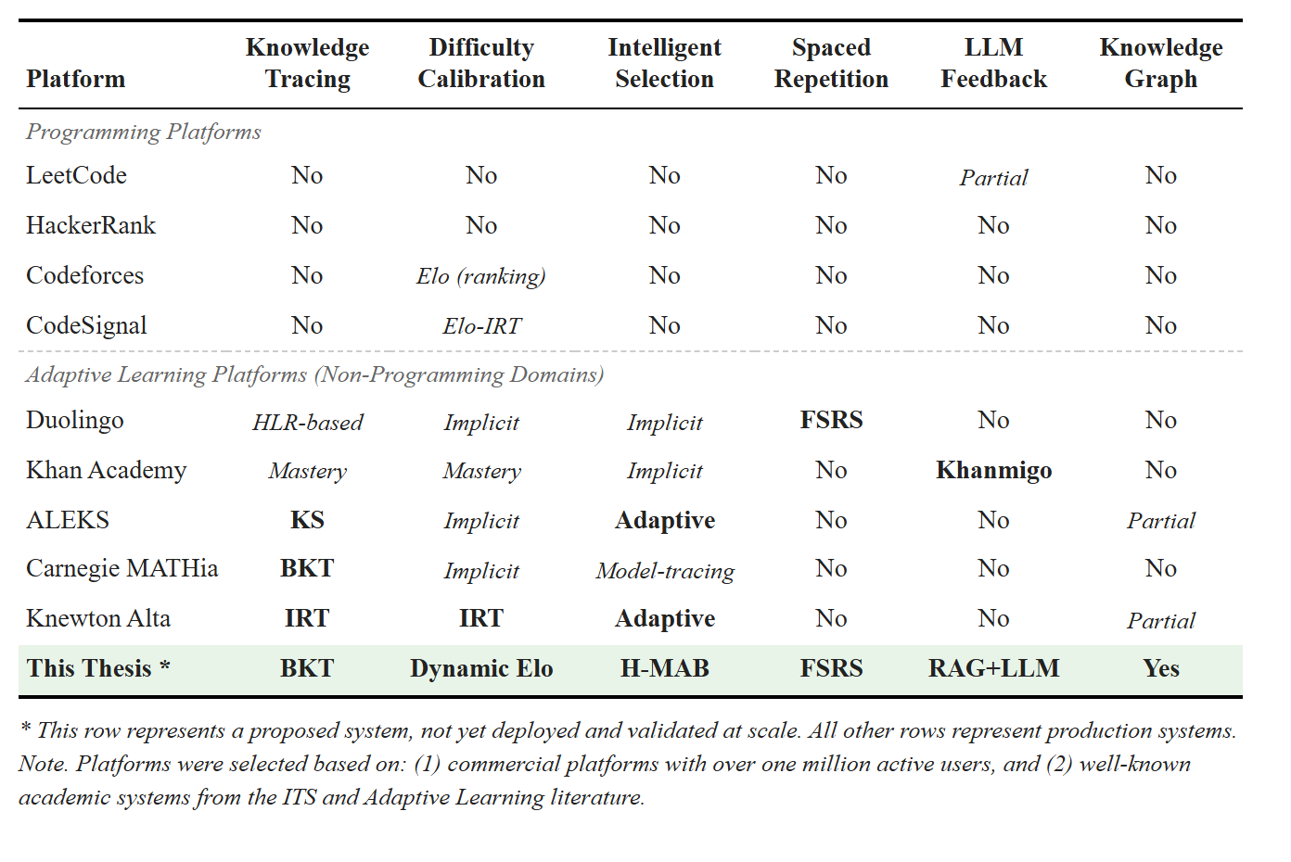
Table 1.1. Comparison of adaptive capabilities across existing platforms and this thesis.

1.3. Research Objectives
This thesis designs and implements an integrated adaptive learning platform for undergraduate programming courses, and specifies a pilot evaluation protocol. The five objectives:
- Design a multi-layer architecture. A modular five-layer engine: knowledge tracing (Layer 1), difficulty calibration (Layer 2), problem selection (Layer 3), review scheduling (Layer 4), and an exploratory LLM hint layer (Layer 5).
- Implement the learner model. Bayesian Knowledge Tracing (BKT) for per-(student, concept) mastery, plus a dual Elo system with a dynamic K-factor for continuous difficulty calibration. The Elo / IRT link [11] grounds difficulty matching in psychometric theory.
- Implement the recommendation and review pipeline. A two-level Hierarchical Multi-Armed Bandit (H-MAB) with Thompson Sampling, gated by knowledge-graph prerequisites and Zone of Proximal Development filtering. Integrate the Free Spaced Repetition Scheduler (FSRS) [12]; map code submission outcomes to FSRS review ratings.
- Deliver a deployable platform. React frontend, NestJS API, FastAPI adaptive service, PostgreSQL, Docker sandbox.
- Specify the pilot protocol. A between-subjects, pre-/post-test pilot at Hanoi University with 40–60 students. Execution and result reporting are out of scope.

1.4. Research Questions
This thesis addresses four research questions. RQ2 and RQ3 use comparative hypotheses tested at α = 0.05. The pilot enables Layers 1–4 together (see Chapter 5), so RQ2 and RQ3 evaluate the integrated platform as a whole, not individual layers in isolation.
RQ1: How accurately does the learner model predict student performance? Primary measure: AUC-ROC of BKT and Elo predictions on held-out submissions. Following standard thresholds in educational data mining [11], the pre-registered target is AUC-ROC ≥ 0.65–0.70. Acceptance rate per difficulty band and Elo convergence speed are reported as supporting indicators in Chapter 5, not as primary outcomes.
RQ2: Does the integrated adaptive pipeline (BKT + Elo + H-MAB + FSRS) produce different learning outcomes than a content-based filtering baseline? The experimental group gets Layers 1–4. The control group gets only content-based filtering over sentence-transformer embeddings. Primary metric: Normalized Learning Gain. Supporting metric: Problems-to-Mastery ratio.
- H2 (alternative): the adaptive group shows higher Normalized Learning Gain.
- H2_0 (null): no difference.
RQ3: Does the platform with FSRS-scheduled reviews yield different short-term retention than the same platform without scheduled reviews? Measured by a retention test administered two weeks after the intervention.
- H3 (alternative): the adaptive group shows higher retention.
- H3_0 (null): no difference.
RQ4: How do students perceive the platform’s usability and usefulness? Measured by the System Usability Scale [13], the TAM constructs Perceived Usefulness and Perceived Ease of Use [14], and semi-structured interviews analysed thematically [15].

1.5. Proposed Solution
This thesis presents an Adaptive Learning Platform for University Programming Courses: a five-layer adaptive engine on top of a knowledge graph of programming concepts. It is a closed-loop system — student interactions update the learner model, which drives the next recommendation.

1.5.1 Architecture Overview
The platform extends a three-tier web stack (React, NestJS, PostgreSQL) with a Python adaptive engine (FastAPI) that has five layers on top of a knowledge graph:
- Foundation: Knowledge Graph. A hand-curated directed graph of ~30 programming concepts. Each problem is tagged with one or more concepts; the graph constrains every adaptive layer.
- Layer 1: BKT. For each (student, concept), Bayesian Knowledge Tracing [16] tracks mastery probability and updates it after each submission.
- Layer 2: Dynamic K-Value Elo. A dual Elo system rates students and problems, updated after each submission [17]. The K-factor adapts to the student’s recent learning trend so ratings converge fast for new students and stay stable for experienced ones [11].
- Layer 3: Hierarchical MAB. A two-level H-MAB with Thompson Sampling [18], [19]. Level 1 picks a concept the student is ready for; Level 2 picks a problem whose Elo rating sits in the student’s Zone of Proximal Development [20], [21].
- Layer 4: FSRS. FSRS [12] tracks memory state per (student, concept) using a power-law forgetting curve. When retrievability drops below a threshold, the MAB prioritizes that concept for review. Submission outcomes map to FSRS review ratings; Chapter 4 explains the mapping.
- Layer 5: LLM Feedback (exploratory). A Retrieval-Augmented Generation module that produces Socratic hints when the student is stuck. Built to test feasibility; disabled in the pilot. Not part of the thesis’s evaluated contribution.
Layer parameters are in Chapter 4.
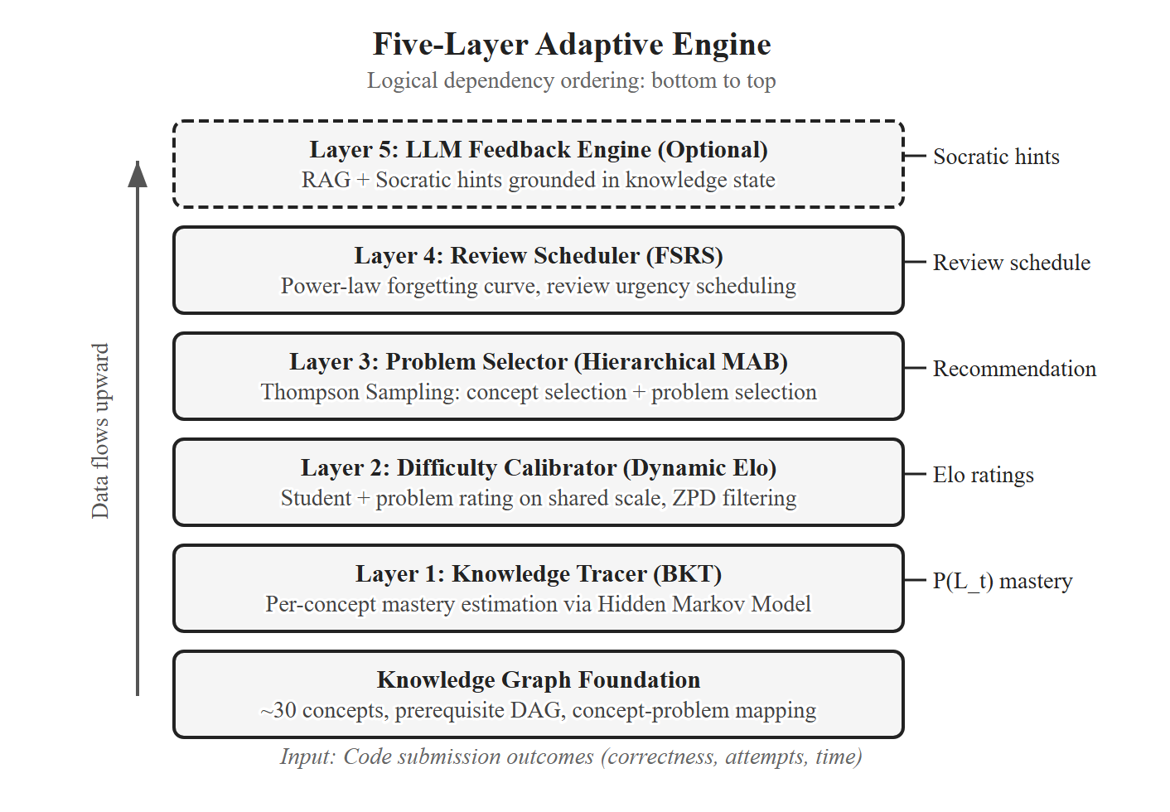
Figure 1.2. Five-layer adaptive engine architecture overview.

1.5.2 Closed-Loop Workflow
The student requests a recommendation. The adaptive engine combines BKT mastery, the FSRS review queue, and Elo ratings, then asks the H-MAB for the next problem. The student submits code; it runs in a Docker sandbox. All models update asynchronously: BKT mastery, Elo ratings, MAB reward distributions, FSRS memory state. The updated learner model feeds the next recommendation. The loop continues, keeping problems at the right level and avoiding stagnation.
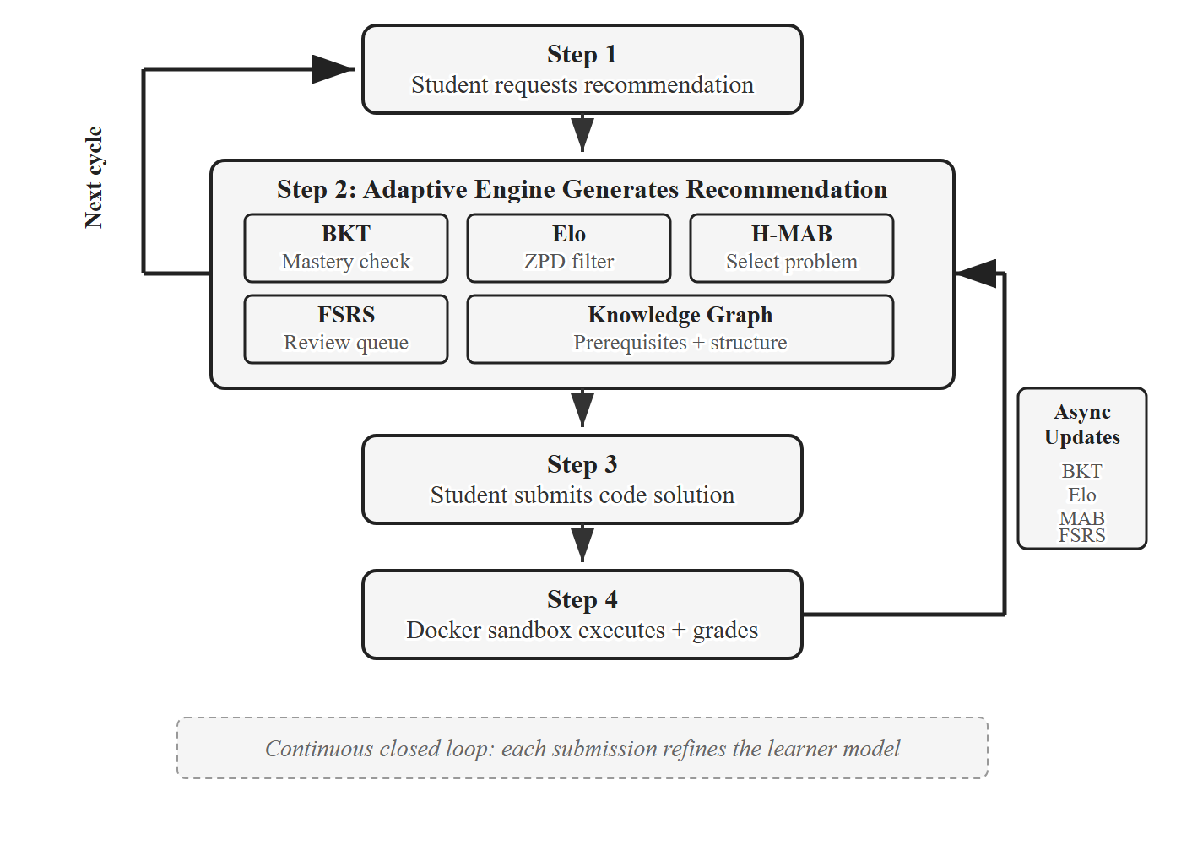
Figure 1.1. Closed-loop adaptive workflow showing continuous knowledge state updates.

1.6. Scope and Limitations

1.6.1 Scope
- Subject matter: Python, ~30 concepts from basics (variables, I/O) to intermediate (functions, recursion, data structures) to advanced (dynamic programming, graph algorithms).
- Population: Hanoi University undergraduates in programming courses.
- Platform: Web application, accessible via modern browsers.
- Adaptive components: Layers 1–4 from §1.5 are evaluated in the pilot. Layer 5 (LLM) is built but disabled in the pilot to avoid confounding the evaluation.
- Evaluation. A pilot protocol is specified for a between-subjects study with 40–60 participants over a four-week intervention plus a two-week retention follow-up. The power analysis in Chapter 5 shows that this sample size detects only large effects (Cohen’s d ≥ 0.8) at α = 0.05 with 80% power. The pilot is presented as a preliminary design, not a completed evaluation. Full execution and reporting are future work.
- Ethics: The design will be submitted for approval to Hanoi University’s academic oversight body. Informed consent, voluntary participation, and grade-independence will be enforced.

1.6.2 Limitations
Out of scope: multi-language support (Python only), mobile app, real-time collaboration, integration with Learning Management Systems, large-scale deployment (single university, 40–60 students), longitudinal evaluation (four weeks only). The cold-start problem is handled by recommending beginner-average problems until ~10 submissions accumulate.

1.7. Contributions
This thesis makes two contributions.
Contribution 1: An integrated adaptive platform for programming courses (Chapters 3–4). A closed-loop platform combining BKT, Dynamic K-Value Elo, prerequisite-constrained Hierarchical MAB with Thompson Sampling, and FSRS — unified by a curated knowledge graph of ~30 concepts. The integration is the central engineering contribution: BKT mastery gates MAB exploration, Elo ratings constrain selection to the Zone of Proximal Development, and FSRS reviews can interrupt the MAB. Released as a working full-stack application (React, NestJS, FastAPI, PostgreSQL, Docker sandbox) for the Vietnamese university context.
Contribution 2: A pilot evaluation protocol (Chapter 5). A between-subjects, pre-/post-test pilot design for Hanoi University undergraduates: recruitment and consent procedure, instruments (custom pre/post-test, SUS, TAM, interviews), quantitative metrics (Normalized Learning Gain, BKT/Elo prediction AUC, acceptance and completion rates, engagement), and a statistical plan with pre-registered thresholds, power assumptions, and a fallback for small samples. The protocol evaluates the whole Layers-1–4 system, not individual layers.
Contribution 1 is implemented and demonstrated technically. Contribution 2 is specified but not yet empirically executed.
A Layer 5 module (LLM-based Socratic hints) was also built as exploratory work to test feasibility of RAG-grounded hint generation. It is described in §1.5.1, Chapter 4, and §6.3 (future work), but is disabled in the pilot to avoid confounding the evaluation of Layers 1–4. It is not a primary contribution of this thesis.

1.8. Thesis Structure
Chapter 2 reviews the relevant literature and ends with a gap analysis. Chapter 3 covers requirements and the five-layer architecture. Chapter 4 covers implementation, including per-difficulty BKT initialization, the dynamic K-factor for Elo, the multi-component MAB reward, and the submission-to-FSRS mapping; feature flags allow control-group mode. Chapter 5 describes the pilot design (recruitment, ethics, metrics, statistical plan); since the intervention has not been executed, this chapter is a protocol, not results. Chapter 6 summarizes the work and discusses limitations and future directions.
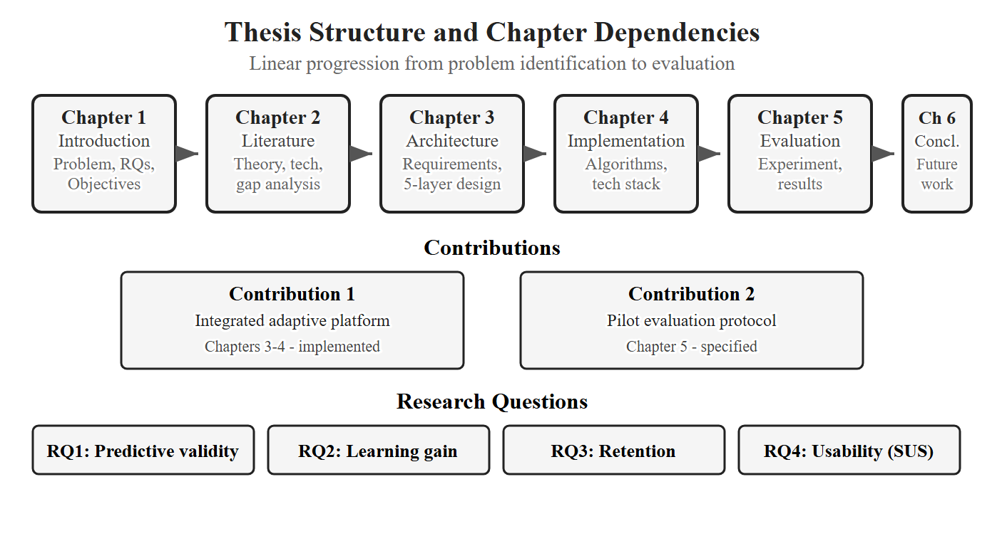
Figure 1.3. Thesis structure roadmap. Six chapters proceed linearly. Two contributions map to their primary chapters; four research questions are addressed across Chapters 5-6.

CHAPTER 2. LITERATURE REVIEW AND THEORETICAL BACKGROUND
This chapter reviews the literature that grounds the platform’s design. §2.1 covers learning theories (adaptive learning, ZPD, desirable difficulties, the spacing effect). §2.2 covers the algorithms each layer uses (BKT, DKT, Elo / IRT, MAB, FSRS, knowledge graphs, LLMs). §2.3 surveys existing platforms and prototypes. §2.4 identifies the gap this thesis fills: an integrated multi-layer adaptive platform for programming education.
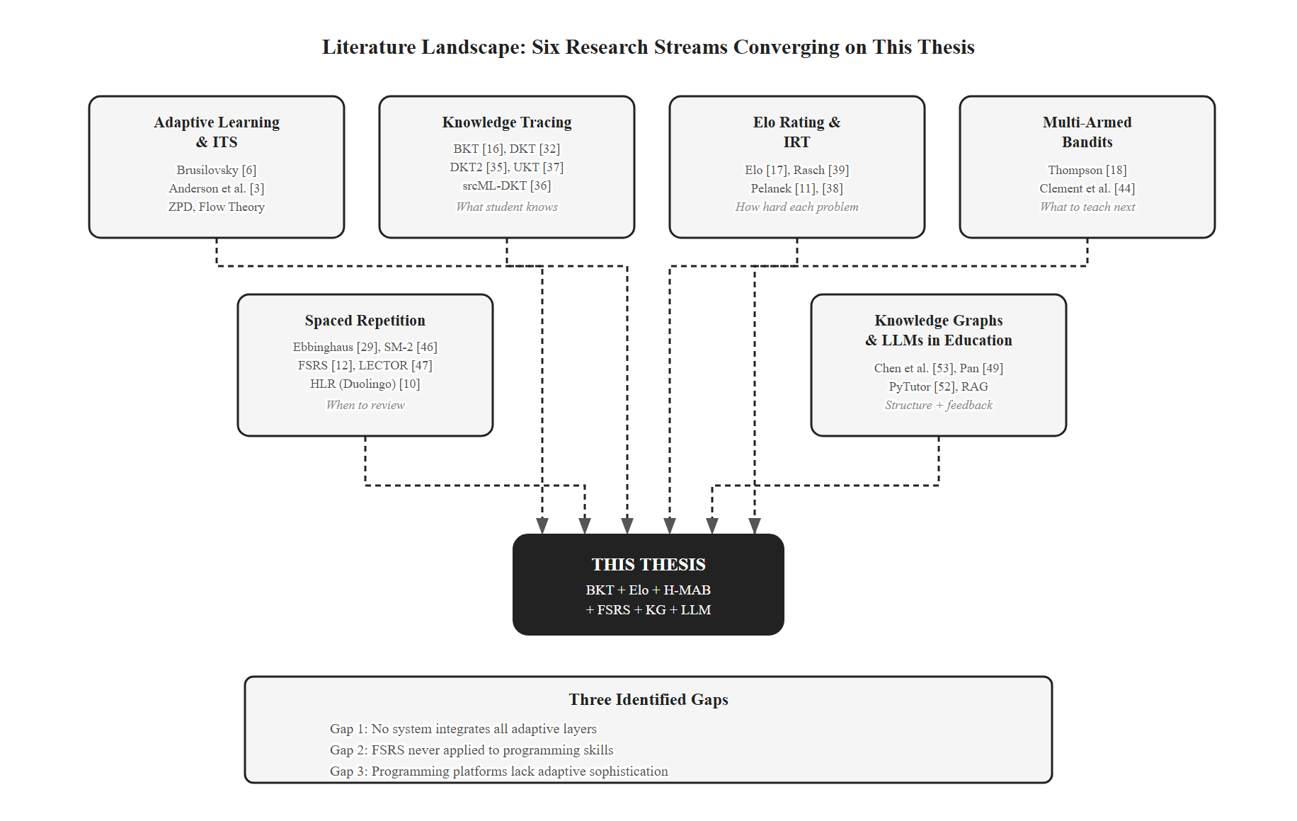
Figure 2.1. Literature landscape map showing six research streams converging on the thesis.

2.1. Theoretical Foundations

2.1.1 Adaptive Learning and Intelligent Tutoring Systems
Adaptive learning is “the ability of the system to adjust the instruction content, speed, and methodology in relation to the characteristics of the learner and the results of the learning process” [6]. Brusilovsky [6] split adaptation into adaptive presentation and adaptive navigation; Paramythis and Loidl-Reisinger [7] extended this to four dimensions, of which this thesis uses adaptive content selection and adaptive assessment.
The first generation of adaptive systems were Intelligent Tutoring Systems (ITS) such as Anderson et al.’s LISP Tutor and the Cognitive Tutor for math [3], [8], which produced 50–100% gains over traditional teaching. Their main contribution was the explicit student model and the distinction between model tracing (compare to expert solution) and knowledge tracing (estimate skill mastery). Both require the domain to be decomposed into fine-grained skills — the same idea that motivates the knowledge graph in this thesis. Later web-based AEH systems (AHA! [22], KnowledgeTree [23]) and ML-based systems (ALEKS [9], Khan Academy [24]) extended adaptation to a larger scale. Duolingo demonstrates the scalability of adaptive techniques in language learning [10]; its success suggests potential transfer to programming education.
Relevance to this thesis. The proposed platform is an ITS-style system for programming, with explicit knowledge tracing (Layer 1, BKT) and skill-decomposed content (the knowledge graph). The design follows the ITS lineage and adopts Brusilovsky’s adaptive content selection.

2.1.2 Zone of Proximal Development
The Zone of Proximal Development (ZPD), introduced by Vygotsky [20], is the gap between what a learner can do alone and what they can do with guidance. Tasks below the ZPD are too easy and produce little learning; tasks above it produce frustration. The flow theory of Csikszentmihalyi [25] makes a related point: optimal engagement happens when challenge matches skill.
Relevance to this thesis. The Elo layer (§2.2.3) operationalizes the ZPD as a numeric range above the student’s rating, calibrated to a 36–64% expected success rate. ZPD acts as a hard filter on the problem selector (Layer 3): no problem outside the ZPD is recommended.

2.1.3 Desirable Difficulties
Bjork and Bjork [21] showed that conditions which slow short-term performance often improve long-term retention and transfer. Three desirable difficulties are directly relevant:
- Spacing effect [26]: spreading practice over time outperforms massed practice. Underpins Layer 4 (FSRS).
- Testing effect [27]: actively retrieving material is more effective for retention than restudying it. The platform’s “review” recommends a new problem on the due concept rather than the concept’s definition.
- Interleaving [28]: mixing concepts beats blocking them. The Hierarchical MAB (Layer 3) is naturally interleaved across many concepts.
Relevance to this thesis. All three principles are encoded directly in the architecture. The platform is not just adaptive; it is built on validated cognitive-science effects.

2.1.4 Spacing Effect and Forgetting Curves
Ebbinghaus [29] first showed that memory decay is fast initially and slows over time. The exact functional form has been debated; recent work [12], [30] settles on a power law: R(t, S) = (1 + t / (9 S))^-1, where R is the probability of recall, t is time since the last review, and S is memory stability (the time at which retrievability falls to 90%). This is the form FSRS uses [12].
Cepeda et al. [26] confirmed the spacing effect across 254 studies: optimal review spacing scales with the desired retention interval. SR algorithms exploit this by scheduling reviews just before forgetting is likely.
Relevance to this thesis. FSRS has only been validated on declarative knowledge (vocabulary, facts). Programming is procedural. This thesis bridges the gap with a submission-outcome-to-FSRS-rating mapping (Chapter 4), so “review” still means deliberate retrieval practice — solving a new problem on the due concept.

2.2. Related Technologies

2.2.1 Bayesian Knowledge Tracing
Bayesian Knowledge Tracing (BKT) [16] models per-skill mastery as a two-state Hidden Markov Model with four parameters: p(L0) prior knowledge, p(T) learn rate per opportunity, p(G) guess rate, p(S) slip rate. After each response, BKT applies Bayes’ theorem to update the mastery posterior, then applies the learn-rate transition. Parameters are typically fit per skill via Expectation-Maximization (e.g., the pyBKT library [31]).
BKT’s strengths: parameters are interpretable (the mastery probability has a direct pedagogical meaning), updates are O(1), the model has 30+ years of validation [8], [16], and it works on sparse data — which matters for a 40–60-student pilot. Its known limitations: the binary skill state is a coarse approximation, skills are assumed independent, and there is no forgetting (Layer 4 fixes this).
Relevance to this thesis. I chose BKT for Layer 1 because the Hierarchical MAB (Layer 3) needs an interpretable mastery probability to gate prerequisites. DKT (§2.2.2) is more accurate on benchmarks but its hidden-state representation is opaque; using DKT would require a separate extraction step before the value is usable as a gate. BKT’s data efficiency is also better-matched to the pilot’s small sample. DKT2 is identified as a future upgrade once enough interaction data is collected (Chapter 6).

2.2.2 Deep Knowledge Tracing and Recent Advances
Deep Knowledge Tracing (DKT) [32] replaces BKT’s HMM with an LSTM, taking a sequence of (skill, correctness) pairs and outputting next-step probabilities. DKT improves predictive accuracy but suffers two problems noted in the literature: the hidden state cannot be directly read as per-skill mastery [33], and the model is reconstruction-inconsistent (different mastery readings for the same skill at the same step) [33]. DKT also needs thousands of student histories to train. Subsequent variants (DKT+ with regularizers [33], DKVMN with memory networks, DKT2 with xLSTM + IRT [35], srcML-DKT [36] for code, UKT [37] with uncertainty) improve accuracy further but inherit DKT’s interpretability and data-volume limitations.
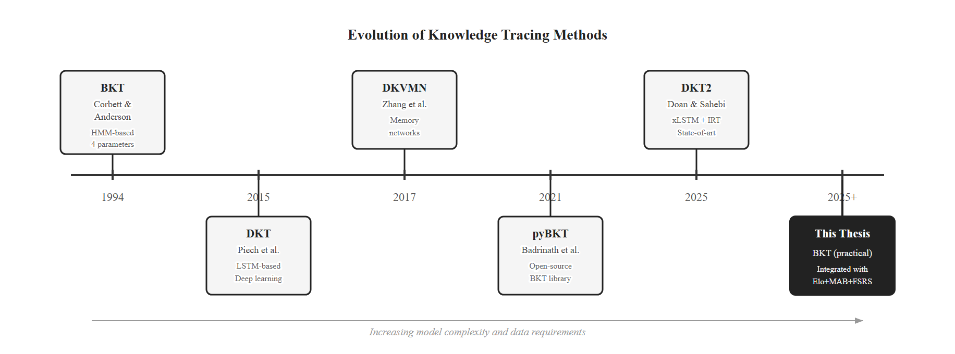
Figure 2.2. Knowledge tracing evolution from BKT (1994) to DKT2 (2025).
Relevance to this thesis. DKT-family models are not chosen as Layer 1 for two reasons. First, the Hierarchical MAB needs an interpretable mastery value to use as a prerequisite gate; DKT does not provide one without extra extraction work. Second, the 40–60-student pilot has nowhere near the sample size DKT needs. BKT delivers what the architecture requires today; DKT2 is a future-work upgrade once data accumulates (Chapter 6).

2.2.3 Elo Rating System and Item Response Theory
The Elo rating system [17] rates competitors via outcomes of pairwise matches. In education, each (student, problem) interaction is one match: P(student solves problem) = 1 / (1 + 10^((R_problem - R_student)/400)). After observing the outcome, both ratings shift by K * (actual - expected), where K is the step size (K-factor).
Pelanek [11] showed Elo ratings converge to stable estimates within ~20 attempts per student and ~30 per problem, and Elo correctly identifies expert-misclassified problems. An empirical study of 76 programming tasks across 299 students (50,055 attempts) reported AUC > 0.7 for Elo prediction [38]. The Elo expected-score formula is mathematically equivalent to the Rasch IRT model with a scaling factor [39]; Elo can therefore be seen as an online, low-overhead form of IRT [11].
A fixed K is a trade-off: large K reacts fast but is noisy; small K is stable but slow. Recent work [40] proposed a dynamic K-factor that scales with the student’s recent learning trend (a windowed sum of residuals between actual and expected outcomes). When the student is improving, K shrinks; when they are struggling, K grows. Multidimensional Elo [41] keeps a separate rating per concept.
Relevance to this thesis. Elo is Layer 2. It (1) operationalizes the ZPD as a per-student rating range and (2) feeds the MAB reward function with expected-success probabilities. The dynamic K is adopted directly so ratings converge fast for new students and stay stable for experienced ones. Concept-level Elo aligns naturally with the knowledge graph in §2.2.6.

2.2.4 Multi-Armed Bandits in Education
The Multi-Armed Bandit (MAB) problem [42] is the classic exploration–exploitation trade-off: each arm has an unknown reward distribution; the agent must maximize cumulative reward. In education, an arm is a learning activity and the reward is learning gain. Thompson Sampling [18], [19] is a Bayesian MAB algorithm that maintains a Beta posterior per arm, samples from each posterior, and picks the maximum. It explores high-uncertainty arms naturally — exactly what is wanted when the system is unsure of a student’s readiness — and requires no tuning parameter.
Standard MAB treats every problem as an arm, which is impractical at hundreds of items. The Hierarchical MAB [43] uses two levels: Level 1 picks a concept (arms = concepts whose prerequisites are met), Level 2 picks a problem (arms = problems within the concept that fall in the ZPD). Clement et al. [44] showed MAB-based selection outperforms random and expert-designed curricula in ITS settings. MAB with abandonment [45] adds a third outcome (the student gives up) as a strong signal that a recommendation was wrong; it informs a future direction for this work.
Relevance to this thesis. The Hierarchical MAB with Thompson Sampling is Layer 3. Combined with BKT prerequisite gating (Layer 1) and Elo ZPD filtering (Layer 2), it produces recommendations that are both pedagogically valid and difficulty-appropriate. The reward function combines BKT learning gain, difficulty match, and time efficiency (Chapter 4).

2.2.5 Free Spaced Repetition Scheduler
The first widely used SR algorithm was SM-2 [46], which schedules reviews via a recursive formula and a subjective 0–5 quality rating. SM-2’s parameters are fixed for all users and are not data-driven. The Free Spaced Repetition Scheduler (FSRS) [12] replaces SM-2 with a data-grounded model based on three states per item: Difficulty D (1–10), Stability S (days, the time for retrievability to drop to 90%), and Retrievability R (current recall probability). The forgetting curve is the power law from §2.1.4. Stability updates after a successful review use 19 parameters fit by gradient descent on the user’s own review history. FSRS uses four ratings (Again / Hard / Good / Easy) and is empirically 20–30% more efficient than SM-2 for the same retention target [12]. It has shipped in Anki since v23.10 (October 2023), giving it large-scale validation.
LECTOR [47] combines spaced repetition with LLM-assisted similarity detection for confusable items, achieving 90.2% retention versus 88.4% baseline across 100 simulated learners.
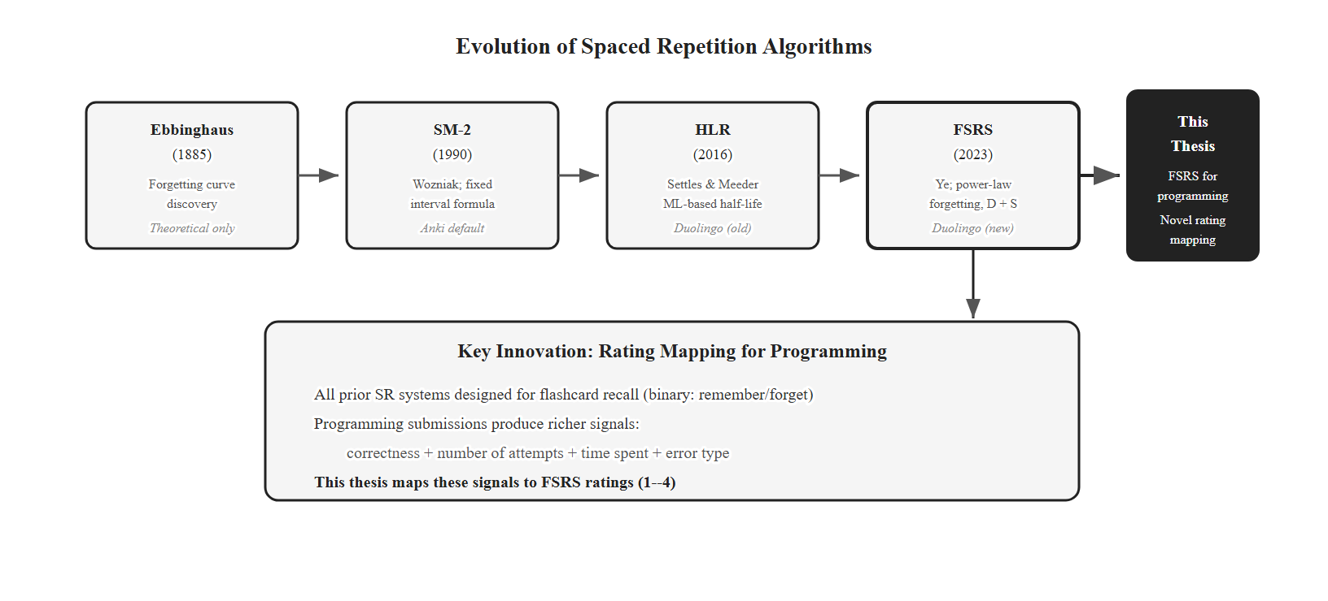
Figure 2.3. Spaced repetition evolution from Ebbinghaus to FSRS.
Relevance to this thesis. FSRS is Layer 4. I chose FSRS over SM-2 because FSRS’s per-user parameter fit is more accurate and it has the open algorithm + production validation that SM-2 lacks. Within the literature surveyed here, this is among the first applications of FSRS to programming-concept review. The novel piece is the rating mapping that converts code-submission outcomes into FSRS ratings (Chapter 4) — without it, FSRS would not work for procedural skills.

2.2.6 Knowledge Graphs
A knowledge graph (KG) represents domain concepts as nodes and prerequisite relations as directed edges. Programming has unusually clear prerequisite structure (variables → arrays → sorting → DP), which the literature has long recognized [2]. KGs can be hand-built, automatically extracted (e.g., the ACE pipeline [48]), or hybrid. Graph Neural Network approaches [49], [50], [51] improve recommendation quality on large educational graphs but require thousands of training examples.
Relevance to this thesis. I use a hand-curated KG of ~30 Python concepts and ~40–50 prerequisite edges. Manual curation is justified at this scale: the concept space is small, prerequisite accuracy matters (one wrong edge can permanently block a student), and the graph must align with the specific Hanoi University curriculum. A learned KG via ACE or GNN methods is future work — it is not viable now because we lack the historical interaction volume needed to train it. The hand-built KG serves three purposes: it is the concept space for BKT, the prerequisite gate for the MAB, and the structural context for the Layer 5 RAG hints.

2.2.7 Large Language Models in Education
LLMs are increasingly used as tutoring agents. PyTutor [52] is a ChatGPT-based Socratic tutor for Python that maintains dialogue state and reports 4.2/5.0 satisfaction in usability studies. Known LLM limitations in education include hallucination, over-eagerness to give direct answers, response inconsistency, and per-call cost.
Retrieval-Augmented Generation (RAG) addresses several of these by grounding LLM responses in retrieved factual content. Chen et al. [53] combined a KG, a RAG retriever, and an LLM to generate personalized programming feedback; their hybrid mode outperformed both adaptive-only and LLM-only baselines on 4,956 code submissions. Wang et al. [54] extended this to multimodal KGs and reported 15% concept-mastery improvements.
Relevance to this thesis. The platform includes Layer 5, an exploratory RAG-grounded LLM hint module that produces Socratic hints when a student fails three or more attempts. It is built but disabled in the pilot to avoid confounding the evaluation of Layers 1–4 (cost, hallucination, and hint quality require their own evaluation). Layer 5 is not a primary contribution of this thesis; it is documented in Chapter 4 and listed as future work in §6.4.

2.3. Related Work

2.3.1 Commercial Programming Platforms
LeetCode, HackerRank, Codeforces, and CodeSignal serve tens of millions of users but are pedagogically static. LeetCode classifies problems into three fixed difficulty tiers (Easy, Medium, Hard) with no per-user adaptation, no knowledge model, no spaced repetition, and no prerequisite awareness; LLM hints were recently added but operate independently of any learner model. HackerRank’s skill tracks use binary skill badges and fixed assessment tests. Codeforces has an Elo rating system, but only for competitive ranking — not for pedagogical recommendation. CodeSignal uses an Elo-IRT hybrid for hiring assessment, not for adaptive practice.
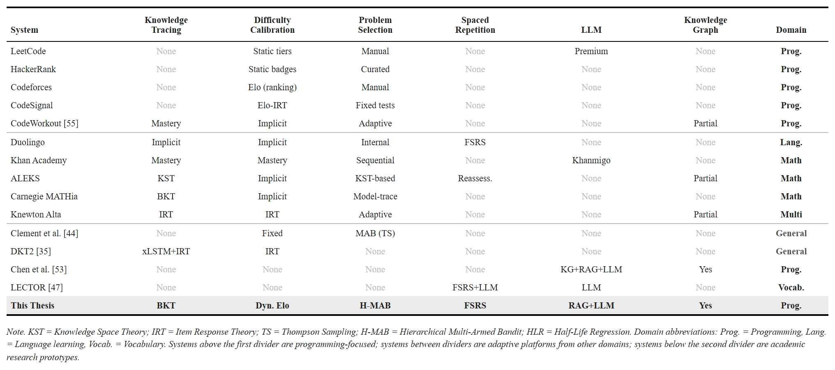
Table 2.1. Detailed comparison of academic and commercial adaptive systems.

2.3.2 Adaptive Learning Platforms (Other Domains)
Duolingo is the most-cited example of data-driven adaptive learning at scale; it migrated from Half-Life Regression [10] to FSRS [12] for vocabulary review scheduling. Duolingo demonstrates the scalability of adaptive techniques in language learning, which suggests potential transfer to programming. Khan Academy uses deterministic mastery learning and has integrated Khanmigo (LLM tutor); ALEKS [9] uses Knowledge Space Theory with binary mastery and prerequisite-aware sequencing. Carnegie MATHia uses BKT + model tracing for math [8] — closest in spirit to this thesis but without Elo, MAB, or FSRS. Knewton Alta uses batch-mode IRT with adaptive sequencing, no MAB or SR.

2.3.3 Academic Research Systems
Research prototypes typically combine subsets, not all five layers. Clement et al. [44] showed MAB beats random / expert curricula but assumed fixed difficulty and skipped knowledge tracing. CodeWorkout [55] uses adaptive selection on concept mastery without Elo or SR. DKT2 [35] is purely predictive — no recommendation or scheduling layer. Chen et al.’s KG + RAG + LLM framework [53] integrates structured knowledge with generative AI but skips KT, Elo, and MAB. LECTOR [47] combines SR + LLM in vocabulary, not programming.
These systems show the value of each individual technique, but the integration challenge remains open.
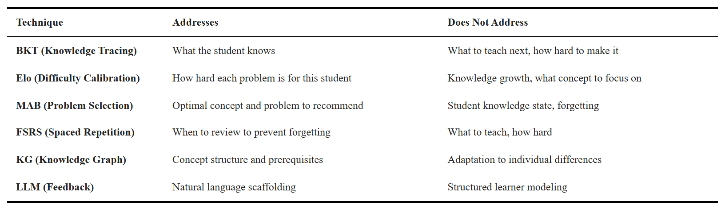
Table 2.2. How each adaptive technique addresses the limitations of the others.

2.4. Research Gap
The literature shows three principal gaps:
Gap 1 — No integration of all five adaptive layers. Each technique addresses one piece. No reviewed system combines knowledge tracing, difficulty calibration, intelligent selection, spaced repetition, and contextual feedback. Table 2.2 makes the complementarity concrete: each technique’s blind spot is another technique’s strength.
Gap 2 — Spaced repetition has not been applied to programming. FSRS and its predecessors were built and validated for declarative knowledge — vocabulary and facts. Programming is procedural. Applying FSRS to programming-concept retention requires a mapping from code-submission outcomes to FSRS ratings (Chapter 4), which has not been done in the literature surveyed here.
Gap 3 — Programming platforms lack adaptive sophistication. The largest programming platforms (LeetCode, HackerRank, Codeforces) skip adaptation. The most adaptive platforms (ALEKS, Carnegie MATHia, Duolingo) skip programming. Programming education sits at the intersection — it needs both the domain infrastructure (sandboxed code execution, test-case grading) and the adaptive engine.
This thesis fills these three gaps via the integrated five-layer architecture in Chapter 3, the FSRS rating mapping in Chapter 4, and the pilot evaluation protocol in Chapter 5.

CHAPTER 3. SYSTEM DESIGN
Chapters 3 and 4 are the technical core of this thesis. Chapter 3 explains the design; Chapter 4 explains how I implemented it. The design must close the three gaps from Chapter 2: no integrated multi-layer adaptive engine for programming, no spaced repetition for procedural skills, and no adaptive sophistication in commercial coding platforms.
This chapter is organized as follows. §3.1 lists the functional and non-functional requirements and maps each to its design and evaluation point. §3.2 gives the four-component architecture. §3.3 describes the five-layer adaptive engine, layer by layer. §3.4 covers the data model. §3.5 walks through the recommendation and submission flows. §3.6 covers cold start. §3.7 covers caching. §3.8 closes with the layer interaction summary.

3.1. Requirements
The requirements come from three sources: the five research objectives in §1.3, the theory in Chapter 2, and the practical realities of running an adaptive platform in a Vietnamese university course. I split them into functional requirements (what the system must do) and non-functional requirements (how it must perform), then trace each to its design section, implementation section, and evaluation metric.

3.1.1. Functional Requirements
Ten functional requirements cover three families: adaptive capabilities (FR1–FR5), platform functions (FR6–FR7), and dashboard / analytics (FR8–FR10). Table 3.1 lists each requirement with priority and source.
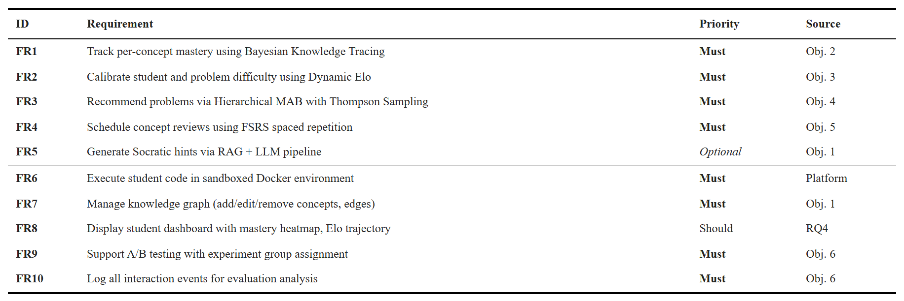
Table 3.1. Functional requirements derived from research objectives.
A few requirements deserve a sentence of context. FR1 (Bayesian Knowledge Tracing) maintains the per-(student, concept) posterior P(L_t); the threshold P(L_t) ≥ 0.85 gates prerequisites for downstream recommendation. FR3 (Hierarchical MAB) is the integration point: it consumes BKT mastery (FR1), Elo ratings (FR2), and FSRS review urgency (FR4) and returns a ranked problem list. FR5 (LLM hints) is exploratory and disabled in the pilot, per §1.5.1.

3.1.2. Non-Functional Requirements
Six non-functional requirements set performance and security targets. Table 3.2 lists them.
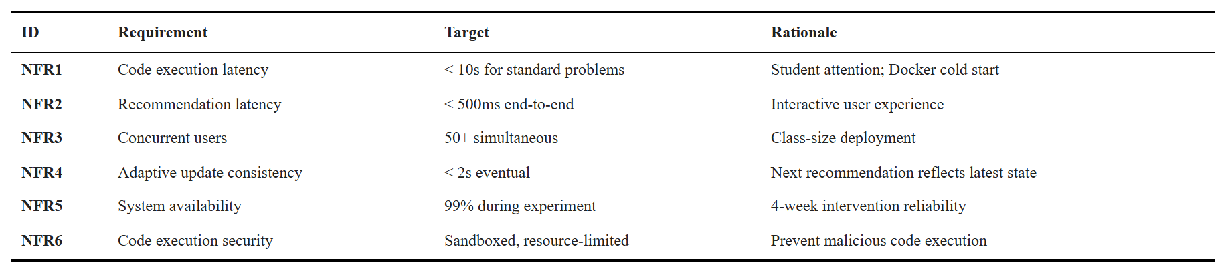
Table 3.2. Non-functional requirements.
NFR2 (recommendation latency under 500 ms end-to-end) is the binding constraint that motivates the Redis caching strategy in §3.7. NFR3 (50+ concurrent users) is the expected pilot cohort size; the FastAPI service is stateless to allow horizontal scaling. NFR6 (sandboxed execution) keeps each Docker container isolated with no network access, a memory cap, and a CPU-time cap.

3.1.3. Requirements Traceability
Table 3.3 maps every requirement to the architectural component that fulfils it, the design section in this chapter, the implementation section in Chapter 4, and the evaluation metric in Chapter 5. The matrix confirms that every requirement has an owner and an evaluation hook.
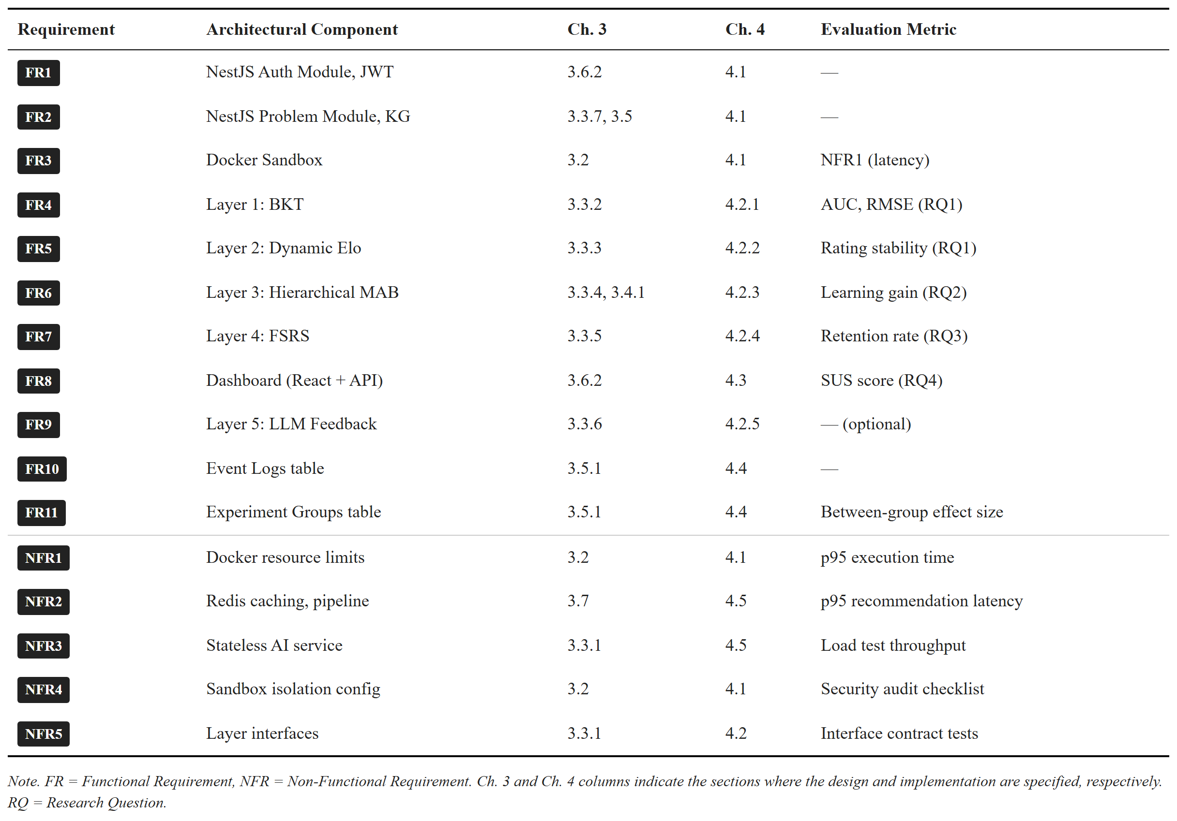
Table 3.3. Requirements traceability matrix.

3.2. Architecture Overview
The platform is built from the ground up for adaptive learning. I did not bolt adaptive features onto an existing online judge; every layer — from the code editor to the AI service — was designed with adaptive learning as a core concern.
The system has four components:
- React + TypeScript frontend (Vite, Ant Design, Monaco editor). The client provides the code editor, the problem browser, the adaptive dashboard (mastery, Elo trends, review queue), and the recommendation panel.
- NestJS API gateway (TypeScript, Prisma ORM). The gateway handles authentication, course and problem CRUD, and code execution. For adaptive features it acts as a proxy to the FastAPI service.
- FastAPI AI service (Python 3.11, SQLAlchemy). The AI service hosts the five-layer adaptive engine. Python is the natural choice because the relevant libraries — pyBKT [31], NumPy, SciPy, and the FSRS reference implementation — are written in Python.
- PostgreSQL + Redis + Docker sandbox. PostgreSQL is the single persistent store. Redis provides caching for adaptive state and per-student locks for concurrency control. Docker containers run student code with the limits in NFR4.
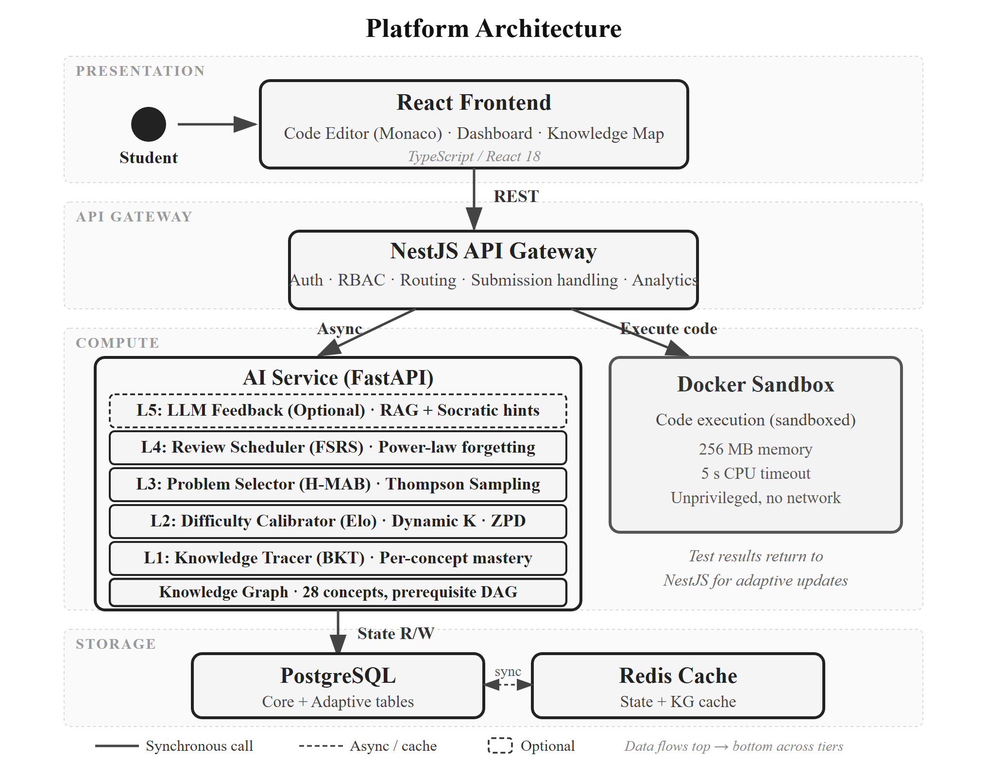
Figure 3.1. System architecture: the four-component platform with the five-layer adaptive engine inside the FastAPI service.
Three design choices deserve a note. First, separating the AI service from the NestJS gateway lets the Python ML ecosystem run natively, lets the adaptive engine scale and deploy independently, and enforces a clean interface contract. Second, the two services share a database under a strict write-ownership rule: NestJS owns writes to core domain tables (users, problems, submissions); the AI service owns writes to adaptive state tables (knowledge states, Elo ratings, MAB states, FSRS cards). Both services have read access to all tables. This eliminates distributed transactions. Third, adaptive updates are asynchronous. The submission verdict is returned to the student synchronously; BKT, Elo, MAB, and FSRS update in the background. This decouples response time from adaptive logic complexity.
The platform also follows progressive enhancement: core functions (browse, submit, run, see verdict) work even when the adaptive engine is off. Each adaptive layer is feature-flagged, which simplifies the control-group condition in the pilot.

3.3. Five-Layer Adaptive Engine
The adaptive engine has five layers stacked on a knowledge graph foundation. The layers communicate through small, well-defined interfaces (NFR5). Layer 3 is the integration point: it consumes outputs from Layers 1, 2, and 4 to choose the next problem. Figure 3.6 summarizes the data dependencies.

3.3.1. Knowledge Graph Foundation
The knowledge graph is a directed acyclic graph: nodes are programming concepts, edges are prerequisite relations. It encodes the pedagogical sequencing every programming curriculum follows (variables before loops, loops before sorting, sorting before dynamic programming).
The graph has 34 Python concepts grouped into seven topic groups: Basics, Control Flow, Functions, Data Structures, OOP, Algorithms, and Advanced. The full 34-concept listing and all 52 prerequisite edges are in Appendix B. Each concept has a difficulty tier (1–5). Edges are weighted (default 1.0) to allow soft prerequisites in future extensions. Instructors and admins manage the graph through the NestJS API; a DAG validation prevents cycles.
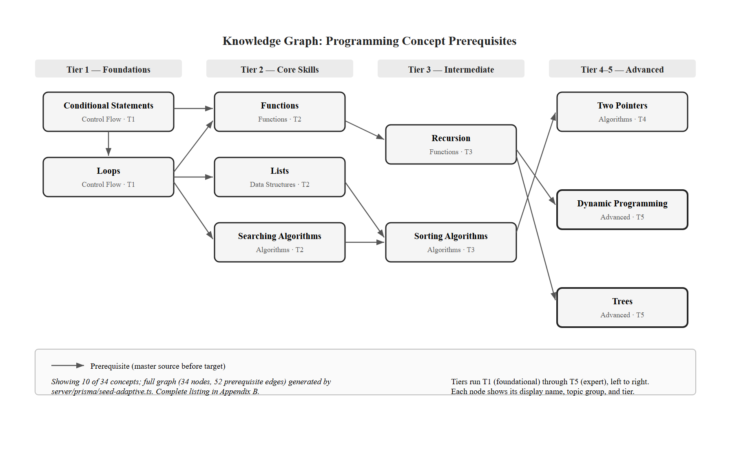
Figure 3.2. Knowledge graph excerpt: 10 of 34 concepts and their prerequisite edges. The full graph (34 nodes, 52 edges) is in Appendix B.
The graph is consumed by every layer. Layer 1 (BKT) uses the problem → concepts mapping to know which mastery posterior to update. Layer 3 (MAB) uses prerequisite edges to gate concept eligibility. Layer 4 (FSRS) uses the graph to make sure a “review” pulls a problem on the due concept, not a related one. Layer 5 (LLM) uses concept descriptions for retrieval context.

3.3.2. Layer 1 — Knowledge Tracing (BKT)
Purpose. Layer 1 maintains a probabilistic estimate of each student’s mastery of each concept. This estimate gates prerequisites in Layer 3 and supplies the learning-gain reward signal to the MAB.
Model. I implemented standard Bayesian Knowledge Tracing [16], described in §2.2.1. Each (student, concept) pair has four parameters — P(L_0), P(T), P(G), P(S) — and a current mastery P(L_t). Defaults follow Corbett and Anderson [16] and pyBKT [31]: P(L_0) = 0.1, P(T) = 0.2, P(G) = 0.15, P(S) = 0.1. These reflect typical introductory programming exercises: low prior knowledge, moderate per-opportunity learning, low guess rate (multi-test-case grading constrains lucky guesses).
Mastery threshold. A concept is treated as mastered for prerequisite gating when P(L_t) ≥ 0.85. The threshold of 0.85 is the midpoint of the 0.80–0.90 range recommended by [16]. It is a design choice from the literature, not empirically optimized on this dataset. The pilot will test sensitivity in the 0.80–0.90 band (§5.4).
Inputs / outputs. After each graded submission, Layer 1 receives the student id, the concept id (the problem’s primary tag), and a binary correctness signal (1 = ACCEPTED, 0 = otherwise). It writes the updated P(L_t) to the knowledge_states table and exposes it to Layers 3 and 4.
Interaction with other layers. Layer 1 feeds Layer 3 in two ways. (1) The ≥ 0.85 classification gates which concepts become eligible at MAB Level 1: concept B with prerequisite A is eligible only when A is mastered. (2) The change in P(L_t) is the learning-gain term in the MAB reward. Layer 1 also triggers Layer 4: when a concept first reaches mastery, an FSRS card is initialized for it.
This enables RQ1, which asks how accurately the learner model predicts student performance. BKT’s per-concept posterior is the main quantity validated in §5.

3.3.3. Layer 2 — Difficulty Calibrator (Dynamic Elo)
Purpose. Layer 2 puts students and problems on a shared rating scale so problem difficulty can be matched to student level. The shared scale operationalizes Vygotsky’s Zone of Proximal Development [20] as a numeric range above the student’s rating.
Model. I implemented a dual Elo system [17] with a dynamic K-factor [11]. Each student and each problem has a rating (initialized at 1200) and a K-factor that controls update sensitivity. The expected probability that student A solves problem B is
$$E_{A}=\frac{1}{1+{10}^{(R_{B}-R_{A})/400}} (3.1)$$
After a submission with outcome S_A (1 = ACCEPTED, 0 = otherwise), both ratings update:
$$R_{A}^{'}=R_{A}+K_{A}(S_{A}-E_{A}), R_{B}^{'}=R_{B}+K_{B}(E_{A}-S_{A}) (3.2)$$
The student’s K-factor is dynamic. It boosts updates when the student is new (few interactions) or on a steep learning curve (high recent residuals):
$$K_{A}=K_{\text{base}}⋅f_{\text{novelty}}(n)⋅f_{\text{trend}}(ΔR_{\text{recent}}) (3.3)$$
where f_novelty(n) = max(1.0, 2.0 − n/30) boosts the first 30 interactions and f_trend scales K with a windowed exponential moving average of recent residuals. Problem K-factors follow the analogous formula keyed on the number of submissions the problem has received.
Hyperparameter disclaimer. K_base = 25 is a heuristic midpoint chosen for moderate volatility in education, not a tuned optimum. Elo [17] originally recommended K = 32 for new and K = 16 for established chess players; 25 sits between. Sensitivity to K is in §5.4.
Interaction with other layers. Layer 2 defines the ZPD filter for Layer 3. Within a selected concept, only problems whose Elo rating satisfies
$$R_{A}+δ_{min}≤R_{B}≤R_{A}+δ_{max} (3.4)$$
are eligible. With δ_min = 50 and δ_max = 250, Equation 3.1 gives expected success probabilities of about 0.43 and 0.15. After accounting for the asymmetric nature of educational gains (students learn most from moderately challenging tasks), this band approximates the 36–64% success-rate range from flow theory [25] and the desirable-difficulty literature [21]. The bounds are design choices, validated by sensitivity analysis in §5.4.
This enables RQ1 by producing a continuous, calibrated difficulty rating per problem and per student, which is the primary input the model uses to predict next-step success.

3.3.4. Layer 3 — Problem Selector (Hierarchical MAB)
Purpose. Layer 3 is the recommendation engine. It frames problem selection as a two-level Hierarchical Multi-Armed Bandit and solves it with Thompson Sampling [18], [19]. The hierarchy mirrors the pedagogical decision: which concept first, then which problem within it.
Level 1 — Concept selection. Each eligible concept is an arm. A concept is eligible if all its prerequisites are mastered (P(L) ≥ 0.85) and either the concept itself is unmastered or it is flagged for review by Layer 4. Each arm has a Beta(α, β) posterior modelling expected learning gain. Thompson Sampling draws one sample per arm and picks the maximum.
Level 2 — Problem selection. Within the selected concept, each unsolved problem whose Elo rating sits in the student’s ZPD (Equation 3.4) is an arm. Each arm has its own Beta posterior. Thompson Sampling again selects the maximum.
Reward signal. After the student submits, the reward combines three terms:
$$r=w_{1}⋅ΔP(L_{t})+w_{2}⋅1[\text{correct}]+w_{3}⋅(1-\text{normalized_attempts}) (3.5)$$
Here ΔP(L_t) is the learning gain from Layer 1, the second term is the binary correctness, and normalized_attempts = min(attempt, M) / M with M = 5. The reward is clipped to [0, 1] and the Beta posterior is updated as α += r, β += 1 − r. While Thompson Sampling’s regret bounds were originally proved for Bernoulli rewards [18], using continuous rewards with Beta priors is an established approximation with good empirical performance [19].
Hyperparameter disclaimer. Weights w_1 = 0.5 (gain), w_2 = 0.3 (correctness), w_3 = 0.2 (efficiency) are heuristic combining values, not learned from data. They prioritize learning gain as the primary optimization signal. Sensitivity will be tested via grid search in §5.4.
Interaction with other layers. Layer 3 is where everything converges. It consumes BKT mastery and prerequisite gating from Layer 1, the ZPD filter from Layer 2, review urgency from Layer 4, and the prerequisite graph from §3.3.1. The integration of FSRS-due concepts into the MAB candidate set is the key novelty: due concepts are added as eligible arms with a priority boost on their Thompson Sampling prior, scaled by how far retrievability has fallen below the threshold. This balances new-material exploration against forgetting prevention without one overriding the other.
The specific combination of (i) prerequisite constraints from a curated knowledge graph, (ii) BKT-based mastery gating, and (iii) FSRS review urgency inside a hierarchical Thompson Sampling framework has not, to my knowledge, been previously reported. Multi-Armed Bandits have been applied to educational recommendation before [44]; the four-component integration is the engineering contribution of Contribution 1 (§1.7).
This enables RQ2, which asks whether the integrated adaptive pipeline produces different learning outcomes than a content-based filtering baseline.

3.3.5. Layer 4 — Review Scheduler (FSRS)
Purpose. Layer 4 fights the forgetting problem. It models memory decay per (student, concept) and surfaces concepts for review before they decay below a useful retrievability.
Model. I implemented FSRS v4 [12], whose power-law retrievability has been validated against SM-2 on millions of Anki reviews. Each (student, concept) is a card with two state variables: difficulty D (1–10) and stability S (the time in days at which retrievability drops to 90%). Retrievability at time t after the last review is
$$R(t)={\left(1+\frac{t}{9S}\right)}^{-1} (3.6)$$
A concept whose retrievability has fallen below the review threshold θ_r = 0.7 is flagged as due. When the student reviews a concept by solving a problem tagged with it, FSRS updates D and S from the review outcome. FSRS expects a 1–4 rating (Again / Hard / Good / Easy); programming submissions don’t naturally produce that. The submission-to-rating mapping — the bridge from procedural code outcomes to FSRS’s declarative rating scale — is in Chapter 4.
Interaction with other layers. Layer 4 feeds Layer 3. Review-due concepts are injected into the MAB Level 1 candidate set even if already mastered, with a priority bonus proportional to the urgency of the review. The result balances three pulls: advance to new concepts (exploitation), explore uncertain concepts (exploration), and review at-risk concepts (retention).
This enables RQ3, which asks whether FSRS-scheduled reviews change short-term retention versus the same platform without scheduled reviews.

3.3.6. Layer 5 — LLM Feedback (Exploratory)
Layer 5 is exploratory engineering work, not a thesis contribution. It is built and disabled in the pilot to avoid confounding the evaluation of Layers 1–4. The design is described here briefly for completeness; the implementation is in §4.6.
What it does. When a student requests a hint or fails three or more attempts on a problem, the system constructs a query from the problem description, the student’s latest code, the error message, and the relevant concept. A Retrieval-Augmented Generation pipeline retrieves concept descriptions, prerequisite information, and similar solved examples from the knowledge graph and problem bank. The retrieved context plus the student’s code goes into a large language model with a prompt template that enforces Socratic questioning — guiding the student rather than giving the answer.
The hint level is calibrated by Layer 1’s mastery estimate: low mastery gets fundamentals, moderate mastery gets a targeted nudge.
This enables future work on cost, hallucination, and hint quality (§6.4). It is not tied to a research question in the pilot.

3.3.7. Hyperparameter Summary
Table 3.4 lists every hyperparameter introduced above with its default value, valid range, and source. The table is referenced throughout Chapter 4 (implementation) and §5.4 (sensitivity analysis).
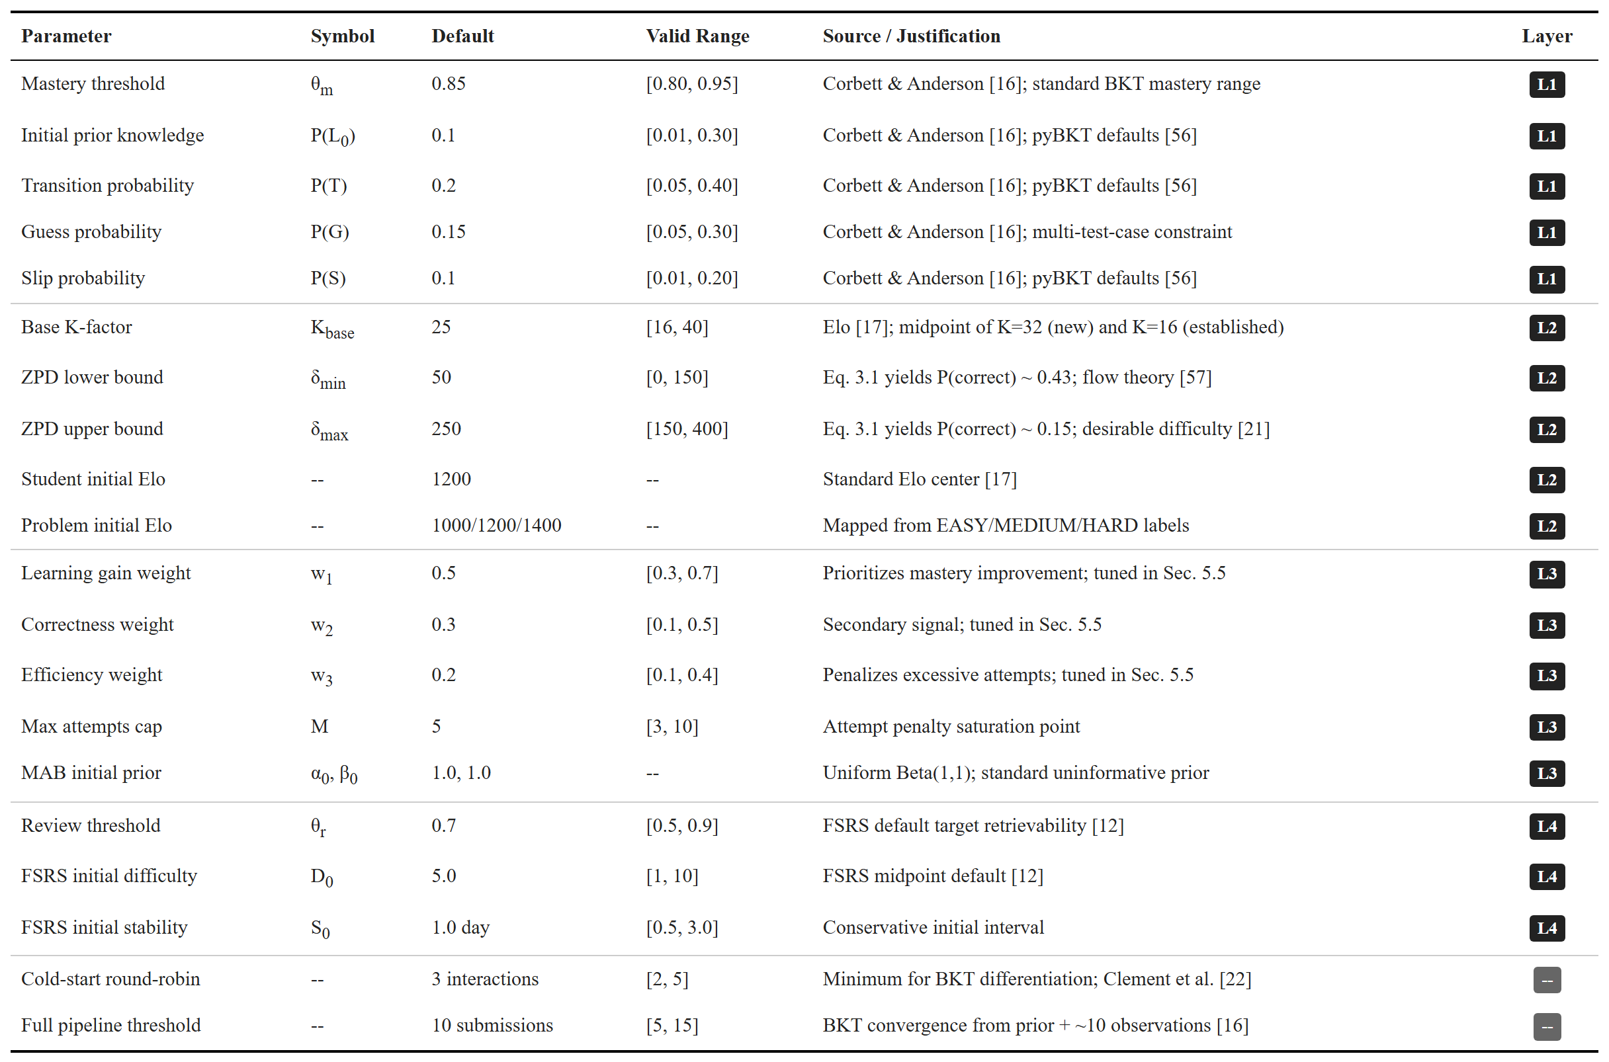
Table 3.4. Hyperparameter summary for the five-layer adaptive engine.

3.4. Data Model
The data model has two halves matching the write-ownership rule. NestJS owns the core domain (users, courses, problems, test cases, submissions, concepts, knowledge graph edges, problem-concept mappings). The AI service owns the adaptive state (knowledge_states, elo_ratings, mab_states, fsrs_cards) and the analytics tables (event_logs, experiment_groups).
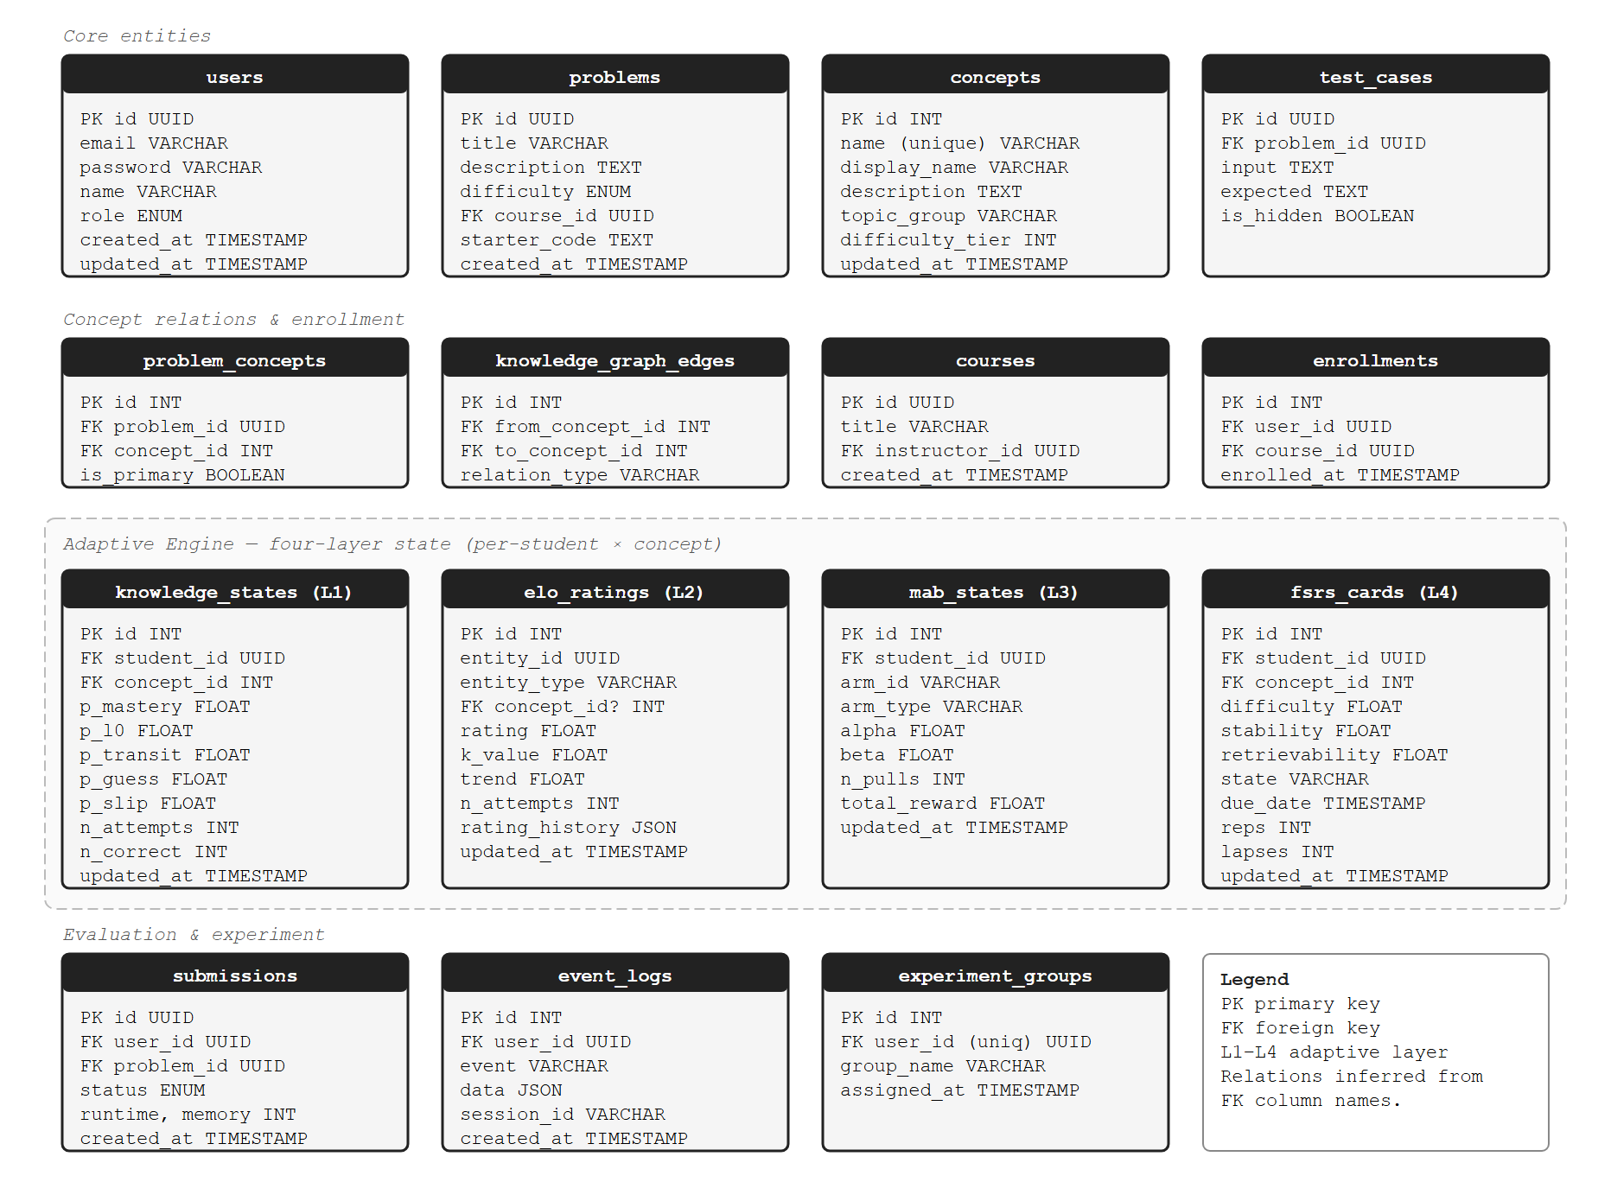
Figure 3.5. Database schema: core domain tables (left) owned by NestJS, adaptive state tables (right) owned by the AI service. Foreign-key relationships are conveyed via column names (e.g., student_id → users.id).
Three design notes. First, every adaptive state row is keyed on (student_id, concept_id) or (student_id, problem_id), which keeps reads O(1) by the lookup key after caching. Second, event_logs records every recommendation shown, accepted, and skipped, with timestamps and session ids; this powers RQ1’s prediction validation and RQ2’s learning-gain analysis. Third, experiment_groups tags each student with a condition (adaptive vs. content-based filtering control), letting the system serve different recommendation logic per group from a single deployment.

3.5. Recommendation and Submission Flows
Two flows exercise the engine: the recommendation flow (synchronous, low-latency), and the submission flow (synchronous code execution + asynchronous adaptive update).

3.5.1. Recommendation Flow
A student requests a practice problem. The flow traverses all adaptive layers and returns a ranked list within the 500ms target (NFR2).
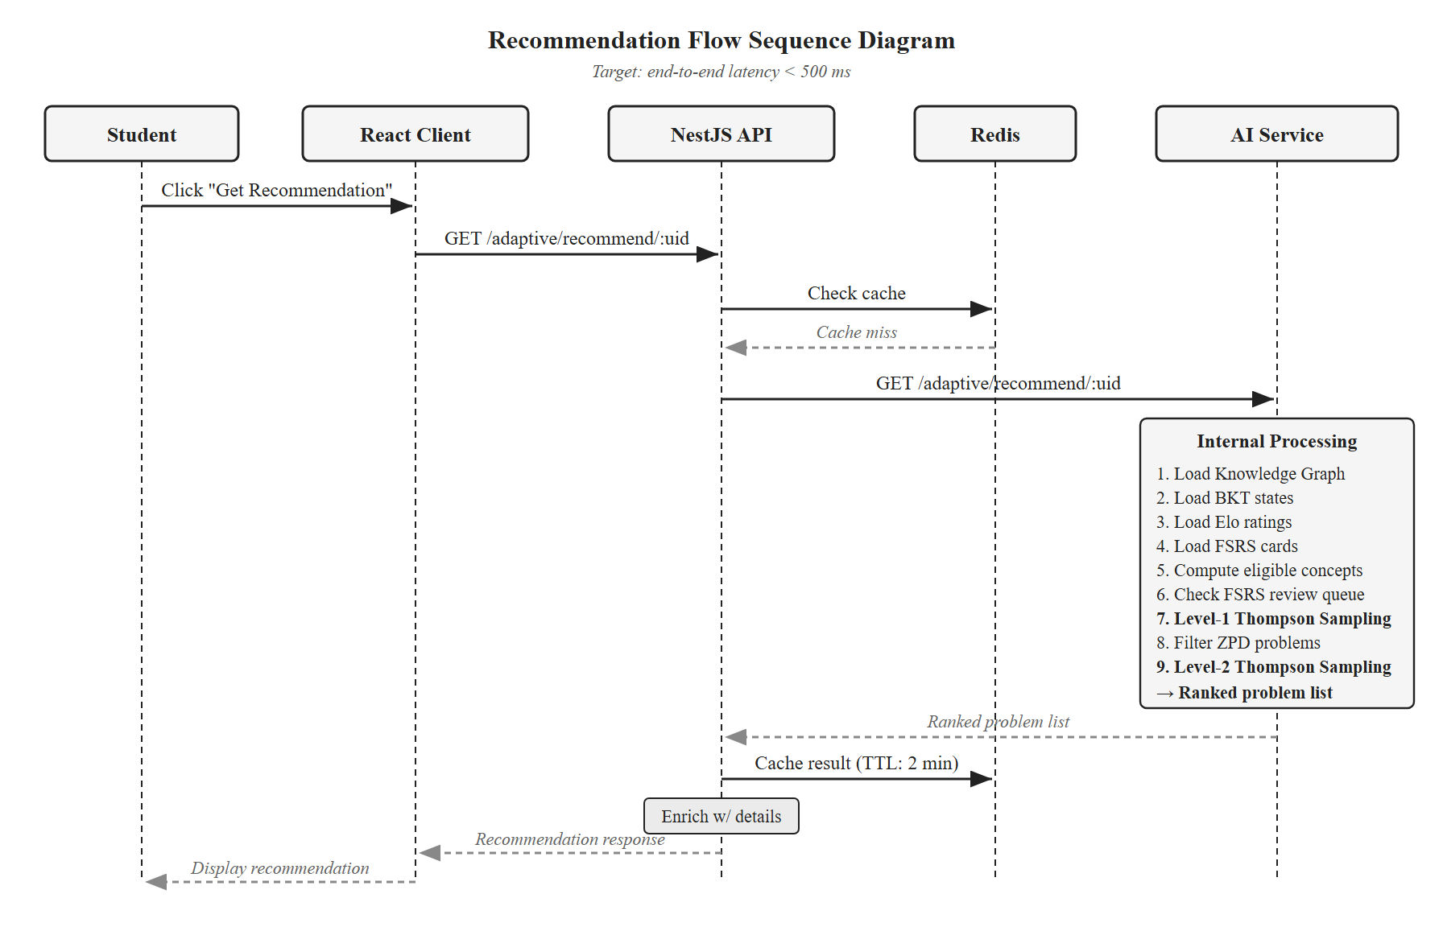
Figure 3.3. Sequence diagram for the recommendation flow.
The AI service does seven things. (1) Load the knowledge graph from Redis (60-minute TTL) or the database. (2) Load the student’s BKT states, Elo rating, MAB states, and FSRS cards from Redis (5-minute TTL) or the database. (3) Compute eligible concepts: prerequisites mastered AND (concept unmastered OR flagged for FSRS review). FSRS-due concepts get a priority boost on their Thompson Sampling prior. (4) Thompson-sample each eligible concept and pick the maximum. (5) Within that concept, retrieve unsolved problems and apply the ZPD filter (Equation 3.4); if empty, fall back to the next concept. (6) Thompson-sample the surviving problems and pick the maximum. (7) Return a ranked list (3–5 items) so the student keeps some agency. NestJS enriches the list with full problem details before returning it to the client.

3.5.2. Submission Processing Flow
A student submits code. The flow has two phases.
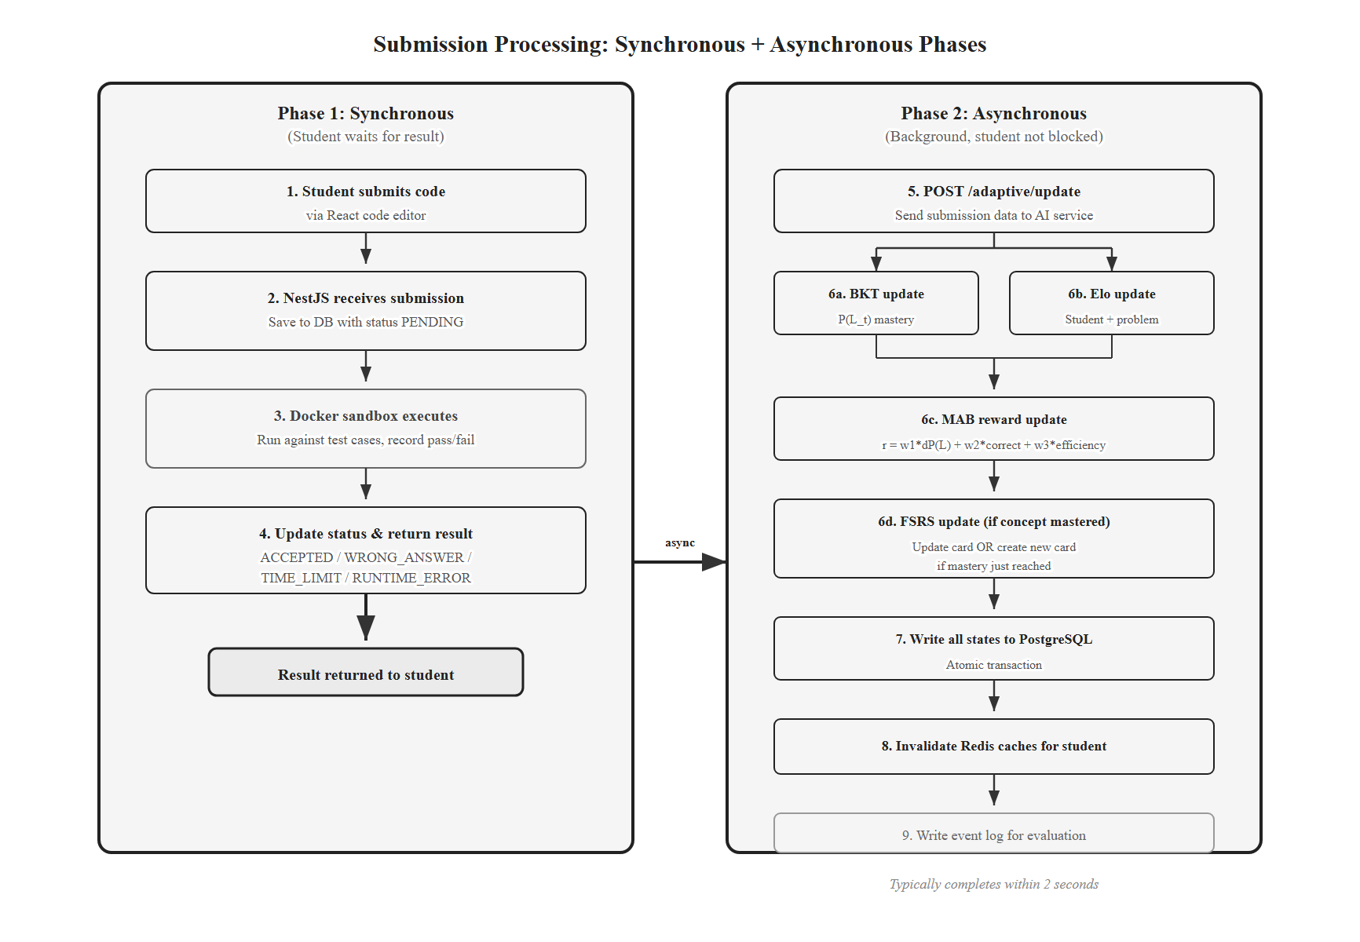
Figure 3.4. Submission processing flow: synchronous code execution returns the verdict to the student; adaptive updates run asynchronously in the background.
Phase 1 — Synchronous execution. NestJS saves the submission as PENDING, dispatches it to the Docker sandbox, and updates the status to ACCEPTED, WRONG_ANSWER, TIME_LIMIT, RUNTIME_ERROR, or COMPILATION_ERROR. The verdict goes back to the student.
Phase 2 — Asynchronous adaptive update. NestJS posts to the AI service /adaptive/update endpoint with the student id, problem id, concept id, correctness, attempt number, time spent, and error type. The service runs the layer updates in order: Layer 1 (BKT mastery, learning gain), Layer 2 (Elo for student and problem), Layer 3 (MAB reward and Beta update), Layer 4 (FSRS card update or initialization). All writes happen in a single database transaction; if any layer fails, the whole update rolls back. The service then invalidates Redis caches for the affected student and writes an event-log entry.
The sequential order matters: Layer 3 needs Layer 1’s learning gain, and Layer 4 needs Layer 1 to know whether mastery has been reached. Layer 2 can run in parallel with Layer 1 because it only depends on the submission outcome.
The asynchronous pattern introduces an eventual-consistency window — typically under 2 seconds. A student who submits and immediately requests a new recommendation may see one based on slightly stale state; the next request reflects the update. The pedagogical impact is negligible.
Failure handling. Failed adaptive updates go onto a Redis-backed retry queue with exponential backoff (1s, 2s, 4s, max 3 retries). After three failures the event lands in a dead-letter table for manual review. The student’s submission verdict is unaffected — Phase 1 always completes, with or without Phase 2. If the AI service is unreachable, NestJS returns a fallback recommendation drawn from the student’s most recent active topic, ordered by static difficulty.
Concurrency. A per-student Redis lock (SETNX with 30-second TTL) serializes adaptive updates, preventing race conditions when two submissions arrive in quick succession.

3.6. Cold Start
The cold-start problem appears in two places: a new student with no submission history, and a new problem with no submission data.
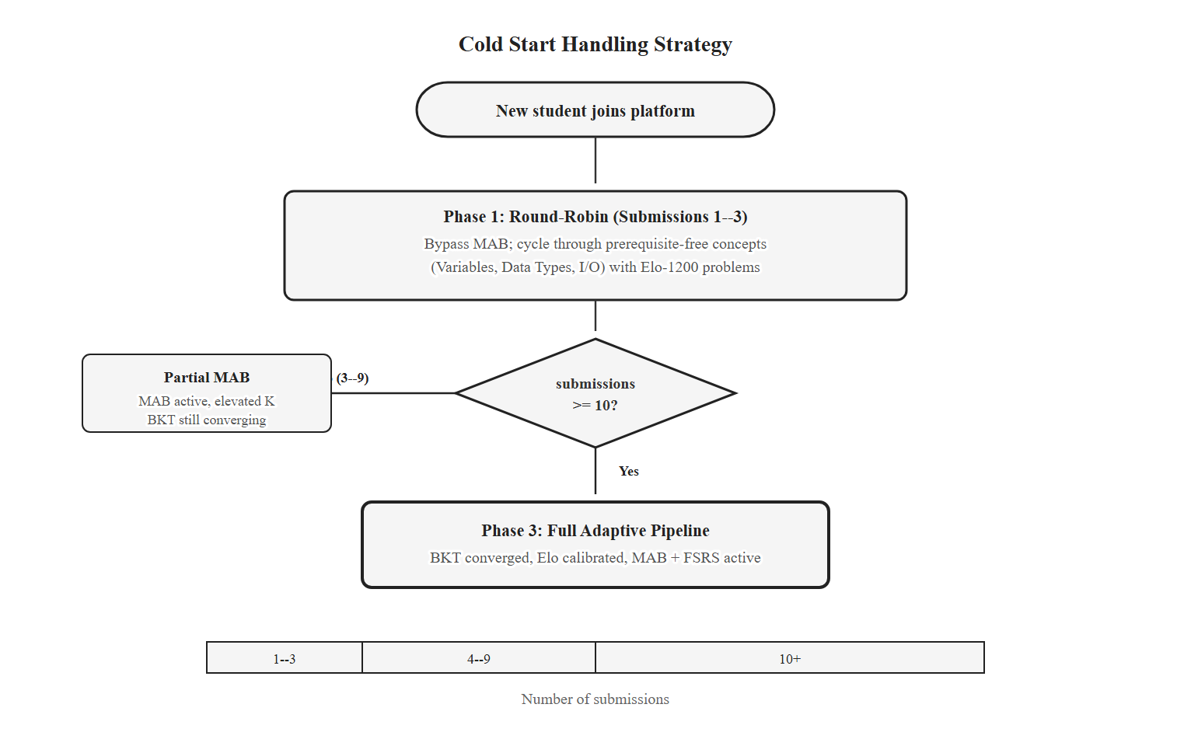
Figure 3.7. Cold start handling: round-robin onboarding for the first 3 interactions, mixed mode through ~10, full pipeline thereafter.
New student. All adaptive state starts at defaults: P(L_0) = 0.1, Elo = 1200, MAB priors Beta(1, 1), no FSRS cards. The system handles this through a three-stage onboarding. For the first 3 interactions, the MAB is bypassed and a round-robin over prerequisite-free concepts (Variables, Data Types, I/O) selects the next concept; within each concept, the problem closest to Elo 1200 is chosen. This guarantees signal across foundational concepts. The threshold of 3 interactions is informed by Clement et al. [44], who showed MAB-based selection needs a minimum exploration period before it outperforms random selection. After approximately 10 submissions, BKT and Elo have enough data to differentiate the student from population means and the full pipeline takes over. This 10-submission threshold reflects BKT’s convergence behavior under P(L_0) = 0.1 and P(T) = 0.2 [16].
New problem. A new problem has no submissions to derive an empirical Elo from. Its rating is initialized from the static difficulty label: EASY → 1000, MEDIUM → 1200, HARD → 1400. The problem K-factor starts at 50 (double the base) so the rating converges fast. After ~30 submissions from diverse students, the rating stabilizes and K decays to base. The MAB prior stays at Beta(1, 1); Thompson Sampling’s natural exploration gives the new problem a fair chance regardless.

3.7. Caching Strategy
Meeting NFR2’s 500ms recommendation latency under concurrent load requires caching. Loading knowledge states, Elo ratings, FSRS cards, MAB states, and the knowledge graph for every recommendation is too slow without a cache. I use Redis with the policies in Table 3.5.
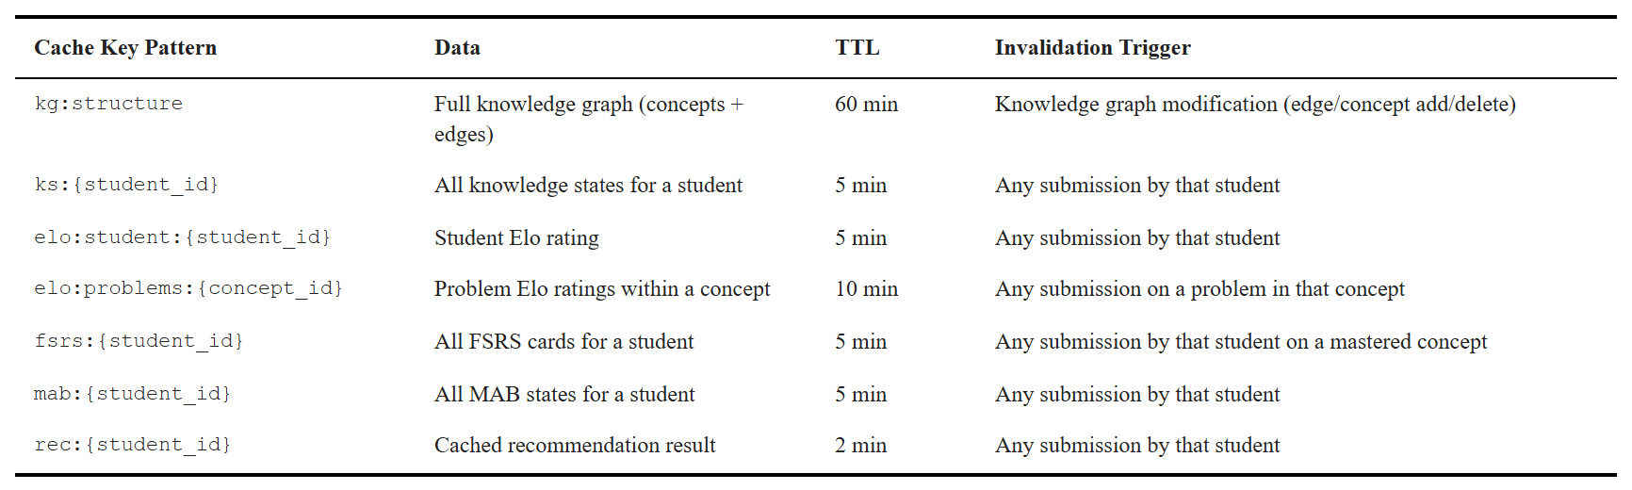
Table 3.5. Redis caching configuration for adaptive state.
The TTL values balance freshness against hit rate. The knowledge graph changes only when instructors modify the curriculum, so a 60-minute TTL is fine. Student-specific state has a 5-minute TTL as a safety net; the primary freshness mechanism is explicit invalidation after each submission update — the AI service deletes the affected entries when it writes new state. Problem-level Elo cache invalidates only when the rating shifts by more than 10 points, which avoids cache churn for small drift.
If Redis is unavailable, the AI service falls back to direct database reads. Recommendation latency may rise to roughly 800–1200ms, but the platform remains functional. Adaptive features are not gated on Redis availability.

3.8. Layer Interaction Summary
Figure 3.6 summarizes the data dependencies between the five layers and the knowledge graph. It is the most concise statement of how the engine fits together.
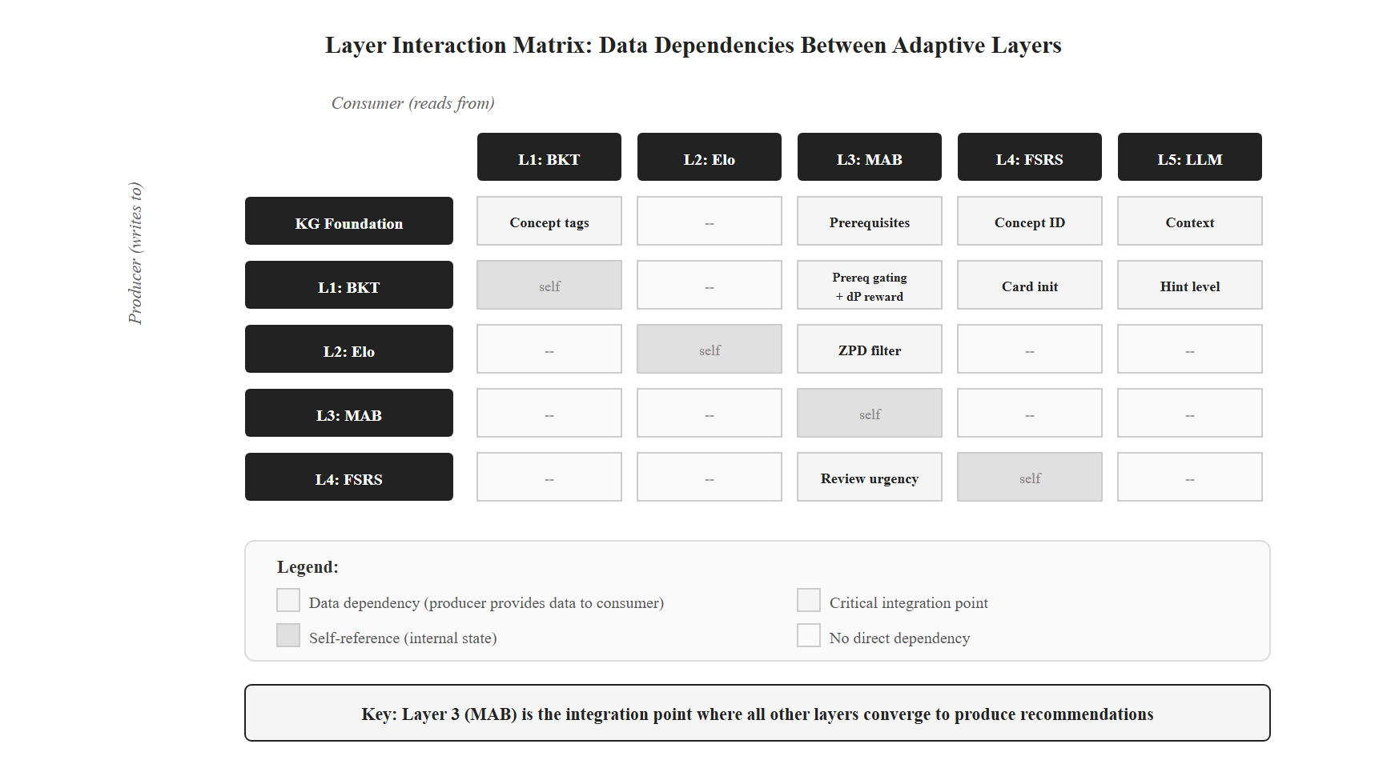
Figure 3.6. Layer interaction matrix: rows are producers, columns are consumers. Layer 3 is the integration point for Layers 1, 2, and 4.
Chapter 4 turns this design into code: parameter values, data structures, the per-layer update functions, the submission-to-FSRS mapping that bridges procedural submissions to declarative review ratings, and the deployment of the four-component stack. The implementation respects every contract specified here, so any layer can be replaced without touching the others — exactly what NFR5 requires.

CHAPTER 4. IMPLEMENTATION
Chapter 3 specified the design. This chapter shows how I turned that design into a working system. The platform is implemented and deployed — every layer in §3.3 has running code, talks to the database, and serves an HTTP endpoint. §4.1 lists the stack. §4.2 covers the backend services and deployment. §4.3 through §4.7 describe each adaptive layer, with the submission-to-FSRS-rating mapping in §4.6 as the bridge from procedural code outcomes to FSRS’s declarative ratings. §4.8 covers the frontend. §4.9 closes by framing the chapter as implementation evidence.

4.1. Technology Stack
I picked four mature components, each chosen for fit rather than novelty. Table 4.1 summarizes the stack with versions and primary responsibilities.
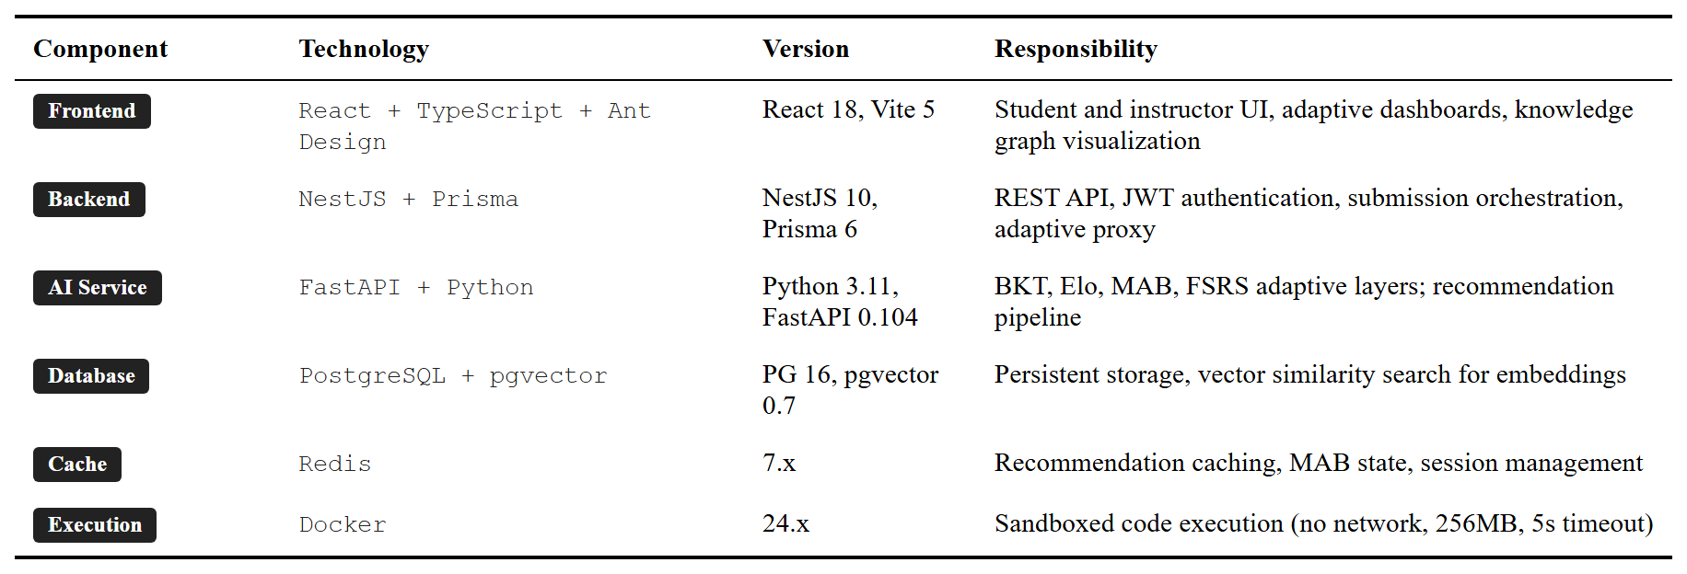
Table 4.1. Technology stack summary.
The choices follow a single principle: use the language each ecosystem is strong in. TypeScript handles the web and API tier, where Prisma and NestJS give type-safe schemas and decorators. Python handles the adaptive engine, where pyBKT [31], NumPy, SciPy, and the FSRS reference implementation [12] are all native. Splitting the two languages into separate services lets each scale independently and keeps a clean boundary.

4.2. Backend Services and Deployment
The platform runs as five Docker Compose services: React frontend (Nginx), NestJS gateway, FastAPI AI service, PostgreSQL, and Redis.
NestJS gateway. The gateway owns authentication (JWT), course and problem CRUD, submissions, and Docker sandbox orchestration. It exposes REST endpoints to the frontend and proxies adaptive endpoints to the FastAPI service. Prisma generates the TypeScript client from schema.prisma, which keeps the database schema and the application types in sync.
FastAPI AI service. The AI service hosts the five-layer engine. Each layer is a Python module in ai-service/app/services/ with a stable interface (NFR5). Endpoints follow /adaptive/<layer>/... for layer-specific operations and /adaptive/recommend, /adaptive/update for orchestration. SQLAlchemy reads the same PostgreSQL database that NestJS writes to, under the write-ownership rule from §3.2.
PostgreSQL with pgvector. PostgreSQL stores both the core domain (users, problems, submissions) and the adaptive state (knowledge states, Elo ratings, MAB arms, FSRS cards). The pgvector extension powers the content-based filtering baseline used by the control group in the pilot, with 384-dimensional sentence-transformer embeddings.
Docker sandbox. Every code submission runs in a fresh container with no network, 256 MB memory, a 5-second CPU cap, and an unprivileged user. The container is destroyed after capturing stdout and stderr. This satisfies NFR4 and isolates students from each other and from the host.
Feature flags. Each adaptive layer is feature-flagged (ENABLE_BKT, ENABLE_ELO, ENABLE_MAB, ENABLE_FSRS, ENABLE_LLM_HINTS). The control group in the pilot runs with the four core flags off and falls back to content-based filtering. The same binary serves both groups.
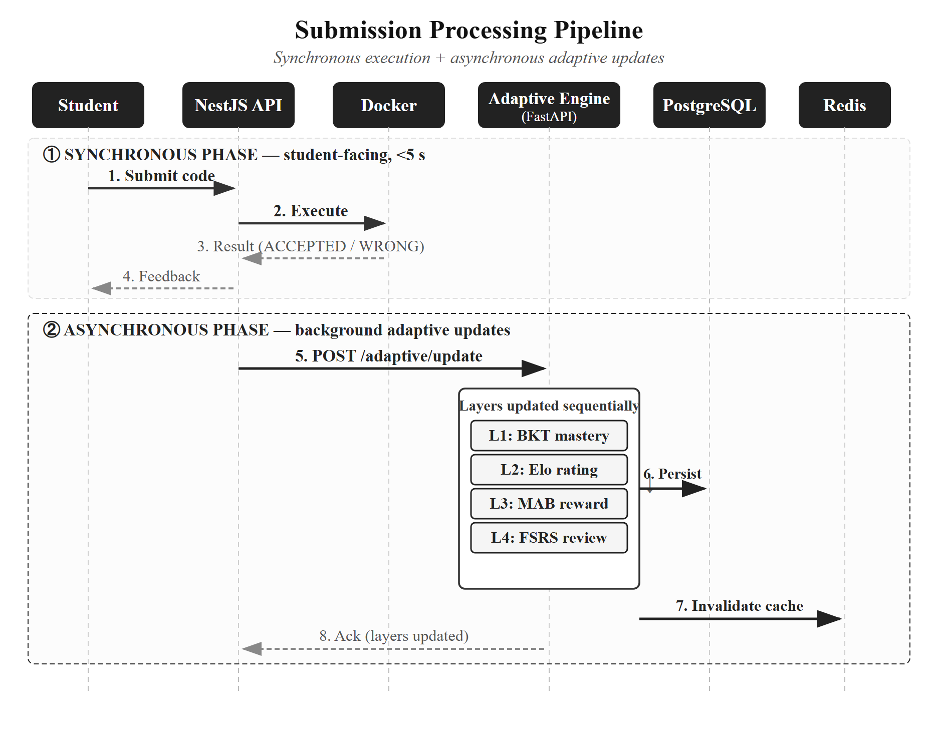
Figure 4.1. Submission processing pipeline. Phase 1 returns the verdict synchronously. Phase 2 runs the four-layer adaptive update asynchronously, in a single database transaction.
The asynchronous pattern is described in §3.5.2. NestJS posts to /adaptive/update with the student id, problem id, primary concept id, correctness, attempt number, and time spent. The AI service runs Layer 1 → Layer 2 → Layer 3 → Layer 4 in order, commits, then invalidates the Redis caches for that student.

4.3. Layer 1 — Bayesian Knowledge Tracing
Layer 1 lives in ai-service/app/services/bkt_service.py. Each (student, concept) pair has the four BKT parameters from §3.3.2 and a current mastery P(L_t). Defaults are the literature values [16], [31] listed in Table 4.2.
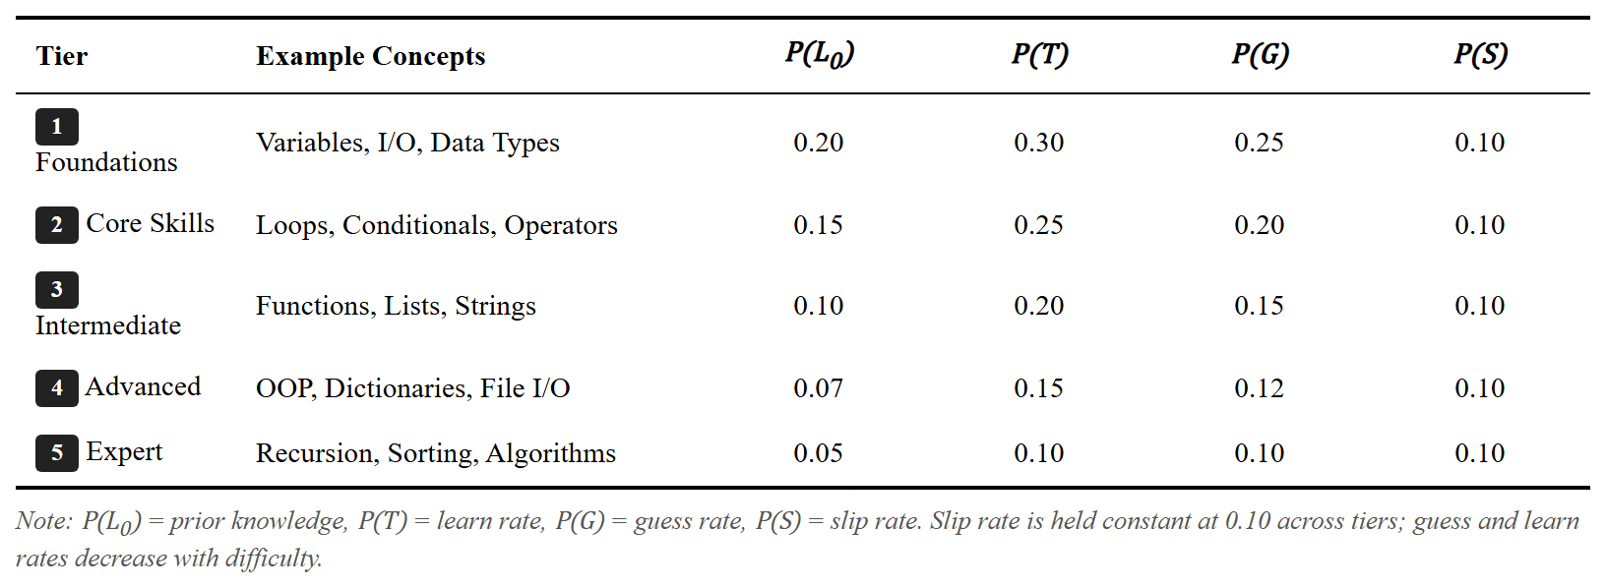
Table 4.2. Default BKT parameters by difficulty tier.
The values relax with difficulty: prior knowledge P(L_0), learn rate P(T), and guess rate P(G) all decrease across tiers, while the slip rate P(S) stays constant at 0.10. Higher-tier concepts are harder to begin with and slower to acquire; the constant slip reflects that even confident students occasionally make errors regardless of concept difficulty. These defaults are heuristics, not optimized on this dataset; per-student fitting would need more data than the pilot collects.
The update is a textbook two-step posterior. Given the prior P(L_t), the slip rate P(S), the guess rate P(G), and the observed correctness, Bayes’ theorem gives the conditional posterior, which the learning transition then bumps by (1 − P(L | obs)) · P(T). The clamp [0.001, 0.999] prevents numerical edge cases.
Listing 1. BKT posterior update.
def bkt_update(p_l: float, is_correct: bool, params: BKTParams) -> float:
p_g, p_s, p_t = params.p_guess, params.p_slip, params.p_transit
if is_correct:
p_obs = p_l * (1 - p_s) + (1 - p_l) * p_g
p_post = (p_l * (1 - p_s)) / p_obs
else:
p_obs = p_l * p_s + (1 - p_l) * (1 - p_g)
p_post = (p_l * p_s) / p_obs
p_new = p_post + (1 - p_post) * p_t
return max(0.001, min(0.999, p_new))
A submission can touch several concepts. The BKTService.update method retrieves all problem_concepts rows for the submitted problem and applies a differentiated rule: the primary concept gets a full update; secondary concepts get a positive update on a correct submission and no penalty on a failure. The reasoning is pedagogical — failing a recursion problem that also uses lists should not erode the list mastery estimate.
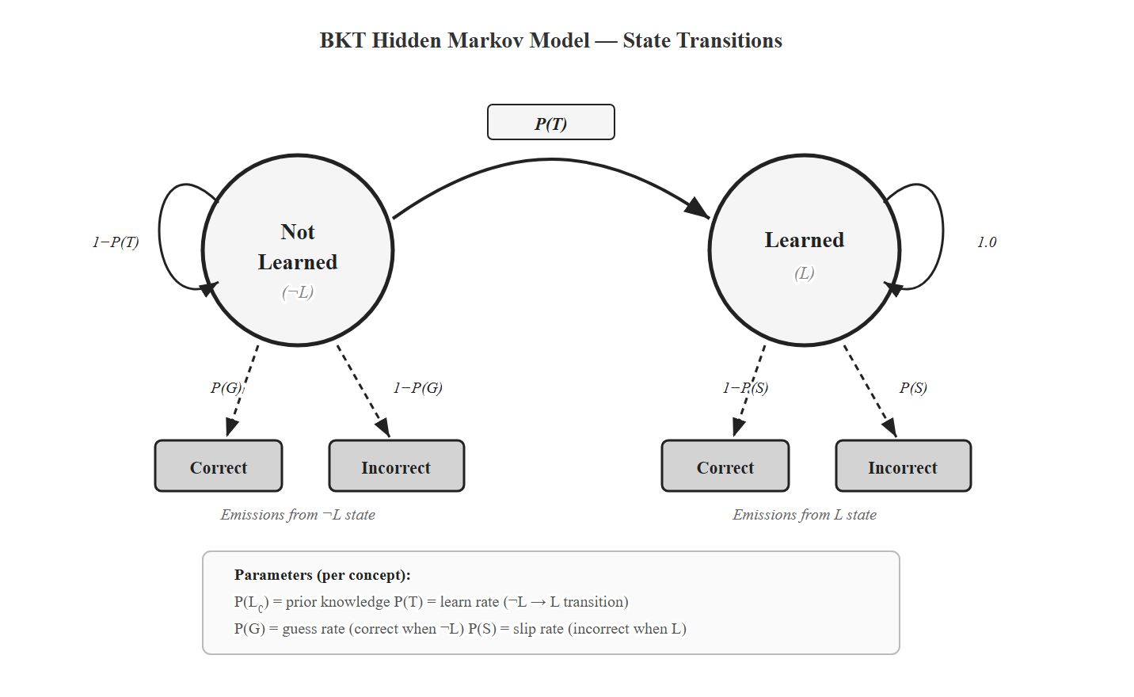
Figure 4.2. BKT as a two-state Hidden Markov Model. The hidden states are Learned (L) and Not Learned (¬L). Four parameters govern the prior, transition, and emission distributions.
After the BKT update completes, the service writes the new P(L_t) and the learning gain ΔP(L_t) to knowledge_states. The gain feeds the MAB reward in §4.5.

4.4. Layer 2 — Dynamic Elo
Layer 2 lives in elo_service.py. Both students and problems carry an Elo rating and a K-factor. Students start at 1200; problems start at 1000 (EASY), 1200 (MEDIUM), or 1400 (HARD), matching the seed data in schema.prisma. Ratings are clamped to [400, 2800] to prevent drift to extreme values.
The expected score and update follow Equations 3.1 and 3.2. The Python is a direct transcription:
Listing 2. Elo expected score and rating update.
def expected_score(r_student: float, r_problem: float) -> float:
return 1.0 / (1.0 + 10 ** ((r_problem - r_student) / 400))
def update_elo(r_s, r_p, k_s, k_p, is_correct):
e_s = expected_score(r_s, r_p)
s = 1.0 if is_correct else 0.0
return r_s + k_s * (s - e_s), r_p + k_p * (e_s - s)
Student and problem ratings move in opposite directions, as expected: a correct submission raises the student rating and lowers the problem’s.
The interesting piece is the dynamic K-factor. A new student should converge fast; an experienced student should stay stable; a streak of unexpected wins or losses should re-open calibration. I implemented the form from Pelanek [11]:
Listing 3. Dynamic K-factor for student ratings.
def compute_dynamic_k(history, k_min=10, k_max=40):
if len(history) < 3:
return k_max # cold start: fast initial calibration
recent = history[-10:]
weights = [0.9 ** (len(recent) - 1 - i) for i in range(len(recent))]
residuals = [(1.0 if h["correct"] else 0.0) - h["expected"] for h in recent]
trend = sum(w * r for w, r in zip(weights, residuals)) / sum(weights)
if trend > 0:
return k_min + (k_max - k_min) * math.exp(-2.0 * trend)
return k_min + (k_max - k_min) * (1 - math.exp(2.0 * trend))
The trend is an exponentially weighted average of recent residuals over the last 10 submissions. A positive trend (better than expected) damps K toward k_min = 10; a negative trend boosts K toward k_max = 40. The bounds and the decay constant λ = 2.0 are heuristics from [11], not tuned on this dataset; sensitivity is in §5.4.
Problem K-factors decay differently. As a problem accumulates submissions, its rating becomes more reliable, so K should drop:
Listing 4. Square-root K-factor decay for problem ratings.
def compute_problem_k(n_attempts: int) -> float:
return max(K_MIN, K_MAX / math.sqrt(max(1, n_attempts)))
The square-root decay matches the noise-floor argument in [11]: rating uncertainty falls as 1/√n. The full ratings history is stored as a JSON array on elo_ratings, capped at the 100 most recent entries. This is enough for trend computation and dashboard visualization without unbounded growth.
The Elo ratings power the ZPD filter consumed by Layer 3, per Equation 3.4. With δ_min = 50 and δ_max = 250, the candidate problems sit at 36–64% expected success — the desirable-difficulty band [21], [25].

4.5. Layer 3 — Hierarchical MAB
Layer 3 lives in mab_service.py. It implements the two-level Thompson Sampling described in §3.3.4: Level 1 picks the concept, Level 2 picks the problem.

4.5.1. Thompson Sampling
Each arm — a concept at Level 1, a problem at Level 2 — has a Beta(α, β) posterior over its expected reward. Sampling and selection are one line each:
Listing 5. Thompson Sampling arm selection.
def thompson_select(arms):
if not arms: return None
samples = [(np.random.beta(a["alpha"], a["beta"]), a) for a in arms]
return max(samples, key=lambda x: x[0])[1]
Every arm starts at Beta(1, 1) — the uniform prior. Beta(1, 1) gives every arm the same chance of being sampled high, which guarantees early exploration before any arm dominates.
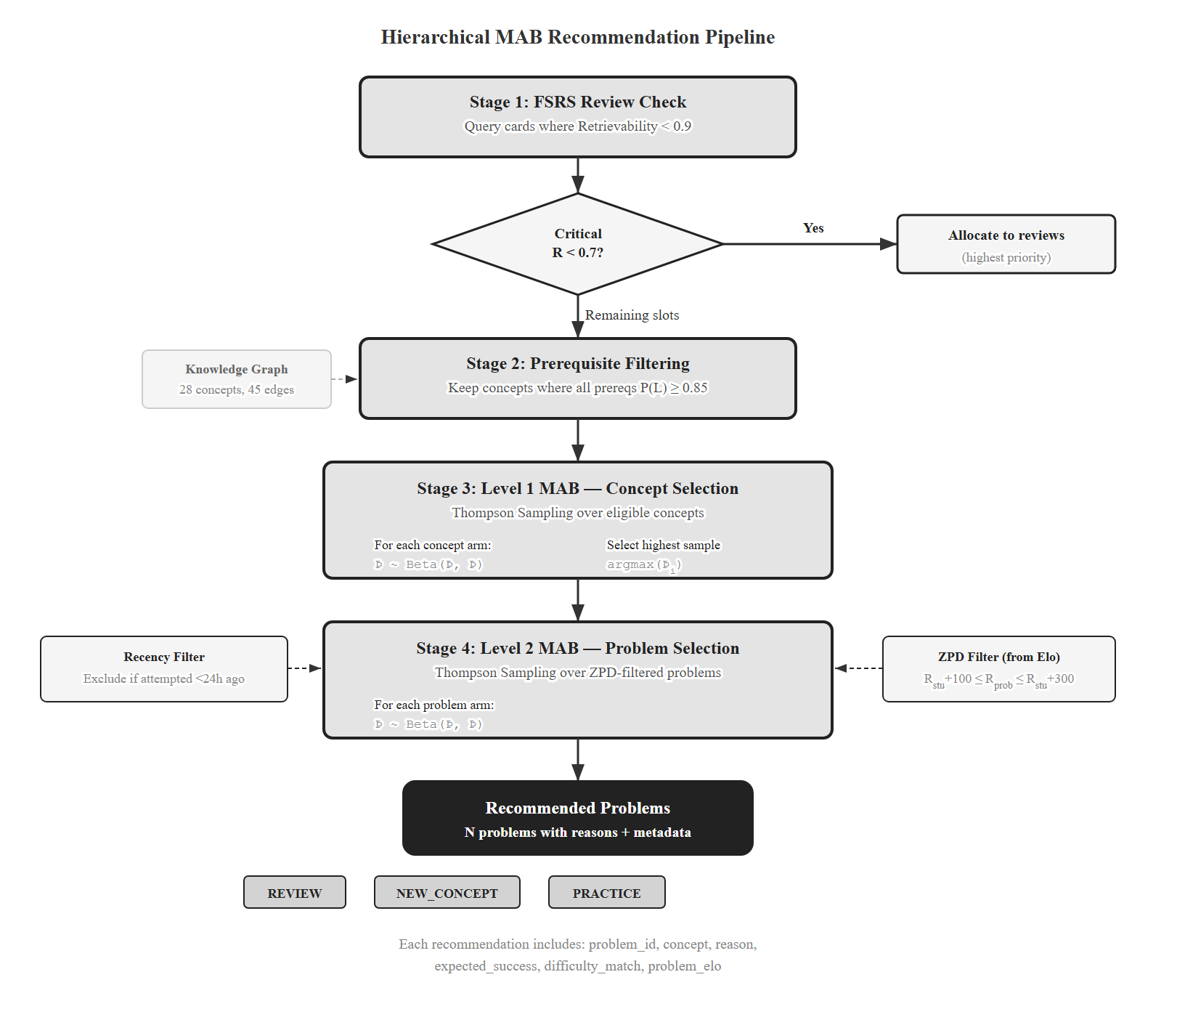
Figure 4.3. Hierarchical MAB decision flow. FSRS-due concepts enter the candidate pool with a priority bonus; remaining slots run two-level Thompson Sampling under prerequisite and ZPD filters.

4.5.2. Reward Function
The reward signal blends three terms, as in Equation 3.5:
Listing 6. MAB reward function (gain + difficulty match + efficiency).
def compute_reward(p_before, p_after, is_correct, attempts, time_spent):
learning_gain = max(0, (p_after - p_before) * 10) # scale up small deltas
if is_correct and attempts <= 3: diff = 1.0
elif is_correct: diff = 0.5
elif attempts >= 3: diff = 0.0
else: diff = 0.3
efficiency = min(1.0, 300.0 / max(time_spent, 30.0))
r = 0.5 * learning_gain + 0.3 * diff + 0.2 * efficiency
return min(1.0, max(0.0, r))
Learning gain is scaled by 10 because raw BKT deltas are typically 0.01–0.05, which would barely move a Beta posterior. Difficulty-match credits a clean first-attempt success and penalizes the opposite. Efficiency adds a small time-based bonus. The auxiliary terms reduce noise from the BKT signal alone.
Hyperparameter disclaimer. Weights w_1 = 0.5 (gain), w_2 = 0.3 (difficulty match), w_3 = 0.2 (efficiency) are heuristic combining values, not learned from data. They will be tuned by grid search in §5.4. This disclaimer mirrors the one in §3.3.4 and is intentional repetition: every reader of Chapter 4 must see it without backtracking to Chapter 3.

4.5.3. Selection Pipeline
The full pipeline runs four stages on each /adaptive/recommend call:
- FSRS conflict resolution. Concepts with retrievability below θ_r = 0.7 enter as priority arms. Critical reviews (R < 0.7) get the first slot; standard reviews (0.7 ≤ R < 0.9) take up to half the remaining slots. The MAB always keeps at least one exploration slot unless critical reviews are very urgent.
- Eligible concept filtering. A query against the knowledge graph keeps concepts whose every prerequisite has P(L_t) ≥ 0.85 and that are not already mastered (P(L_t) < 0.95). FSRS-due concepts are kept regardless.
- Level 1. Thompson Sampling over the eligible concepts.
- Level 2. Within each selected concept, Thompson Sampling over unsolved problems whose Elo sits in the ZPD. Problems attempted in the last 24 hours are excluded.
After the student submits, the update method posts the reward to both arms involved in the pull:
Listing 7. Beta posterior update for MAB arms.
async def update(session, student_id, concept_id, problem_id, reward):
for arm in [(student_id, concept_id, "CONCEPT"),
(student_id, problem_id, "PROBLEM")]:
a = await get_or_create_arm(session, *arm)
a.alpha += reward
a.beta += (1.0 - reward)
a.n_pulls += 1
await session.commit()
The reward is continuous in [0, 1], so the Beta update splits it across α and β. Continuous-reward Thompson Sampling sacrifices the strict regret bounds of the Bernoulli case [18] but keeps the empirical performance [19], and it is the standard treatment in educational MAB applications.

4.6. Layer 4 — FSRS
Layer 4 lives in fsrs_service.py and implements FSRS-5 from [12]. Each (student, concept) is a card with three states: difficulty D ∈ [1, 10], stability S > 0 (days until retrievability drops to 90%), and retrievability R ∈ [0, 1] (current recall probability).
Retrievability decays by the power law in Equation 3.6:
Listing 8. FSRS retrievability decay.
def retrievability(t_days: float, stability: float) -> float:
return (1.0 + t_days / (9.0 * stability)) ** -1
Three properties make this elegant. R(0, S) = 1: a just-reviewed card is fully recalled. R(S, S) = 0.9: stability is defined as the time at which retrievability is 90%. R → 0 as t → ∞: without review, recall vanishes. Solving R(t, S) = θ_r for the next due date gives t = 9S(1/θ_r − 1), so the scheduler simply persists the due timestamp.
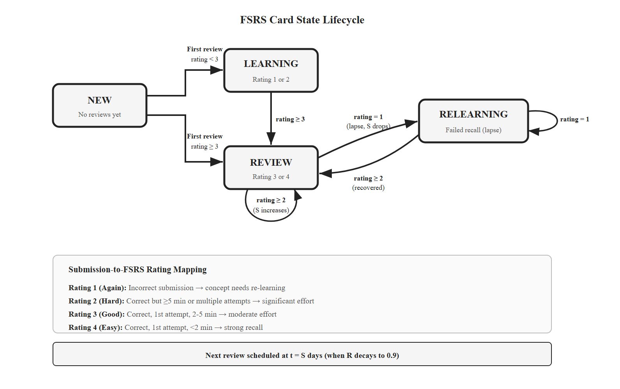
Figure 4.4. FSRS card state machine: NEW → LEARNING → REVIEW, with RELEARNING on a failed review.
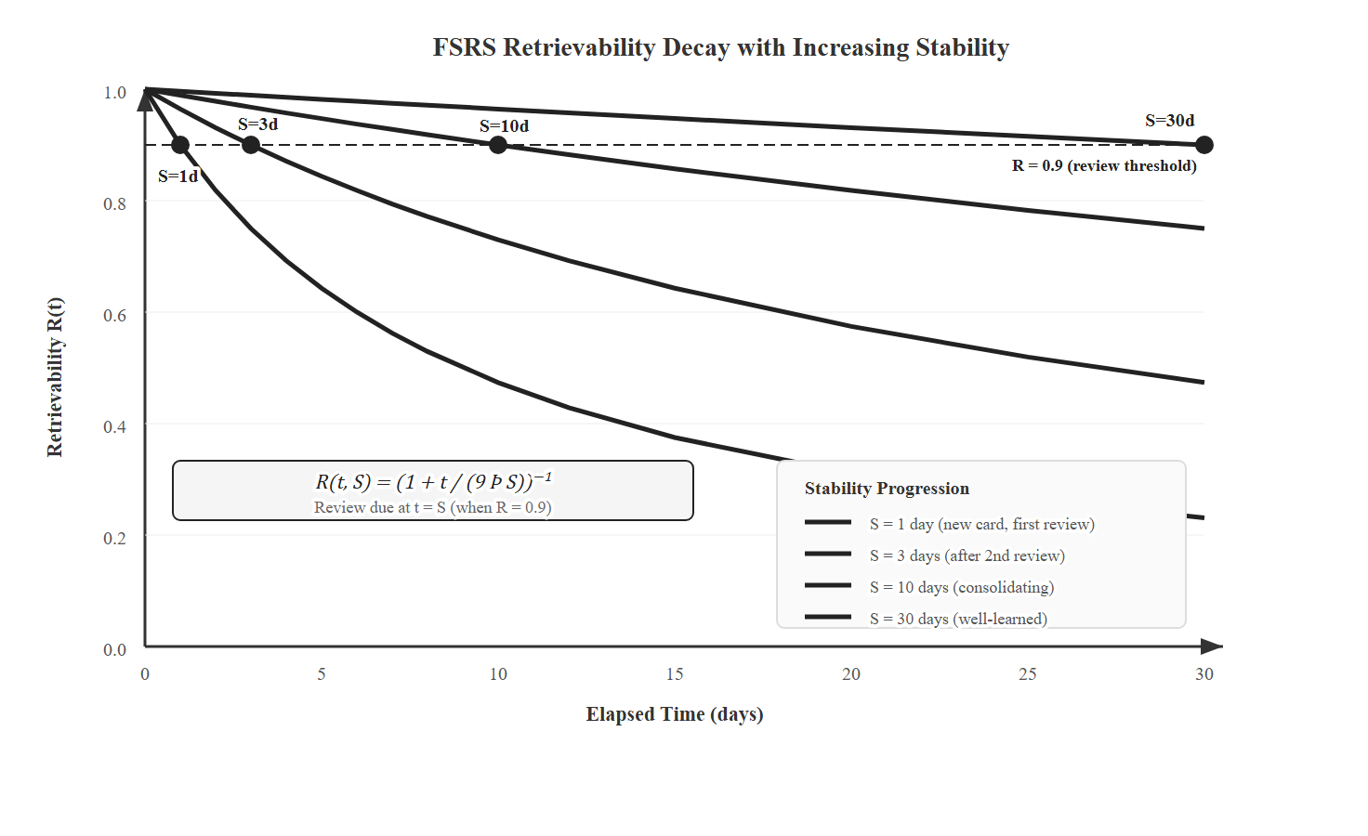
Figure 4.5. Retrievability decay curves at three stability values. Higher stability flattens the curve and stretches the interval before the next review.
I use the FSRS-5 default weights [12] without retraining. The 19 weights w_0–w_18 govern initial stability per rating, difficulty initialization, difficulty/stability updates after success or failure, and the hard/easy modifiers. Retraining the weights would require thousands of card reviews per concept, far beyond what the pilot collects; the published defaults are a reasonable starting point and consistent with the practice in the Anki/FSRS community.

4.6.1. Submission-to-Rating Mapping
FSRS expects a 1–4 review rating: 1 = Again, 2 = Hard, 3 = Good, 4 = Easy. Flashcard users self-report this. A programming submission cannot. The bridge from procedural code outcomes to FSRS’s declarative scale is one of the thesis’s small contributions, and Chapter 3 left it for here.
I infer the rating from two observable signals: correctness and effort (attempts and time). Table 4.3 lists the mapping.
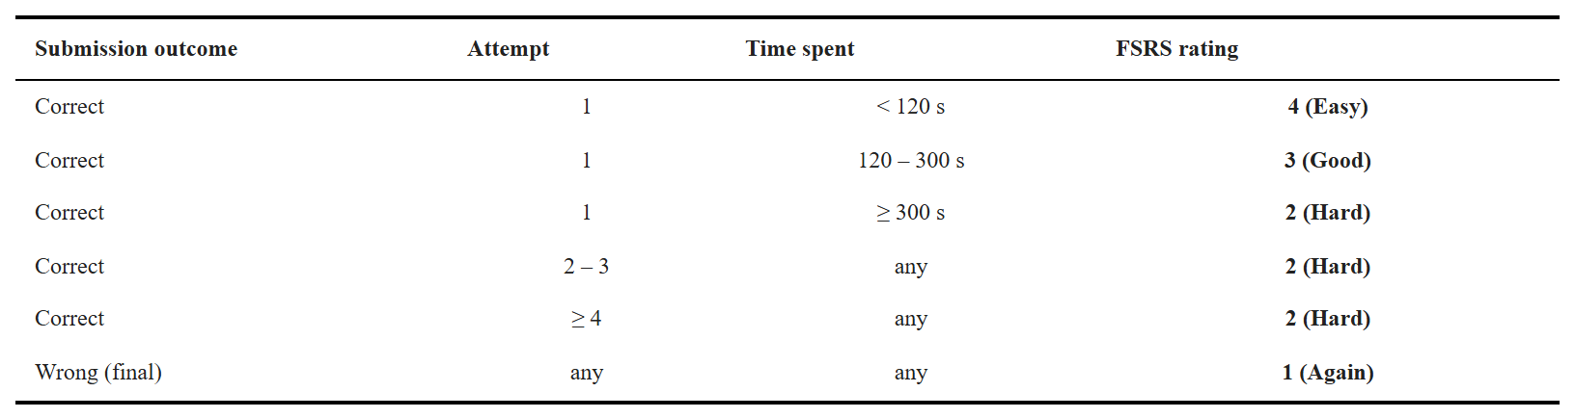
Table 4.3. Submission-to-FSRS-rating mapping. Two observable signals — correctness and effort — replace flashcard self-report.
Listing 9. Submission-to-FSRS-rating mapping.
def submission_to_fsrs_rating(is_correct, attempts, time_spent_s):
if not is_correct: return 1 # Again — needs re-learning
if attempts == 1:
if time_spent_s < 120: return 4 # Easy — strong recall
if time_spent_s < 300: return 3 # Good — moderate effort
return 2 # Hard — slow but correct
return 2 # Hard — multiple attempts
The mapping respects the spirit of FSRS: higher ratings should reflect stronger memory traces. A first-try, sub-two-minute solve is the closest a programming submission gets to “I knew it cold.” Multiple attempts collapse to Hard; a final wrong answer maps to Again, which resets stability per FSRS-5’s failure rule. The thresholds (120 s, 300 s, 3 attempts) are design choices informed by typical introductory-Python solve times in the seed problem bank, not optimized on student data; sensitivity is part of §5.4.
The full FSRS-5 update — the one that consumes this rating to update D and S — is the reference implementation from [12], which I use unmodified. The mapping is the only programming-specific addition.

4.6.2. Review Queue
get_review_queue computes current retrievability for every active card and splits the result into due (R < 0.9) and upcoming (due in the next three days), sorted by urgency. The frontend (§4.8) renders this as the review queue page; the MAB pipeline (§4.5.3) consumes the same list to inject due concepts into the selection candidate pool.

4.7. Layer 5 — LLM Feedback (Exploratory)
Layer 5 was built to test feasibility. It is exploratory engineering work, not a thesis contribution, and is disabled in the pilot to avoid confounding the evaluation of Layers 1–4. I describe it briefly so the reader knows the architecture is end-to-end working code, but no claim about hint quality is made in this thesis.
The layer triggers when a student fails three or more attempts on a single problem. A short Retrieval-Augmented Generation pipeline runs in three steps. The system fetches the problem’s primary concept, its description, and the prerequisite chain from the knowledge graph. A prompt template combines that context with the student’s latest code and error message and asks the language model for a Socratic question — a hint that nudges without revealing. The assembled prompt goes to the language-model API at temperature 0.7. A per-user rate limit caps hint requests per hour.
The feature is gated by ENABLE_LLM_HINTS. Turning it off is a one-line config change and has no effect on Layers 1–4. Quality, cost, and hallucination evaluation are future work (§6.4).

4.8. Frontend
The React frontend exposes three adaptive views: the student dashboard, the recommendation page, and the review queue. All three pull data from the NestJS gateway, which proxies adaptive endpoints to the AI service. TanStack Query handles caching, background refetch, and optimistic updates so the dashboard stays responsive on slow connections.
The dashboard shows a mastery radar chart by topic group (seven topics: basics, control flow, functions, data structures, OOP, algorithms, advanced), an Elo card with a 20-submission sparkline, a review-queue badge, and a concept tree colored by mastery state. The recommendation page lists the MAB’s chosen problems, each annotated with concept, ZPD-based difficulty match, and a recommendation reason (NEW / REVIEW / PRACTICE). The review queue page sorts FSRS-due cards by retrievability and links each to a Level-2-MAB-selected problem on that concept.
Recharts powers the radar and Elo charts; a custom SVG renderer lays out the knowledge graph by tier (vertical) and topic (horizontal) with curved-path edges. Ant Design covers the rest of the UI primitives.

4.9. Chapter Summary
Chapter 4 is implementation evidence. The five layers from Chapter 3 are not vapourware: each has running Python code in ai-service/app/services/, tied into a shared PostgreSQL schema, exposed through a FastAPI service, proxied by a NestJS gateway, and rendered in a React frontend. The platform is deployable as a single docker-compose up and has been used end-to-end during development.
The implementation translates Chapter 3 into roughly 2,500 lines of Python for the adaptive engine, 4,000 lines of TypeScript for the NestJS layer, and 3,000 lines of TypeScript/React for the frontend. The knowledge graph holds 34 concepts and 52 prerequisite edges, matching the seed in server/prisma/seed-adaptive.ts. The submission-to-FSRS-rating mapping in §4.6.1 is the small but load-bearing bridge that lets a spaced-repetition algorithm built for declarative flashcards drive review scheduling for procedural programming skills.
Chapter 5 takes the deployed system and specifies the pilot study that will evaluate it.

CHAPTER 5. PILOT EVALUATION DESIGN
The platform in Chapters 3 and 4 is built and deployed. The classroom study described here is specified, not yet executed. This chapter presents the pilot protocol — research questions, design, instruments, metrics, and statistical plan — for evaluating the platform once recruitment opens. Pilot procedures use future tense; what was already done uses past tense. No results are reported.
The pilot enables Layers 1–4 together for the experimental group. Layer 5 (LLM Socratic hints) is disabled to avoid confounding hint quality with the core adaptive logic. The design evaluates the integrated platform as a whole; per-layer ablations are future work, revisited in §5.4.

5.1. Research Questions and Hypotheses
Four research questions guide the pilot, mirroring §1.4. Predictive validity of the learner model is RQ1’s primary outcome; operational metrics are supporting indicators in §5.3.2. RQ2 and RQ3 are tested with comparative hypotheses at α = 0.05.
RQ1. How accurately does the learner model predict student performance? Primary measure: AUC-ROC of BKT and Elo predictions on held-out submissions. Pre-registered target: AUC-ROC ≥ 0.65, in line with [13] for BKT and [38] for Elo in educational settings.
RQ2. Does the integrated adaptive pipeline (Layers 1–4) produce different learning outcomes than a content-based filtering baseline? Primary metric: Normalized Learning Gain.
- H2 (alternative): the adaptive group shows higher Normalized Learning Gain than the control group.
- H2_0 (null): no difference between groups.
RQ3. Does FSRS-scheduled review yield different short-term retention than the same platform without scheduled review? Measured by a retention test two weeks after the intervention.
- H3 (alternative): the adaptive group shows higher retention.
- H3_0 (null): no difference between groups.
RQ4. How do students perceive the platform’s usability and usefulness? Measured by SUS [51], TAM constructs (Perceived Usefulness, Perceived Ease of Use) [52], and semi-structured interviews analysed thematically [54].
Table 5.1 summarises the four questions and the instruments tied to each.
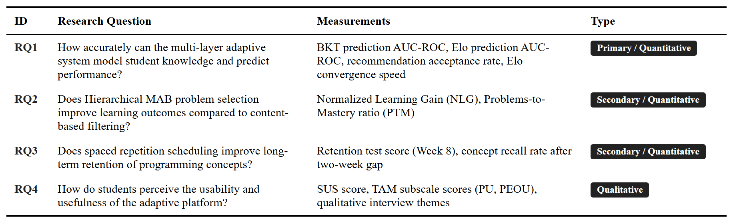
Table 5.1. Research questions and corresponding measurements.

5.2. Experimental Design
The pilot is a between-subjects, pre-/post-test study with a control group. Participants are randomly assigned, after stratification on pre-test score, to one of two conditions:
- Experimental group (E). Receives the full Layers 1–4 pipeline: BKT, Dynamic K-Value Elo, Hierarchical MAB with Thompson Sampling, and FSRS-scheduled review.
- Control group (C). Receives content-based filtering over sentence-transformer embeddings. No BKT, no Elo, no MAB, no FSRS.
This design holds constant the platform interface and problem environment, while varying only the recommendation logic between groups. Both groups use the same UI; the only difference is the algorithm behind it. Layer 5 is disabled in both groups via ENABLE_LLM_HINTS=false. The other adaptive flags (ENABLE_BKT, ENABLE_ELO, ENABLE_MAB, ENABLE_FSRS) toggle between conditions. Table 5.2 shows the feature contrast.
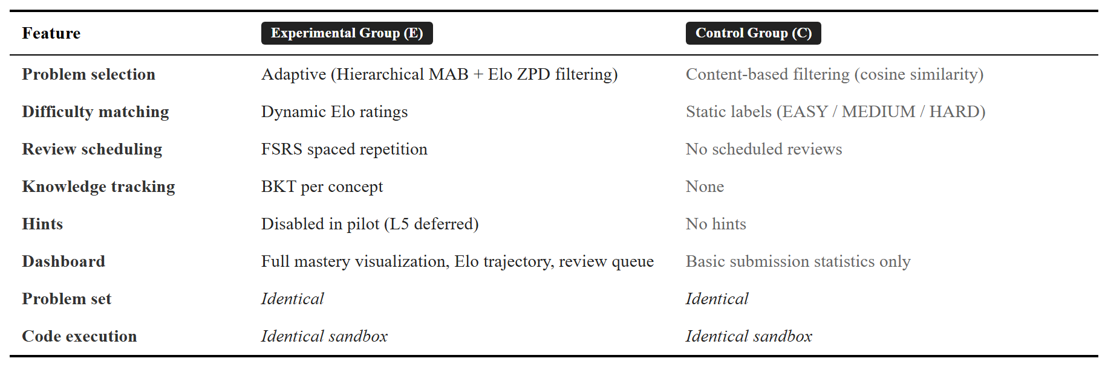
Table 5.2. Experimental versus control group feature comparison.

5.2.1. Participants
The target sample is 40–60 undergraduates from Hanoi University programming courses (Introduction to Programming, Data Structures, Algorithms). All courses use Python and align with the ~30-concept knowledge graph from §3.3.1.
Inclusion. Enrollment in one of the target courses, regular access to the platform, and signed informed consent.
Exclusion. Self-reported competitive programming experience above an estimated Elo of 1600 (the introductory-to-intermediate problem set would not benefit them). Students unable to commit to four weeks of platform use.
Sample size. An a-priori GPower analysis for an independent-samples t-test (medium effect, Cohen’s d* = 0.5; α = 0.05; power 0.80) returned 26 per group [55]. Allowing 20% dropout, the recruitment target is 30 per group (60 total).
Contingency. If recruitment yields 20–30 participants (10–15 per group), the study detects only large effects (d ≥ 0.8). The plan switches to Mann-Whitney U and shifts the contribution to a system-behavior description, with all participants interviewed.
Randomization. Stratified by pre-test tercile (low/medium/high); within each tercile, students are randomly assigned to E or C. This prevents one group from drawing disproportionately from a single ability band.
Ethics. Written informed consent is obtained before any data collection. Identifiers are replaced with random codes at export. Raw data is destroyed after two years. The control group receives full adaptive features after the study ends. The protocol will be submitted to the Hanoi University academic oversight body.

5.2.2. Protocol
The pilot spans eight weeks: a one-week baseline, a four-week intervention, a post-assessment week, a one-week washout (no platform access), and a retention test in Week 8. Figure 5.1 sketches the timeline.
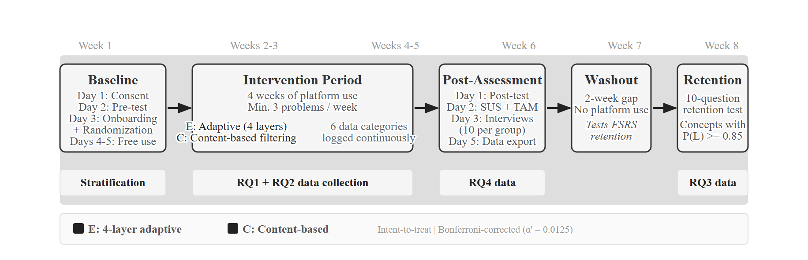
Figure 5.1. Eight-week pilot study timeline: Week 1 baseline, Weeks 2–5 intervention, Week 6 post-assessment, Week 7 washout (no platform use), Week 8 retention test.
Week 1: Baseline. Information session and consent (Day 1), pre-test (Day 2, 60 min, 20 items mixing multiple-choice and short-answer across five difficulty tiers), platform tutorial and stratified randomization (Day 3), free exploration (Days 4–5). This week supports the stratified randomization that opens the intervention period.
Weeks 2–5: Intervention. Both groups use the platform regularly, with a soft minimum of three problems per week. The experimental group receives Layers 1–4 (BKT + Elo + H-MAB + FSRS); the control group receives content-based filtering. Students below the weekly floor are flagged but kept in the intent-to-treat analysis. The platform logs six data streams continuously: every submission (timestamp, code, verdict, attempts, time), every recommendation (problems shown, ranking, reason), clicks, page views and session times, daily BKT snapshots (E), and Elo and FSRS histories (E). These logs are the source for RQ1 (predictive AUC-ROC) and RQ2 (Normalized Learning Gain).
Week 6: Post-assessment. Post-test on Day 1 (parallel-form, different items). SUS and TAM on Day 2 (10 min each). Semi-structured interviews on Day 3 with 10 students per group, sampled across the learning-gain distribution. Data export on Day 5. RQ4 data comes from this week.
Week 7: Washout. No platform access for either group. The week creates a clean two-week gap (counting from the end of Week 5 intervention to the start of Week 8 retention) over which short-term retention differences can develop. No logging occurs.
Week 8: Retention test. A 30-minute, 10-question test on concepts the participant reached mastery on (P(L_t) ≥ 0.85) during the intervention. Two weeks of washout is short relative to FSRS’s full forgetting curves, but it is the minimum window in which FSRS stability differences become observable [25]. Reminders go out one and three days before. RQ3 data comes from this test.

5.2.3. Variables
Independent variable. Treatment condition (E vs C), implemented through the feature flags from §4.2.
Dependent variables. Grouped by research question. RQ1: BKT prediction AUC-ROC, Elo prediction AUC-ROC. RQ2: Normalized Learning Gain, Problems-to-Mastery ratio. RQ3: retention test score, FSRS stability convergence. RQ4: SUS composite, TAM subscale means, interview themes.
Covariates. Pre-test score (used for stratification and as a regression covariate), self-reported prior programming experience (none / <6 months / 6–12 months / >12 months), and course level (introductory vs data structures/algorithms). The covariates allow ANCOVA refinement of the treatment effect estimate and exploration of which subgroups benefit most.

5.3. Evaluation Metrics
This section separates primary metrics (one per research question, used for hypothesis testing) from supporting indicators (used for interpretation and platform diagnostics, not for hypothesis testing). The split follows the advisor’s reframe of RQ1 in §1.4.

5.3.1. Primary Metrics
RQ1 — BKT and Elo prediction AUC-ROC. Each submission in the experimental group’s log is a (prediction, outcome) pair. Before grading, BKT records P(correct) and Elo records the expected score E(A) from the student’s current rating and the problem’s rating. After grading, the binary outcome (1 = correct, 0 = incorrect) is paired with each prediction, and AUC-ROC is computed across all pairs. Pre-registered target: AUC ≥ 0.65 for both models, with bootstrapped 95% confidence intervals (1,000 resamples).
RQ2 — Normalized Learning Gain (NLG). Defined as
NLG = (S_post − S_pre) / (S_max − S_pre)
NLG corrects for ceiling effects: a student starting at 90% has less room to grow than one at 30%. Following Hake [53], values are read as low (< 0.3), medium (0.3–0.7), or high (≥ 0.7). H2 is tested with an independent-samples t-test if Shapiro-Wilk normality holds; otherwise Mann-Whitney U. Effect size is reported as Cohen’s d (or Hedges’ g for small samples) [55].
RQ3 — Retention test score. The 10-item retention test in Week 8 yields a score in [0, 10]. H3 is tested between groups with an independent-samples t-test under normality, Mann-Whitney U otherwise.
RQ4 — SUS composite + TAM construct means. SUS [51] returns a single score on a 0–100 scale. Standard interpretation [Bangor et al., 2008] is: < 50 not acceptable, 50–70 marginal, 70–85 good, > 85 excellent. Pre-registered target for E: SUS ≥ 70. TAM [52] returns Perceived Usefulness and Perceived Ease of Use as means of six 7-point Likert items each. Internal consistency is checked with Cronbach’s α (target ≥ 0.70). Group means are compared with independent-samples t-tests.
Family-wise error across the four primary tests is controlled with Bonferroni (α’ = 0.05 / 4 = 0.0125). Interview transcripts are coded with Braun and Clarke’s six-phase thematic analysis [54]; themes from E and C are compared qualitatively.
Table 5.3 consolidates the primary and supporting metrics with definitions and pre-registered targets.
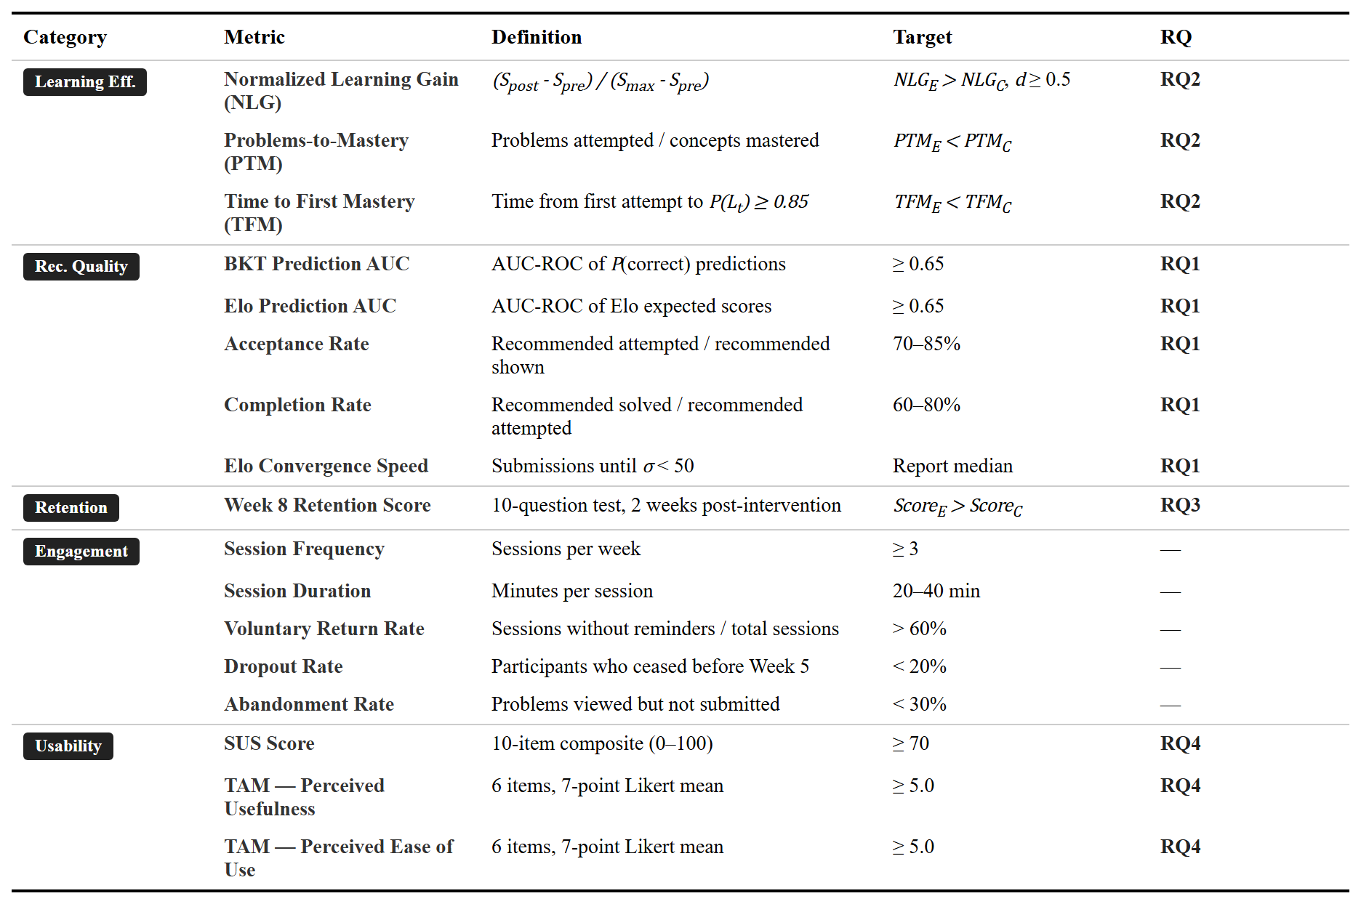
Table 5.3. Complete evaluation metrics summary, with primary metrics for each research question and supporting indicators.

5.3.2. Supporting Indicators
These metrics are reported for interpretation, not for hypothesis testing. They inform whether the recommendation pipeline is behaving as designed.
- Acceptance rate per difficulty band (proportion of recommended problems attempted). Pre-registered range: 70–85% for E, 40–60% for C.
- Completion rate (proportion of attempted recommendations solved). Target range: 60–80% — too high suggests problems are too easy; too low suggests they are too hard. The range maps to the Zone of Proximal Development from §3.3.3.
- Elo convergence speed (number of submissions until rolling Elo standard deviation drops below 50 over 10 attempts). Reported as a median for E only.
- Problems-to-Mastery ratio (PTM = N_attempted / N_mastered). Lower is more efficient.
- Engagement signals. Session frequency, session duration, problems per session, voluntary return rate, dropout rate, and abandonment rate. Reported to disentangle learning-effect differences from engagement differences.

5.4. Threats to Validity and Sensitivity Analysis

5.4.1. Threats to Validity
The pilot’s design has known limits. Stating them up front lets readers calibrate the weight to give any future result.
Small, single-site sample. Recruitment is one cohort at Hanoi University, with a target of 40–60 and a 20–30 fallback. At the nominal sample size, the study detects only large effects (Cohen’s d ≥ 0.8). Generalisation to other universities, curricula, or student populations is not supported by what this pilot can produce.
Short intervention window. Four weeks of intervention plus two weeks before the retention test is short relative to FSRS’s full forgetting curves. RQ3 results should be read as suggestive of short-term retention differences, not as validation of long-term spaced repetition for programming.
Confounded treatment. The experimental group receives Layers 1–4 simultaneously. A positive effect on RQ2 cannot be cleanly separated from FSRS effects, and vice versa. Per-layer ablations are future work.
Metric–model coupling. BKT prediction AUC and Elo convergence speed use the same model that drives recommendations. A favourable value shows internal consistency, not independent evidence of learning effectiveness.
Self-selection, novelty, and attention. Participation is voluntary and the experimental UI is more feature-rich. Differences may partly reflect novelty or self-selection of more motivated students into E.
Unvalidated assessments. The pre-/post-test and retention test were constructed for this study and have not been independently validated. Reliability and concurrent validity will be reported post hoc.
Taken together, any findings reported from this pilot should be interpreted as preliminary, given the small sample size, four-week duration, and single-institution setting.

5.4.2. Sensitivity Analysis Plan
Several hyperparameters were set as design choices from the literature, not optimised on this dataset. The pilot reserves a grid-search pass over the interaction logs after the intervention. Each group is replayed offline against the same submission stream, since the engine is deterministic given fixed parameters and a fixed log.
- BKT mastery threshold. Default 0.85. Grid: {0.80, 0.825, 0.85, 0.875, 0.90}. Outcome: PTM ratio and AUC-ROC.
- Elo K-factor. Default K_base = 25. Grid: {15, 20, 25, 30, 35}. Outcome: AUC-ROC and rolling-SD convergence.
- MAB reward weights. Default w_1 = 0.5, w_2 = 0.3, w_3 = 0.2. Grid: a 5×5×5 simplex (sum to 1, step 0.1). Outcome: NLG and acceptance rate under counterfactual policies.
- FSRS thresholds. Default θ_r = 0.7. Grid: {0.6, 0.7, 0.8, 0.9}. Outcome: review density and a retention proxy on logged correctness.
The sensitivity analysis is descriptive, not a tuning exercise; operating values are fixed for the pilot itself.

5.5. Chapter Summary
The adaptive learning platform has been designed, implemented, and deployed in a functional form. The classroom evaluation has not. This thesis should be read as an implementation thesis with a pilot evaluation protocol, not as a completed classroom evaluation.
This chapter specified the protocol that will turn the platform into evidence: four research questions (with RQ1 reframed around predictive validity); a between-subjects design with stratified randomization at Hanoi University; primary metrics for hypothesis testing (AUC-ROC, NLG, retention score, SUS/TAM) and supporting indicators for interpretation; explicit threats to validity; and a sensitivity-analysis plan for the BKT, Elo, MAB, and FSRS hyperparameters that Chapters 3 and 4 deferred to this section.
Chapter 6 closes the thesis with a summary of contributions, limitations, and directions for future work — including the empirical execution of this pilot.

CHAPTER 6. CONCLUSION

6.1. Summary of Work
This thesis should be read as an implementation thesis with a pilot evaluation protocol, not as a completed classroom evaluation. I designed and built an adaptive learning platform for university programming courses, and I specified — but did not run — a pilot study to evaluate it. Chapter 1 set out the problem: high failure rates and heterogeneous backgrounds in introductory programming, which one-size-fits-all instruction cannot fix at scale [1], [2]. Chapter 2 surveyed the techniques that address it — Bayesian Knowledge Tracing, Elo-based difficulty calibration, multi-armed bandits, spaced repetition, and knowledge graphs — and confirmed that no existing platform integrates all of them for programming. Chapter 3 specified a five-layer adaptive engine over a hand-curated knowledge graph of ~30 Python concepts, and a four-component deployment architecture. Chapter 4 turned that design into a working full-stack system: React frontend, NestJS gateway, FastAPI adaptive service, PostgreSQL, Redis, and a Docker code sandbox. The platform runs end to end. Chapter 5 specified the pilot protocol: a between-subjects, pre-/post-test design with 40–60 students, four-week intervention plus two-week retention, sixteen metrics across four research questions, pre-registered effect-size thresholds, and a full statistical plan.

6.2. Contributions Revisited
Contribution 1 — An integrated adaptive platform for programming courses (Chapters 3–4). I designed and built a closed-loop platform that combines Bayesian Knowledge Tracing, Dynamic K-Value Elo, prerequisite-constrained Hierarchical MAB with Thompson Sampling, and FSRS, unified by a curated knowledge graph. The integration is the engineering contribution: BKT mastery gates MAB exploration, Elo ratings constrain selection to the student’s Zone of Proximal Development [20], and FSRS reviews can interrupt the MAB. The platform is implementation evidence, not a paper design. The system runs end to end. It is deployed with Docker Compose [Chapter 4 §4.2], every adaptive layer in §3.3 has running code that talks to the database and serves an HTTP endpoint, the React frontend renders against live adaptive state, and feature flags allow control-group fallback for the pilot. This is the strongest claim the thesis makes.
Contribution 2 — A pilot evaluation protocol (Chapter 5). I specified a pre-registered, between-subjects pilot for Hanoi University undergraduates: recruitment and consent, instruments (custom pre-/post-test, SUS, TAM, semi-structured interviews), quantitative metrics with predetermined thresholds, and a statistical plan that includes a small-sample contingency. The protocol evaluates Layers 1–4 as a whole, not individual layers. It is a design ready for execution.
The two contributions sit in different states. Contribution 1 is realised in software. Contribution 2 is realised as a study design awaiting empirical execution.

6.3. Limitations
Several limits constrain the claims this thesis can make.
No in-the-wild evaluation yet. The pilot is specified, not run. The four research questions remain open. Effectiveness claims rest on theoretical alignment with prior literature, not on data from the target population.
Layer 5 not evaluated. The LLM Socratic hint module is built but disabled in the pilot to avoid confounding the evaluation of Layers 1–4. It is exploratory engineering, not a contribution. Hint quality, cost, and hallucination risk are unmeasured.
Hyperparameters are heuristic, not learned. The mastery threshold (0.85), the Elo K-base (25), the MAB reward weights, and the FSRS rating mapping are design choices grounded in the literature, not values fitted to this dataset. The pilot includes a sensitivity analysis plan in §5.4.2, but no per-student fitting yet.
Knowledge graph is hand-curated. The ~30-concept graph in Appendix B is an introductory Python curriculum. Extending the platform to broader programming curricula would need substantial graph expansion and re-validation.

6.4. Future Work
Future work follows the limitations and is ordered by priority.
Run the pilot. The most pressing next step is to execute the protocol in Chapter 5. Recruiting 40–60 students, running the four-week intervention, and analysing the resulting submission, recommendation, and survey data will turn Contribution 2 from a specified study into reported results. This unlocks the rest of the list.
Evaluate Layer 5 standalone. A separate controlled study should measure the LLM hint module on three axes: cost per session, hallucination rate, and time-to-solution change against a no-hints baseline. Only with these numbers does Layer 5 earn the right to ship in the main pipeline.
Upgrade BKT to DKT2 once data accumulates. Chapter 2 §2.2.2 explained why I chose BKT over DKT for the first deployment: interpretability and small-data robustness. Once the pilot produces enough submission sequences, swapping in DKT2 [Chapter 2 §2.2.2] becomes practical and is expected to lift predictive AUC.
Expand the knowledge graph. Adding Java and C++ tracks, plus deeper algorithm and data-structure subgraphs, will test the generality of the five-layer architecture across languages and course levels.
Per-student parameter learning. The default BKT parameters are the same for every student. Fitting per-skill parameters with EM, once per-skill response counts are sufficient, should improve predictive validity and reduce reliance on heuristic defaults.
Multi-institution deployment. Deploying across several Vietnamese universities — and eventually across institutions in different educational contexts — would enable larger-scale evaluation, cross-institution comparison, and stress-tests of the platform’s operational assumptions under varied curricula and student populations.

REFERENCES
[1] A. Luxton-Reilly et al., “Introductory programming: A systematic literature review,” in Proc. ITiCSE Companion, 2018, pp. 55–106, doi: https://doi.org/10.1145/3293881.3295779.
[2] A. Robins, J. Rountree, and N. Rountree, “Learning and teaching programming: A review and discussion,” Computer Science Education, vol. 13, no. 2, pp. 137–172, 2003, doi: https://doi.org/10.1076/csed.13.2.137.14200.
[3] J. R. Anderson, C. F. Boyle, and B. J. Reiser, “Intelligent tutoring systems,” Science, vol. 228, no. 4698, pp. 456–462, 1985, doi: https://doi.org/10.1126/science.228.4698.456.
[4] H. B. Nguyen and T. Lê, “ICT in Vietnamese Education,” Technologies for Enhancing Pedagogy, Engagement and Empowerment in Education, pp. 160–171, 2012, doi: https://doi.org/10.4018/978-1-61350-074-3.ch014.
[5] C. Watson and F. W. B. Li, “Failure rates in introductory programming revisited,” in Proc. ITiCSE, 2014, pp. 39–44, doi: https://doi.org/10.1145/2591708.2591749.
[6] P. Brusilovsky, “Adaptive hypermedia,” User Modeling and User-Adapted Interaction, vol. 11, no. 1–2, pp. 87–110, 2001, doi: https://doi.org/10.1023/A:1011143116306.
[7] A. Paramythis and S. Loidl-Reisinger, “Adaptive learning environments and e-learning standards,” Electronic Journal of e-Learning, vol. 2, no. 1, pp. 181–194, 2004.
[8] S. Ritter, J. R. Anderson, K. R. Koedinger, and A. Corbett, “Cognitive Tutor: Applied research in mathematics education,” Psychonomic Bulletin & Review, vol. 14, no. 2, pp. 249–255, 2007, doi: https://doi.org/10.3758/BF03194060.
[9] J.-P. Doignon and J.-C. Falmagne, Knowledge Spaces. Berlin: Springer-Verlag, 1999, doi: https://doi.org/10.1007/978-3-642-58625-5.
[10] B. Settles and B. Meeder, “A trainable spaced repetition model for language learning,” in Proc. ACL, 2016, pp. 1848–1858, doi: https://doi.org/10.18653/v1/P16-1174.
[11] R. Pelanek, “Applications of the Elo rating system in adaptive educational systems,” Computers & Education, vol. 98, pp. 169–179, 2016, doi: https://doi.org/10.1016/j.compedu.2016.03.017.
[12] J. Ye, “A stochastic shortest path algorithm for optimizing spaced repetition scheduling,” in Proc. SIGKDD, 2023, doi: https://doi.org/10.1145/3534678.3539081.
[13] J. Brooke, “SUS: A ‘Quick and Dirty’ Usability Scale,” Usability Evaluation In Industry, pp. 207–212, Jun. 1996, doi: https://doi.org/10.1201/9781498710411-35.
[14] F. D. Davis, “Perceived usefulness, perceived ease of use, and user acceptance of information technology,” MIS Quarterly, vol. 13, no. 3, pp. 319–340, Sep. 1989, doi: https://doi.org/10.2307/249008.
[15] V. Braun and V. Clarke, “Using Thematic Analysis in Psychology,” Qualitative Research in Psychology, vol. 3, no. 2, pp. 77–101, 2006, doi: https://doi.org/10.1191/1478088706qp063oa.
[16] A. T. Corbett and J. R. Anderson, “Knowledge tracing: Modeling the acquisition of procedural knowledge,” User Modelling and User-Adapted Interaction, vol. 4, no. 4, pp. 253–278, 1995, doi: https://doi.org/10.1007/bf01099821.
[17] A. E. Elo, The Rating of Chessplayers, Past and Present. New York: Arco, 1978.
[18] W. R. Thompson, “On the Likelihood that One Unknown Probability Exceeds Another in View of the Evidence of Two Samples,” Biometrika, vol. 25, no. 3/4, p. 285, Dec. 1933, doi: https://doi.org/10.2307/2332286.
[19] D. J. Russo, B. Van Roy, A. Kazerouni, I. Osband, and Z. Wen, “A Tutorial on Thompson Sampling,” Foundations and Trends® in Machine Learning, vol. 11, no. 1, pp. 1–96, 2018, doi: https://doi.org/10.1561/2200000070.
[20] L. S. Vygotsky, Mind in Society: The Development of Higher Psychological Processes. Cambridge, MA: Harvard University Press, 1978.
[21] R. A. Bjork and E. L. Bjork, “Making things hard on yourself, but in a good way: Creating desirable difficulties to enhance learning,” in Psychology and the Real World, M. A. Gernsbacher et al., Eds. New York: Worth, 2011, pp. 56–64.
[22] P. De Bra, A. Aerts, B. Berden, B. de Lange, B. Rousseau, T. Santic, D. Smits, and N. Stash, “AHA! The adaptive hypermedia architecture,” in Proc. ACM Conference on Hypertext and Hypermedia, 2003, pp. 81–84, doi: https://doi.org/10.1145/900051.900068.
[23] P. Brusilovsky, “KnowledgeTree: A distributed architecture for adaptive e-learning,” in Proc. WWW, 2004, pp. 104–113, doi: https://doi.org/10.1145/1013367.1013386.
[24] R. Murphy, L. Gallagher, A. Krumm, J. Mislevy, and A. Hafter, “Research on the use of Khan Academy in schools,” SRI Education, 2014.
[25] M. Csikszentmihalyi, Flow: The Psychology of Optimal Experience. New York: Harper & Row, 1990.
[26] N. J. Cepeda, H. Pashler, E. Vul, J. T. Wixted, and D. Rohrer, “Distributed practice in verbal recall tasks: A review and quantitative synthesis,” Psychological Bulletin, vol. 132, no. 3, pp. 354–380, 2006, doi: https://doi.org/10.1037/0033-2909.132.3.354.
[27] H. L. Roediger and J. D. Karpicke, “Test-enhanced learning: Taking memory tests improves long-term retention,” Psychological Science, vol. 17, no. 3, pp. 249–255, 2006, doi: https://doi.org/10.1111/j.1467-9280.2006.01693.x.
[28] D. Rohrer and K. Taylor, “The shuffling of mathematics problems improves learning,” Instructional Science, vol. 35, no. 6, pp. 481–498, 2007, doi: https://doi.org/10.1007/s11251-007-9015-8.
[29] H. Ebbinghaus, Uber das Gedachtnis: Untersuchungen zur experimentellen Psychologie [Memory: A Contribution to Experimental Psychology]. Leipzig: Duncker & Humblot, 1885.
[30] J. T. Wixted and S. K. Carpenter, “The Wickelgren power law and the Ebbinghaus savings function,” Psychological Science, vol. 18, no. 2, pp. 133–134, 2007, doi: https://doi.org/10.1111/j.1467-9280.2007.01862.x.
[31] A. Badrinath, F. Wang, and Z. Pardos, “pyBKT: An accessible Python library of Bayesian Knowledge Tracing models,” in Proc. EDM, 2021.
[32] C. Piech, J. Bassen, J. Huang, S. Ganguli, M. Sahami, L. J. Guibas, and J. Sohl-Dickstein, “Deep knowledge tracing,” in Advances in Neural Information Processing Systems (NeurIPS), vol. 28, 2015.
[33] C.-K. Yeung and D.-Y. Yeung, “Addressing two problems in deep knowledge tracing via prediction-consistent regularization,” in Proc. ACM L@S, 2018, pp. 1–10.
[34] J. Zhang, X. Shi, I. King, and D.-Y. Yeung, “Dynamic key-value memory networks for knowledge tracing,” in Proc. WWW, 2017, pp. 765–774.
[35] T. N. Doan and Y. Sahebi, “DKT2: Deep knowledge tracing with xLSTM and IRT integration,” in Proc. ECML-PKDD, 2025, doi: https://doi.org/10.1007/978-3-032-06109-6_14.
[36] J. Leinonen et al., “srcML-DKT: Source code-aware deep knowledge tracing for programming exercises,” in Proc. Educational Data Mining (EDM), 2025.
[37] Z. Li, X. Wang, and Y. Chen, “UKT: Uncertainty-aware knowledge tracing,” in Proc. AAAI Conference on Artificial Intelligence, 2025, doi: https://doi.org/10.1609/aaai.v39i1.35007.
[38] R. Pelanek and J. Rihak, “Experimental analysis of the Elo rating system for adaptive practice of programming exercises,” ACM Transactions on Computing Education (TOCE), vol. 22, no. 3, pp. 1–22, 2022, doi: https://doi.org/10.1145/3511886.
[39] G. Rasch, Probabilistic Models for Some Intelligence and Attainment Tests. Copenhagen: Danish Institute for Educational Research, 1960.
[40] S. Klinkenberg, M. Straatemeier, and H. L. J. van der Maas, “Adaptive K-factor Elo rating for personalized education,” User Modeling and User-Adapted Interaction, 2025, doi: https://doi.org/10.1007/s11257-025-09439-z.
[41] R. Pelanek, “Multidimensional Elo ratings for concept-specific ability estimation,” in Proc. Educational Data Mining (EDM), 2025.
[42] H. Robbins, “Some aspects of the sequential design of experiments,” Bulletin of the American Mathematical Society, vol. 58, no. 5, pp. 527–535, 1952.
[43] B. Castleman et al., “Hierarchical multi-armed bandit framework for adaptive learning,” 2024, arXiv: 2408.07208.
[44] B. Clement, D. Roy, P.-Y. Oudeyer, and M. Lopes, “Multi-armed bandits for intelligent tutoring systems,” Journal of Educational Data Mining, vol. 7, no. 2, pp. 20–48, 2015.
[45] Z. Shen et al., “Multi-armed bandits with user abandonment,” in Advances in Neural Information Processing Systems (NeurIPS), 2024.
[46] P. A. Wozniak, “Application of a computer system in the optimization of the repetition spacing algorithm in the process of learning,” M.S. thesis, University of Technology, Poznan, Poland, 1990.
[47] Y. Zhang, J. Wang, and L. Sun, “LECTOR: LLM-enhanced concept-based test-oriented repetition,” 2025, arXiv: 2508.03275.
[48] X. Chen, D. Shi, and H. Zhao, “Automatic concept extraction for building knowledge graphs in education,” Journal of Educational Data Mining, vol. 16, no. 1, 2024, doi: https://doi.org/10.5281/jedm.737.
[49] L. Pan, C. Li, J. Li, and J. Tang, “Prerequisite-enhanced category-aware graph neural networks for educational recommendation,” ACM Transactions on Knowledge Discovery from Data, vol. 18, no. 6, 2024, doi: https://doi.org/10.1145/3643644.
[50] Y. Liu, H. Wang, and Z. Zhang, “Graph neural network-based learning resource recommendation on tripartite graphs,” Interactive Learning Environments, 2025, doi: https://doi.org/10.1177/14727978251374326.
[51] J. Gu, Y. Li, and X. Chen, “Graph attention networks with deep reinforcement learning for personalized learning path generation,” Interactive Learning Environments, 2025, doi: https://doi.org/10.1177/14727978241313260.
[52] M. Al-Hossami, R. Bunescu, and C. Belford, “PyTutor: A ChatGPT-powered intelligent tutoring system for Python programming,” International Journal of Artificial Intelligence in Education, 2024, doi: https://doi.org/10.1016/j.caeai.2024.100276.
[53] X. Chen, M. Zhang, and Y. Wang, “Hybrid knowledge graph and retrieval-augmented generation for adaptive intelligent tutoring,” Computers and Education: Artificial Intelligence, 2025, doi: https://doi.org/10.1016/j.caeai.2025.100276.
[54] L. Wang, H. Li, and J. Zhou, “Multimodal knowledge graph-enhanced retrieval-augmented generation for intelligent tutoring systems,” Frontiers in Computer Science, vol. 8, 2026, doi: https://doi.org/10.3389/fcomp.2026.1777749.
[55] S. H. Edwards, Z. Li, and C. Peng, “CodeWorkout: Short programming exercises with built-in data collection,” in Proc. ITiCSE, 2020, pp. 188–193.

APPENDIX A. EVALUATION INSTRUMENTS

A.1. Overview
The pilot in Chapter 5 uses six instruments: a pre-test, a post-test, a retention test, a demographic survey, the System Usability Scale (SUS) [13], the Technology Acceptance Model (TAM) survey [14], and a semi-structured interview guide analysed thematically [15]. Pre-test and post-test are parallel forms — same difficulty distribution, different items — so change scores are comparable.
This appendix shows representative items so the reader can judge construct validity. The full instruments live in the companion file appendix-a-companion-full-instruments.md, which sits outside the page count.

A.2. Pre-test (Sample Items)
The pre-test is 20 items, four per concept tier (Basics, Control Flow, Functions, Data Structures, Algorithms), mixing 12 multiple-choice and 8 short-answer/code-writing items. Time limit: 60 minutes; each item is worth 5 points. Multiple-choice items are auto-graded; short-answer items run in the platform’s Docker sandbox against hidden test cases, with partial credit by proportion of cases passed. Three representative items follow.
Q2 (Tier 1, multiple-choice). What is the data type of result after result = 10 / 3? A) int B) float C) str D) bool. Answer: B.
Q10 (Tier 3, short-answer). Write is_palindrome(s) that returns True if s reads the same forwards and backwards (case-insensitive, ignoring spaces). Hidden cases: empty string, single-word palindrome, multi-word with spaces, non-palindrome.
Q17 (Tier 5, multiple-choice). What is the time complexity of binary search on a sorted list of n elements? A) O(1) B) O(log n) C) O(n) D) O(n log n). Answer: B.

A.3. Post-test (Sample Items)
The post-test is a parallel form: same 5-tier structure, same item-type mix, same time limit, same scoring. Items differ from the pre-test to avoid test-retest effects. Three representative items follow.
Q4 (Tier 1, multiple-choice). What is printed by x = "5"; y = 3; print(x * y)? A) 15 B) “555” C) 555 D) Error. Answer: C — Python repeats the string "5" three times and prints without quotes.
Q12 (Tier 3, short-answer). Write power(base, exp) that computes base ** exp using a loop, without using ** or pow(). Assume exp is a non-negative integer. Hidden cases include exp = 0 (must return 1), exp = 1, and a large exp.
Q19 (Tier 5, multiple-choice). What does sum_recursive(4) return for a function that returns 0 when n == 0 and n + sum_recursive(n - 1) otherwise? A) 4 B) 6 C) 10 D) 24. Answer: C.

A.4. Retention Test (Sample Item)
The retention test is 10 items (6 multiple-choice, 4 short-answer), 30 minutes, 10 points each. It is administered in Week 8 — two weeks after the intervention ends — and covers only concepts the participant reached mastery on (P(L_t) ≥ 0.85) during Weeks 2–5: variables, conditionals, loops, functions, lists.
R7 (short-answer). Write reverse_list(lst) that returns a new list with the elements of lst in reverse order, without using slicing, reversed(), or .reverse(). Hidden cases: empty list, single-element list, multi-element list of mixed types.

A.5. Demographic Survey (Question Topics)
The survey runs in Week 1 and feeds the covariates in §5.2.3:
- Year of study (1–4)
- Course of enrollment (Introduction to Programming / Data Structures / Algorithms)
- Prior CS coursework (none / introductory only / data structures or beyond)
- Self-rated programming experience (none / under 6 months / 6–12 months / over 12 months)
- Languages used before this course
- Competitive programming experience (yes/no; estimated rating if yes — used for the §5.2.1 exclusion)
- Hours of programming practice in a typical week
- Access to a personal computer outside class
Full question wording is in the companion file.

A.6. System Usability Scale (SUS)
Usability is measured with the standard 10-item SUS [13]. Items alternate positive and negative phrasings on a 5-point Likert scale; “the system” refers to the adaptive learning platform with no other wording changes. Scoring follows Brooke: subtract 1 from odd-item raw scores, subtract even-item raw scores from 5, sum the ten adjusted values, multiply by 2.5 — yielding a 0–100 score. A SUS score above 68 is considered above-average usability. Full 10-item form in the companion file.

A.7. Technology Acceptance Model (TAM)
User acceptance is measured with TAM Perceived Usefulness (PU) and Perceived Ease of Use (PEOU) [14]. Each subscale has six items on a 7-point Likert scale, adapted to reference specific platform features (recommendations, mastery dashboard, review reminders, mastery visualization). Subscale means are reported with standard deviations; internal consistency is checked with Cronbach’s α, with α ≥ 0.70 as the acceptable-reliability threshold. Full 12-item form in the companion file.

A.8. Semi-structured Interview Protocol
Interviews target 10 students per group, sampled to span low, medium, and high learning gains. Sessions run 15–20 minutes, audio-recorded with consent, and transcribed for thematic analysis [15]. Prepared themes: overall experience, perceived recommendation quality, perceived problem difficulty (Zone of Proximal Development), use of the mastery dashboard, experience of review reminders (experimental group only), perceived progress, comparison with prior platforms (LeetCode, HackerRank, Codelearn), and one-thing-to-change. The control guide drops recommendation- and FSRS-specific themes and asks how participants chose problems on their own. Full 8-item experimental and 6-item control guides in the companion file.

A.9. Grading Rubric Summary
All three tests use a uniform rubric. Multiple-choice items are auto-graded as correct or incorrect. Short-answer code items run in the Docker sandbox against hidden test cases, with partial credit equal to (cases passed / total cases) × item weight. The FSRS rating used during the intervention applies the same correctness-and-effort logic in §4.6.1, Table 4.3 — correct first attempt within 120 s maps to Easy; correct but slow or after multiple attempts maps to Hard; a final wrong answer maps to Again — at finer granularity for review scheduling than the test score.
Test | Items | Item value | Total
Pre-test | 20 | 5 pts | 100
Post-test | 20 | 5 pts | 100
Retention test | 10 | 10 pts | 100

A.10. Companion File
Full instruments — 20-item pre-test, 20-item post-test, 10-item retention test, complete demographic survey, full SUS and TAM forms, and full interview guides — are in appendix-a-companion-full-instruments.md, outside the 70-page main paper count.

APPENDIX B. KNOWLEDGE GRAPH SPECIFICATION

B.1 Overview
The knowledge graph contains 34 programming concepts and 52 directed prerequisite edges. I curated the taxonomy from Hanoi University’s introductory Python curriculum and grouped concepts into five difficulty tiers (T1 Foundations through T5 Expert) and seven topic groups. The graph is the foundation of the adaptive engine. Layer 1 (BKT) uses the problem-to-concept mapping; Layer 3 (MAB) uses prerequisite edges for gating; Layer 4 (FSRS) uses the graph to schedule the right concept for review. Figure 3.2 in Chapter 3 shows a 10-concept slice of the graph for visual readability. The data lives in server/prisma/seed-adaptive.ts and seeds the concepts and knowledge_graph_edges tables. The full 34-concept listing and all 52 edges are in the companion file (see B.6).

B.2 Tier Definitions
Table B.1. Difficulty tiers.
Tier | Label | Count | Description
T1 | Foundations | 7 | Variables, types, operators, I/O, strings, conditionals, loops. The first weeks of any introductory course.
T2 | Core Skills | 8 | Functions, parameters, return values, lists, tuples, dictionaries, nested loops, basic searching.
T3 | Intermediate | 8 | Scope, recursion, sets, stacks, queues, classes, sorting, sliding window.
T4 | Advanced Application | 6 | Inheritance, encapsulation, polymorphism, two pointers, greedy, divide and conquer.
T5 | Expert | 5 | Dynamic programming, graphs, trees, backtracking, bit manipulation.
The 7 + 8 + 8 + 6 + 5 split sums to 34. Tiers also drive Elo seeding: T1 problems start at 1000, T3 at 1200, T5 at 1400.

B.3 Topic Groups
Concepts are tagged with a topicGroup field for grouping in the recommendation UI and review queue. The seven groups are: basics (T1 fundamentals), control_flow (conditionals, loops, nested loops), functions (definition, parameters, return values, scope, recursion), data_structures (lists, tuples, dictionaries, sets, stacks, queues), oop (classes, inheritance, encapsulation, polymorphism), algorithms (searching, sorting, sliding window, two pointers, greedy, divide and conquer), and advanced (DP, graphs, trees, backtracking, bit manipulation).

B.4 Sample Concepts
The 10 concepts below match the Figure 3.2 slice in Chapter 3.
Table B.2. Sample concepts (10 of 34) spanning all five tiers.
Name | Display Name | Topic Group | Tier | Description
variables | Variables and Assignment | basics | 1 | Variable declaration, assignment, naming.
conditionals | Conditional Statements | control_flow | 1 | if / elif / else and boolean logic.
loops | Loops | control_flow | 1 | for and while loops, break, continue.
functions | Functions | functions | 2 | Function definition, calling, docstrings.
lists | Lists | data_structures | 2 | Indexing, slicing, comprehensions.
recursion | Recursion | functions | 3 | Base cases, recursive thinking.
sorting | Sorting Algorithms | algorithms | 3 | Bubble, insertion, merge, quicksort.
two_pointers | Two Pointers Technique | algorithms | 4 | Opposite and same-direction patterns.
dynamic_programming | Dynamic Programming | advanced | 5 | Memoization, tabulation, optimal substructure.
trees | Trees | advanced | 5 | Binary trees, BST, traversals.

B.5 Edge Types
Every edge currently uses one relation type, PREREQUISITE, with a default weight of 1.0. An edge u → v means concept u must be mastered before the recommender unlocks concept v (the threshold is mastery probability ≥ 0.85, see Section 3.3.5). The relation column and weight column are reserved for future relation types such as RELATED_TO (lateral suggestions) and EXTENDS (deeper variants), which are noted as future work and not used in the pilot.

B.6 Companion File
The full 34-concept inventory and all 52 prerequisite edges, plus edge statistics (root, leaves, longest path), are in appendix-b-companion-full-kg.md. The companion file lives outside the main paper page count.

