# INTRODUCTION

Data visualization is the graphical representation of information and data. By using visual elements like charts, graphs, and maps, data visualization tools provide an accessible way to see and understand trends, outliers, and patterns in data.

Patterns, trends and correlations that might go undetected in text-based data can be exposed and recognized easier with data visualization software.

In the world of Big Data, data visualization tools and technologies are essential to analyse massive amounts of information and make data-driven decisions.

For checking the distribution of a sample, we can use below visualizations:

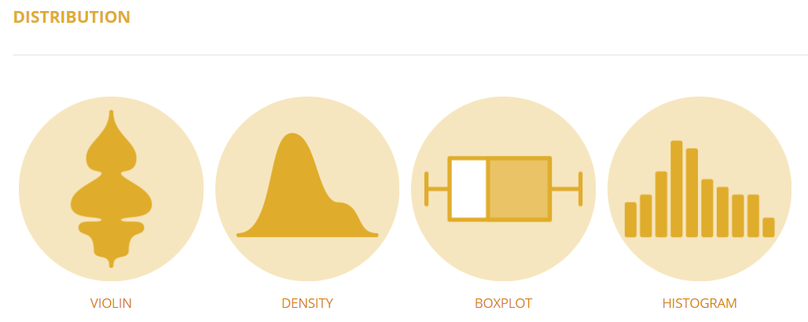

For checking the correlation between features / measures, we can use below visualizations:

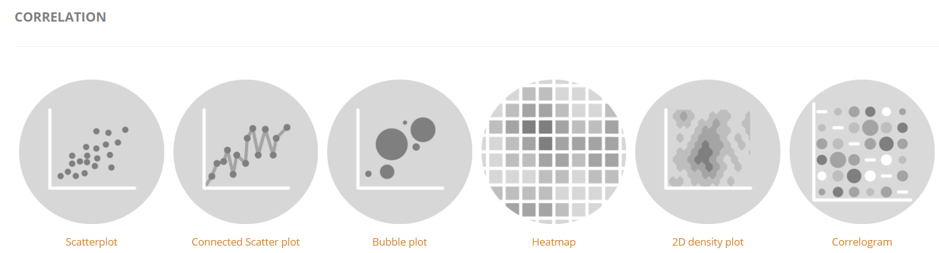

For checking the rank of features in a dataset we can use below visualizations:

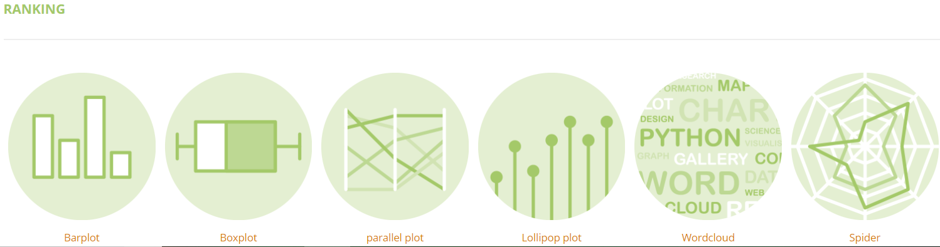

For checking the part of whole, we can use below viz:

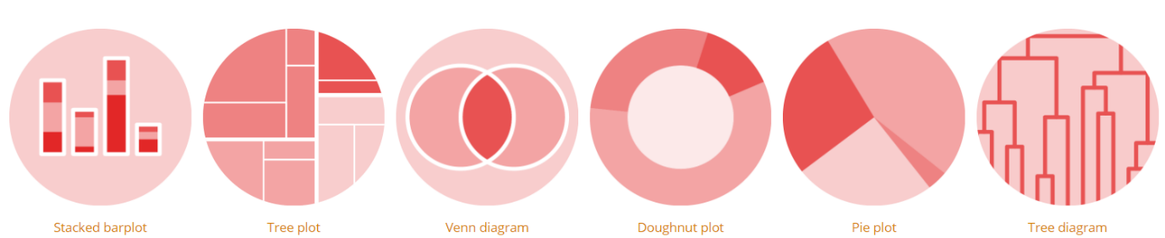

For checking evolution over time, we can use below viz:

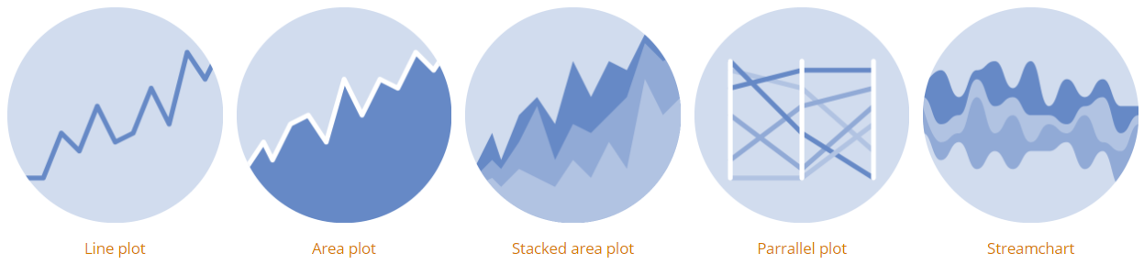

For maps we can use below viz:

