# LAMPIRAN

## Surat Persetujuan PKL Pihak IDUKA

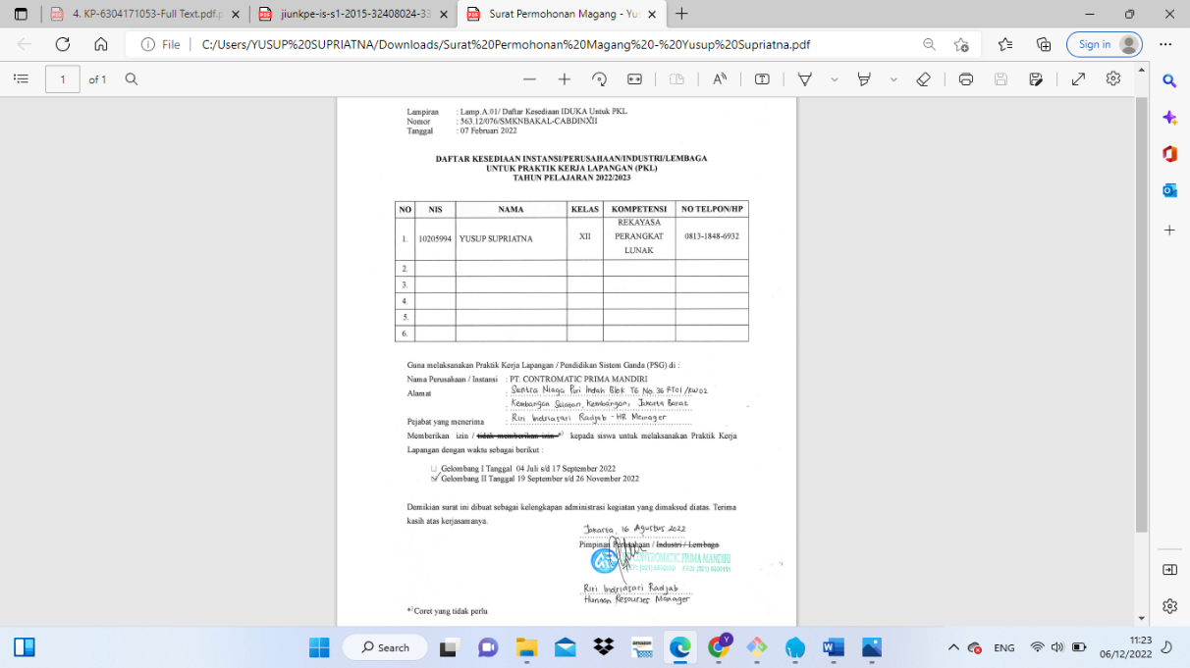

## Poto Kegiatan PKL

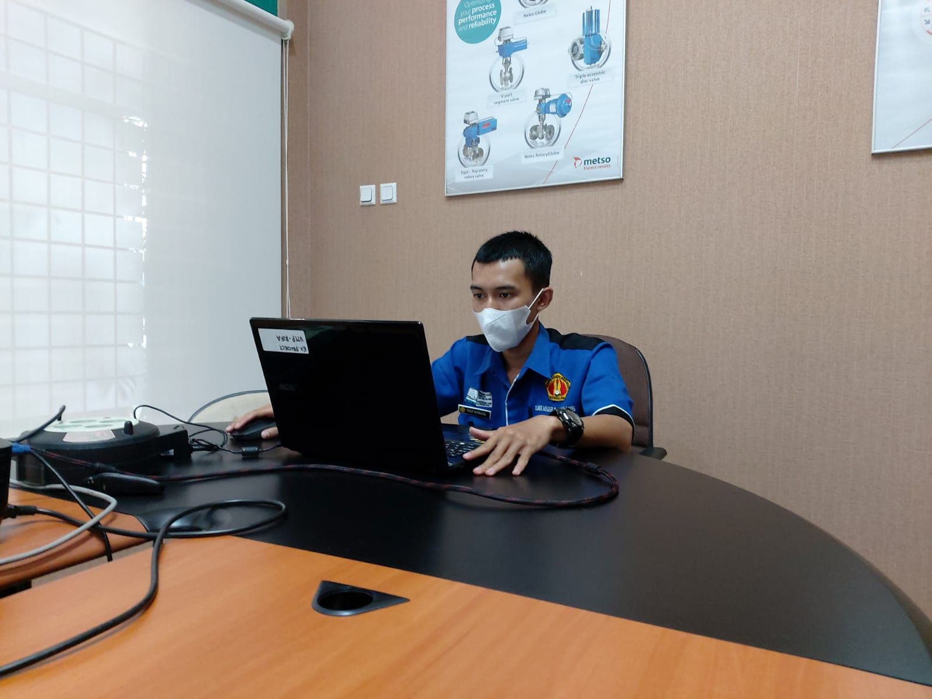

Gambar1.2. Presentasi SAP Business One

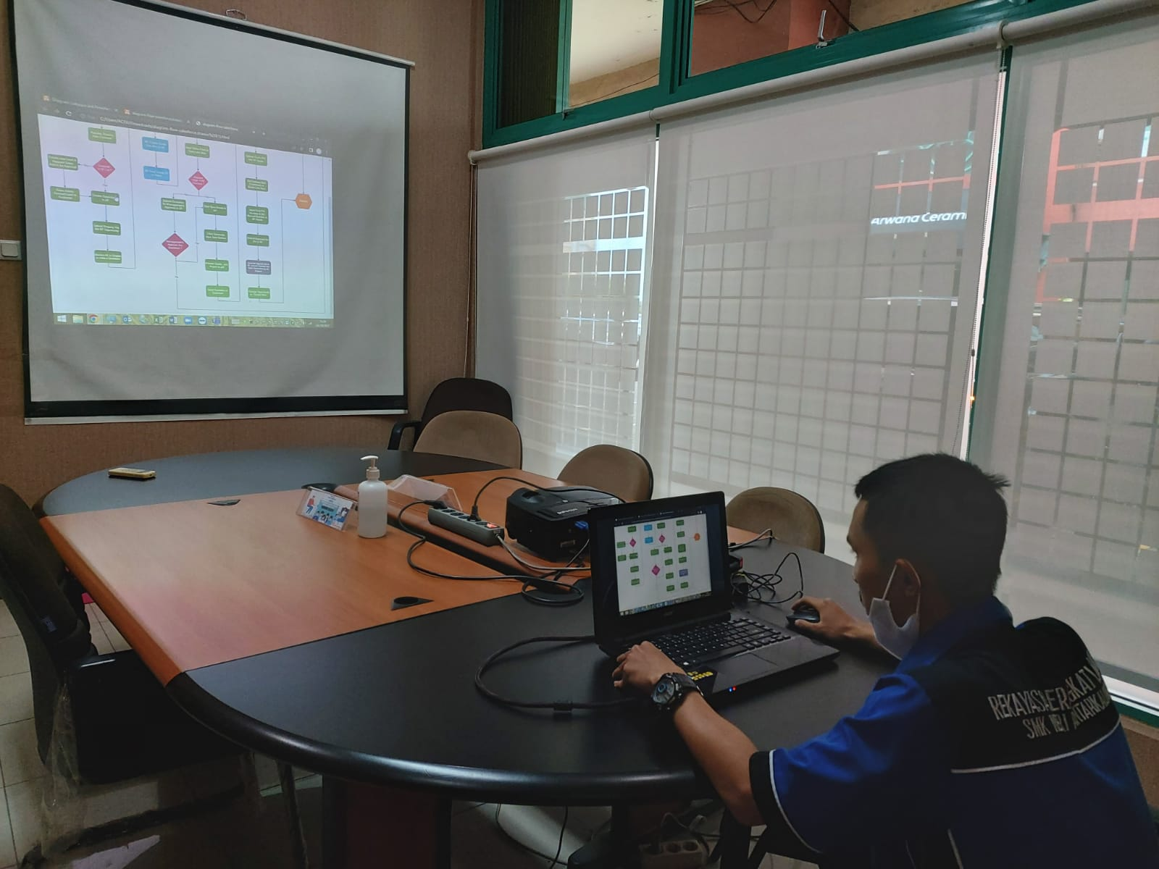

Gambar . Presentasi Bisnis Proses SAP Business One

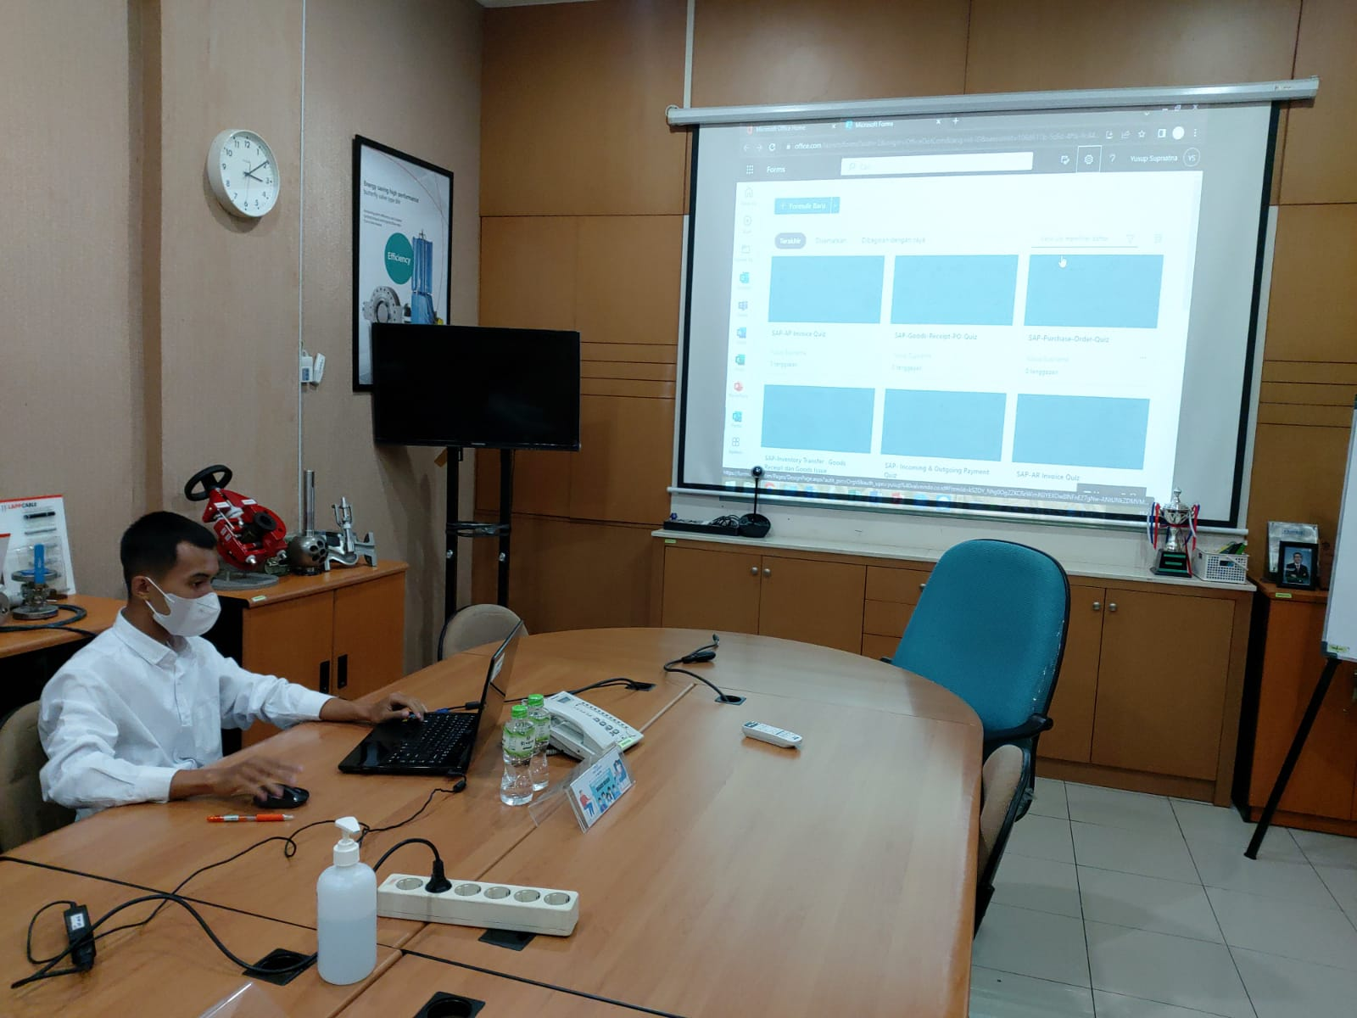

Gambar . Presentasi *SalesForce*

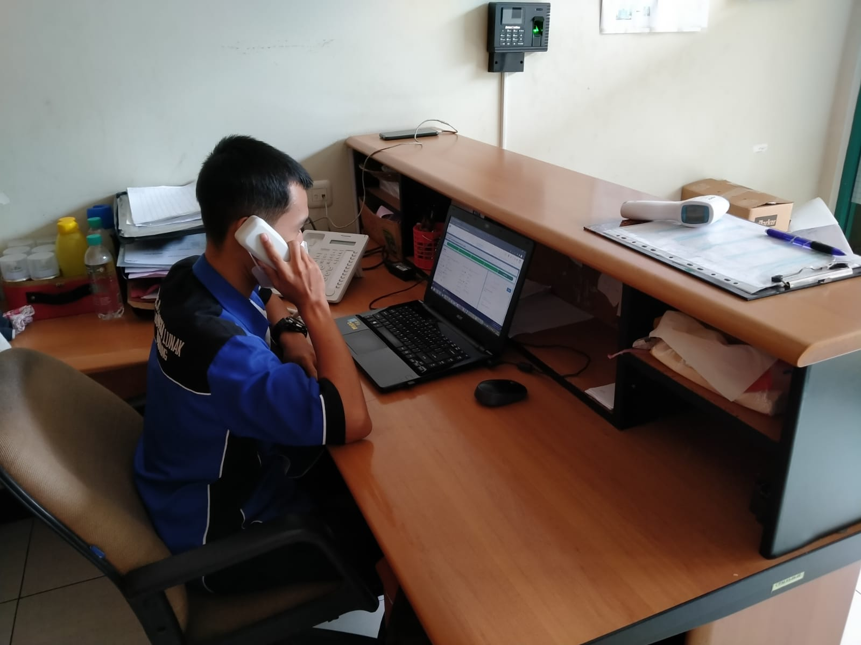

Gambar . Tugas Resepsionis Kantor

PT. Contromatic Prima Mandiri