Nathan Gulley

MSSE670

Week 2 Assignment

**1. Description of Application**

For my MSSE-670 class project, I plan to build a software system that caters to the needs of a music instrument rental business that provides services to local school bands, orchestras and private lesson students that have a need for rented instruments.

The application will support two roles: admin and customer. The admin role will have the ability to create an inventory of musical instruments, make instruments available or unavailable for rental, set rental prices, set Liability & Damage Waiver prices, record instrument pickup, record instrument returns and track instrument statuses. The customer role will have the ability to browse the available inventory of musical instruments and reserve one or more instruments for rental.

The application will automatically send email and text notifications to admin and customer users when events of particular interest to them occur (e.g. “Your Rental of Violin # 3 (Serial # 134534231) is Scheduled to End Tomorrow”).

**2. User Stories**

|  |  |
| --- | --- |
| **User Story** | **Description** |
| 1 | As an admin user, I want to be able to add a new musical instrument to the inventory so that the system has an accurate list of musical instruments |
| 2 | As an admin user or customer user, I want to be able to view the current list of musical instruments in the inventory so that I know which instruments are available and what their rental status is |
| 3 | As an admin user, I want to be able to edit the current list of musical instruments in the inventory so that when the status of a music instrument changes the list remains up to date |
| 4 | As an admin user, I want to be able to delete an existing musical instrument from the inventory so that when an item is lost, stolen or destroyed the list of musical instruments remain up to date |
| 5 | As an admin user or customer user, I want to be able to add a new customer profile into the system so that the system has an accurate list of current customers |
| 6 | As an admin user, I want to be able to view the current list of customers so that I have an accurate list of all customers being serviced |
| 7 | As an admin user, I want to be able to edit an existing customer’s profile so that when a customer’s profile info changes the information remains up to date |
| 8 | As a customer user, I want to be able to edit my own profile so that when my profile info changes the information remains up to date |
| 9 | As an admin user, I want to be able to delete an existing customer’s profile from the system |
| 10 | As an admin or customer user, I want to be able to make a reservation to rent one of the available musical instruments |
| 11 | As an admin user, I want to be able to record the pickup by a customer of a musical instrument that was reserved |
| 12 | As an admin user, I want to be able to record the return of a musical instrument by a customer that was being rented |

**3. Screenshots**

MAIN METHOD

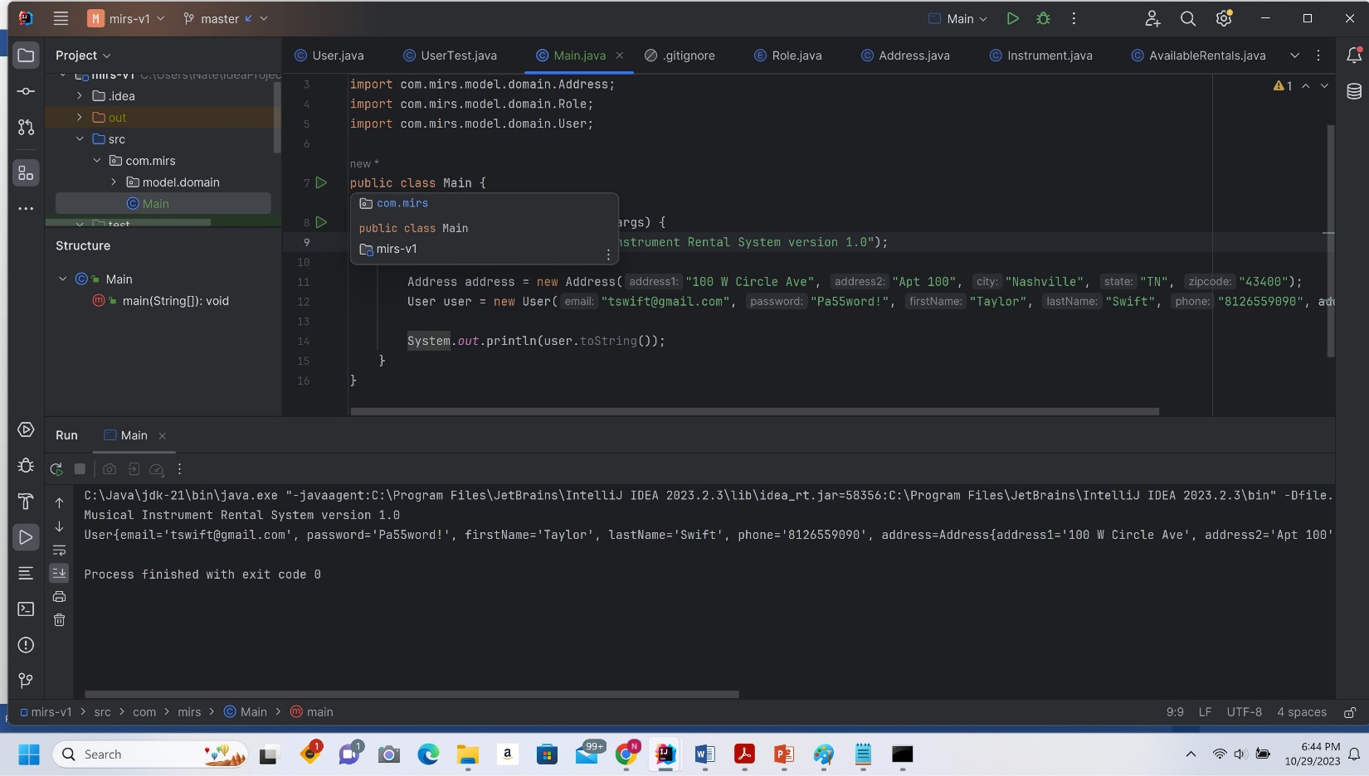

JUNIT TEST

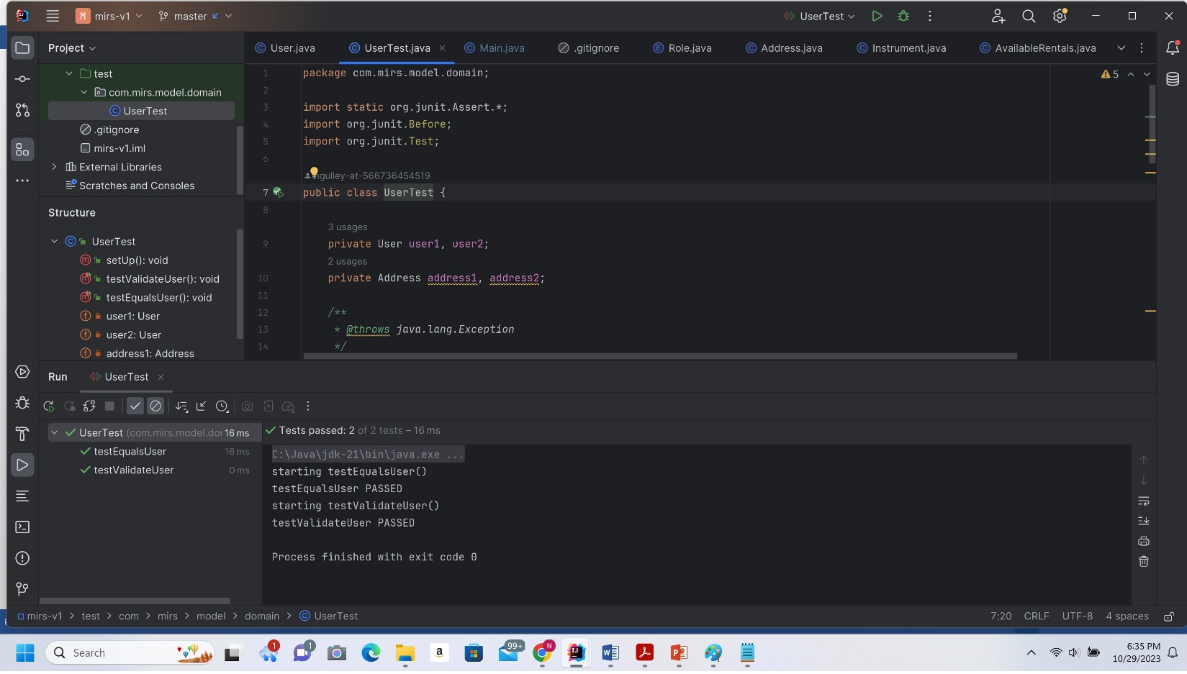

**4. UML Model**

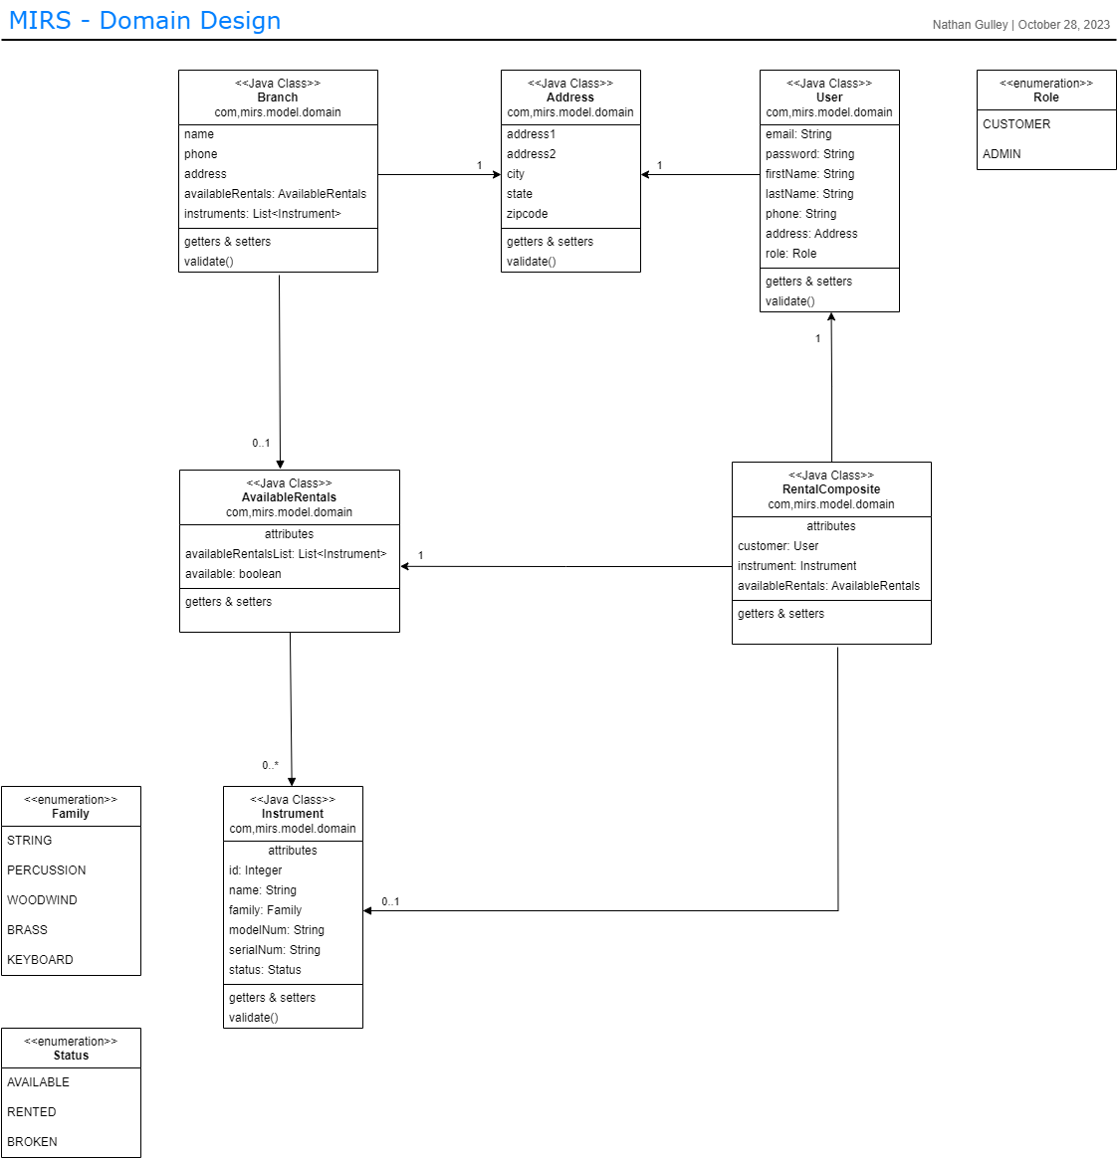

**5. Sequence Diagram**

