Nhanvien.cs

using System;

using System.Collections.Generic;

using System.ComponentModel;

using System.Data;

using System.Drawing;

using System.Text;

using System.Windows.Forms;

using System.Collections;

using System.IO;

using System.Runtime.Serialization.Formatters.Binary;

namespace tapthuchanhthi

{

class NhanVien

{

private string Msnv;

private string HoTen;

private double LuongCb;

private double HeSo;

public string Msnv1 { get { return Msnv; } set { Msnv = value; } }

public string HoTen1 { get { return HoTen; }set { HoTen = value; } }

public double LuongCb1 { get { return LuongCb; } set { LuongCb = value; } }

public double HeSo1 { get { return HeSo; } set { HeSo = value; } }

//public double Luong { get { return LuongCb * HeSo; } }

public NhanVien(string msnv, string hoTen, double luongCb, double heSo)

{

this.Msnv = msnv;

this.HoTen = hoTen;

this.LuongCb = luongCb;

this.HeSo = heSo;

}

public NhanVien()

{

//Msnv = " ";

//HoTen = " ";

//LuongCb = " ";

//HeSo = 0;

}

public double Luong()

{

double l = 0;

l = HeSo * LuongCb;

return 1;

}

}

}

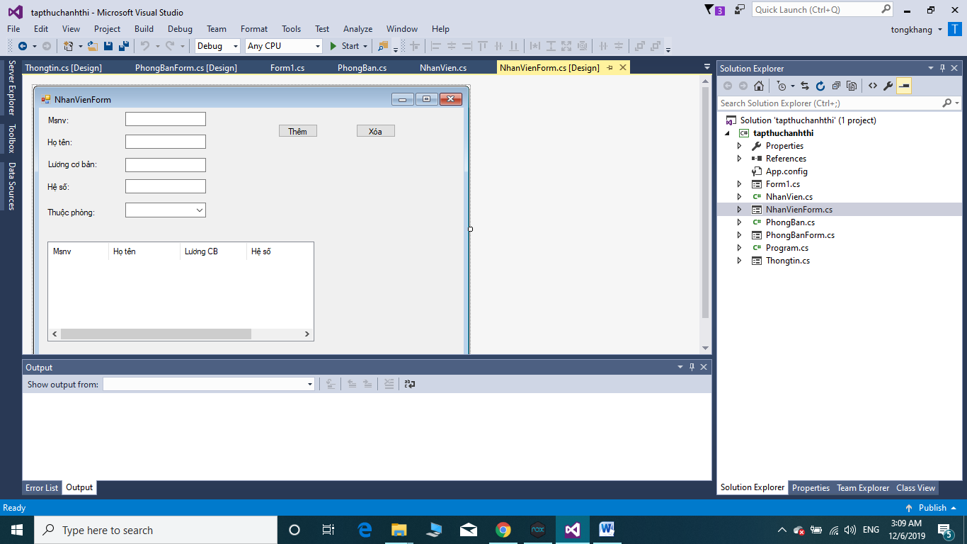

Formnhanvien.cs

using System;

using System.Collections.Generic;

using System.ComponentModel;

using System.Data;

using System.Drawing;

using System.Linq;

using System.Text;

using System.Threading.Tasks;

using System.Windows.Forms;

namespace tapthuchanhthi

{

public partial class NhanVienForm : Form

{

private List<PhongBan> phongs;

private PhongBan phong;

internal List<PhongBan> Phongs { get { return phongs; } set { phongs = value; } }

public NhanVienForm()

{

InitializeComponent();

}

private void addNhanVien(NhanVien nv)

{

ListViewItem item = new ListViewItem(new string[5]);

item.SubItems[0].Text = nv.Msnv1;

item.SubItems[1].Text = nv.HoTen1 ;

item.SubItems[2].Text = nv.LuongCb1.ToString() ;

item.SubItems[3].Text = nv.HeSo1.ToString() ;

item.SubItems[4].Text = nv.Luong().ToString() ;

listView1.Items.Add(item);

}

private void button2_Click(object sender, EventArgs e)

{

if (listView1.SelectedIndices.Count == 0) return;

int pos = listView1.SelectedIndices[0];

string msnv = listView1.SelectedItems[0].Text;

NhanVien nv = (NhanVien)phong.Dsnv[msnv];

phong.xoaNhanVien(nv);

listView1.Items.RemoveAt(pos);

}

private void btnthem_Click(object sender, EventArgs e)

{

NhanVien nv = new NhanVien();

nv.Msnv1 = txtmsnv.Text;

nv.HoTen1 = txthoten.Text;

nv.LuongCb1 = double.Parse(txtluongcb.Text);

nv.HeSo1 = double.Parse(txtheso.Text);

phong.themNhanVien(nv);

addNhanVien(nv);

}

private void NhanVienForm_Load(object sender, EventArgs e)

{

foreach (PhongBan p in phongs)

comboBox1.Items.Add(p);

}

private void comboBox1_SelectedIndexChanged(object sender, EventArgs e)

{

phong = (PhongBan)comboBox1.SelectedItem;

listView1.Items.Clear();

foreach (NhanVien nv in phong.Dsnv.Values)

addNhanVien(nv);

}

}

}

Phongbang.cs

using System;

using System.Collections;

using System.Collections.Generic;

using System.Linq;

using System.Text;

using System.Threading.Tasks;

namespace tapthuchanhthi

{

class PhongBan

{

private string MaPhong;

private string TenPhong;

private Hashtable dsnv = new Hashtable();

public string MaPhong1 { get { return MaPhong; } set { MaPhong = value; } }

public string TenPhong1 { get {return TenPhong; } set { TenPhong = value; } }

public Hashtable Dsnv { get { return dsnv; } set { dsnv = value; } }

public PhongBan(string maPhong, string tenPhong)

{

this.MaPhong = maPhong;

this.TenPhong = tenPhong;

}

public PhongBan() : this("", "")

{

}

public void themNhanVien(NhanVien nv)

{

Dsnv[nv.Msnv1] = nv;

}

public void xoaNhanVien(NhanVien nv)

{

Dsnv.Remove(nv.Msnv1);

}

public override string ToString()

{

return TenPhong;

}

}

}

Fornnphongban.cs

using System;

using System.Collections.Generic;

using System.ComponentModel;

using System.Data;

using System.Drawing;

using System.Linq;

using System.Text;

using System.Threading.Tasks;

using System.Windows.Forms;

namespace tapthuchanhthi

{

public partial class PhongBanForm : Form

{

private List<PhongBan> phongs;

internal List<PhongBan> Phongs { get { return phongs; } set { phongs = value; } }

public PhongBanForm()

{

InitializeComponent();

}

private void btnthemphong_Click(object sender, EventArgs e)

{

PhongBan p = new PhongBan();

p.MaPhong1 = txtmaphong.Text;

p.TenPhong1 = txttenphong.Text;

phongs.Add(p);

addPhongBan(p);

}

private void PhongBanForm_Load(object sender, EventArgs e)

{

foreach (PhongBan p in Phongs)

addPhongBan(p);

}

private void addPhongBan(PhongBan p)

{

ListViewItem item =new ListViewItem(new string[2]);

item.SubItems[0].Text = p.MaPhong1;

item.SubItems[1].Text = p.TenPhong1;

listView1.Items.Add(item);

}

private void btnxoaphong_Click(object sender, EventArgs e)

{

if (listView1.SelectedIndices.Count == 0) return;

int vitri = listView1.SelectedIndices[0];

phongs.RemoveAt(vitri);

listView1.Items.RemoveAt(vitri);

}

}

}

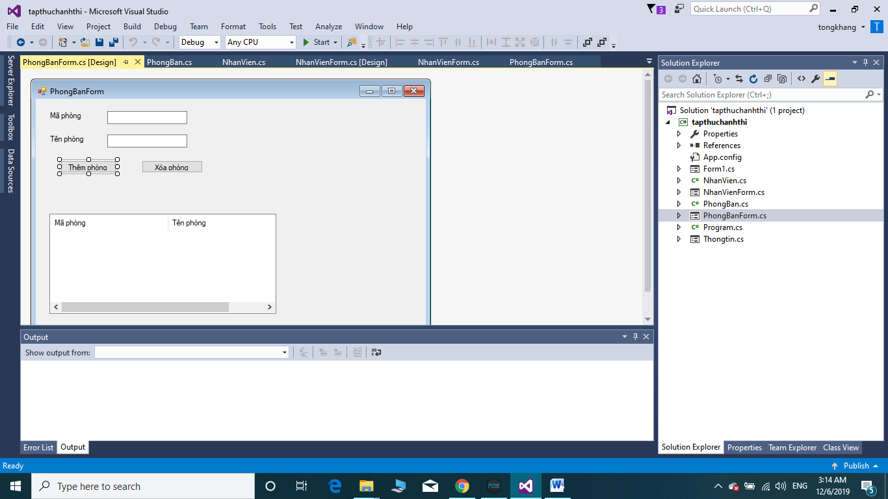

Thongtin.csformusing System;

using System.Collections.Generic;

using System.ComponentModel;

using System.Data;

using System.Drawing;

using System.Linq;

using System.Text;

using System.Threading.Tasks;

using System.Windows.Forms;

namespace tapthuchanhthi

{

public partial class Thongtin : Form

{

public Thongtin()

{

InitializeComponent();

}

private void Thongtin_Load(object sender, EventArgs e)

{

}

}

}