**SWEndor**

**Version: v0.1  
Created: 23 December 2019**

Contents

Introduction 1

Requirements 1

# Introduction

SWEndor is a non-commercial flight-simulation game that was initially planned to be a remake of the games originally made by **Bruno. R. Marcos** back in the early 2000s. There are two such games to his name:

The [Battle of Endor](http://www.moddb.com/games/starwars-battle-of-endor) was the first of such game to be published by him, and the project name is thus named in this honor.  
The [Battle of Yavin](http://www.moddb.com/games/starwars-battle-of-yavin) was released soon after.

While Mr. Marcos had released a preview of the [Escape from Hoth](https://www.youtube.com/watch?v=u1ug51qrJwc), the game was unfortunately not yet published at the start of making of this project (January 2018). Eventually, I hope this project can bring even that into fruition.

This project aims to recreate the enjoyable (and rage-inducing, mostly rage-inducing) elements of the original projects by Mr. Marcos. The open-source nature of this project allows for expansion and improvement, which will hopefully bring about other elements that an fellow enthusiast can think up of.

While this project begins as a recreation of Mr. Marco's SW games, this project's core is a 3D flight/combat simulator, and is thus not limited in content. You may use this to recreate a WWII scenario, for instance, should the right models and logical sequence are available.

# Requirements

The game requires **Microsoft .NET Framework v4.5.**

The game uses TrueVision3D 6.5 (<http://www.truevision3d.com/>) to perform 3D rendering and calculations with DirectX. TV3D can only be run on **32-bit Windows**. The minimum requirements for 3D rendering support are **DirectX 9** and a **matching graphics card (Shader Model 2.0 / 2.0a / 2.0b / 3.0)** to run properly.

While the resource specifications may change with the project, it is recommended to have at least 2 GHz and at least 2 CPU cores for a minimum performance.

This project is created and maintained with **Visual Studio 2015**. It is recommended that programmers who wish to inspect or change the code use **Visual Studio 2015** to do so.

|  |  |
| --- | --- |
| Minimum Requirements | Recommended Requirements |
| Microsoft .NET Framework v4.5 | >= 2 CPU cores |
| DirectX 9.0 | 2 GHz processor |
| Graphics Card supporting Shader Model 2.0 / 2.0a / 2.0b / 3.0 |  |

# Installing the Game

To install the game, either download or clone the repository to a folder of your choice.

Repository: <https://github.com/nguoiyoujie/SWEndor>

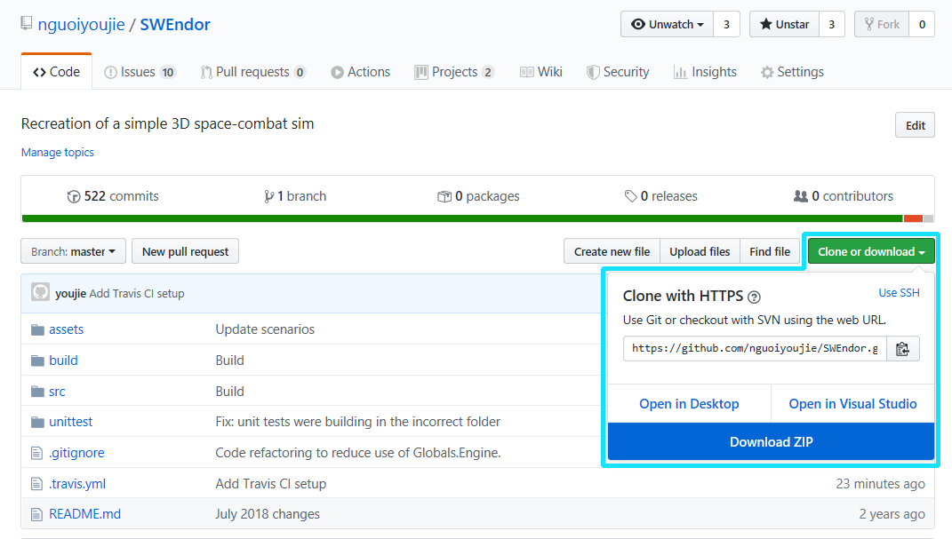

If you download the repository as a zip file, you will need to extract the contents to a folder of your choice before proceeding.

The downloaded repository will look like this:

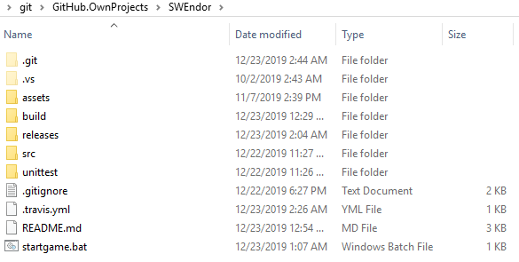

# Starting the Game

There are several ways to start the game.

**Starting the latest release**

* Run startgame.bat on the root directory.



**Selecting a release version**

* Go to /releases
* Go to the version folder that you wish to play (e.g. v0.1_rc)
* Run SWEndor.exe

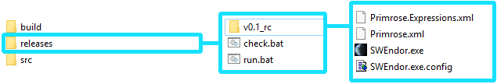

**Starting a development version**

Note: Development versions are often subject to changes and break easily. Use with caution!

* Go to /build
* Choose either /debug or /release
* Run SWEndor.exe

# Navigating the Game

When the game is started, it will begin initializing and loading its assets.

When the game has finished loading, the game will cut to Main Menu.

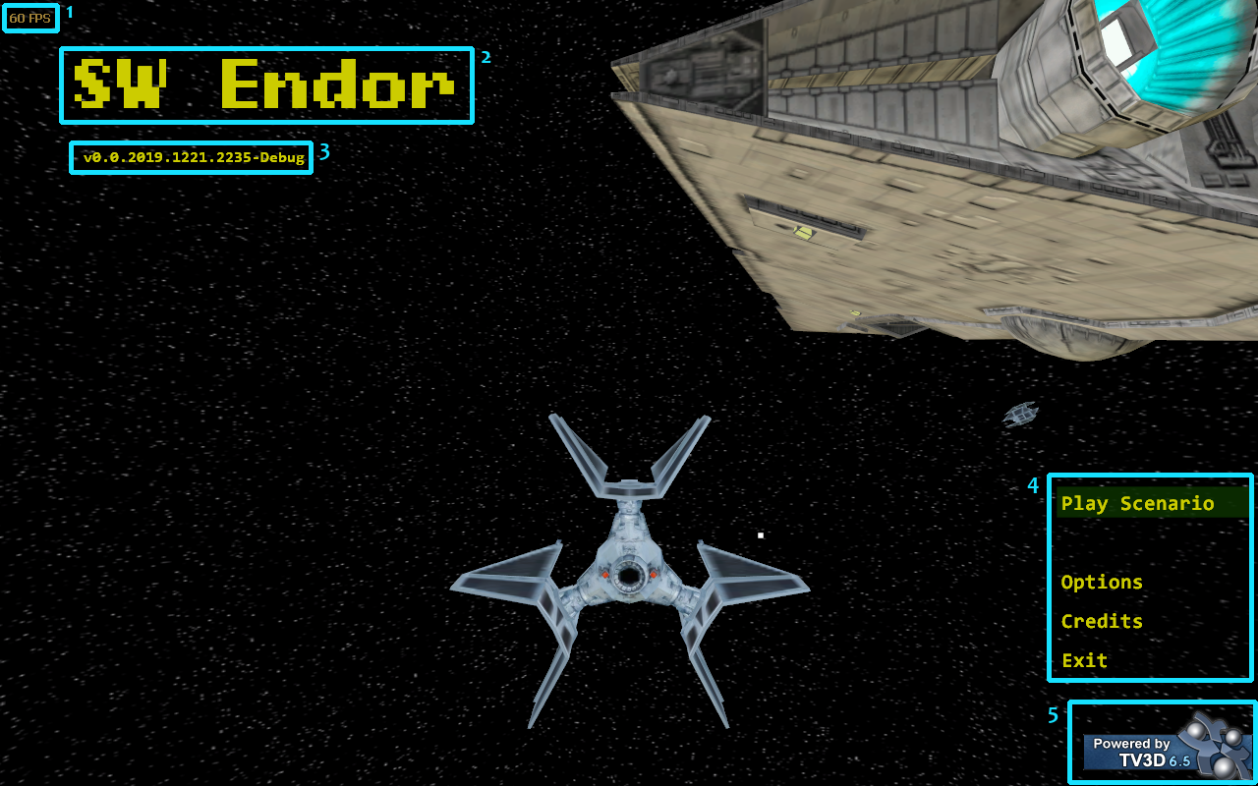

|  |  |
| --- | --- |
| Item | Description |
| 1 | FPS counter. Displays the rendering speed in frames per second. |
| 2 | SWEndor. The game title. |
| 3 | Version build number. |
| 4 | Navigation menu. The currently selected menu is highlighted in green. |
| 5 | TrueVision3D watermark logo. This project would not be possible without it. |

The menu is navigated using the keyboard. Press **UP** or **DOWN** to navigate. Press **ENTER** to select. Press **ESCAPE** to go to the previous menu.

You may select Play Scenario and start playing straight away. Before that, let us look at the Options menu.

# Configuring the Game

**Options**

When you select the Options menu, you are taken to this screen:

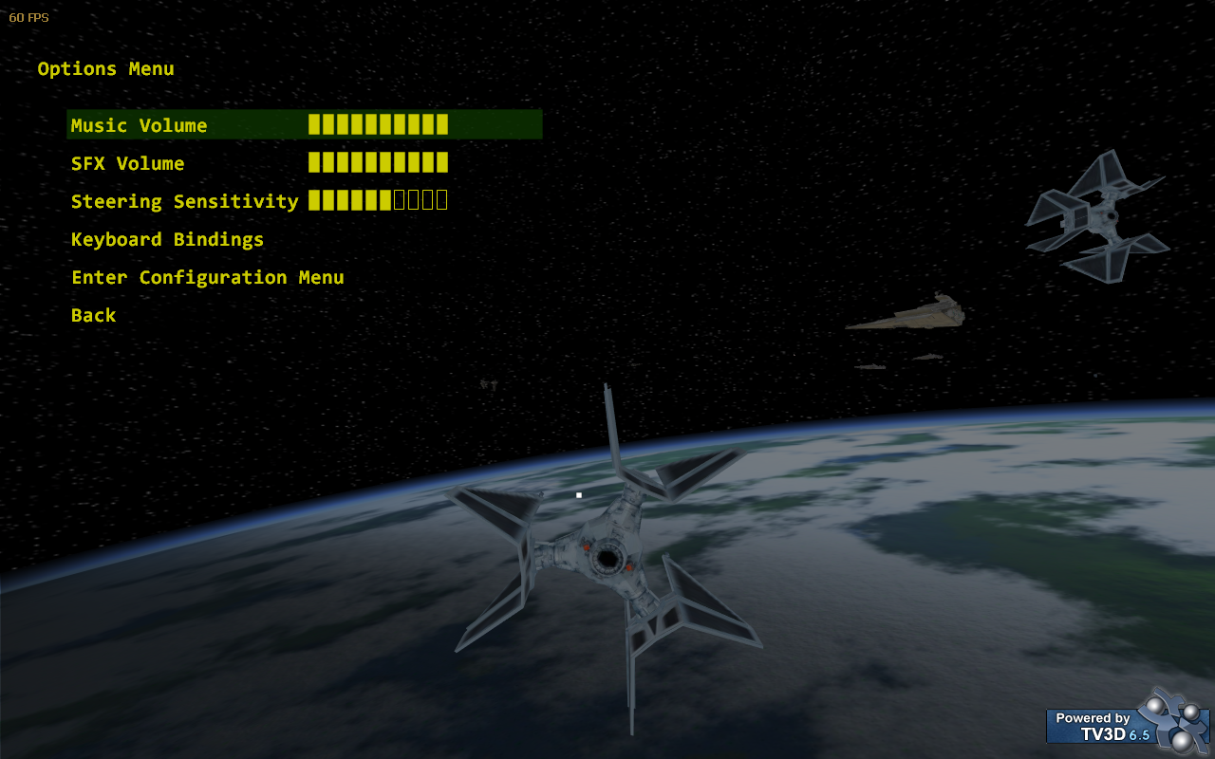

|  |  |
| --- | --- |
| Option | Description |
| Music Volume | Controls the volume of the music. Use LEFT or RIGHT to adjust. |
| SFX Volume | Controls the volume of sound effects. Use LEFT or RIGHT to adjust. |
| Steering Sensitivity | Controls how sensitive the game is to mouse movement. Use LEFT or RIGHT to adjust. |
| Keyboard Bindings | Opens the Keyboard Bindings menu |
| Enter Configuration Menu | Opens the Configuration menu |
| Back | Returns to the Main menu |

# Playing the Game

**Scenario Selection**

When you select Play Scenario from the Main menu, you are taken to this screen:

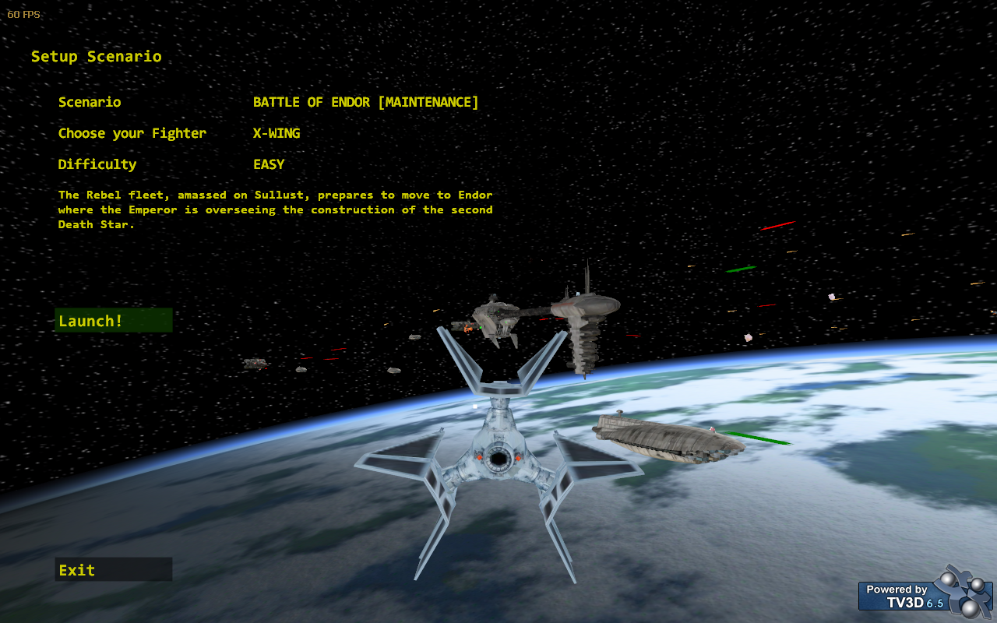

|  |  |
| --- | --- |
| Option | Description |
| Scenario | Shows the currently selected scenario. Use LEFT or RIGHT to choose. |
| Choose your Fighter | Shows your currently selected fighter. Use LEFT or RIGHT to choose. |
| Difficulty | Shows the current difficulty setting. Use LEFT or RIGHT to choose. |
| Launch! | Begin loading the scenario. |
| Exit | Returns to the Main menu |

# Gameplay Display and Controls

**Pilot HUD**

As you take control of your craft, you will see several display controls.

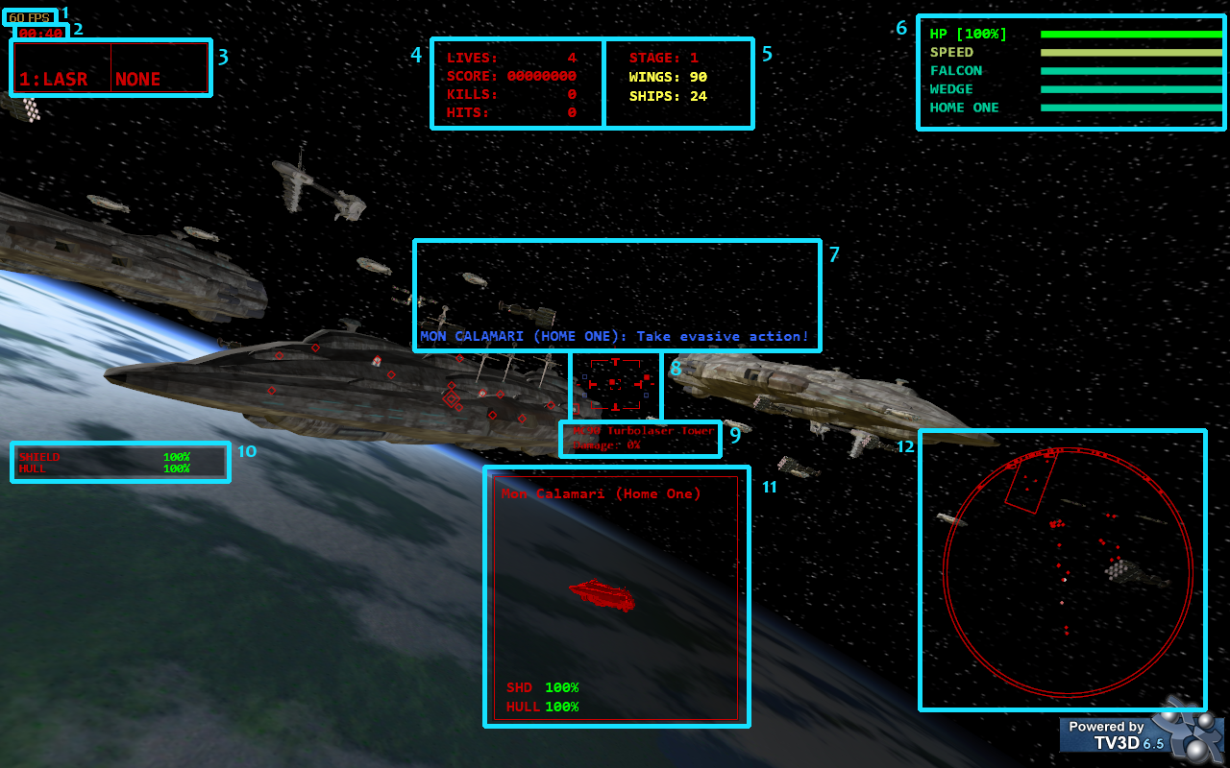

|  |  |
| --- | --- |
| Item | Description |
| 1 | FPS counter. Displays the rendering speed in frames per second. |
| 2 | The elapsed scenario time. |
| 3 | Selected weapons. The left box is your primary weapon, the right box is your secondary weapon. |
| 4 | Scoreboard. Your score information is shown here. |
| 5 | Scenario information. Some scenario information may be shown here. |
| 6 | The sidebar. Your overall HP, your speed, and the strength of your critical allies and enemies are shown here. |
| 7 | Communication messages. |
| 8 | Crosshair. If you have secondary weapons equipped, their ammo information may be shown here. |
| 9 | Current target. Your craft automatically scans and locks-on to targets near your crosshair. |
| 10 | Your system information. |
| 11 | Current target. Additional information is displayed here. |
| 12 | Radar. |

**Controls**

The default controls for the game are as follows

|  |  |
| --- | --- |
| Mouse | Description |
| Movement | Steers the player craft. |
| Left Mouse Button | Fires primary weapon. Hold for continuous fire. |
| Right Mouse Button | Fires secondary weapon. Hold for continuous fire. |
| Scroll Wheel | Rolls the player craft. |

|  |  |
| --- | --- |
| Keyboard | Description |
| Q | Increases speed. |
| A | Decreases speed. |
| Z | Switch to next primary weapon. |
| X | Switch to next secondary weapon. |
| W | Toggles unit indicator. |
| E | Switch camera mode, if more than one camera is supported. |
| S | (Squad leader only) Gives orders to squadron. |
| D | (Squad leader only) Cancels squadron orders. |
| U | Toggle HUD. Overrides all other UI toggles. |
| R | Toggle visibility of Radar. |
| Y | Toggle visibility of Score and Scenario information. |
| / | Shows the map (this will disable your movement controls) |
| SPACE | Locks / Unlocks the target. |
| ESCAPE | Pauses the game. |