Master File

Joanna Duran, Nikhil Gupta, Max Moro

2019-02-15 00:07:06

# User Inputs

output.var = params$output.var   
  
transform.abs = FALSE  
log.pred = params$log.pred  
norm.pred = FALSE  
algo.forward.caret = params$algo.forward.caret  
algo.backward.caret = params$algo.backward.caret  
algo.stepwise.caret = params$algo.stepwise.caret  
algo.LASSO.caret = params$algo.LASSO.caret  
algo.LARS.caret = params$algo.LARS.caret  
message("Parameters used for training/prediction: ")

## Parameters used for training/prediction:

str(params)

## List of 7  
## $ output.var : chr "y3"  
## $ log.pred : logi TRUE  
## $ algo.forward.caret : logi TRUE  
## $ algo.backward.caret: logi TRUE  
## $ algo.stepwise.caret: logi TRUE  
## $ algo.LASSO.caret : logi TRUE  
## $ algo.LARS.caret : logi TRUE

# Setup Labels  
output.var.tr = if (log.pred == TRUE) paste0(output.var,'.log') else output.var.tr = output.var

# Loading Data

feat = read.csv('../../Data/features_highprec.csv')  
labels = read.csv('../../Data/labels.csv')  
predictors = names(dplyr::select(feat,-JobName))  
data.ori = inner_join(feat,labels,by='JobName')  
#data.ori = inner_join(feat,select_at(labels,c('JobName',output.var)),by='JobName')

# Data validation

cc = complete.cases(data.ori)  
data.notComplete = data.ori[! cc,]  
data = data.ori[cc,] %>% select_at(c(predictors,output.var,'JobName'))  
message('Original cases: ',nrow(data.ori))

## Original cases: 10000

message('Non-Complete cases: ',nrow(data.notComplete))

## Non-Complete cases: 3020

message('Complete cases: ',nrow(data))

## Complete cases: 6980

# Output Variable

The Output Variable **y3** shows right skewness, so will proceed with a log transofrmation

## Histogram

ggplot(gather(select_at(data,output.var)), aes(value)) +   
 geom_histogram(aes(y=..density..),bins = 50,fill='light blue') +   
 geom_density() +   
 facet_wrap(~key, scales = 'free',ncol=4)

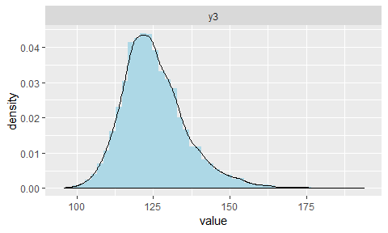

## QQPlot

ggplot(gather(select_at(data,output.var)), aes(sample=value)) +   
 stat_qq() +   
 facet_wrap(~key, scales = 'free',ncol=4)

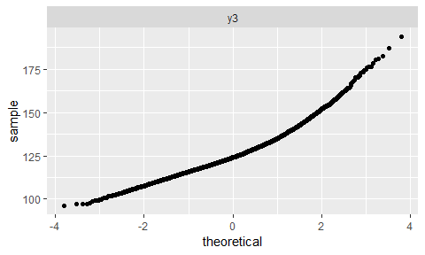

## Trasformation of Output Variable from y3 to y3.log

if(log.pred==TRUE) data[[output.var.tr]] = log(data[[output.var]],10) else  
 data[[output.var.tr]] = data[[output.var]]  
  
ggplot(gather(select_at(data,c(output.var,output.var.tr))), aes(value)) +   
 geom_histogram(aes(y=..density..),bins = 50,fill='light blue') +   
 geom_density() +   
 facet_wrap(~key, scales = 'free',ncol=2)

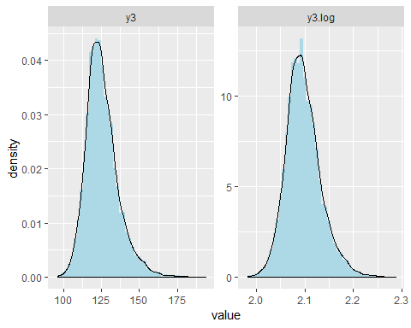

ggplot(gather(select_at(data,c(output.var,output.var.tr))), aes(sample=value)) +   
 stat_qq() +   
 facet_wrap(~key, scales = 'free',ncol=4)

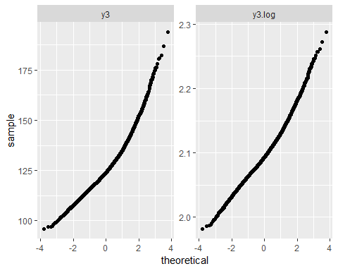

## Best Normalizator y3

Normalization of **y3** using bestNormalize package. (suggested orderNorm) This is cool, but I think is too far for the objective of the project

t=bestNormalize::bestNormalize(data[[output.var]])

t

## Best Normalizing transformation with 6980 Observations  
## Estimated Normality Statistics (Pearson P / df, lower => more normal):  
## - No transform: 2.9649   
## - Box-Cox: 1.4647   
## - Log_b(x+a): 1.9984   
## - sqrt(x+a): 2.4391   
## - exp(x): 749.7304   
## - arcsinh(x): 1.9984   
## - Yeo-Johnson: 1.1956   
## - orderNorm: 1.1716   
## Estimation method: Out-of-sample via CV with 10 folds and 5 repeats  
##   
## Based off these, bestNormalize chose:  
## orderNorm Transformation with 6980 nonmissing obs and no ties   
## - Original quantiles:  
## 0% 25% 50% 75% 100%   
## 95.913 118.289 124.030 131.059 193.726

qqnorm(data[[output.var]])

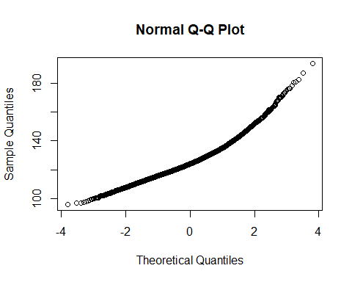

qqnorm(predict(t))

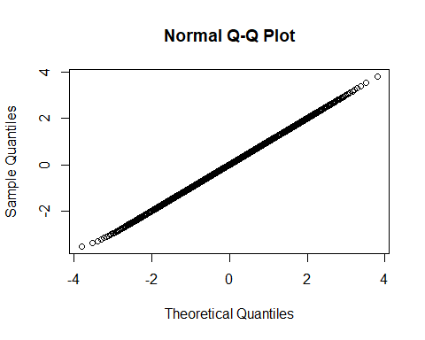

**orderNorm()** is a rank-based procedure by which the values of a vector are mapped to their percentile, which is then mapped to the same percentile of the normal distribution. Without the presence of ties, this essentially guarantees that the transformation leads to a uniform distribution

# Predictors

All predictors show a **Fat-Tail** situation, where the two tails are very tall, and a low distribution around the mean. The orderNorm transromation can help (see [Best Normalizator] section)

## Interesting Predictors

Histograms

cols = c('x11','x18','stat98','x7','stat110')  
ggplot(gather(select_at(data,cols)), aes(value)) +   
 geom_histogram(aes(y=..density..),bins = 50,fill='light blue') +   
 geom_density() +   
 facet_wrap(~key, scales = 'free',ncol=3)

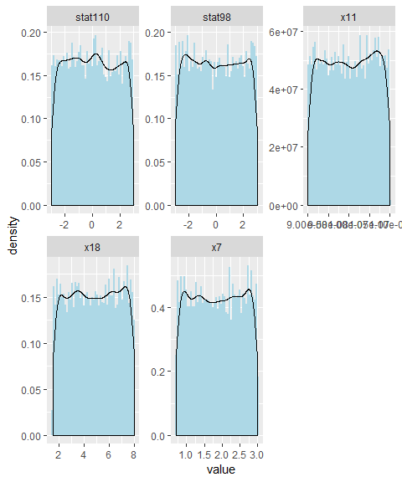

# ggplot(gather(select_at(data,cols)), aes(sample=value)) +   
# stat_qq()+  
# facet_wrap(~key, scales = 'free',ncol=2)  
  
lapply(select_at(data,cols),summary)

## $x11  
## Min. 1st Qu. Median Mean 3rd Qu. Max.   
## 9.000e-08 9.494e-08 1.001e-07 1.001e-07 1.052e-07 1.100e-07   
##   
## $x18  
## Min. 1st Qu. Median Mean 3rd Qu. Max.   
## 1.500 3.147 4.769 4.772 6.418 7.999   
##   
## $stat98  
## Min. 1st Qu. Median Mean 3rd Qu. Max.   
## -2.998619 -1.551882 -0.015993 -0.005946 1.528405 2.999499   
##   
## $x7  
## Min. 1st Qu. Median Mean 3rd Qu. Max.   
## 0.700 1.266 1.854 1.852 2.446 3.000   
##   
## $stat110  
## Min. 1st Qu. Median Mean 3rd Qu. Max.   
## -2.999543 -1.496865 -0.002193 -0.004129 1.504273 2.999563

Scatter plot vs. output variable **y3.log

d = gather(dplyr::select_at(data,c(cols,output.var.tr)),key=target,value=value,-!!output.var.tr)  
ggplot(data=d, aes_string(x='value',y=output.var.tr)) +   
 geom_point(color='light green',alpha=0.5) +   
 geom_smooth() +   
 facet_wrap(~target, scales = 'free',ncol=3)

## `geom_smooth()` using method = 'gam' and formula 'y ~ s(x, bs = "cs")'

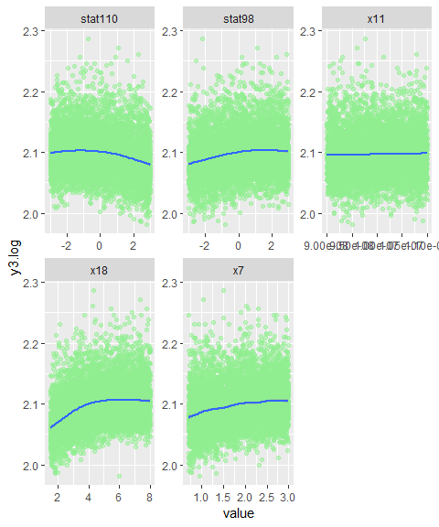

## All Predictors

### Histograms

All indicators have a strong indication of **Fat-Tails**

ggplot(gather(select_at(data,predictors)), aes(value)) +   
 geom_histogram(aes(y=..density..),bins = 50,fill='light blue') +   
 geom_density() +   
 facet_wrap(~key, scales = 'free',ncol=4)

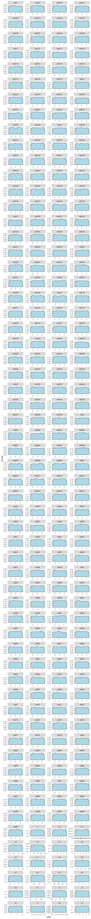

# Correlations

## With Output Variable

#chart.Correlation(select(data,-JobName), pch=21)  
t=as.data.frame(round(cor(dplyr::select(data,-one_of(output.var.tr,'JobName'))  
 ,select_at(data,output.var.tr)),4)) %>%  
 rownames_to_column(var='variable') %>% filter(variable != !!output.var) %>% arrange(-y3.log)  
#DT::datatable(t)  
message("Top Positive")

## Top Positive

kable(head(arrange(t,desc(y3.log)),20))

|  |  |
| --- | --- |
| variable | y3.log |
| x18 | 0.3120 |
| x7 | 0.2091 |
| stat98 | 0.1784 |
| x9 | 0.1127 |
| x17 | 0.0611 |
| x16 | 0.0489 |
| x10 | 0.0472 |
| x21 | 0.0412 |
| x11 | 0.0322 |
| x8 | 0.0318 |
| stat156 | 0.0287 |
| stat23 | 0.0234 |
| stat100 | 0.0206 |
| stat144 | 0.0203 |
| stat59 | 0.0202 |
| stat60 | 0.0199 |
| stat195 | 0.0199 |
| stat141 | 0.0194 |
| stat73 | 0.0192 |
| stat197 | 0.0185 |

message("Top Negative")

## Top Negative

kable(head(arrange(t,y3.log),20))

|  |  |
| --- | --- |
| variable | y3.log |
| stat110 | -0.1594 |
| x4 | -0.0603 |
| stat13 | -0.0345 |
| stat41 | -0.0345 |
| stat14 | -0.0317 |
| stat149 | -0.0309 |
| stat113 | -0.0279 |
| stat4 | -0.0248 |
| stat106 | -0.0236 |
| stat146 | -0.0236 |
| stat186 | -0.0217 |
| stat91 | -0.0210 |
| stat214 | -0.0209 |
| stat5 | -0.0207 |
| stat22 | -0.0202 |
| stat39 | -0.0202 |
| stat175 | -0.0194 |
| stat187 | -0.0193 |
| stat128 | -0.0192 |
| stat37 | -0.0191 |

## Between All Variables

#chart.Correlation(select(data,-JobName), pch=21)  
t=as.data.frame(round(cor(dplyr::select(data,-one_of('JobName'))),4))  
#DT::datatable(t,options=list(scrollX=T))  
message("Showing only 10 variables")

## Showing only 10 variables

kable(t[1:10,1:10])

|  |  |  |  |  |  |  |  |  |  |  |
| --- | --- | --- | --- | --- | --- | --- | --- | --- | --- | --- |
|  | x1 | x2 | x3 | x4 | x5 | x6 | x7 | x8 | x9 | x10 |
| x1 | 1.0000 | 0.0034 | -0.0028 | 0.0085 | 0.0068 | 0.0159 | 0.0264 | -0.0012 | 0.0142 | 0.0013 |
| x2 | 0.0034 | 1.0000 | -0.0057 | 0.0004 | -0.0094 | -0.0101 | 0.0089 | 0.0078 | 0.0049 | -0.0214 |
| x3 | -0.0028 | -0.0057 | 1.0000 | 0.0029 | 0.0046 | 0.0006 | -0.0105 | -0.0002 | 0.0167 | -0.0137 |
| x4 | 0.0085 | 0.0004 | 0.0029 | 1.0000 | -0.0059 | 0.0104 | 0.0098 | 0.0053 | 0.0061 | -0.0023 |
| x5 | 0.0068 | -0.0094 | 0.0046 | -0.0059 | 1.0000 | 0.0016 | -0.0027 | 0.0081 | 0.0259 | -0.0081 |
| x6 | 0.0159 | -0.0101 | 0.0006 | 0.0104 | 0.0016 | 1.0000 | 0.0200 | -0.0157 | 0.0117 | -0.0072 |
| x7 | 0.0264 | 0.0089 | -0.0105 | 0.0098 | -0.0027 | 0.0200 | 1.0000 | -0.0018 | -0.0069 | -0.0221 |
| x8 | -0.0012 | 0.0078 | -0.0002 | 0.0053 | 0.0081 | -0.0157 | -0.0018 | 1.0000 | 0.0142 | -0.0004 |
| x9 | 0.0142 | 0.0049 | 0.0167 | 0.0061 | 0.0259 | 0.0117 | -0.0069 | 0.0142 | 1.0000 | 0.0149 |
| x10 | 0.0013 | -0.0214 | -0.0137 | -0.0023 | -0.0081 | -0.0072 | -0.0221 | -0.0004 | 0.0149 | 1.0000 |

## Scatter Plots with Output Variable

Scatter plots with all predictors and the output variable (y3.log)

d = gather(dplyr::select_at(data,c(predictors,output.var.tr)),key=target,value=value,-!!output.var.tr)  
ggplot(data=d, aes_string(x='value',y=output.var.tr)) +   
 geom_point(color='light blue',alpha=0.5) +   
 geom_smooth() +   
 facet_wrap(~target, scales = 'free',ncol=4)

## `geom_smooth()` using method = 'gam' and formula 'y ~ s(x, bs = "cs")'



## Multicollinearity - VIF

No Multicollinearity among predictors

Showing Top predictor by VIF Value

vifDF = usdm::vif(select_at(data,predictors)) %>% arrange(desc(VIF))  
head(vifDF,15)

## Variables VIF  
## 1 stat204 1.063870  
## 2 stat175 1.063370  
## 3 stat66 1.062060  
## 4 stat105 1.062008  
## 5 x6 1.061394  
## 6 stat2 1.061388  
## 7 stat14 1.061212  
## 8 x7 1.060532  
## 9 stat216 1.060477  
## 10 stat142 1.060190  
## 11 stat154 1.059695  
## 12 stat32 1.059608  
## 13 stat141 1.059564  
## 14 stat138 1.059507  
## 15 stat73 1.059386

# Feature Eng

* Square Root transformation for **x18**

data.tr=data %>%  
 mutate(x18.sqrt = sqrt(x18))   
cols=c('x18','x18.sqrt')

## Comparing Pre and Post Transformation Density Plots

# ggplot(gather(select_at(data.tr,cols)), aes(value)) +   
# geom_histogram(aes(y=..density..),bins = 50,fill='light blue') +   
# geom_density() +   
# facet_wrap(~key, scales = 'free',ncol=4)  
  
d = gather(dplyr::select_at(data.tr,c(cols,output.var.tr)),key=target,value=value,-!!output.var.tr)  
ggplot(data=d, aes_string(x='value',y=output.var.tr)) +   
 geom_point(color='light blue',alpha=0.5) +   
 geom_smooth() +   
 facet_wrap(~target, scales = 'free',ncol=4)

## `geom_smooth()` using method = 'gam' and formula 'y ~ s(x, bs = "cs")'

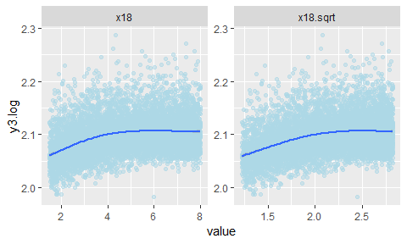

#removing unwanted variables  
data.tr=data.tr %>%  
 dplyr::select_at(names(data.tr)[! names(data.tr) %in% c('x18','y3','JobName')])  
  
data=data.tr  
label.names=output.var.tr

# Modeling

## Train Test Split

data = data[sample(nrow(data)),] # randomly shuffle data  
split = sample.split(data[,label.names], SplitRatio = 0.8)  
  
data.train = subset(data, split == TRUE)  
data.test = subset(data, split == FALSE)

## Common Functions

plot.diagnostics <- function(model, train) {  
 plot(model)  
   
 residuals = resid(model) # Plotted above in plot(lm.out)  
 r.standard = rstandard(model)  
 r.student = rstudent(model)  
  
 plot(predict(model,train),r.student,  
 ylab="Student Residuals", xlab="Predicted Values",   
 main="Student Residual Plot")   
 abline(0, 0)  
   
 plot(predict(model, train),r.standard,  
 ylab="Standard Residuals", xlab="Predicted Values",   
 main="Standard Residual Plot")   
 abline(0, 0)  
 abline(2, 0)  
 abline(-2, 0)  
   
 # Histogram  
 hist(r.student, freq=FALSE, main="Distribution of Studentized Residuals",   
 xlab="Studentized Residuals", ylab="Density", ylim=c(0,0.5))  
  
 # Create range of x-values for normal curve  
 xfit <- seq(min(r.student)-1, max(r.student)+1, length=40)  
  
 # Generate values from the normal distribution at the specified values  
 yfit <- (dnorm(xfit))  
  
 # Add the normal curve  
 lines(xfit, yfit, ylim=c(0,0.5))  
   
 # http://www.stat.columbia.edu/~martin/W2024/R7.pdf  
 # Influential plots  
 inf.meas = influence.measures(model)  
 # print (summary(inf.meas)) # too much data  
   
 # Leverage plot  
 lev = hat(model.matrix(model))  
 plot(lev, ylab = 'Leverage - check')  
   
 # Cook's Distance  
 cd = cooks.distance(model)  
 plot(cd,ylab="Cooks distances")  
 abline(4/nrow(train),0)  
 abline(1,0)  
   
 print (paste("Number of data points that have Cook's D > 4/n: ", length(cd[cd > 4/nrow(train)]), sep = ""))   
 print (paste("Number of data points that have Cook's D > 1: ", length(cd[cd > 1]), sep = ""))   
 return(cd)  
}  
  
# function to set up random seeds  
# Based on http://jaehyeon-kim.github.io/2015/05/Setup-Random-Seeds-on-Caret-Package.html   
setCaretSeeds <- function(method = "cv", numbers = 1, repeats = 1, tunes = NULL, seed = 1701) {  
 #B is the number of resamples and integer vector of M (numbers + tune length if any)  
 B <- if (method == "cv") numbers  
 else if(method == "repeatedcv") numbers * repeats  
 else NULL  
 if(is.null(length)) {  
 seeds <- NULL  
 } else {  
 set.seed(seed = seed)  
 seeds <- vector(mode = "list", length = B)  
 seeds <- lapply(seeds, function(x) sample.int(n = 1000000  
 , size = numbers + ifelse(is.null(tunes), 0, tunes)))  
 seeds[[length(seeds) + 1]] <- sample.int(n = 1000000, size = 1)  
 }  
 # return seeds  
 seeds  
}  
  
train.caret.glmselect = function(formula, data, method  
 ,subopt = NULL, feature.names  
 , train.control = NULL, tune.grid = NULL, pre.proc = NULL){  
   
 if(is.null(train.control)){  
 train.control <- trainControl(method = "cv"  
 ,number = 10  
 ,seeds = setCaretSeeds(method = "cv"  
 , numbers = 10  
 , seed = 1701)  
 ,search = "grid"  
 ,verboseIter = TRUE  
 ,allowParallel = TRUE  
 )  
 }  
   
 if(is.null(tune.grid)){  
 if (method == 'leapForward' | method == 'leapBackward' | method == 'leapSeq'){  
 tune.grid = data.frame(nvmax = 1:length(feature.names))  
 }  
 if (method == 'glmnet' && subopt == 'LASSO'){  
 # Will only show 1 Lambda value during training, but that is OK  
 # https://stackoverflow.com/questions/47526544/why-need-to-tune-lambda-with-carettrain-method-glmnet-and-cv-glmnet  
 # Another option for LASSO is this: https://github.com/topepo/caret/blob/master/RegressionTests/Code/lasso.R  
 lambda = 10^seq(-2,0, length =100)  
 alpha = c(1)  
 tune.grid = expand.grid(alpha = alpha,lambda = lambda)  
 }  
 if (method == 'lars'){  
 # https://github.com/topepo/caret/blob/master/RegressionTests/Code/lars.R  
 fraction = seq(0, 1, length = 100)  
 tune.grid = expand.grid(fraction = fraction)  
 pre.proc = c("center", "scale")   
 }  
 }  
   
 # http://sshaikh.org/2015/05/06/parallelize-machine-learning-in-r-with-multi-core-cpus/  
 cl <- makeCluster(detectCores()*0.75) # use 75% of cores only, leave rest for other tasks  
 registerDoParallel(cl)  
  
 set.seed(1)   
 # note that the seed has to actually be set just before this function is called  
 # settign is above just not ensure reproducibility for some reason  
 model.caret <- caret::train(formula  
 , data = data  
 , method = method  
 , tuneGrid = tune.grid  
 , trControl = train.control  
 , preProc = pre.proc  
 )  
   
 stopCluster(cl)  
 registerDoSEQ() # register sequential engine in case you are not using this function anymore  
   
 if (method == 'leapForward' | method == 'leapBackward' | method == 'leapSeq'){  
 print("All models results")  
 print(model.caret$results) # all model results  
 print("Best Model")  
 print(model.caret$bestTune) # best model  
 model = model.caret$finalModel  
  
 # Metrics Plot   
 dataPlot = model.caret$results %>%  
 gather(key='metric',value='value',-nvmax) %>%  
 dplyr::filter(metric %in% c('MAE','RMSE','Rsquared'))  
 metricsPlot = ggplot(data=dataPlot,aes(x=nvmax,y=value) ) +  
 geom_line(color='lightblue4') +  
 geom_point(color='blue',alpha=0.7,size=.9) +  
 facet_wrap(~metric,ncol=4,scales='free_y')+  
 theme_light()  
 plot(metricsPlot)  
   
 # Residuals Plot  
 # leap function does not support studentized residuals  
 dataPlot=data.frame(pred=predict(model.caret,data),res=resid(model.caret))  
 residPlot = ggplot(dataPlot,aes(x=pred,y=res)) +  
 geom_point(color='light blue',alpha=0.7) +  
 geom_smooth(method="lm")+  
 theme_light()  
 plot(residPlot)  
   
 residHistogram = ggplot(dataPlot,aes(x=res)) +  
 geom_histogram(aes(y=..density..),fill='light blue',alpha=1) +  
 geom_density(color='lightblue4') +   
 theme_light()  
 plot(residHistogram)  
 id = rownames(model.caret$bestTune)   
 # Provides the coefficients of the best model  
 # regsubsets doens return a full model (see documentation of regsubset), so we need to recalcualte themodel  
 # https://stackoverflow.com/questions/13063762/how-to-obtain-a-lm-object-from-regsubsets  
 print("Coefficients of final model:")  
 coefs <- coef(model, id=id)  
 #calculate the model to the the coef intervals  
 nams <- names(coefs)  
 nams <- nams[!nams %in% "(Intercept)"]  
 response <- as.character(formula[[2]])  
 form <- as.formula(paste(response, paste(nams, collapse = " + "), sep = " ~ "))  
 mod <- lm(form, data = data)  
 #coefs  
 #coef(mod)  
 print(car::Confint(mod))  
 return(list(model = model,id = id, residPlot = residPlot, residHistogram=residHistogram  
 ,modelLM=mod))  
 }  
 if (method == 'glmnet' && subopt == 'LASSO'){  
 print(model.caret)  
 print(plot(model.caret))  
 print(model.caret$bestTune)  
   
 print(model.caret$results)  
 model=model.caret$finalModel  
 # Metrics Plot   
 dataPlot = model.caret$results %>%  
 gather(key='metric',value='value',-lambda) %>%  
 dplyr::filter(metric %in% c('MAE','RMSE','Rsquared'))  
 metricsPlot = ggplot(data=dataPlot,aes(x=lambda,y=value) ) +  
 geom_line(color='lightblue4') +  
 geom_point(color='blue',alpha=0.7,size=.9) +  
 facet_wrap(~metric,ncol=4,scales='free_y')+  
 theme_light()  
 plot(metricsPlot)  
   
 # Residuals Plot   
 dataPlot=data.frame(pred=predict(model.caret,data),res=resid(model.caret))  
 residPlot = ggplot(dataPlot,aes(x=pred,y=res)) +  
 geom_point(color='light blue',alpha=0.7) +  
 geom_smooth(method="lm")+  
 theme_light()  
 plot(residPlot)  
  
 residHistogram = ggplot(dataPlot,aes(x=res)) +  
 geom_histogram(aes(y=..density..),fill='light blue',alpha=1) +  
 geom_density(color='lightblue4') +  
 theme_light()  
 plot(residHistogram)  
   
 print("Coefficients")   
 #no interval for glmnet: https://stackoverflow.com/questions/39750965/confidence-intervals-for-ridge-regression  
 t=coef(model,s=model.caret$bestTune$lambda)  
 model.coef = t[which(t[,1]!=0),]  
 print(as.data.frame(model.coef))  
 id = NULL # not really needed but added for consistency  
 return(list(model = model.caret,id = id, residPlot = residPlot, metricsPlot=metricsPlot ))  
 }  
 if (method == 'lars'){  
 print(model.caret)  
 print(plot(model.caret))  
 print(model.caret$bestTune)  
   
 # Metrics Plot  
 dataPlot = model.caret$results %>%  
 gather(key='metric',value='value',-fraction) %>%  
 dplyr::filter(metric %in% c('MAE','RMSE','Rsquared'))  
 metricsPlot = ggplot(data=dataPlot,aes(x=fraction,y=value) ) +  
 geom_line(color='lightblue4') +  
 geom_point(color='blue',alpha=0.7,size=.9) +  
 facet_wrap(~metric,ncol=4,scales='free_y')+  
 theme_light()  
 plot(metricsPlot)  
   
 # Residuals Plot  
 dataPlot=data.frame(pred=predict(model.caret,data),res=resid(model.caret))  
 residPlot = ggplot(dataPlot,aes(x=pred,y=res)) +  
 geom_point(color='light blue',alpha=0.7) +  
 geom_smooth(method="lm")+  
 theme_light()  
 plot(residPlot)  
  
 residHistogram = ggplot(dataPlot,aes(x=res)) +  
 geom_histogram(aes(y=..density..),fill='light blue',alpha=1) +  
 geom_density(color='lightblue4') +   
 theme_light()  
 plot(residHistogram)  
   
 print("Coefficients")   
 t=coef(model.caret$finalModel,s=model.caret$bestTune$fraction,mode='fraction')  
 model.coef = t[which(t!=0)]  
 print(model.coef)  
 id = NULL # not really needed but added for consistency  
 return(list(model = model.caret,id = id, residPlot = residPlot, residHistogram=residHistogram))  
 }  
}  
  
# https://stackoverflow.com/questions/48265743/linear-model-subset-selection-goodness-of-fit-with-k-fold-cross-validation  
# changed slightly since call[[2]] was just returning "formula" without actually returnign the value in formula  
predict.regsubsets <- function(object, newdata, id, formula, ...) {  
 #form <- as.formula(object$call[[2]])  
 mat <- model.matrix(formula, newdata) # adds intercept and expands any interaction terms  
 coefi <- coef(object, id = id)  
 xvars <- names(coefi)  
 return(mat[,xvars]%*%coefi)  
}  
   
test.model = function(model, test, level=0.95  
 ,draw.limits = FALSE, good = 0.1, ok = 0.15  
 ,method = NULL, subopt = NULL  
 ,id = NULL, formula, feature.names, label.names  
 ,transformation = NULL){  
 ## if using caret for glm select equivalent functionality,   
 ## need to pass formula (full is ok as it will select subset of variables from there)  
 if (is.null(method)){  
 pred = predict(model, newdata=test, interval="confidence", level = level)   
 }  
   
 if (method == 'leapForward' | method == 'leapBackward' | method == 'leapSeq'){  
 pred = predict.regsubsets(model, newdata = test, id = id, formula = formula)  
 }  
   
 if (method == 'glmnet' && subopt == 'LASSO'){  
 xtest = as.matrix(test[,feature.names])   
 pred=as.data.frame(predict(model, xtest))  
 }  
   
 if (method == 'lars'){  
 pred=as.data.frame(predict(model, newdata = test))  
 }  
   
 # Summary of predicted values  
 print ("Summary of predicted values: ")  
 print(summary(pred[,1]))  
  
 test.mse = mean((test[,label.names]-pred[,1])^2)  
 print (paste(method, subopt, "Test MSE:", test.mse, sep=" "))  
   
 if(log.pred == TRUE || norm.pred == TRUE){  
 # plot transformewd comparison first  
 plot(test[,label.names],pred[,1],xlab = "Actual (Transformed)", ylab = "Predicted (Transformed)")  
 abline(coef=c(0,1),col='blue')  
 }  
   
 if (log.pred == FALSE && norm.pred == FALSE){  
 x = test[,label.names]  
 y = pred[,1]  
 }  
 if (log.pred == TRUE){  
 x = 10^test[,label.names]  
 y = 10^pred[,1]   
 }  
 if (norm.pred == TRUE){  
 x = predict(transformation, test[,label.names], inverse = TRUE)  
 y = predict(transformation, pred[,1], inverse = TRUE)  
 }  
  
 plot(x, y, xlab = "Actual", ylab = "Predicted")  
 abline(0,(1+good),col='green', lwd = 3)  
 abline(0,(1-good),col='green', lwd = 3)  
 abline(0,(1+ok),col='blue', lwd = 3)  
 abline(0,(1-ok),col='blue', lwd = 3)  
   
}

## Setup Formulae

n <- names(data.train)  
 formula <- as.formula(paste(paste(n[n %in% label.names], collapse = " + ")  
 ," ~", paste(n[!n %in% label.names], collapse = " + ")))   
  
grand.mean.formula = as.formula(paste(paste(n[n %in% label.names], collapse = " + ")," ~ 1"))  
  
print(formula)

## y3.log ~ x1 + x2 + x3 + x4 + x5 + x6 + x7 + x8 + x9 + x10 + x11 +   
## x12 + x13 + x14 + x15 + x16 + x17 + x19 + x20 + x21 + x22 +   
## x23 + stat1 + stat2 + stat3 + stat4 + stat5 + stat6 + stat7 +   
## stat8 + stat9 + stat10 + stat11 + stat12 + stat13 + stat14 +   
## stat15 + stat16 + stat17 + stat18 + stat19 + stat20 + stat21 +   
## stat22 + stat23 + stat24 + stat25 + stat26 + stat27 + stat28 +   
## stat29 + stat30 + stat31 + stat32 + stat33 + stat34 + stat35 +   
## stat36 + stat37 + stat38 + stat39 + stat40 + stat41 + stat42 +   
## stat43 + stat44 + stat45 + stat46 + stat47 + stat48 + stat49 +   
## stat50 + stat51 + stat52 + stat53 + stat54 + stat55 + stat56 +   
## stat57 + stat58 + stat59 + stat60 + stat61 + stat62 + stat63 +   
## stat64 + stat65 + stat66 + stat67 + stat68 + stat69 + stat70 +   
## stat71 + stat72 + stat73 + stat74 + stat75 + stat76 + stat77 +   
## stat78 + stat79 + stat80 + stat81 + stat82 + stat83 + stat84 +   
## stat85 + stat86 + stat87 + stat88 + stat89 + stat90 + stat91 +   
## stat92 + stat93 + stat94 + stat95 + stat96 + stat97 + stat98 +   
## stat99 + stat100 + stat101 + stat102 + stat103 + stat104 +   
## stat105 + stat106 + stat107 + stat108 + stat109 + stat110 +   
## stat111 + stat112 + stat113 + stat114 + stat115 + stat116 +   
## stat117 + stat118 + stat119 + stat120 + stat121 + stat122 +   
## stat123 + stat124 + stat125 + stat126 + stat127 + stat128 +   
## stat129 + stat130 + stat131 + stat132 + stat133 + stat134 +   
## stat135 + stat136 + stat137 + stat138 + stat139 + stat140 +   
## stat141 + stat142 + stat143 + stat144 + stat145 + stat146 +   
## stat147 + stat148 + stat149 + stat150 + stat151 + stat152 +   
## stat153 + stat154 + stat155 + stat156 + stat157 + stat158 +   
## stat159 + stat160 + stat161 + stat162 + stat163 + stat164 +   
## stat165 + stat166 + stat167 + stat168 + stat169 + stat170 +   
## stat171 + stat172 + stat173 + stat174 + stat175 + stat176 +   
## stat177 + stat178 + stat179 + stat180 + stat181 + stat182 +   
## stat183 + stat184 + stat185 + stat186 + stat187 + stat188 +   
## stat189 + stat190 + stat191 + stat192 + stat193 + stat194 +   
## stat195 + stat196 + stat197 + stat198 + stat199 + stat200 +   
## stat201 + stat202 + stat203 + stat204 + stat205 + stat206 +   
## stat207 + stat208 + stat209 + stat210 + stat211 + stat212 +   
## stat213 + stat214 + stat215 + stat216 + stat217 + x18.sqrt

print(grand.mean.formula)

## y3.log ~ 1

# Update feature.names because we may have transformed some features  
feature.names = n[!n %in% label.names]

## Full Model

model.full = lm(formula , data.train)  
summary(model.full)

##   
## Call:  
## lm(formula = formula, data = data.train)  
##   
## Residuals:  
## Min 1Q Median 3Q Max   
## -0.084612 -0.020687 -0.005154 0.016446 0.185193   
##   
## Coefficients:  
## Estimate Std. Error t value Pr(>|t|)   
## (Intercept) 1.969e+00 9.662e-03 203.750 < 2e-16 ***  
## x1 3.700e-04 6.616e-04 0.559 0.576005   
## x2 3.757e-04 4.227e-04 0.889 0.374154   
## x3 1.502e-04 1.157e-04 1.298 0.194359   
## x4 -5.222e-05 9.162e-06 -5.700 1.26e-08 ***  
## x5 2.769e-04 2.975e-04 0.931 0.352010   
## x6 5.006e-04 6.033e-04 0.830 0.406746   
## x7 1.100e-02 6.445e-04 17.067 < 2e-16 ***  
## x8 4.087e-04 1.496e-04 2.732 0.006319 **   
## x9 3.277e-03 3.331e-04 9.837 < 2e-16 ***  
## x10 1.133e-03 3.105e-04 3.649 0.000266 ***  
## x11 1.913e+05 7.468e+04 2.562 0.010441 *   
## x12 -2.006e-04 1.894e-04 -1.059 0.289727   
## x13 7.613e-05 7.579e-05 1.004 0.315209   
## x14 -8.070e-05 3.261e-04 -0.247 0.804562   
## x15 1.216e-04 3.114e-04 0.391 0.696115   
## x16 8.077e-04 2.156e-04 3.746 0.000181 ***  
## x17 1.543e-03 3.305e-04 4.670 3.09e-06 ***  
## x19 1.680e-04 1.662e-04 1.011 0.312077   
## x20 -3.377e-04 1.154e-03 -0.293 0.769903   
## x21 9.510e-05 4.254e-05 2.235 0.025438 *   
## x22 -4.313e-04 3.474e-04 -1.242 0.214417   
## x23 3.057e-05 3.310e-04 0.092 0.926437   
## stat1 -1.576e-04 2.518e-04 -0.626 0.531352   
## stat2 3.666e-04 2.491e-04 1.472 0.141194   
## stat3 3.752e-04 2.499e-04 1.501 0.133383   
## stat4 -5.043e-04 2.513e-04 -2.007 0.044807 *   
## stat5 -1.823e-04 2.508e-04 -0.727 0.467350   
## stat6 -8.332e-05 2.523e-04 -0.330 0.741277   
## stat7 -2.380e-04 2.502e-04 -0.951 0.341565   
## stat8 1.544e-04 2.496e-04 0.619 0.536138   
## stat9 -2.411e-04 2.495e-04 -0.966 0.333942   
## stat10 -1.301e-04 2.498e-04 -0.521 0.602578   
## stat11 -2.181e-04 2.525e-04 -0.864 0.387634   
## stat12 7.042e-05 2.495e-04 0.282 0.777817   
## stat13 -3.251e-04 2.491e-04 -1.305 0.191996   
## stat14 -8.553e-04 2.486e-04 -3.440 0.000587 ***  
## stat15 -1.486e-04 2.477e-04 -0.600 0.548673   
## stat16 -9.989e-05 2.493e-04 -0.401 0.688620   
## stat17 -4.047e-05 2.487e-04 -0.163 0.870748   
## stat18 -3.713e-04 2.497e-04 -1.487 0.136996   
## stat19 -3.231e-06 2.498e-04 -0.013 0.989680   
## stat20 -3.975e-04 2.500e-04 -1.590 0.111857   
## stat21 -6.582e-05 2.504e-04 -0.263 0.792693   
## stat22 -6.522e-04 2.506e-04 -2.603 0.009280 **   
## stat23 6.596e-04 2.481e-04 2.659 0.007864 **   
## stat24 -5.513e-04 2.502e-04 -2.203 0.027603 *   
## stat25 -3.644e-04 2.483e-04 -1.468 0.142249   
## stat26 -5.280e-04 2.497e-04 -2.114 0.034526 *   
## stat27 2.265e-04 2.503e-04 0.905 0.365539   
## stat28 2.716e-04 2.497e-04 1.088 0.276806   
## stat29 2.589e-04 2.531e-04 1.023 0.306289   
## stat30 3.751e-04 2.521e-04 1.488 0.136814   
## stat31 -5.664e-06 2.539e-04 -0.022 0.982201   
## stat32 6.060e-05 2.532e-04 0.239 0.810880   
## stat33 -4.696e-04 2.495e-04 -1.883 0.059805 .   
## stat34 2.206e-04 2.496e-04 0.884 0.376760   
## stat35 -4.922e-04 2.503e-04 -1.967 0.049287 *   
## stat36 6.870e-05 2.494e-04 0.275 0.782960   
## stat37 -3.128e-04 2.508e-04 -1.247 0.212454   
## stat38 3.057e-04 2.512e-04 1.217 0.223640   
## stat39 -2.780e-04 2.488e-04 -1.117 0.263942   
## stat40 -1.897e-04 2.502e-04 -0.758 0.448550   
## stat41 -3.700e-04 2.485e-04 -1.489 0.136584   
## stat42 9.684e-06 2.492e-04 0.039 0.969000   
## stat43 -3.464e-04 2.507e-04 -1.381 0.167228   
## stat44 -4.716e-05 2.496e-04 -0.189 0.850110   
## stat45 -2.113e-04 2.502e-04 -0.844 0.398561   
## stat46 3.871e-04 2.494e-04 1.552 0.120640   
## stat47 1.126e-04 2.513e-04 0.448 0.654288   
## stat48 2.447e-04 2.492e-04 0.982 0.326189   
## stat49 2.251e-04 2.501e-04 0.900 0.368156   
## stat50 1.435e-04 2.487e-04 0.577 0.563824   
## stat51 2.365e-04 2.494e-04 0.948 0.343058   
## stat52 -1.748e-05 2.503e-04 -0.070 0.944335   
## stat53 -1.679e-04 2.530e-04 -0.663 0.507072   
## stat54 -4.365e-04 2.520e-04 -1.732 0.083294 .   
## stat55 1.105e-04 2.475e-04 0.446 0.655390   
## stat56 -1.961e-04 2.516e-04 -0.779 0.435958   
## stat57 1.220e-04 2.455e-04 0.497 0.619107   
## stat58 3.898e-05 2.488e-04 0.157 0.875501   
## stat59 4.344e-04 2.505e-04 1.734 0.083008 .   
## stat60 5.615e-04 2.500e-04 2.247 0.024708 *   
## stat61 -3.040e-04 2.512e-04 -1.210 0.226355   
## stat62 -2.564e-04 2.486e-04 -1.031 0.302367   
## stat63 1.591e-04 2.516e-04 0.632 0.527135   
## stat64 -2.324e-04 2.485e-04 -0.935 0.349679   
## stat65 -4.997e-04 2.510e-04 -1.991 0.046550 *   
## stat66 1.809e-05 2.536e-04 0.071 0.943115   
## stat67 -5.441e-05 2.501e-04 -0.218 0.827798   
## stat68 1.360e-05 2.494e-04 0.055 0.956507   
## stat69 -6.061e-05 2.504e-04 -0.242 0.808752   
## stat70 3.360e-04 2.498e-04 1.345 0.178617   
## stat71 -1.940e-06 2.485e-04 -0.008 0.993769   
## stat72 2.609e-04 2.518e-04 1.036 0.300234   
## stat73 3.203e-04 2.500e-04 1.281 0.200148   
## stat74 -3.771e-05 2.520e-04 -0.150 0.881044   
## stat75 -1.914e-04 2.518e-04 -0.760 0.447212   
## stat76 6.519e-05 2.512e-04 0.259 0.795284   
## stat77 -1.018e-04 2.497e-04 -0.408 0.683405   
## stat78 -1.319e-04 2.505e-04 -0.527 0.598518   
## stat79 -3.488e-06 2.510e-04 -0.014 0.988911   
## stat80 2.554e-04 2.517e-04 1.015 0.310323   
## stat81 2.391e-04 2.516e-04 0.950 0.341993   
## stat82 2.287e-04 2.480e-04 0.922 0.356388   
## stat83 -3.984e-04 2.488e-04 -1.601 0.109342   
## stat84 -3.713e-04 2.493e-04 -1.489 0.136440   
## stat85 2.500e-05 2.505e-04 0.100 0.920482   
## stat86 1.717e-04 2.498e-04 0.687 0.491822   
## stat87 -3.064e-04 2.502e-04 -1.225 0.220813   
## stat88 -1.195e-04 2.466e-04 -0.484 0.628060   
## stat89 -1.629e-04 2.489e-04 -0.654 0.512877   
## stat90 -1.261e-04 2.510e-04 -0.502 0.615569   
## stat91 -3.938e-04 2.475e-04 -1.591 0.111625   
## stat92 -6.349e-04 2.504e-04 -2.536 0.011252 *   
## stat93 -1.058e-04 2.532e-04 -0.418 0.676149   
## stat94 -3.648e-04 2.505e-04 -1.456 0.145397   
## stat95 1.281e-04 2.504e-04 0.511 0.609037   
## stat96 -8.894e-05 2.490e-04 -0.357 0.720990   
## stat97 4.061e-05 2.492e-04 0.163 0.870570   
## stat98 3.533e-03 2.466e-04 14.323 < 2e-16 ***  
## stat99 2.919e-04 2.503e-04 1.166 0.243578   
## stat100 5.634e-04 2.509e-04 2.246 0.024743 *   
## stat101 -1.853e-04 2.495e-04 -0.743 0.457568   
## stat102 1.381e-04 2.515e-04 0.549 0.582989   
## stat103 -3.142e-04 2.536e-04 -1.239 0.215435   
## stat104 -1.691e-04 2.478e-04 -0.682 0.495020   
## stat105 2.300e-04 2.483e-04 0.926 0.354334   
## stat106 -2.070e-04 2.497e-04 -0.829 0.407211   
## stat107 -1.373e-04 2.494e-04 -0.550 0.582086   
## stat108 -1.243e-04 2.495e-04 -0.498 0.618295   
## stat109 -2.040e-04 2.498e-04 -0.817 0.414014   
## stat110 -3.305e-03 2.491e-04 -13.269 < 2e-16 ***  
## stat111 7.956e-05 2.498e-04 0.318 0.750127   
## stat112 3.039e-05 2.499e-04 0.122 0.903234   
## stat113 -2.979e-04 2.520e-04 -1.182 0.237133   
## stat114 1.477e-04 2.484e-04 0.595 0.552164   
## stat115 3.366e-04 2.488e-04 1.353 0.176009   
## stat116 2.951e-04 2.520e-04 1.171 0.241718   
## stat117 4.831e-06 2.499e-04 0.019 0.984575   
## stat118 -3.974e-05 2.486e-04 -0.160 0.872973   
## stat119 6.134e-06 2.503e-04 0.025 0.980448   
## stat120 1.201e-04 2.485e-04 0.483 0.628998   
## stat121 -4.170e-05 2.509e-04 -0.166 0.868007   
## stat122 -4.527e-05 2.493e-04 -0.182 0.855940   
## stat123 -1.502e-06 2.516e-04 -0.006 0.995239   
## stat124 -1.114e-06 2.511e-04 -0.004 0.996462   
## stat125 1.930e-04 2.511e-04 0.769 0.442101   
## stat126 1.335e-04 2.488e-04 0.537 0.591620   
## stat127 -7.178e-05 2.499e-04 -0.287 0.773976   
## stat128 -1.481e-04 2.501e-04 -0.592 0.553713   
## stat129 1.430e-05 2.499e-04 0.057 0.954378   
## stat130 2.663e-04 2.497e-04 1.066 0.286354   
## stat131 1.402e-04 2.502e-04 0.560 0.575301   
## stat132 1.960e-04 2.481e-04 0.790 0.429395   
## stat133 2.375e-04 2.509e-04 0.947 0.343925   
## stat134 -2.400e-04 2.491e-04 -0.963 0.335348   
## stat135 1.636e-04 2.487e-04 0.658 0.510570   
## stat136 -9.787e-05 2.519e-04 -0.389 0.697599   
## stat137 1.389e-04 2.490e-04 0.558 0.576932   
## stat138 9.741e-05 2.504e-04 0.389 0.697315   
## stat139 8.073e-05 2.505e-04 0.322 0.747290   
## stat140 7.664e-05 2.483e-04 0.309 0.757626   
## stat141 1.250e-04 2.486e-04 0.503 0.615160   
## stat142 -1.871e-04 2.537e-04 -0.738 0.460797   
## stat143 3.167e-04 2.496e-04 1.269 0.204594   
## stat144 2.513e-04 2.478e-04 1.014 0.310741   
## stat145 -1.566e-04 2.546e-04 -0.615 0.538444   
## stat146 -8.646e-04 2.517e-04 -3.435 0.000596 ***  
## stat147 -3.957e-04 2.518e-04 -1.571 0.116131   
## stat148 -4.893e-04 2.476e-04 -1.976 0.048161 *   
## stat149 -4.674e-04 2.520e-04 -1.855 0.063657 .   
## stat150 -1.169e-04 2.493e-04 -0.469 0.639079   
## stat151 -4.621e-05 2.535e-04 -0.182 0.855363   
## stat152 -3.793e-04 2.479e-04 -1.530 0.126155   
## stat153 -1.464e-04 2.548e-04 -0.574 0.565657   
## stat154 1.071e-04 2.529e-04 0.424 0.671860   
## stat155 -1.765e-04 2.484e-04 -0.710 0.477463   
## stat156 3.682e-04 2.525e-04 1.458 0.144905   
## stat157 -7.260e-05 2.482e-04 -0.293 0.769902   
## stat158 -3.600e-05 2.532e-04 -0.142 0.886934   
## stat159 3.670e-05 2.500e-04 0.147 0.883309   
## stat160 1.090e-04 2.509e-04 0.434 0.664004   
## stat161 4.458e-04 2.511e-04 1.775 0.075936 .   
## stat162 -2.256e-04 2.491e-04 -0.906 0.365080   
## stat163 -3.430e-05 2.545e-04 -0.135 0.892828   
## stat164 1.637e-04 2.520e-04 0.649 0.516088   
## stat165 -1.714e-04 2.490e-04 -0.688 0.491386   
## stat166 -3.391e-04 2.481e-04 -1.367 0.171719   
## stat167 -2.989e-04 2.518e-04 -1.187 0.235327   
## stat168 -9.626e-05 2.496e-04 -0.386 0.699740   
## stat169 -1.365e-04 2.507e-04 -0.544 0.586175   
## stat170 -4.629e-04 2.513e-04 -1.842 0.065485 .   
## stat171 5.208e-05 2.528e-04 0.206 0.836771   
## stat172 4.434e-04 2.478e-04 1.789 0.073601 .   
## stat173 -1.075e-04 2.517e-04 -0.427 0.669424   
## stat174 -1.811e-04 2.498e-04 -0.725 0.468400   
## stat175 -4.131e-04 2.501e-04 -1.652 0.098633 .   
## stat176 2.758e-04 2.496e-04 1.105 0.269108   
## stat177 -3.223e-04 2.518e-04 -1.280 0.200727   
## stat178 1.610e-04 2.536e-04 0.635 0.525572   
## stat179 1.079e-04 2.486e-04 0.434 0.664233   
## stat180 -3.229e-04 2.481e-04 -1.302 0.193135   
## stat181 2.858e-04 2.510e-04 1.139 0.254771   
## stat182 5.346e-05 2.517e-04 0.212 0.831836   
## stat183 -3.463e-05 2.504e-04 -0.138 0.890001   
## stat184 -3.171e-05 2.532e-04 -0.125 0.900343   
## stat185 -7.435e-05 2.475e-04 -0.300 0.763880   
## stat186 -3.822e-04 2.506e-04 -1.525 0.127233   
## stat187 -4.999e-04 2.485e-04 -2.012 0.044304 *   
## stat188 2.706e-05 2.491e-04 0.109 0.913511   
## stat189 9.538e-05 2.493e-04 0.383 0.702073   
## stat190 8.279e-05 2.487e-04 0.333 0.739250   
## stat191 -3.888e-04 2.506e-04 -1.551 0.120896   
## stat192 -1.034e-04 2.516e-04 -0.411 0.681160   
## stat193 -5.086e-06 2.526e-04 -0.020 0.983935   
## stat194 -1.911e-04 2.506e-04 -0.763 0.445647   
## stat195 3.630e-04 2.503e-04 1.450 0.147135   
## stat196 -1.597e-04 2.542e-04 -0.628 0.529951   
## stat197 1.834e-04 2.481e-04 0.739 0.459969   
## stat198 -3.907e-04 2.510e-04 -1.556 0.119714   
## stat199 1.874e-04 2.475e-04 0.757 0.448966   
## stat200 -1.623e-04 2.468e-04 -0.658 0.510831   
## stat201 6.411e-05 2.484e-04 0.258 0.796345   
## stat202 -4.297e-04 2.545e-04 -1.688 0.091467 .   
## stat203 1.842e-04 2.485e-04 0.741 0.458676   
## stat204 -2.623e-04 2.480e-04 -1.058 0.290146   
## stat205 -1.065e-04 2.494e-04 -0.427 0.669196   
## stat206 9.225e-05 2.519e-04 0.366 0.714196   
## stat207 3.476e-04 2.492e-04 1.395 0.163129   
## stat208 -5.708e-05 2.503e-04 -0.228 0.819650   
## stat209 -2.165e-05 2.486e-04 -0.087 0.930607   
## stat210 1.288e-04 2.512e-04 0.513 0.608057   
## stat211 -1.393e-04 2.496e-04 -0.558 0.576886   
## stat212 2.090e-04 2.503e-04 0.835 0.403752   
## stat213 -9.419e-05 2.517e-04 -0.374 0.708237   
## stat214 -4.480e-04 2.510e-04 -1.785 0.074341 .   
## stat215 -2.659e-04 2.511e-04 -1.059 0.289554   
## stat216 -1.355e-04 2.495e-04 -0.543 0.586939   
## stat217 3.831e-04 2.505e-04 1.529 0.126251   
## x18.sqrt 2.549e-02 9.552e-04 26.685 < 2e-16 ***  
## ---  
## Signif. codes: 0 '***' 0.001 '**' 0.01 '*' 0.05 '.' 0.1 ' ' 1  
##   
## Residual standard error: 0.03167 on 5343 degrees of freedom  
## Multiple R-squared: 0.2607, Adjusted R-squared: 0.2275   
## F-statistic: 7.851 on 240 and 5343 DF, p-value: < 2.2e-16

cd.full = plot.diagnostics(model.full, data.train)

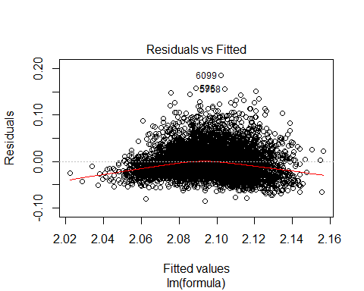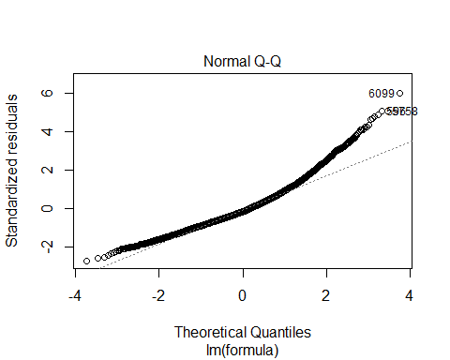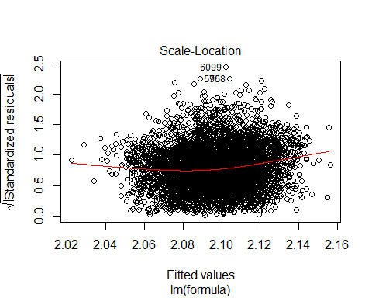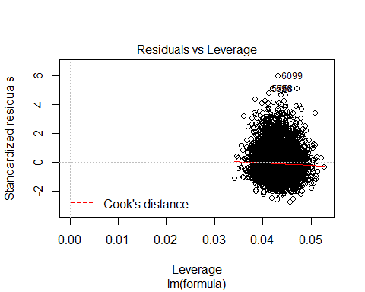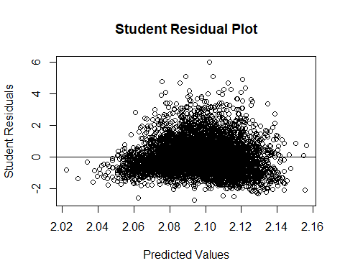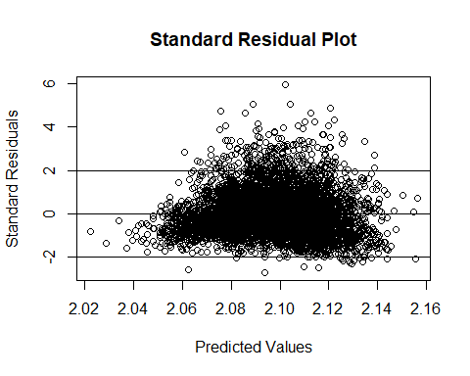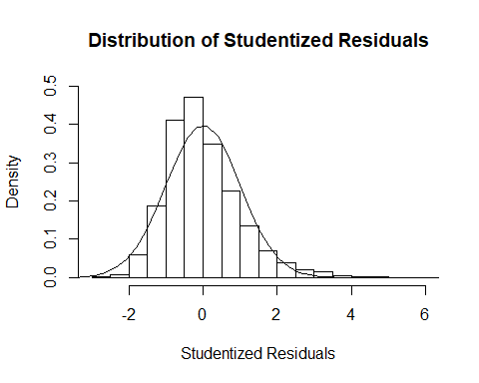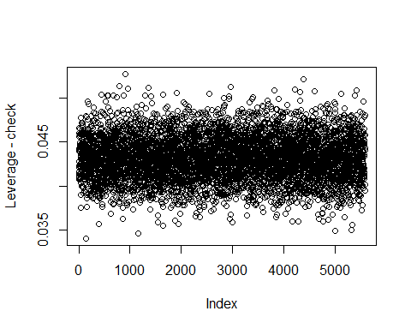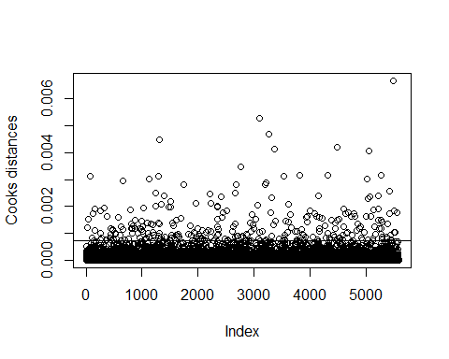

## [1] "Number of data points that have Cook's D > 4/n: 288"  
## [1] "Number of data points that have Cook's D > 1: 0"

## Checking with removal of high influence points

high.cd = names(cd.full[cd.full > 4/nrow(data.train)])  
data.train2 = data.train[!(rownames(data.train)) %in% high.cd,]  
model.full2 = lm(formula , data.train2)  
summary(model.full2)

##   
## Call:  
## lm(formula = formula, data = data.train2)  
##   
## Residuals:  
## Min 1Q Median 3Q Max   
## -0.060870 -0.017467 -0.002688 0.016261 0.069402   
##   
## Coefficients:  
## Estimate Std. Error t value Pr(>|t|)   
## (Intercept) 1.954e+00 7.878e-03 248.004 < 2e-16 ***  
## x1 3.351e-04 5.395e-04 0.621 0.534489   
## x2 5.191e-04 3.438e-04 1.510 0.131142   
## x3 1.219e-04 9.404e-05 1.296 0.194943   
## x4 -5.545e-05 7.468e-06 -7.425 1.32e-13 ***  
## x5 3.514e-04 2.418e-04 1.453 0.146202   
## x6 -1.968e-04 4.907e-04 -0.401 0.688348   
## x7 1.194e-02 5.247e-04 22.763 < 2e-16 ***  
## x8 4.658e-04 1.222e-04 3.813 0.000139 ***  
## x9 3.213e-03 2.706e-04 11.872 < 2e-16 ***  
## x10 1.490e-03 2.529e-04 5.890 4.10e-09 ***  
## x11 2.383e+05 6.103e+04 3.904 9.58e-05 ***  
## x12 -3.705e-05 1.540e-04 -0.241 0.809944   
## x13 1.285e-04 6.183e-05 2.078 0.037735 *   
## x14 7.891e-05 2.651e-04 0.298 0.765948   
## x15 1.756e-04 2.535e-04 0.693 0.488631   
## x16 9.656e-04 1.757e-04 5.494 4.12e-08 ***  
## x17 1.693e-03 2.693e-04 6.284 3.58e-10 ***  
## x19 1.097e-04 1.355e-04 0.810 0.418039   
## x20 -3.763e-04 9.417e-04 -0.400 0.689431   
## x21 9.082e-05 3.464e-05 2.622 0.008764 **   
## x22 -5.578e-04 2.826e-04 -1.974 0.048461 *   
## x23 2.617e-04 2.704e-04 0.968 0.333122   
## stat1 -2.108e-04 2.050e-04 -1.028 0.303955   
## stat2 2.522e-04 2.027e-04 1.244 0.213451   
## stat3 6.161e-04 2.038e-04 3.023 0.002515 **   
## stat4 -4.457e-04 2.050e-04 -2.174 0.029745 *   
## stat5 -2.282e-04 2.046e-04 -1.115 0.264760   
## stat6 -1.158e-04 2.054e-04 -0.564 0.572927   
## stat7 -1.651e-04 2.035e-04 -0.811 0.417316   
## stat8 1.556e-04 2.026e-04 0.768 0.442519   
## stat9 -2.311e-04 2.033e-04 -1.137 0.255693   
## stat10 -6.528e-05 2.032e-04 -0.321 0.747988   
## stat11 -4.435e-04 2.055e-04 -2.158 0.030960 *   
## stat12 1.182e-04 2.033e-04 0.581 0.561032   
## stat13 -2.305e-04 2.028e-04 -1.137 0.255710   
## stat14 -8.915e-04 2.022e-04 -4.409 1.06e-05 ***  
## stat15 -3.671e-04 2.018e-04 -1.820 0.068893 .   
## stat16 -2.433e-04 2.026e-04 -1.201 0.229873   
## stat17 -8.700e-05 2.028e-04 -0.429 0.667966   
## stat18 -3.610e-04 2.032e-04 -1.777 0.075637 .   
## stat19 -4.720e-06 2.043e-04 -0.023 0.981567   
## stat20 -6.393e-05 2.035e-04 -0.314 0.753469   
## stat21 -6.163e-05 2.041e-04 -0.302 0.762668   
## stat22 -3.664e-04 2.039e-04 -1.797 0.072371 .   
## stat23 6.256e-04 2.023e-04 3.093 0.001991 **   
## stat24 -4.906e-04 2.041e-04 -2.404 0.016265 *   
## stat25 -2.280e-04 2.026e-04 -1.125 0.260504   
## stat26 -5.778e-04 2.039e-04 -2.833 0.004625 **   
## stat27 1.076e-04 2.044e-04 0.526 0.598762   
## stat28 1.095e-04 2.032e-04 0.539 0.589939   
## stat29 2.152e-04 2.063e-04 1.043 0.296940   
## stat30 2.257e-04 2.048e-04 1.102 0.270619   
## stat31 3.792e-05 2.068e-04 0.183 0.854540   
## stat32 6.718e-05 2.064e-04 0.325 0.744829   
## stat33 -2.705e-04 2.033e-04 -1.331 0.183384   
## stat34 3.118e-04 2.034e-04 1.533 0.125328   
## stat35 -6.095e-04 2.038e-04 -2.991 0.002797 **   
## stat36 1.390e-05 2.033e-04 0.068 0.945505   
## stat37 -1.721e-04 2.044e-04 -0.842 0.399646   
## stat38 3.608e-04 2.039e-04 1.769 0.076974 .   
## stat39 -1.830e-04 2.023e-04 -0.905 0.365616   
## stat40 -1.692e-04 2.039e-04 -0.830 0.406571   
## stat41 -4.770e-04 2.022e-04 -2.359 0.018343 *   
## stat42 1.414e-04 2.030e-04 0.697 0.485977   
## stat43 -3.472e-04 2.045e-04 -1.698 0.089619 .   
## stat44 9.527e-05 2.035e-04 0.468 0.639711   
## stat45 -7.038e-05 2.041e-04 -0.345 0.730305   
## stat46 3.053e-04 2.033e-04 1.502 0.133282   
## stat47 3.471e-04 2.045e-04 1.698 0.089639 .   
## stat48 1.968e-04 2.025e-04 0.972 0.331116   
## stat49 1.579e-04 2.040e-04 0.774 0.438868   
## stat50 2.828e-04 2.030e-04 1.393 0.163708   
## stat51 3.708e-05 2.030e-04 0.183 0.855101   
## stat52 -7.863e-05 2.042e-04 -0.385 0.700225   
## stat53 -1.363e-04 2.057e-04 -0.662 0.507699   
## stat54 -5.238e-04 2.058e-04 -2.545 0.010948 *   
## stat55 -3.274e-05 2.018e-04 -0.162 0.871132   
## stat56 -4.960e-05 2.050e-04 -0.242 0.808833   
## stat57 3.851e-05 2.005e-04 0.192 0.847664   
## stat58 -1.468e-04 2.021e-04 -0.726 0.467814   
## stat59 3.771e-04 2.039e-04 1.849 0.064455 .   
## stat60 5.782e-04 2.035e-04 2.841 0.004517 **   
## stat61 -3.798e-04 2.045e-04 -1.857 0.063393 .   
## stat62 -2.049e-04 2.021e-04 -1.014 0.310766   
## stat63 4.930e-05 2.052e-04 0.240 0.810192   
## stat64 9.162e-05 2.022e-04 0.453 0.650549   
## stat65 -3.767e-04 2.047e-04 -1.840 0.065799 .   
## stat66 4.327e-05 2.068e-04 0.209 0.834239   
## stat67 1.079e-04 2.038e-04 0.530 0.596416   
## stat68 -6.347e-05 2.031e-04 -0.312 0.754695   
## stat69 1.845e-05 2.040e-04 0.090 0.927935   
## stat70 3.029e-04 2.034e-04 1.489 0.136507   
## stat71 1.156e-04 2.030e-04 0.569 0.569181   
## stat72 2.315e-04 2.052e-04 1.128 0.259293   
## stat73 3.267e-04 2.038e-04 1.603 0.108976   
## stat74 7.211e-05 2.053e-04 0.351 0.725414   
## stat75 -2.274e-06 2.053e-04 -0.011 0.991163   
## stat76 3.330e-05 2.045e-04 0.163 0.870661   
## stat77 1.525e-04 2.035e-04 0.750 0.453486   
## stat78 -3.040e-04 2.035e-04 -1.494 0.135304   
## stat79 1.837e-04 2.042e-04 0.900 0.368229   
## stat80 3.193e-04 2.048e-04 1.559 0.118978   
## stat81 1.001e-04 2.049e-04 0.488 0.625238   
## stat82 -3.229e-05 2.021e-04 -0.160 0.873088   
## stat83 -3.639e-04 2.024e-04 -1.798 0.072284 .   
## stat84 -4.553e-04 2.028e-04 -2.245 0.024792 *   
## stat85 -2.630e-04 2.045e-04 -1.286 0.198391   
## stat86 1.130e-04 2.036e-04 0.555 0.578760   
## stat87 -3.414e-04 2.040e-04 -1.674 0.094262 .   
## stat88 8.538e-05 2.010e-04 0.425 0.671008   
## stat89 6.952e-05 2.036e-04 0.341 0.732773   
## stat90 -1.520e-04 2.045e-04 -0.743 0.457423   
## stat91 -5.073e-04 2.009e-04 -2.525 0.011613 *   
## stat92 -4.627e-04 2.035e-04 -2.274 0.022995 *   
## stat93 7.652e-05 2.072e-04 0.369 0.711868   
## stat94 -1.157e-04 2.039e-04 -0.567 0.570526   
## stat95 3.480e-04 2.043e-04 1.703 0.088557 .   
## stat96 -1.976e-04 2.031e-04 -0.973 0.330503   
## stat97 7.720e-05 2.028e-04 0.381 0.703496   
## stat98 3.254e-03 2.010e-04 16.185 < 2e-16 ***  
## stat99 3.508e-04 2.038e-04 1.721 0.085267 .   
## stat100 8.042e-04 2.042e-04 3.939 8.28e-05 ***  
## stat101 -1.729e-04 2.031e-04 -0.851 0.394650   
## stat102 2.373e-04 2.049e-04 1.158 0.246917   
## stat103 -3.558e-04 2.061e-04 -1.727 0.084305 .   
## stat104 -8.630e-05 2.025e-04 -0.426 0.670055   
## stat105 2.007e-04 2.023e-04 0.992 0.321226   
## stat106 -2.980e-04 2.031e-04 -1.467 0.142463   
## stat107 3.102e-05 2.031e-04 0.153 0.878615   
## stat108 -4.926e-05 2.034e-04 -0.242 0.808629   
## stat109 -3.669e-04 2.038e-04 -1.800 0.071888 .   
## stat110 -3.230e-03 2.026e-04 -15.944 < 2e-16 ***  
## stat111 1.543e-04 2.033e-04 0.759 0.447806   
## stat112 1.981e-05 2.039e-04 0.097 0.922591   
## stat113 -3.829e-04 2.055e-04 -1.863 0.062456 .   
## stat114 3.107e-04 2.024e-04 1.535 0.124774   
## stat115 3.143e-04 2.026e-04 1.551 0.120880   
## stat116 1.903e-04 2.053e-04 0.927 0.354031   
## stat117 7.679e-06 2.029e-04 0.038 0.969818   
## stat118 1.764e-04 2.023e-04 0.872 0.383234   
## stat119 1.052e-04 2.035e-04 0.517 0.605146   
## stat120 -1.032e-06 2.025e-04 -0.005 0.995932   
## stat121 -1.107e-04 2.044e-04 -0.542 0.588111   
## stat122 -8.043e-05 2.036e-04 -0.395 0.692769   
## stat123 1.454e-04 2.045e-04 0.711 0.477159   
## stat124 -7.683e-05 2.045e-04 -0.376 0.707127   
## stat125 1.472e-04 2.047e-04 0.719 0.471940   
## stat126 2.431e-04 2.028e-04 1.199 0.230764   
## stat127 -7.663e-05 2.033e-04 -0.377 0.706229   
## stat128 -3.186e-04 2.032e-04 -1.568 0.117054   
## stat129 1.586e-04 2.035e-04 0.779 0.435892   
## stat130 1.326e-04 2.034e-04 0.652 0.514570   
## stat131 7.586e-05 2.035e-04 0.373 0.709265   
## stat132 1.165e-04 2.022e-04 0.577 0.564289   
## stat133 3.591e-04 2.049e-04 1.753 0.079702 .   
## stat134 -5.839e-05 2.030e-04 -0.288 0.773648   
## stat135 8.029e-05 2.025e-04 0.397 0.691713   
## stat136 -1.819e-04 2.049e-04 -0.888 0.374772   
## stat137 2.204e-04 2.028e-04 1.087 0.277057   
## stat138 3.902e-05 2.042e-04 0.191 0.848440   
## stat139 -5.906e-05 2.039e-04 -0.290 0.772127   
## stat140 9.419e-05 2.014e-04 0.468 0.640068   
## stat141 2.074e-04 2.024e-04 1.025 0.305641   
## stat142 -2.030e-04 2.069e-04 -0.982 0.326367   
## stat143 1.049e-04 2.037e-04 0.515 0.606494   
## stat144 3.221e-04 2.018e-04 1.596 0.110548   
## stat145 -1.471e-04 2.077e-04 -0.708 0.478811   
## stat146 -1.005e-03 2.050e-04 -4.904 9.70e-07 ***  
## stat147 -3.428e-04 2.054e-04 -1.669 0.095227 .   
## stat148 -2.745e-04 2.021e-04 -1.358 0.174389   
## stat149 -4.580e-04 2.058e-04 -2.225 0.026107 *   
## stat150 -3.597e-04 2.033e-04 -1.769 0.076893 .   
## stat151 2.750e-04 2.069e-04 1.330 0.183692   
## stat152 -3.380e-04 2.018e-04 -1.675 0.093968 .   
## stat153 -2.128e-05 2.072e-04 -0.103 0.918215   
## stat154 2.288e-04 2.064e-04 1.109 0.267617   
## stat155 8.722e-05 2.026e-04 0.430 0.666886   
## stat156 2.886e-04 2.052e-04 1.406 0.159668   
## stat157 3.044e-05 2.017e-04 0.151 0.880036   
## stat158 2.581e-04 2.059e-04 1.253 0.210163   
## stat159 7.434e-05 2.033e-04 0.366 0.714554   
## stat160 5.596e-05 2.049e-04 0.273 0.784777   
## stat161 3.675e-04 2.048e-04 1.794 0.072854 .   
## stat162 -2.233e-04 2.023e-04 -1.104 0.269850   
## stat163 -1.537e-04 2.080e-04 -0.739 0.459818   
## stat164 -2.893e-05 2.057e-04 -0.141 0.888138   
## stat165 3.654e-05 2.030e-04 0.180 0.857132   
## stat166 -3.094e-04 2.018e-04 -1.533 0.125284   
## stat167 -3.807e-04 2.052e-04 -1.856 0.063547 .   
## stat168 -7.037e-05 2.032e-04 -0.346 0.729145   
## stat169 -1.007e-04 2.045e-04 -0.492 0.622634   
## stat170 -2.979e-04 2.048e-04 -1.455 0.145787   
## stat171 -5.010e-05 2.058e-04 -0.243 0.807702   
## stat172 6.313e-04 2.014e-04 3.135 0.001727 **   
## stat173 1.145e-04 2.049e-04 0.559 0.576192   
## stat174 -6.104e-05 2.032e-04 -0.300 0.763935   
## stat175 -4.124e-04 2.036e-04 -2.026 0.042845 *   
## stat176 -1.102e-04 2.030e-04 -0.543 0.587298   
## stat177 -5.816e-04 2.052e-04 -2.835 0.004605 **   
## stat178 2.472e-04 2.065e-04 1.197 0.231315   
## stat179 2.608e-05 2.026e-04 0.129 0.897583   
## stat180 -1.980e-04 2.026e-04 -0.977 0.328529   
## stat181 2.819e-04 2.044e-04 1.379 0.167859   
## stat182 1.289e-04 2.056e-04 0.627 0.530769   
## stat183 7.272e-05 2.042e-04 0.356 0.721759   
## stat184 2.706e-04 2.061e-04 1.313 0.189154   
## stat185 6.933e-05 2.015e-04 0.344 0.730819   
## stat186 -5.340e-05 2.041e-04 -0.262 0.793582   
## stat187 -4.579e-04 2.022e-04 -2.264 0.023592 *   
## stat188 1.229e-04 2.029e-04 0.606 0.544706   
## stat189 -7.269e-05 2.035e-04 -0.357 0.720967   
## stat190 -4.556e-05 2.026e-04 -0.225 0.822089   
## stat191 -3.789e-04 2.043e-04 -1.855 0.063665 .   
## stat192 -3.713e-05 2.051e-04 -0.181 0.856364   
## stat193 1.327e-04 2.060e-04 0.644 0.519438   
## stat194 -2.934e-04 2.046e-04 -1.434 0.151610   
## stat195 1.837e-04 2.041e-04 0.900 0.368335   
## stat196 -1.577e-04 2.070e-04 -0.762 0.446356   
## stat197 -1.015e-05 2.023e-04 -0.050 0.959998   
## stat198 -1.852e-04 2.045e-04 -0.906 0.365067   
## stat199 1.484e-04 2.015e-04 0.737 0.461403   
## stat200 -5.995e-05 2.018e-04 -0.297 0.766381   
## stat201 2.279e-04 2.028e-04 1.124 0.261185   
## stat202 -2.315e-04 2.076e-04 -1.115 0.264811   
## stat203 2.476e-04 2.023e-04 1.224 0.221033   
## stat204 -5.413e-05 2.023e-04 -0.268 0.789032   
## stat205 1.367e-04 2.022e-04 0.676 0.498939   
## stat206 -6.829e-05 2.050e-04 -0.333 0.739094   
## stat207 4.417e-04 2.032e-04 2.174 0.029770 *   
## stat208 6.035e-05 2.044e-04 0.295 0.767876   
## stat209 1.741e-04 2.024e-04 0.861 0.389518   
## stat210 -1.589e-05 2.046e-04 -0.078 0.938108   
## stat211 -1.161e-04 2.031e-04 -0.572 0.567643   
## stat212 2.634e-04 2.039e-04 1.292 0.196462   
## stat213 4.145e-05 2.048e-04 0.202 0.839581   
## stat214 -2.645e-04 2.050e-04 -1.290 0.197012   
## stat215 -1.315e-04 2.047e-04 -0.642 0.520660   
## stat216 -1.753e-04 2.029e-04 -0.864 0.387829   
## stat217 2.582e-04 2.037e-04 1.268 0.205005   
## x18.sqrt 2.557e-02 7.759e-04 32.950 < 2e-16 ***  
## ---  
## Signif. codes: 0 '***' 0.001 '**' 0.01 '*' 0.05 '.' 0.1 ' ' 1  
##   
## Residual standard error: 0.02509 on 5055 degrees of freedom  
## Multiple R-squared: 0.3679, Adjusted R-squared: 0.3379   
## F-statistic: 12.26 on 240 and 5055 DF, p-value: < 2.2e-16

cd.full2 = plot.diagnostics(model.full2, data.train2)

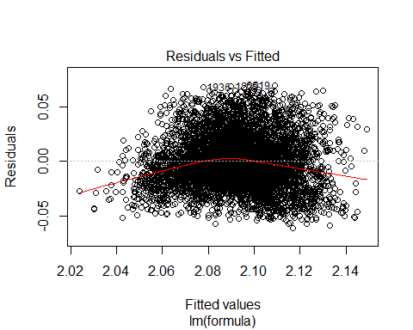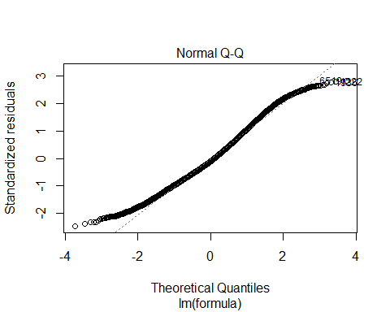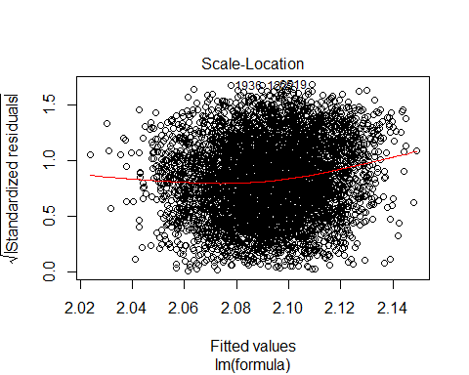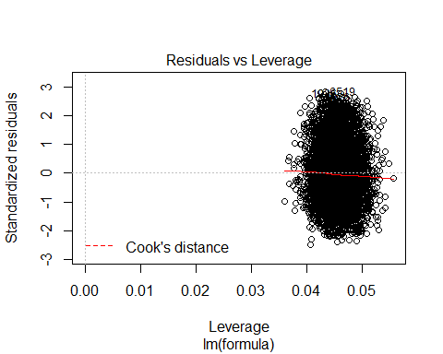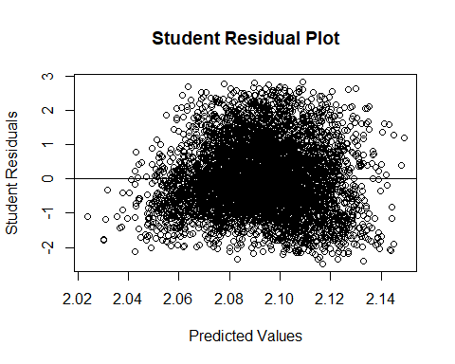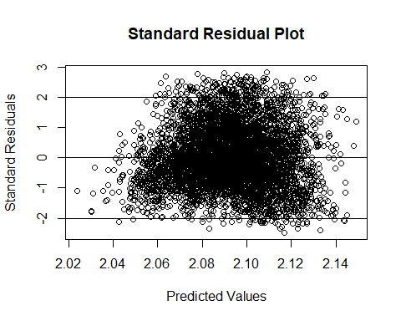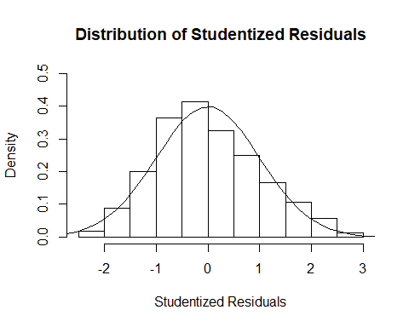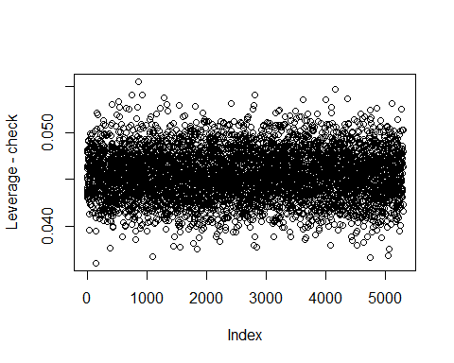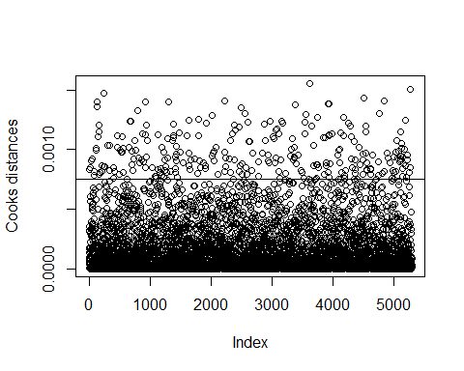

## [1] "Number of data points that have Cook's D > 4/n: 276"  
## [1] "Number of data points that have Cook's D > 1: 0"

# much more normal residuals than before.   
# Checking to see if distributions are different and if so whcih variables  
# High Leverage Plot   
plotData = data.train %>%   
 rownames_to_column() %>%  
 mutate(type=ifelse(rowname %in% high.cd,'High','Normal')) %>%  
 dplyr::select(type,target=one_of(label.names))  
  
ggplot(data=plotData, aes(x=type,y=target)) +  
 geom_boxplot(fill='light blue',outlier.shape=NA) +  
 scale_y_continuous(name="Target Variable Values",label=scales::comma_format(accuracy=.1)) +  
 theme_light() +  
 ggtitle('Distribution of High Leverage Points and Normal Points')

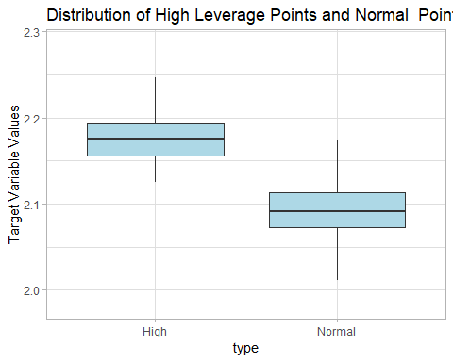

plotData = data.train %>%   
 rownames_to_column() %>%  
 mutate(type=ifelse(rowname %in% high.cd,'High','Normal')) %>%  
 dplyr::select(type,one_of(feature.names))

# 2 sample t-tests  
comp.test = lapply(dplyr::select(plotData, one_of(feature.names))  
 , function(x) t.test(x ~ plotData$type, var.equal = TRUE))   
  
sig.comp = list.filter(comp.test, p.value < 0.05)  
sapply(sig.comp, function(x) x[['p.value']])

## x6 x16 stat4 stat19 stat22 stat74 stat82 stat98 stat110   
## 3.617835e-02 7.268019e-03 2.301543e-02 4.845105e-02 3.109370e-02 3.019453e-02 4.466814e-02 8.225337e-06 3.539145e-03   
## stat148 stat170 stat186   
## 1.534548e-02 3.221414e-02 4.821211e-02

# Distribution (box) Plots  
mm = melt(plotData, id=c('type'))  
  
ggplot(mm) +  
 geom_boxplot(aes(x=type, y=value))+  
 facet_wrap(~variable, ncol=8, scales = 'free_y') +  
 scale_y_continuous(name="values",label=scales::comma_format(accuracy=.1)) +  
 ggtitle('Distribution of High Leverage Points and Normal Points')

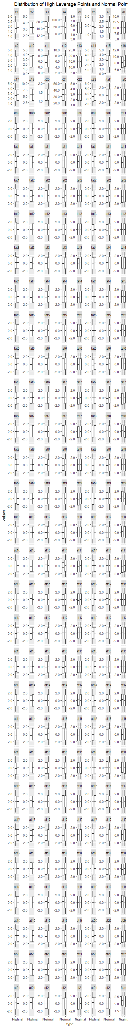

## Grand Means Model

model.null = lm(grand.mean.formula, data.train)  
summary(model.null)

##   
## Call:  
## lm(formula = grand.mean.formula, data = data.train)  
##   
## Residuals:  
## Min 1Q Median 3Q Max   
## -0.114806 -0.023539 -0.003265 0.020437 0.190506   
##   
## Coefficients:  
## Estimate Std. Error t value Pr(>|t|)   
## (Intercept) 2.0966824 0.0004822 4348 <2e-16 ***  
## ---  
## Signif. codes: 0 '***' 0.001 '**' 0.01 '*' 0.05 '.' 0.1 ' ' 1  
##   
## Residual standard error: 0.03603 on 5583 degrees of freedom

## Variable Selection

Basic: <http://www.stat.columbia.edu/~martin/W2024/R10.pdf> Cross Validation + Other Metrics: <http://www.sthda.com/english/articles/37-model-selection-essentials-in-r/154-stepwise-regression-essentials-in-r/>

### Forward Selection with CV

#### Train

if (algo.forward.caret == TRUE){  
 set.seed(1)  
 returned = train.caret.glmselect(formula = formula  
 , data = data.train  
 , method = "leapForward"  
 , feature.names = feature.names)  
 model.forward = returned$model  
 id = returned$id  
}

## Aggregating results  
## Selecting tuning parameters  
## Fitting nvmax = 13 on full training set  
## [1] "All models results"  
## nvmax RMSE Rsquared MAE RMSESD RsquaredSD MAESD  
## 1 1 0.03414881 0.1027550 0.02654757 0.0010798168 0.02349240 0.0007042780  
## 2 2 0.03359504 0.1310755 0.02603434 0.0010681470 0.02431833 0.0007421945  
## 3 3 0.03279504 0.1716686 0.02531976 0.0009569844 0.02286161 0.0006660866  
## 4 4 0.03233351 0.1951555 0.02468646 0.0010015007 0.02703506 0.0007095798  
## 5 5 0.03205496 0.2088695 0.02447848 0.0010179841 0.02788323 0.0007526537  
## 6 6 0.03196903 0.2131306 0.02442296 0.0009951198 0.03091577 0.0007391161  
## 7 7 0.03191516 0.2158179 0.02438911 0.0009956202 0.03069200 0.0007154645  
## 8 8 0.03194539 0.2143727 0.02443650 0.0009946309 0.03222593 0.0007014054  
## 9 9 0.03194592 0.2143643 0.02443077 0.0009857123 0.03123402 0.0006893554  
## 10 10 0.03192342 0.2153769 0.02442505 0.0009840607 0.03008024 0.0007109756  
## 11 11 0.03190953 0.2160726 0.02443209 0.0009421127 0.03082621 0.0006905570  
## 12 12 0.03188296 0.2173705 0.02443371 0.0009356507 0.02993336 0.0006840112  
## 13 13 0.03188210 0.2174660 0.02444101 0.0009198534 0.03042394 0.0006637881  
## 14 14 0.03188567 0.2173652 0.02446726 0.0009383699 0.03103247 0.0006627658  
## 15 15 0.03188913 0.2172793 0.02447629 0.0009784422 0.03133728 0.0006972096  
## 16 16 0.03189245 0.2170118 0.02447532 0.0009586049 0.02996533 0.0006775379  
## 17 17 0.03191404 0.2160358 0.02449296 0.0009590531 0.02973456 0.0006719114  
## 18 18 0.03191369 0.2160896 0.02449345 0.0009749610 0.02891058 0.0006802875  
## 19 19 0.03191769 0.2159257 0.02449943 0.0009631234 0.02885775 0.0006829230  
## 20 20 0.03194733 0.2145757 0.02451659 0.0009591188 0.02738278 0.0006870356  
## 21 21 0.03195884 0.2141053 0.02453210 0.0009904982 0.02795118 0.0006991464  
## 22 22 0.03196104 0.2141175 0.02454287 0.0010125517 0.02898772 0.0007277289  
## 23 23 0.03198083 0.2131602 0.02456461 0.0010111112 0.02835228 0.0007233984  
## 24 24 0.03198822 0.2128387 0.02455997 0.0010001384 0.02757795 0.0007152572  
## 25 25 0.03200615 0.2120979 0.02457008 0.0009980364 0.02797758 0.0007081863  
## 26 26 0.03202031 0.2115046 0.02458234 0.0009970637 0.02719857 0.0007188773  
## 27 27 0.03201655 0.2116533 0.02458807 0.0009622347 0.02624375 0.0007008177  
## 28 28 0.03203057 0.2110213 0.02458221 0.0009604162 0.02550791 0.0007034397  
## 29 29 0.03204781 0.2102069 0.02459842 0.0009492714 0.02516477 0.0006984490  
## 30 30 0.03205536 0.2099297 0.02461174 0.0009447780 0.02512065 0.0006982808  
## 31 31 0.03207641 0.2090305 0.02462392 0.0009399943 0.02556120 0.0006843906  
## 32 32 0.03208142 0.2088516 0.02462599 0.0009523780 0.02703682 0.0006939888  
## 33 33 0.03209514 0.2082283 0.02464556 0.0009405279 0.02726562 0.0006670934  
## 34 34 0.03210569 0.2077404 0.02466220 0.0009290630 0.02704018 0.0006425972  
## 35 35 0.03212477 0.2068848 0.02467892 0.0009104032 0.02618650 0.0006310228  
## 36 36 0.03213154 0.2066160 0.02468017 0.0009069112 0.02647154 0.0006408084  
## 37 37 0.03215875 0.2053820 0.02470083 0.0008823018 0.02630004 0.0006311520  
## 38 38 0.03216602 0.2050473 0.02470643 0.0008659991 0.02599782 0.0006339386  
## 39 39 0.03217149 0.2048300 0.02470245 0.0008751781 0.02645790 0.0006573848  
## 40 40 0.03217583 0.2046443 0.02471067 0.0008709221 0.02615764 0.0006618888  
## 41 41 0.03218759 0.2041743 0.02471547 0.0008687334 0.02698013 0.0006501258  
## 42 42 0.03219494 0.2039034 0.02471559 0.0008615622 0.02660931 0.0006569472  
## 43 43 0.03221195 0.2031515 0.02473126 0.0008463343 0.02635170 0.0006501858  
## 44 44 0.03221649 0.2029626 0.02472489 0.0008294505 0.02639835 0.0006301190  
## 45 45 0.03223325 0.2022190 0.02473698 0.0008447025 0.02605408 0.0006443702  
## 46 46 0.03225625 0.2012464 0.02474984 0.0008460810 0.02535023 0.0006430966  
## 47 47 0.03224941 0.2016514 0.02474173 0.0008391271 0.02642632 0.0006329180  
## 48 48 0.03225060 0.2015958 0.02473500 0.0008403269 0.02662857 0.0006222742  
## 49 49 0.03224937 0.2017003 0.02471620 0.0008414219 0.02644414 0.0006299260  
## 50 50 0.03225814 0.2013454 0.02472922 0.0008524793 0.02627534 0.0006430847  
## 51 51 0.03226676 0.2010309 0.02474232 0.0008635159 0.02730299 0.0006500618  
## 52 52 0.03225963 0.2013712 0.02473054 0.0008637089 0.02767919 0.0006515944  
## 53 53 0.03226854 0.2009015 0.02474889 0.0008485609 0.02754047 0.0006496180  
## 54 54 0.03227323 0.2006431 0.02475509 0.0008564120 0.02735800 0.0006519486  
## 55 55 0.03228848 0.2000575 0.02476794 0.0008630585 0.02738898 0.0006598744  
## 56 56 0.03229033 0.1999945 0.02477196 0.0008765279 0.02727435 0.0006761546  
## 57 57 0.03229525 0.1998200 0.02477006 0.0008704897 0.02670965 0.0006701747  
## 58 58 0.03230173 0.1995834 0.02477531 0.0008673015 0.02710450 0.0006537345  
## 59 59 0.03230437 0.1995467 0.02477912 0.0008637162 0.02722935 0.0006543679  
## 60 60 0.03231734 0.1990528 0.02478899 0.0008572302 0.02716314 0.0006572661  
## 61 61 0.03232752 0.1986555 0.02479951 0.0008476955 0.02698574 0.0006569570  
## 62 62 0.03232180 0.1989382 0.02479303 0.0008453474 0.02672762 0.0006516962  
## 63 63 0.03232127 0.1989716 0.02478603 0.0008478466 0.02673169 0.0006492822  
## 64 64 0.03233301 0.1984460 0.02479971 0.0008495956 0.02627513 0.0006421278  
## 65 65 0.03233874 0.1982097 0.02479504 0.0008529826 0.02639595 0.0006424029  
## 66 66 0.03233789 0.1983110 0.02480174 0.0008593861 0.02670679 0.0006554783  
## 67 67 0.03234026 0.1982331 0.02480541 0.0008584217 0.02654148 0.0006593353  
## 68 68 0.03234579 0.1980073 0.02481819 0.0008550667 0.02634658 0.0006588320  
## 69 69 0.03234036 0.1982502 0.02481159 0.0008679428 0.02595340 0.0006702720  
## 70 70 0.03234600 0.1980695 0.02481980 0.0008663886 0.02665946 0.0006630972  
## 71 71 0.03235834 0.1975469 0.02482528 0.0008787519 0.02704368 0.0006738506  
## 72 72 0.03235837 0.1974975 0.02481622 0.0008776918 0.02665625 0.0006715434  
## 73 73 0.03237126 0.1969866 0.02481961 0.0008783597 0.02637635 0.0006817255  
## 74 74 0.03238580 0.1963482 0.02483113 0.0008810619 0.02576929 0.0006854492  
## 75 75 0.03238830 0.1962622 0.02483136 0.0008843819 0.02647166 0.0006816249  
## 76 76 0.03238709 0.1963148 0.02483296 0.0008662766 0.02620555 0.0006811259  
## 77 77 0.03238942 0.1962470 0.02483017 0.0008564688 0.02576696 0.0006889661  
## 78 78 0.03239848 0.1958597 0.02484405 0.0008546231 0.02571072 0.0006901285  
## 79 79 0.03239689 0.1959629 0.02484024 0.0008498383 0.02583292 0.0006896678  
## 80 80 0.03240119 0.1958162 0.02484316 0.0008466039 0.02662035 0.0006902587  
## 81 81 0.03240888 0.1955138 0.02484904 0.0008590464 0.02689702 0.0007027540  
## 82 82 0.03241793 0.1951471 0.02485230 0.0008546199 0.02696278 0.0007042131  
## 83 83 0.03242944 0.1947117 0.02486062 0.0008575938 0.02706349 0.0007063287  
## 84 84 0.03243200 0.1946138 0.02486621 0.0008616758 0.02671087 0.0007042959  
## 85 85 0.03243475 0.1945632 0.02486682 0.0008643311 0.02679894 0.0007069335  
## 86 86 0.03243755 0.1944314 0.02486572 0.0008616705 0.02649558 0.0007078450  
## 87 87 0.03242550 0.1949669 0.02486015 0.0008622674 0.02651607 0.0007040337  
## 88 88 0.03242470 0.1949844 0.02486438 0.0008561799 0.02673893 0.0006985176  
## 89 89 0.03242584 0.1948918 0.02485921 0.0008619341 0.02653116 0.0007087101  
## 90 90 0.03242698 0.1948641 0.02485546 0.0008567832 0.02673024 0.0007026703  
## 91 91 0.03243244 0.1946763 0.02485607 0.0008720694 0.02709647 0.0007232802  
## 92 92 0.03243115 0.1947386 0.02485451 0.0008645847 0.02731722 0.0007180287  
## 93 93 0.03242329 0.1951170 0.02485000 0.0008740911 0.02742897 0.0007271653  
## 94 94 0.03241859 0.1953061 0.02484436 0.0008793197 0.02727273 0.0007259313  
## 95 95 0.03241698 0.1954354 0.02484099 0.0008729450 0.02776282 0.0007169521  
## 96 96 0.03241795 0.1953989 0.02484094 0.0008634581 0.02756746 0.0007135019  
## 97 97 0.03241503 0.1955760 0.02483167 0.0008549009 0.02748863 0.0007116870  
## 98 98 0.03241799 0.1954950 0.02482929 0.0008457246 0.02758087 0.0006936791  
## 99 99 0.03241491 0.1956427 0.02482557 0.0008524880 0.02788508 0.0006888557  
## 100 100 0.03242323 0.1953032 0.02482830 0.0008508116 0.02716364 0.0006880230  
## 101 101 0.03242402 0.1952722 0.02482741 0.0008451991 0.02657523 0.0006887690  
## 102 102 0.03241935 0.1954907 0.02482479 0.0008324730 0.02682807 0.0006832576  
## 103 103 0.03242069 0.1954474 0.02482955 0.0008279761 0.02676649 0.0006814740  
## 104 104 0.03242021 0.1954939 0.02483152 0.0008246473 0.02707945 0.0006772874  
## 105 105 0.03241849 0.1956098 0.02482383 0.0008341662 0.02762384 0.0006891651  
## 106 106 0.03242746 0.1952465 0.02483026 0.0008477402 0.02750440 0.0007013329  
## 107 107 0.03242950 0.1951977 0.02482858 0.0008355040 0.02732511 0.0007007133  
## 108 108 0.03242765 0.1953036 0.02482447 0.0008376818 0.02745328 0.0007033624  
## 109 109 0.03242896 0.1952639 0.02482174 0.0008386237 0.02732932 0.0007060464  
## 110 110 0.03243146 0.1951576 0.02482347 0.0008357029 0.02726785 0.0007075686  
## 111 111 0.03243480 0.1950379 0.02483045 0.0008453546 0.02711131 0.0007108817  
## 112 112 0.03244458 0.1946475 0.02483466 0.0008510499 0.02709385 0.0007143838  
## 113 113 0.03245663 0.1941213 0.02484330 0.0008475662 0.02695216 0.0007112082  
## 114 114 0.03245691 0.1941206 0.02483995 0.0008409248 0.02711520 0.0007054279  
## 115 115 0.03246123 0.1939154 0.02484324 0.0008348239 0.02693712 0.0006999518  
## 116 116 0.03246012 0.1939637 0.02484260 0.0008329459 0.02686775 0.0007030869  
## 117 117 0.03246376 0.1938251 0.02484607 0.0008302301 0.02694854 0.0006971868  
## 118 118 0.03246907 0.1935998 0.02485031 0.0008226592 0.02679056 0.0006892401  
## 119 119 0.03247516 0.1933140 0.02485654 0.0008181500 0.02684923 0.0006762904  
## 120 120 0.03247567 0.1933181 0.02485942 0.0008140301 0.02729497 0.0006725616  
## 121 121 0.03247712 0.1932676 0.02486105 0.0008108571 0.02728907 0.0006742467  
## 122 122 0.03248537 0.1928786 0.02487066 0.0008070176 0.02702577 0.0006702411  
## 123 123 0.03248741 0.1928055 0.02486469 0.0008055342 0.02681623 0.0006753575  
## 124 124 0.03248756 0.1928251 0.02486857 0.0008099560 0.02693697 0.0006778022  
## 125 125 0.03248952 0.1927764 0.02486885 0.0008145221 0.02697241 0.0006762870  
## 126 126 0.03248394 0.1930324 0.02486194 0.0008104191 0.02688869 0.0006801485  
## 127 127 0.03248358 0.1931107 0.02486280 0.0008113433 0.02742606 0.0006732054  
## 128 128 0.03248724 0.1929686 0.02486473 0.0008176007 0.02757205 0.0006750650  
## 129 129 0.03248462 0.1930600 0.02485937 0.0008091675 0.02726430 0.0006721300  
## 130 130 0.03248514 0.1930226 0.02485484 0.0008097507 0.02709634 0.0006765856  
## 131 131 0.03248272 0.1931723 0.02485776 0.0008077205 0.02692810 0.0006756360  
## 132 132 0.03248735 0.1929723 0.02486352 0.0007973901 0.02668163 0.0006690744  
## 133 133 0.03249206 0.1927540 0.02487287 0.0007934769 0.02657249 0.0006680917  
## 134 134 0.03249462 0.1926495 0.02487204 0.0007990489 0.02668902 0.0006712810  
## 135 135 0.03249334 0.1927049 0.02487248 0.0007967423 0.02642473 0.0006693377  
## 136 136 0.03249779 0.1925208 0.02487164 0.0007994138 0.02640570 0.0006651584  
## 137 137 0.03250571 0.1921959 0.02487841 0.0007982809 0.02647665 0.0006637113  
## 138 138 0.03250615 0.1921260 0.02487957 0.0007977181 0.02632775 0.0006591126  
## 139 139 0.03250983 0.1919793 0.02488379 0.0008000043 0.02645302 0.0006617521  
## 140 140 0.03251559 0.1917255 0.02488947 0.0008007841 0.02588183 0.0006620347  
## 141 141 0.03251531 0.1917512 0.02488988 0.0007987270 0.02571494 0.0006585237  
## 142 142 0.03250923 0.1920116 0.02488632 0.0008014545 0.02559967 0.0006628244  
## 143 143 0.03250261 0.1923169 0.02487949 0.0007990808 0.02537664 0.0006638944  
## 144 144 0.03250015 0.1924052 0.02487629 0.0007977984 0.02529120 0.0006642669  
## 145 145 0.03250120 0.1923720 0.02487965 0.0007963310 0.02522302 0.0006632720  
## 146 146 0.03249871 0.1924698 0.02487572 0.0007980537 0.02494526 0.0006707379  
## 147 147 0.03249802 0.1925013 0.02487596 0.0008014706 0.02490502 0.0006775540  
## 148 148 0.03249788 0.1925027 0.02487204 0.0007986110 0.02483450 0.0006745861  
## 149 149 0.03249723 0.1925538 0.02487243 0.0007930905 0.02482522 0.0006702332  
## 150 150 0.03249800 0.1925279 0.02486950 0.0007854246 0.02453335 0.0006626688  
## 151 151 0.03249893 0.1925065 0.02487148 0.0007850596 0.02460554 0.0006623461  
## 152 152 0.03250295 0.1923475 0.02487393 0.0007878131 0.02456646 0.0006639830  
## 153 153 0.03249844 0.1925394 0.02486710 0.0007894941 0.02466197 0.0006600935  
## 154 154 0.03249621 0.1926575 0.02486634 0.0007885307 0.02474579 0.0006563943  
## 155 155 0.03249578 0.1926986 0.02486574 0.0007892120 0.02484060 0.0006519725  
## 156 156 0.03250288 0.1924211 0.02487145 0.0007860493 0.02488043 0.0006465643  
## 157 157 0.03250597 0.1923073 0.02487485 0.0007912250 0.02488968 0.0006512248  
## 158 158 0.03250746 0.1922637 0.02487419 0.0007866057 0.02513580 0.0006479648  
## 159 159 0.03251092 0.1921136 0.02487468 0.0007858756 0.02518133 0.0006483968  
## 160 160 0.03251484 0.1919671 0.02487726 0.0007844404 0.02506290 0.0006475871  
## 161 161 0.03252198 0.1916814 0.02487939 0.0007778363 0.02504422 0.0006431711  
## 162 162 0.03251958 0.1917887 0.02487798 0.0007756917 0.02498151 0.0006413609  
## 163 163 0.03251891 0.1918508 0.02487915 0.0007743006 0.02515974 0.0006359589  
## 164 164 0.03251943 0.1918698 0.02487830 0.0007721849 0.02532282 0.0006333420  
## 165 165 0.03251659 0.1920205 0.02487138 0.0007723542 0.02546402 0.0006305701  
## 166 166 0.03251568 0.1920701 0.02486822 0.0007742459 0.02559439 0.0006323183  
## 167 167 0.03251474 0.1921249 0.02486845 0.0007749202 0.02578112 0.0006346494  
## 168 168 0.03251399 0.1921591 0.02486533 0.0007727150 0.02591897 0.0006334058  
## 169 169 0.03251938 0.1919229 0.02486852 0.0007742957 0.02566764 0.0006345817  
## 170 170 0.03252142 0.1918281 0.02487038 0.0007801722 0.02570672 0.0006374753  
## 171 171 0.03252701 0.1915851 0.02487300 0.0007763839 0.02574544 0.0006341801  
## 172 172 0.03253092 0.1914460 0.02487818 0.0007735758 0.02582034 0.0006327762  
## 173 173 0.03252926 0.1915117 0.02487624 0.0007758719 0.02580753 0.0006343663  
## 174 174 0.03252392 0.1917341 0.02487163 0.0007749510 0.02572003 0.0006358254  
## 175 175 0.03251993 0.1919261 0.02486823 0.0007787573 0.02578698 0.0006376184  
## 176 176 0.03252061 0.1919008 0.02486762 0.0007721469 0.02587190 0.0006319167  
## 177 177 0.03251970 0.1919411 0.02486745 0.0007717465 0.02594036 0.0006309486  
## 178 178 0.03251966 0.1919450 0.02486497 0.0007710990 0.02597602 0.0006299654  
## 179 179 0.03252075 0.1918919 0.02486669 0.0007672040 0.02575481 0.0006317541  
## 180 180 0.03251679 0.1920549 0.02486041 0.0007644304 0.02583563 0.0006265222  
## 181 181 0.03251327 0.1921986 0.02485758 0.0007648131 0.02584613 0.0006240049  
## 182 182 0.03251549 0.1921189 0.02485913 0.0007613617 0.02588307 0.0006244484  
## 183 183 0.03251684 0.1920686 0.02486061 0.0007660682 0.02590479 0.0006255825  
## 184 184 0.03251768 0.1920401 0.02486039 0.0007652844 0.02576482 0.0006242709  
## 185 185 0.03251551 0.1921428 0.02486278 0.0007679052 0.02588583 0.0006256028  
## 186 186 0.03251464 0.1922065 0.02486152 0.0007659281 0.02594356 0.0006249513  
## 187 187 0.03251491 0.1921886 0.02486212 0.0007633099 0.02590697 0.0006260972  
## 188 188 0.03251550 0.1921639 0.02486225 0.0007622307 0.02596802 0.0006229973  
## 189 189 0.03251386 0.1922329 0.02486221 0.0007627018 0.02595963 0.0006233958  
## 190 190 0.03251305 0.1922639 0.02486112 0.0007636044 0.02602909 0.0006259634  
## 191 191 0.03251227 0.1922987 0.02486045 0.0007622181 0.02587191 0.0006242780  
## 192 192 0.03251048 0.1923781 0.02485924 0.0007641903 0.02590013 0.0006247526  
## 193 193 0.03250986 0.1924015 0.02486135 0.0007682070 0.02598209 0.0006254412  
## 194 194 0.03251081 0.1923692 0.02486050 0.0007667004 0.02596377 0.0006243944  
## 195 195 0.03250942 0.1924316 0.02486013 0.0007634688 0.02601404 0.0006217108  
## 196 196 0.03250920 0.1924607 0.02486039 0.0007640832 0.02615248 0.0006218932  
## 197 197 0.03250819 0.1925000 0.02486230 0.0007669936 0.02617522 0.0006246992  
## 198 198 0.03250562 0.1926076 0.02486023 0.0007685041 0.02614698 0.0006284158  
## 199 199 0.03250570 0.1926040 0.02486155 0.0007698665 0.02619319 0.0006291169  
## 200 200 0.03250967 0.1924397 0.02486539 0.0007722124 0.02628250 0.0006325208  
## 201 201 0.03250890 0.1924849 0.02486248 0.0007741071 0.02627855 0.0006353010  
## 202 202 0.03250682 0.1925729 0.02486045 0.0007752388 0.02632925 0.0006353785  
## 203 203 0.03250613 0.1926020 0.02486094 0.0007733440 0.02628386 0.0006345733  
## 204 204 0.03250487 0.1926469 0.02485963 0.0007722271 0.02623395 0.0006351962  
## 205 205 0.03250411 0.1926587 0.02485817 0.0007731668 0.02616583 0.0006356856  
## 206 206 0.03250347 0.1926874 0.02485825 0.0007739672 0.02621051 0.0006346528  
## 207 207 0.03250307 0.1926898 0.02485801 0.0007737318 0.02611358 0.0006368424  
## 208 208 0.03250216 0.1927243 0.02485771 0.0007733763 0.02604733 0.0006366986  
## 209 209 0.03250419 0.1926345 0.02485831 0.0007736642 0.02613146 0.0006363167  
## 210 210 0.03250299 0.1926750 0.02485851 0.0007722131 0.02615926 0.0006355338  
## 211 211 0.03250329 0.1926578 0.02485831 0.0007725399 0.02612871 0.0006364304  
## 212 212 0.03250272 0.1926804 0.02485936 0.0007701096 0.02612700 0.0006349690  
## 213 213 0.03250240 0.1926903 0.02485970 0.0007703704 0.02606410 0.0006371193  
## 214 214 0.03250425 0.1926091 0.02486095 0.0007677840 0.02611638 0.0006331107  
## 215 215 0.03250418 0.1926036 0.02486047 0.0007684133 0.02603498 0.0006340586  
## 216 216 0.03250526 0.1925575 0.02486057 0.0007673683 0.02603162 0.0006334000  
## 217 217 0.03250533 0.1925477 0.02486108 0.0007685392 0.02596224 0.0006340540  
## 218 218 0.03250605 0.1925220 0.02486161 0.0007674299 0.02591501 0.0006330460  
## 219 219 0.03250491 0.1925682 0.02486081 0.0007684041 0.02586843 0.0006344536  
## 220 220 0.03250474 0.1925732 0.02486010 0.0007680536 0.02586593 0.0006344588  
## 221 221 0.03250557 0.1925376 0.02485954 0.0007680350 0.02589563 0.0006348057  
## 222 222 0.03250613 0.1925177 0.02485956 0.0007681388 0.02593368 0.0006352604  
## 223 223 0.03250655 0.1925076 0.02485983 0.0007691803 0.02592383 0.0006355052  
## 224 224 0.03250657 0.1925058 0.02486000 0.0007693423 0.02593855 0.0006352065  
## 225 225 0.03250616 0.1925245 0.02485935 0.0007692123 0.02598677 0.0006348766  
## 226 226 0.03250598 0.1925313 0.02485930 0.0007695132 0.02597942 0.0006354394  
## 227 227 0.03250554 0.1925444 0.02485925 0.0007693996 0.02596096 0.0006357276  
## 228 228 0.03250588 0.1925311 0.02485942 0.0007695066 0.02598213 0.0006361605  
## 229 229 0.03250513 0.1925643 0.02485935 0.0007699973 0.02600882 0.0006362488  
## 230 230 0.03250498 0.1925728 0.02485906 0.0007707046 0.02599107 0.0006367760  
## 231 231 0.03250444 0.1925955 0.02485861 0.0007708874 0.02598528 0.0006371458  
## 232 232 0.03250451 0.1925924 0.02485859 0.0007706370 0.02599322 0.0006366921  
## 233 233 0.03250464 0.1925888 0.02485891 0.0007704475 0.02599655 0.0006367696  
## 234 234 0.03250459 0.1925912 0.02485872 0.0007702601 0.02601755 0.0006367012  
## 235 235 0.03250488 0.1925782 0.02485919 0.0007700091 0.02600495 0.0006361535  
## 236 236 0.03250499 0.1925748 0.02485934 0.0007699652 0.02600973 0.0006362848  
## 237 237 0.03250500 0.1925742 0.02485941 0.0007697320 0.02601312 0.0006362493  
## 238 238 0.03250487 0.1925797 0.02485947 0.0007698748 0.02601705 0.0006361698  
## 239 239 0.03250490 0.1925783 0.02485953 0.0007699437 0.02601415 0.0006361804  
## 240 240 0.03250488 0.1925788 0.02485955 0.0007699308 0.02601434 0.0006361434  
## [1] "Best Model"  
## nvmax  
## 13 13

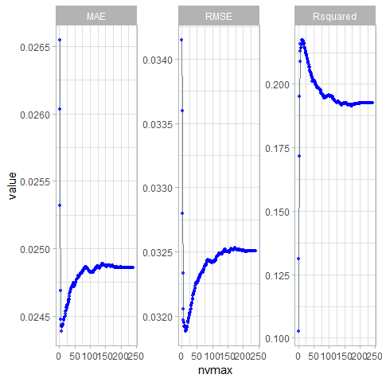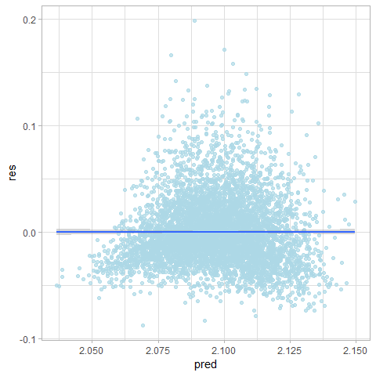

## `stat_bin()` using `bins = 30`. Pick better value with `binwidth`.

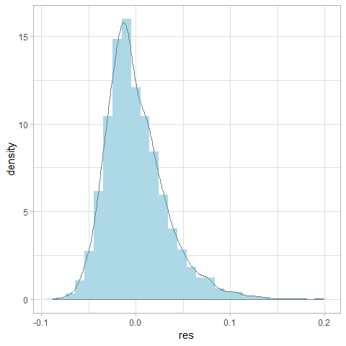

## [1] "Coefficients of final model:"  
## Estimate 2.5 % 97.5 %  
## (Intercept) 1.997264e+00 1.990119e+00 2.004409e+00  
## x4 -5.208812e-05 -6.967037e-05 -3.450587e-05  
## x7 1.087549e-02 9.638690e-03 1.211229e-02  
## x8 4.449295e-04 1.574138e-04 7.324453e-04  
## x9 3.273601e-03 2.632944e-03 3.914258e-03  
## x10 1.057845e-03 4.603127e-04 1.655378e-03  
## x16 8.335013e-04 4.194785e-04 1.247524e-03  
## x17 1.504412e-03 8.703803e-04 2.138443e-03  
## stat14 -7.961817e-04 -1.272531e-03 -3.198326e-04  
## stat92 -7.279772e-04 -1.210233e-03 -2.457216e-04  
## stat98 3.613590e-03 3.139791e-03 4.087389e-03  
## stat110 -3.175507e-03 -3.655198e-03 -2.695815e-03  
## stat146 -8.450001e-04 -1.328278e-03 -3.617223e-04  
## x18.sqrt 2.528483e-02 2.345068e-02 2.711899e-02

#### Test

if (algo.forward.caret == TRUE){  
 test.model(model.forward, data.test  
 ,method = 'leapForward',subopt = NULL  
 ,formula = formula, feature.names = feature.names, label.names = label.names  
 ,id = id  
 ,draw.limits = TRUE, transformation = t)  
}

## [1] "Summary of predicted values: "  
## Min. 1st Qu. Median Mean 3rd Qu. Max.   
## 2.042 2.085 2.096 2.096 2.108 2.151   
## [1] "leapForward Test MSE: 0.000961019233400988"

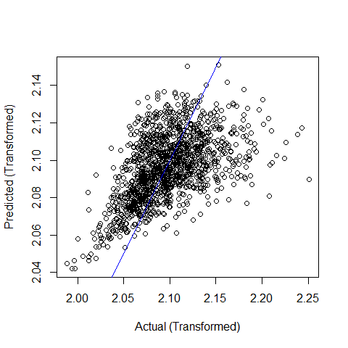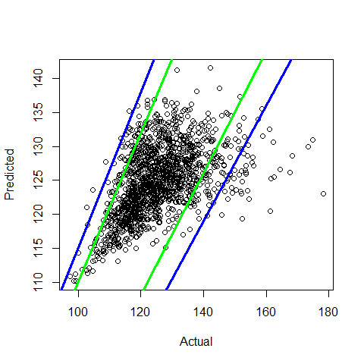

### Backward Elimination with CV

#### Train

if (algo.backward.caret == TRUE){  
 set.seed(1)  
 returned = train.caret.glmselect(formula = formula  
 ,data = data.train  
 ,method = "leapBackward"  
 ,feature.names = feature.names)  
 model.backward = returned$model  
 id = returned$id  
}

## Aggregating results  
## Selecting tuning parameters  
## Fitting nvmax = 13 on full training set  
## [1] "All models results"  
## nvmax RMSE Rsquared MAE RMSESD RsquaredSD MAESD  
## 1 1 0.03414881 0.1027550 0.02654757 0.0010798168 0.02349240 0.0007042780  
## 2 2 0.03359504 0.1310755 0.02603434 0.0010681470 0.02431833 0.0007421945  
## 3 3 0.03279504 0.1716686 0.02531976 0.0009569844 0.02286161 0.0006660866  
## 4 4 0.03233351 0.1951555 0.02468646 0.0010015007 0.02703506 0.0007095798  
## 5 5 0.03205496 0.2088695 0.02447848 0.0010179841 0.02788323 0.0007526537  
## 6 6 0.03196903 0.2131306 0.02442296 0.0009951198 0.03091577 0.0007391161  
## 7 7 0.03191516 0.2158179 0.02438911 0.0009956202 0.03069200 0.0007154645  
## 8 8 0.03194539 0.2143727 0.02443650 0.0009946309 0.03222593 0.0007014054  
## 9 9 0.03194592 0.2143643 0.02443077 0.0009857123 0.03123402 0.0006893554  
## 10 10 0.03192342 0.2153769 0.02442505 0.0009840607 0.03008024 0.0007109756  
## 11 11 0.03190953 0.2160726 0.02443209 0.0009421127 0.03082621 0.0006905570  
## 12 12 0.03188079 0.2174754 0.02443784 0.0009363662 0.02987360 0.0006802511  
## 13 13 0.03188006 0.2175659 0.02444490 0.0009207716 0.03038468 0.0006597596  
## 14 14 0.03188567 0.2173652 0.02446726 0.0009383699 0.03103247 0.0006627658  
## 15 15 0.03188913 0.2172793 0.02447629 0.0009784422 0.03133728 0.0006972096  
## 16 16 0.03189841 0.2167310 0.02448105 0.0009522240 0.02990266 0.0006721418  
## 17 17 0.03192337 0.2155979 0.02450260 0.0009574796 0.02945478 0.0006703027  
## 18 18 0.03192554 0.2155538 0.02450949 0.0009825926 0.02830090 0.0006906929  
## 19 19 0.03192648 0.2155314 0.02450533 0.0009698113 0.02822490 0.0006837955  
## 20 20 0.03195402 0.2142822 0.02452327 0.0009634674 0.02705081 0.0006915840  
## 21 21 0.03196247 0.2139297 0.02453676 0.0009929600 0.02777142 0.0007026277  
## 22 22 0.03196104 0.2141175 0.02454287 0.0010125517 0.02898772 0.0007277289  
## 23 23 0.03198083 0.2131602 0.02456461 0.0010111112 0.02835228 0.0007233984  
## 24 24 0.03198844 0.2128453 0.02456438 0.0009998517 0.02774046 0.0007086219  
## 25 25 0.03200760 0.2120168 0.02458038 0.0009954590 0.02725678 0.0006927357  
## 26 26 0.03201601 0.2116840 0.02458233 0.0009946317 0.02742589 0.0007046296  
## 27 27 0.03201740 0.2115891 0.02458265 0.0009642810 0.02655425 0.0006974065  
## 28 28 0.03203293 0.2109006 0.02458731 0.0009624854 0.02556070 0.0007081129  
## 29 29 0.03205018 0.2100855 0.02460790 0.0009528329 0.02564234 0.0007083927  
## 30 30 0.03207558 0.2090197 0.02463112 0.0009628981 0.02596583 0.0007192415  
## 31 31 0.03209216 0.2083357 0.02465069 0.0009493306 0.02599595 0.0006996950  
## 32 32 0.03211732 0.2072711 0.02467299 0.0009690829 0.02741028 0.0007182100  
## 33 33 0.03211193 0.2074854 0.02466629 0.0009434729 0.02739876 0.0006966202  
## 34 34 0.03212015 0.2071543 0.02466779 0.0009398549 0.02785203 0.0007004587  
## 35 35 0.03213861 0.2063346 0.02468628 0.0009272827 0.02719886 0.0006816038  
## 36 36 0.03213849 0.2062932 0.02467335 0.0009078735 0.02678749 0.0006770292  
## 37 37 0.03214908 0.2057944 0.02467638 0.0008767021 0.02611065 0.0006622498  
## 38 38 0.03214846 0.2058374 0.02467960 0.0008777663 0.02631436 0.0006685074  
## 39 39 0.03217098 0.2048116 0.02469108 0.0008689787 0.02602539 0.0006734985  
## 40 40 0.03216916 0.2048702 0.02468853 0.0008606700 0.02584703 0.0006655747  
## 41 41 0.03219107 0.2039177 0.02471038 0.0008515421 0.02589751 0.0006545974  
## 42 42 0.03220090 0.2034923 0.02470663 0.0008627856 0.02546425 0.0006659189  
## 43 43 0.03219487 0.2038250 0.02469471 0.0008626368 0.02609554 0.0006817556  
## 44 44 0.03220075 0.2036014 0.02470296 0.0008572816 0.02661694 0.0006566809  
## 45 45 0.03222047 0.2027466 0.02472370 0.0008553971 0.02598035 0.0006536078  
## 46 46 0.03222183 0.2027592 0.02471661 0.0008554652 0.02590697 0.0006540511  
## 47 47 0.03223170 0.2023516 0.02472168 0.0008437988 0.02624234 0.0006491358  
## 48 48 0.03223576 0.2022174 0.02472138 0.0008401402 0.02608676 0.0006451222  
## 49 49 0.03224792 0.2017249 0.02472047 0.0008247423 0.02631794 0.0006276026  
## 50 50 0.03223842 0.2021818 0.02471569 0.0008266245 0.02712457 0.0006291669  
## 51 51 0.03225941 0.2012541 0.02473341 0.0008324015 0.02683137 0.0006395567  
## 52 52 0.03226468 0.2010505 0.02474092 0.0008490241 0.02655133 0.0006642934  
## 53 53 0.03225816 0.2012769 0.02474839 0.0008475288 0.02625204 0.0006723997  
## 54 54 0.03226357 0.2010737 0.02475578 0.0008511992 0.02624537 0.0006737256  
## 55 55 0.03226451 0.2010108 0.02475695 0.0008451001 0.02561218 0.0006755513  
## 56 56 0.03227453 0.2005862 0.02475287 0.0008336882 0.02547271 0.0006665841  
## 57 57 0.03228556 0.2001912 0.02476376 0.0008332503 0.02609161 0.0006537386  
## 58 58 0.03228891 0.2000973 0.02476683 0.0008363622 0.02696949 0.0006440475  
## 59 59 0.03228885 0.2001846 0.02476654 0.0008385725 0.02704800 0.0006363226  
## 60 60 0.03229489 0.1999389 0.02477485 0.0008416183 0.02670140 0.0006320214  
## 61 61 0.03230945 0.1993403 0.02477908 0.0008440281 0.02619042 0.0006338385  
## 62 62 0.03231478 0.1991040 0.02479685 0.0008335195 0.02594304 0.0006348082  
## 63 63 0.03232070 0.1989595 0.02480272 0.0008217794 0.02648175 0.0006266772  
## 64 64 0.03233781 0.1982219 0.02481347 0.0008244766 0.02656673 0.0006376953  
## 65 65 0.03234451 0.1979836 0.02482140 0.0008350325 0.02648649 0.0006514027  
## 66 66 0.03233888 0.1982725 0.02481664 0.0008557267 0.02672384 0.0006613122  
## 67 67 0.03234944 0.1978476 0.02482503 0.0008497084 0.02680166 0.0006618424  
## 68 68 0.03234898 0.1978392 0.02482024 0.0008533531 0.02661599 0.0006572207  
## 69 69 0.03234702 0.1979329 0.02482200 0.0008619599 0.02651492 0.0006680283  
## 70 70 0.03235948 0.1974328 0.02482942 0.0008742740 0.02677836 0.0006718524  
## 71 71 0.03235548 0.1976334 0.02483149 0.0008850598 0.02688667 0.0006725622  
## 72 72 0.03235346 0.1977373 0.02482986 0.0008801907 0.02665973 0.0006744667  
## 73 73 0.03236111 0.1973996 0.02482879 0.0008721534 0.02637269 0.0006775168  
## 74 74 0.03237194 0.1969142 0.02483497 0.0008703407 0.02604344 0.0006811678  
## 75 75 0.03237609 0.1967667 0.02483181 0.0008627731 0.02570348 0.0006760279  
## 76 76 0.03238150 0.1965355 0.02483684 0.0008618537 0.02535817 0.0006887417  
## 77 77 0.03239023 0.1961756 0.02484389 0.0008509149 0.02528709 0.0006905279  
## 78 78 0.03239013 0.1962215 0.02484679 0.0008499307 0.02571238 0.0006888690  
## 79 79 0.03239706 0.1959590 0.02484430 0.0008406403 0.02667359 0.0006898050  
## 80 80 0.03239421 0.1961037 0.02484343 0.0008534499 0.02696154 0.0006904906  
## 81 81 0.03239738 0.1960148 0.02484005 0.0008497614 0.02733199 0.0006999905  
## 82 82 0.03240785 0.1956286 0.02484905 0.0008452383 0.02729959 0.0006942191  
## 83 83 0.03240862 0.1955717 0.02485517 0.0008401796 0.02675385 0.0006910577  
## 84 84 0.03240679 0.1956693 0.02485094 0.0008453777 0.02649426 0.0006952201  
## 85 85 0.03241538 0.1953215 0.02485118 0.0008448203 0.02644649 0.0006860279  
## 86 86 0.03240339 0.1958262 0.02484872 0.0008486454 0.02619470 0.0006876467  
## 87 87 0.03240172 0.1958934 0.02484452 0.0008327434 0.02621911 0.0006742519  
## 88 88 0.03239829 0.1960175 0.02483553 0.0008380100 0.02605933 0.0006852934  
## 89 89 0.03241069 0.1955092 0.02484398 0.0008340412 0.02627739 0.0006834963  
## 90 90 0.03241293 0.1954373 0.02484345 0.0008338828 0.02626573 0.0006813194  
## 91 91 0.03240642 0.1957722 0.02483391 0.0008462919 0.02654505 0.0006957317  
## 92 92 0.03240700 0.1957275 0.02483378 0.0008589727 0.02652828 0.0006996463  
## 93 93 0.03240733 0.1957360 0.02482915 0.0008568346 0.02690282 0.0007077630  
## 94 94 0.03240809 0.1957234 0.02483042 0.0008633703 0.02673946 0.0007075867  
## 95 95 0.03239863 0.1962040 0.02482732 0.0008558203 0.02693639 0.0006980886  
## 96 96 0.03240514 0.1959127 0.02483261 0.0008483356 0.02714169 0.0007009900  
## 97 97 0.03240921 0.1958200 0.02482737 0.0008443726 0.02705000 0.0007018530  
## 98 98 0.03241559 0.1955830 0.02483098 0.0008387246 0.02707241 0.0006938885  
## 99 99 0.03241811 0.1954875 0.02482921 0.0008301363 0.02718657 0.0006806936  
## 100 100 0.03241516 0.1956587 0.02482701 0.0008369901 0.02693661 0.0006925367  
## 101 101 0.03241263 0.1957807 0.02481718 0.0008308996 0.02654979 0.0006825198  
## 102 102 0.03241898 0.1955212 0.02482217 0.0008325507 0.02666661 0.0006818563  
## 103 103 0.03241989 0.1954839 0.02482162 0.0008325012 0.02697235 0.0006771221  
## 104 104 0.03242439 0.1953155 0.02482279 0.0008326217 0.02725245 0.0006763360  
## 105 105 0.03241868 0.1955907 0.02481219 0.0008318542 0.02754664 0.0006852265  
## 106 106 0.03242133 0.1955122 0.02481879 0.0008408402 0.02750077 0.0006922067  
## 107 107 0.03242863 0.1952370 0.02482754 0.0008345130 0.02728350 0.0007005667  
## 108 108 0.03242367 0.1954506 0.02482075 0.0008431268 0.02698484 0.0007069733  
## 109 109 0.03243505 0.1949750 0.02482899 0.0008447018 0.02690244 0.0007058655  
## 110 110 0.03243814 0.1948766 0.02482809 0.0008445302 0.02703882 0.0007079404  
## 111 111 0.03243821 0.1948895 0.02482979 0.0008475381 0.02715981 0.0007098088  
## 112 112 0.03244702 0.1945640 0.02482956 0.0008496169 0.02698878 0.0007096439  
## 113 113 0.03245928 0.1940201 0.02484078 0.0008433843 0.02690335 0.0007064723  
## 114 114 0.03245550 0.1941635 0.02484083 0.0008463251 0.02712245 0.0007090744  
## 115 115 0.03246092 0.1939177 0.02484322 0.0008406674 0.02694751 0.0007008118  
## 116 116 0.03246628 0.1937165 0.02484487 0.0008351989 0.02696065 0.0007005525  
## 117 117 0.03247513 0.1933523 0.02485174 0.0008355000 0.02712521 0.0006941451  
## 118 118 0.03248018 0.1931177 0.02485995 0.0008297839 0.02698128 0.0006890988  
## 119 119 0.03248172 0.1930377 0.02486105 0.0008185874 0.02692306 0.0006748432  
## 120 120 0.03247256 0.1934593 0.02485500 0.0008171335 0.02695910 0.0006820326  
## 121 121 0.03247688 0.1932740 0.02486189 0.0008170284 0.02712951 0.0006877162  
## 122 122 0.03247753 0.1932207 0.02486320 0.0008117353 0.02676509 0.0006814670  
## 123 123 0.03247983 0.1931578 0.02486049 0.0008073608 0.02681376 0.0006757088  
## 124 124 0.03247762 0.1932839 0.02485646 0.0008093691 0.02709226 0.0006742419  
## 125 125 0.03247602 0.1933752 0.02485092 0.0008129440 0.02727293 0.0006721159  
## 126 126 0.03247647 0.1933472 0.02485294 0.0008095314 0.02717693 0.0006719290  
## 127 127 0.03248411 0.1930522 0.02486202 0.0008109485 0.02729298 0.0006749516  
## 128 128 0.03249350 0.1926623 0.02486557 0.0008132678 0.02706016 0.0006737989  
## 129 129 0.03248775 0.1929214 0.02485891 0.0008091545 0.02722886 0.0006713929  
## 130 130 0.03249273 0.1927021 0.02486123 0.0008094443 0.02714289 0.0006735333  
## 131 131 0.03249316 0.1926824 0.02486356 0.0008094284 0.02693771 0.0006756181  
## 132 132 0.03249361 0.1926794 0.02486801 0.0007985012 0.02672965 0.0006663499  
## 133 133 0.03249762 0.1925020 0.02487038 0.0008008728 0.02668559 0.0006686015  
## 134 134 0.03250124 0.1923908 0.02487319 0.0007992233 0.02695184 0.0006619786  
## 135 135 0.03249958 0.1924264 0.02487515 0.0007946603 0.02663900 0.0006604963  
## 136 136 0.03250474 0.1922119 0.02487582 0.0007994021 0.02654606 0.0006616851  
## 137 137 0.03250908 0.1920262 0.02487902 0.0007980129 0.02640876 0.0006621703  
## 138 138 0.03250975 0.1919407 0.02488302 0.0007917030 0.02593957 0.0006535623  
## 139 139 0.03251280 0.1918131 0.02488705 0.0007896956 0.02574983 0.0006571616  
## 140 140 0.03251447 0.1917637 0.02488923 0.0007972883 0.02559223 0.0006589781  
## 141 141 0.03251229 0.1918580 0.02488937 0.0007948546 0.02562278 0.0006519011  
## 142 142 0.03250951 0.1920113 0.02488789 0.0007906306 0.02560269 0.0006547524  
## 143 143 0.03250846 0.1920672 0.02488488 0.0007965576 0.02547703 0.0006606681  
## 144 144 0.03250977 0.1920016 0.02488325 0.0007931618 0.02545809 0.0006593741  
## 145 145 0.03250789 0.1921006 0.02488287 0.0007920552 0.02534475 0.0006609042  
## 146 146 0.03250933 0.1920474 0.02488185 0.0007916346 0.02514712 0.0006658456  
## 147 147 0.03250863 0.1920782 0.02488200 0.0007949455 0.02510034 0.0006726226  
## 148 148 0.03250588 0.1922020 0.02487541 0.0007945833 0.02494672 0.0006722387  
## 149 149 0.03250317 0.1923304 0.02487377 0.0007929249 0.02479562 0.0006702678  
## 150 150 0.03250152 0.1924005 0.02487193 0.0007879370 0.02438647 0.0006650946  
## 151 151 0.03250572 0.1922311 0.02487719 0.0007864646 0.02454340 0.0006628504  
## 152 152 0.03250792 0.1921250 0.02487834 0.0007860104 0.02464111 0.0006625728  
## 153 153 0.03250013 0.1924629 0.02486944 0.0007878971 0.02468701 0.0006603712  
## 154 154 0.03249714 0.1926199 0.02486657 0.0007877382 0.02495515 0.0006573281  
## 155 155 0.03249457 0.1927371 0.02486476 0.0007852062 0.02486941 0.0006515030  
## 156 156 0.03250148 0.1924744 0.02486939 0.0007848403 0.02497445 0.0006465889  
## 157 157 0.03250343 0.1924193 0.02487193 0.0007864806 0.02505476 0.0006458354  
## 158 158 0.03250444 0.1923907 0.02487017 0.0007852731 0.02519639 0.0006462965  
## 159 159 0.03250582 0.1923249 0.02487213 0.0007840818 0.02528106 0.0006479877  
## 160 160 0.03250734 0.1922829 0.02487493 0.0007811911 0.02524330 0.0006471719  
## 161 161 0.03251587 0.1919375 0.02487839 0.0007742655 0.02519292 0.0006425238  
## 162 162 0.03251483 0.1919807 0.02487535 0.0007728941 0.02512115 0.0006394360  
## 163 163 0.03251908 0.1918303 0.02487810 0.0007741137 0.02514252 0.0006351946  
## 164 164 0.03251766 0.1919360 0.02487422 0.0007709169 0.02532191 0.0006311111  
## 165 165 0.03251658 0.1920098 0.02487258 0.0007739646 0.02551856 0.0006316233  
## 166 166 0.03251788 0.1919688 0.02486963 0.0007779418 0.02565358 0.0006334526  
## 167 167 0.03251785 0.1919892 0.02486987 0.0007801639 0.02586060 0.0006358029  
## 168 168 0.03251956 0.1919272 0.02486866 0.0007821172 0.02605479 0.0006361538  
## 169 169 0.03252404 0.1917310 0.02487185 0.0007782668 0.02577565 0.0006351344  
## 170 170 0.03252415 0.1917153 0.02487387 0.0007803792 0.02575834 0.0006382013  
## 171 171 0.03252913 0.1915107 0.02487574 0.0007759653 0.02574344 0.0006341506  
## 172 172 0.03252983 0.1914885 0.02487758 0.0007732503 0.02585007 0.0006321084  
## 173 173 0.03252839 0.1915477 0.02487788 0.0007765611 0.02579978 0.0006337152  
## 174 174 0.03252753 0.1915951 0.02487307 0.0007739159 0.02579767 0.0006322010  
## 175 175 0.03252265 0.1917998 0.02486917 0.0007769690 0.02591857 0.0006378854  
## 176 176 0.03252268 0.1918048 0.02486866 0.0007717427 0.02598374 0.0006334204  
## 177 177 0.03252185 0.1918456 0.02486878 0.0007703154 0.02607332 0.0006299812  
## 178 178 0.03252217 0.1918292 0.02486550 0.0007700882 0.02607839 0.0006295943  
## 179 179 0.03252540 0.1916878 0.02486859 0.0007687075 0.02592246 0.0006309346  
## 180 180 0.03252051 0.1919055 0.02486299 0.0007696914 0.02589114 0.0006284150  
## 181 181 0.03251906 0.1919646 0.02486256 0.0007716557 0.02587056 0.0006276722  
## 182 182 0.03252246 0.1918337 0.02486441 0.0007684802 0.02581168 0.0006282562  
## 183 183 0.03251782 0.1920291 0.02486090 0.0007667454 0.02585402 0.0006258221  
## 184 184 0.03251599 0.1921201 0.02485902 0.0007688835 0.02593209 0.0006268185  
## 185 185 0.03251622 0.1921150 0.02486317 0.0007698775 0.02586934 0.0006276930  
## 186 186 0.03251540 0.1921771 0.02486177 0.0007682640 0.02593963 0.0006281030  
## 187 187 0.03251309 0.1922692 0.02485997 0.0007637698 0.02595222 0.0006275983  
## 188 188 0.03251588 0.1921537 0.02486137 0.0007628246 0.02598507 0.0006233935  
## 189 189 0.03251477 0.1922032 0.02486196 0.0007616801 0.02601357 0.0006214637  
## 190 190 0.03251175 0.1923301 0.02486037 0.0007615766 0.02597523 0.0006209568  
## 191 191 0.03251002 0.1924120 0.02485894 0.0007638195 0.02597591 0.0006216483  
## 192 192 0.03251031 0.1923975 0.02486060 0.0007650612 0.02596066 0.0006211325  
## 193 193 0.03251031 0.1923842 0.02486291 0.0007653471 0.02591068 0.0006196112  
## 194 194 0.03251094 0.1923730 0.02486205 0.0007640398 0.02599908 0.0006174227  
## 195 195 0.03251126 0.1923629 0.02486184 0.0007620174 0.02608309 0.0006193487  
## 196 196 0.03250887 0.1924714 0.02486017 0.0007638774 0.02615145 0.0006216279  
## 197 197 0.03250821 0.1924939 0.02486122 0.0007665398 0.02614856 0.0006250864  
## 198 198 0.03250723 0.1925338 0.02486063 0.0007673790 0.02605998 0.0006290106  
## 199 199 0.03250577 0.1926008 0.02486060 0.0007704070 0.02614098 0.0006318207  
## 200 200 0.03250802 0.1925146 0.02486278 0.0007730501 0.02624403 0.0006350443  
## 201 201 0.03250889 0.1924746 0.02486245 0.0007723240 0.02613672 0.0006348313  
## 202 202 0.03250800 0.1925148 0.02486159 0.0007729337 0.02620909 0.0006336365  
## 203 203 0.03250617 0.1925975 0.02486178 0.0007732587 0.02627464 0.0006332922  
## 204 204 0.03250487 0.1926469 0.02485963 0.0007722271 0.02623395 0.0006351962  
## 205 205 0.03250443 0.1926459 0.02485926 0.0007722667 0.02621346 0.0006351602  
## 206 206 0.03250377 0.1926752 0.02485929 0.0007730608 0.02625882 0.0006341426  
## 207 207 0.03250337 0.1926838 0.02485940 0.0007725450 0.02617282 0.0006362426  
## 208 208 0.03250277 0.1927035 0.02485842 0.0007724127 0.02608708 0.0006354128  
## 209 209 0.03250526 0.1925963 0.02486027 0.0007730022 0.02614906 0.0006360653  
## 210 210 0.03250503 0.1925924 0.02486126 0.0007736043 0.02605366 0.0006379173  
## 211 211 0.03250432 0.1926168 0.02486049 0.0007732416 0.02607637 0.0006383240  
## 212 212 0.03250345 0.1926529 0.02486069 0.0007714159 0.02610334 0.0006366911  
## 213 213 0.03250252 0.1926848 0.02486025 0.0007701312 0.02605286 0.0006363049  
## 214 214 0.03250425 0.1926091 0.02486095 0.0007677840 0.02611638 0.0006331107  
## 215 215 0.03250393 0.1926145 0.02486045 0.0007680003 0.02602895 0.0006340435  
## 216 216 0.03250500 0.1925690 0.02486055 0.0007669299 0.02602535 0.0006333868  
## 217 217 0.03250533 0.1925477 0.02486108 0.0007685392 0.02596224 0.0006340540  
## 218 218 0.03250605 0.1925220 0.02486161 0.0007674299 0.02591501 0.0006330460  
## 219 219 0.03250491 0.1925682 0.02486081 0.0007684041 0.02586843 0.0006344536  
## 220 220 0.03250474 0.1925732 0.02486010 0.0007680536 0.02586593 0.0006344588  
## 221 221 0.03250557 0.1925376 0.02485954 0.0007680350 0.02589563 0.0006348057  
## 222 222 0.03250613 0.1925177 0.02485956 0.0007681388 0.02593368 0.0006352604  
## 223 223 0.03250655 0.1925076 0.02485983 0.0007691803 0.02592383 0.0006355052  
## 224 224 0.03250656 0.1925049 0.02486015 0.0007693497 0.02593902 0.0006350983  
## 225 225 0.03250615 0.1925237 0.02485950 0.0007692192 0.02598727 0.0006347665  
## 226 226 0.03250598 0.1925313 0.02485930 0.0007695132 0.02597942 0.0006354394  
## 227 227 0.03250554 0.1925444 0.02485925 0.0007693996 0.02596096 0.0006357276  
## 228 228 0.03250588 0.1925311 0.02485942 0.0007695066 0.02598213 0.0006361605  
## 229 229 0.03250513 0.1925643 0.02485935 0.0007699973 0.02600882 0.0006362488  
## 230 230 0.03250498 0.1925728 0.02485906 0.0007707046 0.02599107 0.0006367760  
## 231 231 0.03250444 0.1925955 0.02485861 0.0007708874 0.02598528 0.0006371458  
## 232 232 0.03250451 0.1925924 0.02485859 0.0007706370 0.02599322 0.0006366921  
## 233 233 0.03250464 0.1925888 0.02485891 0.0007704475 0.02599655 0.0006367696  
## 234 234 0.03250459 0.1925912 0.02485872 0.0007702601 0.02601755 0.0006367012  
## 235 235 0.03250488 0.1925782 0.02485919 0.0007700091 0.02600495 0.0006361535  
## 236 236 0.03250499 0.1925748 0.02485934 0.0007699652 0.02600973 0.0006362848  
## 237 237 0.03250500 0.1925742 0.02485941 0.0007697320 0.02601312 0.0006362493  
## 238 238 0.03250487 0.1925797 0.02485947 0.0007698748 0.02601705 0.0006361698  
## 239 239 0.03250490 0.1925783 0.02485953 0.0007699437 0.02601415 0.0006361804  
## 240 240 0.03250488 0.1925788 0.02485955 0.0007699308 0.02601434 0.0006361434  
## [1] "Best Model"  
## nvmax  
## 13 13

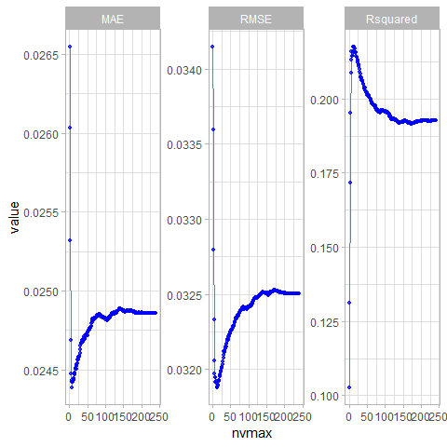

## `stat_bin()` using `bins = 30`. Pick better value with `binwidth`.



## [1] "Coefficients of final model:"  
## Estimate 2.5 % 97.5 %  
## (Intercept) 1.997264e+00 1.990119e+00 2.004409e+00  
## x4 -5.208812e-05 -6.967037e-05 -3.450587e-05  
## x7 1.087549e-02 9.638690e-03 1.211229e-02  
## x8 4.449295e-04 1.574138e-04 7.324453e-04  
## x9 3.273601e-03 2.632944e-03 3.914258e-03  
## x10 1.057845e-03 4.603127e-04 1.655378e-03  
## x16 8.335013e-04 4.194785e-04 1.247524e-03  
## x17 1.504412e-03 8.703803e-04 2.138443e-03  
## stat14 -7.961817e-04 -1.272531e-03 -3.198326e-04  
## stat92 -7.279772e-04 -1.210233e-03 -2.457216e-04  
## stat98 3.613590e-03 3.139791e-03 4.087389e-03  
## stat110 -3.175507e-03 -3.655198e-03 -2.695815e-03  
## stat146 -8.450001e-04 -1.328278e-03 -3.617223e-04  
## x18.sqrt 2.528483e-02 2.345068e-02 2.711899e-02

#### Test

if (algo.backward.caret == TRUE){  
 test.model(model.backward, data.test  
 ,method = 'leapBackward',subopt = NULL  
 ,formula = formula, feature.names = feature.names, label.names = label.names  
 ,id = id  
 ,draw.limits = TRUE, transformation = t)  
}

## [1] "Summary of predicted values: "  
## Min. 1st Qu. Median Mean 3rd Qu. Max.   
## 2.042 2.085 2.096 2.096 2.108 2.151   
## [1] "leapBackward Test MSE: 0.000961019233400987"



### Stepwise Selection with CV

#### Train

if (algo.stepwise.caret == TRUE){  
 set.seed(1)  
 returned = train.caret.glmselect(formula = formula  
 ,data = data.train  
 ,method = "leapSeq"  
 ,feature.names = feature.names)  
 model.stepwise = returned$model  
 id = returned$id  
}

## Aggregating results  
## Selecting tuning parameters  
## Fitting nvmax = 13 on full training set  
## [1] "All models results"  
## nvmax RMSE Rsquared MAE RMSESD RsquaredSD MAESD  
## 1 1 0.03414881 0.1027550 0.02654757 0.0010798168 0.02349240 0.0007042780  
## 2 2 0.03359504 0.1310755 0.02603434 0.0010681470 0.02431833 0.0007421945  
## 3 3 0.03279504 0.1716686 0.02531976 0.0009569844 0.02286161 0.0006660866  
## 4 4 0.03233351 0.1951555 0.02468646 0.0010015007 0.02703506 0.0007095798  
## 5 5 0.03205496 0.2088695 0.02447848 0.0010179841 0.02788323 0.0007526537  
## 6 6 0.03196903 0.2131306 0.02442296 0.0009951198 0.03091577 0.0007391161  
## 7 7 0.03191516 0.2158179 0.02438911 0.0009956202 0.03069200 0.0007154645  
## 8 8 0.03194539 0.2143727 0.02443650 0.0009946309 0.03222593 0.0007014054  
## 9 9 0.03194592 0.2143643 0.02443077 0.0009857123 0.03123402 0.0006893554  
## 10 10 0.03192342 0.2153769 0.02442505 0.0009840607 0.03008024 0.0007109756  
## 11 11 0.03190953 0.2160726 0.02443209 0.0009421127 0.03082621 0.0006905570  
## 12 12 0.03188296 0.2173705 0.02443371 0.0009356507 0.02993336 0.0006840112  
## 13 13 0.03188006 0.2175659 0.02444490 0.0009207716 0.03038468 0.0006597596  
## 14 14 0.03188567 0.2173652 0.02446726 0.0009383699 0.03103247 0.0006627658  
## 15 15 0.03188913 0.2172793 0.02447629 0.0009784422 0.03133728 0.0006972096  
## 16 16 0.03189245 0.2170118 0.02447532 0.0009586049 0.02996533 0.0006775379  
## 17 17 0.03191842 0.2158125 0.02449766 0.0009544890 0.02969253 0.0006673927  
## 18 18 0.03222302 0.1996968 0.02477711 0.0011407927 0.05799120 0.0009466685  
## 19 19 0.03191299 0.2161524 0.02449328 0.0009614384 0.02891945 0.0006765251  
## 20 20 0.03195402 0.2142822 0.02452327 0.0009634674 0.02705081 0.0006915840  
## 21 21 0.03259706 0.1820930 0.02498313 0.0018539665 0.06424172 0.0013890144  
## 22 22 0.03229106 0.1976983 0.02477166 0.0015996783 0.05098908 0.0011369396  
## 23 23 0.03198083 0.2131602 0.02456461 0.0010111112 0.02835228 0.0007233984  
## 24 24 0.03198822 0.2128387 0.02455997 0.0010001384 0.02757795 0.0007152572  
## 25 25 0.03198881 0.2128741 0.02455796 0.0009896604 0.02745886 0.0007046598  
## 26 26 0.03227674 0.1974424 0.02481079 0.0009129331 0.06286344 0.0007414868  
## 27 27 0.03240500 0.1916525 0.02486098 0.0011181224 0.04820965 0.0008559460  
## 28 28 0.03266113 0.1793631 0.02504432 0.0018936596 0.06623328 0.0013963279  
## 29 29 0.03204781 0.2102069 0.02459842 0.0009492714 0.02516477 0.0006984490  
## 30 30 0.03205536 0.2099297 0.02461174 0.0009447780 0.02512065 0.0006982808  
## 31 31 0.03207641 0.2090305 0.02462392 0.0009399943 0.02556120 0.0006843906  
## 32 32 0.03208564 0.2086636 0.02462795 0.0009546582 0.02678734 0.0006952913  
## 33 33 0.03244480 0.1909297 0.02489041 0.0015227096 0.04757648 0.0010883359  
## 34 34 0.03268522 0.1775255 0.02514163 0.0014360387 0.06823276 0.0011837824  
## 35 35 0.03241311 0.1922068 0.02489315 0.0014766804 0.05711194 0.0010743432  
## 36 36 0.03242924 0.1915532 0.02488151 0.0013522896 0.05074578 0.0010358794  
## 37 37 0.03248008 0.1889510 0.02494446 0.0014822107 0.06049508 0.0011562542  
## 38 38 0.03216602 0.2050473 0.02470643 0.0008659991 0.02599782 0.0006339386  
## 39 39 0.03216826 0.2049904 0.02470059 0.0008763063 0.02635842 0.0006592556  
## 40 40 0.03217782 0.2045471 0.02470921 0.0008701983 0.02621651 0.0006633883  
## 41 41 0.03219878 0.2036680 0.02472640 0.0008669646 0.02681109 0.0006503120  
## 42 42 0.03313315 0.1555613 0.02541366 0.0013776557 0.06912469 0.0010668919  
## 43 43 0.03250700 0.1881633 0.02494408 0.0014271839 0.05630767 0.0010523702  
## 44 44 0.03257714 0.1843924 0.02497534 0.0009904922 0.04667593 0.0008089430  
## 45 45 0.03288900 0.1683578 0.02520085 0.0014440916 0.06512587 0.0011889251  
## 46 46 0.03247295 0.1897917 0.02497505 0.0013734234 0.04983022 0.0011169962  
## 47 47 0.03223657 0.2021438 0.02473235 0.0008515580 0.02599783 0.0006388552  
## 48 48 0.03282221 0.1719354 0.02521443 0.0014501374 0.06004558 0.0011765684  
## 49 49 0.03249576 0.1885757 0.02496217 0.0008179931 0.06180308 0.0006776954  
## 50 50 0.03274927 0.1766481 0.02512125 0.0011082509 0.04927765 0.0009056088  
## 51 51 0.03278424 0.1740059 0.02522385 0.0015214585 0.06829932 0.0011585629  
## 52 52 0.03225658 0.2014873 0.02473006 0.0008671254 0.02778146 0.0006499811  
## 53 53 0.03226358 0.2010591 0.02473924 0.0008545257 0.02586820 0.0006608259  
## 54 54 0.03288258 0.1699964 0.02519391 0.0017388619 0.06030317 0.0013096459  
## 55 55 0.03257567 0.1854141 0.02497805 0.0013783122 0.05284280 0.0010455680  
## 56 56 0.03264127 0.1820609 0.02500598 0.0009754665 0.04336482 0.0008129804  
## 57 57 0.03290081 0.1688093 0.02523059 0.0015467246 0.07315102 0.0011375344  
## 58 58 0.03264775 0.1818080 0.02501102 0.0009552672 0.04342363 0.0007888973  
## 59 59 0.03294532 0.1658271 0.02539358 0.0010555059 0.07574960 0.0009295835  
## 60 60 0.03230349 0.1995547 0.02476767 0.0008448556 0.02652470 0.0006603720  
## 61 61 0.03255408 0.1867169 0.02503183 0.0013803668 0.05122139 0.0011429951  
## 62 62 0.03260558 0.1841172 0.02503468 0.0010839466 0.05513506 0.0007396815  
## 63 63 0.03294082 0.1676495 0.02522675 0.0017608455 0.06555009 0.0013470934  
## 64 64 0.03258217 0.1847768 0.02505090 0.0009956183 0.05348314 0.0009099342  
## 65 65 0.03290262 0.1689717 0.02527455 0.0013671254 0.05657724 0.0011624992  
## 66 66 0.03342961 0.1415909 0.02572597 0.0019571872 0.07857186 0.0015941891  
## 67 67 0.03291278 0.1690579 0.02524623 0.0013652465 0.06793926 0.0010331072  
## 68 68 0.03288564 0.1700692 0.02522864 0.0013816928 0.06462373 0.0010174803  
## 69 69 0.03381156 0.1215087 0.02613167 0.0015511076 0.09003332 0.0011544839  
## 70 70 0.03234570 0.1980064 0.02481494 0.0008790715 0.02639305 0.0006739607  
## 71 71 0.03260550 0.1845489 0.02504341 0.0008561689 0.06098699 0.0006968124  
## 72 72 0.03313855 0.1570438 0.02551722 0.0017577594 0.07594866 0.0013171927  
## 73 73 0.03280573 0.1746446 0.02515735 0.0014880916 0.05751665 0.0011142311  
## 74 74 0.03320352 0.1533661 0.02548300 0.0016658144 0.07645246 0.0014153699  
## 75 75 0.03322271 0.1529718 0.02554449 0.0012154137 0.07281182 0.0010710354  
## 76 76 0.03267354 0.1814539 0.02503958 0.0014108708 0.05701492 0.0011176424  
## 77 77 0.03296677 0.1666060 0.02526374 0.0017154298 0.06968323 0.0013434614  
## 78 78 0.03347742 0.1396586 0.02578126 0.0013608433 0.08278951 0.0010156868  
## 79 79 0.03239603 0.1960247 0.02484480 0.0008564129 0.02623216 0.0006909025  
## 80 80 0.03329308 0.1498051 0.02554400 0.0016375943 0.06932543 0.0013923438  
## 81 81 0.03269355 0.1809559 0.02506447 0.0013769300 0.05323853 0.0010708085  
## 82 82 0.03313045 0.1581821 0.02543245 0.0015746009 0.07297617 0.0011943036  
## 83 83 0.03266140 0.1825857 0.02511197 0.0013783402 0.05108058 0.0011946453  
## 84 84 0.03270178 0.1806778 0.02503692 0.0012694866 0.04855991 0.0010124834  
## 85 85 0.03243144 0.1946643 0.02486254 0.0008703967 0.02651001 0.0007119970  
## 86 86 0.03271014 0.1802898 0.02507261 0.0014125431 0.05744653 0.0011455891  
## 87 87 0.03338438 0.1463051 0.02553098 0.0016259149 0.06008307 0.0012814344  
## 88 88 0.03266346 0.1817180 0.02510704 0.0010389644 0.05317851 0.0009683977  
## 89 89 0.03289944 0.1698565 0.02533355 0.0013214275 0.07137676 0.0011522638  
## 90 90 0.03268795 0.1812219 0.02508916 0.0010883385 0.05369548 0.0007987842  
## 91 91 0.03242767 0.1948531 0.02485795 0.0008633692 0.02701789 0.0007139053  
## 92 92 0.03266180 0.1822497 0.02508124 0.0008155727 0.05947570 0.0006837941  
## 93 93 0.03282834 0.1739261 0.02519759 0.0012416619 0.05909128 0.0009016120  
## 94 94 0.03303443 0.1643892 0.02526906 0.0017621335 0.06195246 0.0013174960  
## 95 95 0.03290258 0.1696723 0.02529139 0.0010257111 0.07425500 0.0007383622  
## 96 96 0.03324502 0.1530508 0.02555148 0.0018314039 0.07212406 0.0014258924  
## 97 97 0.03270087 0.1809309 0.02504243 0.0014167750 0.05820450 0.0011626918  
## 98 98 0.03348157 0.1405708 0.02576460 0.0018685109 0.08902450 0.0015279092  
## 99 99 0.03242549 0.1951900 0.02484686 0.0008518309 0.02777736 0.0006901634  
## 100 100 0.03293077 0.1691120 0.02520778 0.0010661267 0.04889447 0.0008847851  
## 101 101 0.03356501 0.1366956 0.02580925 0.0020008643 0.07980365 0.0016720837  
## 102 102 0.03241360 0.1957611 0.02481622 0.0008302508 0.02698936 0.0006809722  
## 103 103 0.03297347 0.1672514 0.02533365 0.0017758684 0.07109428 0.0015302246  
## 104 104 0.03327913 0.1518743 0.02549624 0.0019416202 0.06869347 0.0015860395  
## 105 105 0.03241641 0.1956898 0.02481129 0.0008302779 0.02750926 0.0006848981  
## 106 106 0.03309848 0.1612726 0.02529063 0.0013897917 0.05201016 0.0010971135  
## 107 107 0.03302882 0.1648829 0.02529884 0.0015460087 0.06374072 0.0011378620  
## 108 108 0.03242593 0.1953626 0.02482418 0.0008401829 0.02734361 0.0007038516  
## 109 109 0.03266507 0.1826422 0.02505689 0.0008299457 0.06017223 0.0007087486  
## 110 110 0.03330981 0.1495326 0.02562424 0.0014018118 0.06868823 0.0013098908  
## 111 111 0.03314568 0.1582450 0.02540673 0.0014713099 0.07083386 0.0011022333  
## 112 112 0.03272858 0.1801183 0.02501028 0.0012714085 0.04921327 0.0010432375  
## 113 113 0.03316249 0.1576531 0.02538807 0.0014782457 0.06816979 0.0011496706  
## 114 114 0.03269622 0.1817106 0.02510508 0.0014139239 0.05301024 0.0012560940  
## 115 115 0.03280732 0.1761306 0.02509605 0.0009030973 0.04288632 0.0007957511  
## 116 116 0.03273091 0.1796313 0.02511372 0.0010425562 0.05440675 0.0009774392  
## 117 117 0.03246740 0.1936702 0.02484507 0.0008331630 0.02701050 0.0006958984  
## 118 118 0.03277884 0.1781804 0.02508550 0.0014177800 0.05780758 0.0011978235  
## 119 119 0.03263584 0.1846514 0.02497866 0.0010495244 0.04028540 0.0008147283  
## 120 120 0.03248494 0.1929083 0.02486759 0.0008170769 0.02680524 0.0006789603  
## 121 121 0.03264240 0.1845011 0.02508143 0.0011771165 0.04235939 0.0011086122  
## 122 122 0.03289849 0.1712662 0.02520376 0.0014011714 0.05754167 0.0011664769  
## 123 123 0.03266657 0.1828197 0.02506350 0.0007340722 0.05183294 0.0006204548  
## 124 124 0.03274997 0.1797861 0.02506973 0.0012277572 0.04584582 0.0009832281  
## 125 125 0.03290194 0.1717455 0.02527080 0.0014768339 0.04765106 0.0012844898  
## 126 126 0.03248500 0.1929926 0.02486344 0.0008095638 0.02689781 0.0006793207  
## 127 127 0.03316009 0.1586334 0.02544002 0.0014891618 0.05997202 0.0011491139  
## 128 128 0.03308360 0.1620487 0.02532952 0.0013399803 0.05986217 0.0011005717  
## 129 129 0.03248423 0.1930704 0.02485822 0.0008103735 0.02734614 0.0006704598  
## 130 130 0.03269886 0.1819155 0.02504434 0.0011703942 0.04697725 0.0009619187  
## 131 131 0.03248052 0.1932417 0.02485689 0.0008088391 0.02684359 0.0006771477  
## 132 132 0.03249390 0.1926664 0.02487259 0.0007941077 0.02681239 0.0006633445  
## 133 133 0.03345692 0.1438969 0.02568102 0.0009801218 0.05837820 0.0006943466  
## 134 134 0.03283098 0.1750422 0.02517003 0.0006487504 0.03479103 0.0006531548  
## 135 135 0.03278057 0.1776064 0.02502625 0.0011012926 0.04057677 0.0008853422  
## 136 136 0.03267148 0.1835673 0.02504527 0.0007182708 0.04869462 0.0005856055  
## 137 137 0.03274794 0.1788701 0.02521193 0.0010164634 0.04334576 0.0010006391  
## 138 138 0.03250848 0.1920137 0.02488070 0.0007933036 0.02596723 0.0006554278  
## 139 139 0.03290273 0.1721300 0.02515777 0.0012933566 0.04815891 0.0010175820  
## 140 140 0.03281107 0.1764484 0.02509963 0.0009901416 0.04287844 0.0007596069  
## 141 141 0.03272391 0.1812699 0.02506080 0.0011271095 0.04335286 0.0008911841  
## 142 142 0.03283226 0.1751348 0.02513622 0.0010722352 0.04805963 0.0008166381  
## 143 143 0.03311912 0.1603753 0.02546216 0.0013100849 0.05008443 0.0011574428  
## 144 144 0.03265212 0.1842668 0.02503626 0.0008350701 0.03802388 0.0007278095  
## 145 145 0.03266150 0.1838936 0.02496935 0.0010172893 0.03763165 0.0008105277  
## 146 146 0.03265345 0.1842274 0.02503744 0.0008385807 0.03813951 0.0007380480  
## 147 147 0.03261072 0.1864422 0.02506410 0.0010072863 0.03354745 0.0009935912  
## 148 148 0.03303410 0.1649336 0.02537247 0.0004190735 0.05100622 0.0004648686  
## 149 149 0.03249921 0.1924943 0.02487204 0.0007917952 0.02485122 0.0006705345  
## 150 150 0.03278247 0.1774676 0.02509816 0.0009350395 0.04029901 0.0008044196  
## 151 151 0.03250049 0.1924349 0.02487249 0.0007844288 0.02465366 0.0006613879  
## 152 152 0.03264305 0.1851132 0.02494209 0.0009247074 0.03053292 0.0007527484  
## 153 153 0.03263813 0.1853292 0.02493554 0.0009269215 0.03054152 0.0007510771  
## 154 154 0.03273837 0.1809003 0.02505790 0.0011768164 0.04210697 0.0009407269  
## 155 155 0.03272775 0.1813074 0.02502296 0.0011842177 0.03436628 0.0009071025  
## 156 156 0.03271481 0.1816990 0.02503460 0.0006698602 0.02564702 0.0006279853  
## 157 157 0.03250829 0.1922074 0.02487631 0.0007887320 0.02503742 0.0006486841  
## 158 158 0.03318345 0.1573706 0.02551316 0.0014010477 0.05517707 0.0012053595  
## 159 159 0.03272175 0.1816116 0.02504476 0.0011453133 0.04426643 0.0009085930  
## 160 160 0.03268557 0.1832253 0.02503481 0.0009017847 0.04136201 0.0006993026  
## 161 161 0.03252191 0.1916865 0.02488111 0.0007777224 0.02504142 0.0006444965  
## 162 162 0.03251461 0.1919952 0.02487474 0.0007727285 0.02511585 0.0006391287  
## 163 163 0.03276687 0.1799001 0.02506801 0.0011912088 0.04332918 0.0009349380  
## 164 164 0.03269718 0.1828722 0.02503435 0.0009070434 0.04244800 0.0006984219  
## 165 165 0.03287834 0.1738004 0.02512465 0.0012304115 0.04695918 0.0009807388  
## 166 166 0.03276389 0.1801037 0.02505815 0.0011898597 0.04349894 0.0009358264  
## 167 167 0.03274120 0.1807166 0.02505308 0.0006633367 0.02721670 0.0006324119  
## 168 168 0.03251956 0.1919272 0.02486866 0.0007821172 0.02605479 0.0006361538  
## 169 169 0.03261186 0.1867407 0.02504824 0.0009607706 0.03279999 0.0009523118  
## 170 170 0.03270333 0.1827096 0.02506106 0.0006976902 0.04862198 0.0005650260  
## 171 171 0.03278493 0.1779421 0.02514604 0.0011063112 0.03824902 0.0010427525  
## 172 172 0.03284325 0.1748662 0.02514248 0.0010195613 0.04638973 0.0008543195  
## 173 173 0.03252882 0.1915297 0.02487670 0.0007761048 0.02579966 0.0006347809  
## 174 174 0.03252482 0.1916993 0.02487086 0.0007757011 0.02566704 0.0006350541  
## 175 175 0.03274924 0.1803873 0.02506221 0.0006711036 0.02784289 0.0006494079  
## 176 176 0.03252113 0.1918773 0.02486788 0.0007741793 0.02584505 0.0006348427  
## 177 177 0.03283984 0.1749836 0.02513780 0.0010200286 0.04667878 0.0008516065  
## 178 178 0.03274828 0.1807758 0.02505150 0.0011605643 0.04558885 0.0009266779  
## 179 179 0.03335333 0.1494107 0.02559192 0.0014316182 0.05741683 0.0012157762  
## 180 180 0.03314975 0.1605153 0.02539298 0.0008831085 0.04699785 0.0007243328  
## 181 181 0.03275241 0.1807205 0.02503687 0.0011623595 0.04248915 0.0009080373  
## 182 182 0.03252040 0.1919157 0.02486242 0.0007670857 0.02591799 0.0006266447  
## 183 183 0.03275347 0.1807032 0.02503715 0.0011589940 0.04235690 0.0009077533  
## 184 184 0.03286606 0.1744088 0.02521394 0.0013202088 0.04013202 0.0011495391  
## 185 185 0.03251678 0.1920891 0.02486394 0.0007687811 0.02581657 0.0006265541  
## 186 186 0.03251594 0.1921518 0.02486267 0.0007668220 0.02587310 0.0006259040  
## 187 187 0.03274591 0.1808892 0.02502028 0.0011655237 0.03450872 0.0008985323  
## 188 188 0.03251536 0.1921705 0.02486165 0.0007624979 0.02598132 0.0006238681  
## 189 189 0.03274152 0.1807898 0.02505694 0.0006521493 0.02803174 0.0006418068  
## 190 190 0.03274366 0.1811068 0.02505560 0.0011606033 0.04556159 0.0009422945  
## 191 191 0.03298763 0.1693691 0.02520798 0.0014226891 0.04550125 0.0011053324  
## 192 192 0.03274129 0.1812230 0.02505722 0.0011570035 0.04522447 0.0009454986  
## 193 193 0.03267071 0.1839601 0.02495833 0.0009999995 0.03777319 0.0007947125  
## 194 194 0.03251094 0.1923730 0.02486205 0.0007640398 0.02599908 0.0006174227  
## 195 195 0.03316185 0.1601323 0.02542094 0.0010397907 0.04790346 0.0008911573  
## 196 196 0.03269030 0.1833184 0.02504408 0.0008782444 0.04245261 0.0007435805  
## 197 197 0.03250737 0.1925322 0.02486179 0.0007664875 0.02617211 0.0006240808  
## 198 198 0.03265683 0.1845923 0.02494434 0.0009812636 0.03699131 0.0007699551  
## 199 199 0.03250659 0.1925637 0.02486234 0.0007700816 0.02617351 0.0006299397  
## 200 200 0.03250893 0.1924759 0.02486454 0.0007725908 0.02626167 0.0006331678  
## 201 201 0.03268772 0.1834425 0.02504766 0.0008857495 0.04234892 0.0007573314  
## 202 202 0.03250682 0.1925729 0.02486045 0.0007752388 0.02632925 0.0006353785  
## 203 203 0.03250617 0.1925975 0.02486178 0.0007732587 0.02627464 0.0006332922  
## 204 204 0.03315741 0.1607863 0.02545127 0.0005892272 0.05793407 0.0005221836  
## 205 205 0.03250411 0.1926587 0.02485817 0.0007731668 0.02616583 0.0006356856  
## 206 206 0.03250328 0.1926953 0.02485876 0.0007738365 0.02622049 0.0006350964  
## 207 207 0.03250337 0.1926838 0.02485940 0.0007725450 0.02617282 0.0006362426  
## 208 208 0.03272606 0.1817670 0.02501350 0.0011538029 0.03389602 0.0009036113  
## 209 209 0.03306013 0.1647380 0.02522533 0.0013584156 0.04929245 0.0010946081  
## 210 210 0.03250503 0.1925924 0.02486126 0.0007736043 0.02605366 0.0006379173  
## 211 211 0.03277143 0.1794311 0.02508410 0.0007107658 0.03156718 0.0006946349  
## 212 212 0.03250376 0.1926383 0.02486093 0.0007708179 0.02607320 0.0006363308  
## 213 213 0.03272883 0.1816139 0.02501305 0.0011586055 0.03411173 0.0008980734  
## 214 214 0.03278003 0.1790687 0.02509289 0.0007230553 0.03266494 0.0007077298  
## 215 215 0.03273011 0.1815531 0.02501353 0.0011567623 0.03407324 0.0008967697  
## 216 216 0.03250500 0.1925690 0.02486055 0.0007669299 0.02602535 0.0006333868  
## 217 217 0.03263943 0.1855842 0.02505548 0.0010565863 0.03682081 0.0009926117  
## 218 218 0.03270151 0.1831410 0.02504744 0.0007043658 0.04991459 0.0005657997  
## 219 219 0.03250491 0.1925682 0.02486081 0.0007684041 0.02586843 0.0006344536  
## 220 220 0.03312912 0.1624298 0.02538944 0.0011250105 0.06019644 0.0008265553  
## 221 221 0.03250557 0.1925376 0.02485954 0.0007680350 0.02589563 0.0006348057  
## 222 222 0.03250613 0.1925177 0.02485956 0.0007681388 0.02593368 0.0006352604  
## 223 223 0.03250655 0.1925076 0.02485983 0.0007691803 0.02592383 0.0006355052  
## 224 224 0.03317304 0.1602182 0.02532489 0.0015112108 0.04753054 0.0012054285  
## 225 225 0.03250615 0.1925237 0.02485950 0.0007692192 0.02598727 0.0006347665  
## 226 226 0.03250598 0.1925313 0.02485930 0.0007695132 0.02597942 0.0006354394  
## 227 227 0.03269597 0.1833457 0.02503988 0.0007015675 0.04941606 0.0005620551  
## 228 228 0.03250588 0.1925311 0.02485942 0.0007695066 0.02598213 0.0006361605  
## 229 229 0.03250513 0.1925643 0.02485935 0.0007699973 0.02600882 0.0006362488  
## 230 230 0.03298758 0.1696196 0.02523888 0.0014540098 0.04896163 0.0011672909  
## 231 231 0.03301756 0.1676162 0.02524780 0.0010874372 0.03570346 0.0009175811  
## 232 232 0.03314444 0.1614747 0.02549782 0.0010767185 0.05052715 0.0010108484  
## 233 233 0.03250464 0.1925888 0.02485891 0.0007704475 0.02599655 0.0006367696  
## 234 234 0.03342977 0.1479883 0.02564775 0.0010962181 0.05079109 0.0008963315  
## 235 235 0.03307675 0.1644896 0.02536874 0.0014620736 0.05129220 0.0012743833  
## 236 236 0.03250499 0.1925748 0.02485934 0.0007699652 0.02600973 0.0006362848  
## 237 237 0.03250500 0.1925742 0.02485941 0.0007697320 0.02601312 0.0006362493  
## 238 238 0.03353534 0.1431251 0.02582396 0.0014524078 0.06670302 0.0011581120  
## 239 239 0.03319521 0.1591080 0.02542546 0.0010343355 0.05165131 0.0009047345  
## 240 240 0.03250488 0.1925788 0.02485955 0.0007699308 0.02601434 0.0006361434  
## [1] "Best Model"  
## nvmax  
## 13 13

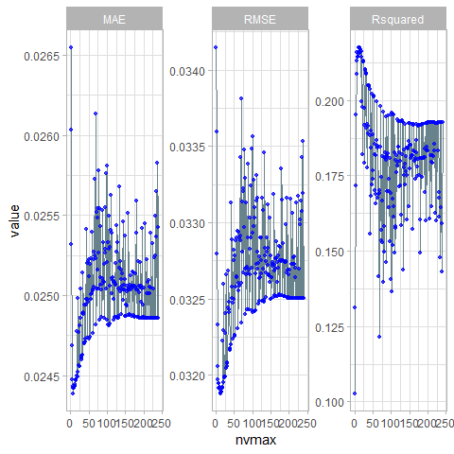

## `stat_bin()` using `bins = 30`. Pick better value with `binwidth`.



## [1] "Coefficients of final model:"  
## Estimate 2.5 % 97.5 %  
## (Intercept) 1.997264e+00 1.990119e+00 2.004409e+00  
## x4 -5.208812e-05 -6.967037e-05 -3.450587e-05  
## x7 1.087549e-02 9.638690e-03 1.211229e-02  
## x8 4.449295e-04 1.574138e-04 7.324453e-04  
## x9 3.273601e-03 2.632944e-03 3.914258e-03  
## x10 1.057845e-03 4.603127e-04 1.655378e-03  
## x16 8.335013e-04 4.194785e-04 1.247524e-03  
## x17 1.504412e-03 8.703803e-04 2.138443e-03  
## stat14 -7.961817e-04 -1.272531e-03 -3.198326e-04  
## stat92 -7.279772e-04 -1.210233e-03 -2.457216e-04  
## stat98 3.613590e-03 3.139791e-03 4.087389e-03  
## stat110 -3.175507e-03 -3.655198e-03 -2.695815e-03  
## stat146 -8.450001e-04 -1.328278e-03 -3.617223e-04  
## x18.sqrt 2.528483e-02 2.345068e-02 2.711899e-02

#### Test

if (algo.stepwise.caret == TRUE){  
 test.model(model.stepwise, data.test  
 ,method = 'leapSeq',subopt = NULL  
 ,formula = formula, feature.names = feature.names, label.names = label.names  
 ,id = id  
 ,draw.limits = TRUE, transformation = t)  
   
}

## [1] "Summary of predicted values: "  
## Min. 1st Qu. Median Mean 3rd Qu. Max.   
## 2.042 2.085 2.096 2.096 2.108 2.151   
## [1] "leapSeq Test MSE: 0.000961019233400987"



### LASSO with CV

#### Train

if (algo.LASSO.caret == TRUE){  
 set.seed(1)  
 tune.grid= expand.grid(alpha = 1,lambda = 10^seq(from=-4,to=0,length=100))  
 returned = train.caret.glmselect(formula = formula  
 ,data = data.train  
 ,method = "glmnet"  
 ,subopt = 'LASSO'  
 ,tune.grid = tune.grid  
 ,feature.names = feature.names)  
 model.LASSO.caret = returned$model  
}

## Warning in nominalTrainWorkflow(x = x, y = y, wts = weights, info = trainInfo, : There were missing values in resampled  
## performance measures.

## Aggregating results  
## Selecting tuning parameters  
## Fitting alpha = 1, lambda = 0.000705 on full training set  
## glmnet   
##   
## 5584 samples  
## 240 predictor  
##   
## No pre-processing  
## Resampling: Cross-Validated (10 fold)   
## Summary of sample sizes: 5026, 5026, 5026, 5025, 5025, 5026, ...   
## Resampling results across tuning parameters:  
##   
## lambda RMSE Rsquared MAE   
## 0.0001000000 0.03229079 0.19966919 0.02471731  
## 0.0001097499 0.03227425 0.20025068 0.02470766  
## 0.0001204504 0.03225674 0.20087468 0.02469829  
## 0.0001321941 0.03223811 0.20155080 0.02468870  
## 0.0001450829 0.03221808 0.20229261 0.02467853  
## 0.0001592283 0.03219703 0.20309033 0.02466787  
## 0.0001747528 0.03217498 0.20394622 0.02465663  
## 0.0001917910 0.03215212 0.20485380 0.02464498  
## 0.0002104904 0.03212845 0.20581485 0.02463355  
## 0.0002310130 0.03210420 0.20682450 0.02462189  
## 0.0002535364 0.03208054 0.20783097 0.02461048  
## 0.0002782559 0.03205748 0.20884172 0.02459972  
## 0.0003053856 0.03203542 0.20984534 0.02458926  
## 0.0003351603 0.03201450 0.21083313 0.02457925  
## 0.0003678380 0.03199432 0.21182751 0.02456881  
## 0.0004037017 0.03197538 0.21280974 0.02455951  
## 0.0004430621 0.03195821 0.21375818 0.02454998  
## 0.0004862602 0.03194306 0.21466649 0.02454229  
## 0.0005336699 0.03192966 0.21555417 0.02453660  
## 0.0005857021 0.03192168 0.21623210 0.02453421  
## 0.0006428073 0.03191702 0.21681020 0.02453282  
## 0.0007054802 0.03191578 0.21728569 0.02453345  
## 0.0007742637 0.03192010 0.21753762 0.02453746  
## 0.0008497534 0.03193531 0.21728292 0.02454872  
## 0.0009326033 0.03195948 0.21662868 0.02456771  
## 0.0010235310 0.03198870 0.21580460 0.02459071  
## 0.0011233240 0.03202347 0.21478317 0.02461946  
## 0.0012328467 0.03206492 0.21351363 0.02465545  
## 0.0013530478 0.03211107 0.21211442 0.02469782  
## 0.0014849683 0.03215885 0.21079718 0.02474354  
## 0.0016297508 0.03221102 0.20944961 0.02479611  
## 0.0017886495 0.03226931 0.20800015 0.02485508  
## 0.0019630407 0.03233538 0.20638442 0.02492242  
## 0.0021544347 0.03240971 0.20463038 0.02499700  
## 0.0023644894 0.03249014 0.20296965 0.02507577  
## 0.0025950242 0.03257917 0.20130254 0.02516103  
## 0.0028480359 0.03268503 0.19911941 0.02525865  
## 0.0031257158 0.03281202 0.19614214 0.02537064  
## 0.0034304693 0.03296431 0.19201259 0.02550058  
## 0.0037649358 0.03314559 0.18628819 0.02565275  
## 0.0041320124 0.03334802 0.17939799 0.02581916  
## 0.0045348785 0.03356095 0.17229672 0.02598948  
## 0.0049770236 0.03380636 0.16268676 0.02618472  
## 0.0054622772 0.03408895 0.14895966 0.02640487  
## 0.0059948425 0.03437314 0.13395619 0.02661666  
## 0.0065793322 0.03464999 0.11801037 0.02681307  
## 0.0072208090 0.03488494 0.10551862 0.02697422  
## 0.0079248290 0.03505527 0.10284518 0.02708587  
## 0.0086974900 0.03523833 0.10275505 0.02720980  
## 0.0095454846 0.03545697 0.10275505 0.02735862  
## 0.0104761575 0.03571854 0.10275505 0.02753652  
## 0.0114975700 0.03600275 0.08479868 0.02773138  
## 0.0126185688 0.03601758 NaN 0.02774324  
## 0.0138488637 0.03601758 NaN 0.02774324  
## 0.0151991108 0.03601758 NaN 0.02774324  
## 0.0166810054 0.03601758 NaN 0.02774324  
## 0.0183073828 0.03601758 NaN 0.02774324  
## 0.0200923300 0.03601758 NaN 0.02774324  
## 0.0220513074 0.03601758 NaN 0.02774324  
## 0.0242012826 0.03601758 NaN 0.02774324  
## 0.0265608778 0.03601758 NaN 0.02774324  
## 0.0291505306 0.03601758 NaN 0.02774324  
## 0.0319926714 0.03601758 NaN 0.02774324  
## 0.0351119173 0.03601758 NaN 0.02774324  
## 0.0385352859 0.03601758 NaN 0.02774324  
## 0.0422924287 0.03601758 NaN 0.02774324  
## 0.0464158883 0.03601758 NaN 0.02774324  
## 0.0509413801 0.03601758 NaN 0.02774324  
## 0.0559081018 0.03601758 NaN 0.02774324  
## 0.0613590727 0.03601758 NaN 0.02774324  
## 0.0673415066 0.03601758 NaN 0.02774324  
## 0.0739072203 0.03601758 NaN 0.02774324  
## 0.0811130831 0.03601758 NaN 0.02774324  
## 0.0890215085 0.03601758 NaN 0.02774324  
## 0.0977009957 0.03601758 NaN 0.02774324  
## 0.1072267222 0.03601758 NaN 0.02774324  
## 0.1176811952 0.03601758 NaN 0.02774324  
## 0.1291549665 0.03601758 NaN 0.02774324  
## 0.1417474163 0.03601758 NaN 0.02774324  
## 0.1555676144 0.03601758 NaN 0.02774324  
## 0.1707352647 0.03601758 NaN 0.02774324  
## 0.1873817423 0.03601758 NaN 0.02774324  
## 0.2056512308 0.03601758 NaN 0.02774324  
## 0.2257019720 0.03601758 NaN 0.02774324  
## 0.2477076356 0.03601758 NaN 0.02774324  
## 0.2718588243 0.03601758 NaN 0.02774324  
## 0.2983647240 0.03601758 NaN 0.02774324  
## 0.3274549163 0.03601758 NaN 0.02774324  
## 0.3593813664 0.03601758 NaN 0.02774324  
## 0.3944206059 0.03601758 NaN 0.02774324  
## 0.4328761281 0.03601758 NaN 0.02774324  
## 0.4750810162 0.03601758 NaN 0.02774324  
## 0.5214008288 0.03601758 NaN 0.02774324  
## 0.5722367659 0.03601758 NaN 0.02774324  
## 0.6280291442 0.03601758 NaN 0.02774324  
## 0.6892612104 0.03601758 NaN 0.02774324  
## 0.7564633276 0.03601758 NaN 0.02774324  
## 0.8302175681 0.03601758 NaN 0.02774324  
## 0.9111627561 0.03601758 NaN 0.02774324  
## 1.0000000000 0.03601758 NaN 0.02774324  
##   
## Tuning parameter 'alpha' was held constant at a value of 1  
## RMSE was used to select the optimal model using the smallest value.  
## The final values used for the model were alpha = 1 and lambda = 0.0007054802.

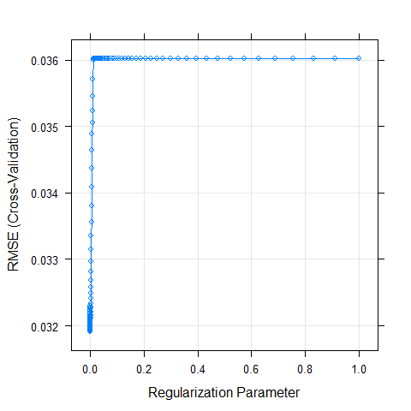

## alpha lambda  
## 22 1 0.0007054802  
## alpha lambda RMSE Rsquared MAE RMSESD RsquaredSD MAESD  
## 1 1 0.0001000000 0.03229079 0.19966919 0.02471731 0.0008068181 0.02658855 0.0006564475  
## 2 1 0.0001097499 0.03227425 0.20025068 0.02470766 0.0008106937 0.02666287 0.0006579723  
## 3 1 0.0001204504 0.03225674 0.20087468 0.02469829 0.0008156365 0.02676086 0.0006598813  
## 4 1 0.0001321941 0.03223811 0.20155080 0.02468870 0.0008216060 0.02684797 0.0006625315  
## 5 1 0.0001450829 0.03221808 0.20229261 0.02467853 0.0008277221 0.02691012 0.0006654309  
## 6 1 0.0001592283 0.03219703 0.20309033 0.02466787 0.0008337472 0.02699871 0.0006685785  
## 7 1 0.0001747528 0.03217498 0.20394622 0.02465663 0.0008400080 0.02714329 0.0006716936  
## 8 1 0.0001917910 0.03215212 0.20485380 0.02464498 0.0008467978 0.02731577 0.0006751266  
## 9 1 0.0002104904 0.03212845 0.20581485 0.02463355 0.0008537571 0.02751222 0.0006784078  
## 10 1 0.0002310130 0.03210420 0.20682450 0.02462189 0.0008608091 0.02770968 0.0006812675  
## 11 1 0.0002535364 0.03208054 0.20783097 0.02461048 0.0008688893 0.02784725 0.0006839831  
## 12 1 0.0002782559 0.03205748 0.20884172 0.02459972 0.0008770229 0.02795424 0.0006855929  
## 13 1 0.0003053856 0.03203542 0.20984534 0.02458926 0.0008852171 0.02808550 0.0006863667  
## 14 1 0.0003351603 0.03201450 0.21083313 0.02457925 0.0008921747 0.02820932 0.0006864242  
## 15 1 0.0003678380 0.03199432 0.21182751 0.02456881 0.0008993982 0.02828643 0.0006863355  
## 16 1 0.0004037017 0.03197538 0.21280974 0.02455951 0.0009075973 0.02831182 0.0006871234  
## 17 1 0.0004430621 0.03195821 0.21375818 0.02454998 0.0009142556 0.02831592 0.0006857709  
## 18 1 0.0004862602 0.03194306 0.21466649 0.02454229 0.0009219584 0.02834339 0.0006823781  
## 19 1 0.0005336699 0.03192966 0.21555417 0.02453660 0.0009317873 0.02844704 0.0006792498  
## 20 1 0.0005857021 0.03192168 0.21623210 0.02453421 0.0009411538 0.02857400 0.0006779841  
## 21 1 0.0006428073 0.03191702 0.21681020 0.02453282 0.0009520375 0.02882900 0.0006786976  
## 22 1 0.0007054802 0.03191578 0.21728569 0.02453345 0.0009621089 0.02904908 0.0006796166  
## 23 1 0.0007742637 0.03192010 0.21753762 0.02453746 0.0009691861 0.02927587 0.0006795980  
## 24 1 0.0008497534 0.03193531 0.21728292 0.02454872 0.0009711920 0.02940018 0.0006788941  
## 25 1 0.0009326033 0.03195948 0.21662868 0.02456771 0.0009693948 0.02932379 0.0006771521  
## 26 1 0.0010235310 0.03198870 0.21580460 0.02459071 0.0009684864 0.02923335 0.0006787849  
## 27 1 0.0011233240 0.03202347 0.21478317 0.02461946 0.0009704732 0.02896964 0.0006833647  
## 28 1 0.0012328467 0.03206492 0.21351363 0.02465545 0.0009745051 0.02872034 0.0006895897  
## 29 1 0.0013530478 0.03211107 0.21211442 0.02469782 0.0009766790 0.02850093 0.0006936803  
## 30 1 0.0014849683 0.03215885 0.21079718 0.02474354 0.0009755821 0.02818073 0.0006955901  
## 31 1 0.0016297508 0.03221102 0.20944961 0.02479611 0.0009762155 0.02776530 0.0006983931  
## 32 1 0.0017886495 0.03226931 0.20800015 0.02485508 0.0009794773 0.02720306 0.0007015348  
## 33 1 0.0019630407 0.03233538 0.20638442 0.02492242 0.0009822869 0.02664438 0.0007033153  
## 34 1 0.0021544347 0.03240971 0.20463038 0.02499700 0.0009854914 0.02618159 0.0007025718  
## 35 1 0.0023644894 0.03249014 0.20296965 0.02507577 0.0009900206 0.02607788 0.0007031438  
## 36 1 0.0025950242 0.03257917 0.20130254 0.02516103 0.0009917504 0.02580396 0.0007007705  
## 37 1 0.0028480359 0.03268503 0.19911941 0.02525865 0.0009928951 0.02548927 0.0006966487  
## 38 1 0.0031257158 0.03281202 0.19614214 0.02537064 0.0009946969 0.02513834 0.0006913650  
## 39 1 0.0034304693 0.03296431 0.19201259 0.02550058 0.0009976748 0.02474292 0.0006864188  
## 40 1 0.0037649358 0.03314559 0.18628819 0.02565275 0.0010008993 0.02440508 0.0006810272  
## 41 1 0.0041320124 0.03334802 0.17939799 0.02581916 0.0010056832 0.02415427 0.0006764659  
## 42 1 0.0045348785 0.03356095 0.17229672 0.02598948 0.0010193353 0.02430388 0.0006797574  
## 43 1 0.0049770236 0.03380636 0.16268676 0.02618472 0.0010356620 0.02490531 0.0006860244  
## 44 1 0.0054622772 0.03408895 0.14895966 0.02640487 0.0010511933 0.02525970 0.0006930996  
## 45 1 0.0059948425 0.03437314 0.13395619 0.02661666 0.0010719635 0.02524495 0.0006999130  
## 46 1 0.0065793322 0.03464999 0.11801037 0.02681307 0.0010817982 0.02450619 0.0006936330  
## 47 1 0.0072208090 0.03488494 0.10551862 0.02697422 0.0010865478 0.02411541 0.0006892129  
## 48 1 0.0079248290 0.03505527 0.10284518 0.02708587 0.0010851102 0.02343617 0.0006803093  
## 49 1 0.0086974900 0.03523833 0.10275505 0.02720980 0.0010894279 0.02349240 0.0006775011  
## 50 1 0.0095454846 0.03545697 0.10275505 0.02735862 0.0010958576 0.02349240 0.0006766098  
## 51 1 0.0104761575 0.03571854 0.10275505 0.02753652 0.0011038542 0.02349240 0.0006787612  
## 52 1 0.0114975700 0.03600275 0.08479868 0.02773138 0.0010984724 0.01361570 0.0006759935  
## 53 1 0.0126185688 0.03601758 NaN 0.02774324 0.0010926219 NA 0.0006755701  
## 54 1 0.0138488637 0.03601758 NaN 0.02774324 0.0010926219 NA 0.0006755701  
## 55 1 0.0151991108 0.03601758 NaN 0.02774324 0.0010926219 NA 0.0006755701  
## 56 1 0.0166810054 0.03601758 NaN 0.02774324 0.0010926219 NA 0.0006755701  
## 57 1 0.0183073828 0.03601758 NaN 0.02774324 0.0010926219 NA 0.0006755701  
## 58 1 0.0200923300 0.03601758 NaN 0.02774324 0.0010926219 NA 0.0006755701  
## 59 1 0.0220513074 0.03601758 NaN 0.02774324 0.0010926219 NA 0.0006755701  
## 60 1 0.0242012826 0.03601758 NaN 0.02774324 0.0010926219 NA 0.0006755701  
## 61 1 0.0265608778 0.03601758 NaN 0.02774324 0.0010926219 NA 0.0006755701  
## 62 1 0.0291505306 0.03601758 NaN 0.02774324 0.0010926219 NA 0.0006755701  
## 63 1 0.0319926714 0.03601758 NaN 0.02774324 0.0010926219 NA 0.0006755701  
## 64 1 0.0351119173 0.03601758 NaN 0.02774324 0.0010926219 NA 0.0006755701  
## 65 1 0.0385352859 0.03601758 NaN 0.02774324 0.0010926219 NA 0.0006755701  
## 66 1 0.0422924287 0.03601758 NaN 0.02774324 0.0010926219 NA 0.0006755701  
## 67 1 0.0464158883 0.03601758 NaN 0.02774324 0.0010926219 NA 0.0006755701  
## 68 1 0.0509413801 0.03601758 NaN 0.02774324 0.0010926219 NA 0.0006755701  
## 69 1 0.0559081018 0.03601758 NaN 0.02774324 0.0010926219 NA 0.0006755701  
## 70 1 0.0613590727 0.03601758 NaN 0.02774324 0.0010926219 NA 0.0006755701  
## 71 1 0.0673415066 0.03601758 NaN 0.02774324 0.0010926219 NA 0.0006755701  
## 72 1 0.0739072203 0.03601758 NaN 0.02774324 0.0010926219 NA 0.0006755701  
## 73 1 0.0811130831 0.03601758 NaN 0.02774324 0.0010926219 NA 0.0006755701  
## 74 1 0.0890215085 0.03601758 NaN 0.02774324 0.0010926219 NA 0.0006755701  
## 75 1 0.0977009957 0.03601758 NaN 0.02774324 0.0010926219 NA 0.0006755701  
## 76 1 0.1072267222 0.03601758 NaN 0.02774324 0.0010926219 NA 0.0006755701  
## 77 1 0.1176811952 0.03601758 NaN 0.02774324 0.0010926219 NA 0.0006755701  
## 78 1 0.1291549665 0.03601758 NaN 0.02774324 0.0010926219 NA 0.0006755701  
## 79 1 0.1417474163 0.03601758 NaN 0.02774324 0.0010926219 NA 0.0006755701  
## 80 1 0.1555676144 0.03601758 NaN 0.02774324 0.0010926219 NA 0.0006755701  
## 81 1 0.1707352647 0.03601758 NaN 0.02774324 0.0010926219 NA 0.0006755701  
## 82 1 0.1873817423 0.03601758 NaN 0.02774324 0.0010926219 NA 0.0006755701  
## 83 1 0.2056512308 0.03601758 NaN 0.02774324 0.0010926219 NA 0.0006755701  
## 84 1 0.2257019720 0.03601758 NaN 0.02774324 0.0010926219 NA 0.0006755701  
## 85 1 0.2477076356 0.03601758 NaN 0.02774324 0.0010926219 NA 0.0006755701  
## 86 1 0.2718588243 0.03601758 NaN 0.02774324 0.0010926219 NA 0.0006755701  
## 87 1 0.2983647240 0.03601758 NaN 0.02774324 0.0010926219 NA 0.0006755701  
## 88 1 0.3274549163 0.03601758 NaN 0.02774324 0.0010926219 NA 0.0006755701  
## 89 1 0.3593813664 0.03601758 NaN 0.02774324 0.0010926219 NA 0.0006755701  
## 90 1 0.3944206059 0.03601758 NaN 0.02774324 0.0010926219 NA 0.0006755701  
## 91 1 0.4328761281 0.03601758 NaN 0.02774324 0.0010926219 NA 0.0006755701  
## 92 1 0.4750810162 0.03601758 NaN 0.02774324 0.0010926219 NA 0.0006755701  
## 93 1 0.5214008288 0.03601758 NaN 0.02774324 0.0010926219 NA 0.0006755701  
## 94 1 0.5722367659 0.03601758 NaN 0.02774324 0.0010926219 NA 0.0006755701  
## 95 1 0.6280291442 0.03601758 NaN 0.02774324 0.0010926219 NA 0.0006755701  
## 96 1 0.6892612104 0.03601758 NaN 0.02774324 0.0010926219 NA 0.0006755701  
## 97 1 0.7564633276 0.03601758 NaN 0.02774324 0.0010926219 NA 0.0006755701  
## 98 1 0.8302175681 0.03601758 NaN 0.02774324 0.0010926219 NA 0.0006755701  
## 99 1 0.9111627561 0.03601758 NaN 0.02774324 0.0010926219 NA 0.0006755701  
## 100 1 1.0000000000 0.03601758 NaN 0.02774324 0.0010926219 NA 0.0006755701

## Warning: Removed 48 rows containing missing values (geom_path).

## Warning: Removed 48 rows containing missing values (geom_point).

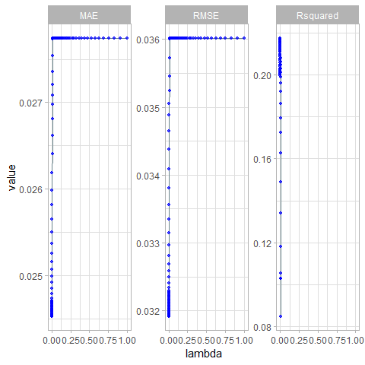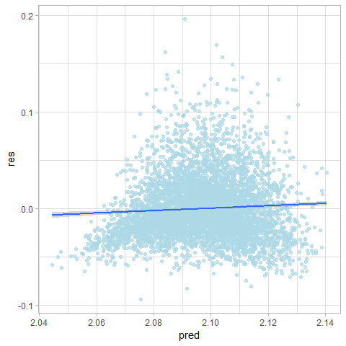

## `stat_bin()` using `bins = 30`. Pick better value with `binwidth`.

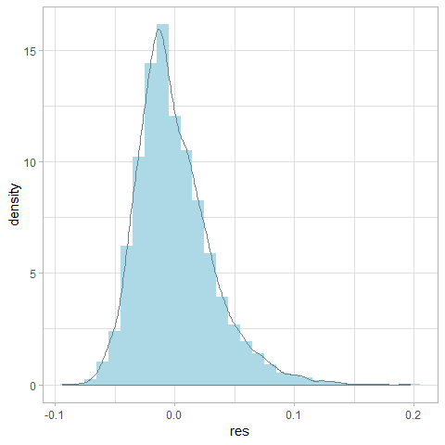

## [1] "Coefficients"  
## model.coef  
## (Intercept) 2.005096e+00  
## x4 -3.673734e-05  
## x7 9.742547e-03  
## x8 1.942694e-04  
## x9 2.732192e-03  
## x10 5.570192e-04  
## x11 6.323931e+04  
## x16 4.873876e-04  
## x17 9.561956e-04  
## x21 1.262178e-05  
## stat4 -8.588090e-05  
## stat14 -3.966990e-04  
## stat22 -2.180449e-04  
## stat23 2.503451e-04  
## stat24 -1.136040e-04  
## stat26 -7.757010e-05  
## stat33 -3.181030e-05  
## stat35 -5.013437e-05  
## stat41 -3.208051e-05  
## stat59 9.831766e-05  
## stat60 1.086724e-04  
## stat65 -3.691905e-05  
## stat83 -1.608524e-05  
## stat92 -2.978588e-04  
## stat98 3.221435e-03  
## stat100 1.099313e-04  
## stat110 -2.785204e-03  
## stat113 -3.699963e-07  
## stat146 -4.236168e-04  
## stat148 -1.649193e-05  
## stat149 -9.015653e-05  
## stat170 -7.690041e-05  
## stat172 2.889952e-05  
## stat187 -3.312674e-05  
## stat202 -3.559011e-05  
## stat214 -5.559261e-05  
## stat217 2.734993e-05  
## x18.sqrt 2.370080e-02

#### Test

if (algo.LASSO.caret == TRUE){  
 test.model(model.LASSO.caret, data.test  
 ,method = 'glmnet',subopt = "LASSO"  
 ,formula = formula, feature.names = feature.names, label.names = label.names  
 ,draw.limits = TRUE, transformation = t)  
}

## [1] "Summary of predicted values: "  
## Min. 1st Qu. Median Mean 3rd Qu. Max.   
## 2.049 2.086 2.097 2.096 2.107 2.144   
## [1] "glmnet LASSO Test MSE: 0.000965849932005973"

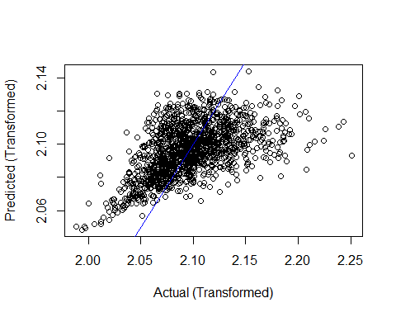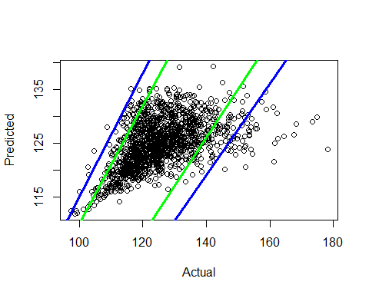

### LARS with CV

#### Train

if (algo.LARS.caret == TRUE){  
 set.seed(1)  
 returned = train.caret.glmselect(formula = formula  
 ,data = data.train  
 ,method = "lars"  
 ,subopt = 'NULL'  
 ,feature.names = feature.names)  
 model.LARS.caret = returned$model  
}

## Warning in nominalTrainWorkflow(x = x, y = y, wts = weights, info = trainInfo, : There were missing values in resampled  
## performance measures.

## Aggregating results  
## Selecting tuning parameters  
## Fitting fraction = 0.323 on full training set  
## Least Angle Regression   
##   
## 5584 samples  
## 240 predictor  
##   
## Pre-processing: centered (240), scaled (240)   
## Resampling: Cross-Validated (10 fold)   
## Summary of sample sizes: 5026, 5026, 5026, 5025, 5025, 5026, ...   
## Resampling results across tuning parameters:  
##   
## fraction RMSE Rsquared MAE   
## 0.00000000 0.03601758 NaN 0.02774324  
## 0.01010101 0.03560998 0.1027550 0.02746400  
## 0.02020202 0.03524972 0.1027550 0.02721883  
## 0.03030303 0.03493909 0.1030454 0.02701207  
## 0.04040404 0.03468651 0.1155973 0.02683997  
## 0.05050505 0.03444452 0.1298182 0.02667003  
## 0.06060606 0.03421294 0.1423141 0.02650051  
## 0.07070707 0.03400029 0.1536910 0.02633636  
## 0.08080808 0.03379502 0.1635834 0.02617656  
## 0.09090909 0.03360235 0.1712321 0.02602344  
## 0.10101010 0.03342402 0.1771185 0.02588067  
## 0.11111111 0.03326236 0.1824504 0.02575017  
## 0.12121212 0.03310599 0.1879240 0.02562112  
## 0.13131313 0.03295917 0.1924926 0.02549871  
## 0.14141414 0.03282290 0.1961776 0.02538185  
## 0.15151515 0.03269729 0.1991383 0.02527127  
## 0.16161616 0.03258413 0.2014665 0.02516770  
## 0.17171717 0.03248575 0.2032336 0.02507486  
## 0.18181818 0.03239562 0.2050902 0.02498610  
## 0.19191919 0.03231402 0.2070283 0.02490396  
## 0.20202020 0.03224179 0.2087815 0.02483108  
## 0.21212121 0.03217950 0.2104105 0.02476825  
## 0.22222222 0.03212644 0.2117927 0.02471483  
## 0.23232323 0.03208076 0.2130707 0.02467041  
## 0.24242424 0.03204047 0.2142838 0.02463460  
## 0.25252525 0.03200603 0.2153152 0.02460578  
## 0.26262626 0.03197798 0.2161010 0.02458204  
## 0.27272727 0.03195521 0.2167397 0.02456381  
## 0.28282828 0.03193735 0.2172420 0.02454997  
## 0.29292929 0.03192593 0.2174871 0.02454172  
## 0.30303030 0.03191923 0.2175365 0.02453705  
## 0.31313131 0.03191591 0.2174554 0.02453467  
## 0.32323232 0.03191555 0.2172470 0.02453468  
## 0.33333333 0.03191567 0.2170468 0.02453403  
## 0.34343434 0.03191622 0.2168455 0.02453336  
## 0.35353535 0.03191782 0.2166135 0.02453414  
## 0.36363636 0.03191994 0.2163713 0.02453464  
## 0.37373737 0.03192255 0.2161177 0.02453551  
## 0.38383838 0.03192519 0.2158794 0.02453630  
## 0.39393939 0.03192842 0.2156245 0.02453732  
## 0.40404040 0.03193231 0.2153457 0.02453885  
## 0.41414141 0.03193730 0.2150200 0.02454115  
## 0.42424242 0.03194273 0.2146803 0.02454347  
## 0.43434343 0.03194809 0.2143521 0.02454603  
## 0.44444444 0.03195349 0.2140293 0.02454893  
## 0.45454545 0.03195873 0.2137237 0.02455150  
## 0.46464646 0.03196419 0.2134148 0.02455431  
## 0.47474747 0.03197005 0.2130930 0.02455734  
## 0.48484848 0.03197621 0.2127623 0.02456064  
## 0.49494949 0.03198236 0.2124365 0.02456370  
## 0.50505051 0.03198860 0.2121131 0.02456715  
## 0.51515152 0.03199533 0.2117713 0.02457090  
## 0.52525253 0.03200214 0.2114322 0.02457441  
## 0.53535354 0.03200917 0.2110881 0.02457790  
## 0.54545455 0.03201630 0.2107445 0.02458141  
## 0.55555556 0.03202332 0.2104105 0.02458470  
## 0.56565657 0.03203055 0.2100707 0.02458791  
## 0.57575758 0.03203803 0.2097229 0.02459134  
## 0.58585859 0.03204602 0.2093556 0.02459512  
## 0.59595960 0.03205422 0.2089842 0.02459891  
## 0.60606061 0.03206258 0.2086118 0.02460273  
## 0.61616162 0.03207115 0.2082347 0.02460667  
## 0.62626263 0.03207996 0.2078521 0.02461073  
## 0.63636364 0.03208891 0.2074685 0.02461497  
## 0.64646465 0.03209833 0.2070678 0.02461938  
## 0.65656566 0.03210827 0.2066479 0.02462420  
## 0.66666667 0.03211841 0.2062236 0.02462925  
## 0.67676768 0.03212860 0.2058022 0.02463415  
## 0.68686869 0.03213898 0.2053759 0.02463916  
## 0.69696970 0.03214918 0.2049637 0.02464411  
## 0.70707071 0.03215950 0.2045499 0.02464921  
## 0.71717172 0.03217000 0.2041332 0.02465454  
## 0.72727273 0.03218061 0.2037158 0.02465991  
## 0.73737374 0.03219133 0.2032988 0.02466530  
## 0.74747475 0.03220205 0.2028874 0.02467069  
## 0.75757576 0.03221291 0.2024758 0.02467616  
## 0.76767677 0.03222391 0.2020636 0.02468171  
## 0.77777778 0.03223488 0.2016581 0.02468728  
## 0.78787879 0.03224575 0.2012609 0.02469287  
## 0.79797980 0.03225677 0.2008616 0.02469866  
## 0.80808081 0.03226785 0.2004648 0.02470457  
## 0.81818182 0.03227899 0.2000700 0.02471075  
## 0.82828283 0.03229015 0.1996789 0.02471729  
## 0.83838384 0.03230153 0.1992829 0.02472413  
## 0.84848485 0.03231315 0.1988798 0.02473141  
## 0.85858586 0.03232472 0.1984828 0.02473868  
## 0.86868687 0.03233662 0.1980759 0.02474608  
## 0.87878788 0.03234890 0.1976563 0.02475376  
## 0.88888889 0.03236131 0.1972346 0.02476167  
## 0.89898990 0.03237391 0.1968083 0.02476985  
## 0.90909091 0.03238663 0.1963809 0.02477827  
## 0.91919192 0.03239940 0.1959562 0.02478674  
## 0.92929293 0.03241210 0.1955383 0.02479523  
## 0.93939394 0.03242501 0.1951160 0.02480390  
## 0.94949495 0.03243806 0.1946927 0.02481262  
## 0.95959596 0.03245119 0.1942708 0.02482136  
## 0.96969697 0.03246434 0.1938533 0.02483043  
## 0.97979798 0.03247770 0.1934318 0.02483992  
## 0.98989899 0.03249120 0.1930071 0.02484963  
## 1.00000000 0.03250488 0.1925788 0.02485955  
##   
## RMSE was used to select the optimal model using the smallest value.  
## The final value used for the model was fraction = 0.3232323.

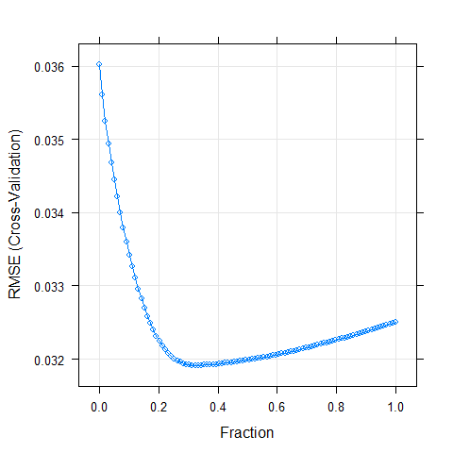

## fraction  
## 33 0.3232323

## Warning: Removed 1 rows containing missing values (geom_point).

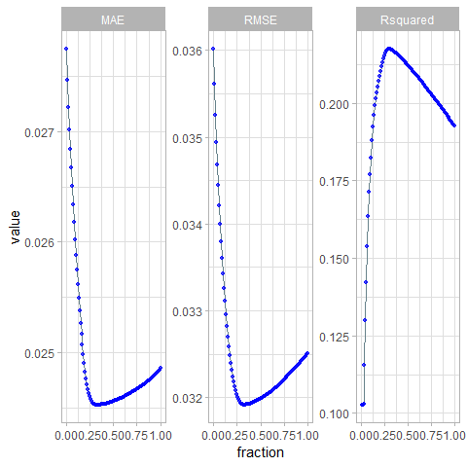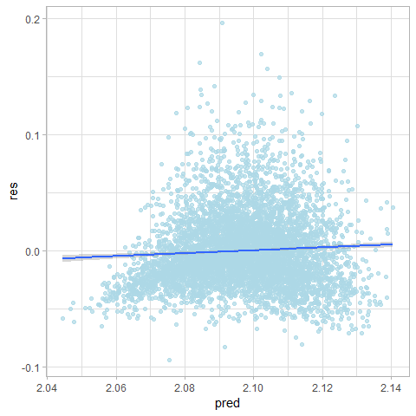

## `stat_bin()` using `bins = 30`. Pick better value with `binwidth`.

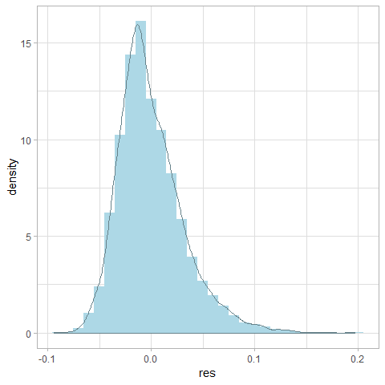

## [1] "Coefficients"  
## x4 x7 x8 x9 x10 x11 x16 x17   
## -1.743525e-03 6.562070e-03 5.663782e-04 3.554358e-03 7.806284e-04 3.700841e-04 9.833944e-04 1.260171e-03   
## x21 stat4 stat14 stat22 stat23 stat24 stat26 stat33   
## 1.323125e-04 -1.517750e-04 -6.975184e-04 -3.801387e-04 4.402131e-04 -2.009242e-04 -1.387546e-04 -5.883005e-05   
## stat35 stat41 stat59 stat60 stat65 stat83 stat92 stat98   
## -9.078835e-05 -5.905732e-05 1.737364e-04 1.921507e-04 -6.733540e-05 -3.070645e-05 -5.178105e-04 5.665627e-03   
## stat100 stat110 stat113 stat146 stat148 stat149 stat170 stat172   
## 1.941746e-04 -4.837878e-03 -2.659505e-06 -7.335459e-04 -3.154388e-05 -1.584070e-04 -1.365057e-04 5.390691e-05   
## stat187 stat202 stat214 stat217 x18.sqrt   
## -6.130055e-05 -6.409534e-05 -9.919367e-05 5.019530e-05 1.077416e-02

#### Test

if (algo.LARS.caret == TRUE){  
 test.model(model.LARS.caret, data.test  
 ,method = 'lars',subopt = NULL  
 ,formula = formula, feature.names = feature.names, label.names = label.names  
 ,draw.limits = TRUE, transformation = t)  
}

## [1] "Summary of predicted values: "  
## Min. 1st Qu. Median Mean 3rd Qu. Max.   
## 2.048 2.086 2.097 2.096 2.107 2.144   
## [1] "lars Test MSE: 0.000965763872835344"

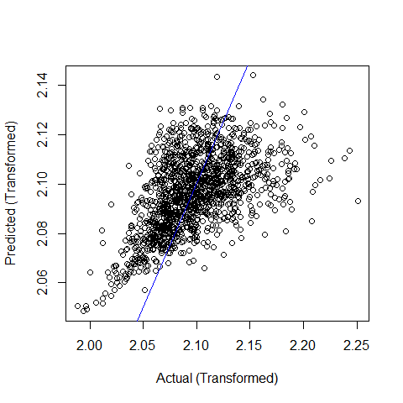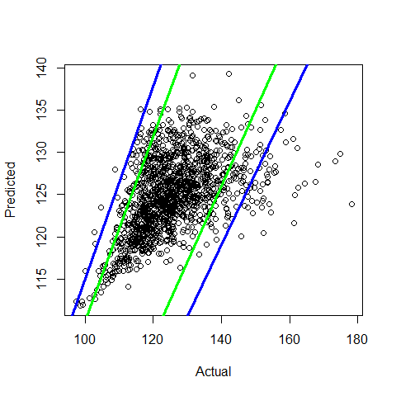

# Session Info

sessionInfo()

## R version 3.5.2 (2018-12-20)  
## Platform: x86_64-w64-mingw32/x64 (64-bit)  
## Running under: Windows 10 x64 (build 17763)  
##   
## Matrix products: default  
##   
## locale:  
## [1] LC_COLLATE=English_United States.1252 LC_CTYPE=English_United States.1252 LC_MONETARY=English_United States.1252  
## [4] LC_NUMERIC=C LC_TIME=English_United States.1252   
##   
## attached base packages:  
## [1] parallel stats graphics grDevices utils datasets methods base   
##   
## other attached packages:  
## [1] bindrcpp_0.2.2 knitr_1.21 htmltools_0.3.6 reshape2_1.4.3   
## [5] lars_1.2 doParallel_1.0.14 iterators_1.0.10 caret_6.0-81   
## [9] leaps_3.0 ggforce_0.1.3 rlist_0.4.6.1 car_3.0-2   
## [13] carData_3.0-2 bestNormalize_1.3.0 scales_1.0.0 onewaytests_2.0   
## [17] caTools_1.17.1.1 mosaic_1.5.0 mosaicData_0.17.0 ggformula_0.9.1   
## [21] ggstance_0.3.1 lattice_0.20-38 DT_0.5 ggiraphExtra_0.2.9   
## [25] ggiraph_0.6.0 investr_1.4.0 glmnet_2.0-16 foreach_1.4.4   
## [29] Matrix_1.2-15 MASS_7.3-51.1 PerformanceAnalytics_1.5.2 xts_0.11-2   
## [33] zoo_1.8-4 forcats_0.3.0 stringr_1.4.0 dplyr_0.7.8   
## [37] purrr_0.3.0 readr_1.3.1 tidyr_0.8.2 tibble_2.0.1   
## [41] ggplot2_3.1.0 tidyverse_1.2.1 usdm_1.1-18 raster_2.8-19   
## [45] sp_1.3-1 pacman_0.5.0   
##   
## loaded via a namespace (and not attached):  
## [1] readxl_1.2.0 backports_1.1.3 plyr_1.8.4 lazyeval_0.2.1 splines_3.5.2 mycor_0.1.1   
## [7] crosstalk_1.0.0 leaflet_2.0.2 digest_0.6.18 magrittr_1.5 mosaicCore_0.6.0 openxlsx_4.1.0   
## [13] recipes_0.1.4 modelr_0.1.3 gower_0.1.2 colorspace_1.4-0 rvest_0.3.2 ggrepel_0.8.0   
## [19] haven_2.0.0 xfun_0.4 crayon_1.3.4 jsonlite_1.6 bindr_0.1.1 survival_2.43-3   
## [25] glue_1.3.0 registry_0.5 gtable_0.2.0 ppcor_1.1 ipred_0.9-8 sjmisc_2.7.7   
## [31] abind_1.4-5 rngtools_1.3.1 bibtex_0.4.2 Rcpp_1.0.0 xtable_1.8-3 units_0.6-2   
## [37] foreign_0.8-71 stats4_3.5.2 lava_1.6.5 prodlim_2018.04.18 prediction_0.3.6.2 htmlwidgets_1.3   
## [43] httr_1.4.0 RColorBrewer_1.1-2 pkgconfig_2.0.2 farver_1.1.0 nnet_7.3-12 labeling_0.3   
## [49] tidyselect_0.2.5 rlang_0.3.1 later_0.8.0 munsell_0.5.0 cellranger_1.1.0 tools_3.5.2   
## [55] cli_1.0.1 generics_0.0.2 moments_0.14 sjlabelled_1.0.16 broom_0.5.1 evaluate_0.13   
## [61] ggdendro_0.1-20 yaml_2.2.0 ModelMetrics_1.2.2 zip_1.0.0 nlme_3.1-137 doRNG_1.7.1   
## [67] mime_0.6 xml2_1.2.0 compiler_3.5.2 rstudioapi_0.9.0 curl_3.3 tweenr_1.0.1   
## [73] stringi_1.3.1 highr_0.7 gdtools_0.1.7 stringdist_0.9.5.1 pillar_1.3.1 data.table_1.12.0   
## [79] bitops_1.0-6 httpuv_1.4.5.1 R6_2.4.0 promises_1.0.1 gridExtra_2.3 rio_0.5.16   
## [85] codetools_0.2-15 assertthat_0.2.0 pkgmaker_0.27 withr_2.1.2 nortest_1.0-4 mgcv_1.8-26   
## [91] hms_0.4.2 rpart_4.1-13 quadprog_1.5-5 grid_3.5.2 timeDate_3043.102 class_7.3-14   
## [97] rmarkdown_1.11 snakecase_0.9.2 shiny_1.2.0 lubridate_1.7.4