Live Session Assignment 5

Nikhil Gupta

2020-02-08 08:04:36

Table of Contents

# Setup

library(tswge)

## Warning: package 'tswge' was built under R version 3.5.3

library(dplyr)

## Warning: package 'dplyr' was built under R version 3.5.3

##   
## Attaching package: 'dplyr'

## The following objects are masked from 'package:stats':  
##   
## filter, lag

## The following objects are masked from 'package:base':  
##   
## intersect, setdiff, setequal, union

library(tidyquant)

## Warning: package 'tidyquant' was built under R version 3.5.3

## Loading required package: lubridate

##   
## Attaching package: 'lubridate'

## The following object is masked from 'package:base':  
##   
## date

## Loading required package: PerformanceAnalytics

## Warning: package 'PerformanceAnalytics' was built under R version 3.5.3

## Loading required package: xts

## Warning: package 'xts' was built under R version 3.5.2

## Loading required package: zoo

## Warning: package 'zoo' was built under R version 3.5.3

##   
## Attaching package: 'zoo'

## The following objects are masked from 'package:base':  
##   
## as.Date, as.Date.numeric

##   
## Attaching package: 'xts'

## The following objects are masked from 'package:dplyr':  
##   
## first, last

##   
## Attaching package: 'PerformanceAnalytics'

## The following object is masked from 'package:graphics':  
##   
## legend

## Loading required package: quantmod

## Warning: package 'quantmod' was built under R version 3.5.3

## Loading required package: TTR

## Warning: package 'TTR' was built under R version 3.5.2

## Version 0.4-0 included new data defaults. See ?getSymbols.

## Loading required package: tidyverse

## Warning: package 'tidyverse' was built under R version 3.5.3

## -- Attaching packages -------------------------------------------------------------------------------- tidyverse 1.2.1 --

## v ggplot2 3.2.0 v readr 1.3.1  
## v tibble 2.1.3 v purrr 0.3.2  
## v tidyr 0.8.3 v stringr 1.4.0  
## v ggplot2 3.2.0 v forcats 0.4.0

## Warning: package 'ggplot2' was built under R version 3.5.3

## Warning: package 'tibble' was built under R version 3.5.3

## Warning: package 'tidyr' was built under R version 3.5.3

## Warning: package 'readr' was built under R version 3.5.2

## Warning: package 'purrr' was built under R version 3.5.3

## Warning: package 'stringr' was built under R version 3.5.3

## Warning: package 'forcats' was built under R version 3.5.3

## -- Conflicts ----------------------------------------------------------------------------------- tidyverse_conflicts() --  
## x lubridate::as.difftime() masks base::as.difftime()  
## x lubridate::date() masks base::date()  
## x dplyr::filter() masks stats::filter()  
## x xts::first() masks dplyr::first()  
## x lubridate::intersect() masks base::intersect()  
## x dplyr::lag() masks stats::lag()  
## x xts::last() masks dplyr::last()  
## x lubridate::setdiff() masks base::setdiff()  
## x lubridate::union() masks base::union()

source("common_functions.R")

# For pre-live

## 2

s = 7; factor.wge(c(rep(0,s-1), 1))

##   
## Coefficients of Original polynomial:   
## 0.0000 0.0000 0.0000 0.0000 0.0000 0.0000 1.0000   
##   
## Factor Roots Abs Recip System Freq   
## 1-1.0000B 1.0000 1.0000 0.0000  
## 1+0.4450B+1.0000B^2 -0.2225+-0.9749i 1.0000 0.2857  
## 1-1.2470B+1.0000B^2 0.6235+-0.7818i 1.0000 0.1429  
## 1+1.8019B+1.0000B^2 -0.9010+-0.4339i 1.0000 0.4286  
##   
##

## 3

### A

# (1 - B^4)Xt = (1 + 0.3B)(1 - 0.6B + 0.8B^2)at  
  
# (1 - B^4) -> s = 4  
# There are no (1-B)^d term -> d = 0  
# There is no dependence on X with lag, hence there are no AR components -> p = 0  
# There are 3 roots in the characteristic equation for the MA side -> q = 3  
  
# Hence, this is a seasonal ARUMA model with d = 0, s = 4, p = 0 and q = 3

### B

# (1 + 0.3B)Xt = (1 - 0.6B + 0.8B^2)at  
  
theta = c(0.6, -0.8)  
factor.wge(phi = theta)

##   
## Coefficients of Original polynomial:   
## 0.6000 -0.8000   
##   
## Factor Roots Abs Recip System Freq   
## 1-0.6000B+0.8000B^2 0.3750+-1.0533i 0.8944 0.1956  
##   
##

# There are no seasonal (1-B^s) terms -> s = 0  
# There are no (1-B)^d term -> d = 0  
# There is 1 root of the characteristic equation of the AR side. There are 2 roots of the characteristic equation of the MA side (and none of the factors on the AR and MA side cancel) -> -> p = 1, q = 2  
  
# Hence, this is a ARMA(1,2) model

### C

# (1 - 0.1B - 0.99B^2 + 0.013B^3 + 0.2078B^4 + 0.0888B^5 + 0.00864B^6) * (1-B)^2 * (1-B^12) * Xt = (1 - 0.6B + 0.8B^2) * at  
  
phi = c(0.1, 0.99, -0.13, -0.2078, -0.0888, -0.00864)  
factor.wge(phi = phi)

##   
## Coefficients of Original polynomial:   
## 0.1000 0.9900 -0.1300 -0.2078 -0.0888 -0.0086   
##   
## Factor Roots Abs Recip System Freq   
## 1+0.9459B -1.0572 0.9459 0.5000  
## 1-1.5764B+0.6809B^2 1.1577+-0.3585i 0.8251 0.0478  
## 1+0.3995B+0.1024B^2 -1.9502+-2.4411i 0.3201 0.3573  
## 1+0.1310B -7.6355 0.1310 0.5000  
##   
##

theta = c(0.6, -0.8)  
factor.wge(phi = theta)

##   
## Coefficients of Original polynomial:   
## 0.6000 -0.8000   
##   
## Factor Roots Abs Recip System Freq   
## 1-0.6000B+0.8000B^2 0.3750+-1.0533i 0.8944 0.1956  
##   
##

# There is a seasonal component (1-B^s) -> s = 12  
# There is a (1-B)^d term -> d = 2  
# There are 6 roots of the characteristic equation of the AR side. There are 2 roots of the characteristic equation of the MA side (and none of the factors on the AR and MA side cancel) -> p = 6, q = 2  
  
# Hence, this is a Seasonal ARUMA model with p = 6, d = 2, q = 2 and s = 12

## 4

txn = tidyquant::tq_get("TXN", get = "stock.prices", from = "2019-01-01")  
txn %>%   
 glimpse()

## Observations: 278  
## Variables: 7  
## $ date <date> 2019-01-02, 2019-01-03, 2019-01-04, 2019-01-07, 2019...  
## $ open <dbl> 92.76, 91.83, 89.93, 92.80, 95.26, 95.05, 95.76, 97.0...  
## $ high <dbl> 95.25, 92.79, 93.38, 95.22, 95.64, 96.49, 97.94, 99.0...  
## $ low <dbl> 92.46, 88.68, 89.47, 92.36, 93.03, 94.72, 95.47, 96.8...  
## $ close <dbl> 94.45, 88.88, 92.90, 94.50, 94.38, 96.24, 97.72, 98.5...  
## $ volume <dbl> 6478800, 11667500, 7707600, 5023900, 5863500, 6909400...  
## $ adjusted <dbl> 91.21481, 85.83559, 89.71790, 91.26310, 91.14720, 92....

px = plotts.sample.wge(txn$adjusted)

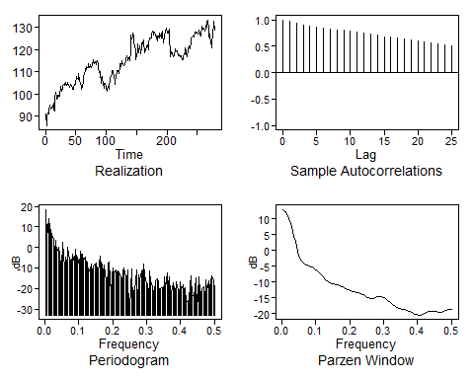

dif1 = artrans.wge(txn$adjusted, phi.tr = 1)

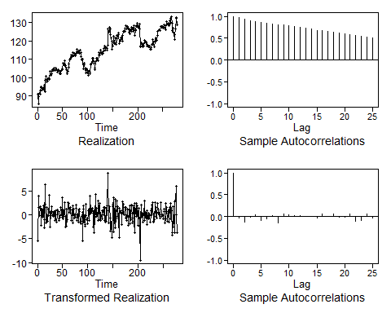

px = plotts.sample.wge(dif1)

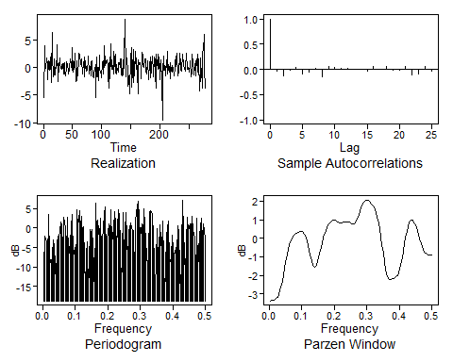

aic5.wge(dif1)

## ---------WORKING... PLEASE WAIT...   
##   
##   
## Five Smallest Values of aic

## p q aic  
## 7 2 0 1.319327  
## 3 0 2 1.321404  
## 6 1 2 1.324496  
## 8 2 1 1.324633  
## 10 3 0 1.325800

* ‘dif1’ looks to be just white noise. Hence the model best suited for this could be a simple ARIMA(0,1,0)
* The Spectral Density does indicate a few small peaks and dips, indicating that there may be some AR and MA components as well. After checking the AIC values, a fit with p = 2 and q = 0 does give the best AIC and hence we could also use ARIMA(2,1,0) and compare the results of the 2 models.