# LA CMORT

## Default

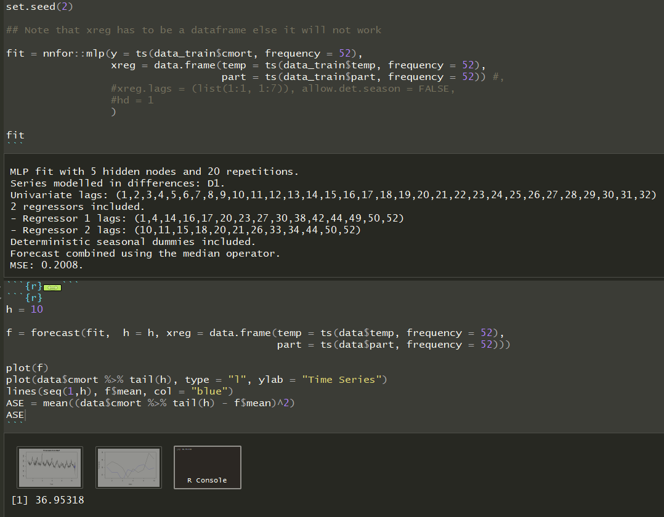

## With Limited lags (y and xreg) & no seasons

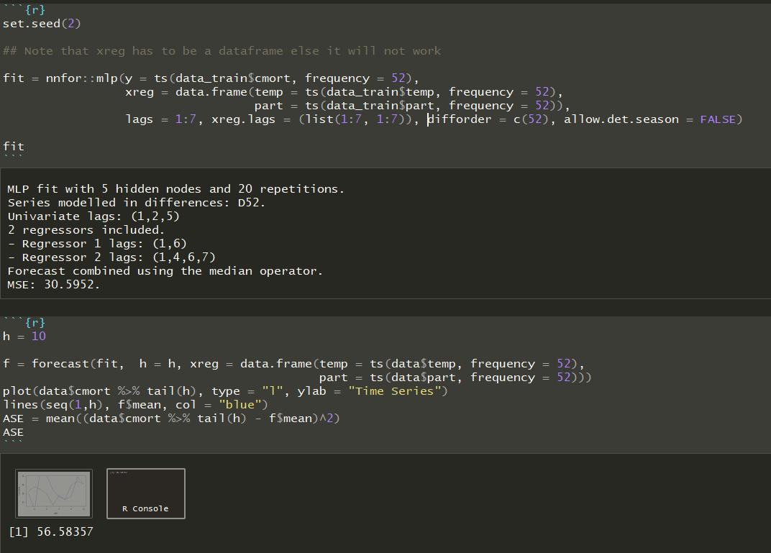

## With Limited lags (only for xreg) and no seasons

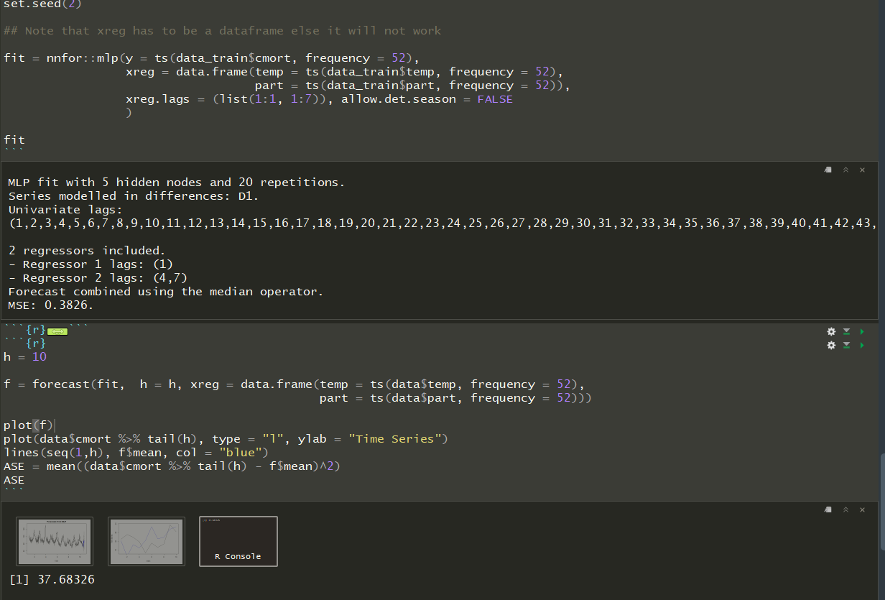

## With Limited lags (only for xreg) and no seasons with hd = 1

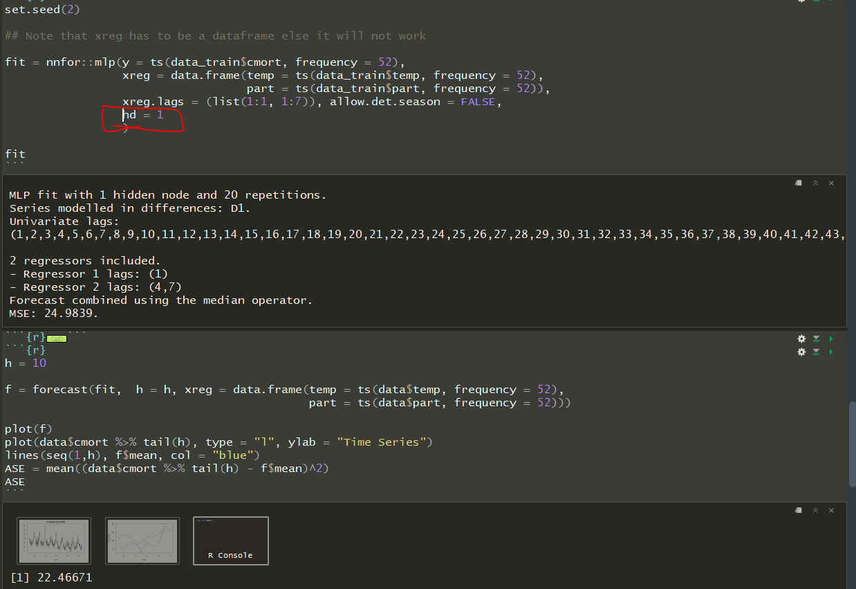

No overfitting now, but MSE has increased. Maybe try increasing hd = 2

## With Limited lags (only for xreg) and no seasons with hd = 2

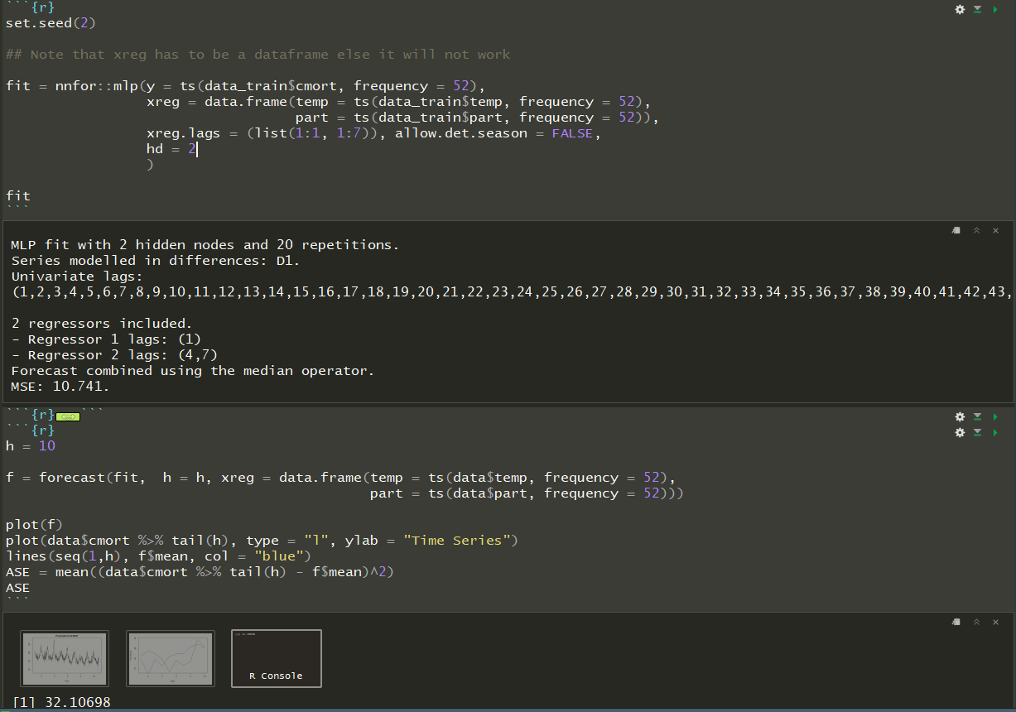

Again overfitting. Maybe try reducing lags for y 🡪 This does not help, infact makes it much worse. So prevous lags of y arew very important.

Next maybe try uncreasing lags of xregs with hd = 1

# My Series

## Default

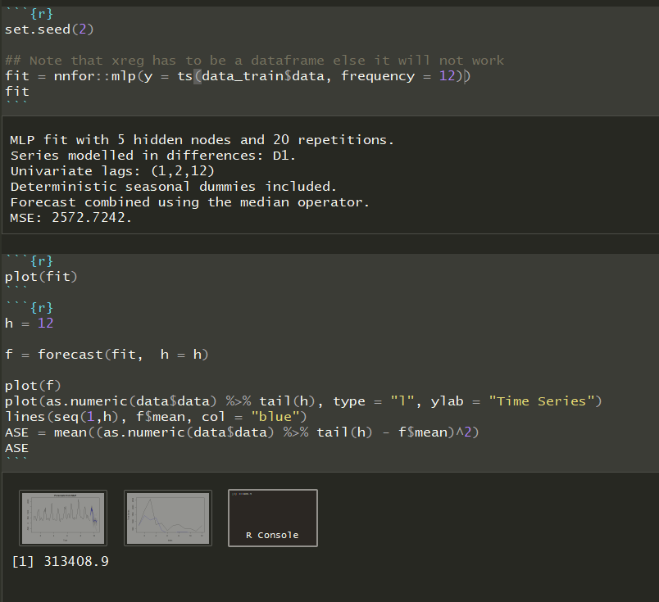

## D = 1 and 12

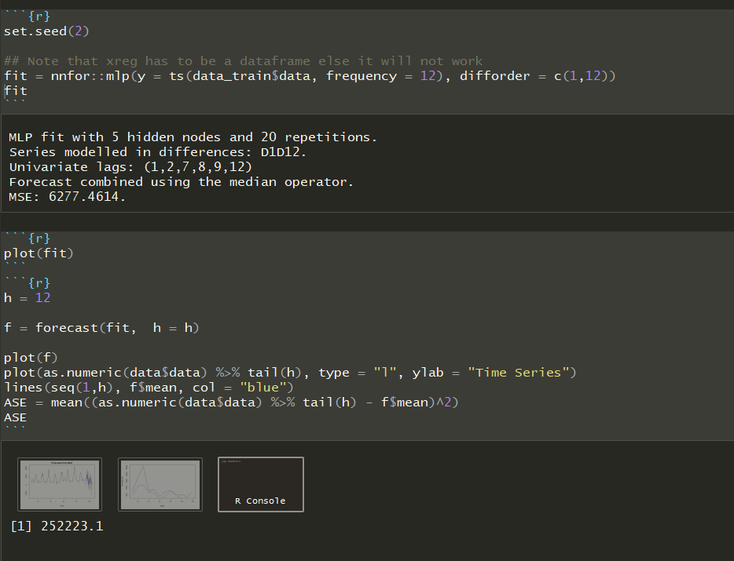

## D = 12 only

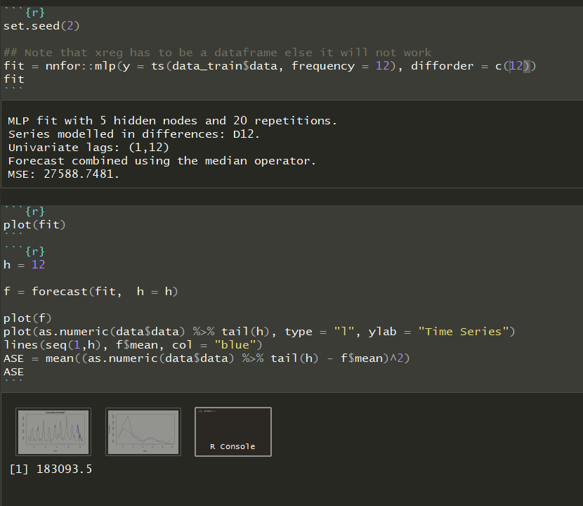

## Reduce hd to see if overfitting is reduced

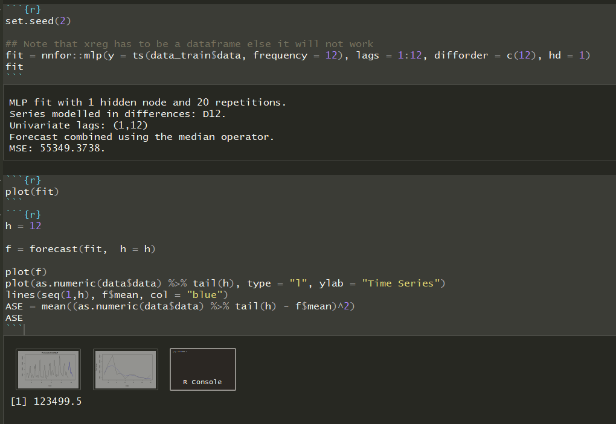

## Increase univariate lags to 36

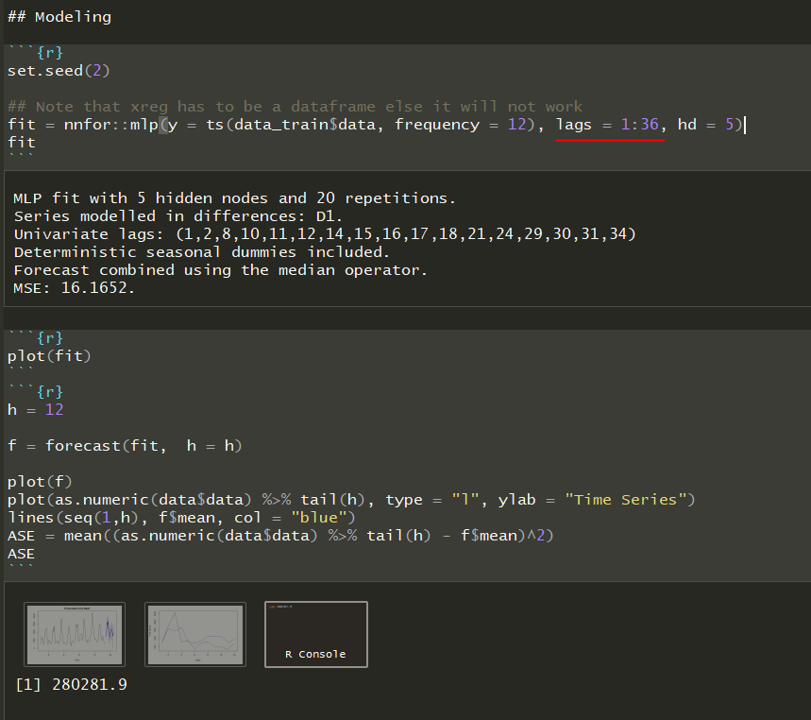

Overfitting, lets reduce hd