Time Series - Async Week 1

Nikhil Gupta

2020-01-11 13:49:08

Table of Contents

library(tswge)

## Warning: package 'tswge' was built under R version 3.5.3

source("common_functions.R")

# Noctula vs Lavon (Stationarity)

data("noctula")  
plot(noctula)

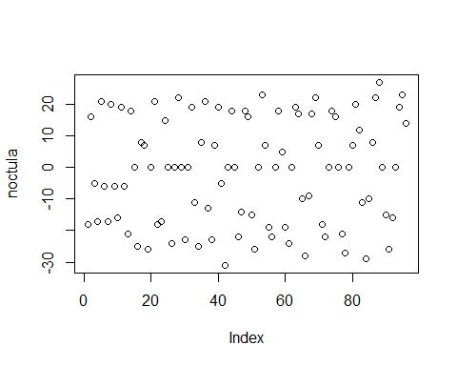

acf(noctula[1:48])

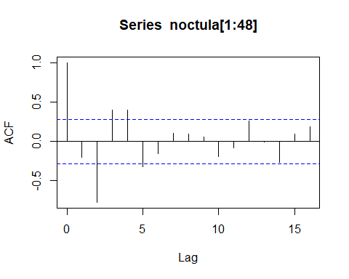

acf(noctula[49:96])

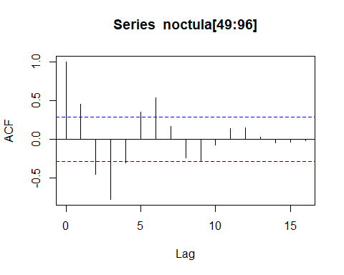

data("lavon")   
plot(lavon)

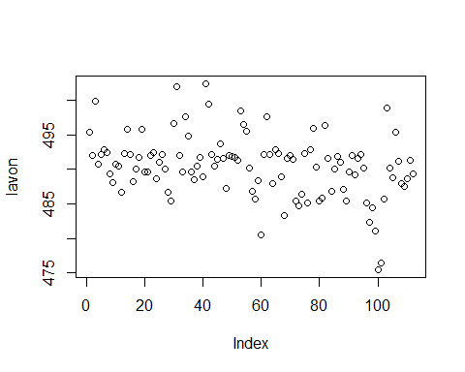

acf(lavon[1:56])

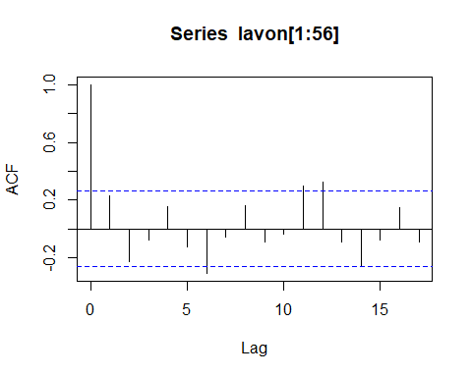

acf(lavon[57:112])

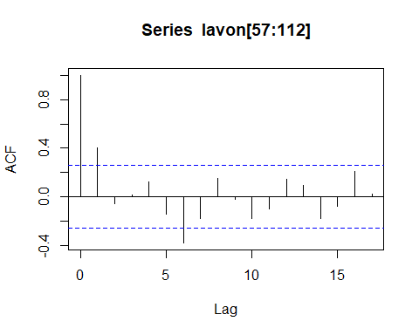

# Whale Dataset (Staionarity)

data("whale")  
plot(whale)  
lines(whale)

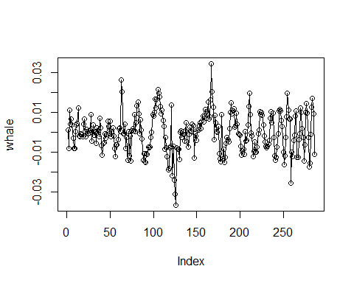

len = length(whale)  
len_by_2 = round(len/2)  
seg_2_start = len_by_2+1  
acf(whale[1:len_by_2])

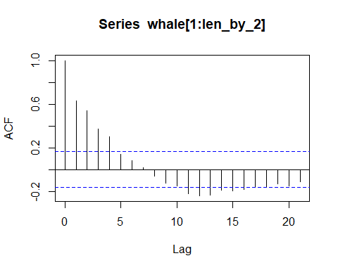

acf(whale[seg_2_start:len])

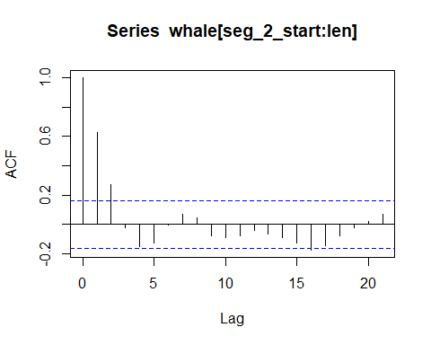

# Checking functionality of function  
check_stationarity(whale)

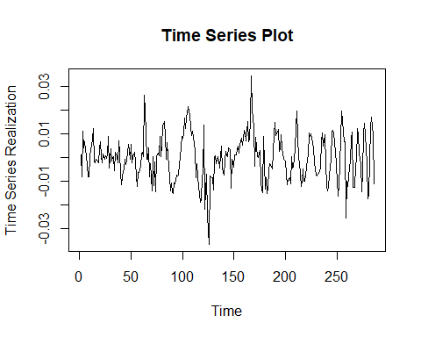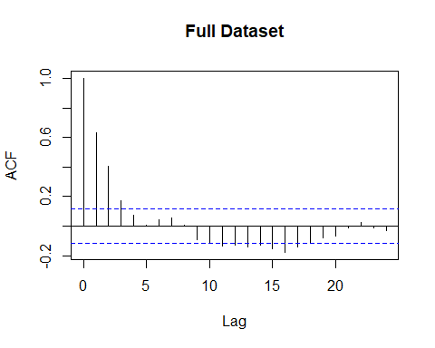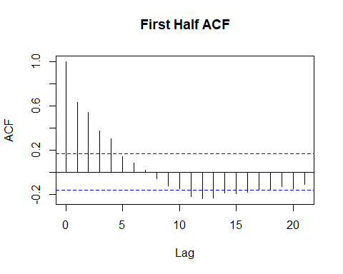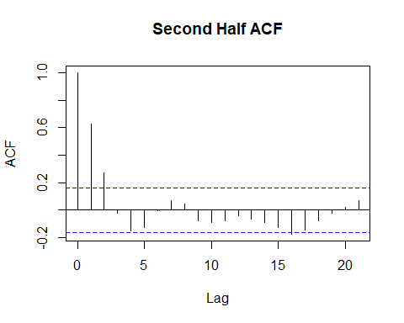

bond = read.csv("../Datasets/10_year_bond_rate_2010-2015.csv")  
head(bond)

## Date Open High Low Close Adj.Close Volume  
## 1 1/4/10 3.859 3.859 3.808 3.841 3.841 0  
## 2 1/5/10 3.790 3.800 3.749 3.755 3.755 0  
## 3 1/6/10 3.771 3.837 3.761 3.808 3.808 0  
## 4 1/7/10 3.845 3.859 3.800 3.822 3.822 0  
## 5 1/8/10 3.843 3.851 3.775 3.808 3.808 0  
## 6 1/11/10 3.816 3.836 3.796 3.818 3.818 0

check_stationarity(bond$Adj.Close)

