Time Series - Async Week 2

Nikhil Gupta

2020-01-11 13:45:26

Table of Contents

library(tswge)

## Warning: package 'tswge' was built under R version 3.5.3

data(patemp)  
parzen.wge(patemp)

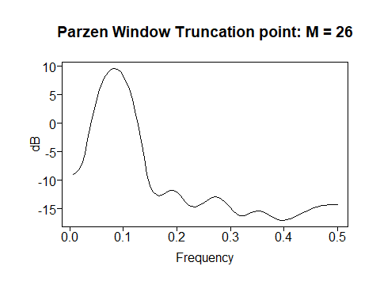

## $freq  
## [1] 0.005555556 0.011111111 0.016666667 0.022222222 0.027777778  
## [6] 0.033333333 0.038888889 0.044444444 0.050000000 0.055555556  
## [11] 0.061111111 0.066666667 0.072222222 0.077777778 0.083333333  
## [16] 0.088888889 0.094444444 0.100000000 0.105555556 0.111111111  
## [21] 0.116666667 0.122222222 0.127777778 0.133333333 0.138888889  
## [26] 0.144444444 0.150000000 0.155555556 0.161111111 0.166666667  
## [31] 0.172222222 0.177777778 0.183333333 0.188888889 0.194444444  
## [36] 0.200000000 0.205555556 0.211111111 0.216666667 0.222222222  
## [41] 0.227777778 0.233333333 0.238888889 0.244444444 0.250000000  
## [46] 0.255555556 0.261111111 0.266666667 0.272222222 0.277777778  
## [51] 0.283333333 0.288888889 0.294444444 0.300000000 0.305555556  
## [56] 0.311111111 0.316666667 0.322222222 0.327777778 0.333333333  
## [61] 0.338888889 0.344444444 0.350000000 0.355555556 0.361111111  
## [66] 0.366666667 0.372222222 0.377777778 0.383333333 0.388888889  
## [71] 0.394444444 0.400000000 0.405555556 0.411111111 0.416666667  
## [76] 0.422222222 0.427777778 0.433333333 0.438888889 0.444444444  
## [81] 0.450000000 0.455555556 0.461111111 0.466666667 0.472222222  
## [86] 0.477777778 0.483333333 0.488888889 0.494444444 0.500000000  
##   
## $pzgram  
## [1] -9.0635551 -8.7758339 -8.2478675 -7.1942384 -5.3394096  
## [6] -2.8823656 -0.2994674 2.0866138 4.1504327 5.8649465  
## [11] 7.2380115 8.2860937 9.0248968 9.4663558 9.6178361  
## [16] 9.4819963 9.0567536 8.3351594 7.3051630 5.9494181  
## [21] 4.2456923 2.1696059 -0.2950985 -3.1239353 -6.1636626  
## [26] -8.9851089 -10.9775927 -12.0114597 -12.5044080 -12.7146594  
## [31] -12.6426496 -12.3321682 -11.9698923 -11.7548308 -11.7991427  
## [36] -12.1219488 -12.6680603 -13.3227770 -13.9378706 -14.3864929  
## [41] -14.6181580 -14.6548624 -14.5387365 -14.3010169 -13.9740804  
## [46] -13.6107407 -13.2808100 -13.0511725 -12.9693040 -13.0578680  
## [51] -13.3165064 -13.7254520 -14.2480344 -14.8311694 -15.4049124  
## [56] -15.8860495 -16.1947397 -16.2866352 -16.1801305 -15.9499454  
## [61] -15.6907757 -15.4826657 -15.3760004 -15.3915982 -15.5263162  
## [66] -15.7590151 -16.0557111 -16.3743360 -16.6698487 -16.9003877  
## [71] -17.0346024 -17.0585852 -16.9787680 -16.8178056 -16.6048321  
## [76] -16.3653849 -16.1158248 -15.8636206 -15.6117067 -15.3636386  
## [81] -15.1265440 -14.9106152 -14.7260933 -14.5798649 -14.4734506  
## [86] -14.4030283 -14.3611201 -14.3390407 -14.3291670 -14.3264567

plotts.sample.wge(patemp) # Gets the same information in one command

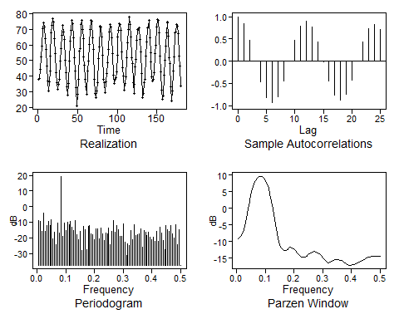

## $autplt  
## [1] 1.0000000000 0.8386381052 0.4803421817 -0.0010081916 -0.4717907055  
## [6] -0.8176935421 -0.9340050360 -0.7999823229 -0.4527311287 0.0089564844  
## [11] 0.4659219410 0.7959391935 0.9002977221 0.7656850843 0.4360703243  
## [16] -0.0098189556 -0.4511591540 -0.7618069185 -0.8701222437 -0.7482146632  
## [21] -0.4297051103 0.0008229813 0.4253734168 0.7280472951 0.8317412380  
## [26] 0.7119144914  
##   
## $freq  
## [1] 0.005555556 0.011111111 0.016666667 0.022222222 0.027777778  
## [6] 0.033333333 0.038888889 0.044444444 0.050000000 0.055555556  
## [11] 0.061111111 0.066666667 0.072222222 0.077777778 0.083333333  
## [16] 0.088888889 0.094444444 0.100000000 0.105555556 0.111111111  
## [21] 0.116666667 0.122222222 0.127777778 0.133333333 0.138888889  
## [26] 0.144444444 0.150000000 0.155555556 0.161111111 0.166666667  
## [31] 0.172222222 0.177777778 0.183333333 0.188888889 0.194444444  
## [36] 0.200000000 0.205555556 0.211111111 0.216666667 0.222222222  
## [41] 0.227777778 0.233333333 0.238888889 0.244444444 0.250000000  
## [46] 0.255555556 0.261111111 0.266666667 0.272222222 0.277777778  
## [51] 0.283333333 0.288888889 0.294444444 0.300000000 0.305555556  
## [56] 0.311111111 0.316666667 0.322222222 0.327777778 0.333333333  
## [61] 0.338888889 0.344444444 0.350000000 0.355555556 0.361111111  
## [66] 0.366666667 0.372222222 0.377777778 0.383333333 0.388888889  
## [71] 0.394444444 0.400000000 0.405555556 0.411111111 0.416666667  
## [76] 0.422222222 0.427777778 0.433333333 0.438888889 0.444444444  
## [81] 0.450000000 0.455555556 0.461111111 0.466666667 0.472222222  
## [86] 0.477777778 0.483333333 0.488888889 0.494444444 0.500000000  
##   
## $db  
## [1] -8.771088 -9.360721 -15.737798 -4.313122 -15.743661 -12.208996  
## [7] -9.428949 -11.968248 -8.239294 -20.720590 -16.271042 -24.596701  
## [13] -10.683798 -17.053219 19.370989 -18.932365 -10.614868 -15.091067  
## [19] -10.156834 -11.480831 -9.680582 -13.060651 -15.499787 -8.778419  
## [25] -18.242187 -21.294686 -16.068197 -28.197994 -12.526897 -15.017696  
## [31] -27.314825 -12.775833 -12.091626 -17.397303 -18.024097 -21.291777  
## [37] -14.326317 -14.271900 -20.370206 -13.669982 -17.195521 -21.862748  
## [43] -16.728130 -17.341597 -13.898914 -24.516083 -15.624845 -8.786330  
## [49] -16.560375 -12.010207 -14.681674 -18.916961 -18.939517 -11.225404  
## [55] -23.024727 -31.110785 -23.696819 -24.669930 -15.468664 -21.121657  
## [61] -11.827490 -18.590177 -17.849549 -17.487407 -14.074204 -26.044079  
## [67] -15.560006 -16.238814 -18.521560 -16.321596 -19.433220 -20.984045  
## [73] -19.408283 -22.352876 -15.812703 -22.318467 -13.088358 -16.828632  
## [79] -21.554603 -27.546740 -11.872237 -15.028974 -15.998016 -12.067287  
## [85] -17.620445 -20.127600 -11.533721 -24.526866 -14.993360 -37.462392  
##   
## $dbz  
## [1] -9.0635551 -8.7758339 -8.2478675 -7.1942384 -5.3394096  
## [6] -2.8823656 -0.2994674 2.0866138 4.1504327 5.8649465  
## [11] 7.2380115 8.2860937 9.0248968 9.4663558 9.6178361  
## [16] 9.4819963 9.0567536 8.3351594 7.3051630 5.9494181  
## [21] 4.2456923 2.1696059 -0.2950985 -3.1239353 -6.1636626  
## [26] -8.9851089 -10.9775927 -12.0114597 -12.5044080 -12.7146594  
## [31] -12.6426496 -12.3321682 -11.9698923 -11.7548308 -11.7991427  
## [36] -12.1219488 -12.6680603 -13.3227770 -13.9378706 -14.3864929  
## [41] -14.6181580 -14.6548624 -14.5387365 -14.3010169 -13.9740804  
## [46] -13.6107407 -13.2808100 -13.0511725 -12.9693040 -13.0578680  
## [51] -13.3165064 -13.7254520 -14.2480344 -14.8311694 -15.4049124  
## [56] -15.8860495 -16.1947397 -16.2866352 -16.1801305 -15.9499454  
## [61] -15.6907757 -15.4826657 -15.3760004 -15.3915982 -15.5263162  
## [66] -15.7590151 -16.0557111 -16.3743360 -16.6698487 -16.9003877  
## [71] -17.0346024 -17.0585852 -16.9787680 -16.8178056 -16.6048321  
## [76] -16.3653849 -16.1158248 -15.8636206 -15.6117067 -15.3636386  
## [81] -15.1265440 -14.9106152 -14.7260933 -14.5798649 -14.4734506  
## [86] -14.4030283 -14.3611201 -14.3390407 -14.3291670 -14.3264567

data(airlog)  
plot(airlog, type = 'l')

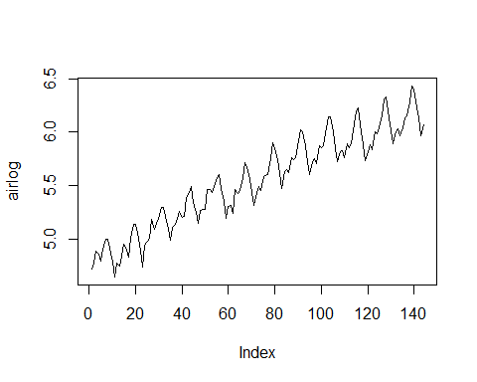

plotts.wge(airlog) # equivalent of the above for plotting

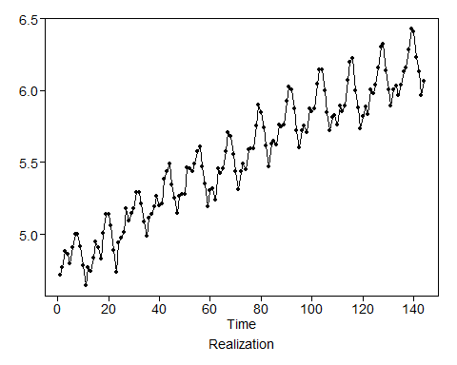

parzen.wge(airlog)

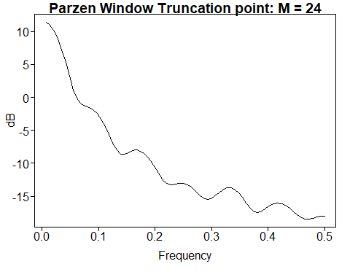

## $freq  
## [1] 0.006944444 0.013888889 0.020833333 0.027777778 0.034722222  
## [6] 0.041666667 0.048611111 0.055555556 0.062500000 0.069444444  
## [11] 0.076388889 0.083333333 0.090277778 0.097222222 0.104166667  
## [16] 0.111111111 0.118055556 0.125000000 0.131944444 0.138888889  
## [21] 0.145833333 0.152777778 0.159722222 0.166666667 0.173611111  
## [26] 0.180555556 0.187500000 0.194444444 0.201388889 0.208333333  
## [31] 0.215277778 0.222222222 0.229166667 0.236111111 0.243055556  
## [36] 0.250000000 0.256944444 0.263888889 0.270833333 0.277777778  
## [41] 0.284722222 0.291666667 0.298611111 0.305555556 0.312500000  
## [46] 0.319444444 0.326388889 0.333333333 0.340277778 0.347222222  
## [51] 0.354166667 0.361111111 0.368055556 0.375000000 0.381944444  
## [56] 0.388888889 0.395833333 0.402777778 0.409722222 0.416666667  
## [61] 0.423611111 0.430555556 0.437500000 0.444444444 0.451388889  
## [66] 0.458333333 0.465277778 0.472222222 0.479166667 0.486111111  
## [71] 0.493055556 0.500000000  
##   
## $pzgram  
## [1] 11.4654366 10.9402294 10.0590071 8.8164678 7.2162262  
## [6] 5.2946980 3.1768189 1.1618879 -0.3081259 -1.0306219  
## [11] -1.2919915 -1.4941980 -1.8606232 -2.4646056 -3.3131502  
## [16] -4.3858382 -5.6296105 -6.9173670 -8.0045606 -8.6064604  
## [21] -8.6554265 -8.3893942 -8.1090657 -7.9990125 -8.1318582  
## [26] -8.5188051 -9.1418634 -9.9633188 -10.9162381 -11.8823737  
## [31] -12.6853883 -13.1569739 -13.2679842 -13.1632662 -13.0423784  
## [36] -13.0491791 -13.2490611 -13.6450446 -14.1898757 -14.7847644  
## [41] -15.2784729 -15.5045413 -15.3786493 -14.9725277 -14.4620652  
## [46] -14.0193387 -13.7595675 -13.7426596 -13.9886449 -14.4865070  
## [51] -15.1914119 -16.0104400 -16.7868134 -17.3199722 -17.4658590  
## [56] -17.2504902 -16.8437217 -16.4316935 -16.1411403 -16.0357959  
## [61] -16.1342649 -16.4226496 -16.8585671 -17.3711175 -17.8654359  
## [66] -18.2428288 -18.4379904 -18.4500786 -18.3378652 -18.1841683  
## [71] -18.0614831 -18.0155070

parzen.wge(airlog,trunc = 70)

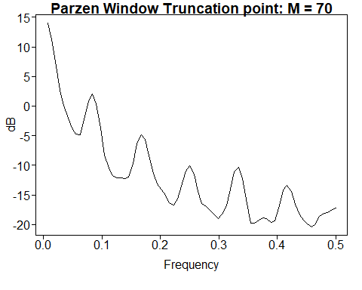

## $freq  
## [1] 0.006944444 0.013888889 0.020833333 0.027777778 0.034722222  
## [6] 0.041666667 0.048611111 0.055555556 0.062500000 0.069444444  
## [11] 0.076388889 0.083333333 0.090277778 0.097222222 0.104166667  
## [16] 0.111111111 0.118055556 0.125000000 0.131944444 0.138888889  
## [21] 0.145833333 0.152777778 0.159722222 0.166666667 0.173611111  
## [26] 0.180555556 0.187500000 0.194444444 0.201388889 0.208333333  
## [31] 0.215277778 0.222222222 0.229166667 0.236111111 0.243055556  
## [36] 0.250000000 0.256944444 0.263888889 0.270833333 0.277777778  
## [41] 0.284722222 0.291666667 0.298611111 0.305555556 0.312500000  
## [46] 0.319444444 0.326388889 0.333333333 0.340277778 0.347222222  
## [51] 0.354166667 0.361111111 0.368055556 0.375000000 0.381944444  
## [56] 0.388888889 0.395833333 0.402777778 0.409722222 0.416666667  
## [61] 0.423611111 0.430555556 0.437500000 0.444444444 0.451388889  
## [66] 0.458333333 0.465277778 0.472222222 0.479166667 0.486111111  
## [71] 0.493055556 0.500000000  
##   
## $pzgram  
## [1] 14.0782330 11.1846190 6.7669122 2.7225190 0.1413136  
## [6] -1.9895866 -3.6652378 -4.7747713 -4.8736175 -2.2809751  
## [11] 0.9293132 1.9790395 0.3596980 -3.7619986 -8.2435327  
## [16] -10.3924068 -11.7384956 -12.1447321 -12.1072795 -12.1859201  
## [21] -11.9730618 -9.6702548 -6.3942851 -4.8013202 -5.5756246  
## [26] -8.3555021 -11.4084737 -13.1662712 -14.1688463 -14.9826821  
## [31] -16.2818744 -16.7202491 -15.6765945 -13.5087507 -11.0097143  
## [36] -10.1348742 -11.5326612 -14.4421130 -16.3928971 -16.9726903  
## [41] -17.5352060 -18.4057529 -18.9491709 -18.2328950 -16.8528361  
## [46] -13.9754946 -11.0640623 -10.2840082 -12.1834941 -16.4685704  
## [51] -19.8081260 -19.7294415 -19.2187695 -18.8716870 -18.9992206  
## [56] -19.6131320 -19.4141208 -16.8412557 -14.1981022 -13.3535350  
## [61] -14.4146483 -16.5260034 -18.3226420 -19.3056864 -19.8847445  
## [66] -20.3602293 -19.8454272 -18.6503277 -18.0884319 -17.9772374  
## [71] -17.5141828 -17.1597927

plotts.sample.wge(airlog, trunc = 70)

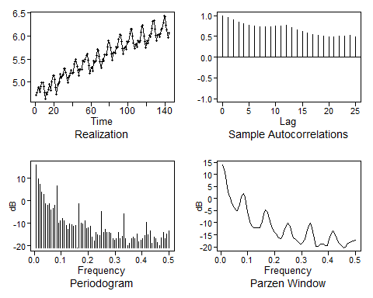

## $autplt  
## [1] 1.0000000 0.9537034 0.8989159 0.8508025 0.8084252 0.7788994 0.7564422  
## [8] 0.7376017 0.7271313 0.7336487 0.7442552 0.7580266 0.7619429 0.7165045  
## [15] 0.6630428 0.6183629 0.5762087 0.5438013 0.5194561 0.5007029 0.4904028  
## [22] 0.4981819 0.5061666 0.5167434 0.5204897 0.4835237  
##   
## $freq  
## [1] 0.006944444 0.013888889 0.020833333 0.027777778 0.034722222  
## [6] 0.041666667 0.048611111 0.055555556 0.062500000 0.069444444  
## [11] 0.076388889 0.083333333 0.090277778 0.097222222 0.104166667  
## [16] 0.111111111 0.118055556 0.125000000 0.131944444 0.138888889  
## [21] 0.145833333 0.152777778 0.159722222 0.166666667 0.173611111  
## [26] 0.180555556 0.187500000 0.194444444 0.201388889 0.208333333  
## [31] 0.215277778 0.222222222 0.229166667 0.236111111 0.243055556  
## [36] 0.250000000 0.256944444 0.263888889 0.270833333 0.277777778  
## [41] 0.284722222 0.291666667 0.298611111 0.305555556 0.312500000  
## [46] 0.319444444 0.326388889 0.333333333 0.340277778 0.347222222  
## [51] 0.354166667 0.361111111 0.368055556 0.375000000 0.381944444  
## [56] 0.388888889 0.395833333 0.402777778 0.409722222 0.416666667  
## [61] 0.423611111 0.430555556 0.437500000 0.444444444 0.451388889  
## [66] 0.458333333 0.465277778 0.472222222 0.479166667 0.486111111  
## [71] 0.493055556 0.500000000  
##   
## $db  
## [1] 16.074652 9.707151 7.450389 3.951430 2.870990 -1.362910  
## [7] -1.963401 -1.207527 -4.037011 -3.261281 -2.144731 6.659726  
## [13] -10.049663 -8.832691 -7.989512 -8.870613 -10.863837 -12.810353  
## [19] -10.215250 -10.798307 -11.364355 -10.996384 -20.907381 -1.379644  
## [25] -9.873929 -10.397306 -9.049324 -12.219998 -12.007972 -11.480775  
## [31] -16.052737 -17.938246 -14.082488 -15.083055 -15.354353 -4.875903  
## [37] -14.208957 -12.796969 -14.274424 -14.257255 -14.330363 -16.861169  
## [43] -17.397169 -17.013422 -14.168538 -16.792001 -15.802334 -5.751597  
## [49] -16.984530 -20.043553 -18.839272 -16.953054 -16.136041 -17.027935  
## [55] -14.816991 -18.351344 -17.674782 -16.968754 -15.500680 -9.585170  
## [61] -15.148437 -13.462485 -18.912460 -16.196325 -16.978206 -18.433174  
## [67] -19.887023 -16.486009 -14.193681 -16.910723 -14.772011 -13.254041  
##   
## $dbz  
## [1] 14.0782330 11.1846190 6.7669122 2.7225190 0.1413136  
## [6] -1.9895866 -3.6652378 -4.7747713 -4.8736175 -2.2809751  
## [11] 0.9293132 1.9790395 0.3596980 -3.7619986 -8.2435327  
## [16] -10.3924068 -11.7384956 -12.1447321 -12.1072795 -12.1859201  
## [21] -11.9730618 -9.6702548 -6.3942851 -4.8013202 -5.5756246  
## [26] -8.3555021 -11.4084737 -13.1662712 -14.1688463 -14.9826821  
## [31] -16.2818744 -16.7202491 -15.6765945 -13.5087507 -11.0097143  
## [36] -10.1348742 -11.5326612 -14.4421130 -16.3928971 -16.9726903  
## [41] -17.5352060 -18.4057529 -18.9491709 -18.2328950 -16.8528361  
## [46] -13.9754946 -11.0640623 -10.2840082 -12.1834941 -16.4685704  
## [51] -19.8081260 -19.7294415 -19.2187695 -18.8716870 -18.9992206  
## [56] -19.6131320 -19.4141208 -16.8412557 -14.1981022 -13.3535350  
## [61] -14.4146483 -16.5260034 -18.3226420 -19.3056864 -19.8847445  
## [66] -20.3602293 -19.8454272 -18.6503277 -18.0884319 -17.9772374  
## [71] -17.5141828 -17.1597927

data(bat)  
parzen.wge(bat)

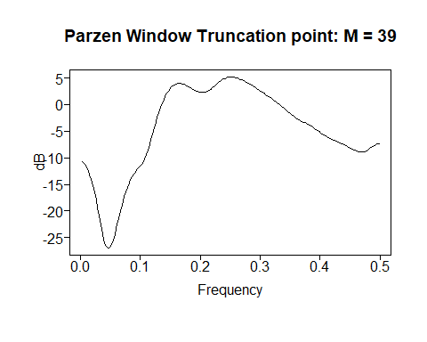

## $freq  
## [1] 0.002624672 0.005249344 0.007874016 0.010498688 0.013123360  
## [6] 0.015748031 0.018372703 0.020997375 0.023622047 0.026246719  
## [11] 0.028871391 0.031496063 0.034120735 0.036745407 0.039370079  
## [16] 0.041994751 0.044619423 0.047244094 0.049868766 0.052493438  
## [21] 0.055118110 0.057742782 0.060367454 0.062992126 0.065616798  
## [26] 0.068241470 0.070866142 0.073490814 0.076115486 0.078740157  
## [31] 0.081364829 0.083989501 0.086614173 0.089238845 0.091863517  
## [36] 0.094488189 0.097112861 0.099737533 0.102362205 0.104986877  
## [41] 0.107611549 0.110236220 0.112860892 0.115485564 0.118110236  
## [46] 0.120734908 0.123359580 0.125984252 0.128608924 0.131233596  
## [51] 0.133858268 0.136482940 0.139107612 0.141732283 0.144356955  
## [56] 0.146981627 0.149606299 0.152230971 0.154855643 0.157480315  
## [61] 0.160104987 0.162729659 0.165354331 0.167979003 0.170603675  
## [66] 0.173228346 0.175853018 0.178477690 0.181102362 0.183727034  
## [71] 0.186351706 0.188976378 0.191601050 0.194225722 0.196850394  
## [76] 0.199475066 0.202099738 0.204724409 0.207349081 0.209973753  
## [81] 0.212598425 0.215223097 0.217847769 0.220472441 0.223097113  
## [86] 0.225721785 0.228346457 0.230971129 0.233595801 0.236220472  
## [91] 0.238845144 0.241469816 0.244094488 0.246719160 0.249343832  
## [96] 0.251968504 0.254593176 0.257217848 0.259842520 0.262467192  
## [101] 0.265091864 0.267716535 0.270341207 0.272965879 0.275590551  
## [106] 0.278215223 0.280839895 0.283464567 0.286089239 0.288713911  
## [111] 0.291338583 0.293963255 0.296587927 0.299212598 0.301837270  
## [116] 0.304461942 0.307086614 0.309711286 0.312335958 0.314960630  
## [121] 0.317585302 0.320209974 0.322834646 0.325459318 0.328083990  
## [126] 0.330708661 0.333333333 0.335958005 0.338582677 0.341207349  
## [131] 0.343832021 0.346456693 0.349081365 0.351706037 0.354330709  
## [136] 0.356955381 0.359580052 0.362204724 0.364829396 0.367454068  
## [141] 0.370078740 0.372703412 0.375328084 0.377952756 0.380577428  
## [146] 0.383202100 0.385826772 0.388451444 0.391076115 0.393700787  
## [151] 0.396325459 0.398950131 0.401574803 0.404199475 0.406824147  
## [156] 0.409448819 0.412073491 0.414698163 0.417322835 0.419947507  
## [161] 0.422572178 0.425196850 0.427821522 0.430446194 0.433070866  
## [166] 0.435695538 0.438320210 0.440944882 0.443569554 0.446194226  
## [171] 0.448818898 0.451443570 0.454068241 0.456692913 0.459317585  
## [176] 0.461942257 0.464566929 0.467191601 0.469816273 0.472440945  
## [181] 0.475065617 0.477690289 0.480314961 0.482939633 0.485564304  
## [186] 0.488188976 0.490813648 0.493438320 0.496062992 0.498687664  
##   
## $pzgram  
## [1] -10.68542934 -10.89385912 -11.24268011 -11.73401216 -12.37071965  
## [6] -13.15622709 -14.09412575 -15.18736419 -16.43662482 -17.83715032  
## [11] -19.37277543 -21.00555265 -22.66073696 -24.21435312 -25.50650467  
## [16] -26.40346908 -26.86915410 -26.95673828 -26.73107072 -26.22191871  
## [21] -25.44230491 -24.42764234 -23.24759262 -21.98616388 -20.71717845  
## [26] -19.49324870 -18.34671528 -17.29502841 -16.34595540 -15.50123374  
## [31] -14.75873550 -14.11353775 -13.55822579 -13.08261865 -12.67301149  
## [36] -12.31102741 -11.97232339 -11.62576918 -11.23427577 -10.75876707  
## [41] -10.16591524 -9.43757237 -8.57700779 -7.60778208 -6.56595495  
## [46] -5.49047072 -4.41613706 -3.37048973 -2.37354119 -1.43891974  
## [51] -0.57535483 0.21198974 0.92048637 1.54931083 2.09894729  
## [56] 2.57086770 2.96733261 3.29127283 3.54622093 3.73626860  
## [61] 3.86602958 3.94059162 3.96544369 3.94637046 3.88931408  
## [66] 3.80021494 3.68485621 3.54874850 3.39709553 3.23487459  
## [71] 3.06704415 2.89885621 2.73620845 2.58592888 2.45585592  
## [76] 2.35457763 2.29074632 2.27200412 2.30372201 2.38789824  
## [81] 2.52258240 2.70203553 2.91756933 3.15877688 3.41479288  
## [86] 3.67530625 3.93120467 4.17486736 4.40019649 4.60249378  
## [91] 4.77827152 4.92505868 5.04123612 5.12591476 5.17885678  
## [96] 5.20043221 5.19159811 5.15388547 5.08937787 5.00066663  
## [101] 4.89076917 4.76300222 4.62080897 4.46754958 4.30627642  
## [106] 4.13952509 3.96915715 3.79628586 3.62130333 3.44400706  
## [111] 3.26380397 3.07995379 2.89180755 2.69899945 2.50156008  
## [116] 2.29993398 2.09490047 1.88741378 1.67839353 1.46850806  
## [121] 1.25799699 1.04657441 0.83343848 0.61739219 0.39705714  
## [126] 0.17114526 -0.06125537 -0.30042512 -0.54582648 -0.79601729  
## [131] -1.04868418 -1.30080514 -1.54893473 -1.78958500 -2.01965303  
## [136] -2.23682686 -2.43989658 -2.62891101 -2.80515303 -2.97094781  
## [141] -3.12935249 -3.28379291 -3.43770886 -3.59425070 -3.75604672  
## [146] -3.92504132 -4.10239275 -4.28841763 -4.48257431 -4.68348632  
## [151] -4.88901593 -5.09640346 -5.30248564 -5.50399467 -5.69791752  
## [156] -5.88186909 -6.05441085 -6.21524275 -6.36521539 -6.50615126  
## [161] -6.64051214 -6.77098862 -6.90010273 -7.02990474 -7.16181601  
## [166] -7.29663109 -7.43465279 -7.57589860 -7.72029326 -7.86775535  
## [171] -8.01810143 -8.17072963 -8.32410101 -8.47510472 -8.61846566  
## [176] -8.74642439 -8.84896563 -8.91484153 -8.93345324 -8.89729097  
## [181] -8.80422037 -8.65874151 -8.47167541 -8.25841941 -8.03649082  
## [186] -7.82318807 -7.63389370 -7.48113209 -7.37422034 -7.31926179

plotts.sample.wge(bat)

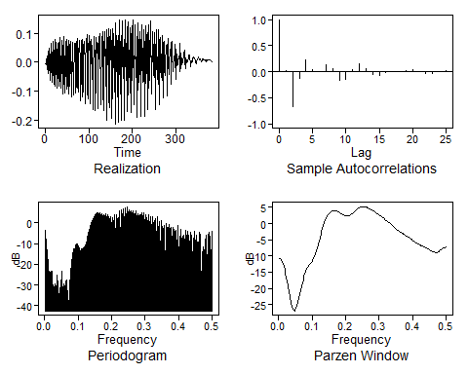

## $autplt  
## [1] 1.000000000 0.026299388 -0.669107417 -0.119605013 0.225015156  
## [6] 0.037437299 0.001691383 0.127361873 0.051042928 -0.156036504  
## [11] -0.147735345 0.042436579 0.161201294 0.068717397 -0.054547762  
## [16] -0.064530125 -0.006477584 -0.005047795 0.006357790 0.024066074  
## [21] 0.045226474 0.012875623 -0.033345250 -0.033577058 0.007287397  
## [26] 0.013130475  
##   
## $freq  
## [1] 0.002624672 0.005249344 0.007874016 0.010498688 0.013123360  
## [6] 0.015748031 0.018372703 0.020997375 0.023622047 0.026246719  
## [11] 0.028871391 0.031496063 0.034120735 0.036745407 0.039370079  
## [16] 0.041994751 0.044619423 0.047244094 0.049868766 0.052493438  
## [21] 0.055118110 0.057742782 0.060367454 0.062992126 0.065616798  
## [26] 0.068241470 0.070866142 0.073490814 0.076115486 0.078740157  
## [31] 0.081364829 0.083989501 0.086614173 0.089238845 0.091863517  
## [36] 0.094488189 0.097112861 0.099737533 0.102362205 0.104986877  
## [41] 0.107611549 0.110236220 0.112860892 0.115485564 0.118110236  
## [46] 0.120734908 0.123359580 0.125984252 0.128608924 0.131233596  
## [51] 0.133858268 0.136482940 0.139107612 0.141732283 0.144356955  
## [56] 0.146981627 0.149606299 0.152230971 0.154855643 0.157480315  
## [61] 0.160104987 0.162729659 0.165354331 0.167979003 0.170603675  
## [66] 0.173228346 0.175853018 0.178477690 0.181102362 0.183727034  
## [71] 0.186351706 0.188976378 0.191601050 0.194225722 0.196850394  
## [76] 0.199475066 0.202099738 0.204724409 0.207349081 0.209973753  
## [81] 0.212598425 0.215223097 0.217847769 0.220472441 0.223097113  
## [86] 0.225721785 0.228346457 0.230971129 0.233595801 0.236220472  
## [91] 0.238845144 0.241469816 0.244094488 0.246719160 0.249343832  
## [96] 0.251968504 0.254593176 0.257217848 0.259842520 0.262467192  
## [101] 0.265091864 0.267716535 0.270341207 0.272965879 0.275590551  
## [106] 0.278215223 0.280839895 0.283464567 0.286089239 0.288713911  
## [111] 0.291338583 0.293963255 0.296587927 0.299212598 0.301837270  
## [116] 0.304461942 0.307086614 0.309711286 0.312335958 0.314960630  
## [121] 0.317585302 0.320209974 0.322834646 0.325459318 0.328083990  
## [126] 0.330708661 0.333333333 0.335958005 0.338582677 0.341207349  
## [131] 0.343832021 0.346456693 0.349081365 0.351706037 0.354330709  
## [136] 0.356955381 0.359580052 0.362204724 0.364829396 0.367454068  
## [141] 0.370078740 0.372703412 0.375328084 0.377952756 0.380577428  
## [146] 0.383202100 0.385826772 0.388451444 0.391076115 0.393700787  
## [151] 0.396325459 0.398950131 0.401574803 0.404199475 0.406824147  
## [156] 0.409448819 0.412073491 0.414698163 0.417322835 0.419947507  
## [161] 0.422572178 0.425196850 0.427821522 0.430446194 0.433070866  
## [166] 0.435695538 0.438320210 0.440944882 0.443569554 0.446194226  
## [171] 0.448818898 0.451443570 0.454068241 0.456692913 0.459317585  
## [176] 0.461942257 0.464566929 0.467191601 0.469816273 0.472440945  
## [181] 0.475065617 0.477690289 0.480314961 0.482939633 0.485564304  
## [186] 0.488188976 0.490813648 0.493438320 0.496062992 0.498687664  
##   
## $db  
## [1] -3.48578686 -11.67305472 -13.69002660 -20.40961465 -25.02334622  
## [6] -23.80056797 -23.20083143 -28.70397548 -23.48181496 -35.82381478  
## [11] -32.10447386 -29.47453027 -35.44409007 -25.02563386 -30.14598123  
## [16] -37.34368278 -31.17384430 -30.88506447 -31.30645496 -23.28026851  
## [21] -37.39235650 -29.32494040 -31.97369375 -28.68702796 -27.55989549  
## [26] -37.32733988 -42.43126768 -31.59795491 -30.90443047 -24.11946784  
## [31] -19.57399728 -15.93540307 -12.64172235 -13.75500643 -10.93157608  
## [36] -10.29512143 -10.33896487 -11.50692488 -10.89653690 -12.66441324  
## [41] -14.05839555 -12.35477408 -12.29179794 -11.77862021 -11.34063803  
## [46] -11.94588191 -9.06307816 -8.69885237 -6.86949325 -5.19313725  
## [51] -3.70303686 -2.11603867 -0.25938873 0.91282248 1.89016896  
## [56] 2.68380092 3.85443681 4.48208245 5.07571826 5.10190296  
## [61] 5.15282677 4.43227157 4.77012501 3.44909032 4.31050740  
## [66] 3.64926893 3.79577144 3.61049345 2.05419684 4.30515483  
## [71] 1.99777536 3.97990711 2.93544395 1.83238726 3.15755261  
## [76] -1.49403171 2.78128922 0.70031504 -0.53113628 4.00280889  
## [81] -8.95848001 3.92103067 1.29604607 -0.08248701 5.72749836  
## [86] -10.06954922 6.50925377 2.98154259 3.66849147 6.81793536  
## [91] -1.29958740 7.40262666 0.94169982 7.88506362 3.84338466  
## [96] 6.17931906 5.23751601 6.06620502 4.64920946 5.88353831  
## [101] 5.56986281 4.20712561 3.16844179 5.97249669 2.06475628  
## [106] 4.53253605 3.55762986 3.93531685 2.89614643 4.93680713  
## [111] 1.28805752 2.43043711 5.09657397 -0.92302661 3.98676023  
## [116] 2.00709820 -1.71105146 3.96941805 -1.95067718 1.47458546  
## [121] 2.90069954 -4.66761789 2.82776340 -2.05033834 0.89772191  
## [126] 2.02252561 -11.06508052 2.89814541 -5.31419377 -1.62396642  
## [131] 0.54134864 -17.98454754 1.26114238 -3.84273908 -3.60647775  
## [136] -1.39761362 -26.00638131 -0.36596271 -3.63427224 -3.73526391  
## [141] -0.91654381 -8.98703149 -2.68264248 -2.05079955 -10.59714507  
## [146] -2.16518938 -3.63426724 -4.60728738 -3.56447838 -12.58669728  
## [151] -4.67284059 -1.36508014 -21.41509723 -9.03778275 -3.03672955  
## [156] -10.79796347 -6.86376719 -5.73047771 -11.73962328 -3.63140876  
## [161] -7.40723745 -11.84881516 -4.03582615 -7.50250551 -13.17678416  
## [166] -4.47441241 -6.60279863 -20.08219766 -10.25490580 -4.05108685  
## [171] -21.76799800 -10.41283309 -5.95859515 -11.32196002 -14.01818830  
## [176] -4.53537186 -5.65083070 -40.57997853 -16.04132031 -11.71726742  
## [181] -13.61623662 -17.00236758 -9.34241707 -5.72142559 -23.89306883  
## [186] -6.36375994 -4.44355692 -7.97289484 -21.58060726 -3.97077635  
##   
## $dbz  
## [1] -10.68542934 -10.89385912 -11.24268011 -11.73401216 -12.37071965  
## [6] -13.15622709 -14.09412575 -15.18736419 -16.43662482 -17.83715032  
## [11] -19.37277543 -21.00555265 -22.66073696 -24.21435312 -25.50650467  
## [16] -26.40346908 -26.86915410 -26.95673828 -26.73107072 -26.22191871  
## [21] -25.44230491 -24.42764234 -23.24759262 -21.98616388 -20.71717845  
## [26] -19.49324870 -18.34671528 -17.29502841 -16.34595540 -15.50123374  
## [31] -14.75873550 -14.11353775 -13.55822579 -13.08261865 -12.67301149  
## [36] -12.31102741 -11.97232339 -11.62576918 -11.23427577 -10.75876707  
## [41] -10.16591524 -9.43757237 -8.57700779 -7.60778208 -6.56595495  
## [46] -5.49047072 -4.41613706 -3.37048973 -2.37354119 -1.43891974  
## [51] -0.57535483 0.21198974 0.92048637 1.54931083 2.09894729  
## [56] 2.57086770 2.96733261 3.29127283 3.54622093 3.73626860  
## [61] 3.86602958 3.94059162 3.96544369 3.94637046 3.88931408  
## [66] 3.80021494 3.68485621 3.54874850 3.39709553 3.23487459  
## [71] 3.06704415 2.89885621 2.73620845 2.58592888 2.45585592  
## [76] 2.35457763 2.29074632 2.27200412 2.30372201 2.38789824  
## [81] 2.52258240 2.70203553 2.91756933 3.15877688 3.41479288  
## [86] 3.67530625 3.93120467 4.17486736 4.40019649 4.60249378  
## [91] 4.77827152 4.92505868 5.04123612 5.12591476 5.17885678  
## [96] 5.20043221 5.19159811 5.15388547 5.08937787 5.00066663  
## [101] 4.89076917 4.76300222 4.62080897 4.46754958 4.30627642  
## [106] 4.13952509 3.96915715 3.79628586 3.62130333 3.44400706  
## [111] 3.26380397 3.07995379 2.89180755 2.69899945 2.50156008  
## [116] 2.29993398 2.09490047 1.88741378 1.67839353 1.46850806  
## [121] 1.25799699 1.04657441 0.83343848 0.61739219 0.39705714  
## [126] 0.17114526 -0.06125537 -0.30042512 -0.54582648 -0.79601729  
## [131] -1.04868418 -1.30080514 -1.54893473 -1.78958500 -2.01965303  
## [136] -2.23682686 -2.43989658 -2.62891101 -2.80515303 -2.97094781  
## [141] -3.12935249 -3.28379291 -3.43770886 -3.59425070 -3.75604672  
## [146] -3.92504132 -4.10239275 -4.28841763 -4.48257431 -4.68348632  
## [151] -4.88901593 -5.09640346 -5.30248564 -5.50399467 -5.69791752  
## [156] -5.88186909 -6.05441085 -6.21524275 -6.36521539 -6.50615126  
## [161] -6.64051214 -6.77098862 -6.90010273 -7.02990474 -7.16181601  
## [166] -7.29663109 -7.43465279 -7.57589860 -7.72029326 -7.86775535  
## [171] -8.01810143 -8.17072963 -8.32410101 -8.47510472 -8.61846566  
## [176] -8.74642439 -8.84896563 -8.91484153 -8.93345324 -8.89729097  
## [181] -8.80422037 -8.65874151 -8.47167541 -8.25841941 -8.03649082  
## [186] -7.82318807 -7.63389370 -7.48113209 -7.37422034 -7.31926179

data(sunspot.classic)  
parzen.wge(sunspot.classic)

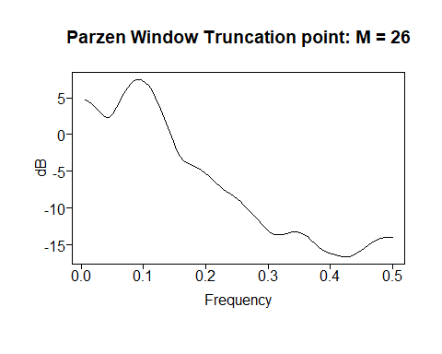

## $freq  
## [1] 0.005681818 0.011363636 0.017045455 0.022727273 0.028409091  
## [6] 0.034090909 0.039772727 0.045454545 0.051136364 0.056818182  
## [11] 0.062500000 0.068181818 0.073863636 0.079545455 0.085227273  
## [16] 0.090909091 0.096590909 0.102272727 0.107954545 0.113636364  
## [21] 0.119318182 0.125000000 0.130681818 0.136363636 0.142045455  
## [26] 0.147727273 0.153409091 0.159090909 0.164772727 0.170454545  
## [31] 0.176136364 0.181818182 0.187500000 0.193181818 0.198863636  
## [36] 0.204545455 0.210227273 0.215909091 0.221590909 0.227272727  
## [41] 0.232954545 0.238636364 0.244318182 0.250000000 0.255681818  
## [46] 0.261363636 0.267045455 0.272727273 0.278409091 0.284090909  
## [51] 0.289772727 0.295454545 0.301136364 0.306818182 0.312500000  
## [56] 0.318181818 0.323863636 0.329545455 0.335227273 0.340909091  
## [61] 0.346590909 0.352272727 0.357954545 0.363636364 0.369318182  
## [66] 0.375000000 0.380681818 0.386363636 0.392045455 0.397727273  
## [71] 0.403409091 0.409090909 0.414772727 0.420454545 0.426136364  
## [76] 0.431818182 0.437500000 0.443181818 0.448863636 0.454545455  
## [81] 0.460227273 0.465909091 0.471590909 0.477272727 0.482954545  
## [86] 0.488636364 0.494318182 0.500000000  
##   
## $pzgram  
## [1] 4.7488071 4.5365492 4.1873742 3.7174233 3.1708076  
## [6] 2.6438737 2.3003992 2.3267685 2.8035777 3.6254364  
## [11] 4.5886722 5.5179388 6.3074089 6.9049566 7.2888195  
## [16] 7.4522850 7.3957570 7.1231997 6.6409529 5.9579339  
## [21] 5.0868864 4.0467174 2.8661861 1.5891057 0.2801730  
## [26] -0.9726177 -2.0679982 -2.9220573 -3.5082291 -3.8721203  
## [31] -4.1044763 -4.2988181 -4.5243785 -4.8184824 -5.1888998  
## [36] -5.6195435 -6.0784971 -6.5294201 -6.9450296 -7.3170785  
## [41] -7.6568877 -7.9867125 -8.3286459 -8.6976364 -9.1004926  
## [46] -9.5387934 -10.0122858 -10.5199658 -11.0577882 -11.6140184  
## [51] -12.1648585 -12.6737913 -13.0976587 -13.3995324 -13.5628871  
## [56] -13.5984093 -13.5395863 -13.4317513 -13.3217918 -13.2517088  
## [61] -13.2552294 -13.3556978 -13.5641070 -13.8769043 -14.2739693  
## [66] -14.7183591 -15.1608383 -15.5518822 -15.8587771 -16.0776526  
## [71] -16.2301798 -16.3464494 -16.4457607 -16.5253553 -16.5606501  
## [76] -16.5167617 -16.3674419 -16.1114997 -15.7756592 -15.4028964  
## [81] -15.0363314 -14.7083723 -14.4373496 -14.2291001 -14.0806080  
## [86] -13.9840663 -13.9306584 -13.9136833

plotts.sample.wge(sunspot.classic)

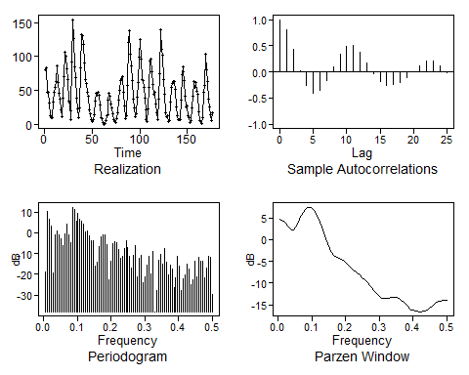

## $autplt  
## [1] 1.00000000 0.80776602 0.42942128 0.03120451 -0.26097905  
## [6] -0.39862840 -0.35774363 -0.17405682 0.09752071 0.34406602  
## [11] 0.49011286 0.50015597 0.37451702 0.16582428 -0.03864681  
## [16] -0.18383023 -0.25189064 -0.24372974 -0.19326618 -0.10227310  
## [21] 0.01087493 0.12094663 0.20079829 0.20173421 0.12186592  
## [26] -0.01280215  
##   
## $freq  
## [1] 0.005681818 0.011363636 0.017045455 0.022727273 0.028409091  
## [6] 0.034090909 0.039772727 0.045454545 0.051136364 0.056818182  
## [11] 0.062500000 0.068181818 0.073863636 0.079545455 0.085227273  
## [16] 0.090909091 0.096590909 0.102272727 0.107954545 0.113636364  
## [21] 0.119318182 0.125000000 0.130681818 0.136363636 0.142045455  
## [26] 0.147727273 0.153409091 0.159090909 0.164772727 0.170454545  
## [31] 0.176136364 0.181818182 0.187500000 0.193181818 0.198863636  
## [36] 0.204545455 0.210227273 0.215909091 0.221590909 0.227272727  
## [41] 0.232954545 0.238636364 0.244318182 0.250000000 0.255681818  
## [46] 0.261363636 0.267045455 0.272727273 0.278409091 0.284090909  
## [51] 0.289772727 0.295454545 0.301136364 0.306818182 0.312500000  
## [56] 0.318181818 0.323863636 0.329545455 0.335227273 0.340909091  
## [61] 0.346590909 0.352272727 0.357954545 0.363636364 0.369318182  
## [66] 0.375000000 0.380681818 0.386363636 0.392045455 0.397727273  
## [71] 0.403409091 0.409090909 0.414772727 0.420454545 0.426136364  
## [76] 0.431818182 0.437500000 0.443181818 0.448863636 0.454545455  
## [81] 0.460227273 0.465909091 0.471590909 0.477272727 0.482954545  
## [86] 0.488636364 0.494318182 0.500000000  
##   
## $db  
## [1] -18.8457831 10.0538637 6.5308558 3.1162146 -19.5128534  
## [6] -1.2277502 0.6979840 -1.0424684 -2.8890178 -6.2233011  
## [11] -0.5523434 3.9505577 -0.9256838 -4.8493116 12.2766905  
## [16] 11.2322339 5.5824079 9.3434931 6.3269415 5.3476245  
## [21] 4.1606783 0.5589012 0.8903287 -1.3782938 -3.9548626  
## [26] -3.9255491 -16.1391915 -13.9507112 -6.7109043 -1.9192534  
## [31] -0.8738757 -1.0789278 -5.5823942 -22.5781421 -13.5780674  
## [36] -5.2998413 -4.1523563 -4.9423363 -8.1771599 -12.3730964  
## [41] -11.4100568 -7.4075684 -3.8429696 -6.9510688 -11.2496867  
## [46] -17.0974164 -11.0832745 -6.1124385 -21.3128505 -12.2917431  
## [51] -10.7085485 -23.8877032 -21.0198338 -15.4760895 -11.2604694  
## [56] -19.8142176 -9.2097826 -37.9297376 -27.9746622 -13.4047871  
## [61] -10.2709095 -15.2715464 -7.7629237 -13.9932723 -20.4824204  
## [66] -15.6992608 -17.6631641 -26.2000832 -21.8119600 -11.5499730  
## [71] -15.9647505 -27.7820493 -22.3359923 -20.0436103 -15.1049167  
## [76] -17.2181380 -24.8629300 -22.6292747 -13.4939276 -20.9824866  
## [81] -11.9235996 -13.6058784 -13.5992247 -21.6448741 -16.7901488  
## [86] -11.2106178 -11.6133293 -29.7372169  
##   
## $dbz  
## [1] 4.7488071 4.5365492 4.1873742 3.7174233 3.1708076  
## [6] 2.6438737 2.3003992 2.3267685 2.8035777 3.6254364  
## [11] 4.5886722 5.5179388 6.3074089 6.9049566 7.2888195  
## [16] 7.4522850 7.3957570 7.1231997 6.6409529 5.9579339  
## [21] 5.0868864 4.0467174 2.8661861 1.5891057 0.2801730  
## [26] -0.9726177 -2.0679982 -2.9220573 -3.5082291 -3.8721203  
## [31] -4.1044763 -4.2988181 -4.5243785 -4.8184824 -5.1888998  
## [36] -5.6195435 -6.0784971 -6.5294201 -6.9450296 -7.3170785  
## [41] -7.6568877 -7.9867125 -8.3286459 -8.6976364 -9.1004926  
## [46] -9.5387934 -10.0122858 -10.5199658 -11.0577882 -11.6140184  
## [51] -12.1648585 -12.6737913 -13.0976587 -13.3995324 -13.5628871  
## [56] -13.5984093 -13.5395863 -13.4317513 -13.3217918 -13.2517088  
## [61] -13.2552294 -13.3556978 -13.5641070 -13.8769043 -14.2739693  
## [66] -14.7183591 -15.1608383 -15.5518822 -15.8587771 -16.0776526  
## [71] -16.2301798 -16.3464494 -16.4457607 -16.5253553 -16.5606501  
## [76] -16.5167617 -16.3674419 -16.1114997 -15.7756592 -15.4028964  
## [81] -15.0363314 -14.7083723 -14.4373496 -14.2291001 -14.0806080  
## [86] -13.9840663 -13.9306584 -13.9136833

#ICC: Estimate the frequency in the Canadian lynx data  
data(llynx)  
parzen.wge(llynx)

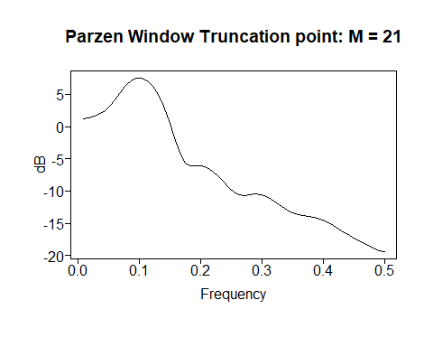

## $freq  
## [1] 0.00877193 0.01754386 0.02631579 0.03508772 0.04385965 0.05263158  
## [7] 0.06140351 0.07017544 0.07894737 0.08771930 0.09649123 0.10526316  
## [13] 0.11403509 0.12280702 0.13157895 0.14035088 0.14912281 0.15789474  
## [19] 0.16666667 0.17543860 0.18421053 0.19298246 0.20175439 0.21052632  
## [25] 0.21929825 0.22807018 0.23684211 0.24561404 0.25438596 0.26315789  
## [31] 0.27192982 0.28070175 0.28947368 0.29824561 0.30701754 0.31578947  
## [37] 0.32456140 0.33333333 0.34210526 0.35087719 0.35964912 0.36842105  
## [43] 0.37719298 0.38596491 0.39473684 0.40350877 0.41228070 0.42105263  
## [49] 0.42982456 0.43859649 0.44736842 0.45614035 0.46491228 0.47368421  
## [55] 0.48245614 0.49122807 0.50000000  
##   
## $pzgram  
## [1] 1.1753509 1.3511153 1.5753819 1.8635887 2.3336839  
## [6] 3.1100133 4.1669574 5.3169758 6.3465290 7.1072249  
## [11] 7.5172265 7.5336678 7.1303431 6.2852567 4.9759181  
## [16] 3.1838074 0.9211568 -1.6774676 -4.1452165 -5.6762325  
## [21] -6.0682228 -6.0156299 -6.0622478 -6.3593344 -6.8971875  
## [26] -7.6335566 -8.5121525 -9.4261267 -10.1901428 -10.6158726  
## [31] -10.6825142 -10.5678298 -10.4838885 -10.5554412 -10.8150217  
## [36] -11.2380392 -11.7715263 -12.3485685 -12.8942669 -13.3375211  
## [41] -13.6388066 -13.8166308 -13.9401193 -14.0899185 -14.3227190  
## [46] -14.6593278 -15.0901935 -15.5860839 -16.1074694 -16.6141487  
## [51] -17.0799978 -17.5088444 -17.9336691 -18.3864353 -18.8503497  
## [56] -19.2284562 -19.3785945

plotts.sample.wge(llynx)

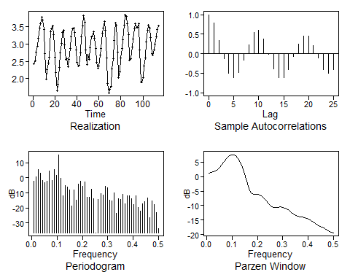

## $autplt  
## [1] 1.00000000 0.78512404 0.34023015 -0.13228159 -0.49388380  
## [6] -0.62054195 -0.48794219 -0.15780881 0.23485148 0.53720742  
## [11] 0.60550677 0.38294450 -0.01228951 -0.38479494 -0.60733157  
## [16] -0.61018644 -0.40689315 -0.07271135 0.25318841 0.45500655  
## [21] 0.44648981 0.21763175 -0.11553859 -0.39958162 -0.50753139  
## [26] -0.41464422  
##   
## $freq  
## [1] 0.00877193 0.01754386 0.02631579 0.03508772 0.04385965 0.05263158  
## [7] 0.06140351 0.07017544 0.07894737 0.08771930 0.09649123 0.10526316  
## [13] 0.11403509 0.12280702 0.13157895 0.14035088 0.14912281 0.15789474  
## [19] 0.16666667 0.17543860 0.18421053 0.19298246 0.20175439 0.21052632  
## [25] 0.21929825 0.22807018 0.23684211 0.24561404 0.25438596 0.26315789  
## [31] 0.27192982 0.28070175 0.28947368 0.29824561 0.30701754 0.31578947  
## [37] 0.32456140 0.33333333 0.34210526 0.35087719 0.35964912 0.36842105  
## [43] 0.37719298 0.38596491 0.39473684 0.40350877 0.41228070 0.42105263  
## [49] 0.42982456 0.43859649 0.44736842 0.45614035 0.46491228 0.47368421  
## [55] 0.48245614 0.49122807 0.50000000  
##   
## $db  
## [1] -2.0987073 0.5616822 5.6768748 3.1569589 -1.9016069  
## [6] -3.2251525 -2.1665170 4.3386929 -1.8216219 5.3552457  
## [11] 1.6924135 15.3165718 -0.2982973 -11.9093201 -5.3221942  
## [16] -5.9237816 -8.2524885 -18.8730245 -8.2356864 -14.6010551  
## [21] -3.9172311 -2.3191809 -5.4123132 -2.8826021 -12.6292747  
## [26] -12.9473842 -7.6943505 -13.7858407 -36.3741504 -14.3114198  
## [31] -10.2043421 -11.4750684 -5.8151323 -6.7026728 -14.6016054  
## [36] -15.1796495 -9.9925752 -23.6705226 -13.7430793 -14.3021371  
## [41] -10.9543360 -16.9959837 -11.7440333 -11.8452356 -13.8370142  
## [46] -17.7380886 -11.8277380 -19.6707687 -22.2227378 -17.2860681  
## [51] -15.7542829 -13.1537257 -26.1473552 -15.0813041 -17.7089815  
## [56] -23.2073054 -33.6272067  
##   
## $dbz  
## [1] 1.1753509 1.3511153 1.5753819 1.8635887 2.3336839  
## [6] 3.1100133 4.1669574 5.3169758 6.3465290 7.1072249  
## [11] 7.5172265 7.5336678 7.1303431 6.2852567 4.9759181  
## [16] 3.1838074 0.9211568 -1.6774676 -4.1452165 -5.6762325  
## [21] -6.0682228 -6.0156299 -6.0622478 -6.3593344 -6.8971875  
## [26] -7.6335566 -8.5121525 -9.4261267 -10.1901428 -10.6158726  
## [31] -10.6825142 -10.5678298 -10.4838885 -10.5554412 -10.8150217  
## [36] -11.2380392 -11.7715263 -12.3485685 -12.8942669 -13.3375211  
## [41] -13.6388066 -13.8166308 -13.9401193 -14.0899185 -14.3227190  
## [46] -14.6593278 -15.0901935 -15.5860839 -16.1074694 -16.6141487  
## [51] -17.0799978 -17.5088444 -17.9336691 -18.3864353 -18.8503497  
## [56] -19.2284562 -19.3785945

# Amplitude Modulated Signal (Has Carrier Frequency and Modulation Frequency)  
t = seq(1,250)  
y1 = ts(sin(2*pi*0.1*t))  
y2 = ts(1 * sin(2*pi*0.09*t))  
y3 = ts(1 * sin(2*pi*0.11*t))  
plot(y1)

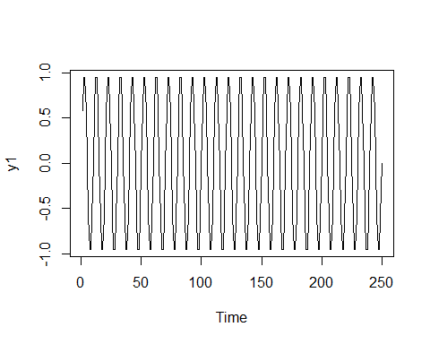

plot(y2)

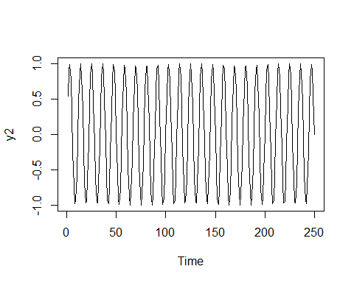

plot(y3)

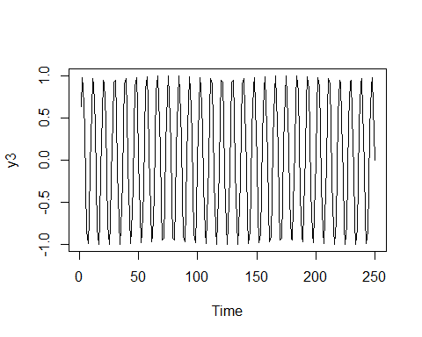

ysum = y1 + y2 + y3  
plot(ysum)

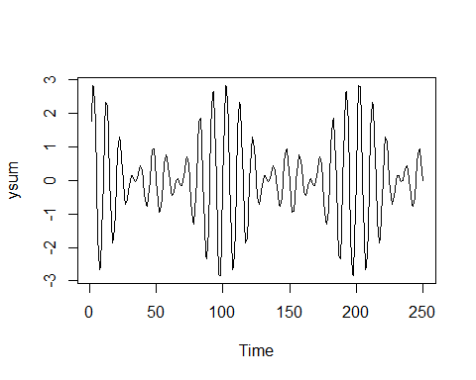

plotts.sample.wge(ysum, trunc = 200)

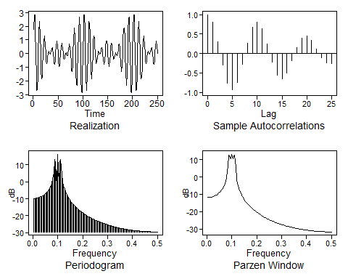

## $autplt  
## [1] 1.0000000 0.8079887 0.3120414 -0.2905226 -0.7654577 -0.9347761  
## [7] -0.7450160 -0.2838230 0.2601198 0.6755823 0.8125547 0.6374164  
## [13] 0.2388433 -0.2151208 -0.5485560 -0.6470416 -0.4971000 -0.1820852  
## [19] 0.1602229 0.3977019 0.4554482 0.3384797 0.1192045 -0.1012461  
## [25] -0.2385332 -0.2572727  
##   
## $freq  
## [1] 0.004 0.008 0.012 0.016 0.020 0.024 0.028 0.032 0.036 0.040 0.044  
## [12] 0.048 0.052 0.056 0.060 0.064 0.068 0.072 0.076 0.080 0.084 0.088  
## [23] 0.092 0.096 0.100 0.104 0.108 0.112 0.116 0.120 0.124 0.128 0.132  
## [34] 0.136 0.140 0.144 0.148 0.152 0.156 0.160 0.164 0.168 0.172 0.176  
## [45] 0.180 0.184 0.188 0.192 0.196 0.200 0.204 0.208 0.212 0.216 0.220  
## [56] 0.224 0.228 0.232 0.236 0.240 0.244 0.248 0.252 0.256 0.260 0.264  
## [67] 0.268 0.272 0.276 0.280 0.284 0.288 0.292 0.296 0.300 0.304 0.308  
## [78] 0.312 0.316 0.320 0.324 0.328 0.332 0.336 0.340 0.344 0.348 0.352  
## [89] 0.356 0.360 0.364 0.368 0.372 0.376 0.380 0.384 0.388 0.392 0.396  
## [100] 0.400 0.404 0.408 0.412 0.416 0.420 0.424 0.428 0.432 0.436 0.440  
## [111] 0.444 0.448 0.452 0.456 0.460 0.464 0.468 0.472 0.476 0.480 0.484  
## [122] 0.488 0.492 0.496 0.500  
##   
## $db  
## [1] -9.8481262 -9.8026549 -9.7263306 -9.6183230 -9.4774234  
## [6] -9.3019933 -9.0898903 -8.8383644 -8.5439108 -8.2020622  
## [11] -7.8070888 -7.3515559 -6.8256504 -6.2161179 -5.5045049  
## [16] -4.6640805 -3.6540413 -2.4075270 -0.8034731 1.4128923  
## [21] 4.9339512 13.1802517 11.0746020 -2.9761221 16.2002095  
## [26] -1.3856100 11.4145766 12.9031706 4.1965018 0.2768538  
## [31] -2.3080971 -4.2645169 -5.8542272 -7.2023585 -8.3783528  
## [36] -9.4247940 -10.3697349 -11.2326784 -12.0277631 -12.7655876  
## [41] -13.4543163 -14.1003830 -14.7089547 -15.2842498 -15.8297605  
## [46] -16.3484136 -16.8426887 -17.3147063 -17.7662955 -18.1990459  
## [51] -18.6143486 -19.0134287 -19.3973707 -19.7671403 -20.1236010  
## [56] -20.4675285 -20.7996222 -21.1205154 -21.4307832 -21.7309497  
## [61] -22.0214940 -22.3028549 -22.5754359 -22.8396086 -23.0957159  
## [66] -23.3440751 -23.5849804 -23.8187050 -24.0455030 -24.2656114  
## [71] -24.4792512 -24.6866290 -24.8879384 -25.0833605 -25.2730655  
## [76] -25.4572131 -25.6359538 -25.8094289 -25.9777717 -26.1411080  
## [81] -26.2995563 -26.4532288 -26.6022313 -26.7466640 -26.8866217  
## [86] -27.0221941 -27.1534661 -27.2805184 -27.4034271 -27.5222646  
## [91] -27.6370995 -27.7479969 -27.8550184 -27.9582226 -28.0576649  
## [96] -28.1533980 -28.2454716 -28.3339331 -28.4188271 -28.5001961  
## [101] -28.5780800 -28.6525169 -28.7235423 -28.7911901 -28.8554921  
## [106] -28.9164781 -28.9741763 -29.0286130 -29.0798127 -29.1277986  
## [111] -29.1725918 -29.2142123 -29.2526783 -29.2880066 -29.3202124  
## [116] -29.3493098 -29.3753112 -29.3982277 -29.4180690 -29.4348437  
## [121] -29.4485588 -29.4592202 -29.4668322 -29.4713981 -29.4729199  
##   
## $dbz  
## [1] -11.7887619 -11.6951970 -11.7171051 -11.6278062 -11.5024133  
## [6] -11.3234866 -11.1214146 -10.8711396 -10.5698407 -10.2441095  
## [11] -9.8282282 -9.3917009 -8.8610376 -8.2260904 -7.5558579  
## [16] -6.6229098 -5.6738797 -4.3403487 -2.4897586 -0.2923097  
## [21] 6.1660247 12.4792122 12.1802109 10.4640363 13.1175801  
## [26] 10.4610307 12.2121637 12.3845737 5.7904175 -1.3383062  
## [31] -3.8424128 -6.1358785 -7.8487137 -9.0940075 -10.4376641  
## [36] -11.4026253 -12.4068542 -13.2837850 -14.0368589 -14.8352794  
## [41] -15.4830617 -16.1581274 -16.7719135 -17.3243982 -17.9044344  
## [46] -18.3980447 -18.9112372 -19.3865164 -19.8237024 -20.2800685  
## [51] -20.6782963 -21.0913977 -21.4779364 -21.8378222 -22.2120671  
## [56] -22.5435848 -22.8868312 -23.2100293 -23.5131722 -23.8275267  
## [61] -24.1086814 -24.3993043 -24.6740292 -24.9329050 -25.2007569  
## [66] -25.4418170 -25.6906282 -25.9263814 -26.1491597 -26.3792294  
## [71] -26.5870820 -26.8013274 -27.0045605 -27.1968836 -27.3951739  
## [76] -27.5746580 -27.7594284 -27.9347165 -28.1006331 -28.2714458  
## [81] -28.4260759 -28.5850739 -28.7357649 -28.8782610 -29.0247709  
## [86] -29.1571597 -29.2931461 -29.4217450 -29.5430642 -29.6676641  
## [91] -29.7797832 -29.8948524 -30.0032603 -30.1051069 -30.2096249  
## [96] -30.3029722 -30.3987286 -30.4883981 -30.5720696 -30.6579114  
## [101] -30.7336224 -30.8112978 -30.8833365 -30.9498138 -31.0180580  
## [106] -31.0769813 -31.1375142 -31.1927548 -31.2427634 -31.2942264  
## [111] -31.3369759 -31.3810657 -31.4201146 -31.4541666 -31.4894471  
## [116] -31.5164370 -31.5445810 -31.5678508 -31.5862730 -31.6057820  
## [121] -31.6172499 -31.6297679 -31.6374982 -31.6404500 -31.6444293