Time Series - Async Week 7

Nikhil Gupta

2020-02-09 08:26:23

Table of Contents

library(tswge)

## Warning: package 'tswge' was built under R version 3.5.3

# Forecasting AR(p) models

## AR(1)

### Positive Phi

data(fig6.1nf)  
f = fore.arma.wge(fig6.1nf, phi=.8, n.ahead=20, plot=TRUE, limits=FALSE)

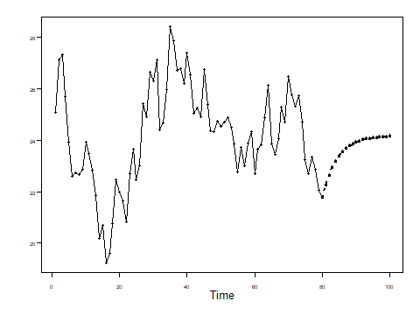

# These commands plot the realization and the n.ahead=20 forecasts.   
# The values of the forecasts are in $f of the output.

### Negative Phi

"Test"

## [1] "Test"

## 

## AR(2)

x2=gen.arma.wge(n=75,phi=c(1.6,-.8),sn=24)

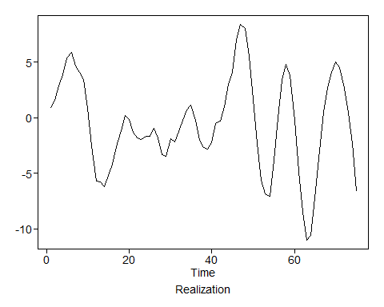

x2=x2+25  
f = fore.arma.wge(x2, phi=c(1.6,-.8), n.ahead=20, limits=FALSE)

