Live Session Assignment 1

Nikhil Gupta

2020-01-11 13:39:19

Table of Contents

library(tswge)

## Warning: package 'tswge' was built under R version 3.5.3

source("../Code/common_functions.R")

# Problem 1.2

data("wtcrude")  
data("patemp")

plotts.sample.wge(wtcrude)

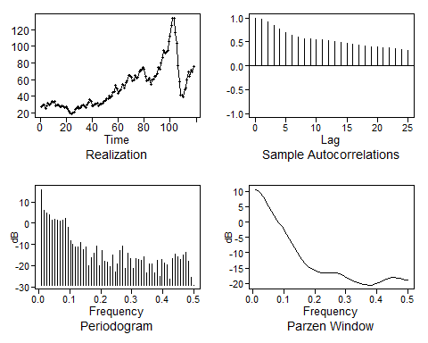

## $autplt  
## [1] 1.0000000 0.9680875 0.9160532 0.8459771 0.7724321 0.6999948 0.6419989  
## [8] 0.6012009 0.5720853 0.5558048 0.5455630 0.5386875 0.5239727 0.5077421  
## [15] 0.4902317 0.4720104 0.4483721 0.4282124 0.4124267 0.4012710 0.3920747  
## [22] 0.3857370 0.3761661 0.3629215 0.3418472 0.3204255  
##   
## $freq  
## [1] 0.008474576 0.016949153 0.025423729 0.033898305 0.042372881  
## [6] 0.050847458 0.059322034 0.067796610 0.076271186 0.084745763  
## [11] 0.093220339 0.101694915 0.110169492 0.118644068 0.127118644  
## [16] 0.135593220 0.144067797 0.152542373 0.161016949 0.169491525  
## [21] 0.177966102 0.186440678 0.194915254 0.203389831 0.211864407  
## [26] 0.220338983 0.228813559 0.237288136 0.245762712 0.254237288  
## [31] 0.262711864 0.271186441 0.279661017 0.288135593 0.296610169  
## [36] 0.305084746 0.313559322 0.322033898 0.330508475 0.338983051  
## [41] 0.347457627 0.355932203 0.364406780 0.372881356 0.381355932  
## [46] 0.389830508 0.398305085 0.406779661 0.415254237 0.423728814  
## [51] 0.432203390 0.440677966 0.449152542 0.457627119 0.466101695  
## [56] 0.474576271 0.483050847 0.491525424 0.500000000  
##   
## $db  
## [1] 15.8836922 5.8893485 4.7258557 3.8214785 1.4642490  
## [6] 2.0018715 1.6045258 0.9020399 1.5032278 2.2448431  
## [11] -1.7469156 -8.0591372 -9.7586717 -11.0839579 -11.3157758  
## [16] -8.9218139 -12.6463833 -11.3269115 -19.9617557 -16.0793744  
## [21] -14.0745330 -10.8525198 -20.1265359 -12.8820102 -17.9476712  
## [26] -18.2596929 -20.3598459 -14.9946031 -23.0872701 -19.0906270  
## [31] -12.9016842 -10.9904647 -21.4757421 -14.3554878 -16.8686457  
## [36] -21.2128051 -16.7994413 -17.1902498 -17.6943734 -15.6829043  
## [41] -23.3397986 -19.1318435 -19.0358382 -23.5949904 -17.7081535  
## [46] -25.1005021 -17.2286803 -18.8192620 -19.8276817 -26.3397426  
## [51] -16.8401683 -14.4129384 -15.6843059 -17.2434860 -14.8511599  
## [56] -13.9073624 -17.9584781 -25.6236551 -29.1808167  
##   
## $dbz  
## [1] 10.5819754 10.0624863 9.2075283 8.0415104 6.6164330  
## [6] 5.0288774 3.4245625 1.9558889 0.6896967 -0.4402192  
## [11] -1.5650047 -2.7816592 -4.1123407 -5.5204077 -6.9556417  
## [16] -8.3968913 -9.8513687 -11.3012735 -12.6484630 -13.7413003  
## [21] -14.5081742 -15.0365109 -15.4674900 -15.8658785 -16.2080980  
## [26] -16.4502708 -16.5850733 -16.6378358 -16.6356417 -16.6035602  
## [31] -16.5841746 -16.6412529 -16.8349603 -17.1896987 -17.6753919  
## [36] -18.2126800 -18.7092522 -19.1138894 -19.4399472 -19.7314363  
## [41] -20.0124827 -20.2690812 -20.4664871 -20.5744360 -20.5749223  
## [46] -20.4554742 -20.2102717 -19.8545040 -19.4317949 -19.0016222  
## [51] -18.6194933 -18.3266638 -18.1507205 -18.1082621 -18.2020451  
## [56] -18.4107730 -18.6766253 -18.9048807 -18.9958037

plotts.sample.wge(patemp)

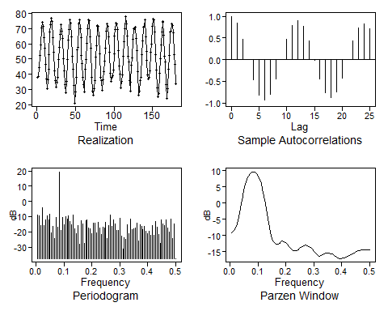

## $autplt  
## [1] 1.0000000000 0.8386381052 0.4803421817 -0.0010081916 -0.4717907055  
## [6] -0.8176935421 -0.9340050360 -0.7999823229 -0.4527311287 0.0089564844  
## [11] 0.4659219410 0.7959391935 0.9002977221 0.7656850843 0.4360703243  
## [16] -0.0098189556 -0.4511591540 -0.7618069185 -0.8701222437 -0.7482146632  
## [21] -0.4297051103 0.0008229813 0.4253734168 0.7280472951 0.8317412380  
## [26] 0.7119144914  
##   
## $freq  
## [1] 0.005555556 0.011111111 0.016666667 0.022222222 0.027777778  
## [6] 0.033333333 0.038888889 0.044444444 0.050000000 0.055555556  
## [11] 0.061111111 0.066666667 0.072222222 0.077777778 0.083333333  
## [16] 0.088888889 0.094444444 0.100000000 0.105555556 0.111111111  
## [21] 0.116666667 0.122222222 0.127777778 0.133333333 0.138888889  
## [26] 0.144444444 0.150000000 0.155555556 0.161111111 0.166666667  
## [31] 0.172222222 0.177777778 0.183333333 0.188888889 0.194444444  
## [36] 0.200000000 0.205555556 0.211111111 0.216666667 0.222222222  
## [41] 0.227777778 0.233333333 0.238888889 0.244444444 0.250000000  
## [46] 0.255555556 0.261111111 0.266666667 0.272222222 0.277777778  
## [51] 0.283333333 0.288888889 0.294444444 0.300000000 0.305555556  
## [56] 0.311111111 0.316666667 0.322222222 0.327777778 0.333333333  
## [61] 0.338888889 0.344444444 0.350000000 0.355555556 0.361111111  
## [66] 0.366666667 0.372222222 0.377777778 0.383333333 0.388888889  
## [71] 0.394444444 0.400000000 0.405555556 0.411111111 0.416666667  
## [76] 0.422222222 0.427777778 0.433333333 0.438888889 0.444444444  
## [81] 0.450000000 0.455555556 0.461111111 0.466666667 0.472222222  
## [86] 0.477777778 0.483333333 0.488888889 0.494444444 0.500000000  
##   
## $db  
## [1] -8.771088 -9.360721 -15.737798 -4.313122 -15.743661 -12.208996  
## [7] -9.428949 -11.968248 -8.239294 -20.720590 -16.271042 -24.596701  
## [13] -10.683798 -17.053219 19.370989 -18.932365 -10.614868 -15.091067  
## [19] -10.156834 -11.480831 -9.680582 -13.060651 -15.499787 -8.778419  
## [25] -18.242187 -21.294686 -16.068197 -28.197994 -12.526897 -15.017696  
## [31] -27.314825 -12.775833 -12.091626 -17.397303 -18.024097 -21.291777  
## [37] -14.326317 -14.271900 -20.370206 -13.669982 -17.195521 -21.862748  
## [43] -16.728130 -17.341597 -13.898914 -24.516083 -15.624845 -8.786330  
## [49] -16.560375 -12.010207 -14.681674 -18.916961 -18.939517 -11.225404  
## [55] -23.024727 -31.110785 -23.696819 -24.669930 -15.468664 -21.121657  
## [61] -11.827490 -18.590177 -17.849549 -17.487407 -14.074204 -26.044079  
## [67] -15.560006 -16.238814 -18.521560 -16.321596 -19.433220 -20.984045  
## [73] -19.408283 -22.352876 -15.812703 -22.318467 -13.088358 -16.828632  
## [79] -21.554603 -27.546740 -11.872237 -15.028974 -15.998016 -12.067287  
## [85] -17.620445 -20.127600 -11.533721 -24.526866 -14.993360 -37.462392  
##   
## $dbz  
## [1] -9.0635551 -8.7758339 -8.2478675 -7.1942384 -5.3394096  
## [6] -2.8823656 -0.2994674 2.0866138 4.1504327 5.8649465  
## [11] 7.2380115 8.2860937 9.0248968 9.4663558 9.6178361  
## [16] 9.4819963 9.0567536 8.3351594 7.3051630 5.9494181  
## [21] 4.2456923 2.1696059 -0.2950985 -3.1239353 -6.1636626  
## [26] -8.9851089 -10.9775927 -12.0114597 -12.5044080 -12.7146594  
## [31] -12.6426496 -12.3321682 -11.9698923 -11.7548308 -11.7991427  
## [36] -12.1219488 -12.6680603 -13.3227770 -13.9378706 -14.3864929  
## [41] -14.6181580 -14.6548624 -14.5387365 -14.3010169 -13.9740804  
## [46] -13.6107407 -13.2808100 -13.0511725 -12.9693040 -13.0578680  
## [51] -13.3165064 -13.7254520 -14.2480344 -14.8311694 -15.4049124  
## [56] -15.8860495 -16.1947397 -16.2866352 -16.1801305 -15.9499454  
## [61] -15.6907757 -15.4826657 -15.3760004 -15.3915982 -15.5263162  
## [66] -15.7590151 -16.0557111 -16.3743360 -16.6698487 -16.9003877  
## [71] -17.0346024 -17.0585852 -16.9787680 -16.8178056 -16.6048321  
## [76] -16.3653849 -16.1158248 -15.8636206 -15.6117067 -15.3636386  
## [81] -15.1265440 -14.9106152 -14.7260933 -14.5798649 -14.4734506  
## [86] -14.4030283 -14.3611201 -14.3390407 -14.3291670 -14.3264567

# Problem 1.5

data("fig1.21a")

plotts.sample.wge(fig1.21a, trunc = 31) # Plots in dB by default. Use parzen.wge to plot parzen plot with more flexibility

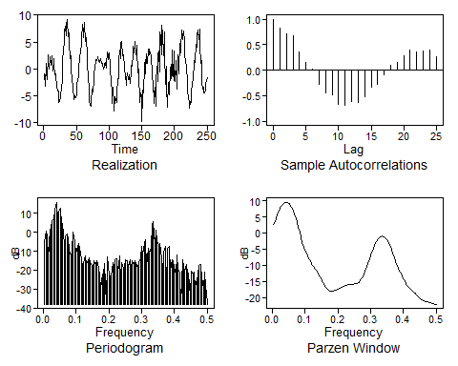

## $autplt  
## [1] 1.00000000 0.82547672 0.72146990 0.67862533 0.35619888  
## [6] 0.14752699 0.02704873 -0.28417119 -0.44166776 -0.49039554  
## [11] -0.67309150 -0.69397430 -0.60966113 -0.63644483 -0.52153924  
## [16] -0.33438851 -0.26850638 -0.09518628 0.10261313 0.15340823  
## [21] 0.28030637 0.39525171 0.35074667 0.38298584 0.39280668  
## [26] 0.26650280  
##   
## $freq  
## [1] 0.004 0.008 0.012 0.016 0.020 0.024 0.028 0.032 0.036 0.040 0.044  
## [12] 0.048 0.052 0.056 0.060 0.064 0.068 0.072 0.076 0.080 0.084 0.088  
## [23] 0.092 0.096 0.100 0.104 0.108 0.112 0.116 0.120 0.124 0.128 0.132  
## [34] 0.136 0.140 0.144 0.148 0.152 0.156 0.160 0.164 0.168 0.172 0.176  
## [45] 0.180 0.184 0.188 0.192 0.196 0.200 0.204 0.208 0.212 0.216 0.220  
## [56] 0.224 0.228 0.232 0.236 0.240 0.244 0.248 0.252 0.256 0.260 0.264  
## [67] 0.268 0.272 0.276 0.280 0.284 0.288 0.292 0.296 0.300 0.304 0.308  
## [78] 0.312 0.316 0.320 0.324 0.328 0.332 0.336 0.340 0.344 0.348 0.352  
## [89] 0.356 0.360 0.364 0.368 0.372 0.376 0.380 0.384 0.388 0.392 0.396  
## [100] 0.400 0.404 0.408 0.412 0.416 0.420 0.424 0.428 0.432 0.436 0.440  
## [111] 0.444 0.448 0.452 0.456 0.460 0.464 0.468 0.472 0.476 0.480 0.484  
## [122] 0.488 0.492 0.496 0.500  
##   
## $db  
## [1] -5.362312707 0.366344961 -1.445886425 -13.809003067 1.755220457  
## [6] 2.136580888 5.936583112 6.662282082 11.633264536 15.864548847  
## [11] 6.412292167 10.721737397 12.925575058 4.506746570 4.871962095  
## [16] -6.250836639 -1.950216175 -0.696705587 -2.804391698 -9.424665488  
## [21] -12.290523789 -10.215409905 0.007140881 -4.862115410 -11.332925724  
## [26] -7.329364970 -5.908992276 -8.317573572 -14.238661544 -18.286172715  
## [31] -16.217916136 -12.477398194 -16.758288217 -14.838345694 -13.449731786  
## [36] -15.782901152 -18.072932375 -18.540945864 -14.875312445 -17.028468289  
## [41] -15.228060322 -18.557564803 -22.745958312 -30.301757348 -22.076541889  
## [46] -22.140287349 -16.389109856 -38.058461974 -13.253167879 -22.582597618  
## [51] -23.084919320 -23.069973979 -16.136714989 -18.935207786 -14.296452908  
## [56] -14.212188935 -21.577190665 -12.729012394 -25.772327749 -15.803365923  
## [61] -19.194102290 -17.900661731 -14.286589327 -14.951488394 -18.705308996  
## [66] -14.567921028 -18.397006217 -15.243238171 -17.117926722 -14.973674888  
## [71] -16.023098198 -19.125032348 -16.262081660 -13.449776335 -7.579424886  
## [76] -11.805920794 -5.895635890 -3.709221039 -17.897968262 -8.659598300  
## [81] -10.997039955 -8.101915888 4.254491199 5.393082003 -6.448033009  
## [86] 0.965411687 -4.226333744 -6.643925007 -5.811660689 -13.640826479  
## [91] -22.193602483 -10.675283870 -7.542870043 -29.376537632 -8.376263090  
## [96] -7.321382742 -20.639950914 -14.585415495 -14.840057936 -17.813610711  
## [101] -22.140984549 -11.765936789 -18.985384999 -21.747733179 -38.007500586  
## [106] -14.506798616 -18.002933123 -20.418280098 -17.084519747 -21.311114539  
## [111] -21.620138444 -33.556026703 -20.750195444 -21.930100114 -21.130826243  
## [116] -29.022558217 -24.985482468 -22.582047856 -17.533565589 -16.871552927  
## [121] -24.006657999 -29.547956056 -21.326562732 -27.991855314 -36.997336287  
##   
## $dbz  
## [1] 2.5317768 3.4146229 4.5418152 5.6884356 6.7368601  
## [6] 7.6364732 8.3681506 8.9257365 9.3078646 9.5145799  
## [11] 9.5459980 9.4018104 9.0811641 8.5827581 7.9051540  
## [16] 7.0474064 6.0102369 4.7981374 3.4229798 1.9097481  
## [21] 0.3042602 -1.3202200 -2.8666529 -4.2403146 -5.3923875  
## [26] -6.3442276 -7.1638507 -7.9191673 -8.6483811 -9.3579331  
## [31] -10.0374865 -10.6793036 -11.2913106 -11.8975298 -12.5278666  
## [36] -13.2049836 -13.9346241 -14.7015386 -15.4712074 -16.1975396  
## [41] -16.8353243 -17.3523463 -17.7342889 -17.9808581 -18.0993148  
## [46] -18.1021087 -18.0085820 -17.8456639 -17.6441997 -17.4324350  
## [51] -17.2303807 -17.0473945 -16.8831485 -16.7310556 -16.5829651  
## [56] -16.4337953 -16.2846543 -16.1433021 -16.0216655 -15.9310664  
## [61] -15.8762783 -15.8495409 -15.8259809 -15.7631015 -15.6081113  
## [66] -15.3142608 -14.8587425 -14.2482664 -13.5070008 -12.6580717  
## [71] -11.7137283 -10.6791826 -9.5642035 -8.3922825 -7.2008333  
## [76] -6.0338538 -4.9332347 -3.9333244 -3.0594519 -2.3289382  
## [81] -1.7530065 -1.3386556 -1.0901291 -1.0099166 -1.0993240  
## [86] -1.3586543 -1.7869965 -2.3815603 -3.1364288 -4.0405713  
## [91] -5.0750511 -6.2098010 -7.4014214 -8.5951105 -9.7344059  
## [96] -10.7783016 -11.7163266 -12.5686441 -13.3692514 -14.1441557  
## [101] -14.8972193 -15.6089489 -16.2481456 -16.7917916 -17.2419801  
## [106] -17.6278191 -17.9916044 -18.3703840 -18.7832394 -19.2269116  
## [111] -19.6782813 -20.1024656 -20.4653700 -20.7468778 -20.9481644  
## [116] -21.0890412 -21.1980392 -21.3018355 -21.4184502 -21.5546109  
## [121] -21.7058137 -21.8579758 -21.9905897 -22.0816957 -22.1142219

parzen.wge(fig1.21a, trunc = 31, dbcalc = FALSE)

## $freq  
## [1] 0.004 0.008 0.012 0.016 0.020 0.024 0.028 0.032 0.036 0.040 0.044  
## [12] 0.048 0.052 0.056 0.060 0.064 0.068 0.072 0.076 0.080 0.084 0.088  
## [23] 0.092 0.096 0.100 0.104 0.108 0.112 0.116 0.120 0.124 0.128 0.132  
## [34] 0.136 0.140 0.144 0.148 0.152 0.156 0.160 0.164 0.168 0.172 0.176  
## [45] 0.180 0.184 0.188 0.192 0.196 0.200 0.204 0.208 0.212 0.216 0.220  
## [56] 0.224 0.228 0.232 0.236 0.240 0.244 0.248 0.252 0.256 0.260 0.264  
## [67] 0.268 0.272 0.276 0.280 0.284 0.288 0.292 0.296 0.300 0.304 0.308  
## [78] 0.312 0.316 0.320 0.324 0.328 0.332 0.336 0.340 0.344 0.348 0.352  
## [89] 0.356 0.360 0.364 0.368 0.372 0.376 0.380 0.384 0.388 0.392 0.396  
## [100] 0.400 0.404 0.408 0.412 0.416 0.420 0.424 0.428 0.432 0.436 0.440  
## [111] 0.444 0.448 0.452 0.456 0.460 0.464 0.468 0.472 0.476 0.480 0.484  
## [122] 0.488 0.492 0.496 0.500  
##   
## $pzgram  
## [1] 1.791338569 2.195140329 2.845650237 3.705472190 4.717218671  
## [6] 5.802929865 6.867759203 7.808608452 8.526807432 8.942480271  
## [11] 9.007407300 8.713267361 8.093128074 7.215655867 6.173271831  
## [16] 5.066880288 3.990466709 3.018656814 2.199368415 1.552296987  
## [21] 1.072570937 0.737866847 0.516814526 0.376676514 0.288909122  
## [26] 0.232047683 0.192138736 0.161466810 0.136509191 0.115932897  
## [31] 0.099140557 0.085520383 0.074279495 0.064602158 0.055874460  
## [36] 0.047808117 0.040414535 0.033872413 0.028371301 0.024001923  
## [41] 0.020723713 0.018397778 0.016848883 0.015918942 0.015490610  
## [46] 0.015480648 0.015817644 0.016422286 0.017202043 0.018061612  
## [51] 0.018921777 0.019736064 0.020496757 0.021227285 0.021963598  
## [56] 0.022731101 0.023525268 0.024303554 0.024993867 0.025520746  
## [61] 0.025844740 0.026004344 0.026145799 0.026527104 0.027490894  
## [66] 0.029415344 0.032668241 0.037598746 0.044596413 0.054224160  
## [71] 0.067394922 0.085522765 0.110555321 0.144801063 0.190509513  
## [76] 0.249238210 0.321126784 0.404266320 0.494373074 0.584933081  
## [81] 0.667881406 0.734741287 0.778013425 0.792516550 0.776367952  
## [86] 0.731365672 0.662674638 0.577888392 0.485687715 0.394405412  
## [91] 0.310809934 0.239342541 0.181910537 0.138193926 0.106306400  
## [96] 0.083592985 0.067354612 0.055352289 0.046033592 0.038510968  
## [101] 0.032380092 0.027485593 0.023723865 0.020932488 0.018871308  
## [106] 0.017267048 0.015879600 0.014553304 0.013233541 0.011948375  
## [111] 0.010768913 0.009766826 0.008983860 0.008420003 0.008038658  
## [116] 0.007782083 0.007589201 0.007409970 0.007213649 0.006990994  
## [121] 0.006751785 0.006519322 0.006323260 0.006191993 0.006145791

parzen.wge(fig1.21a, trunc = 31, dbcalc = TRUE)

## $freq  
## [1] 0.004 0.008 0.012 0.016 0.020 0.024 0.028 0.032 0.036 0.040 0.044  
## [12] 0.048 0.052 0.056 0.060 0.064 0.068 0.072 0.076 0.080 0.084 0.088  
## [23] 0.092 0.096 0.100 0.104 0.108 0.112 0.116 0.120 0.124 0.128 0.132  
## [34] 0.136 0.140 0.144 0.148 0.152 0.156 0.160 0.164 0.168 0.172 0.176  
## [45] 0.180 0.184 0.188 0.192 0.196 0.200 0.204 0.208 0.212 0.216 0.220  
## [56] 0.224 0.228 0.232 0.236 0.240 0.244 0.248 0.252 0.256 0.260 0.264  
## [67] 0.268 0.272 0.276 0.280 0.284 0.288 0.292 0.296 0.300 0.304 0.308  
## [78] 0.312 0.316 0.320 0.324 0.328 0.332 0.336 0.340 0.344 0.348 0.352  
## [89] 0.356 0.360 0.364 0.368 0.372 0.376 0.380 0.384 0.388 0.392 0.396  
## [100] 0.400 0.404 0.408 0.412 0.416 0.420 0.424 0.428 0.432 0.436 0.440  
## [111] 0.444 0.448 0.452 0.456 0.460 0.464 0.468 0.472 0.476 0.480 0.484  
## [122] 0.488 0.492 0.496 0.500  
##   
## $pzgram  
## [1] 2.5317768 3.4146229 4.5418152 5.6884356 6.7368601  
## [6] 7.6364732 8.3681506 8.9257365 9.3078646 9.5145799  
## [11] 9.5459980 9.4018104 9.0811641 8.5827581 7.9051540  
## [16] 7.0474064 6.0102369 4.7981374 3.4229798 1.9097481  
## [21] 0.3042602 -1.3202200 -2.8666529 -4.2403146 -5.3923875  
## [26] -6.3442276 -7.1638507 -7.9191673 -8.6483811 -9.3579331  
## [31] -10.0374865 -10.6793036 -11.2913106 -11.8975298 -12.5278666  
## [36] -13.2049836 -13.9346241 -14.7015386 -15.4712074 -16.1975396  
## [41] -16.8353243 -17.3523463 -17.7342889 -17.9808581 -18.0993148  
## [46] -18.1021087 -18.0085820 -17.8456639 -17.6441997 -17.4324350  
## [51] -17.2303807 -17.0473945 -16.8831485 -16.7310556 -16.5829651  
## [56] -16.4337953 -16.2846543 -16.1433021 -16.0216655 -15.9310664  
## [61] -15.8762783 -15.8495409 -15.8259809 -15.7631015 -15.6081113  
## [66] -15.3142608 -14.8587425 -14.2482664 -13.5070008 -12.6580717  
## [71] -11.7137283 -10.6791826 -9.5642035 -8.3922825 -7.2008333  
## [76] -6.0338538 -4.9332347 -3.9333244 -3.0594519 -2.3289382  
## [81] -1.7530065 -1.3386556 -1.0901291 -1.0099166 -1.0993240  
## [86] -1.3586543 -1.7869965 -2.3815603 -3.1364288 -4.0405713  
## [91] -5.0750511 -6.2098010 -7.4014214 -8.5951105 -9.7344059  
## [96] -10.7783016 -11.7163266 -12.5686441 -13.3692514 -14.1441557  
## [101] -14.8972193 -15.6089489 -16.2481456 -16.7917916 -17.2419801  
## [106] -17.6278191 -17.9916044 -18.3703840 -18.7832394 -19.2269116  
## [111] -19.6782813 -20.1024656 -20.4653700 -20.7468778 -20.9481644  
## [116] -21.0890412 -21.1980392 -21.3018355 -21.4184502 -21.5546109  
## [121] -21.7058137 -21.8579758 -21.9905897 -22.0816957 -22.1142219

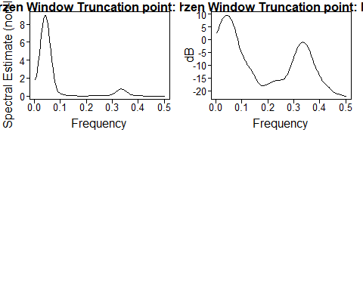

# Problem 1.6

t = seq(1:100)  
a = rnorm(n = 100, mean = 0, sd = 1)  
X = ts(3*cos(2*pi*0.05*t) + 1.5*cos(2*pi*0.35*t + 2) + a)  
plotts.sample.wge(X)

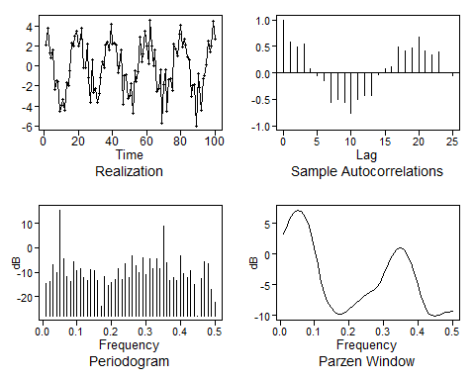

## $autplt  
## [1] 1.00000000 0.57649694 0.48730800 0.54914851 0.07354010  
## [6] -0.06116788 -0.13844976 -0.55363657 -0.51070762 -0.54830762  
## [11] -0.76673235 -0.51009353 -0.42309887 -0.43487633 -0.03986560  
## [16] 0.06986427 0.11409173 0.49286186 0.41765742 0.46483568  
## [21] 0.66979732 0.41175408 0.33950499 0.39804396 0.01204542  
## [26] -0.05551153  
##   
## $freq  
## [1] 0.01 0.02 0.03 0.04 0.05 0.06 0.07 0.08 0.09 0.10 0.11 0.12 0.13 0.14  
## [15] 0.15 0.16 0.17 0.18 0.19 0.20 0.21 0.22 0.23 0.24 0.25 0.26 0.27 0.28  
## [29] 0.29 0.30 0.31 0.32 0.33 0.34 0.35 0.36 0.37 0.38 0.39 0.40 0.41 0.42  
## [43] 0.43 0.44 0.45 0.46 0.47 0.48 0.49 0.50  
##   
## $db  
## [1] -14.603564 -13.678558 -6.844573 -10.337737 15.563429 -4.326190  
## [7] -11.683824 -13.798632 -5.644154 -9.433816 -8.443263 -12.153130  
## [13] -13.257109 -8.743059 -9.446786 -13.312254 -23.803599 -11.924102  
## [19] -15.438468 -14.308479 -13.072200 -8.375123 -13.122082 -6.652491  
## [25] -12.258502 -3.104116 -7.208106 -10.000891 -4.031931 -10.847264  
## [31] -4.394226 -8.396649 -4.513377 -8.660297 8.805839 -6.270994  
## [37] -13.344349 -12.238503 -13.607683 -3.435261 -10.457853 -12.335398  
## [43] -9.520183 -15.180198 -27.913297 -12.743681 -5.635351 -6.477901  
## [49] -16.977185 -22.431091  
##   
## $dbz  
## [1] 3.1970359 4.6451726 5.9691243 6.8371158 7.1801469  
## [6] 6.9941215 6.2797954 5.0306884 3.2388176 0.9209970  
## [11] -1.8064432 -4.5783894 -6.7690371 -8.0943700 -8.9236205  
## [16] -9.5405810 -9.8593178 -9.7872785 -9.4553140 -9.0402091  
## [21] -8.6015586 -8.1222534 -7.6011963 -7.0836513 -6.6285202  
## [26] -6.2584341 -5.9135726 -5.4277901 -4.6031250 -3.4044758  
## [31] -2.0330426 -0.7592858 0.2240762 0.8150832 0.9667242  
## [36] 0.6586424 -0.1153931 -1.3463284 -2.9926179 -4.9385276  
## [41] -6.9315487 -8.5855001 -9.6066645 -10.0345819 -10.0919272  
## [46] -9.9581131 -9.7507812 -9.5560725 -9.4266009 -9.3823257

# Equivalently  
X2 = gen.sigplusnoise.wge(n = 100, coef = c(3,1.5), freq = c(0.05, 0.35), psi = c(0, 2))

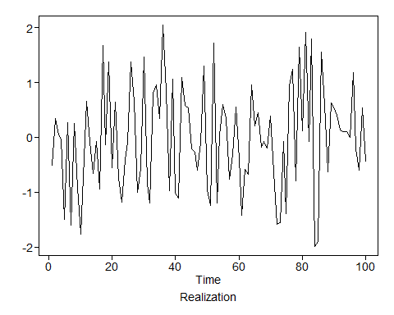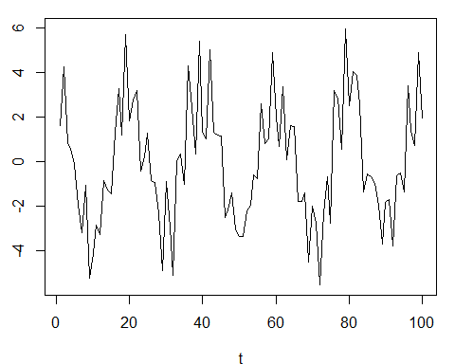

plotts.sample.wge(X)



## $autplt  
## [1] 1.00000000 0.57649694 0.48730800 0.54914851 0.07354010  
## [6] -0.06116788 -0.13844976 -0.55363657 -0.51070762 -0.54830762  
## [11] -0.76673235 -0.51009353 -0.42309887 -0.43487633 -0.03986560  
## [16] 0.06986427 0.11409173 0.49286186 0.41765742 0.46483568  
## [21] 0.66979732 0.41175408 0.33950499 0.39804396 0.01204542  
## [26] -0.05551153  
##   
## $freq  
## [1] 0.01 0.02 0.03 0.04 0.05 0.06 0.07 0.08 0.09 0.10 0.11 0.12 0.13 0.14  
## [15] 0.15 0.16 0.17 0.18 0.19 0.20 0.21 0.22 0.23 0.24 0.25 0.26 0.27 0.28  
## [29] 0.29 0.30 0.31 0.32 0.33 0.34 0.35 0.36 0.37 0.38 0.39 0.40 0.41 0.42  
## [43] 0.43 0.44 0.45 0.46 0.47 0.48 0.49 0.50  
##   
## $db  
## [1] -14.603564 -13.678558 -6.844573 -10.337737 15.563429 -4.326190  
## [7] -11.683824 -13.798632 -5.644154 -9.433816 -8.443263 -12.153130  
## [13] -13.257109 -8.743059 -9.446786 -13.312254 -23.803599 -11.924102  
## [19] -15.438468 -14.308479 -13.072200 -8.375123 -13.122082 -6.652491  
## [25] -12.258502 -3.104116 -7.208106 -10.000891 -4.031931 -10.847264  
## [31] -4.394226 -8.396649 -4.513377 -8.660297 8.805839 -6.270994  
## [37] -13.344349 -12.238503 -13.607683 -3.435261 -10.457853 -12.335398  
## [43] -9.520183 -15.180198 -27.913297 -12.743681 -5.635351 -6.477901  
## [49] -16.977185 -22.431091  
##   
## $dbz  
## [1] 3.1970359 4.6451726 5.9691243 6.8371158 7.1801469  
## [6] 6.9941215 6.2797954 5.0306884 3.2388176 0.9209970  
## [11] -1.8064432 -4.5783894 -6.7690371 -8.0943700 -8.9236205  
## [16] -9.5405810 -9.8593178 -9.7872785 -9.4553140 -9.0402091  
## [21] -8.6015586 -8.1222534 -7.6011963 -7.0836513 -6.6285202  
## [26] -6.2584341 -5.9135726 -5.4277901 -4.6031250 -3.4044758  
## [31] -2.0330426 -0.7592858 0.2240762 0.8150832 0.9667242  
## [36] 0.6586424 -0.1153931 -1.3463284 -2.9926179 -4.9385276  
## [41] -6.9315487 -8.5855001 -9.6066645 -10.0345819 -10.0919272  
## [46] -9.9581131 -9.7507812 -9.5560725 -9.4266009 -9.3823257