Homework 5

Nikhil Gupta

2020-02-23 09:06:49

Table of Contents

# Setup

library(tswge)

## Warning: package 'tswge' was built under R version 3.5.3

source("../Code/common_functions.R")

# Problem 3.1

## a

theta = c(0.95, -0.9, 0.855)  
x = gen.arma.wge(n=200, theta = theta, sn = 101)

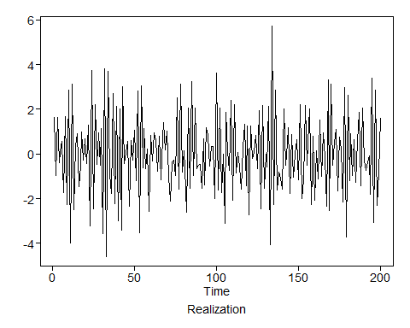

x = 25 + x  
px = plotts.sample.wge(x)

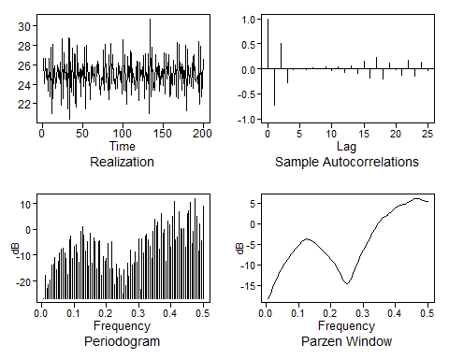

## b & c

pt = plotts.true.wge(theta = theta)

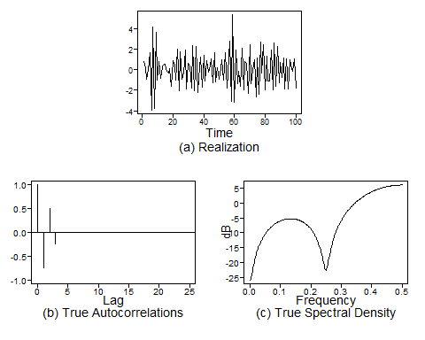

## d

muX = 25 # from the equation, we can see that it is of the 0 mean form  
varX = pt$acv[1]  
  
print(paste0("Mean of X: ", muX))

## [1] "Mean of X: 25"

print(paste0("Var of X : ", varX))

## [1] "Var of X : 3.443525"

#print(paste0("Var of X (alternatively): ", calculate_arp_varx(phi = phi, p = pt, vara = 1)))

## e

# Since the model is stationary, we can use all the data to compute mean and variance  
muX_est = mean(x)  
varX_est = var(x)  
  
print(paste0("Est. Mean of X: ", muX_est))

## [1] "Est. Mean of X: 25.0020161710545"

print(paste0("Est. Var of X : ", varX_est))

## [1] "Est. Var of X : 3.41942287218011"

# 3.3

## c

# Moving Average Models are always stationary  
  
# This is a moving average model which is always stationary since it is a linear combination of white noise terms which are individually stationary. All moving average models are stationary, they may not be invertible, but they are stationary.

# 3.6

## a

p = 4 # Incorrect  
q = 3 # Incorrect  
  
phi = c(1, -0.26, -0.64, 0.576)  
factor.wge(phi = phi)

##   
## Coefficients of Original polynomial:   
## 1.0000 -0.2600 -0.6400 0.5760   
##   
## Factor Roots Abs Recip System Freq   
## 1-1.0000B+0.9000B^2 0.5556+-0.8958i 0.9487 0.1616  
## 1-0.8000B 1.2500 0.8000 0.0000  
## 1+0.8000B -1.2500 0.8000 0.5000  
##   
##

theta = c(2.4, -2.18, 0.72)  
factor.wge(phi = theta)

##   
## Coefficients of Original polynomial:   
## 2.4000 -2.1800 0.7200   
##   
## Factor Roots Abs Recip System Freq   
## 1-1.6000B+0.9000B^2 0.8889+-0.5666i 0.9487 0.0903  
## 1-0.8000B 1.2500 0.8000 0.0000  
##   
##

# The factors (1-0.8B) cancel each other, hence it is an AR(3,2) model not an AR(4,3) model.  
  
# All the Abs Reciprocals of AR components are < 1 so the model is stationary  
# All the Abs Reciprocals of MA components are < 1 so the model is invertible

# 3.7

## a

phi = c(0.1, -0.5, -0.08, 0.24)  
factor.wge(phi = phi)

##   
## Coefficients of Original polynomial:   
## 0.1000 -0.5000 -0.0800 0.2400   
##   
## Factor Roots Abs Recip System Freq   
## 1-0.1455B+0.8048B^2 0.0904+-1.1110i 0.8971 0.2371  
## 1+0.5693B -1.7565 0.5693 0.5000  
## 1-0.5238B 1.9091 0.5238 0.0000  
##   
##

# theta = c(2.4, -2.18, 0.72)  
# factor.wge(phi = theta)  
  
# Stationary since all roots of the AR component are < 1  
# AR models can be thought to have MA component with theta1 approaching 0  
# hence the MA root will be approaching infinity. Hence invertible.  
  
pt = plotts.true.wge(phi = phi)

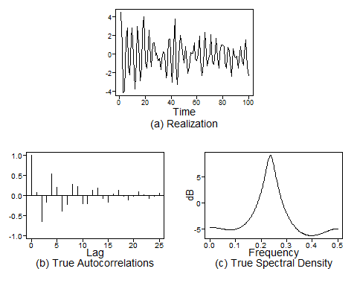

# Freq at 0.2371 is dominant since abs reciprocal is ~ 0.9.   
# Other roots are not as dominant since abs reciprocal is < 0.6  
# Hence we see a peak at 0.2371 only and the generated signal  
# is also showing a pseudi sinuisoidal frequency of ~ 0.25  
  
# This pseudo cyclical behavior is also seen in the ACF   
# (we can see the ACF repeat after lag of 4, hence period = 0.25)

## b

phi = c(1.3, -0.4)  
factor.wge(phi = phi)

##   
## Coefficients of Original polynomial:   
## 1.3000 -0.4000   
##   
## Factor Roots Abs Recip System Freq   
## 1-0.8000B 1.2500 0.8000 0.0000  
## 1-0.5000B 2.0000 0.5000 0.0000  
##   
##

theta = c(1.9)  
factor.wge(phi = theta)

##   
## Coefficients of Original polynomial:   
## 1.9000   
##   
## Factor Roots Abs Recip System Freq   
## 1-1.9000B 0.5263 1.9000 0.0000  
##   
##

# Stationary since all roots of the AR component are < 1  
# MA component has abs reciprocal > 1, hence non invertible  
  
# pt = plotts.true.wge(phi = phi, theta = theta)

## c

phi = c(1.9)  
factor.wge(phi = phi)

##   
## Coefficients of Original polynomial:   
## 1.9000   
##   
## Factor Roots Abs Recip System Freq   
## 1-1.9000B 0.5263 1.9000 0.0000  
##   
##

theta = c(1.3, -0.4)  
factor.wge(phi = theta)

##   
## Coefficients of Original polynomial:   
## 1.3000 -0.4000   
##   
## Factor Roots Abs Recip System Freq   
## 1-0.8000B 1.2500 0.8000 0.0000  
## 1-0.5000B 2.0000 0.5000 0.0000  
##   
##

# Non Stationary model since one of the roots of the AR component are > 1  
# MA component has abs reciprocal < 1, hence it is invertible  
  
# pt = plotts.true.wge(phi = phi, theta = theta)

## d

phi = c(2.95, -3.87, 2.82, -0.92)  
factor.wge(phi = phi)

##   
## Coefficients of Original polynomial:   
## 2.9500 -3.8700 2.8200 -0.9200   
##   
## Factor Roots Abs Recip System Freq   
## 1-1.9484B+0.9695B^2 1.0049+-0.1475i 0.9846 0.0232  
## 1-1.0016B+0.9490B^2 0.5278+-0.8805i 0.9742 0.1641  
##   
##

theta = c(0.9)  
factor.wge(phi = theta)

##   
## Coefficients of Original polynomial:   
## 0.9000   
##   
## Factor Roots Abs Recip System Freq   
## 1-0.9000B 1.1111 0.9000 0.0000  
##   
##

# Stationary since all roots of the AR component are < 1  
# MA component has abs reciprocal < 1, hence it is invertible  
  
pt = plotts.true.wge(phi = phi, theta = theta)

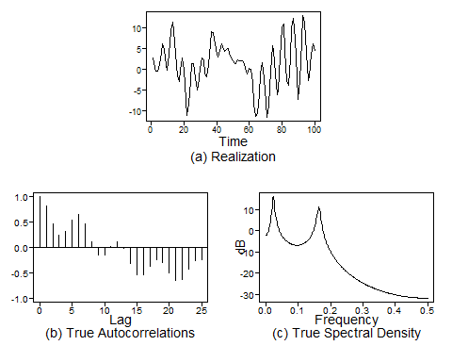

## e

phi = c(1, 0.49, -0.9, 0.369)  
factor.wge(phi = phi)

##   
## Coefficients of Original polynomial:   
## 1.0000 0.4900 -0.9000 0.3690   
##   
## Factor Roots Abs Recip System Freq   
## 1+0.9487B -1.0541 0.9487 0.5000  
## 1-0.9487B 1.0541 0.9487 0.0000  
## 1-1.0000B+0.4100B^2 1.2195+-0.9756i 0.6403 0.1074  
##   
##

theta = c(-1, -1, -0.75)  
factor.wge(phi = theta)

##   
## Coefficients of Original polynomial:   
## -1.0000 -1.0000 -0.7500   
##   
## Factor Roots Abs Recip System Freq   
## 1+0.1443B+0.8765B^2 -0.0823+-1.0650i 0.9362 0.2623  
## 1+0.8557B -1.1687 0.8557 0.5000  
##   
##

# Stationary since all roots of the AR component are < 1  
# MA component has abs reciprocal < 1, hence it is invertible  
  
pt = plotts.true.wge(phi = phi, theta = theta) # Can not see slower frequency here

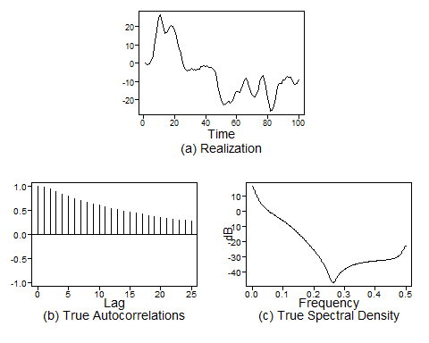

# pt = plotts.true.wge(n = 200, phi = phi, theta = theta,lag.max = 100) # Can see slower frequency here  
  
# AR Components  
# There are roots at f = 0 and f = 0.5 and both seem to be dominant  
# (abs reciprocal ~ 0.95)  
# There is also a complex root at system frequencies of 0.1074  
# but this is not as dominant since abs reciprocal ~ 0.64 only  
#  
# MA Components  
# There should be a dips at a system frequency of 0.5 (real root) and 0.2623 (complex root).   
# Both are dominant although the complex root is more dominant.   
# The dip at 0.5 may cancel out the peak at 0.5 from the AR component   
# although not completely since it is not as dominant as the AR component.  
  
# The realization should show a strong wandering behavior with pseudo cyclical   
# frequency of 0.1  
  
# The ACF should be dominanted by the AR component with freq = 0 which looks   
# like decaying exponentials. Alternating exponentials may not be seen since   
# the MA component at f = 0.5 cancels out the AR component at that frequency   
# to some extent.  
  
# We can see the wandering behavior from the realization.  
# We also see a pseudo cyclical behavior.   
# ~ 8 cycles in 80 time points (from 20 to 100) => Freq = 0.1

# 3.8

## a

theta = c(0.5, 5)  
factor.wge(phi = theta)

##   
## Coefficients of Original polynomial:   
## 0.5000 5.0000   
##   
## Factor Roots Abs Recip System Freq   
## 1-2.5000B 0.4000 2.5000 0.0000  
## 1+2.0000B -0.5000 2.0000 0.5000  
##   
##

acf1 = true.arma.aut.wge(theta = theta)

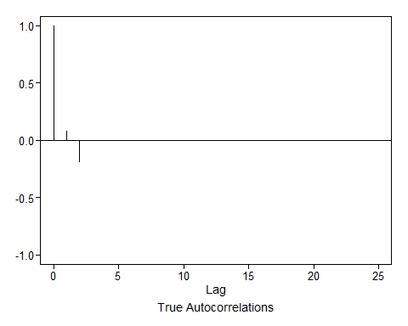

# Non Invertible since abs reciprocal > 1  
  
# The invertible model will have the reciprocal of the current roots  
# For Real roots, you can get this from the abs reciprocal from the original model  
# Only need to take this for the non invertible part  
# The invertible part can be taken as is.  
# Root 1 = 2.5   
# Root 2 = -2  
# (1 - 0.4B)(1 + 0.5B) = 0  
factors = mult.wge(0.4, -0.5)  
theta = factors$model.coef  
  
factor.wge(phi = theta)

##   
## Coefficients of Original polynomial:   
## -0.1000 0.2000   
##   
## Factor Roots Abs Recip System Freq   
## 1+0.5000B -2.0000 0.5000 0.5000  
## 1-0.4000B 2.5000 0.4000 0.0000  
##   
##

acf2 = true.arma.aut.wge(theta = theta)



print(paste0("Are the ACFs for the 2 models equal: ", all(round(acf1$acf,4) == round(acf2$acf,4))))

## [1] "Are the ACFs for the 2 models equal: TRUE"

print(acf1$acf)

## [1] 1.00000000 0.07619048 -0.19047619 0.00000000 0.00000000  
## [6] 0.00000000 0.00000000 0.00000000 0.00000000 0.00000000  
## [11] 0.00000000 0.00000000 0.00000000 0.00000000 0.00000000  
## [16] 0.00000000 0.00000000 0.00000000 0.00000000 0.00000000  
## [21] 0.00000000 0.00000000 0.00000000 0.00000000 0.00000000  
## [26] 0.00000000

print(acf2$acf)

## [1] 1.00000000 0.07619048 -0.19047619 0.00000000 0.00000000  
## [6] 0.00000000 0.00000000 0.00000000 0.00000000 0.00000000  
## [11] 0.00000000 0.00000000 0.00000000 0.00000000 0.00000000  
## [16] 0.00000000 0.00000000 0.00000000 0.00000000 0.00000000  
## [21] 0.00000000 0.00000000 0.00000000 0.00000000 0.00000000  
## [26] 0.00000000

## b

theta = c(2, -1.5)  
factor.wge(phi = theta)

##   
## Coefficients of Original polynomial:   
## 2.0000 -1.5000   
##   
## Factor Roots Abs Recip System Freq   
## 1-2.0000B+1.5000B^2 0.6667+-0.4714i 1.2247 0.0980  
##   
##

acf1 = true.arma.aut.wge(theta = theta)

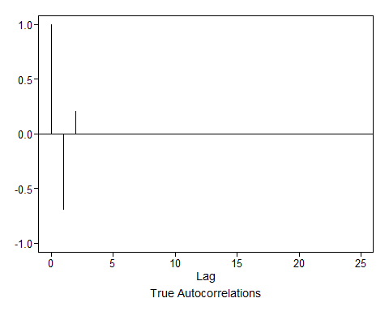

# Non Invertible since abs reciprocal > 1 for one of the roots  
# The invertible model will have the reciprocal of the current roots  
  
# Original Roots  
root1_org = complex(real = 0.6667, imaginary = 0.4714)  
root2_org = complex(real = 0.6667, imaginary = -0.4714)  
  
# Inverse of the roots  
inv_root1 = 1/root1_org  
inv_root2 = 1/root2_org   
inv_root1

## [1] 0.9999897-0.7070574i

inv_root2

## [1] 0.9999897+0.7070574i

# Compute Characteristic Equation  
  
prod = inv_root1 * inv_root2  
prod

## [1] 1.49991+0i

# Char equation: (z - inv_root1) * (z - inv_root2)  
# = [Z - (1 -0.707i)] * [Z - (1 + 0.717i)]  
# = Z^2 -Z -0.717i*Z -Z +0.717i*Z + prod  
# = Z^2 -2Z + 1.5   
# = 1 -1.3333Z + 0.6667Z^2  
  
theta = c(1.333, -0.667)  
factor.wge(phi = theta)

##   
## Coefficients of Original polynomial:   
## 1.3330 -0.6670   
##   
## Factor Roots Abs Recip System Freq   
## 1-1.3330B+0.6670B^2 0.9993+-0.7076i 0.8167 0.0981  
##   
##

acf2 = true.arma.aut.wge(theta = theta)



print(paste0("Are the ACFs for the 2 models equal: ", all(round(acf1$acf,3) == round(acf2$acf,3))))

## [1] "Are the ACFs for the 2 models equal: TRUE"

print(acf1$acf)

## [1] 1.0000000 -0.6896552 0.2068966 0.0000000 0.0000000 0.0000000  
## [7] 0.0000000 0.0000000 0.0000000 0.0000000 0.0000000 0.0000000  
## [13] 0.0000000 0.0000000 0.0000000 0.0000000 0.0000000 0.0000000  
## [19] 0.0000000 0.0000000 0.0000000 0.0000000 0.0000000 0.0000000  
## [25] 0.0000000 0.0000000

print(acf2$acf)

## [1] 1.0000000 -0.6897157 0.2070285 0.0000000 0.0000000 0.0000000  
## [7] 0.0000000 0.0000000 0.0000000 0.0000000 0.0000000 0.0000000  
## [13] 0.0000000 0.0000000 0.0000000 0.0000000 0.0000000 0.0000000  
## [19] 0.0000000 0.0000000 0.0000000 0.0000000 0.0000000 0.0000000  
## [25] 0.0000000 0.0000000

# 3.11

phi = c(1, 0.49, -0.9, 0.369)  
factor.wge(phi = phi)

##   
## Coefficients of Original polynomial:   
## 1.0000 0.4900 -0.9000 0.3690   
##   
## Factor Roots Abs Recip System Freq   
## 1+0.9487B -1.0541 0.9487 0.5000  
## 1-0.9487B 1.0541 0.9487 0.0000  
## 1-1.0000B+0.4100B^2 1.2195+-0.9756i 0.6403 0.1074  
##   
##

theta = c(-1, -1, -0.75)  
factor.wge(phi = theta)

##   
## Coefficients of Original polynomial:   
## -1.0000 -1.0000 -0.7500   
##   
## Factor Roots Abs Recip System Freq   
## 1+0.1443B+0.8765B^2 -0.0823+-1.0650i 0.9362 0.2623  
## 1+0.8557B -1.1687 0.8557 0.5000  
##   
##

# Stationary since all roots of the AR component are < 1  
# MA component has abs reciprocal < 1, hence invertible  
  
psi.weights.wge(phi=phi, theta=theta, lag.max = 10)

## [1] 2.000000 3.490000 4.320000 4.599100 4.312900 3.966269 3.534480  
## [8] 3.293410 3.047123 2.943415

# 3.13

## i

phi = c(2.2, -2.1, 0.8)  
factor.wge(phi = phi)

##   
## Coefficients of Original polynomial:   
## 2.2000 -2.1000 0.8000   
##   
## Factor Roots Abs Recip System Freq   
## 1-1.3685B+0.9621B^2 0.7112+-0.7305i 0.9809 0.1271  
## 1-0.8315B 1.2026 0.8315 0.0000  
##   
##

# Realization  
x = gen.arma.wge(n = 100, phi = phi, sn = 101)

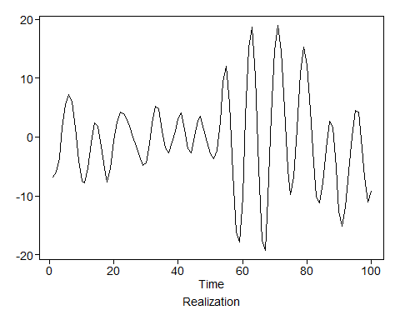

px = plotts.sample.wge(x)

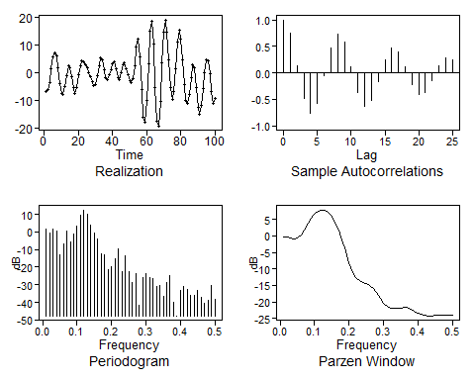

# AR Order p = 3  
# Number of factors = 2 (from factor table)  
pf = factor.comp.wge(x, p = 3, ncomp = 2)

##   
## Coefficients of Original polynomial:   
## 2.1581 -2.0222 0.7344   
##   
## Factor Roots Abs Recip System Freq   
## 1-1.3876B+0.9531B^2 0.7279+-0.7206i 0.9763 0.1242  
## 1-0.7705B 1.2979 0.7705 0.0000  
##   
##

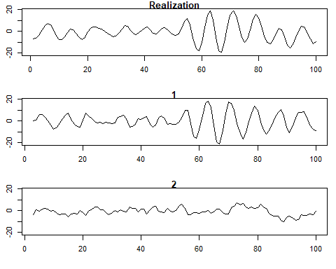

### factor.comp.wge eval

phi = c(2.2, -2.1, 0.8)  
  
# True Factors  
factor.wge(phi = phi)

##   
## Coefficients of Original polynomial:   
## 2.2000 -2.1000 0.8000   
##   
## Factor Roots Abs Recip System Freq   
## 1-1.3685B+0.9621B^2 0.7112+-0.7305i 0.9809 0.1271  
## 1-0.8315B 1.2026 0.8315 0.0000  
##   
##

# Realization  
x = gen.arma.wge(n = 200, phi = phi, sn = 101)

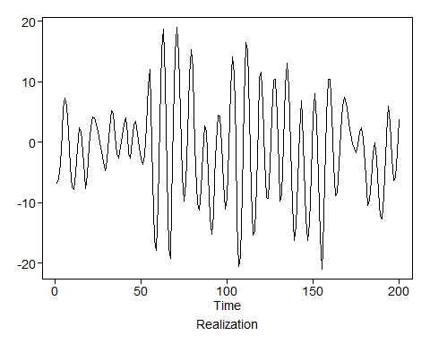

# Factors in the realization (should match the true ones in theory)  
# User should specify p, ncomp is only to limit number of components that are plotted  
pf = factor.comp.wge(x, p = 3, ncomp = 2)

##   
## Coefficients of Original polynomial:   
## 2.2208 -2.1158 0.7962   
##   
## Factor Roots Abs Recip System Freq   
## 1-1.3946B+0.9636B^2 0.7236+-0.7170i 0.9816 0.1243  
## 1-0.8262B 1.2103 0.8262 0.0000  
##   
##

