<https://github.com/SouthernMethodistUniversity/singularity_docker>

# SINGULARITY

## Definition File Format

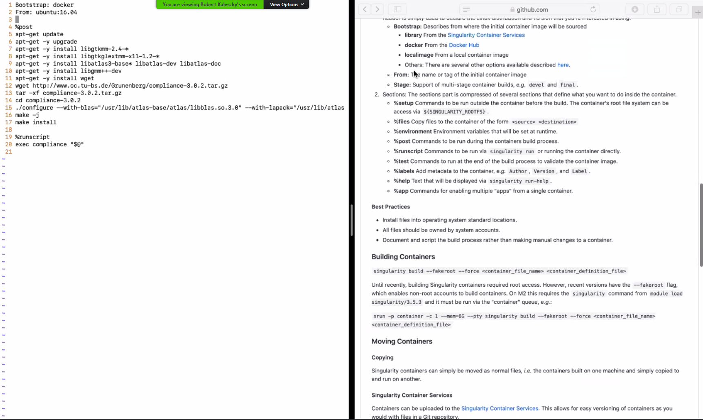

### Header

* Bootstrap Region:
  + Where is your image coming from?
  + Singularity Container Services or Docker Hub or a Local Image (custom built)
* From: What do you want to source from the hub. Syntax = Name:Version

### Sections

* %setup – create directories
* %files – only to copy files
* %environment
  + environment variables (only for run time).
  + Any variable set here will not be accessible in %post
* %post –
  + Post as in after setup
  + The biggest section
  + Define what your container is.
* %runscript
  + Unique to Singularity
* %test – test that things happened correctly
* %labels – add metadata
* %help – help files, how to run the container, etc.
* %app – Use a single container for multiple purposes. It is advisable to have single “purpose” workflows in a single container.

# DOCKER

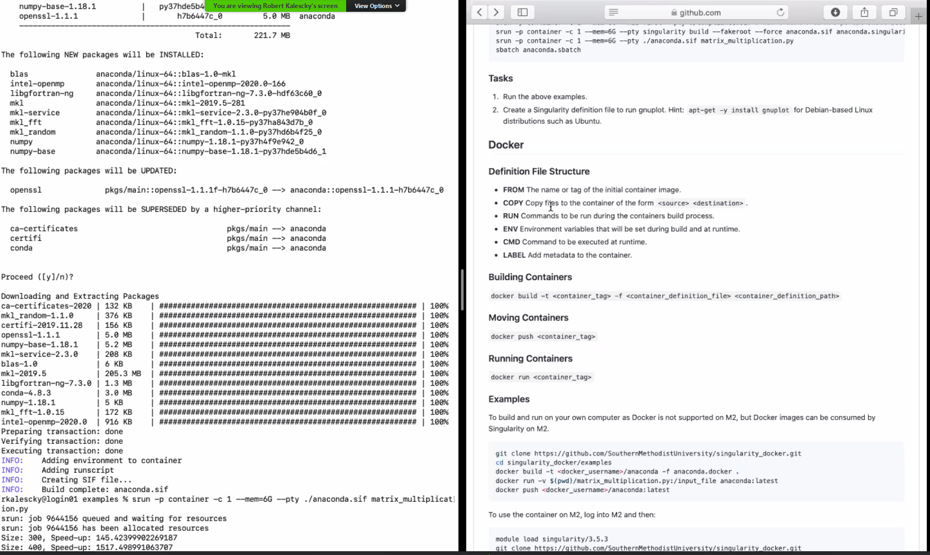

* Many similar commands to Singularity
* RUN – similar to %post in singularity
* ENV –
  + set environment variables
  + In this case, order maters, they can be reused between build and run time.
* CMD – similar to %runtime in Singularity – commands to run when container exe is run.

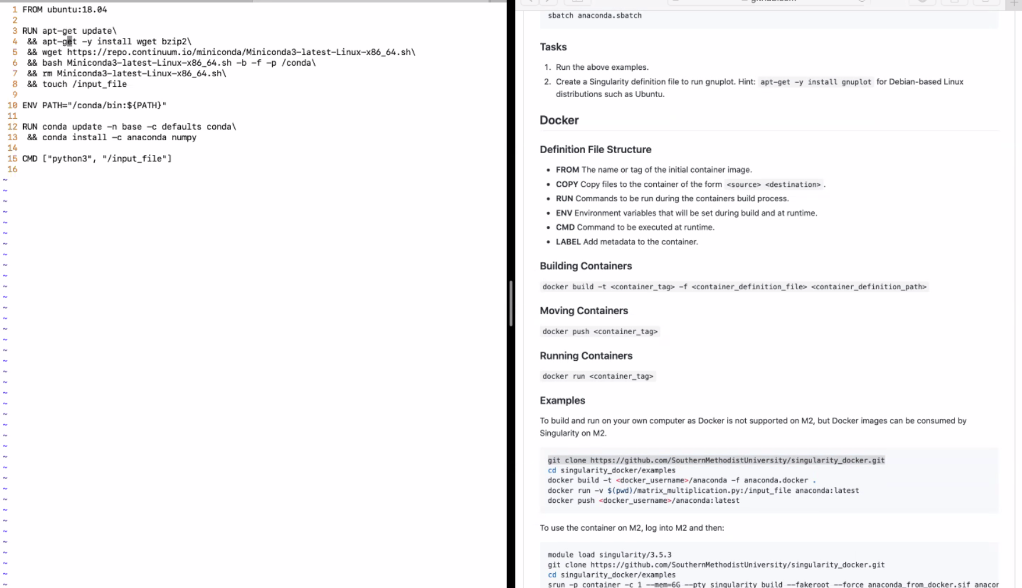

* Docker builds a new version of the container at each step. Hence, Docker can rebuild at the command level. So, if I make a change in the middle, it won’t have to rebuild from the start unlike Singularity which has to build from the beginning.
* To move docker containers around, the preferred method is to push and pull to Docker Hub. You can get a free account.