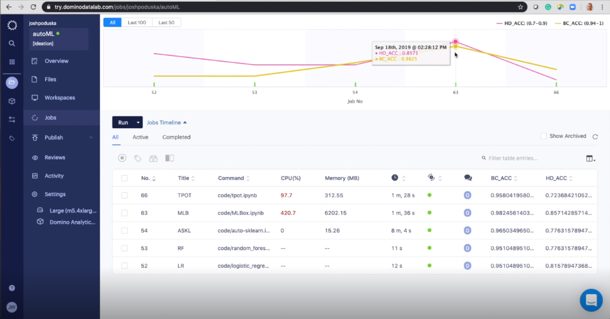

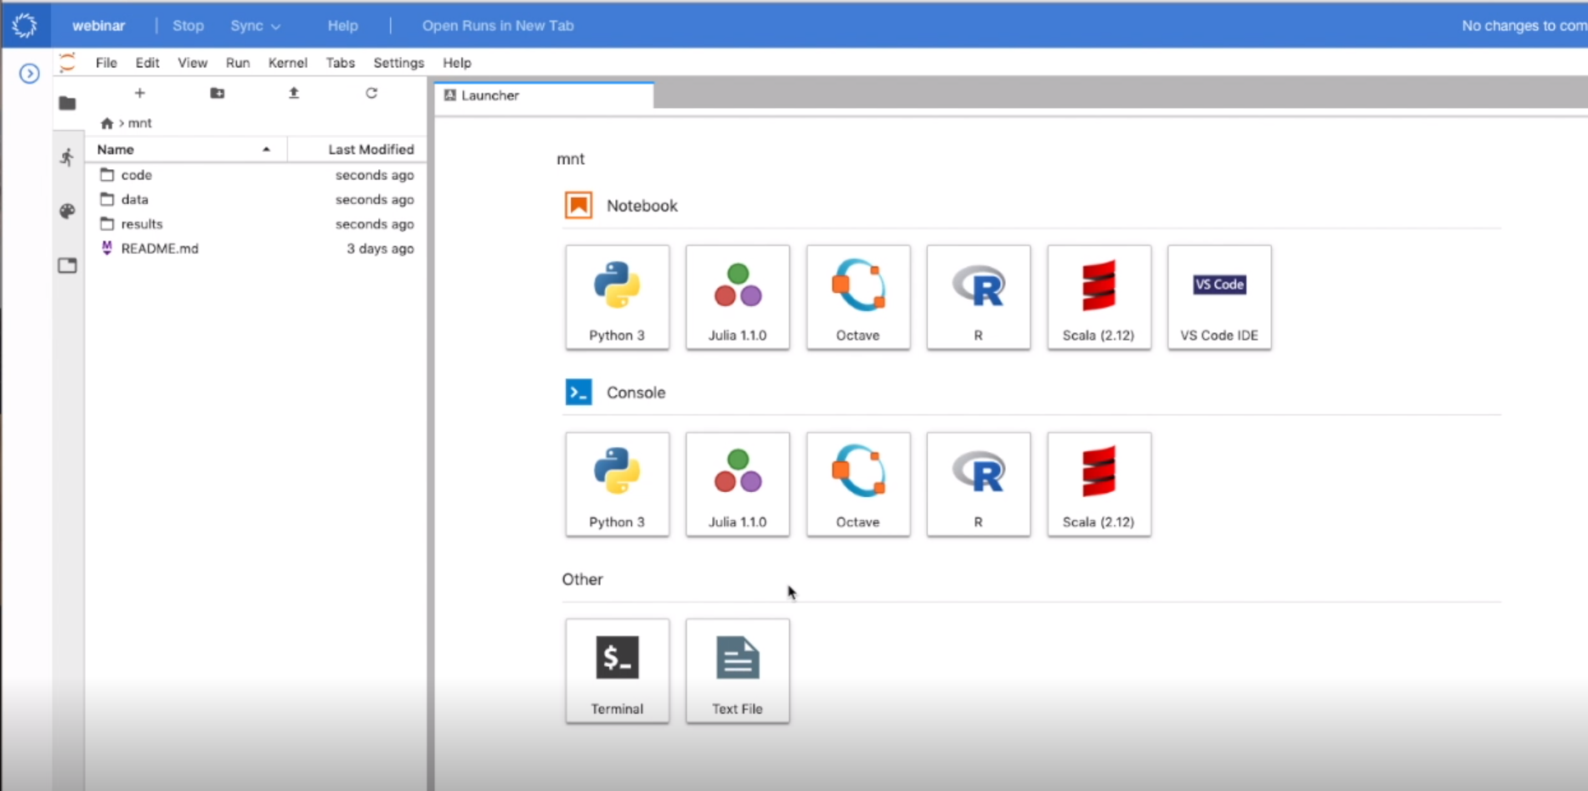

* <https://github.com/hibayesian/awesome-automl-papers>
* <https://www.dominodatalab.com/>
* <https://try.dominodatalab.com/u/mywork_ng/webinar-automl/overview>
* auto-sklearn
  + not much control over hyperparameters
  + can do auto feature engineering for categorical variables
  + with cv, you have to manually call the refit function
  + presenter found that manually doing ohe was giving better results
* MLBox
  + MLBox gives better control over auto-sklearn (this has limited user control)
  + Can infer categorical fields (using data types)
    - Does not work if categorical fields are coded as numbers
    - Have to manually add a text before those categorical field values
  + 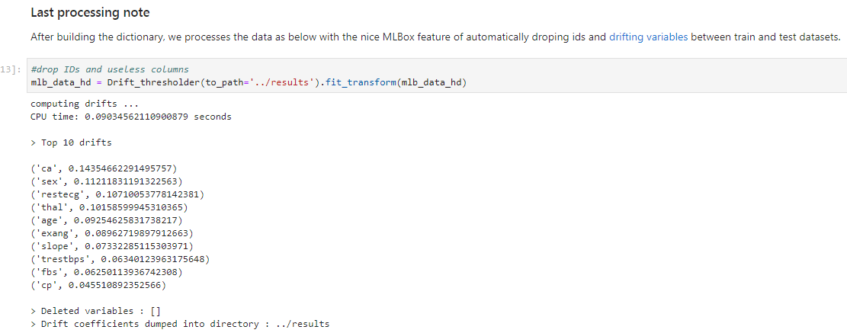
  + Define your space (lot more flexibility over auto-sklearn)
    - 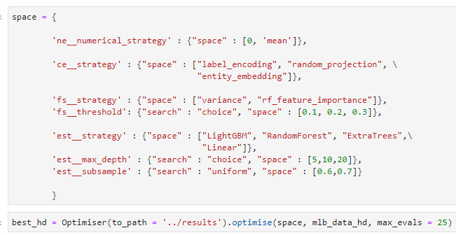
  + **No Option to parallelize**
* Tpot
  + Also a wrapper over scikit-learn
  + Can dump out the pipeline in a py file
* Auto-Keras

