PyTest pytest.org reference

Tutorial: <https://www.guru99.com/pytest-tutorial.html> (good overview)

Fixture = Setup/teardown

Conftest.py 🡪 Contains Setup and Teardown

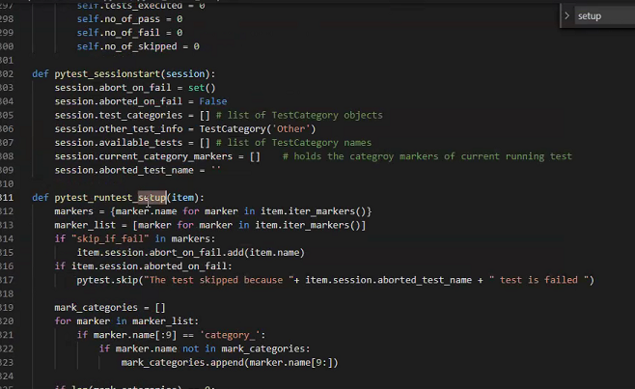

@pytest.mark.<name> -- groups tests

Also built in such as

* mark.skip
* mark.parameteize

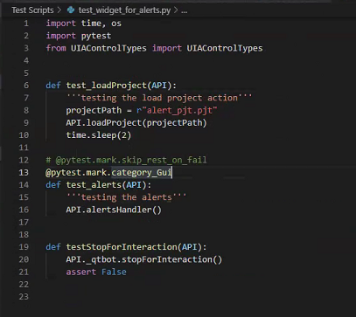

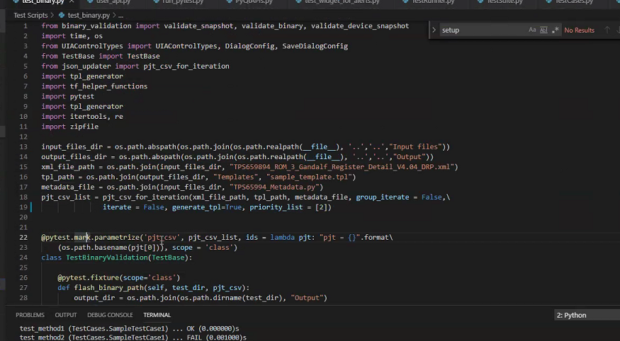

HTML report is also available – pytest-html library