Codebook for testData

Autogenerated data summary from dataMaid

2019-09-27 04:10:41

# Data report overview

The dataset examined has the following dimensions:

|  |  |
| --- | --- |
| Feature | Result |
| Number of observations | 15 |
| Number of variables | 15 |

# Codebook summary table

|  |  |  |  |  |  |
| --- | --- | --- | --- | --- | --- |
| Label | Variable | Class | # unique values | Missing | Description |
|  | **charVar** | character | 5 | 6.67 % |  |
|  | **factorVar** | factor | 5 | 0.00 % |  |
|  | **numVar** | numeric | 10 | 0.00 % |  |
|  | **intVar** | integer | 10 | 0.00 % |  |
|  | **boolVar** | logical | 3 | 20.00 % |  |
|  | **keyVar** | character | 15 | 0.00 % |  |
|  | **emptyVar** | numeric | 1 | 0.00 % |  |
|  | **numOutlierVar** | numeric | 15 | 0.00 % |  |
|  | **smartNumVar** | numeric | 2 | 0.00 % |  |
|  | **cprVar** | character | 5 | 0.00 % |  |
|  | **cprKeyVar** | character | 15 | 0.00 % |  |
|  | **miscodedMissingVar** | character | 14 | 0.00 % |  |
|  | **misclassifiedNumVar** | factor | 12 | 0.00 % |  |
|  | **dateVar** | Date | 4 | 0.00 % |  |
|  | **labelledVar** | labelled | 3 | 13.33 % |  |

# Variable list

## charVar

|  |  |
| --- | --- |
| Feature | Result |
| Variable type | character |
| Number of missing obs. | 1 (6.67 %) |
| Number of unique values | 4 |
| Mode | “a” |

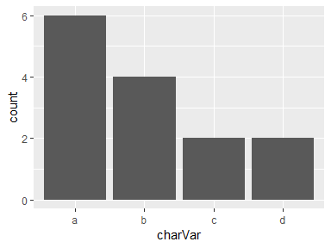

* Observed factor levels: "a", "b", "c", "d".

## factorVar

|  |  |
| --- | --- |
| Feature | Result |
| Variable type | factor |
| Number of missing obs. | 0 (0 %) |
| Number of unique values | 5 |
| Mode | “a” |
| Reference category | 999 |

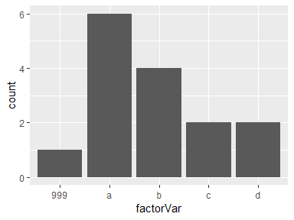

* Observed factor levels: "999", "a", "b", "c", "d".

## numVar

|  |  |
| --- | --- |
| Feature | Result |
| Variable type | numeric |
| Number of missing obs. | 0 (0 %) |
| Number of unique values | 10 |
| Median | 5 |
| 1st and 3rd quartiles | 1.5; 6.5 |
| Min. and max. | 1; 10 |

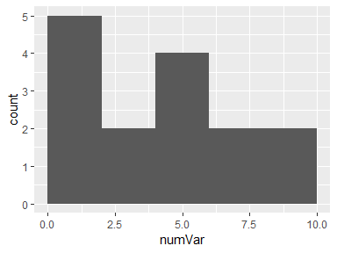

## intVar

|  |  |
| --- | --- |
| Feature | Result |
| Variable type | integer |
| Number of missing obs. | 0 (0 %) |
| Number of unique values | 10 |
| Median | 5 |
| 1st and 3rd quartiles | 1.5; 6.5 |
| Min. and max. | 1; 10 |

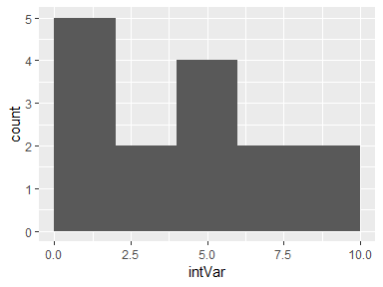

## boolVar

|  |  |
| --- | --- |
| Feature | Result |
| Variable type | logical |
| Number of missing obs. | 3 (20 %) |
| Number of unique values | 2 |
| Mode | “TRUE” |

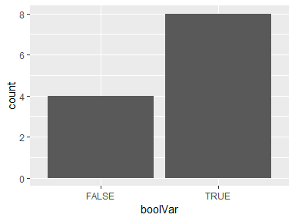

## keyVar

* The variable is a key (distinct values for each observation).

## emptyVar

* The variable only takes one (non-missing) value: "1". The variable contains 0 % missing observations.

## numOutlierVar

|  |  |
| --- | --- |
| Feature | Result |
| Variable type | numeric |
| Number of missing obs. | 0 (0 %) |
| Number of unique values | 15 |
| Median | 8 |
| 1st and 3rd quartiles | 4.5; 11.5 |
| Min. and max. | 1; 100 |

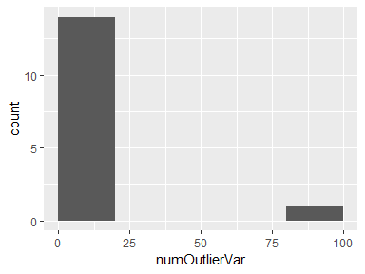

## smartNumVar

|  |  |
| --- | --- |
| Feature | Result |
| Variable type | numeric |
| Number of missing obs. | 0 (0 %) |
| Number of unique values | 2 |
| Median | 1 |
| 1st and 3rd quartiles | 0; 1 |
| Min. and max. | 0; 1 |

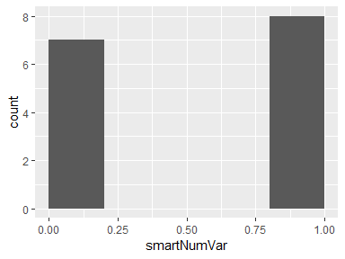

## cprVar

|  |  |
| --- | --- |
| Feature | Result |
| Variable type | character |
| Number of missing obs. | 0 (0 %) |
| Number of unique values | 5 |
| Mode | “010188-1350” |

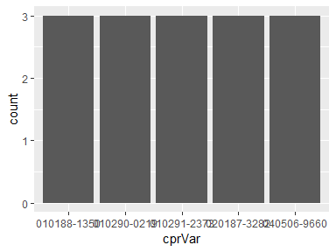

* Observed factor levels: "010188-1350", "010290-0219", "010291-2373", "020187-3282", "040506-9660".

## cprKeyVar

* The variable is a key (distinct values for each observation).

## miscodedMissingVar

|  |  |
| --- | --- |
| Feature | Result |
| Variable type | character |
| Number of missing obs. | 0 (0 %) |
| Number of unique values | 14 |
| Mode | “9” |

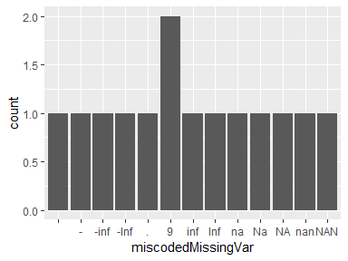

* Observed factor levels: "", "-", "-inf", "-Inf", ".", "9", "inf", "Inf", "na", "Na", "NA", "nan", "NaN", "NAN".

## misclassifiedNumVar

|  |  |
| --- | --- |
| Feature | Result |
| Variable type | factor |
| Number of missing obs. | 0 (0 %) |
| Number of unique values | 12 |
| Mode | “1” |
| Reference category | 1 |

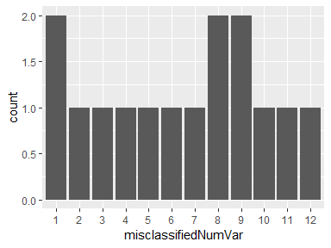

* Observed factor levels: "1", "10", "11", "12", "2", "3", "4", "5", "6", "7", "8", "9".

## dateVar

|  |  |
| --- | --- |
| Feature | Result |
| Variable type | Date |
| Number of missing obs. | 0 (0 %) |
| Number of unique values | 4 |
| Mode | “1997-05-10” |
| Min. and max. | 1997-05-10; 2013-04-02 |
| 1st and 3rd quartiles | 1997-05-10; 2005-12-10 |

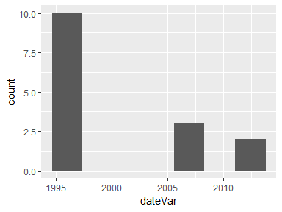

## labelledVar

|  |  |
| --- | --- |
| Feature | Result |
| Variable type | labelled |
| Number of missing obs. | 2 (13.33 %) |
| Number of unique values | 2 |
| Mode | “Joe” |

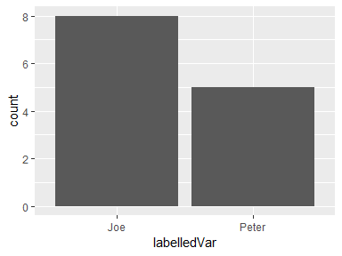

* Observed factor levels: "Joe", "Peter".

Report generation information:

* Created by Nikhil Gupta (username: Nikhil).
* Report creation time: Fri Sep 27 2019 04:10:42
* Report was run from directory: C:/Users/Nikhil/Google Drive Work/gre/evaluations/r/eda
* dataMaid v1.3.2 [Pkg: 2019-07-27 from CRAN (R 3.5.3)]
* R version 3.5.1 (2018-07-02).
* Platform: x86_64-w64-mingw32/x64 (64-bit)(Windows >= 8 x64 (build 9200)).
* Function call: makeDataReport(data = testData, mode = c("summarize", "visualize", "check"), smartNum = FALSE, file = "codebook_testData.Rmd", checks = list( character = "showAllFactorLevels", factor = "showAllFactorLevels", labelled = "showAllFactorLevels", haven_labelled = "showAllFactorLevels", numeric = NULL, integer = NULL, logical = NULL, Date = NULL), listChecks = FALSE, maxProbVals = Inf, codebook = TRUE, reportTitle = "Codebook for testData")