STAT 511 Final Project

Part 1
Question 1
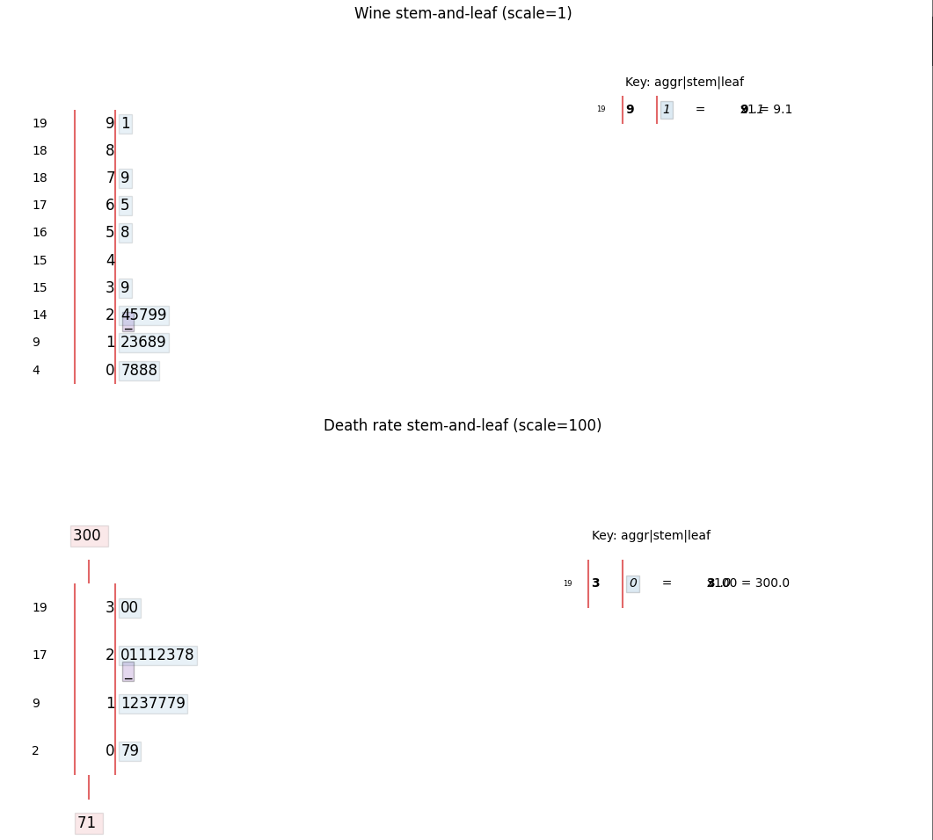
Shape of the wine dataset is also skew right and centered around 1. Death rate dataset is roughly uniform centered around 1-2

Question 2

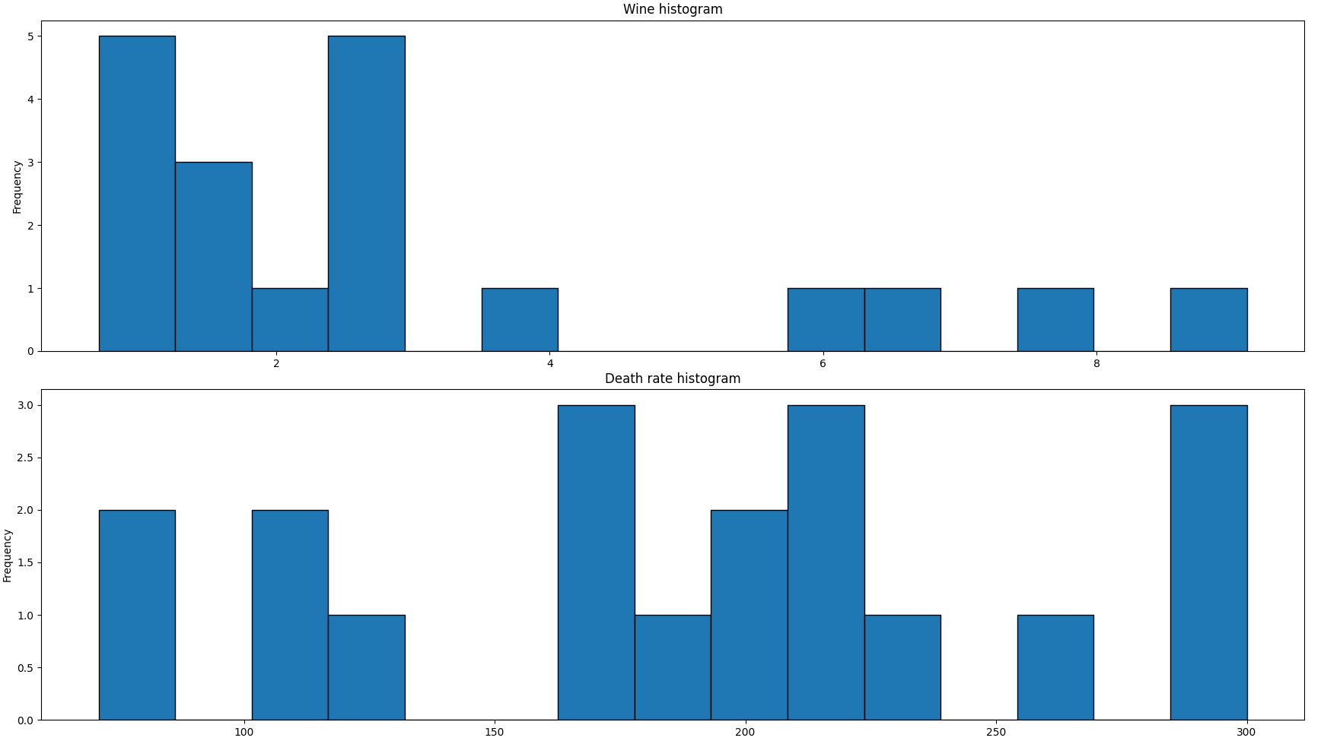
The wine histogram is skew right with clustering around 0-3. The death rate histogram is widely varied with the most clustering around 200.

Question 3
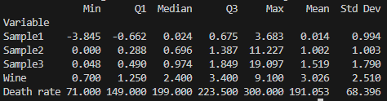

Question 4
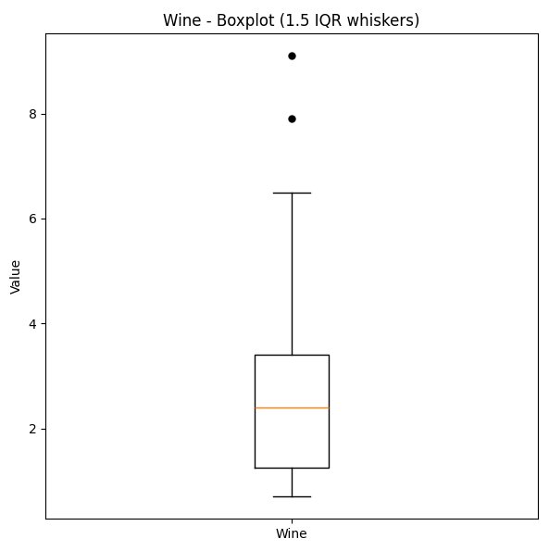
The wine dataset has 2 outliers outside of the 1.5IQR range one around 8 and the other around 9
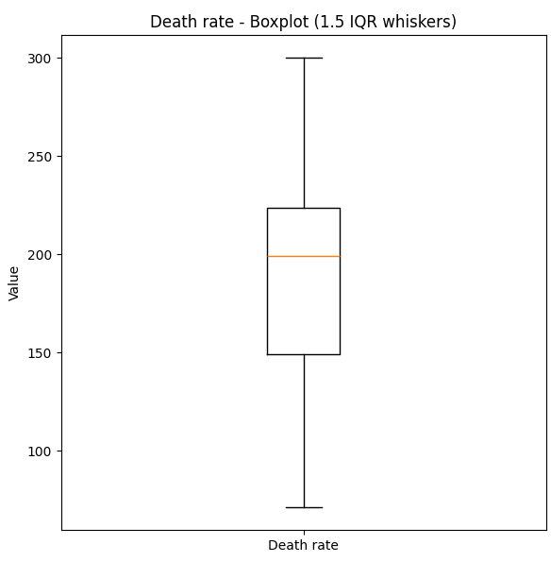
The death rate dataset doesn’t have any outliers outside of a 1.5IQR range

Question 5
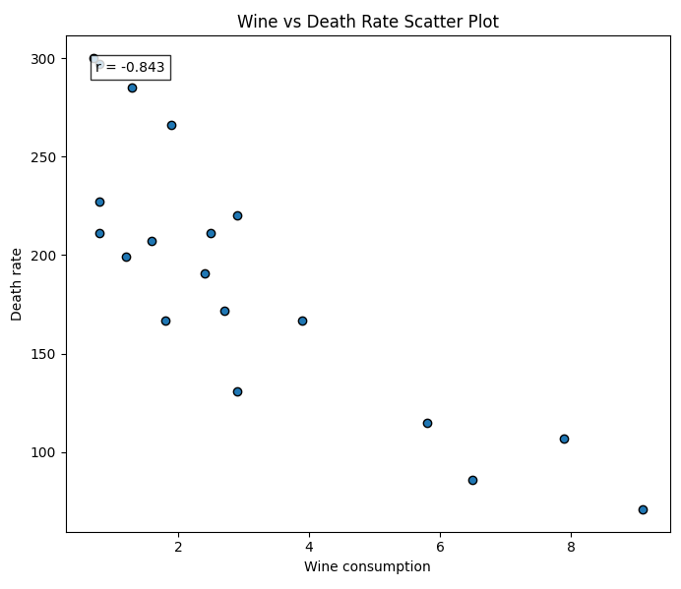
This indicates that there is a strong negative correlation between the 2 variables. As wine consumption goes up, the death rate goes down with strong correlation.
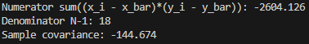

Part 2
Question 1
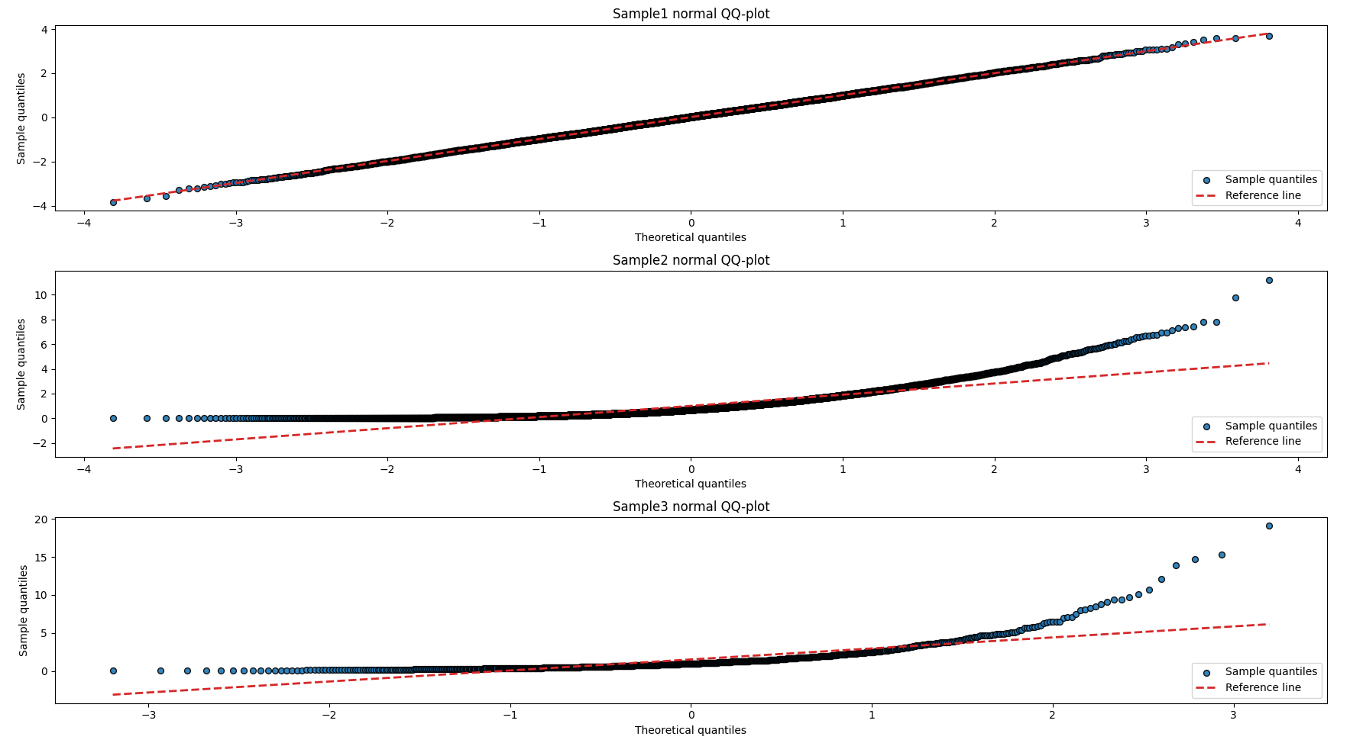
Question 2
We can roughly approximate the mean and standard deviation of a dataset if it follows a roughly normal distribution such as sample 1. Since sample1 roughly is normal we can use the relationship $y= μ+ σx$ to visually estimate parameters using the plot. At the y-axis (x=0) the line appears to fall on y = 0 meaning the mean is roughly around 0. And the slope of the graph appears to be 1 meaning the standard deviation is 1.

Part 3

