- docker –version
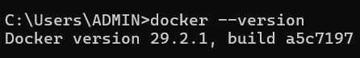
- docker run hello-world
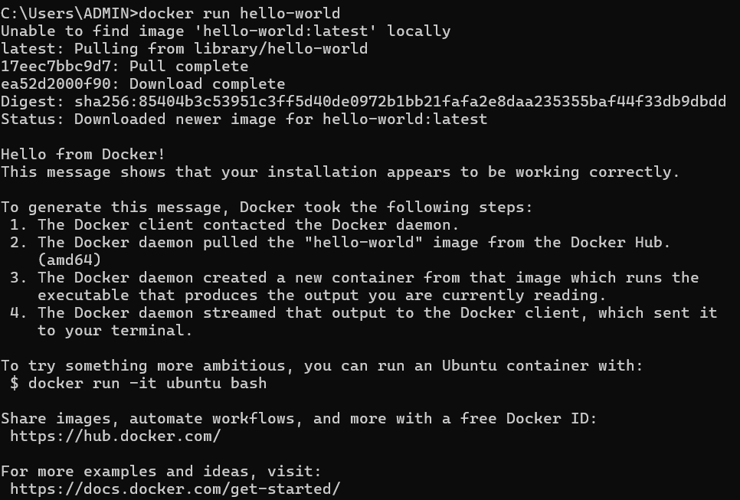
- docker pull nginx
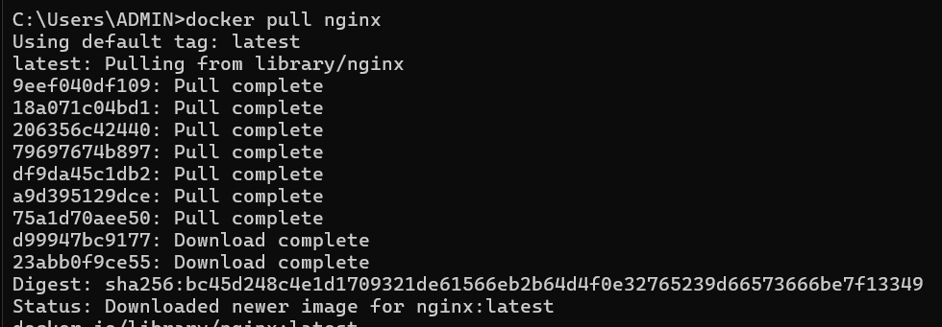
- docker images
- docker run -d nginx
- docker ps
- docker ps -a
- docker logs <container_id>
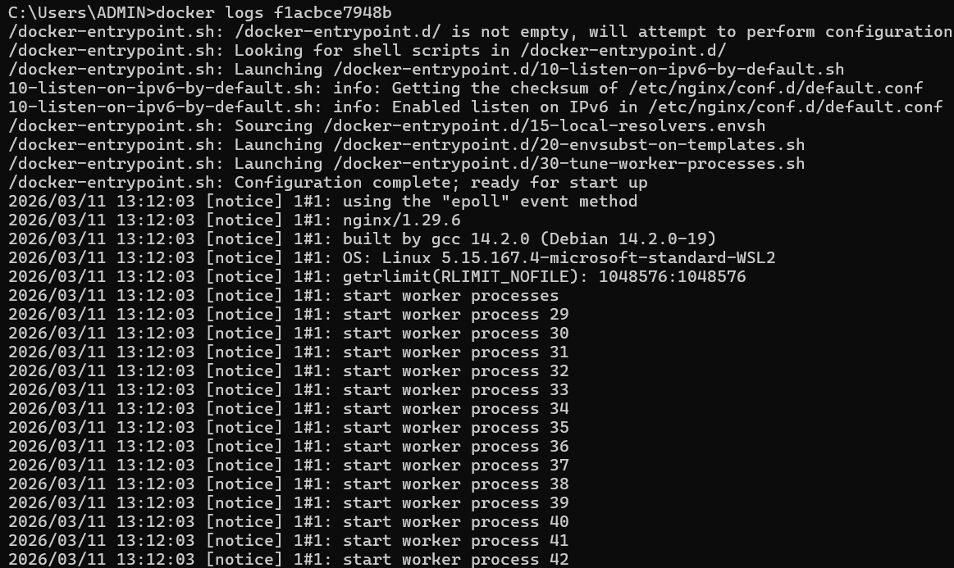
- docker exec -it <container_id> /bin/sh
- docker stop <container_id>
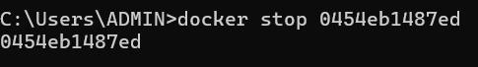
- docker restart <container_id>
- docker rm <container_id>
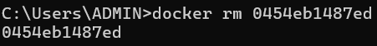
- docker container prune
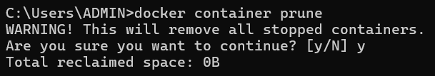
- docker rmi <image_id>
- docker image prune -a
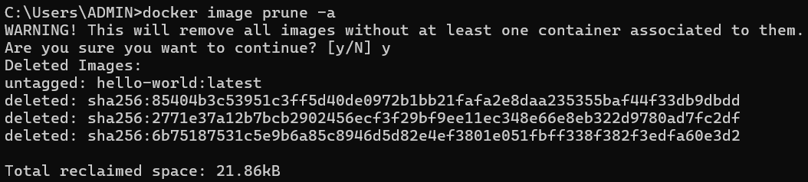
- docker run -d -p 8080:80 nginx
- docker inspect <container_id>
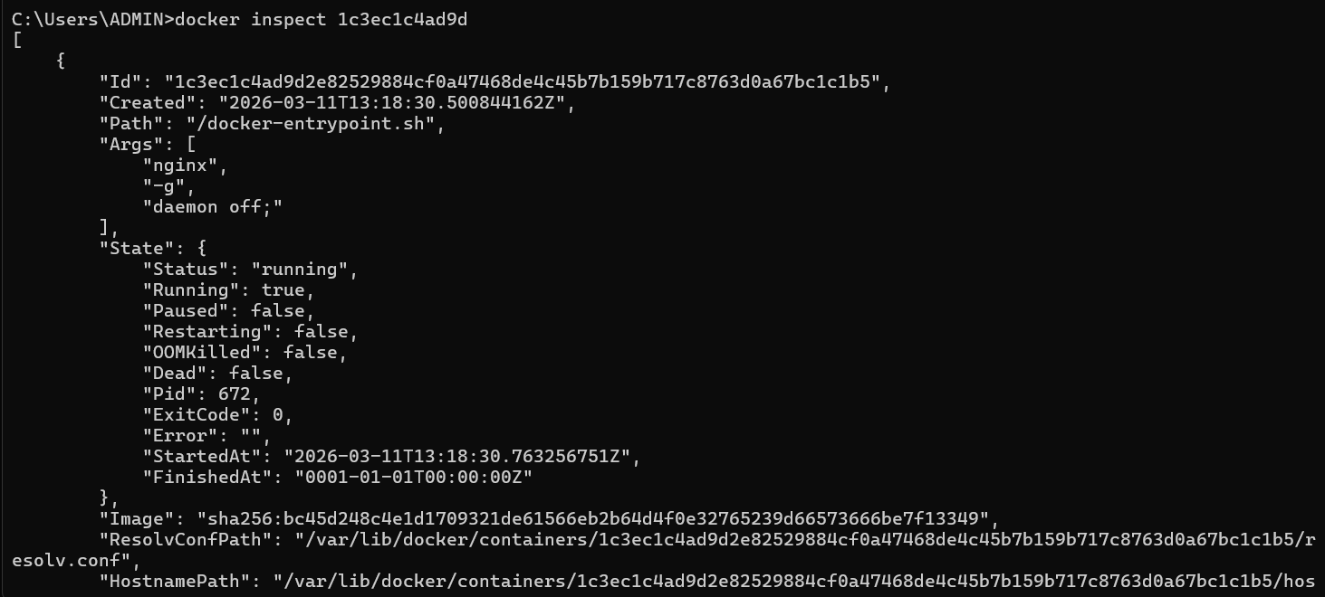
- docker run -d -v mydata:/data nginx
- docker volume ls
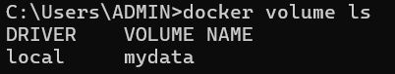
- docker volume prune
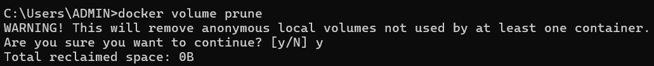
- docker run -d --name my_nginx nginx
- docker stats
- docker network ls
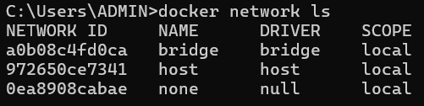
- docker network create my_network
- docker run -d --network my_network --name my_container nginx
- docker network connect my_network my_nginx

