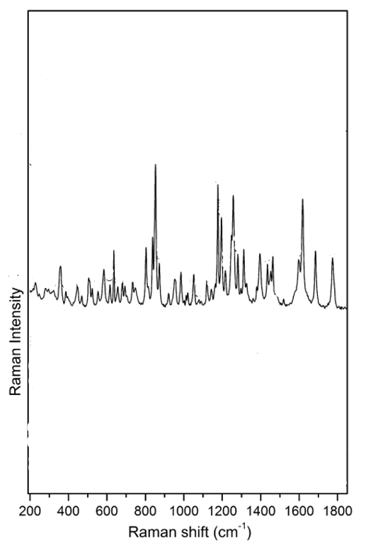
Figure 1:http://dx.doi.org/10.1016/j.molstruc.2010.11.067
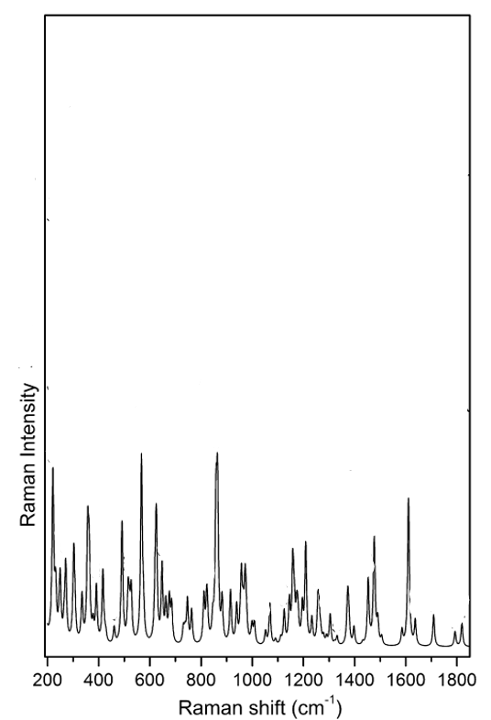
Figure 2:http://dx.doi.org/10.1016/j.molstruc.2010.11.067
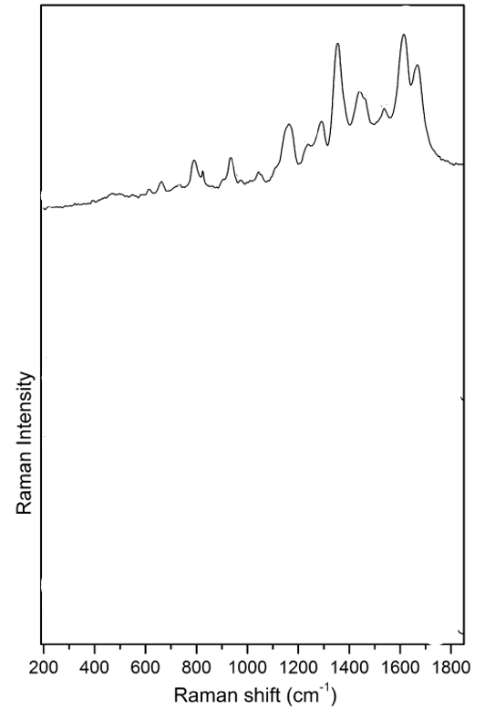
Figure 3:http://dx.doi.org/10.1016/j.molstruc.2010.11.067
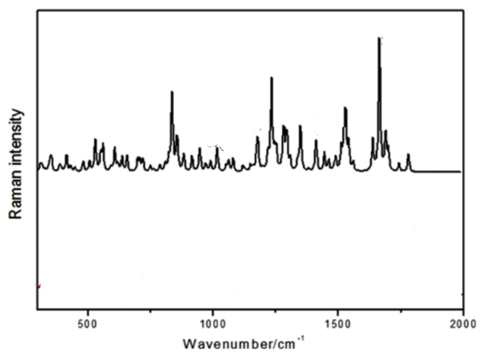
Figure 4:http://www.tandfonline.com/action/showCitFormats?doi=10.1080/00387010.2013.807843
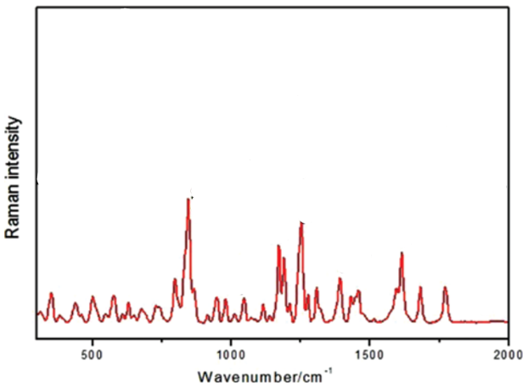
Figure 5:http://www.tandfonline.com/action/showCitFormats?doi=10.1080/00387010.2013.807843
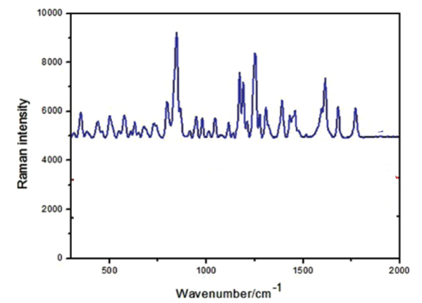
Figure 6:http://www.tandfonline.com/action/showCitFormats?doi=10.1080/00387010.2013.807843
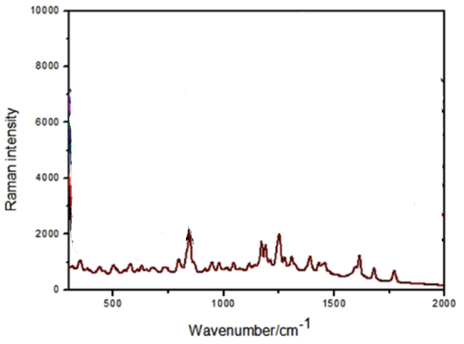
Figure 7:http://www.tandfonline.com/action/showCitFormats?doi=10.1080/00387010.2013.807843
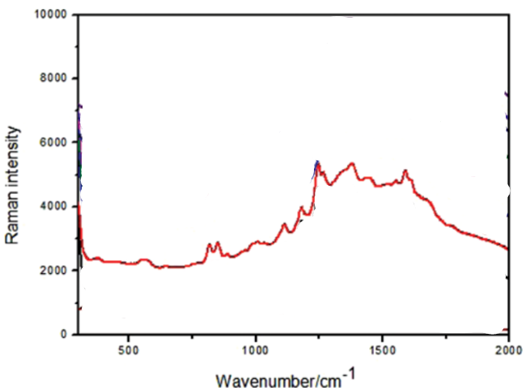
Figure 8:http://www.tandfonline.com/action/showCitFormats?doi=10.1080/00387010.2013.807843
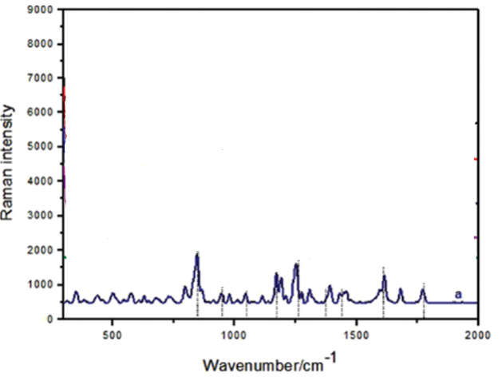
Figure 9:http://www.tandfonline.com/action/showCitFormats?doi=10.1080/00387010.2013.807843
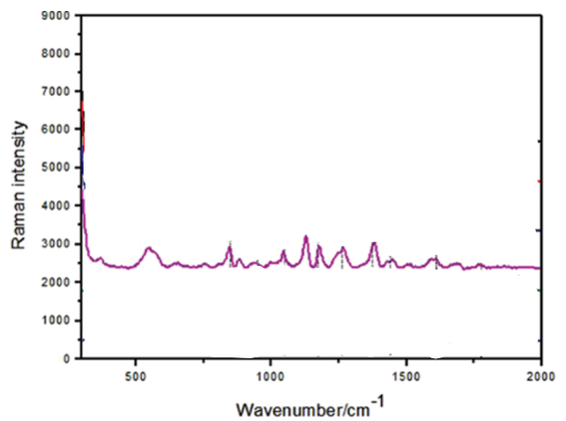
Figure 10:http://www.tandfonline.com/action/showCitFormats?doi=10.1080/00387010.2013.807843
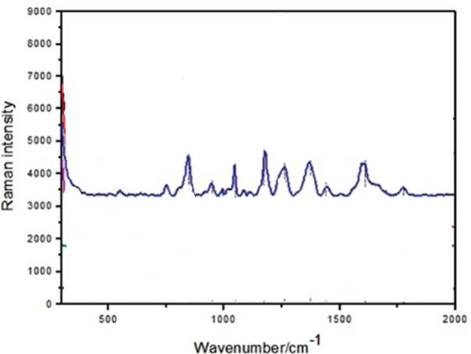
Figure 11:http://www.tandfonline.com/action/showCitFormats?doi=10.1080/00387010.2013.807843

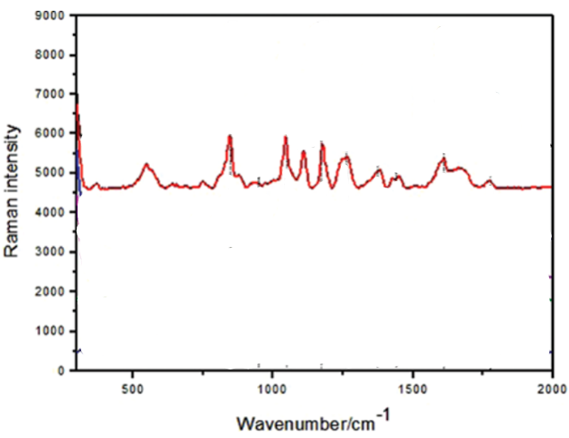
Figure 12:http://www.tandfonline.com/action/showCitFormats?doi=10.1080/00387010.2013.807843

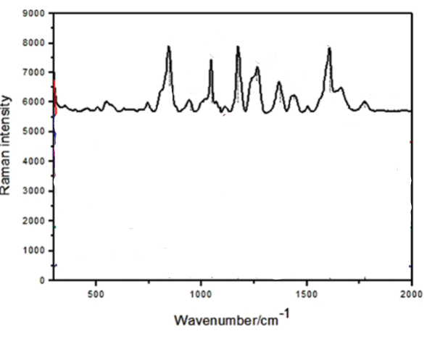
Figure 13:http://www.tandfonline.com/action/showCitFormats?doi=10.1080/00387010.2013.807843
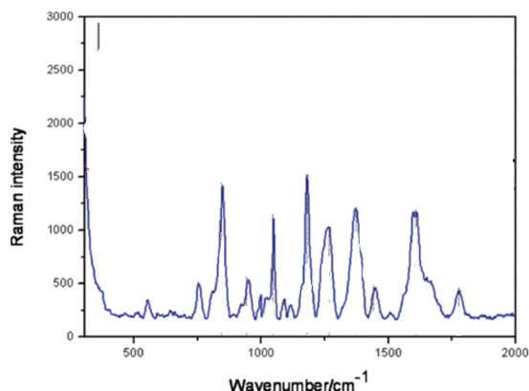
Figure 14:http://www.tandfonline.com/action/showCitFormats?doi=10.1080/00387010.2013.807843
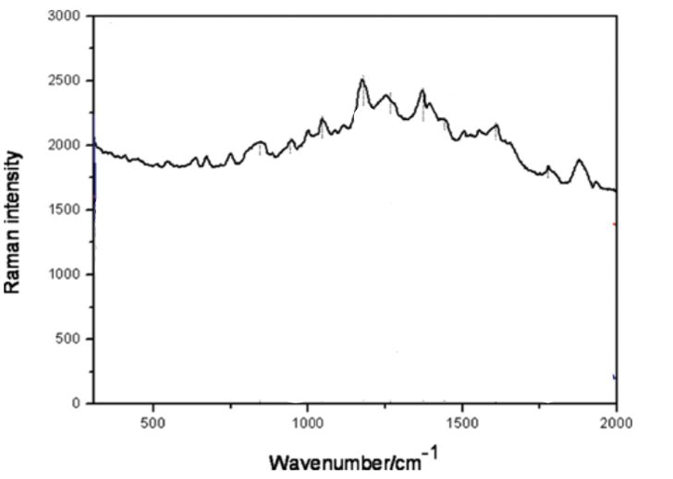
Figure 15:http://www.tandfonline.com/action/showCitFormats?doi=10.1080/00387010.2013.807843
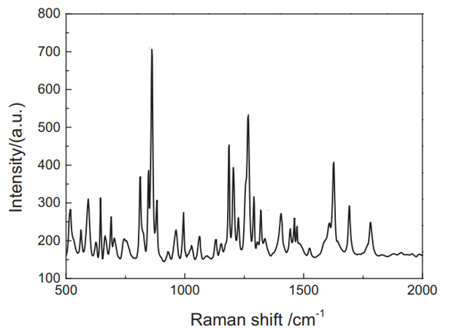
Figure 16:https://doi.org/10.1016/j.saa.2020.118262
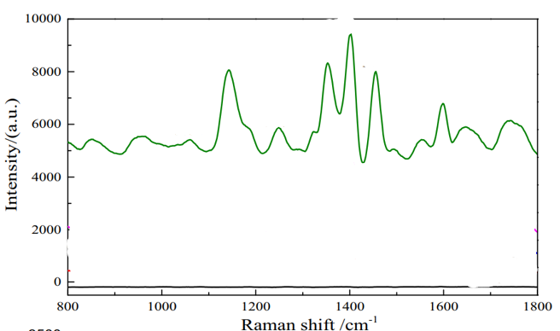
Figure 17:https://doi.org/10.1016/j.saa.2020.118262
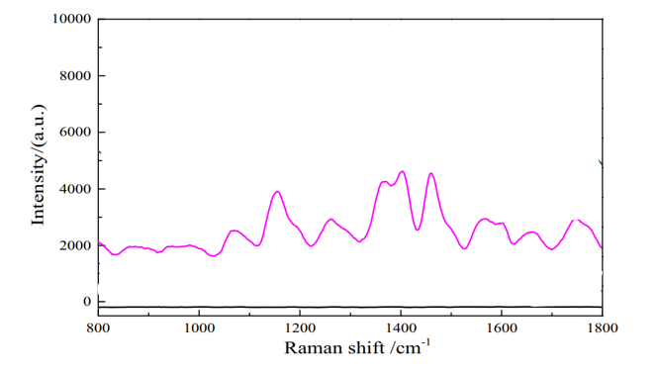
Figure 18:https://doi.org/10.1016/j.saa.2020.118262

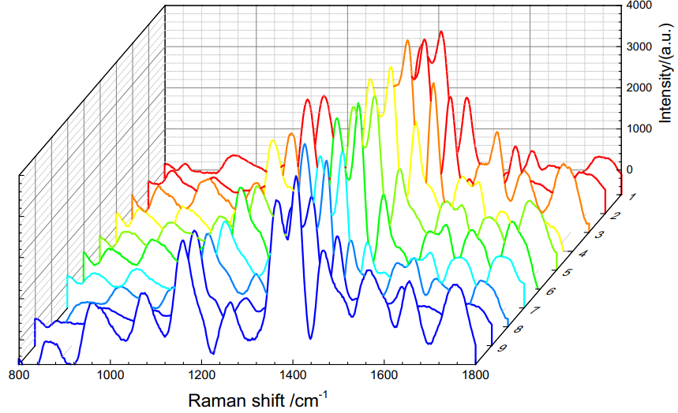
Figure 19:https://doi.org/10.1016/j.saa.2020.118262
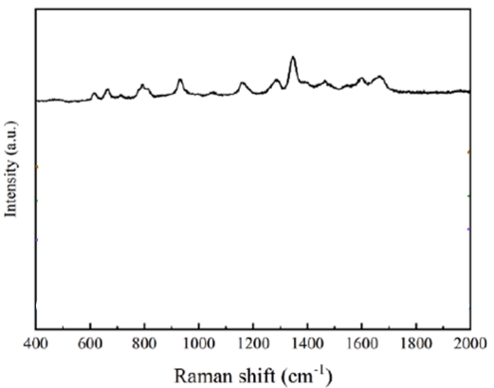
Figure 20:https://doi.org/10.1016/j.saa.2023.122365
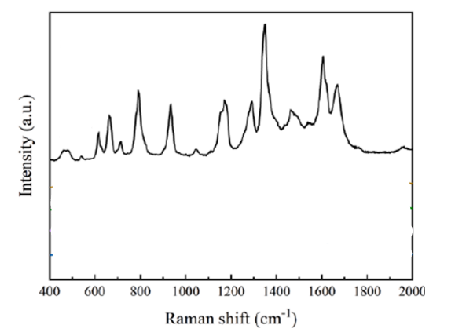
Figure 21:https://doi.org/10.1016/j.saa.2023.122365
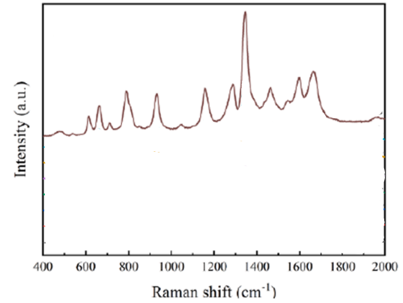
Figure 22:https://doi.org/10.1016/j.saa.2023.122365
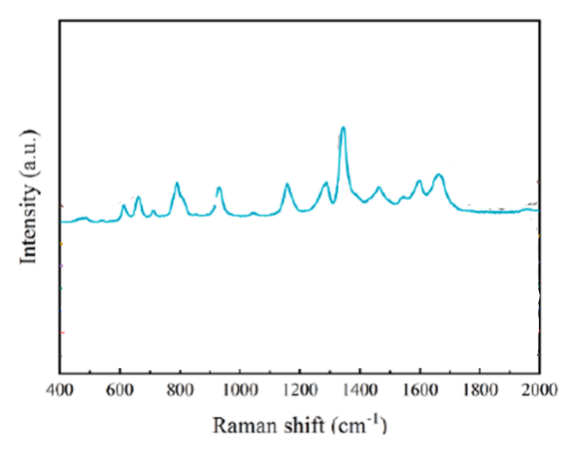
Figure 23:https://doi.org/10.1016/j.saa.2023.122365
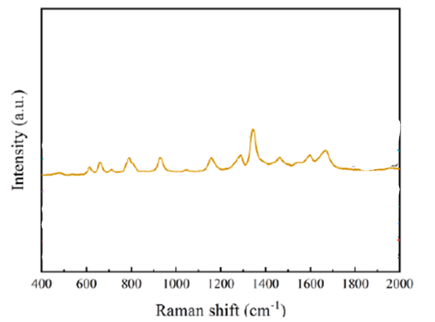
Figure 24:https://doi.org/10.1016/j.saa.2023.122365
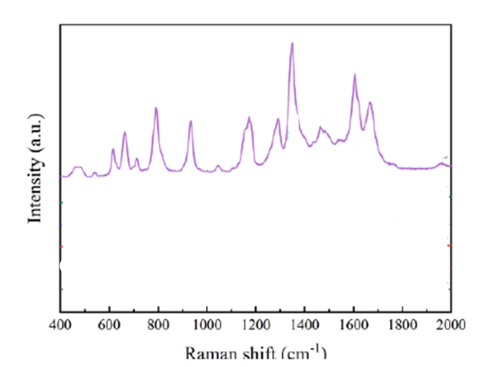
Figure 25:https://doi.org/10.1016/j.saa.2023.122365
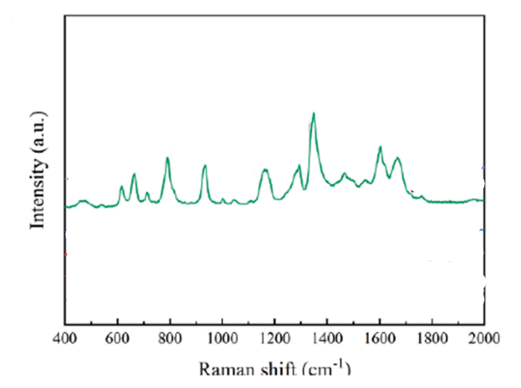
Figure 26:https://doi.org/10.1016/j.saa.2023.122365
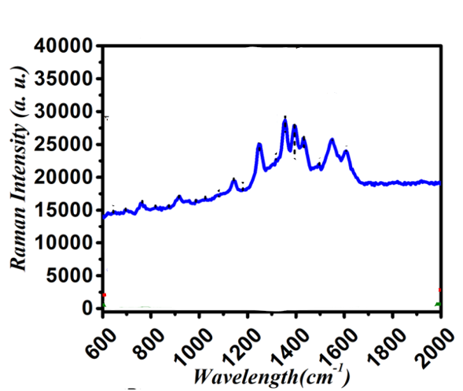
Figure 27
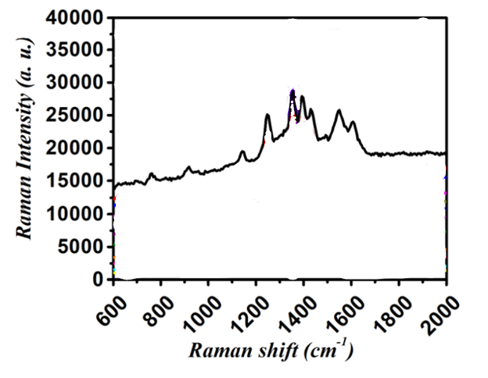
Figure 28:https://doi.org/10.1007/s11468-023-02106-2
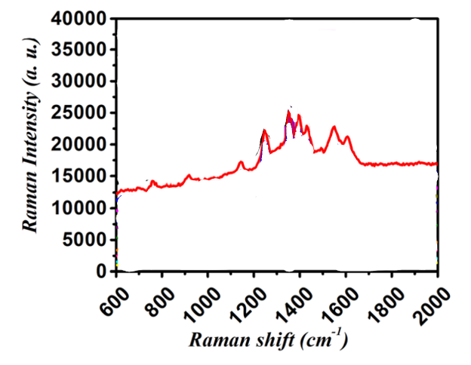
Figure 29:https://doi.org/10.1007/s11468-023-02106-2
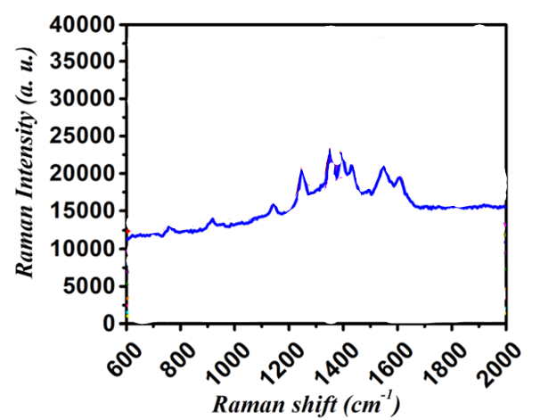
Figure 30:https://doi.org/10.1007/s11468-023-02106-2
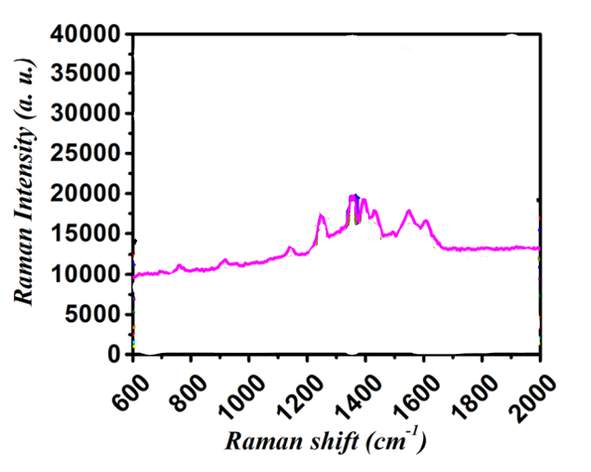
Figure 31:https://doi.org/10.1007/s11468-023-02106-2
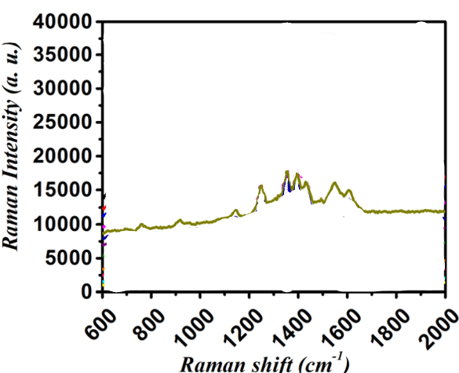
Figure 32: https://doi.org/10.1007/s11468-023-02106-2
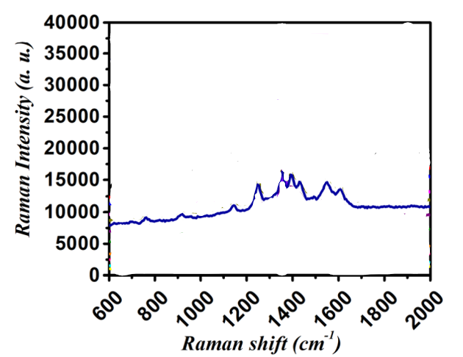
Figure 33::https://doi.org/10.1007/s11468-023-02106-2
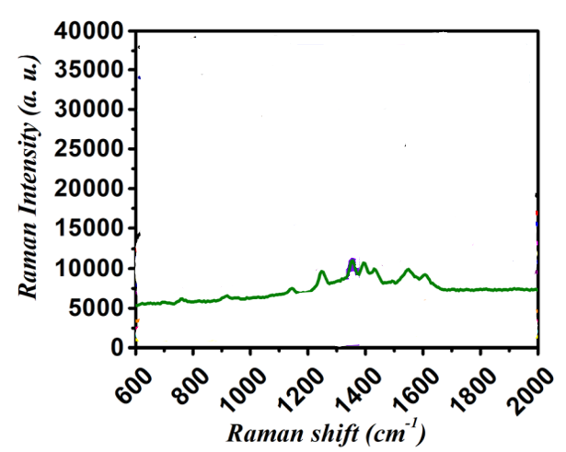
Figure 34:https://doi.org/10.1007/s11468-023-02106-2
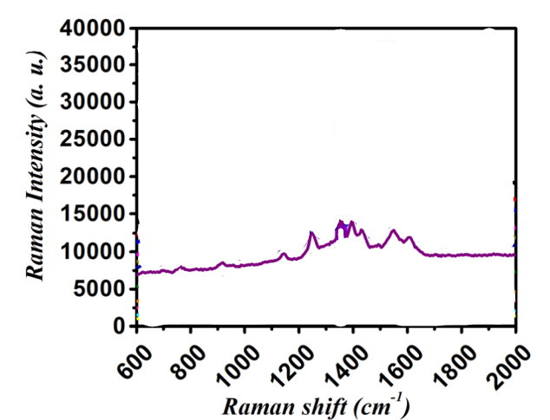
Figure 35:https://doi.org/10.1007/s11468-023-02106-2
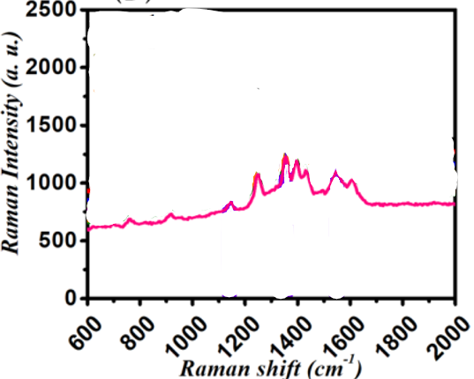
Figure 36:https://doi.org/10.1007/s11468-023-02106-2
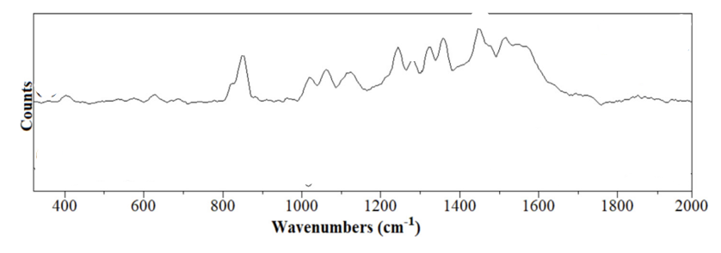
Figure 37:https://doi.org/10.1016/j.saa.2022.121308
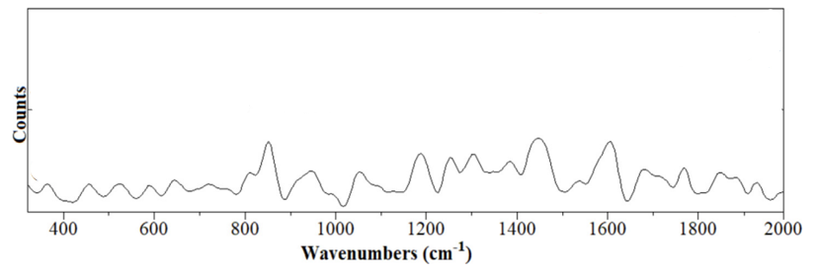
Figure 38:https://doi.org/10.1016/j.saa.2022.121308
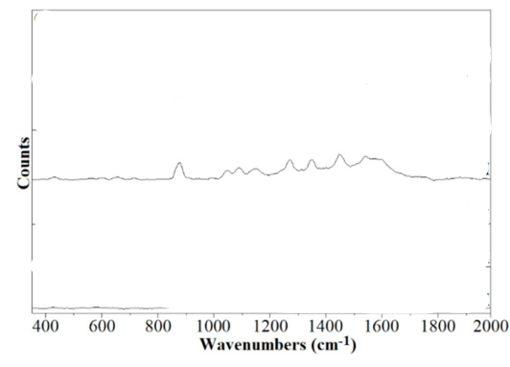
Figure 39:https://doi.org/10.1016/j.saa.2022.121308
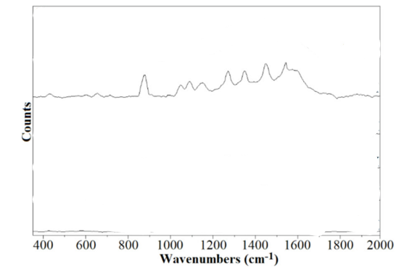
Figure 40:https://doi.org/10.1016/j.saa.2022.121308
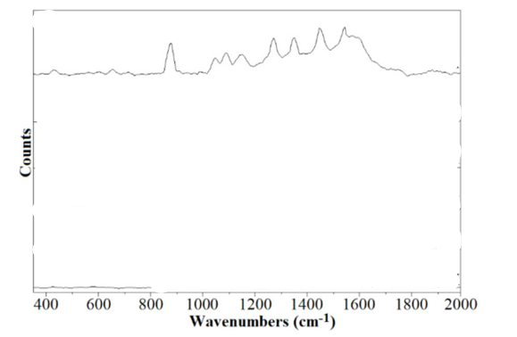
Figure 41:https://doi.org/10.1016/j.saa.2022.121308
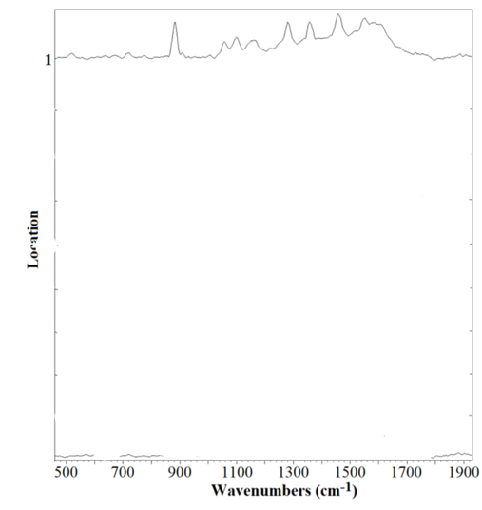
Figure 42:https://doi.org/10.1016/j.saa.2022.121308

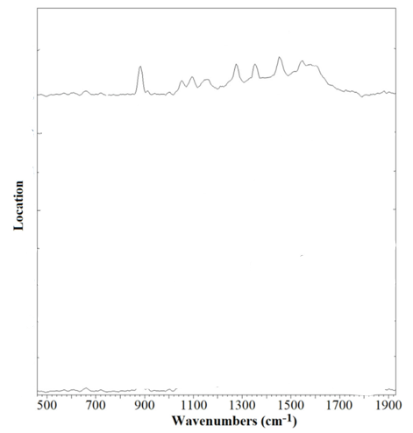
Figure 43:https://doi.org/10.1016/j.saa.2022.121308

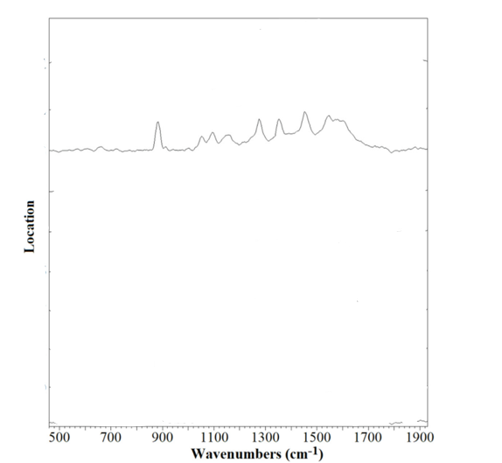
Figure 44:https://doi.org/10.1016/j.saa.2022.121308
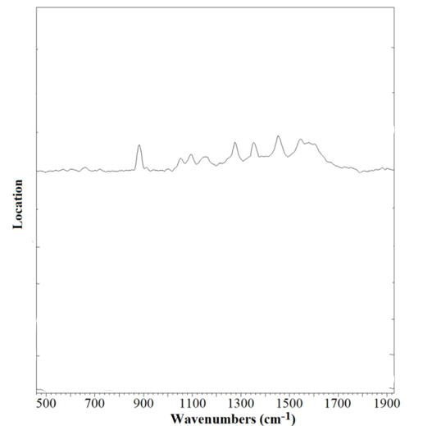
Figure 45:https://doi.org/10.1016/j.saa.2022.121308

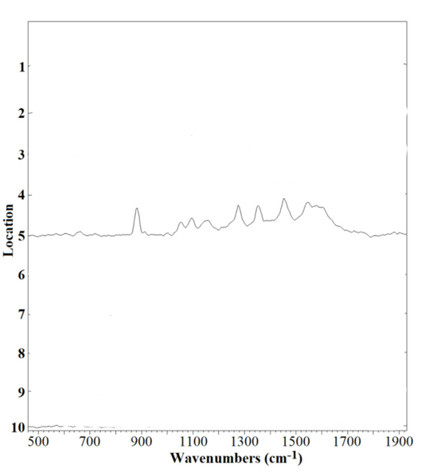
Figure 46:https://doi.org/10.1016/j.saa.2022.121308

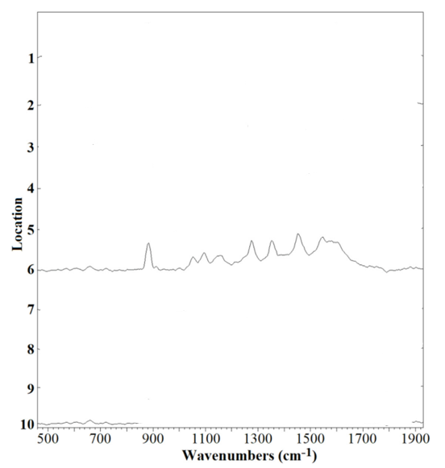
Figure 47:https://doi.org/10.1016/j.saa.2022.121308

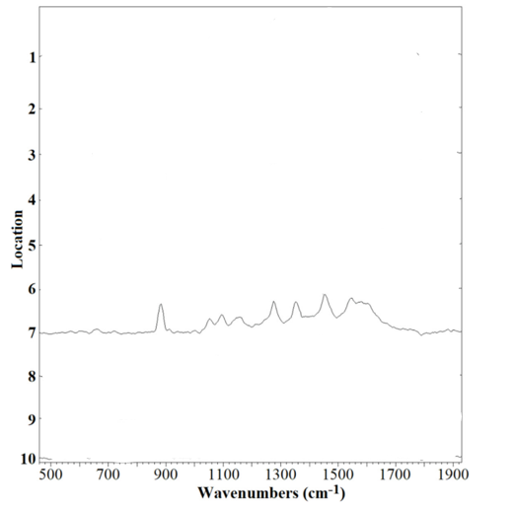
Figure 48:https://doi.org/10.1016/j.saa.2022.121308
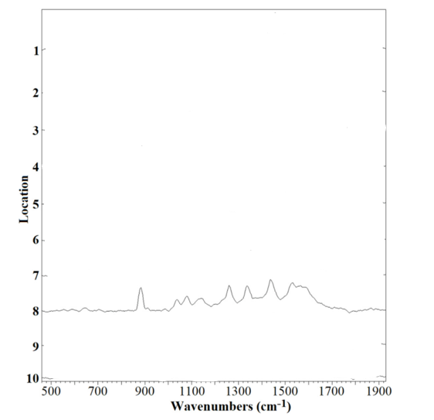
Figure 49:https://doi.org/10.1016/j.saa.2022.121308

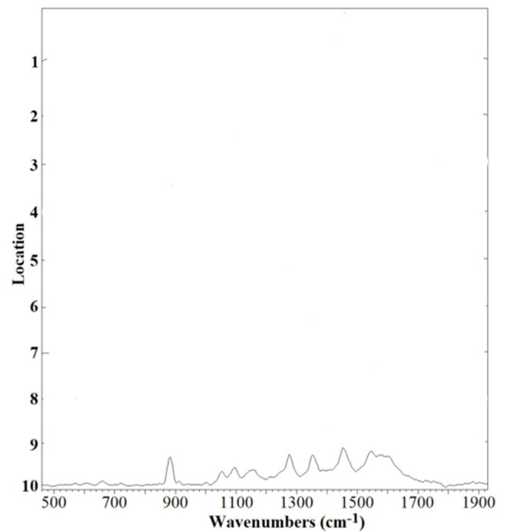
Figure 50:https://doi.org/10.1016/j.saa.2022.121308

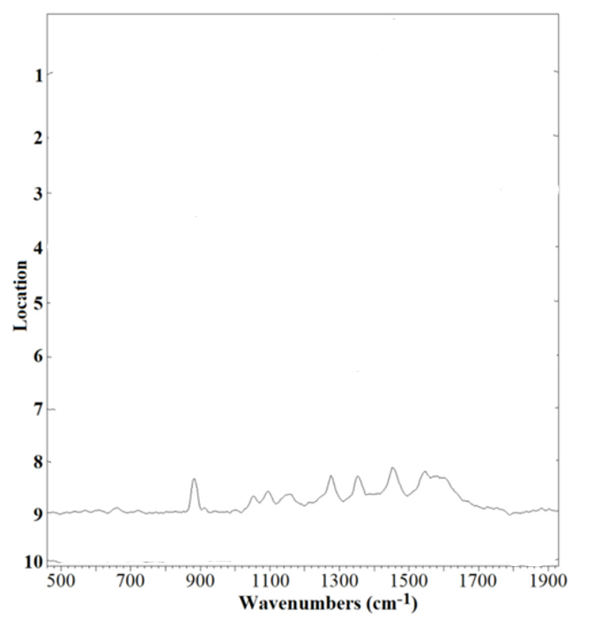
Figure 51:https://doi.org/10.1016/j.saa.2022.121308
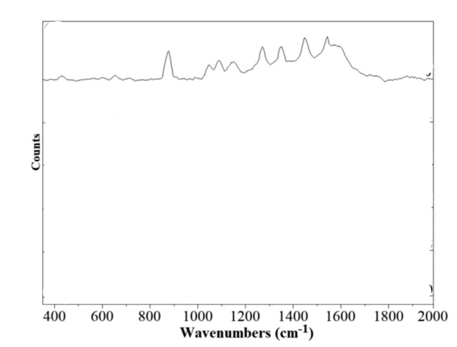
Figure 52:https://doi.org/10.1016/j.saa.2022.121308
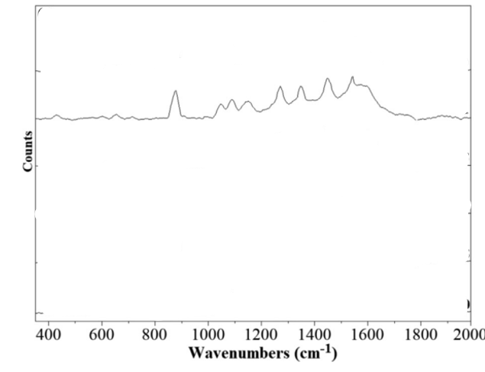
Figure 53:https://doi.org/10.1016/j.saa.2022.121308

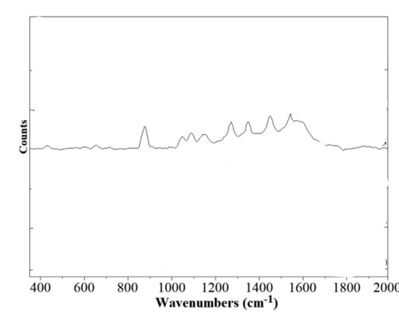
Figure 54:https://doi.org/10.1016/j.saa.2022.121308
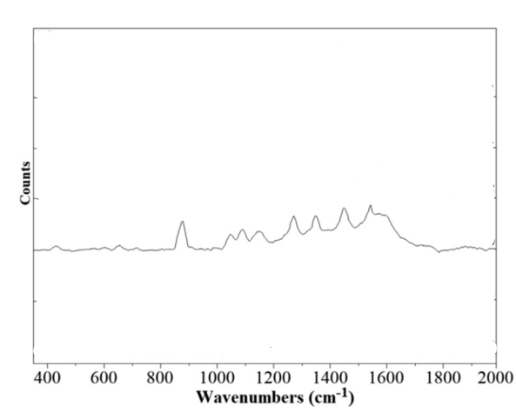
Figure 55:https://doi.org/10.1016/j.saa.2022.121308

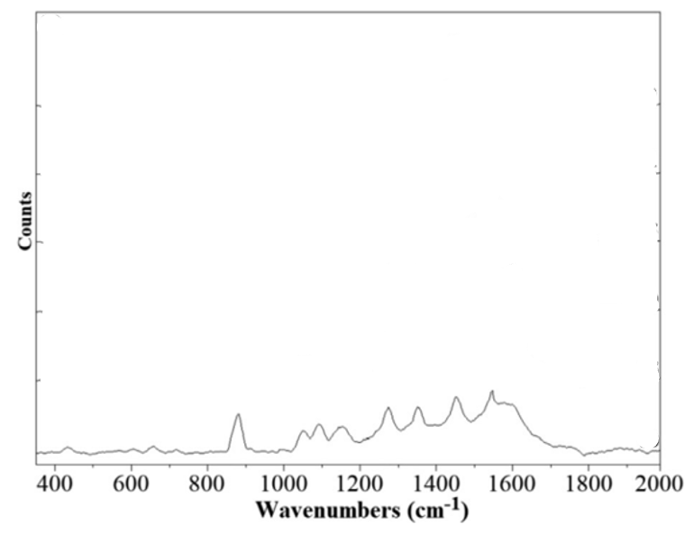
Figure 56:https://doi.org/10.1016/j.saa.2022.121308
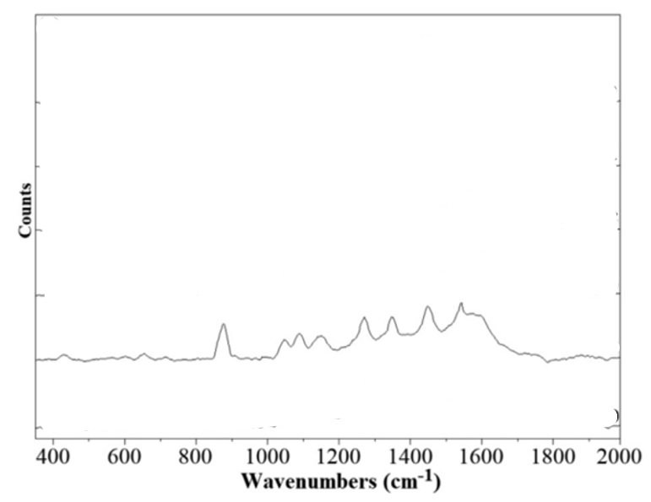
Figure 57:https://doi.org/10.1016/j.saa.2022.121308

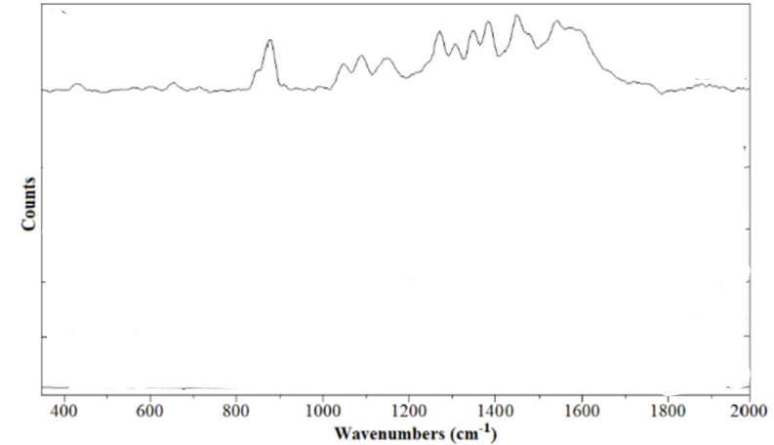
Figure 58:https://doi.org/10.1016/j.saa.2022.121308
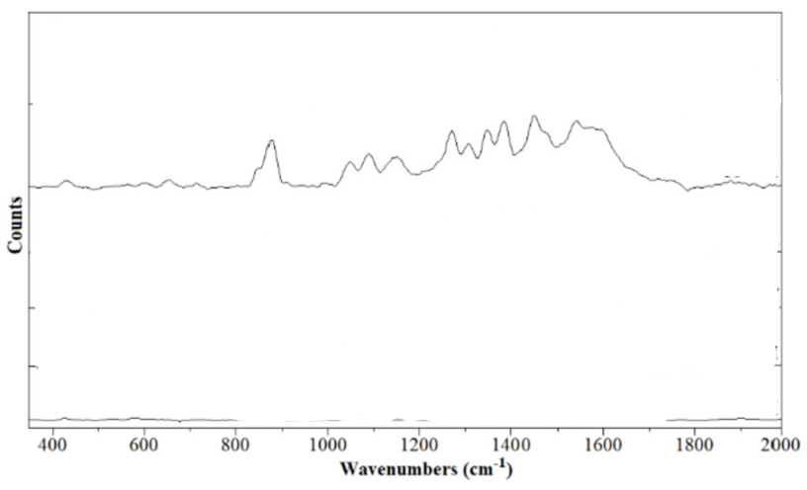
Figure 59:https://doi.org/10.1016/j.saa.2022.121308

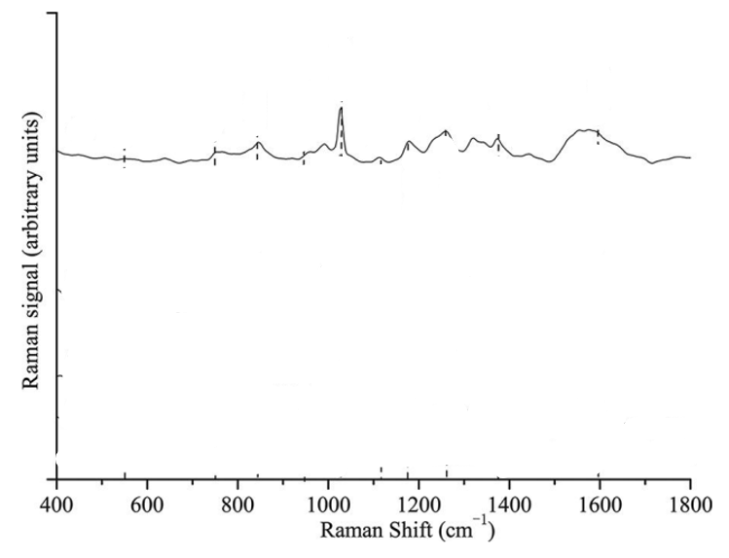
Figure 60:https://doi.org/10.1080/00387010.2017.1397029

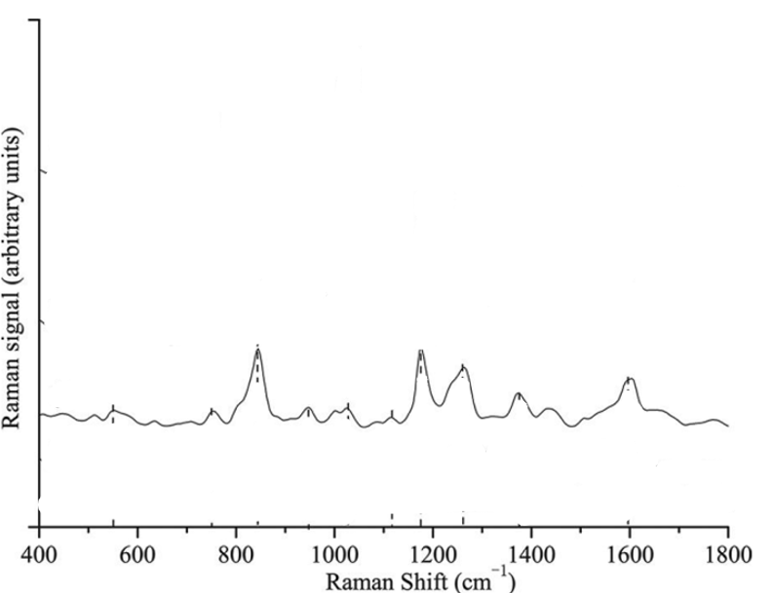
Figure 61:https://doi.org/10.1080/00387010.2017.1397029

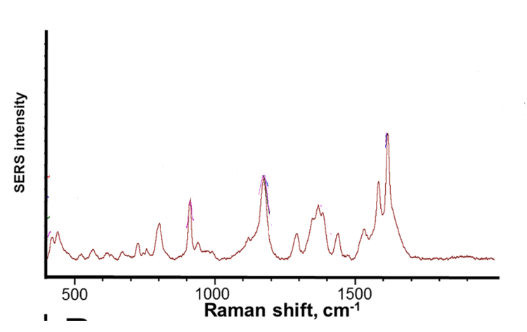
Figure 62:https://doi.org/10.1016/j.vibspec.2022.103473
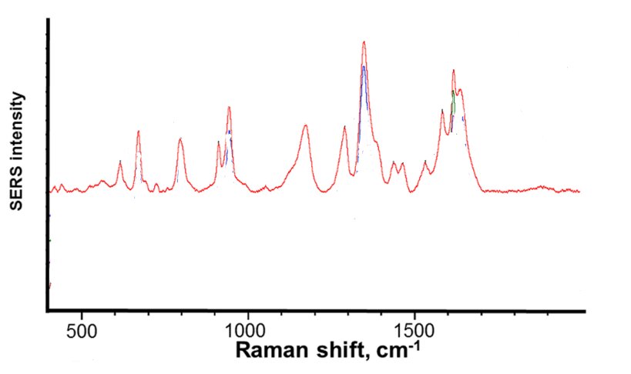
Figure 63:https://doi.org/10.1016/j.vibspec.2022.103473
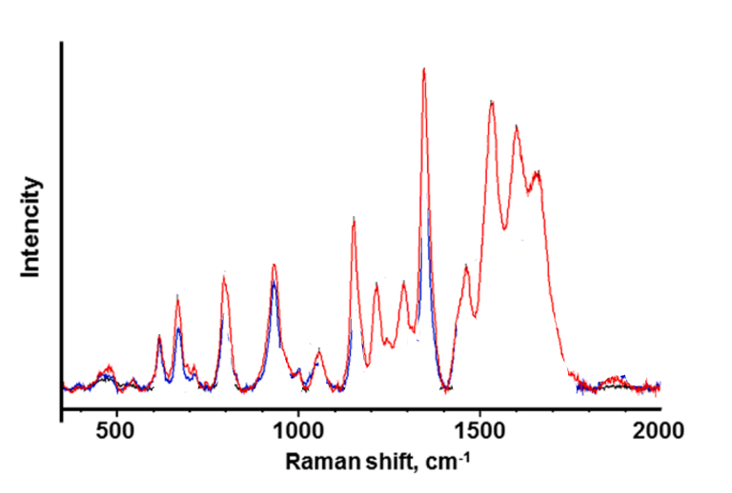
Figure 64:https://doi.org/10.1016/j.vibspec.2022.103388
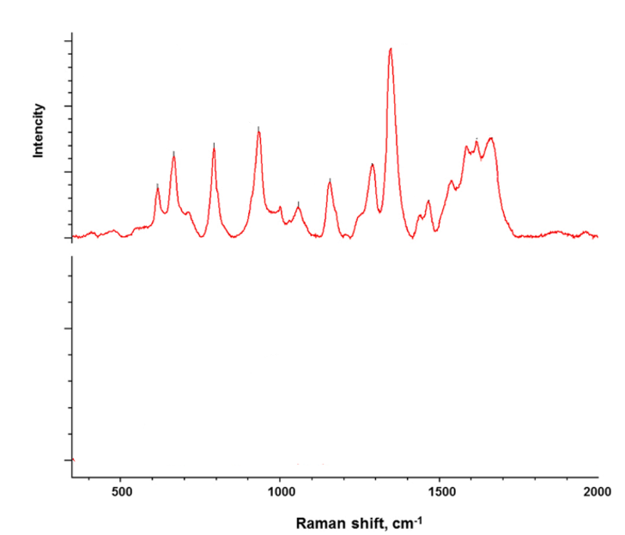
Figure 65:https://doi.org/10.1016/j.vibspec.2022.103388

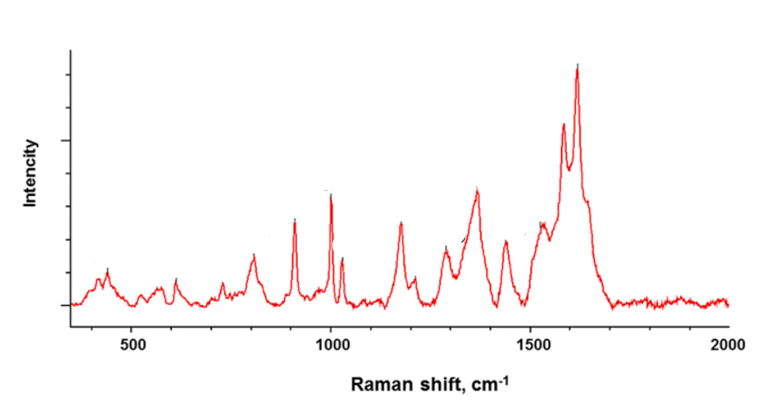
Figure 66:https://doi.org/10.1016/j.vibspec.2022.103388
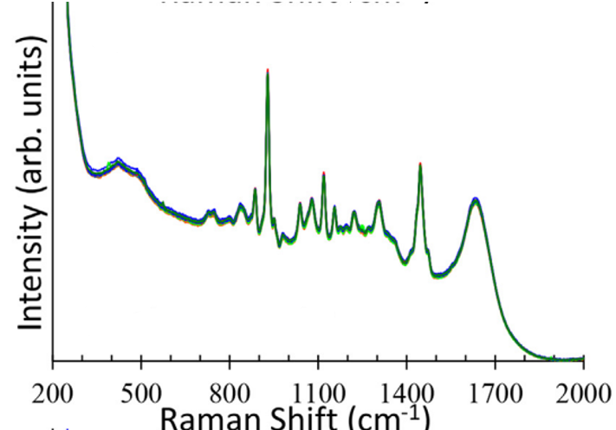
Figure 67:http://dx.doi.org/10.1016/j.aca.2017.04.016

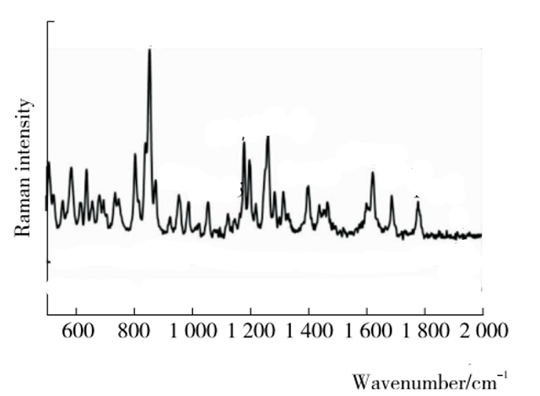
Figure 68:DOI: 10.13652/j.issn.1003-5788.2019.02.017
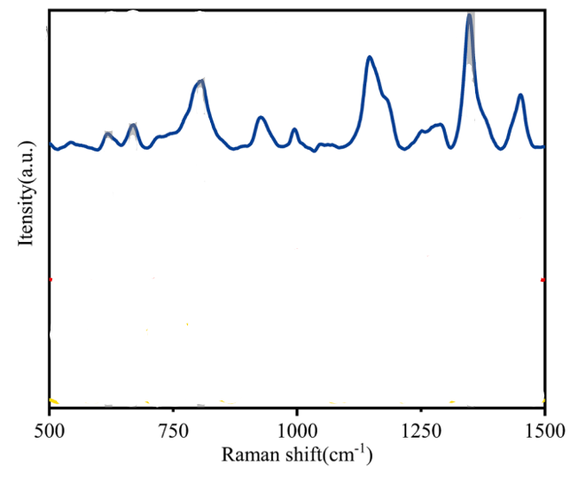
Figure 69:https://doi.org/10.1016/j.saa.2024.124165
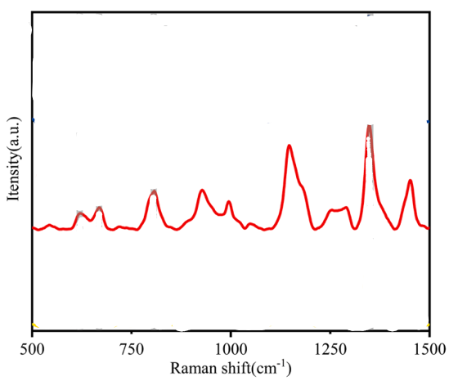
Figure 70:https://doi.org/10.1016/j.saa.2024.124165
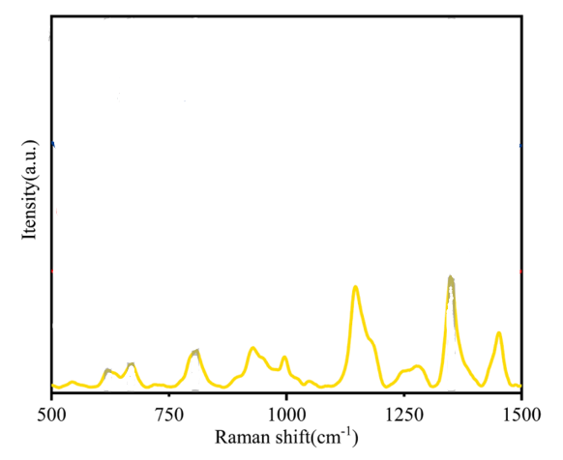
Figure 71:https://doi.org/10.1016/j.saa.2024.124165

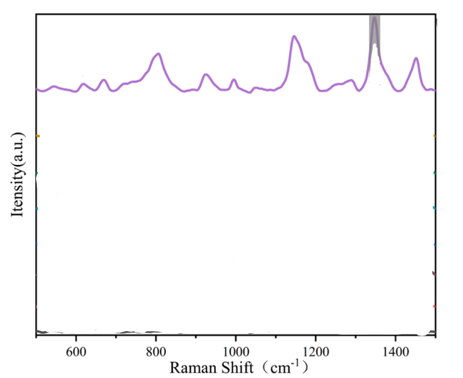
Figure 72:https://doi.org/10.1016/j.saa.2024.124165
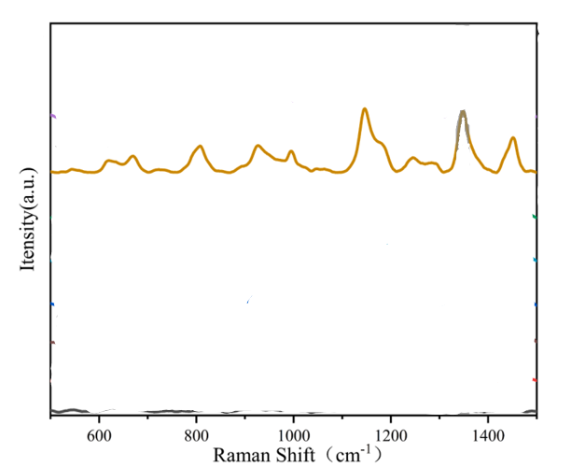
Figure 73:https://doi.org/10.1016/j.saa.2024.124165

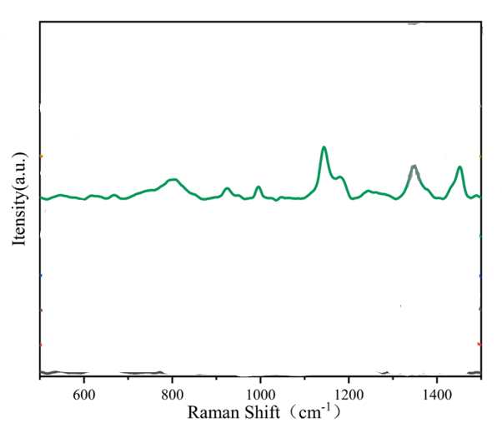
Figure 74:https://doi.org/10.1016/j.saa.2024.124165
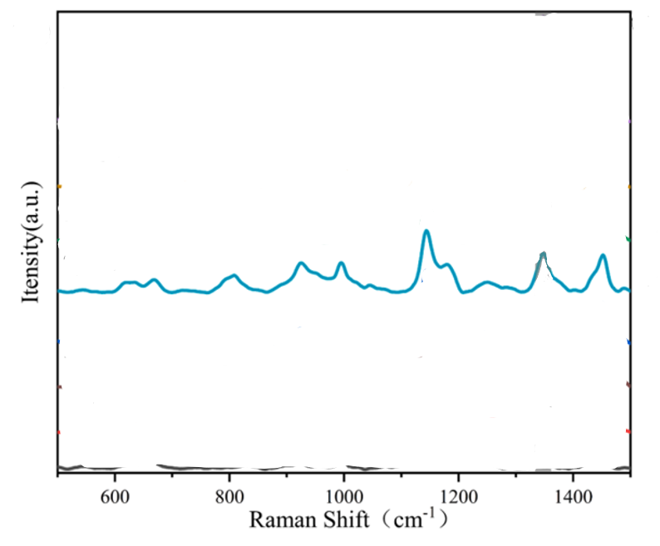
Figure 75:https://doi.org/10.1016/j.saa.2024.124165
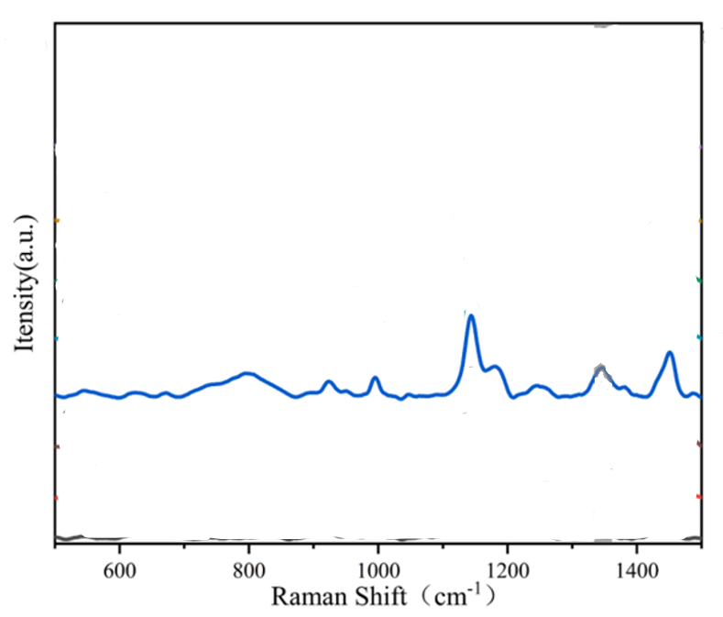
Figure 76:https://doi.org/10.1016/j.saa.2024.124165

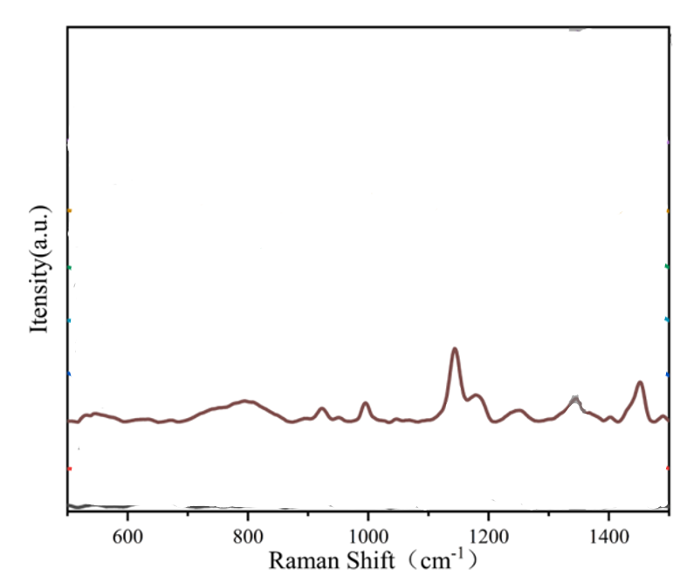
Figure 77:https://doi.org/10.1016/j.saa.2024.124165

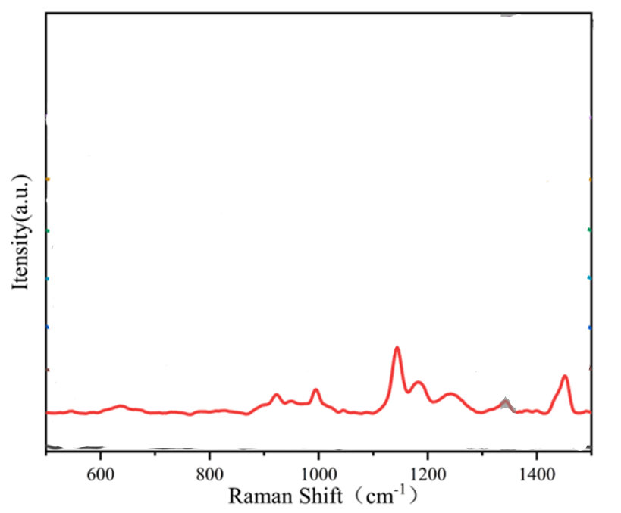
Figure 78:https://doi.org/10.1016/j.saa.2024.124165
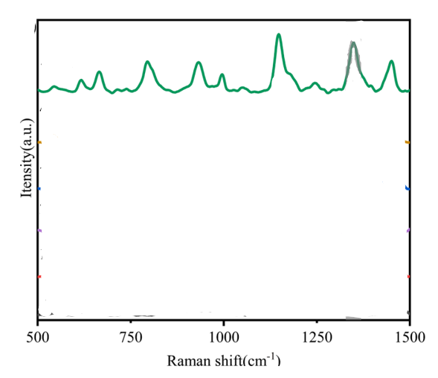
Figure 79:https://doi.org/10.1016/j.saa.2024.124165
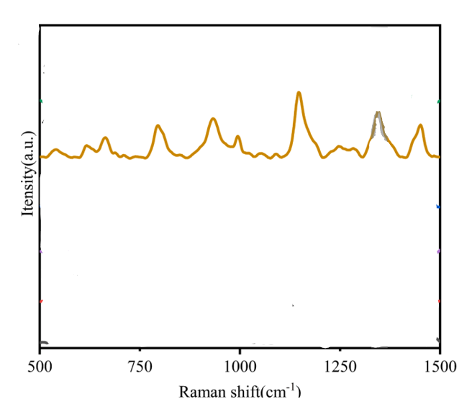
Figure 80:https://doi.org/10.1016/j.saa.2024.124165
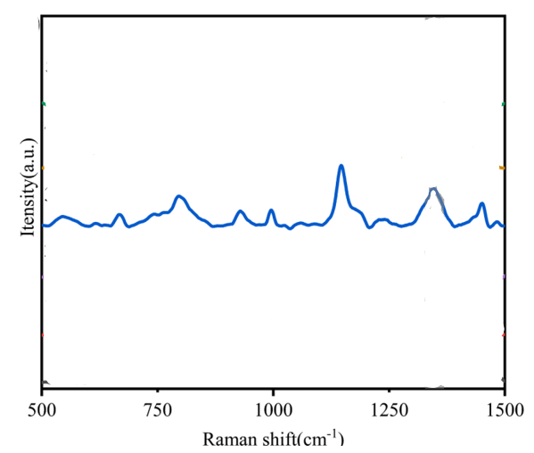
Figure 81:https://doi.org/10.1016/j.saa.2024.124165
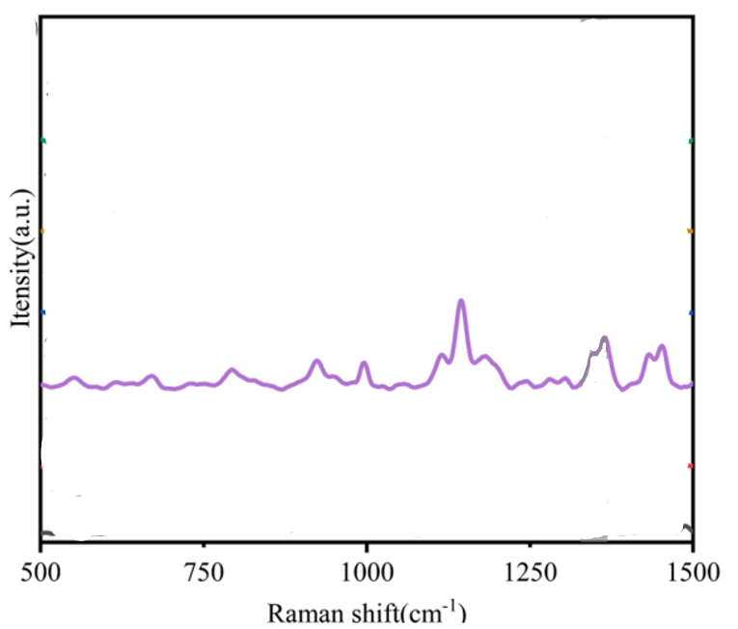
Figure 82:https://doi.org/10.1016/j.saa.2024.124165

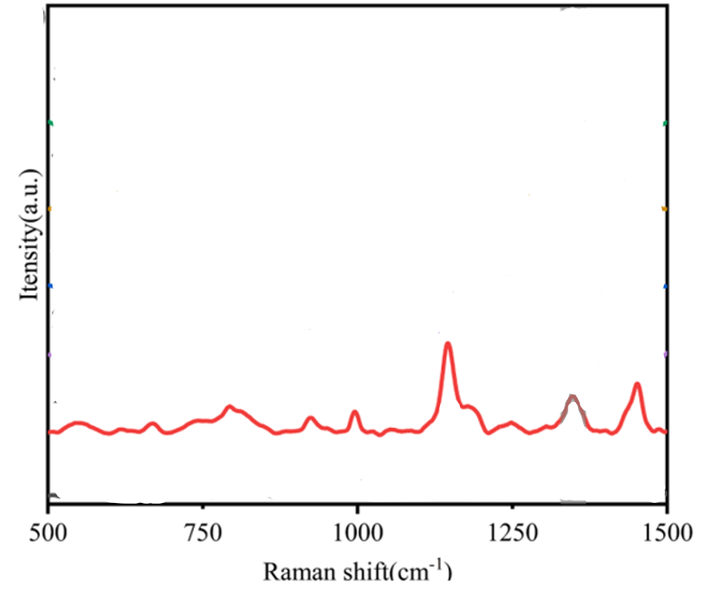
Figure 83:https://doi.org/10.1016/j.saa.2024.124165

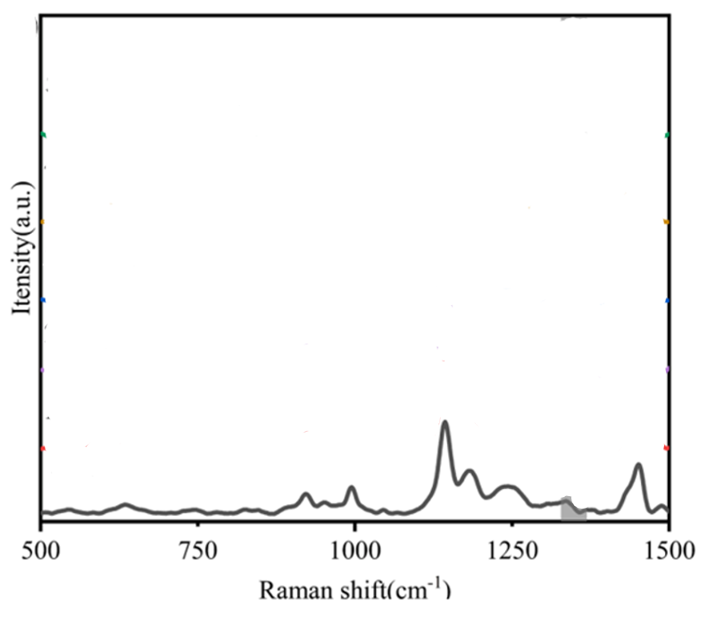
Figure 84:https://doi.org/10.1016/j.saa.2024.124165
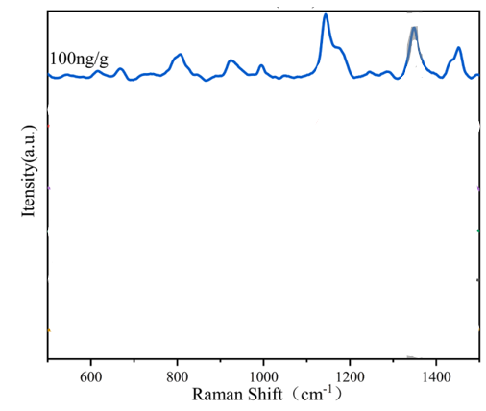
Figure 85:https://doi.org/10.1016/j.saa.2024.124165
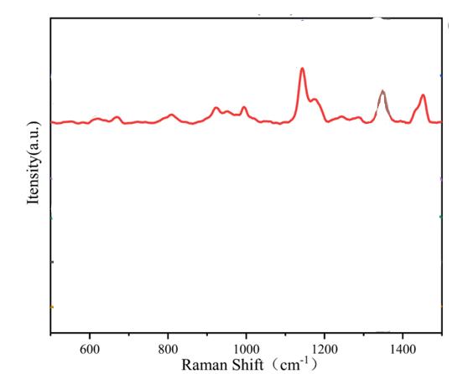
Figure 86:https://doi.org/10.1016/j.saa.2024.124165
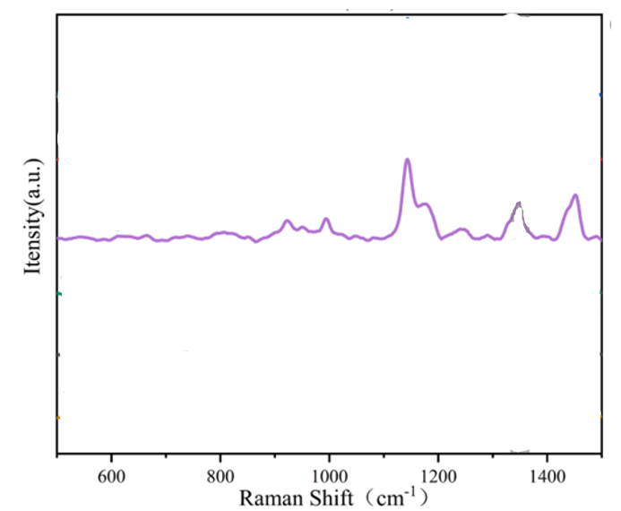
Figure 87:https://doi.org/10.1016/j.saa.2024.124165
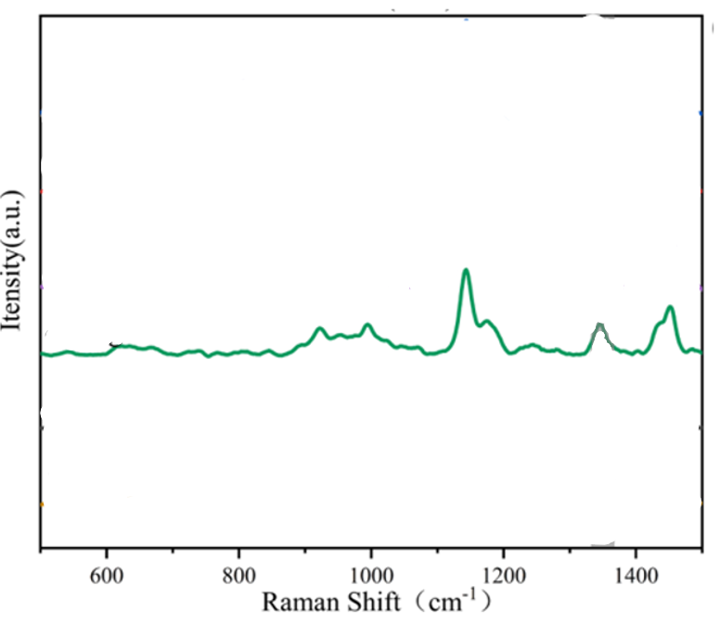
Figure 88:https://doi.org/10.1016/j.saa.2024.124165

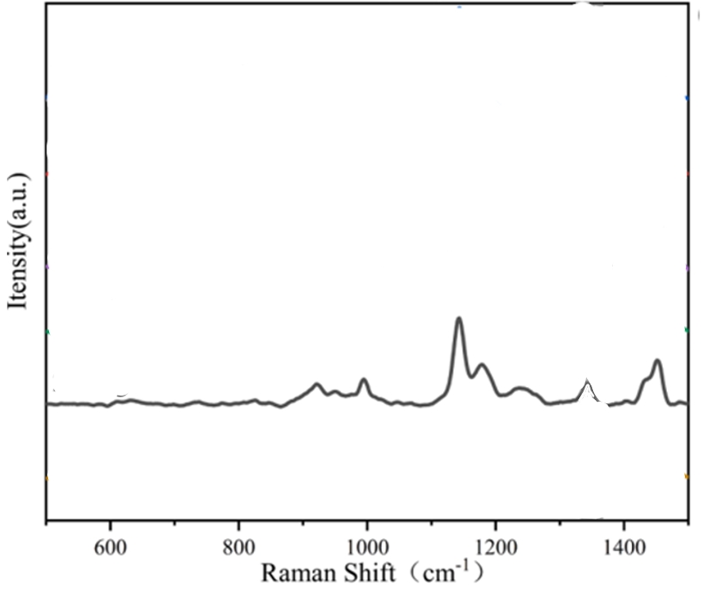
Figure 89:https://doi.org/10.1016/j.saa.2024.124165
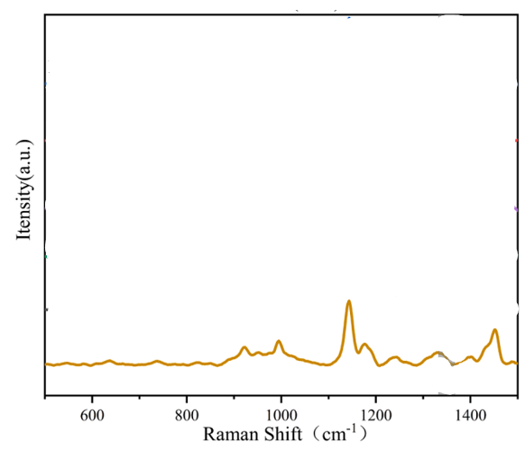
Figure 90:https://doi.org/10.1016/j.saa.2024.124165
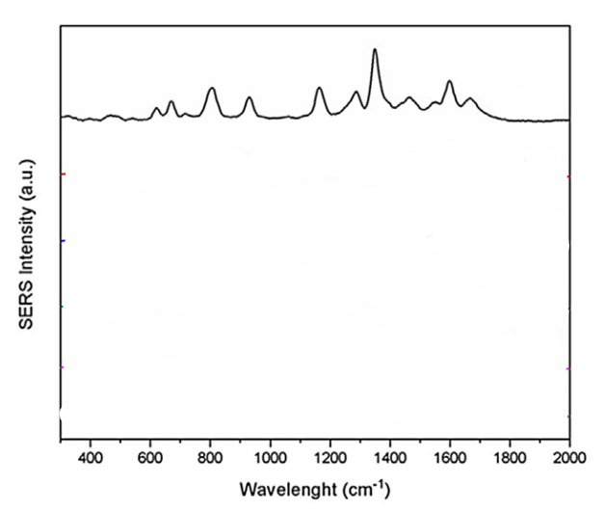
Figure 91:http://dx.doi.org/10.1016/j.molstruc.2016.04.086
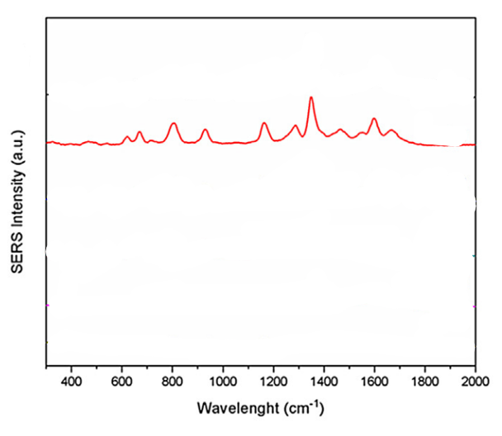
Figure 92:http://dx.doi.org/10.1016/j.molstruc.2016.04.086
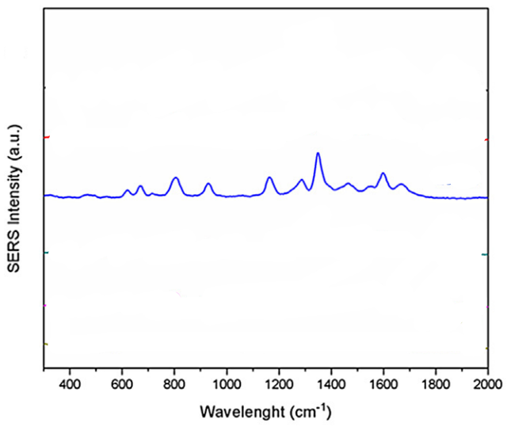
Figure 93:http://dx.doi.org/10.1016/j.molstruc.2016.04.086

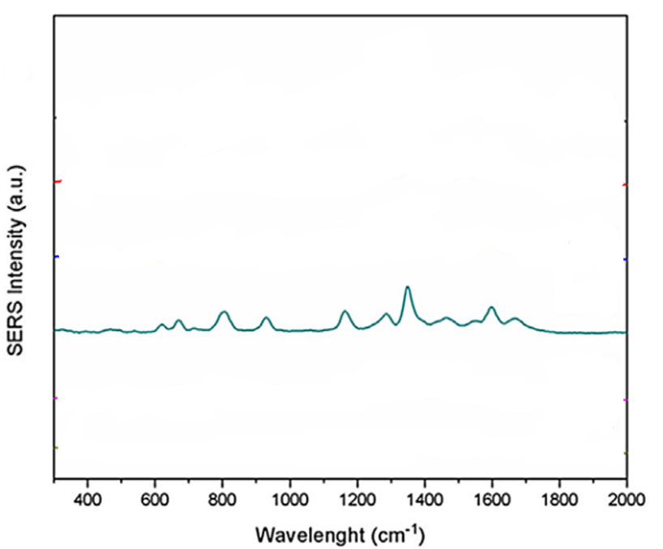
Figure 94:http://dx.doi.org/10.1016/j.molstruc.2016.04.086
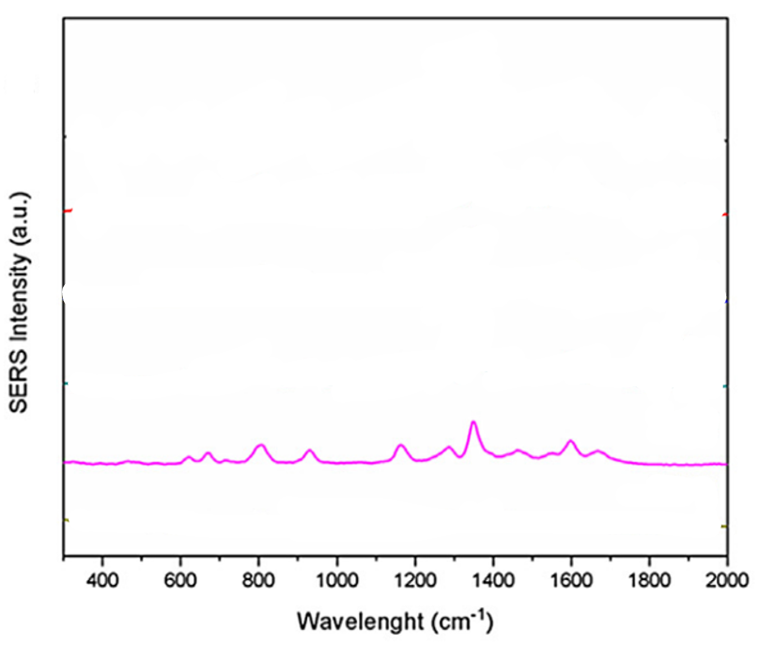
Figure 95:http://dx.doi.org/10.1016/j.molstruc.2016.04.086

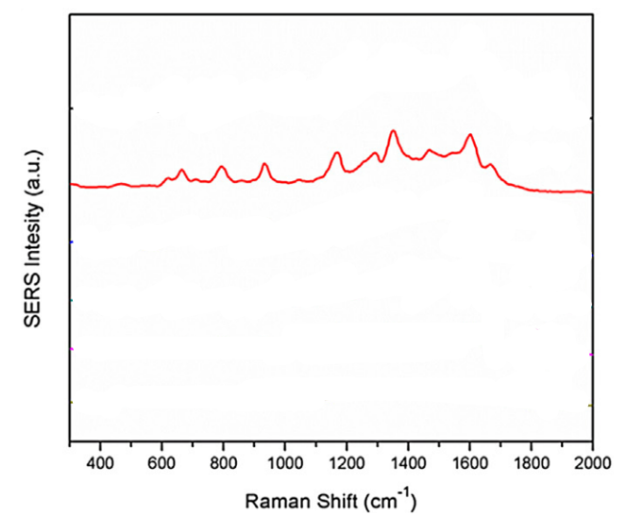
Figure 96:http://dx.doi.org/10.1016/j.molstruc.2016.04.086
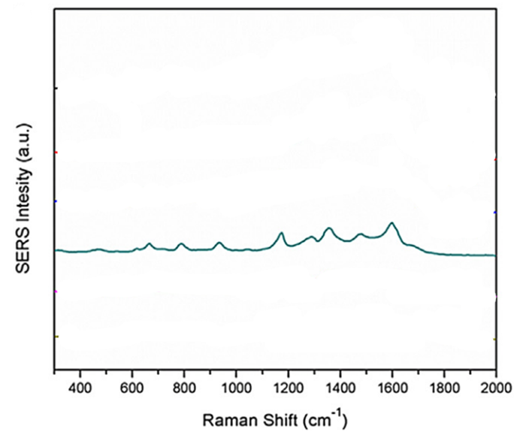
Figure 97:http://dx.doi.org/10.1016/j.molstruc.2016.04.086

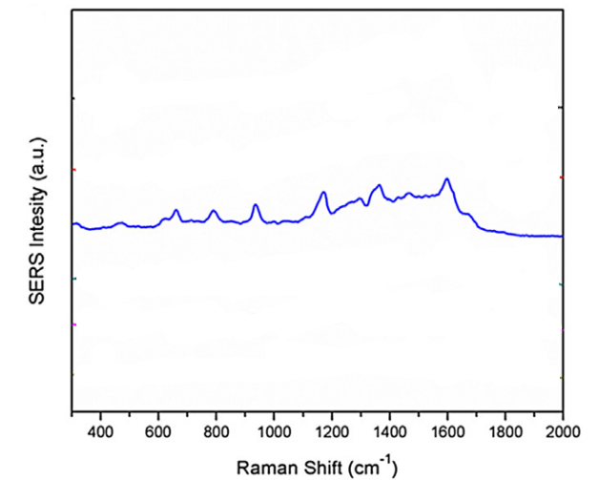
Figure 98:http://dx.doi.org/10.1016/j.molstruc.2016.04.086
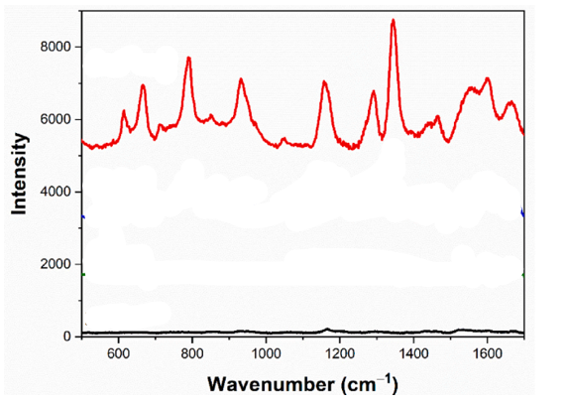
Figure 99:https://doi.org/10.1016/j.optmat.2024.116550

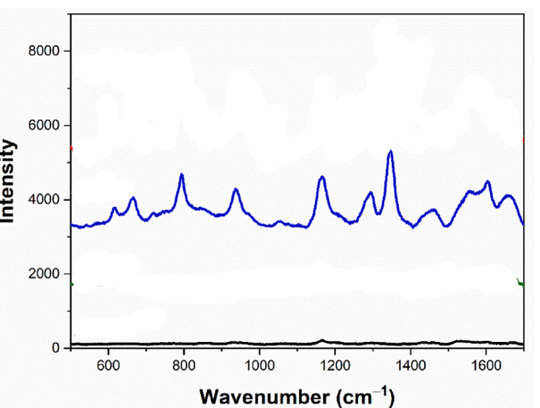
Figure 100:https://doi.org/10.1016/j.optmat.2024.116550
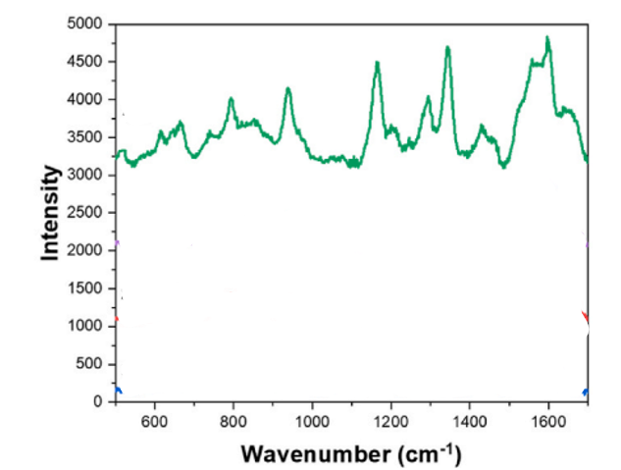
Figure 101:https://doi.org/10.1016/j.optmat.2024.116550

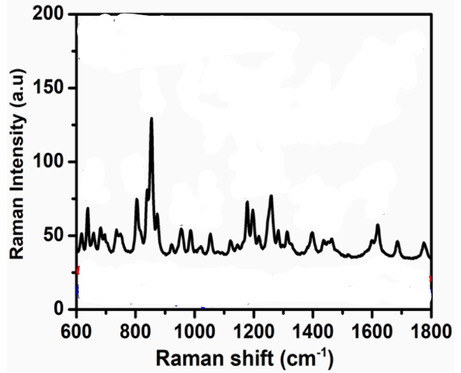
Figure 102:https://doi.org/10.1016/j.materresbull.2021.111649
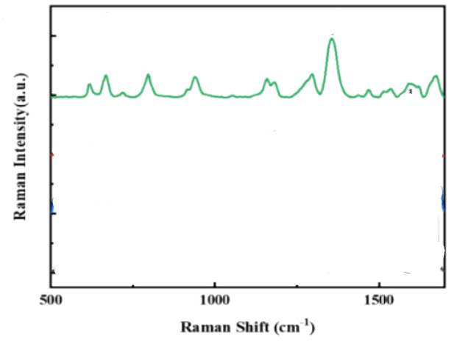
Figure 103:https://papers.ssrn.com/sol3/papers.cfm?abstract_id=4238372

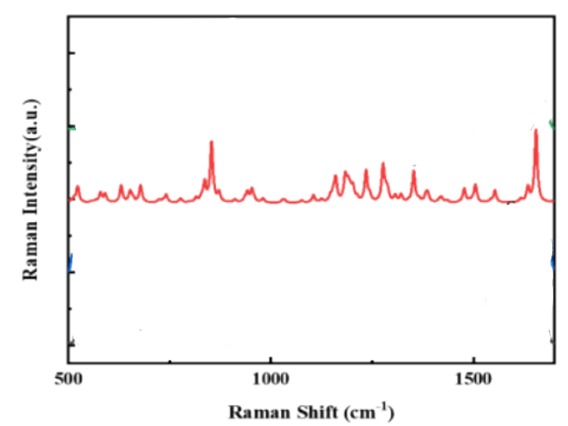
Figure 104:https://papers.ssrn.com/sol3/papers.cfm?abstract_id=4238372

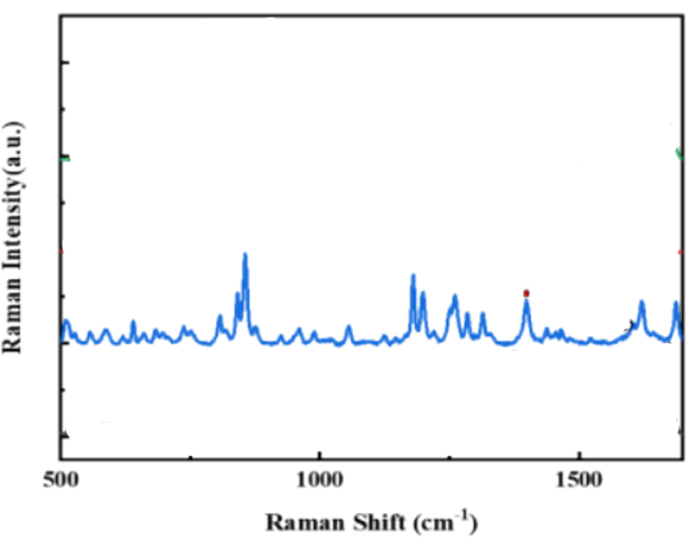
Figure 105:https://papers.ssrn.com/sol3/papers.cfm?abstract_id=4238372

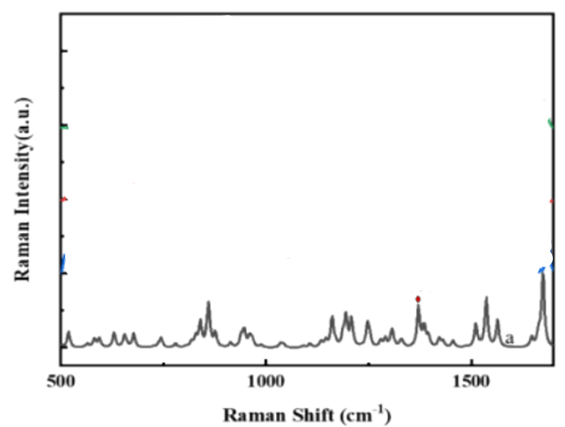
Figure 106:https://papers.ssrn.com/sol3/papers.cfm?abstract_id=4238372

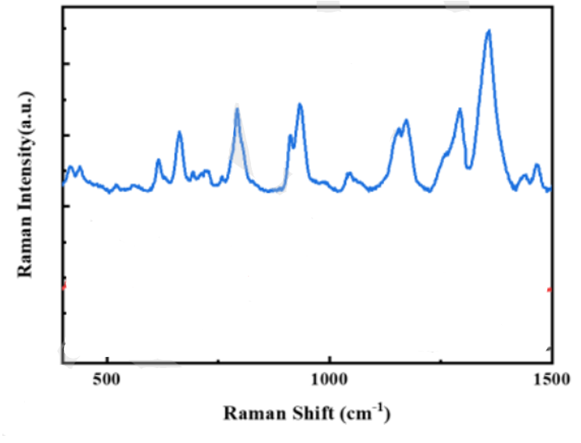
Figure 107:https://papers.ssrn.com/sol3/papers.cfm?abstract_id=4238372

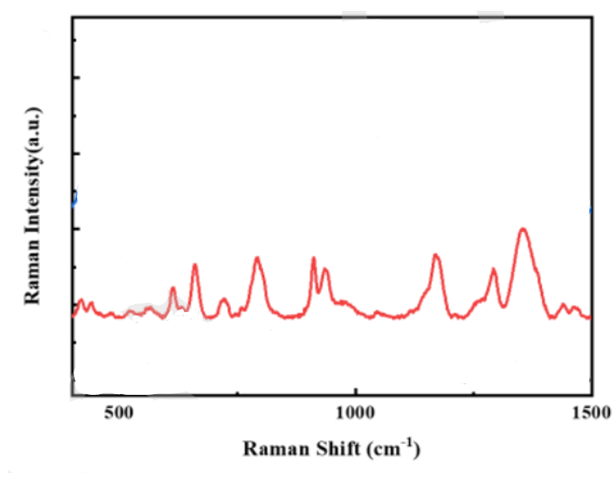
Figure 108:https://papers.ssrn.com/sol3/papers.cfm?abstract_id=4238372

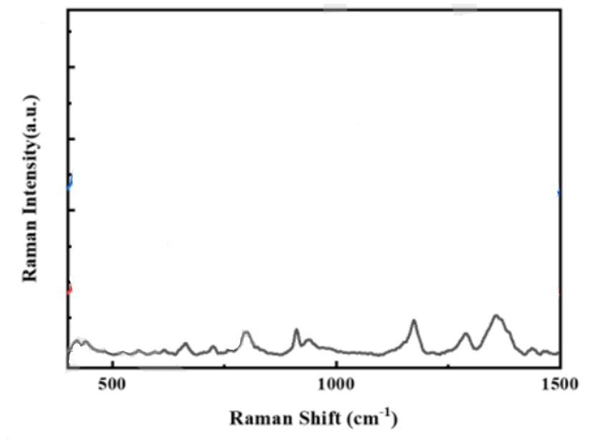
Figure 109:https://papers.ssrn.com/sol3/papers.cfm?abstract_id=4238372
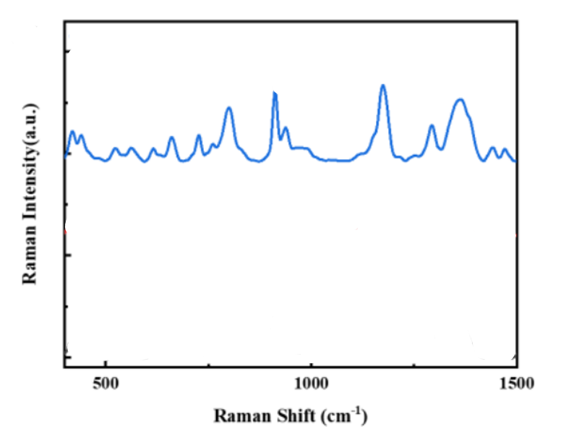
Figure 110:https://papers.ssrn.com/sol3/papers.cfm?abstract_id=4238372
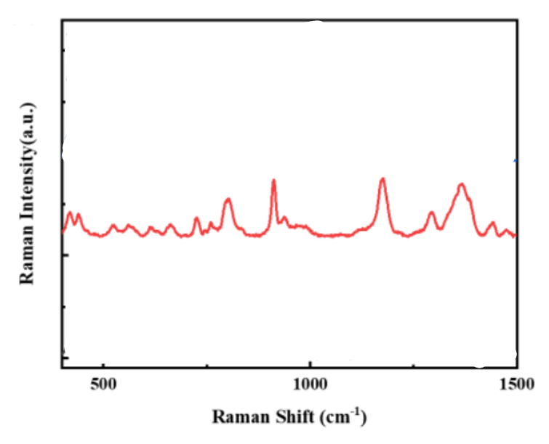
Figure 111:https://papers.ssrn.com/sol3/papers.cfm?abstract_id=4238372
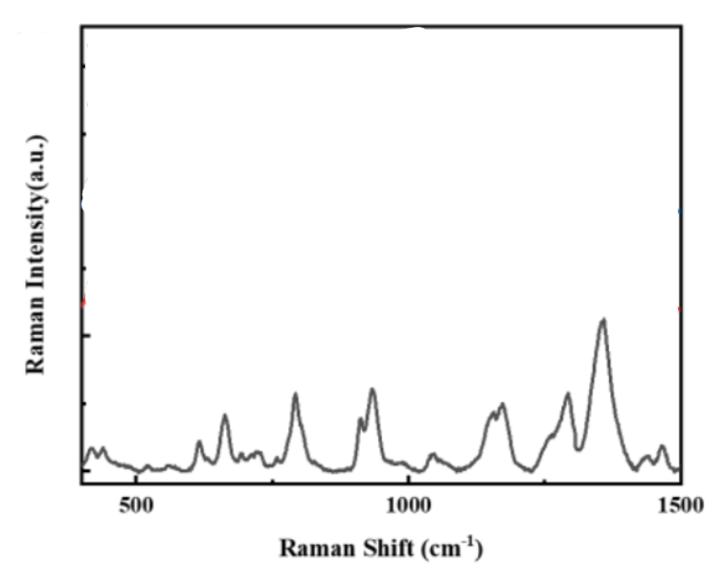
Figure 112:https://papers.ssrn.com/sol3/papers.cfm?abstract_id=4238372

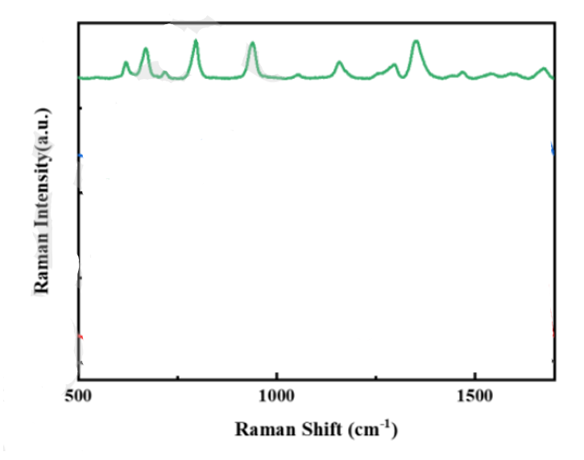
Figure 113:https://papers.ssrn.com/sol3/papers.cfm?abstract_id=4238372

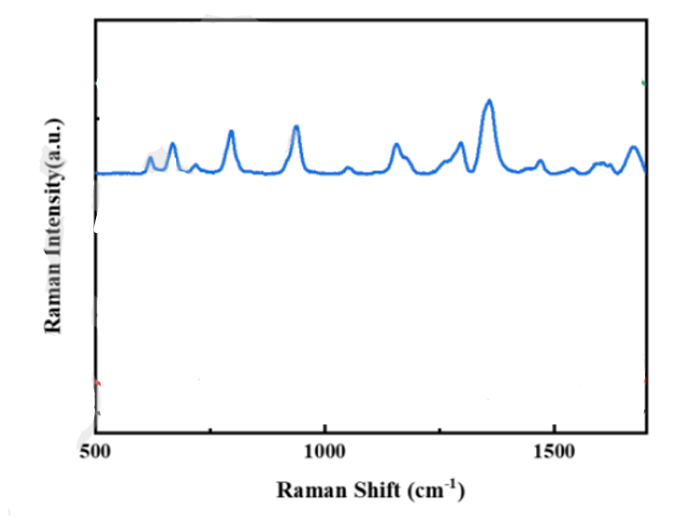
Figure 114:https://papers.ssrn.com/sol3/papers.cfm?abstract_id=4238372
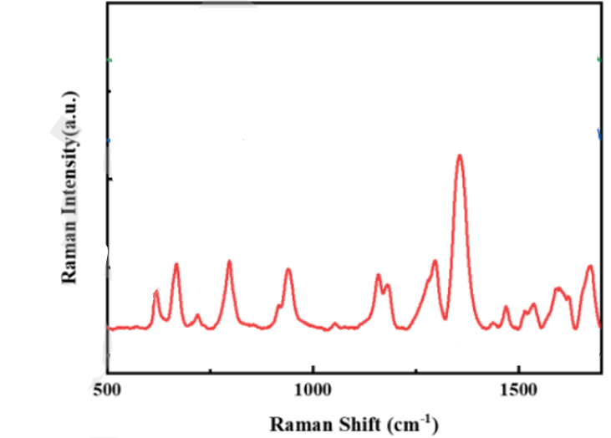
Figure 115:https://papers.ssrn.com/sol3/papers.cfm?abstract_id=4238372
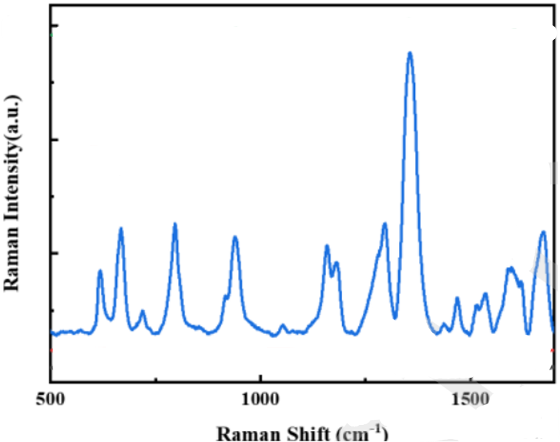
Figure 116:https://papers.ssrn.com/sol3/papers.cfm?abstract_id=4238372

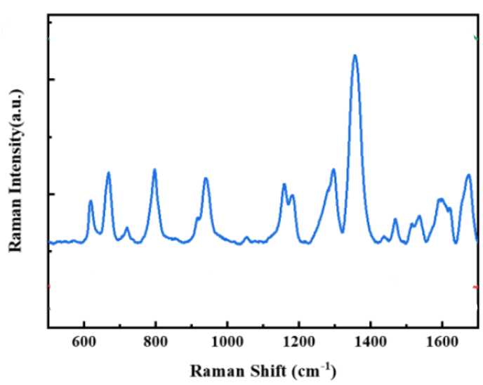
Figure 117:https://papers.ssrn.com/sol3/papers.cfm?abstract_id=4238372

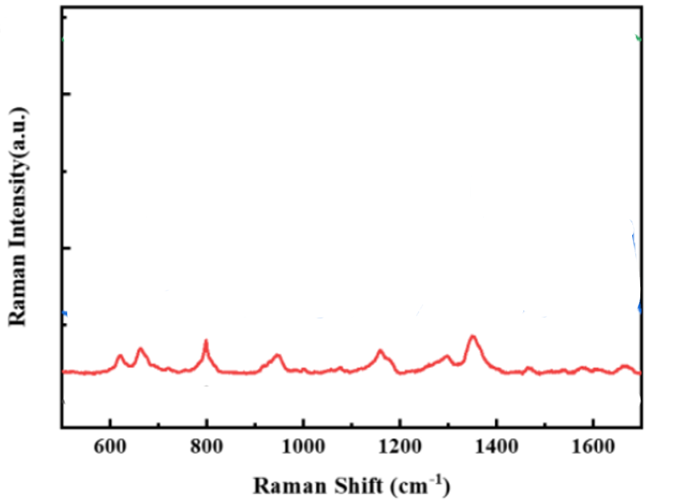
Figure 118:https://papers.ssrn.com/sol3/papers.cfm?abstract_id=4238372
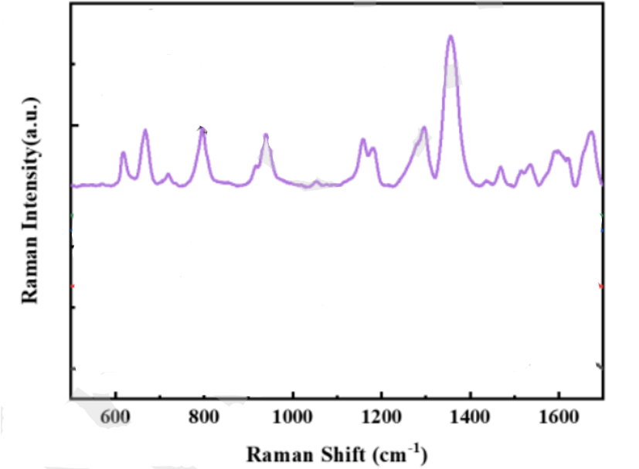
Figure 119:https://papers.ssrn.com/sol3/papers.cfm?abstract_id=4238372

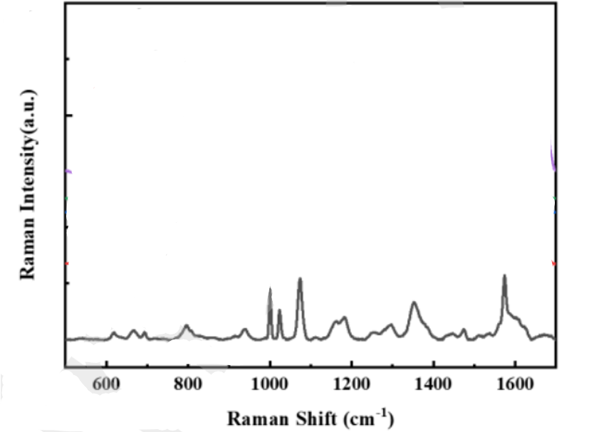
Figure 120:https://papers.ssrn.com/sol3/papers.cfm?abstract_id=4238372
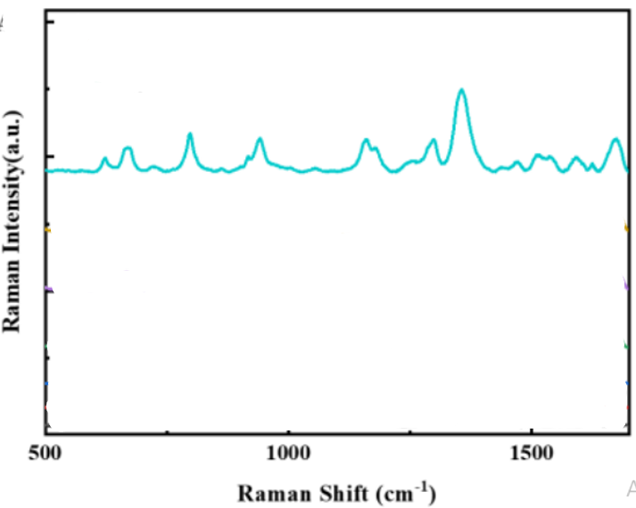
Figure 121:https://papers.ssrn.com/sol3/papers.cfm?abstract_id=4238372
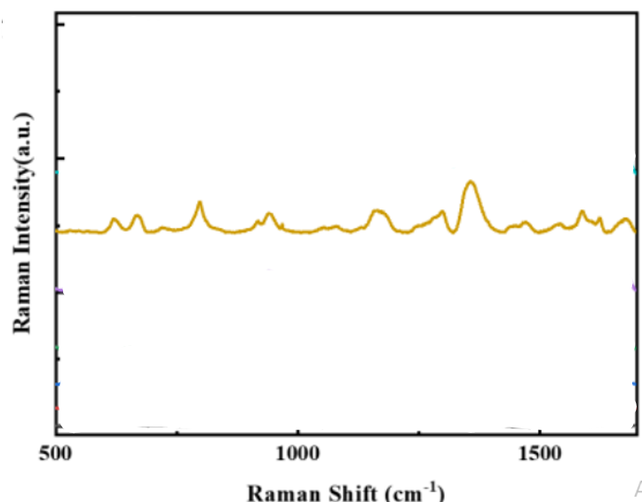
Figure 122:https://papers.ssrn.com/sol3/papers.cfm?abstract_id=4238372
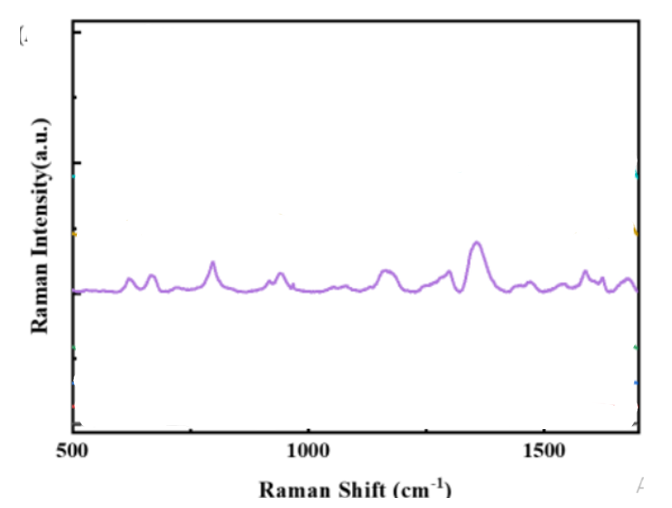
Figure 123:https://papers.ssrn.com/sol3/papers.cfm?abstract_id=4238372
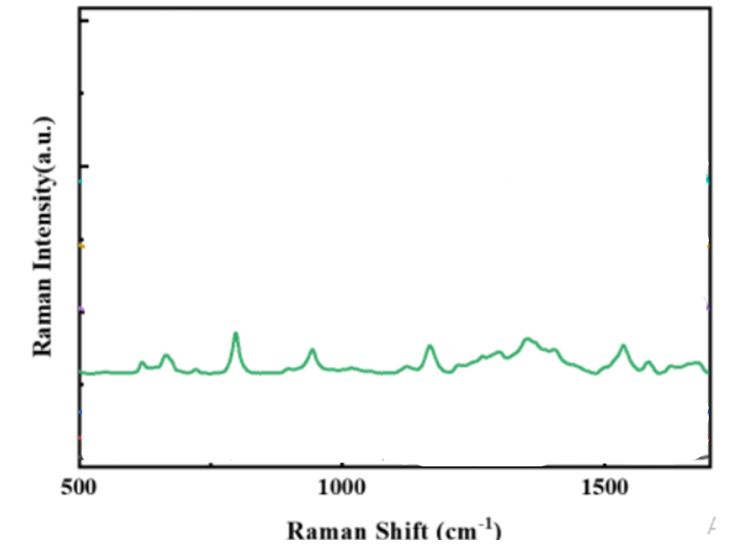
Figure 124:https://papers.ssrn.com/sol3/papers.cfm?abstract_id=4238372
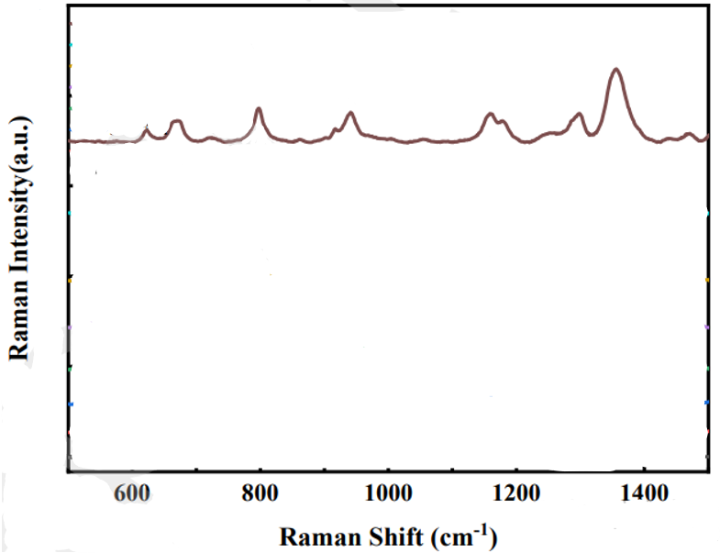
Figure 125:https://papers.ssrn.com/sol3/papers.cfm?abstract_id=4238372
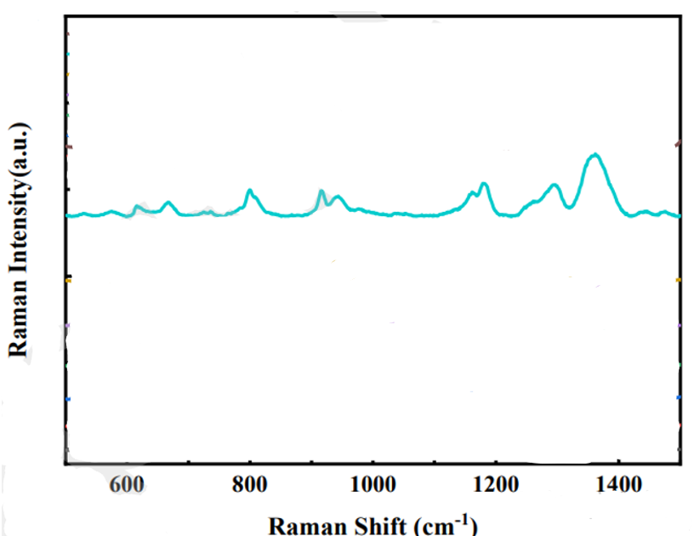
Figure 126:https://papers.ssrn.com/sol3/papers.cfm?abstract_id=4238372
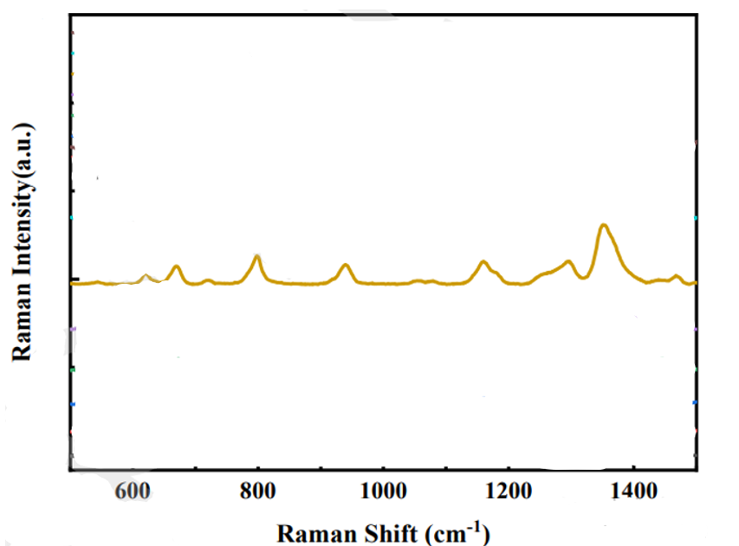
Figure 127:https://papers.ssrn.com/sol3/papers.cfm?abstract_id=4238372
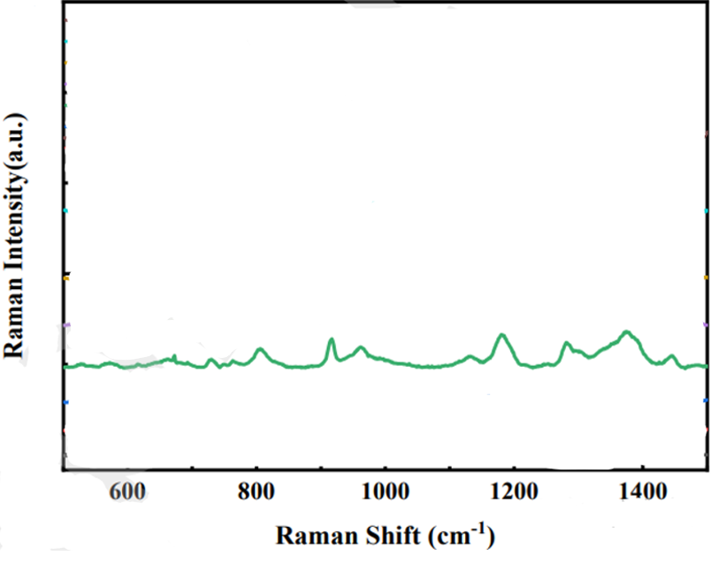
Figure 128:https://papers.ssrn.com/sol3/papers.cfm?abstract_id=4238372
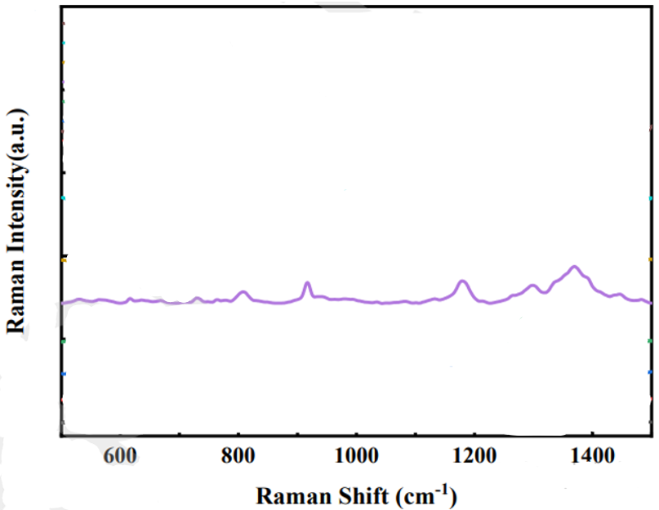
Figure 129:https://papers.ssrn.com/sol3/papers.cfm?abstract_id=4238372
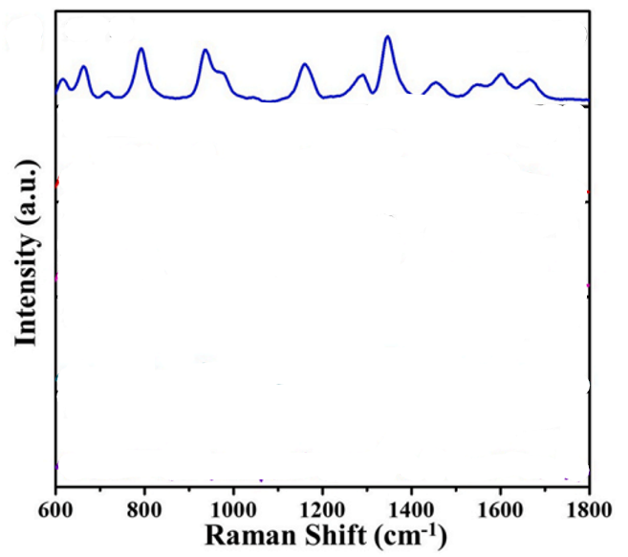
Figure 130:https://doi.org/10.1016/j.matchemphys.2022.125823
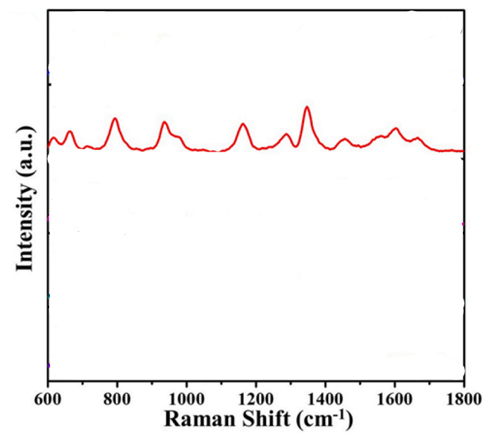
Figure 131:https://doi.org/10.1016/j.matchemphys.2022.125823
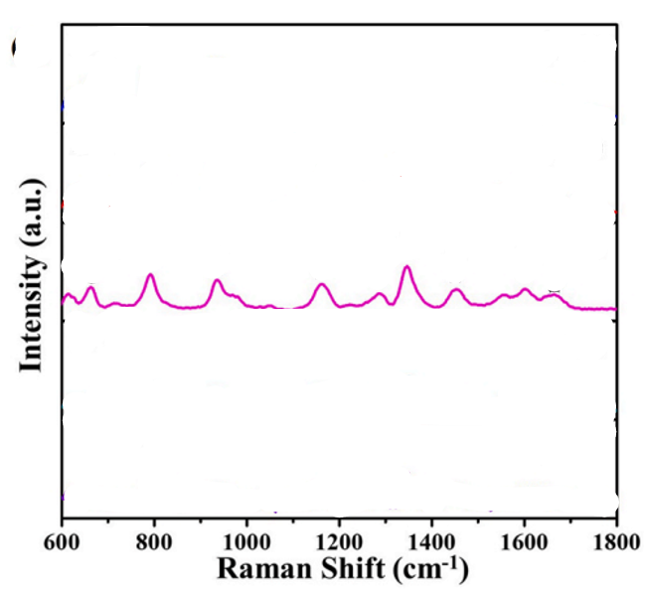
Figure 132:https://doi.org/10.1016/j.matchemphys.2022.125823
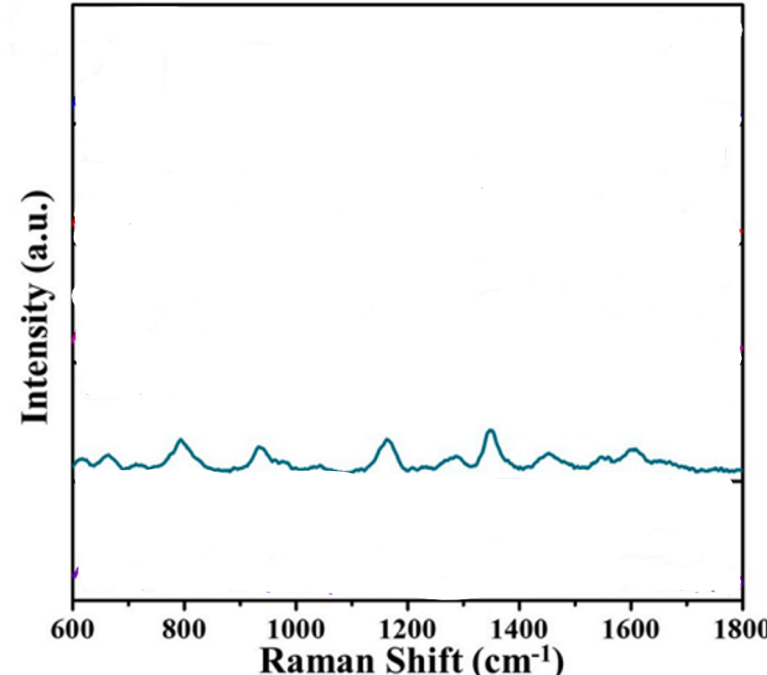
Figure 133:https://doi.org/10.1016/j.matchemphys.2022.125823
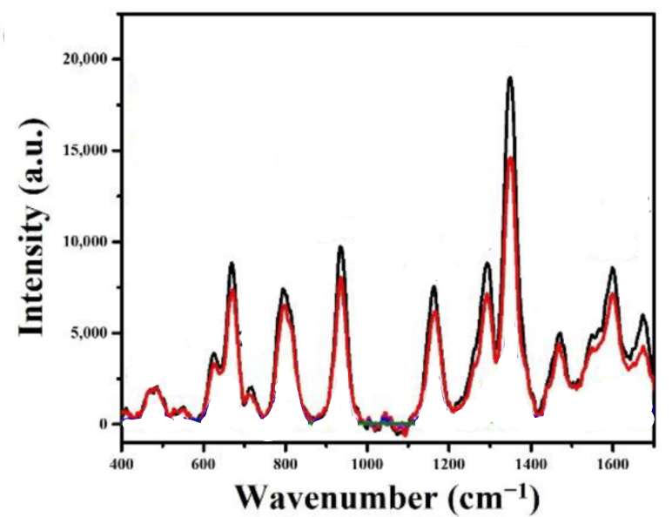
Figure 134:https://doi.org/10.3390/nano12223989
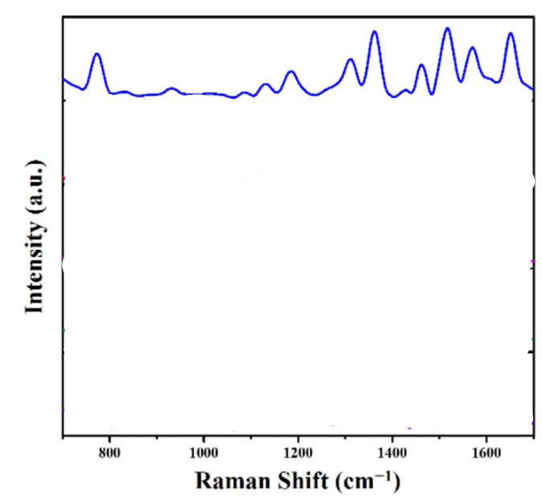
Figure 135:https://doi.org/10.3390/molecules27238460
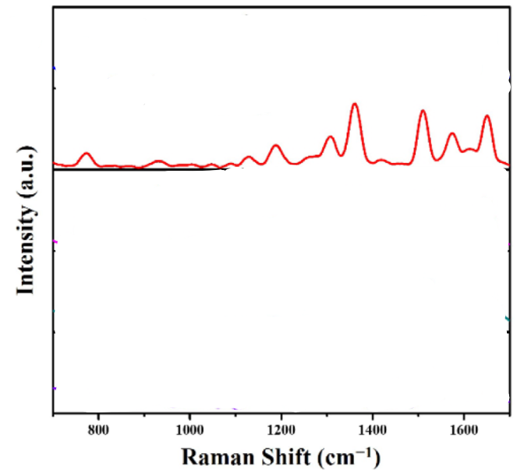
Figure 136:https://doi.org/10.3390/molecules27238460
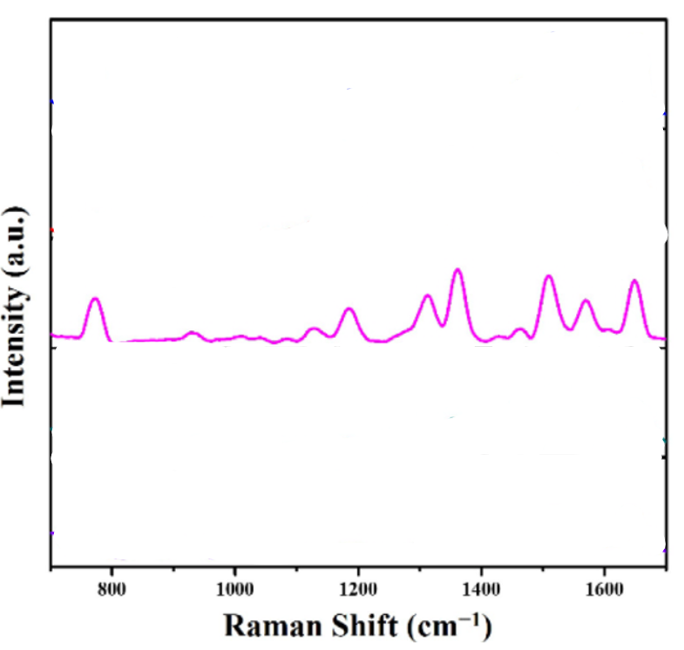
Figure 137:https://doi.org/10.3390/molecules27238460
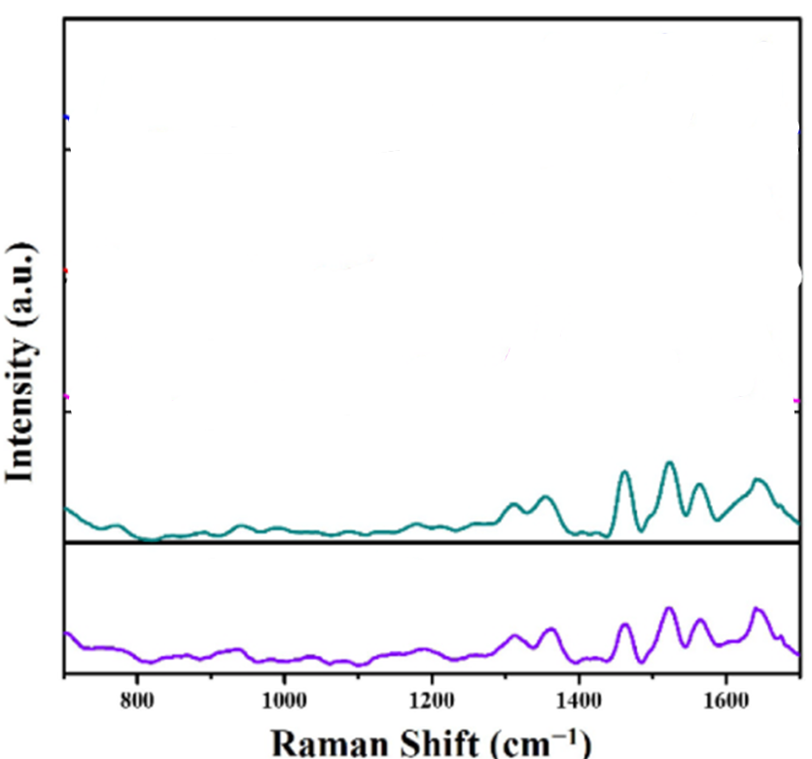
Figure 138:https://doi.org/10.3390/molecules27238460
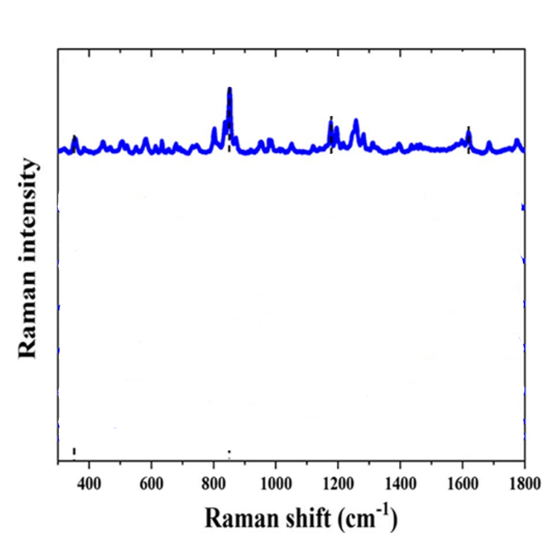
Figure 139:https://doi.org/10.1007/s00604-025-07118-9
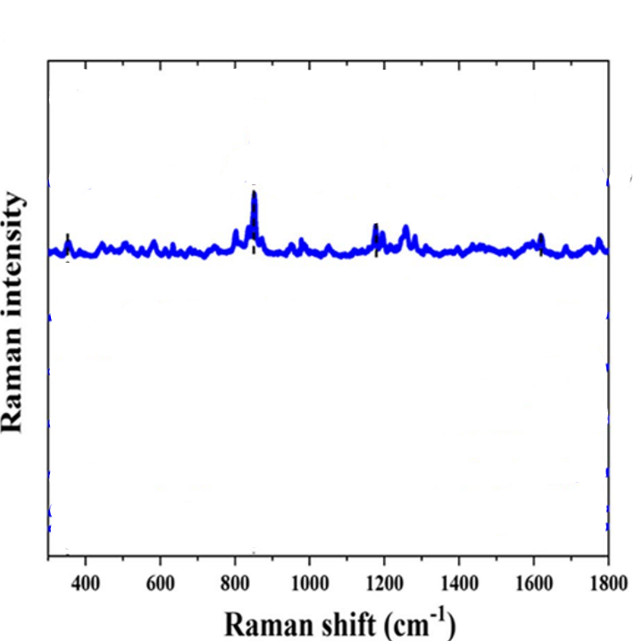
Figure 140:https://doi.org/10.1007/s00604-025-07118-9
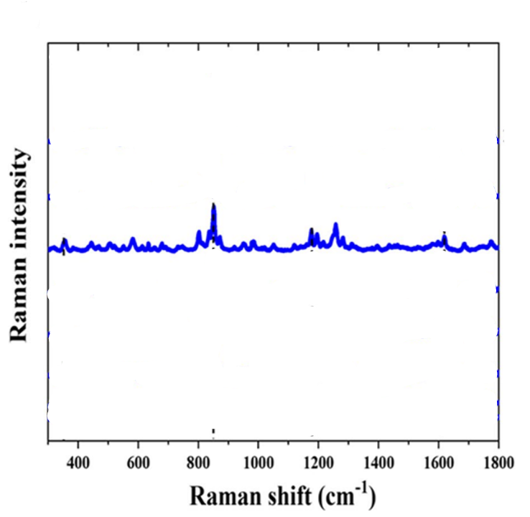
Figure 141:https://doi.org/10.1007/s00604-025-07118-9
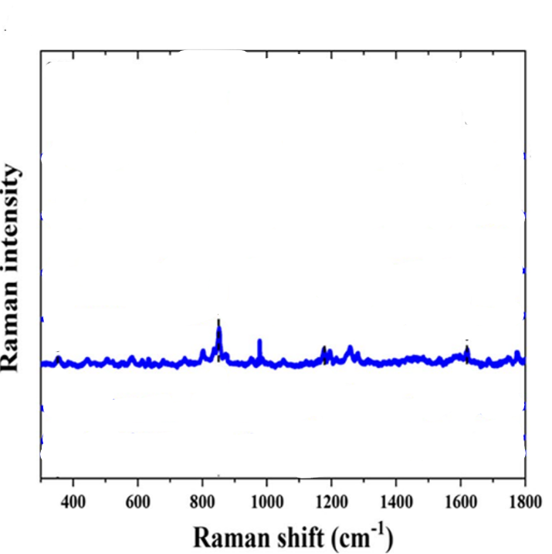
Figure 142:https://doi.org/10.1007/s00604-025-07118-9
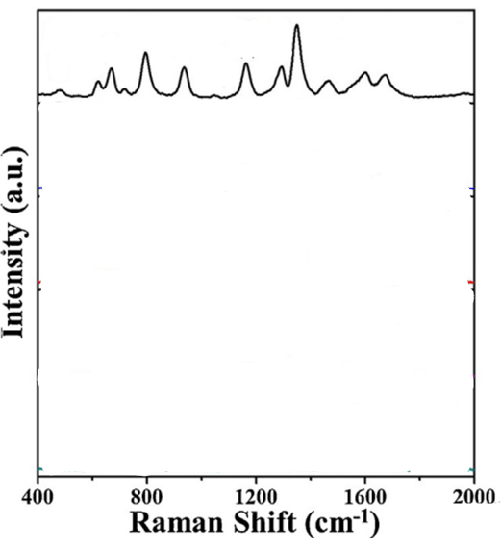
Figure 143:https://doi.org/10.1016/j.jiec.2019.03.058
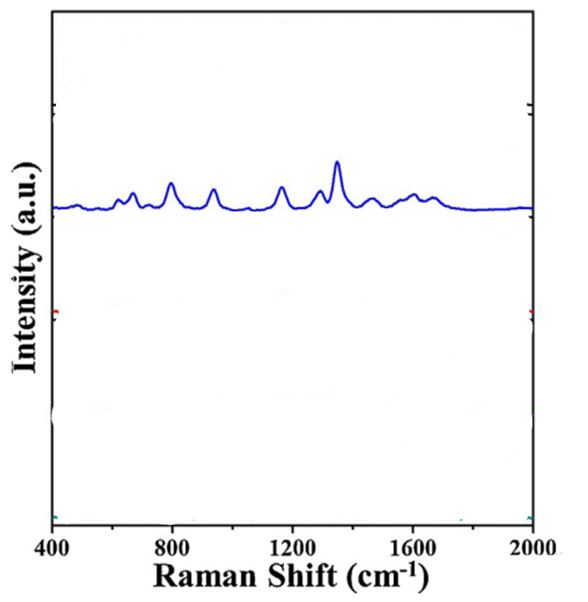
Figure 144:https://doi.org/10.1016/j.jiec.2019.03.058
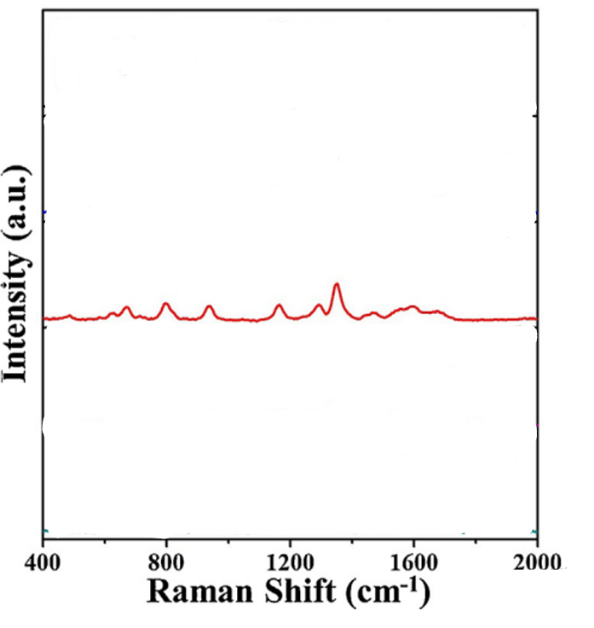
Figure 145:https://doi.org/10.1016/j.jiec.2019.03.058
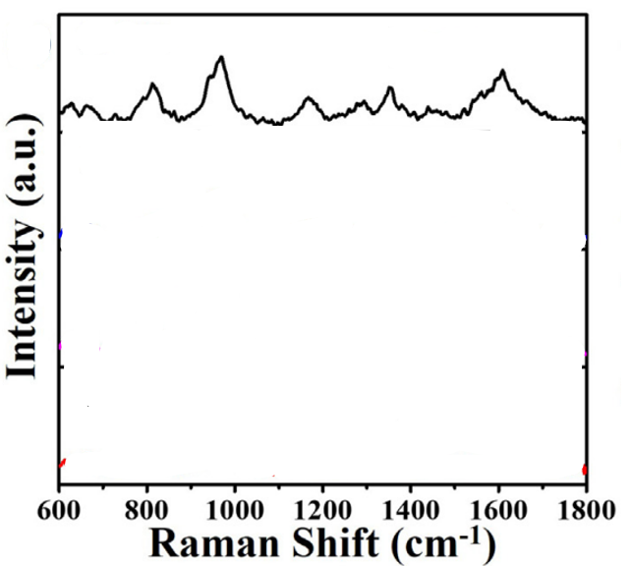
Figure 146:https://doi.org/10.1016/j.jallcom.2018.12.264
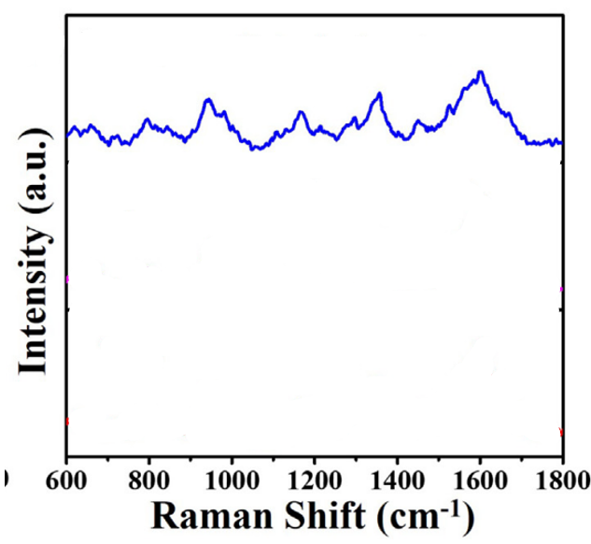
Figure 147:https://doi.org/10.1016/j.jallcom.2018.12.264
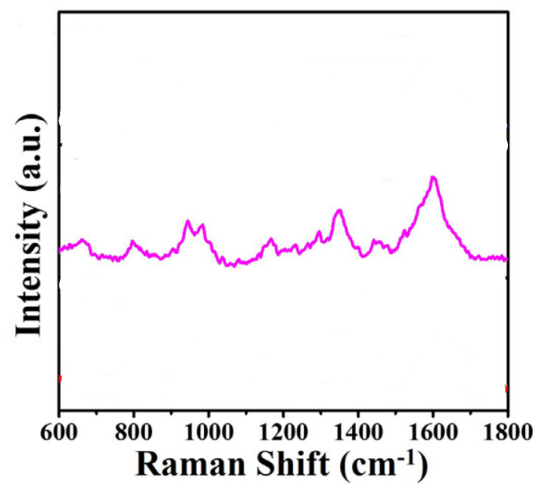
Figure 148:https://doi.org/10.1016/j.jallcom.2018.12.264
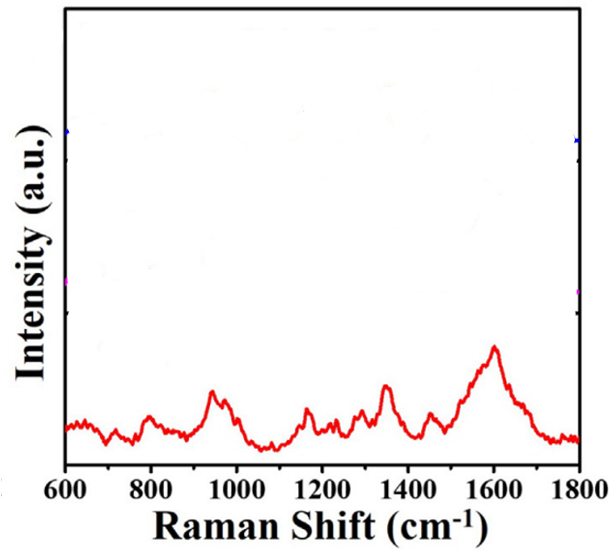
Figure 149:https://doi.org/10.1016/j.jallcom.2018.12.264
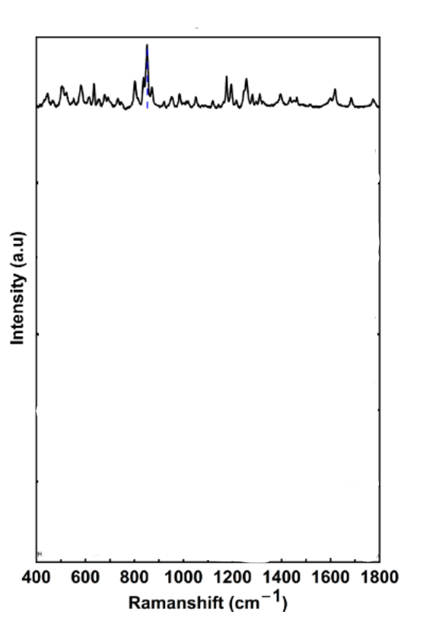
Figure 150:https://doi.org/10.3390/nano14211689
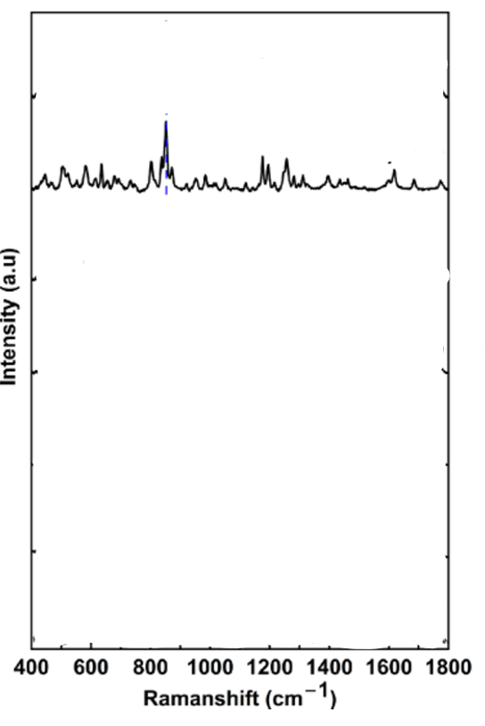
Figure 151:https://doi.org/10.3390/nano14211689
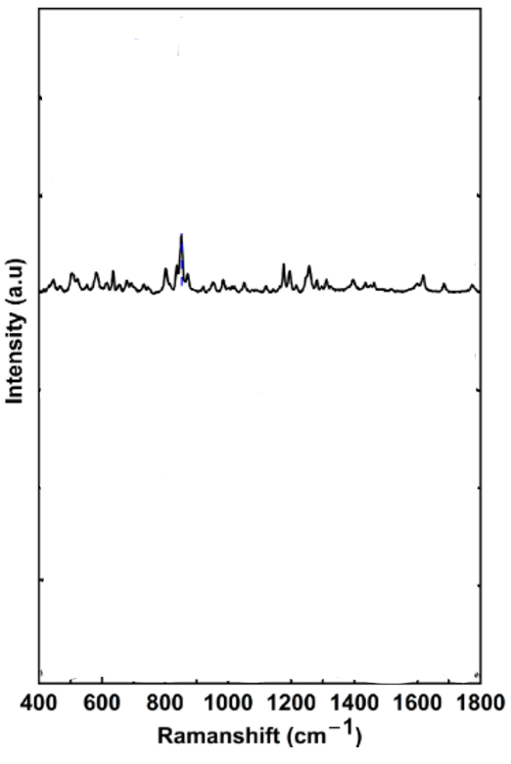
Figure 152:https://doi.org/10.3390/nano14211689
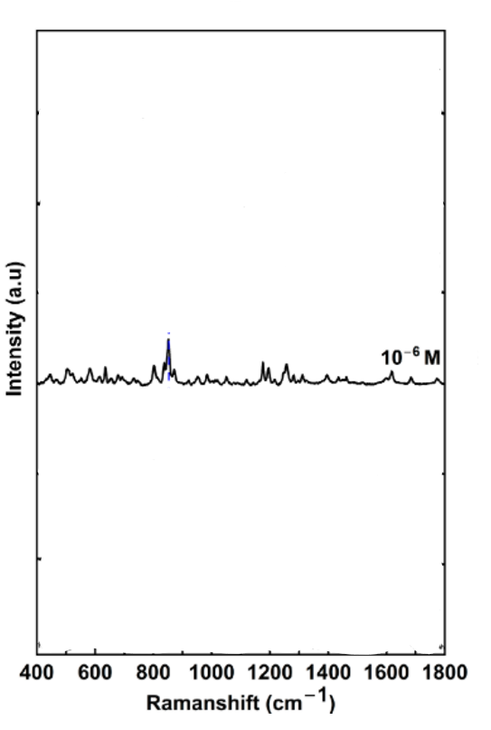
Figure 153:https://doi.org/10.3390/nano14211689
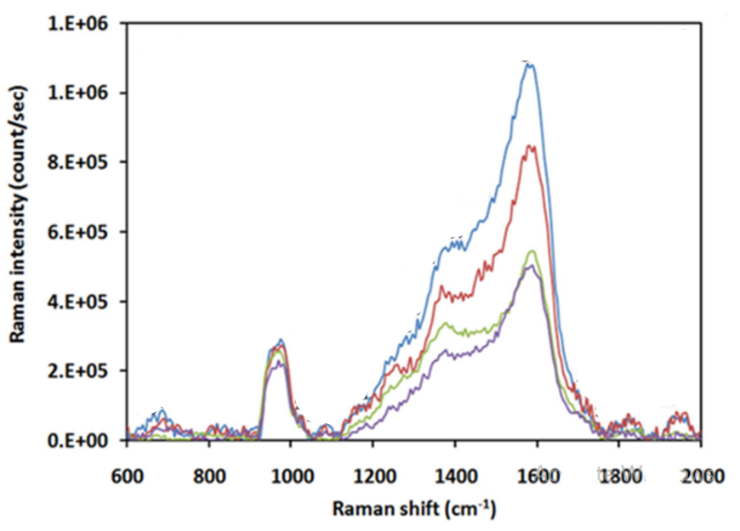
Figure 154:https://doi.org/10.3390/nano14211689

