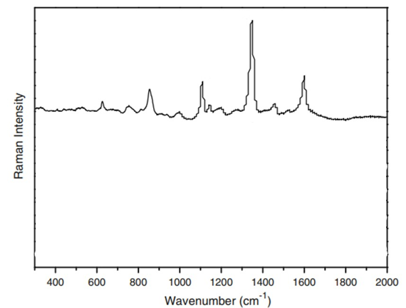
Figure 1:DOI 10.1007/s11694-011-9106-8
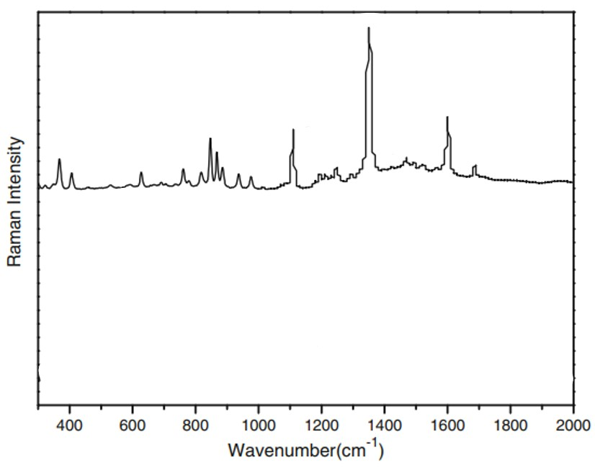
Figure 2:DOI 10.1007/s11694-011-9106-8
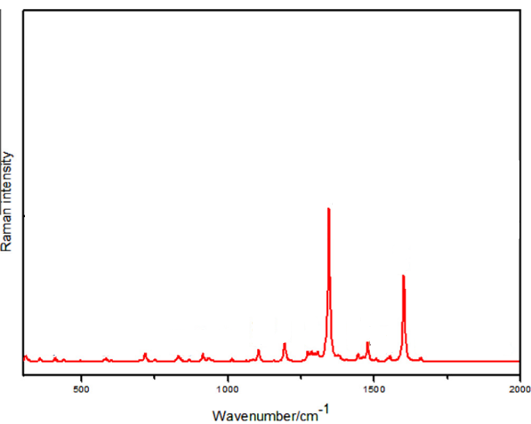
Figure 3:https://doi.org/10.1016/j.saa.2015.02.029

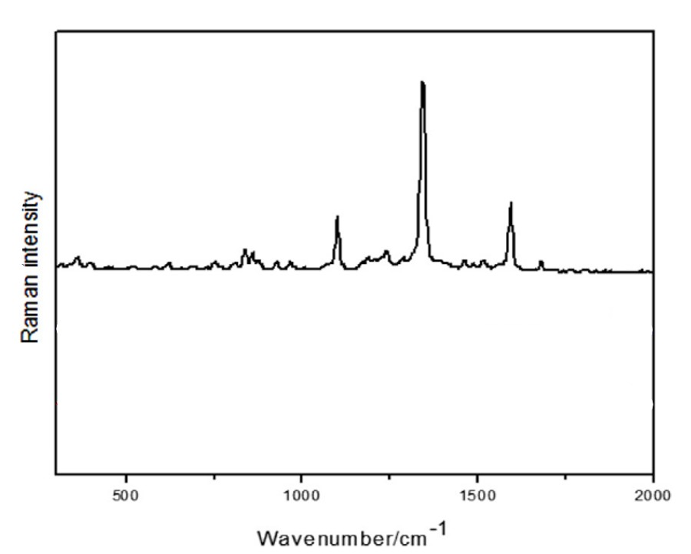
Figure 4:https://doi.org/10.1016/j.saa.2015.02.029
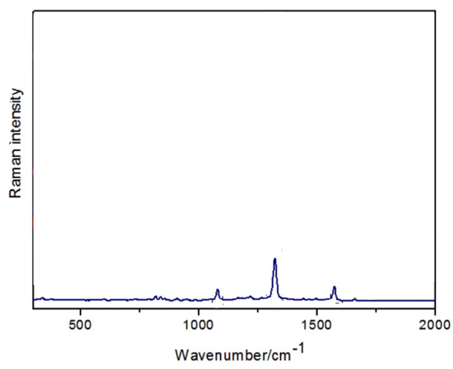
Figure 5:https://doi.org/10.1016/j.saa.2015.02.029
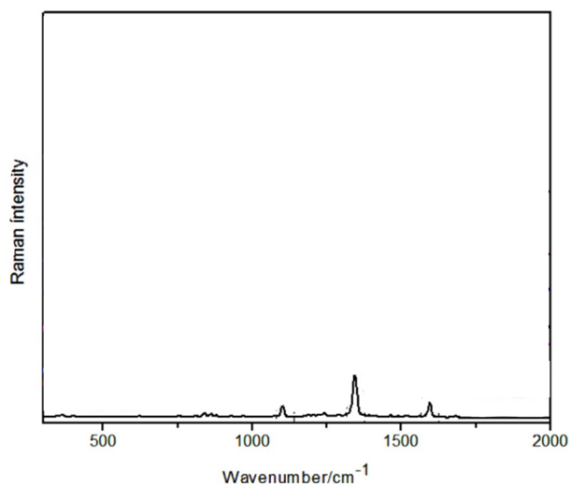
Figure 6:https://doi.org/10.1016/j.saa.2015.02.029
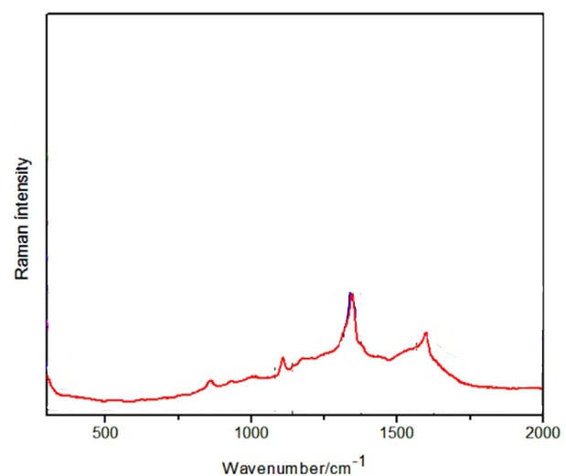
Figure 7:https://doi.org/10.1016/j.saa.2015.02.029
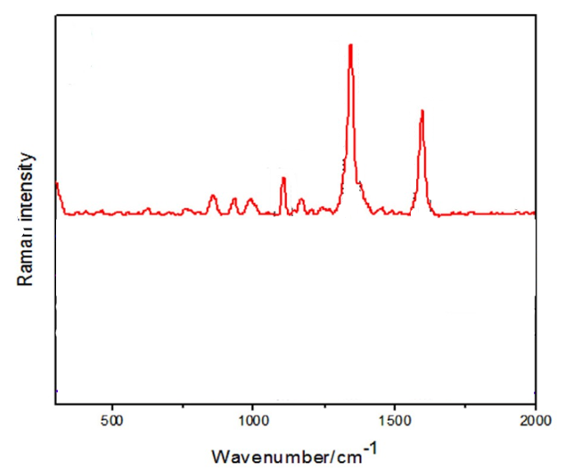
Figure 8:https://doi.org/10.1016/j.saa.2015.02.029
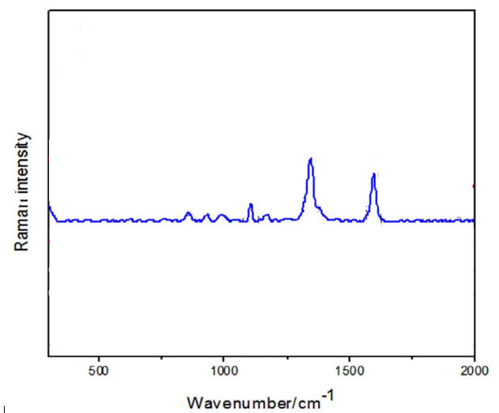
Figure 9:https://doi.org/10.1016/j.saa.2015.02.029
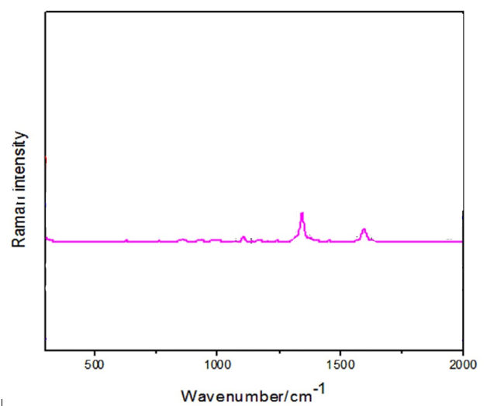
Figure 10:https://doi.org/10.1016/j.saa.2015.02.029
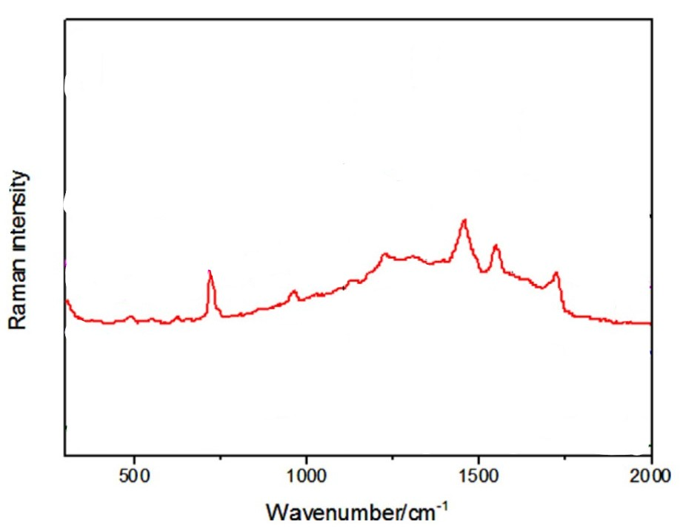
Figure 11:https://doi.org/10.1016/j.saa.2015.02.029
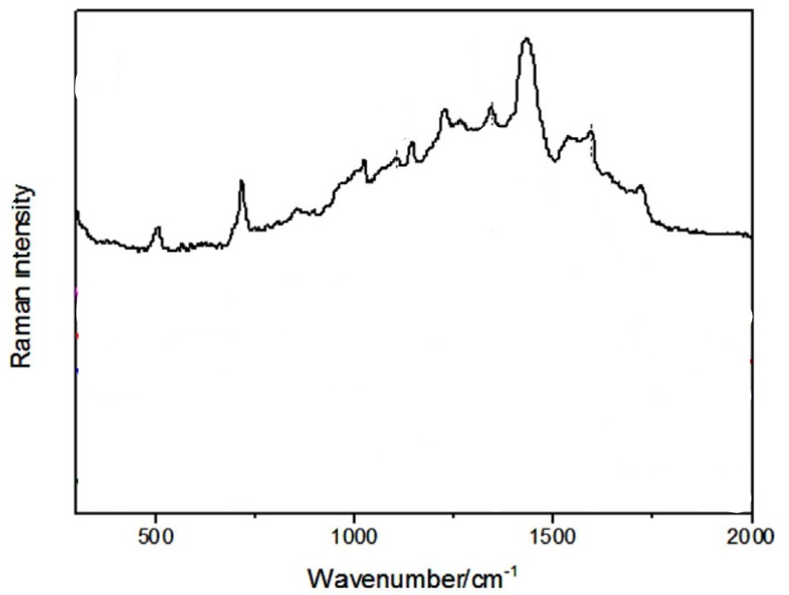
Figure 12:https://doi.org/10.1016/j.saa.2015.02.029
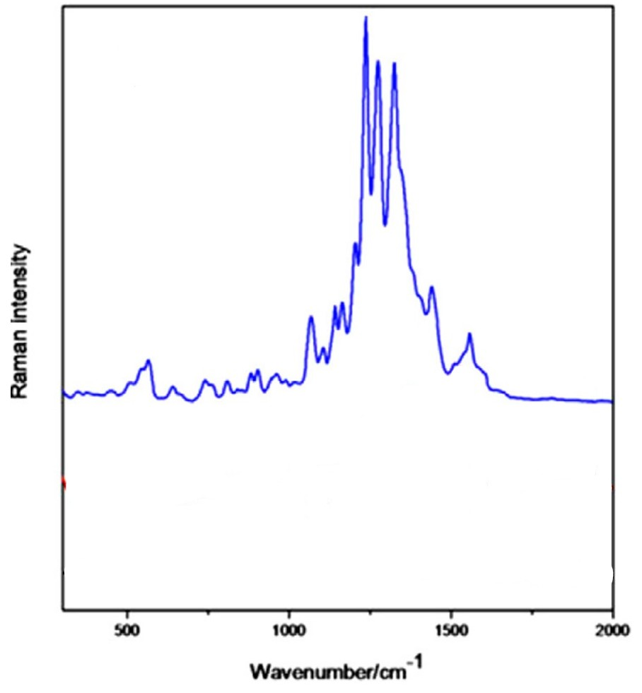
Figure 13:https://doi.org/10.1016/j.saa.2015.02.029
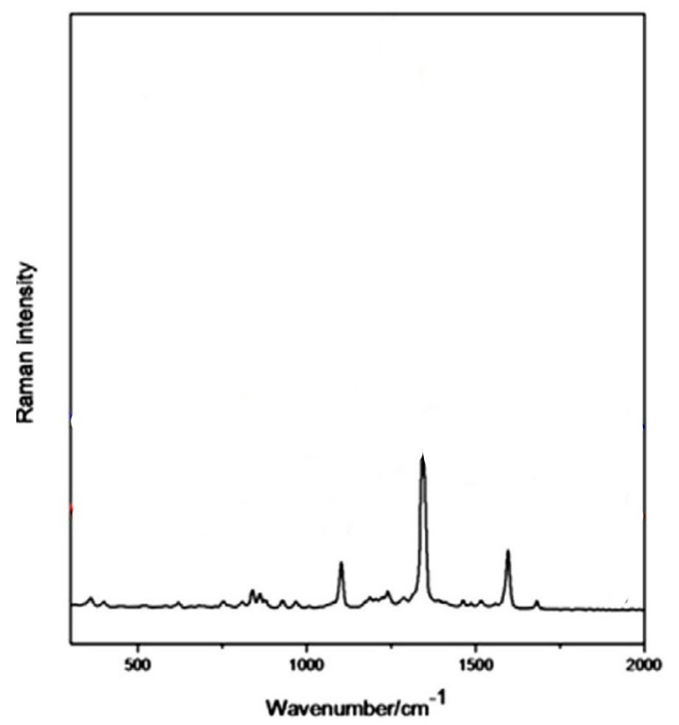
Figure 14:https://doi.org/10.1016/j.saa.2015.02.029
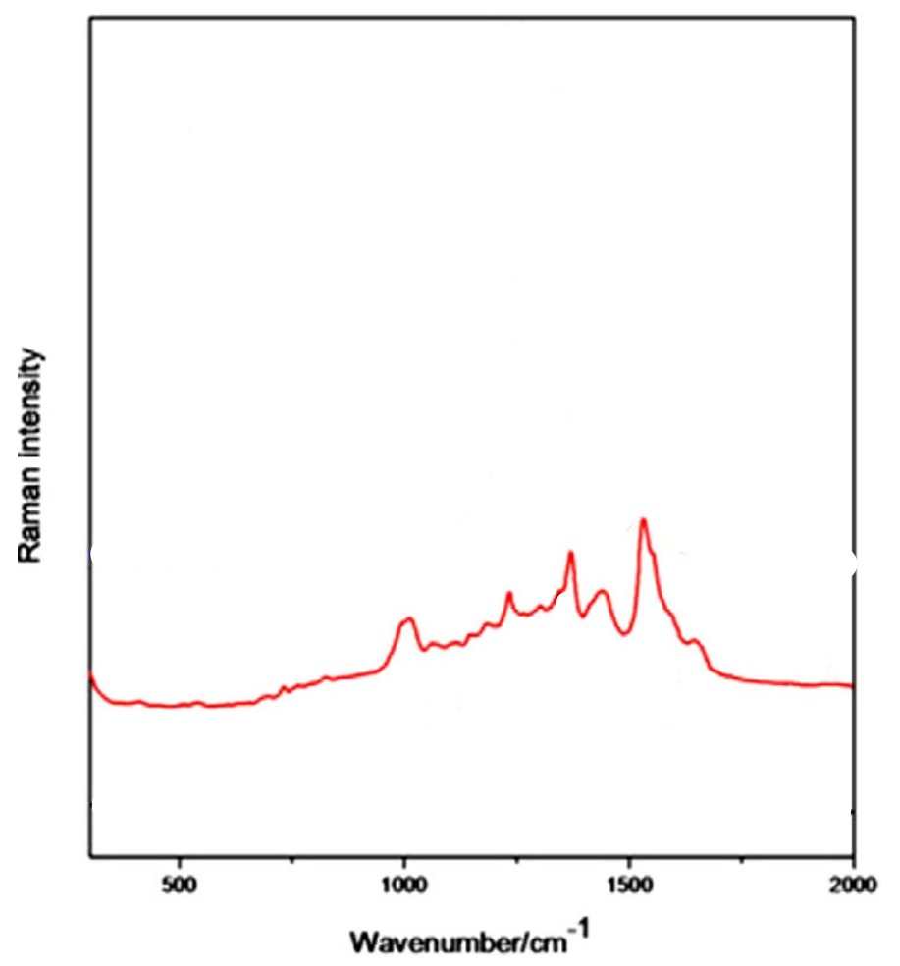
Figure 15:https://doi.org/10.1016/j.saa.2015.02.029
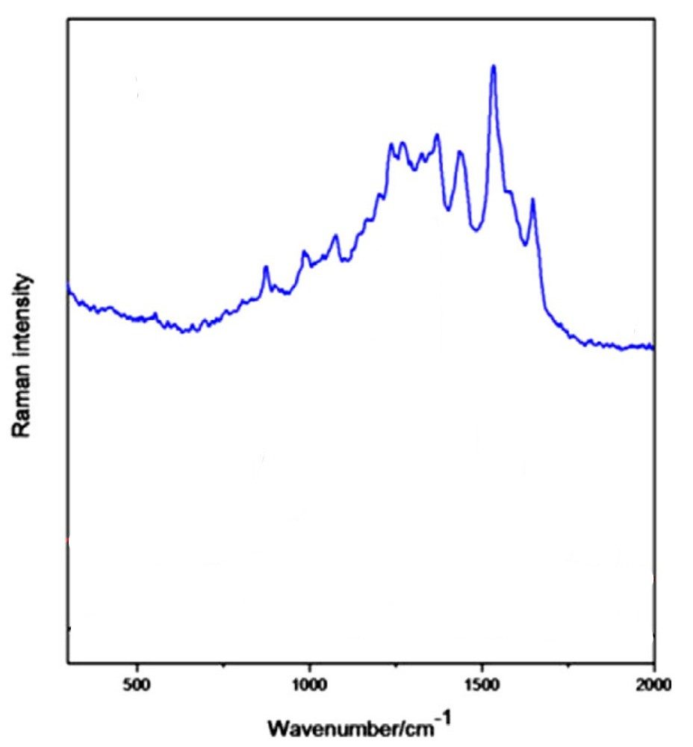
Figure 16:https://doi.org/10.1016/j.saa.2015.02.029
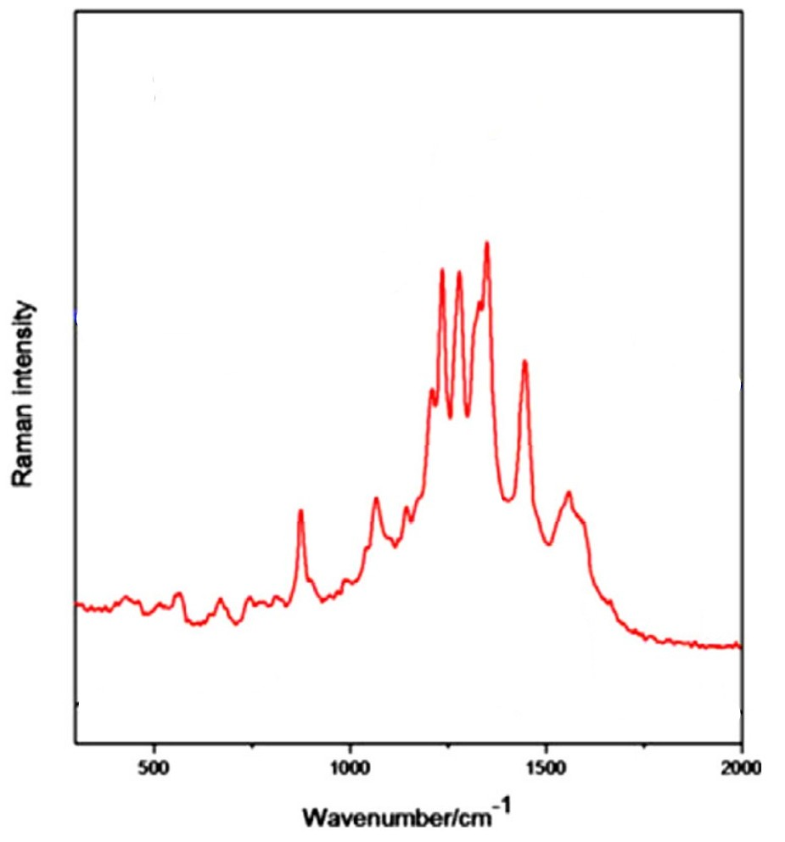
Figure 17:https://doi.org/10.1016/j.saa.2015.02.029
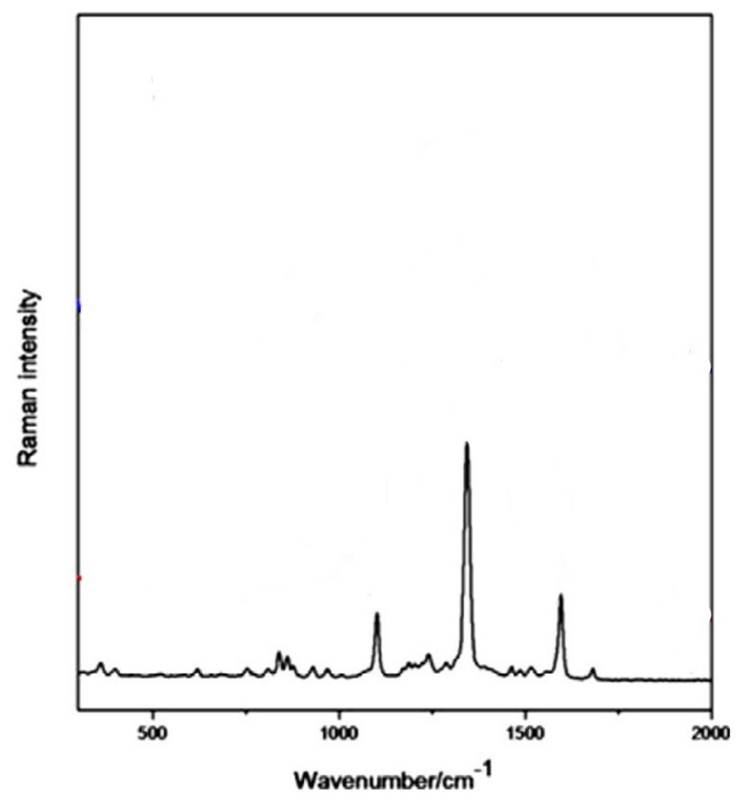
Figure 18:https://doi.org/10.1016/j.saa.2015.02.029
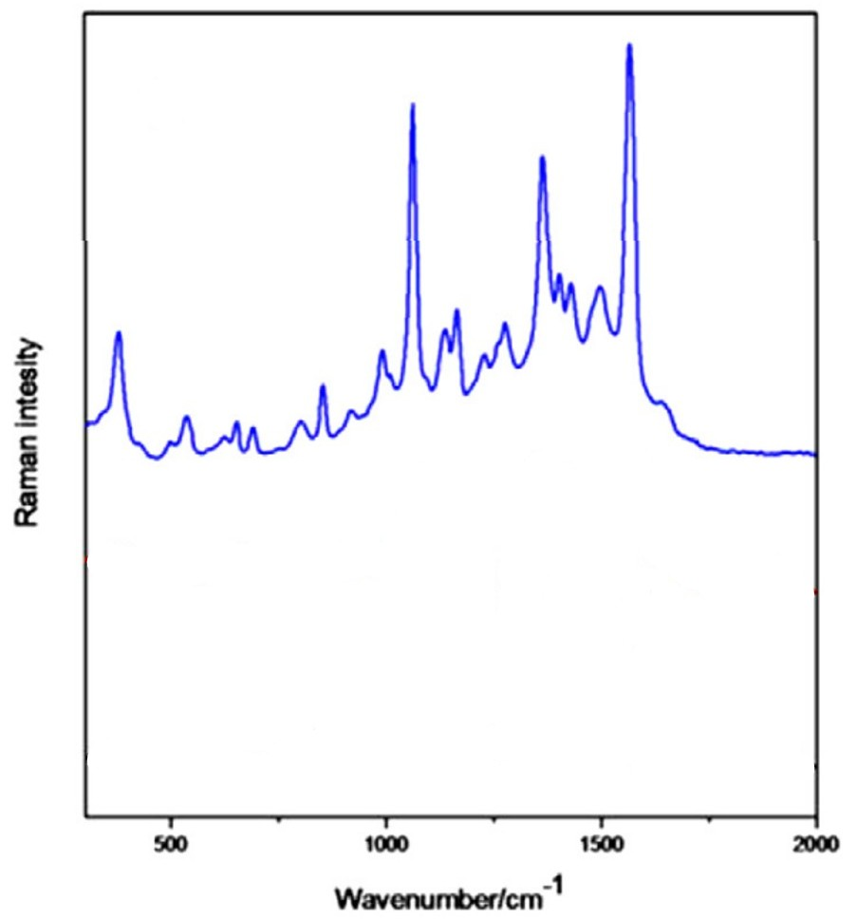
Figure 19:https://doi.org/10.1016/j.saa.2015.02.029
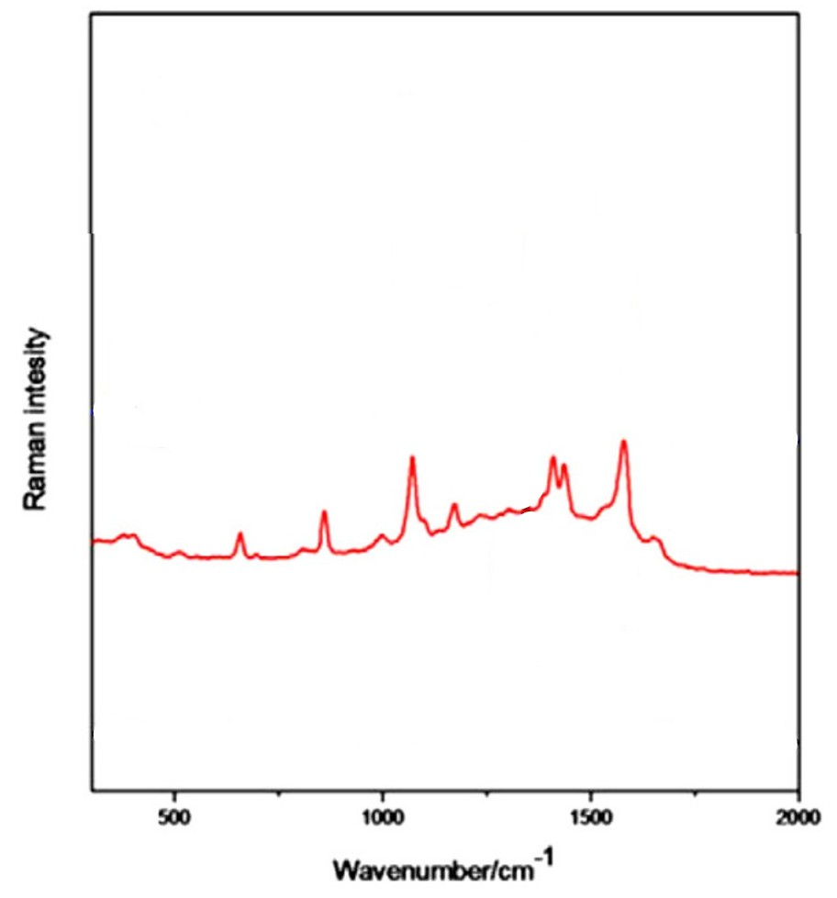
Figure 20:https://doi.org/10.1016/j.saa.2015.02.029
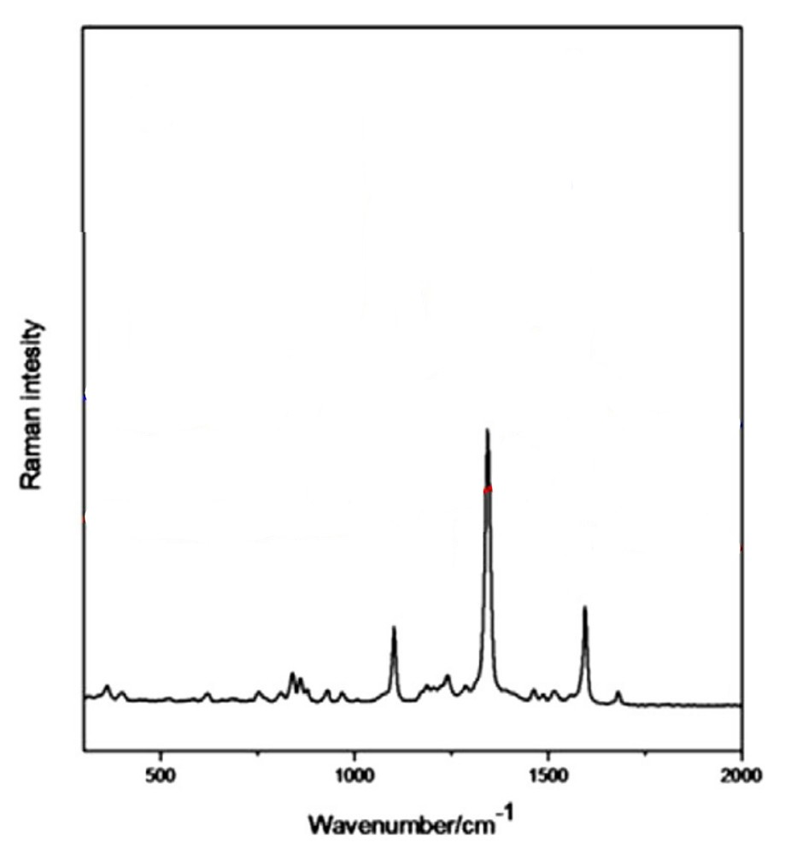
Figure 21:https://doi.org/10.1016/j.saa.2015.02.029
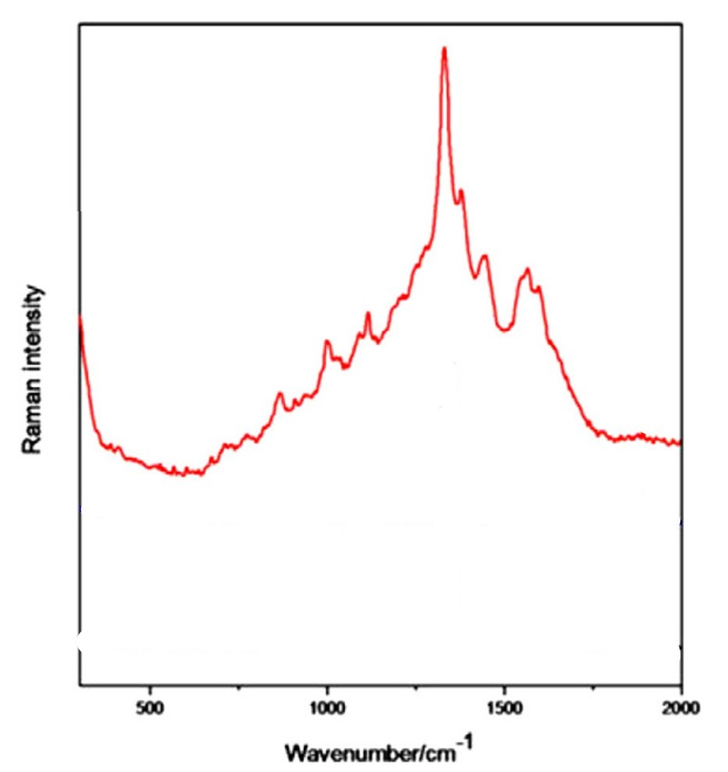
Figure 22:https://doi.org/10.1016/j.saa.2015.02.029

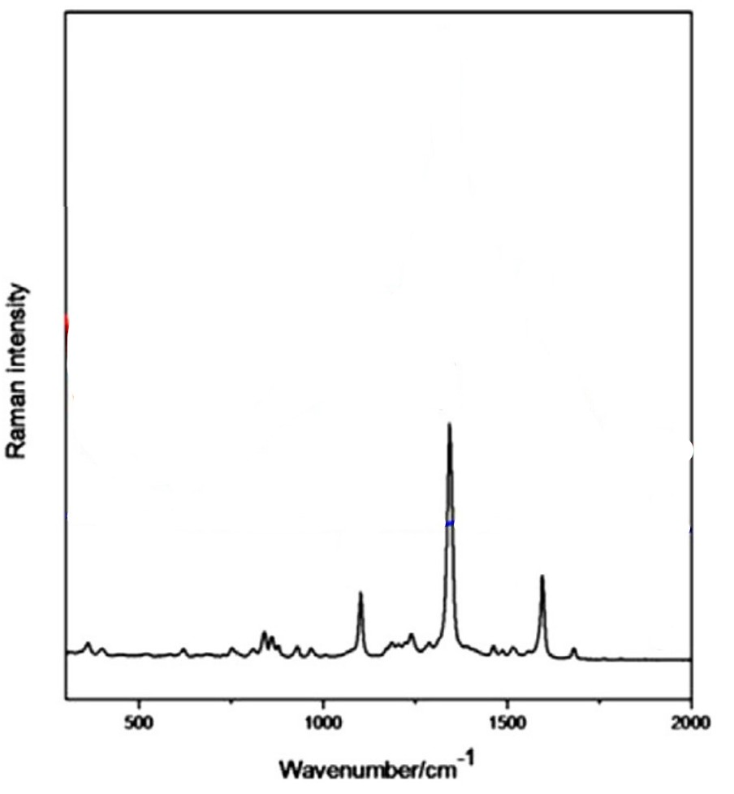
Figure 23:https://doi.org/10.1016/j.saa.2015.02.029
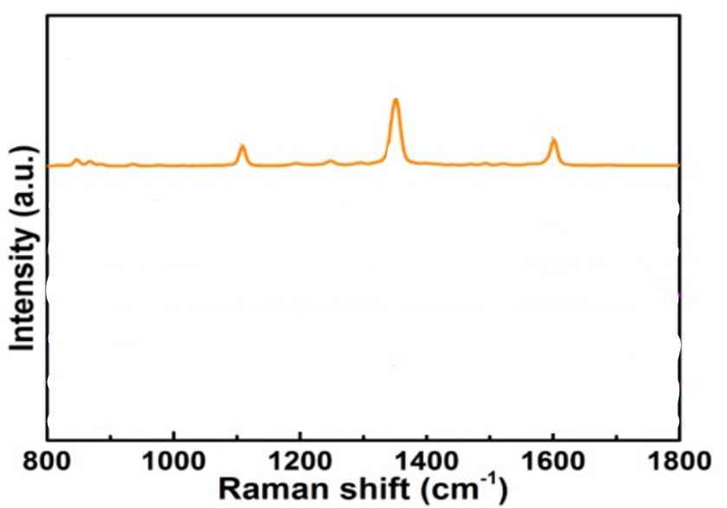
Figure 24:https://doi.org/10.3390/s17122962
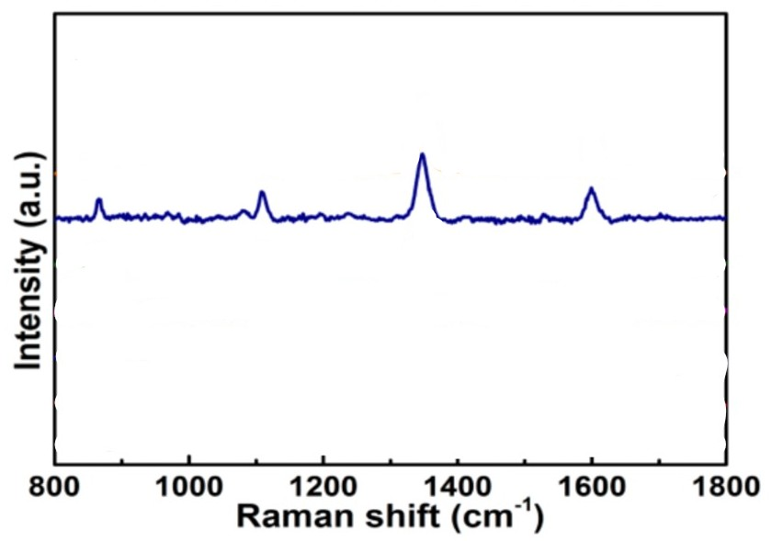
Figure 25:https://doi.org/10.3390/s17122962
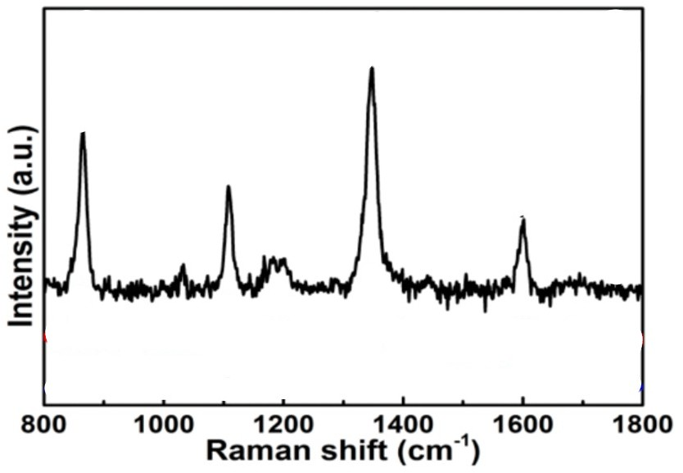
Figure 26:https://doi.org/10.3390/s17122962
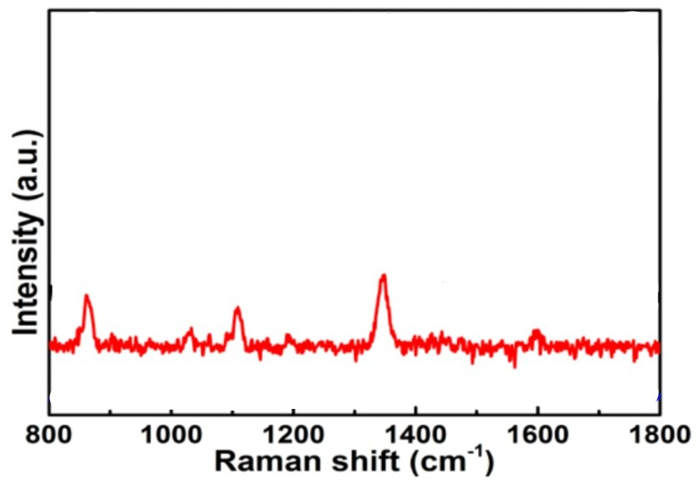
Figure 27:https://doi.org/10.3390/s17122962
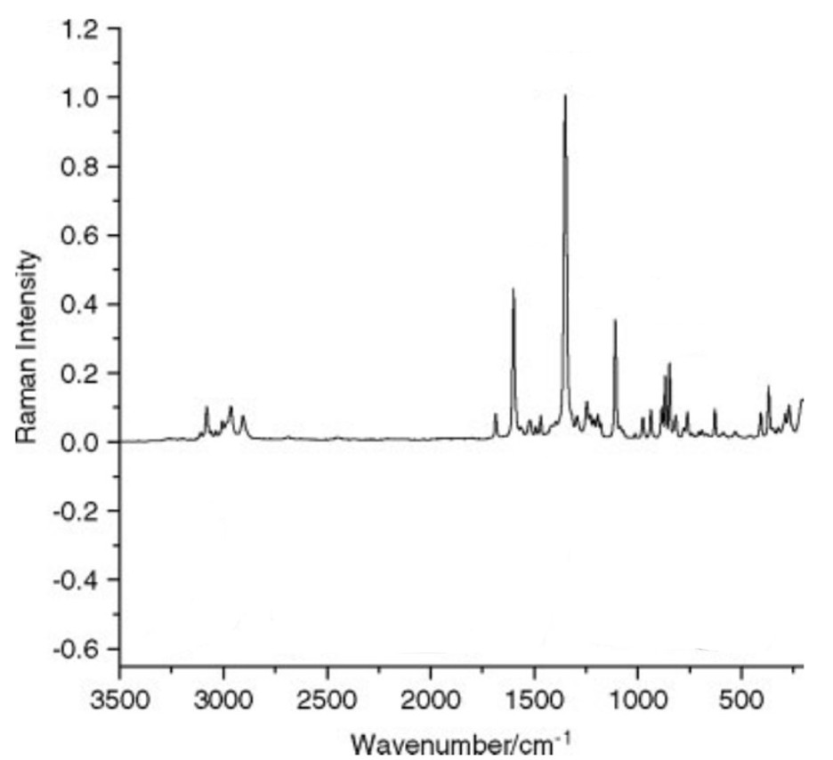
Figure 28:https://doi.org/10.1002/jrs.2033
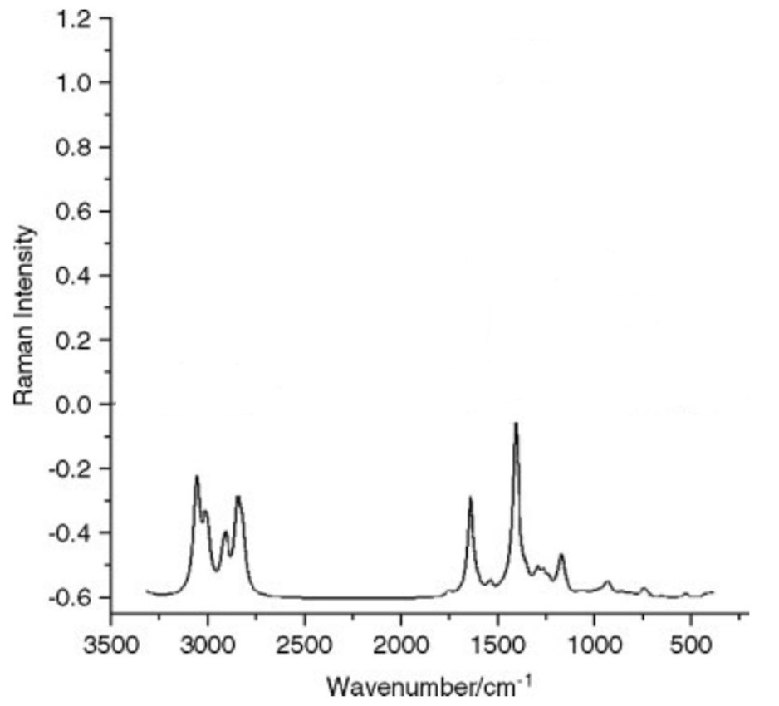
Figure 29:https://doi.org/10.1002/jrs.2033
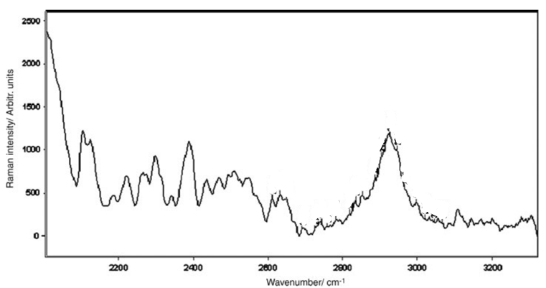
Figure 30:https://doi.org/10.1002/jrs.2033
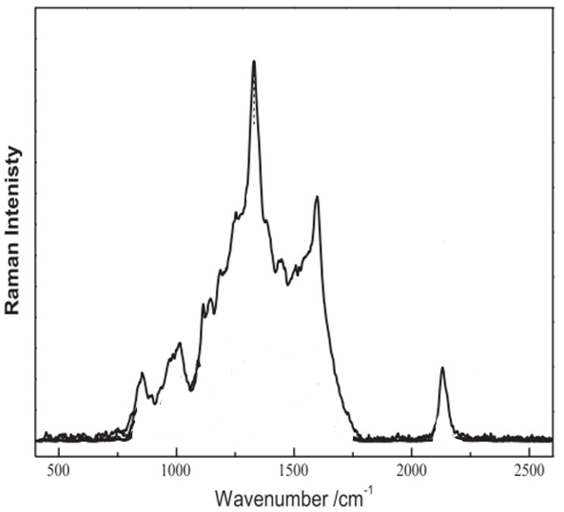
Figure 31:https://doi.org/10.1002/jrs.2033

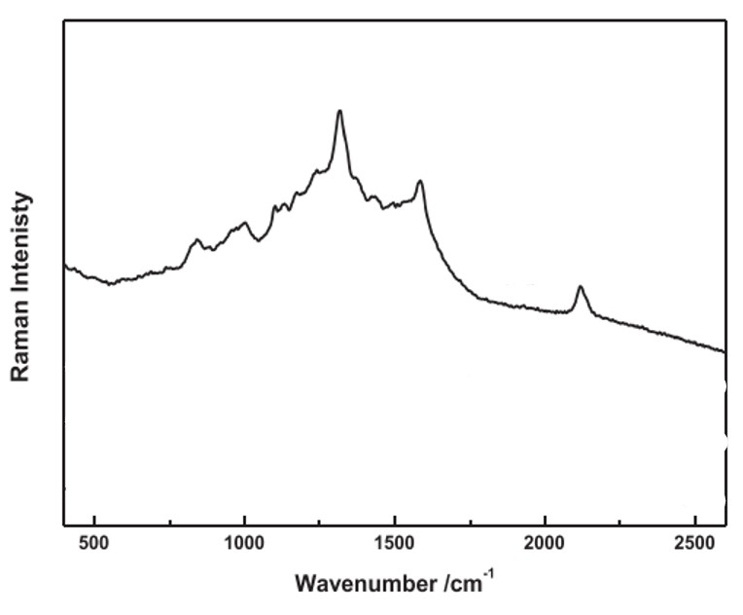
Figure 32:https://doi.org/10.1002/jrs.5034
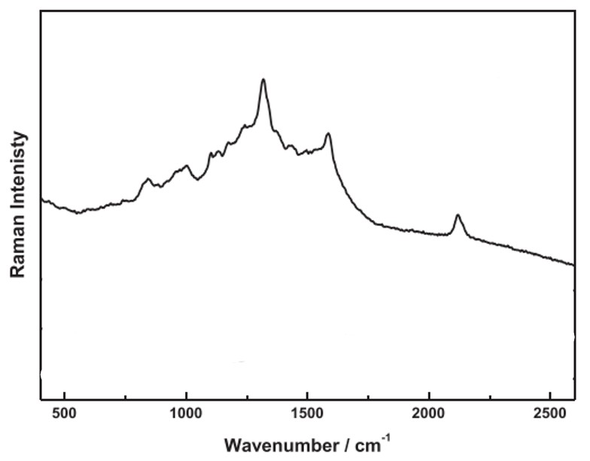
Figure 33:https://doi.org/10.1002/jrs.5034
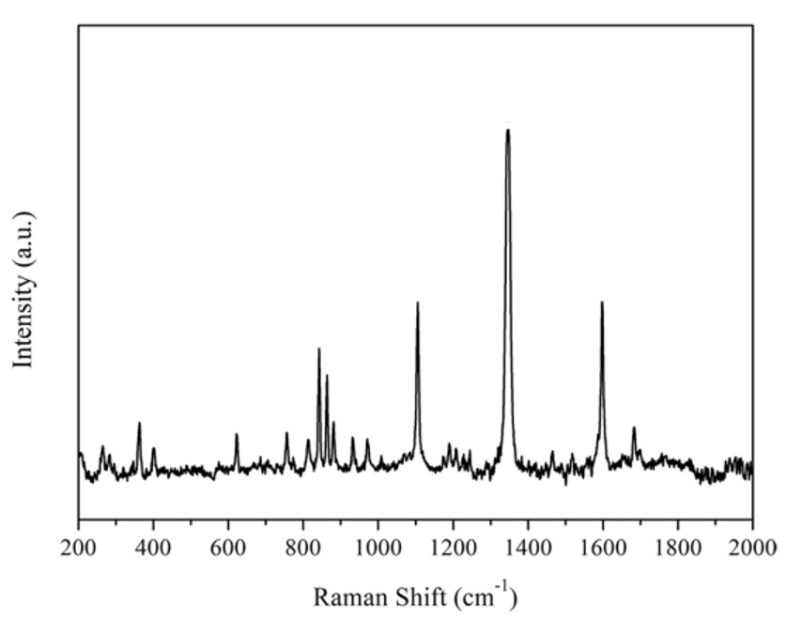
Figure 34:DOI https://doi.org/10.1007/s12161-021-02091-4
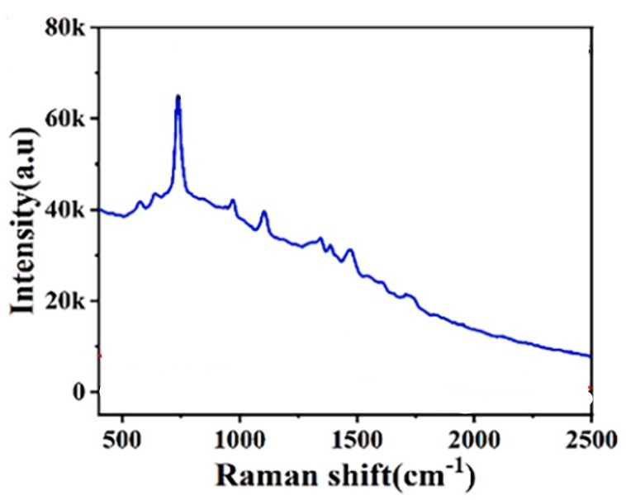
Figure 35:https://doi.org/10.1016/j.foodchem.2023.138026
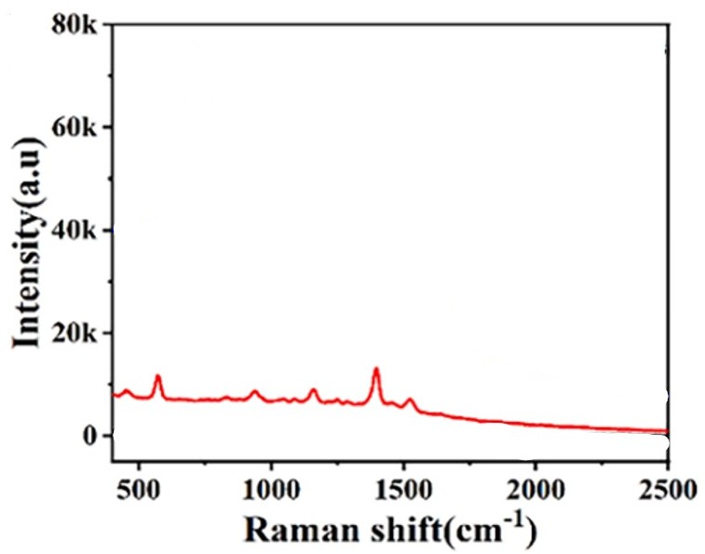
Figure 36:https://doi.org/10.1016/j.foodchem.2023.138026
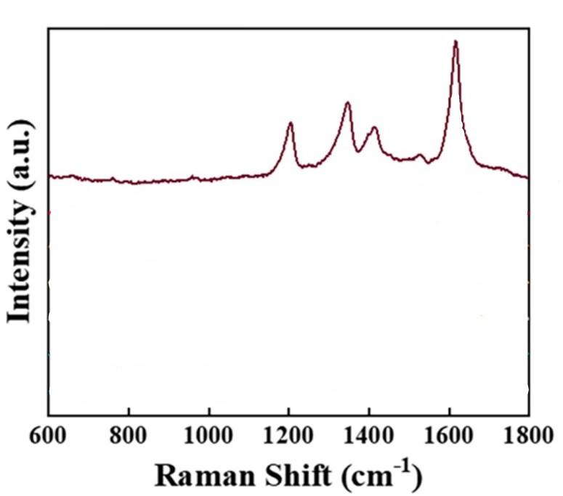
Figure 37:https://doi.org/10.1016/j.microc.2024.111990
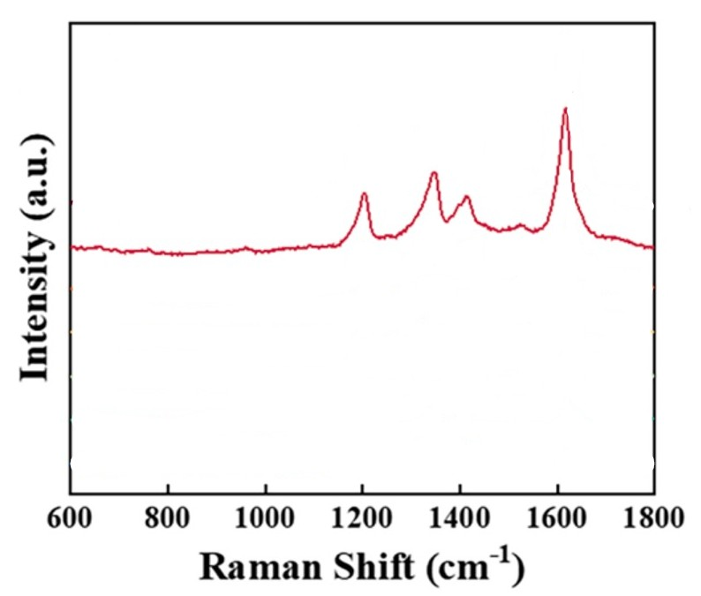
Figure 38:https://doi.org/10.1016/j.microc.2024.111990
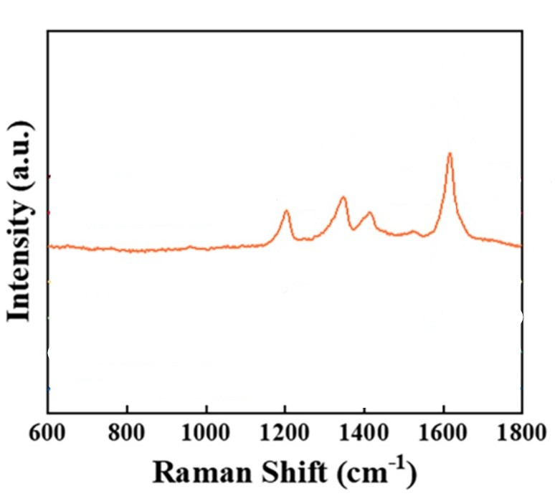
Figure 39:https://doi.org/10.1016/j.microc.2024.111990
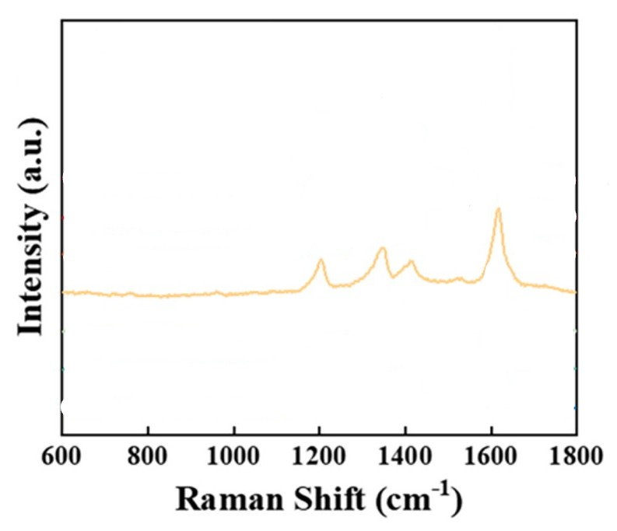
Figure 40:https://doi.org/10.1016/j.microc.2024.111990
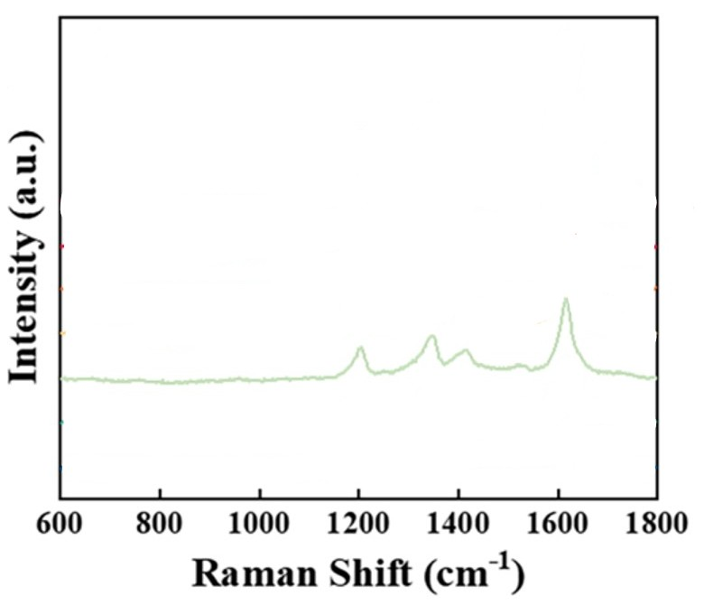
Figure 41:https://doi.org/10.1016/j.microc.2024.111990
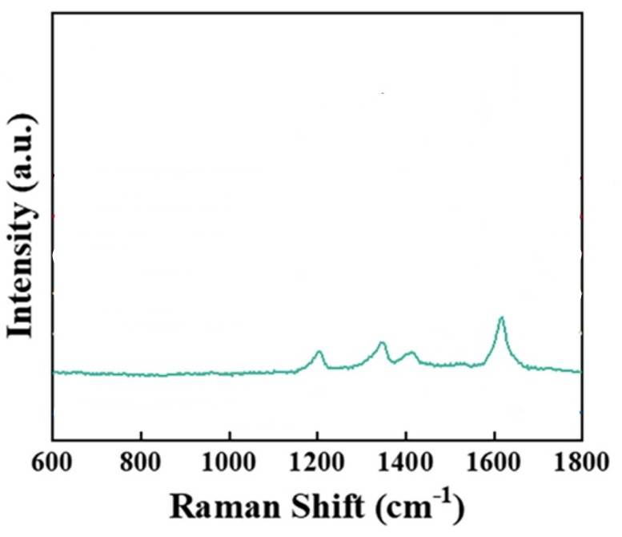
Figure 42:https://doi.org/10.1016/j.microc.2024.111990
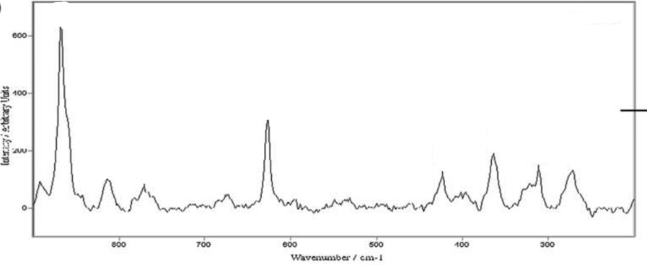
Figure 43:https://doi.org/10.1016/j.molstruc.2005.10.012
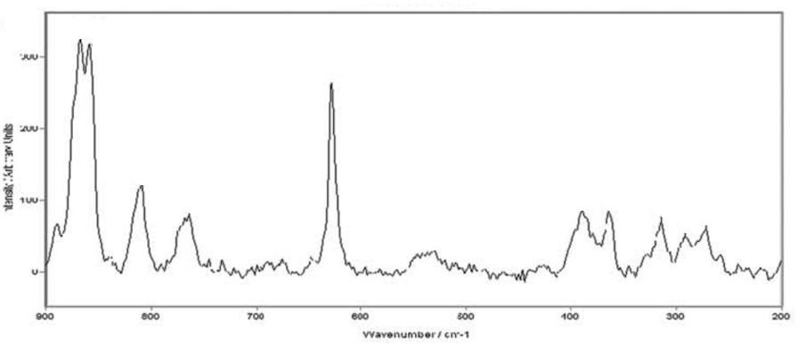
Figure 44:https://doi.org/10.1016/j.molstruc.2005.10.012
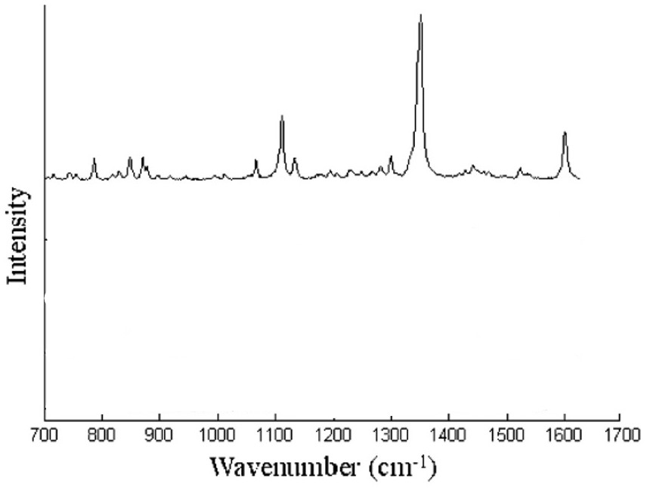
Figure 45:https://doi.org/10.1021/ac0520902
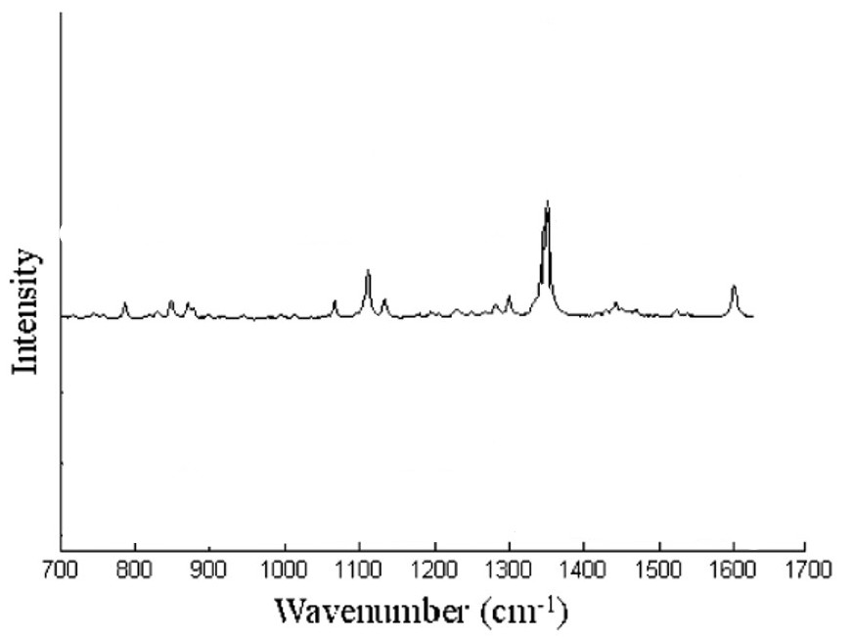
Figure 46:https://doi.org/10.1021/ac0520902
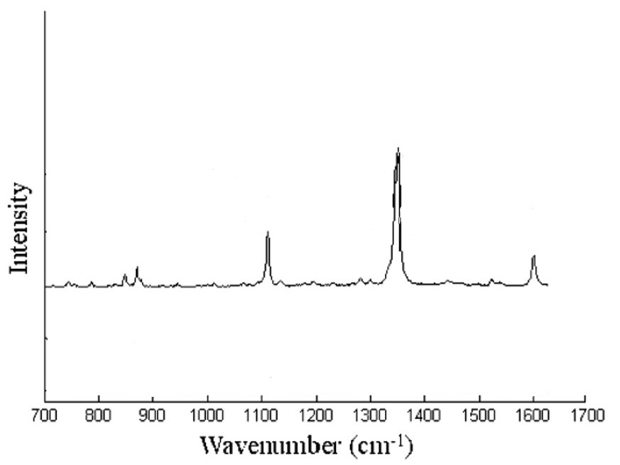
Figure 47:https://doi.org/10.1021/ac0520902
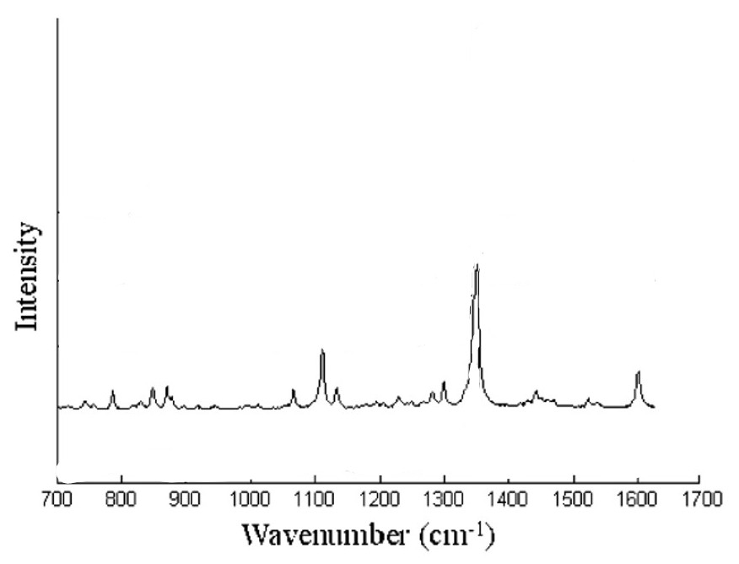
Figure 48:https://doi.org/10.1021/ac0520902
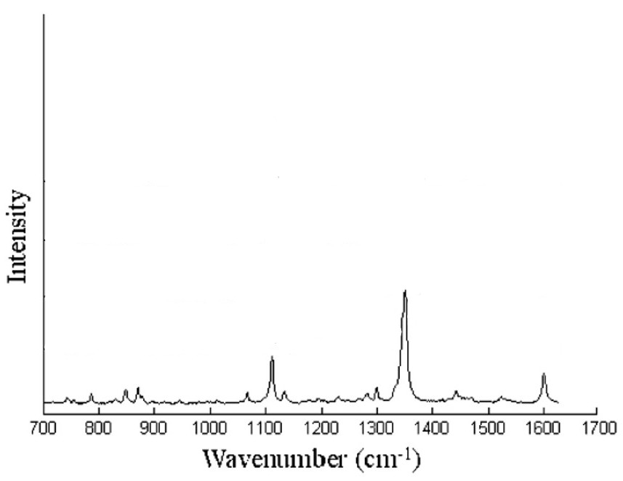
Figure 49:https://doi.org/10.1021/ac0520902
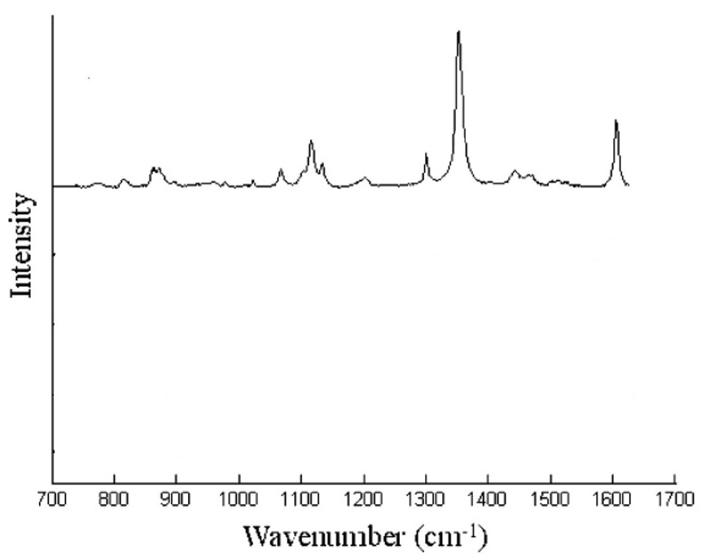
Figure 50:https://doi.org/10.1021/ac0520902
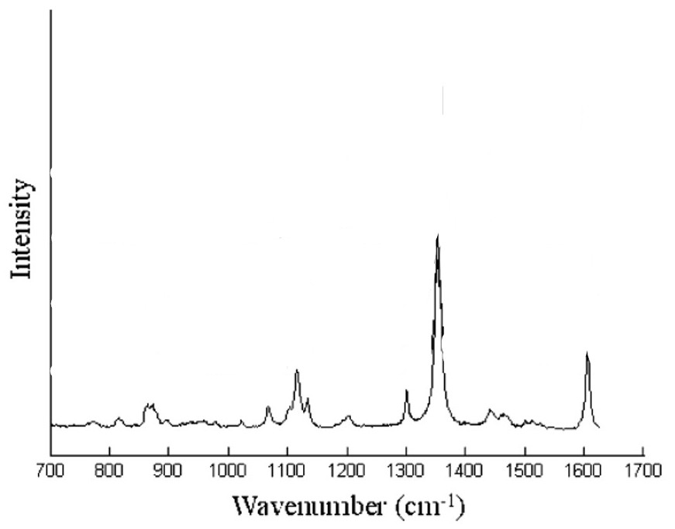
Figure 51:https://doi.org/10.1021/ac0520902
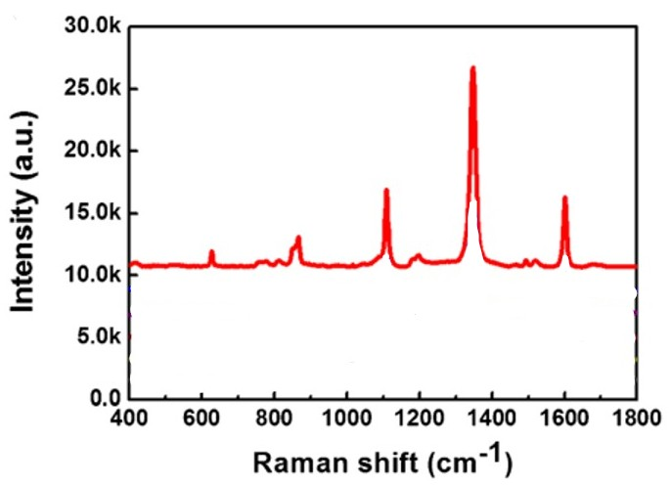
Figure 52:https://link.springer.com/article/10.1007/s00604-020-04567-2#:~:text=07%20October%202020-,DOI,https%3A//doi.org/10.1007/s00604%2D020%2D04567%2D2,-Share%20this%20article
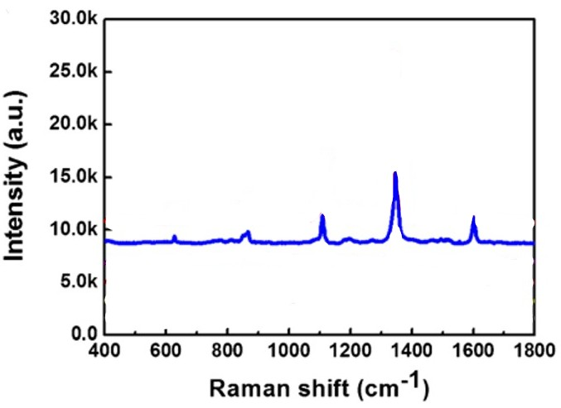
Figure 53:https://link.springer.com/article/10.1007/s00604-020-04567-2#:~:text=07%20October%202020-,DOI,https%3A//doi.org/10.1007/s00604%2D020%2D04567%2D2,-Share%20this%20article
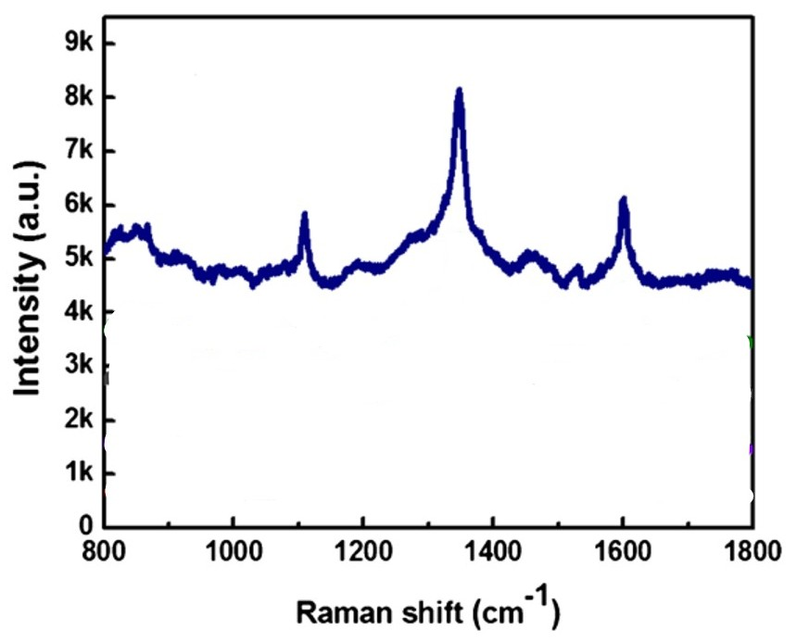
Figure 54:https://link.springer.com/article/10.1007/s00604-020-04567-2#:~:text=07%20October%202020-,DOI,https%3A//doi.org/10.1007/s00604%2D020%2D04567%2D2,-Share%20this%20article
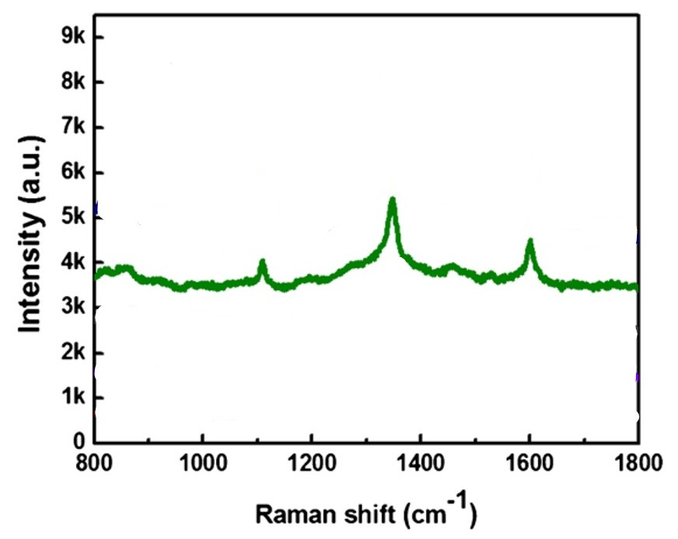
Figure 55:https://link.springer.com/article/10.1007/s00604-020-04567-2#:~:text=07%20October%202020-,DOI,https%3A//doi.org/10.1007/s00604%2D020%2D04567%2D2,-Share%20this%20article

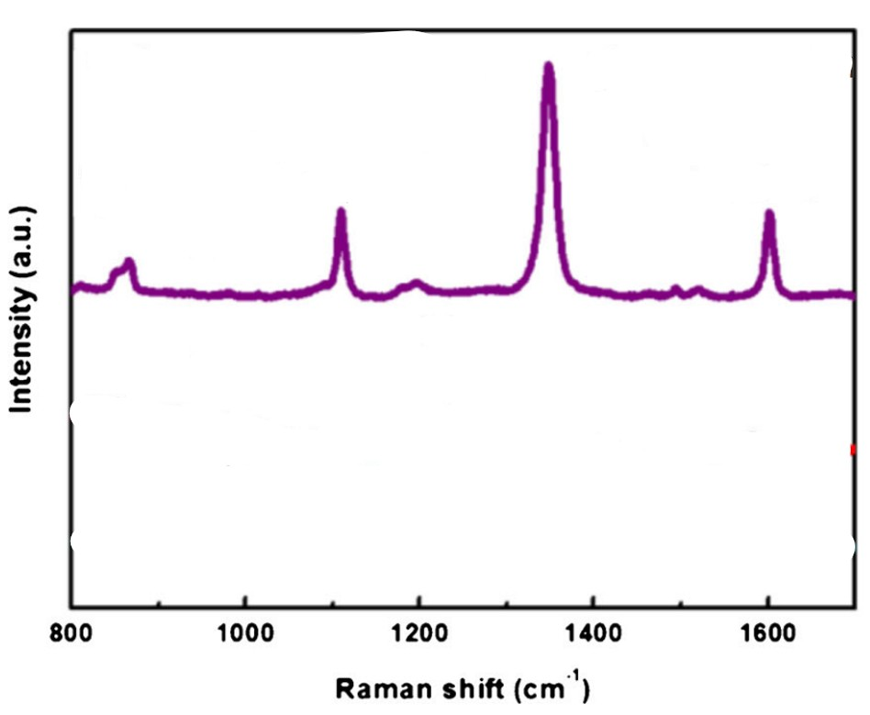
Figure 56:https://link.springer.com/article/10.1007/s00604-020-04567-2#:~:text=07%20October%202020-,DOI,https%3A//doi.org/10.1007/s00604%2D020%2D04567%2D2,-Share%20this%20article
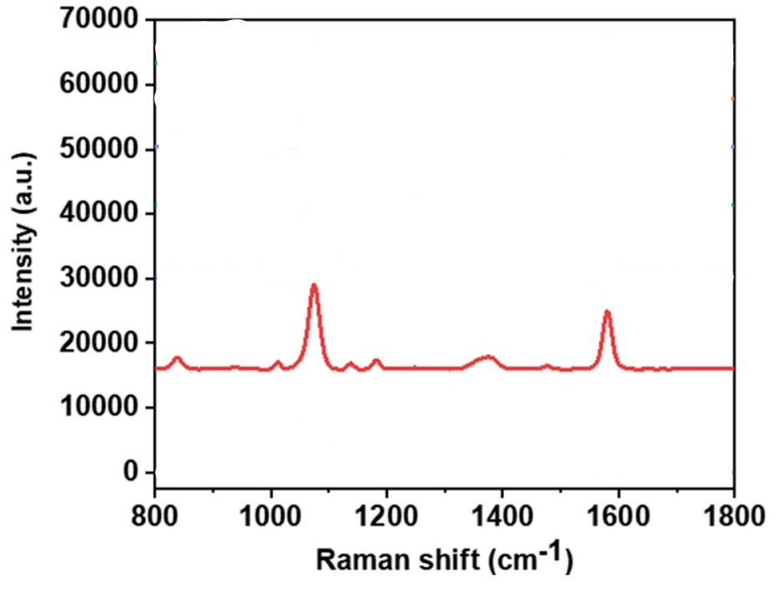
Figure 57: https://doi.org/10.1016/j.saa.2023.123211
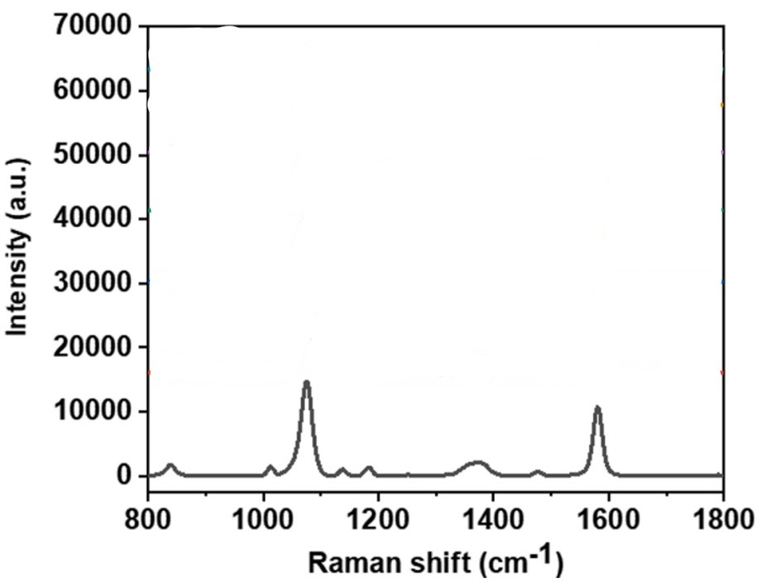
Figure 58:https://doi.org/10.1016/j.saa.2023.123211

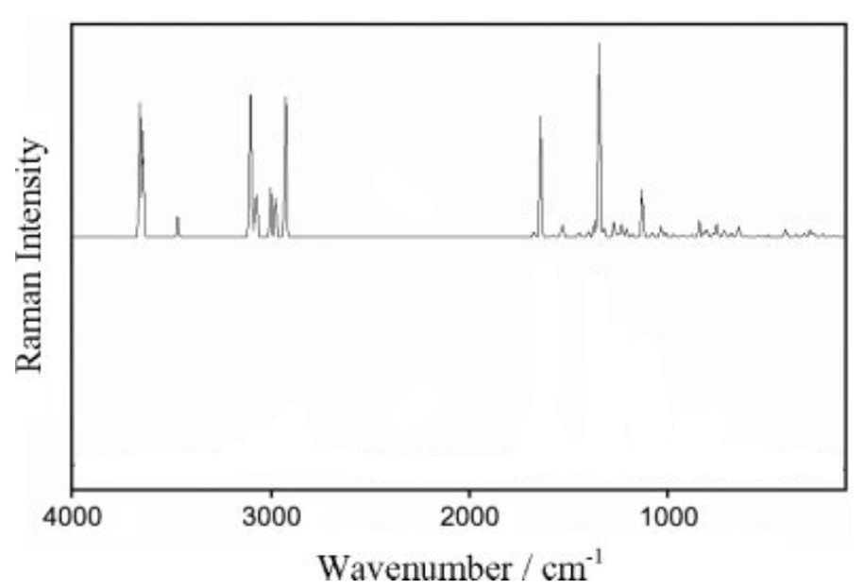
Figure 59: DOI 10.1002/jrs.2286
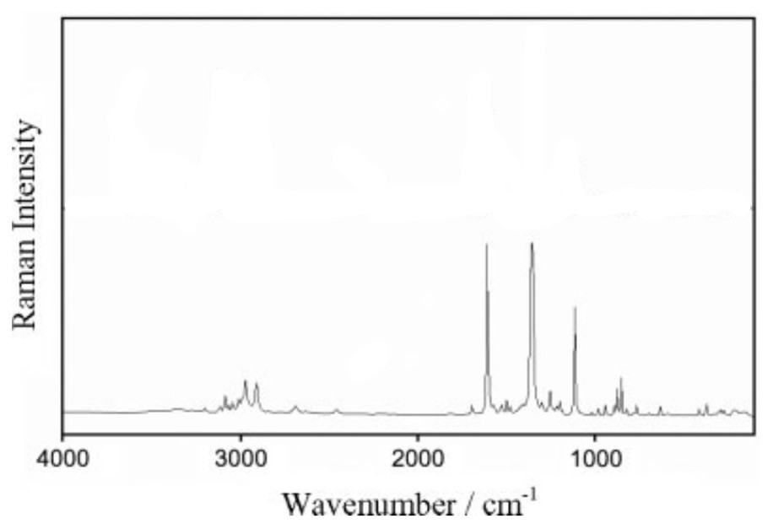
Figure 60:DOI 10.1002/jrs.2286

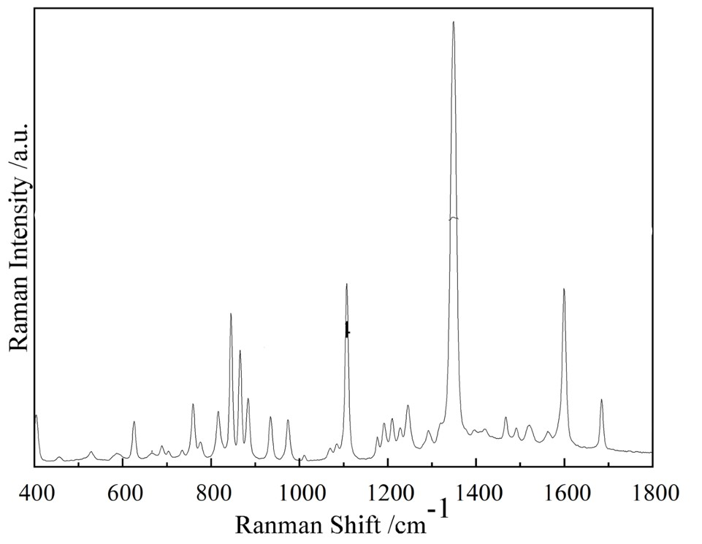
Figure 61:https://doi.org/10.3390/s25133920
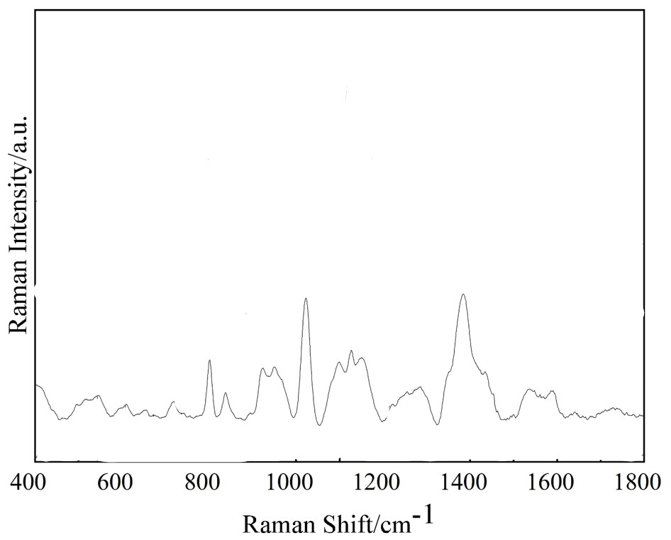
Figure 62:https://doi.org/10.3390/s25133920
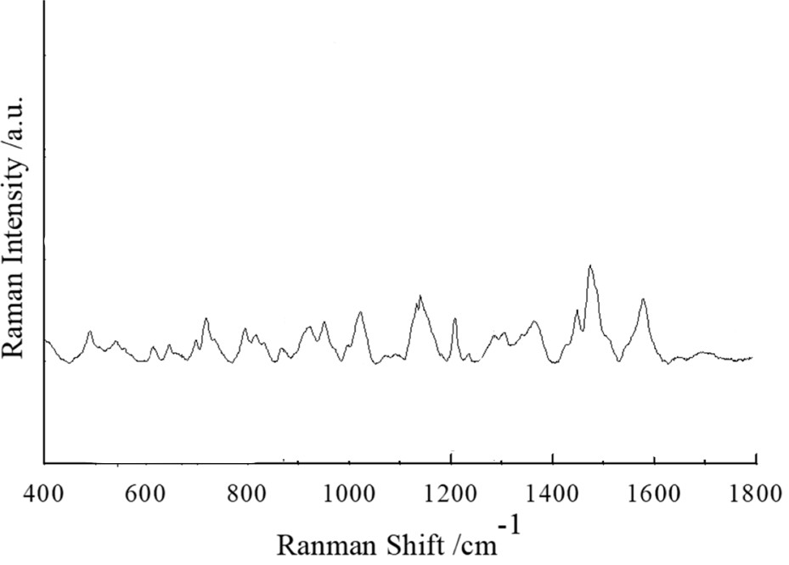
Figure 63:https://doi.org/10.3390/s25133920
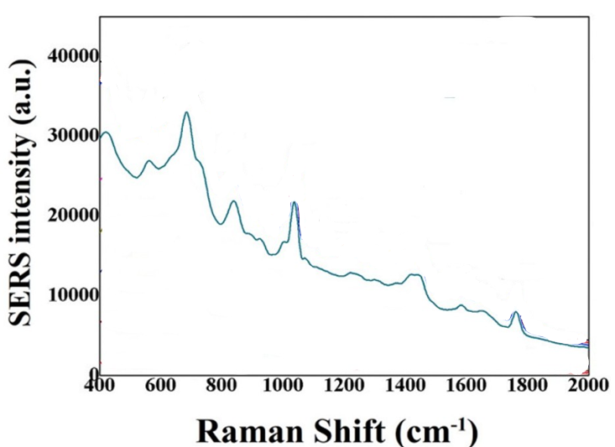
Figure 64:https://doi.org/10.1016/j.foodcont.2021.108186
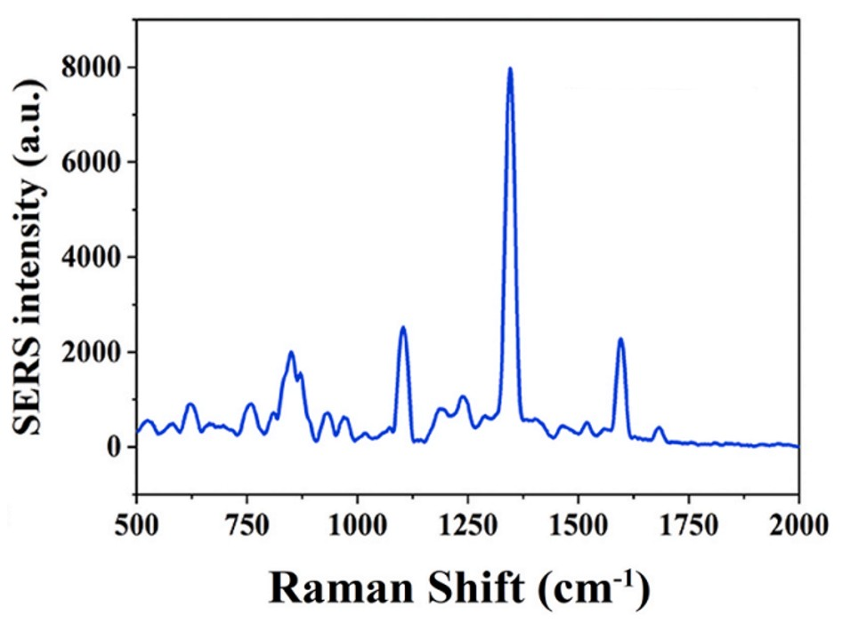
Figure 65:https://doi.org/10.1016/j.foodcont.2021.108186
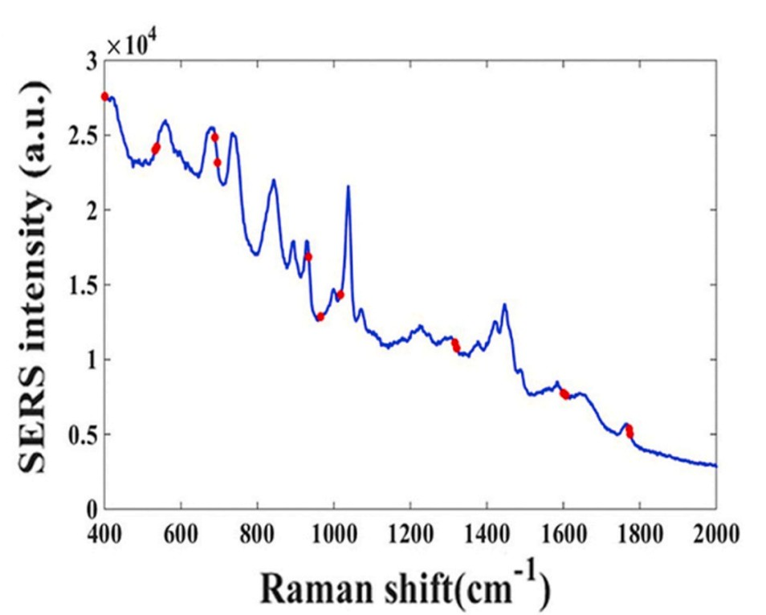
Figure 66:https://doi.org/10.1016/j.foodcont.2021.108186
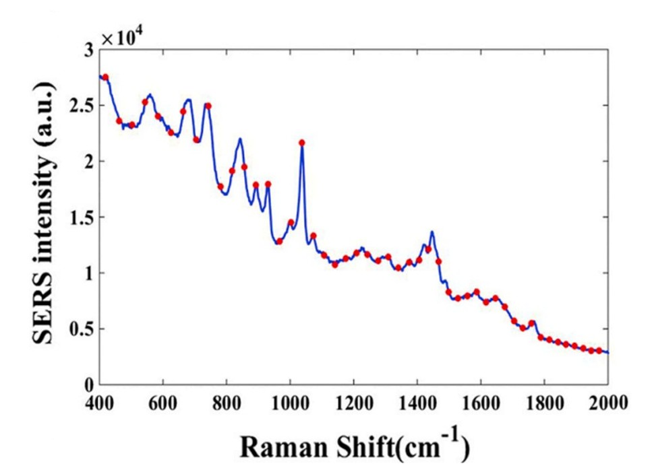
Figure 67:https://doi.org/10.1016/j.foodcont.2021.108186
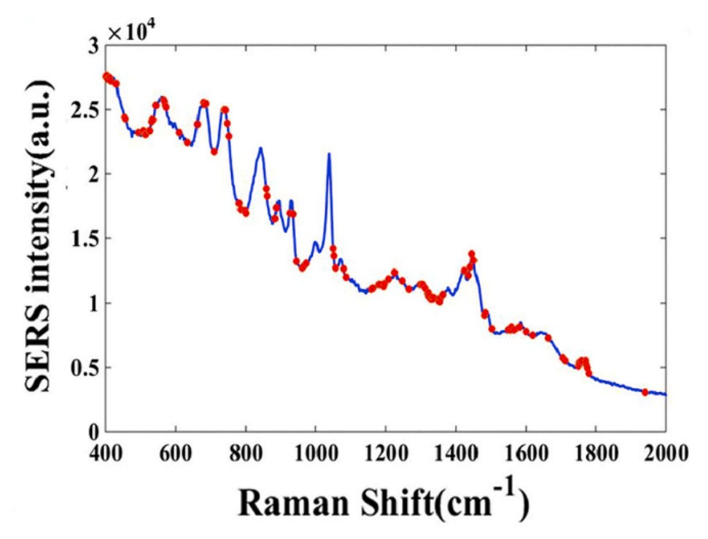
Figure 68:https://doi.org/10.1016/j.foodcont.2021.108186
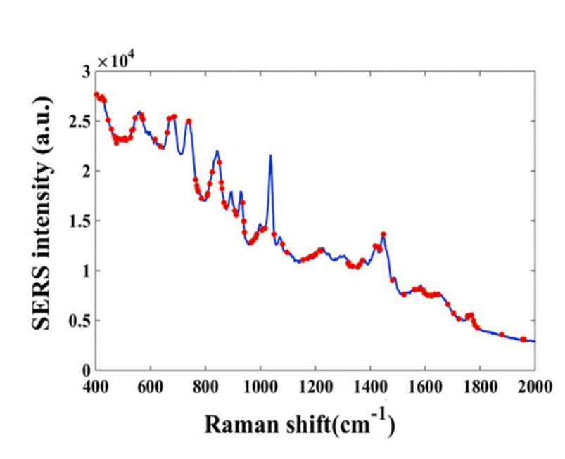
Figure 69:https://doi.org/10.1016/j.foodcont.2021.108186
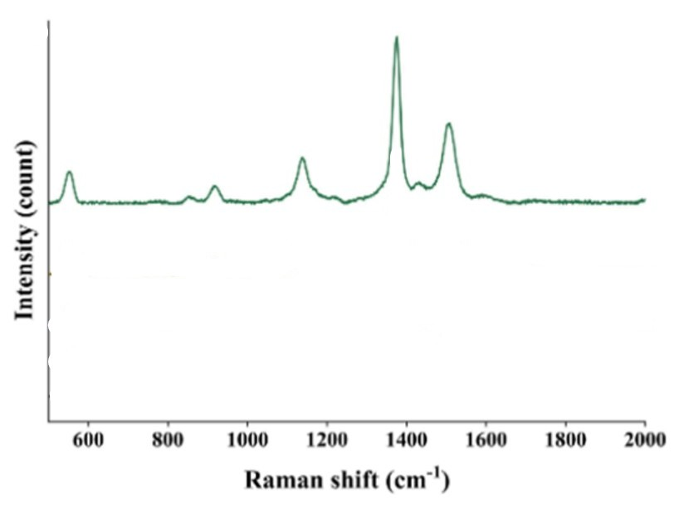
Figure 70:https://doi.org/10.1016/j.saa.2022.121817
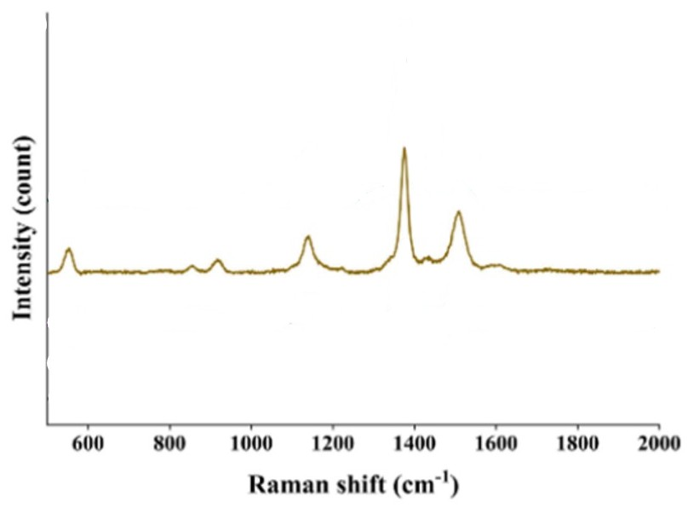
Figure 71:https://doi.org/10.1016/j.saa.2022.121817
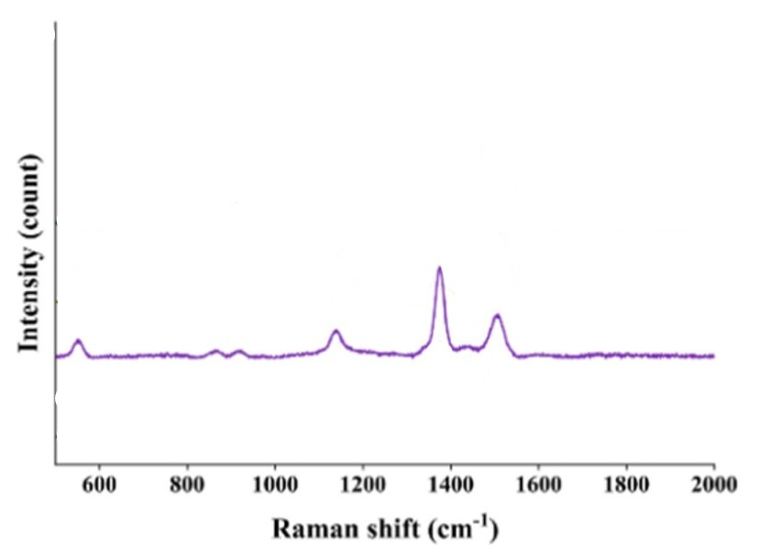
Figure 72:https://doi.org/10.1016/j.saa.2022.121817
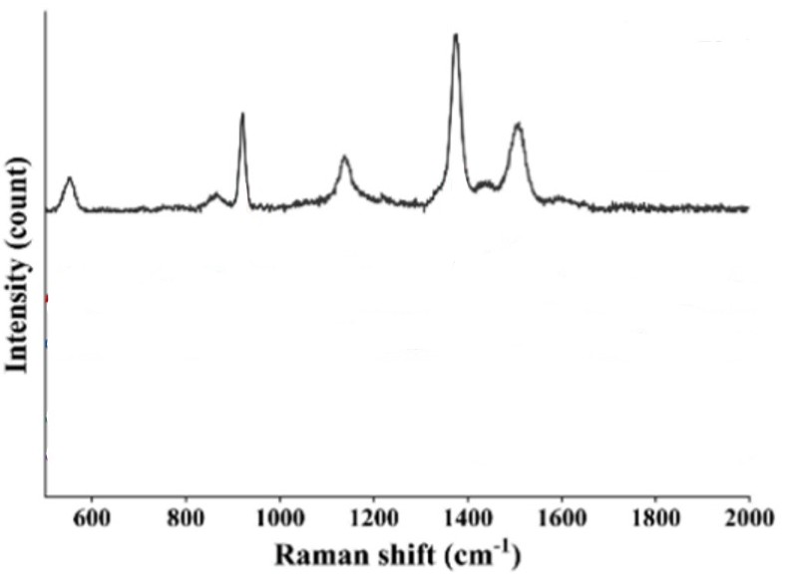
Figure 73:https://doi.org/10.1016/j.saa.2022.121817
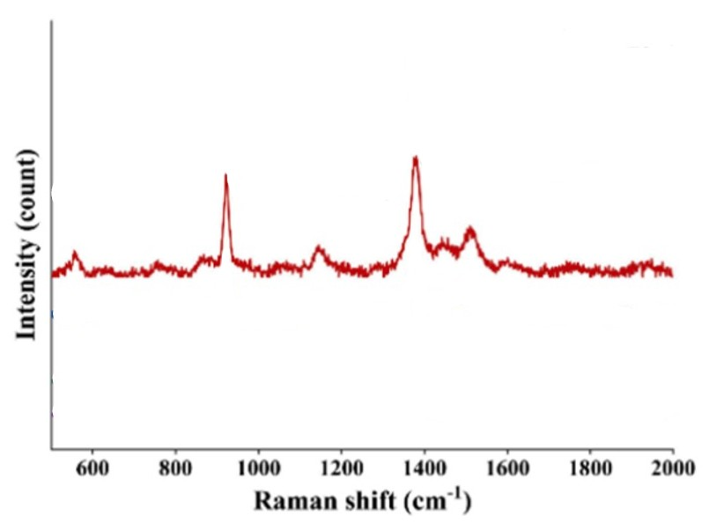
Figure 74:https://doi.org/10.1016/j.saa.2022.121817
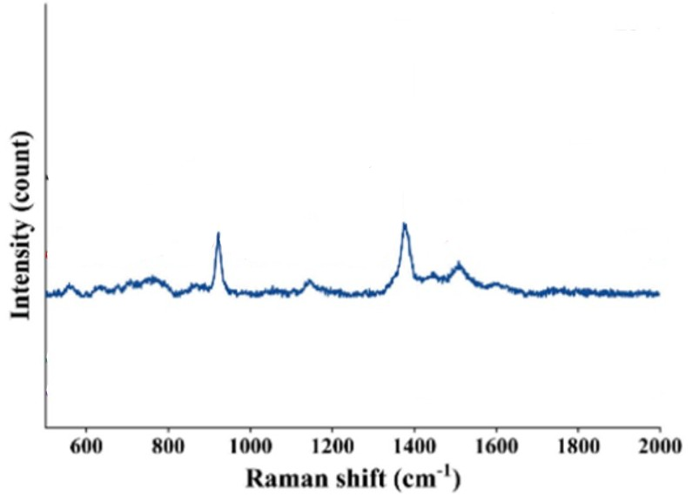
Figure 75:https://doi.org/10.1016/j.saa.2022.121817
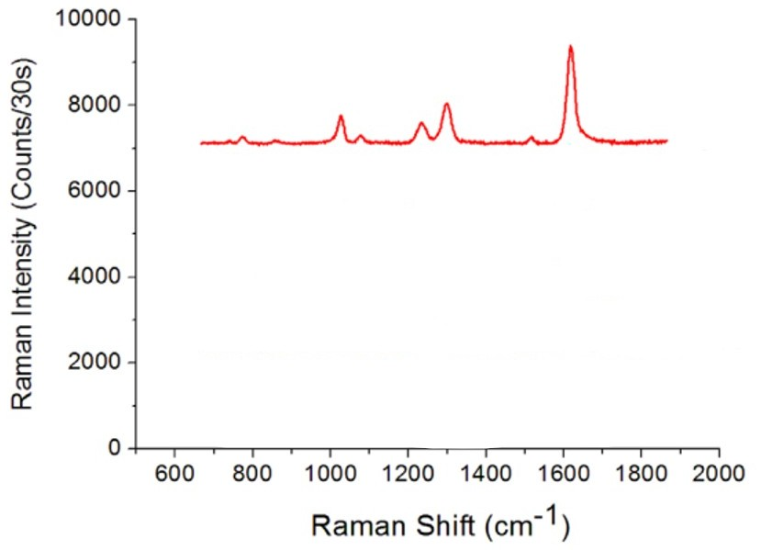
Figure 76:http://dx.doi.org/10.1016/j.bios.2016.01.064
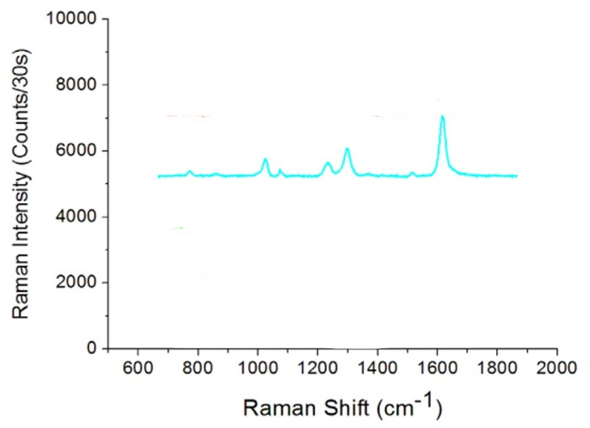
Figure 77:http://dx.doi.org/10.1016/j.bios.2016.01.064

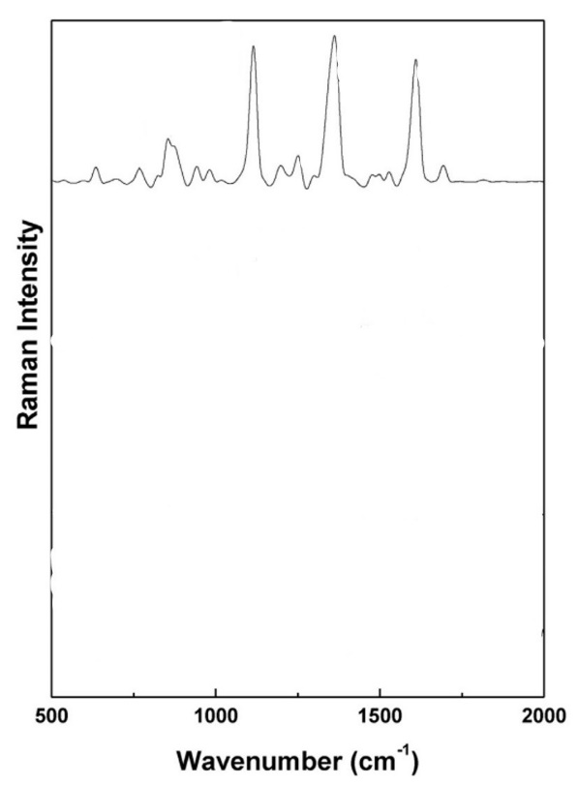
Figure 78:https://doi.org/10.1016/j.jinorgbio.2016.01.008
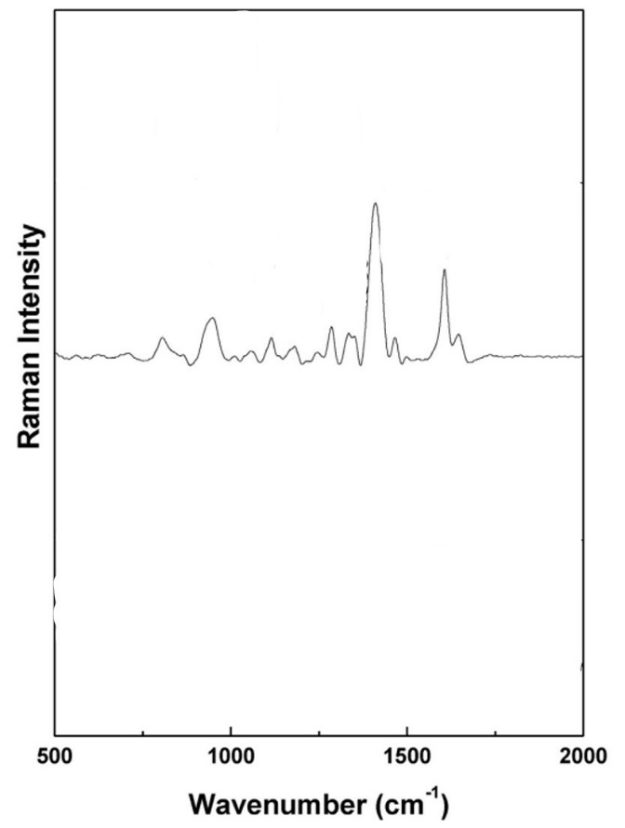
Figure 79:https://doi.org/10.1016/j.jinorgbio.2016.01.008
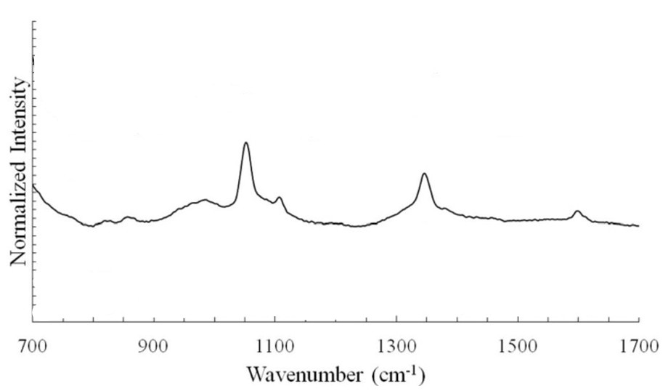
Figure 80:https://doi.org/10.1111/1750-3841.12705
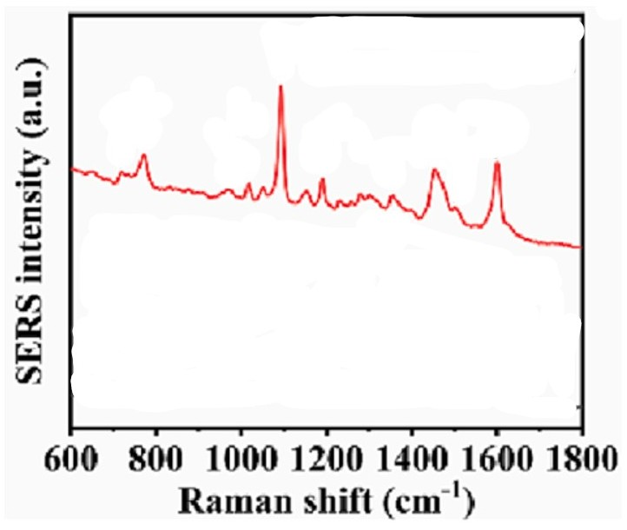
Figure 81:https://doi.org/10.1016/j.foodchem.2023.135998
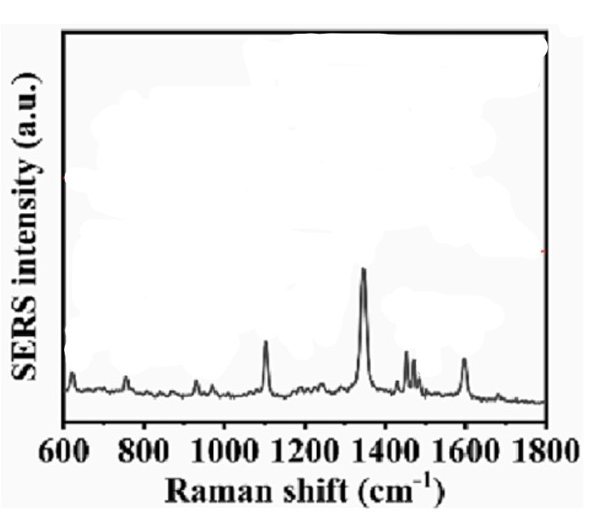
Figure 82:https://doi.org/10.1016/j.foodchem.2023.135998
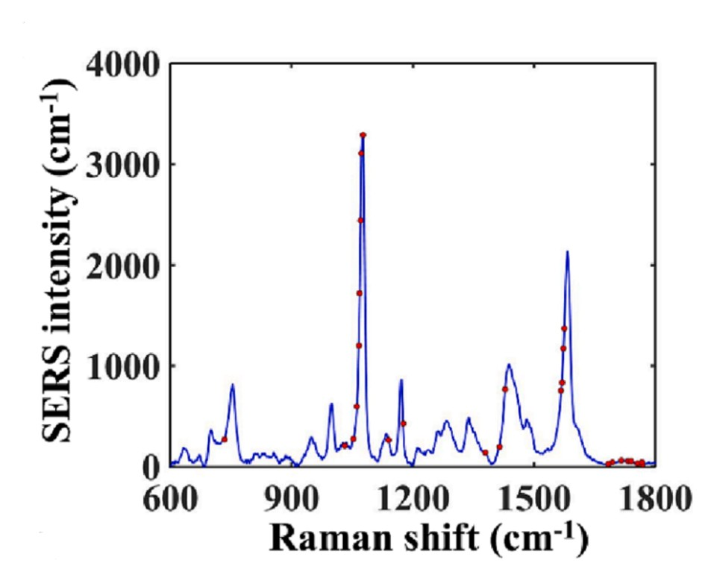
Figure 83:https://doi.org/10.1016/j.foodchem.2023.135998
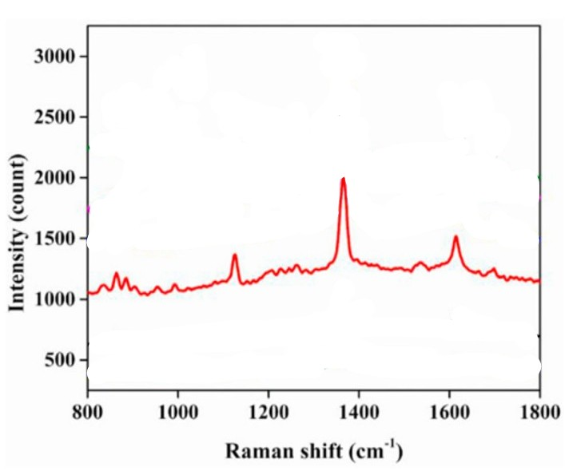
Figure 84:https://doi.org/10.1016/j.chemosphere.2021.130115
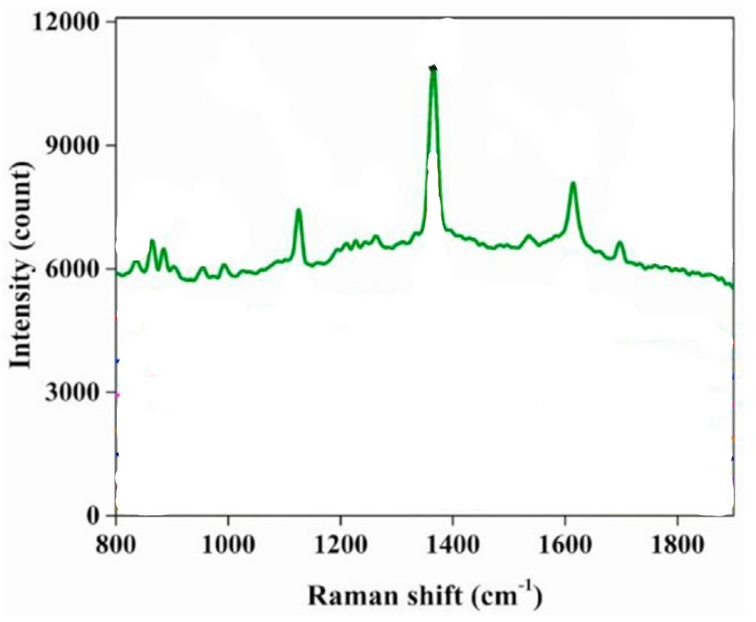
Figure 85:https://doi.org/10.1016/j.chemosphere.2021.130115
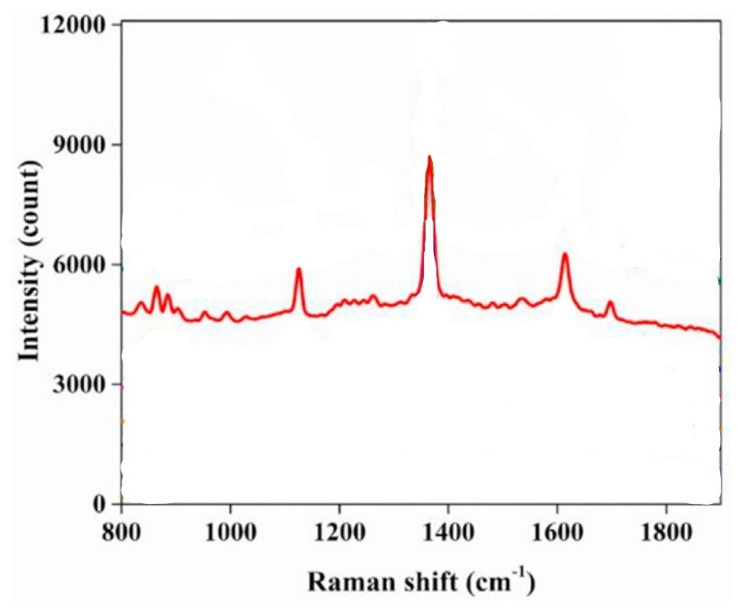
Figure 86:https://doi.org/10.1016/j.chemosphere.2021.130115
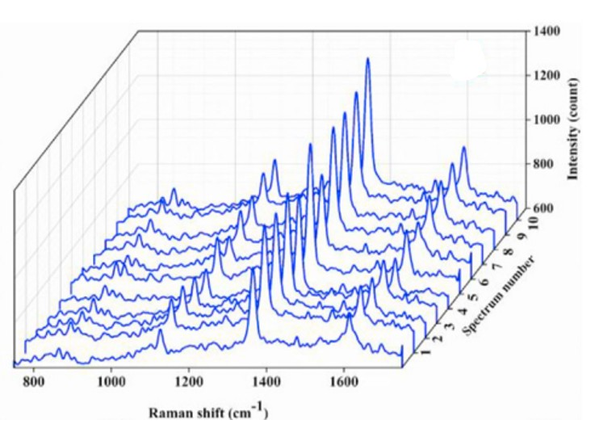
Figure 87:https://doi.org/10.1016/j.chemosphere.2021.130115
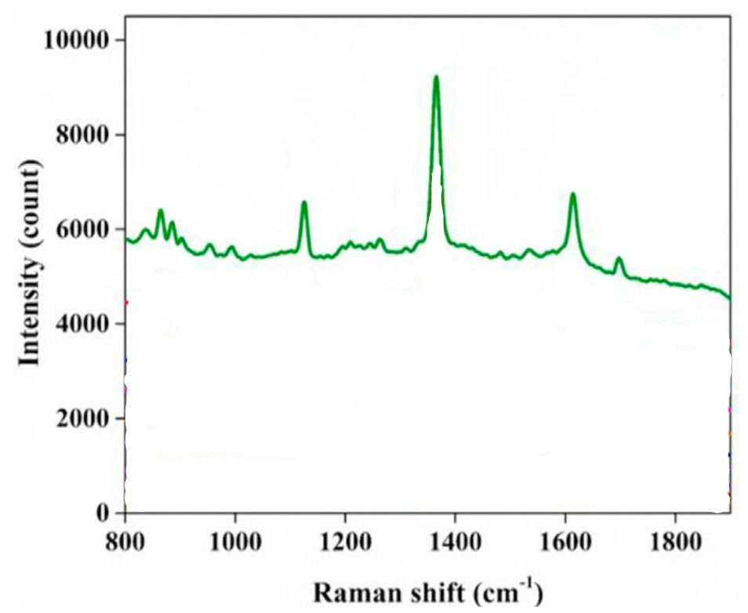
Figure 88:https://doi.org/10.1016/j.chemosphere.2021.130115
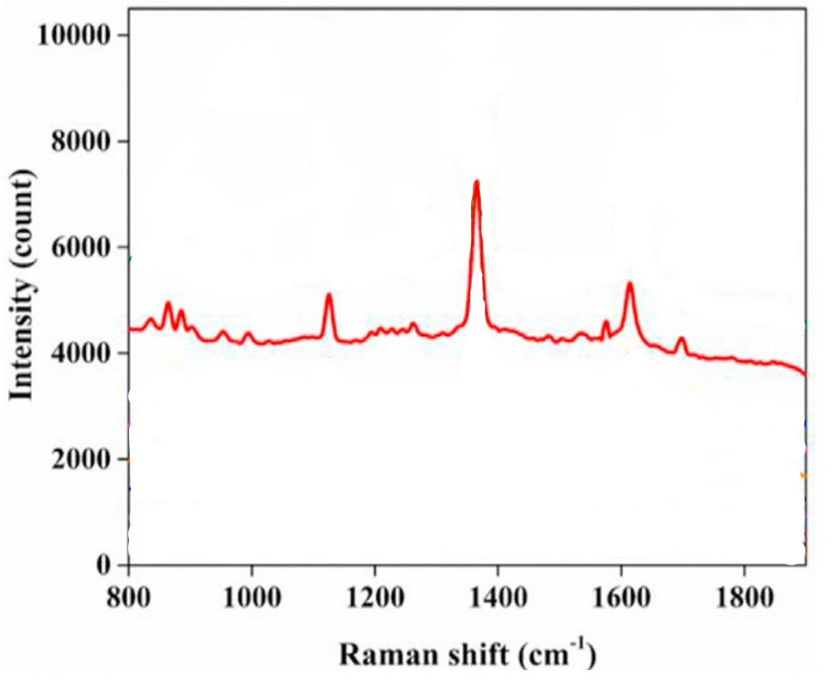
Figure 89:https://doi.org/10.1016/j.chemosphere.2021.130115
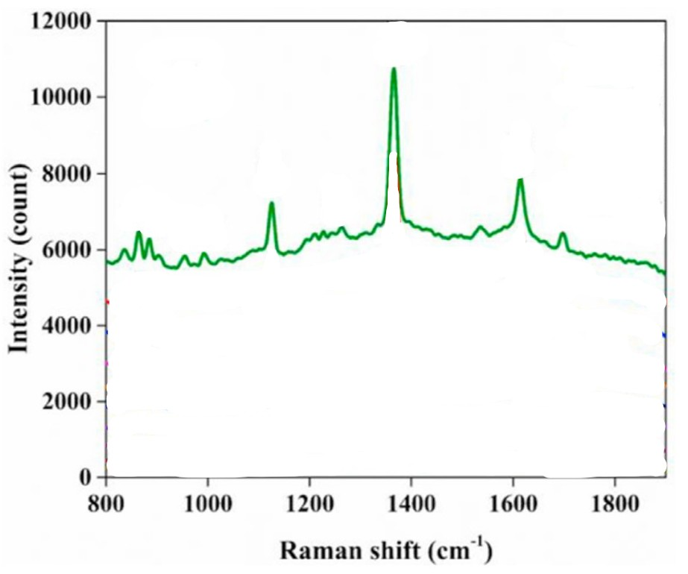
Figure 90:https://doi.org/10.1016/j.chemosphere.2021.130115
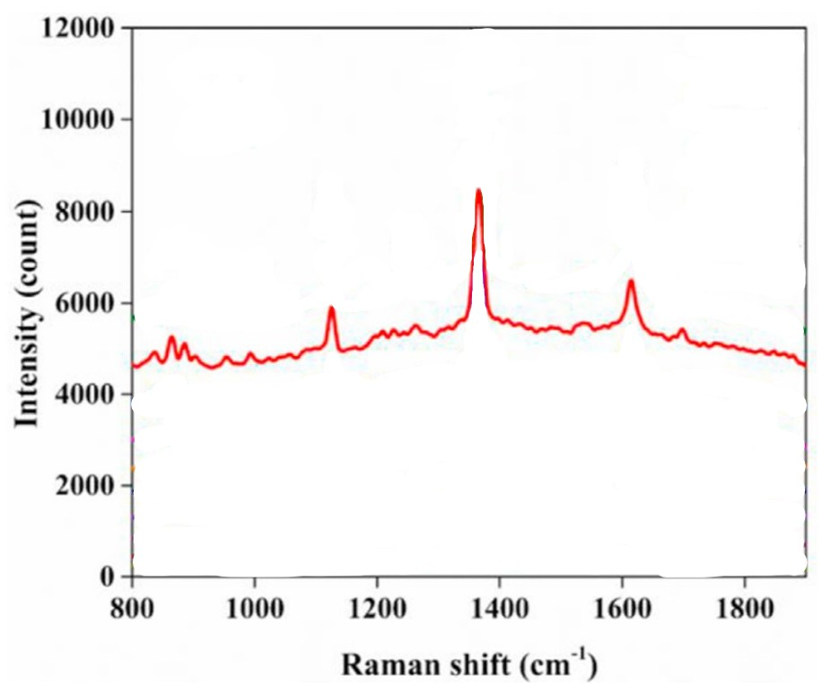
Figure 91:https://doi.org/10.1016/j.chemosphere.2021.130115
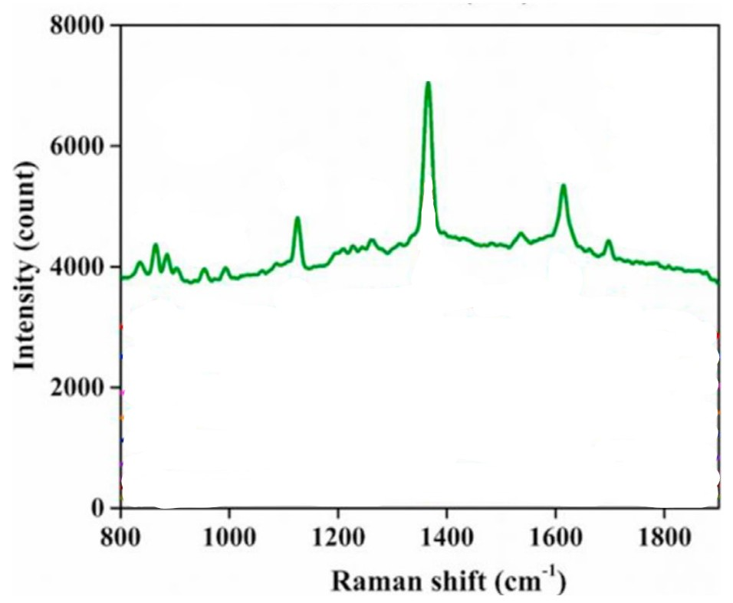
Figure 92:https://doi.org/10.1016/j.chemosphere.2021.130115
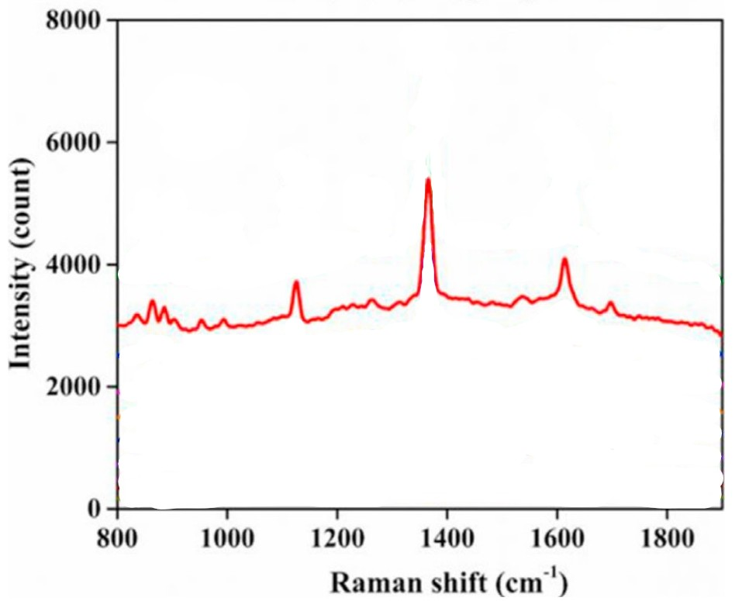
Figure 93:https://doi.org/10.1016/j.chemosphere.2021.130115
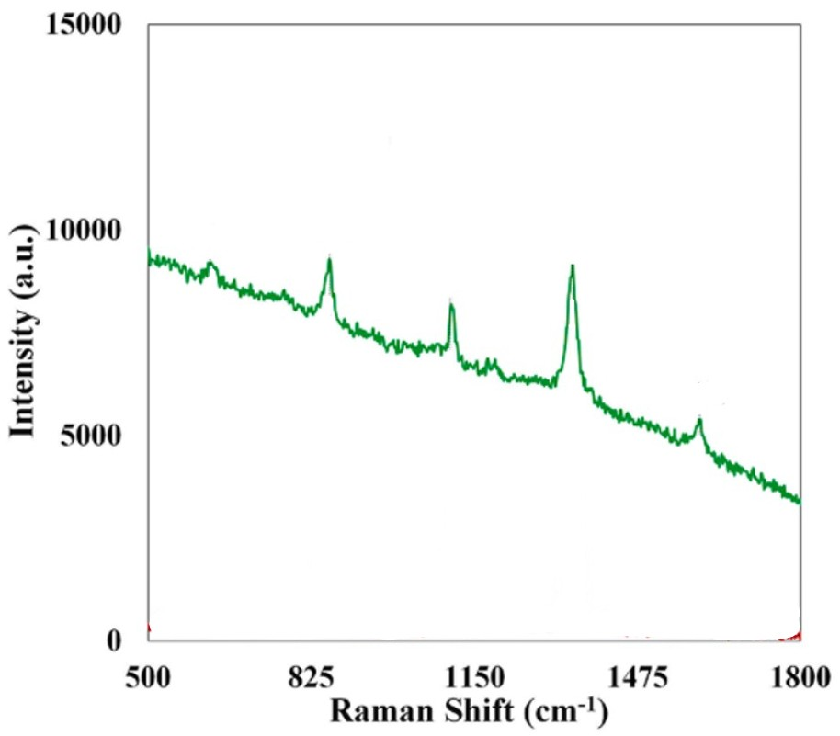
Figure 94:https://doi.org/10.1016/j.foodchem.2021.131765
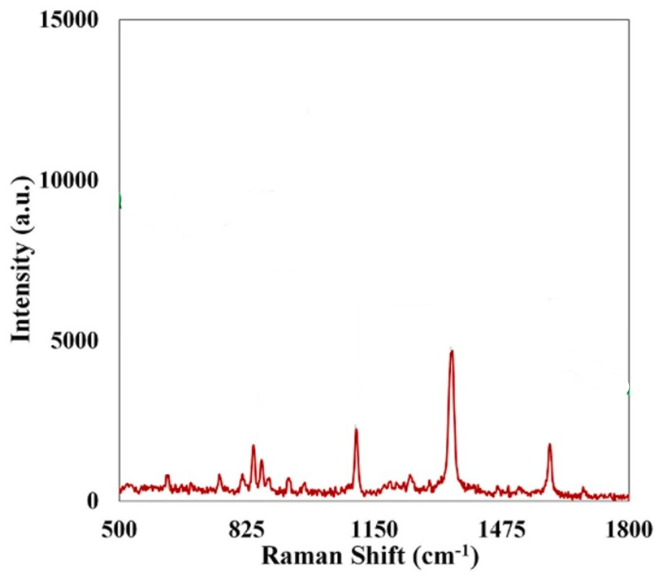
Figure 95:https://doi.org/10.1016/j.foodchem.2021.131765
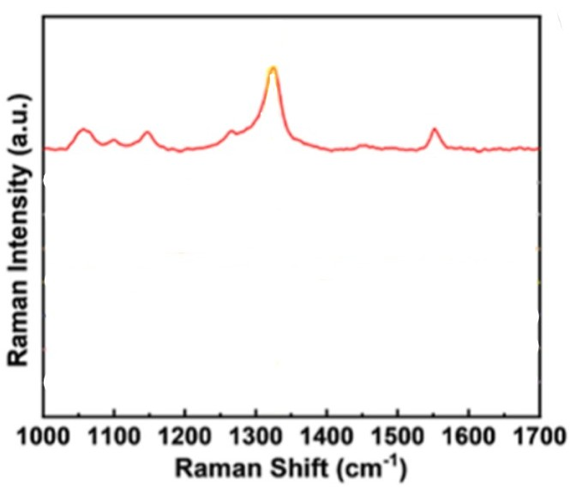
Figure 96:https://pubs.acs.org/doi/10.1021/acsanm.4c03280?goto=supporting-info
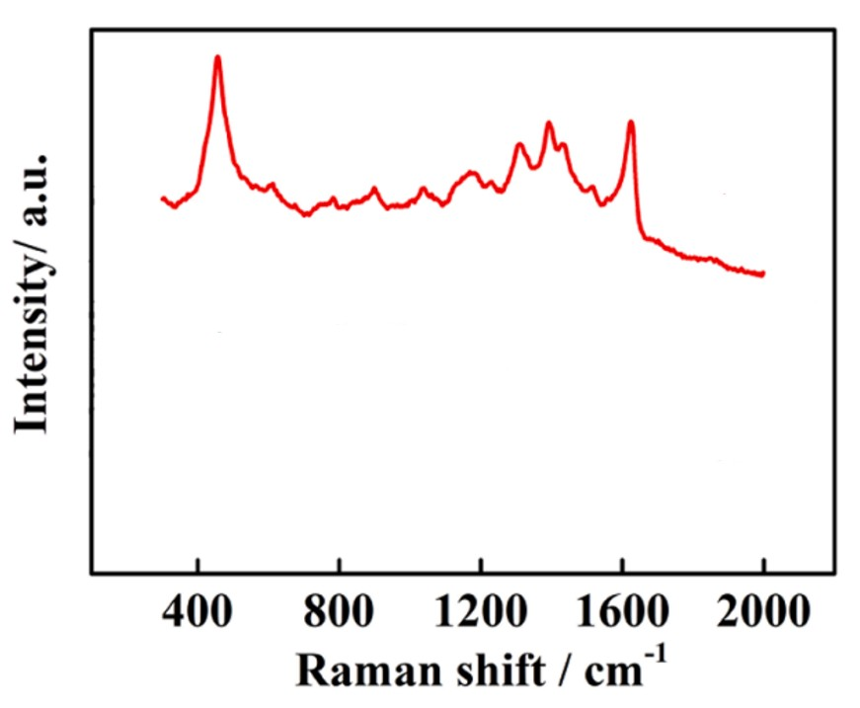
Figure 97:https://doi.org/10.1016/j.snb.2023.134962
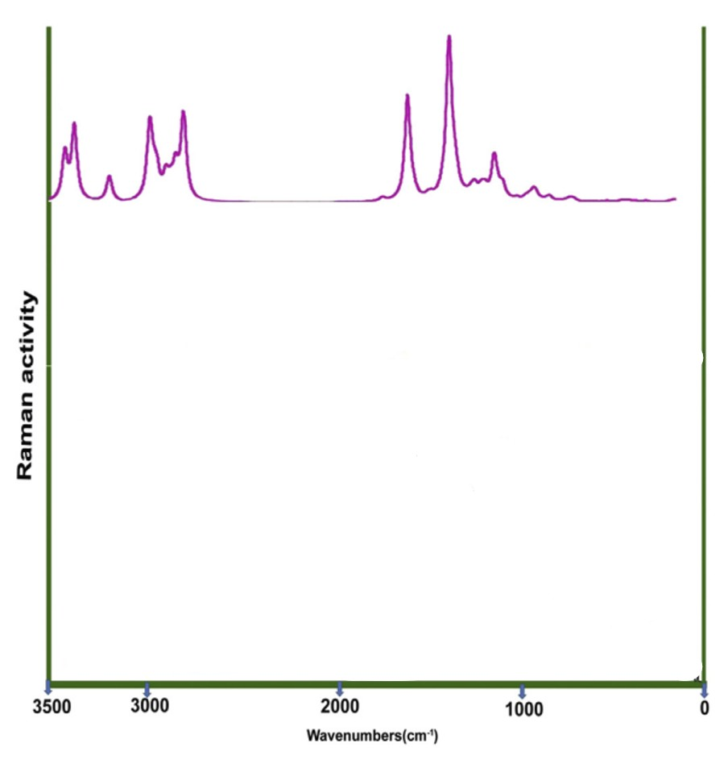
Figure 98:https://www.cell.com/action/showPdf?pii=S2405-8440%2820%2930278-4
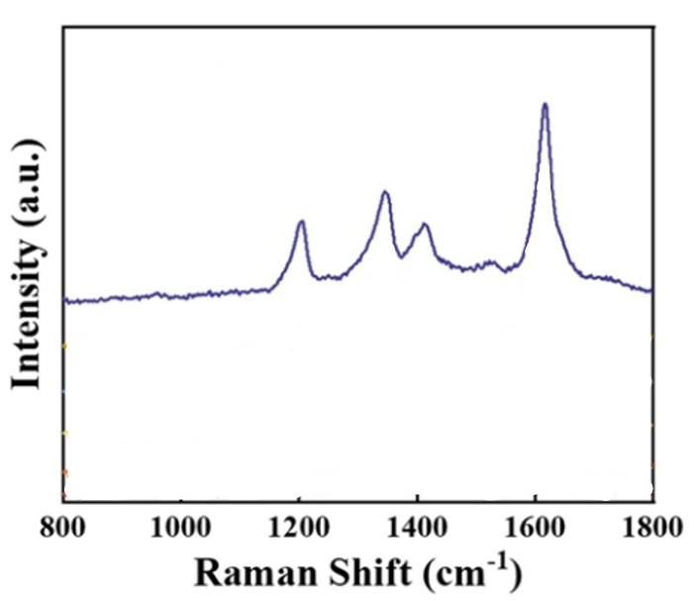
Figure 99:https://doi.org/10.1007/s00604-024-06872-6
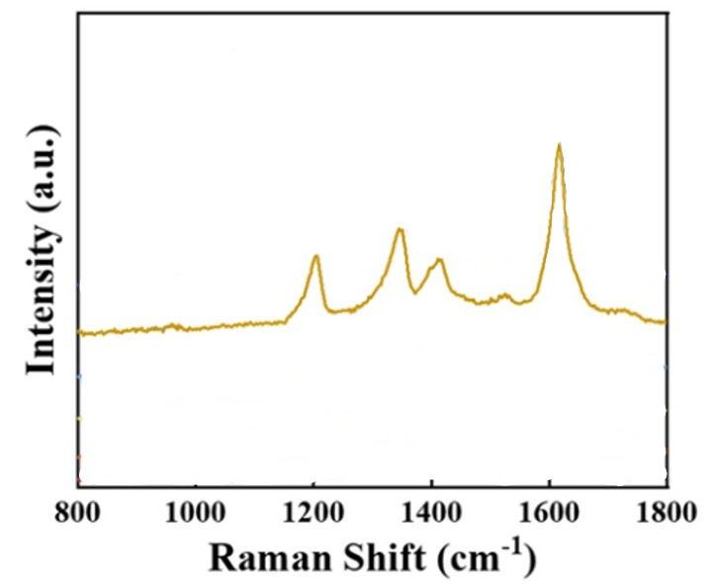
Figure 100;https://doi.org/10.1007/s00604-024-06872-6
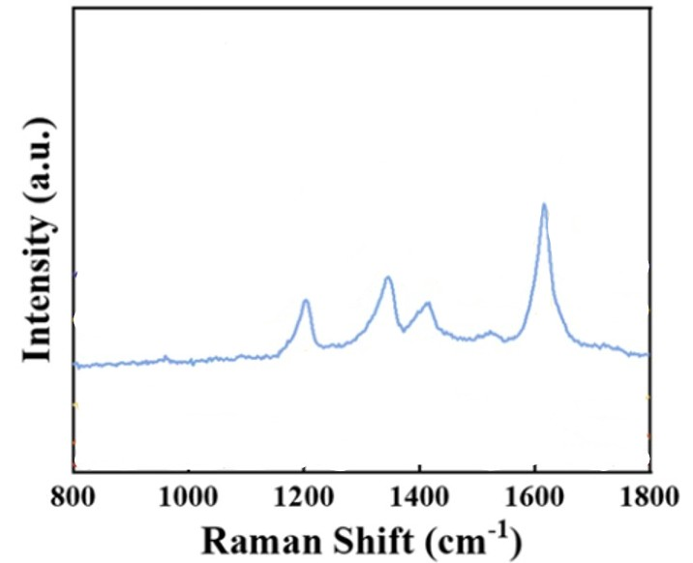
Figure 101:https://doi.org/10.1007/s00604-024-06872-6
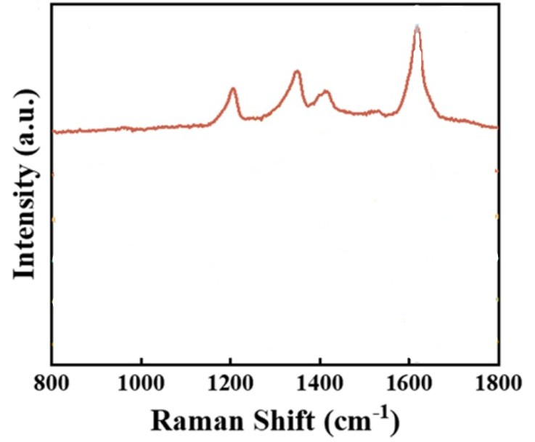
Figure 102:https://doi.org/10.1007/s00604-024-06872-6
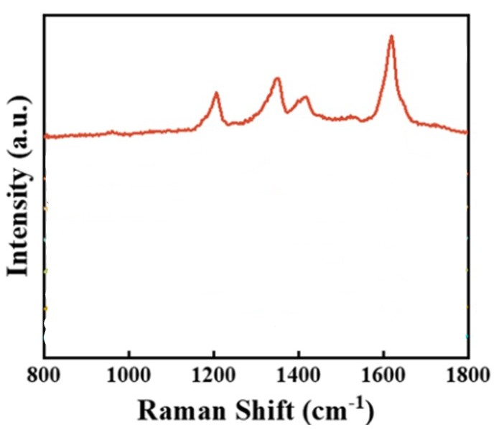
Figure 103:https://doi.org/10.1007/s00604-024-06872-6
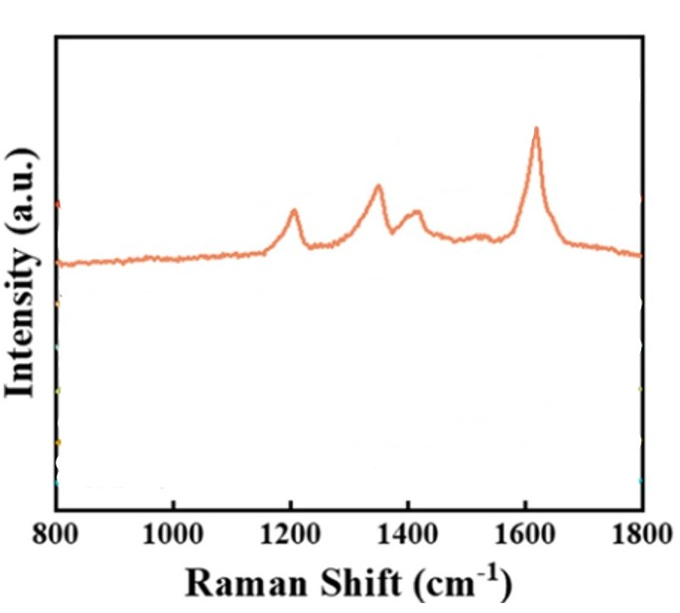
Figure 104:https://doi.org/10.1007/s00604-024-06872-6
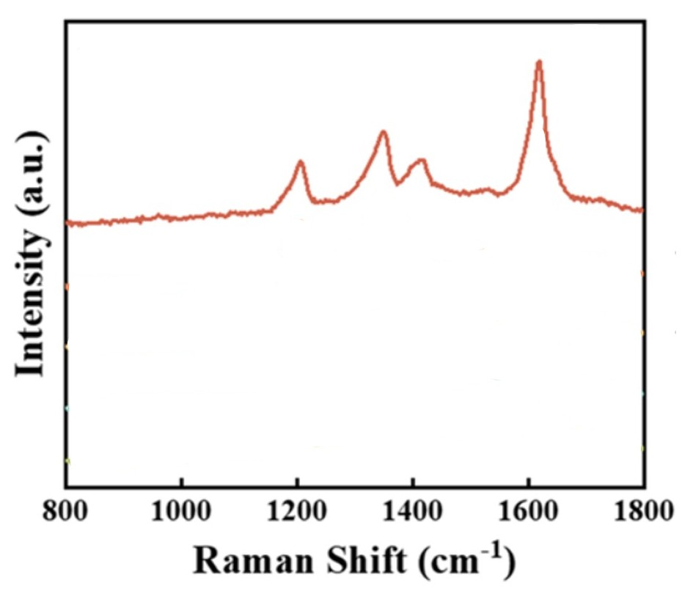
Figure 105:https://doi.org/10.1007/s00604-024-06872-6
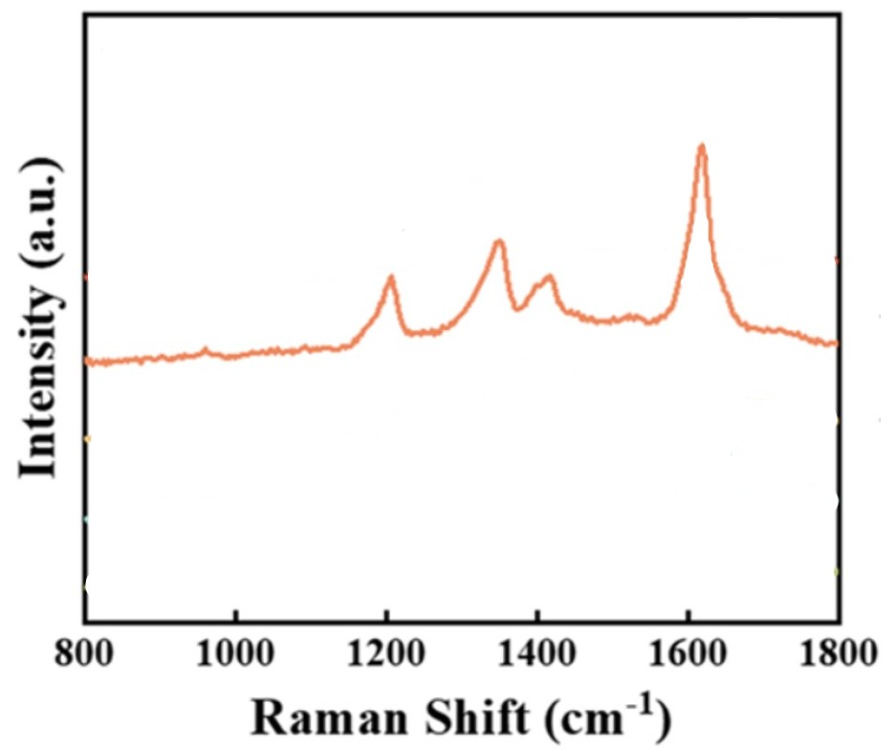
Figure 106:https://doi.org/10.1007/s00604-024-06872-6
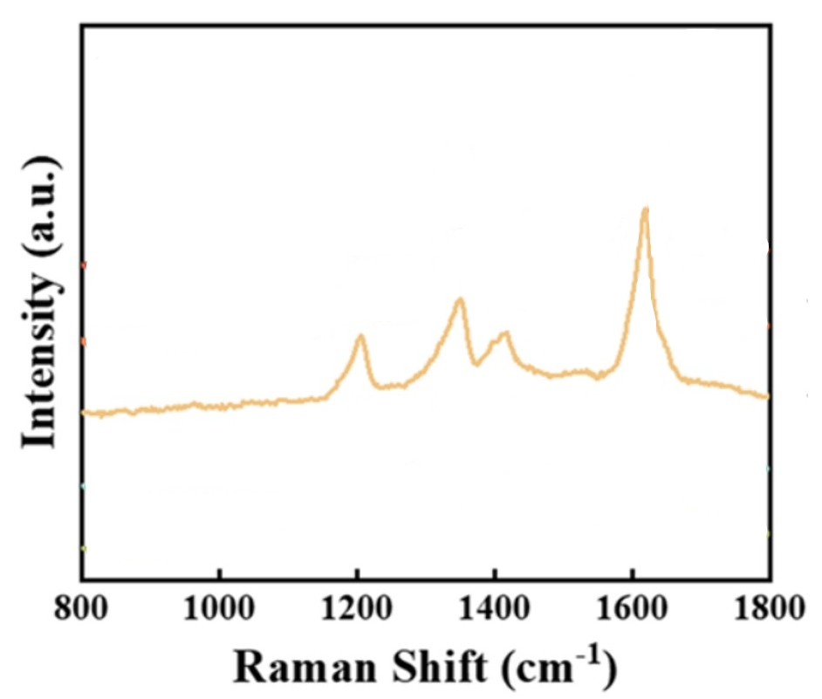
Figure 107: https://doi.org/10.1007/s00604-024-06872-6
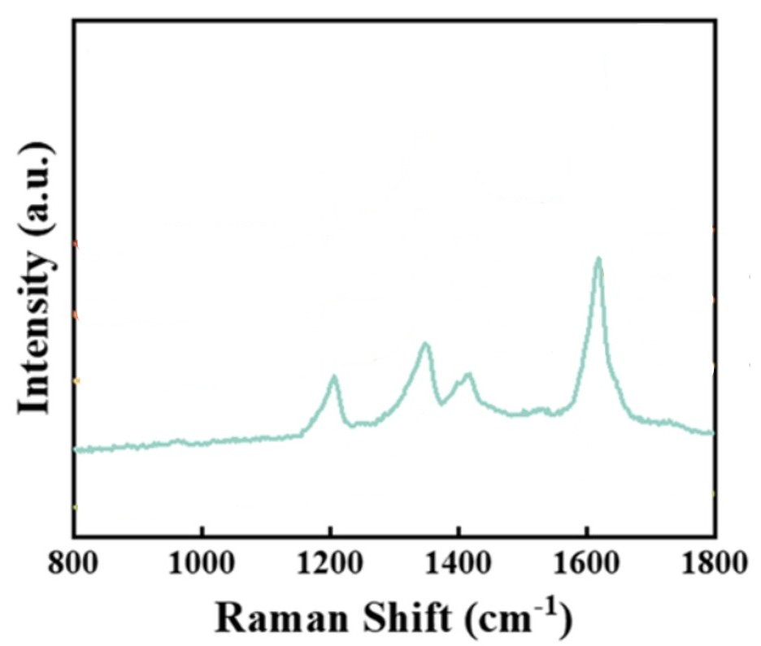
Figure 108:https://doi.org/10.1007/s00604-024-06872-6
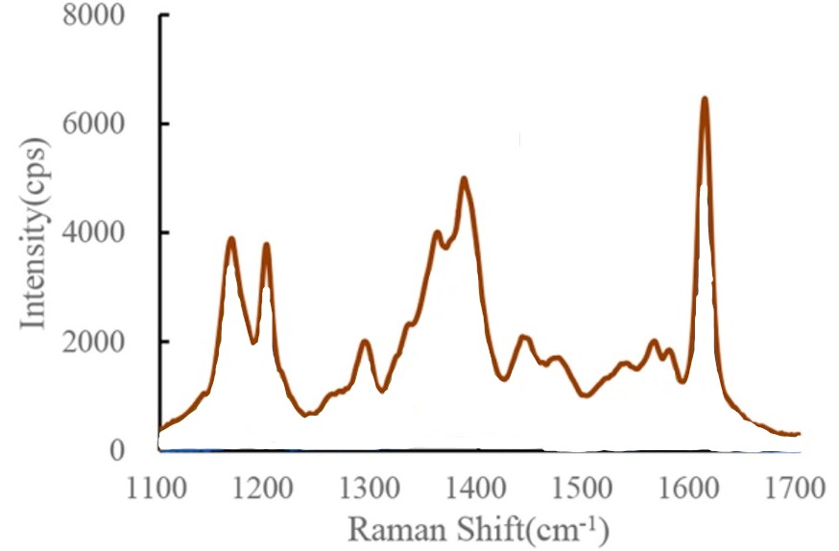
Figure 109:https://doi.org/10.1016/j.saa.2024.124732
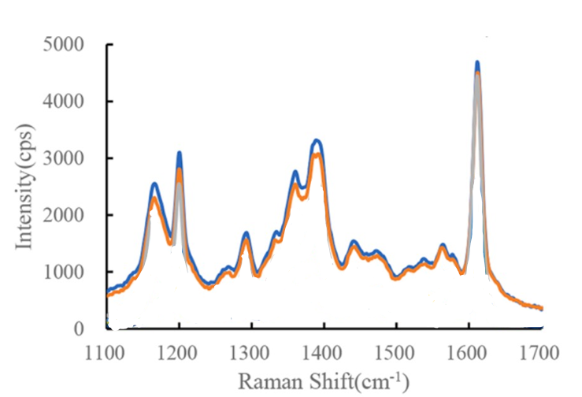
Figure 110:https://doi.org/10.1016/j.saa.2024.124732
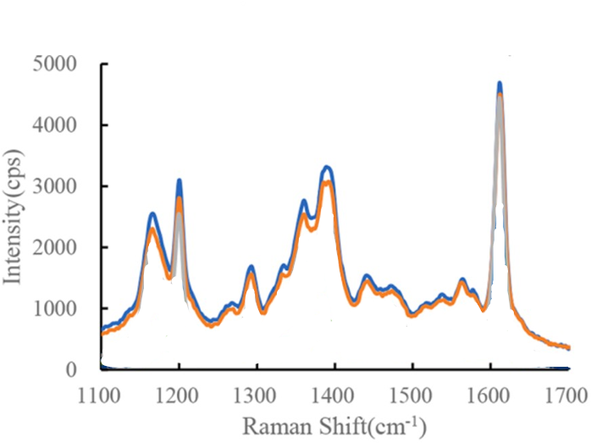
Figure 111:https://doi.org/10.1016/j.saa.2024.124732

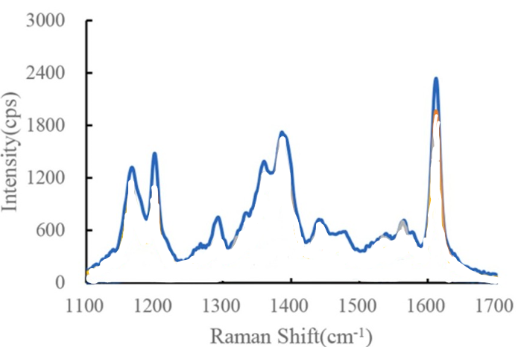
Figure 112:https://doi.org/10.1016/j.saa.2024.124732
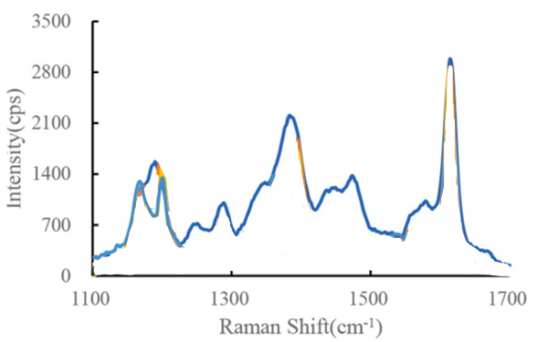
Figure 113:https://doi.org/10.1016/j.saa.2024.124732
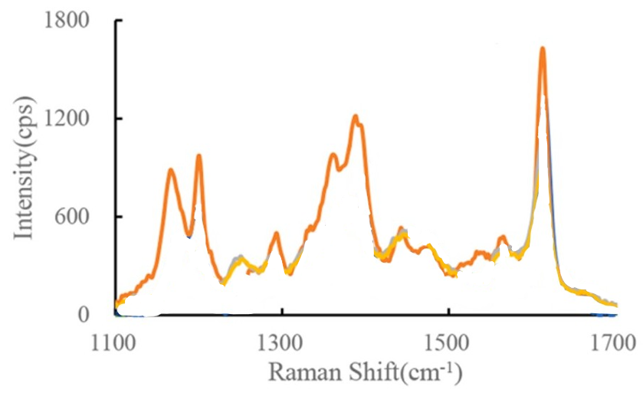
Figure 114:https://doi.org/10.1016/j.saa.2024.124732

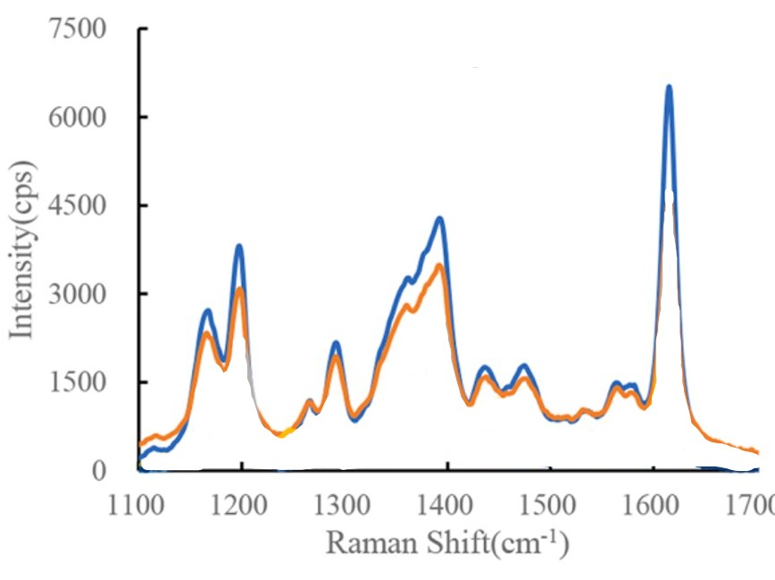
Figure 115:https://doi.org/10.1016/j.saa.2024.124732
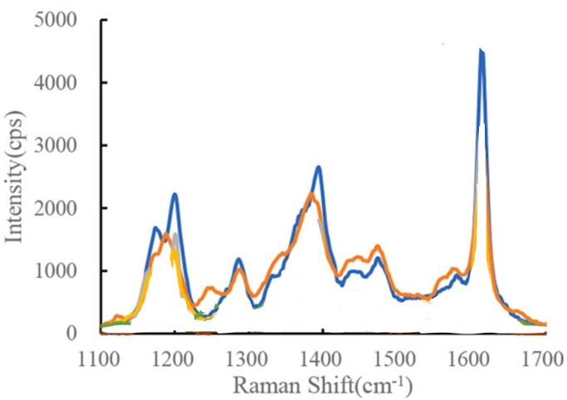
Figure 116:https://doi.org/10.1016/j.saa.2024.124732

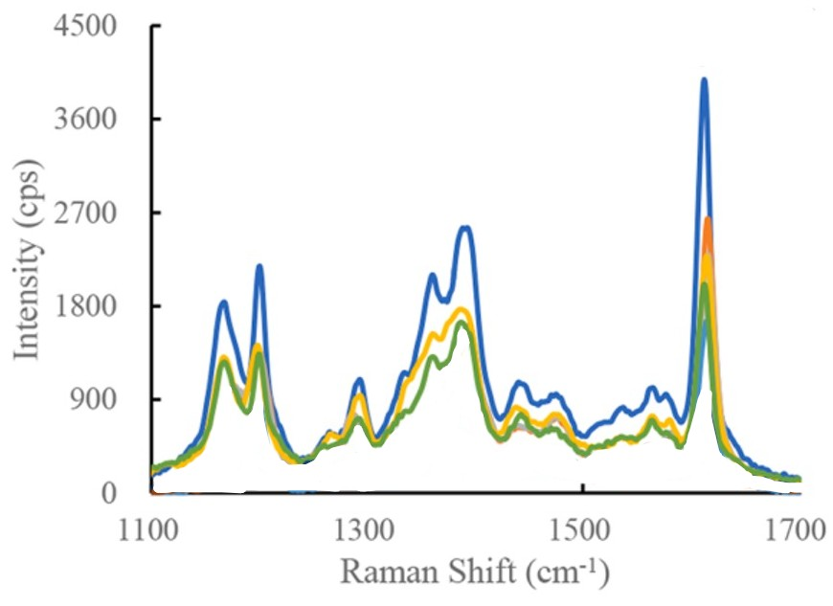
Figure 117:https://doi.org/10.1016/j.saa.2024.124732

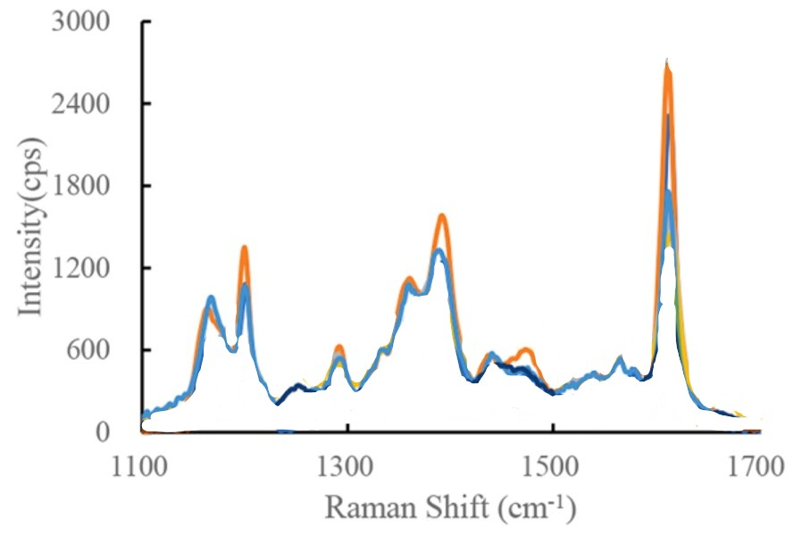
Figure 118:https://doi.org/10.1016/j.saa.2024.124732

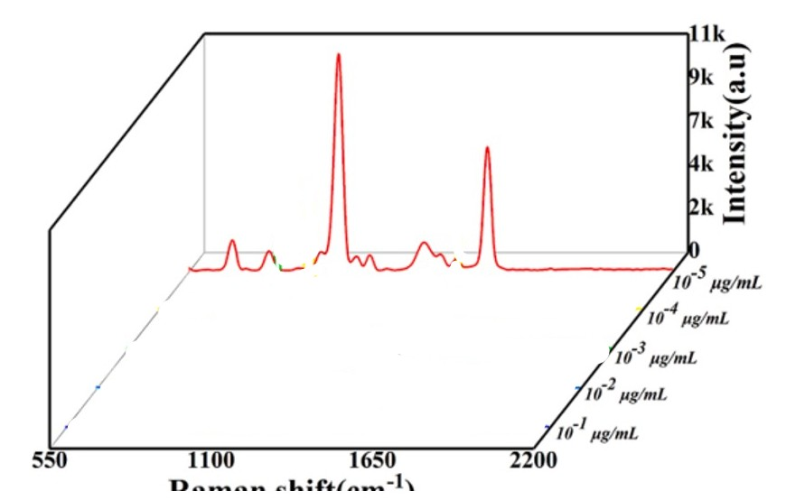
Figure 119:Raman spectra of 4-MBA, Ag@Au CSNPs, and Ag@Au4-MBA CSNPs (E
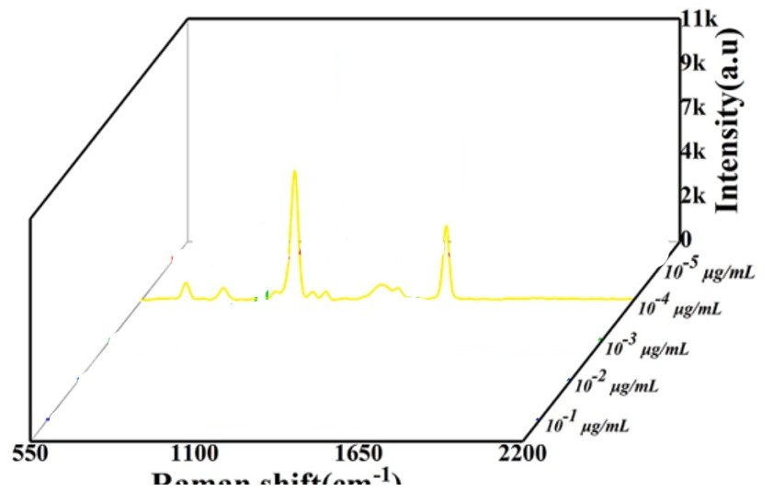
Figure 120:Raman spectra of 4-MBA, Ag@Au CSNPs, and Ag@Au4-MBA CSNPs (E
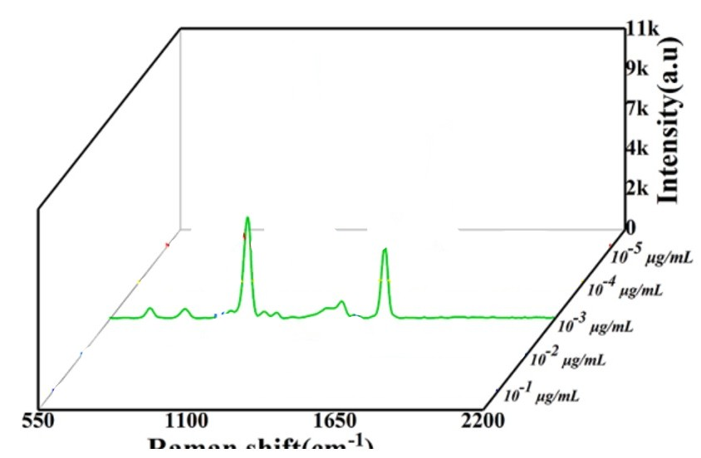
Figure 121:Raman spectra of 4-MBA, Ag@Au CSNPs, and Ag@Au4-MBA CSNPs (E

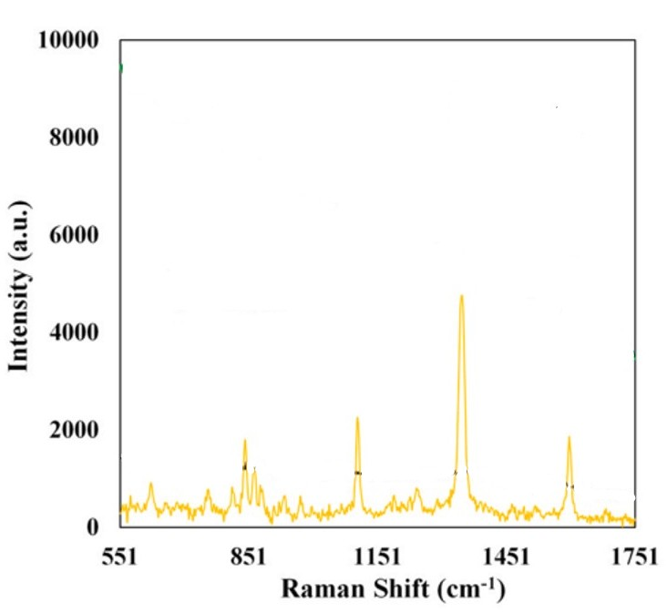
Figure 122:https://doi.org/10.1016/j.jfca.2024.106106
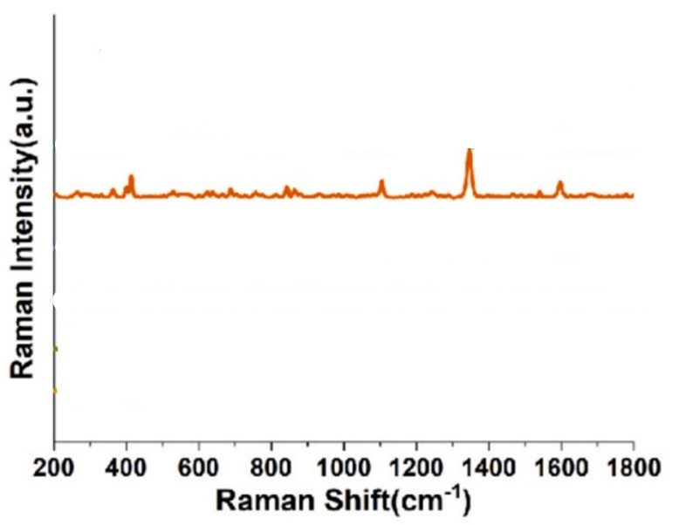
Figure 123: https://doi.org/10.1016/j.foodchem.2025.144618
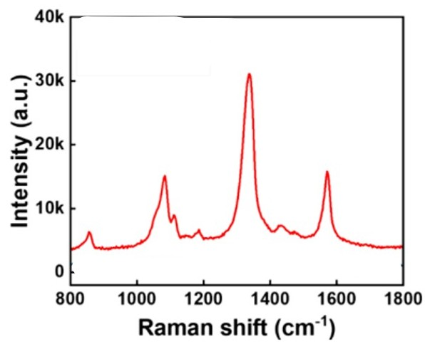
Figure 124:https://doi.org/10.1021/acsanm.4c04933
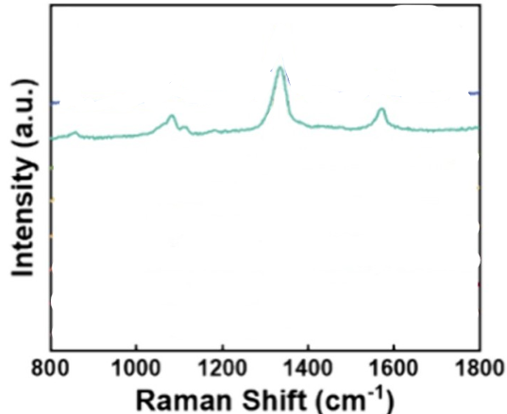
Figure 125:https://doi.org/10.1021/acsanm.4c04933
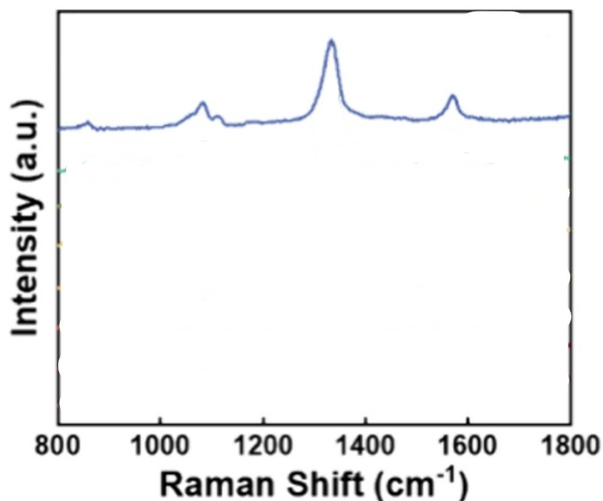
Figure 126:https://doi.org/10.1021/acsanm.4c04933
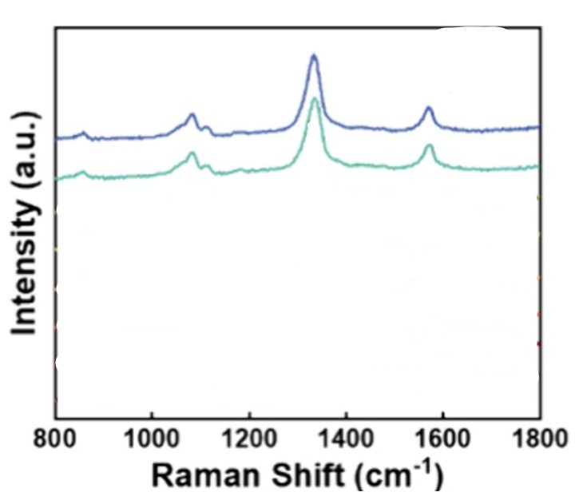
Figure 127:https://doi.org/10.1021/acsanm.4c04933
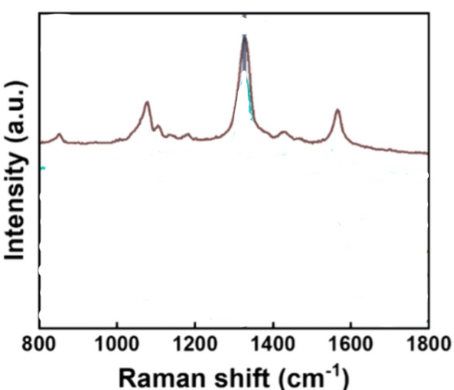
Figure 128:https://doi.org/10.1021/acsanm.4c04933
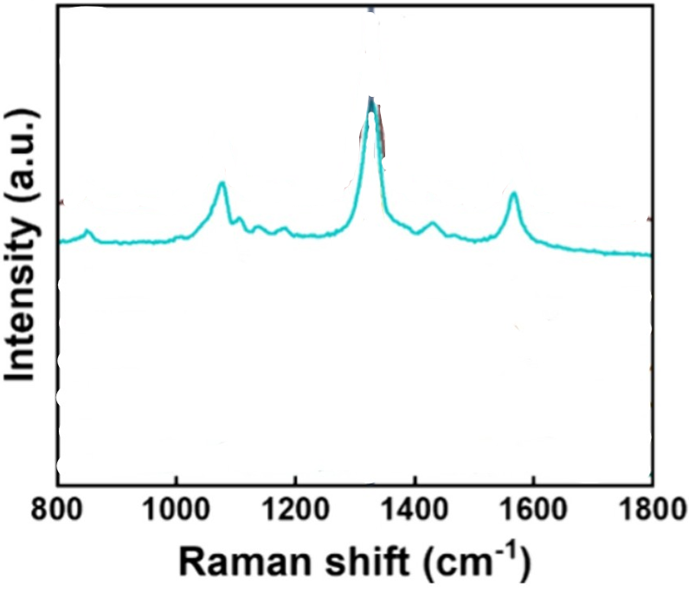
Figure 129:https://doi.org/10.1021/acsanm.4c04933
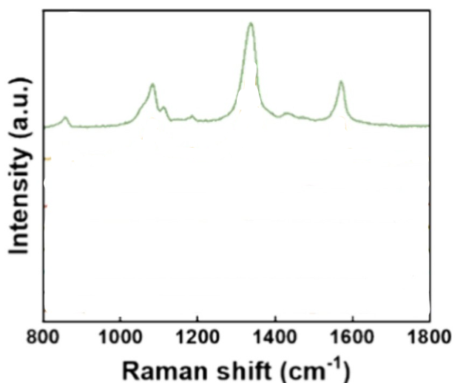
Figure 130:https://doi.org/10.1021/acsanm.4c04933
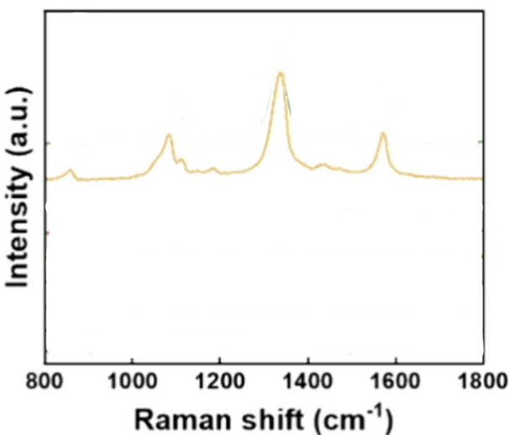
Figure 131:https://doi.org/10.1021/acsanm.4c04933
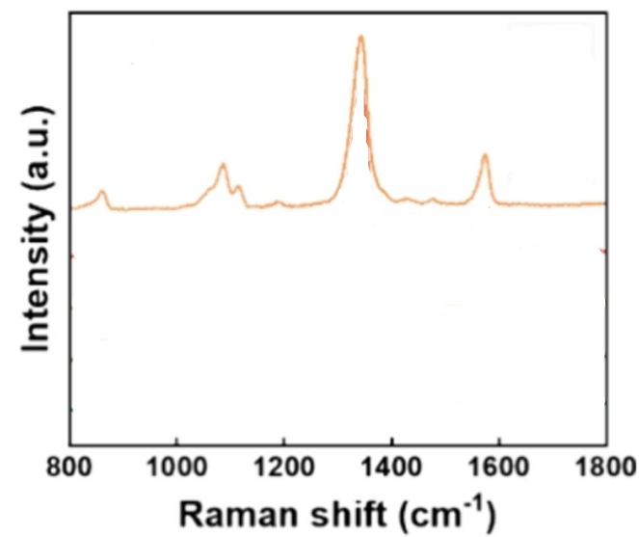
Figure 132:https://doi.org/10.1021/acsanm.4c04933
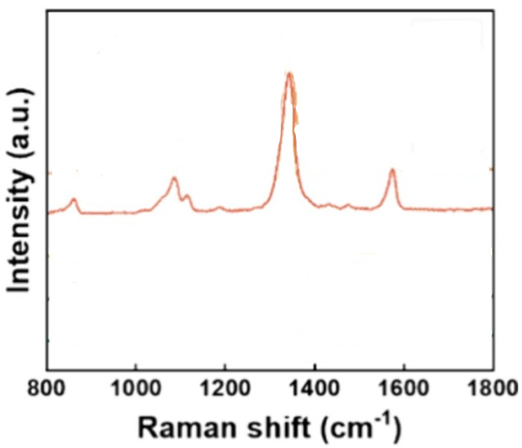
Figure 133:https://doi.org/10.1021/acsanm.4c04933
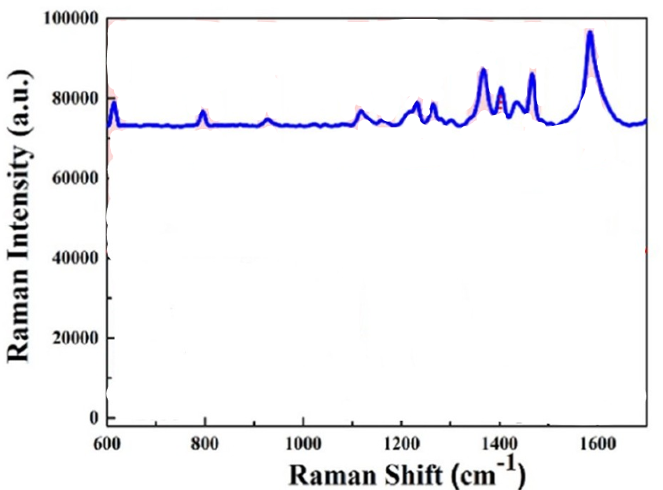
Figure 134:https://doi.org/10.1021/jacsau.3c00758
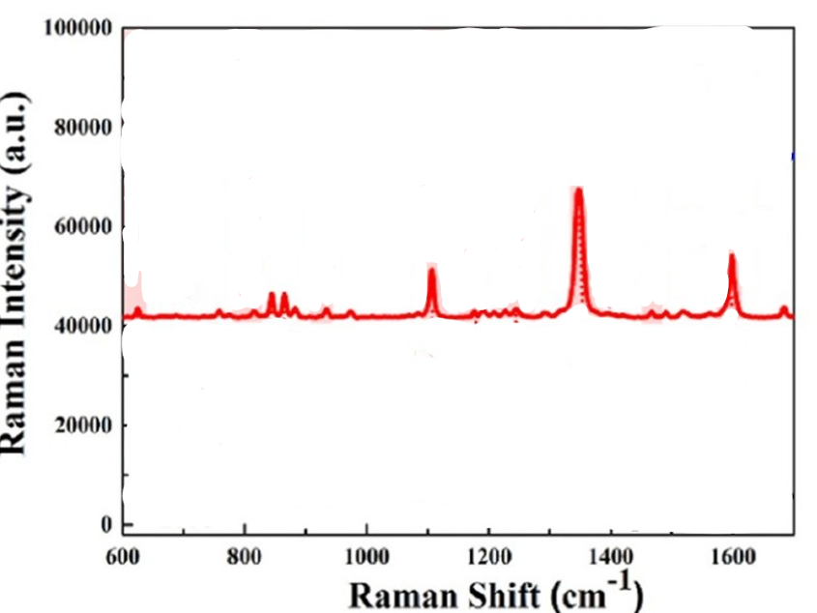
Figure 135:https://doi.org/10.1021/jacsau.3c00758
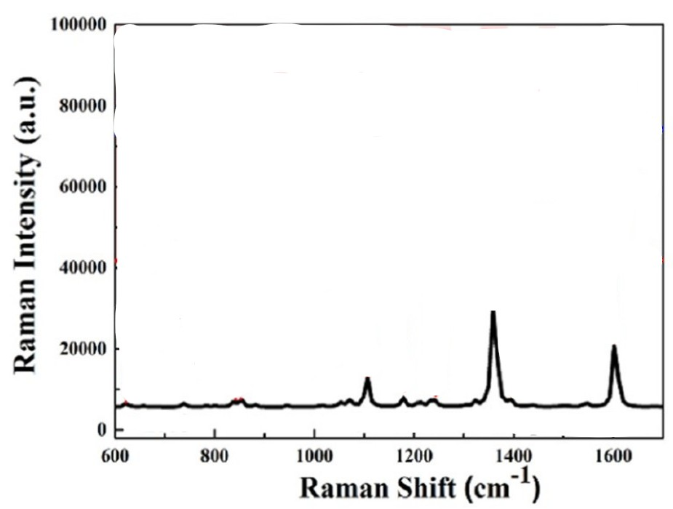
Figure 136:https://doi.org/10.1021/jacsau.3c00758
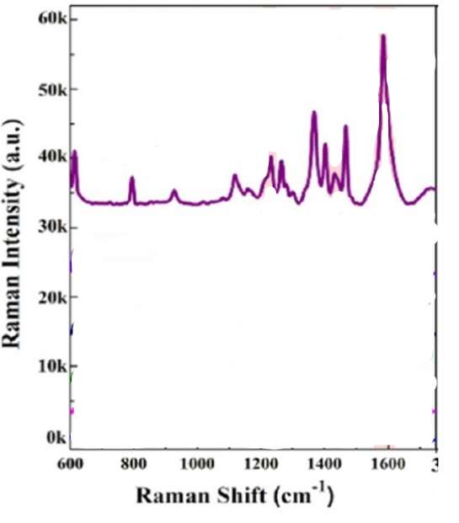
Figure 137:https://doi.org/10.1021/jacsau.3c00758
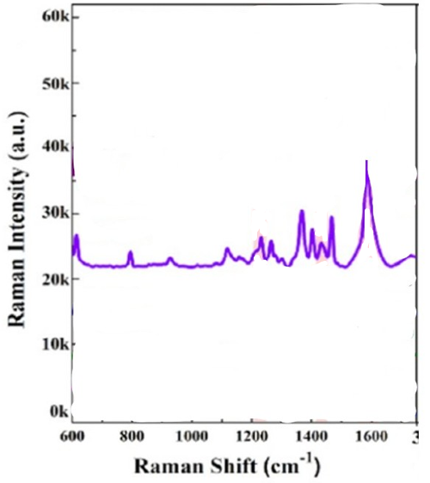
Figure 138:https://doi.org/10.1021/jacsau.3c00758
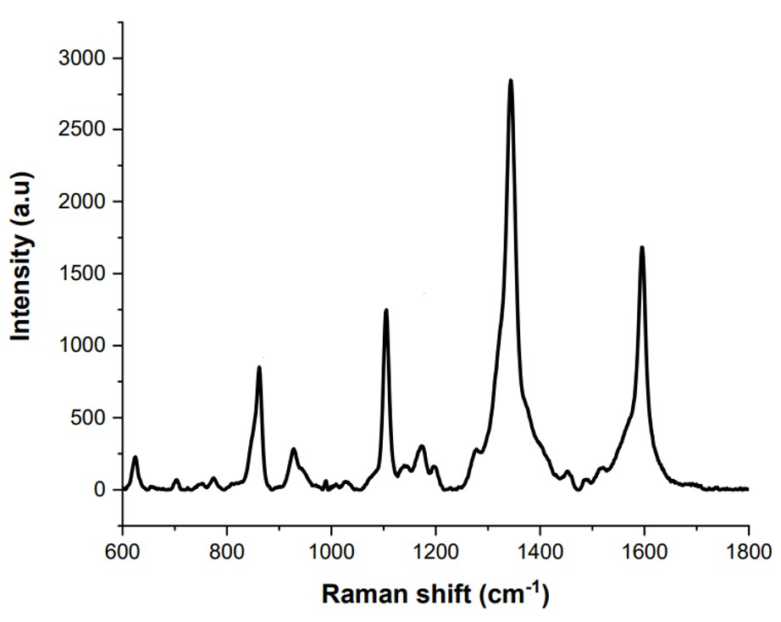
Figure 139:https://gust.edu.vn/media/29/uftai-ve-tai-day29805.pdf
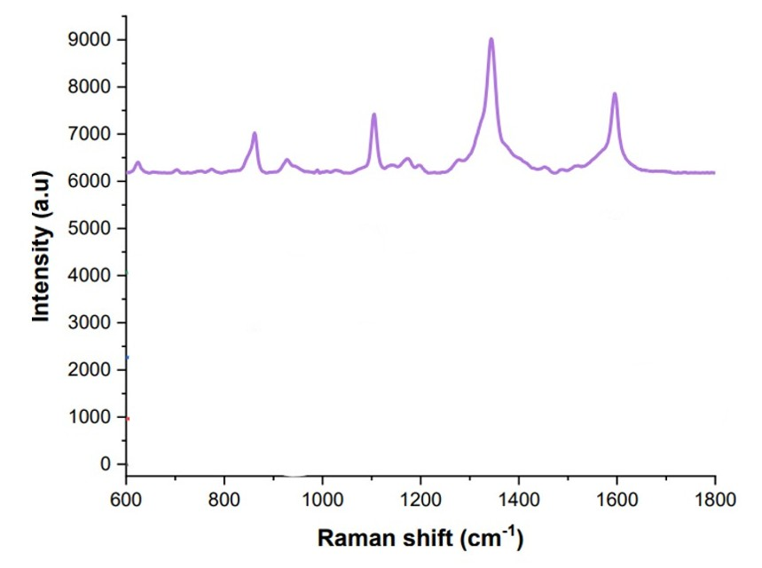
Figure 140:https://gust.edu.vn/media/29/uftai-ve-tai-day29805.pdf
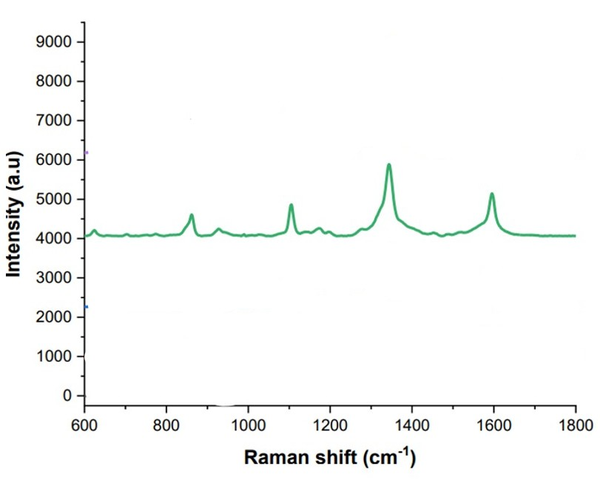
Figure 141:https://gust.edu.vn/media/29/uftai-ve-tai-day29805.pdf
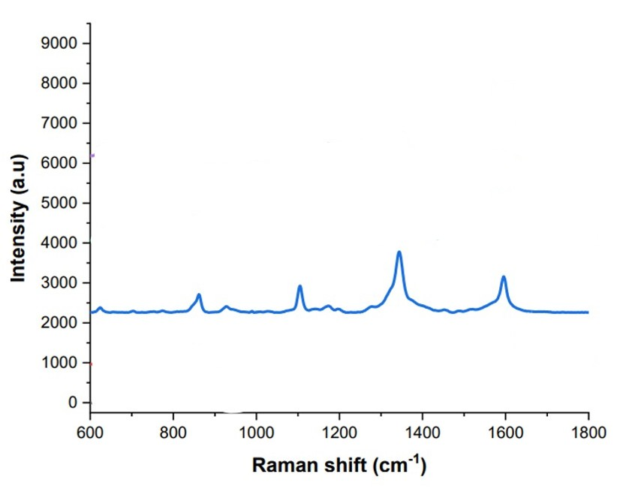
Figure 142:https://gust.edu.vn/media/29/uftai-ve-tai-day29805.pdf
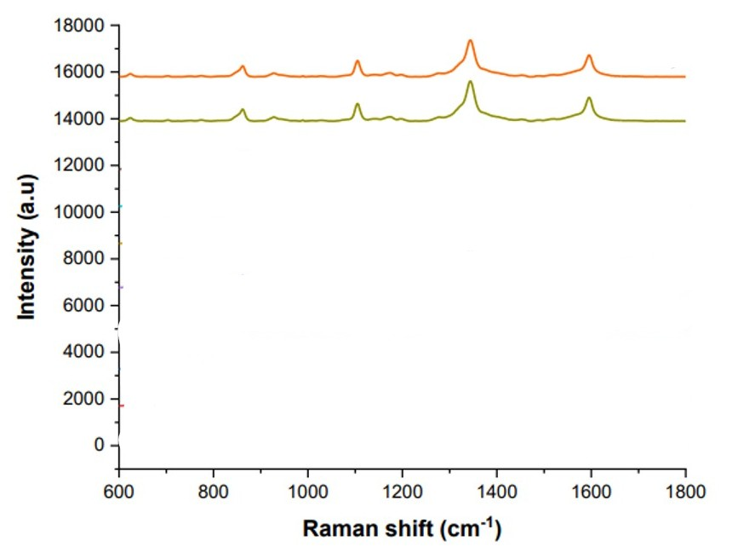
Figure 143:https://gust.edu.vn/media/29/uftai-ve-tai-day29805.pdf
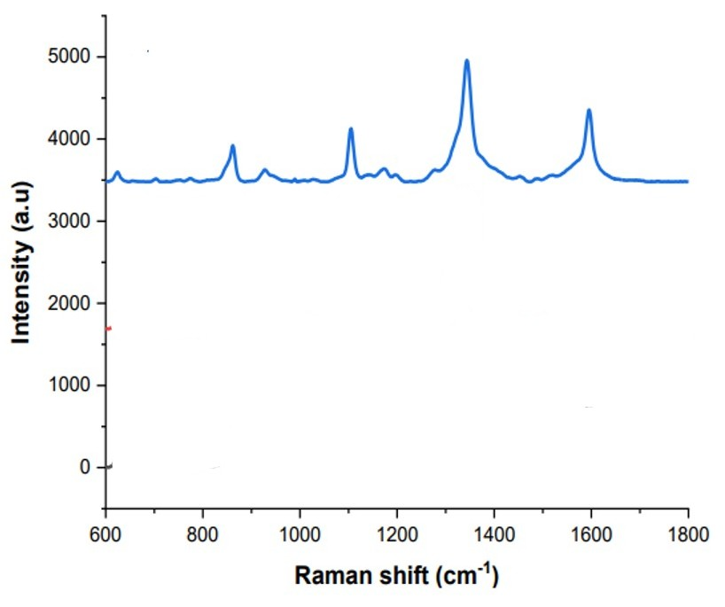
Figure 144:https://gust.edu.vn/media/29/uftai-ve-tai-day29805.pdf
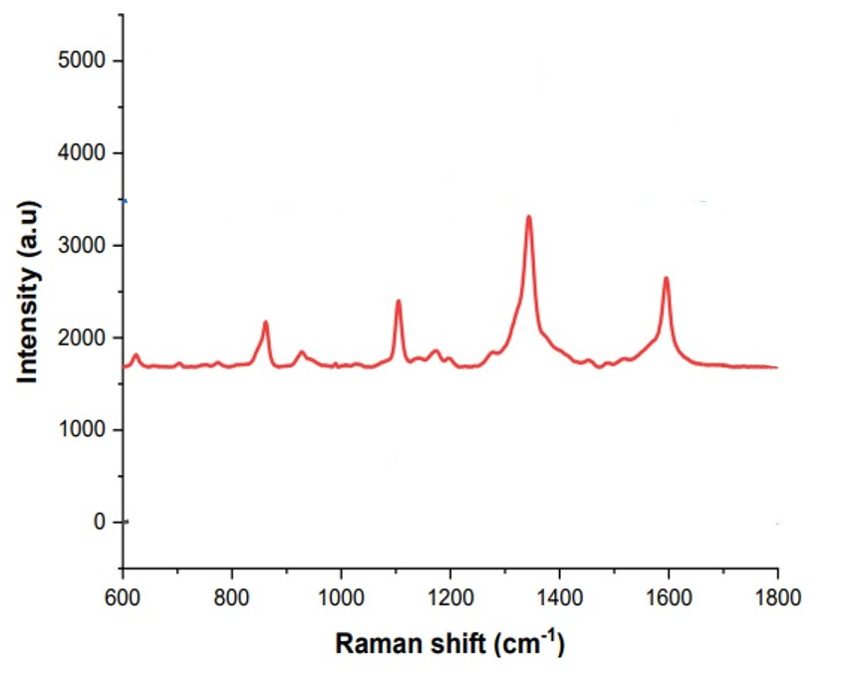
Figure 145:https://gust.edu.vn/media/29/uftai-ve-tai-day29805.pdf
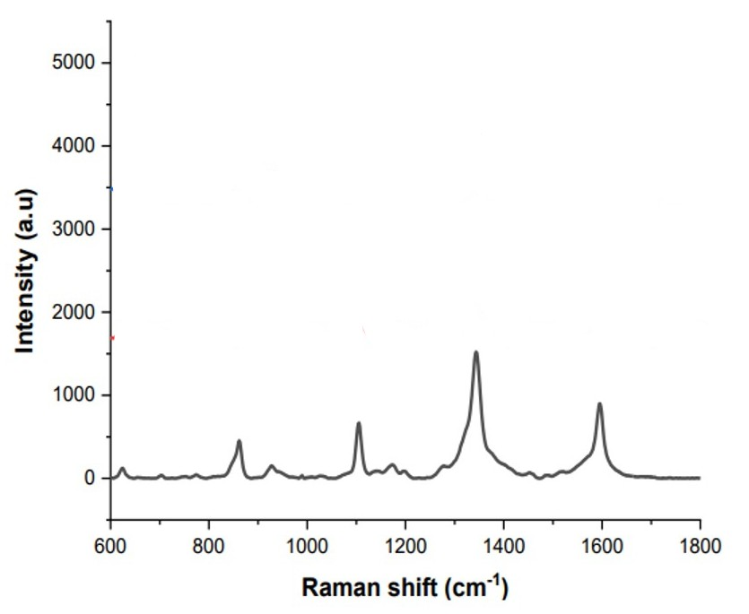
Figure 146:https://gust.edu.vn/media/29/uftai-ve-tai-day29805.pdf
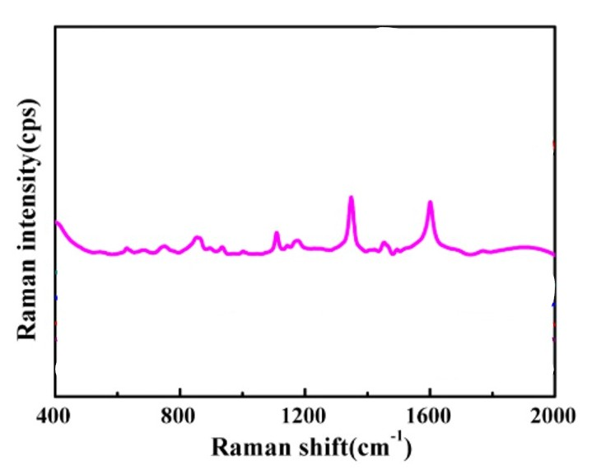
Figure 147:https://doi.org/10.3390/nano6090175
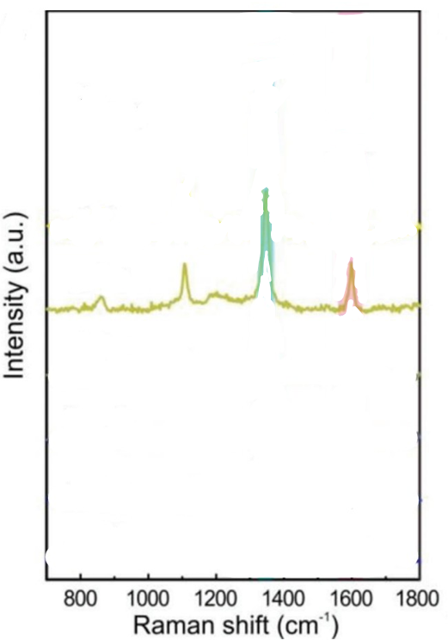
Figure 148:https://doi.org/10.1002/adom.202301609
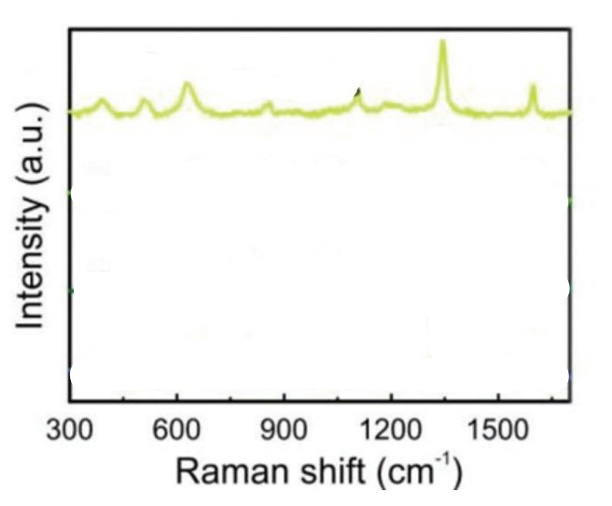
Figure 149:https://doi.org/10.1002/adom.202301609
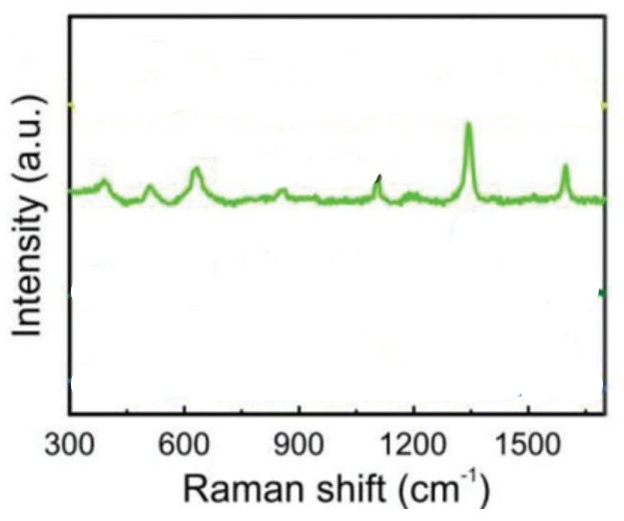
Figure 150:https://doi.org/10.1002/adom.202301609
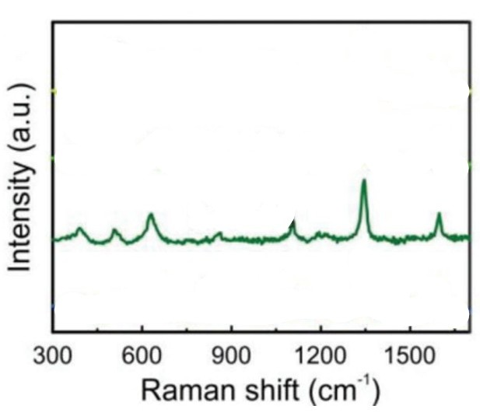
Figure 151:https://doi.org/10.1002/adom.202301609
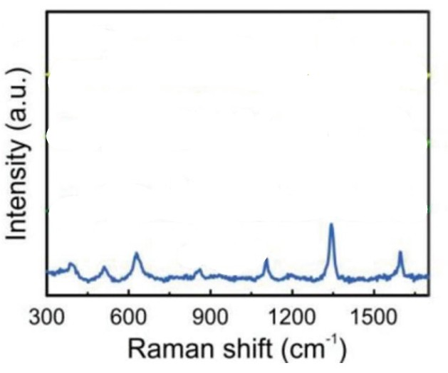
Figure 152:https://doi.org/10.1002/adom.202301609
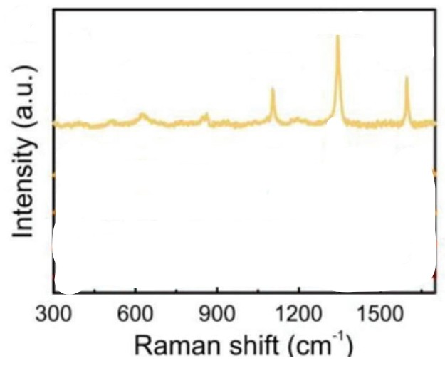
Figure 153:https://doi.org/10.1002/adom.202301609
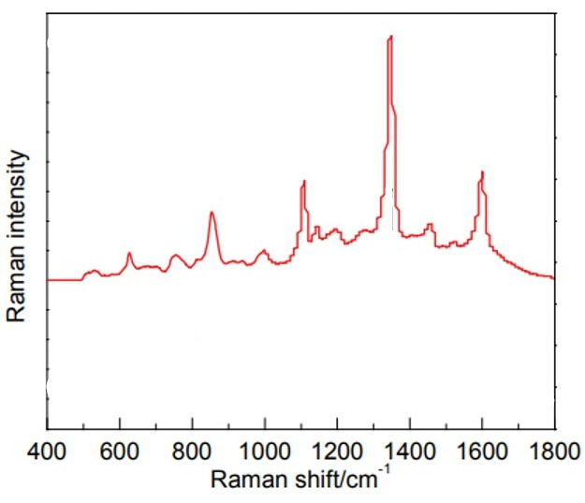
Figure 154: DOI: 10.6023/A12100831
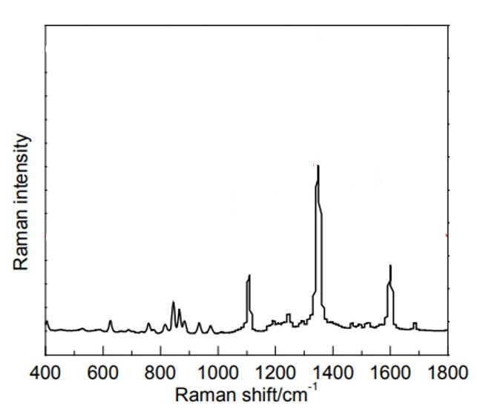
Figure 155:DOI: 10.6023/A12100831
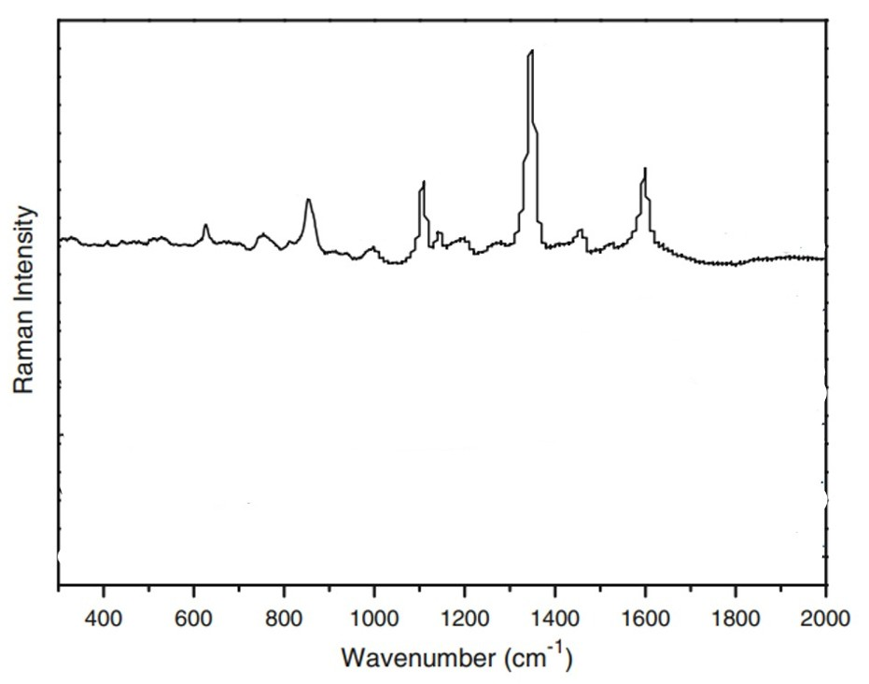
Figure 156:https://doi.org/10.1007/s11694-011-9106-8
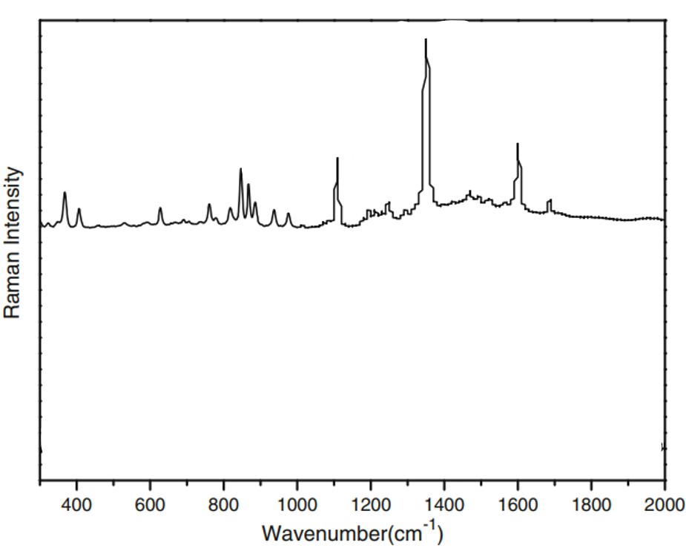
Figure 157:https://doi.org/10.1007/s11694-011-9106-8

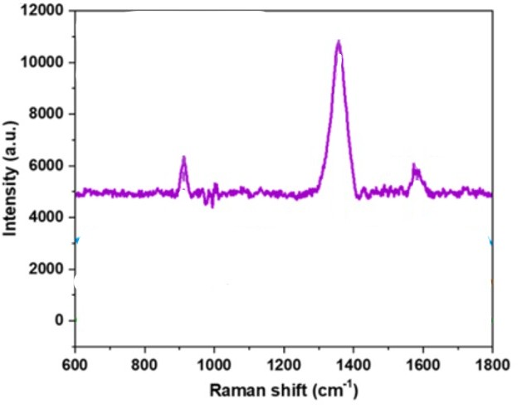
Figure 158:https://doi.org/10.1021/acsanm.5c02300
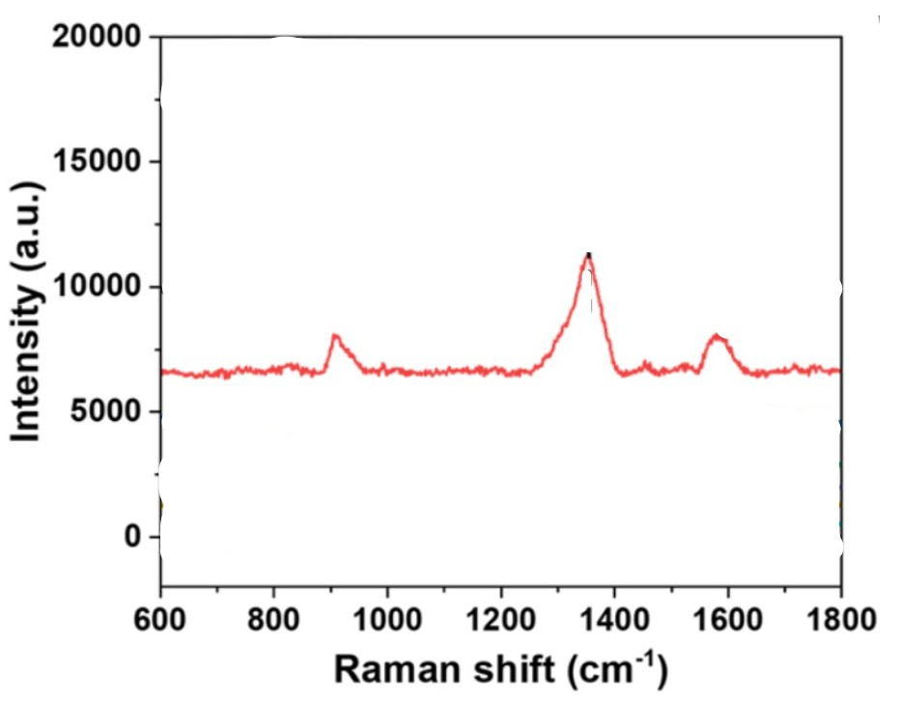
Figure 159:https://doi.org/10.1021/acsanm.5c02300

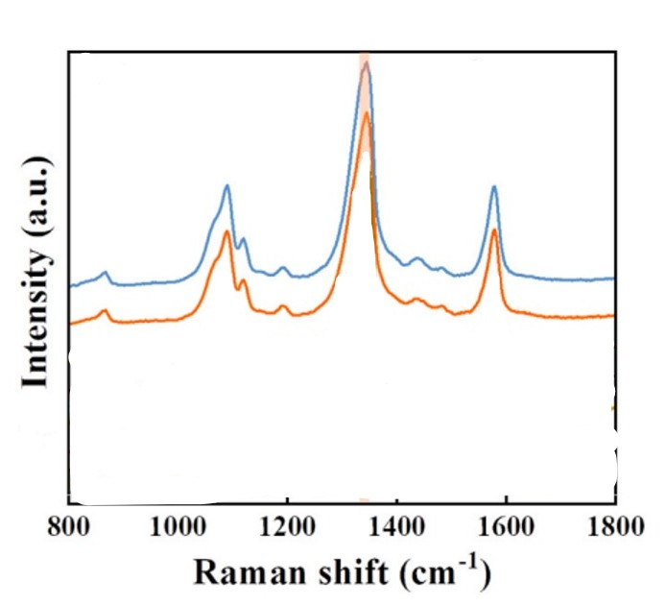
Figure 160:https://doi.org/10.1016/j.aca.2024.343308
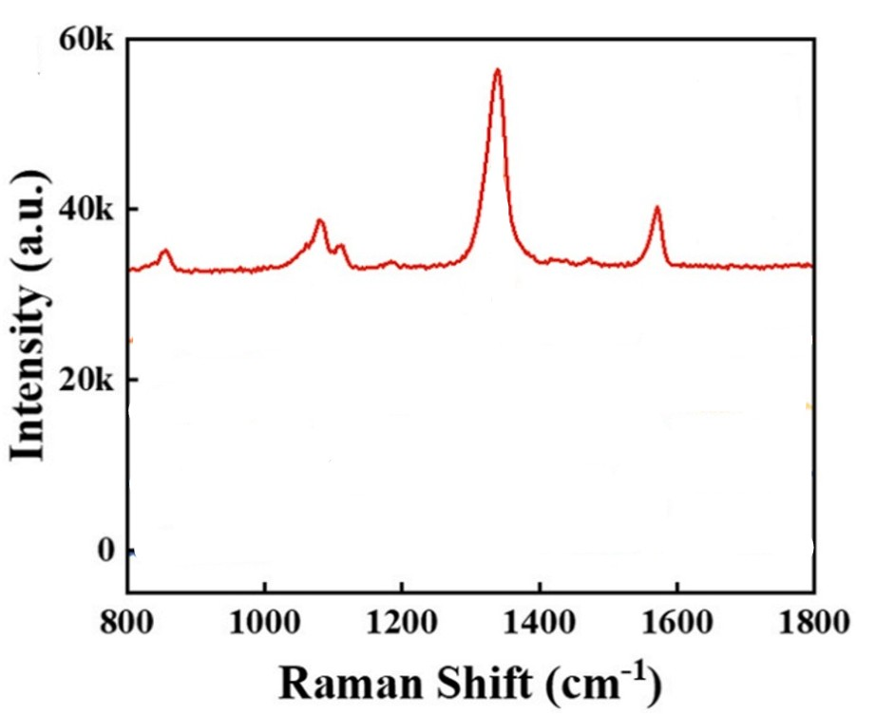
Figure 161:https://doi.org/10.1016/j.aca.2024.343308
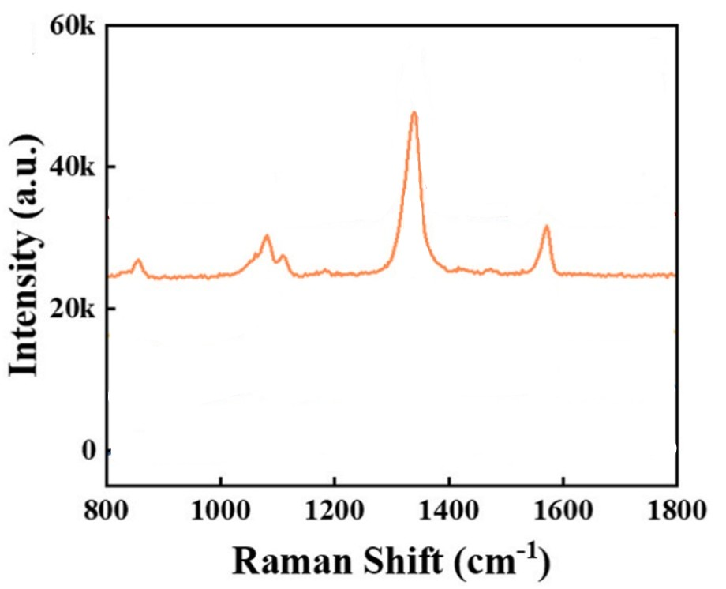
Figure 162:https://doi.org/10.1016/j.aca.2024.343308
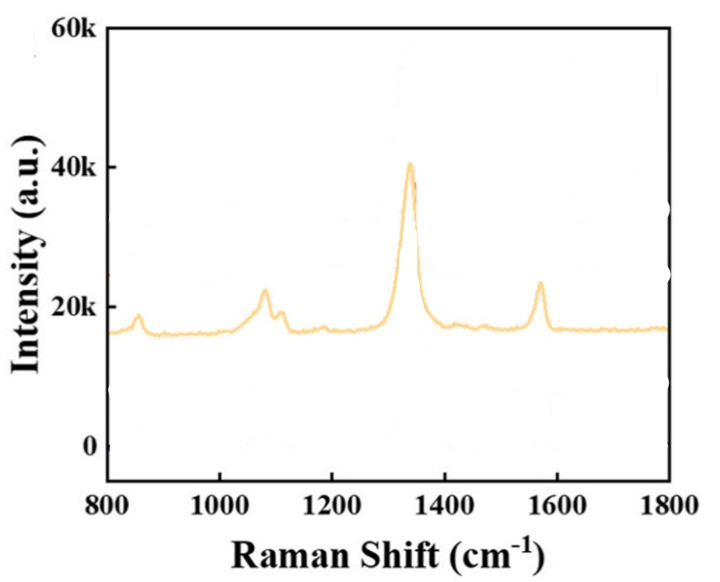
Figure 163: https://doi.org/10.1016/j.aca.2024.343308
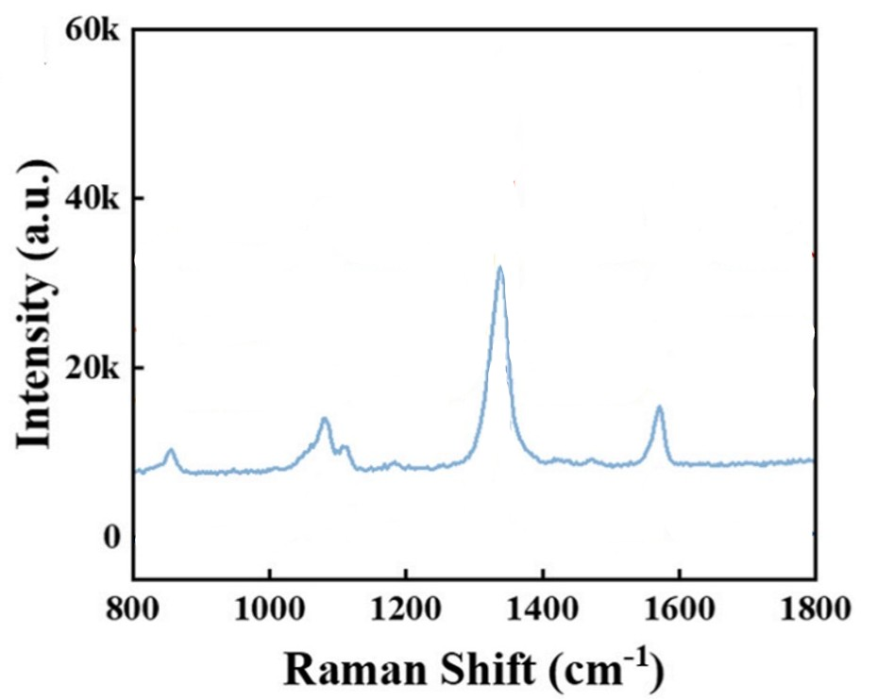
Figure 164:https://doi.org/10.1016/j.aca.2024.343308
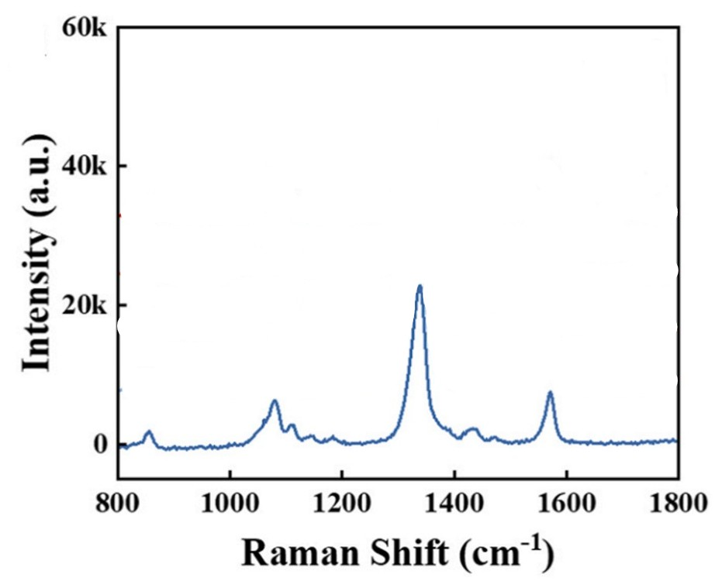
Figure 165:https://doi.org/10.1016/j.aca.2024.343308
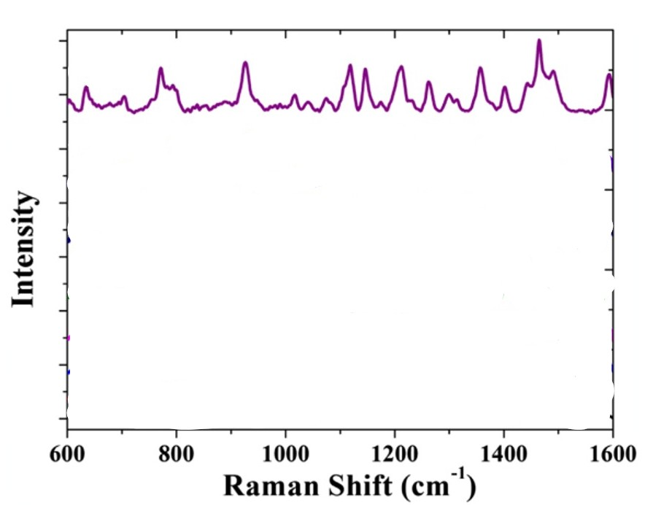
Figure 166:http://dx.doi.org/10.1016/j.bios.2015.11.011
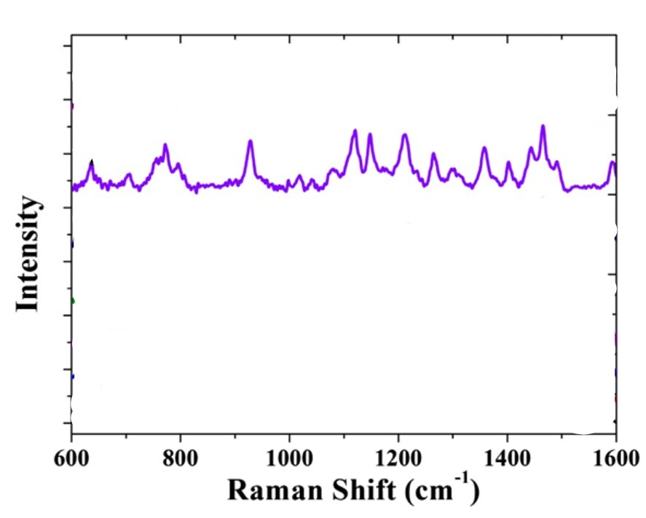
Figure 167:http://dx.doi.org/10.1016/j.bios.2015.11.011
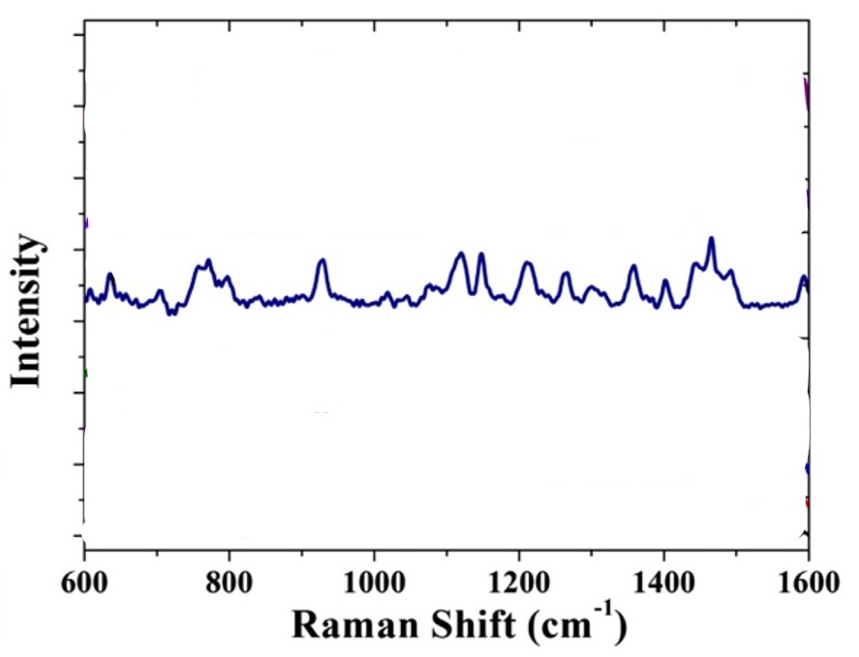
Figure 168:http://dx.doi.org/10.1016/j.bios.2015.11.011
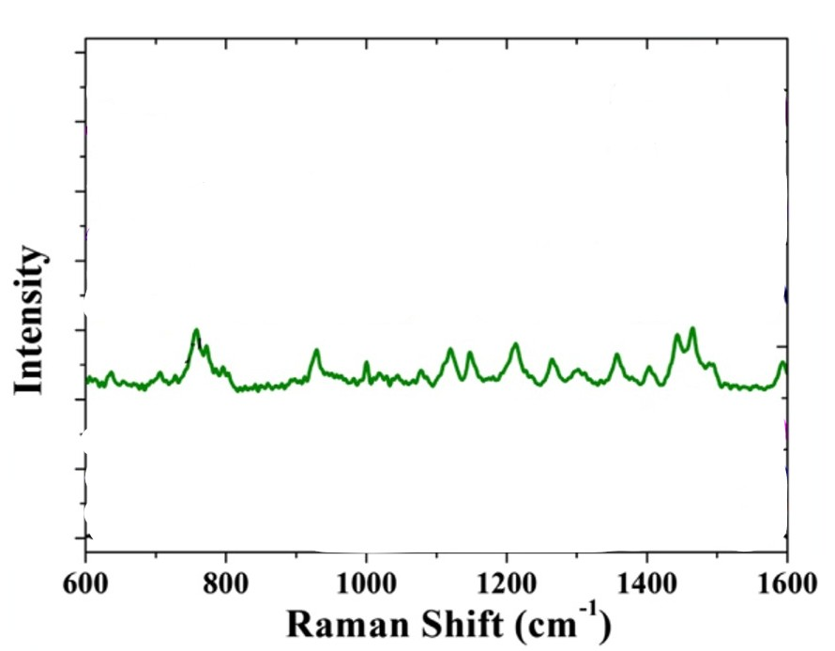
Figure 169:http://dx.doi.org/10.1016/j.bios.2015.11.011

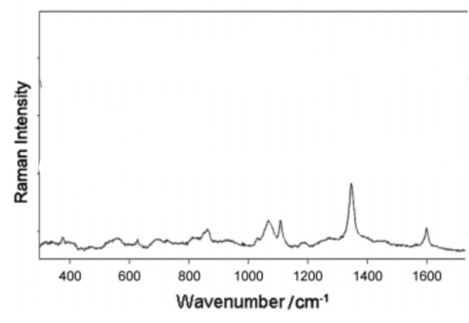
Figure 170:https://doi.org/10.1002/jrs.2505
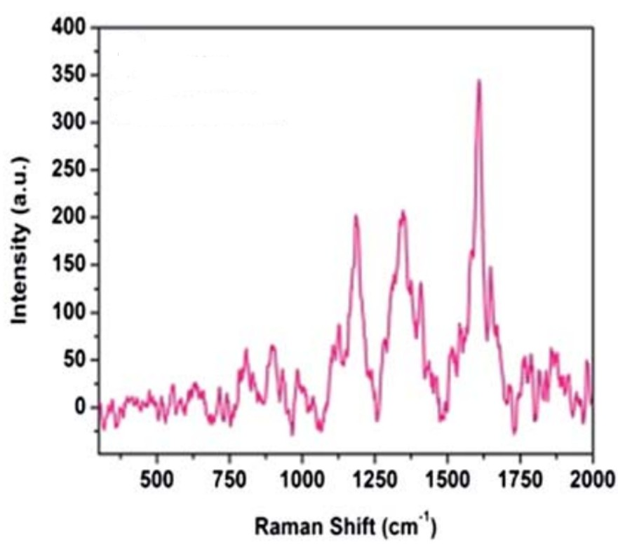
Figure 171:DOI: 10.1039/c5ra11643k
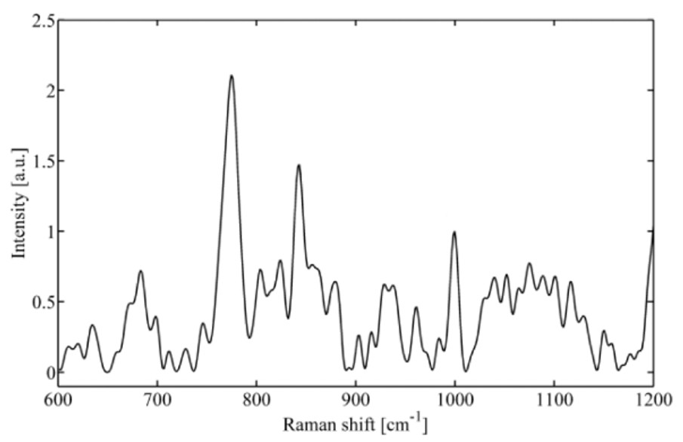
Figure 172:https://doi.org/10.3390/molecules181113188
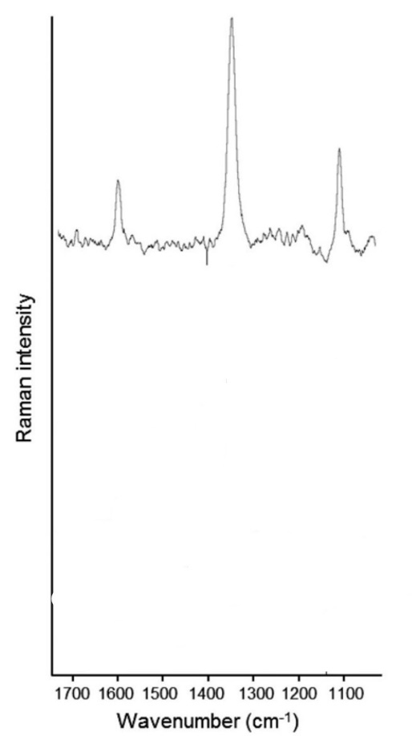
Figure 173:https://doi.org/10.1111/1750-3841.12825
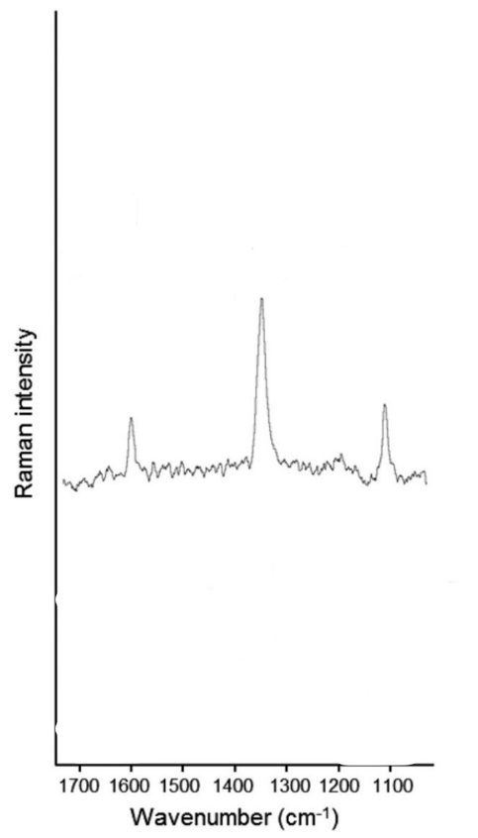
Figure 174:https://doi.org/10.1111/1750-3841.12825
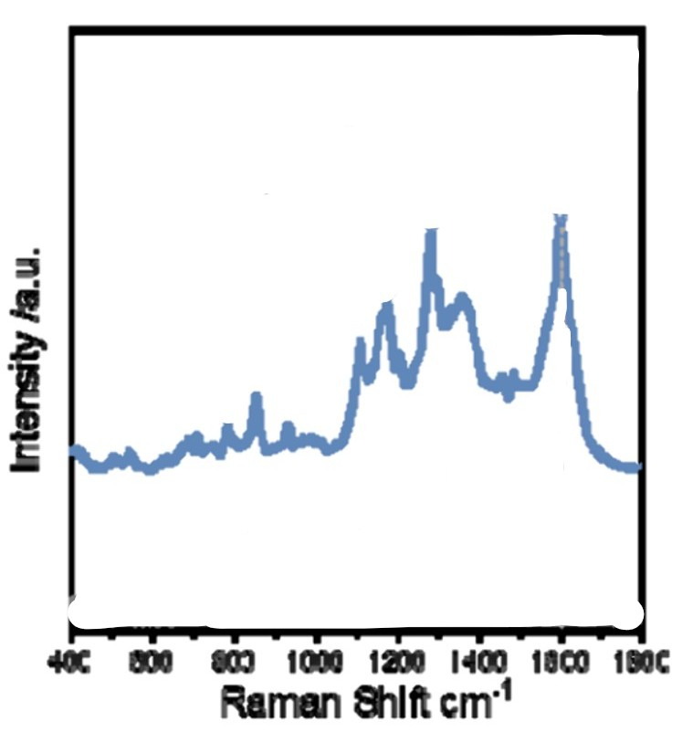
Figure 175:https://doi.org/10.1021/acsami.4c21938
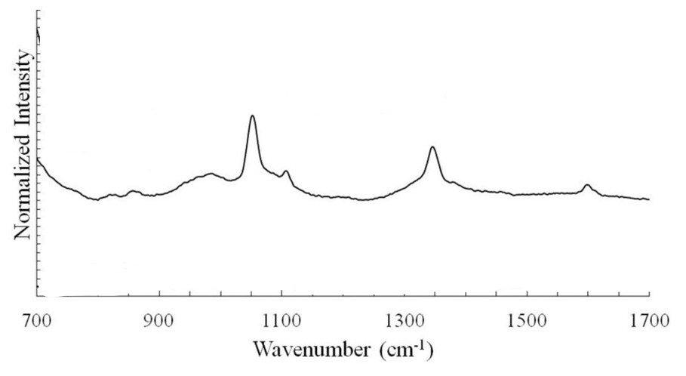
Figure 176:Lhttps://www.sciencedirect.com/science/article/pii/S0026265X25011452
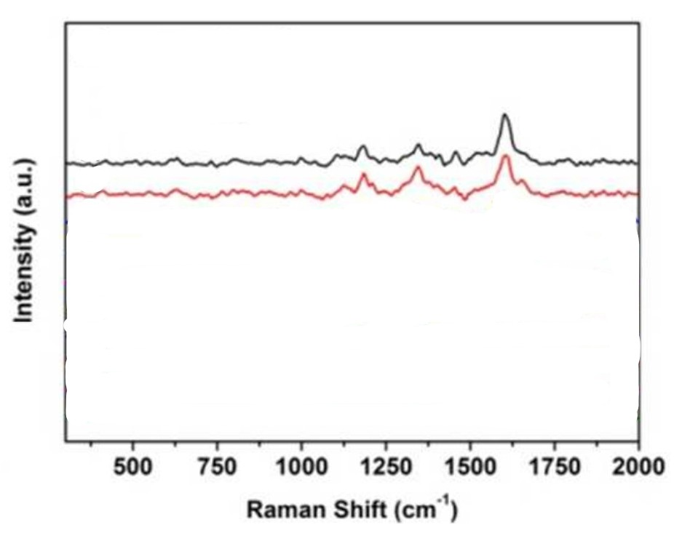
177:DOI: 10.1039/C5RA08076B
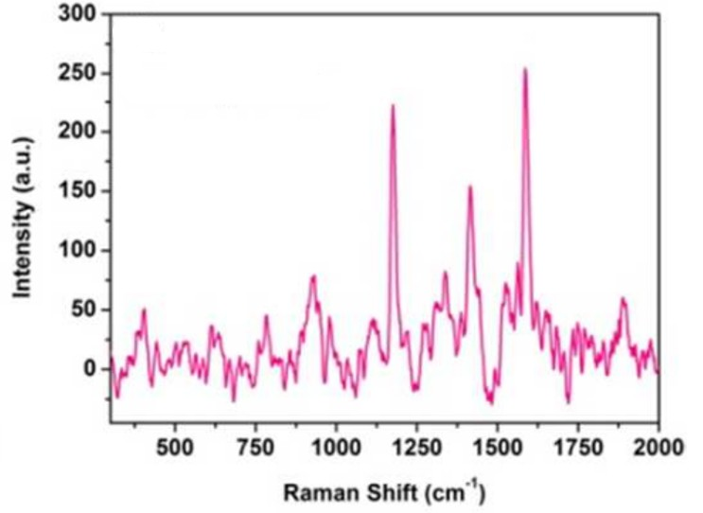
178:DOI: 10.1039/C5RA08076

