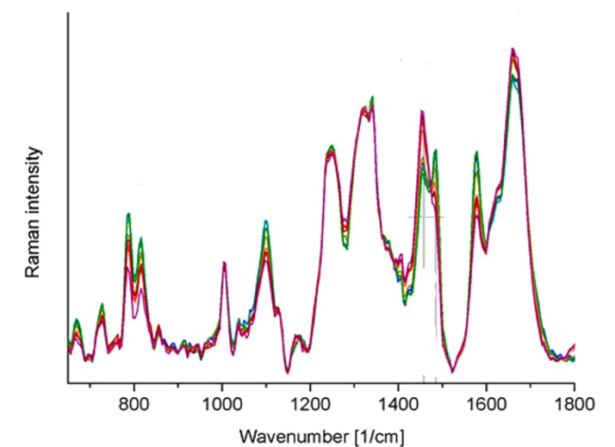
Figure 1:http://dx.doi.org/10.1021/acs.analchem.7b03800
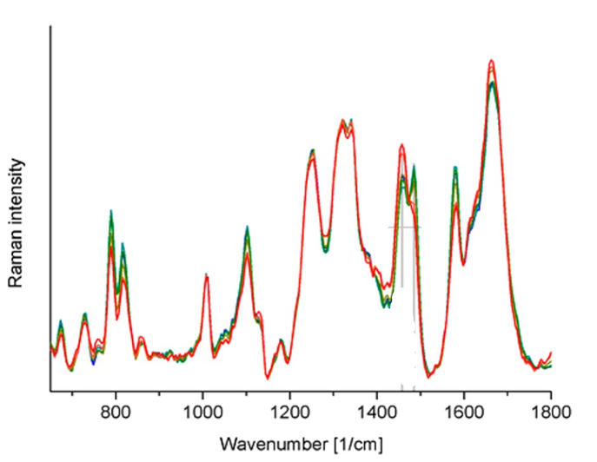
Figure 2:http://dx.doi.org/10.1021/acs.analchem.7b03800
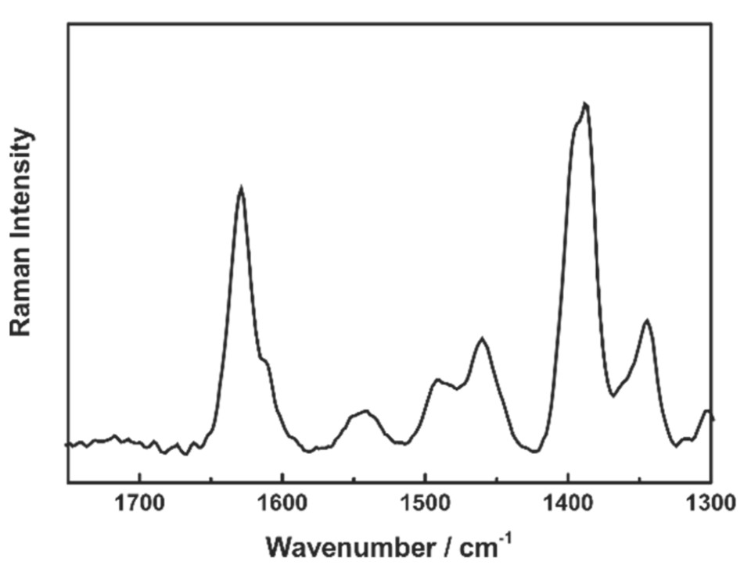
Figure 3:https://doi.org/10.3390/molecules24244512
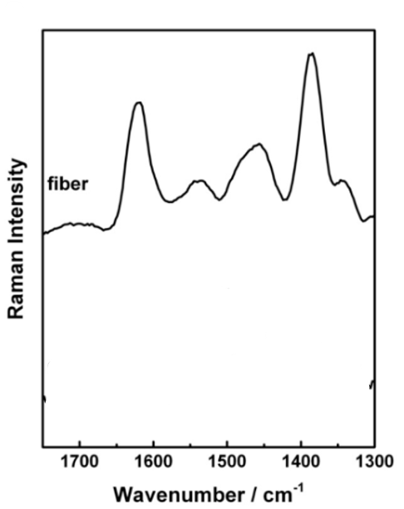
Figure 4:https://doi.org/10.3390/molecules24244512
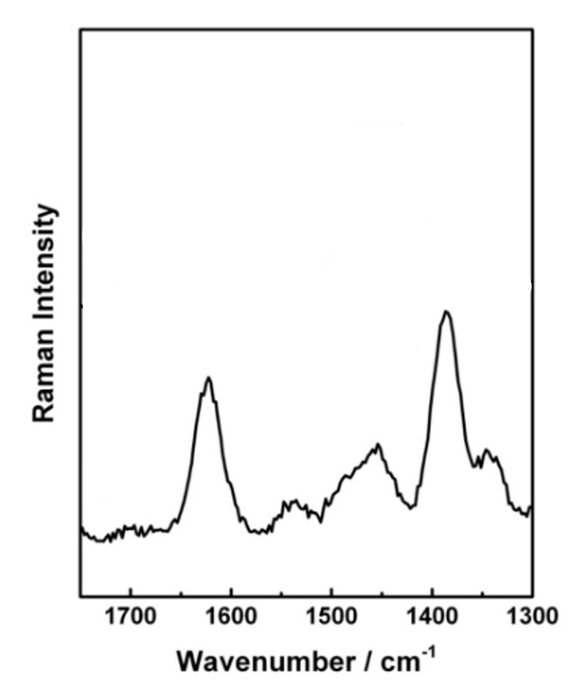
Figure 5:https://doi.org/10.1016/j.molstruc.2020.128946
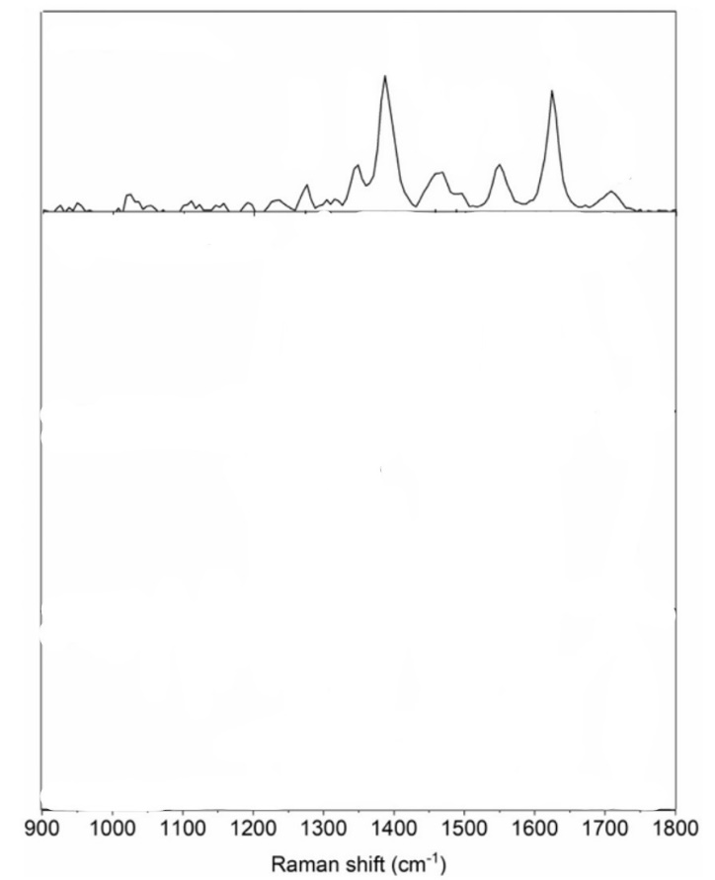
Figure 6:https://doi.org/10.3390/molecules24244512
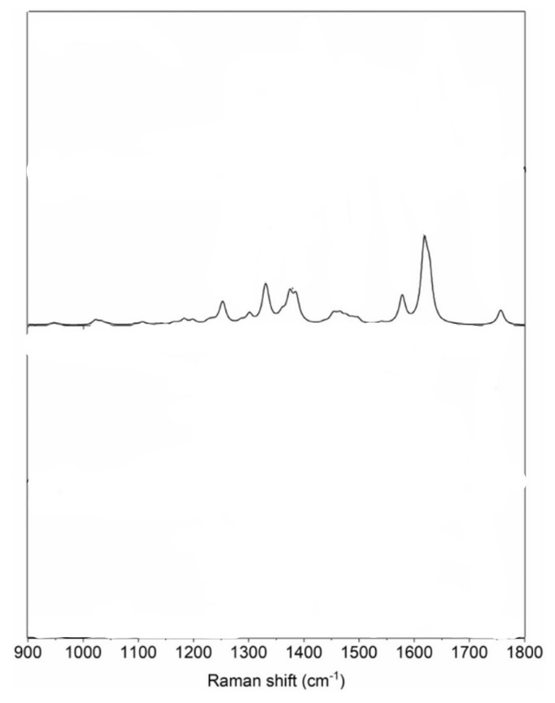
Figure 7:https://doi.org/10.1016/j.molstruc.2020.128946
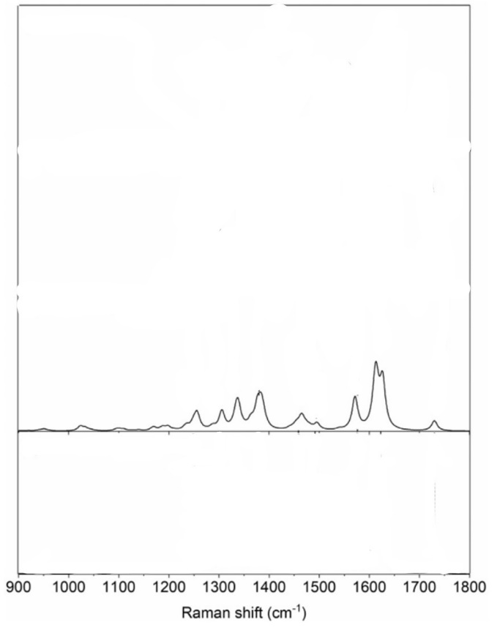
Figure 8:https://doi.org/10.1016/j.molstruc.2020.128946

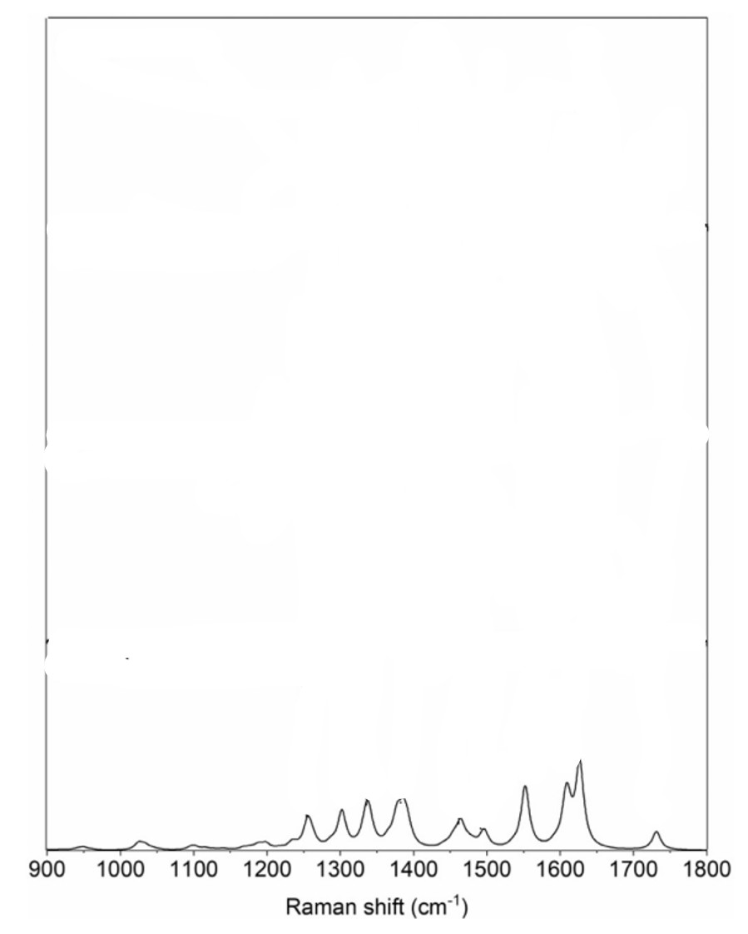
Figure 9:https://doi.org/10.1016/j.molstruc.2020.128946
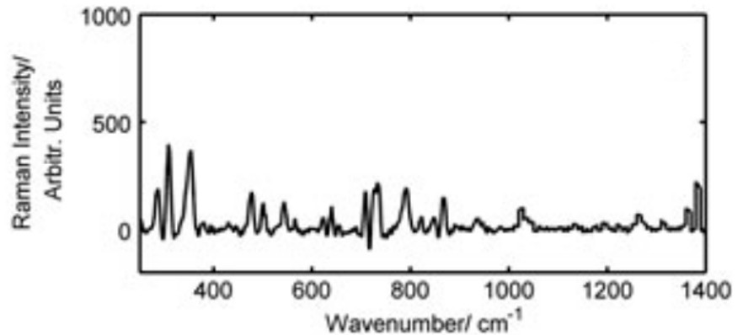
Figure 10:https://doi.org/10.1002/jrs.3125
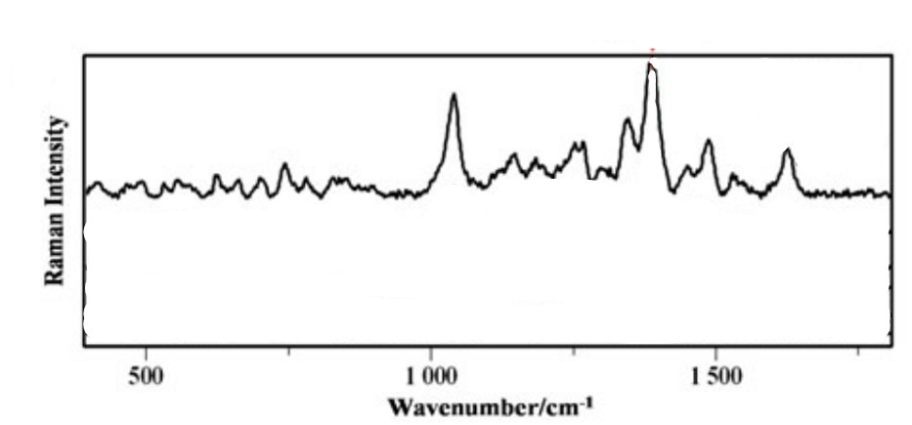
Figure 11:https://doi.org/10.1002/jrs.5071
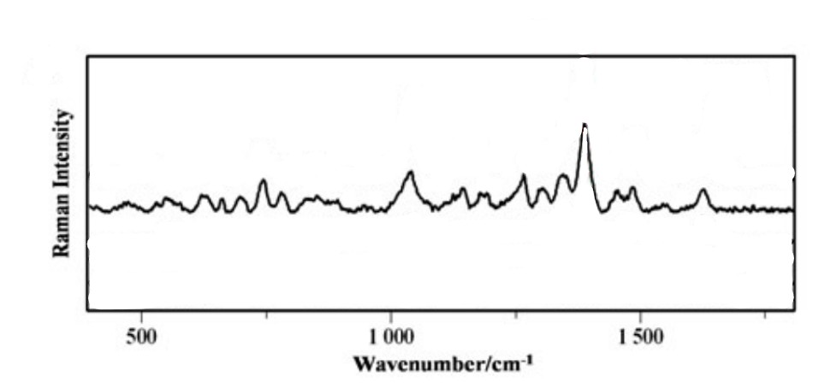
Figure 12:https://doi.org/10.1002/jrs.5071

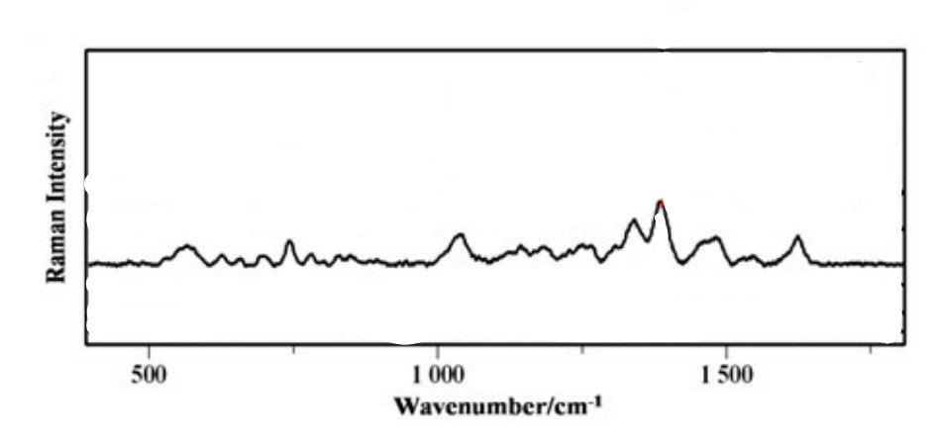
Figure 13:https://doi.org/10.1002/jrs.5071

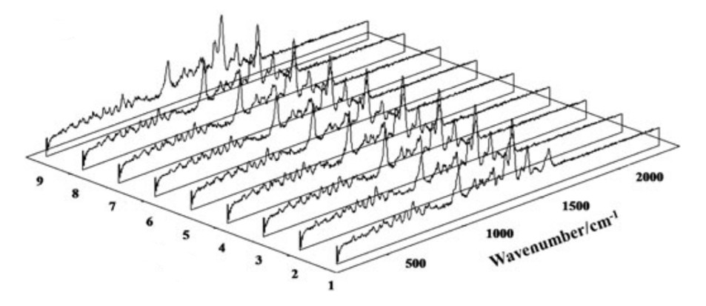
Figure 14:https://doi.org/10.1002/jrs.5071

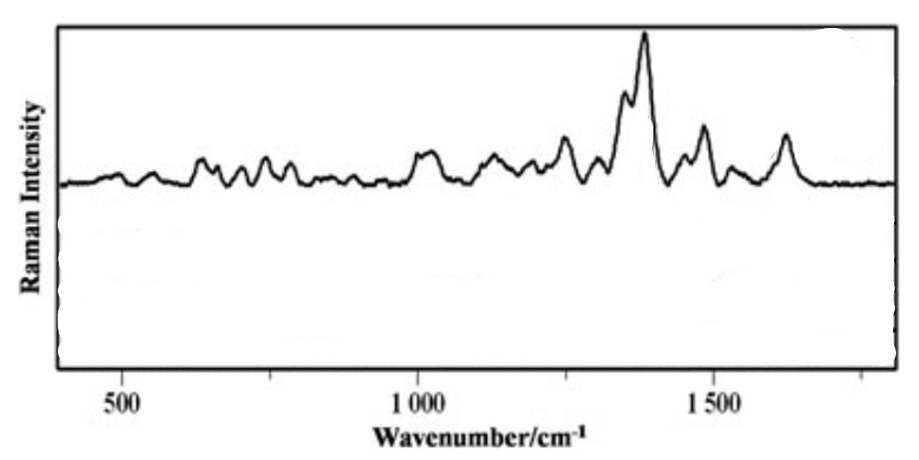
Figure 15:https://doi.org/10.1002/jrs.5071

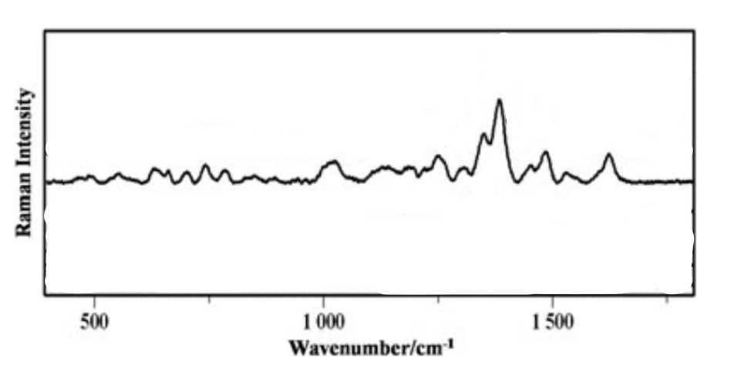
Figure 16:https://doi.org/10.1002/jrs.5071

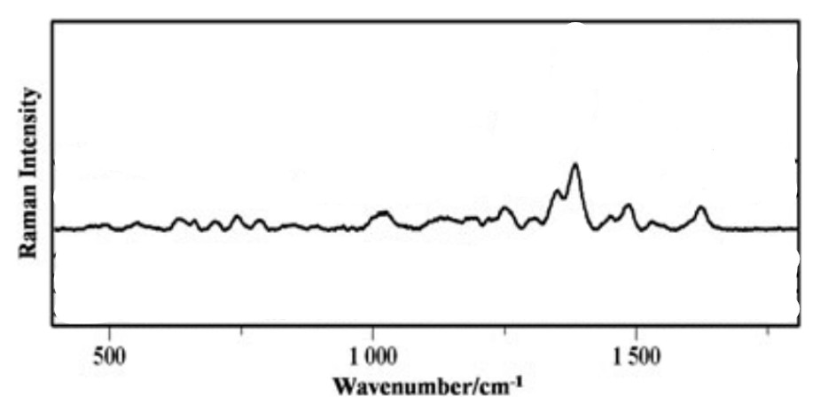
Figure 17:https://doi.org/10.1002/jrs.5071

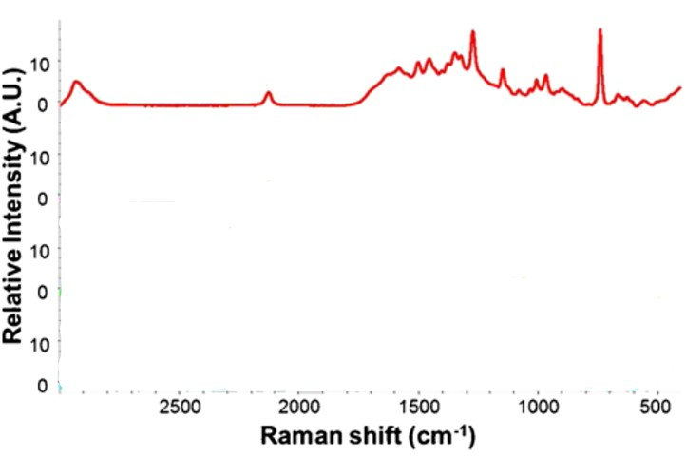
Figure 18:DOI 10.1007/s00216-015-9184-2

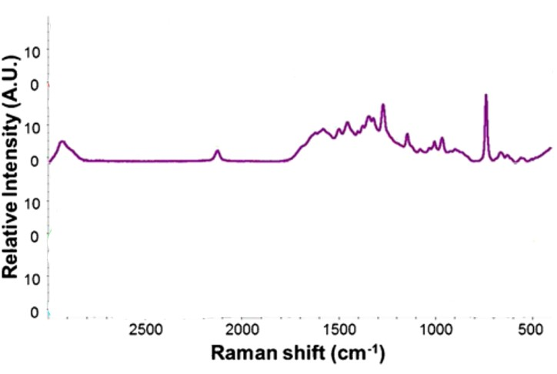
Figure 19:DOI 10.1007/s00216-015-9184-2

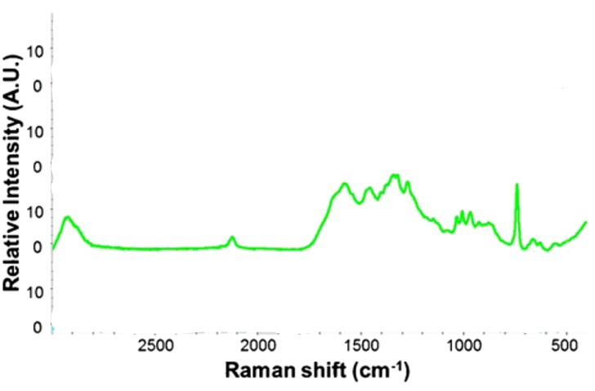
Figure 20:DOI 10.1007/s00216-015-9184-2

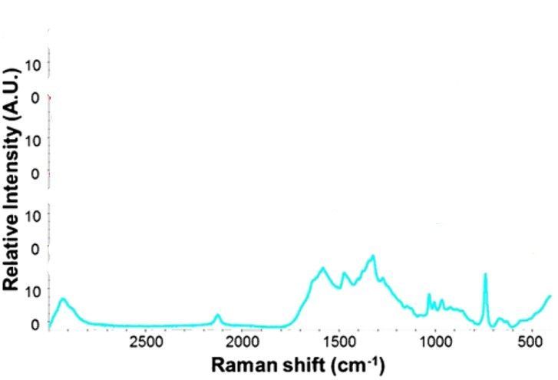
Figure 21:DOI 10.1007/s00216-015-9184-2

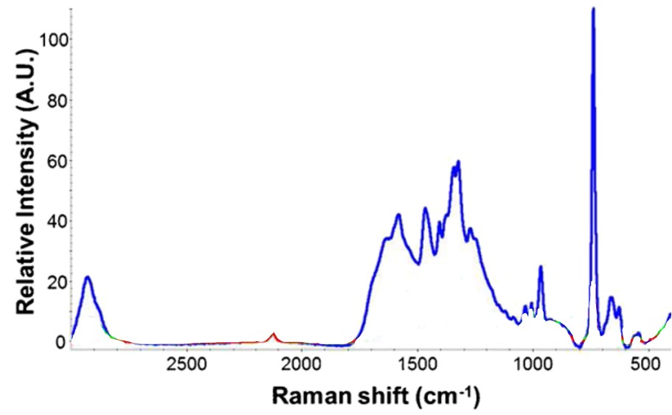
Figure 22:DOI 10.1007/s00216-015-9184-2

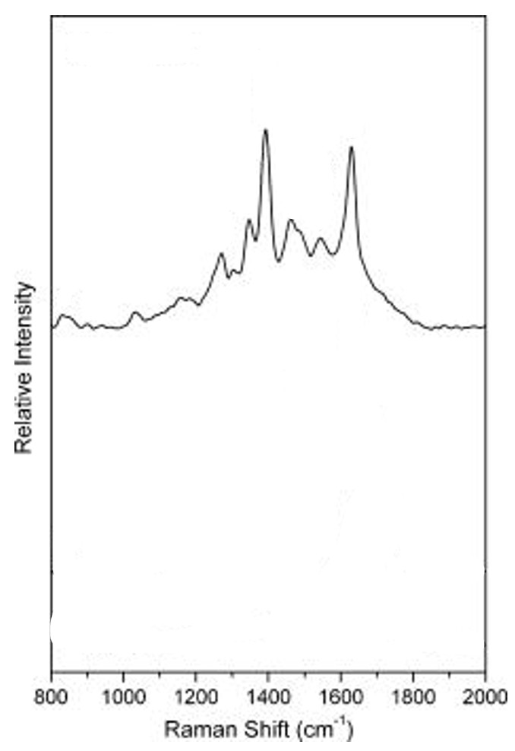
Figure 23:https://doi.org/10.1117/1.2737385
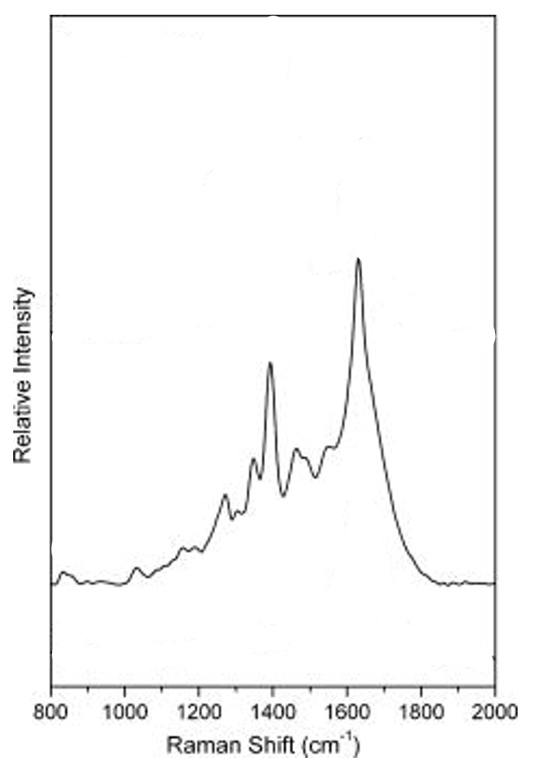
Figure 24:https://doi.org/10.1117/1.2737385
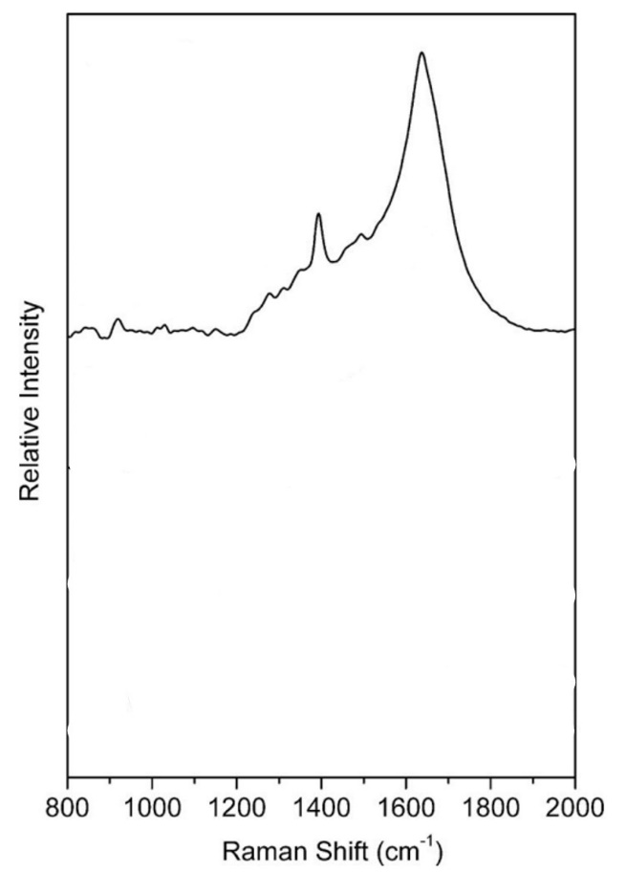
Figure 25:https://doi.org/10.1117/1.2737385

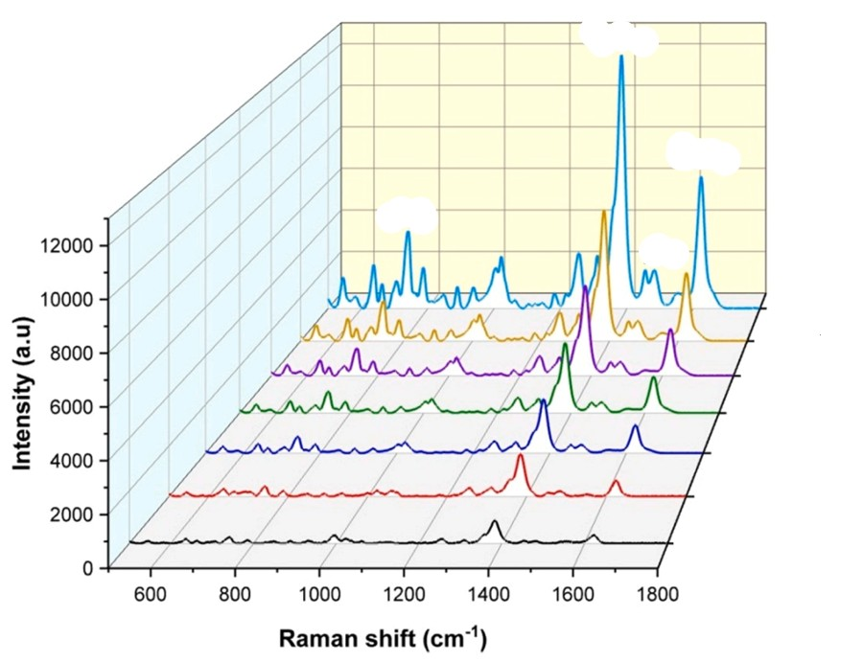
Figure 26:https://doi.org/10.1016/j.ijleo.2022.169043
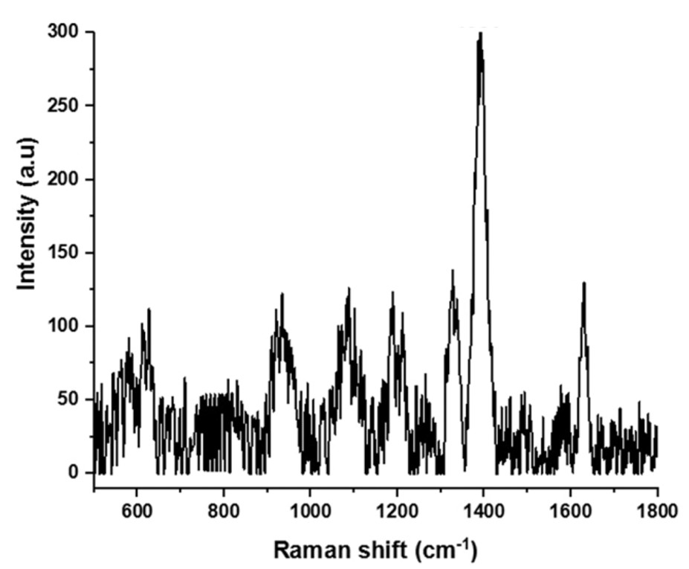
Figure 27:https://doi.org/10.1016/j.ijleo.2022.169043
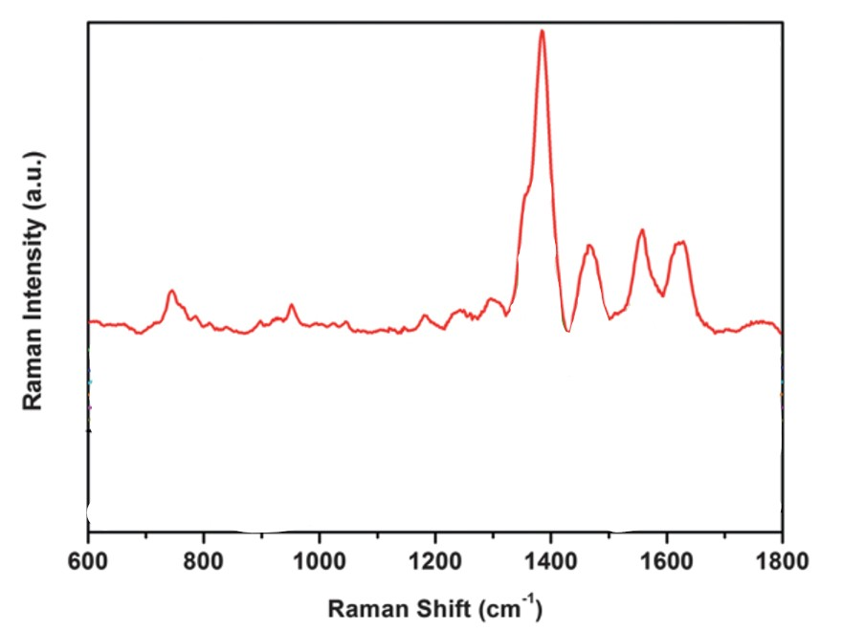
Figure 28:https://doi.org/10.1039/C3AY40866C

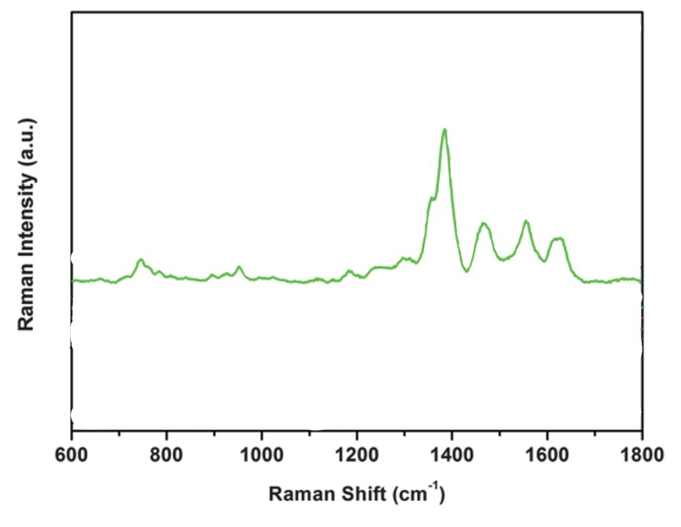
Figure 29:https://doi.org/10.1039/C3AY40866C
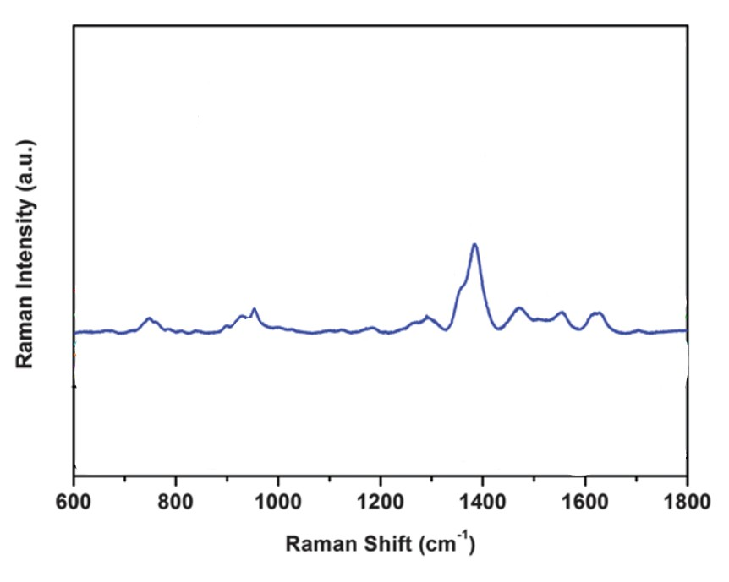
Figure 30:https://doi.org/10.1039/C3AY40866C
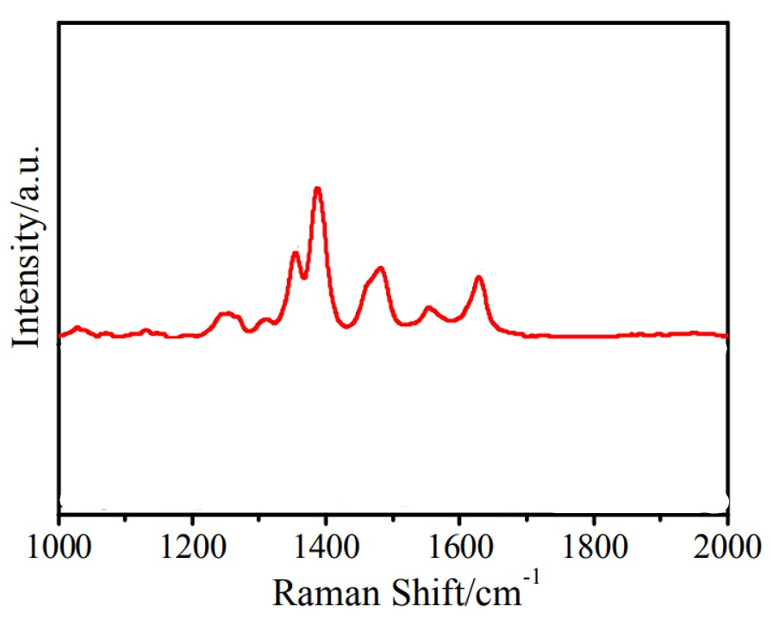
Figure 31:http://dx.doi.org/10.1039/c5cp02666k
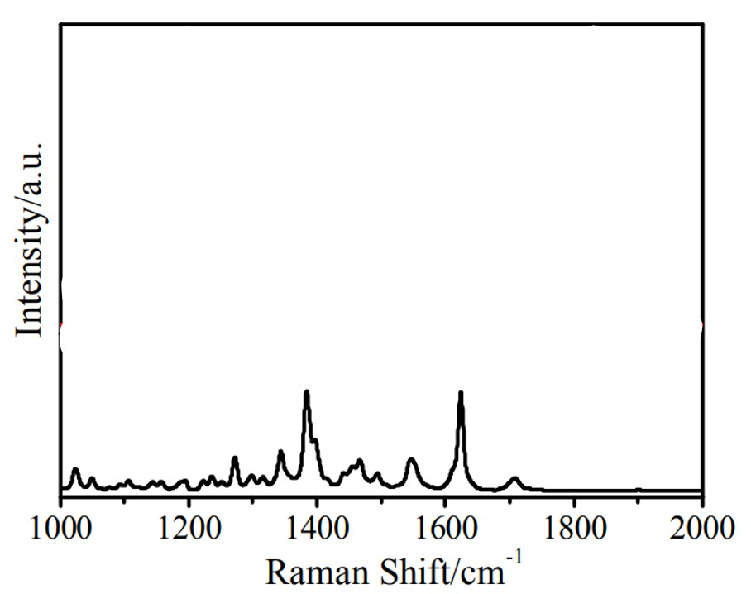
Figure 31:http://dx.doi.org/10.1039/c5cp02666k
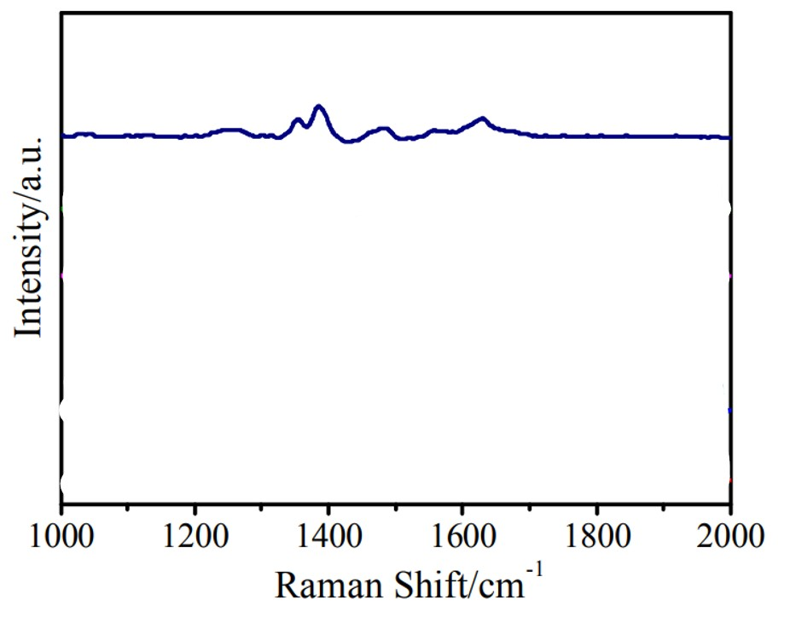
Figure 32:http://dx.doi.org/10.1039/c5cp02666k
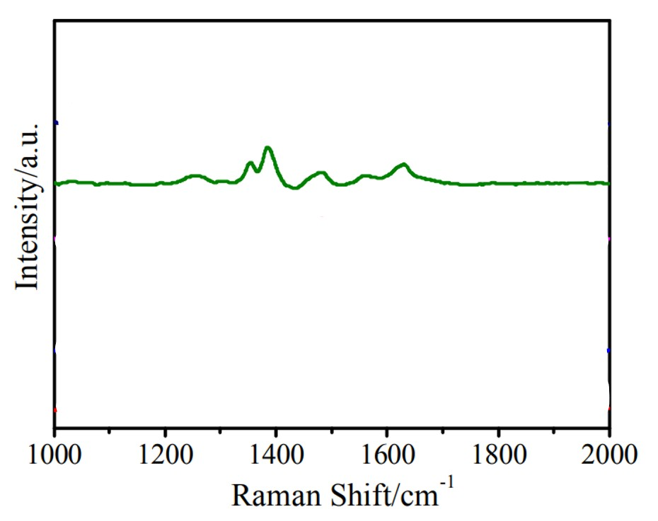
Figure 33:http://dx.doi.org/10.1039/c5cp02666k
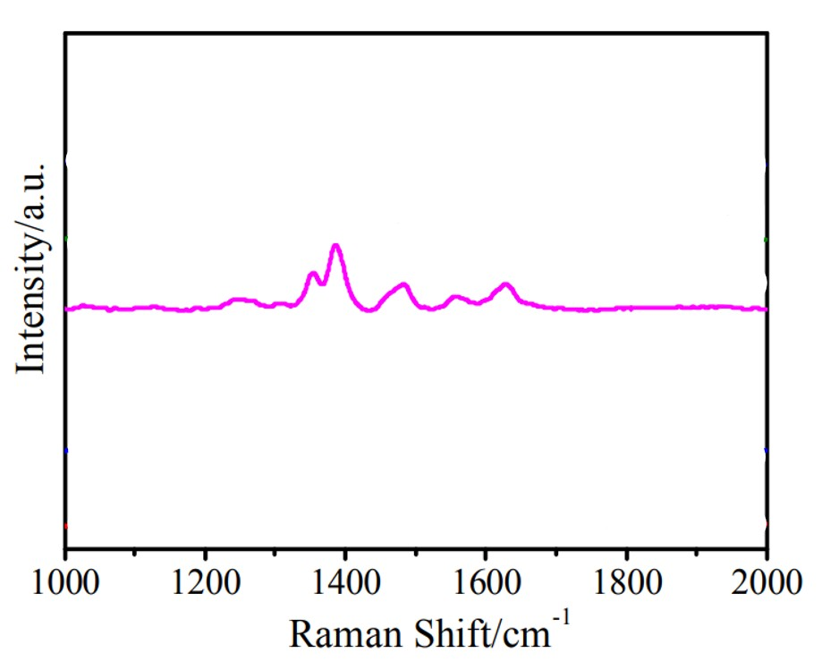
Figure 34:http://dx.doi.org/10.1039/c5cp02666k
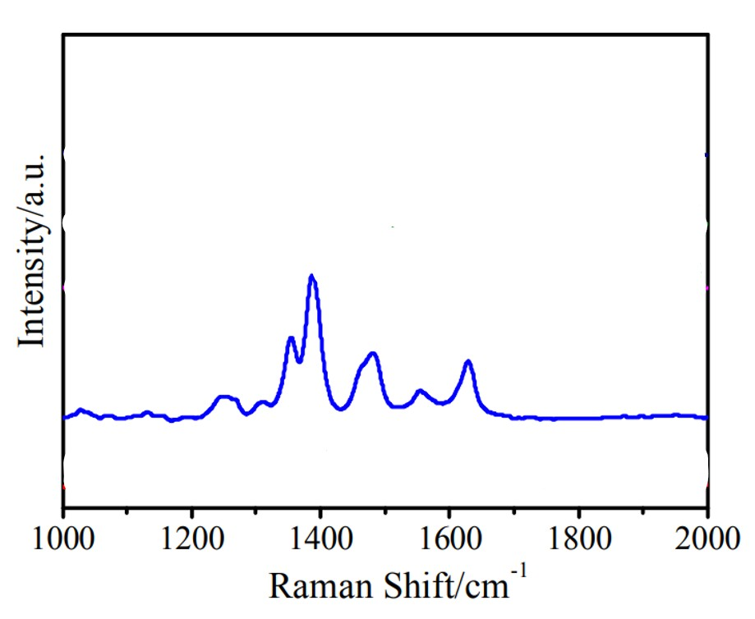
Figure 35:http://dx.doi.org/10.1039/c5cp02666k
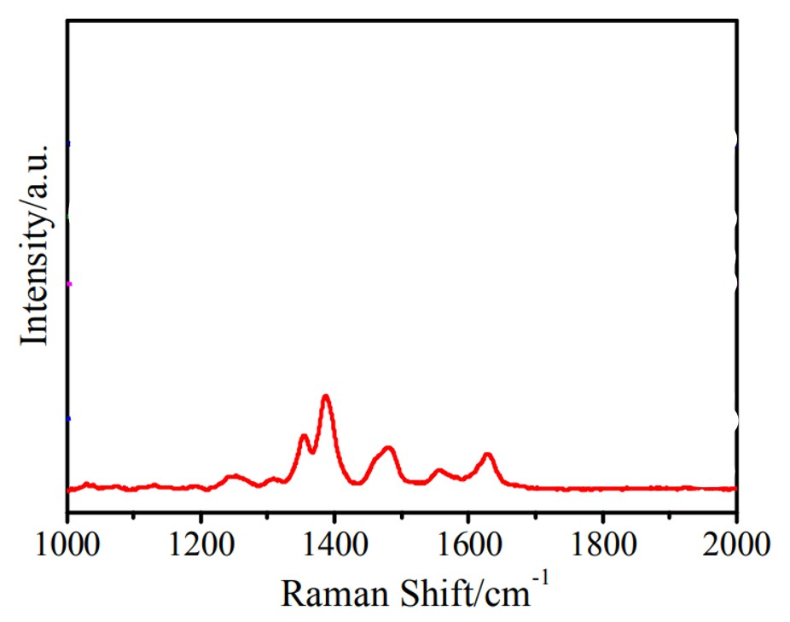
Figure 36:http://dx.doi.org/10.1039/c5cp02666k
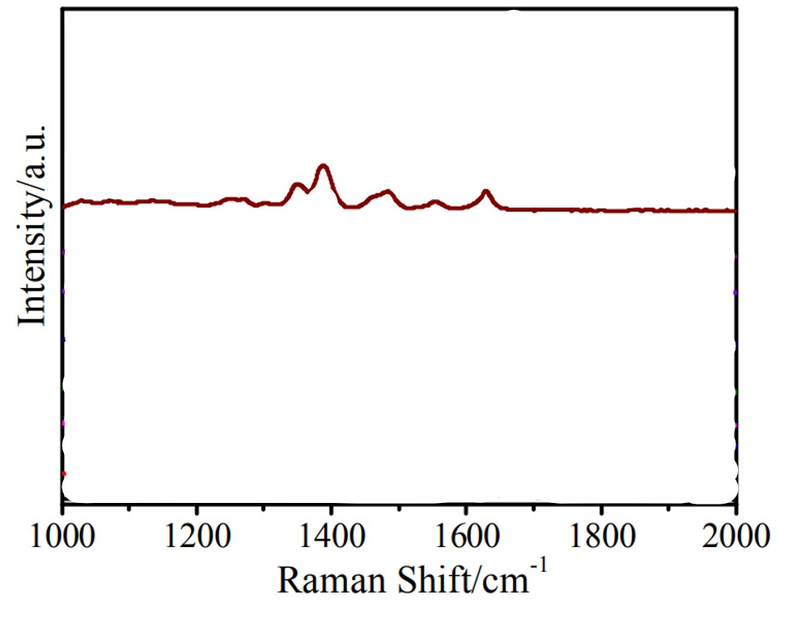
Figure 37:http://dx.doi.org/10.1039/c5cp02666k
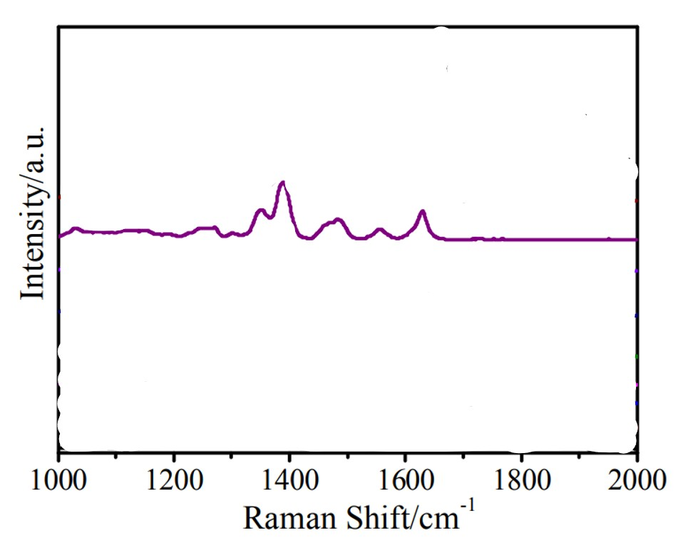
Figure 38:http://dx.doi.org/10.1039/c5cp02666k
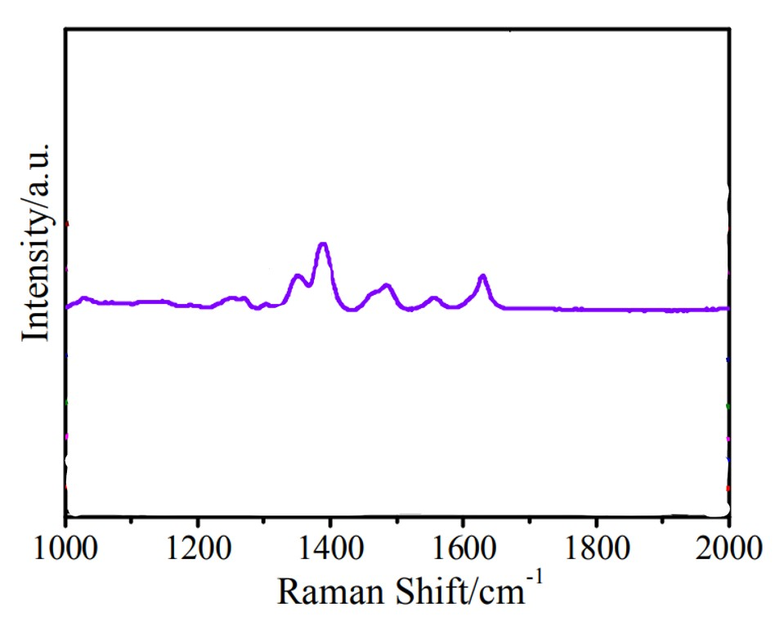
Figure 39:http://dx.doi.org/10.1039/c5cp02666k
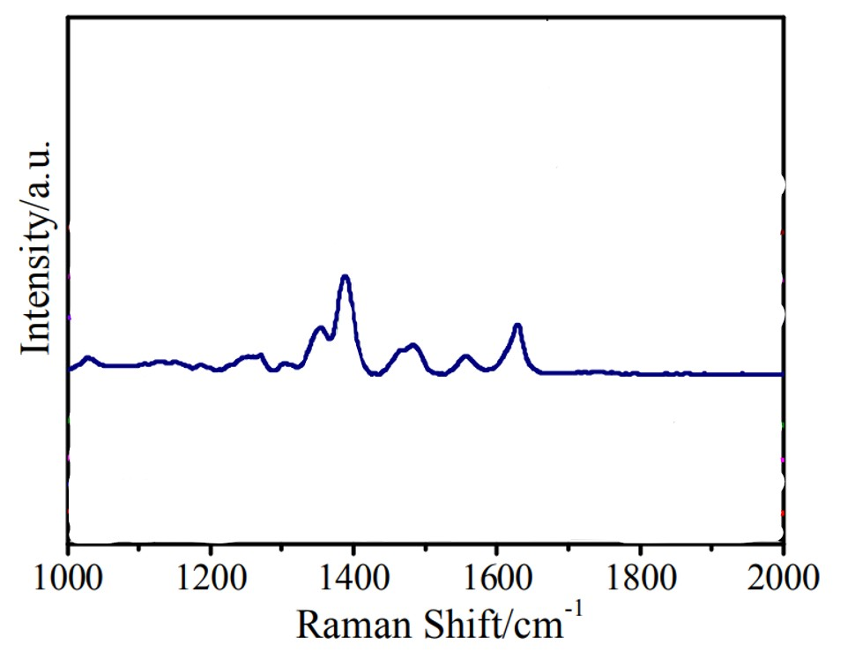
Figure 40:http://dx.doi.org/10.1039/c5cp02666k
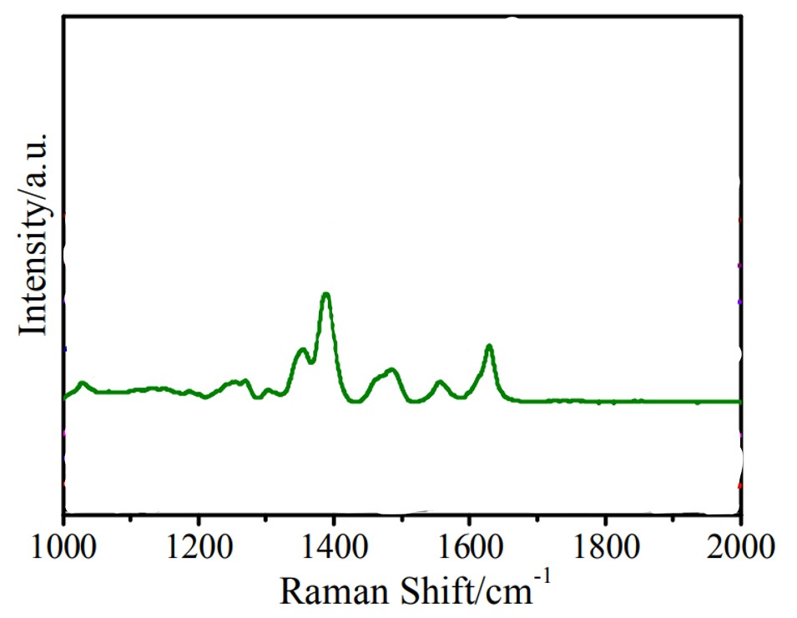
Figure 41:http://dx.doi.org/10.1039/c5cp02666k
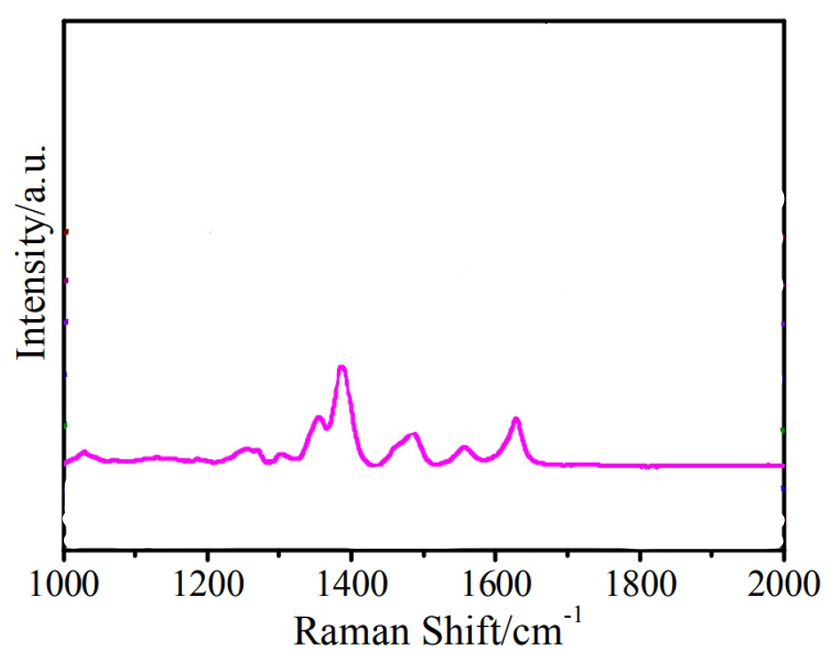
Figure 42:http://dx.doi.org/10.1039/c5cp02666k
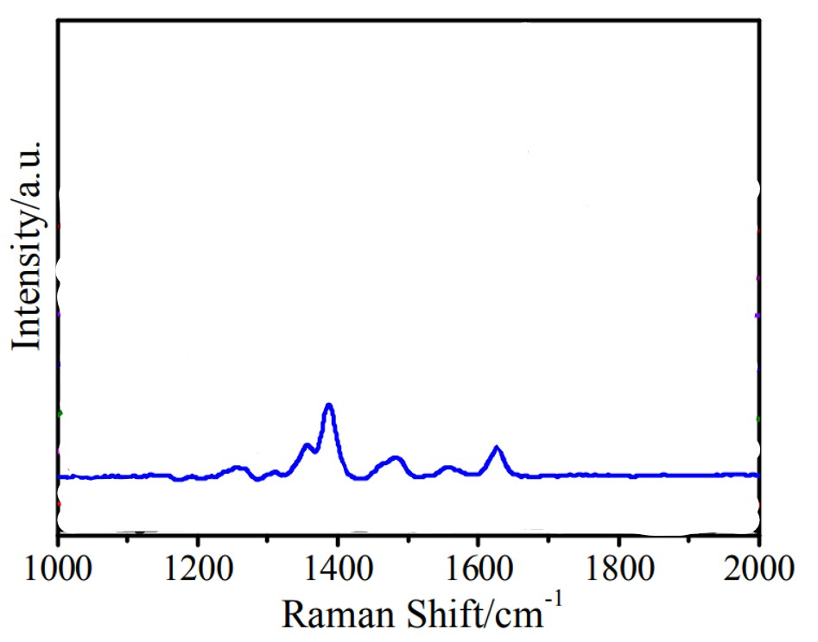
Figure 43:http://dx.doi.org/10.1039/c5cp02666k
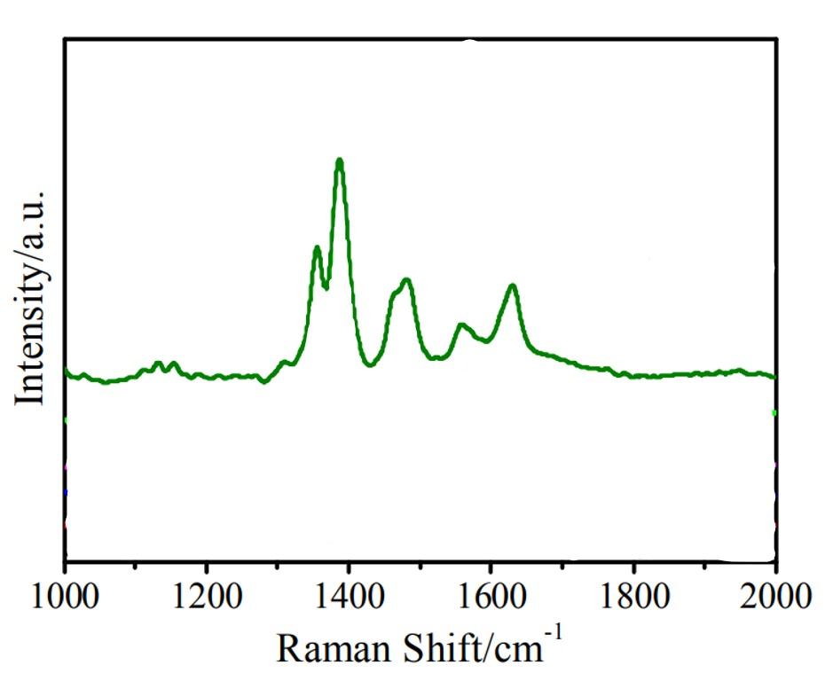
Figure 44:http://dx.doi.org/10.1039/c5cp02666k
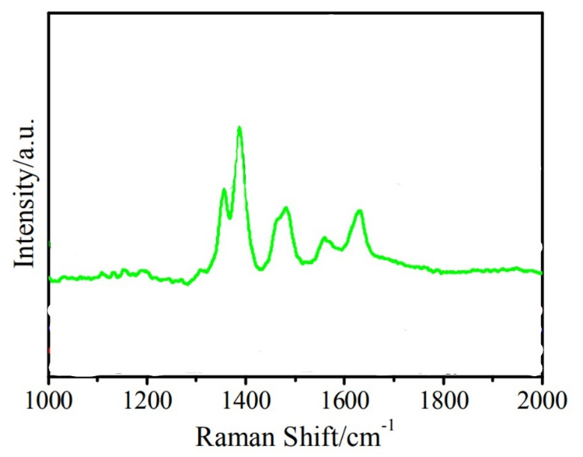
Figure 45:http://dx.doi.org/10.1039/c5cp02666k
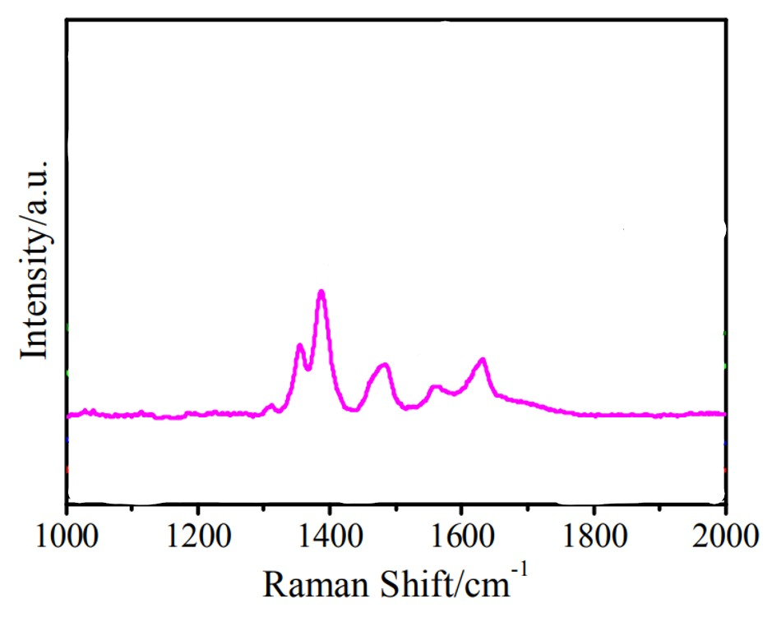
Figure 46:http://dx.doi.org/10.1039/c5cp02666k
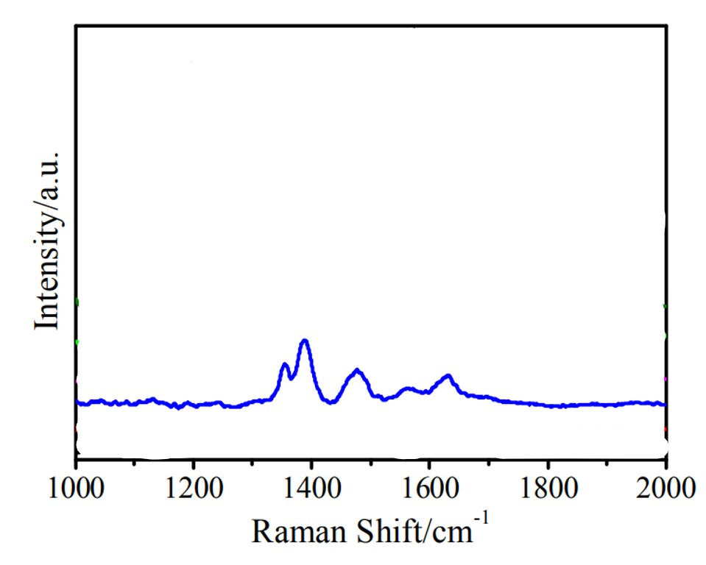
Figure 47:http://dx.doi.org/10.1039/c5cp02666k
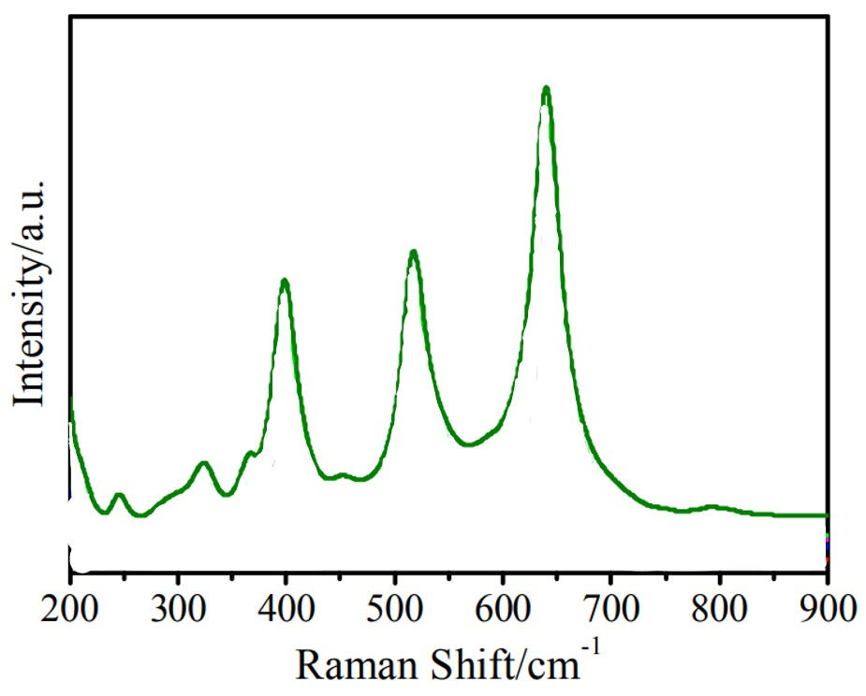
Figure 48:http://dx.doi.org/10.1039/c5cp02666k
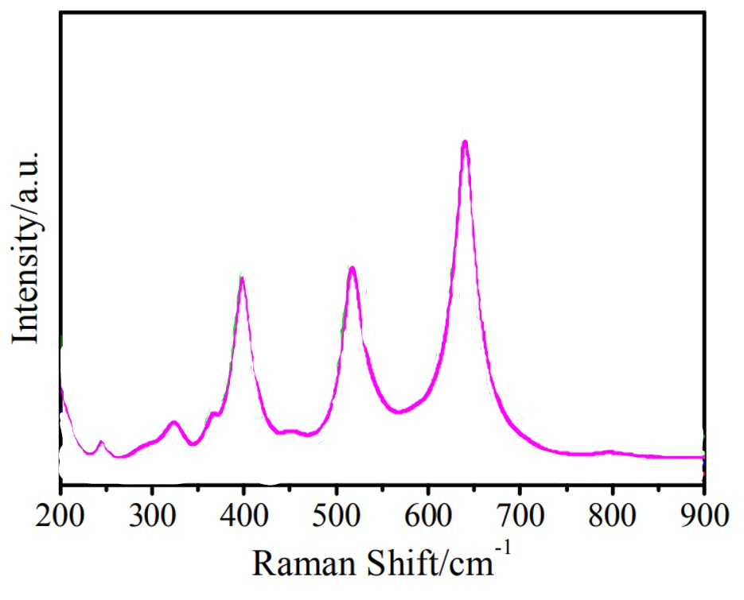
Figure 49:http://dx.doi.org/10.1039/c5cp02666k
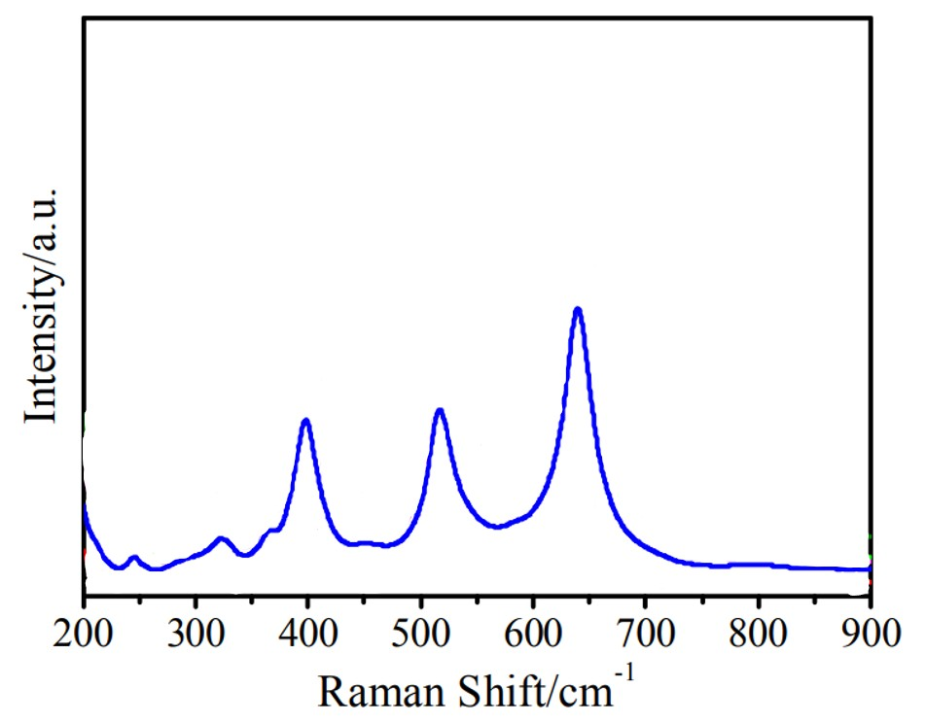
Figure 50:http://dx.doi.org/10.1039/c5cp02666k
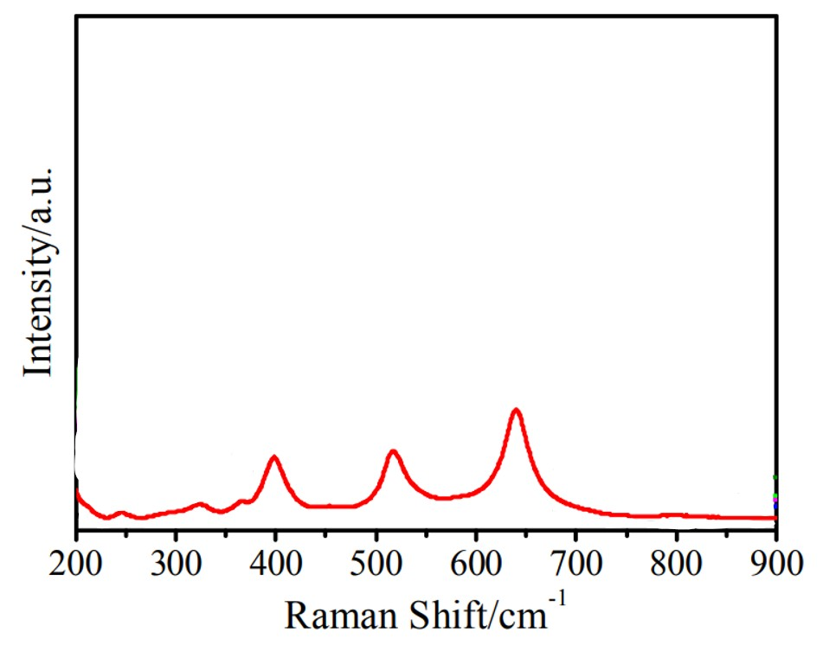
Figure 51:http://dx.doi.org/10.1039/c5cp02666k
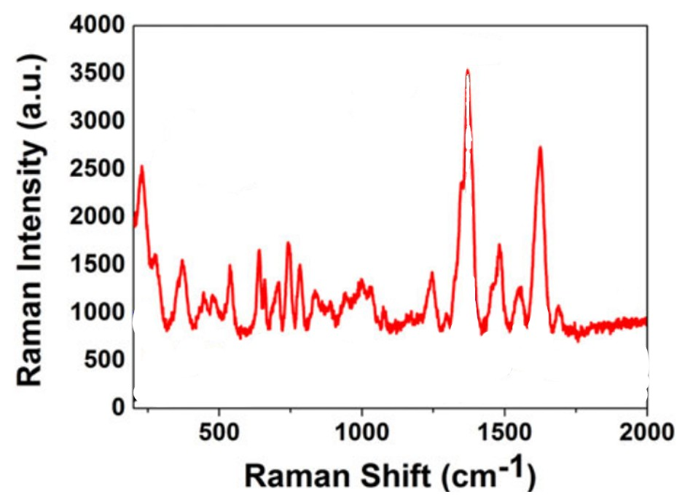
Figure 52:https://doi.org/10.1080/00032719.2019.1663861
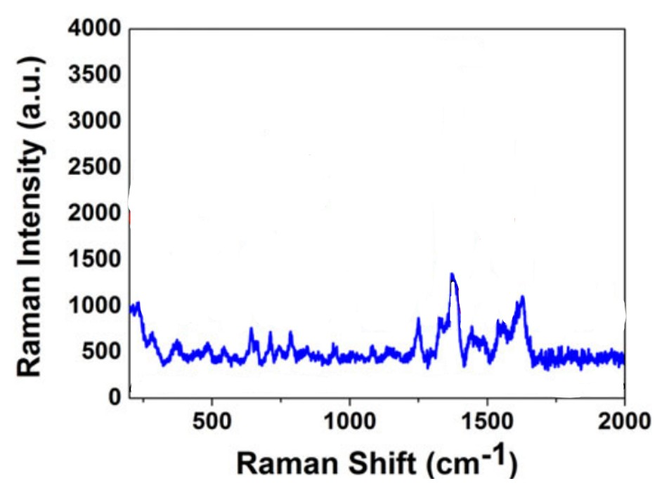
Figure 53:https://doi.org/10.1080/00032719.2019.1663861
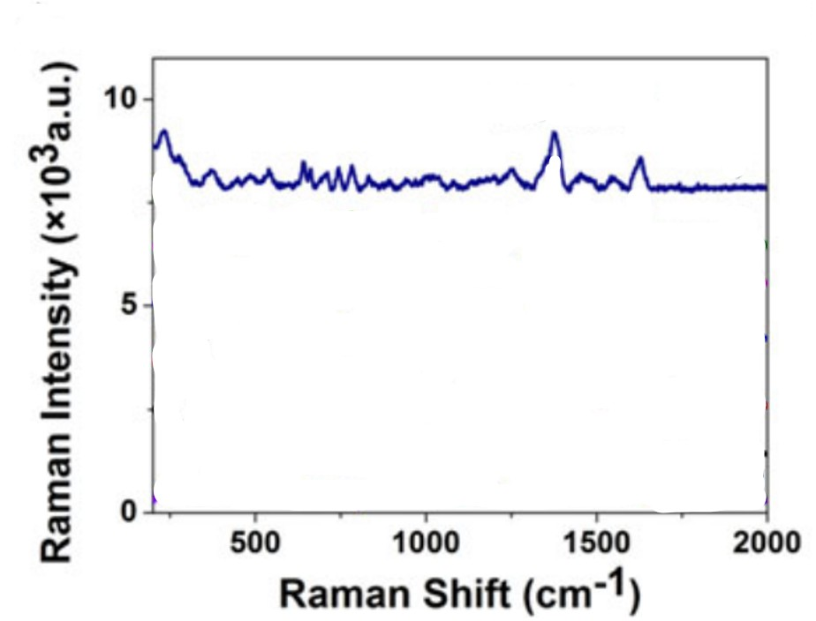
Figure 54:https://doi.org/10.1080/00032719.2019.1663861
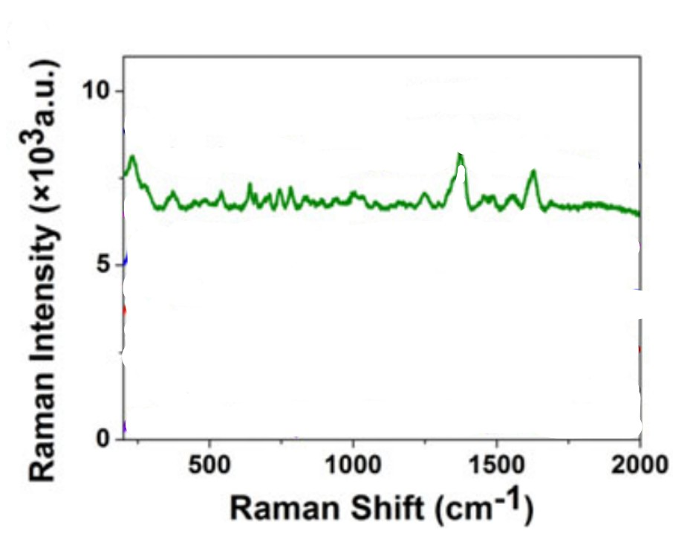
Figure 55:https://doi.org/10.1080/00032719.2019.1663861
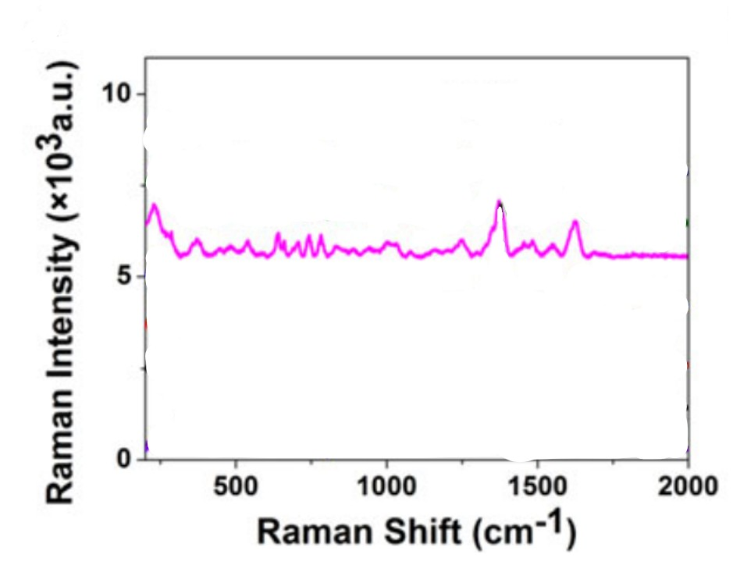
Figure 56:https://doi.org/10.1080/00032719.2019.1663861
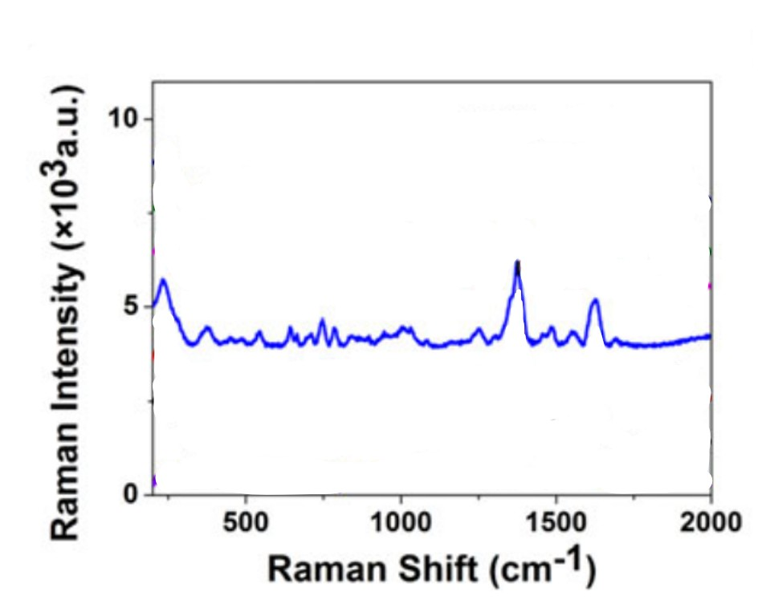
Figure 57:https://doi.org/10.1080/00032719.2019.1663861
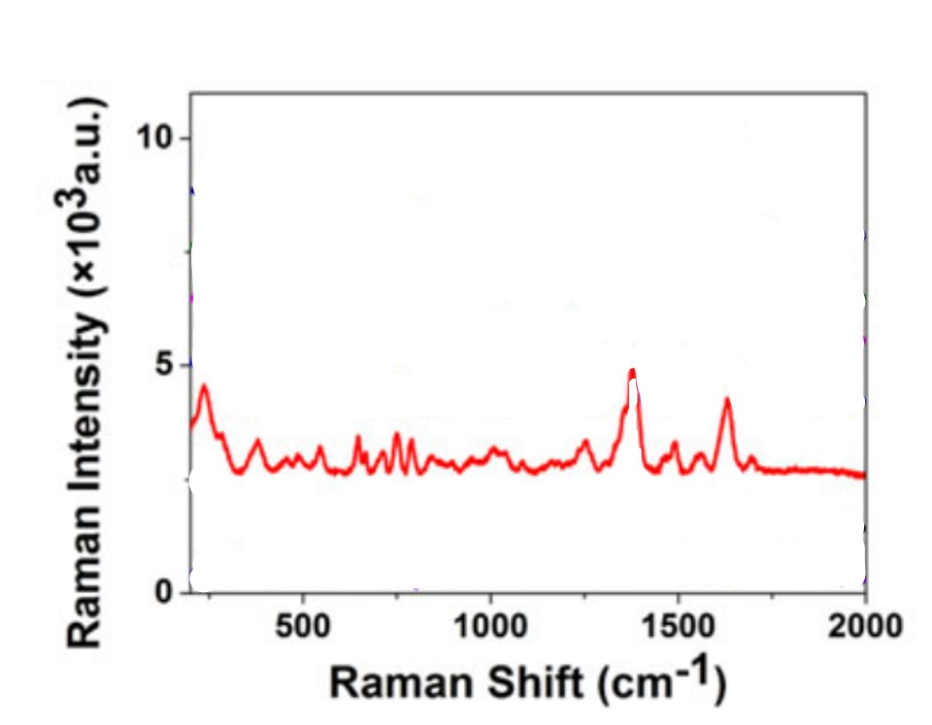
Figure 58:https://doi.org/10.1080/00032719.2019.1663861
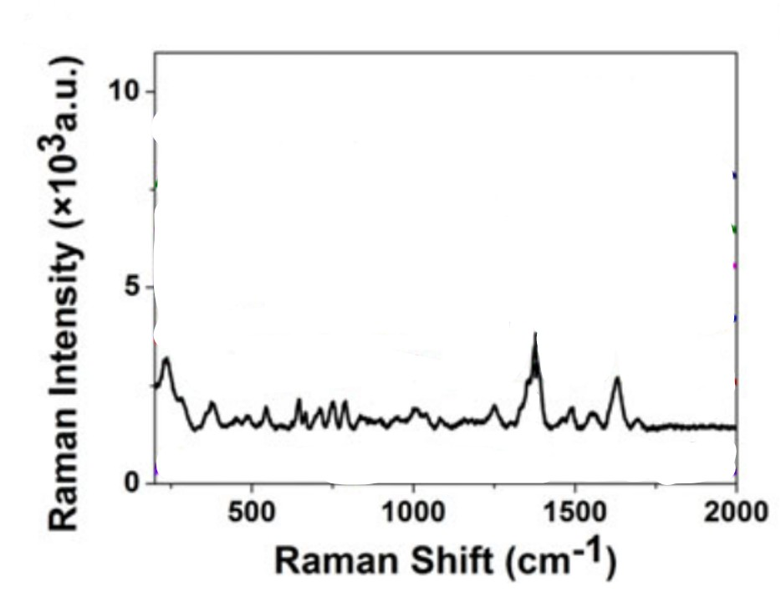
Figure 59:https://doi.org/10.1080/00032719.2019.1663861
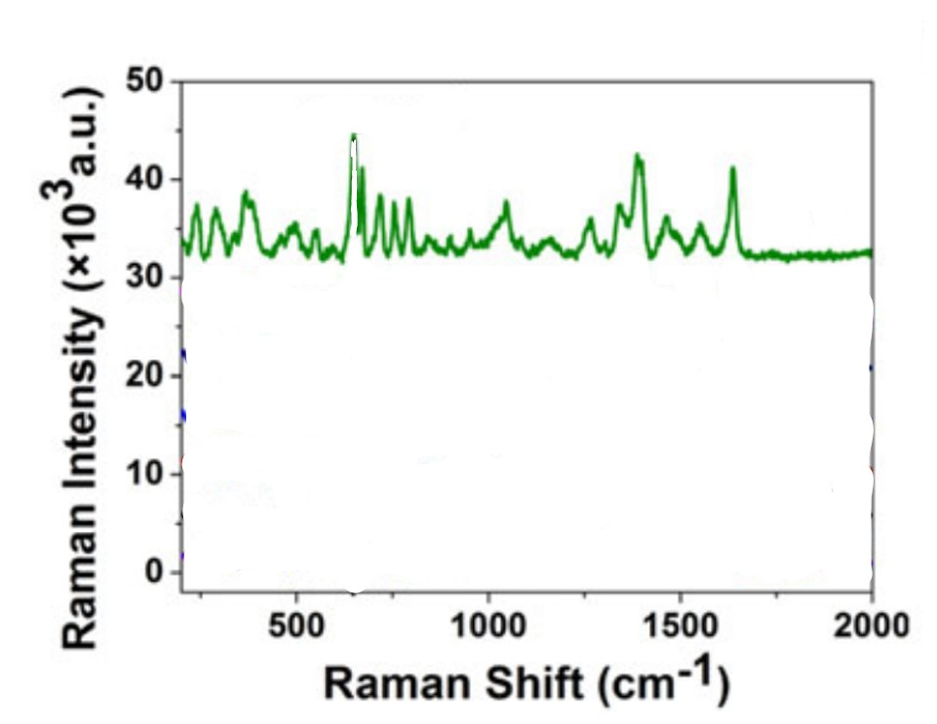
Figure 60:https://doi.org/10.1080/00032719.2019.1663861
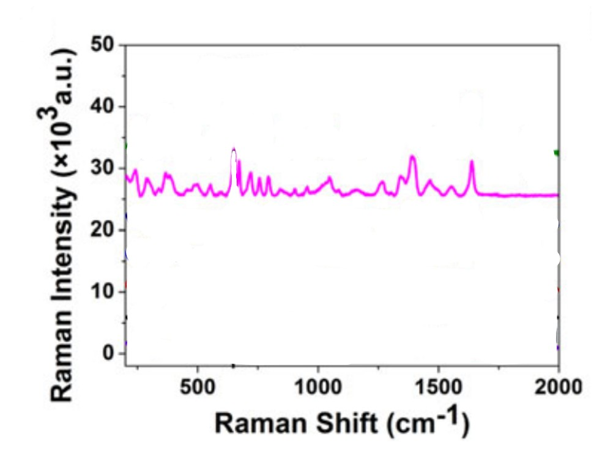
Figure 61:https://doi.org/10.1080/00032719.2019.1663861
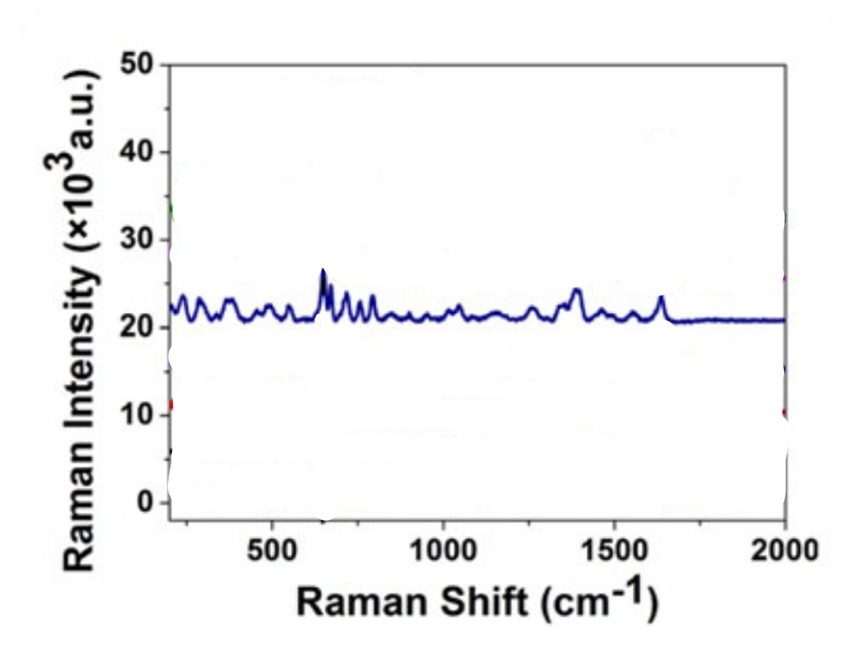
Figure 62:https://doi.org/10.1080/00032719.2019.1663861
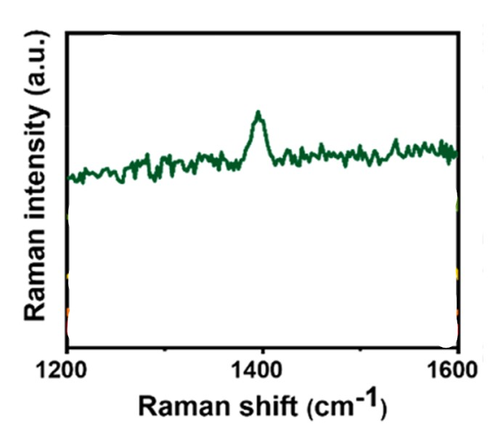
Figure 63:https://doi.org/10.1021/acsaenm.3c00326?urlappend=%3Fref%3DPDF&jav=VoR&rel=cite-as
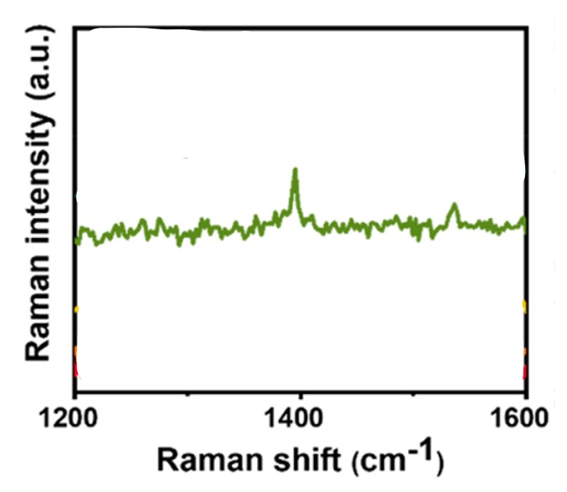
Figure 64:https://doi.org/10.1021/acsaenm.3c00326?urlappend=%3Fref%3DPDF&jav=VoR&rel=cite-as
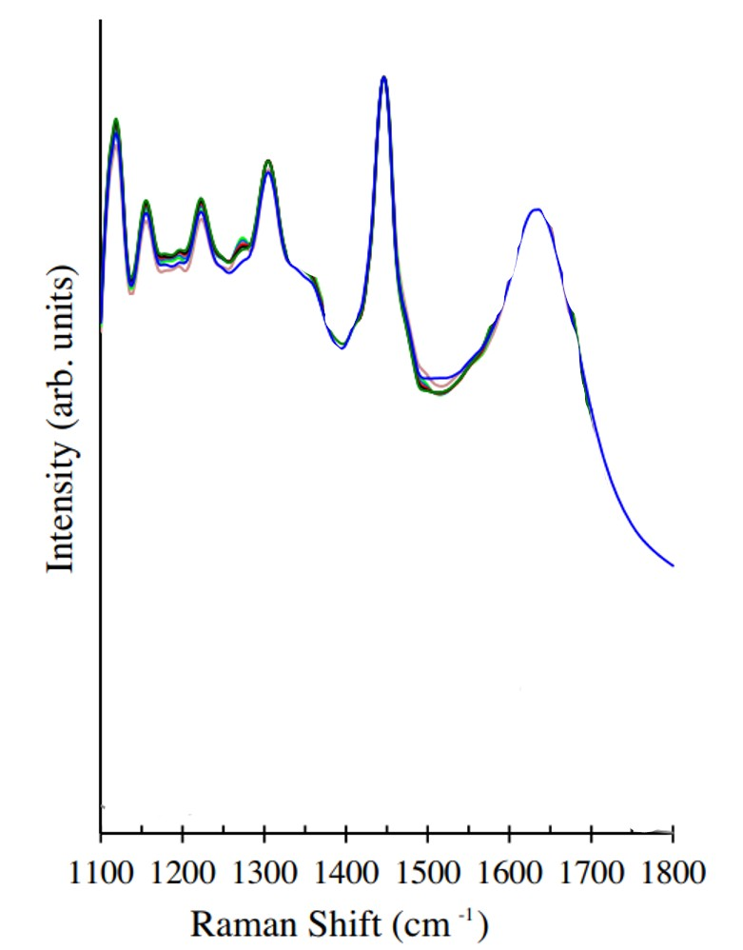
Figure 65:http://dx.doi.org/10.1016/j.jpba.2016.12.02
Figure 66:
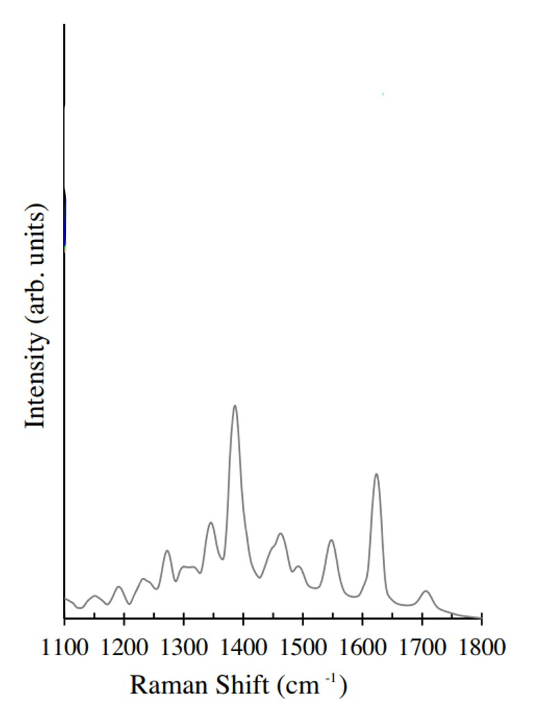
Figure 66:http://dx.doi.org/10.1016/j.jpba.2016.12.020
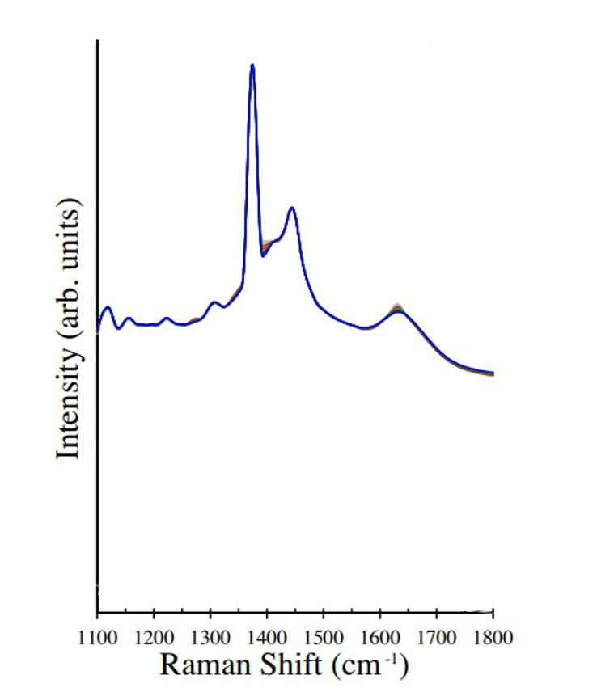
Figure 67:http://dx.doi.org/10.1016/j.jpba.2016.12.020
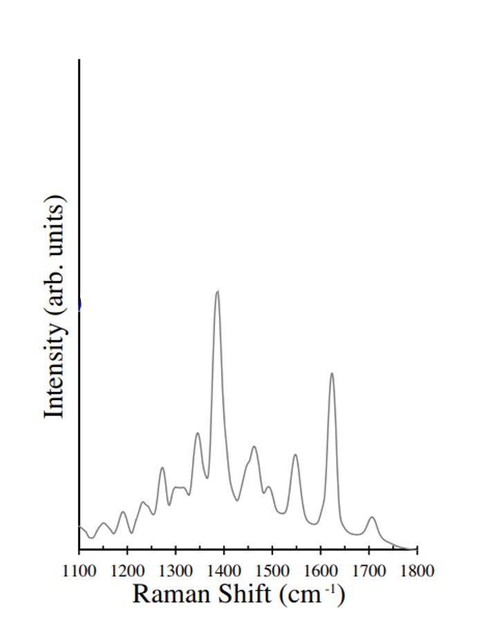
Figure 68:http://dx.doi.org/10.1016/j.jpba.2016.12.020
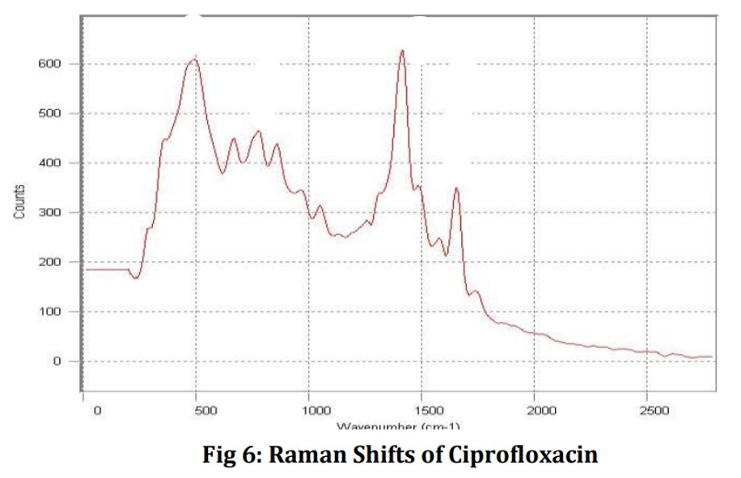
Figure 69:https://www.researchgate.net/publication/375496075_FTIR_AND_RAMAN_SPECTROSCOPIC_INVESTIGATIONS_OF_A_CONTROLLED_RELEASE_CIPROFLOXACIN_CARBOPOL940_MUCOADHESIVE_SUSPENSION?enrichId=rgreq-fd1f55c9a575de888d592ab40d10962e-XXX&enrichSource=Y292ZXJQYWdlOzM3NTQ
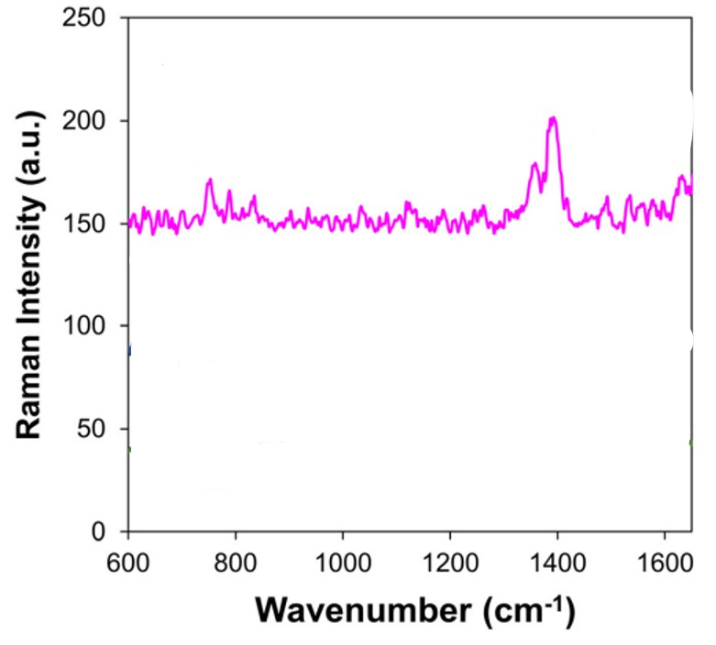
Figure 70:DOI: 10.1039/d3an01449e
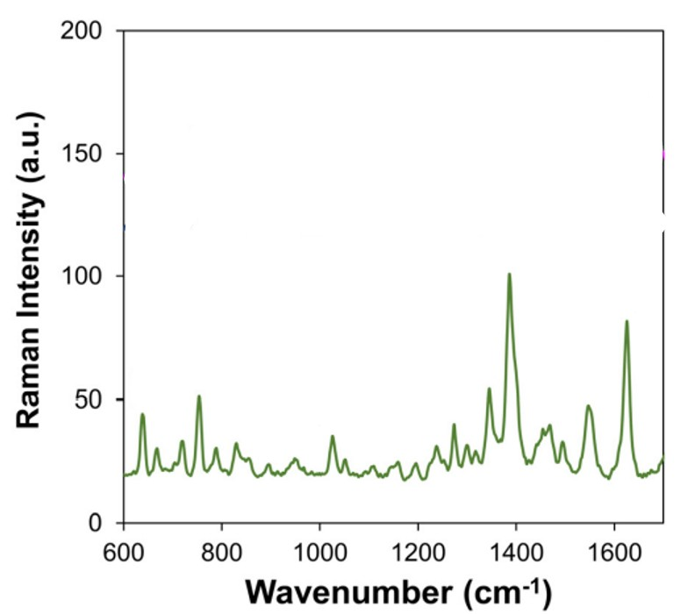
Figure 71:DOI: 10.1039/d3an01449e
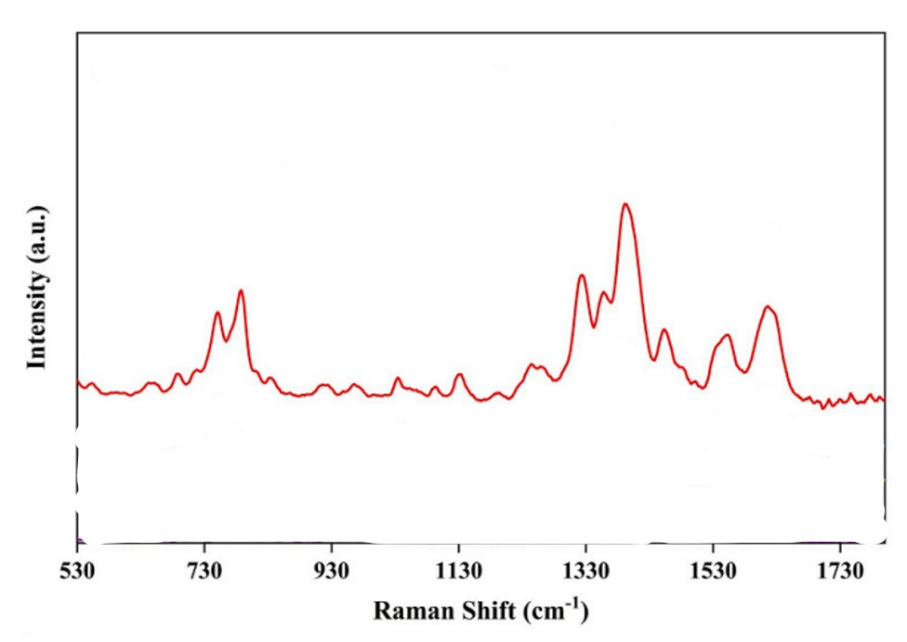
Figure 72:https://doi.org/10.1016/j.eti.2024.103987
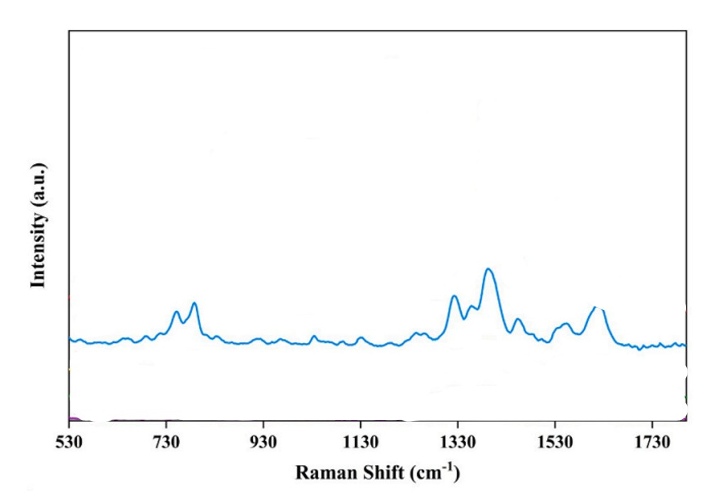
Figure 73:https://doi.org/10.1016/j.eti.2024.103987
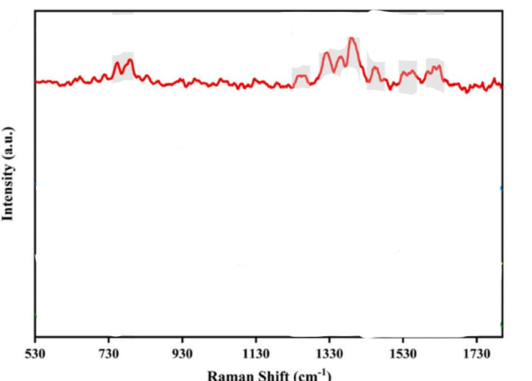
Figure 74:https://doi.org/10.1016/j.eti.2024.103987
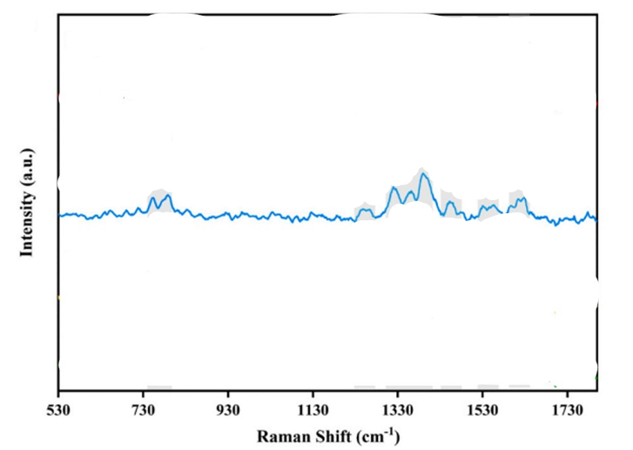
Figure 75:https://doi.org/10.1016/j.eti.2024.103987
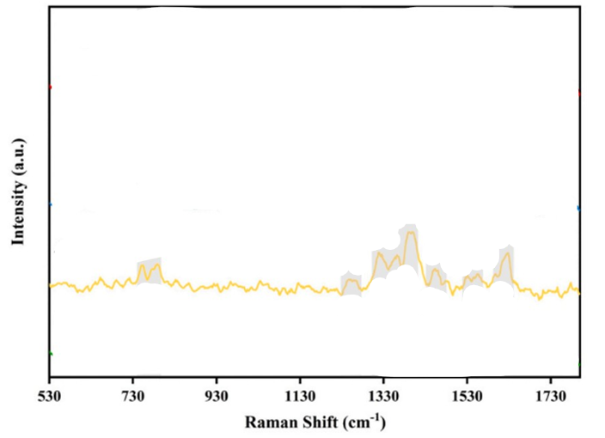
Figure 76:https://doi.org/10.1016/j.eti.2024.103987
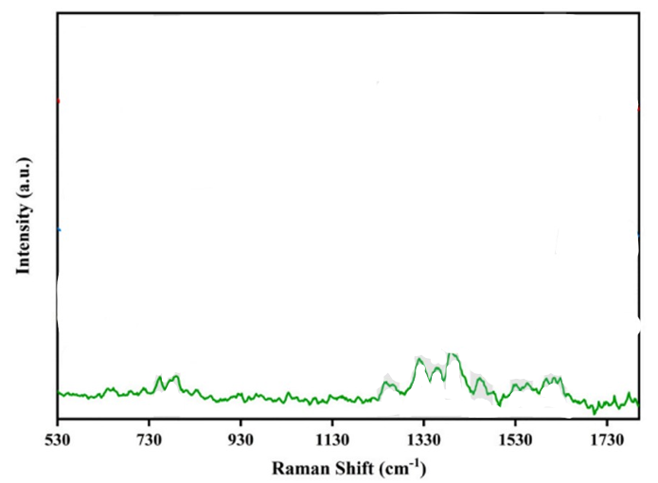
Figure 77:https://doi.org/10.1016/j.eti.2024.103987
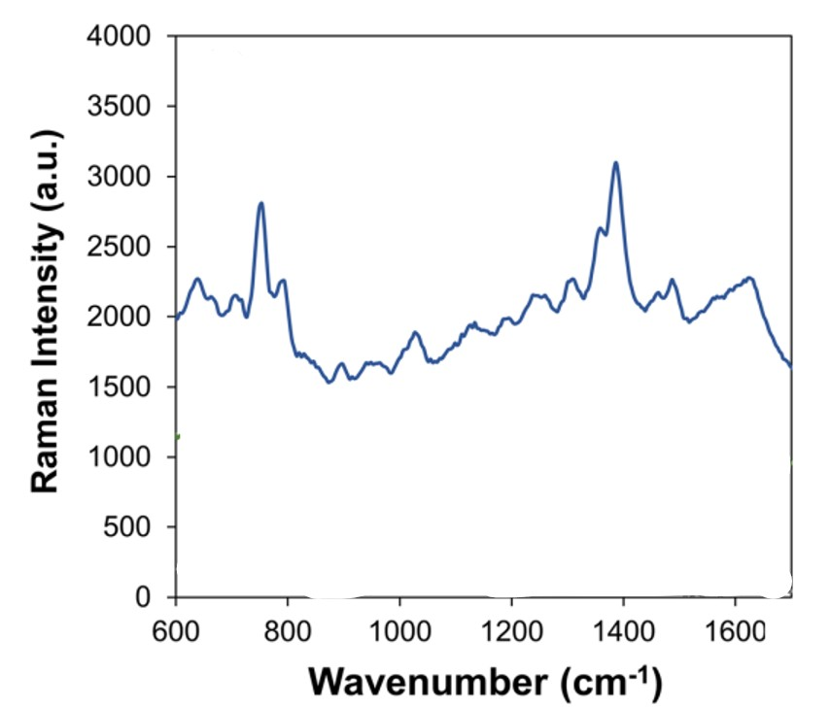
Figure 78:DOI: 10.1039/d3an01449e
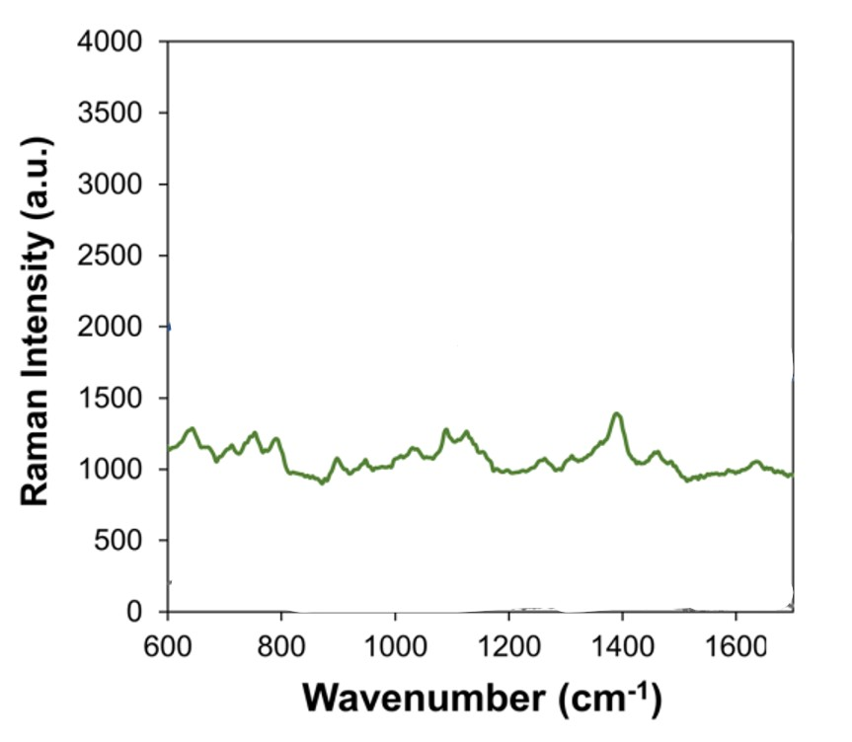
Figure 79:DOI: 10.1039/d3an01449e
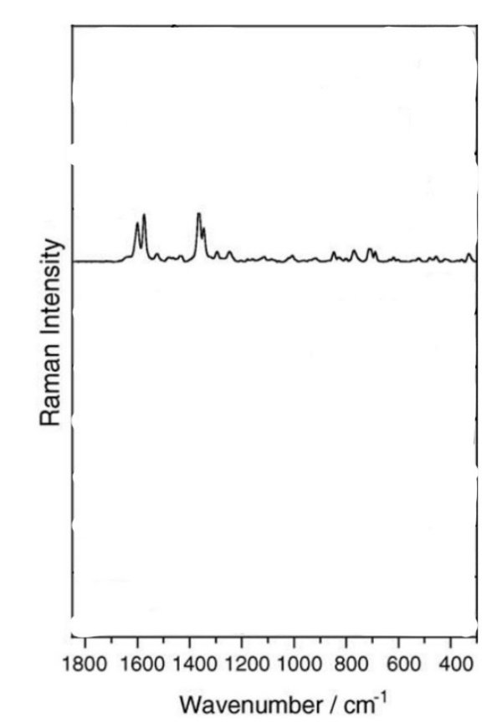
Figure 80:doi:10.1016/j.saa.2004.11.014
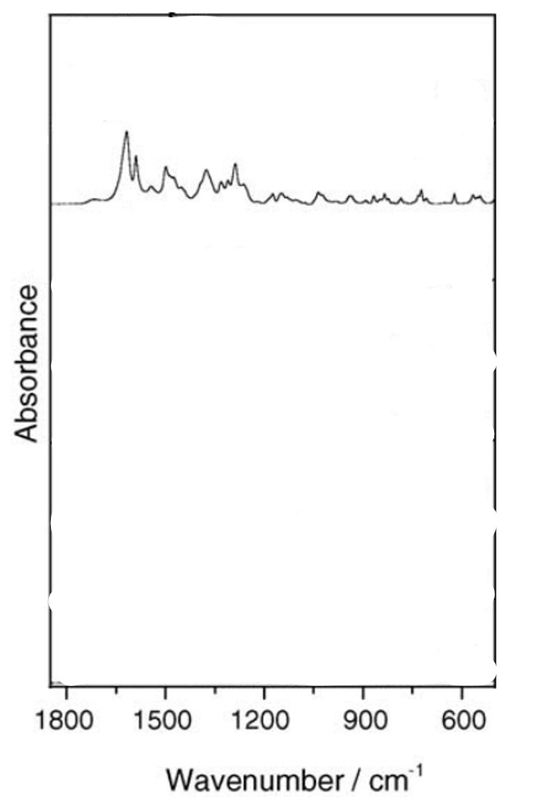
Figure 81:doi:10.1016/j.saa.2004.11.014
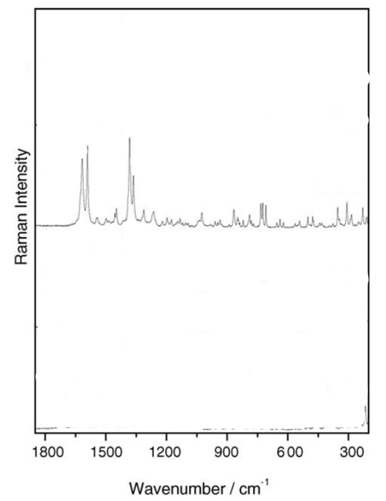
Figure 82:doi:10.1016/j.saa.2004.11.014
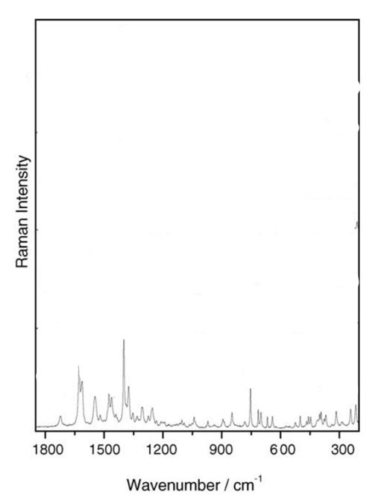
Figure 83:doi:10.1016/j.saa.2004.11.014
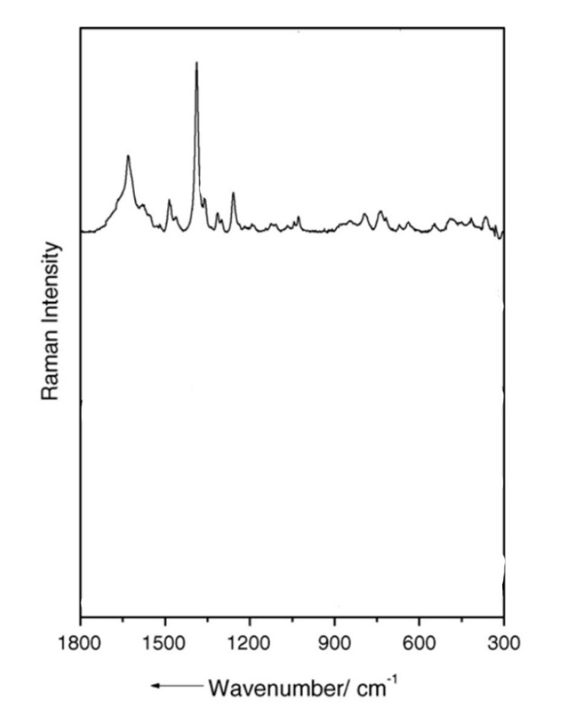
Figure 84:doi:10.1016/j.saa.2004.11.014
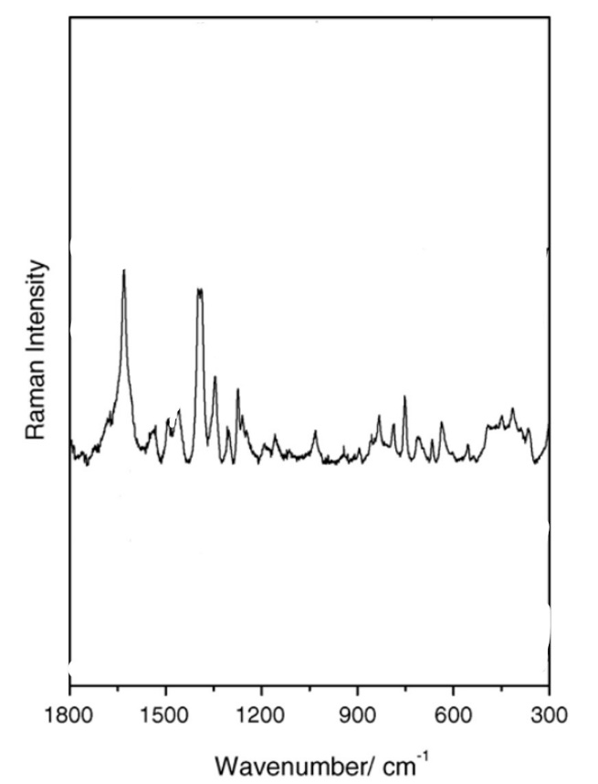
Figure 85:doi:10.1016/j.saa.2004.11.014
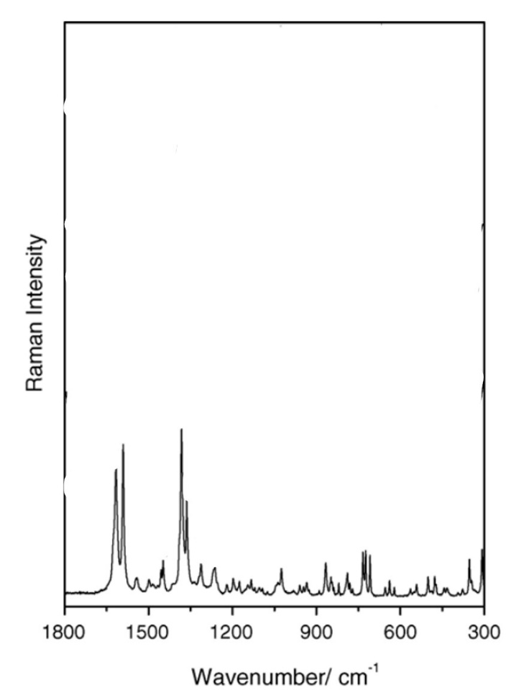
Figure 86:doi:10.1016/j.saa.2004.11.014
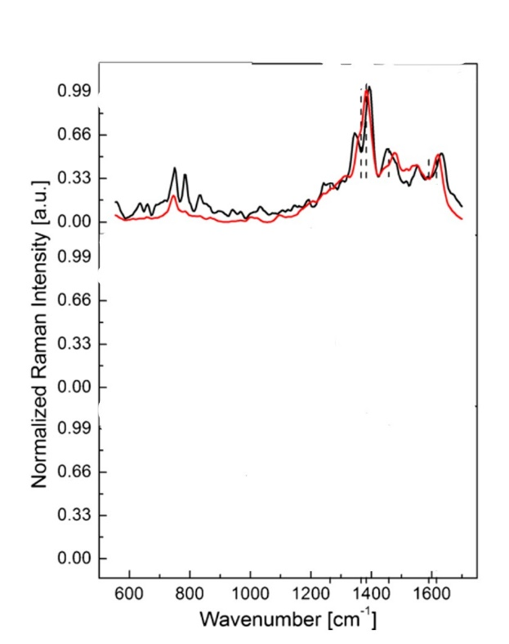
Figure 87: doi:10.1007/s00216-016-9957-2
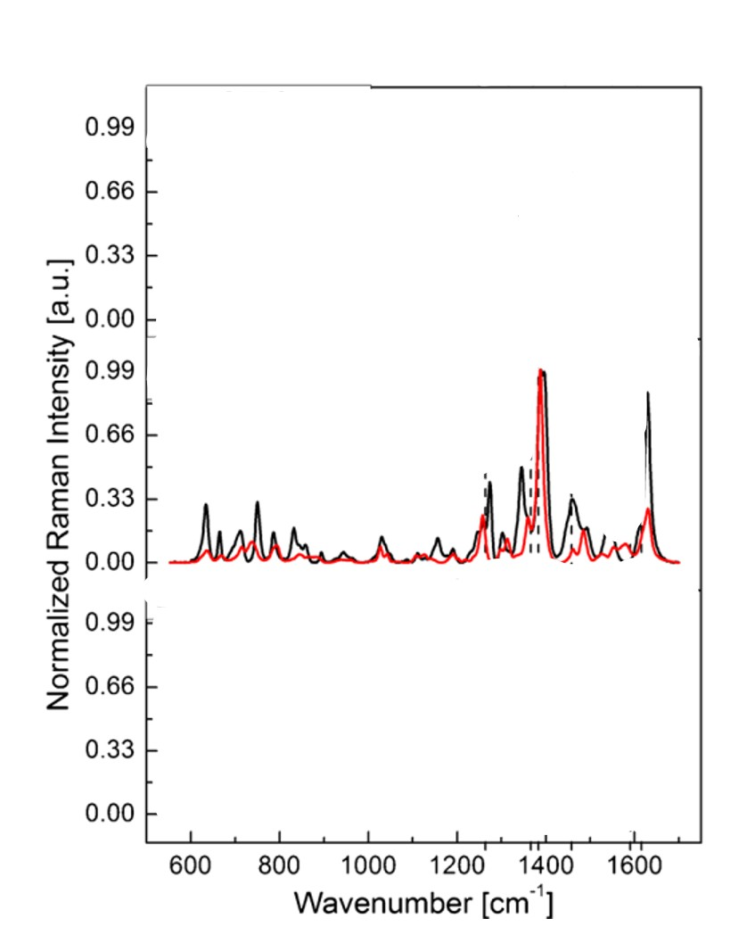
Figure 88: doi:10.1007/s00216-016-9957-2
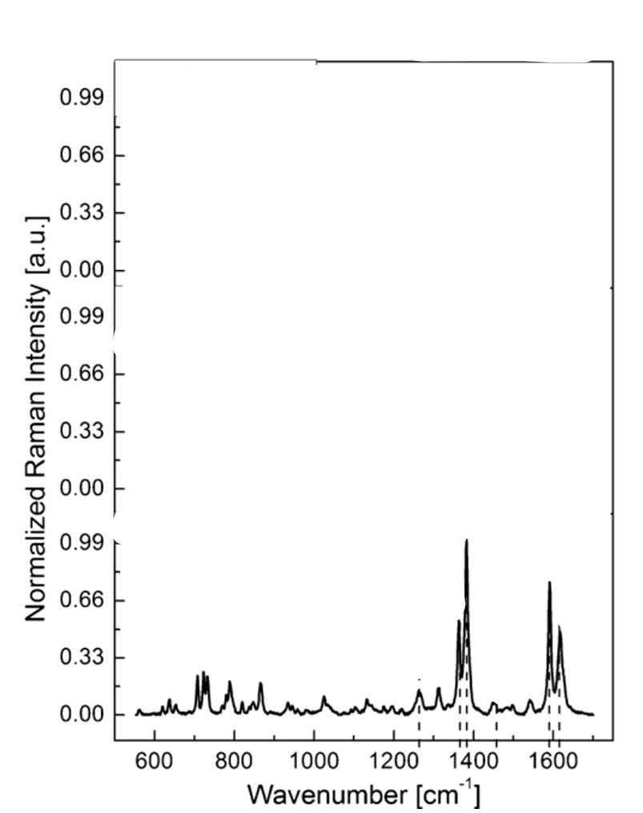
Figure 89: doi:10.1007/s00216-016-9957-2
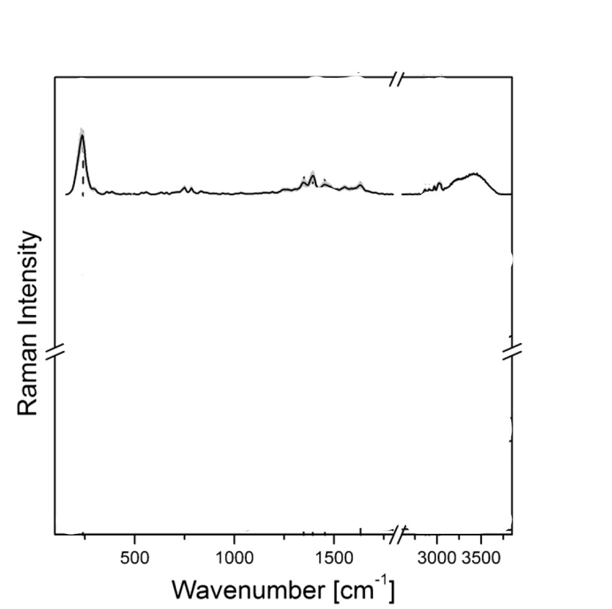
Figure 90: doi:10.1007/s00216-016-9957-2
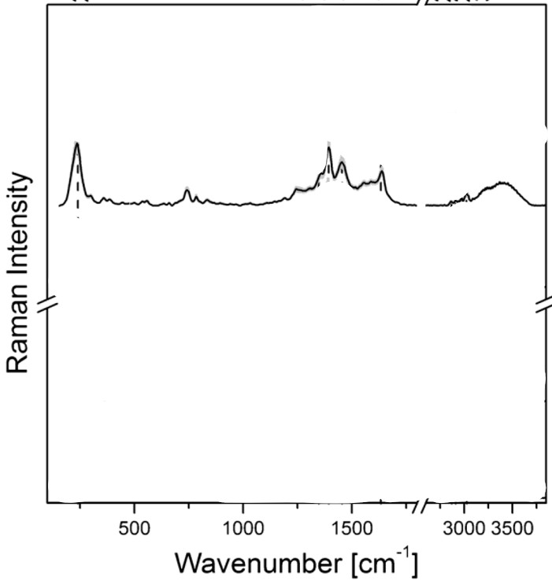
Figure 91: doi:10.1007/s00216-016-9957-2
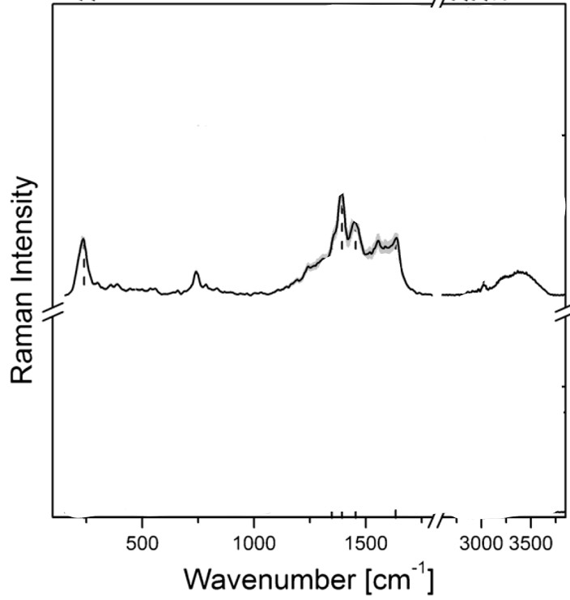
Figure 92: doi:10.1007/s00216-016-9957-2
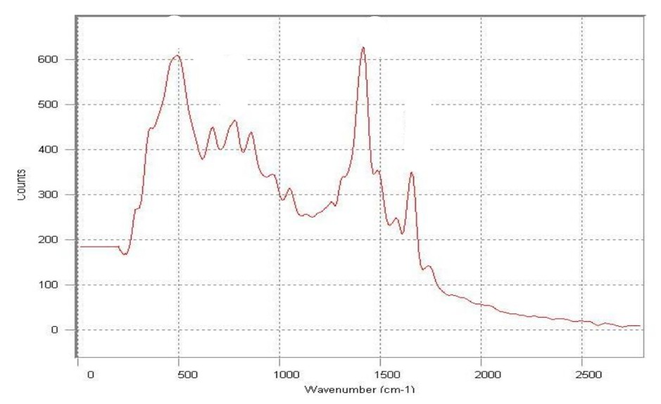
Figure 93: https://www.researchgate.net/profile/Subhashree-Sahoo-6/publication/375497320_SPECTROSCOPIC_INVESTIGATIONS_OF_A_CIPROFLOXACIN_HPMC_MUCOADHESIVE_SUSPENSION/links/654cb0a4b1398a779d73328a/Spectroscopic-investigations-of-a-Ciprofloxacin-HPMC-mucoadhesive-s
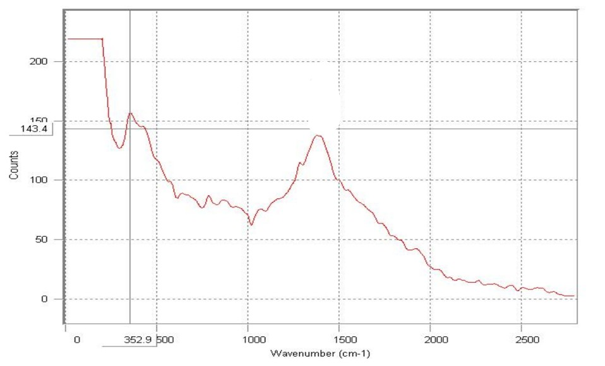
Figure 94: https://www.researchgate.net/profile/Subhashree-Sahoo-6/publication/375497320_SPECTROSCOPIC_INVESTIGATIONS_OF_A_CIPROFLOXACIN_HPMC_MUCOADHESIVE_SUSPENSION/links/654cb0a4b1398a779d73328a/Spectroscopic-investigations-of-a-Ciprofloxacin-HPMC-mucoadhesive-s
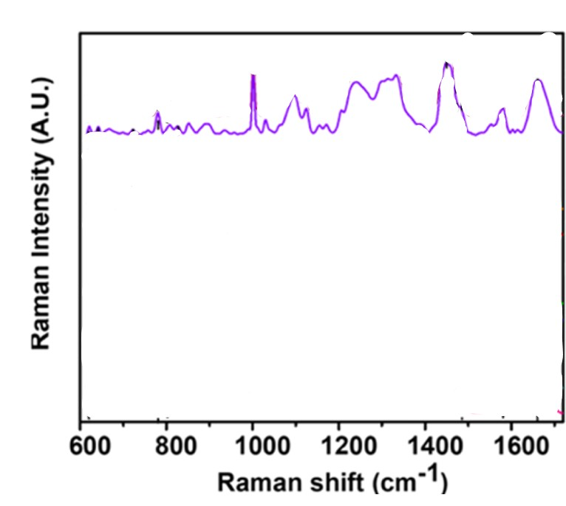
Figure 95: https://doi.org/10.1021/acs.analchem.3c01453
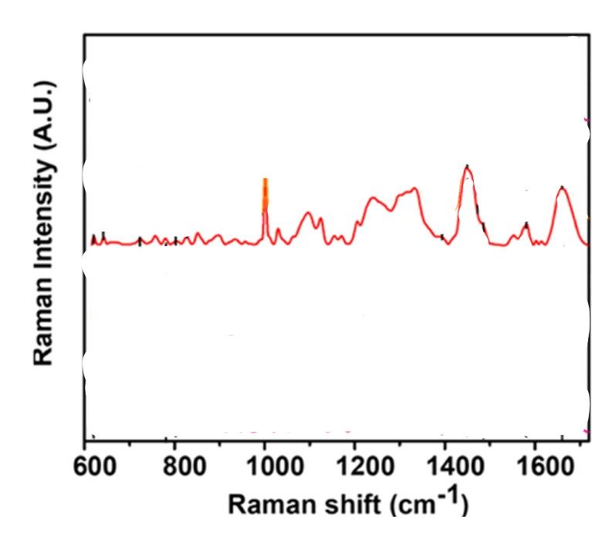
Figure 96: https://doi.org/10.1021/acs.analchem.3c01453
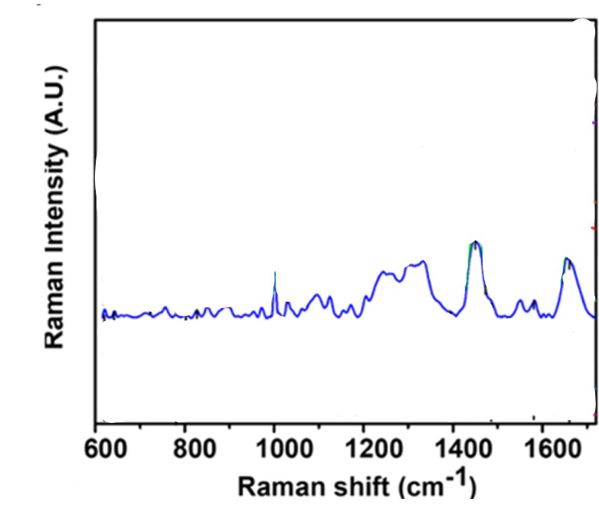
Figure 97: https://doi.org/10.1021/acs.analchem.3c01453
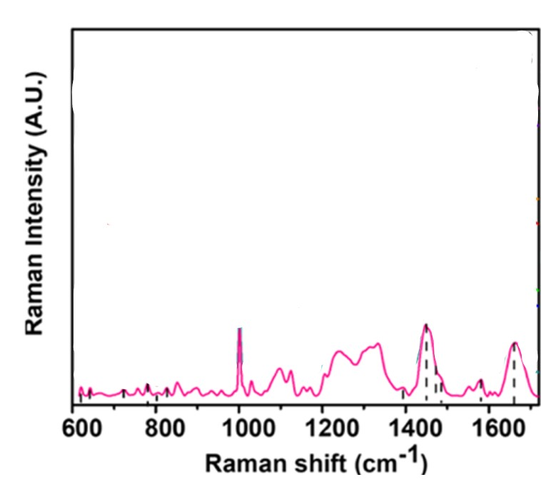
Figure 98: https://doi.org/10.1021/acs.analchem.3c01453
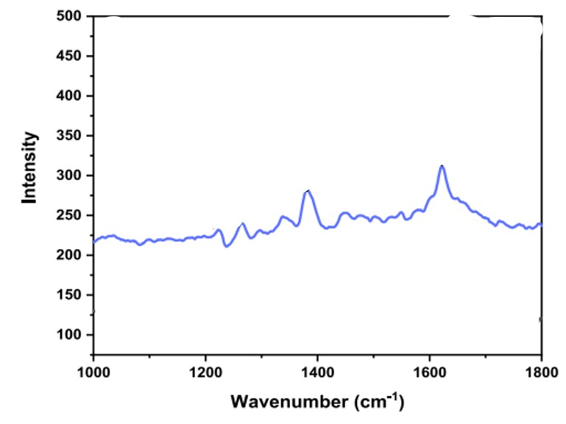
Figure 99: https://doi.org/10.1016/j.saa.2024.125237
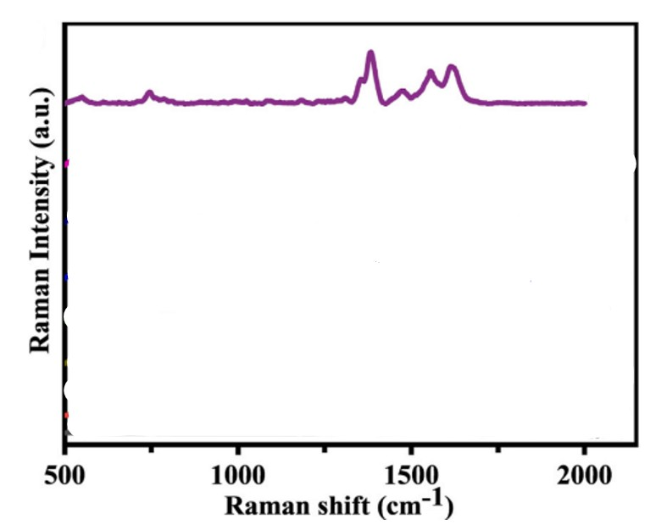
Figure 100: https://doi.org/10.1016/j.talanta.2023.124725
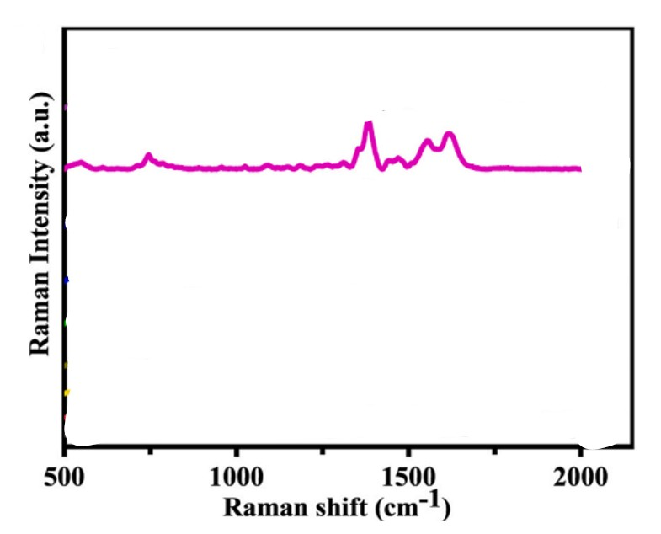
Figure 101: https://doi.org/10.1016/j.talanta.2023.124725
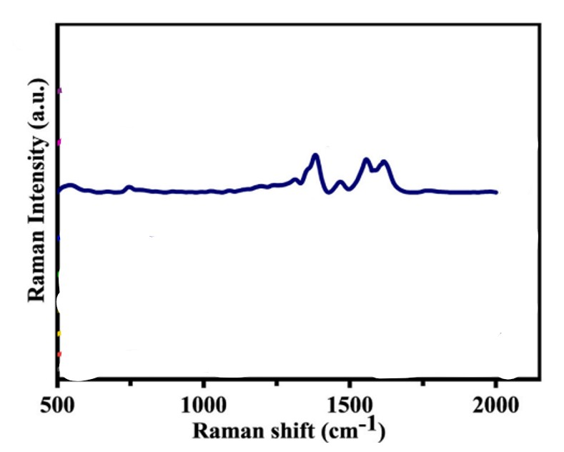
Figure102: https://doi.org/10.1016/j.talanta.2023.124725
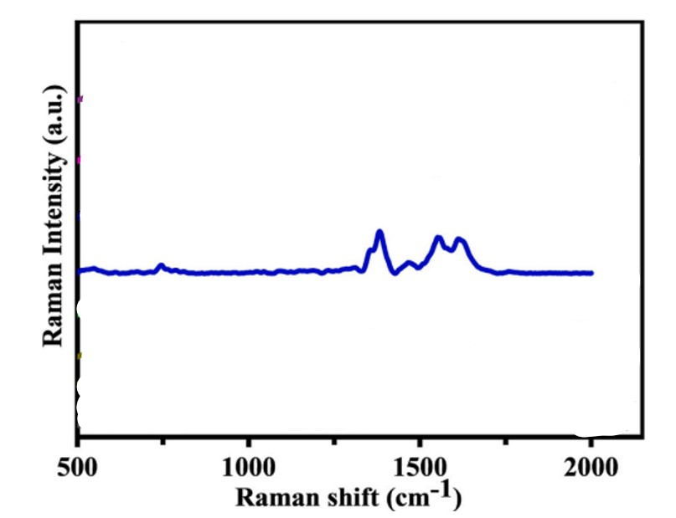
Figure 103: https://doi.org/10.1016/j.talanta.2023.124725
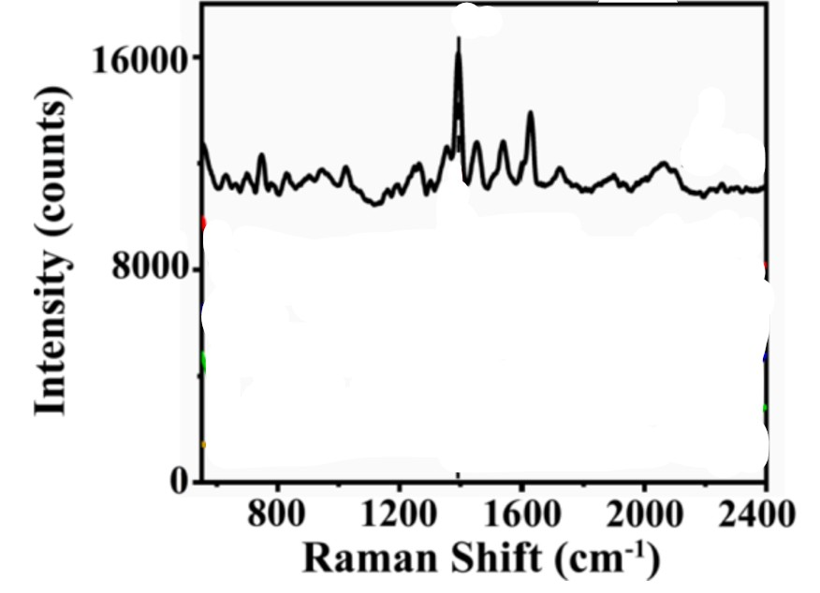
Figure 104: https://doi.org/10.1016/j.apsusc.2022.152543
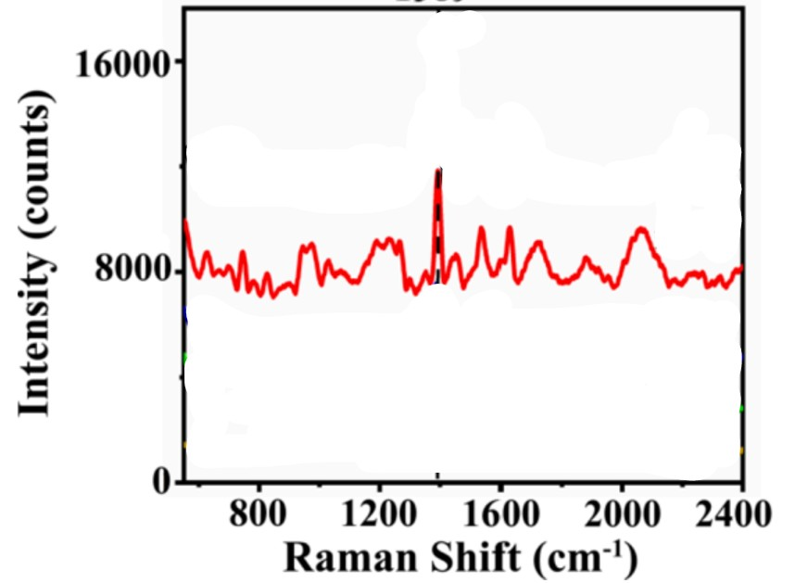
Figure 105: https://doi.org/10.1016/j.apsusc.2022.152543
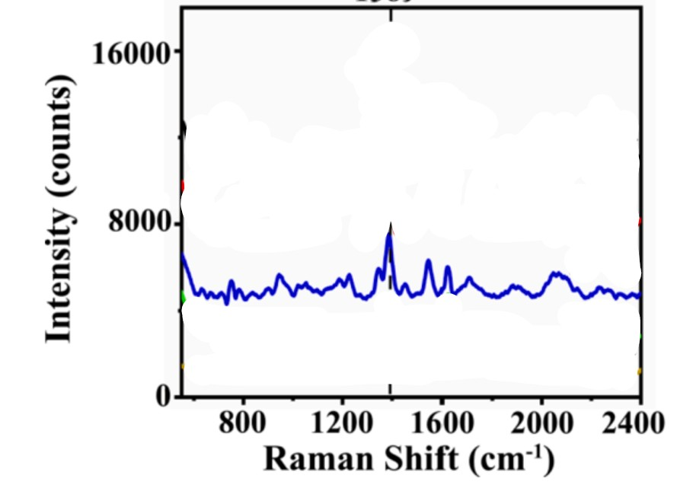
Figure 106: https://doi.org/10.1016/j.apsusc.2022.152543
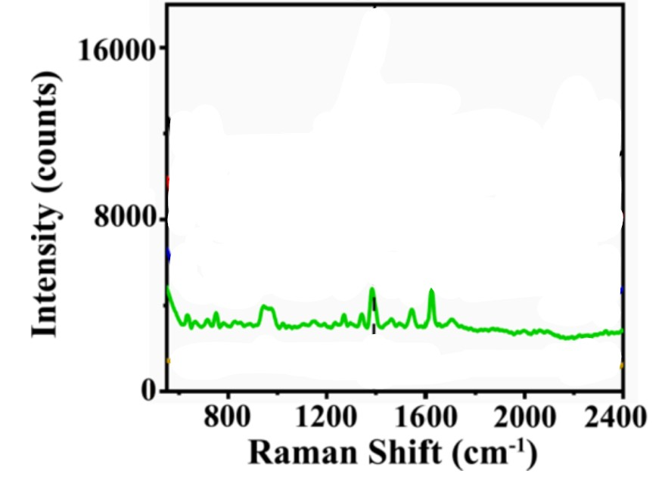
Figure 107: https://doi.org/10.1016/j.apsusc.2022.152543
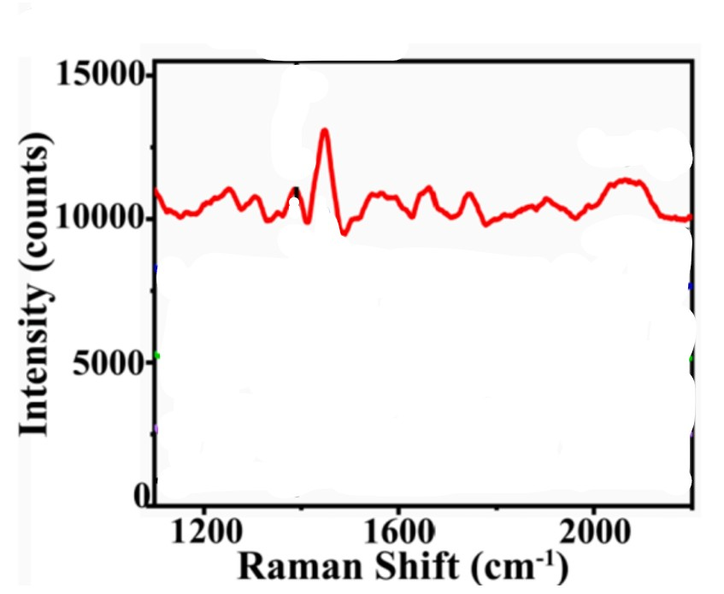
Figure 108: https://doi.org/10.1016/j.apsusc.2022.152543
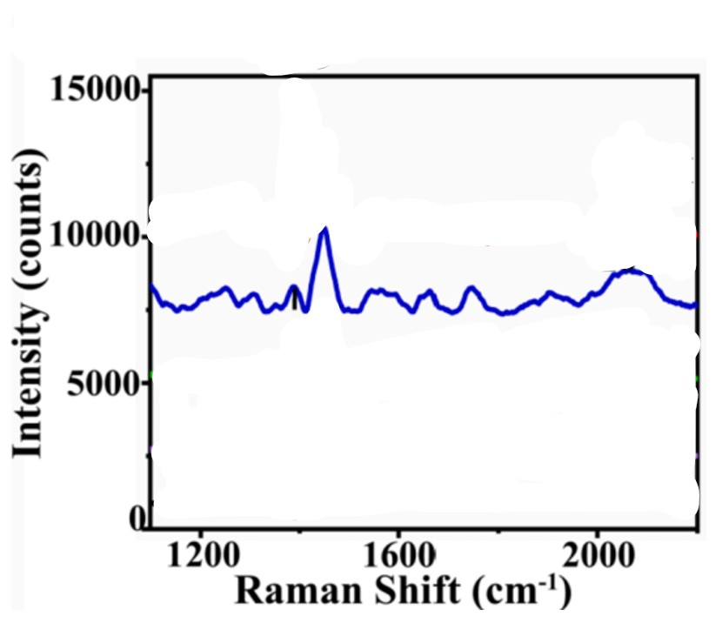
Figure 109: https://doi.org/10.1016/j.apsusc.2022.152543
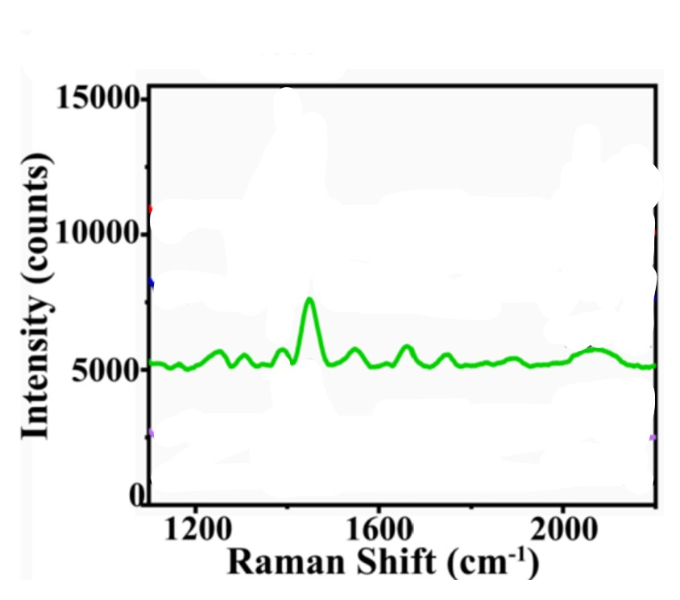
Figure 110: https://doi.org/10.1016/j.apsusc.2022.152543
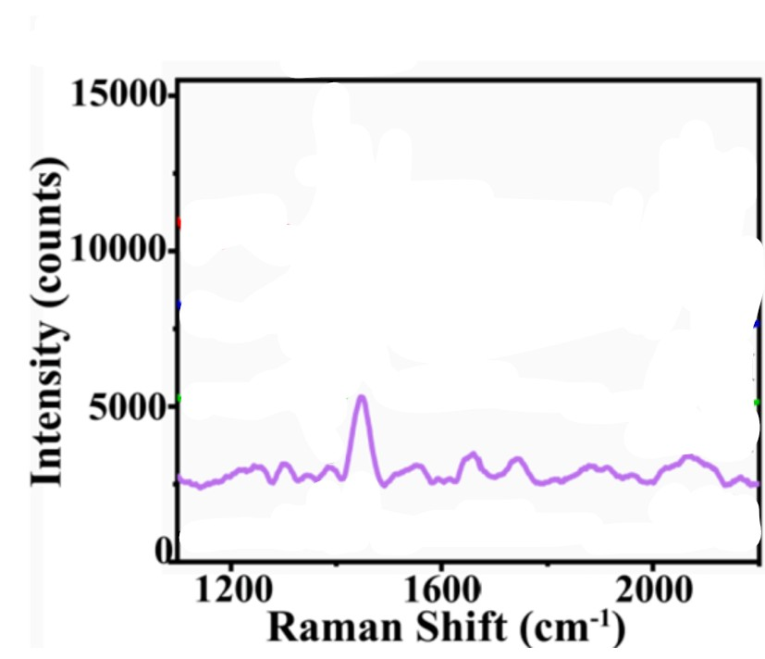
Figure 111: https://doi.org/10.1016/j.apsusc.2022.152543
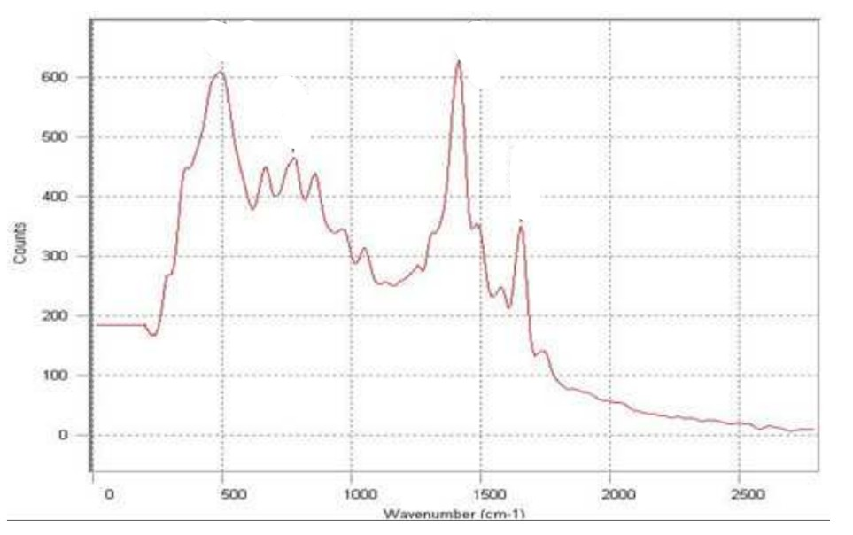
Figure 112: https://www.researchgate.net/profile/Subhashree-Sahoo-6/publication/375496251_QUALITATIVE_ANALYSIS_OF_A_CIPROFLOXACIN_HPMC_MUCOADHESIVE_SUSPENSION/links/654c7873ce88b87031d6d3a4/Qualitative-analysis-of-a-Ciprofloxacin-HPMC-mucoadhesive-suspension.pdf
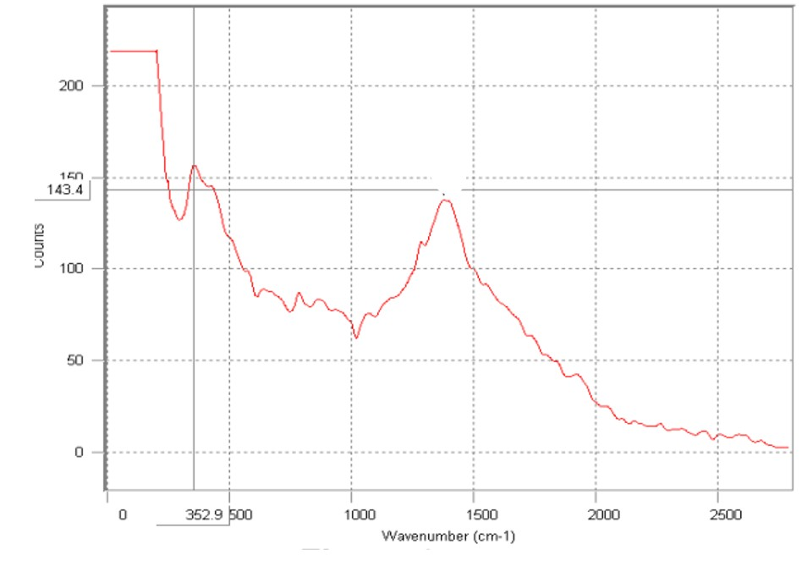
Figure 113: https://www.researchgate.net/profile/Subhashree-Sahoo-6/publication/375496251_QUALITATIVE_ANALYSIS_OF_A_CIPROFLOXACIN_HPMC_MUCOADHESIVE_SUSPENSION/links/654c7873ce88b87031d6d3a4/Qualitative-analysis-of-a-Ciprofloxacin-HPMC-mucoadhesive-suspension.pdf
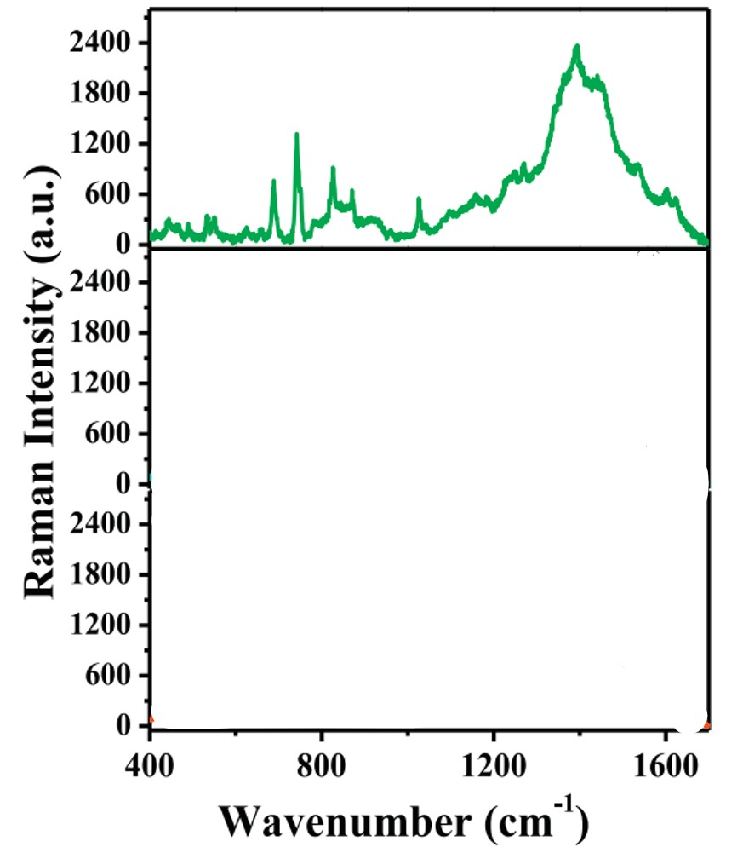
Figure 114: https://doi.org/10.1016/j.reactfunctpolym.2018.01.002
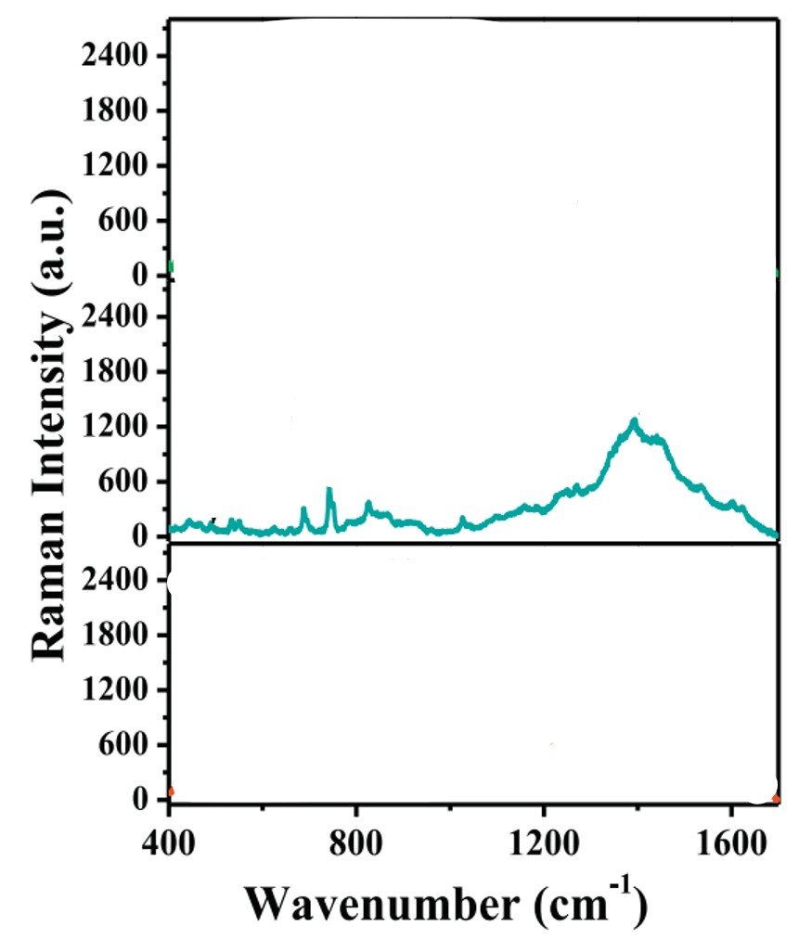
Figure 115: https://doi.org/10.1016/j.reactfunctpolym.2018.01.002
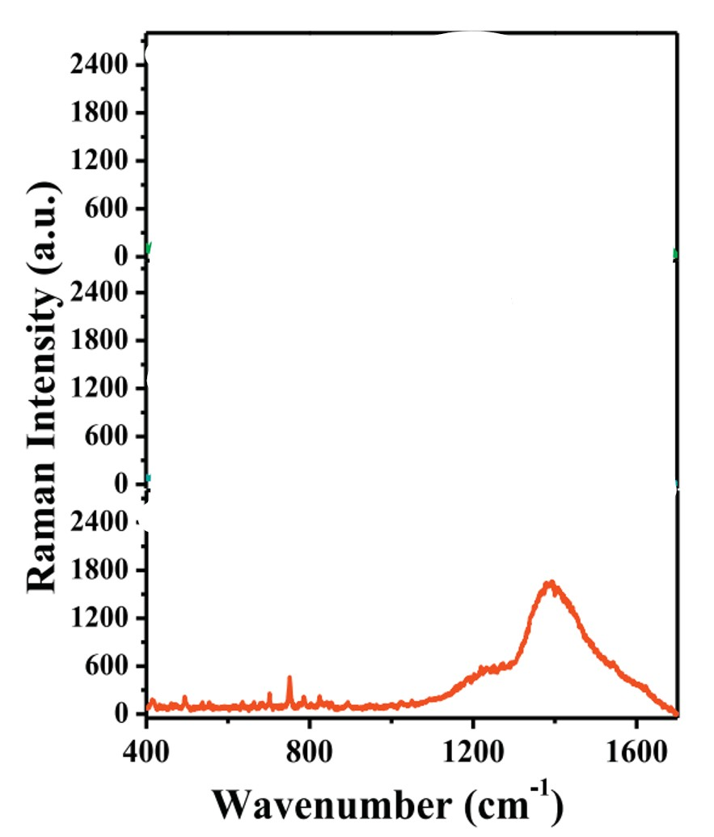
Figure 116: https://doi.org/10.1016/j.reactfunctpolym.2018.01.002

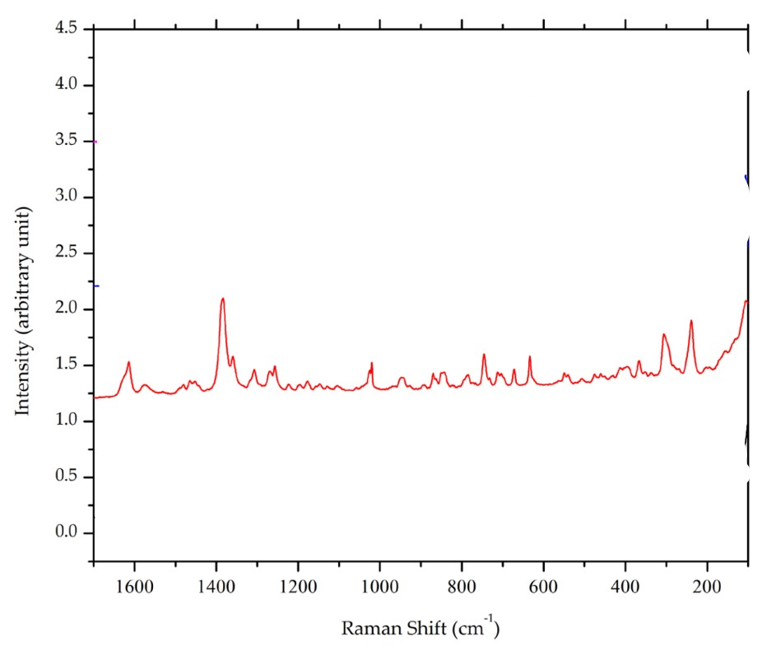
Figure 117: doi:10.3390/cryst10050349
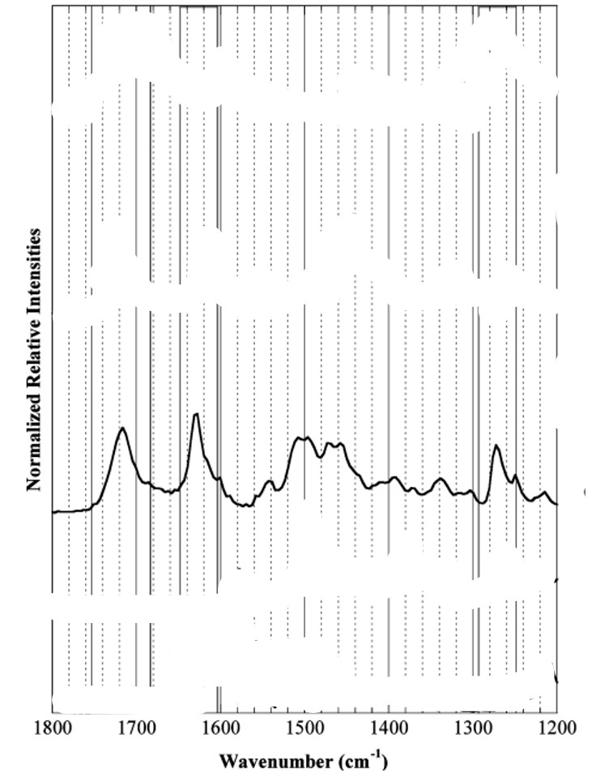
Figure 118: https://doi.org/10.1021/es061921y
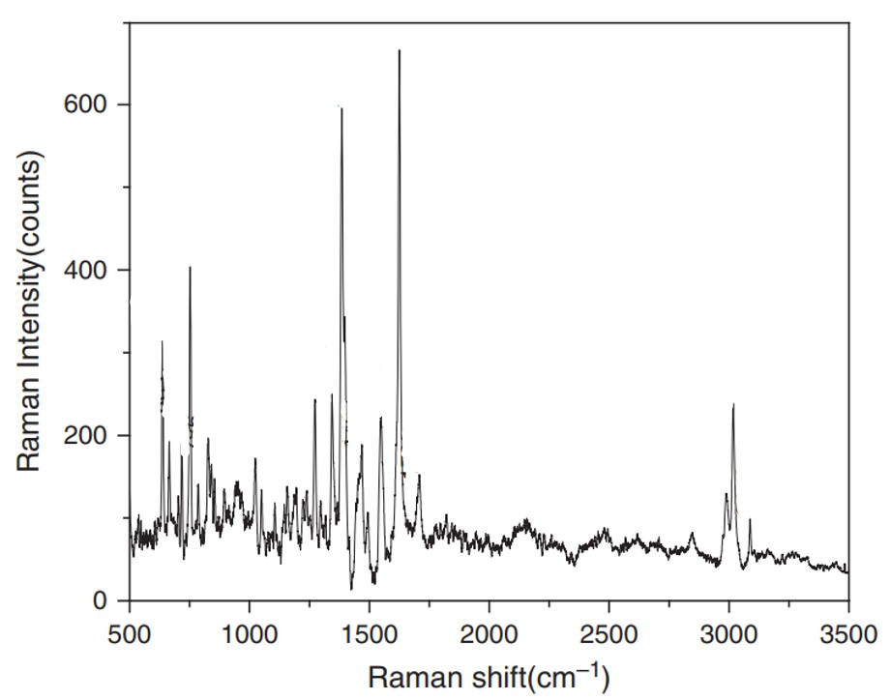
Figure 119: doi:10.1166/jbn.2011.1350

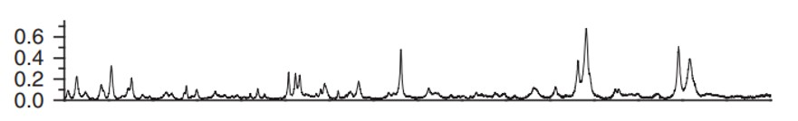
Figure 120: doi:10.1166/jbn.2011.1350

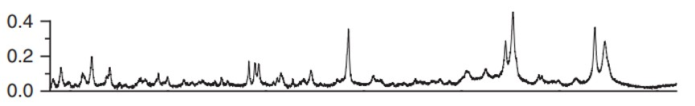
Figure 121: doi:10.1166/jbn.2011.1350

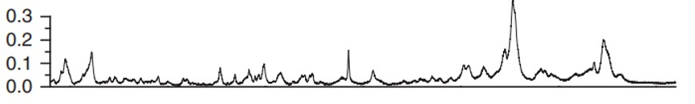
Figure 122: doi:10.1166/jbn.2011.1350

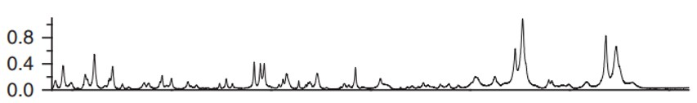
Figure 123: doi:10.1166/jbn.2011.1350

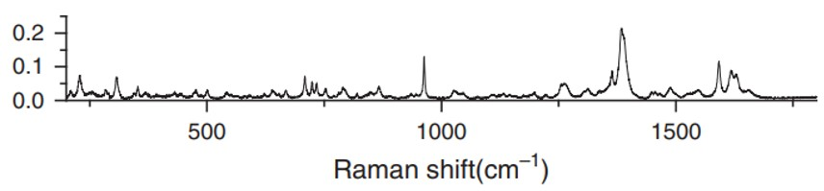
Figure 124: doi:10.1166/jbn.2011.1350
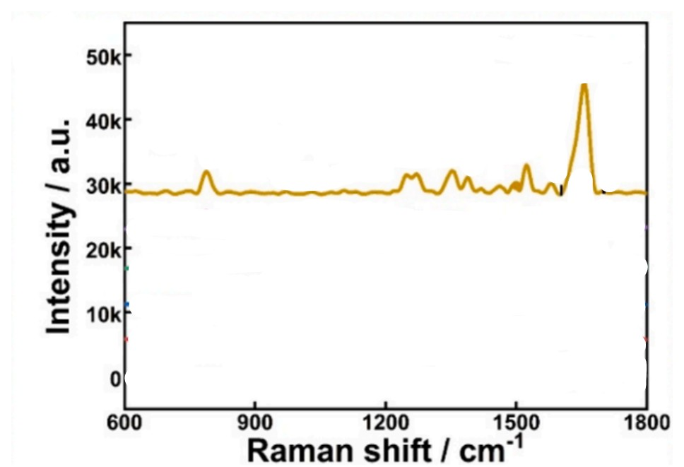
Figure 125: https://doi.org/10.1016/j.microc.2024.110830
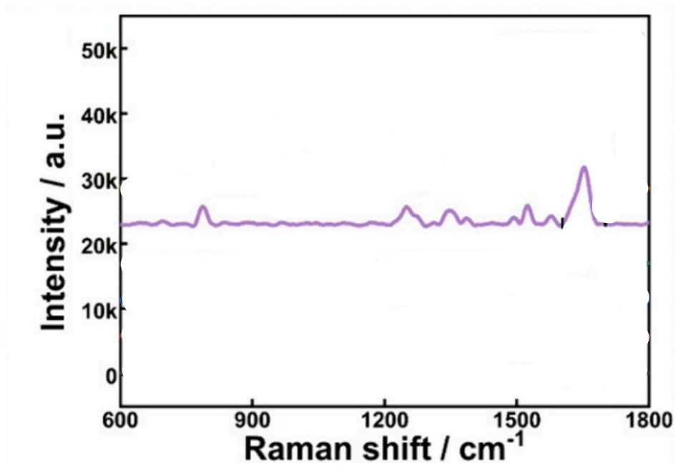
Figure 126: https://doi.org/10.1016/j.microc.2024.110830
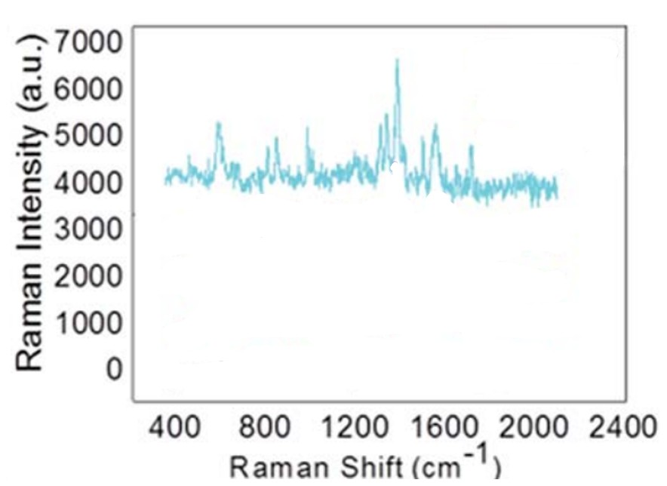
Figure 127: DOI: 10.1039/c9ra00817a
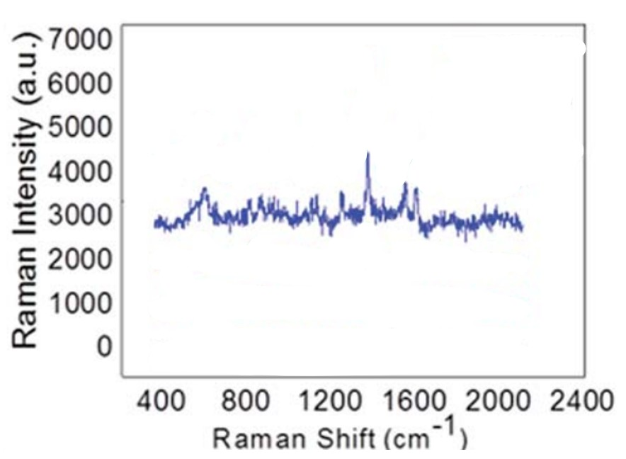
Figure 128: DOI: 10.1039/c9ra00817a

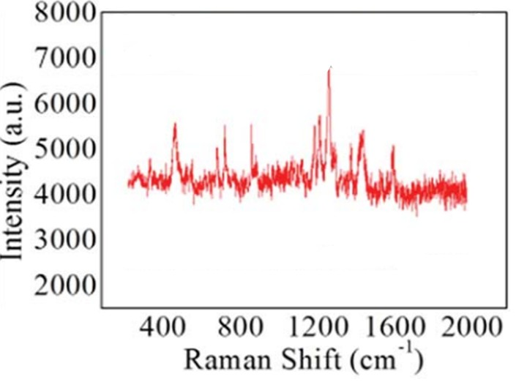
Figure 129: DOI: 10.1039/c9ra00817a
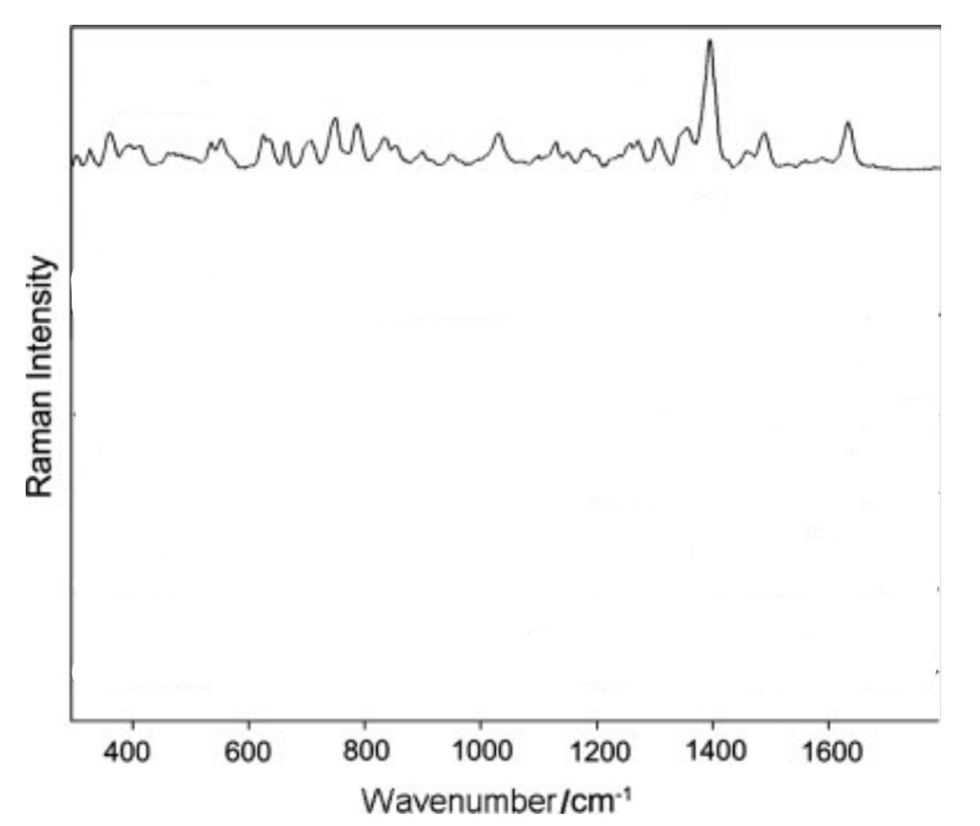
Figure 130: https://doi.org/10.1002/jrs.2505
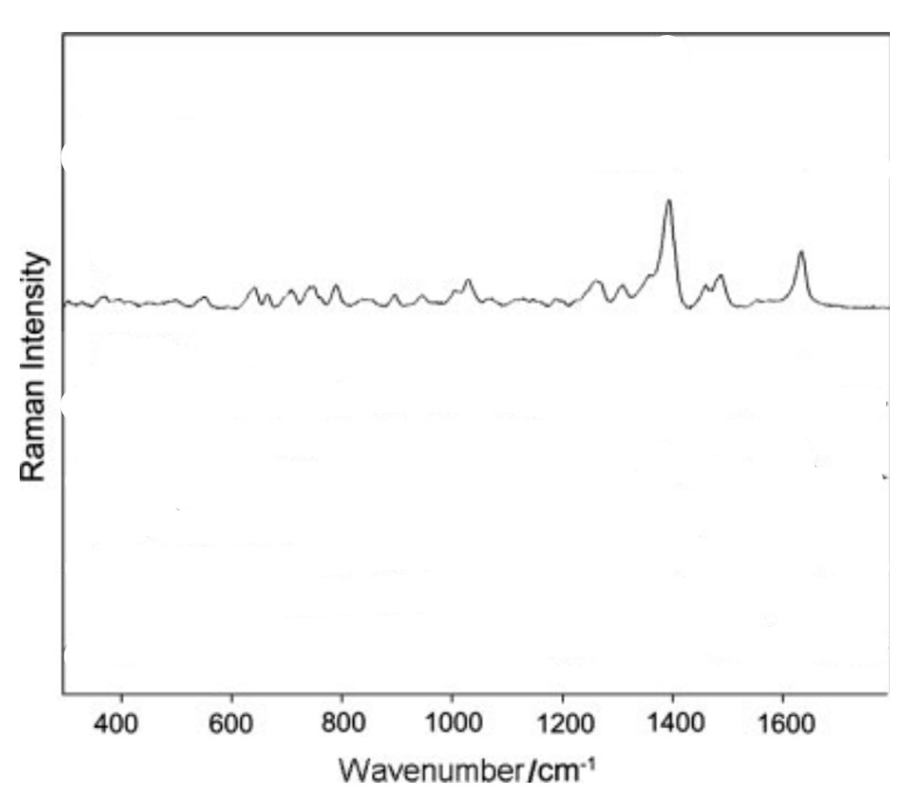
Figure 131: https://doi.org/10.1002/jrs.2505

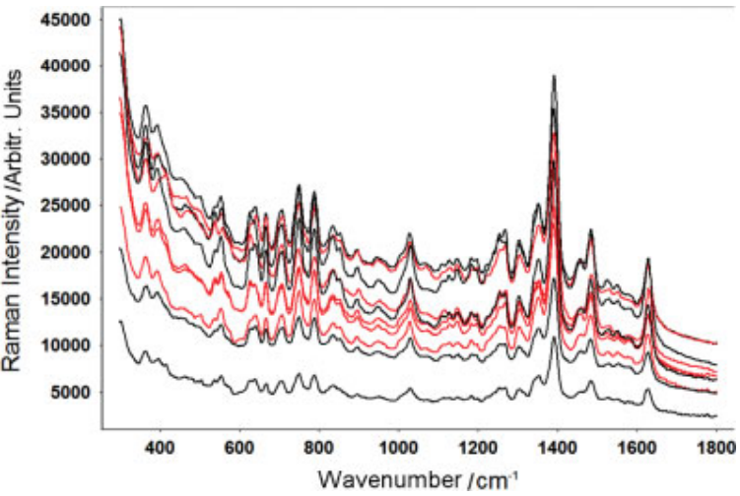
Figure 132: https://doi.org/10.1002/jrs.2505

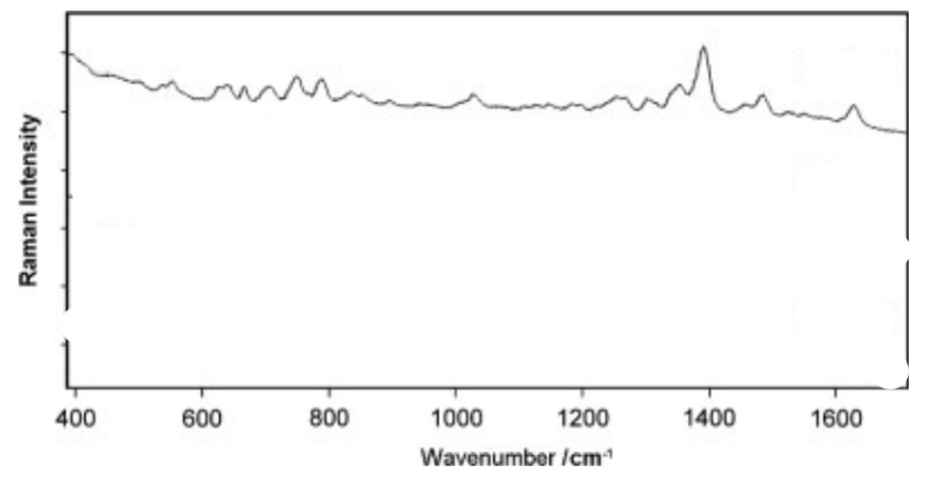
Figure 133: https://doi.org/10.1002/jrs.2505

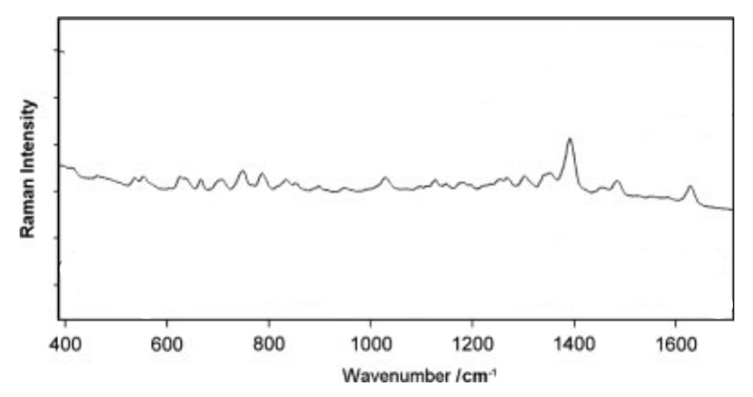
Figure 134: https://doi.org/10.1002/jrs.2505

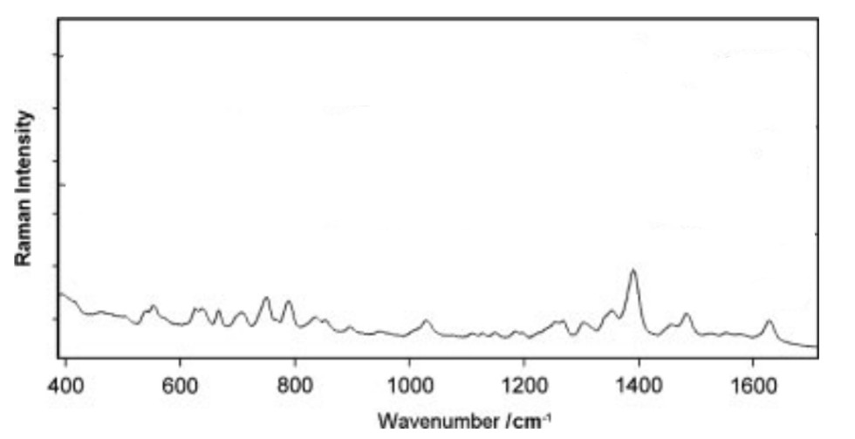
Figure 135: https://doi.org/10.1002/jrs.2505

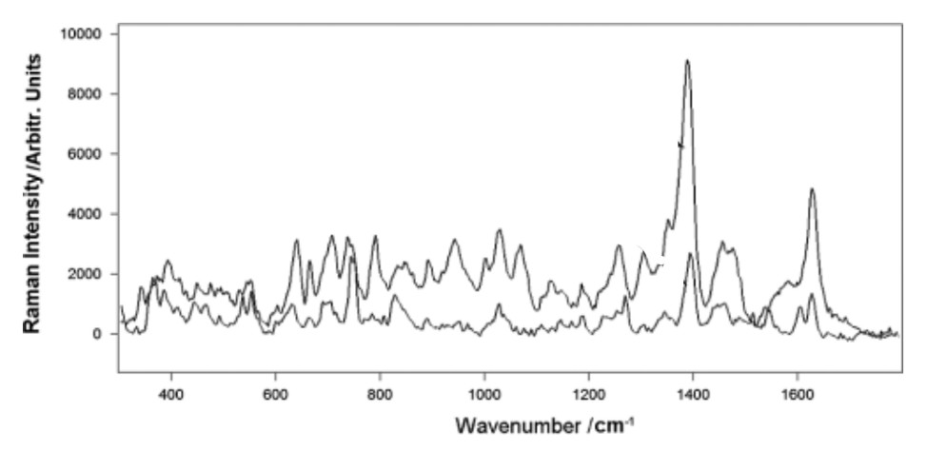
Figure 136: https://doi.org/10.1002/jrs.2505

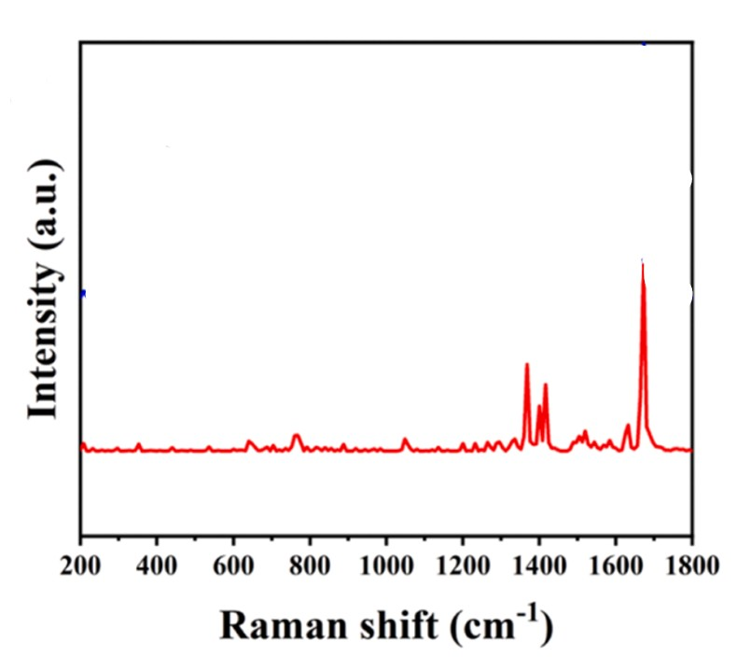
Figure137: https://doi.org/10.1016/j.jallcom.2024.178184
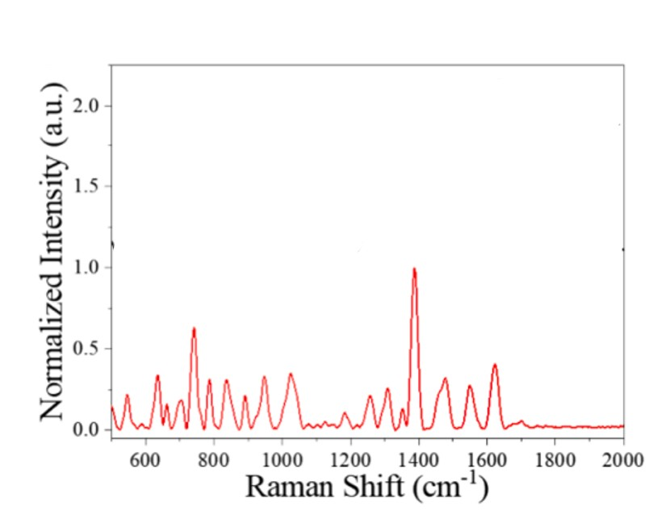
Figure 138: https://doi.org/10.1016/j.saa.2024.125641
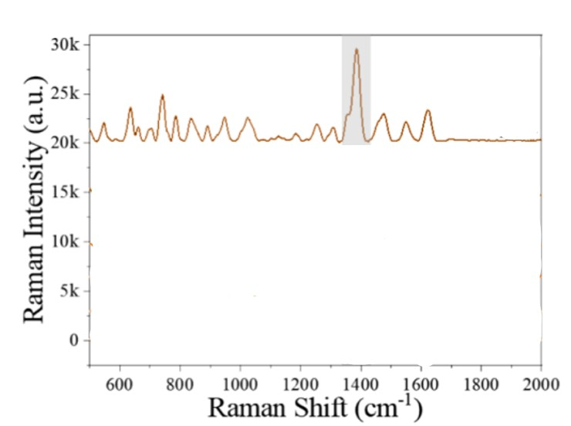
Figure 139: https://doi.org/10.1016/j.saa.2024.125641
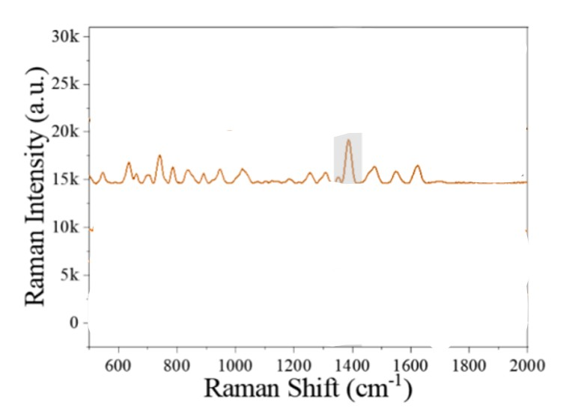
Figure 140: https://doi.org/10.1016/j.saa.2024.125641
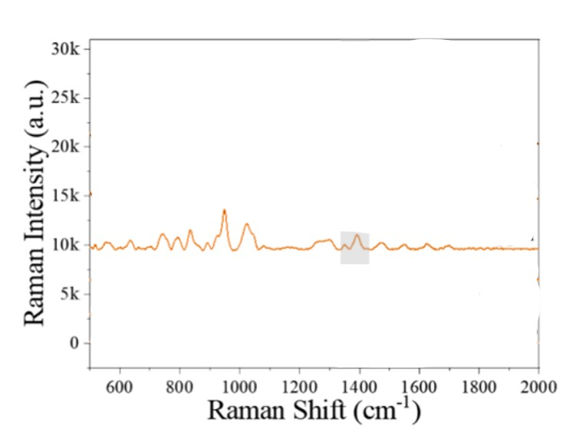
Figure 141: https://doi.org/10.1016/j.saa.2024.125641

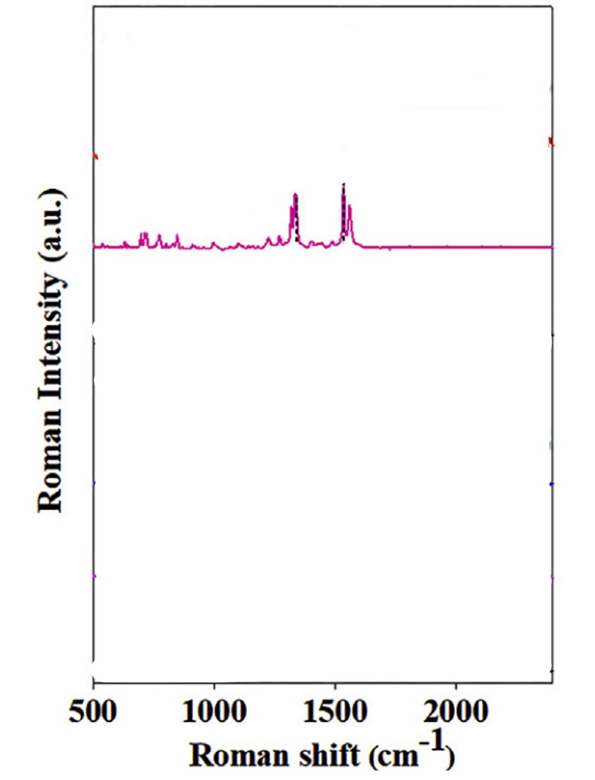
Figure 142: https://doi.org/10.1016/j.watres.2020.115475
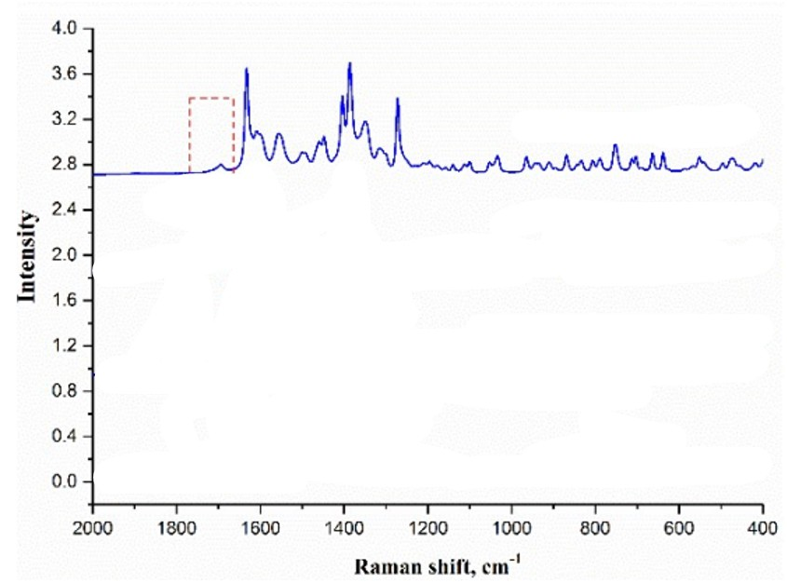
Figure 143: DOI: 10.1039/x0xx00000x

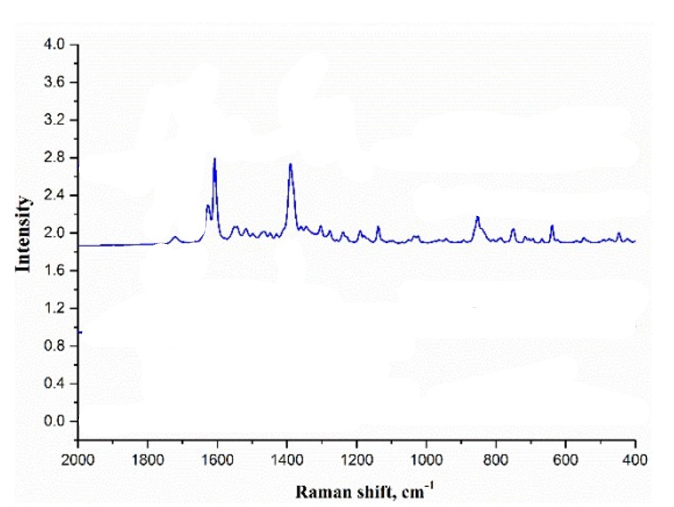
Figure 144: DOI: 10.1039/x0xx00000x
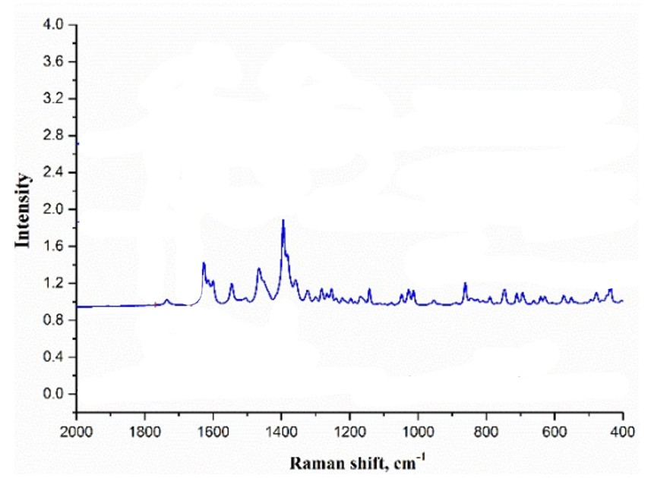
Figure 145: DOI: 10.1039/x0xx00000x
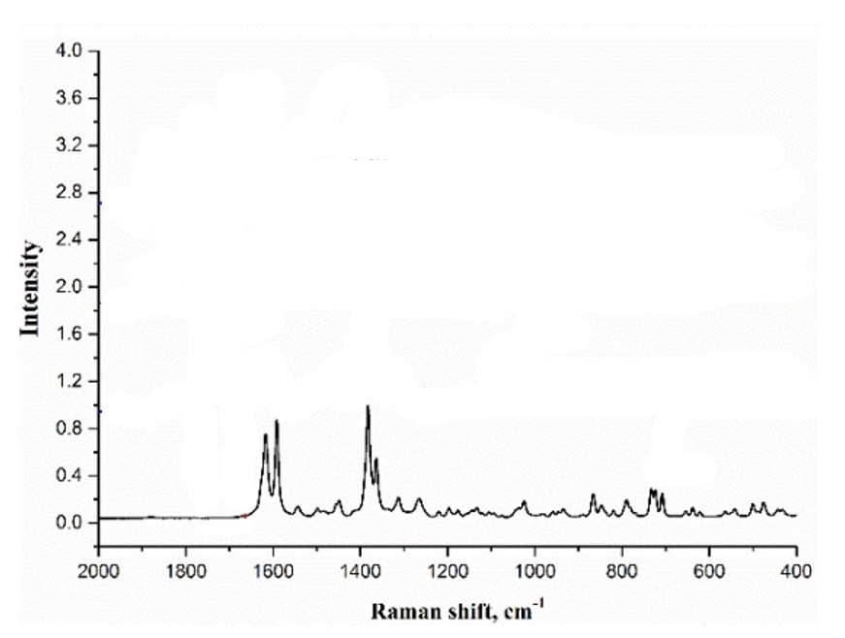
Figure 146: DOI: 10.1039/x0xx00000x
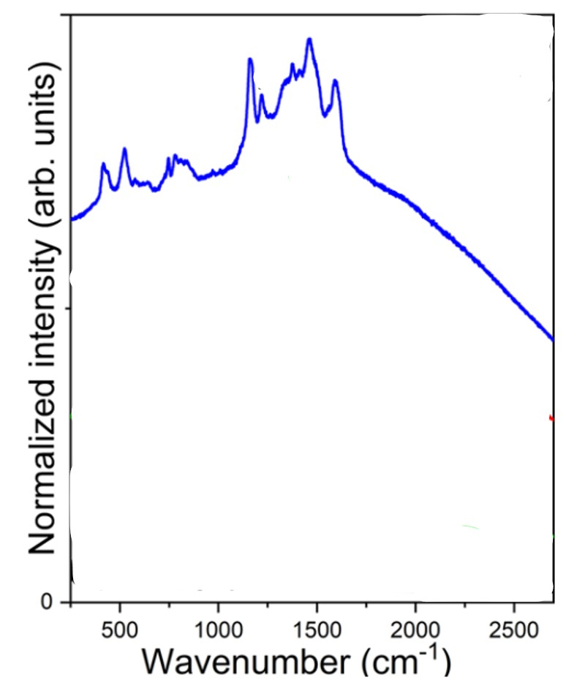
Figure 147: https://dx.doi.org/10.1021/acs.analchem.0c02355
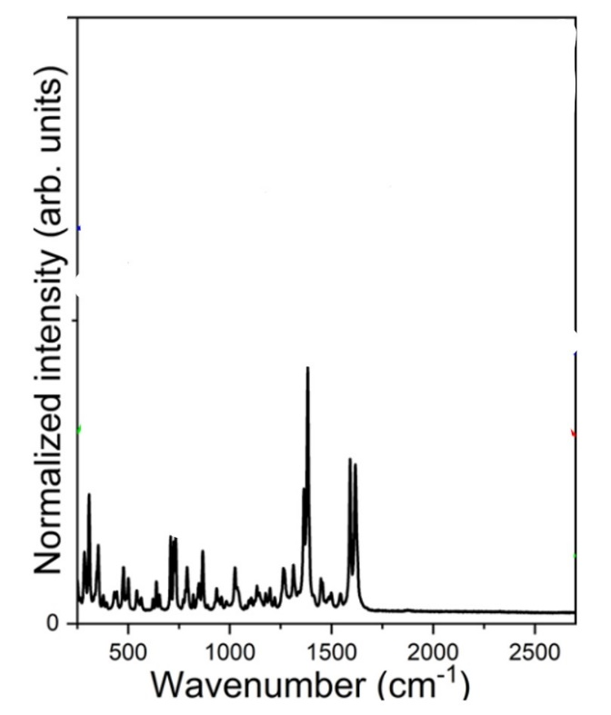
Figure 148: https://dx.doi.org/10.1021/acs.analchem.0c02355
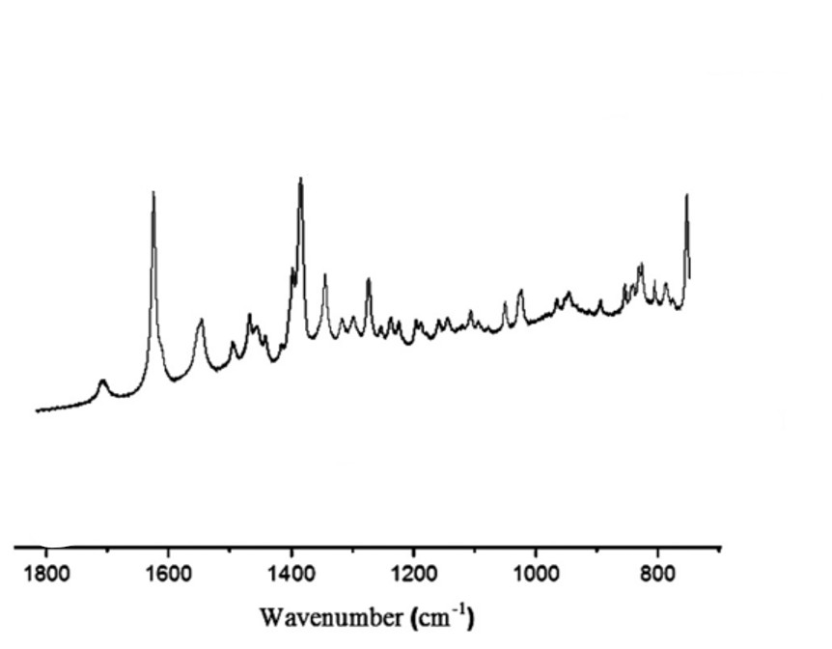
Figure 149: https://doi.org/10.1016/j.jece.2023.111791
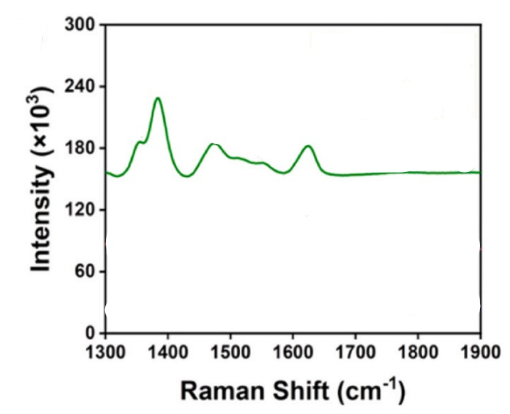
Figure 150: https://doi.org/10.1016/j.talanta.2023.125140
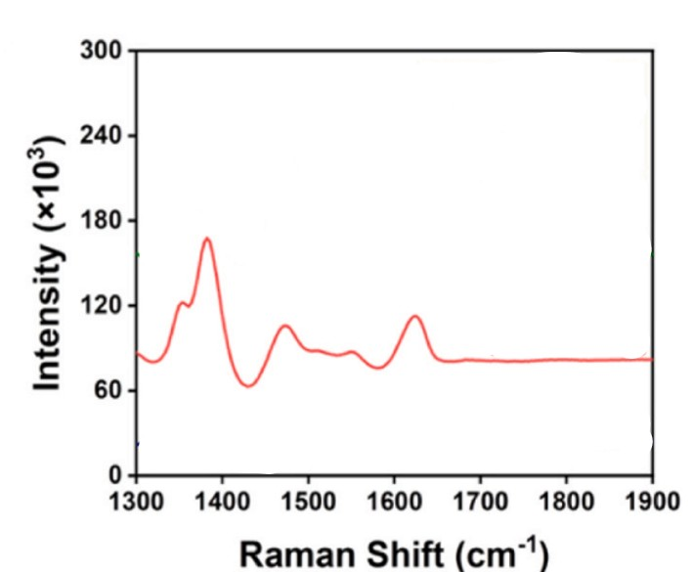
Figure 151: https://doi.org/10.1016/j.talanta.2023.125140
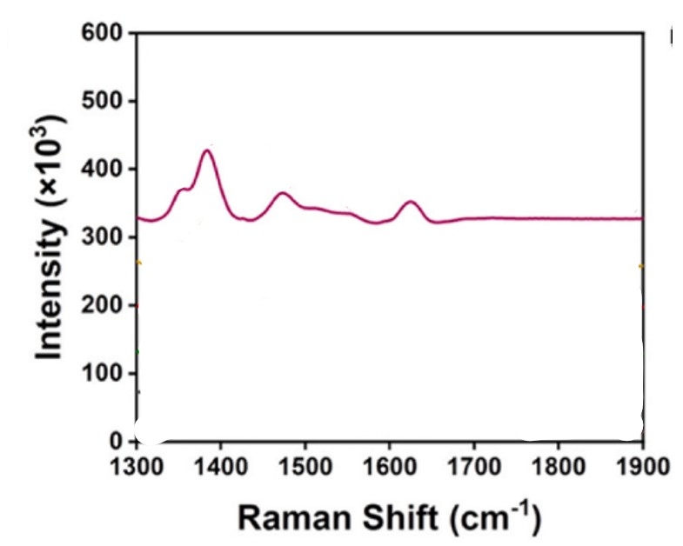
Figure 152: https://doi.org/10.1016/j.talanta.2023.125140
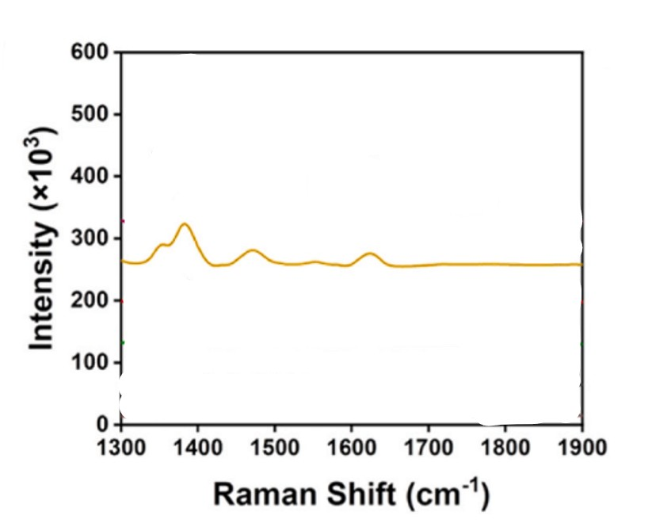
Figure 153: https://doi.org/10.1016/j.talanta.2023.125140

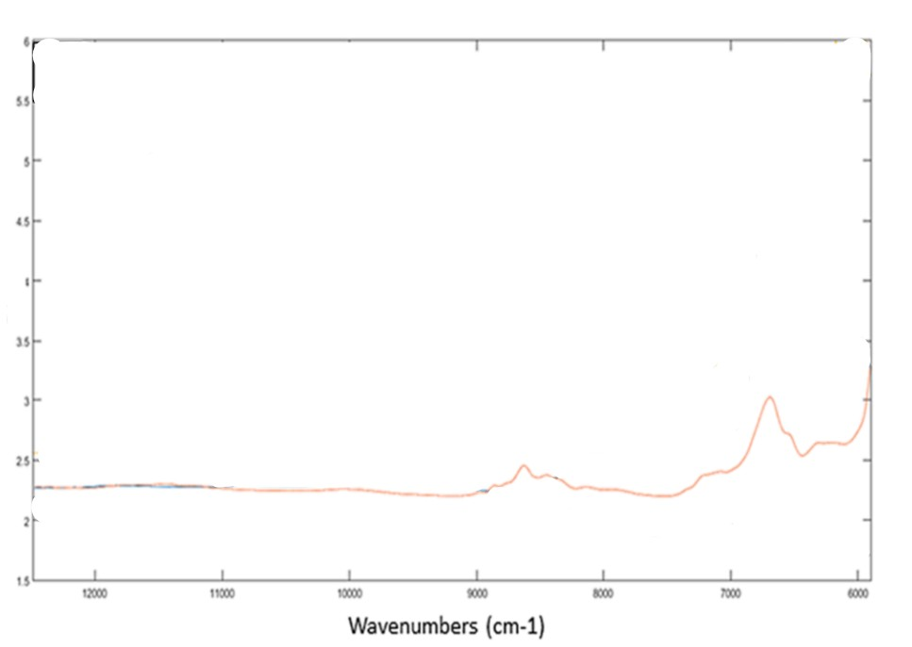
Figure 154: https://doi.org/10.1016/j.saa.2023.123268
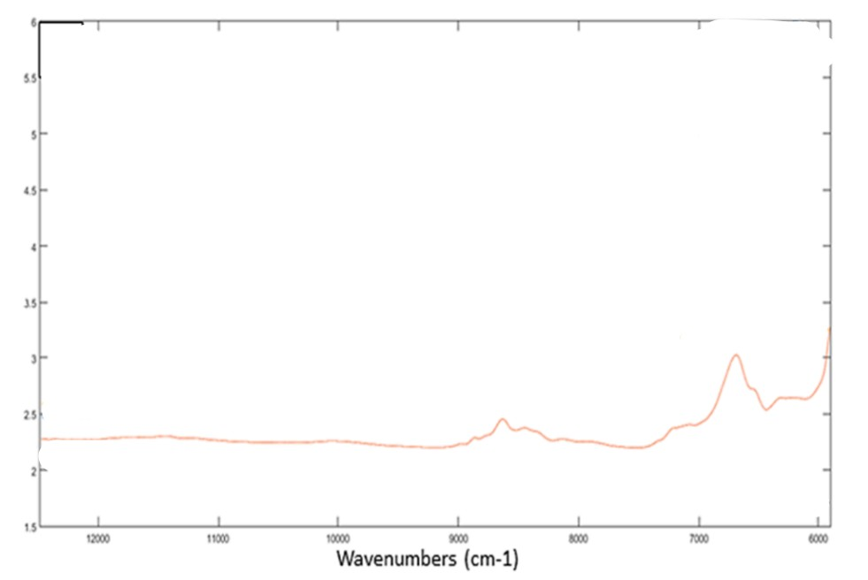
Figure 155: https://doi.org/10.1016/j.saa.2023.123268
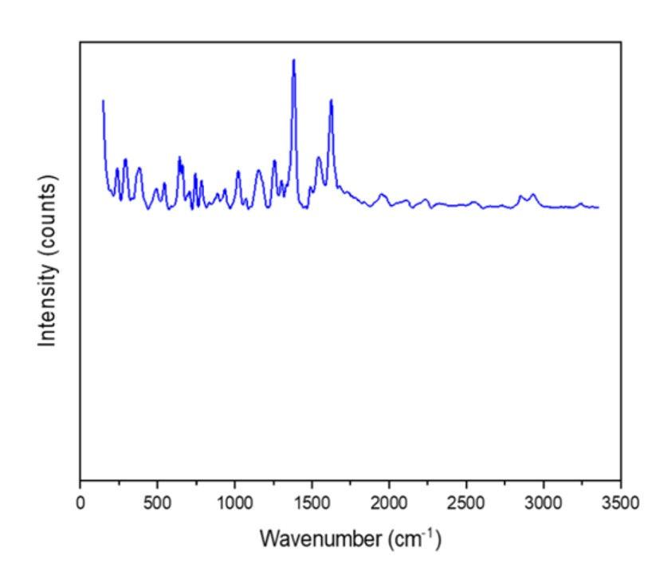
Figure 156: https://doi.org/10.1021/acsomega.2c06099?urlappend=%3Fref%3DPDF&jav=VoR&rel=cite-as
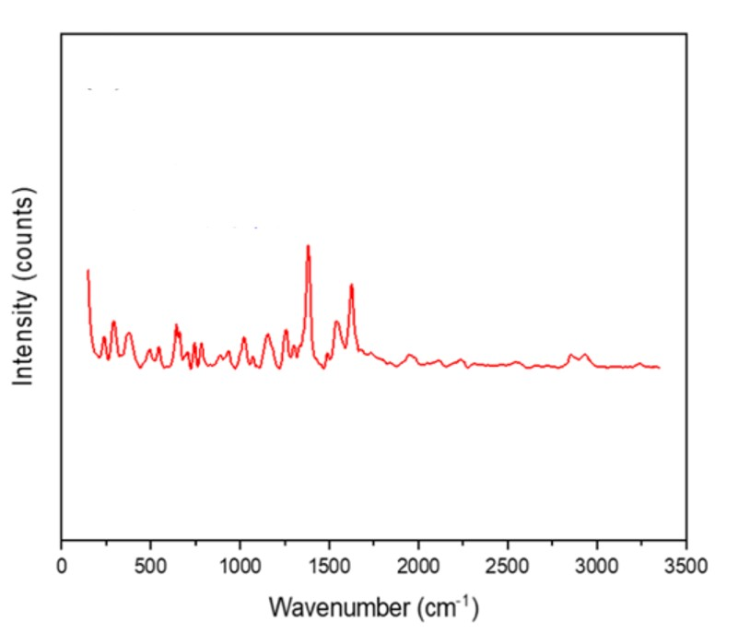
Figure157: https://doi.org/10.1021/acsomega.2c06099?urlappend=%3Fref%3DPDF&jav=VoR&rel=cite-as

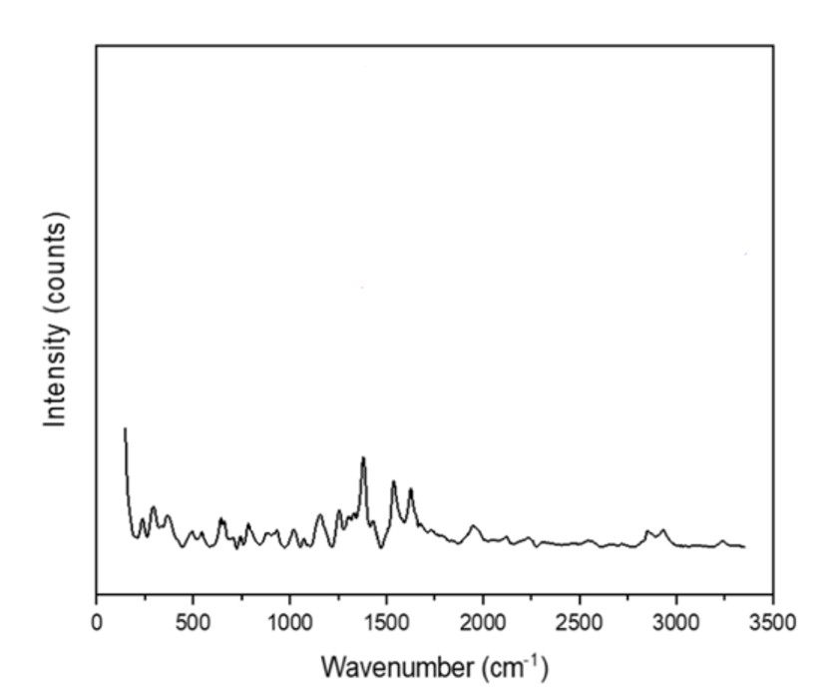
Figure 158: https://doi.org/10.1021/acsomega.2c06099?urlappend=%3Fref%3DPDF&jav=VoR&rel=cite-as
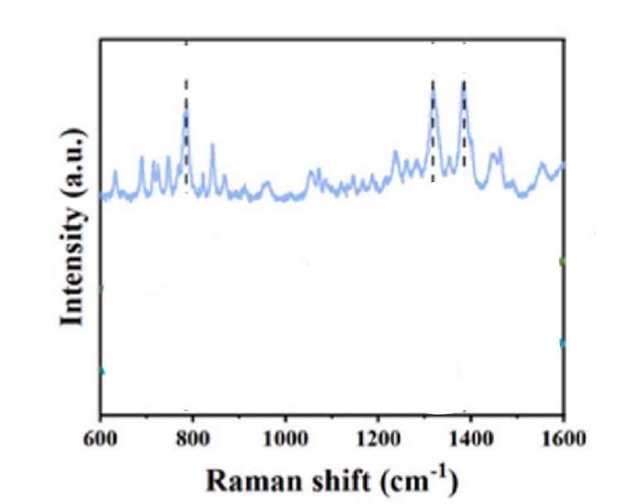
Figure 159: https://doi.org/10.1016/j.ceramint.2025.08.130
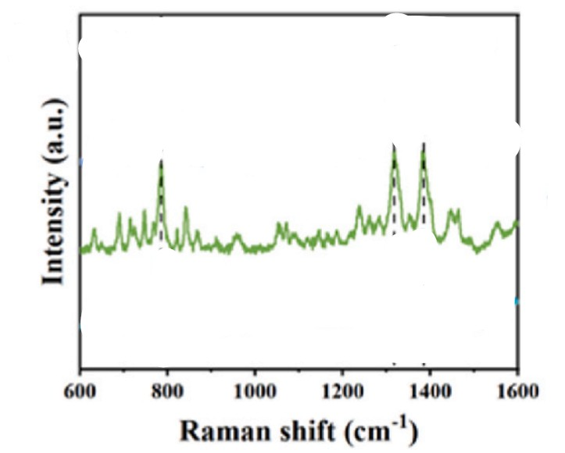
Figure 160: https://doi.org/10.1016/j.ceramint.2025.08.130
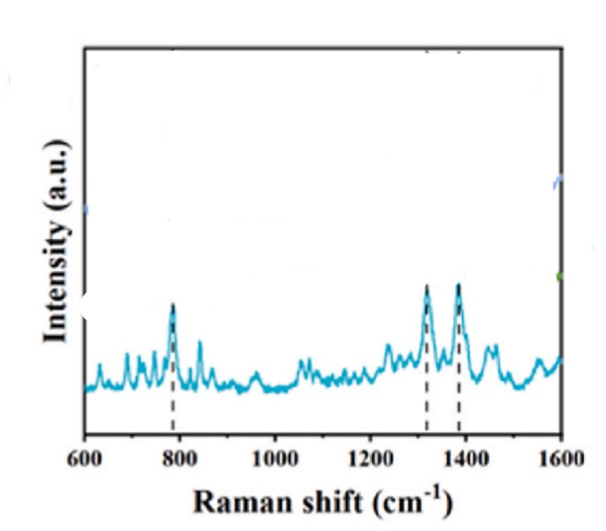
Figure 161: https://doi.org/10.1016/j.ceramint.2025.08.130

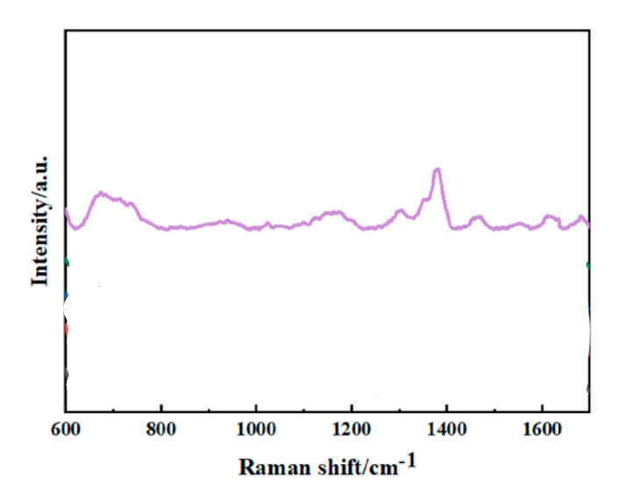
Figure 162: https://doi.org/10.1016/j.optmat.2025.117209
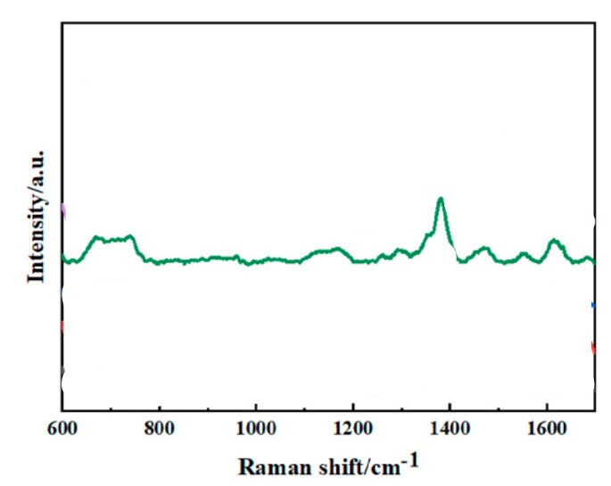
Figure 163: https://doi.org/10.1016/j.optmat.2025.117209

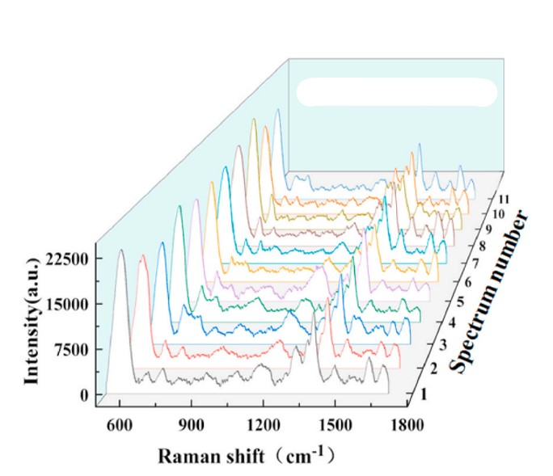
Figure 164: https://doi.org/10.1016/j.optmat.2025.117209
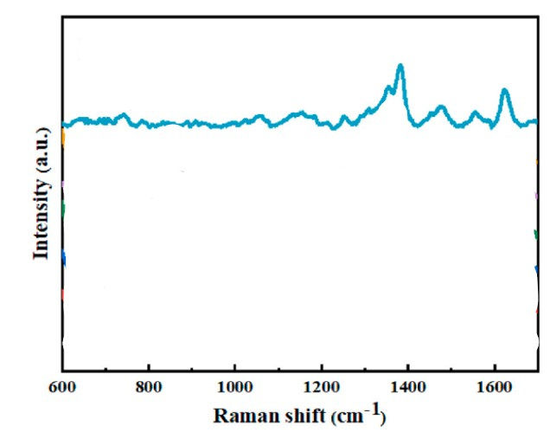
Figure 165: https://doi.org/10.1016/j.optmat.2025.117209
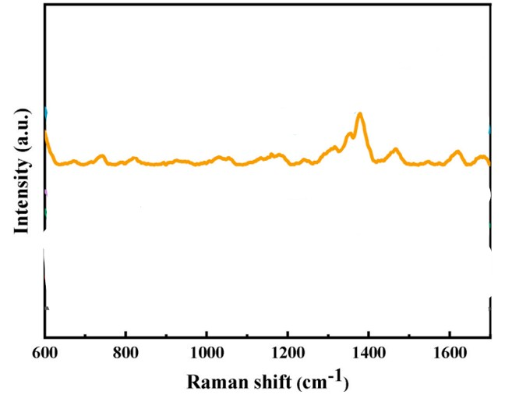
Figure 166: https://doi.org/10.1016/j.optmat.2025.117209
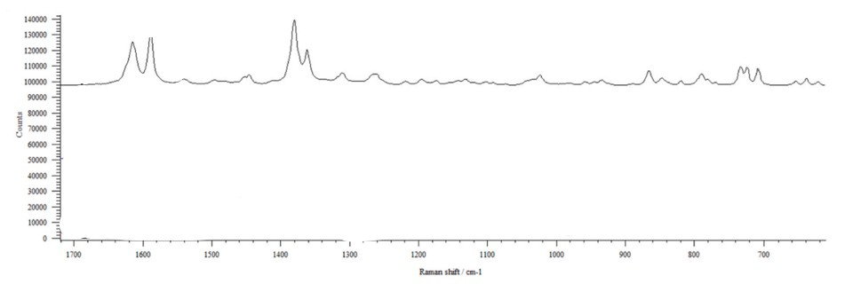
Figure 167: https://doi.org/10.1016/j.jddst.2024.106061
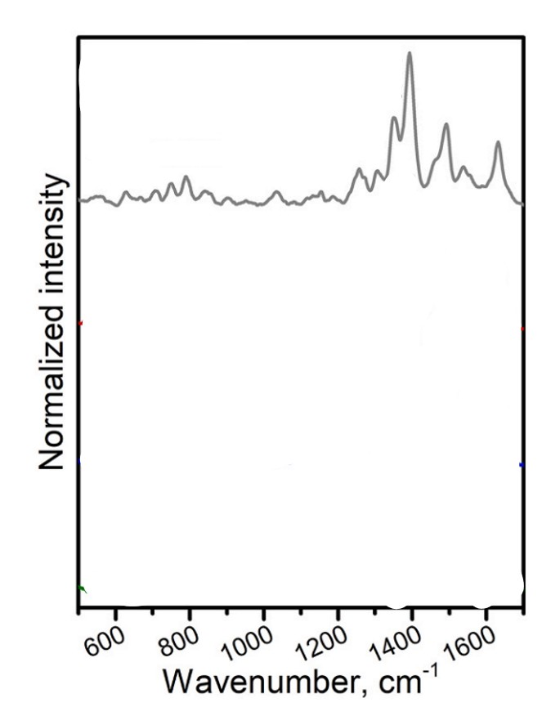
Figure 168: https://doi.org/10.1016/j.talanta.2022.124083

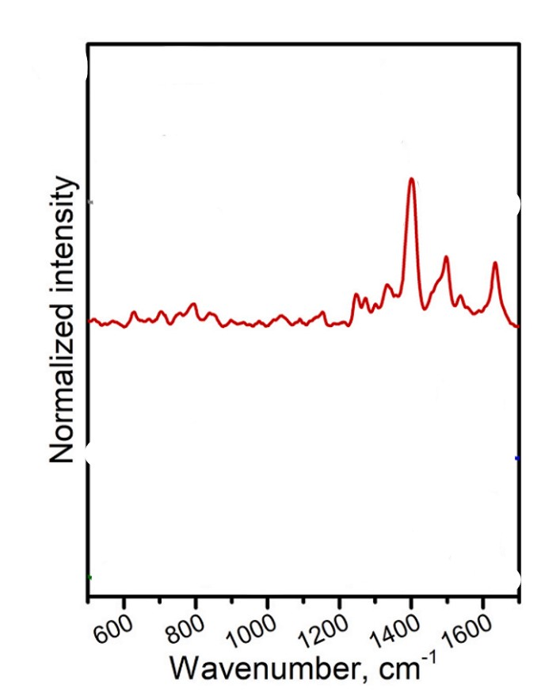
Figure 169: https://doi.org/10.1016/j.talanta.2022.124083
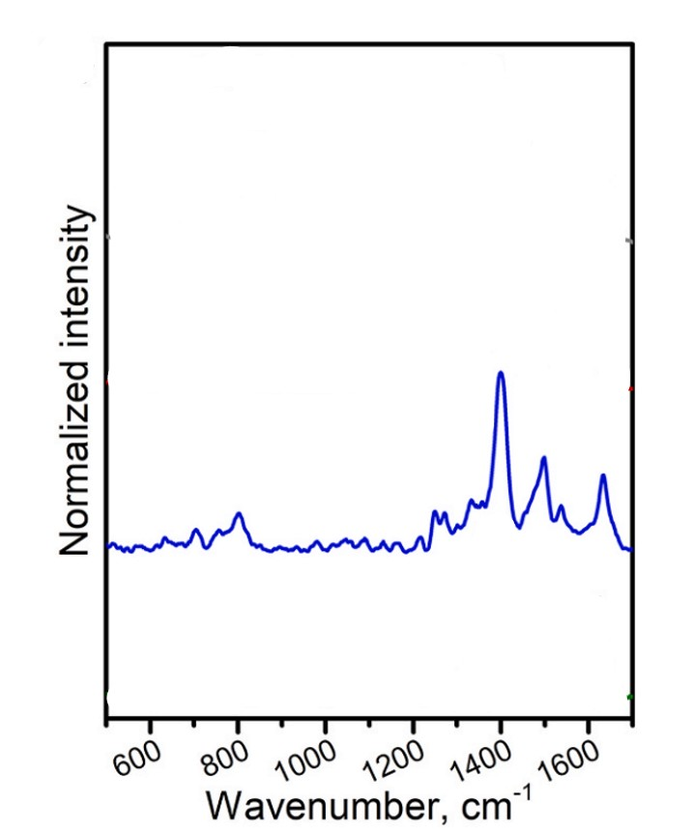
Figure 170: https://doi.org/10.1016/j.talanta.2022.124083
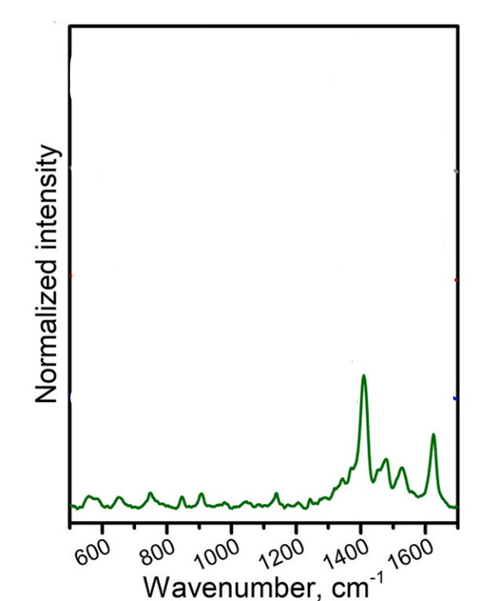
Figure 171: https://doi.org/10.1016/j.talanta.2022.124083
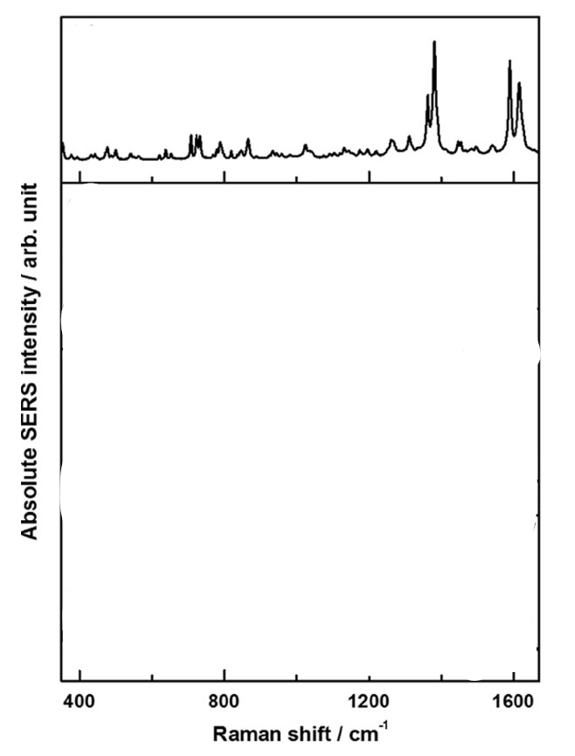
Figure 172: http://dx.doi.org/10.1016/j.aca.2017.05.025
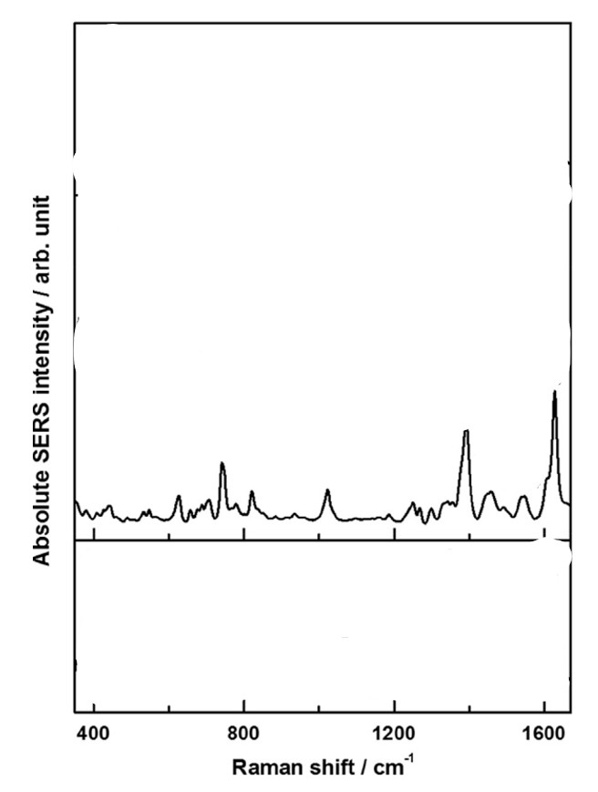
Figure 173: http://dx.doi.org/10.1016/j.aca.2017.05.025
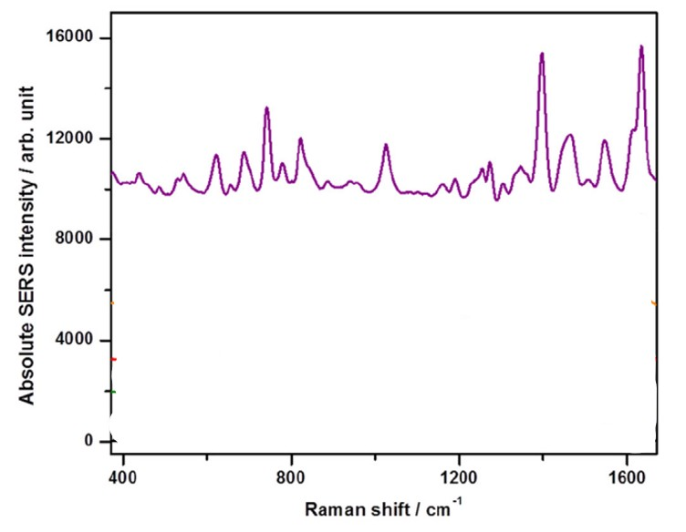
Figure 174: http://dx.doi.org/10.1016/j.aca.2017.05.025
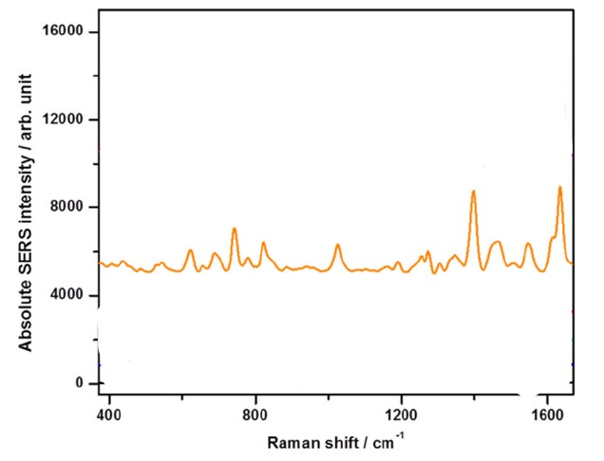
Figure 175: http://dx.doi.org/10.1016/j.aca.2017.05.025
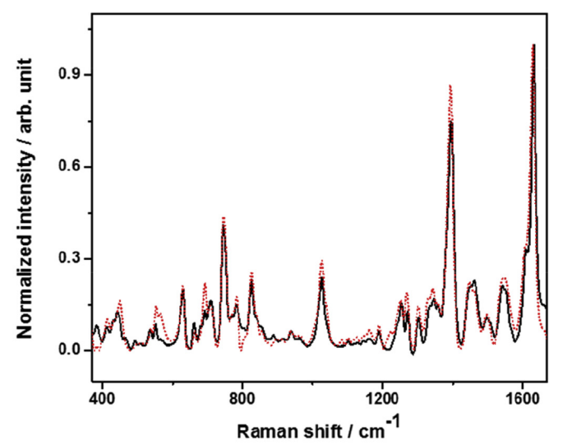
Figure 176: http://dx.doi.org/10.1016/j.aca.2017.05.025
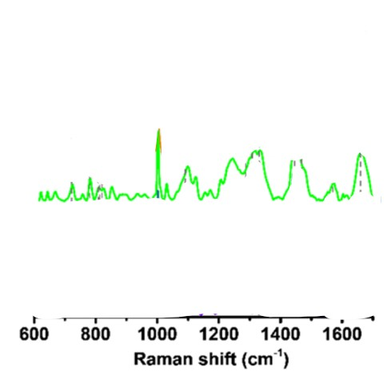
Figure 177: https://doi.org/10.1021/acs.jpcb.2c04151?urlappend=%3Fref%3DPDF&jav=VoR&rel=cite-as

