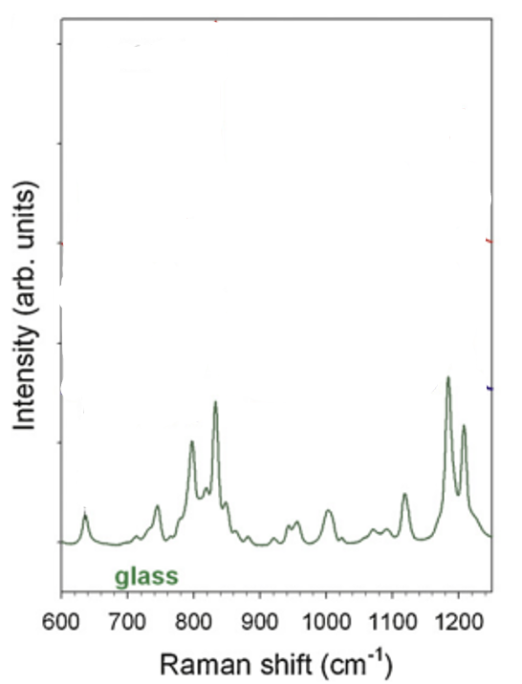
Figure 1:https://doi.org/10.1016/j.ijpharm.2011.09.015
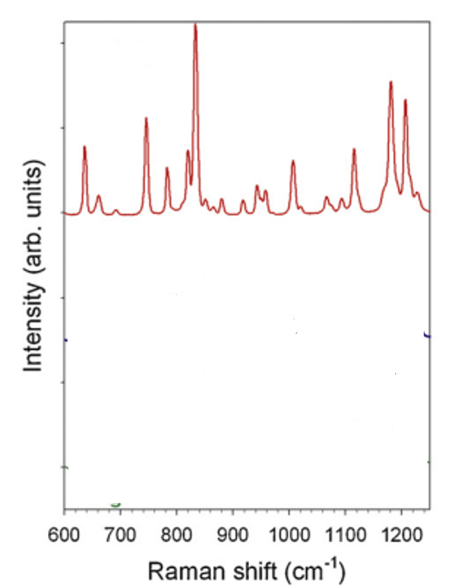
Figure 2:https://doi.org/10.1016/j.ijpharm.2011.09.015
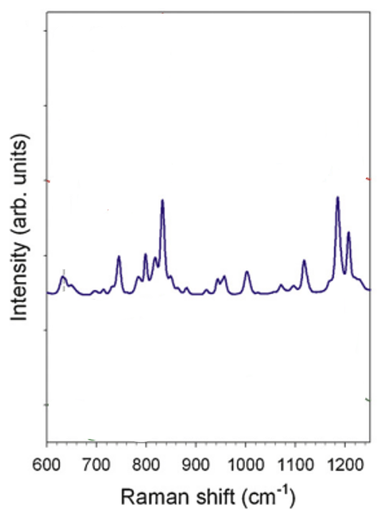
Figure 3:https://doi.org/10.1016/j.ijpharm.2011.09.015
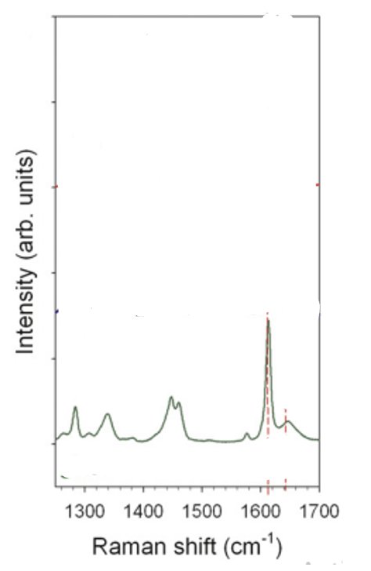
Figure 4:https://doi.org/10.1016/j.ijpharm.2011.09.015
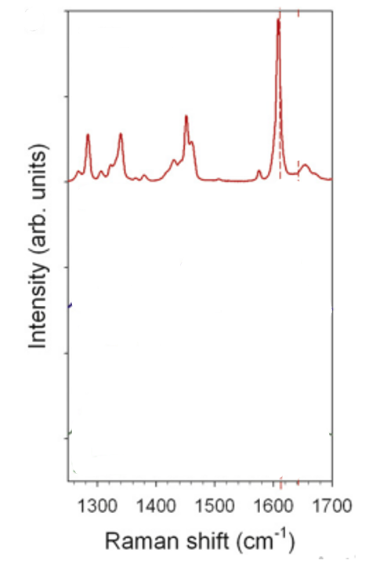
Figure 5:https://doi.org/10.1016/j.ijpharm.2011.09.015
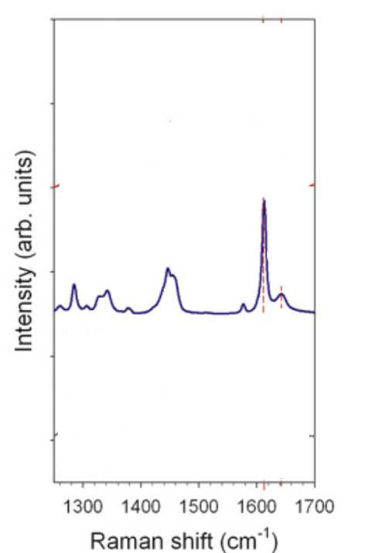
Figure 6:https://doi.org/10.1016/j.ijpharm.2011.09.015
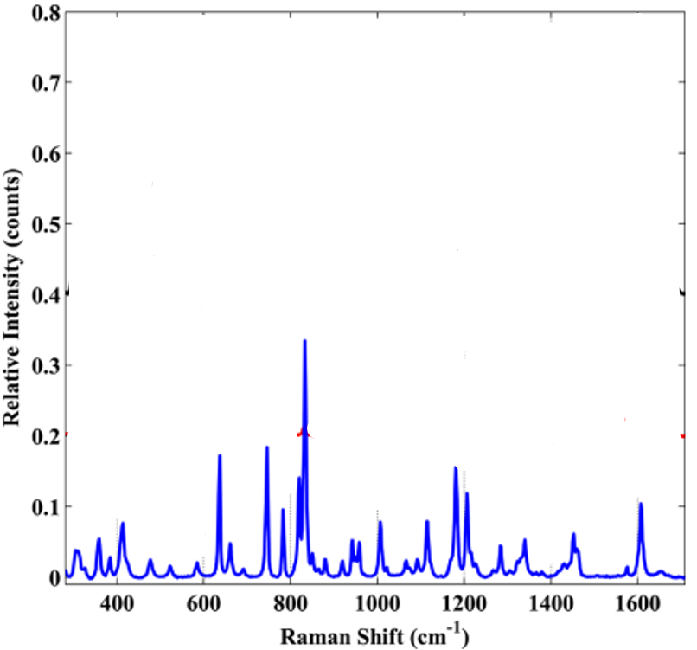
Figure 7:https://doi.org/10.1021/cg3017112
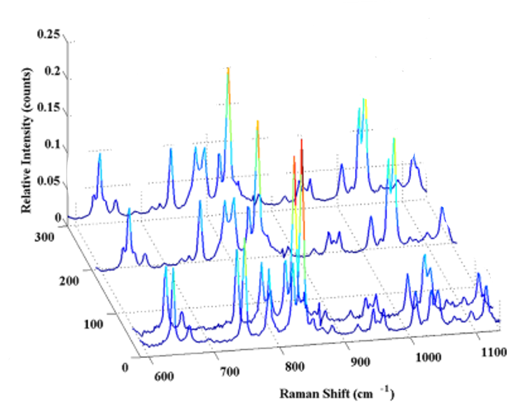
Figure 8:https://doi.org/10.1021/cg3017112
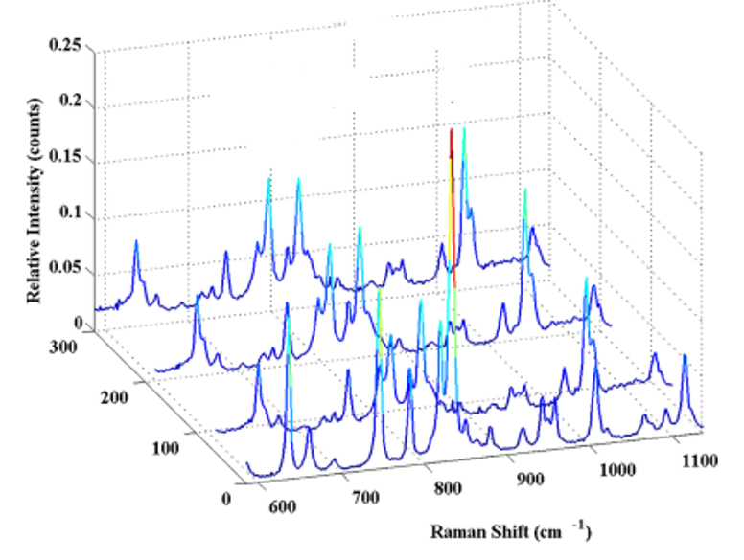
Figure 9:https://doi.org/10.1021/cg3017112
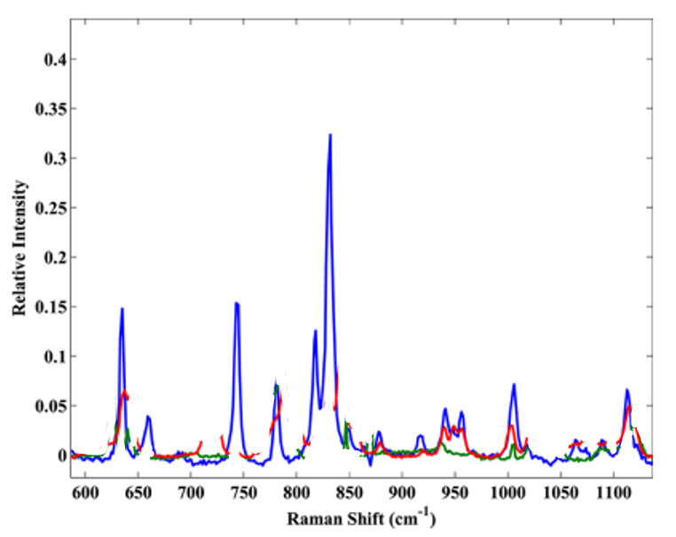
Figure 10:https://doi.org/10.1021/cg3017112
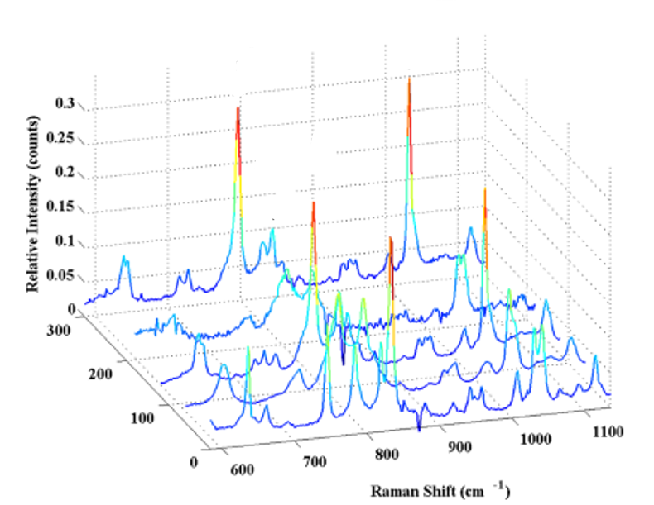
Figure 11:https://doi.org/10.1021/cg3017112
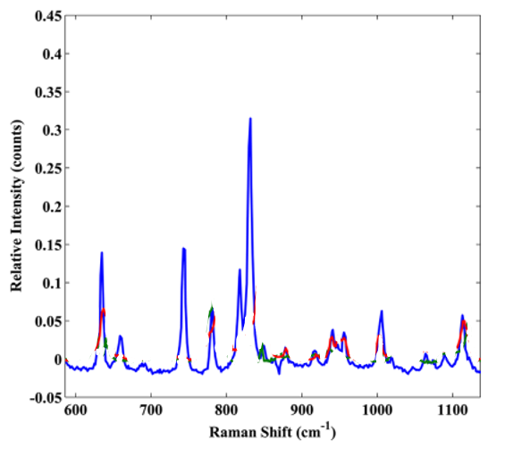
Figure 12:https://doi.org/10.1021/cg3017112
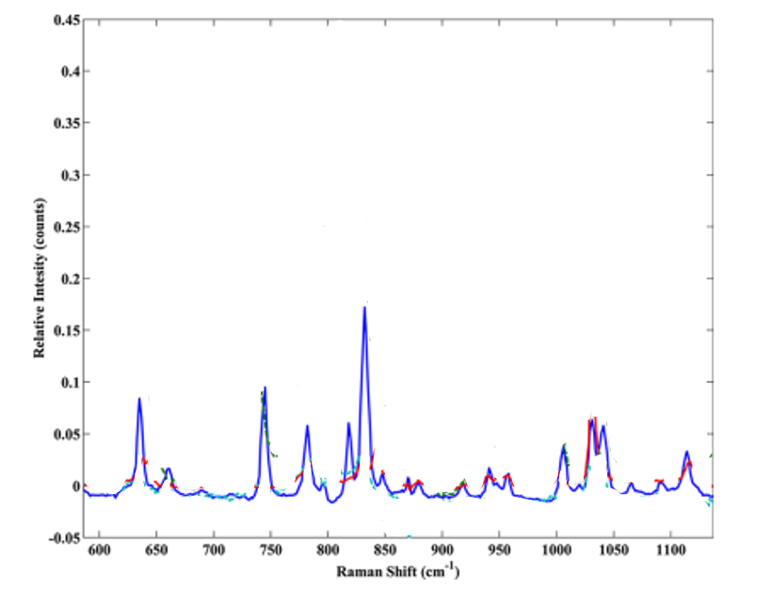
Figure 13:https://doi.org/10.1021/cg3017112
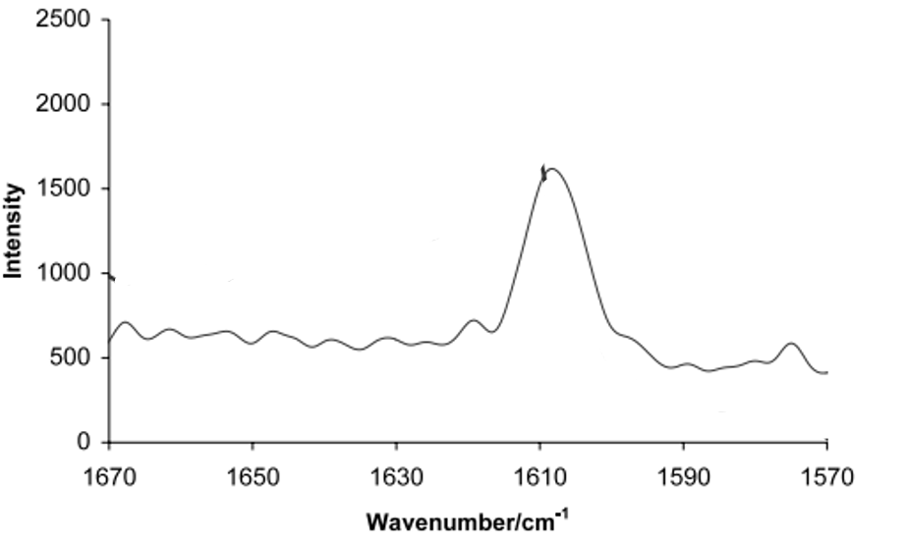
Figure 14:https://doi.org/10.1016/S0378-5173(01)00905-X
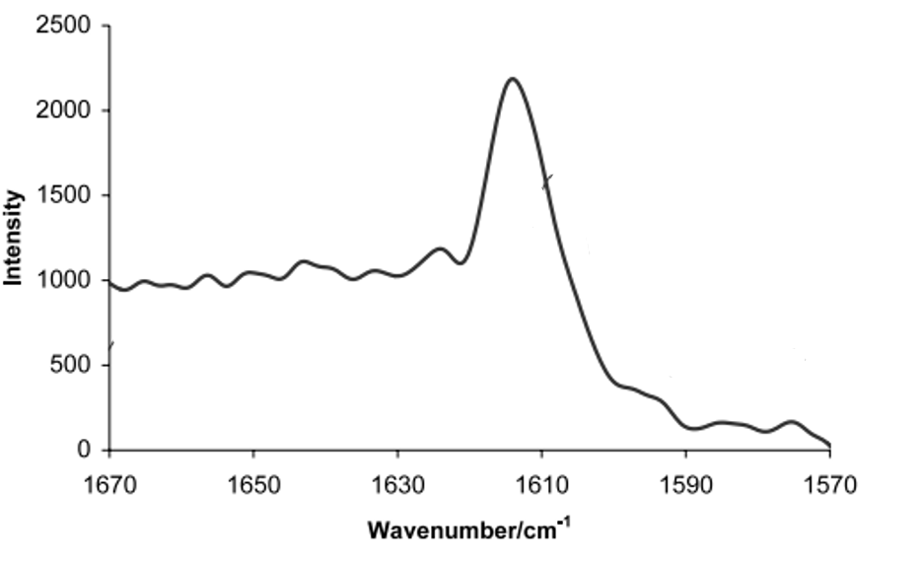
Figure 15:https://doi.org/10.1016/S0378-5173(01)00905-X
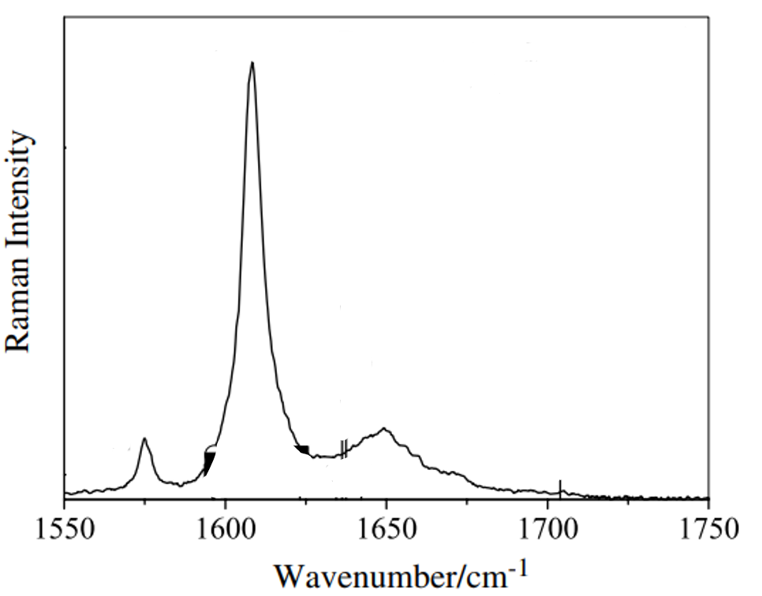
Figure 16:http://dx.doi.org/10.1016/j.saa.2014.01.135
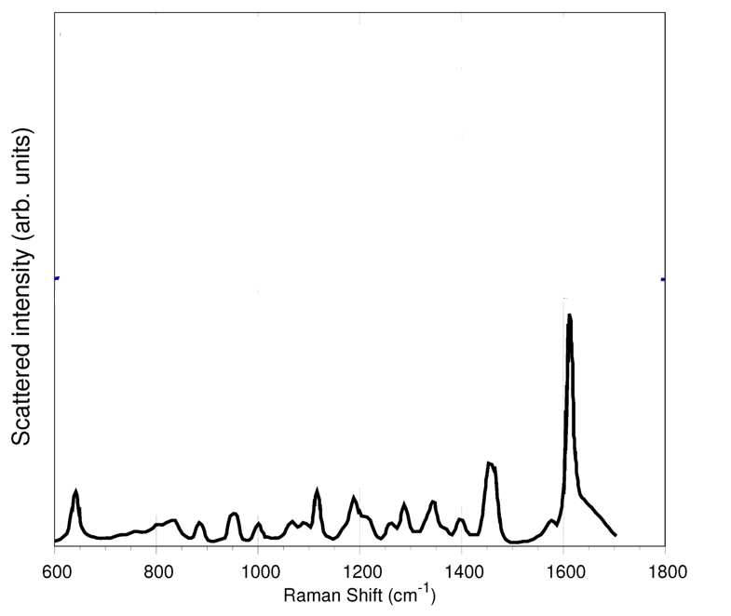
Figure 17:https://doi.org/10.3390/molecules27020442
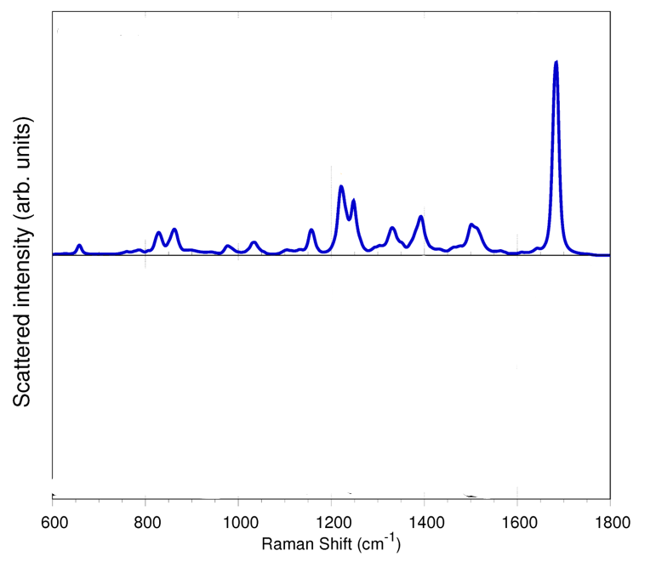
Figure 18:https://doi.org/10.3390/molecules27020442
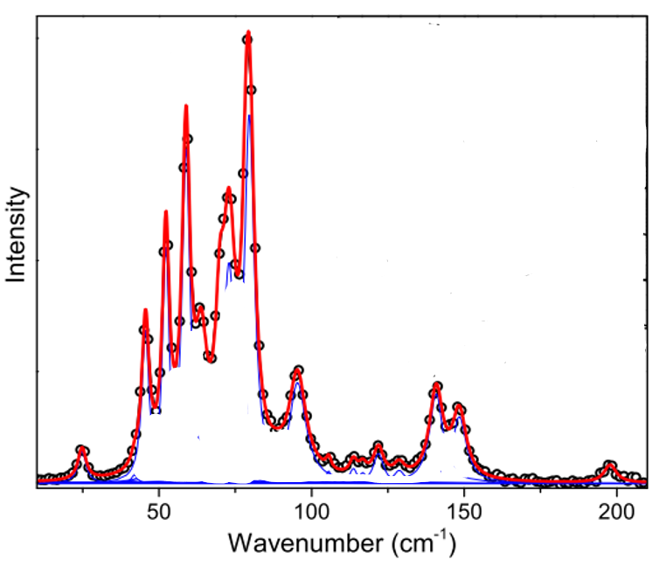
Figure 19:http://dx.doi.org/10.1016/j.saa.2014.01.135
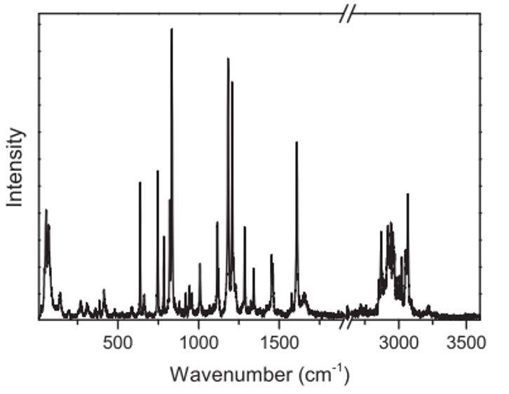
Figure 20:http://dx.doi.org/10.1016/j.saa.2014.01.135
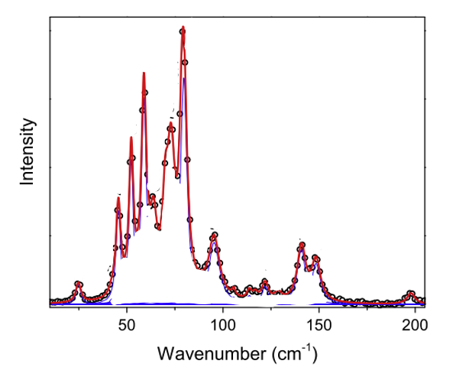
Figure 21:http://dx.doi.org/10.1016/j.saa.2014.01.135

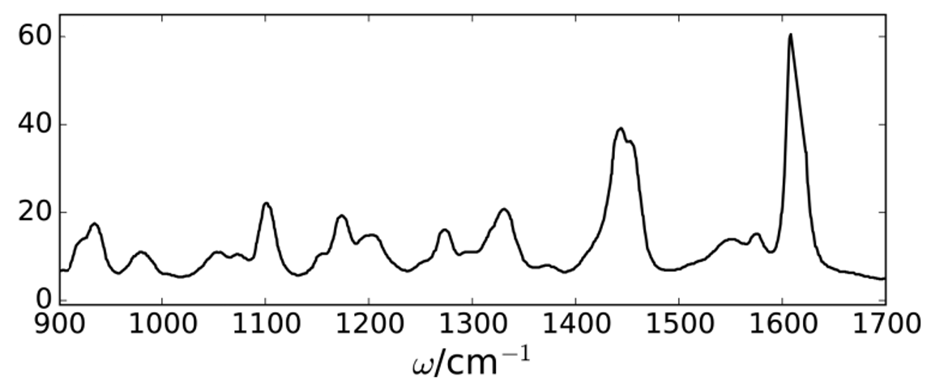
Figure 22:https://doi.org/10.1021/acs.jpca.6b09975
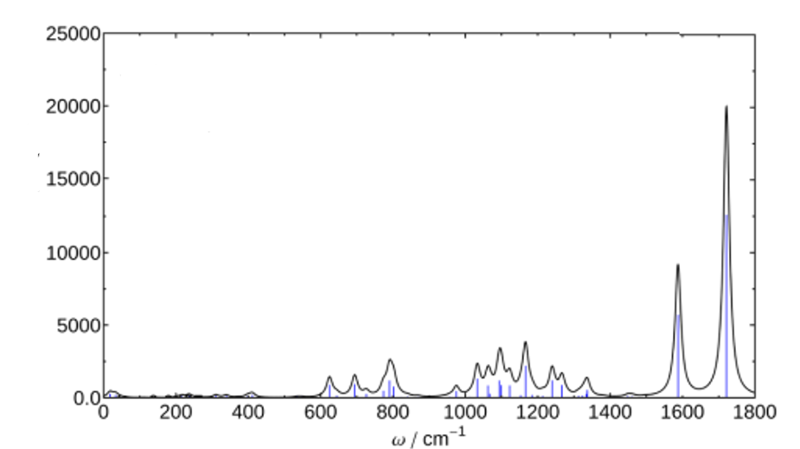
Figure 23:https://doi.org/10.1021/acs.jpca.6b09975
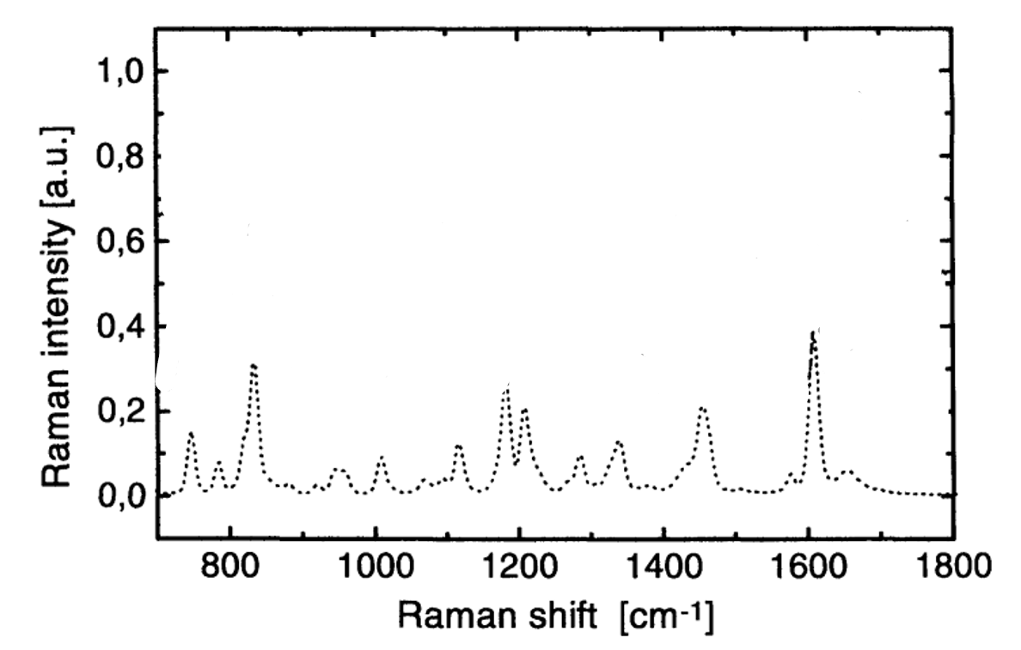
Figure 24:https://link.springer.com/content/pdf/10.1023/A%3A1018956304595.pdf

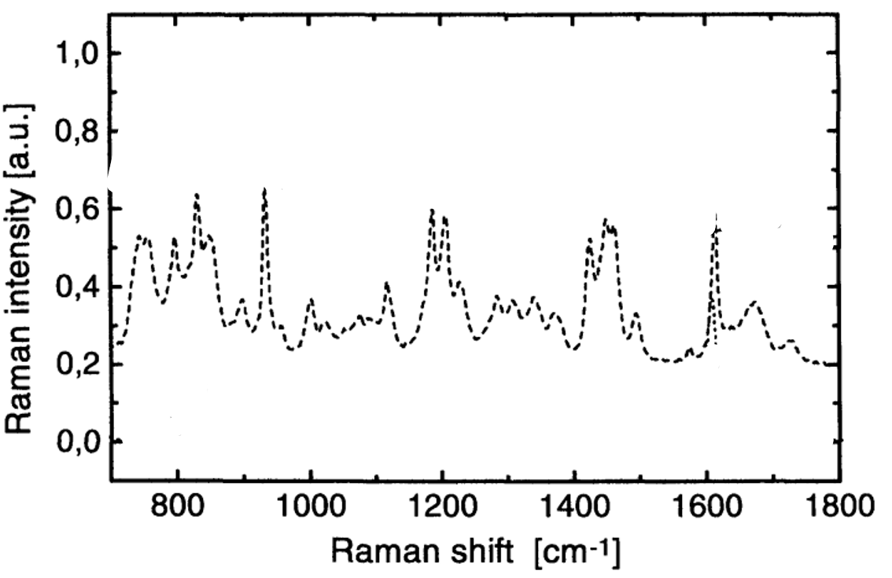
Figure 25:https://link.springer.com/content/pdf/10.1023/A%3A1018956304595.pdf
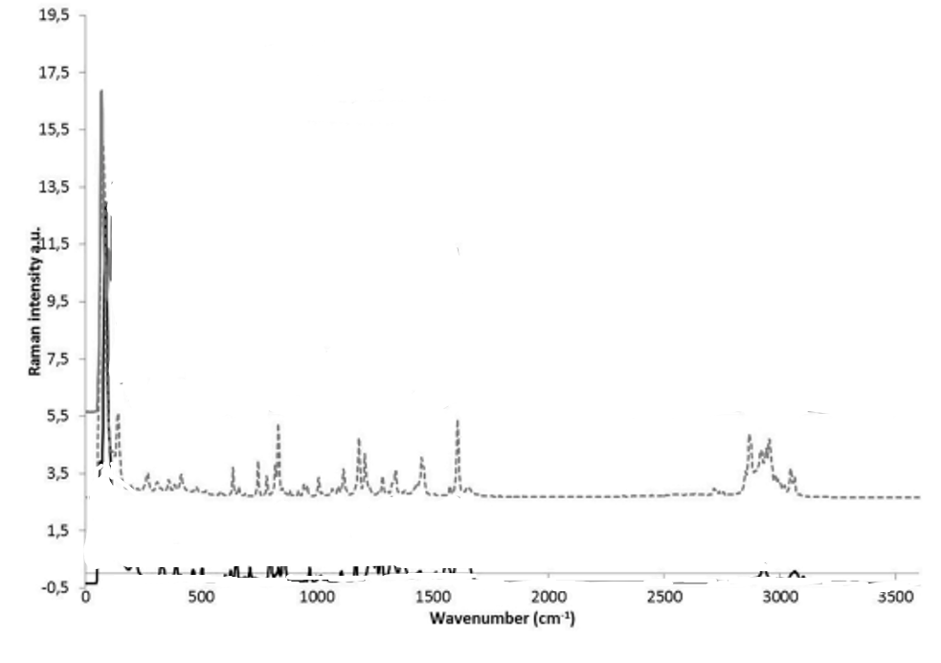
Figure 26:https://doi.org/10.1016/j.vibspec.2020.103147
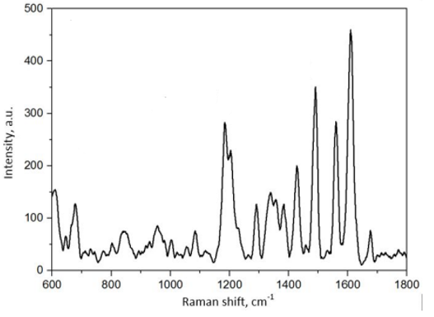
Figure 27:DOI 10.1088/1742-6596/1866/1/012007
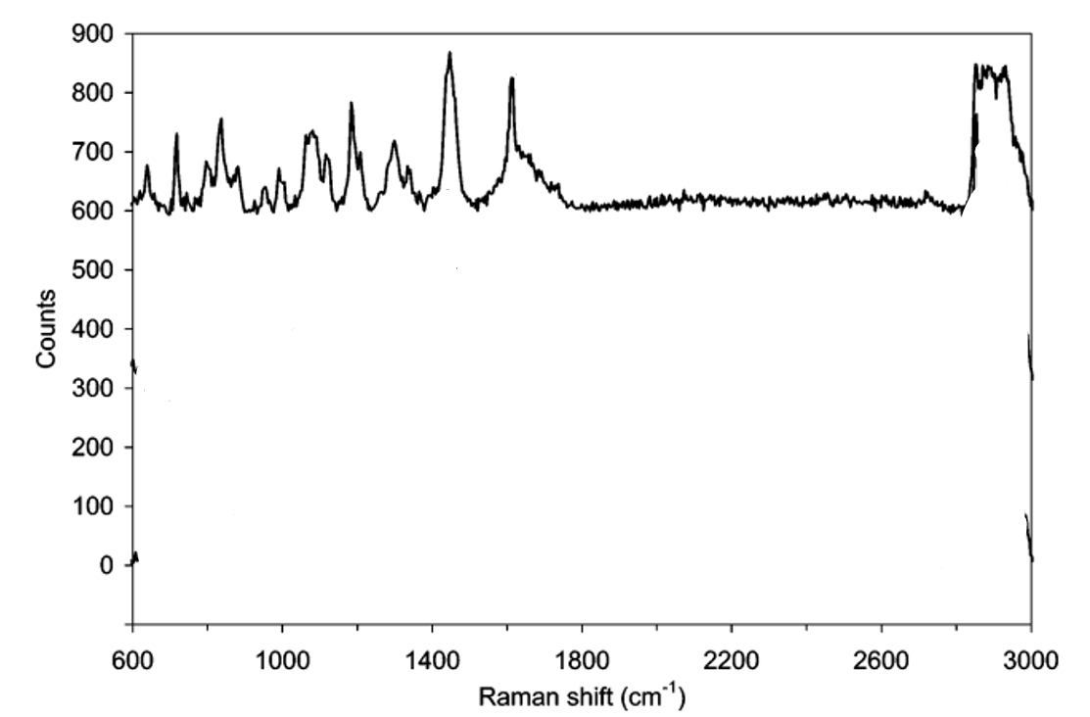
Figure 28:https://doi.org/10.1021/ac0605290
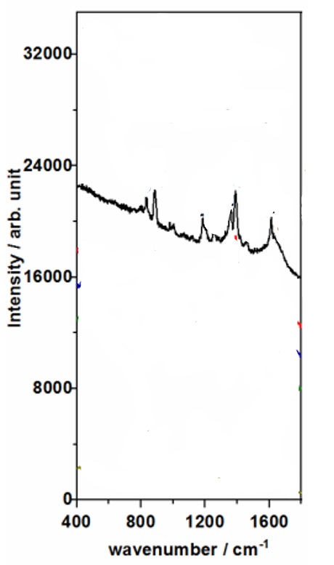
Figure 29:https://doi.org/10.3390/nano10122339
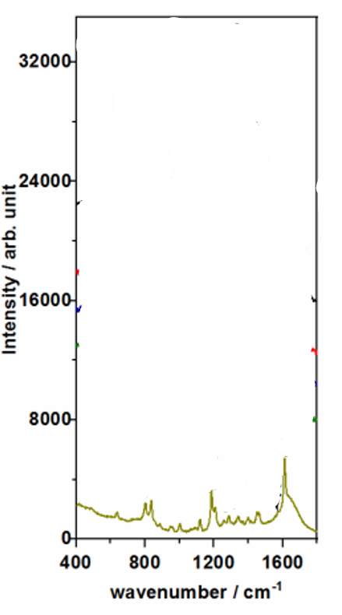
Figure 30:https://doi.org/10.3390/nano10122339
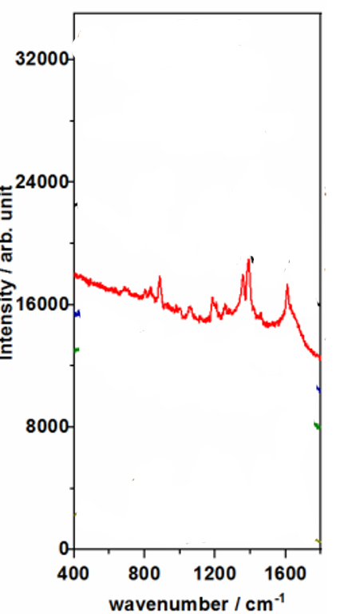
Figure 31:https://doi.org/10.3390/nano10122339
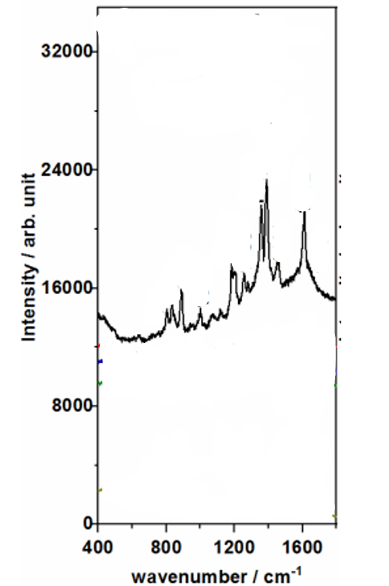
Figure 32:https://doi.org/10.3390/nano10122339
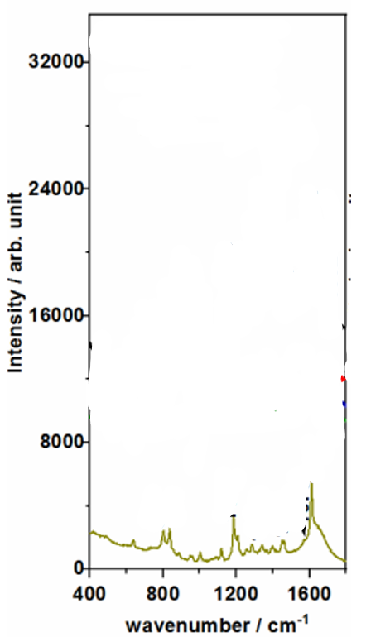
Figure 33:https://doi.org/10.3390/nano10122339
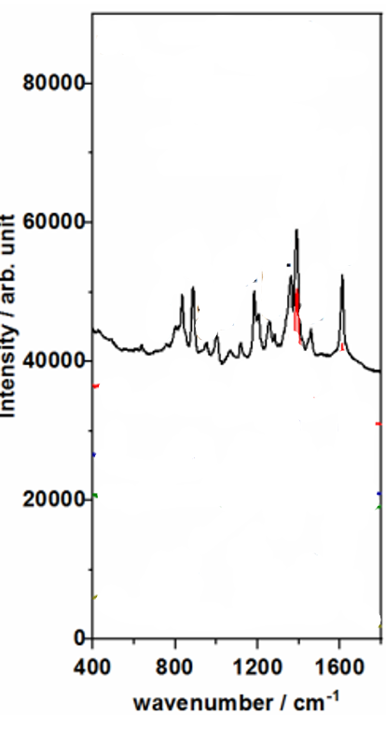
Figure 34:https://doi.org/10.3390/nano10122339
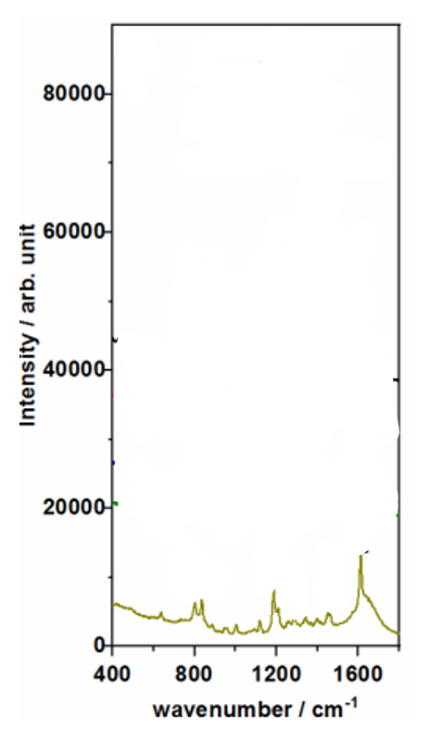
Figure 35:https://doi.org/10.3390/nano10122339
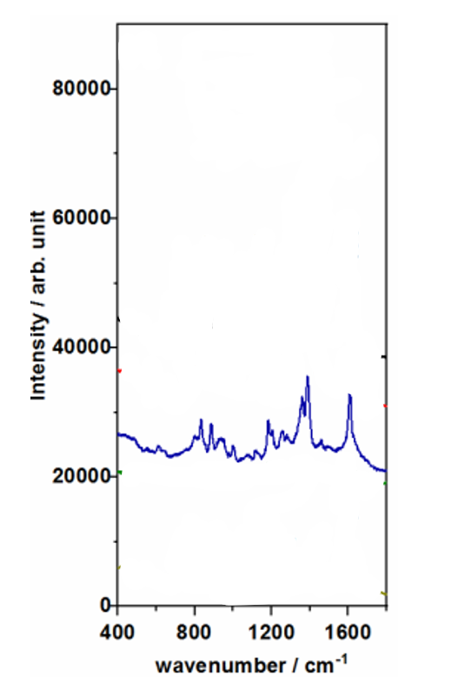
Figure 36:https://doi.org/10.3390/nano10122339
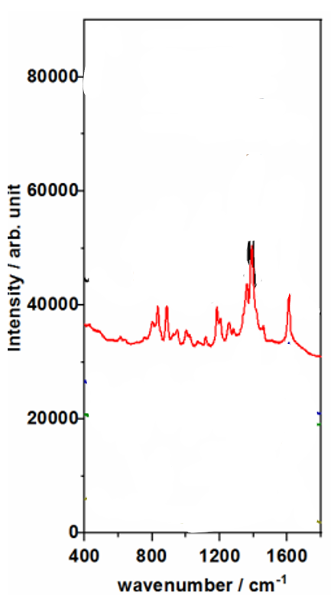
Figure 37:https://doi.org/10.3390/nano10122339
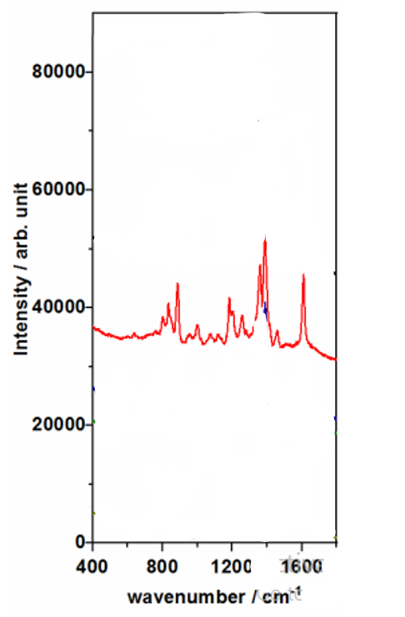
Figure 38:https://doi.org/10.3390/nano10122339
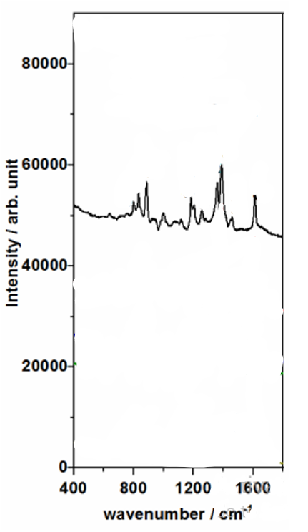
Figure 39:https://doi.org/10.3390/nano10122339
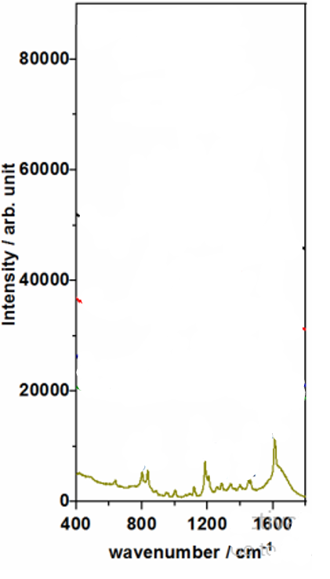
Figure 40:https://doi.org/10.3390/nano10122339
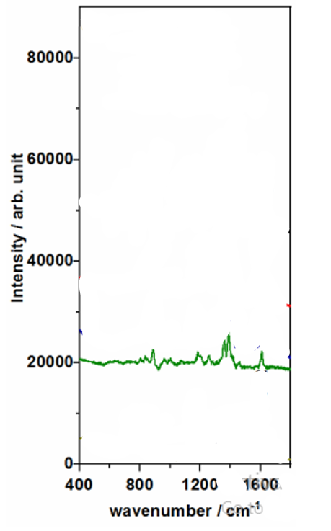
Figure 41:https://doi.org/10.3390/nano10122339
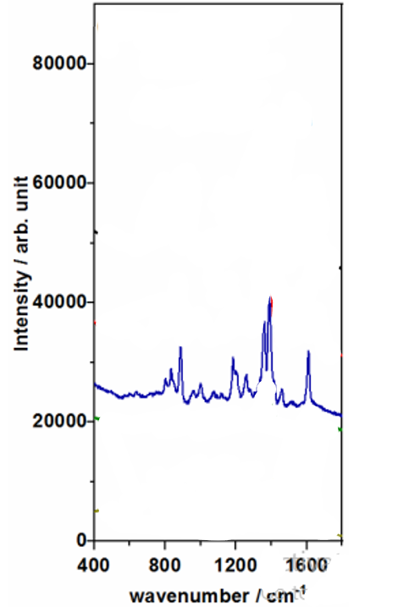
Figure 42:https://doi.org/10.3390/nano10122339
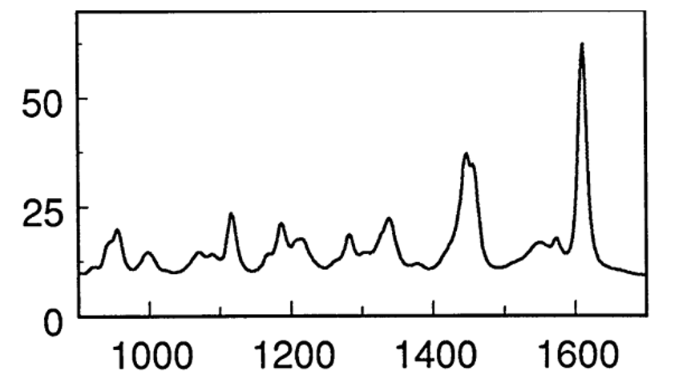
Figure 43:https://doi.org/10.1016/S0009-2614(98)00017-7
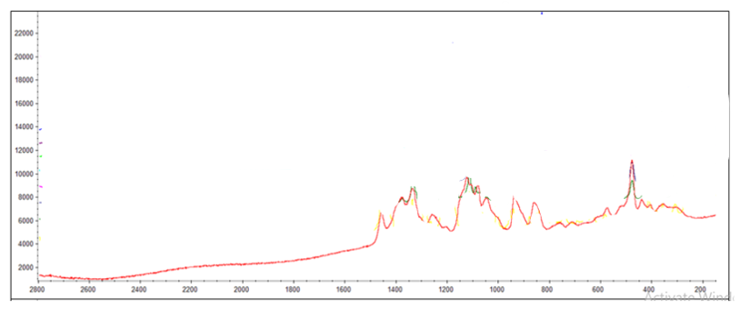
Figure 44:DOI: 10.34071/jmp.2025.4.3
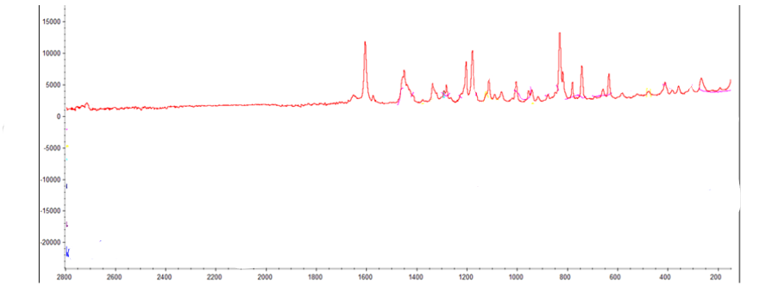
Figure 45:DOI: 10.34071/jmp.2025.4.3
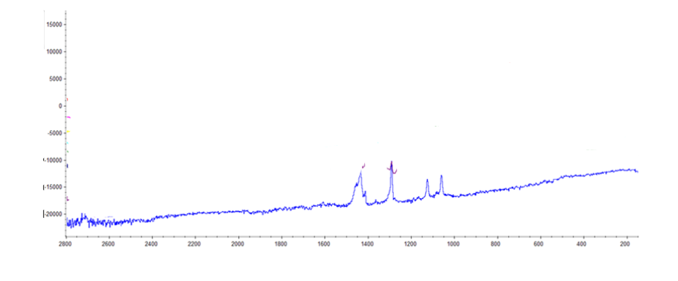
Figure 46:DOI: 10.34071/jmp.2025.4.3
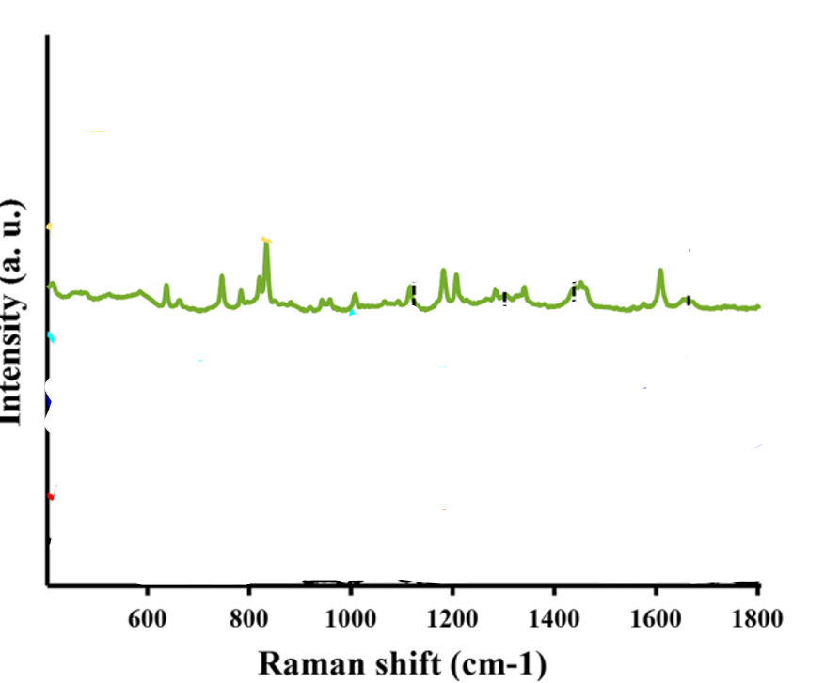
Figure 47:https://doi.org/10.1038/s41598-022-07168-6
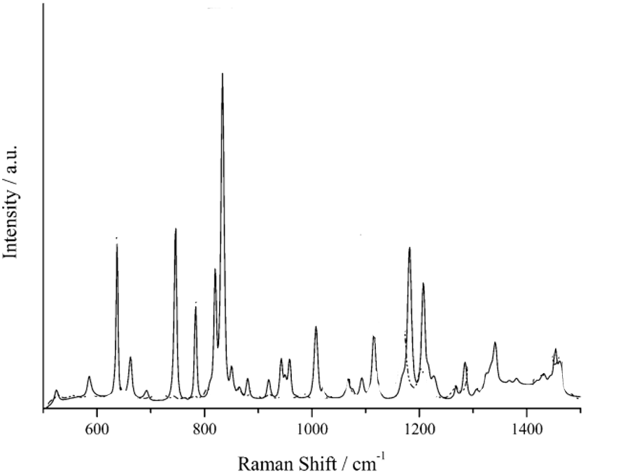
Figure 48:https://doi.org/10.1002/ceat.200800649
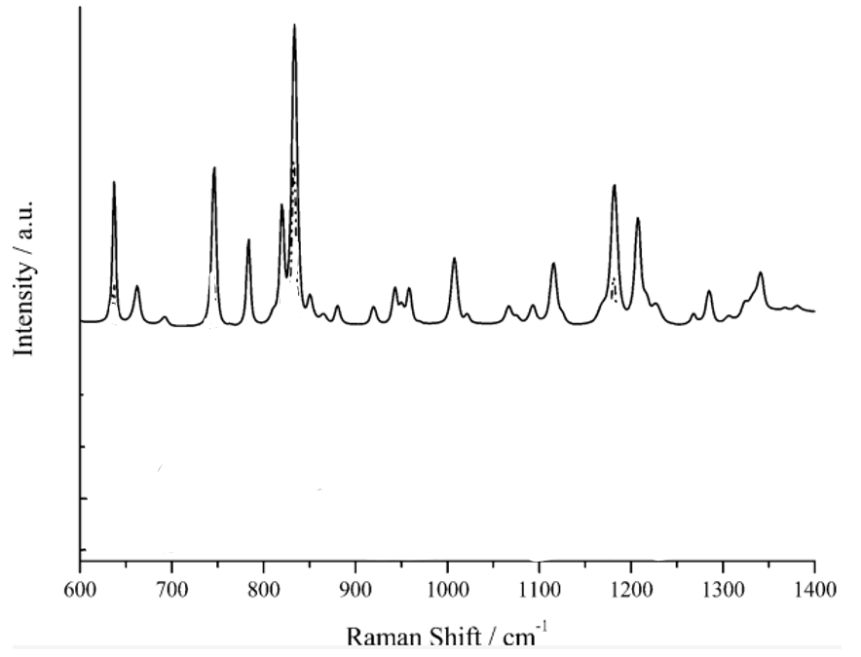
Figure 49:https://doi.org/10.1002/ceat.200800649
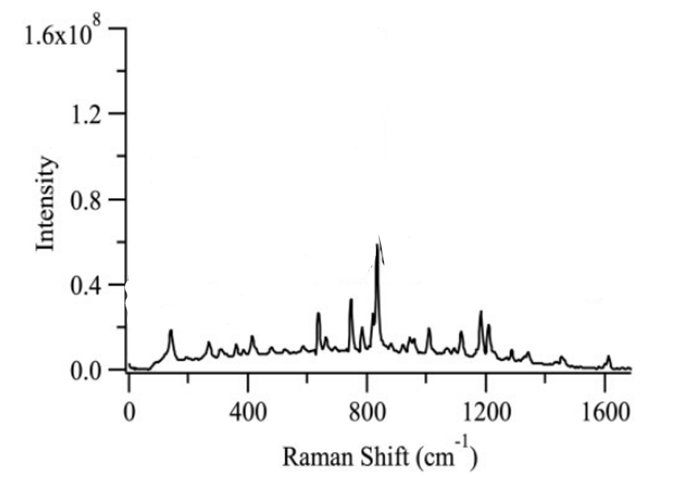
Figure 50:https://doi.org/10.1177/0003702816654156

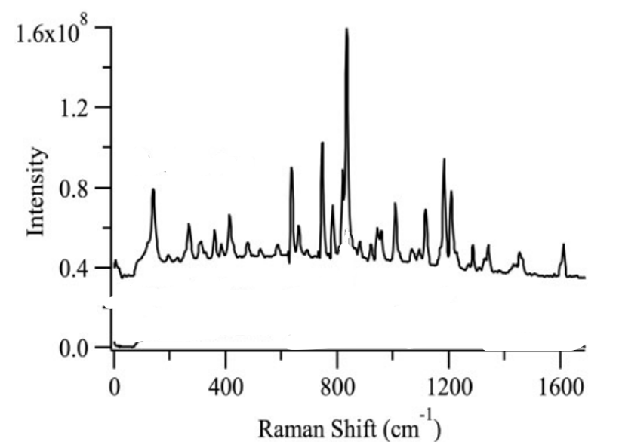
Figure 51:https://doi.org/10.1177/0003702816654156
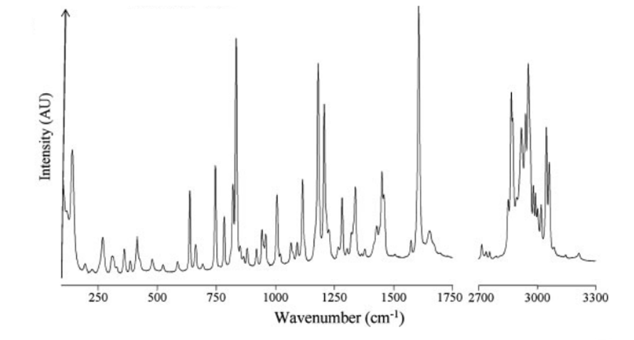
Figure 52:https://doi.org/10.1002/jps.21007
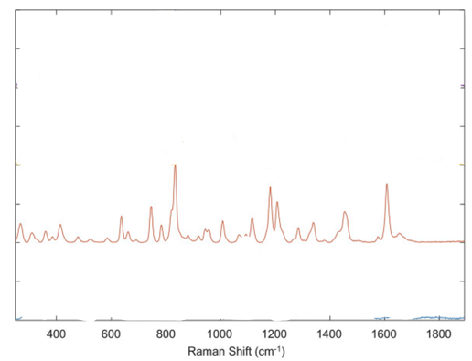
Figure 53:https://doi.org/10.1016/j.talanta.2019.120306
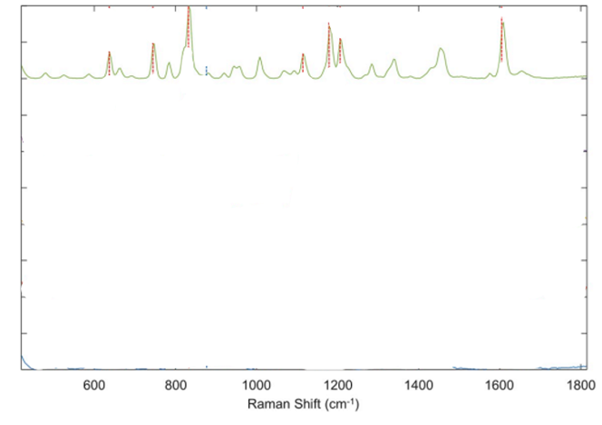
Figure 54:https://doi.org/10.1016/j.talanta.2019.120306
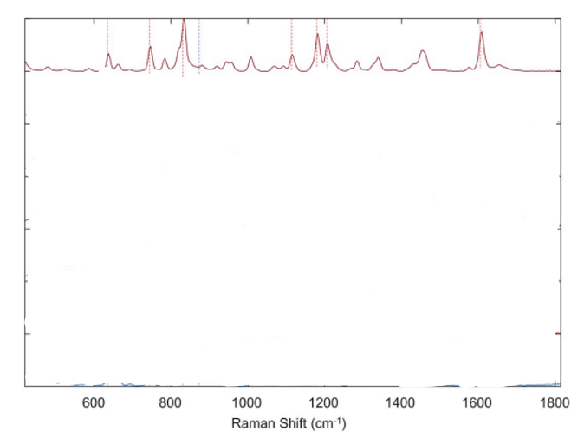
Figure 55:https://doi.org/10.1016/j.talanta.2019.120306
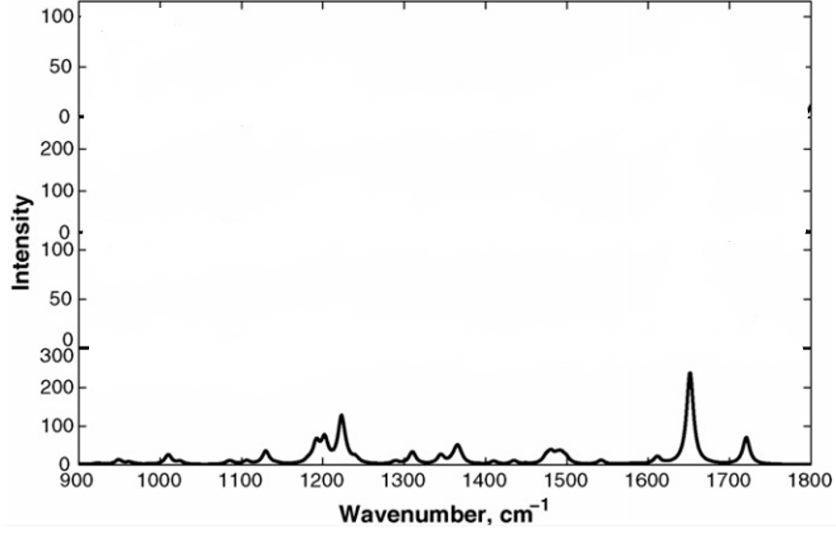
Figure 56:https://doi.org/10.1016/j.saa.2006.02.045
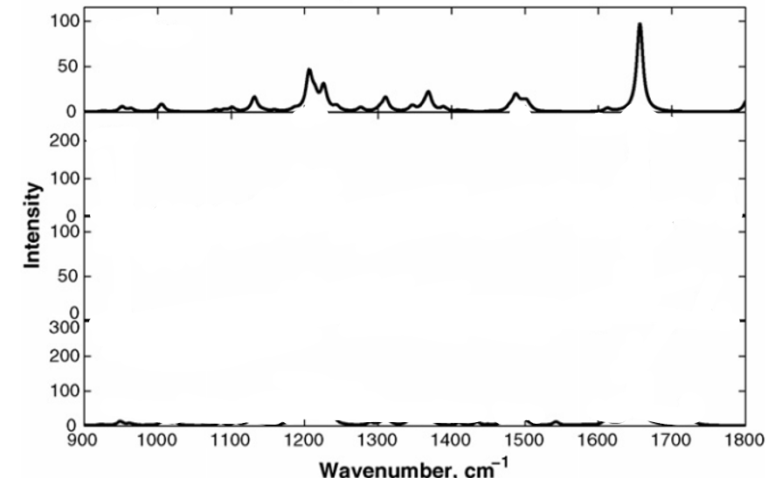
Figure 57:https://doi.org/10.1016/j.saa.2006.02.045
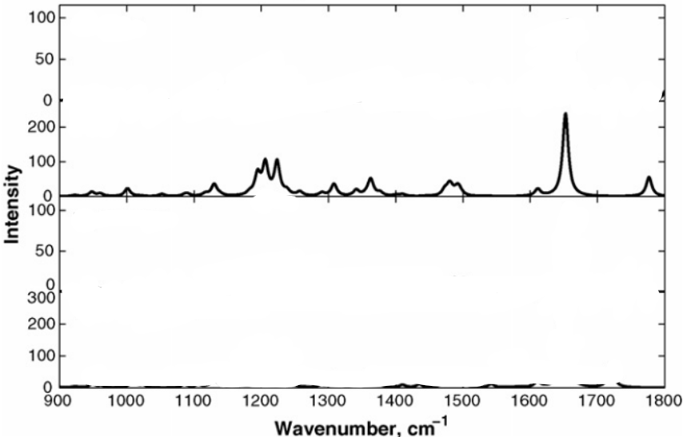
Figure 58:https://doi.org/10.1016/j.saa.2006.02.045
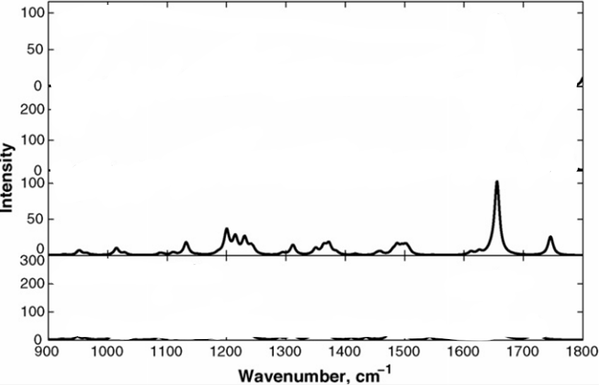
Figure 59:https://doi.org/10.1016/j.saa.2006.02.045
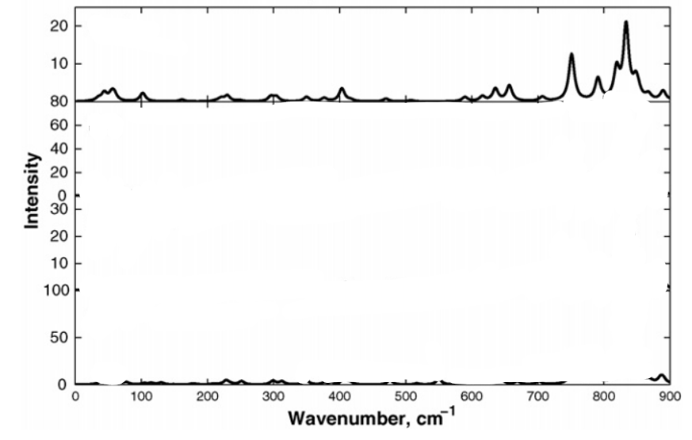
Figure 60:https://doi.org/10.1016/j.saa.2006.02.045
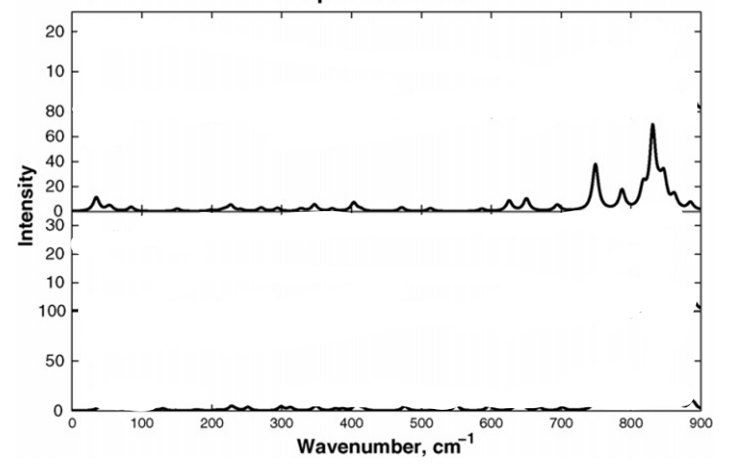
Figure 61:https://doi.org/10.1016/j.saa.2006.02.045
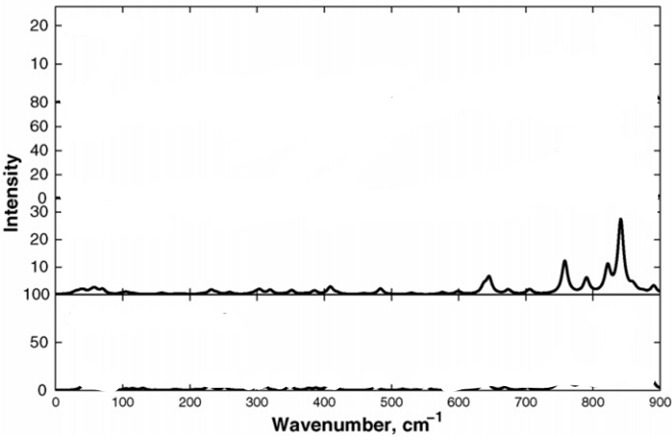
Figure 62:https://doi.org/10.1016/j.saa.2006.02.045
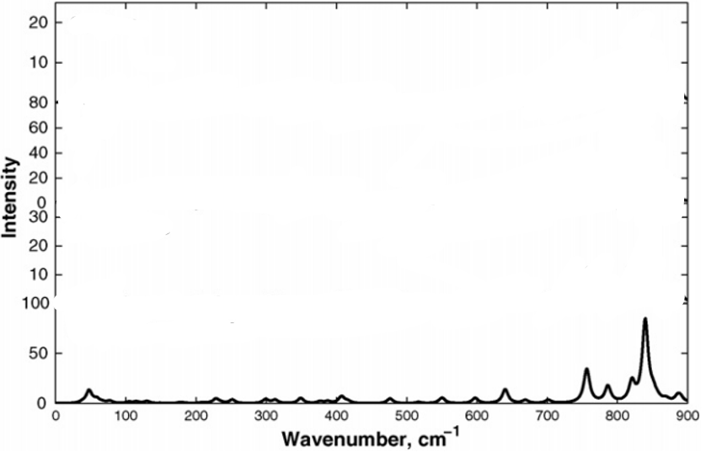
Figure 63:https://doi.org/10.1016/j.saa.2006.02.045
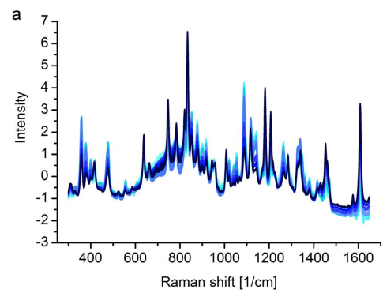
Figure 64:https://doi.org/10.1016/j.ejpb.2018.01.015
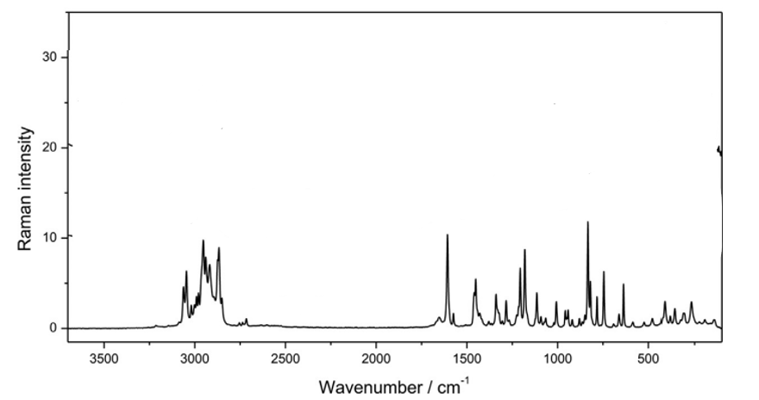
Figure 65:https://doi.org/10.1016/j.vibspec.2017.10.003
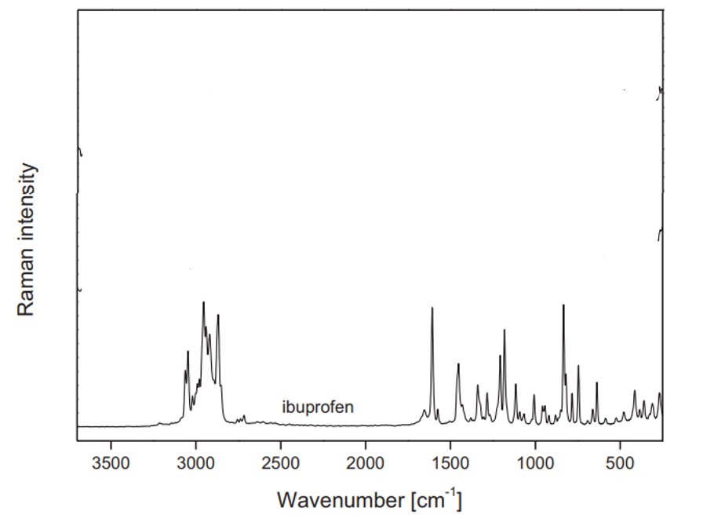
Figure 66:https://doi.org/10.1016/j.vibspec.2015.12.005
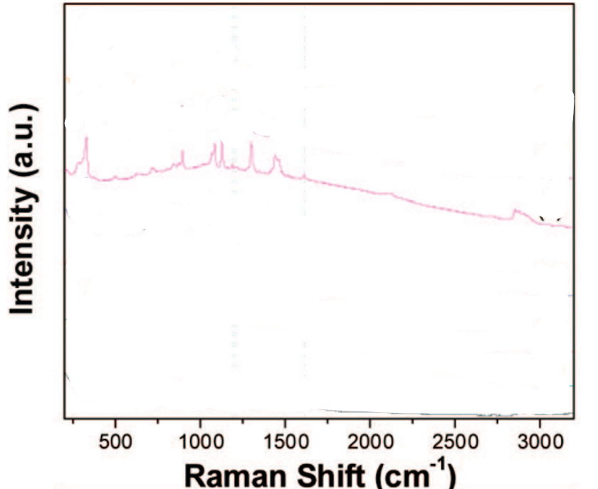
Figure 67:https://doi.org/10.1021/jp804374e
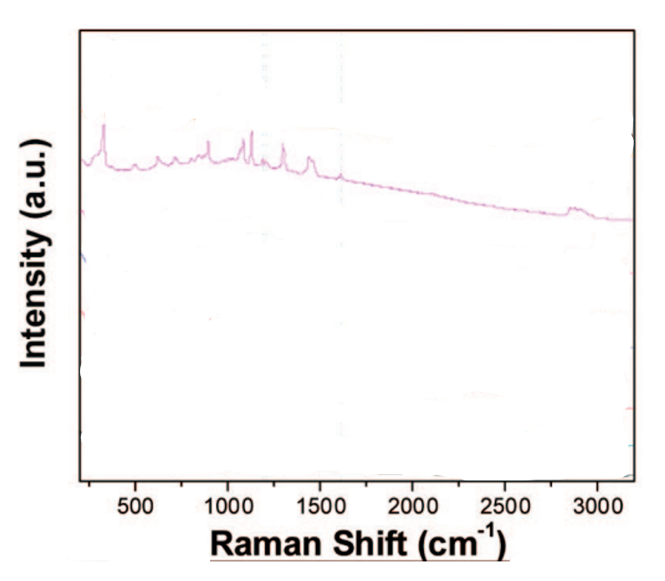
Figure 68:https://doi.org/10.1021/jp804374e
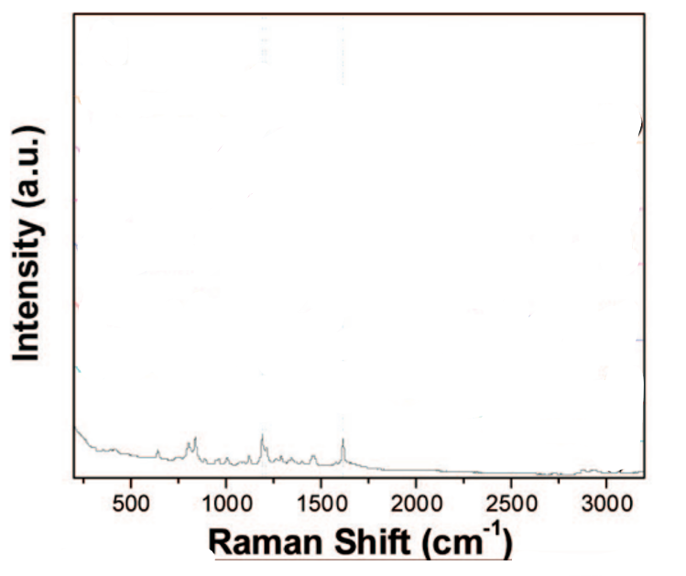
Figure 69:https://doi.org/10.1021/jp804374e
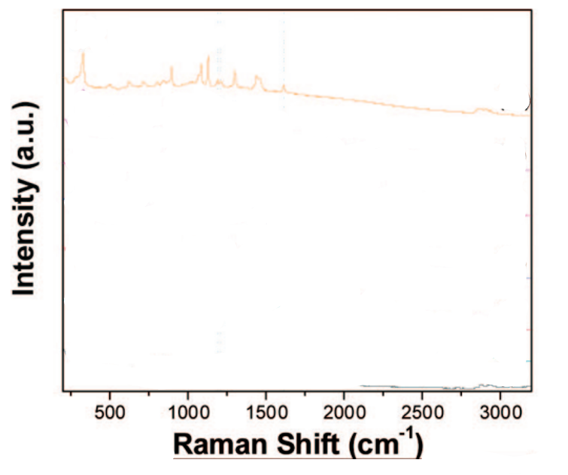
Figure 70:https://doi.org/10.1021/jp804374e
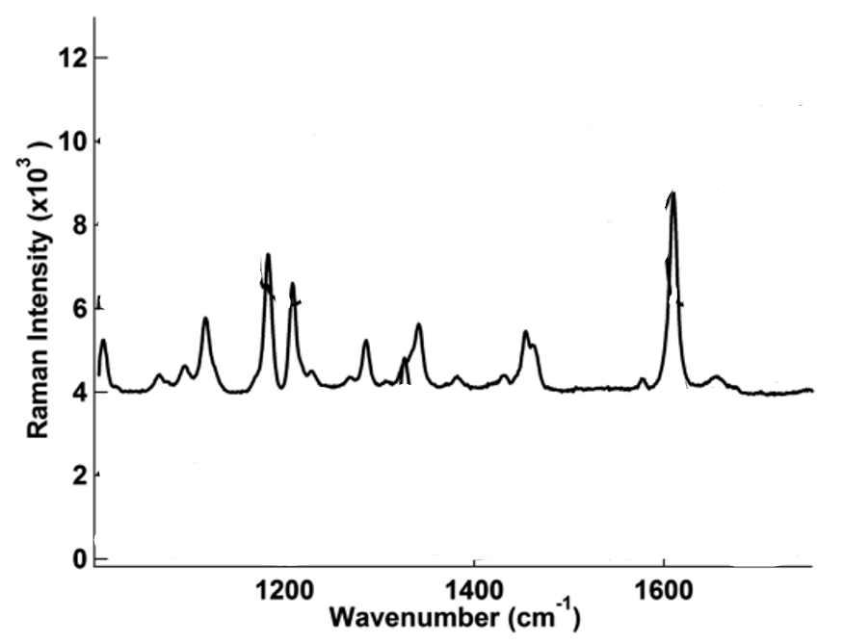
Figure 71:DOI: 10.1021/bk-2018-1305.ch005
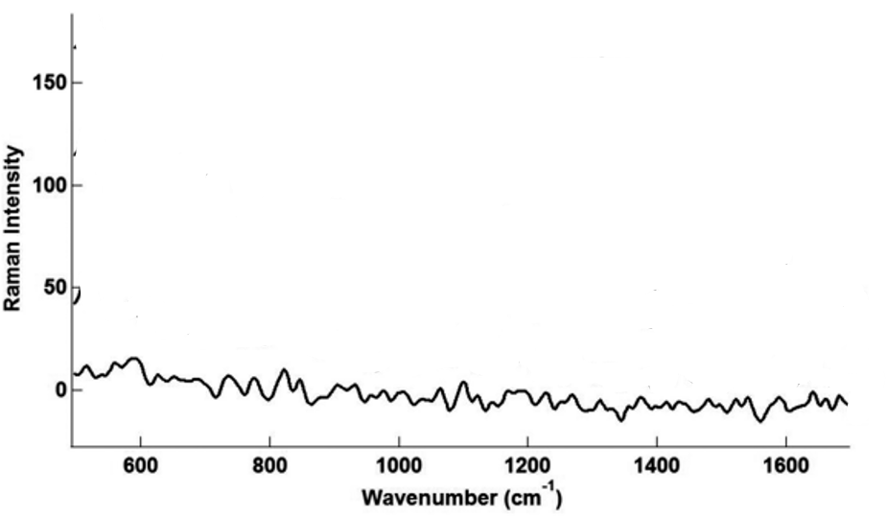
Figure 72:DOI: 10.1021/bk-2018-1305.ch005
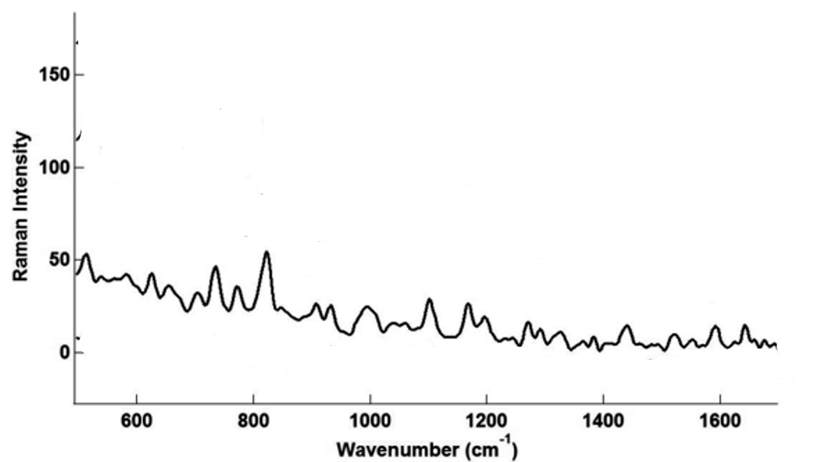
Figure 73:DOI: 10.1021/bk-2018-1305.ch005
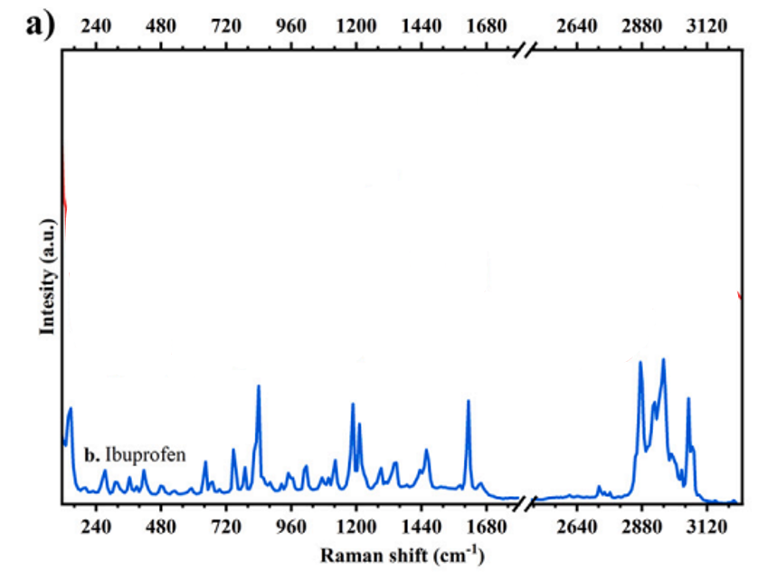
Figure 74:https://doi.org/10.1016/j.cartre.2025.100505
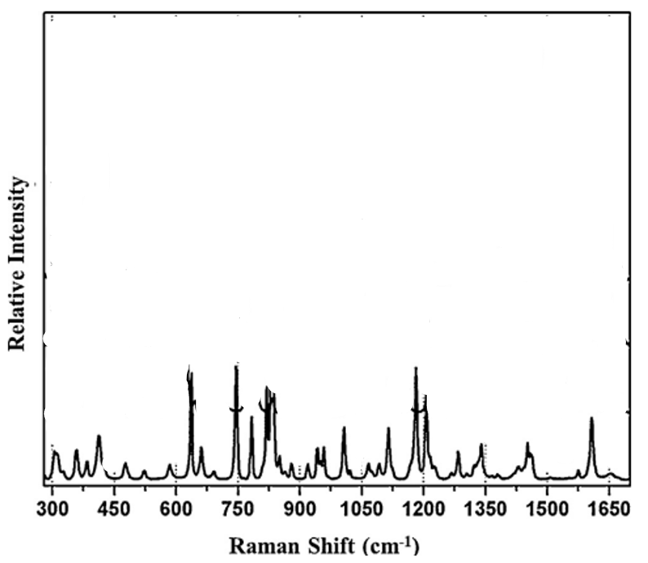
Figure 75:https://doi.org/10.1016/j.jpba.2013.11.005
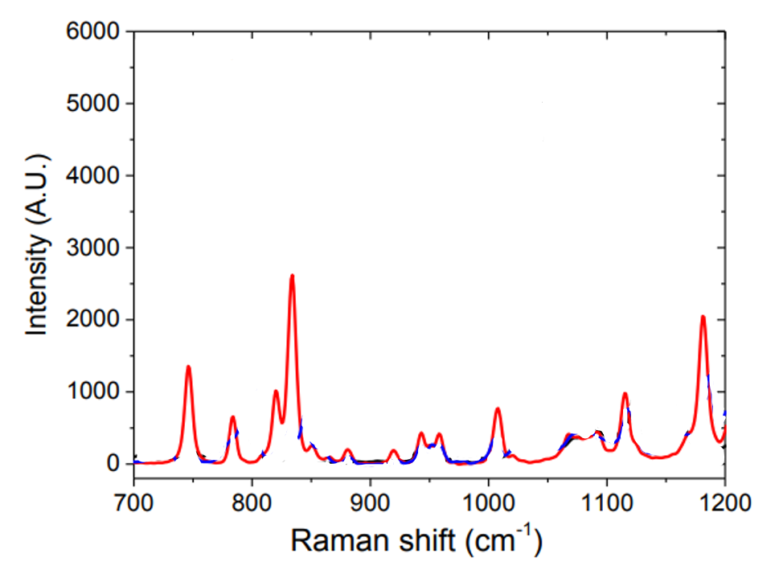
Figure 76:https://doi.org/10.1016/j.ijpharm.2021.120555
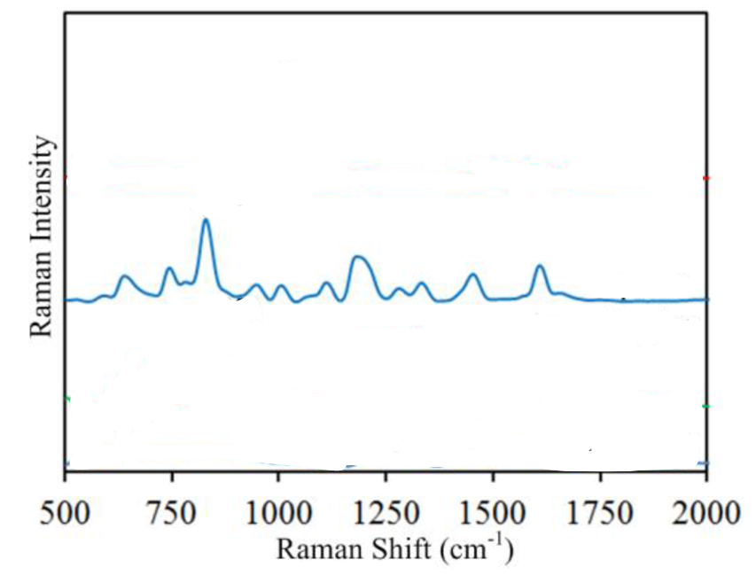
Figure 77:https://doi.org/10.3390/s17030618
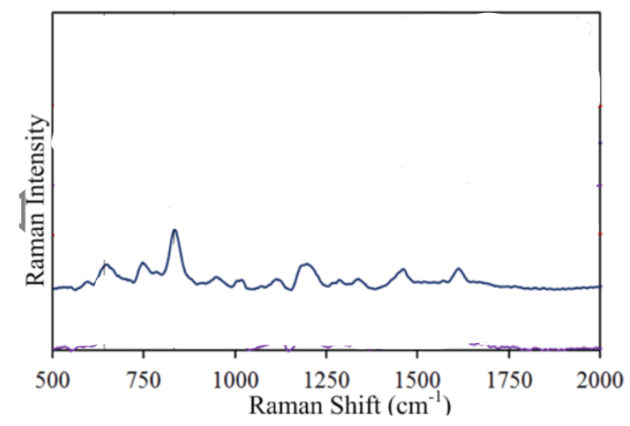
Figure 78:https://doi.org/10.3390/s17030618
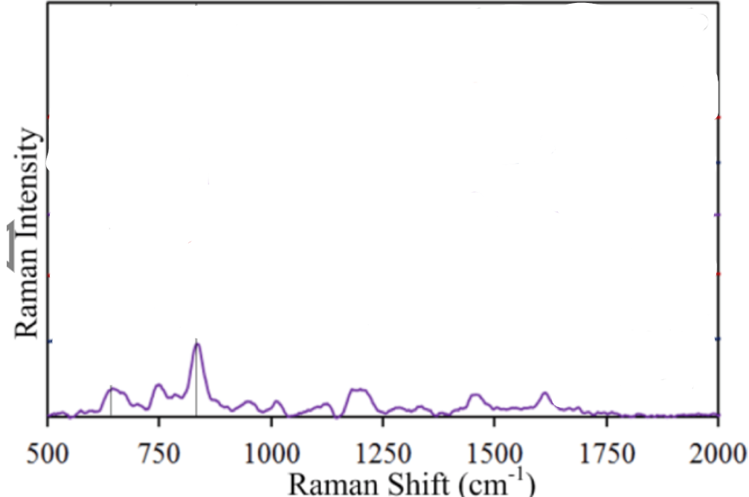
Figure 79:https://doi.org/10.3390/s17030618
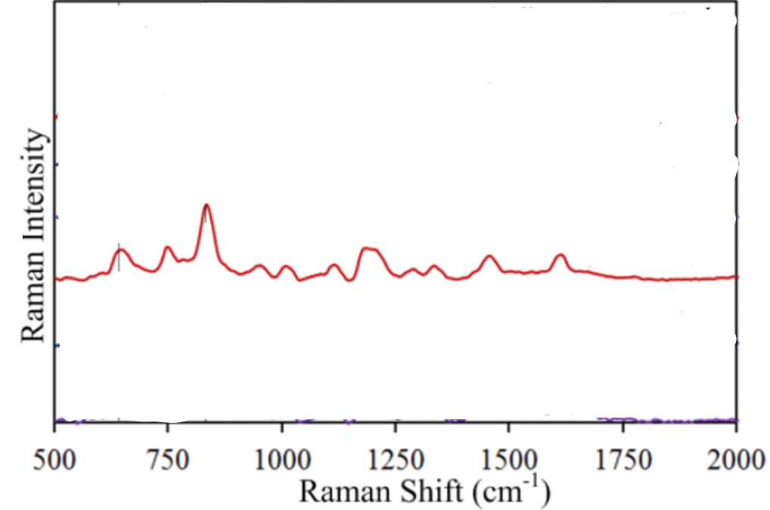
Figure 80:https://doi.org/10.3390/s17030618
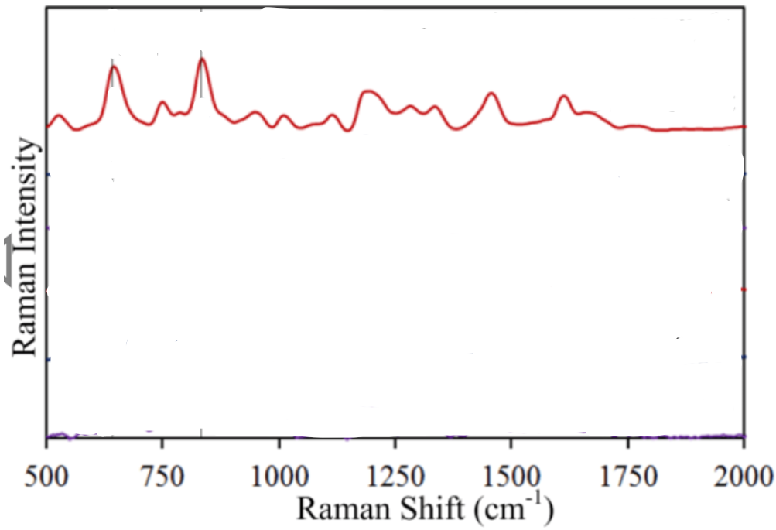
Figure 81:https://doi.org/10.3390/s17030618
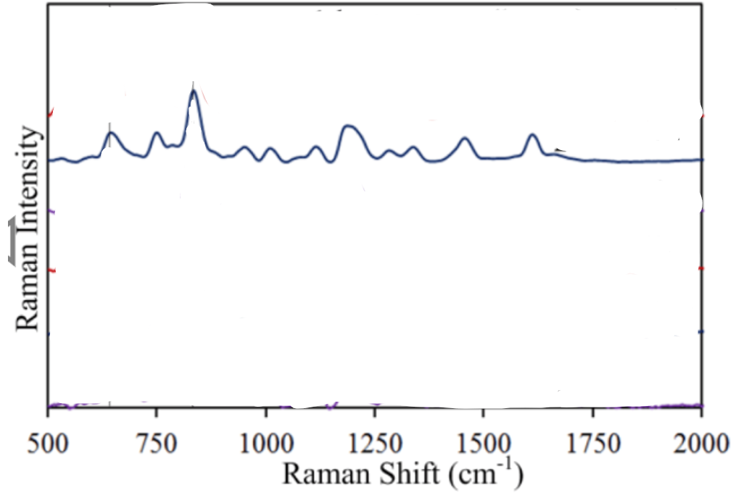
Figure 82:https://doi.org/10.3390/s17030618
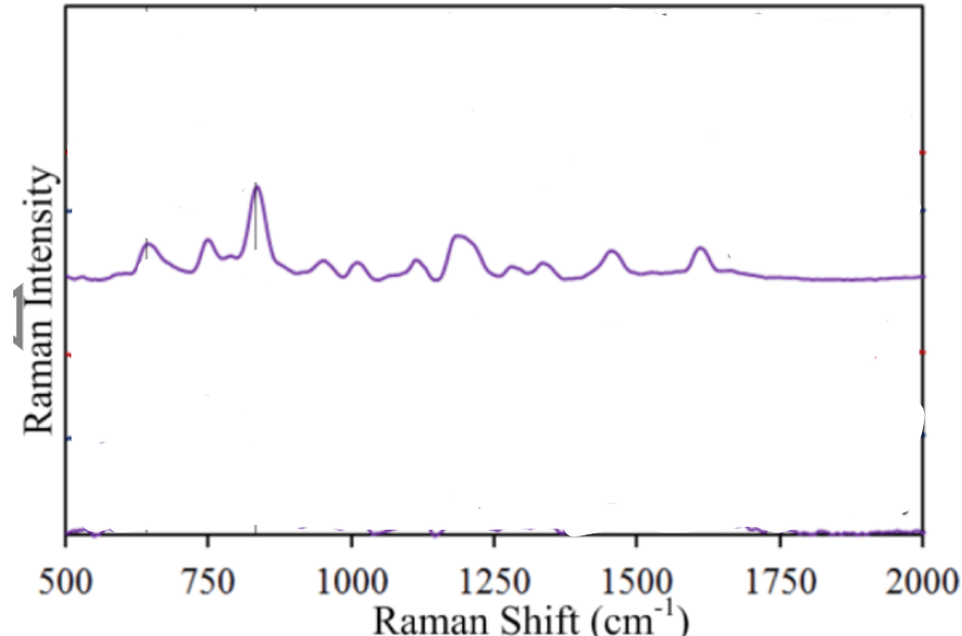
Figure 83:https://doi.org/10.3390/s17030618
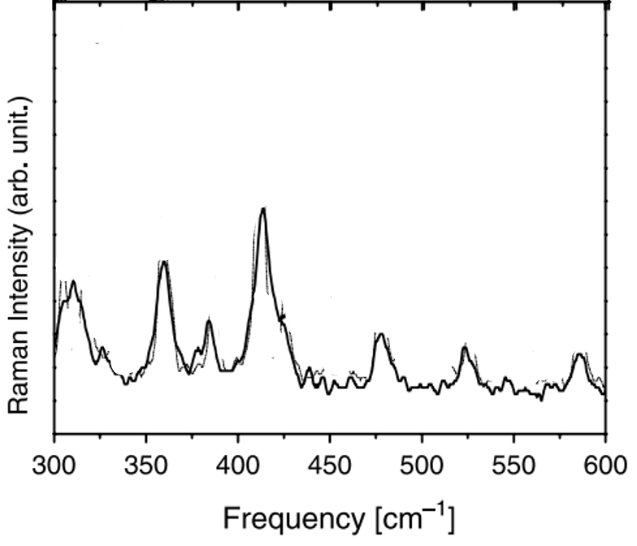
Figure 84:https://doi.org/10.1016/j.molstruc.2005.08.018
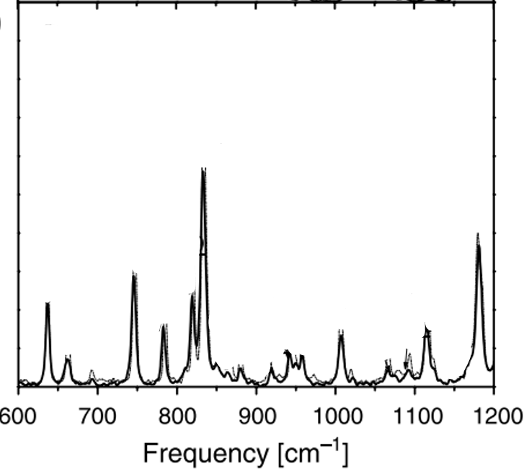
Figure 85:https://doi.org/10.1016/j.molstruc.2005.08.018
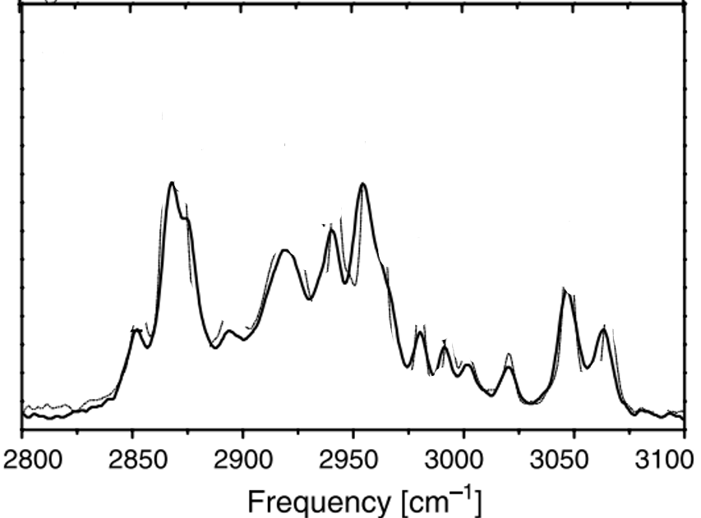
Figure 86:https://doi.org/10.1016/j.molstruc.2005.08.018
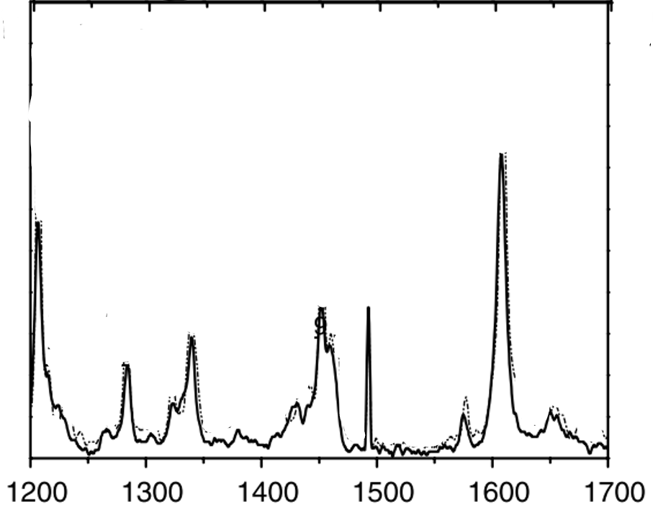
Figure 87:https://doi.org/10.1016/j.molstruc.2005.08.018
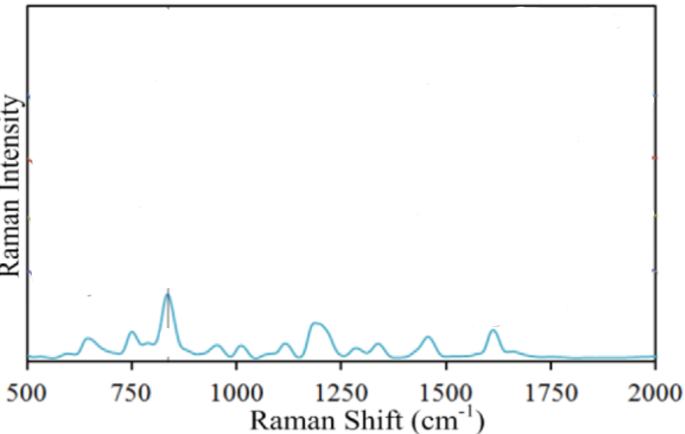
Figure 88:https://doi.org/10.3390/s17030618
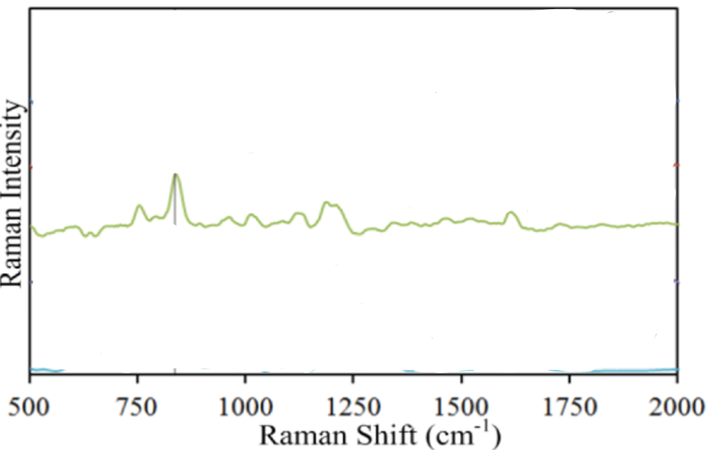
Figure 89:https://doi.org/10.3390/s17030618
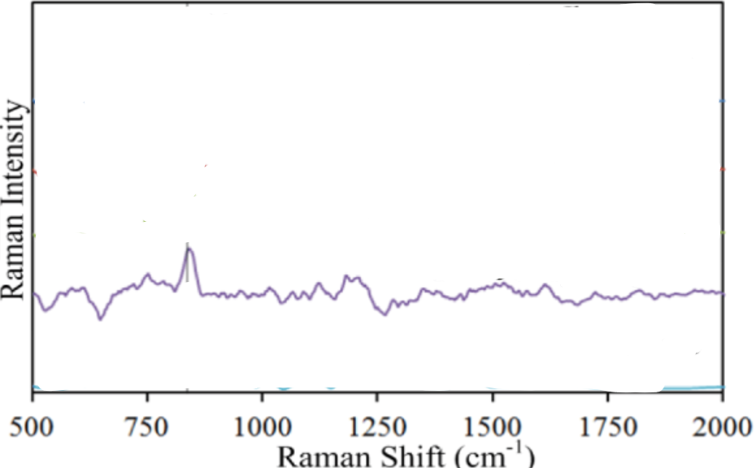
Figure 90:https://doi.org/10.3390/s17030618
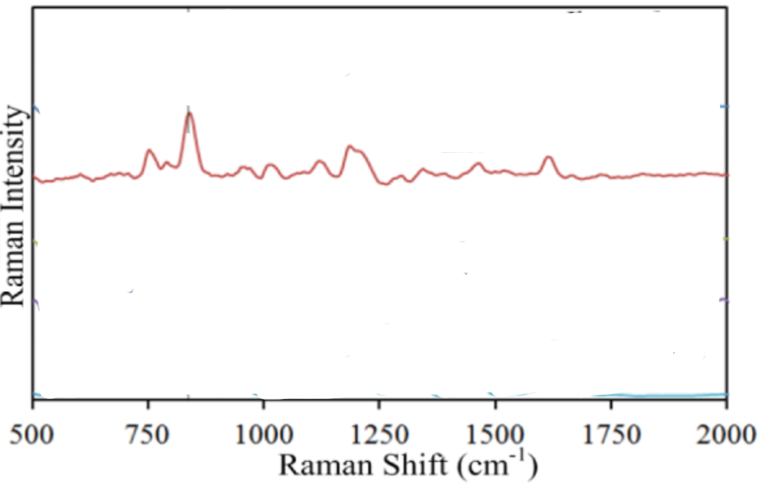
Figure 91:https://doi.org/10.3390/s17030618
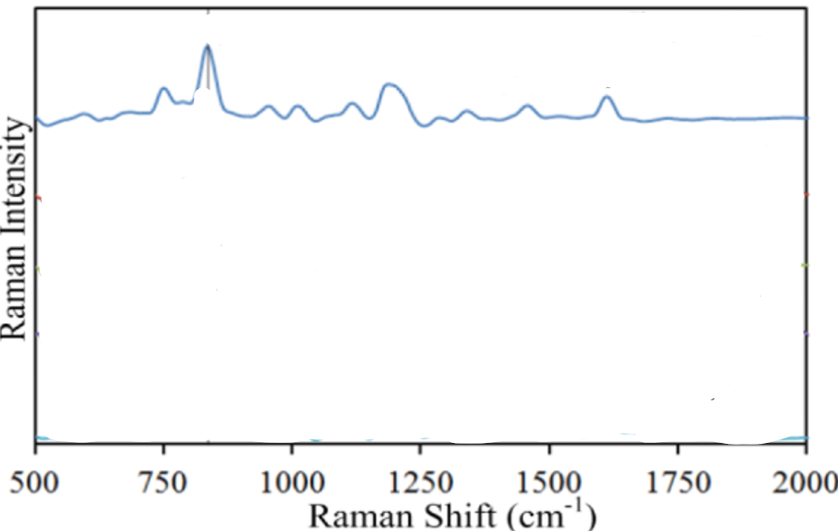
Figure 92:https://doi.org/10.3390/s17030618
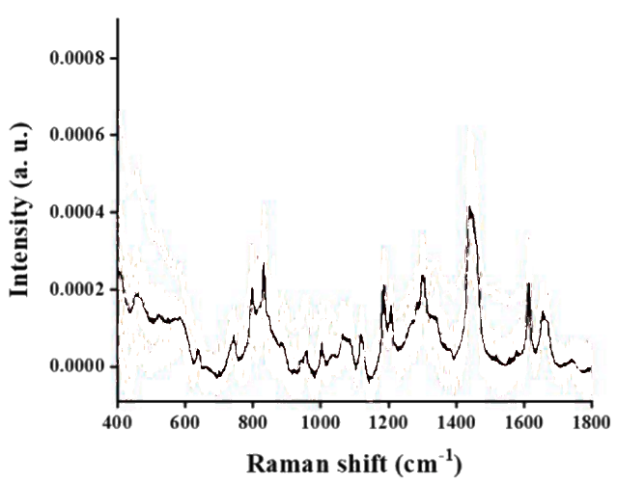
Figure 93:https://doi.org/10.1016/j.forc.2022.100457
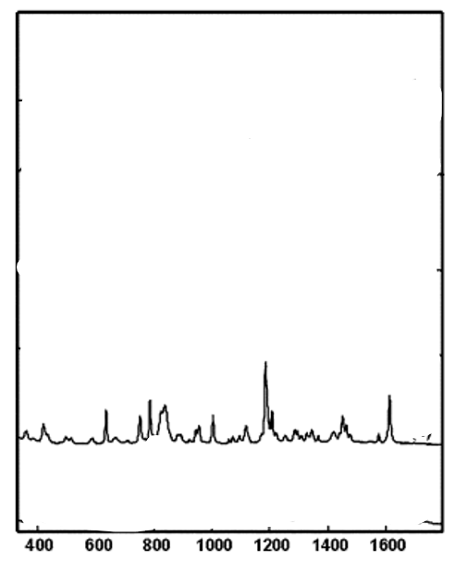
Figure 94:https://doi.org/10.1039/B808259F
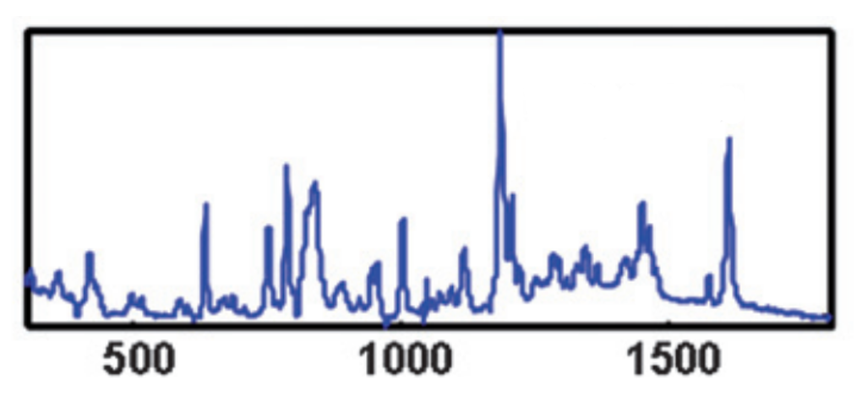
Figure 95:https://doi.org/10.1039/B808259F
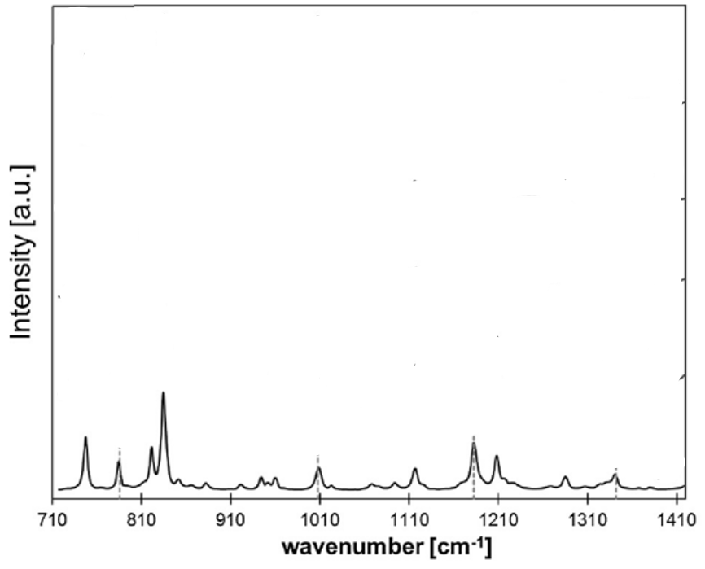
Figure 96:https://doi.org/10.1016/j.ijpharm.2019.118816
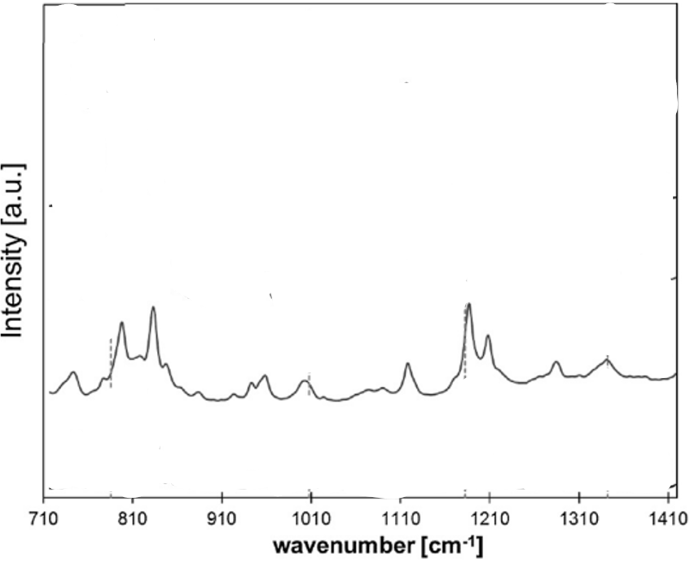
Figure 97:https://doi.org/10.1016/j.ijpharm.2019.118816
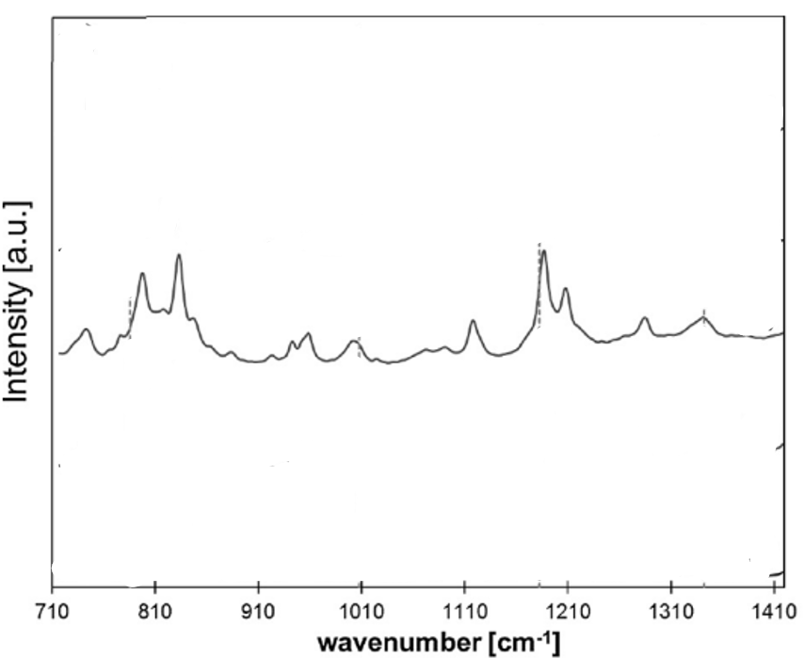
Figure 98:https://doi.org/10.1016/j.ijpharm.2019.118816
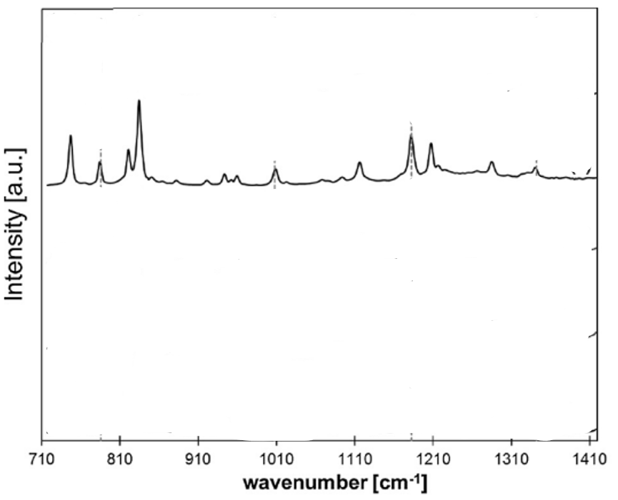
Figure 99:https://doi.org/10.1016/j.ijpharm.2019.118816
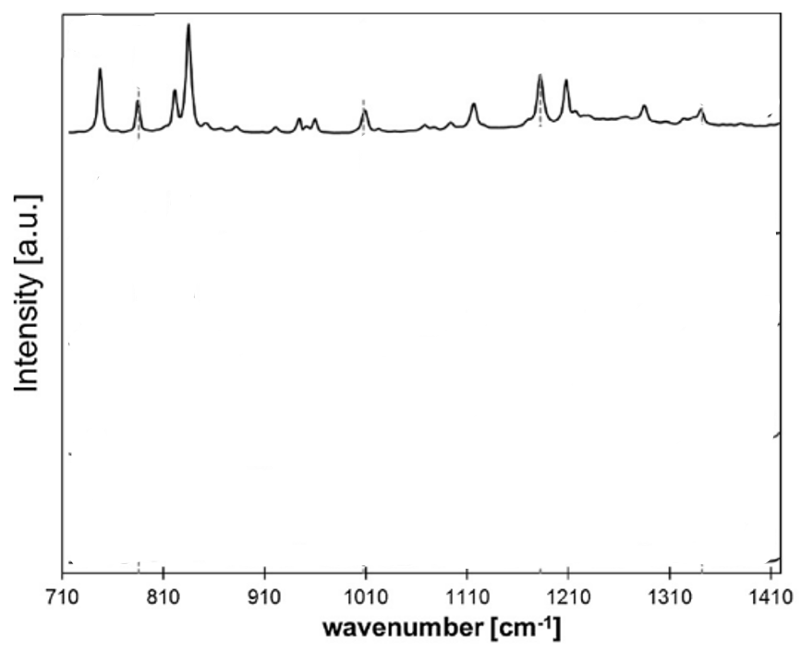
Figure 100:https://doi.org/10.1016/j.ijpharm.2019.118816
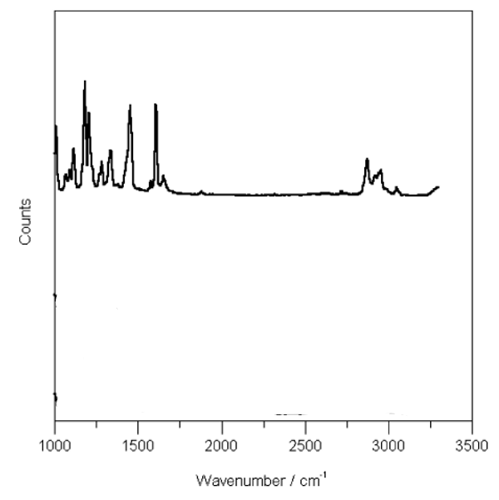
Figure 101:https://doi.org/10.1039/B821281C
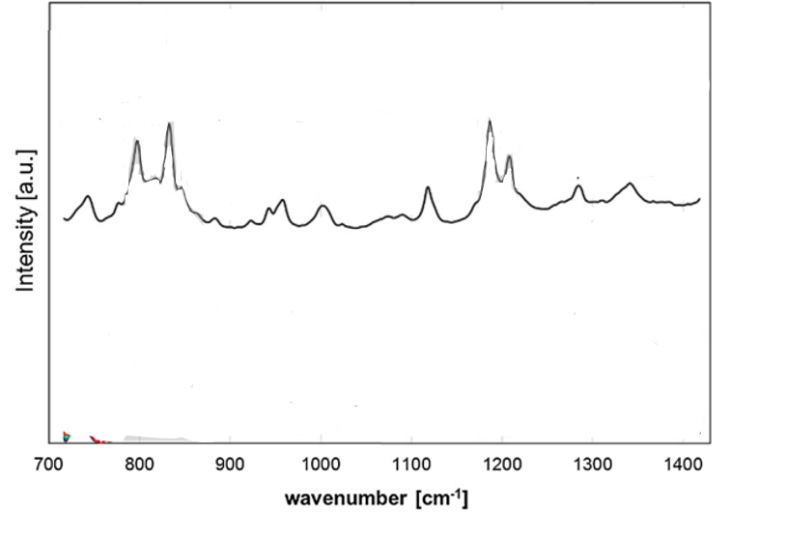
Figure 102:https://doi.org/10.1016/j.ijpharm.2019.118816
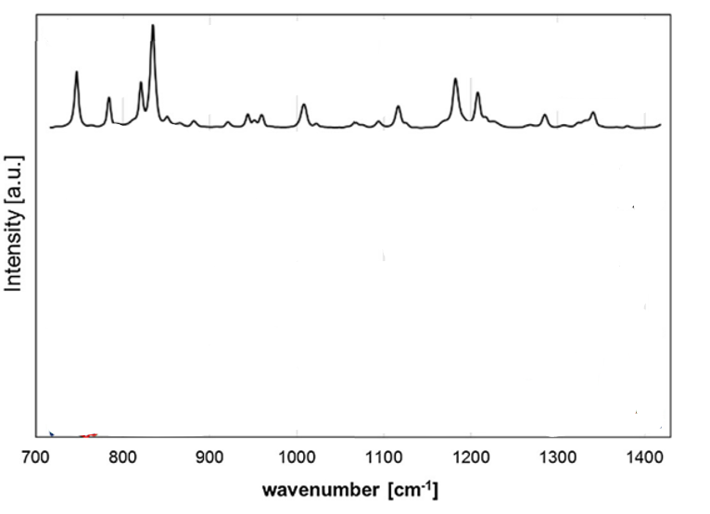
Figure 103:https://doi.org/10.1016/j.ijpharm.2019.118816
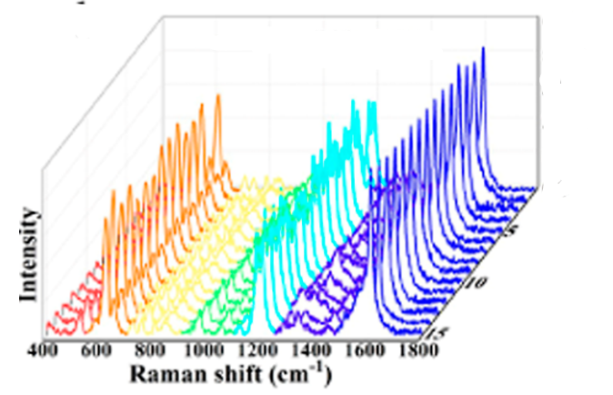
Figure 104:https://doi.org/10.1021/acs.analchem.5c02529
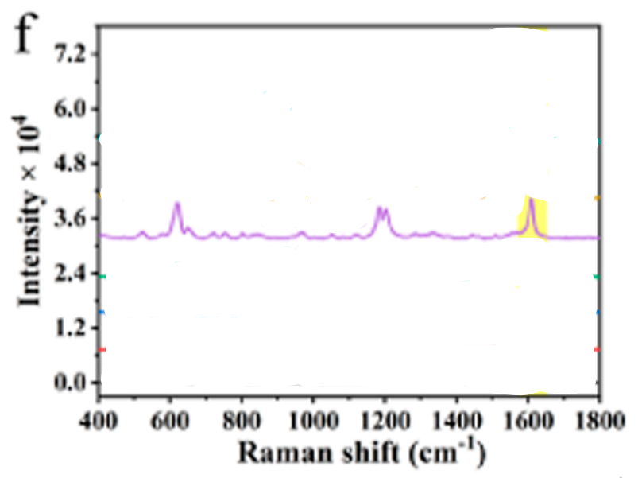
Figure 105:https://doi.org/10.1021/acs.analchem.5c02529
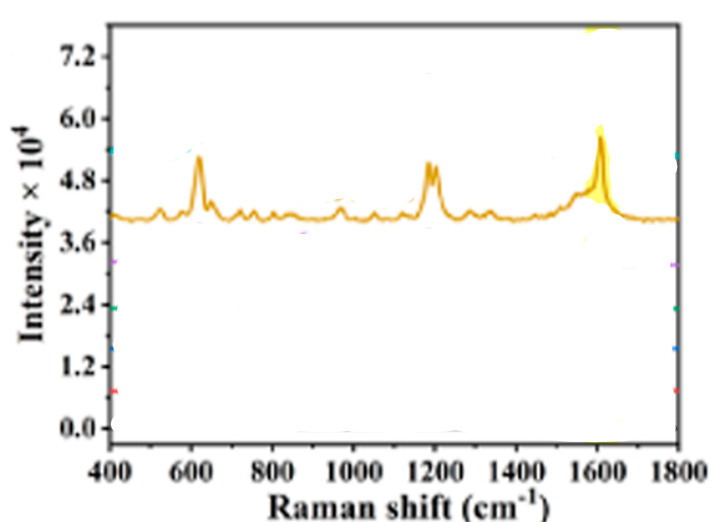
Figure 106:https://doi.org/10.1021/acs.analchem.5c02529
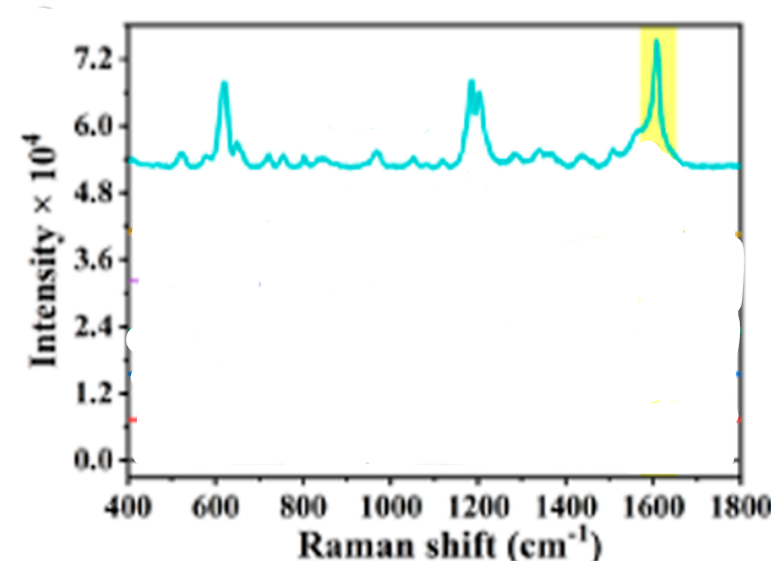
Figure 107:https://doi.org/10.1021/acs.analchem.5c02529
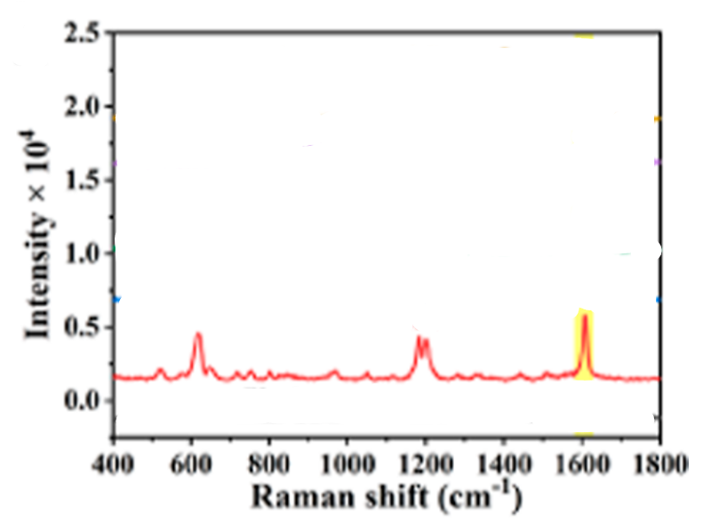
Figure 108:https://doi.org/10.1021/acs.analchem.5c02529
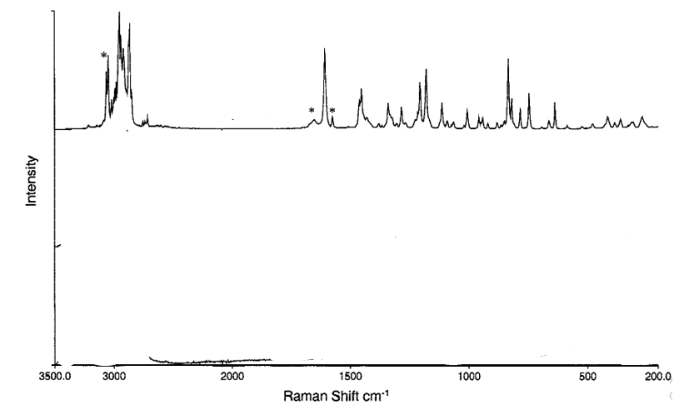
Figure 109:https://doi.org/10.1002/1520-6017(200010)89:10%3C1342::AID-JPS12%3E3.0.CO;2-X
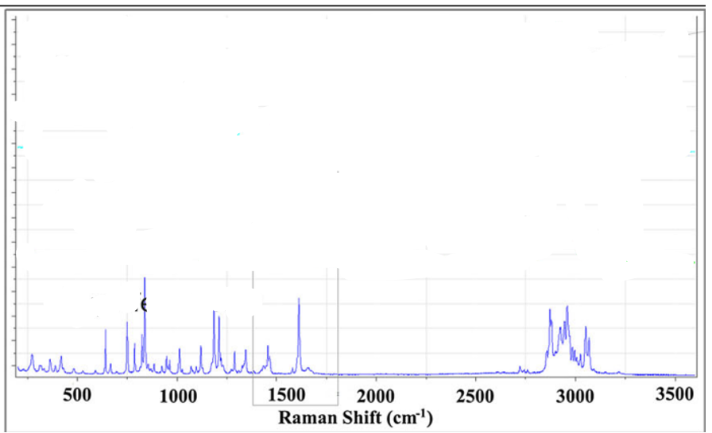
Figure 110:https://doi.org/10.1002/term.1792
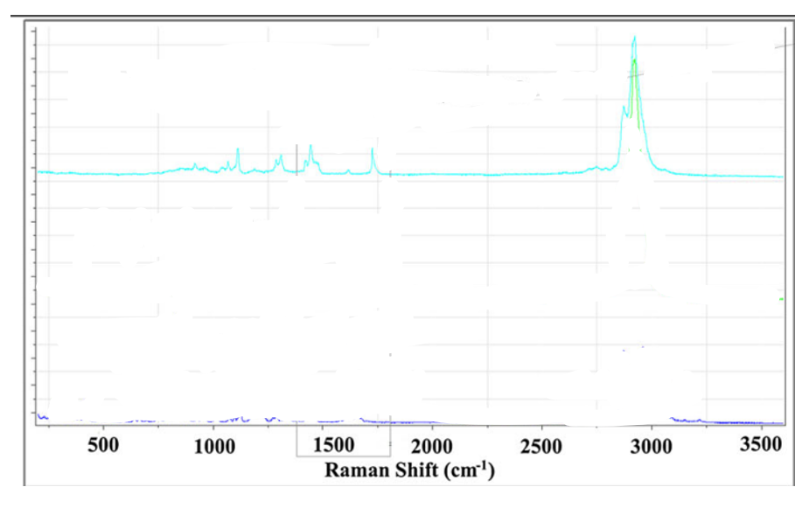
Figure 111:https://doi.org/10.1002/term.1792
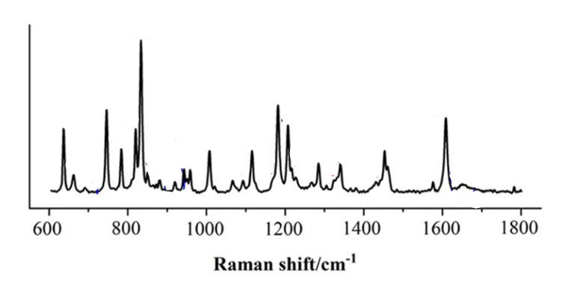
Figure 112:https://doi.org/10.1021/acs.cgd.2c00971
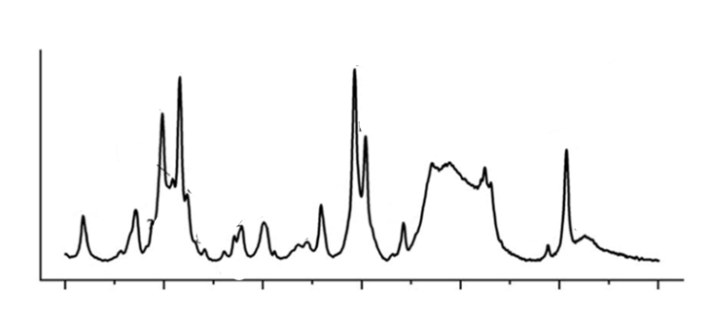
Figure 113:https://doi.org/10.1021/acs.cgd.2c00971
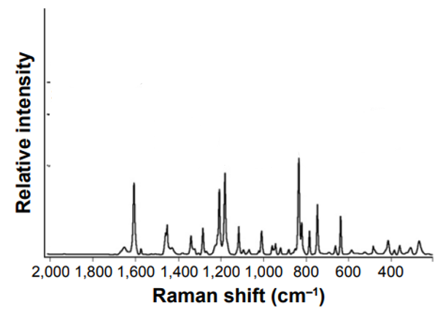
Figure 114:https://doi.org/10.2147/IJN.S99198
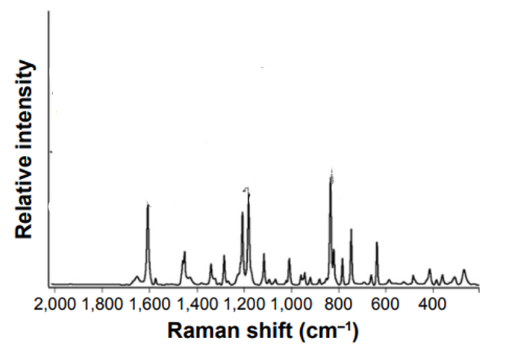
Figure 115:https://doi.org/10.2147/IJN.S99198
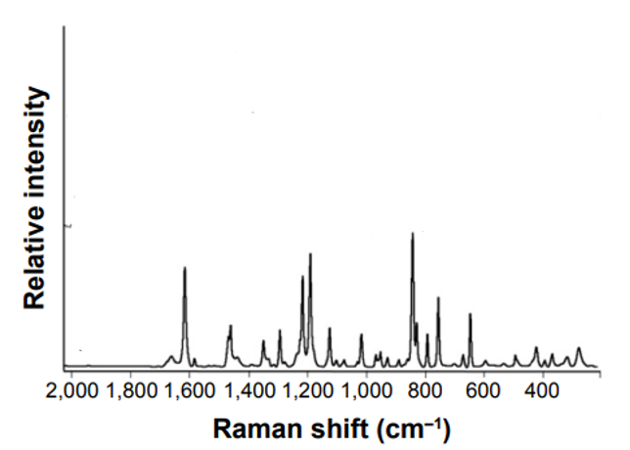
Figure 116:https://doi.org/10.2147/IJN.S99198
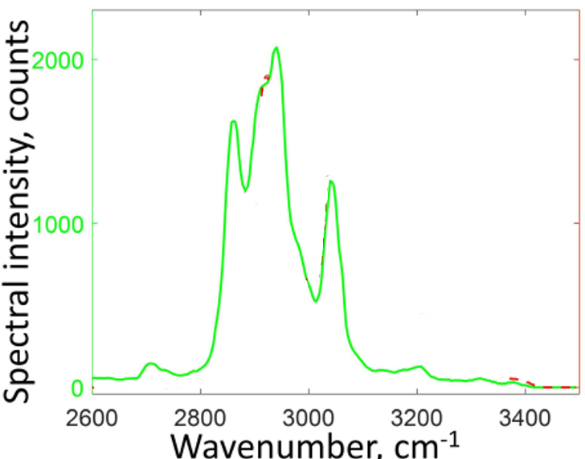
Figure 117:https://doi.org/10.1364/OE.25.013782
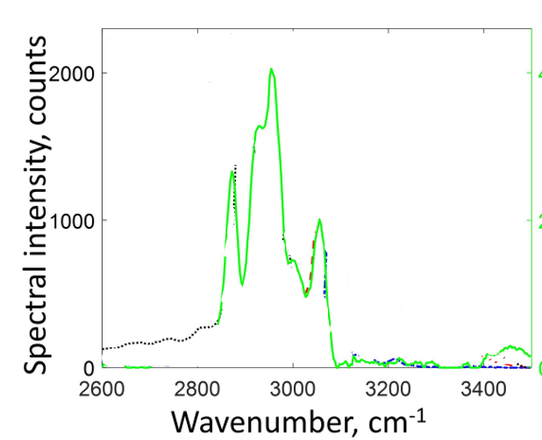
Figure 118:https://doi.org/10.1364/OE.25.013782
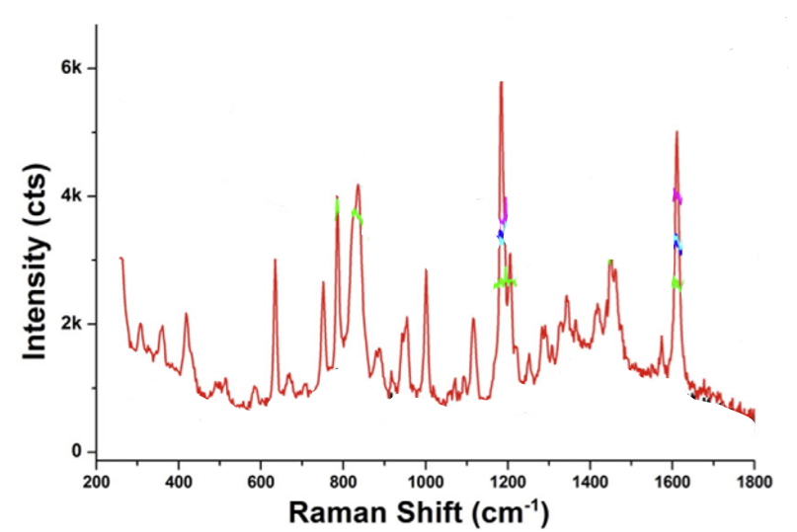
Figure 119:https://doi.org/10.1016/j.powtec.2014.10.036
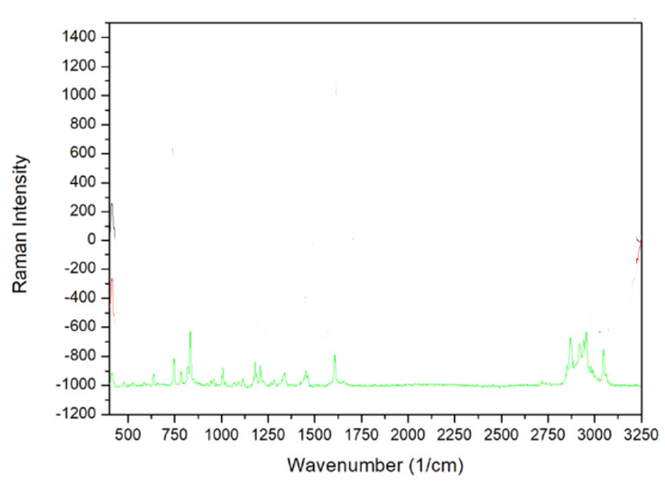
Figure 120:https://doi.org/10.1016/j.apsusc.2019.06.254
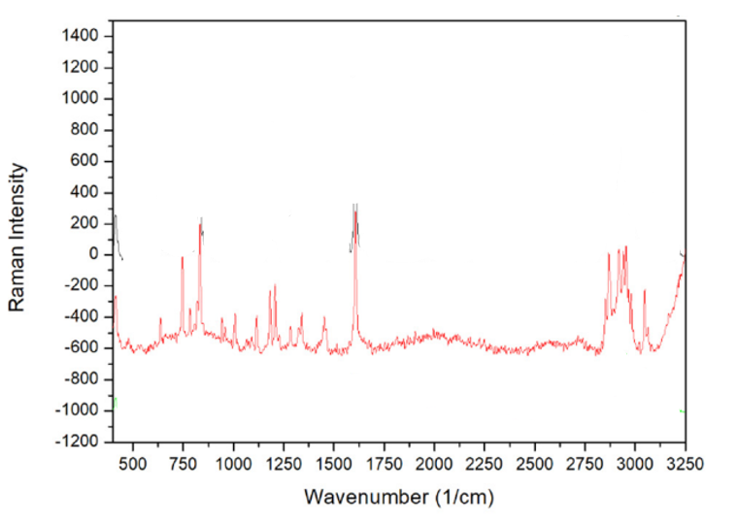
Figure 121:https://doi.org/10.1016/j.apsusc.2019.06.254
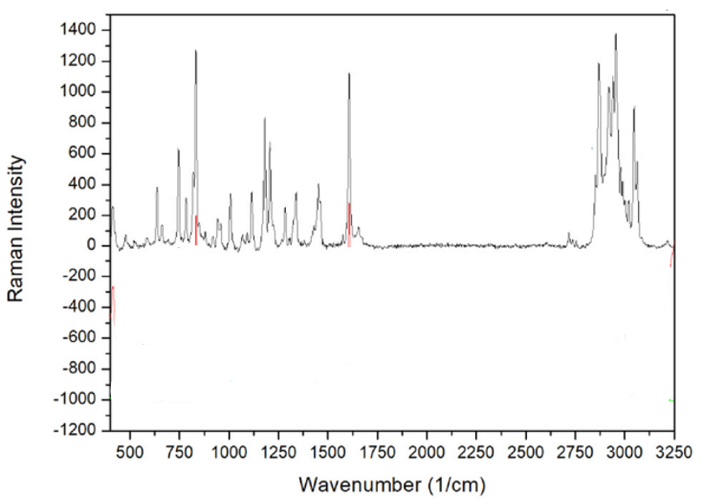
Figure 122:https://doi.org/10.1016/j.apsusc.2019.06.254
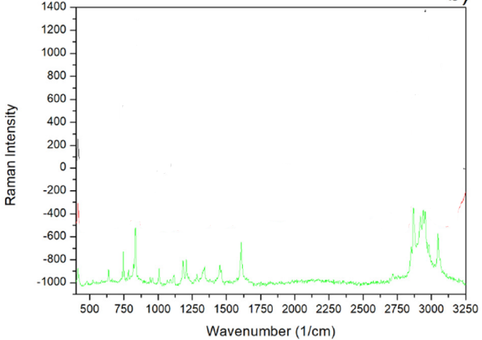
Figure 123:https://doi.org/10.1016/j.apsusc.2019.06.254
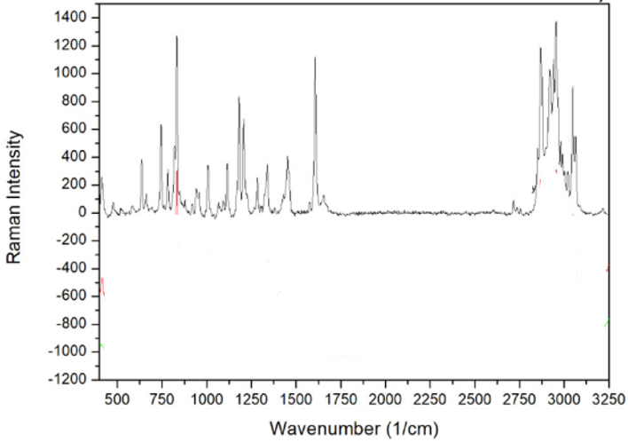
Figure 124:https://doi.org/10.1016/j.apsusc.2019.06.254
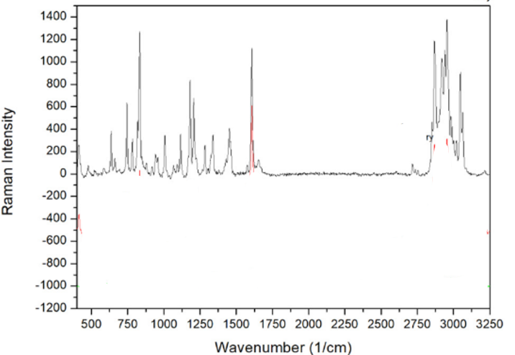
Figure 125:https://doi.org/10.1016/j.apsusc.2019.06.254
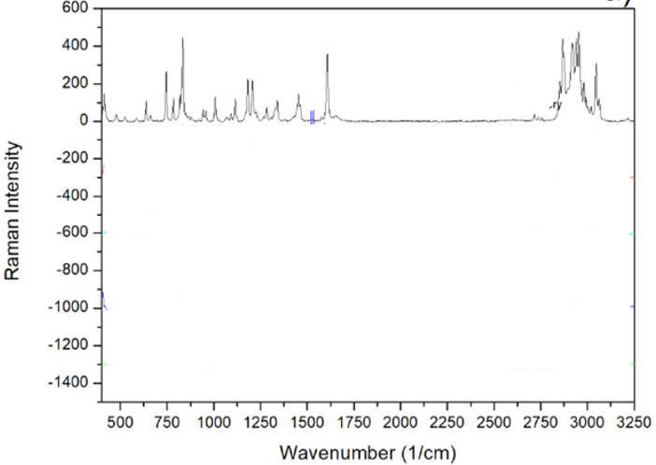
Figure 126:https://doi.org/10.1016/j.apsusc.2019.06.254
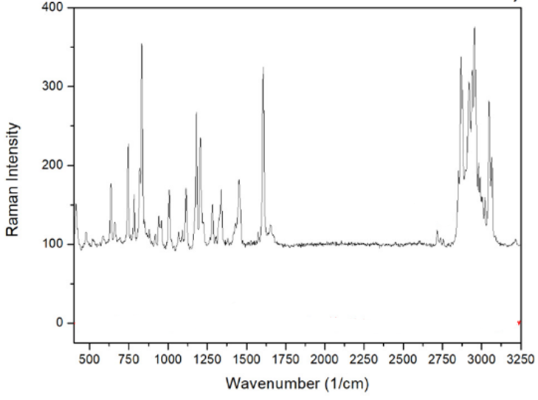
Figure 127:https://doi.org/10.1016/j.apsusc.2019.06.254
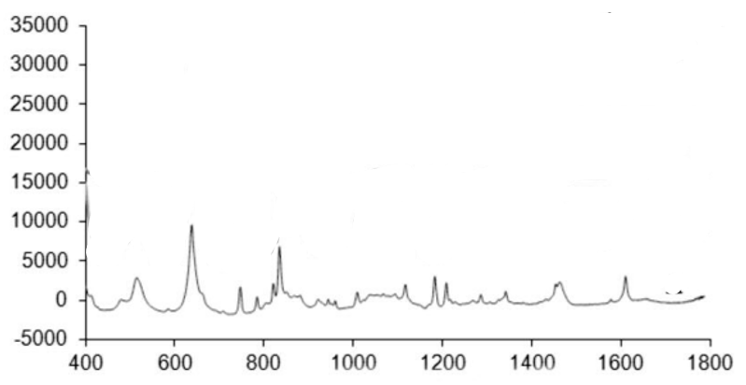
Figure 128:https://repositorio.unip.br/wp-content/uploads/2020/12/01V37_n3_2019_p199a202.pdf
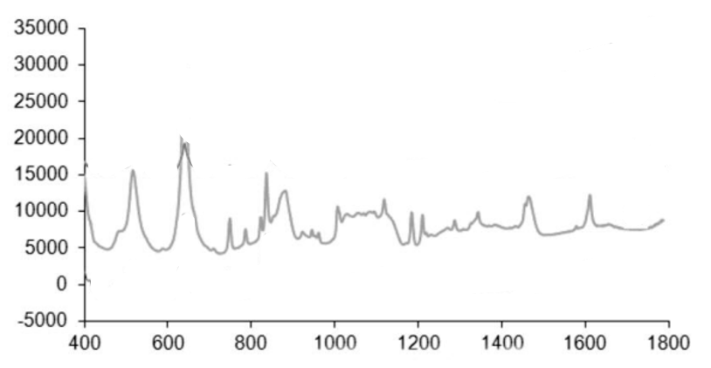
Figure 129:https://repositorio.unip.br/wp-content/uploads/2020/12/01V37_n3_2019_p199a202.pdf
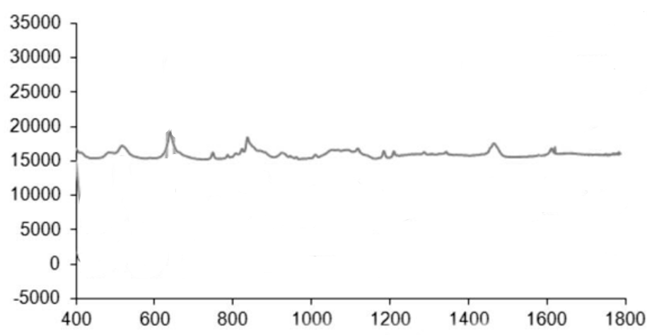
Figure 130:https://repositorio.unip.br/wp-content/uploads/2020/12/01V37_n3_2019_p199a202.pdf
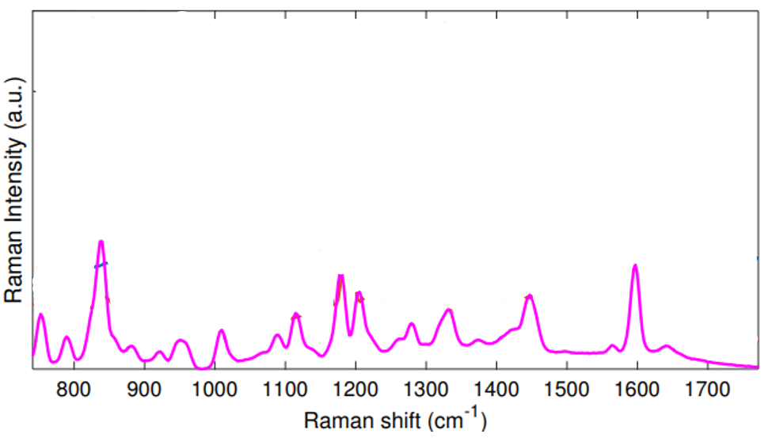
Figure 131:https://doi.org/10.1002/jbio.201700129
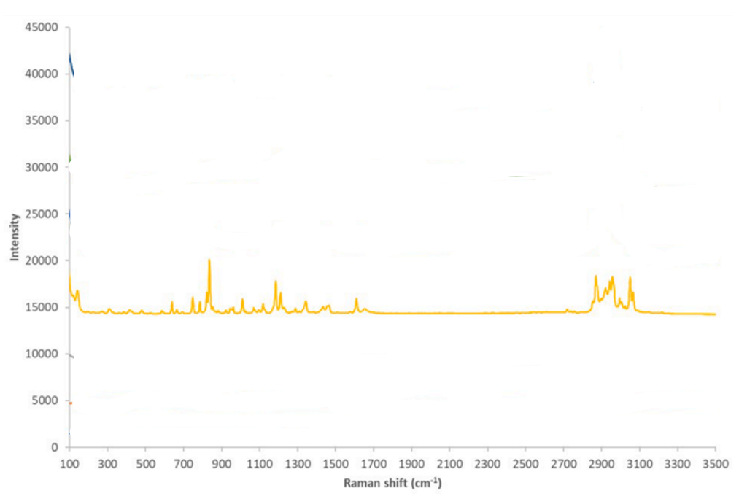
Figure 132:https://doi.org/10.1016/j.ijpharm.2022.122135
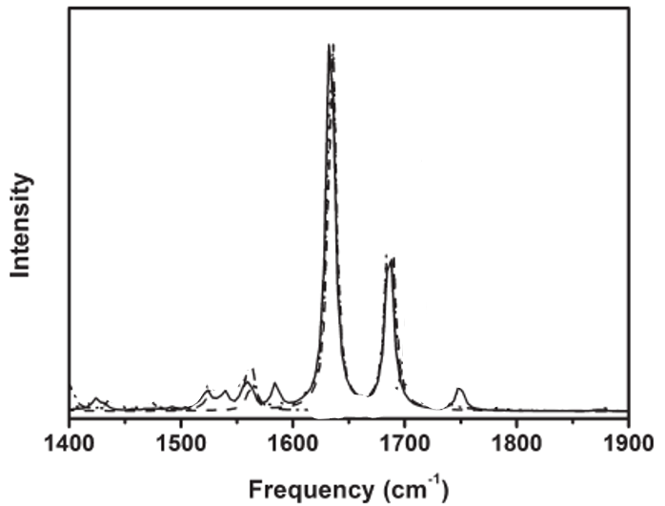
Figure 133:https://doi.org/10.1021/jp2066277
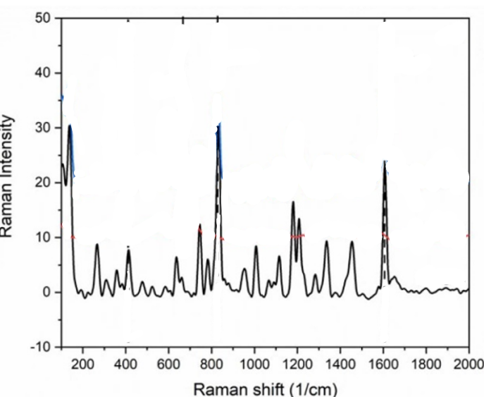
Figure 134:DOI 10.1088/1361-6463/ac07df
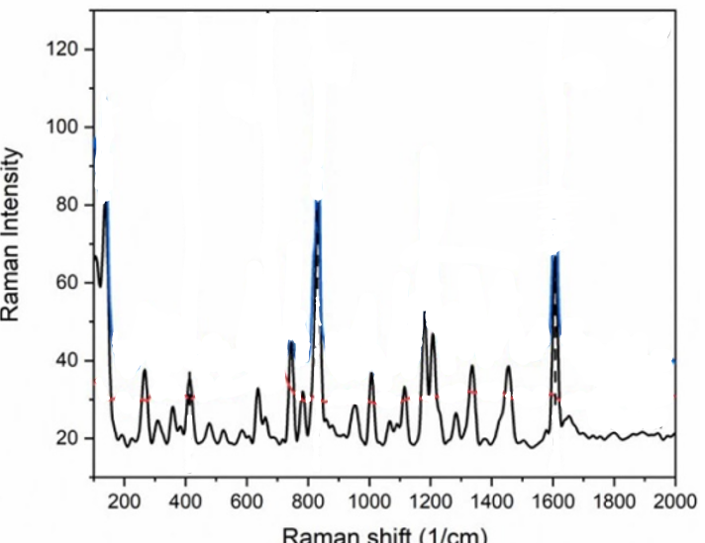
Figure 135:DOI 10.1088/1361-6463/ac07df
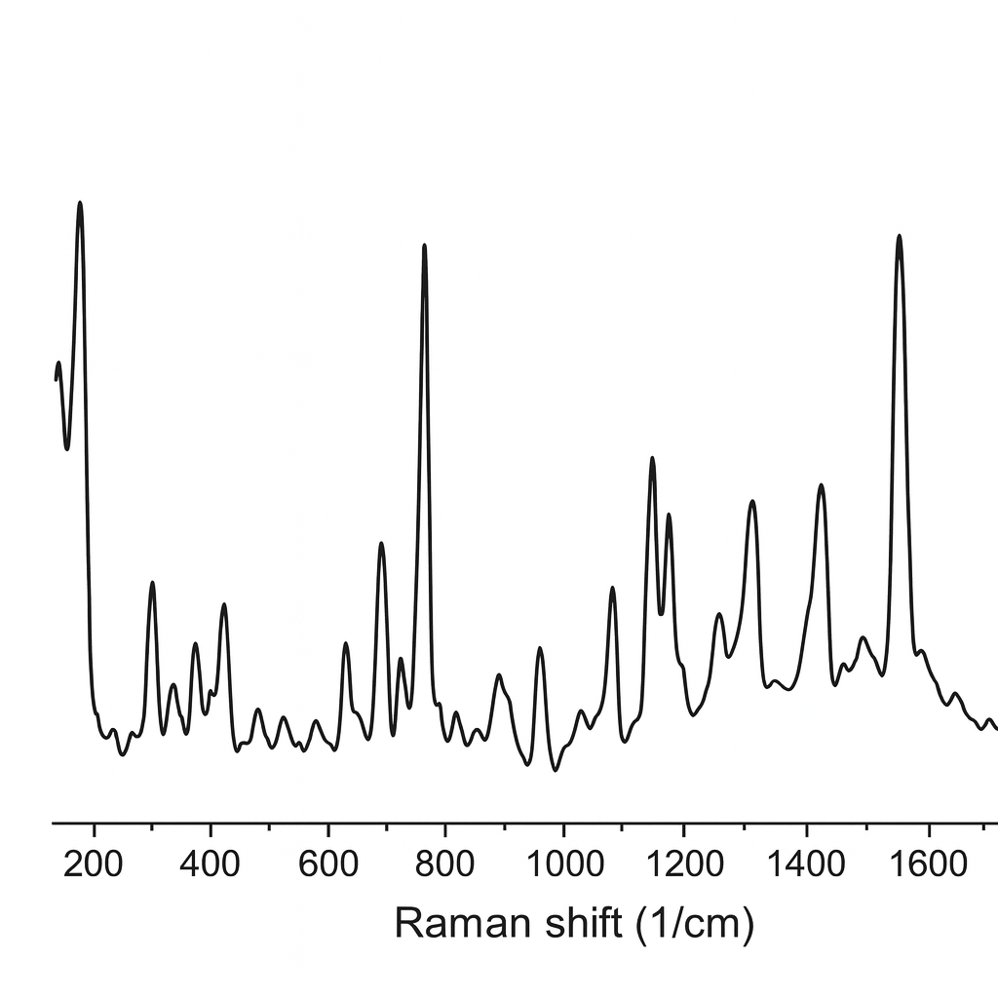
Figure 136:DOI 10.1088/1361-6463/ac07df
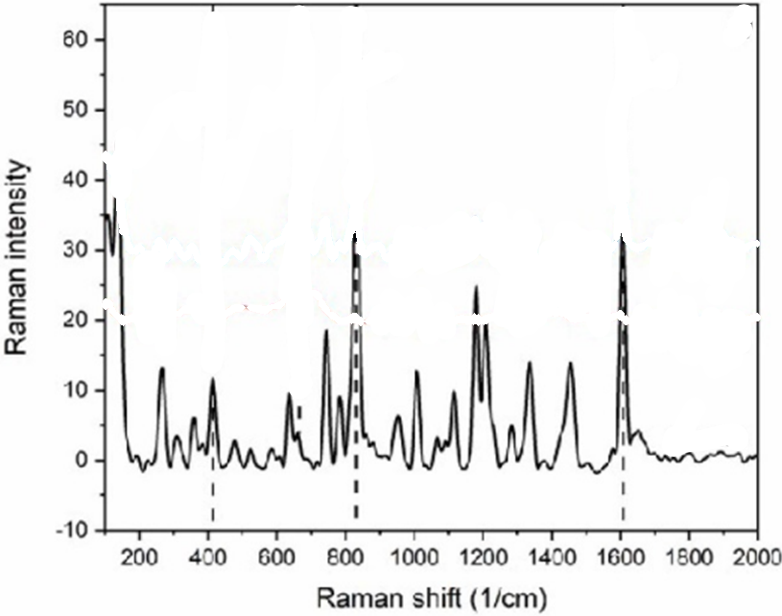
Figure 137:DOI 10.1088/1361-6463/ac07df

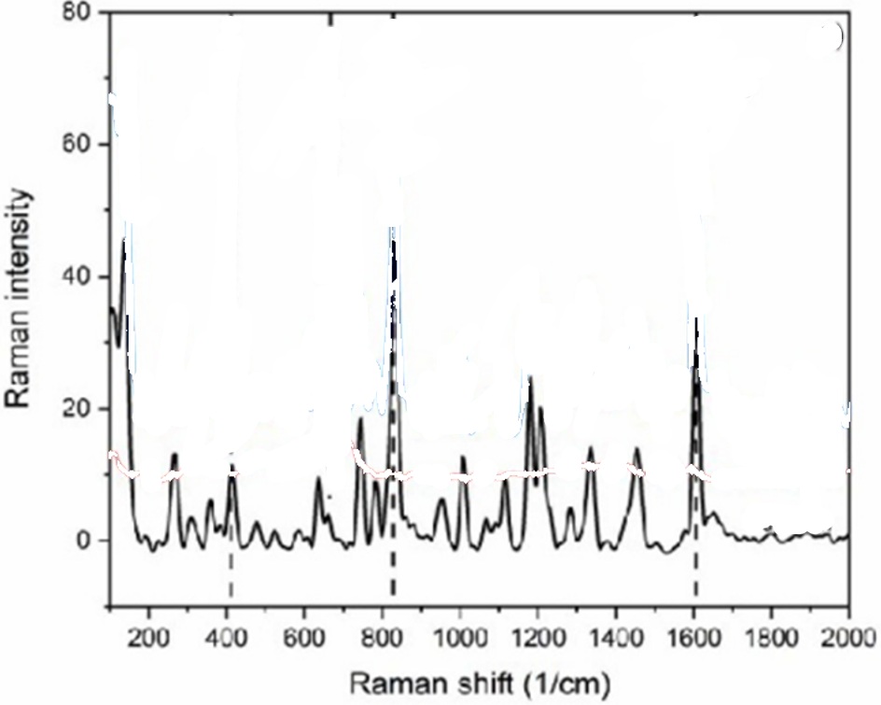
Figure 138:DOI 10.1088/1361-6463/ac07df
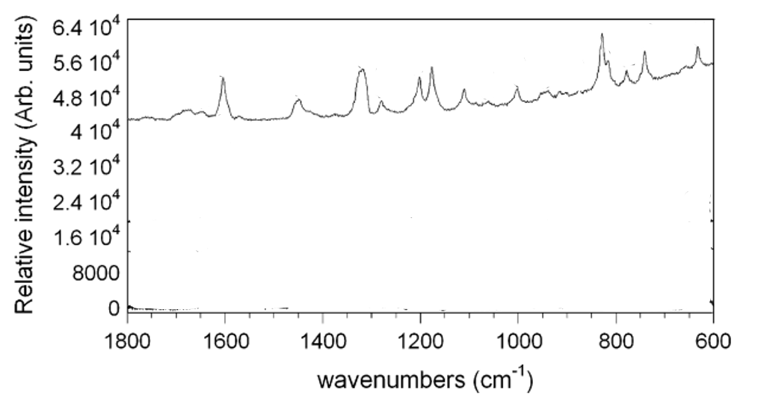
Figure 139:https://doi.org/10.1016/j.vibspec.2008.11.002
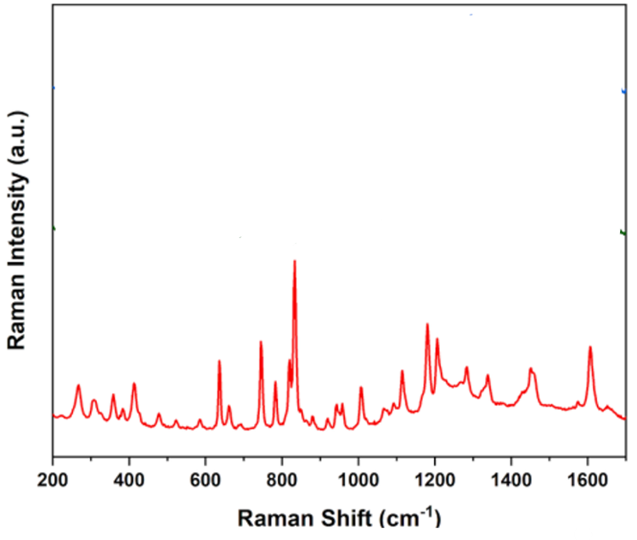
Figure 140:https://doi.org/10.1016/j.ijpharm.2022.122052
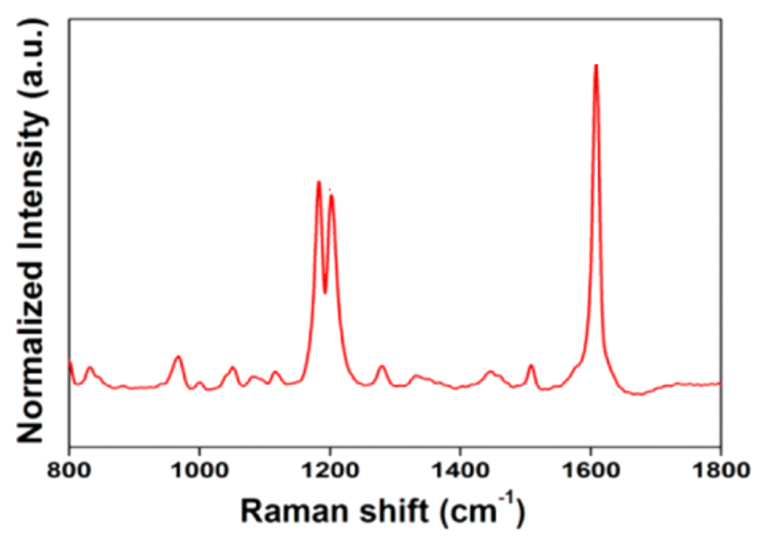
Figure 141:https://doi.org/10.1021/acs.analchem.5b00328
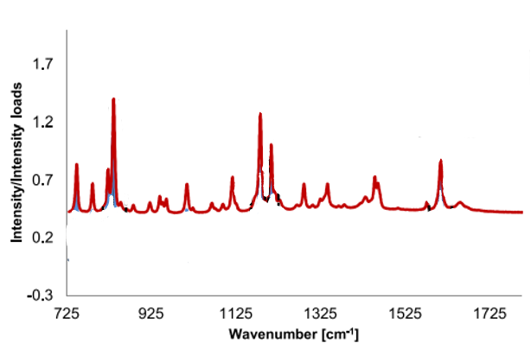
Figure 142:https://doi.org/10.1016/j.jpba.2019.02.019
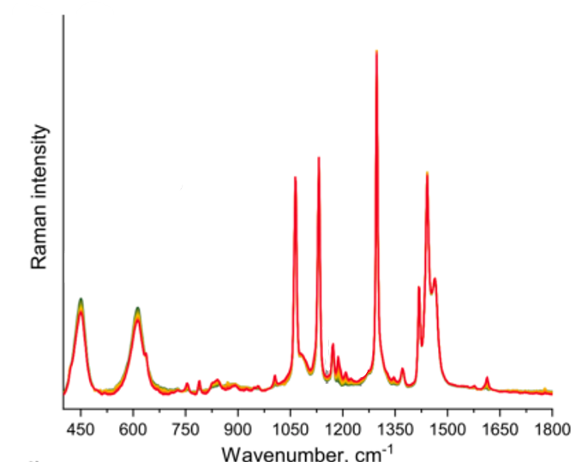
Figure 143:https://doi.org/10.1016/j.measurement.2025.117360
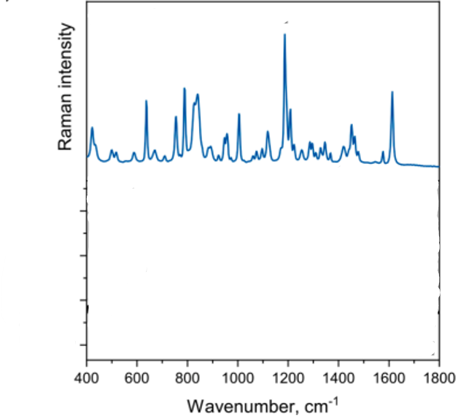
Figure 144:https://doi.org/10.1016/j.measurement.2025.117360
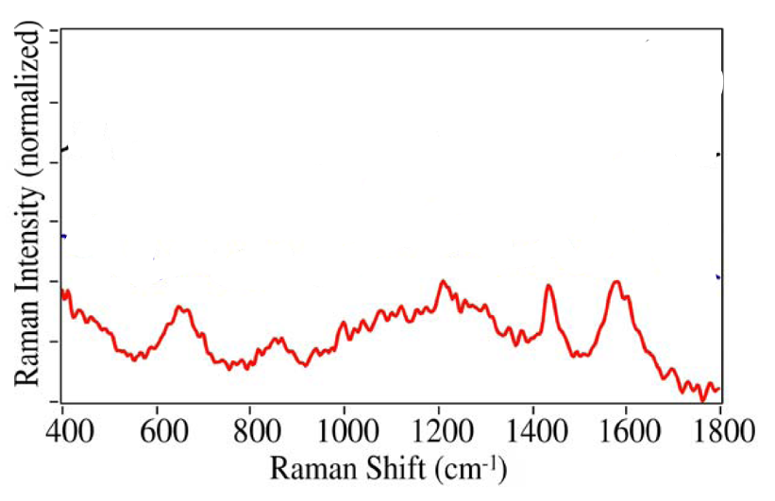
Figure 145:https://doi.org/10.3390/pharmaceutics3030425
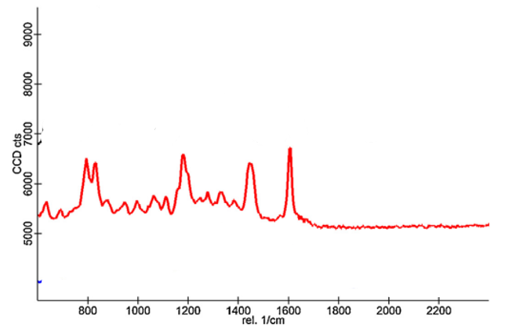
Figure 146:https://doi.org/10.1016/j.supflu.2015.11.019

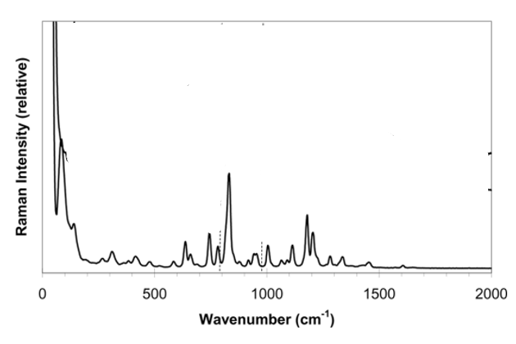
Figure 147:https://doi.org/10.1080/01932690802644095
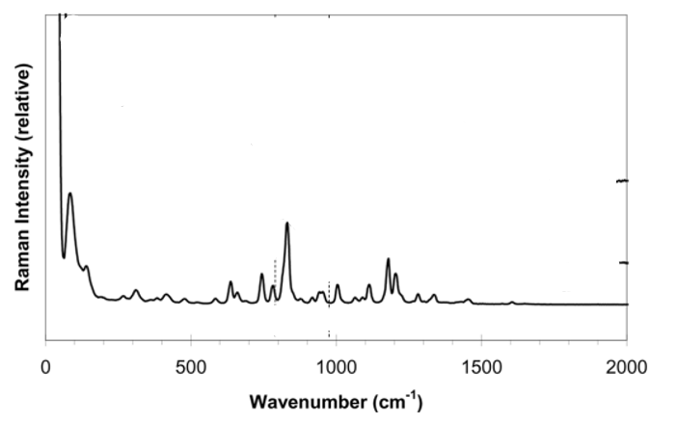
Figure 148:https://doi.org/10.1080/01932690802644095
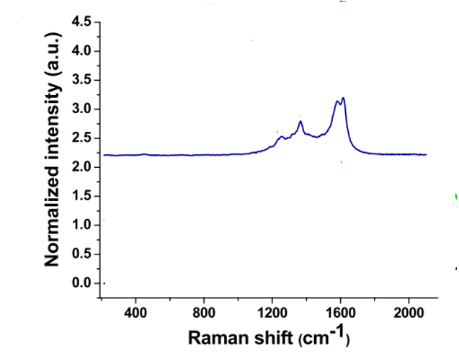
Figure 149:https://doi.org/10.1021/acsbiomaterials.2c01045
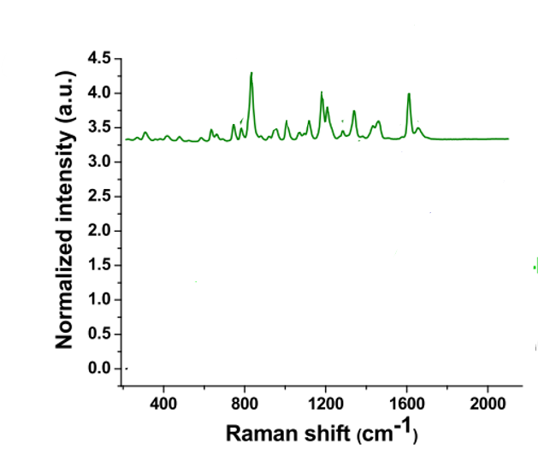
Figure 150:https://doi.org/10.1021/acsbiomaterials.2c01045

