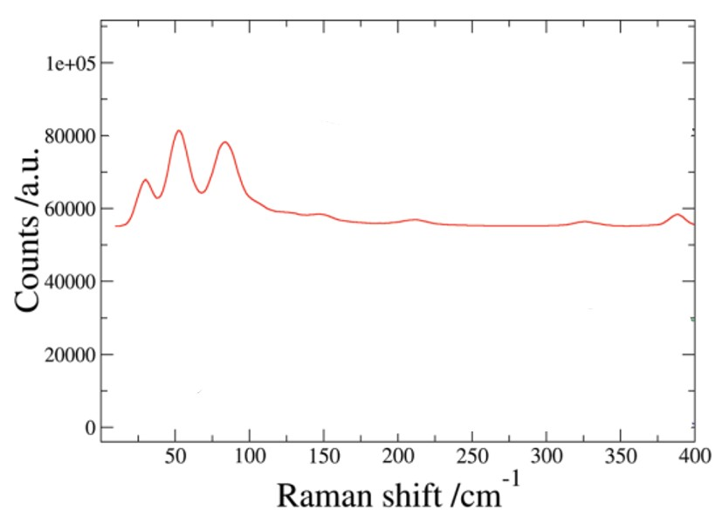
Figure 1:https://doi.org/10.1021/mp300035g
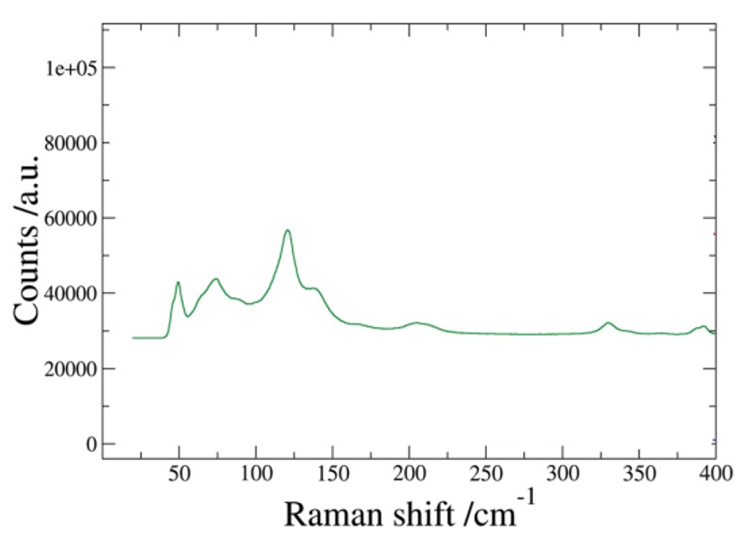
Figure 2:https://doi.org/10.1021/mp300035g
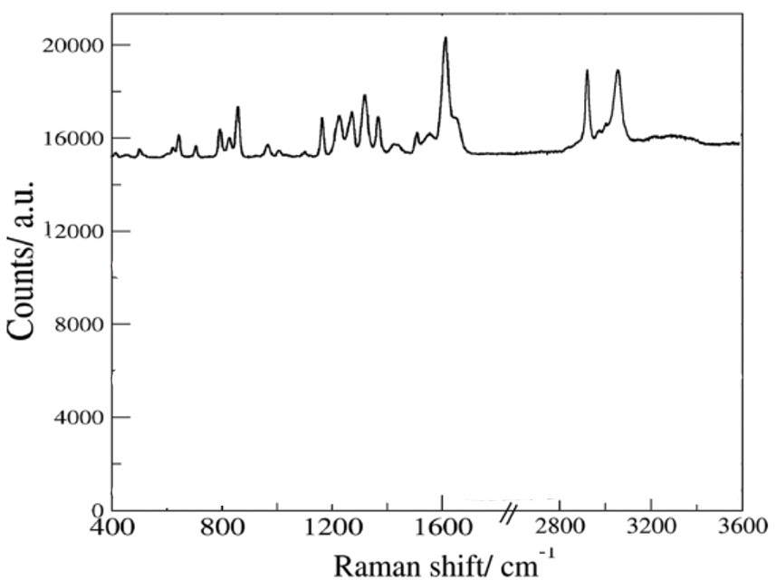
Figure 3:https://doi.org/10.1021/mp300035g
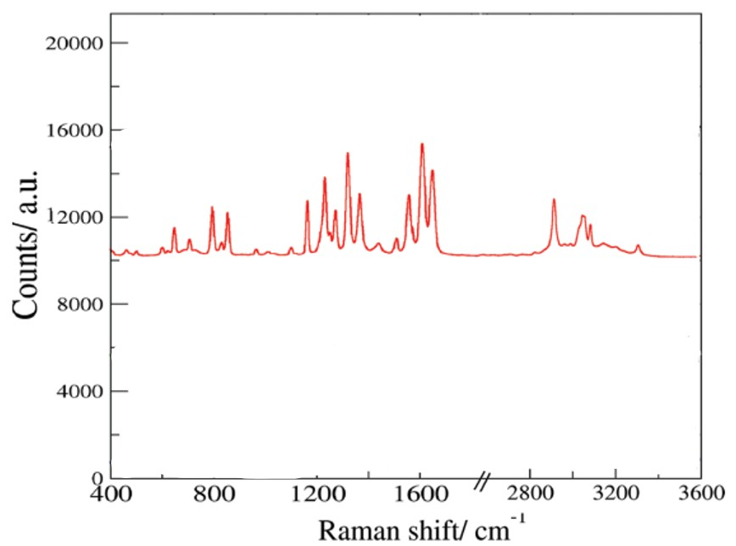
Figure 4:https://doi.org/10.1021/mp300035g
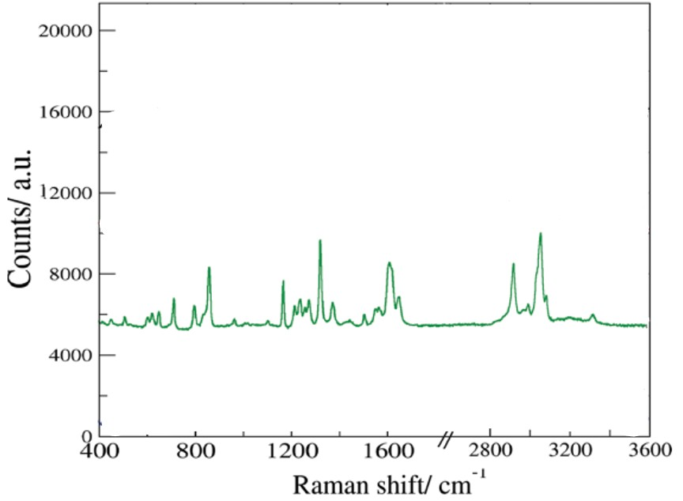
Figure 5:https://doi.org/10.1021/mp300035g

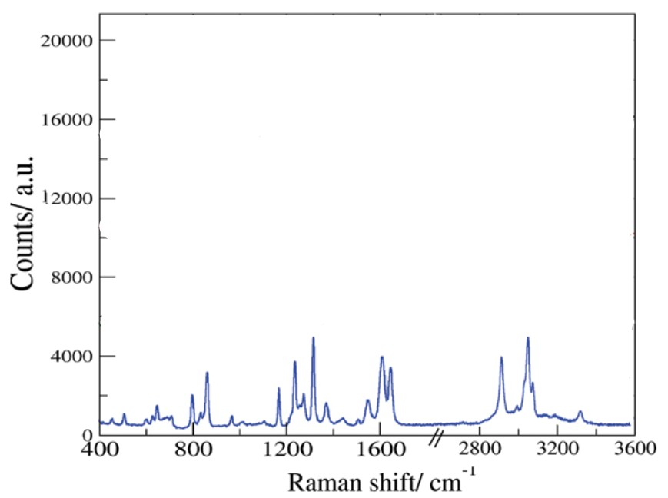
Figure 6:https://doi.org/10.1021/mp300035g

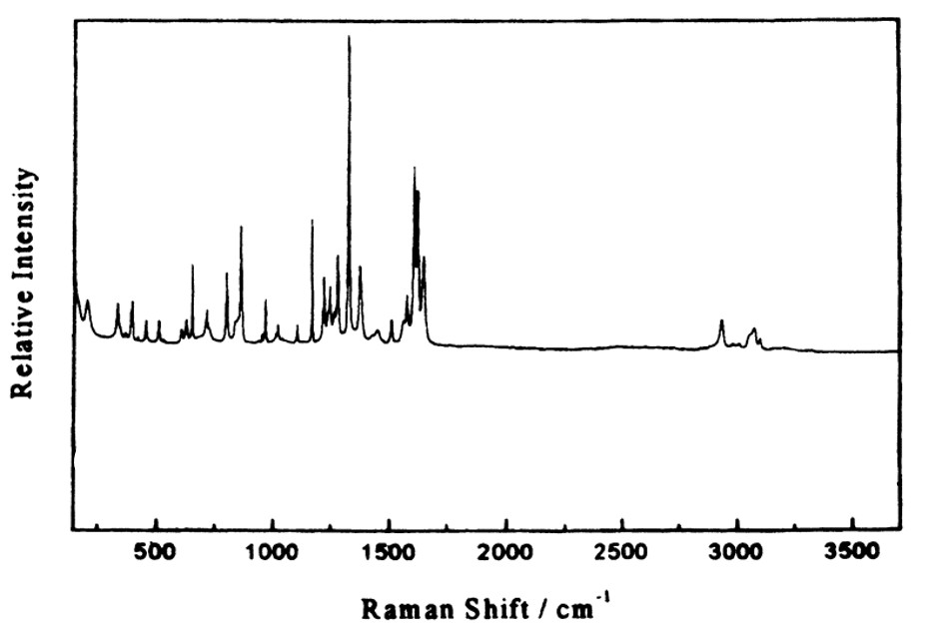

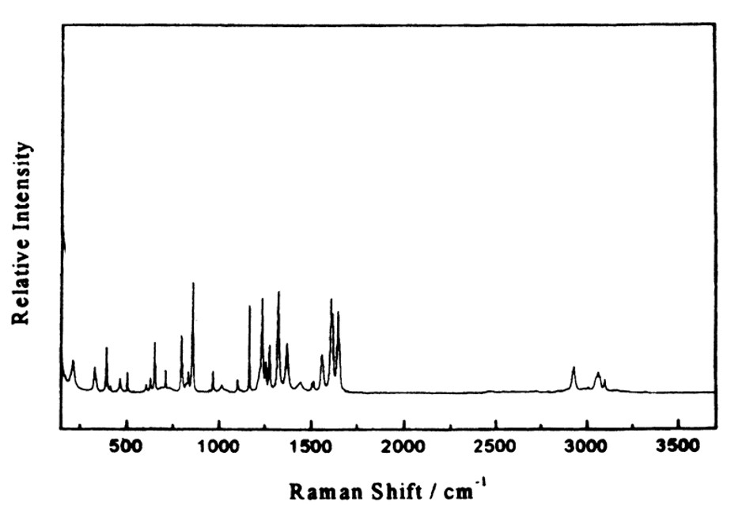

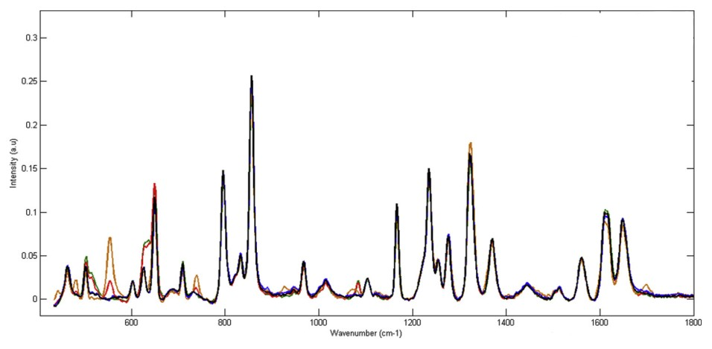
Figure 7:https://doi.org/10.1016/j.vibspec.2019.05.002
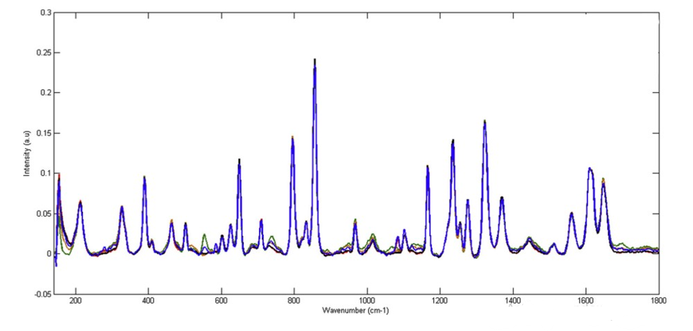
Figure 8:https://doi.org/10.1016/j.vibspec.2019.05.002
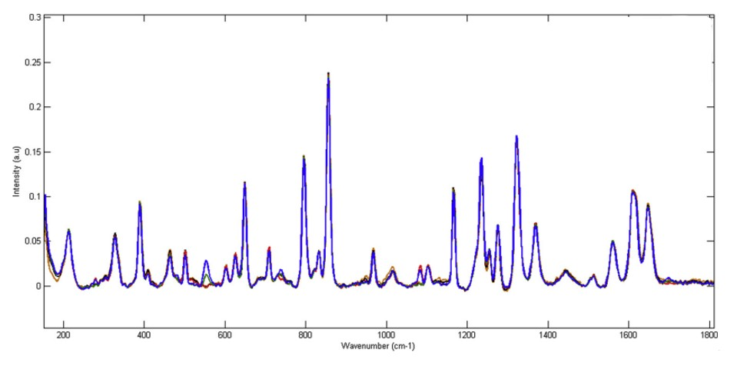
Figure 9:https://doi.org/10.1016/j.vibspec.2019.05.002
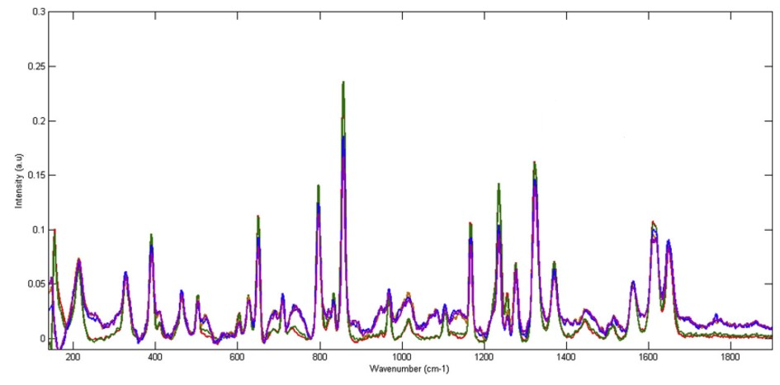
Figure 10:https://doi.org/10.1016/j.vibspec.2019.05.002
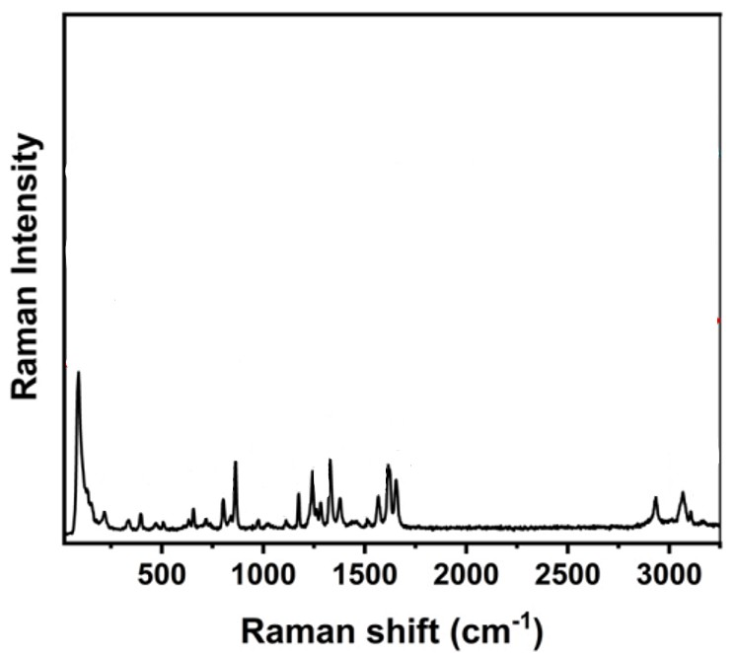
Figure 11:https://doi.org/10.1016/j.vibspec.2022.103488
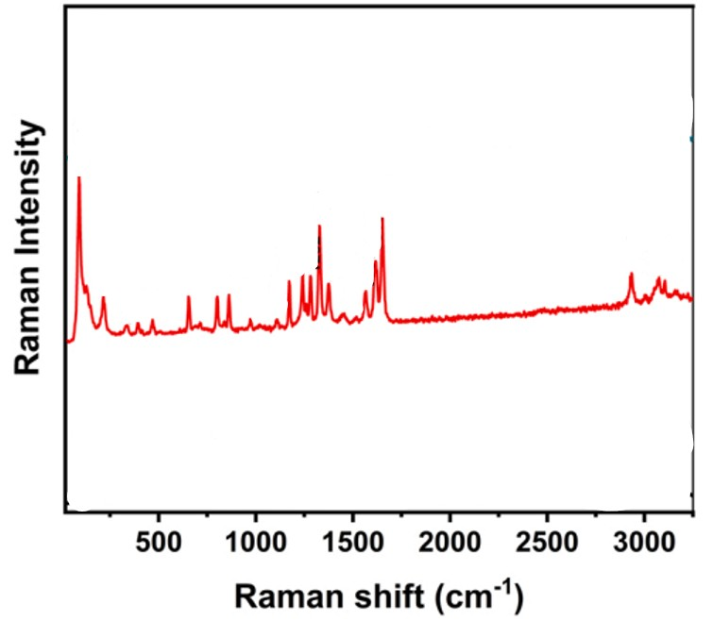
Figure 12:https://doi.org/10.1016/j.vibspec.2022.103488

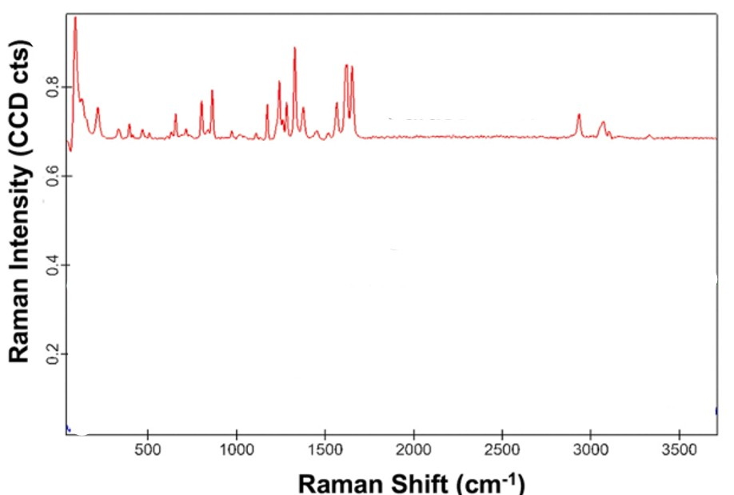
Figure 13:https://doi.org/10.1016/j.vibspec.2022.103488

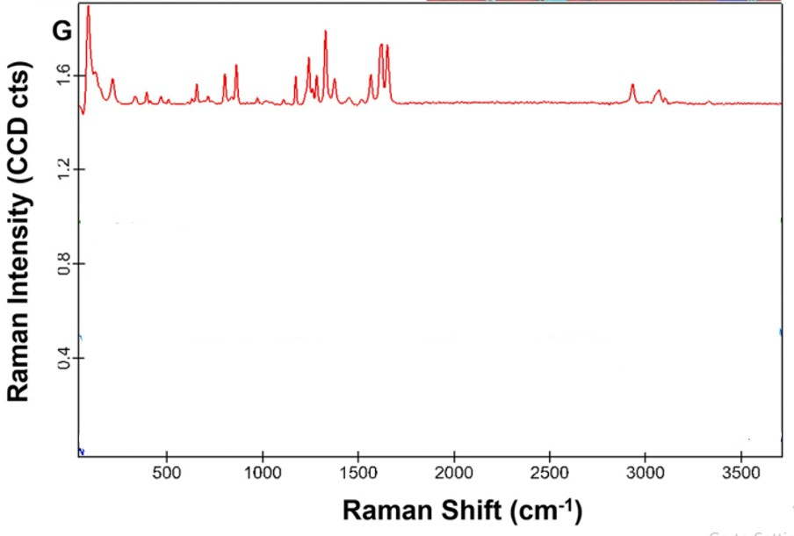
Figure 14:https://doi.org/10.1016/j.vibspec.2022.103488
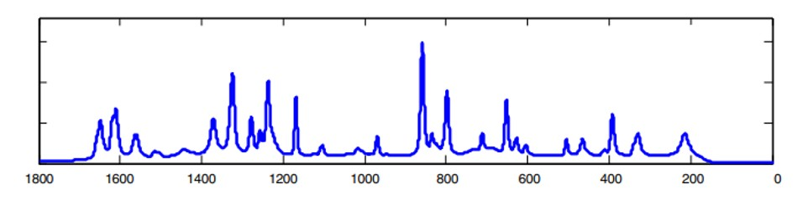

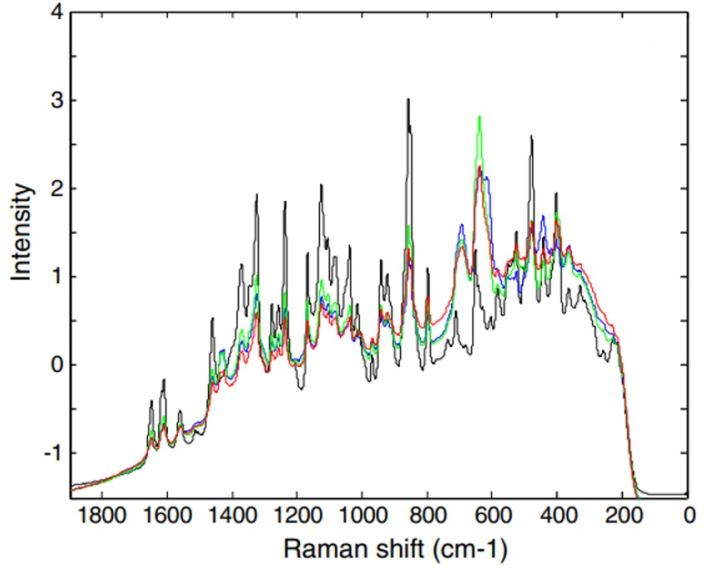
Figure 15:https://doi.org/10.1016/j.chemolab.2013.03.014
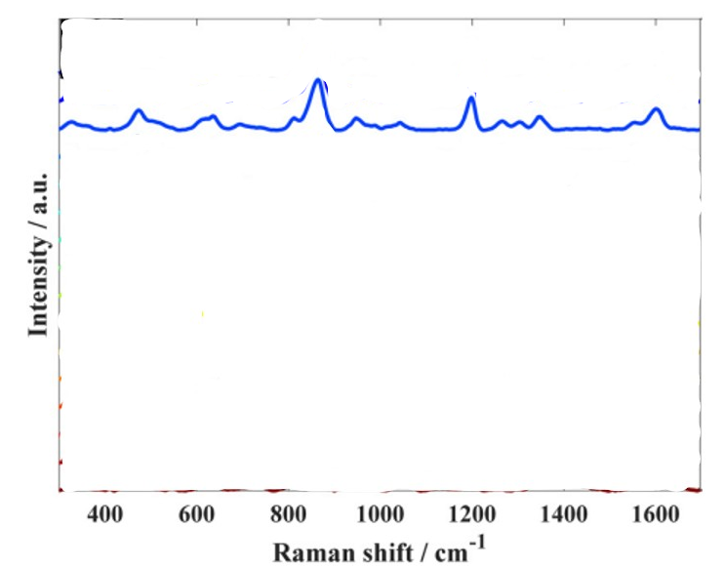
Figure 16:https://doi.org/10.1039/D3AN00249G
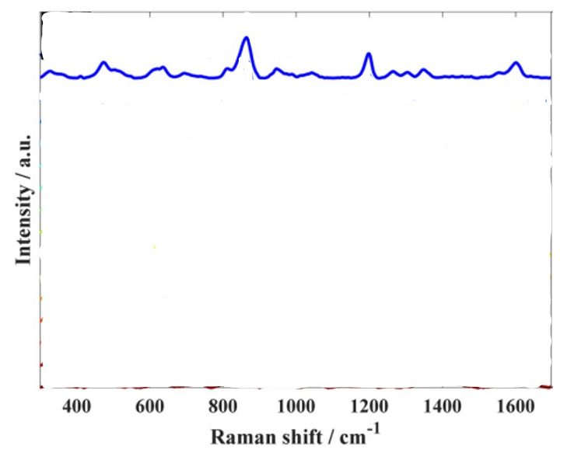
Figure 17:https://doi.org/10.1039/D3AN00249G
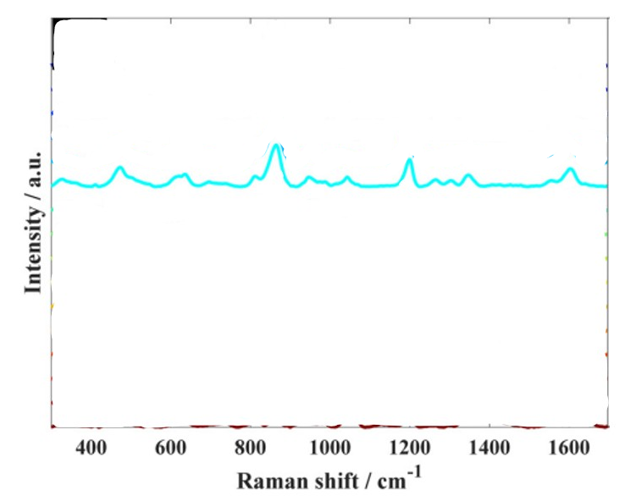
Figure 18:https://doi.org/10.1039/D3AN00249G
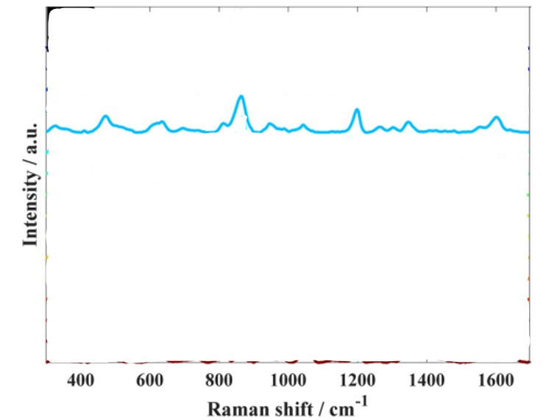
Figure 19:https://doi.org/10.1039/D3AN00249G
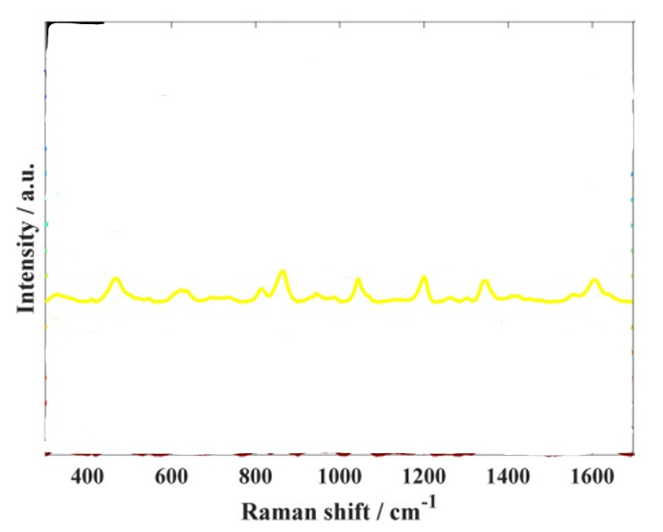
Figure 20:https://doi.org/10.1039/D3AN00249G
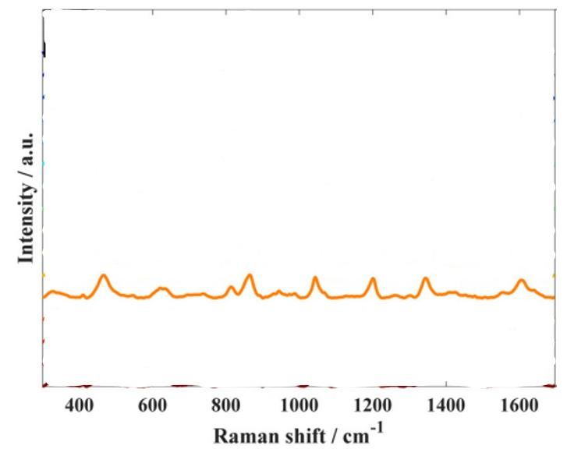
Figure 21:https://doi.org/10.1039/D3AN00249G
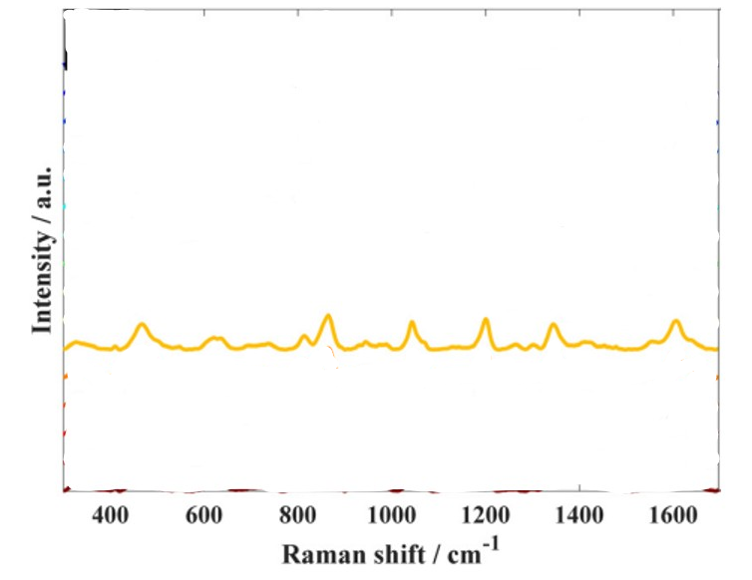
Figure 22:https://doi.org/10.1039/D3AN00249G
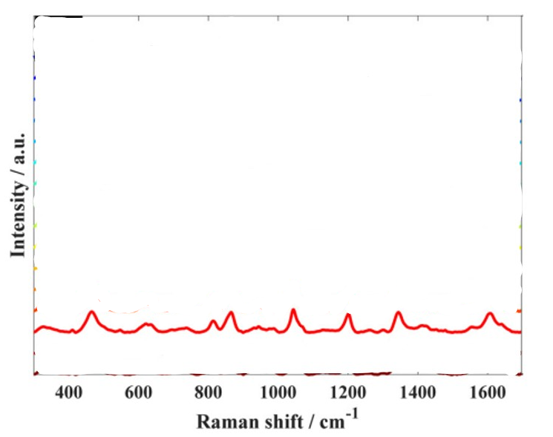
Figure 23:https://doi.org/10.1039/D3AN00249G
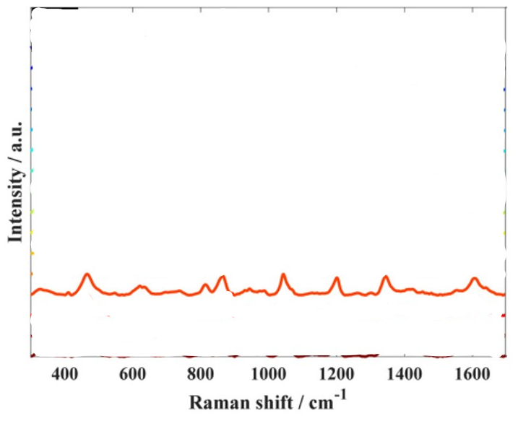
Figure 24:https://doi.org/10.1039/D3AN00249G

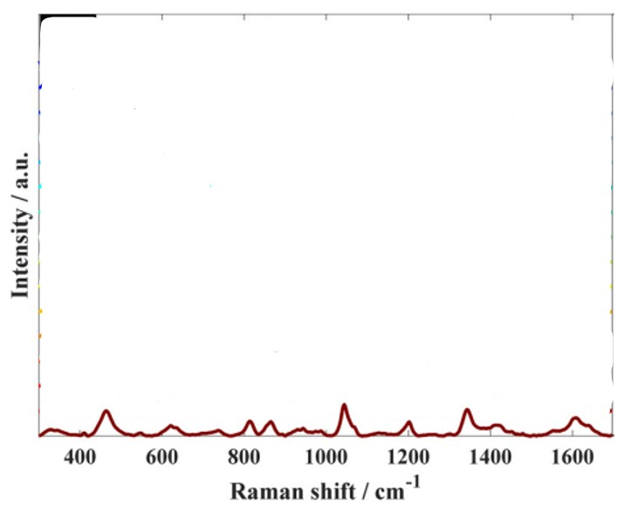
Figure 25:https://doi.org/10.1039/D3AN00249G
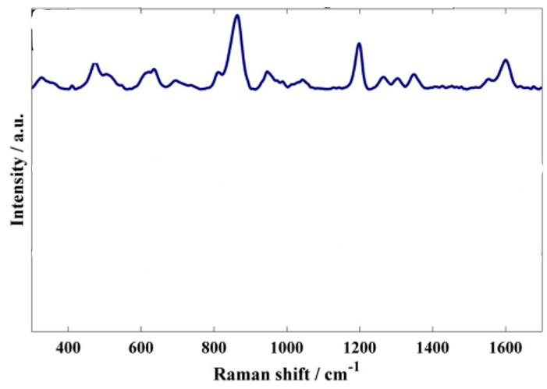
Figure 26:https://doi.org/10.1039/D3AN00249G
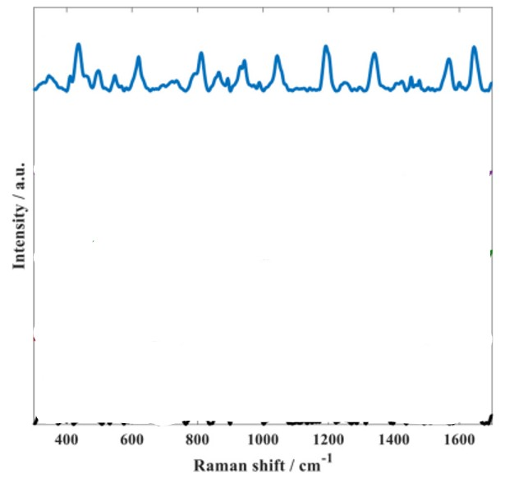
Figure 27:https://doi.org/10.1039/D3AN00249G
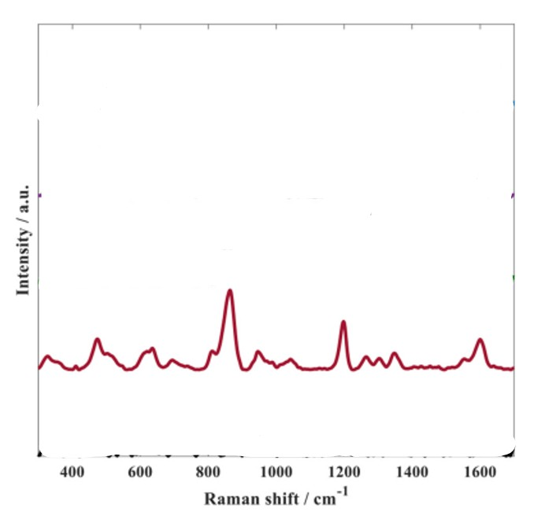
Figure 28:https://doi.org/10.1039/D3AN00249G
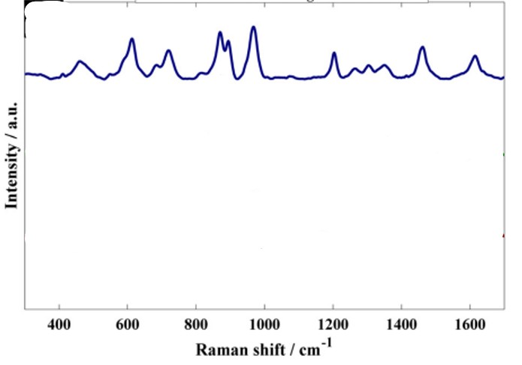
Figure 29:https://doi.org/10.1039/D3AN00249G

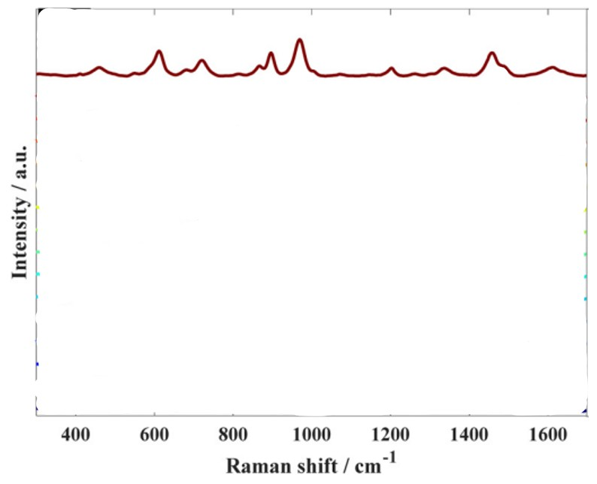
Figure 30:https://doi.org/10.1039/D3AN00249G
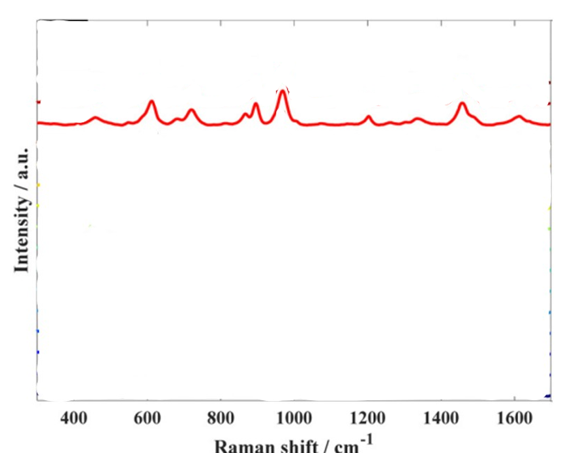
Figure 31:https://doi.org/10.1039/D3AN00249G
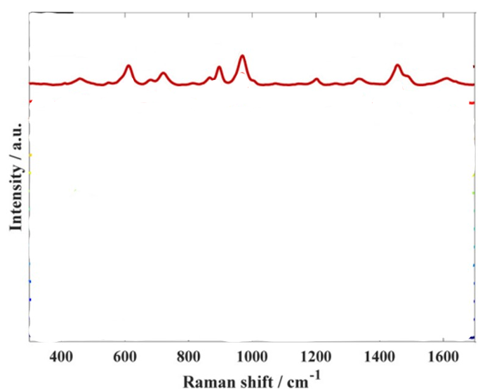
Figure 32:https://doi.org/10.1039/D3AN00249G

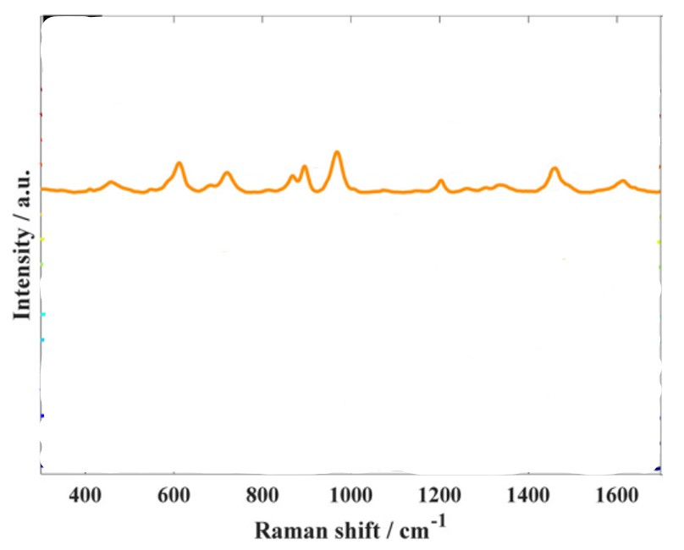
Figure 33:https://doi.org/10.1039/D3AN00249G

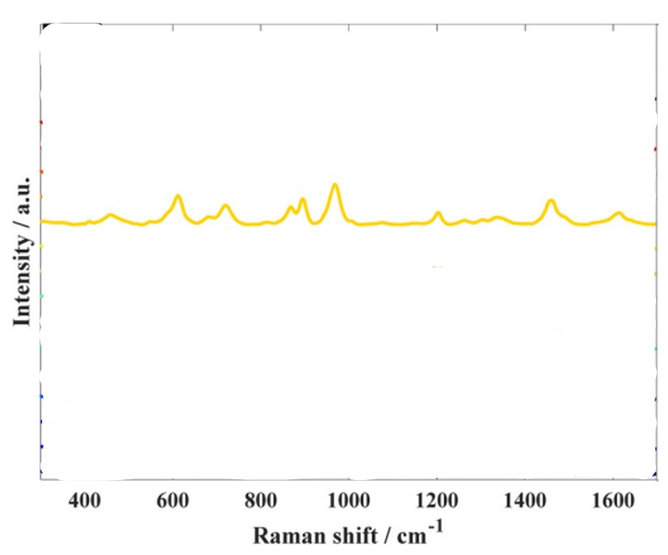
Figure 34:https://doi.org/10.1039/D3AN00249G

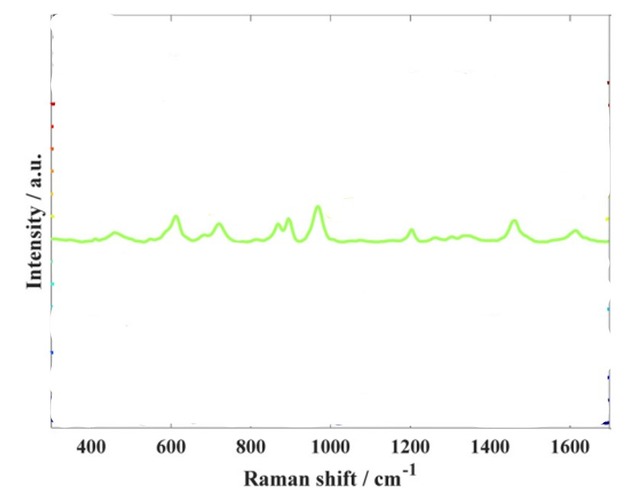
Figure 35:https://doi.org/10.1039/D3AN00249G

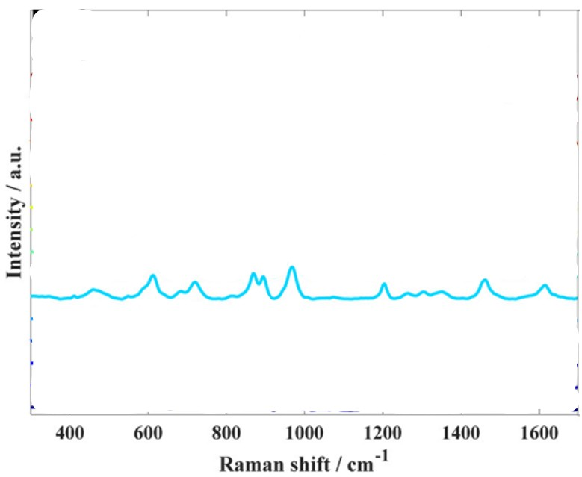
Figure 36:https://doi.org/10.1039/D3AN00249G
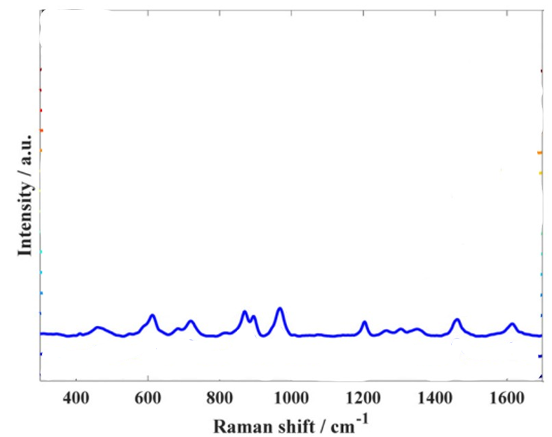
Figure 37:https://doi.org/10.1039/D3AN00249G
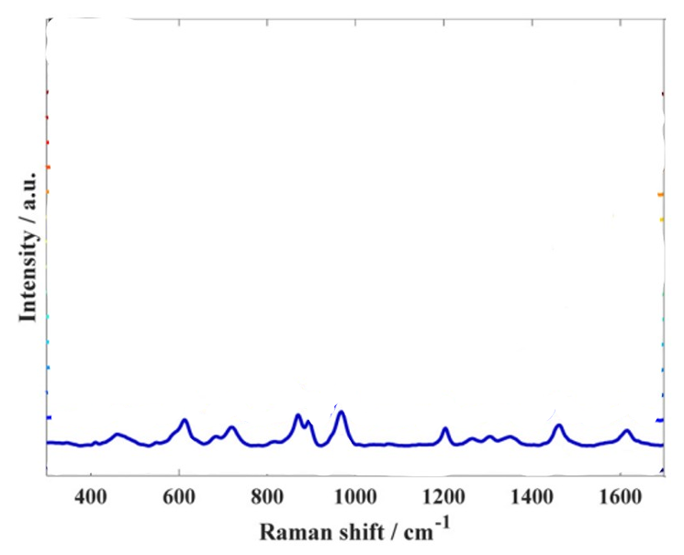
Figure 38:https://doi.org/10.1039/D3AN00249G
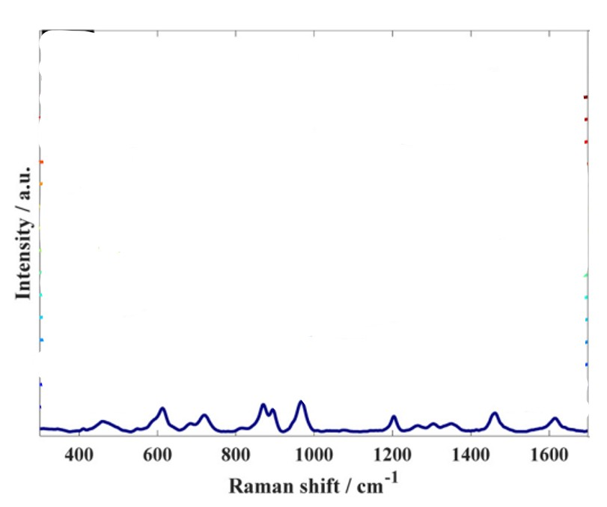
Figure 39:https://doi.org/10.1039/D3AN00249G

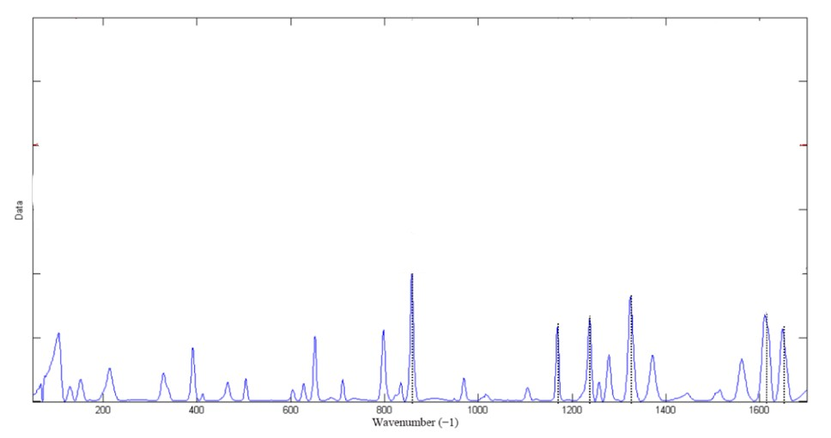
Figure 40:https://doi.org/10.3390/molecules27051707

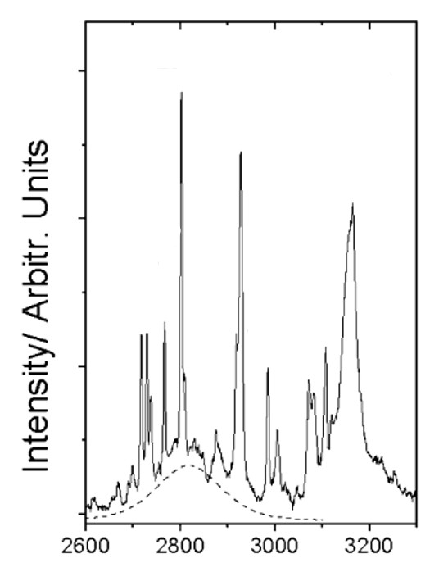
Figure 41:https://doi.org/10.1039/C1CP20139E
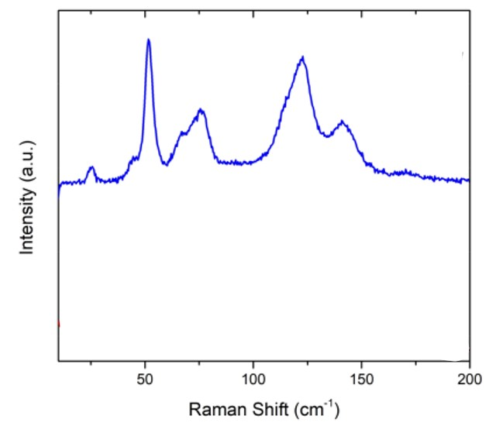
Figure 42:https://doi.org/10.1021/acsomega.8b01246
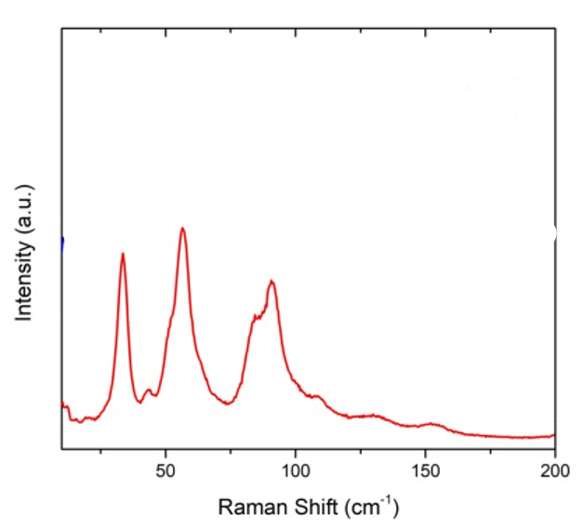
Figure 43:https://doi.org/10.1021/acsomega.8b01246

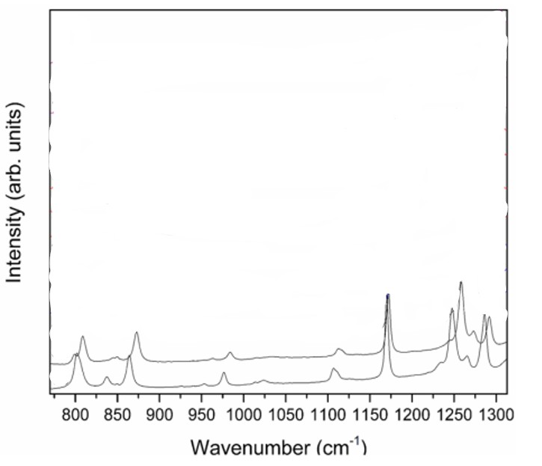
Figure 44:https://doi.org/10.1021/jp411810y
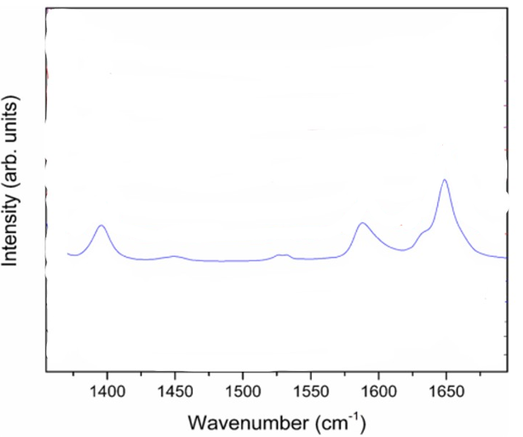
Figure 45:https://doi.org/10.1021/jp411810y
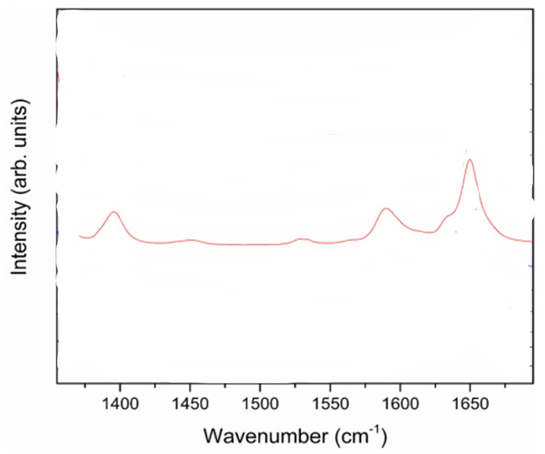
Figure 46:https://doi.org/10.1021/jp411810y
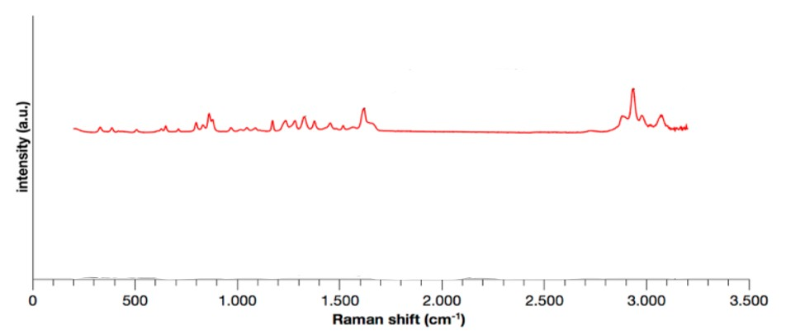
Figure 47:https://doi.org/10.1021/acs.cgd.3c00617

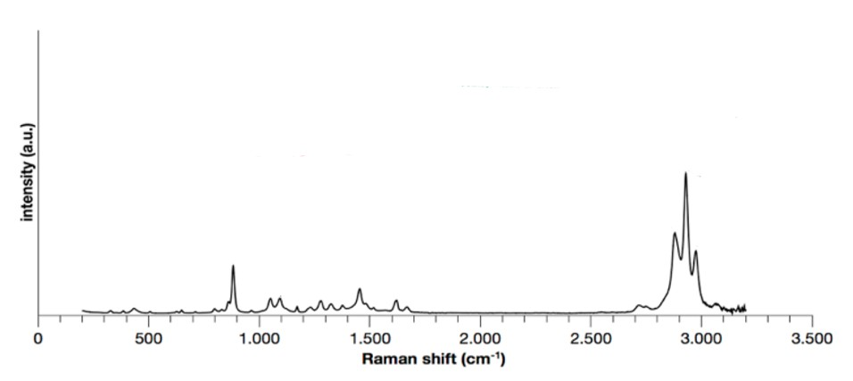
Figure 48:https://doi.org/10.1021/acs.cgd.3c00617
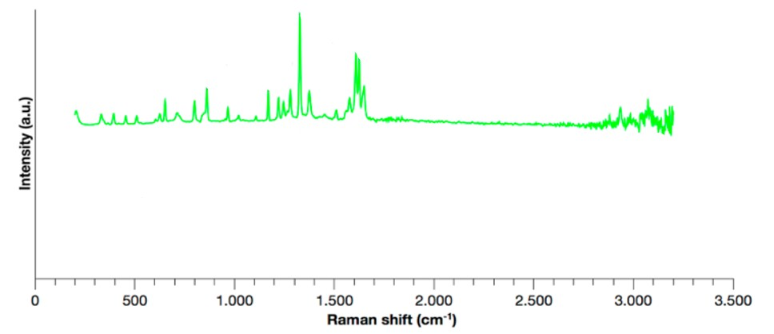
Figure 49:https://doi.org/10.1021/acs.cgd.3c00617

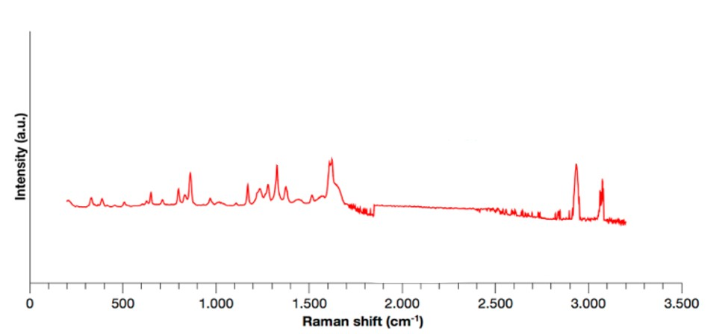
Figure 50:https://doi.org/10.1021/acs.cgd.3c00617

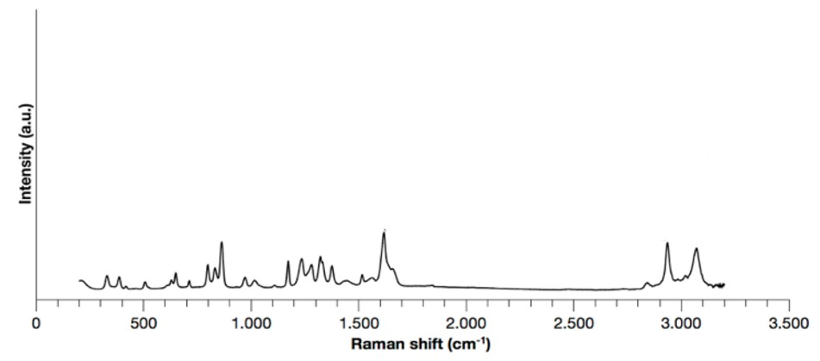
Figure 51:https://doi.org/10.1021/acs.cgd.3c00617
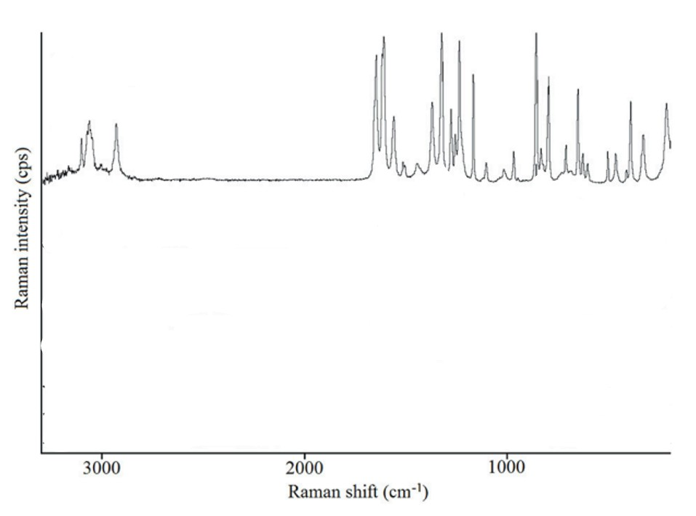
Figure 52:https://doi.org/10.3389/fphar.2019.00014

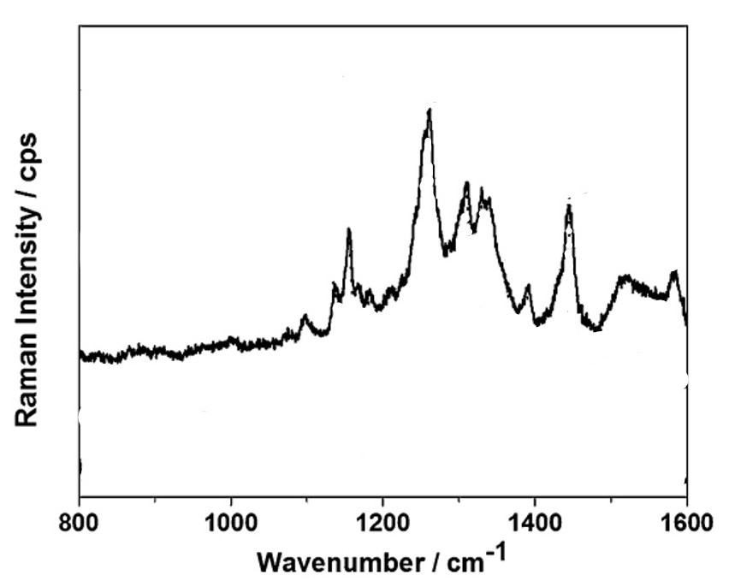
Figure 53:https://doi.org/10.1039/C4AY00635F
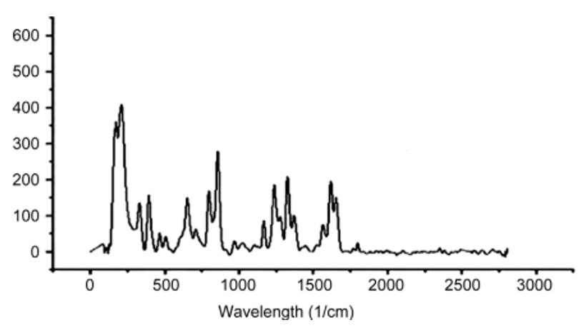
Figure 54:https://pmc.ncbi.nlm.nih.gov/articles/PMC3757861/
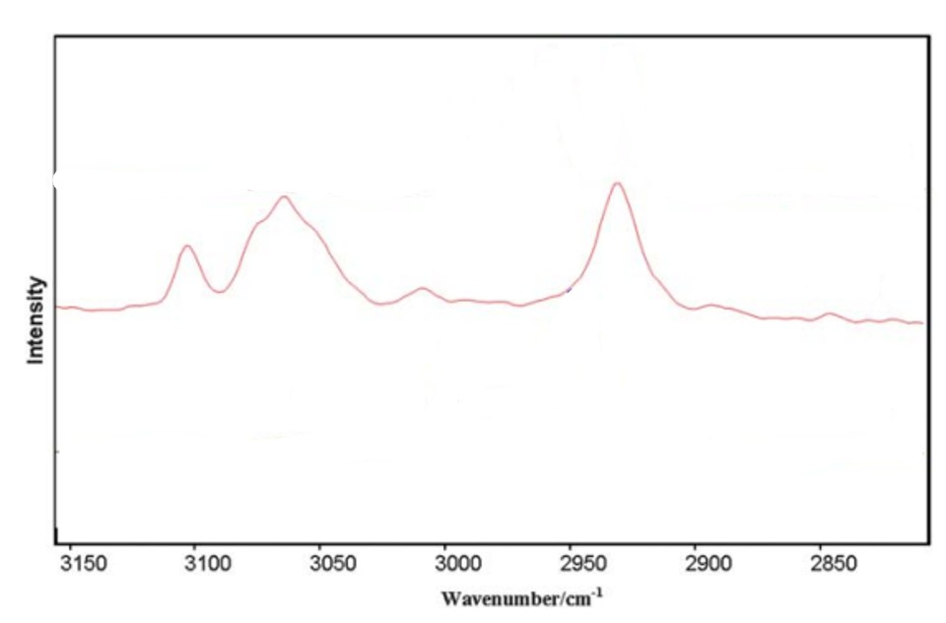
Figure 55:https://doi.org/10.1039/C0CE00461H
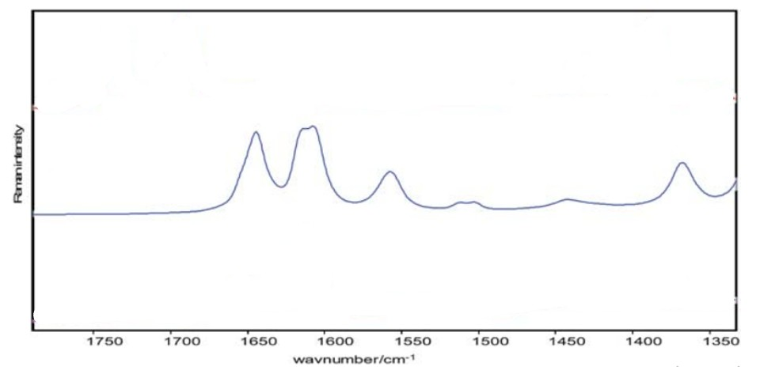
Figure 56:https://doi.org/10.1039/C0CE00461H
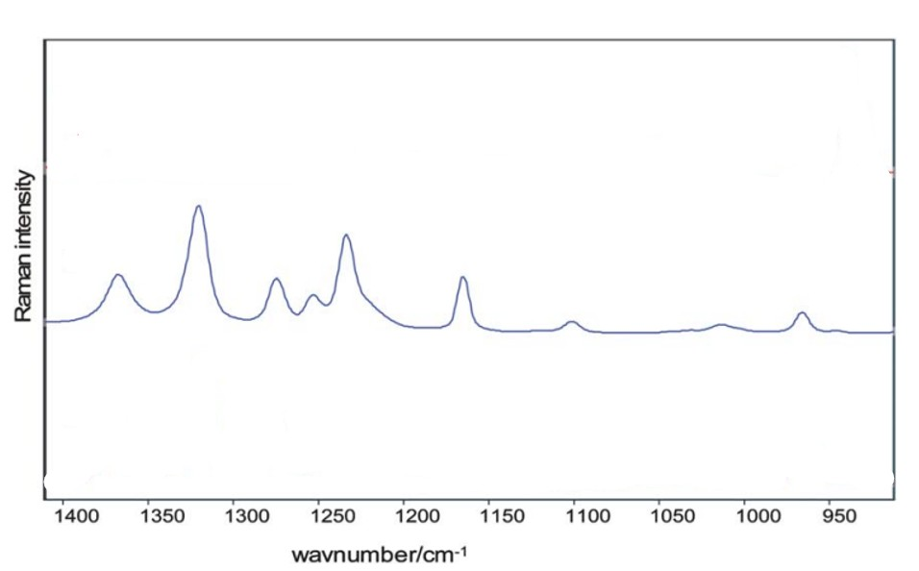
Figure 57:https://doi.org/10.1039/C0CE00461H
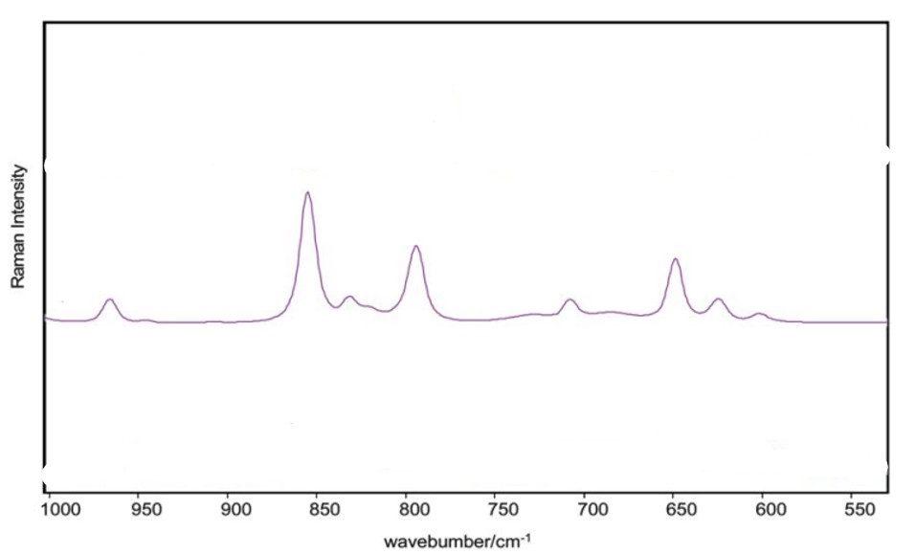
Figure 58:https://doi.org/10.1039/C0CE00461H
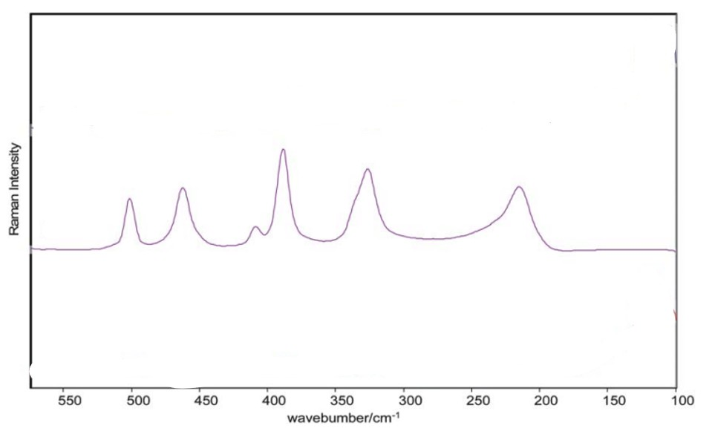
Figure 59:https://doi.org/10.1039/C0CE00461H
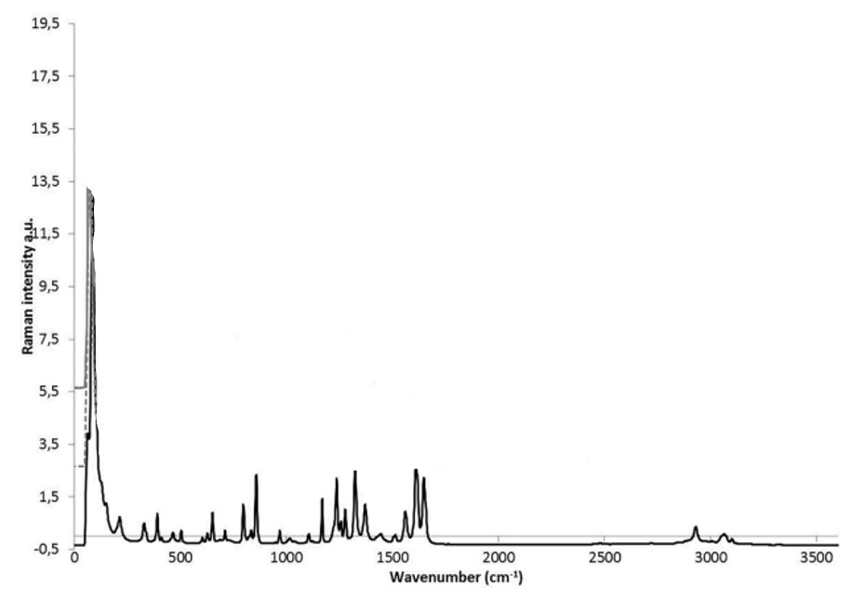
Figure 60:https://doi.org/10.1016/j.vibspec.2020.103147

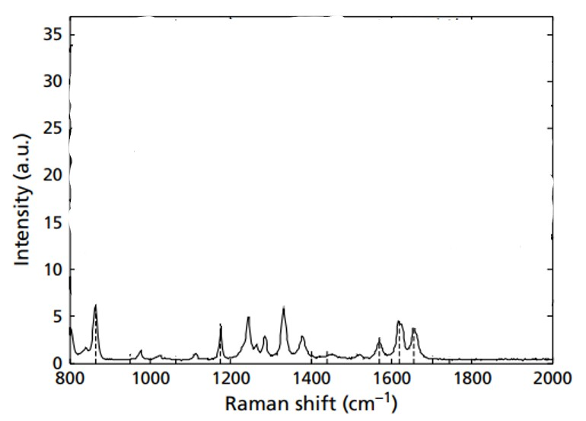
Figure 61:https://doi.org/10.1211/jpp.59.3.0006
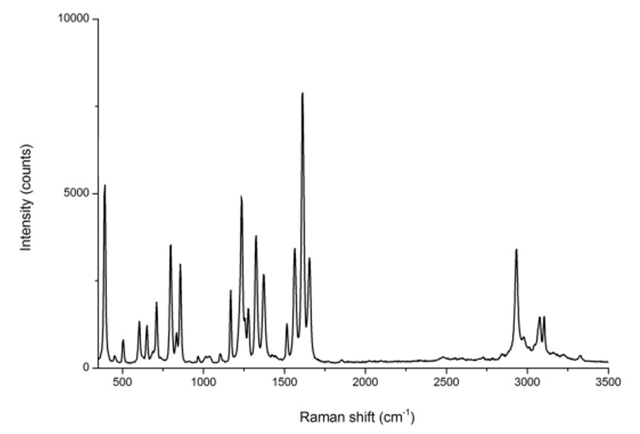
Figure 62:https://doi.org/10.1021/acs.cgd.7b01411
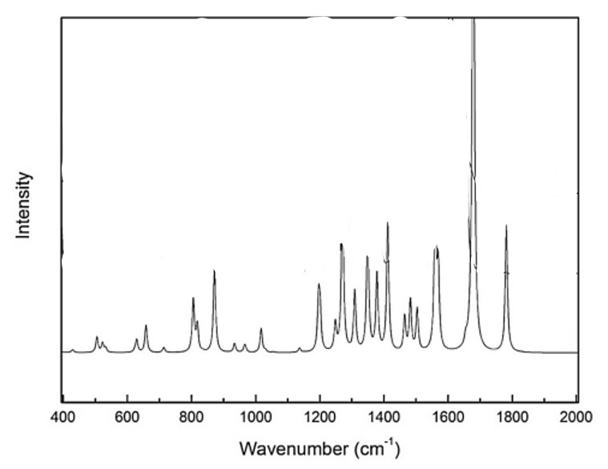
Figure 63:DOI: 10.32383/appdr/110690
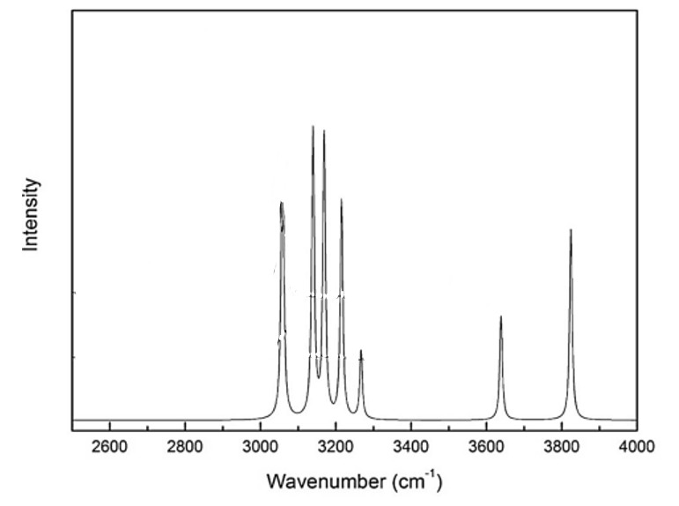
Figure 64:DOI: 10.32383/appdr/110690
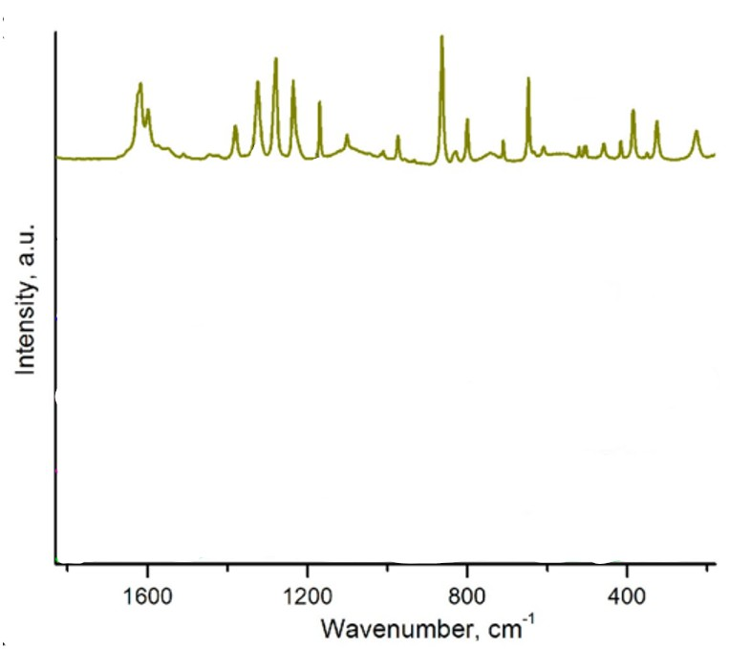
Figure 65:http://dx.doi.org/10.1021/acs.cgd.9b00473

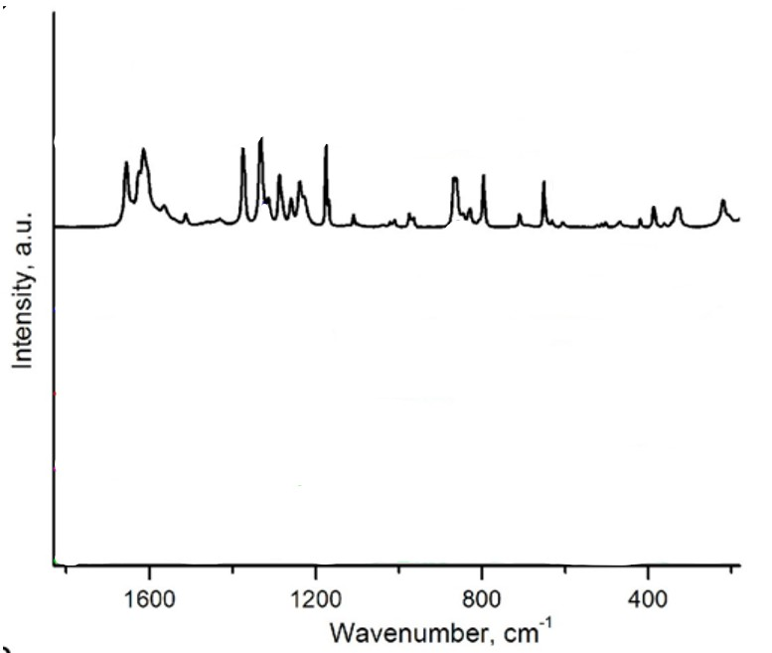
Figure 66:http://dx.doi.org/10.1021/acs.cgd.9b00473
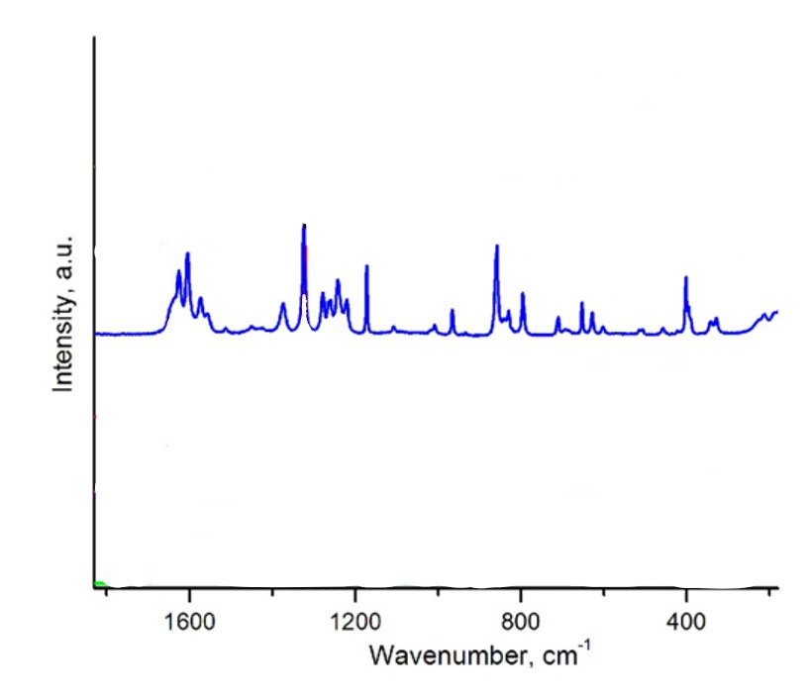
Figure 67:http://dx.doi.org/10.1021/acs.cgd.9b00473
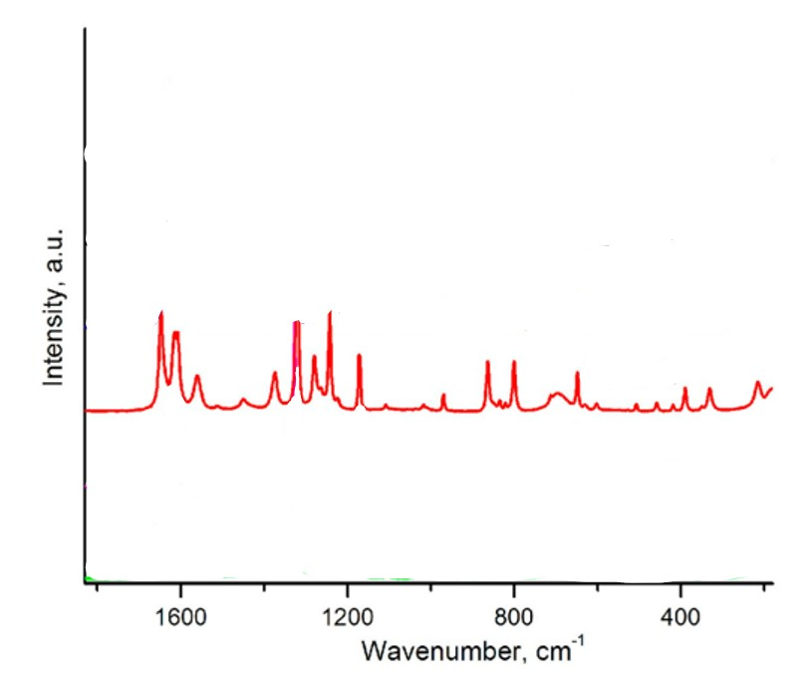
Figure 68:http://dx.doi.org/10.1021/acs.cgd.9b00473
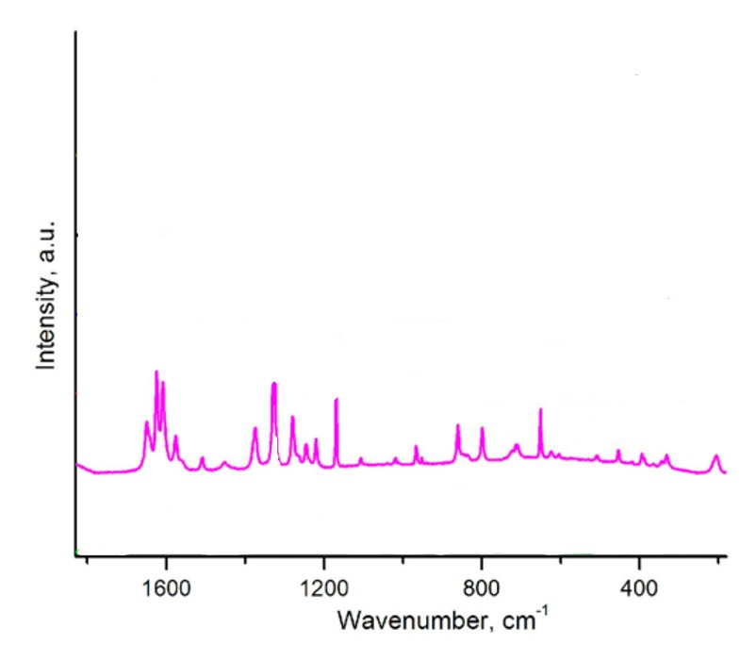
Figure 69:http://dx.doi.org/10.1021/acs.cgd.9b00473
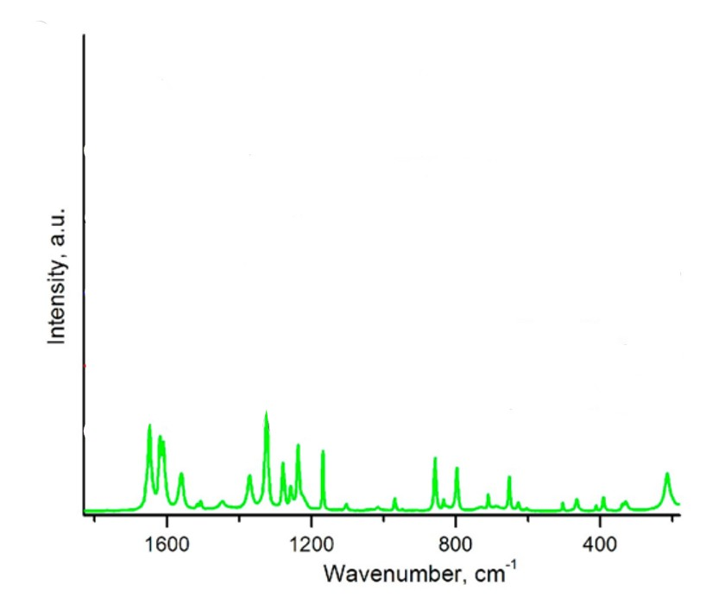
Figure 70:http://dx.doi.org/10.1021/acs.cgd.9b00473
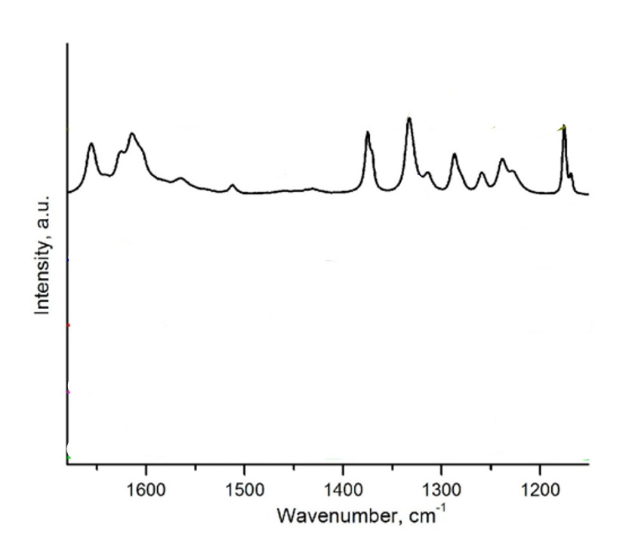
Figure 72:http://dx.doi.org/10.1021/acs.cgd.9b00473
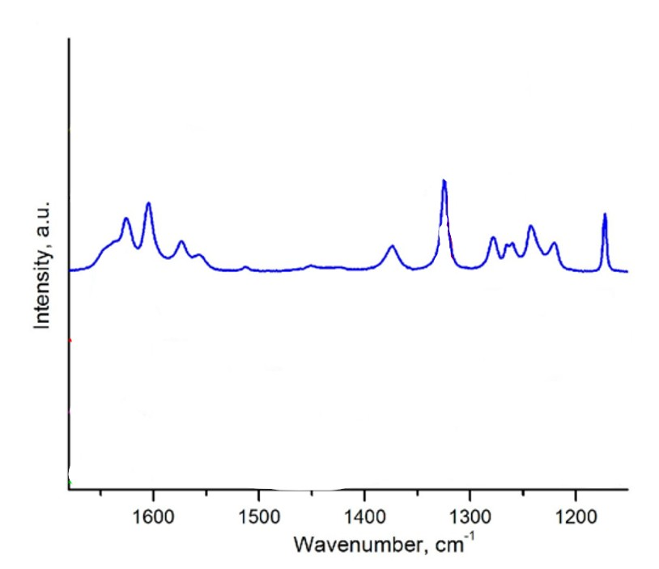
Figure 73:http://dx.doi.org/10.1021/acs.cgd.9b00473
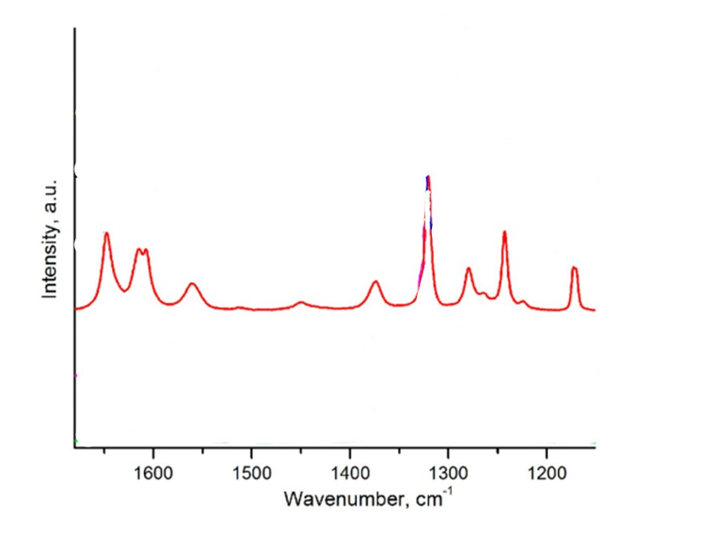
Figure 74:http://dx.doi.org/10.1021/acs.cgd.9b00473

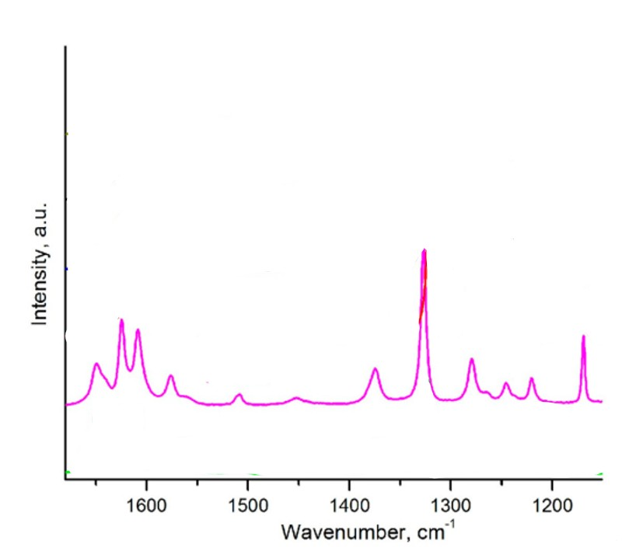
Figure 75:http://dx.doi.org/10.1021/acs.cgd.9b00473

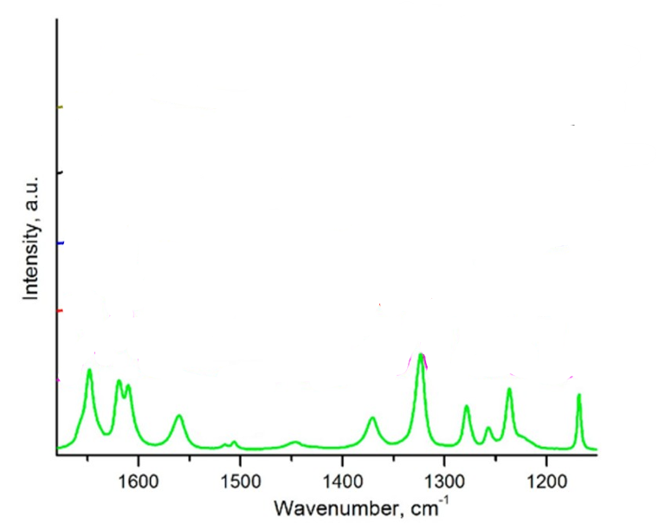
Figure 77:http://dx.doi.org/10.1021/acs.cgd.9b00473

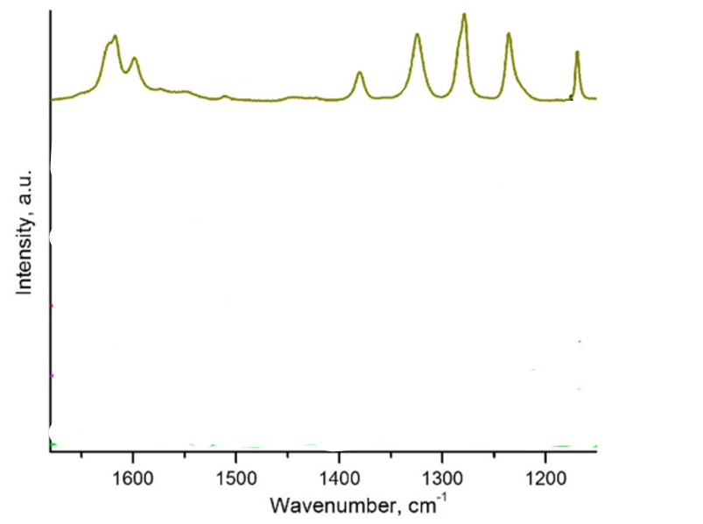
Figure 80:http://dx.doi.org/10.1021/acs.cgd.9b00473
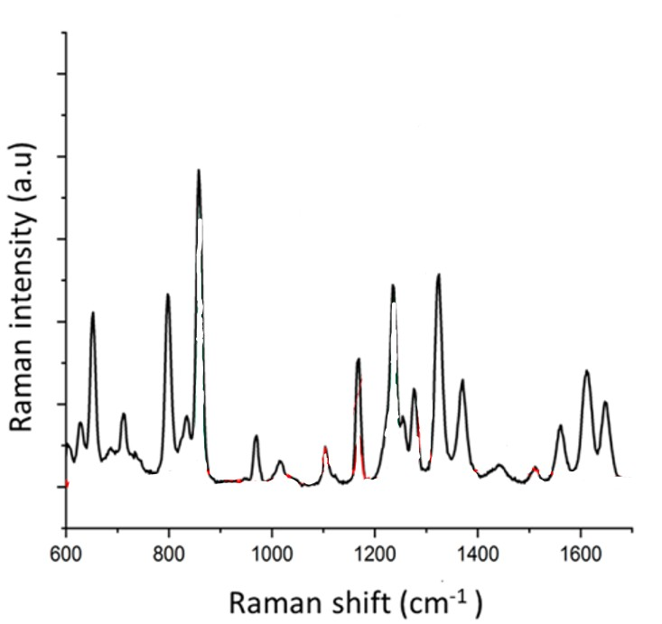
Figure 83:https://doi.org/10.1021/acs.analchem.9b01222
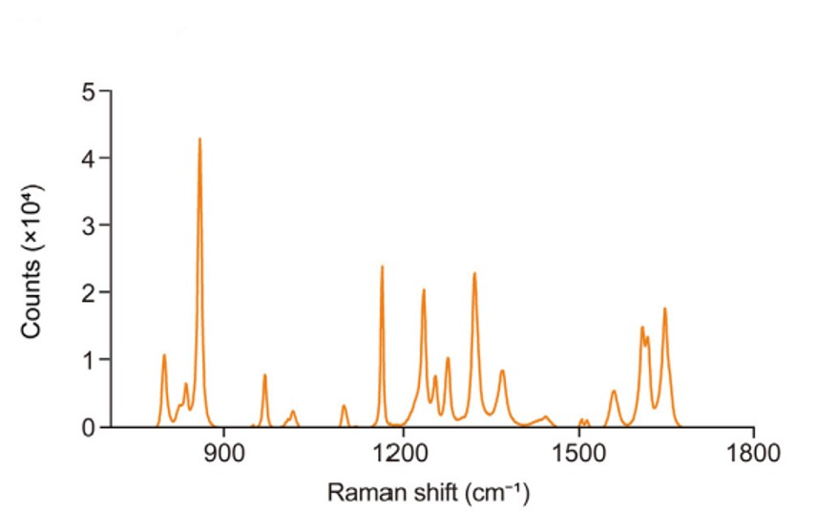
Figure 84:https://doi.org/10.1016/j.jpha.2023.02.004
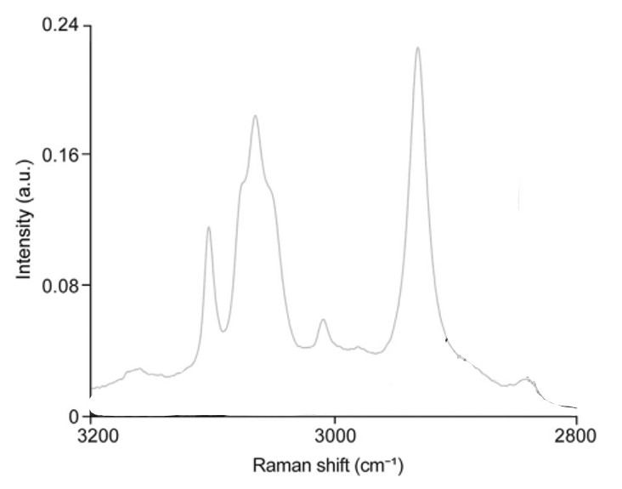
Figure 85:https://doi.org/10.1016/j.jpha.2023.02.004
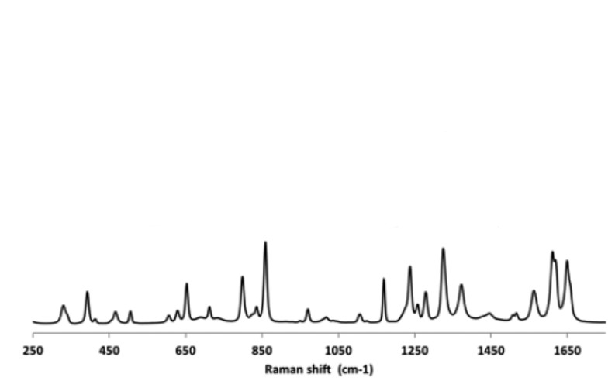
Figure 86:http://dx.doi.org/10.1021/acs.cgd.6b01831
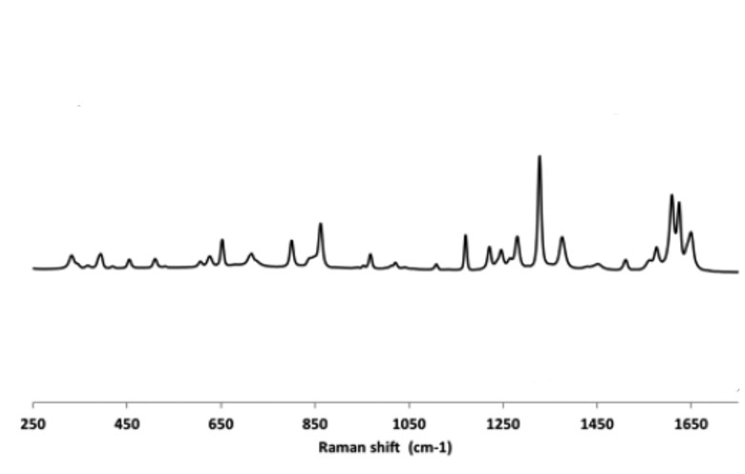
Figure 87:http://dx.doi.org/10.1021/acs.cgd.6b01831
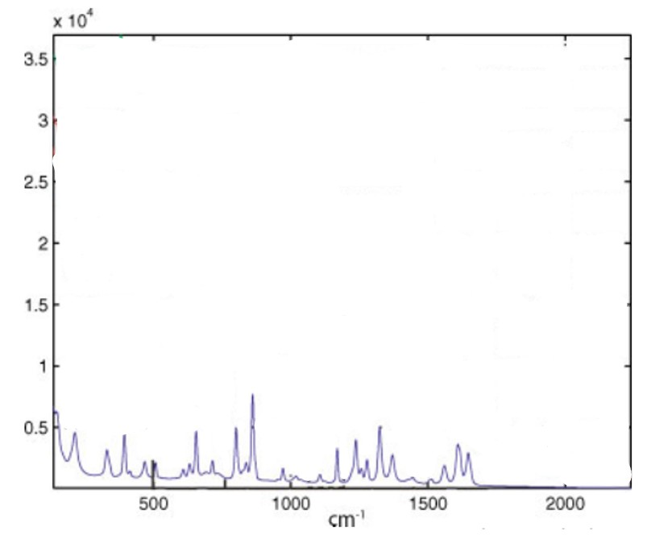
Figure 88:https://doi.org/10.1002/cem.1330
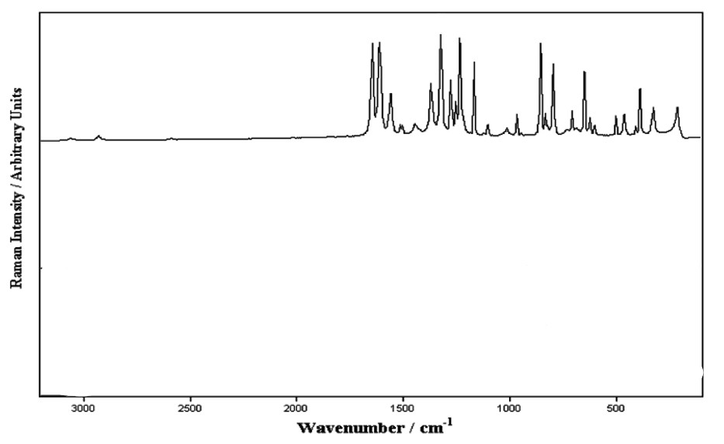
Figure 89:DOI 10.1007/s00216-007-1776-z
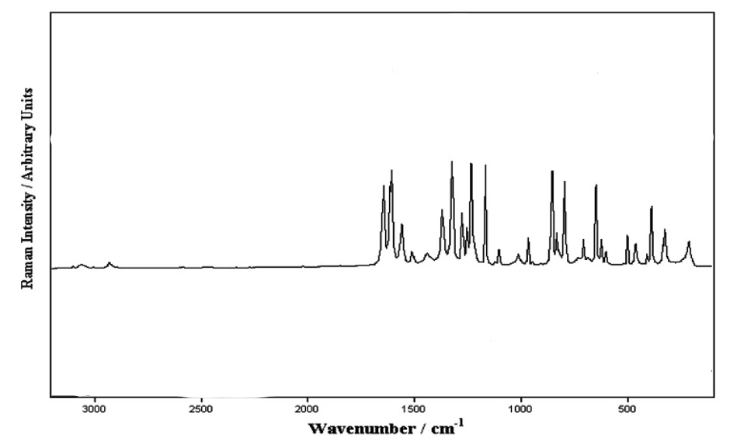
Figure 90:DOI 10.1007/s00216-007-1776-z
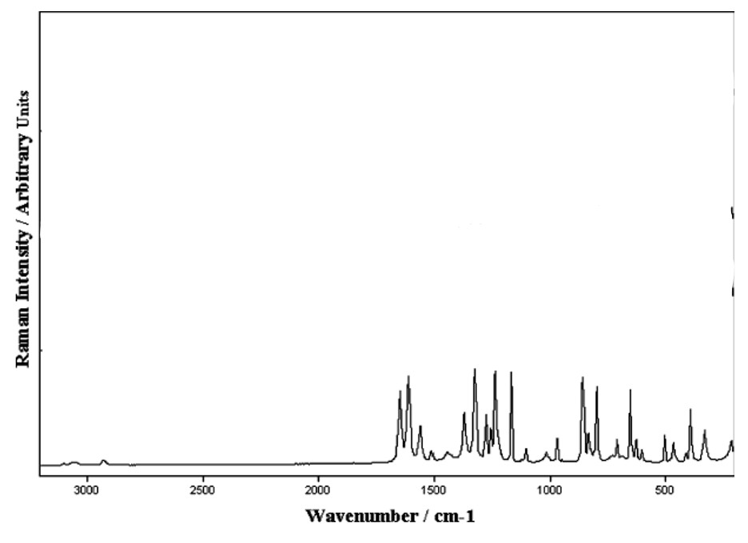
Figure 91:DOI 10.1007/s00216-007-1776-z
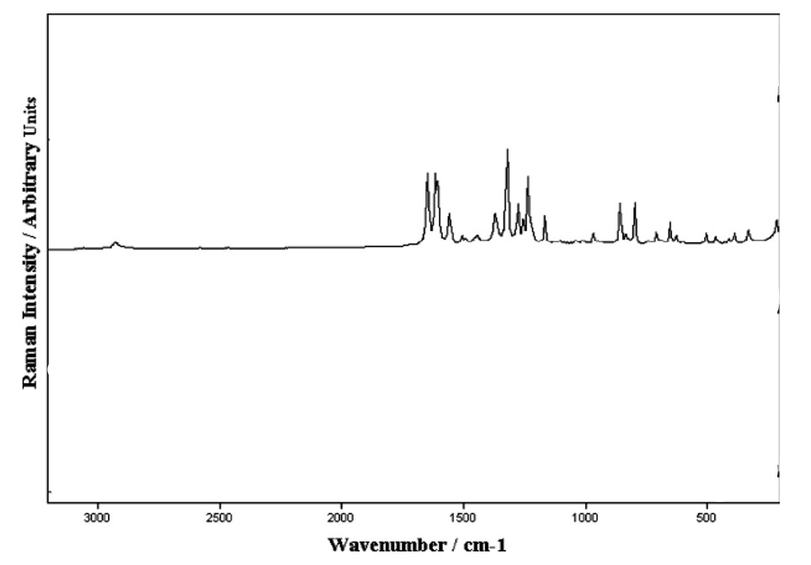
Figure 92:DOI 10.1007/s00216-007-1776-z
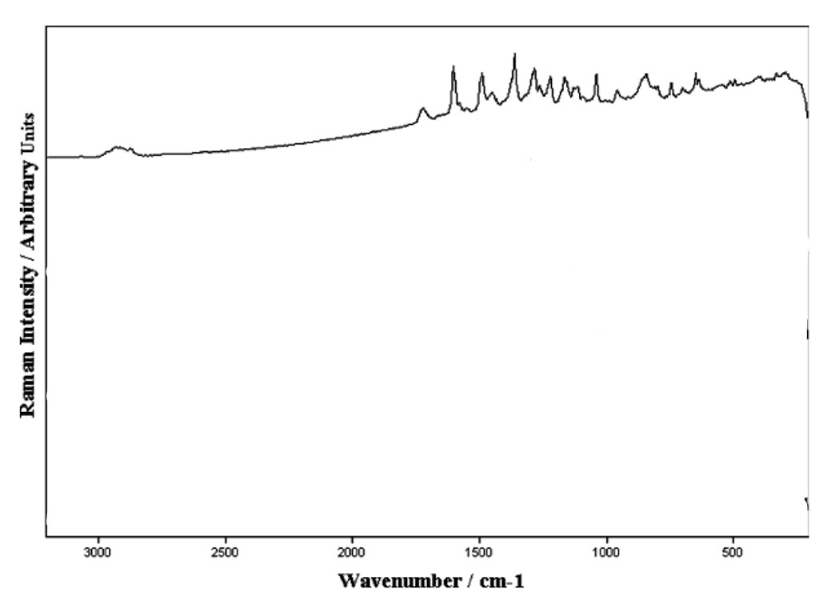
Figure 93:DOI 10.1007/s00216-007-1776-z
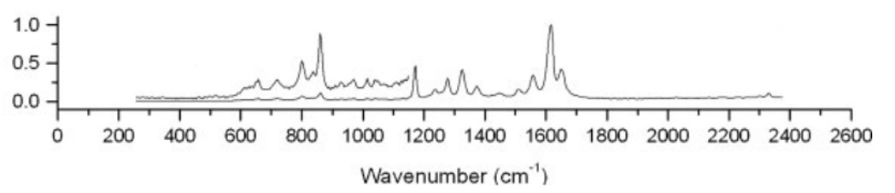
Figure 94:https://doi.org/10.1002/jrs.1446
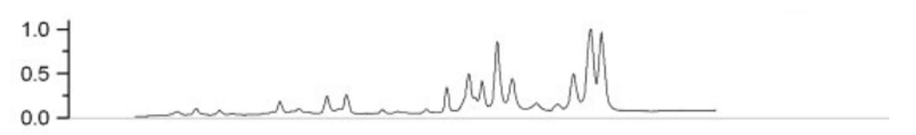
Figure 95:https://doi.org/10.1002/jrs.1446
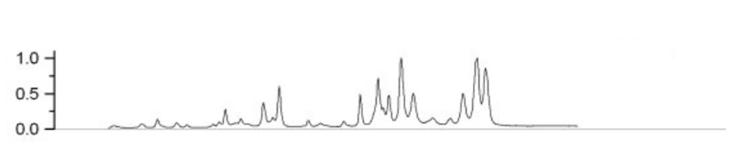
Figure 96:https://doi.org/10.1002/jrs.1446
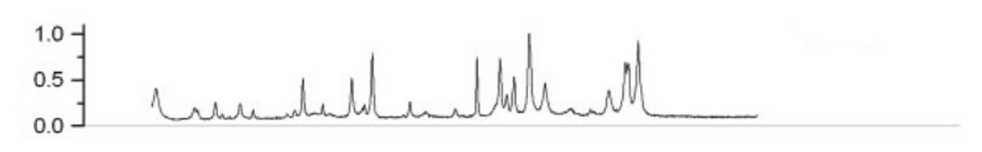
Figure 97:https://doi.org/10.1002/jrs.1446
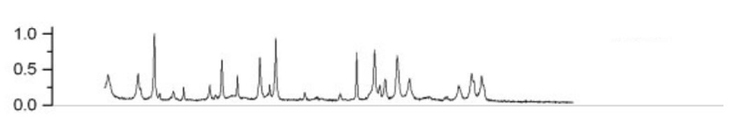
Figure 98:https://doi.org/10.1002/jrs.1446
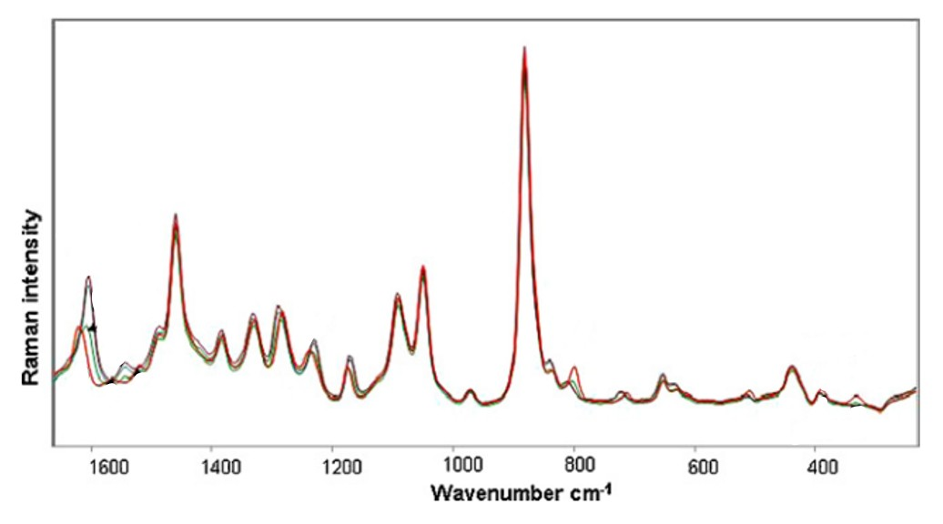
Figure 99:https://doi.org/10.1016/j.saa.2010.01.008
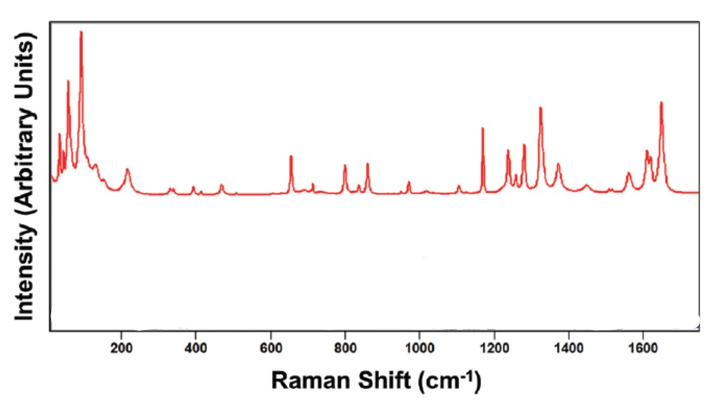
Figure 100:https://www.spectroscopyonline.com/view/raman-spectroscopy-and-polymorphism
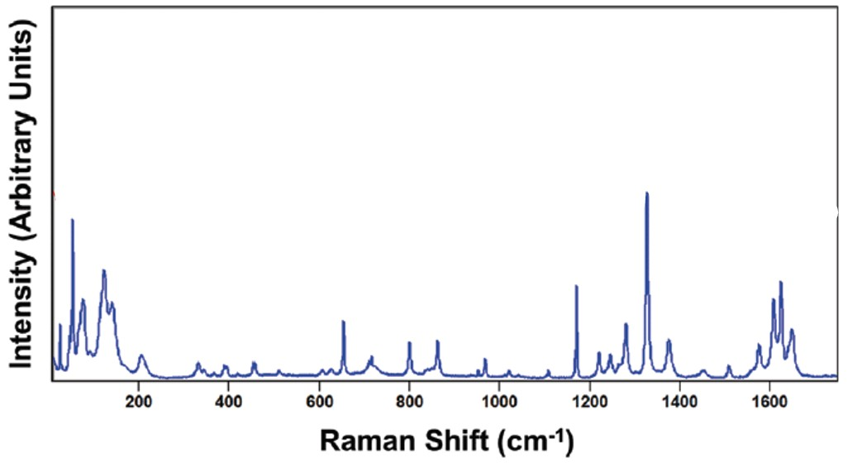
Figure 101:https://www.spectroscopyonline.com/view/raman-spectroscopy-and-polymorphism
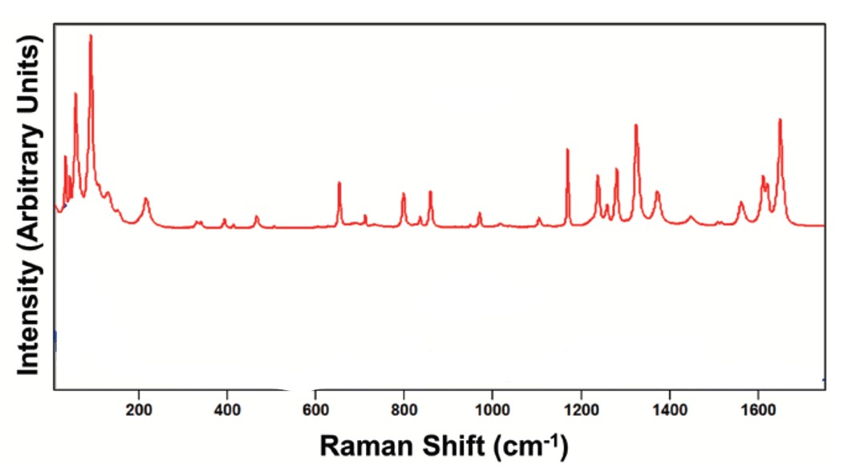
Figure 102:https://www.spectroscopyonline.com/view/raman-spectroscopy-and-polymorphism
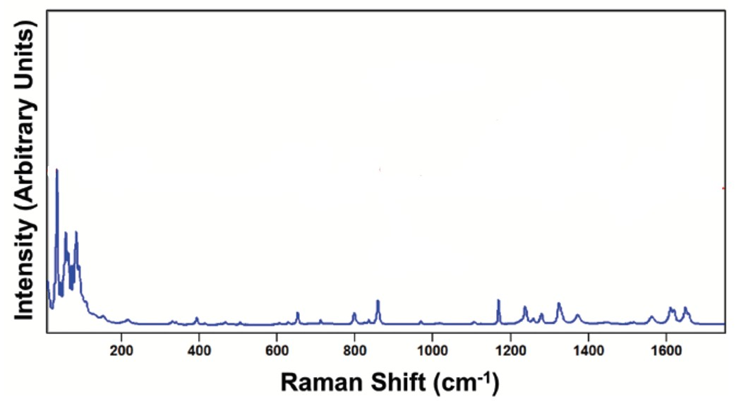
Figure 103:https://www.spectroscopyonline.com/view/raman-spectroscopy-and-polymorphism
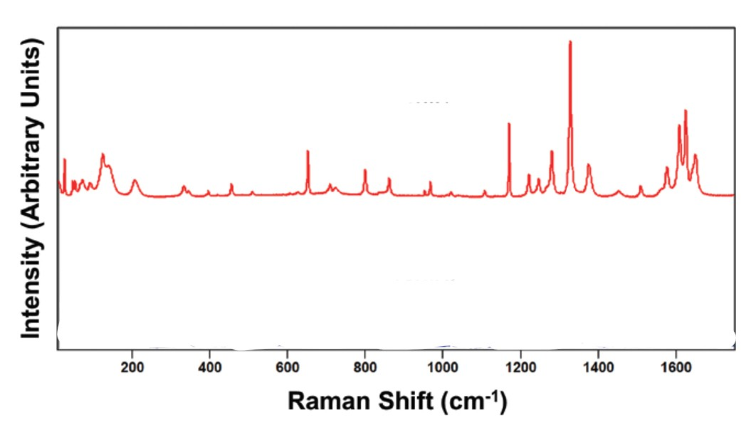
Figure 104:https://www.spectroscopyonline.com/view/raman-spectroscopy-and-polymorphism
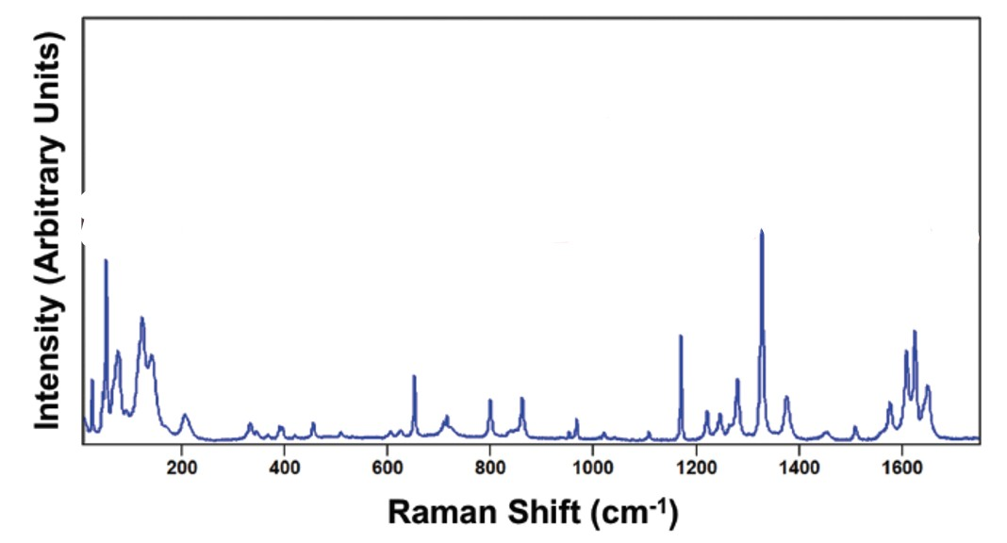
Figure 105:https://www.spectroscopyonline.com/view/raman-spectroscopy-and-polymorphism
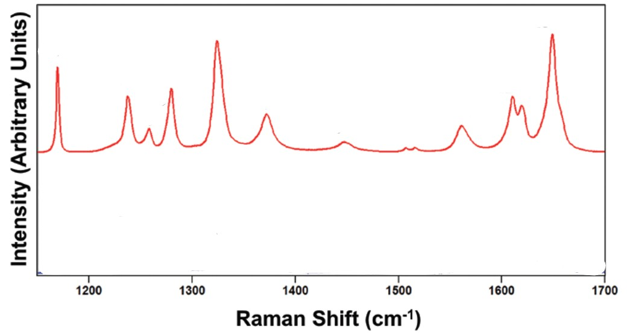
Figure 106:https://www.spectroscopyonline.com/view/raman-spectroscopy-and-polymorphism
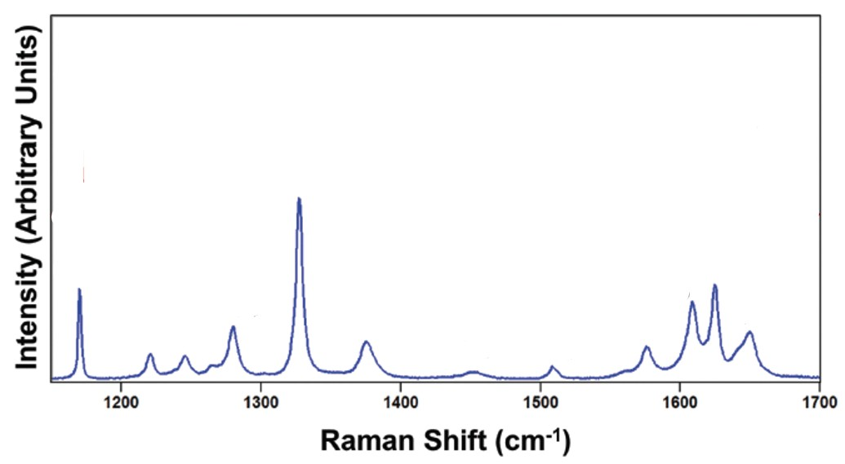
Figure 107:https://www.spectroscopyonline.com/view/raman-spectroscopy-and-polymorphism
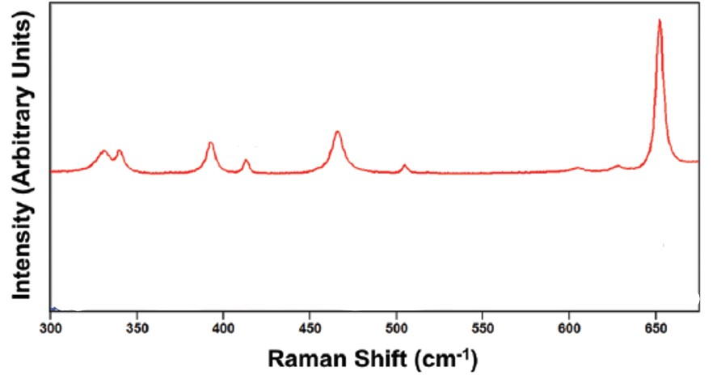
Figure 108:https://www.spectroscopyonline.com/view/raman-spectroscopy-and-polymorphism
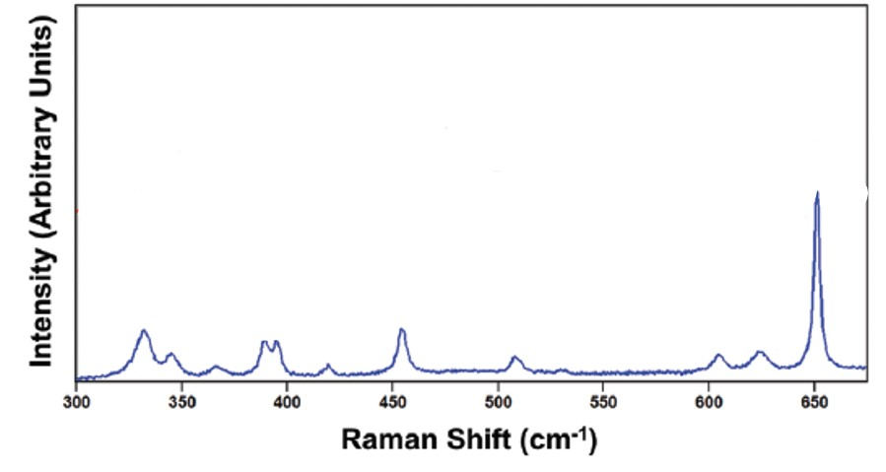
Figure 109:https://www.spectroscopyonline.com/view/raman-spectroscopy-and-polymorphism
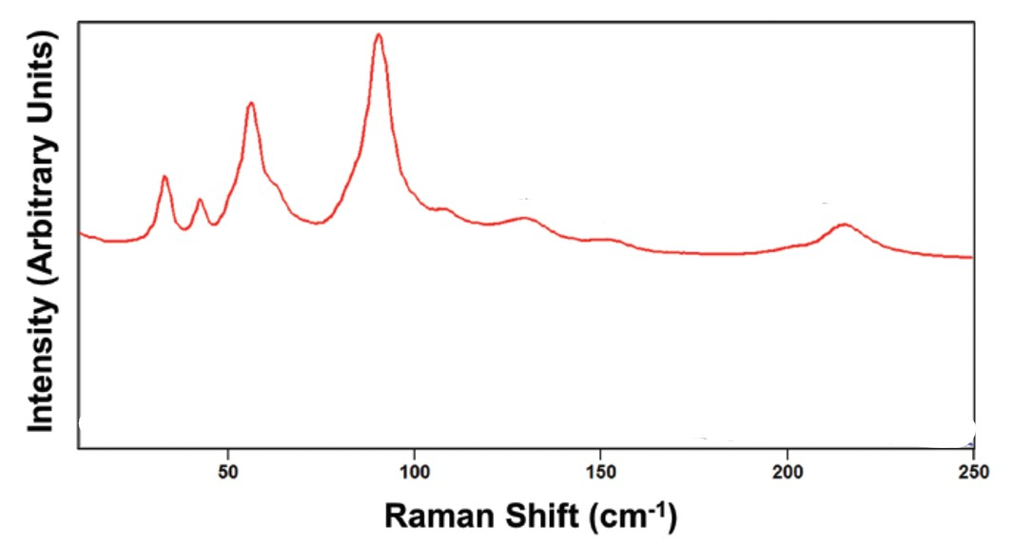
Figure 110:https://www.spectroscopyonline.com/view/raman-spectroscopy-and-polymorphism
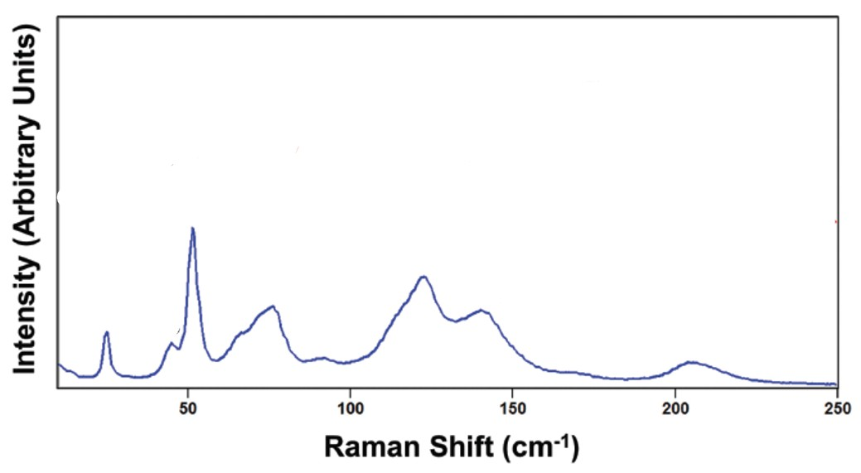
Figure 111:https://www.spectroscopyonline.com/view/raman-spectroscopy-and-polymorphism
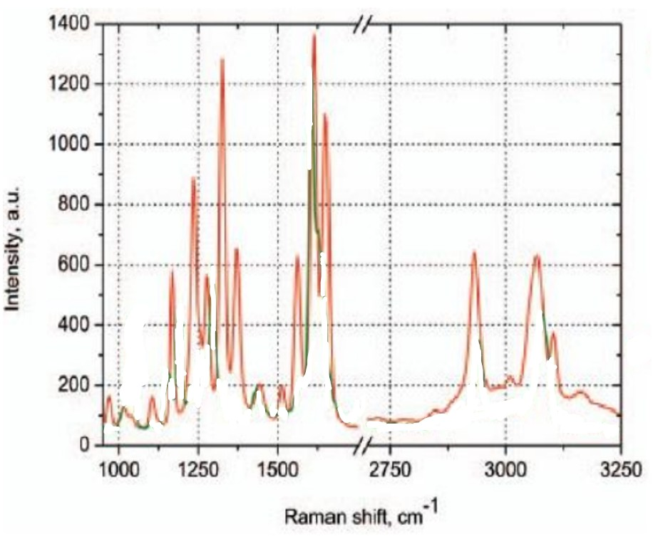
Figure 112:https://core.ac.uk/download/pdf/145037709.pdf
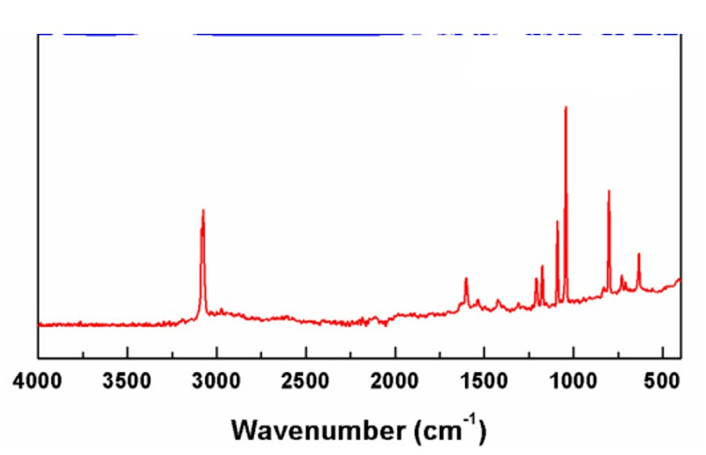
Figure 113:https://doi.org/10.1016/j.saa.2015.05.091
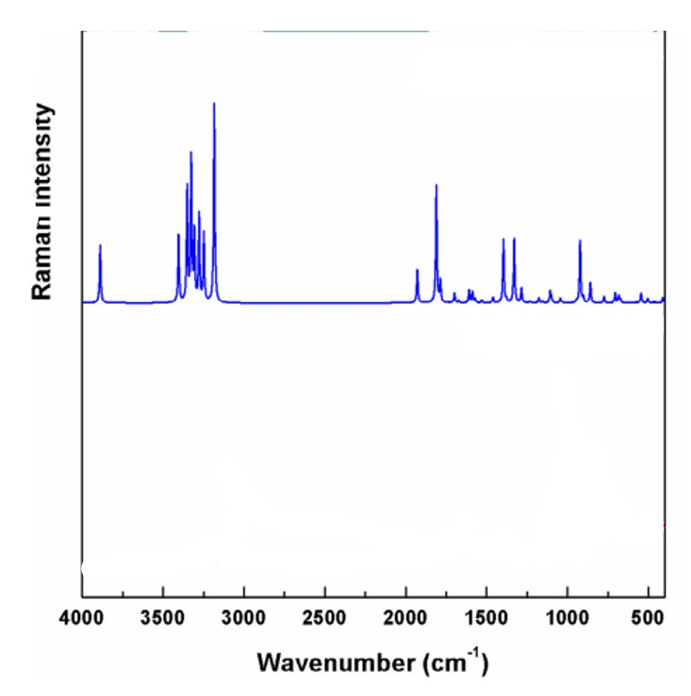
Figure 114:https://doi.org/10.1016/j.saa.2015.05.091
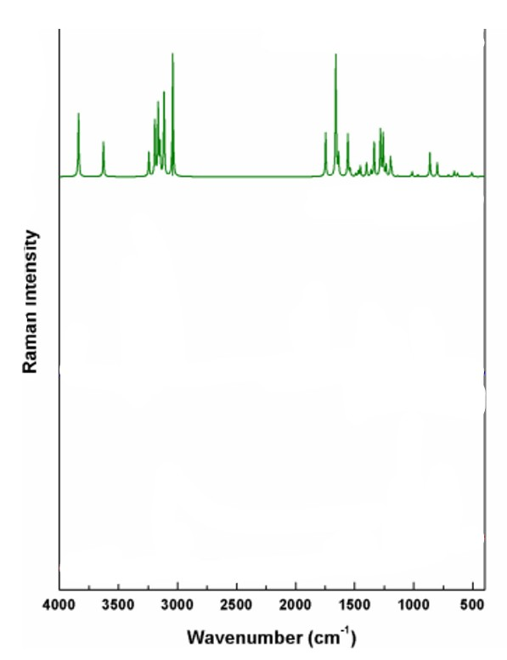
Figure 115:https://doi.org/10.1016/j.saa.2015.05.091
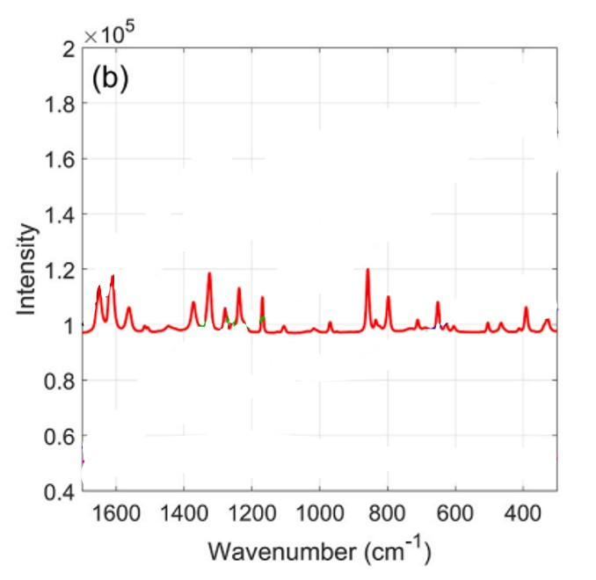
Figure 116:https://doi.org/10.1016/j.aca.2024.343310
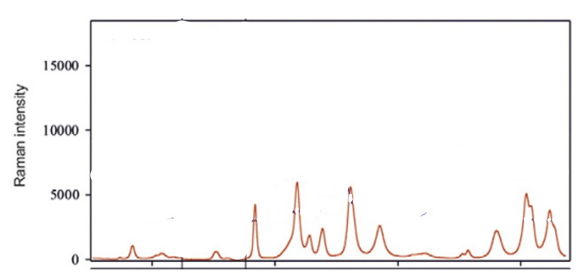
Figure 117:http://dx.doi.org/10.1016/j.ejps.2016.08.006
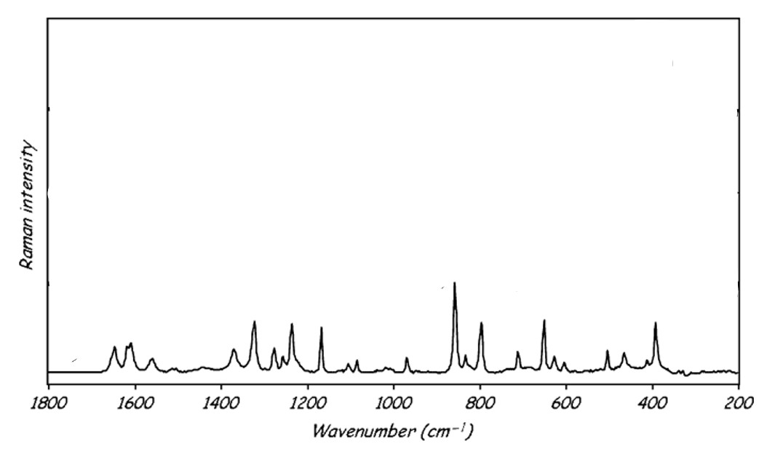
Figure 118:DOI: 10.1002/jrs.1621
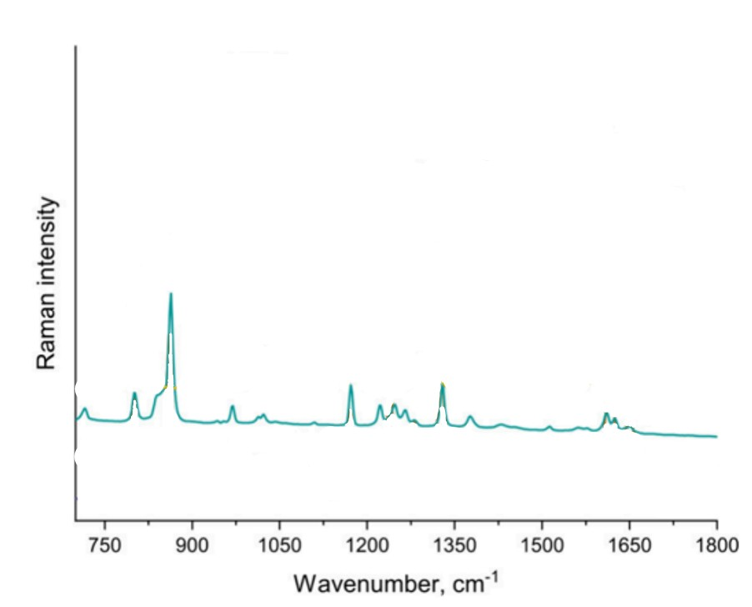
Figure 119:https://doi.org/10.1021/acs.analchem.4c01977
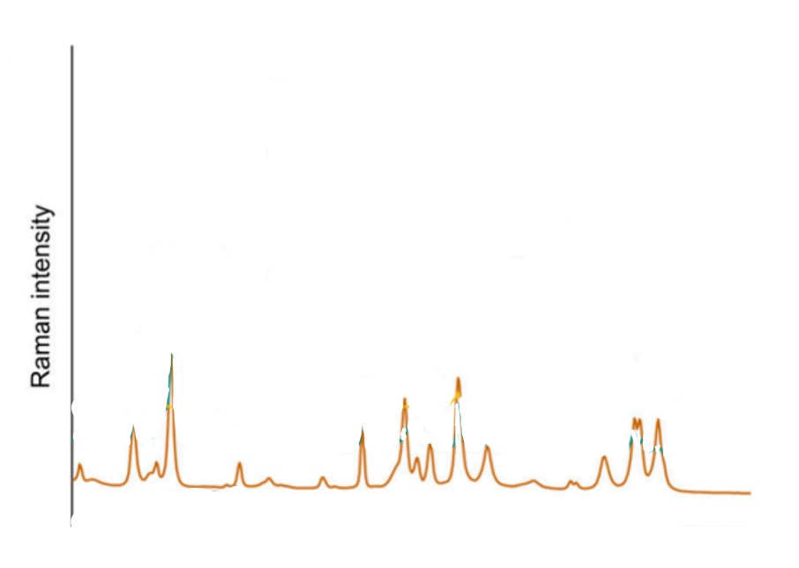
Figure 120:https://doi.org/10.1021/acs.analchem.4c01977
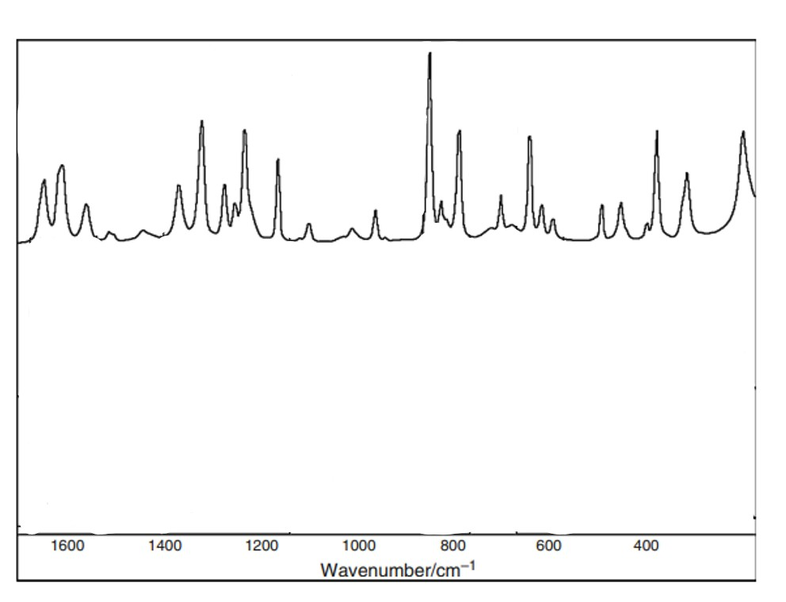
Figure 121:DOI 10.1007/s10973-015-5223-7
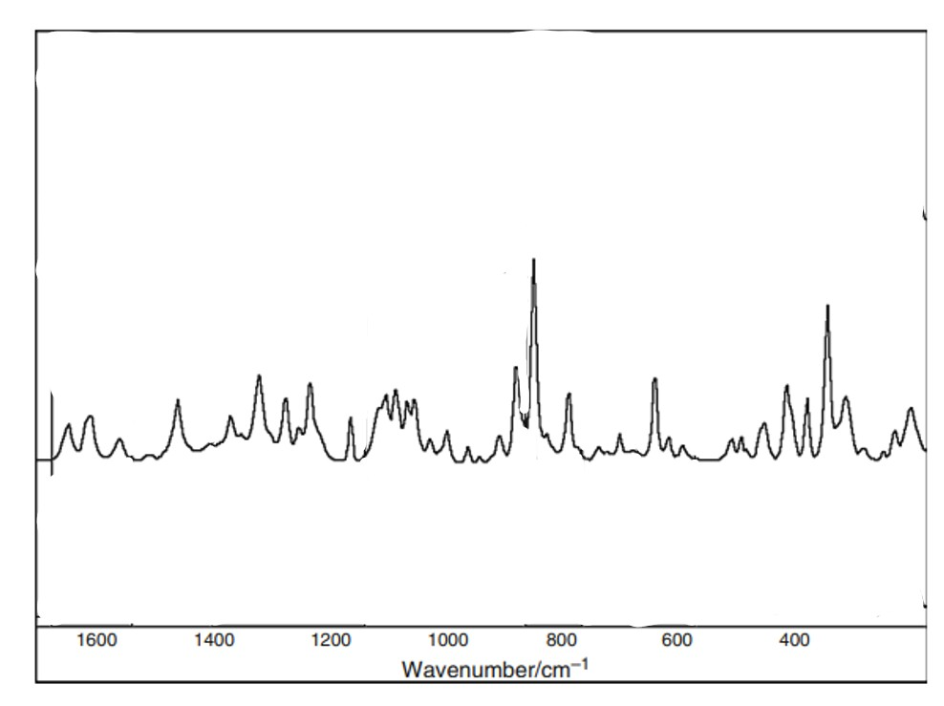
Figure 122:DOI 10.1007/s10973-015-5223-7
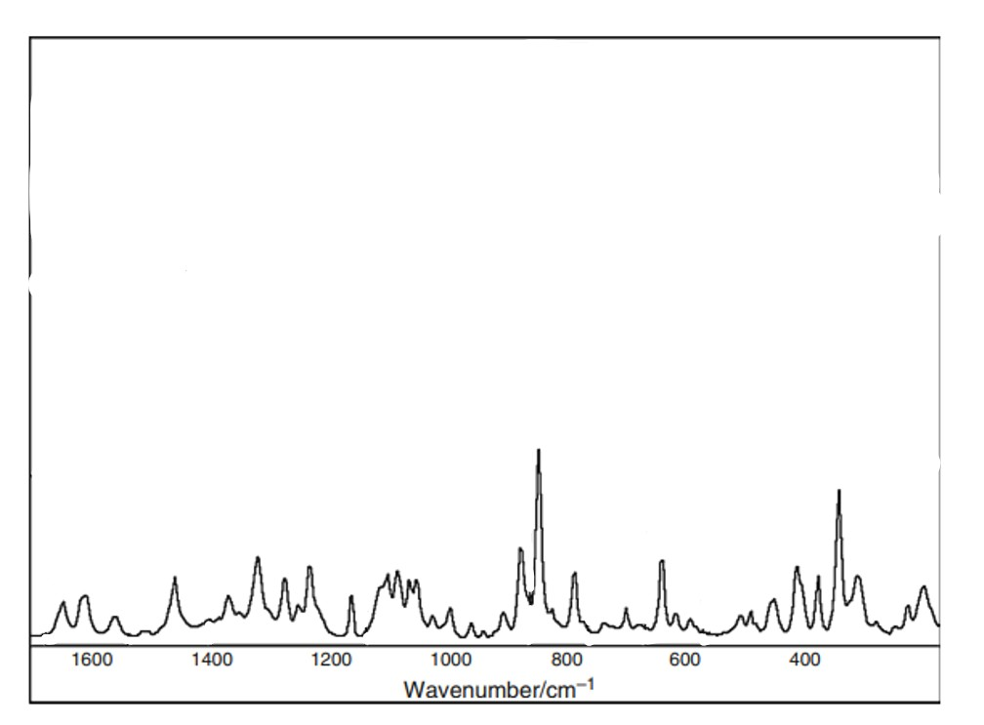
Figure 123:DOI 10.1007/s10973-015-5223-7
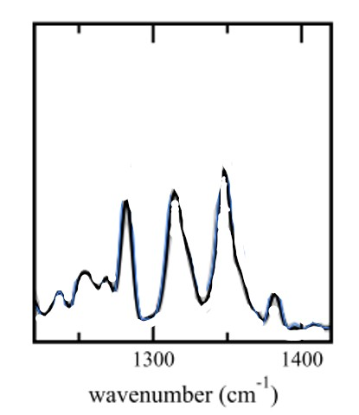
Figure 124:DOI 10.1088/1367-2630/ab4509
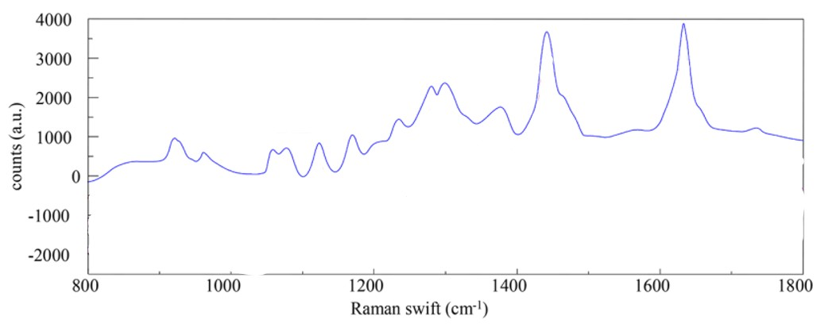
Figure 125:http://dx.doi.org/10.1021/acs.cgd.8b00346
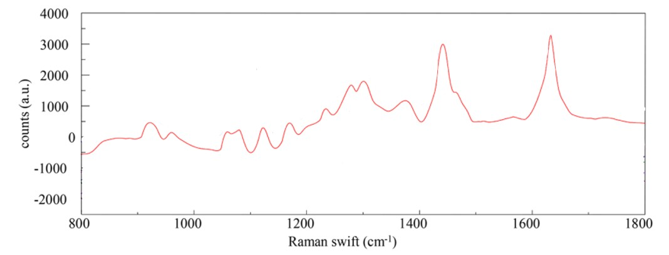
Figure 126:http://dx.doi.org/10.1021/acs.cgd.8b00346
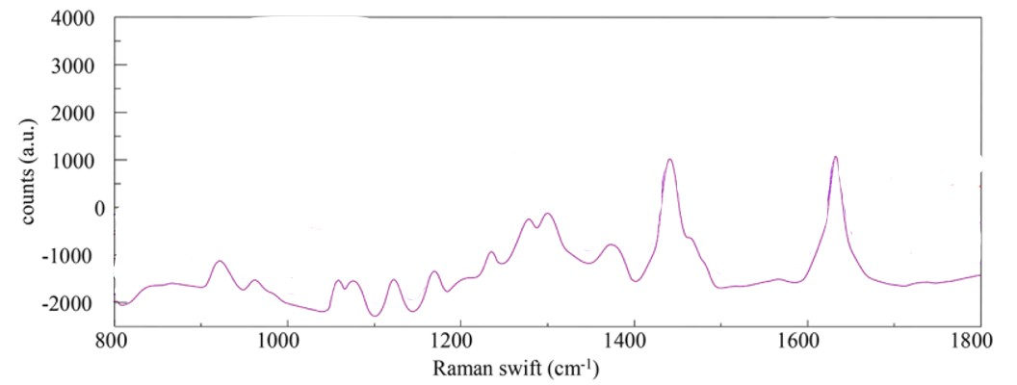
Figure 127:http://dx.doi.org/10.1021/acs.cgd.8b00346
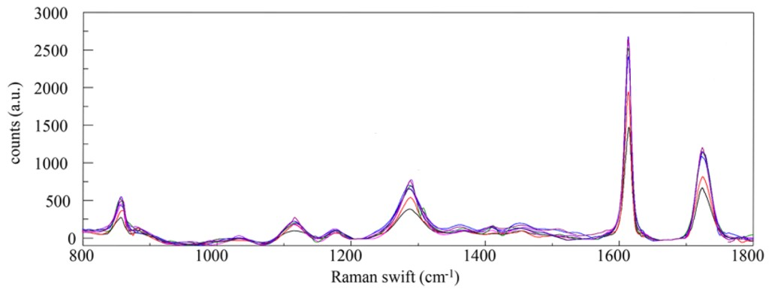
Figure 128:http://dx.doi.org/10.1021/acs.cgd.8b00346
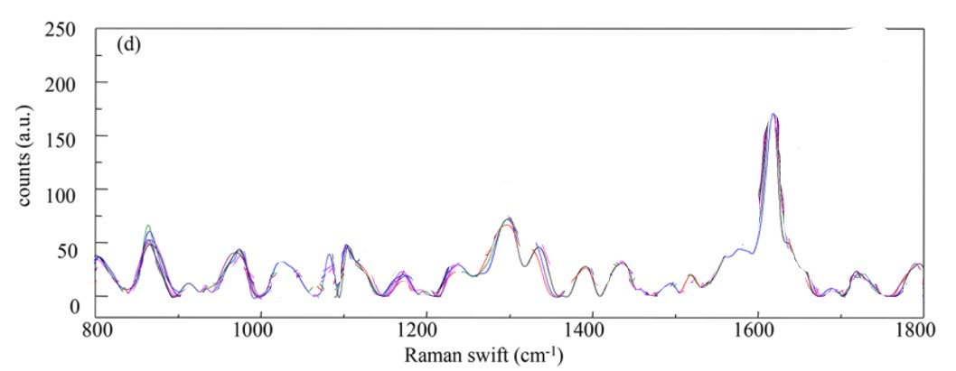
Figure 129:http://dx.doi.org/10.1021/acs.cgd.8b00346
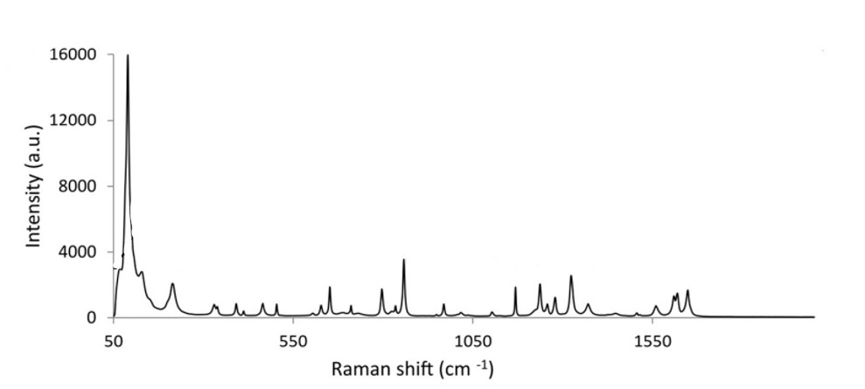
Figure 130:https://doi.org/10.1016/j.ejps.2018.01.036
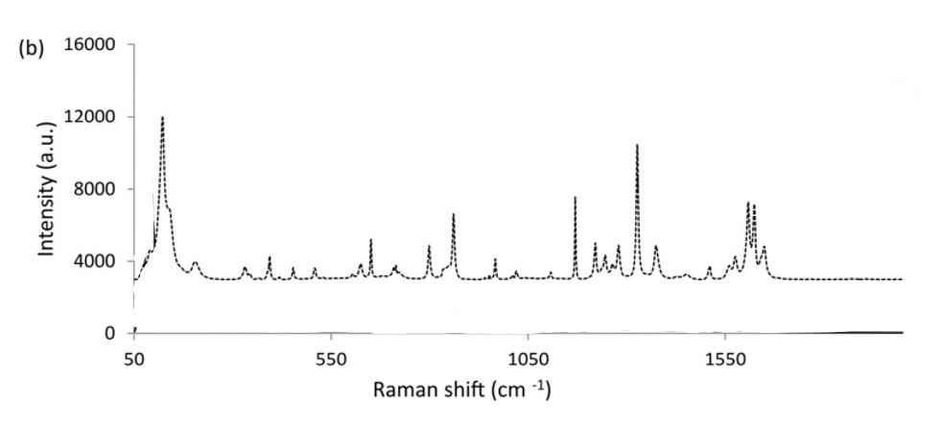
Figure 131:https://doi.org/10.1016/j.ejps.2018.01.036
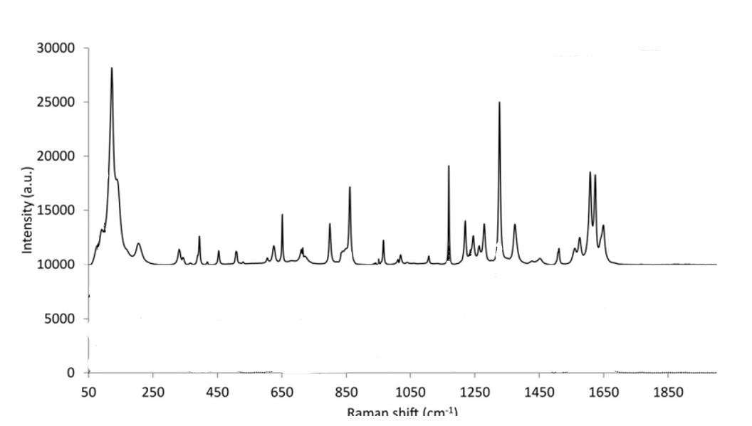
Figure 132:https://doi.org/10.1016/j.ejps.2018.01.036
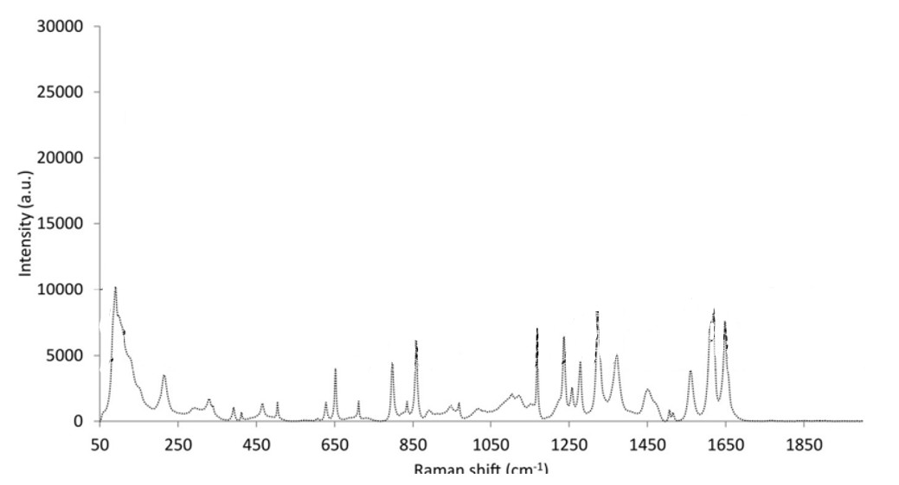
Figure 133:https://doi.org/10.1016/j.ejps.2018.01.036
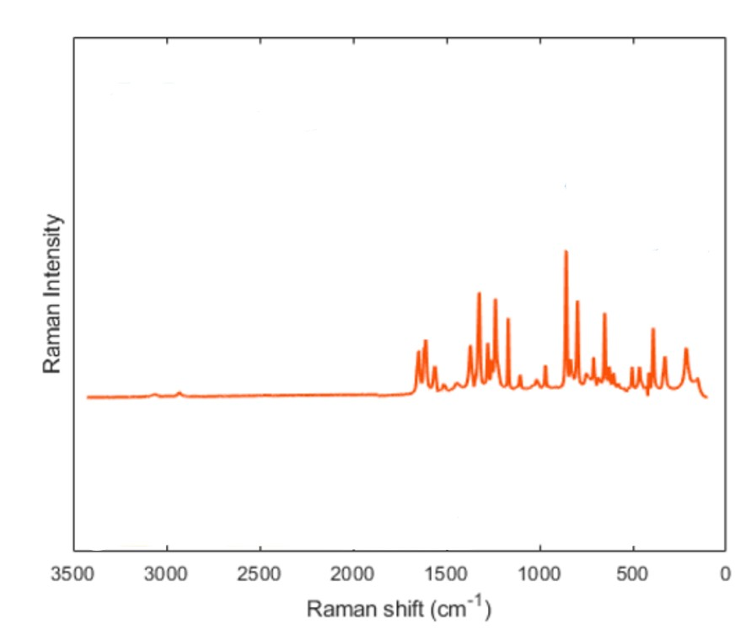
Figure 134:https://dx.doi.org/10.1021/acs.cgd.9b01482?ref=pdf
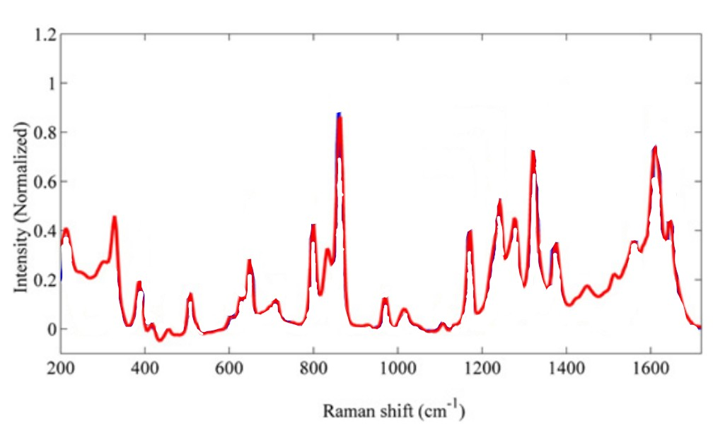
Figure 135:http://dx.doi.org/10.1016/j.microc.2015.07.003
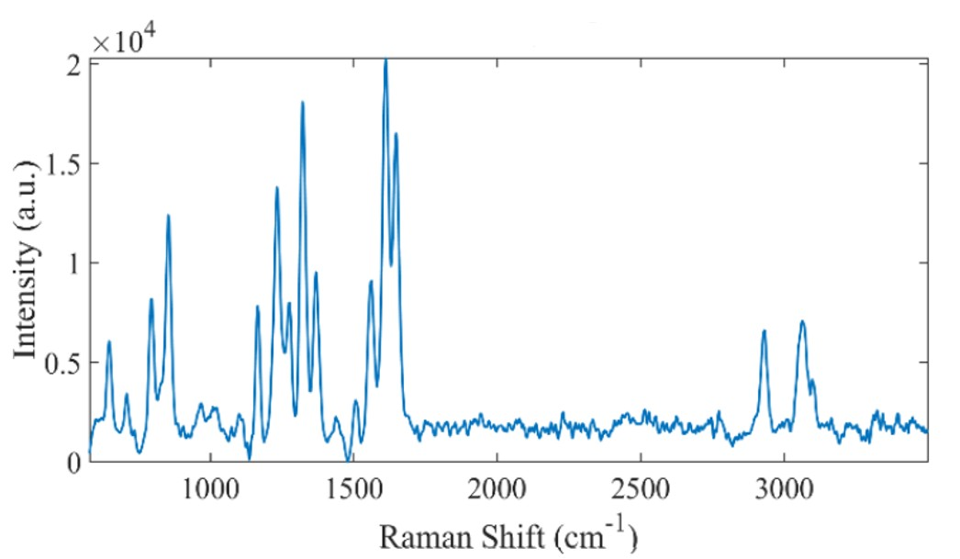
Figure 136:doi:10.1088/1742-6596/2431/1/012020
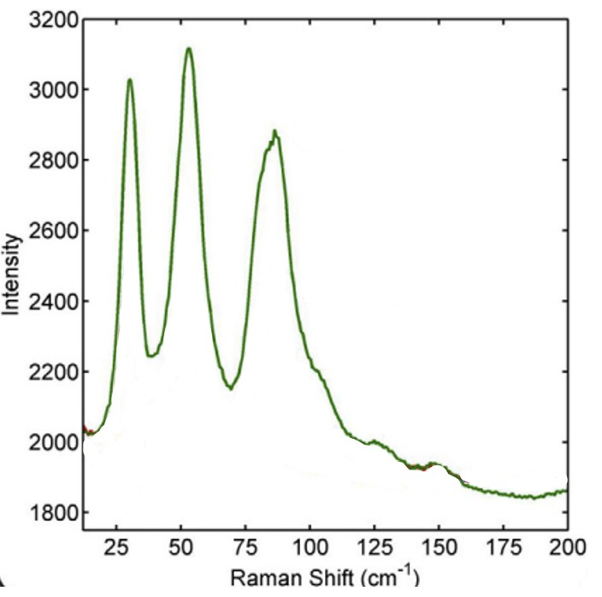
Figure 137:https://doi.org/10.1016/j.saa.2019.117798
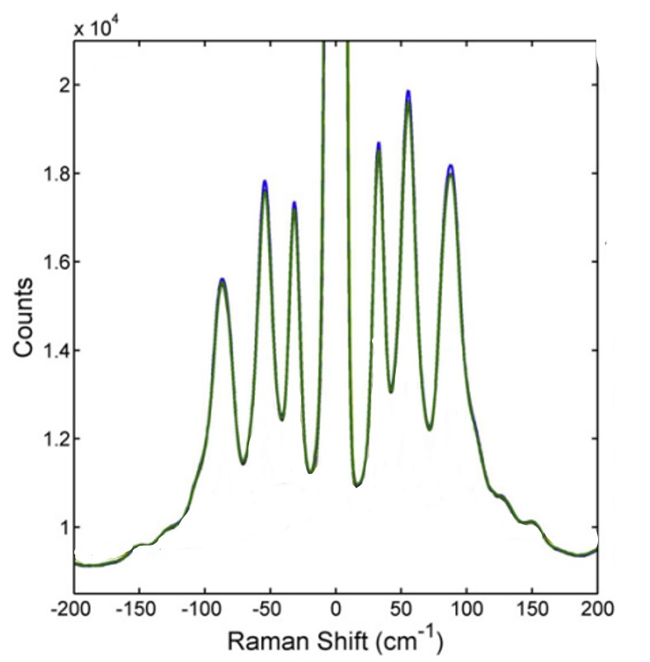
Figure 138:https://doi.org/10.1016/j.saa.2019.117798
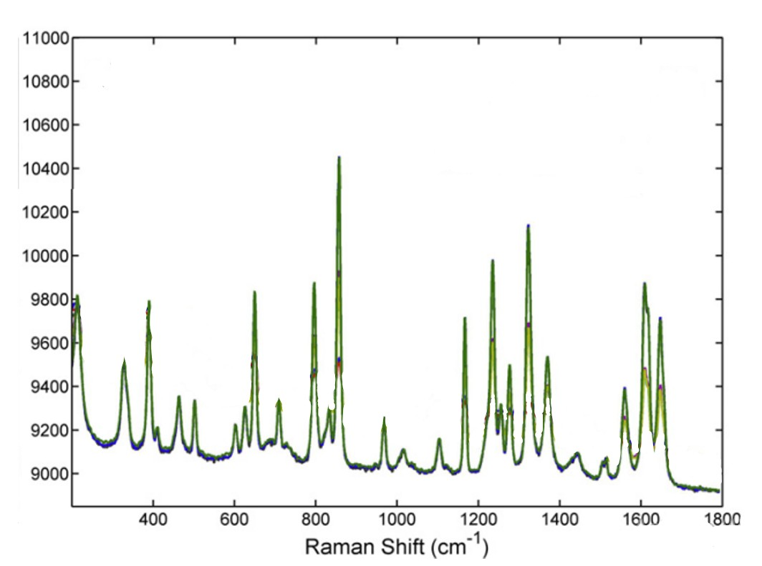
Figure 139:https://doi.org/10.1016/j.saa.2019.117798
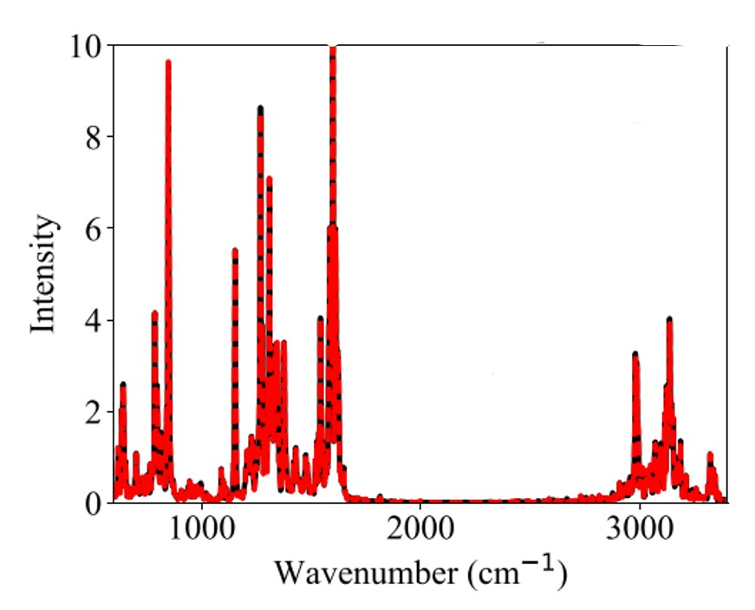
Figure 140:doi: 10.1063/5.0040190
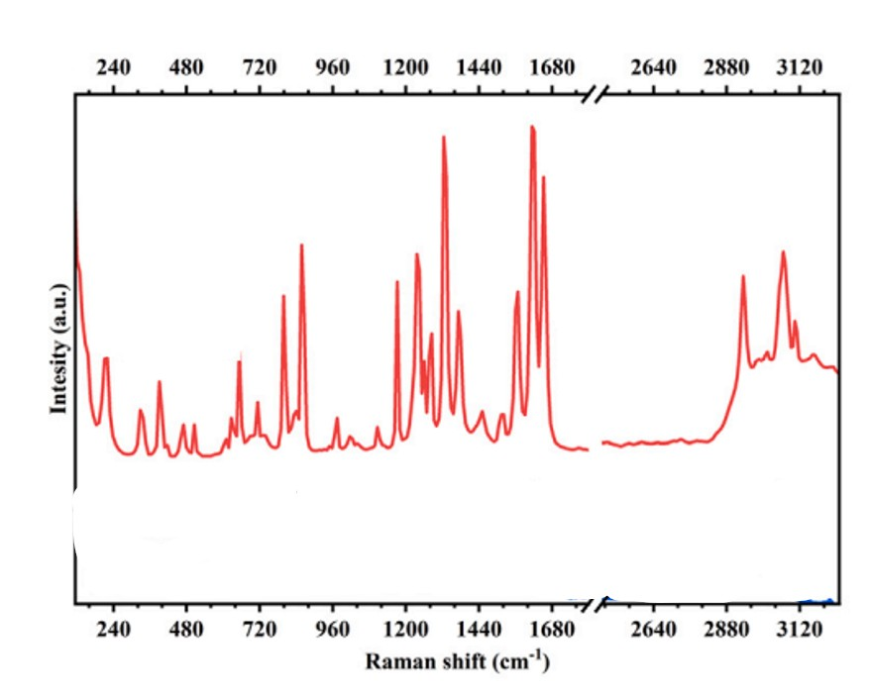
Figure 141:https://doi.org/10.1016/j.cartre.2025.100505
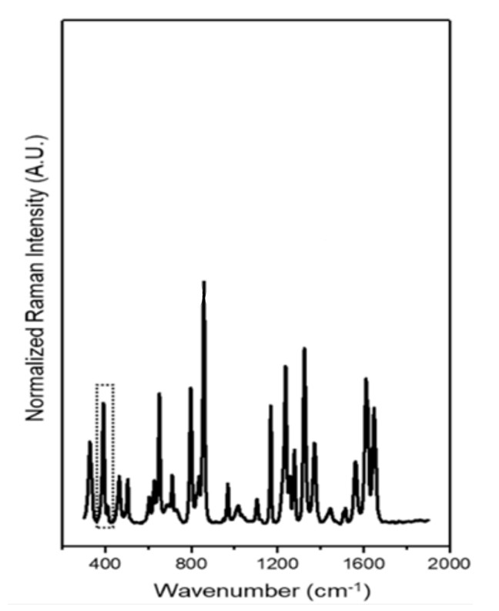
Figure 142:http://dx.doi.org/10.1021/acs.analchem.9b00047
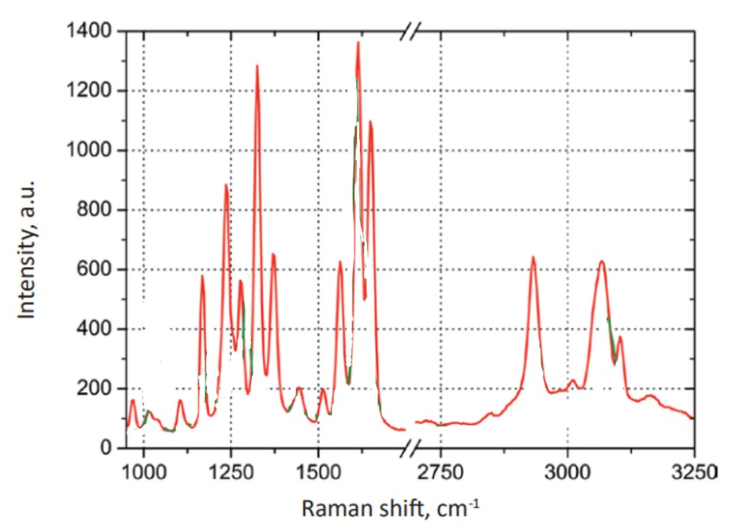
Figure 143:https://www.ntmdt-si.com/data/media/files/applications/application_notes/092_AFM-%20Raman_Characterization_of_Pharmaceutical_Tablets__A4_en.pdf
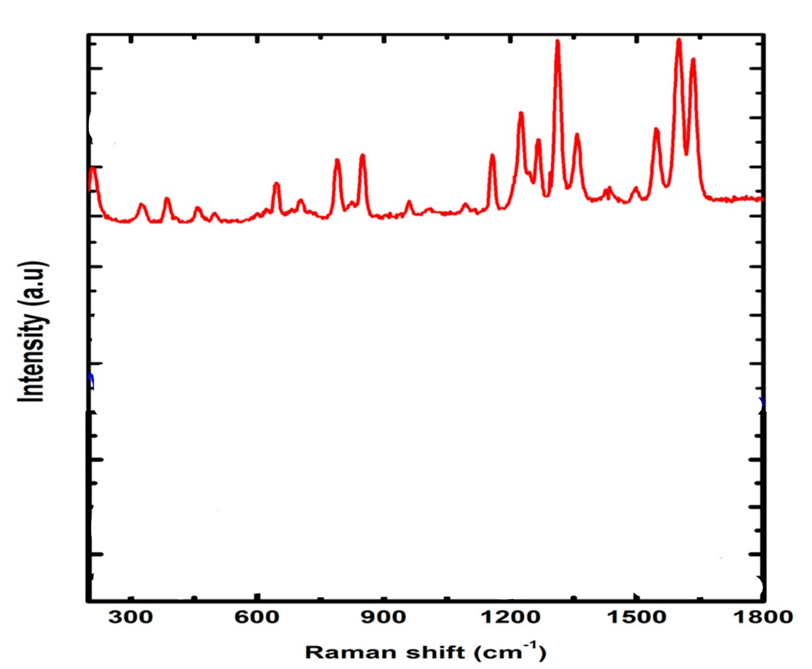
Figure 144:https://doi.org/10.3390/antibiotics10080939
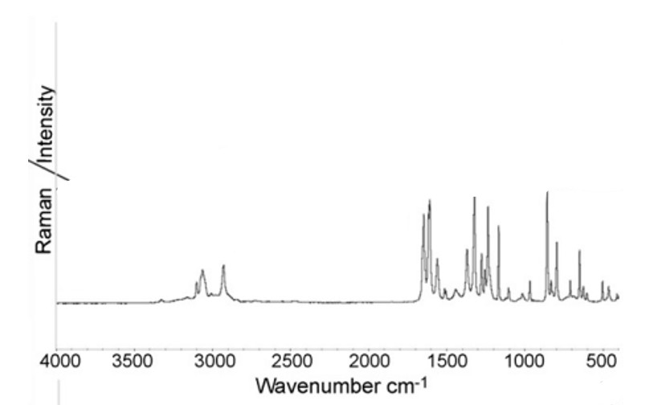
Figure 145:http://dx.doi.org/10.1016/j.vibspec.2007.12.016
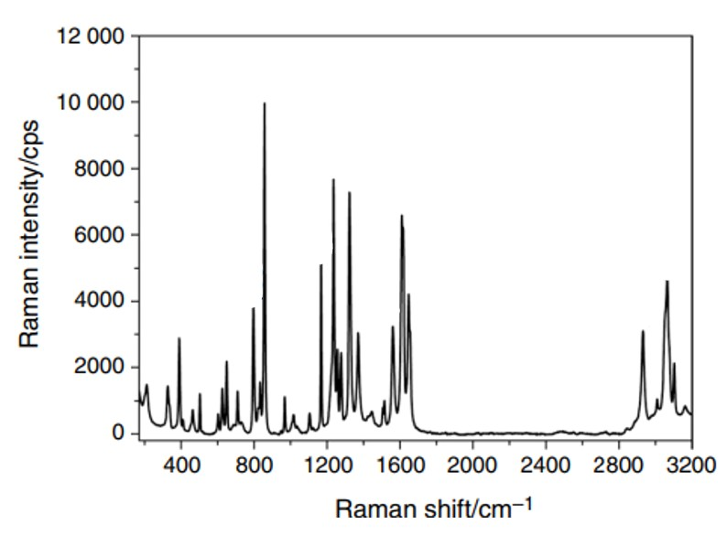
Figure 146:DOI:https://doi.org/10.1007/s10973-023-12239-5
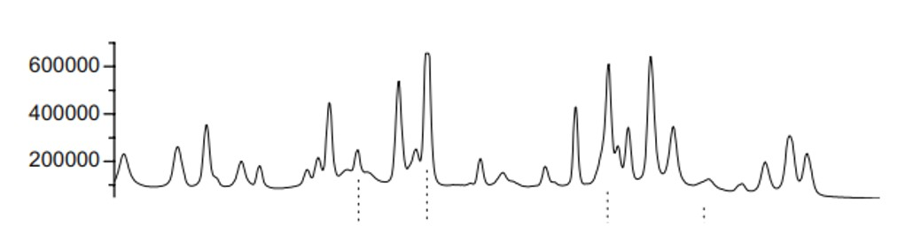
Figure 147:DOI 10.1007/s00216-007-1543-1
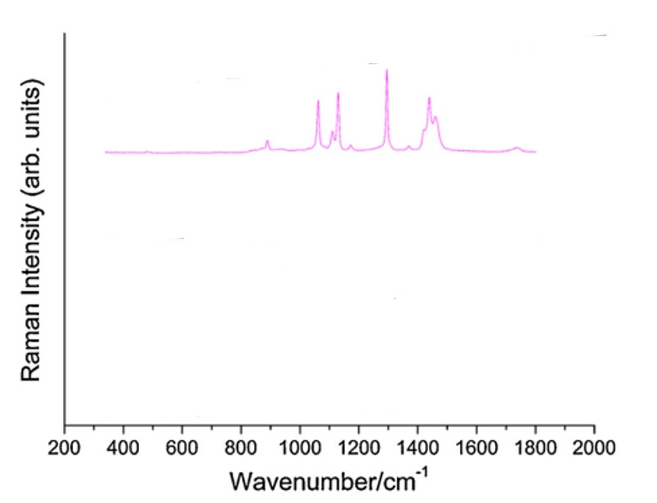
Figure 148:http://dx.doi.org/10.1016/j.ijpharm.2014.05.007
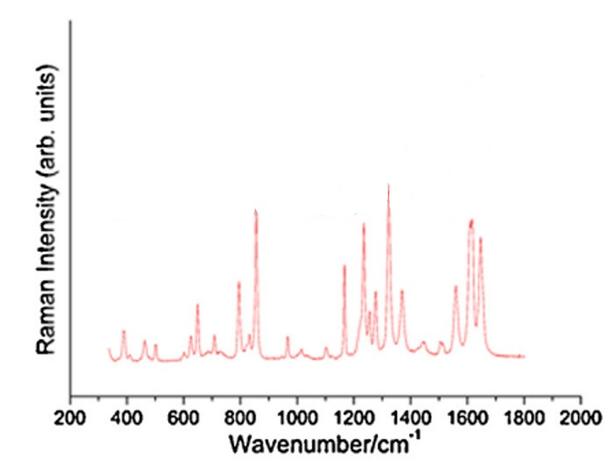
Figure 149:http://dx.doi.org/10.1016/j.ijpharm.2014.05.007
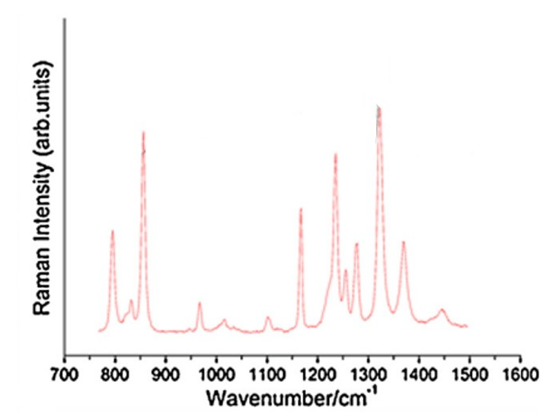
Figure 150:http://dx.doi.org/10.1016/j.ijpharm.2014.05.007

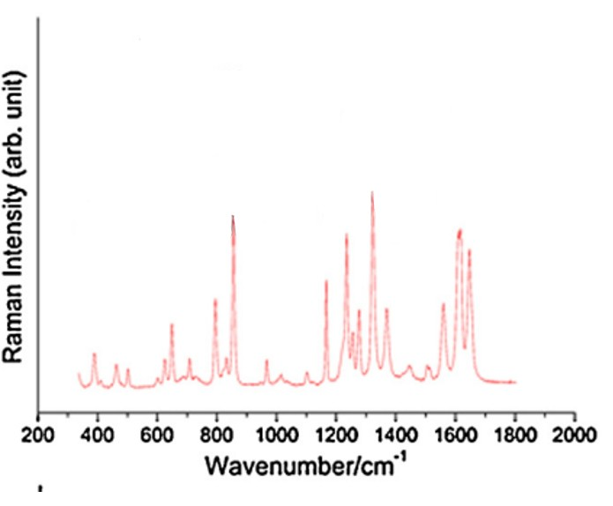
Figure 151:http://dx.doi.org/10.1016/j.ijpharm.2014.05.007

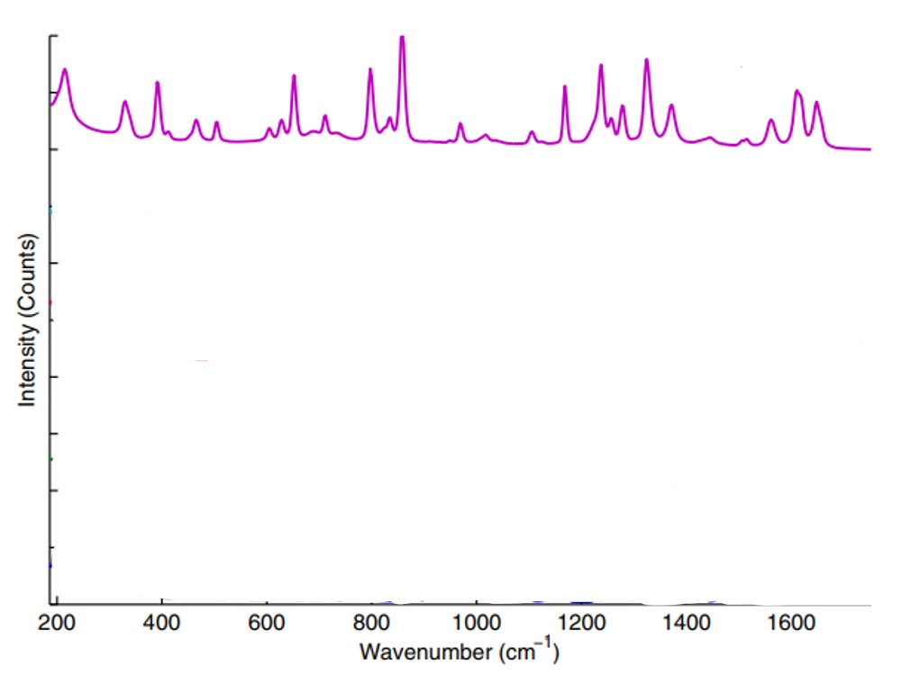
Figure 152:https://doi.org/10.1016/j.jpba.2015.07.019
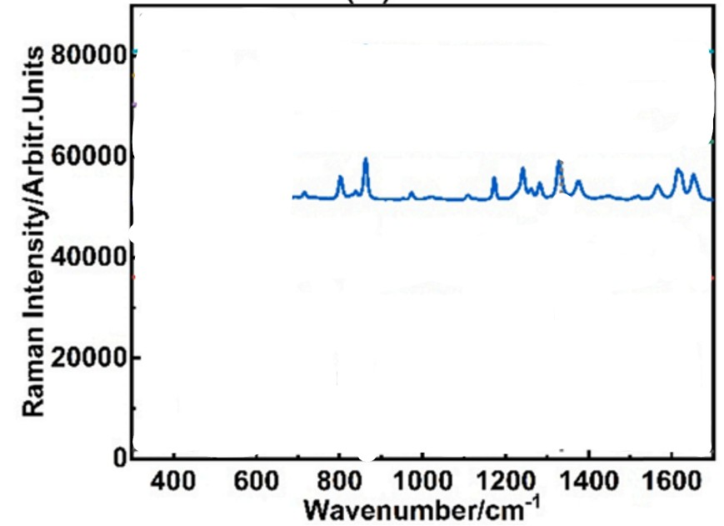
Figure 153:https://doi.org/10.1016/j.cherd.2023.02.041
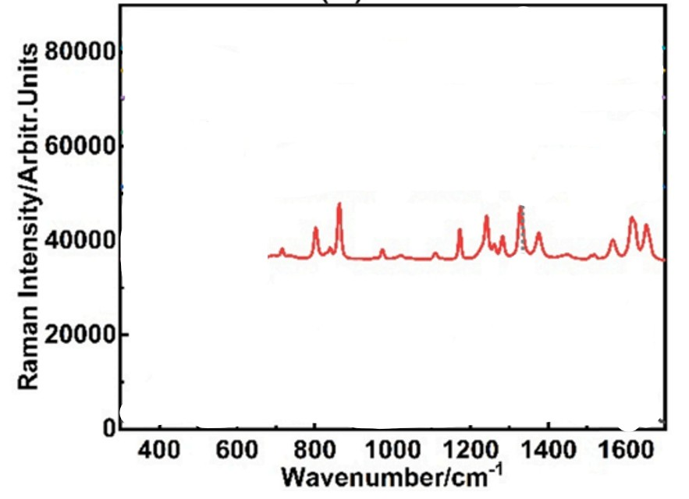
Figure 154:https://doi.org/10.1016/j.cherd.2023.02.041
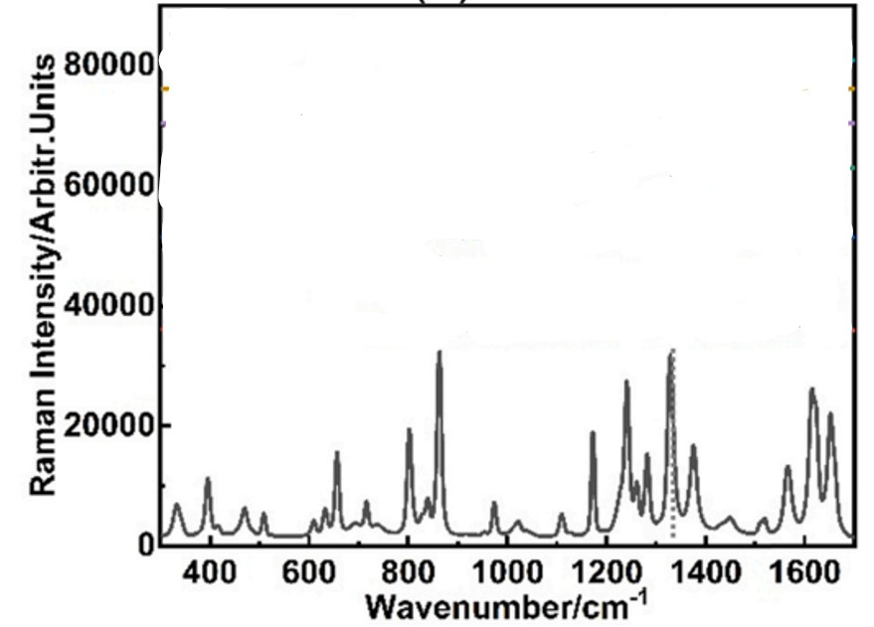
Figure 155:https://doi.org/10.1016/j.cherd.2023.02.041
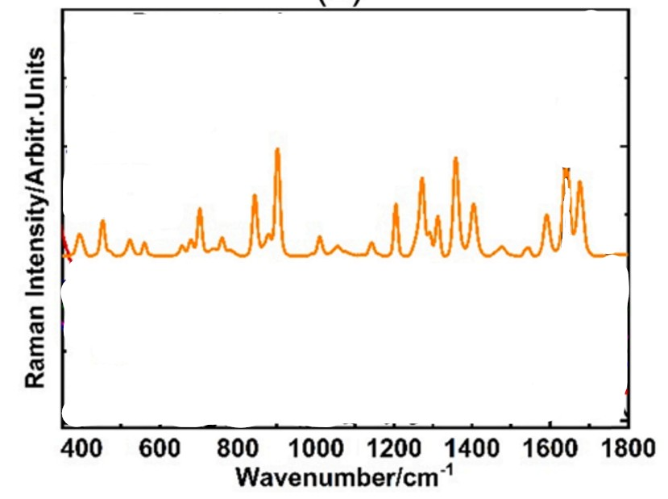
Figure 156:https://doi.org/10.1016/j.cherd.2023.02.041
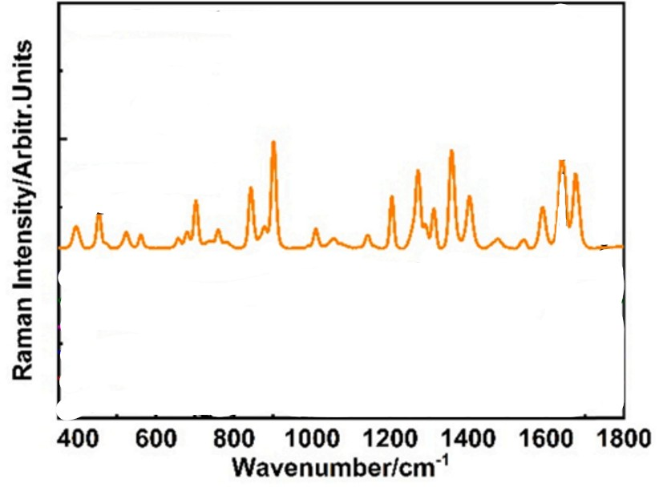
Figure 157:https://doi.org/10.1016/j.cherd.2023.02.041
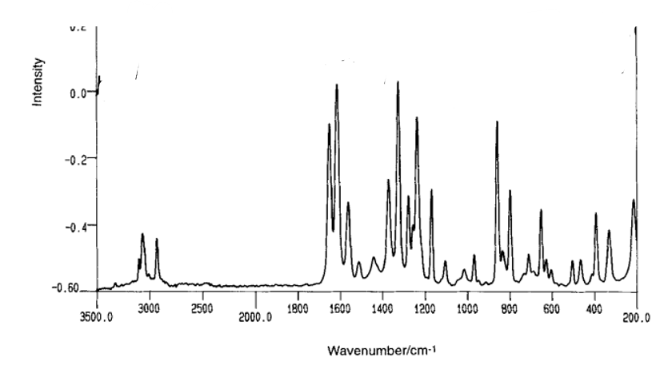
Figure 158:https://doi.org/10.1002/jrs.1250240412
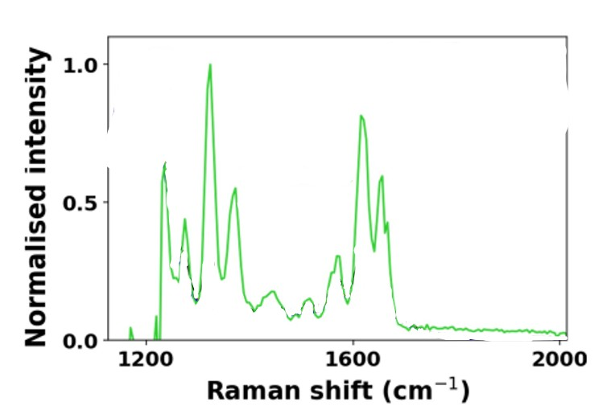
Figure 159: https://doi.org/10.1364/BOE.560826
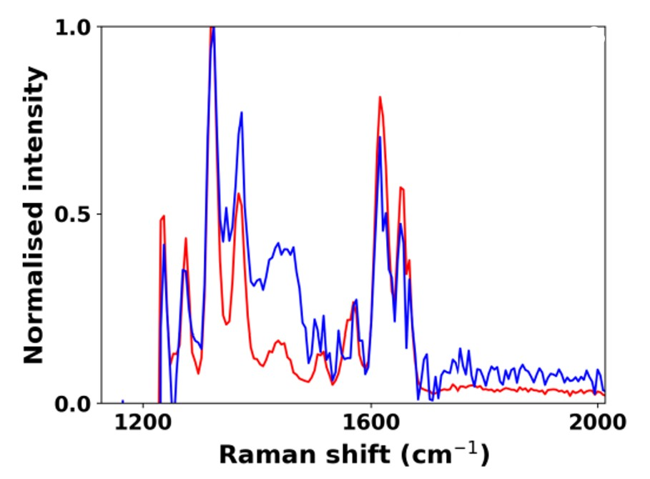
Figure 160:https://doi.org/10.1364/BOE.560826
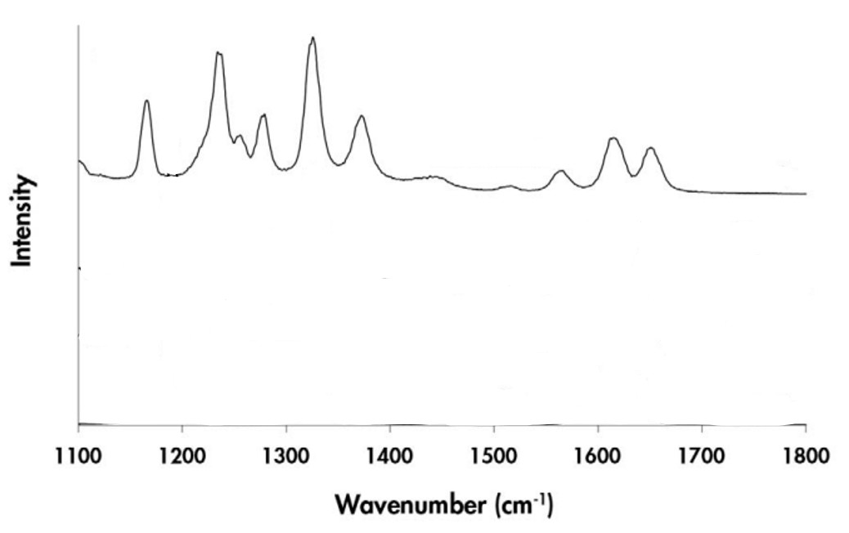
Figure 161:https://doi.org/10.1366/000370208786401527
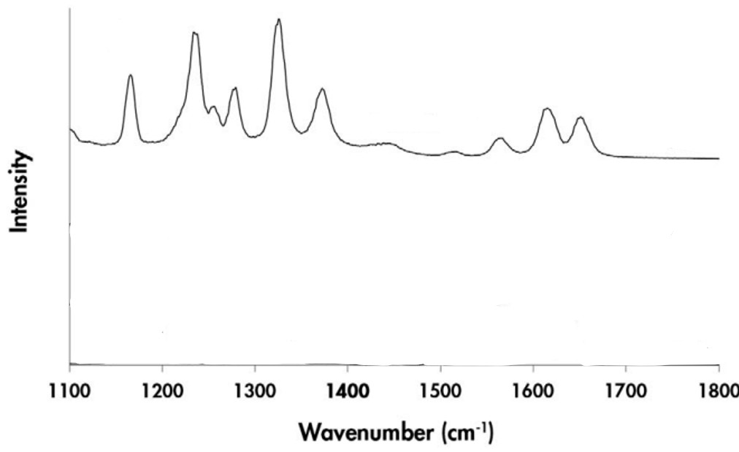
Figure 162:https://doi.org/10.1366/000370208786401527
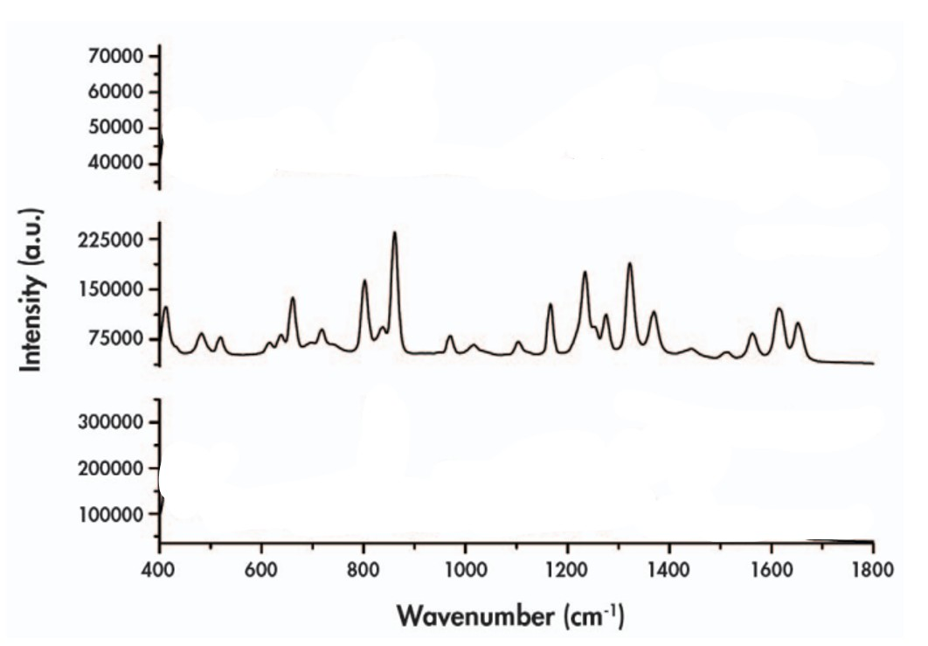
Figure 163:https://doi.org/10.1366/000370208786401527
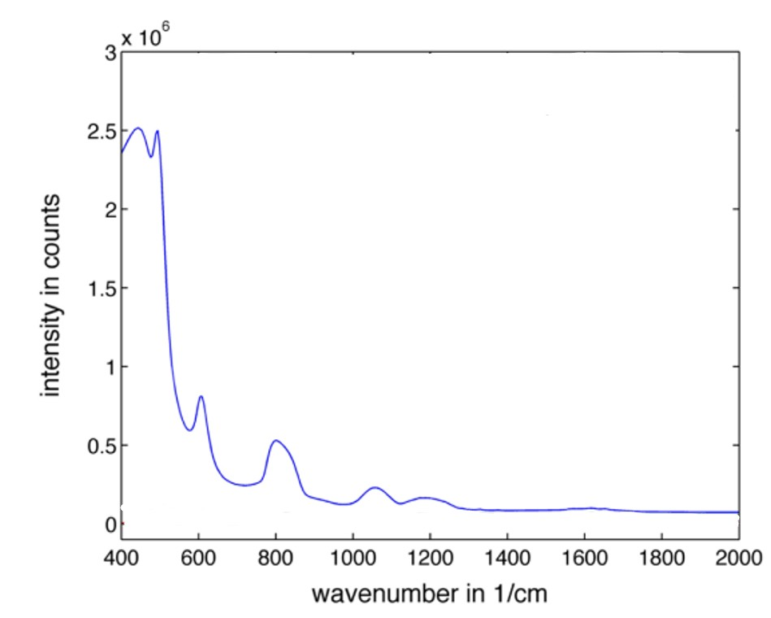
Figure 164:DOI 10.1007/s00345-014-1477-0
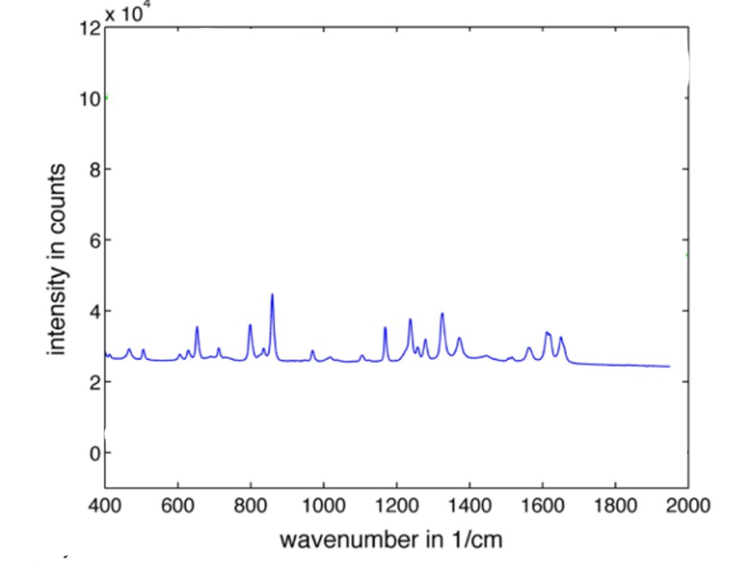
Figure 165:DOI 10.1007/s00345-014-1477-0
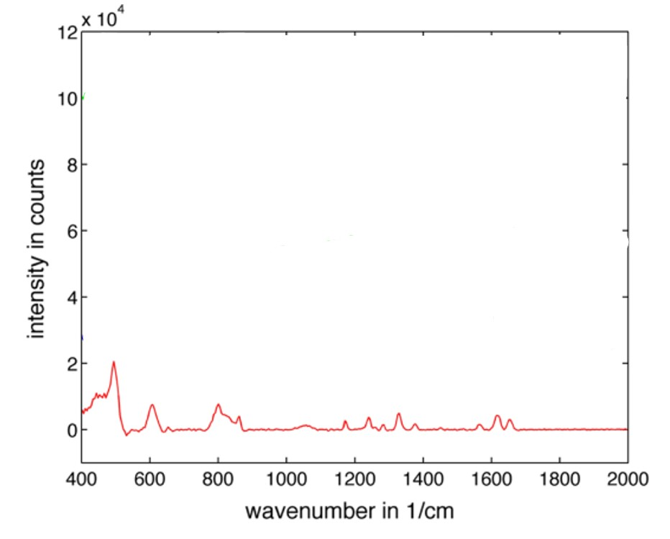
Figure 166:DOI 10.1007/s00345-014-1477-0
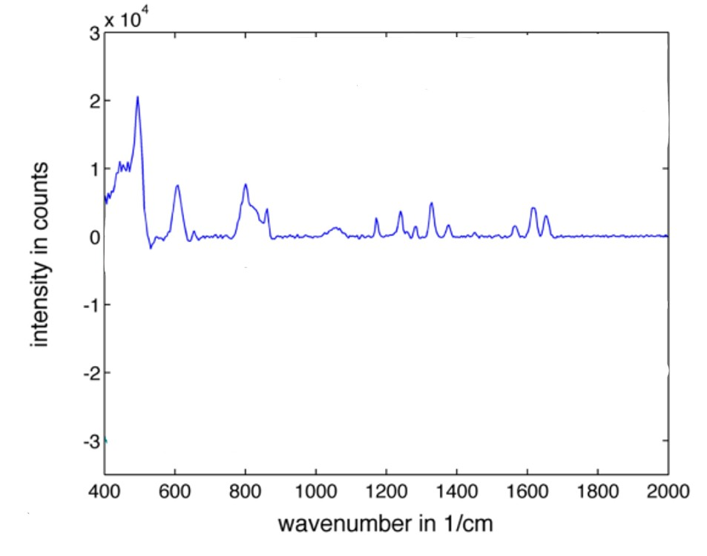
Figure 167:DOI 10.1007/s00345-014-1477-0
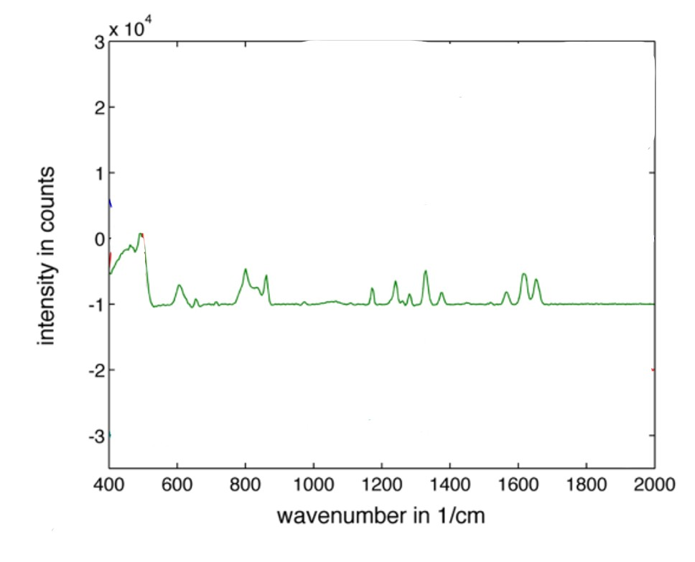
Figure 168:DOI 10.1007/s00345-014-1477-0
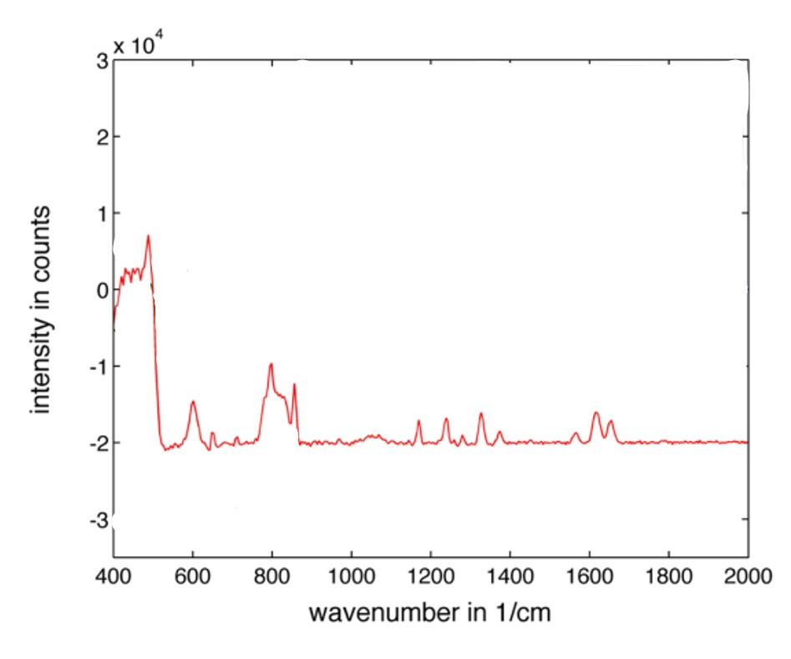
Figure 169:DOI 10.1007/s00345-014-1477-0

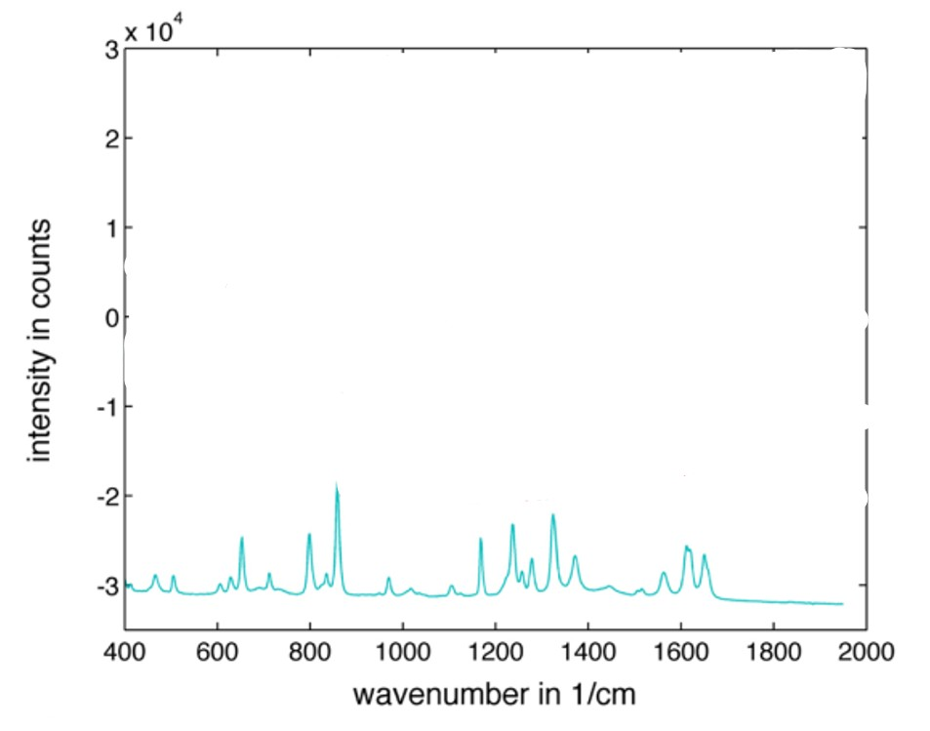
Figure 170:DOI 10.1007/s00345-014-1477-0
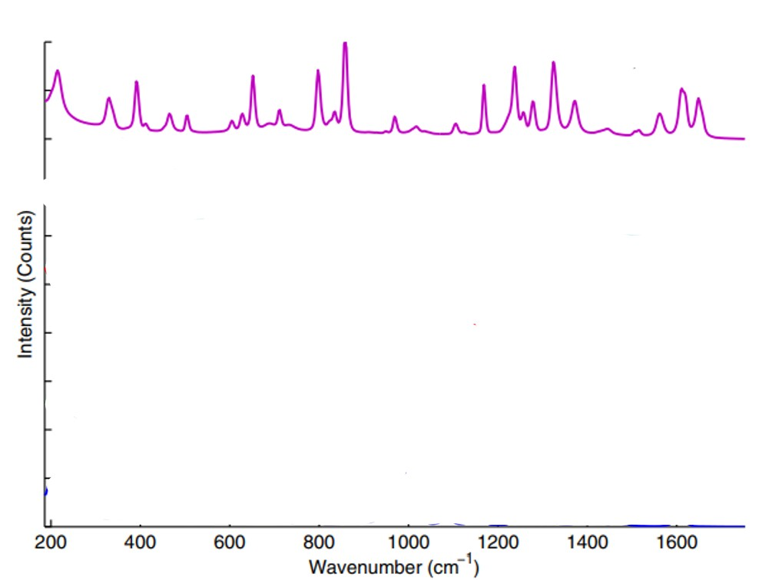
Figure 171:DOI 10.1007/s00345-014-1477-0
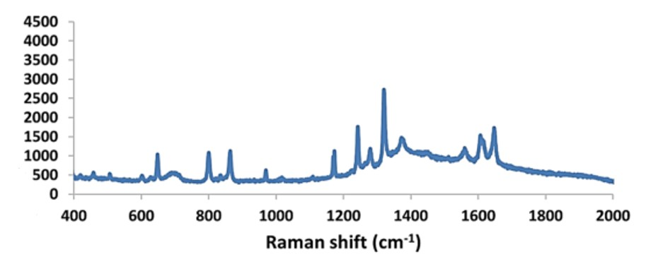
Figure 172:http://dx.doi.org/10.1021/acs.cgd.8b01121
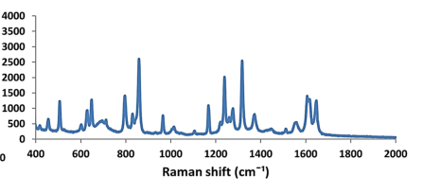
Figure 173:http://dx.doi.org/10.1021/acs.cgd.8b01121
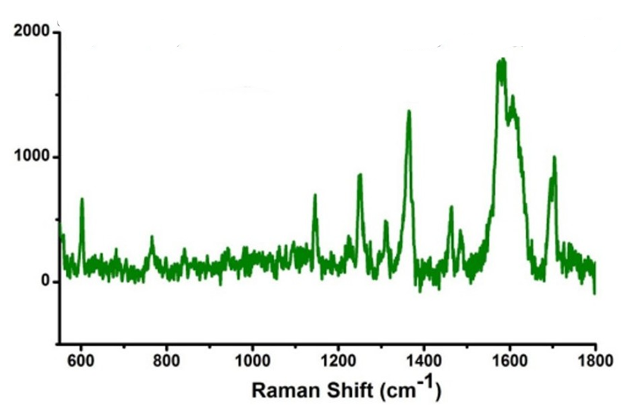
Figure 174:DOI: 10.1038/srep03336
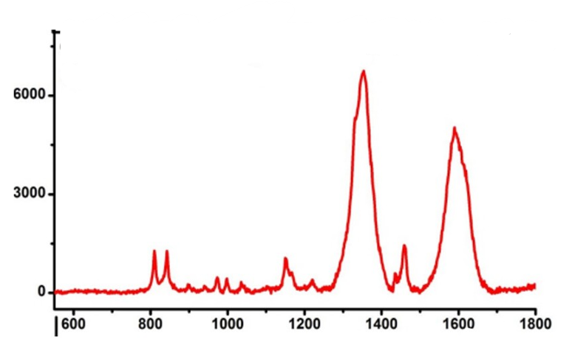
Figure 175:DOI: 10.1038/srep03336
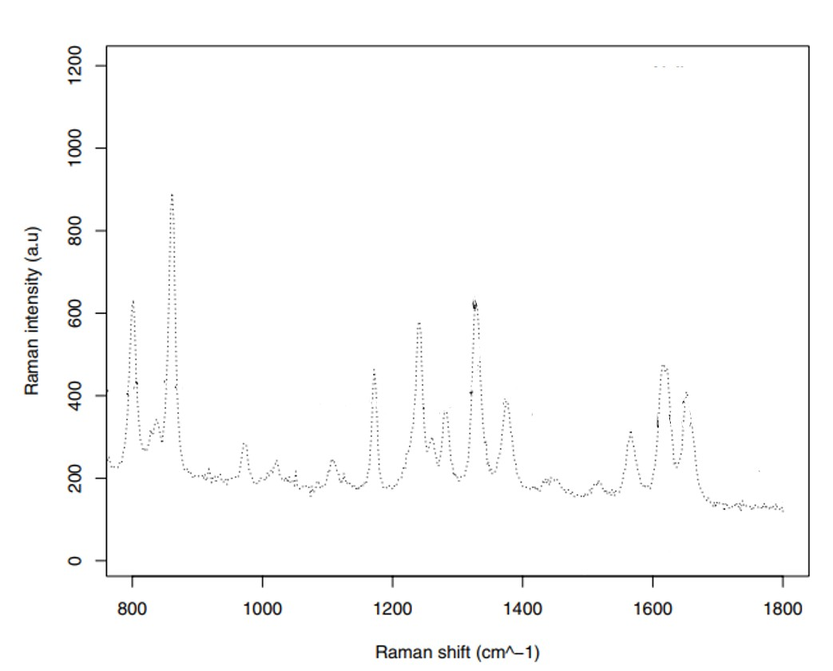
Figure 176:https://doi.org/10.1142/S0129183117501169
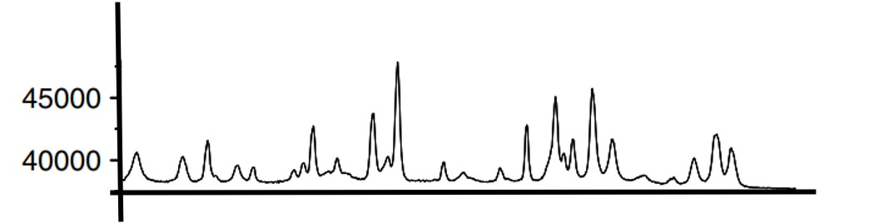
Figure 177:https://doi.org/10.1002/jrs.1898
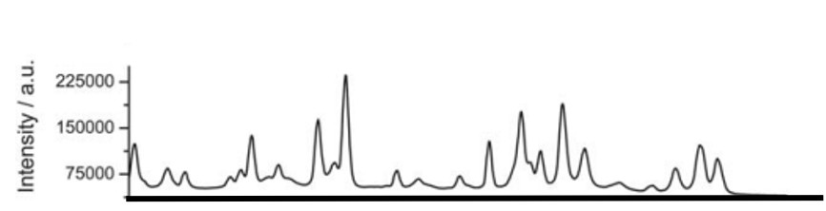
Figure 178:https://doi.org/10.1039/C0AN00723D
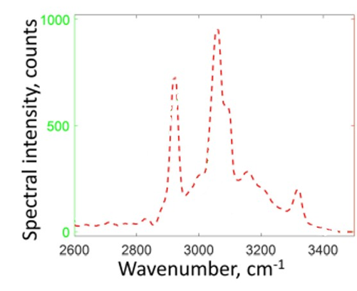
Figure 179:https://doi.org/10.1364/OE.25.013782
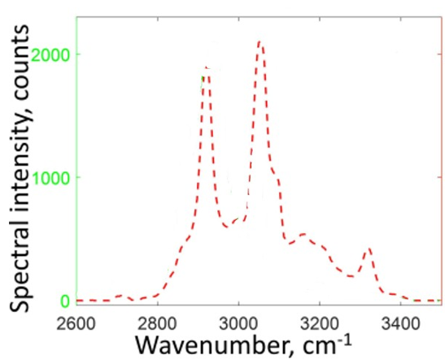
Figure 180:https://doi.org/10.1364/OE.25.013782
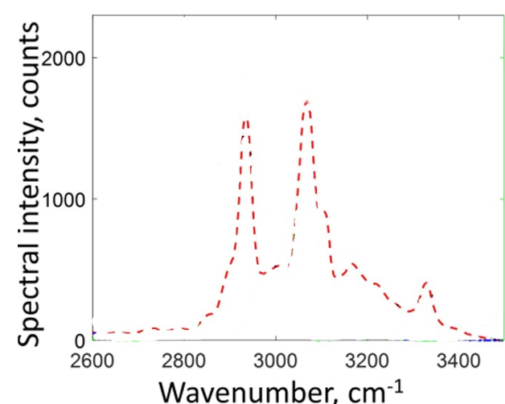
Figure 181:https://doi.org/10.1364/OE.25.013782
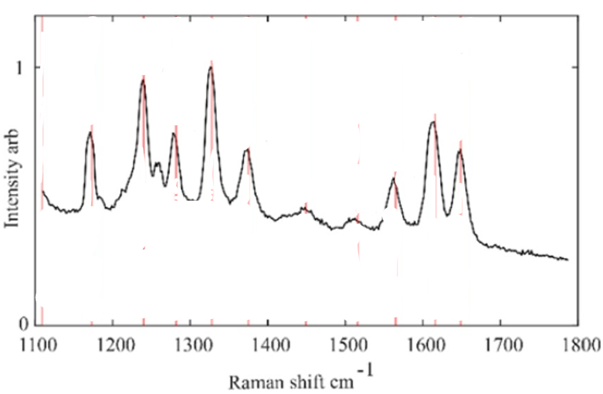
Figure 182:https://doi.org/10.1364/OE.537094
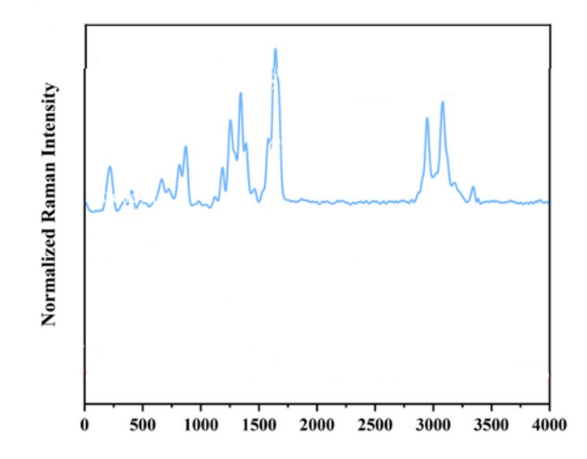
Figure 183:https://doi.org/10.1016/j.vibspec.2024.103732
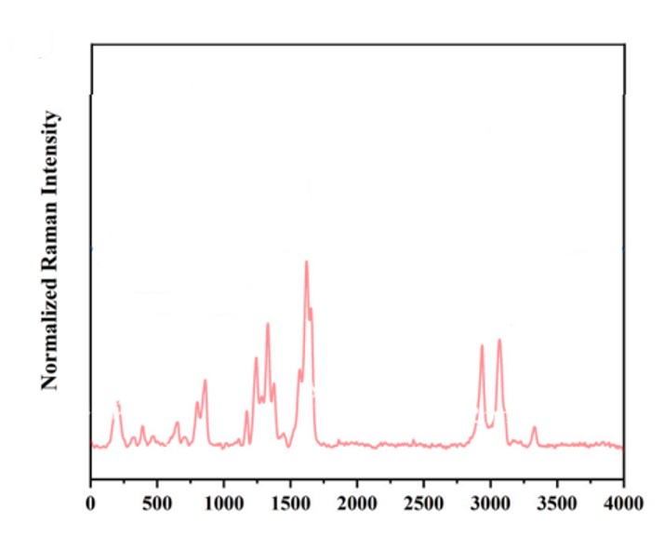
Figure 184:https://doi.org/10.1016/j.vibspec.2024.103732
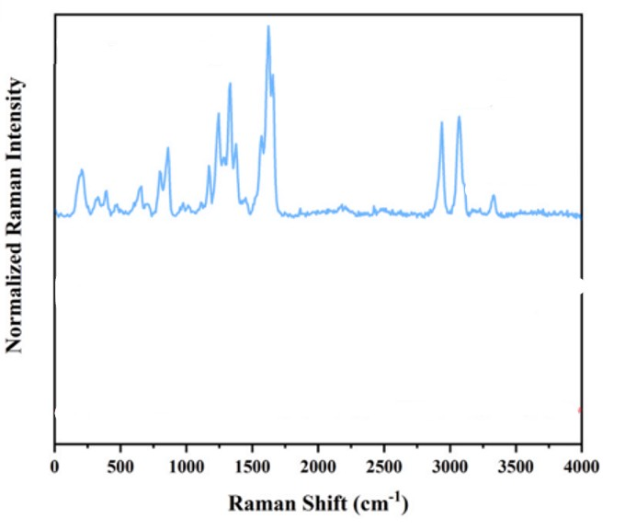
Figure 185:https://doi.org/10.1016/j.vibspec.2024.103732
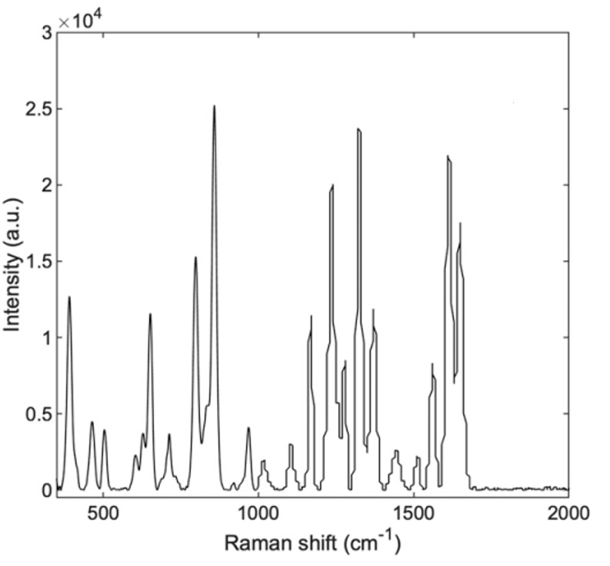
Figure 186:https://doi.org/10.1016/j.vibspec.2024.103662
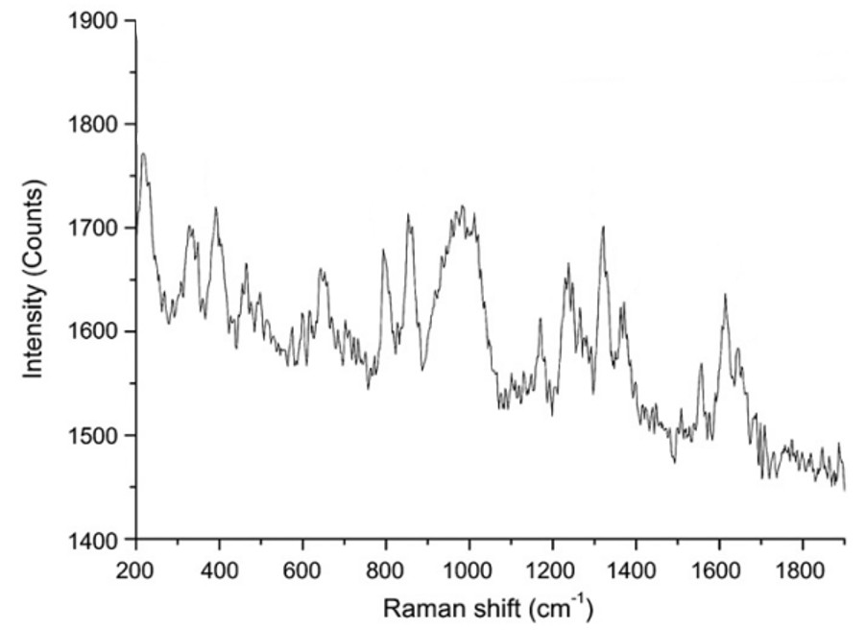
Figure 187:http://dx.doi.org/10.1016/j.optcom.2010.04.037
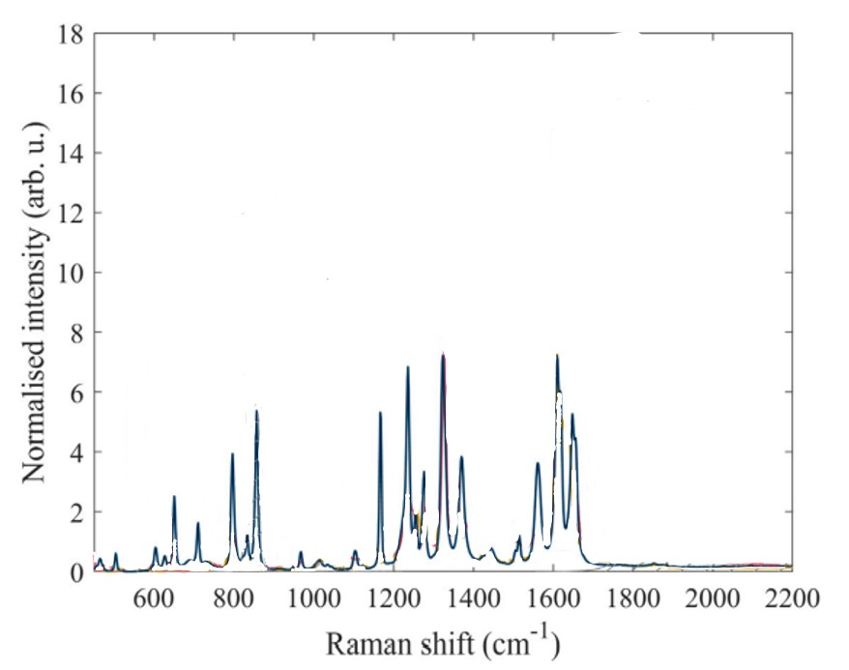
Figure 188:https://doi.org/10.1016/j.saa.2024.124388
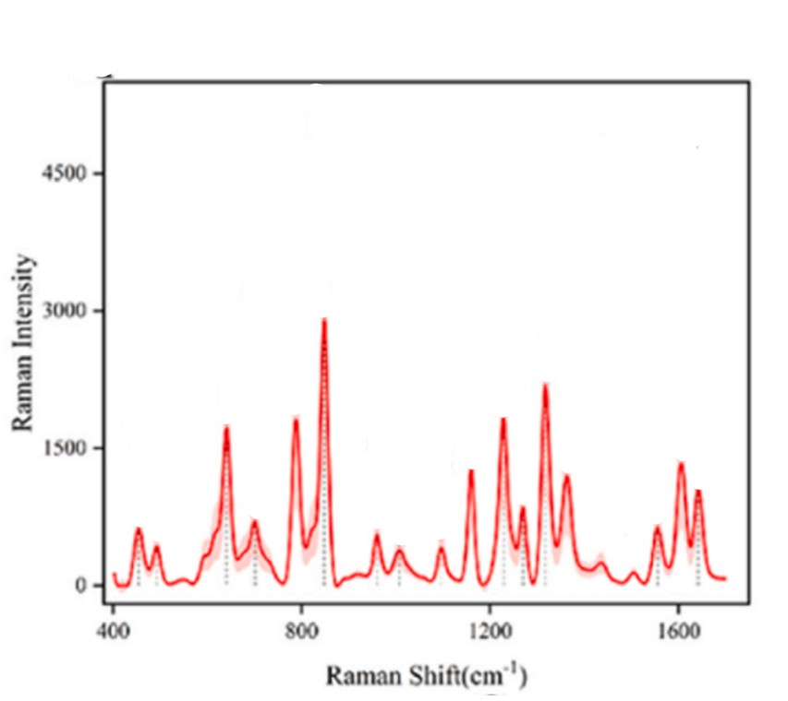
Figure 189:https://doi.org/10.1016/j.talanta.2023.125120
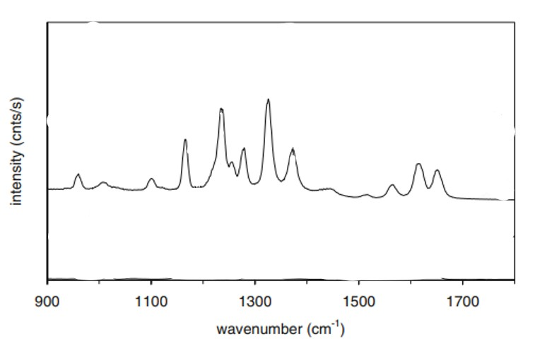
Figure 190:DOI: 10.1007/s11095-008-9587-2
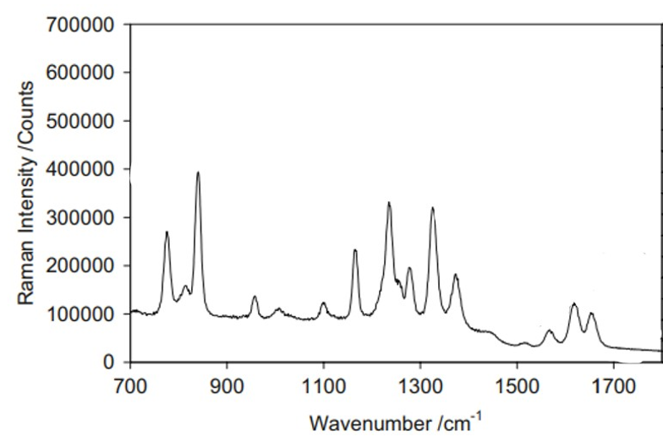
Figure 191:DOI: 10.1007/s11095-008-9587-2
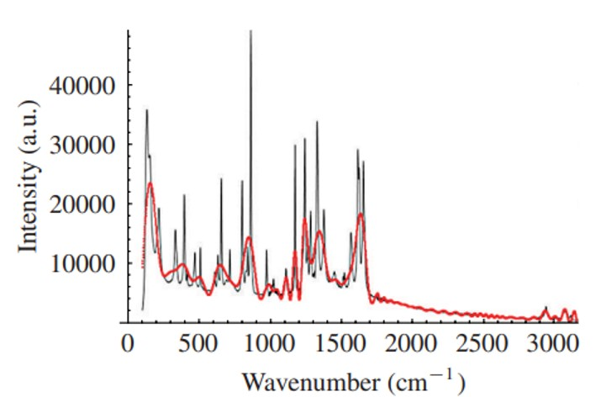
Figure 192:https://doi.org/10.1155/2012/530791
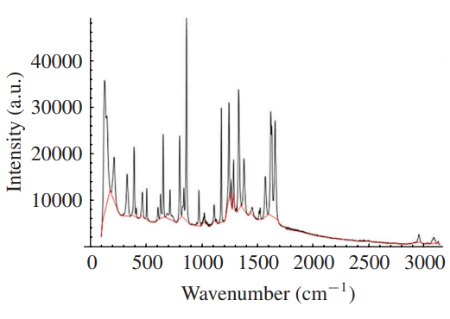
Figure 193:https://doi.org/10.1155/2012/530791
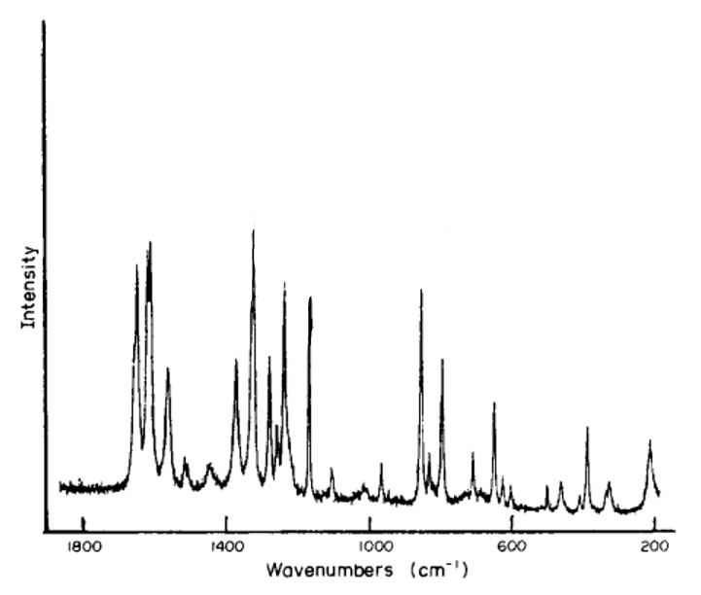
Figure 194:https://doi.org/10.1016/0731-7085(86)80091-7
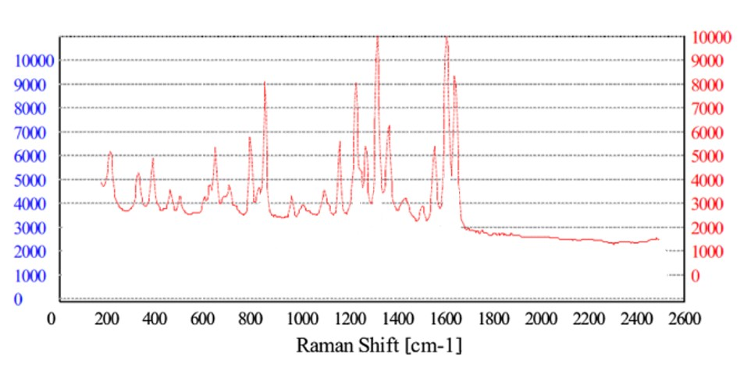
Figure 195:DOI 10.1186/s12936-016-1212-y
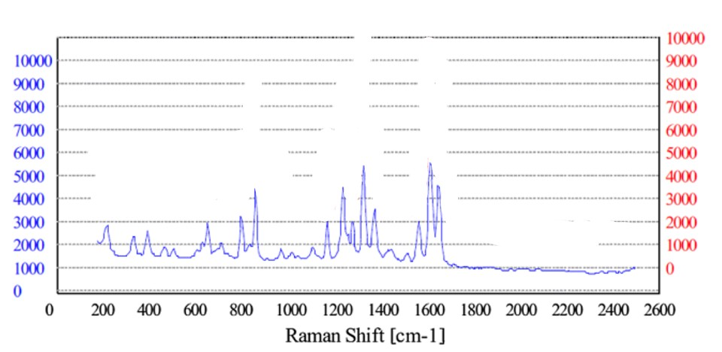
Figure 196:DOI 10.1186/s12936-016-1212-y
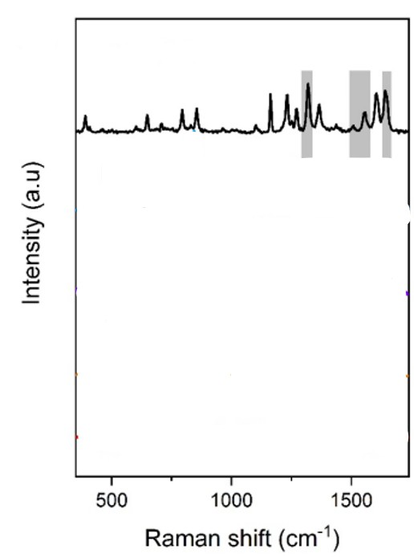
Figure 197:https://download.ssrn.com/apsadv/40f755ce-4137-4f98-8237-67bb23cbf033-meca.pdf?response-content-disposition=inline&X-Amz-Security-Token=IQoJb3JpZ2luX2VjEBEaCXVzLWVhc3QtMSJHMEUCIQD0a7JoJfkyL61Tf%2Fd54yF8QOBhwr3o1zZcEGoCRIwjMwIgJMBVaaFHJNSkuRrT16AiJVdss6G
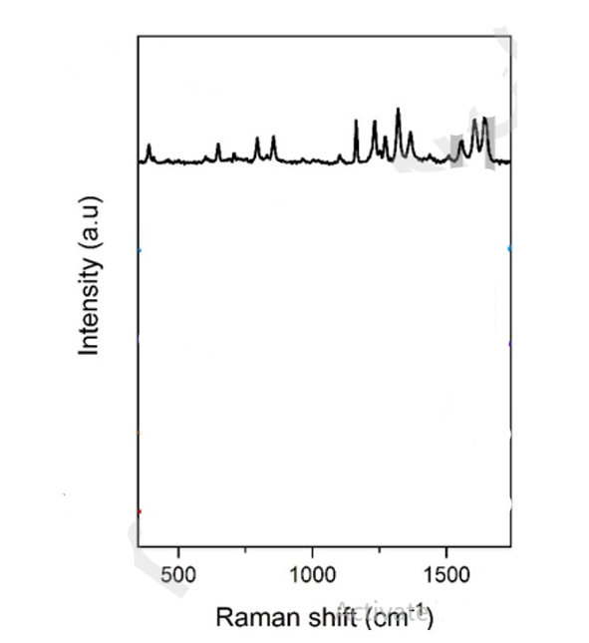
Figure 198:https://download.ssrn.com/apsadv/40f755ce-4137-4f98-8237-67bb23cbf033-meca.pdf?response-content-disposition=inline&X-Amz-Security-Token=IQoJb3JpZ2luX2VjEBEaCXVzLWVhc3QtMSJHMEUCIQD0a7JoJfkyL61Tf%2Fd54yF8QOBhwr3o1zZcEGoCRIwjMwIgJMBVaaFHJNSkuRrT16AiJVdss6G
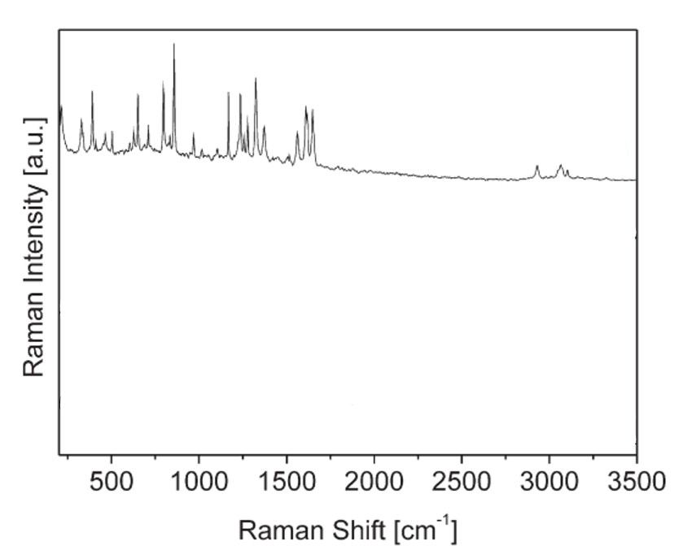
Figure 199:http://dx.doi.org/10.1016/j.sab.2009.09.004
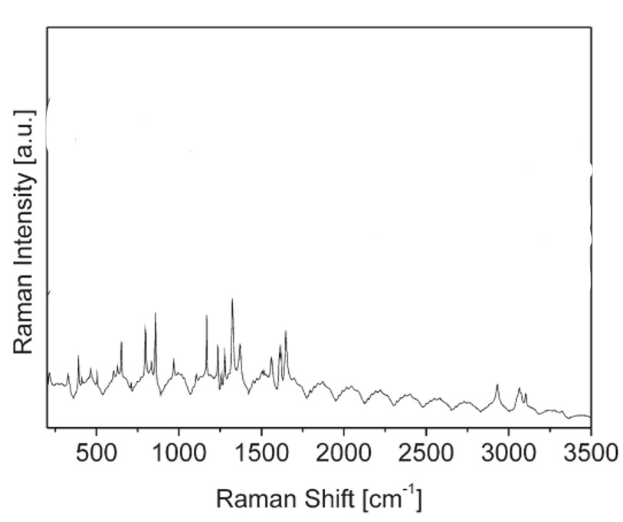
Figure 200:http://dx.doi.org/10.1016/j.sab.2009.09.004
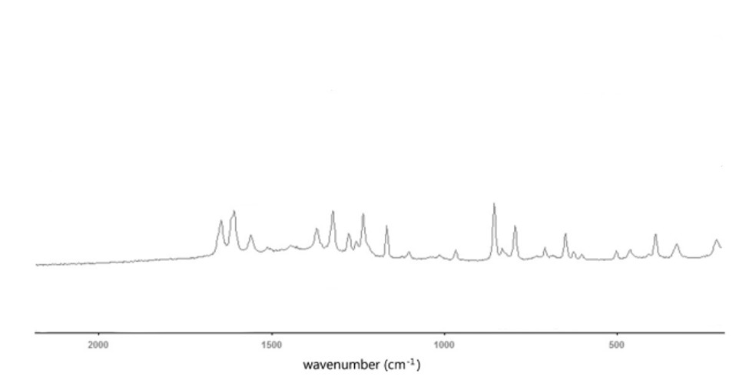
Figure 201:http://dx.doi.org/10.1016/j.forsciint.2010.11.027
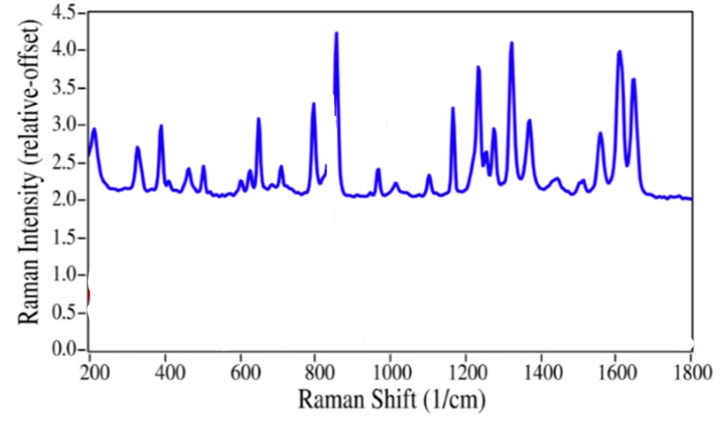
Figure 202:https://doi.org/10.3390/pharmaceutics6040651

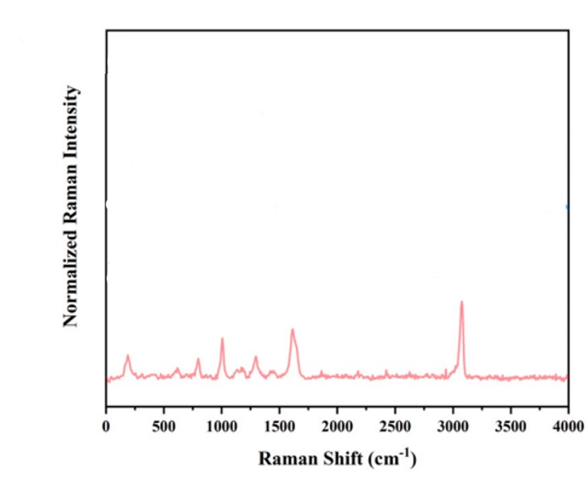
Figure 203:https://doi.org/10.1016/j.vibspec.2024.103732

