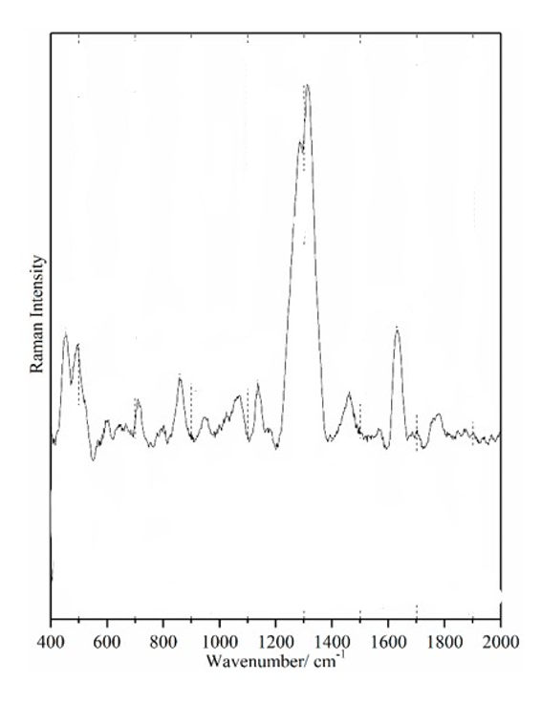
Figure 1:https://doi.org/10.3390/s18020424
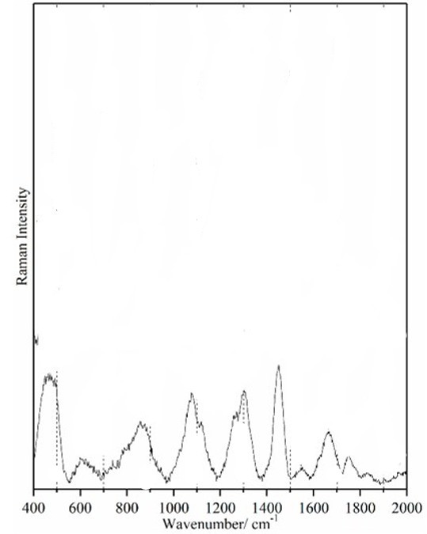
Figure 2:https://doi.org/10.3390/s18020424
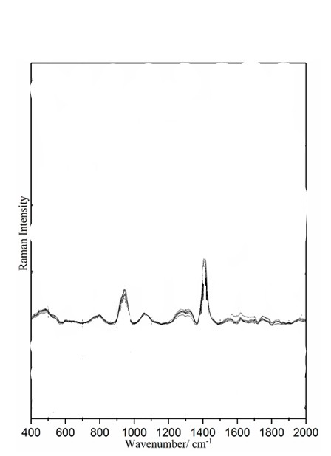
Figure 3:https://doi.org/10.3390/s18020424
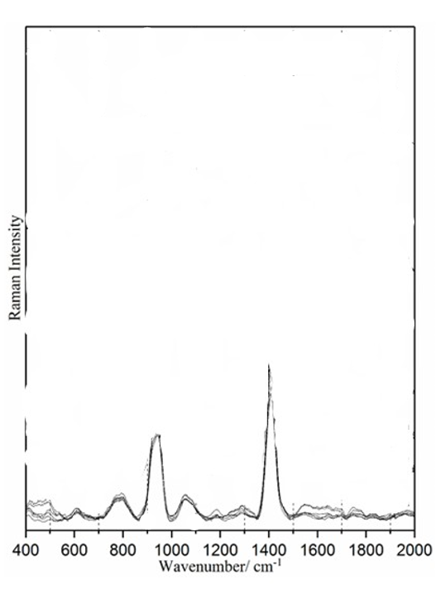
Figure 4: https://doi.org/10.3390/s18020424
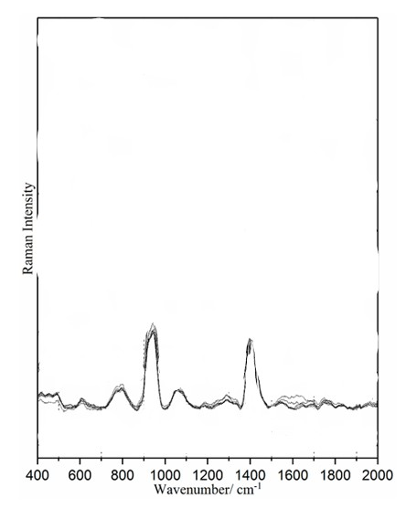
Figure 5: https://doi.org/10.3390/s18020424
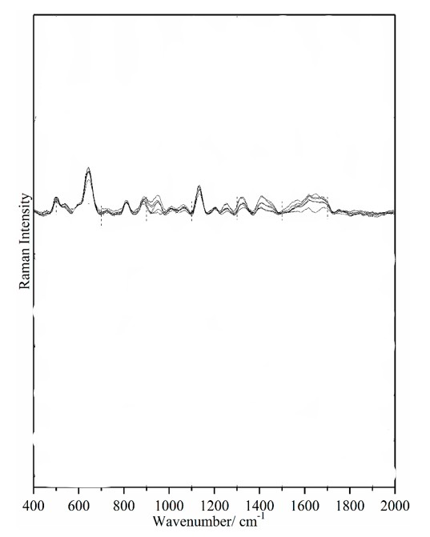
Figure 6: https://doi.org/10.3390/s18020424
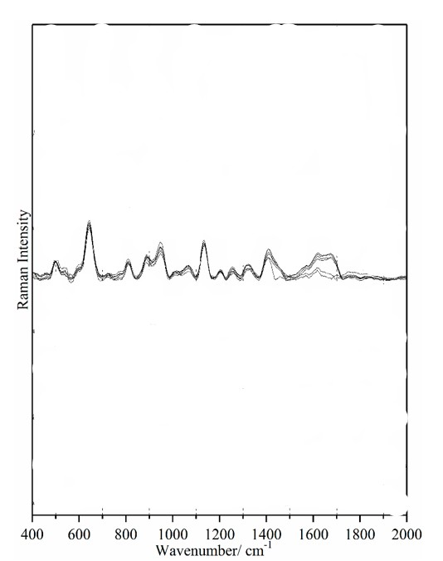
Figure 7: https://doi.org/10.3390/s18020424
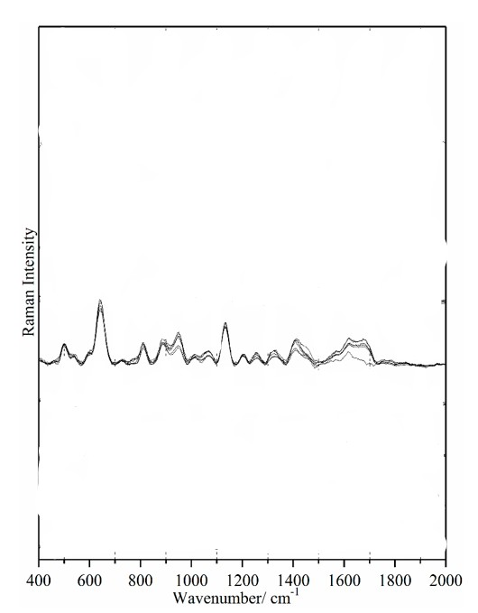
Figure 8: https://doi.org/10.3390/s18020424
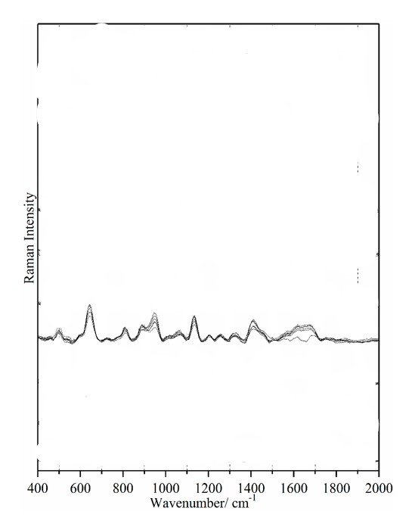
Figure 9: https://doi.org/10.3390/s18020424
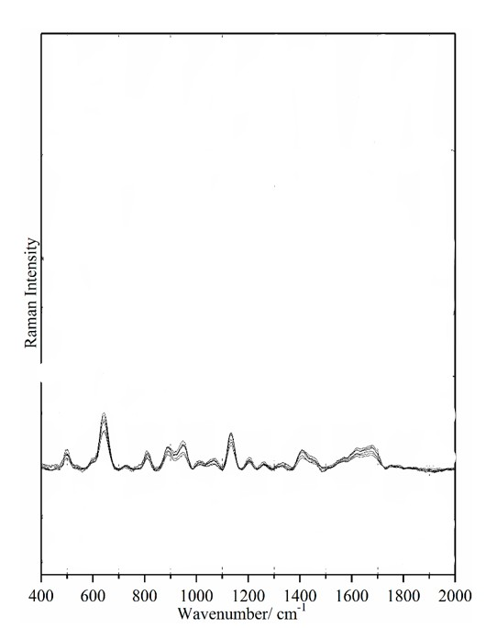
Figure 10: https://doi.org/10.3390/s18020424
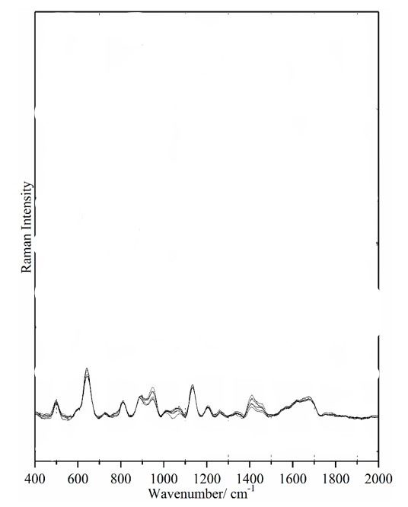
Figure 11: https://doi.org/10.3390/s18020424
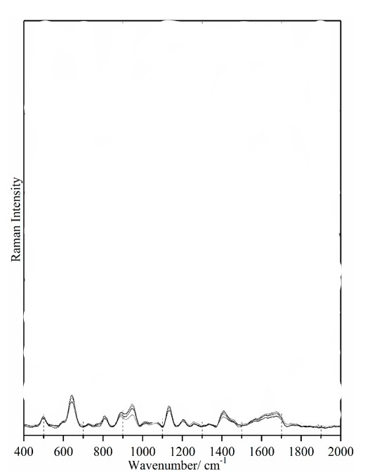
Figure 12: https://doi.org/10.3390/s18020424
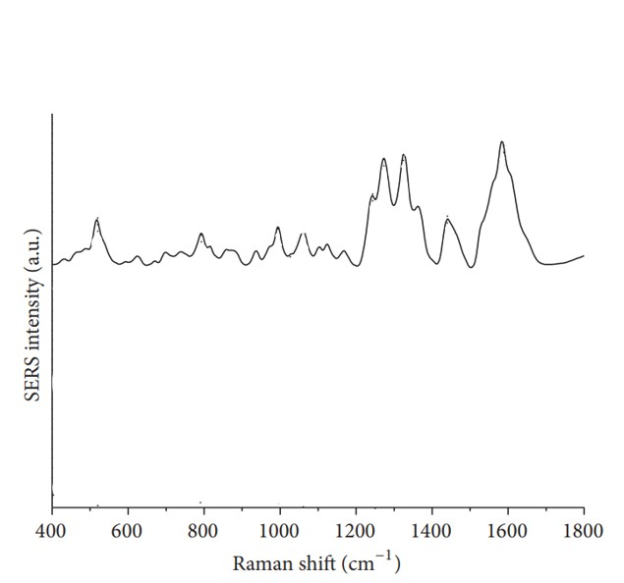
Figure 13: https://doi.org/10.1155/2016/1845237
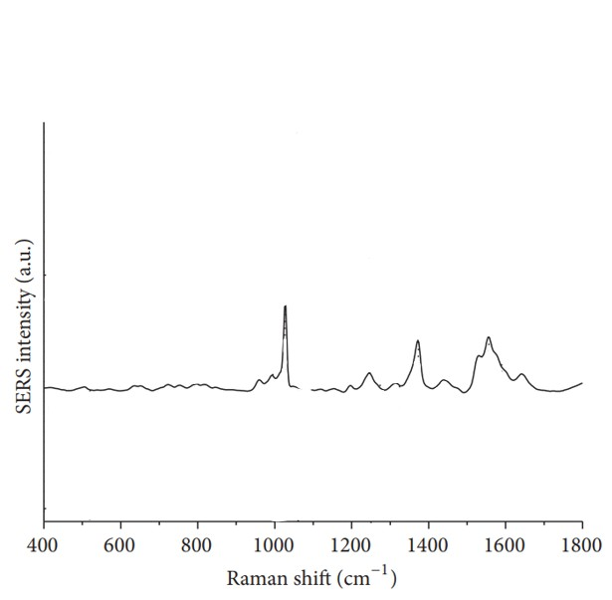
Figure 14: https://doi.org/10.1155/2016/1845237
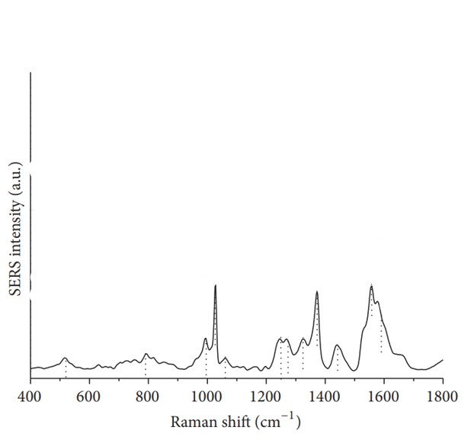
Figure 15: https://doi.org/10.1155/2016/1845237
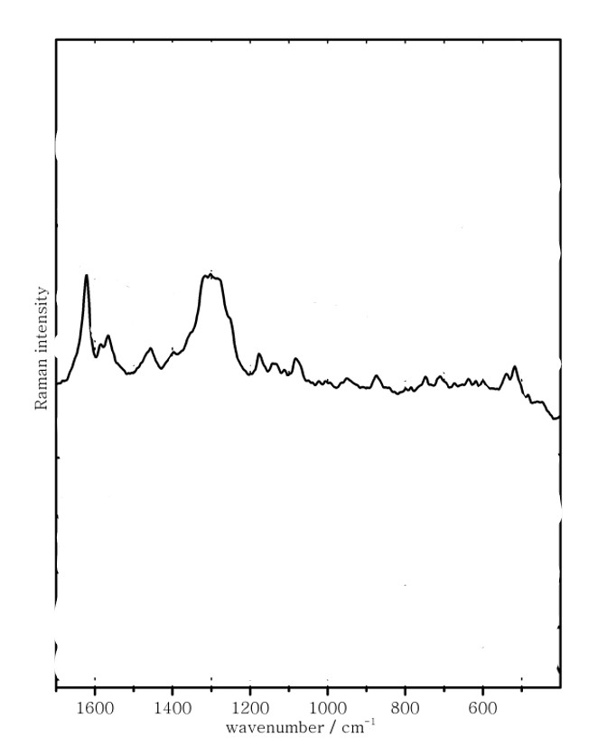
Figure 14:https://doi.org/10.1039/B210522E
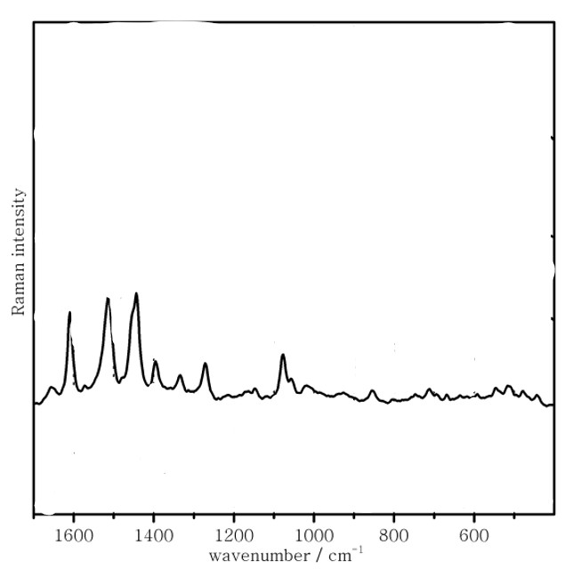
Figure 15:https://doi.org/10.1039/B210522E
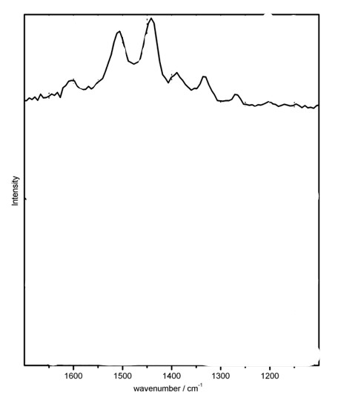
Figure 16:https://doi.org/10.1039/B210522E
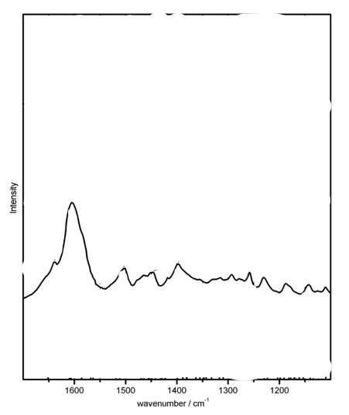
Figure 19: https://doi.org/10.1039/B210522E
Figure 20: https://doi.org/10.1039/B210522E
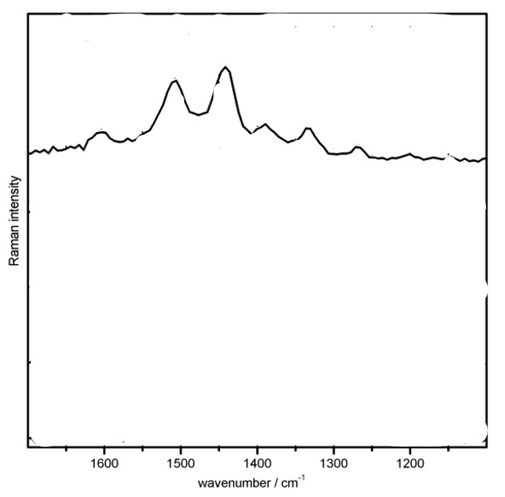
Figure 21: https://doi.org/10.1039/B210522E
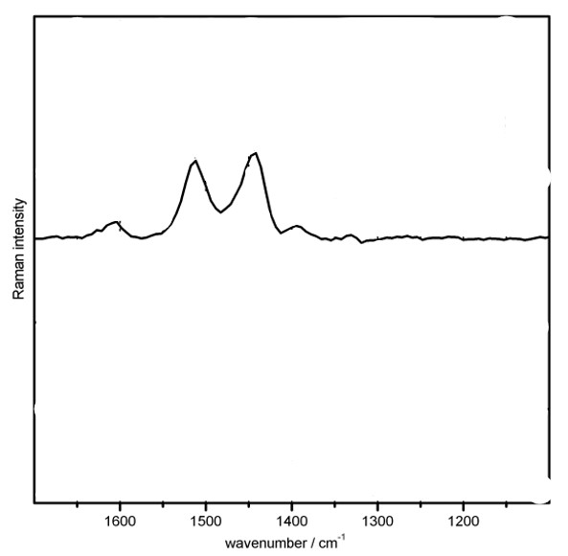
Figure 22: https://doi.org/10.1039/B210522E
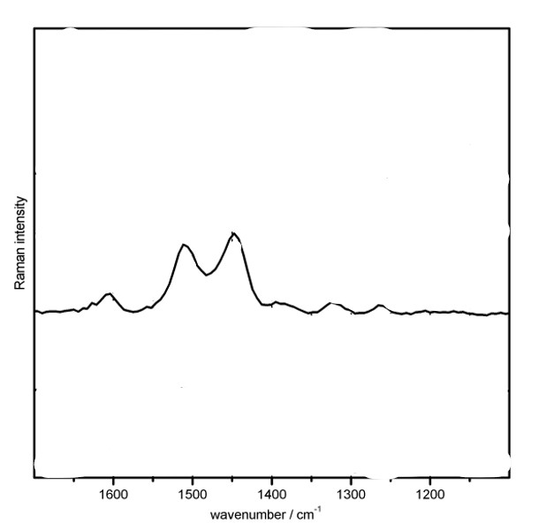
Figure 23: https://doi.org/10.1039/B210522E
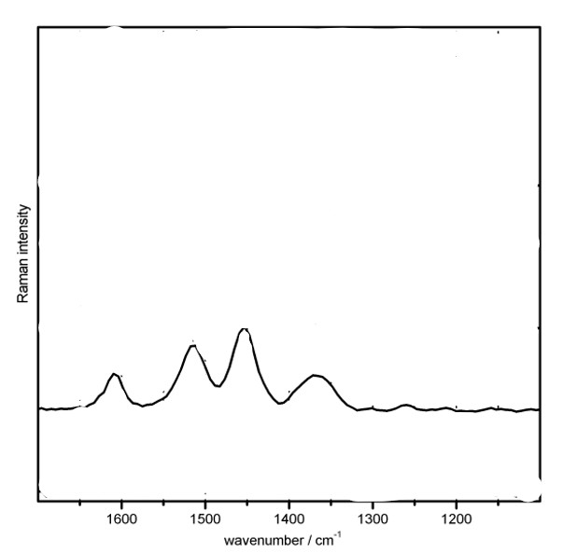
Figure 24: https://doi.org/10.1039/B210522E

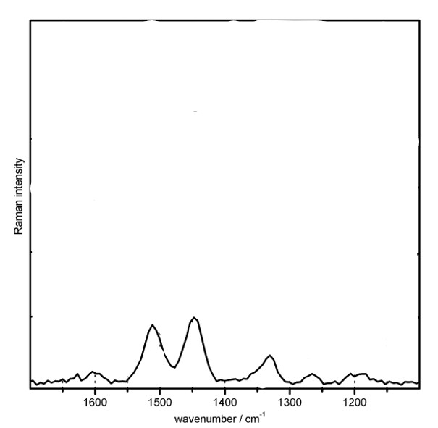
Figure 25: https://doi.org/10.1039/B210522E
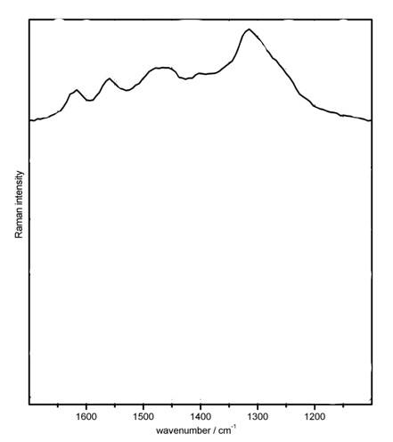
Figure 26: https://doi.org/10.1039/B210522E

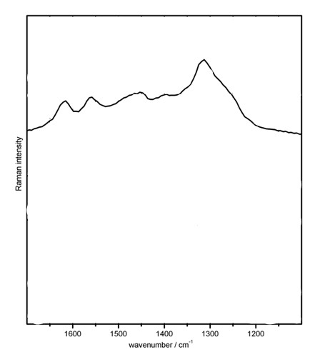
Figure 27: https://doi.org/10.1039/B210522E
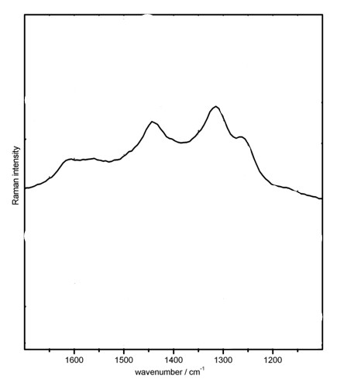
Figure 28: https://doi.org/10.1039/B210522E

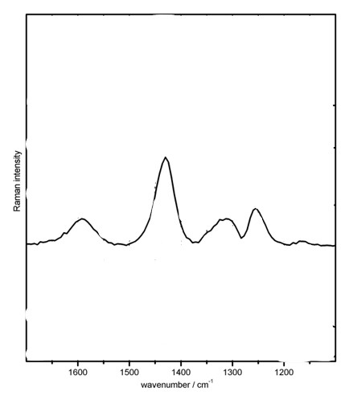
Figure 29: https://doi.org/10.1039/B210522E
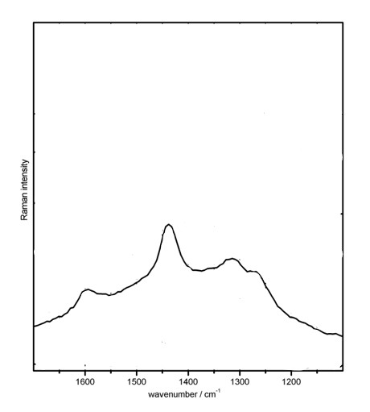
Figure 30: https://doi.org/10.1039/B210522E

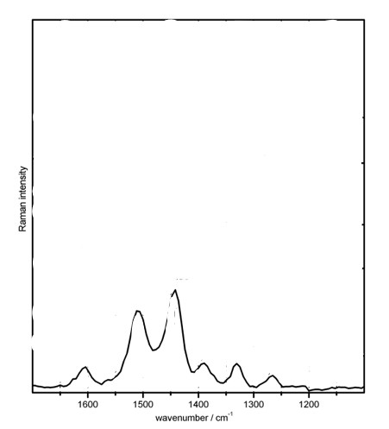
Figure 31: https://doi.org/10.1039/B210522E

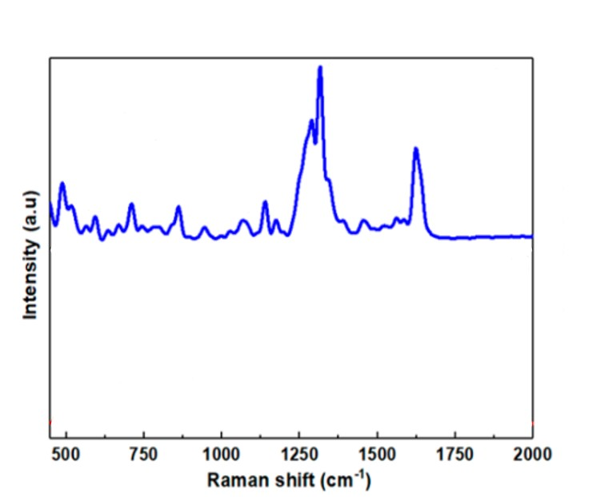
Figure 32: https://pubs.acs.org/doi/10.1021/acsanm.0c01389?goto=supporting-info

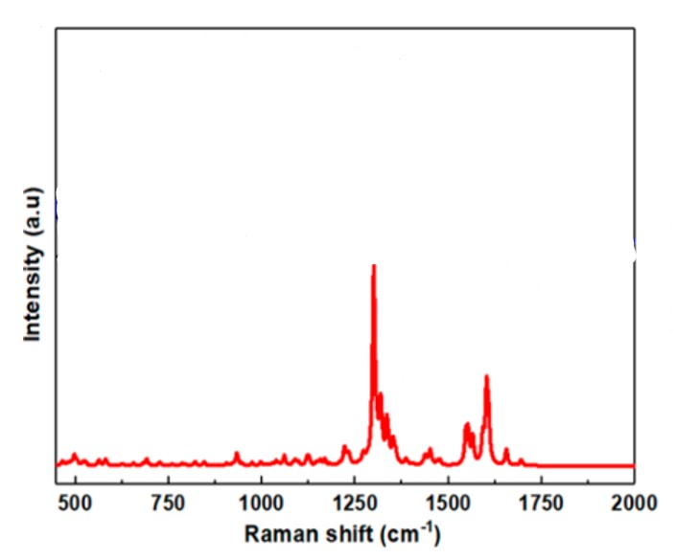
Figure 33: https://pubs.acs.org/doi/10.1021/acsanm.0c01389?goto=supporting-info
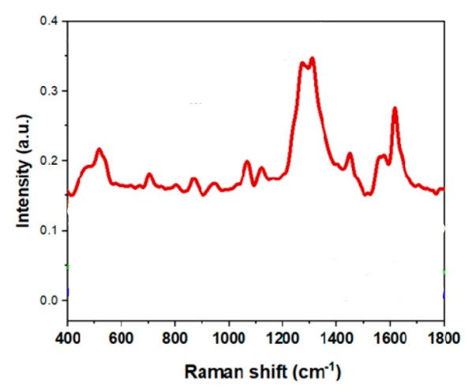
Figure 34: https://pubs.acs.org/doi/10.1021/acsanm.0c01389?goto=supporting-info

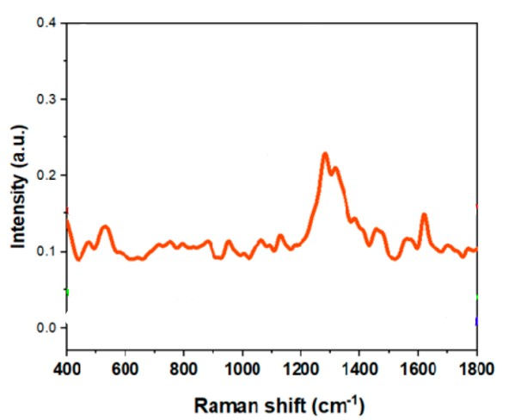
Figure 35: https://pubs.acs.org/doi/10.1021/acsanm.0c01389?goto=supporting-info
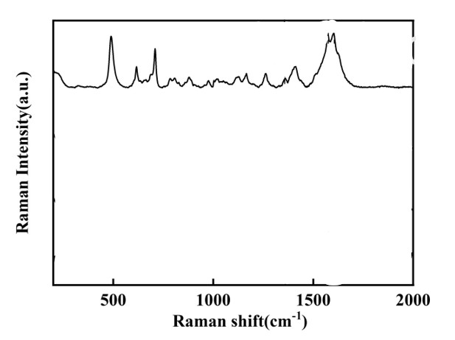
Figure 36: https://doi.org/10.1177/0003702820978233

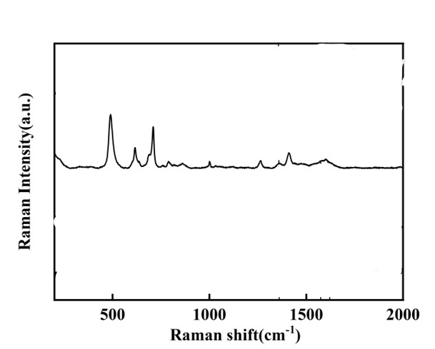
Figure 37: https://doi.org/10.1177/0003702820978233
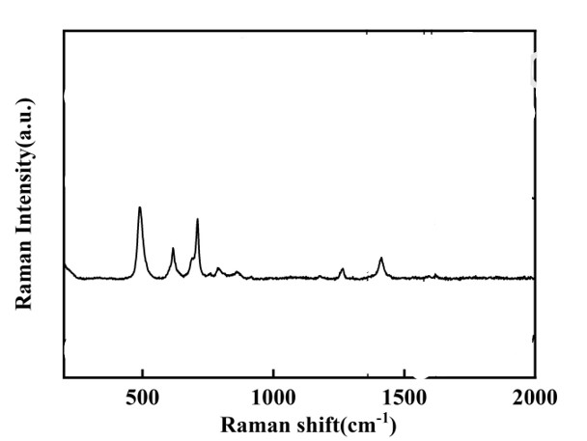
Figure 38: https://doi.org/10.1177/0003702820978233
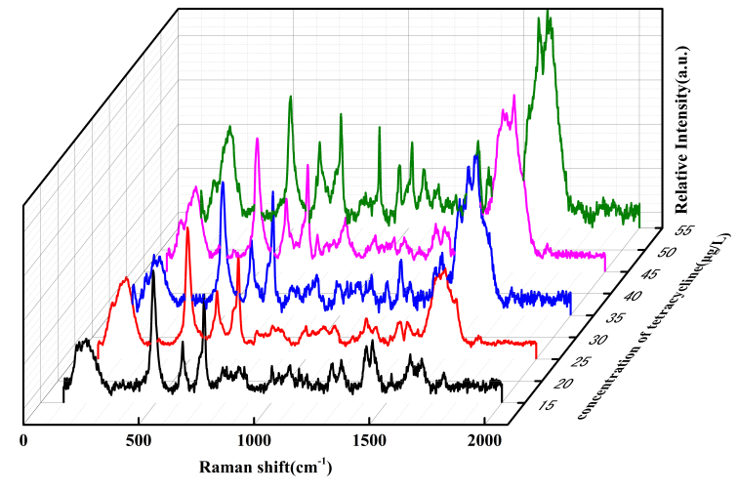
Figure 39: https://doi.org/10.1177/0003702820978233
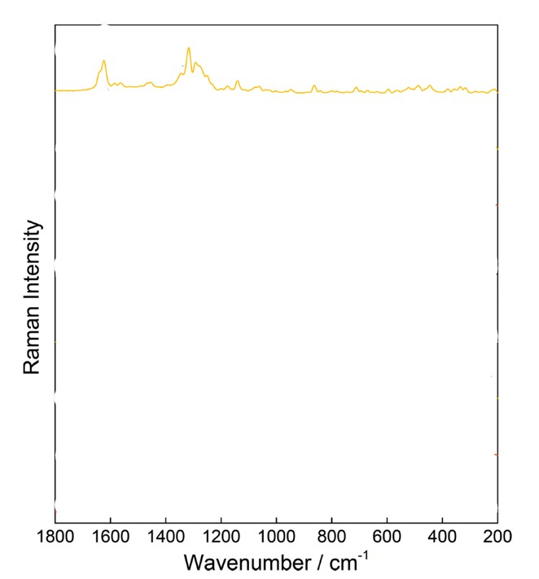
Figure 40: https://doi.org/10.3390/molecules25081866
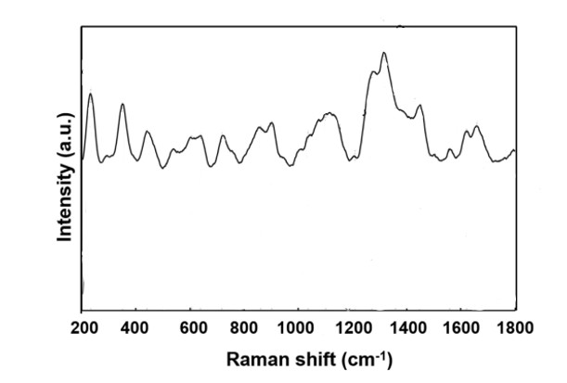
Figure 41: https://doi.org/10.1038/s41598-019-54380-y

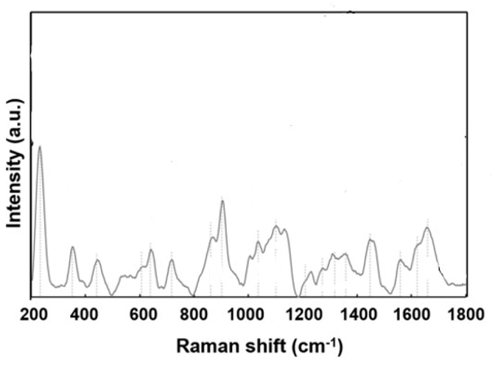
Figure 42: https://doi.org/10.1038/s41598-019-54380-y
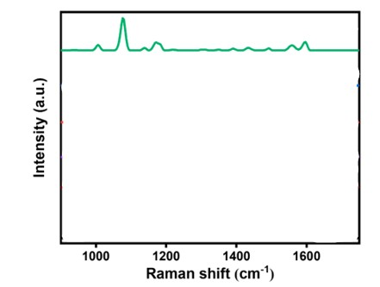
Figure 43: https://pubs.acs.org/doi/10.1021/acsanm.3c04633?goto=supporting-info
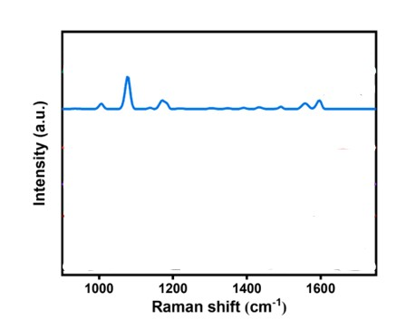
Figure 44: https://pubs.acs.org/doi/10.1021/acsanm.3c04633?goto=supporting-info

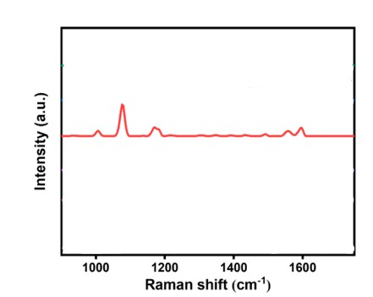
Figure 45: https://pubs.acs.org/doi/10.1021/acsanm.3c04633?goto=supporting-info
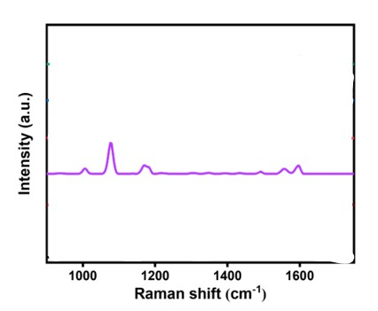
Figure 46: https://pubs.acs.org/doi/10.1021/acsanm.3c04633?goto=supporting-info
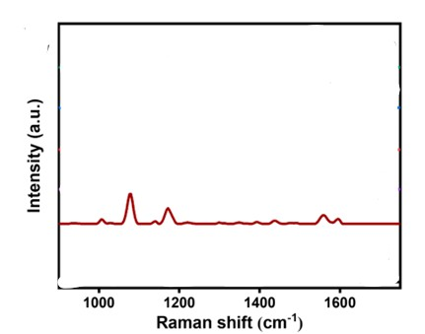
Figure 7: https://pubs.acs.org/doi/10.1021/acsanm.3c04633?goto=supporting-info
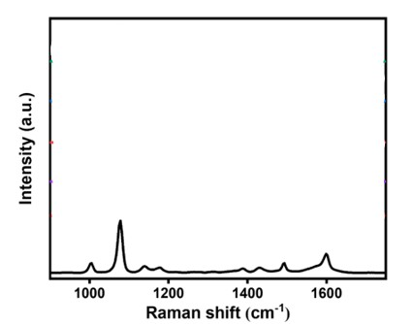
Figure 48: https://pubs.acs.org/doi/10.1021/acsanm.3c04633?goto=supporting-info
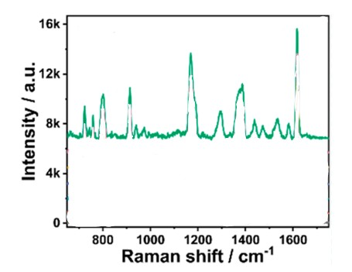
Figure 49: https://doi.org/10.1016/j.apsusc.2022.155270
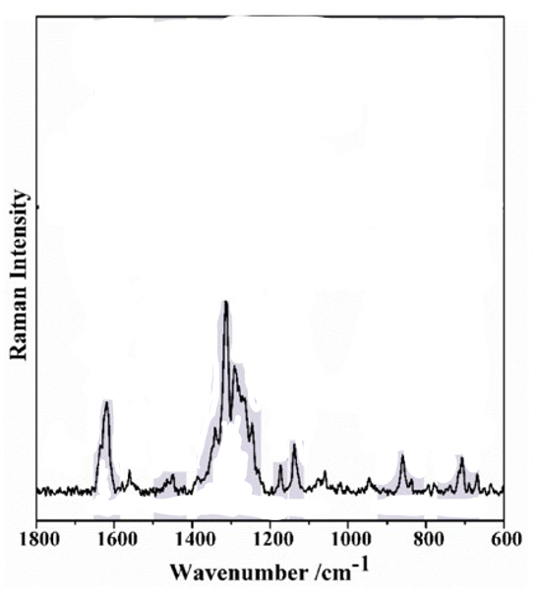
Figure 50: https://doi.org/10.3390/nano9010031
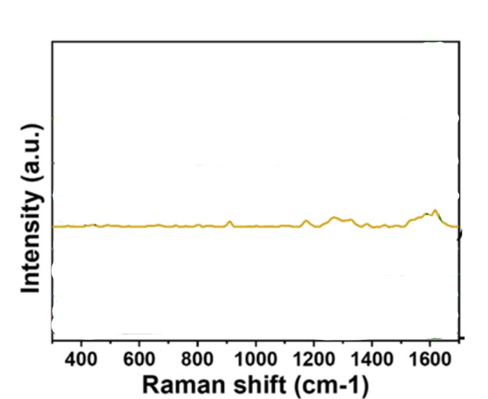
Figure 51: https://doi.org/10.1021/acsomega.5c01637?urlappend=%3Fref%3DPDF&jav=VoR&rel=cite-as
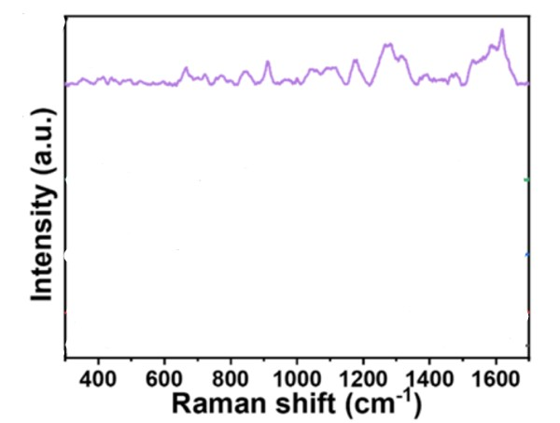
Figure 52: https://doi.org/10.1021/acsomega.5c01637?urlappend=%3Fref%3DPDF&jav=VoR&rel=cite-as

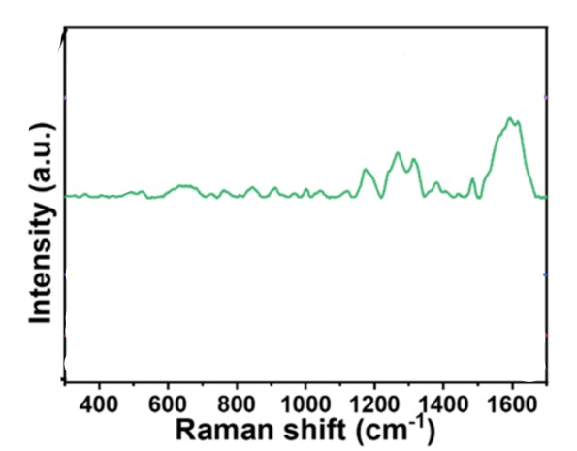
Figure 53: https://doi.org/10.1021/acsomega.5c01637?urlappend=%3Fref%3DPDF&jav=VoR&rel=cite-as

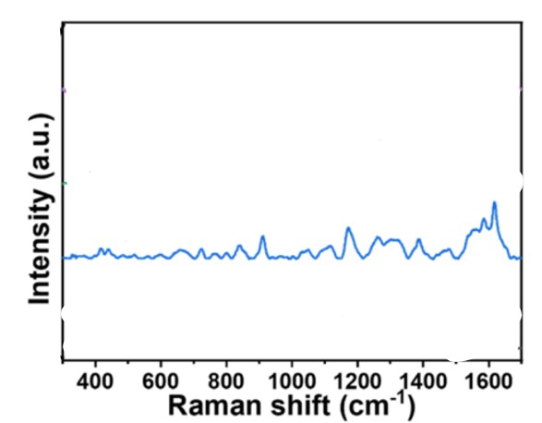
Figure 54: https://doi.org/10.1021/acsomega.5c01637?urlappend=%3Fref%3DPDF&jav=VoR&rel=cite-as
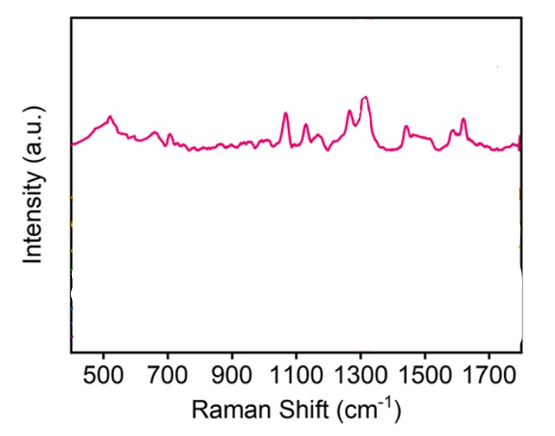
Figure 55: https://doi.org/10.1016/j.saa.2022.121843
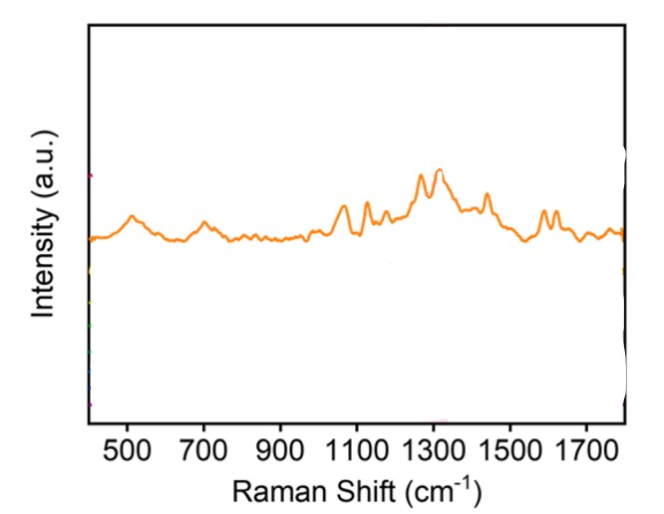
Figure 56: https://doi.org/10.1016/j.saa.2022.121843
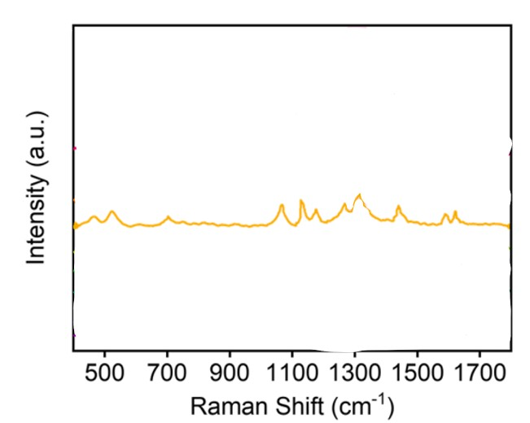
Figure 57: https://doi.org/10.1016/j.saa.2022.121843

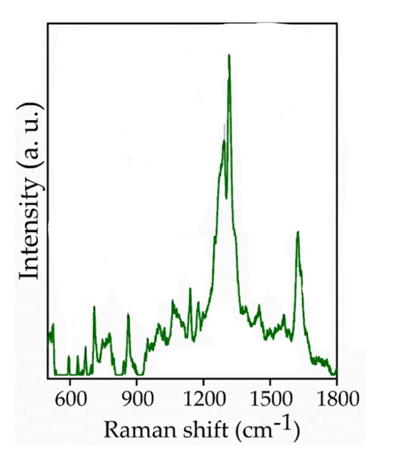
Figure 58: https://doi.org/10.1016/j.matchemphys.2025.130885
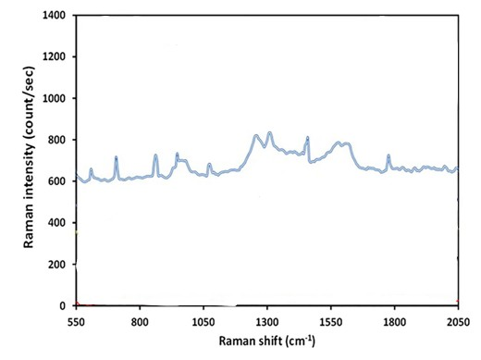
Figure 59: https://doi.org/10.1007/s13404-020-00272-3
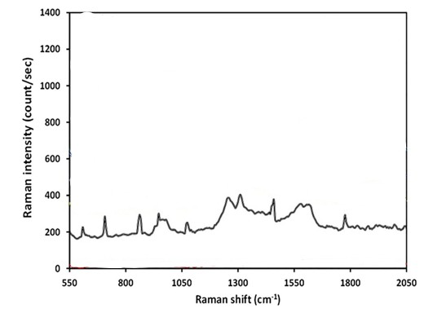
Figure 60: https://doi.org/10.1007/s13404-020-00272-3

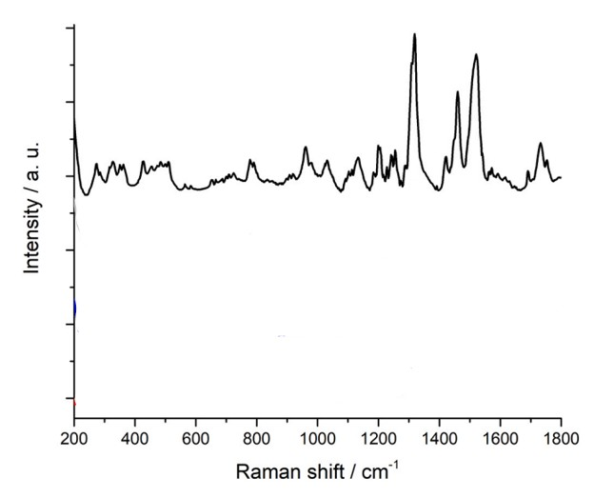
Figure 61: https://doi.org/10.1016/j.colsurfa.2021.126787

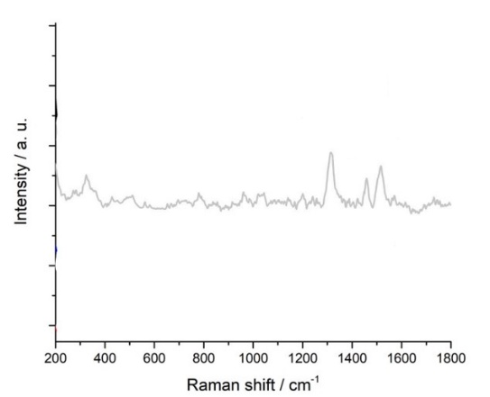
Figure 62: https://doi.org/10.1016/j.colsurfa.2021.126787
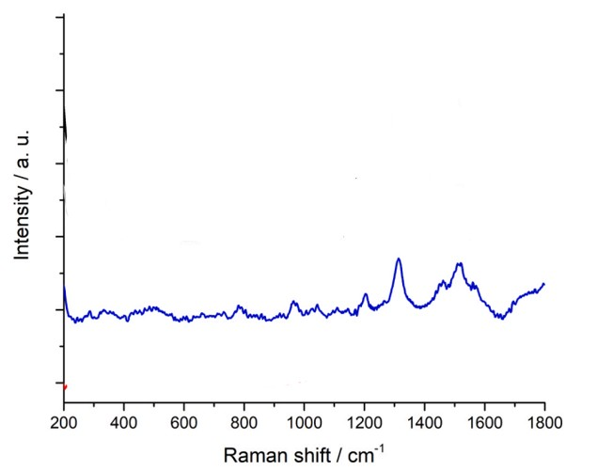
Figure 63: https://doi.org/10.1016/j.colsurfa.2021.126787
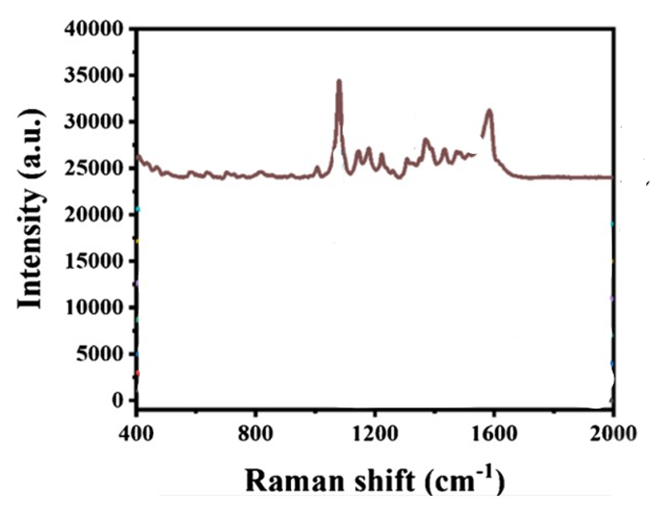
Figure 64: https://doi.org/10.1007/s00604-025-07328-1
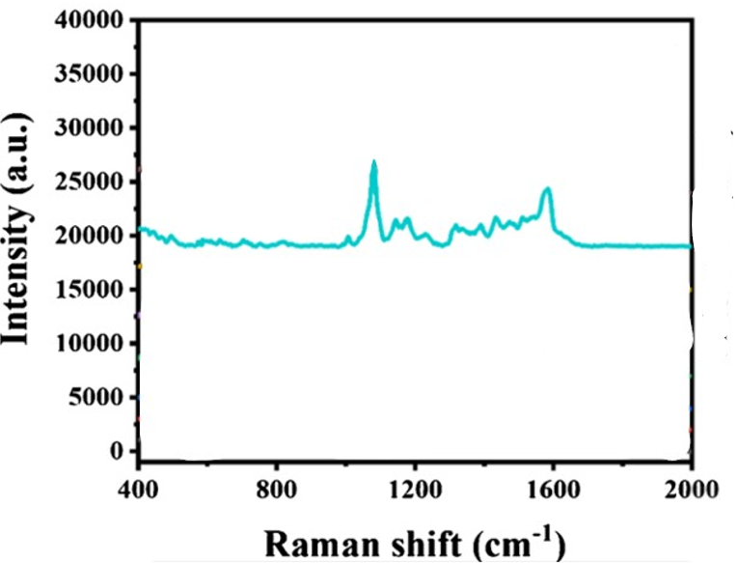
Figure 65: https://doi.org/10.1007/s00604-025-07328-1
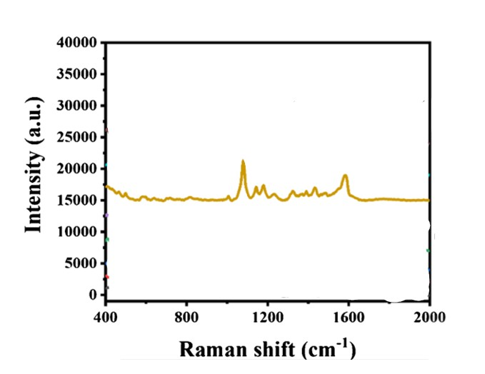
Figure 66: https://doi.org/10.1007/s00604-025-07328-1

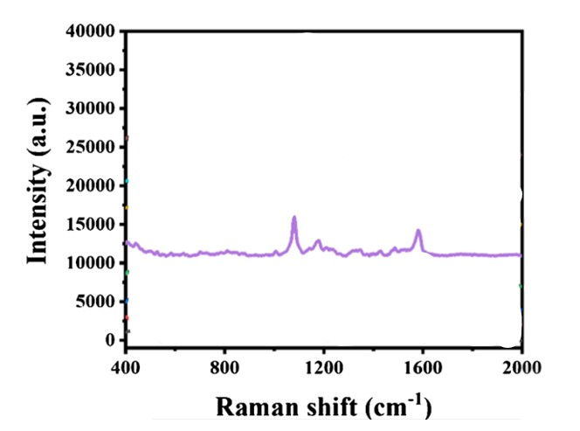
Figure 67: https://doi.org/10.1007/s00604-025-07328-1
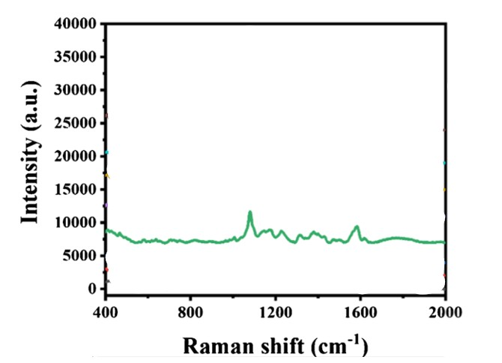
Figure 68: https://doi.org/10.1007/s00604-025-07328-1
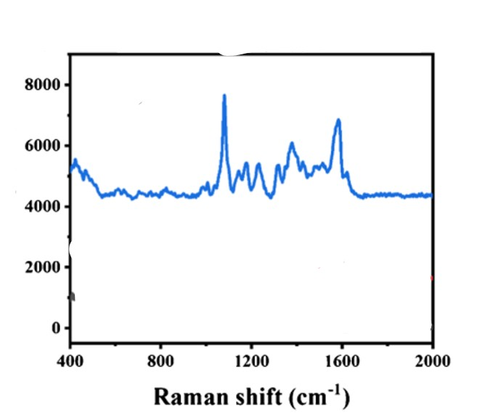
Figure 69: https://doi.org/10.1007/s00604-025-07328-1
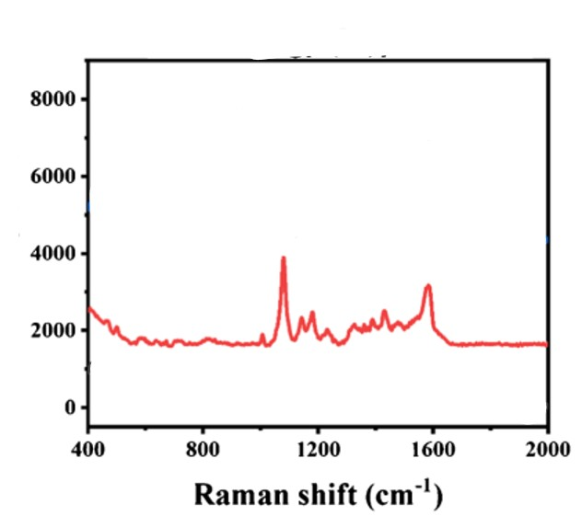
Figure 70: https://doi.org/10.1007/s00604-025-07328-1

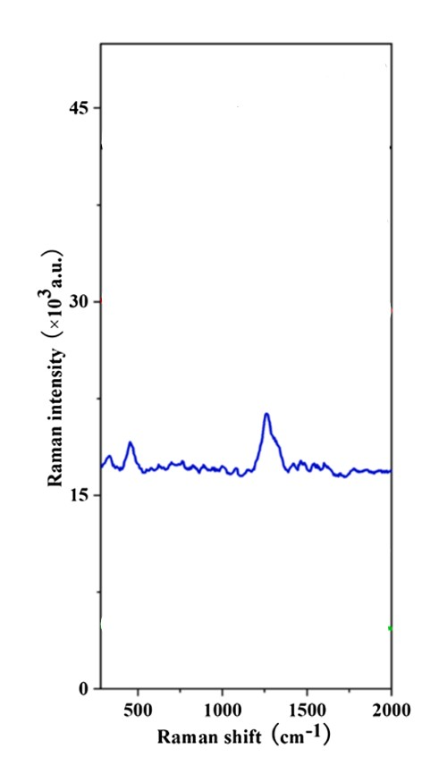
Figure 71: https://doi.org/10.1016/j.saa.2022.122195
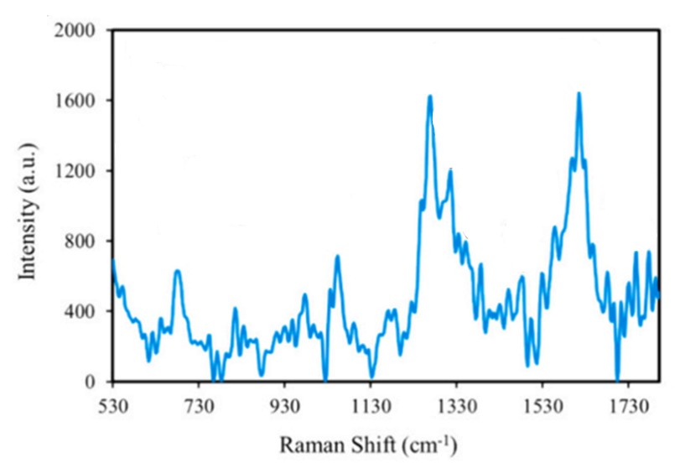
Figure 72: https://doi.org/10.1016/j.fochx.2024.101507
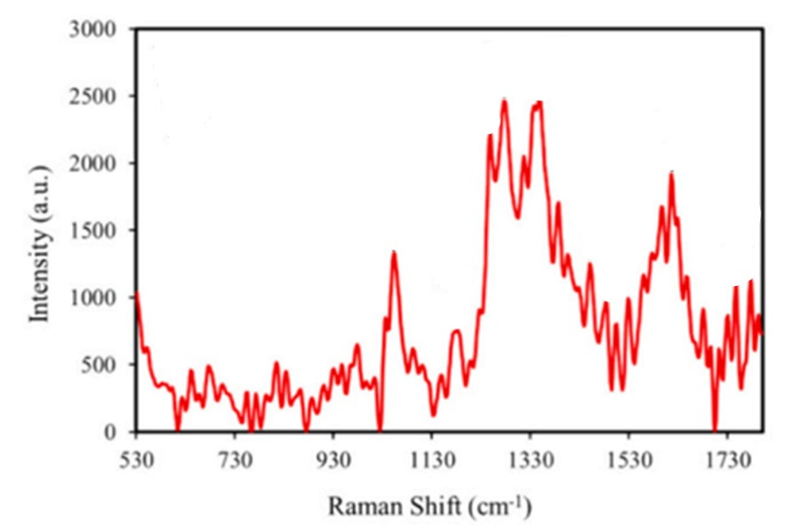
Figure 73: https://doi.org/10.1016/j.fochx.2024.101507
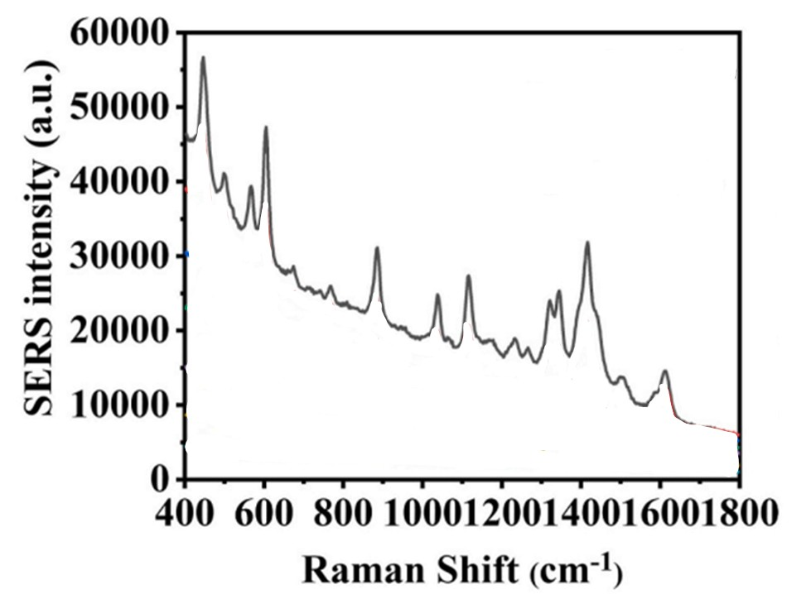
Figure 74: https://doi.org/10.1016/j.aca.2022.339999

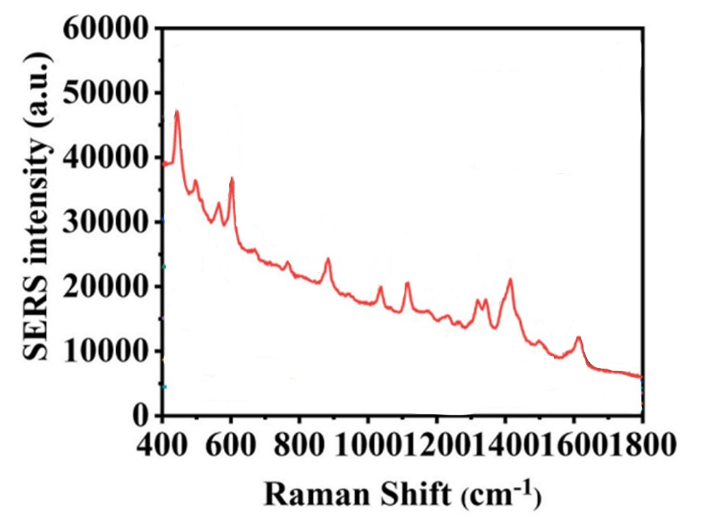
Figure 75: https://doi.org/10.1016/j.aca.2022.339999
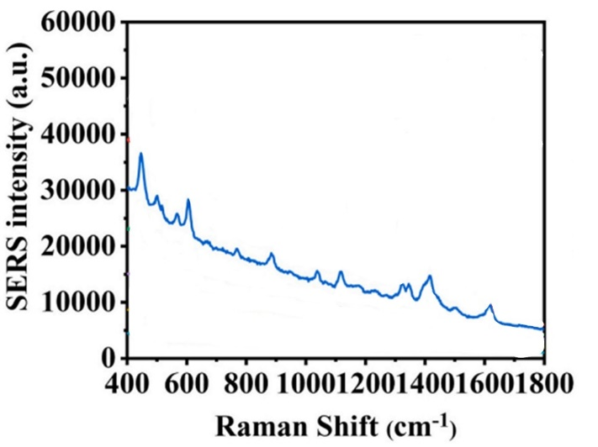
Figure 76: https://doi.org/10.1016/j.aca.2022.339999
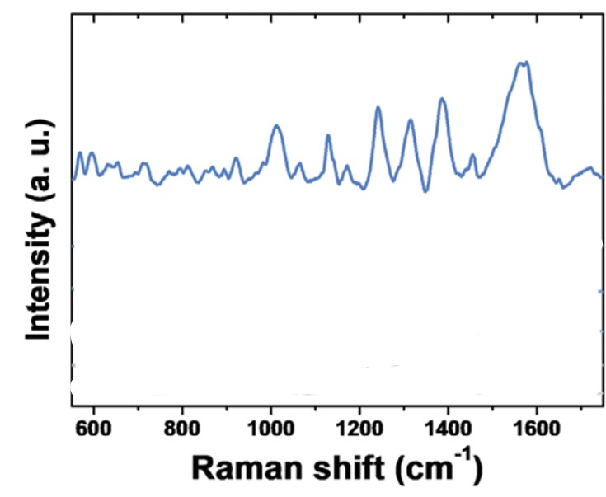
Figure 77: DOI: 10.1002/adfm.202000612
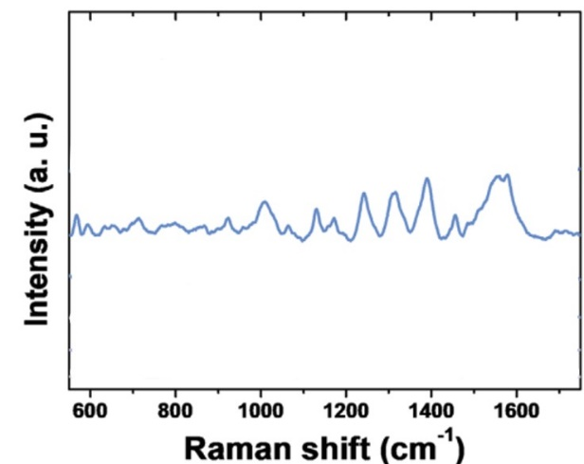
Figure 78: DOI: 10.1002/adfm.202000612
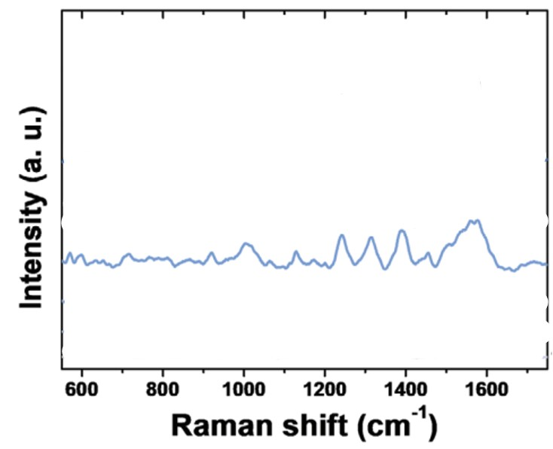
Figure 79: DOI: 10.1002/adfm.202000612
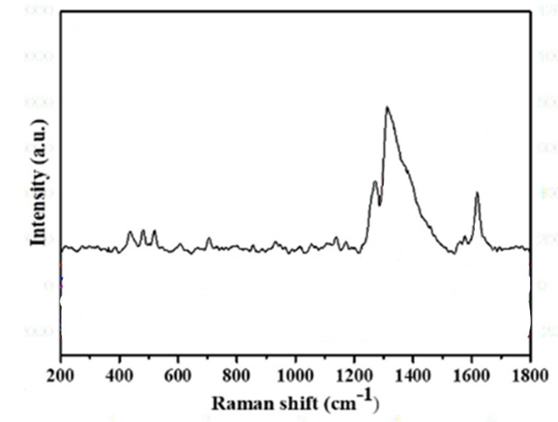
Figure 80: http://dx.doi.org/10.1016/j.scitotenv.2022.158879
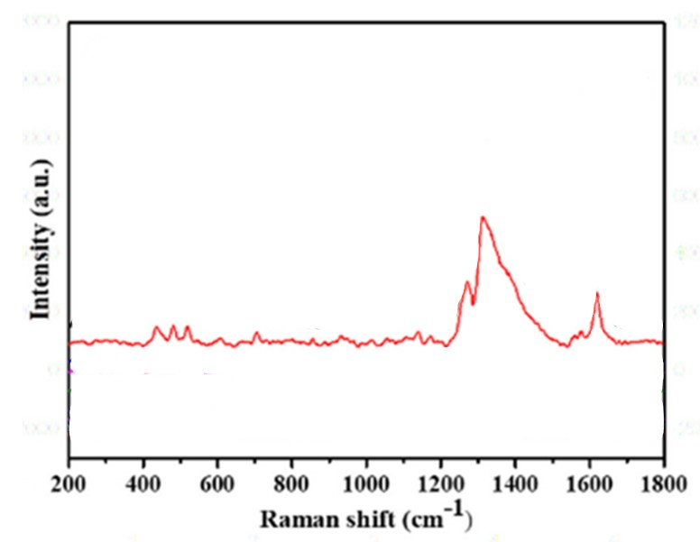
Figure 81: http://dx.doi.org/10.1016/j.scitotenv.2022.158879
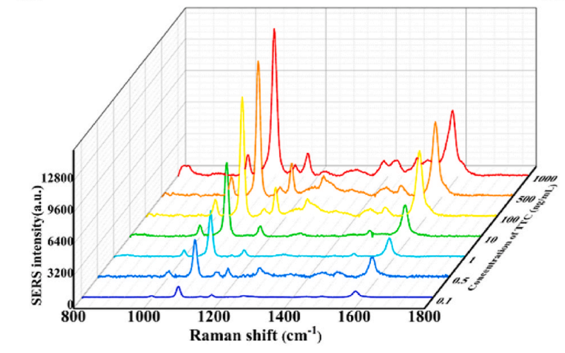
Figure 82: https://doi.org/10.1016/j.bios.2023.115122
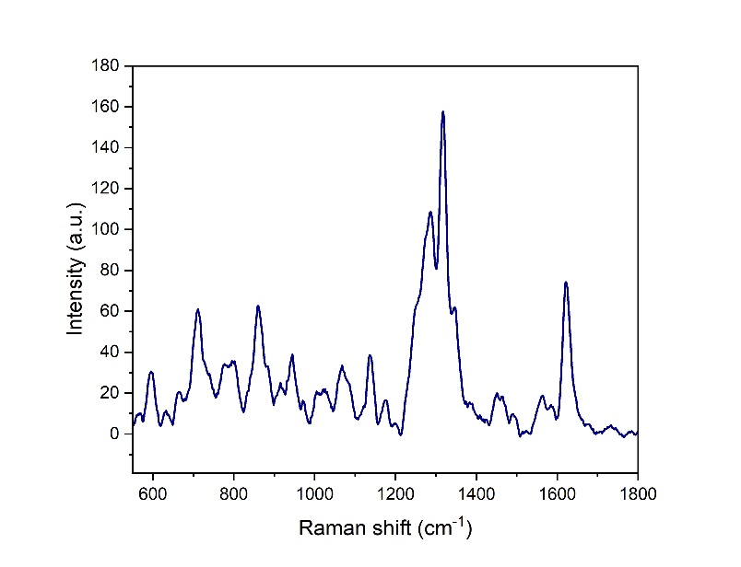
Figure 83
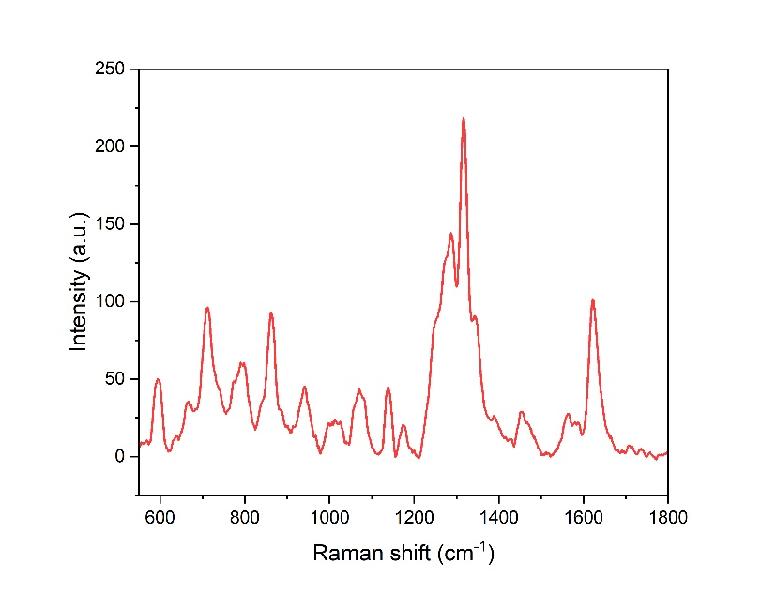
Figure 84
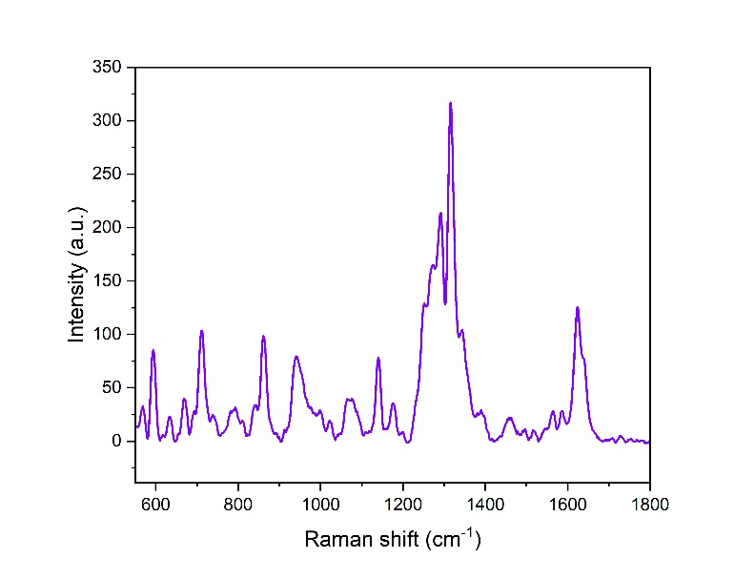
Figure 85
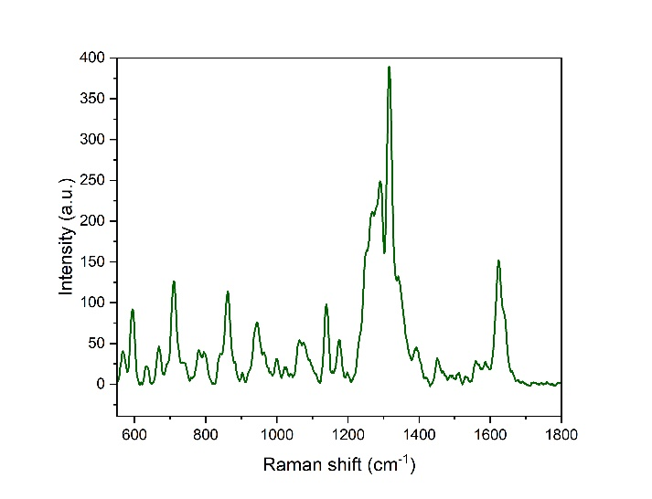
Figure 85
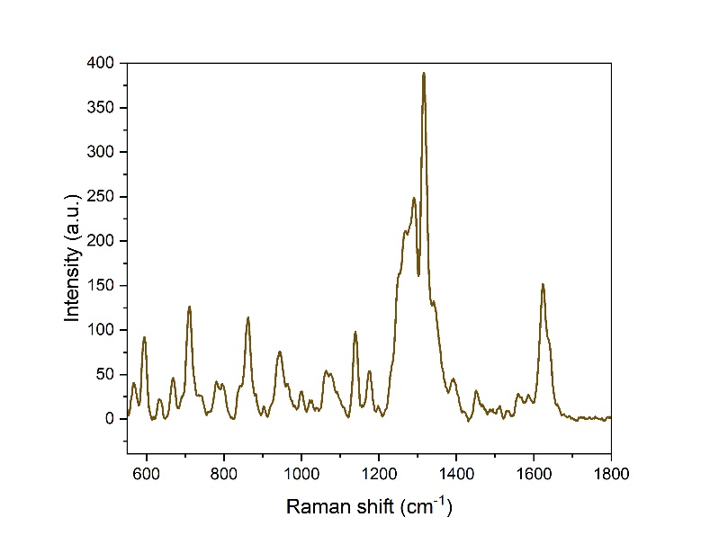
Figure 86
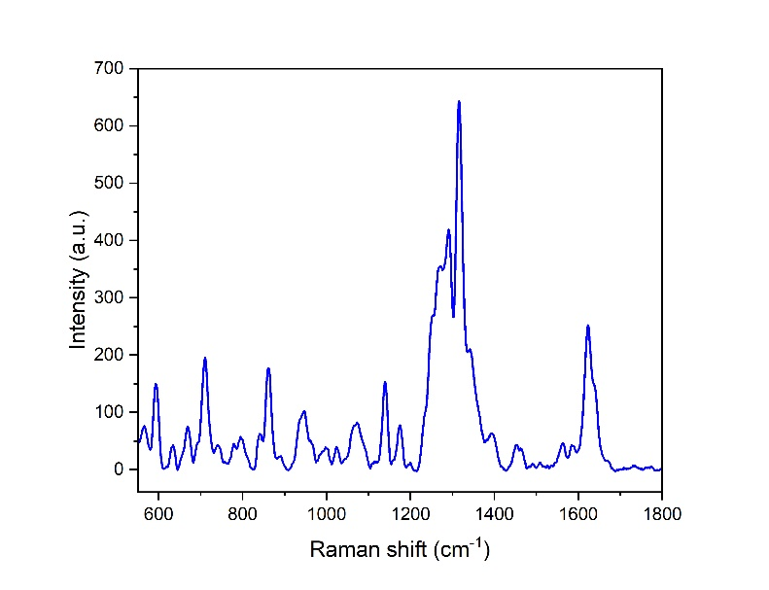
Figure 87
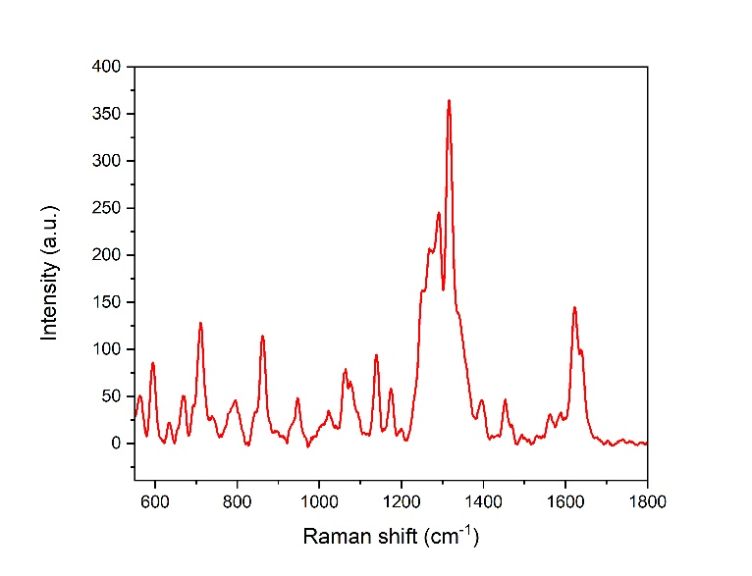
Figure 88
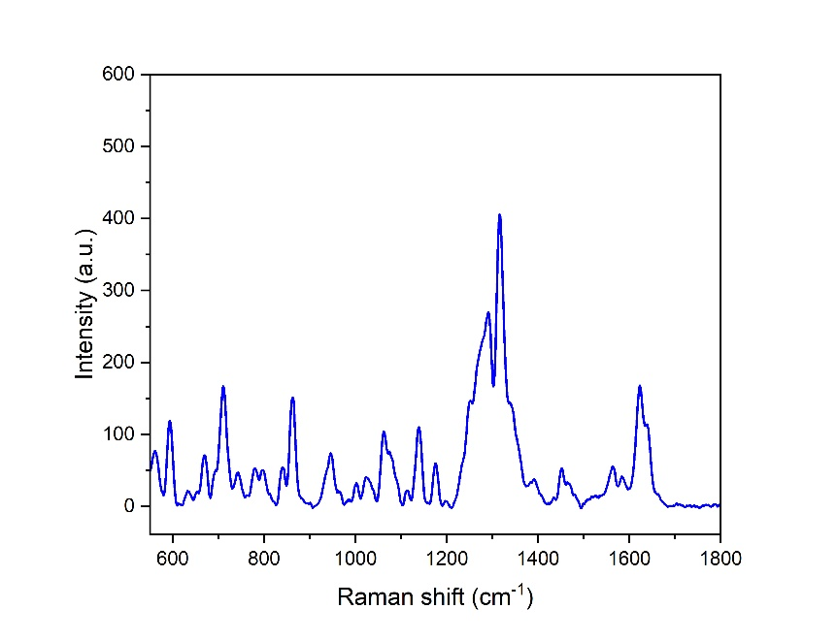
Figure 89
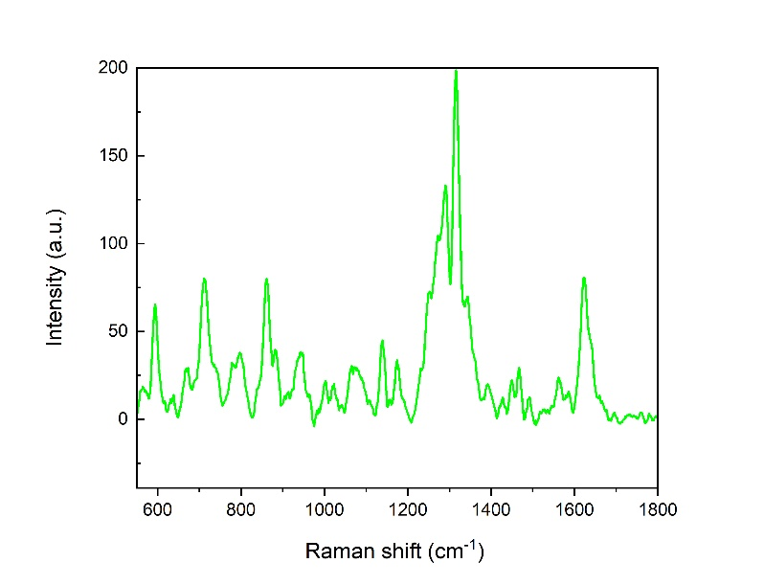
Figure 90
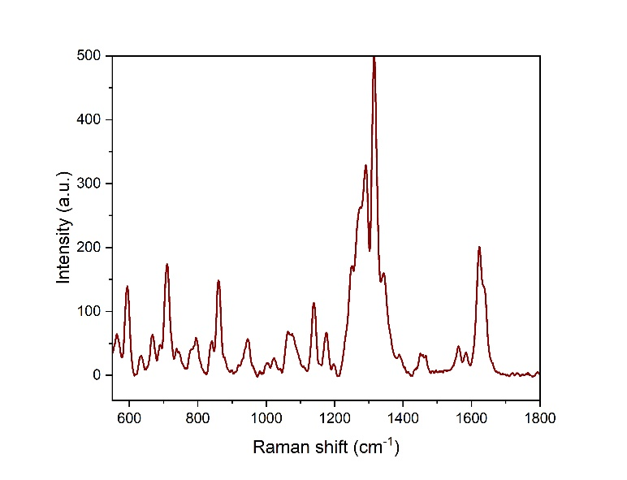
Figure 91
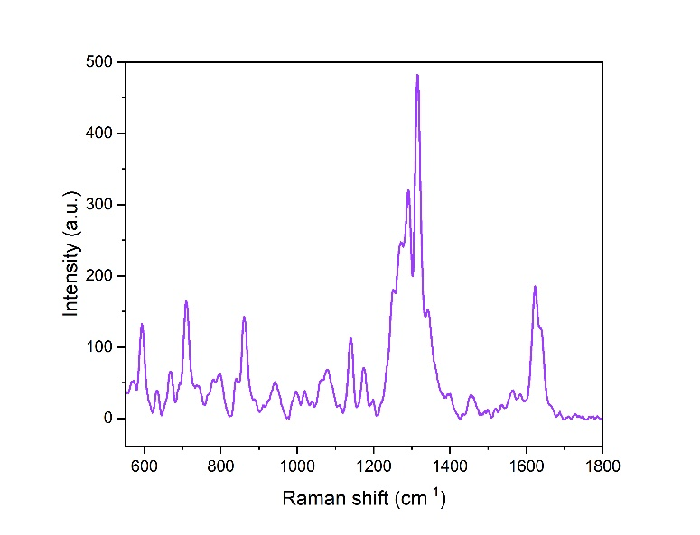
Figure 92
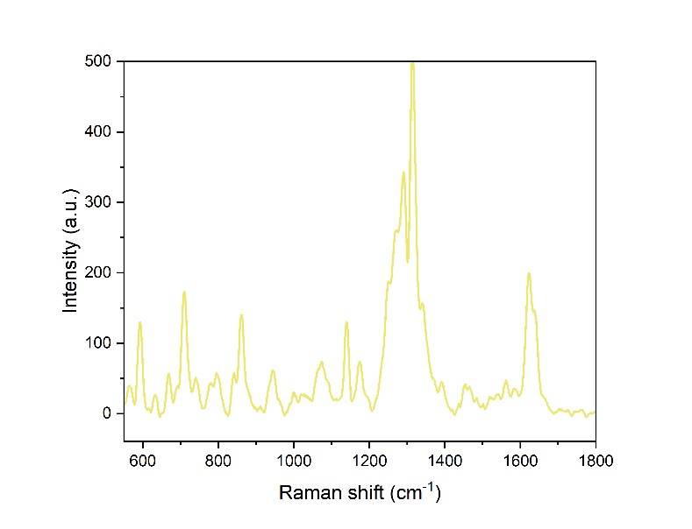
Figure 93
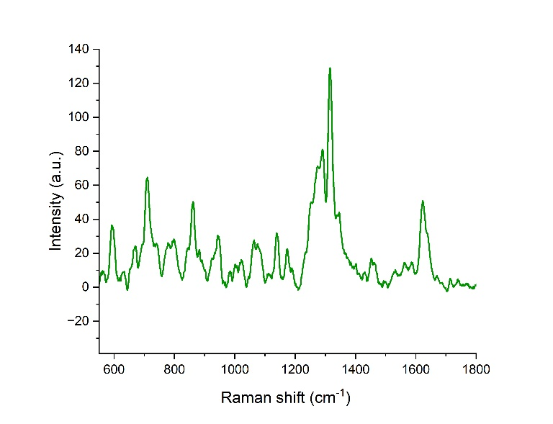
Figure 94
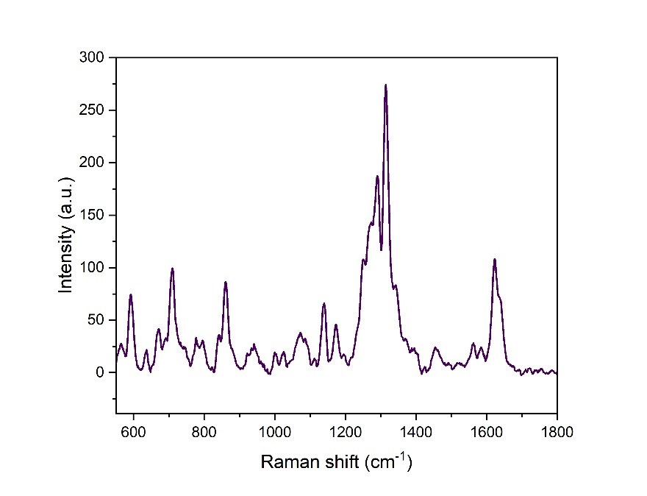
Figure 95
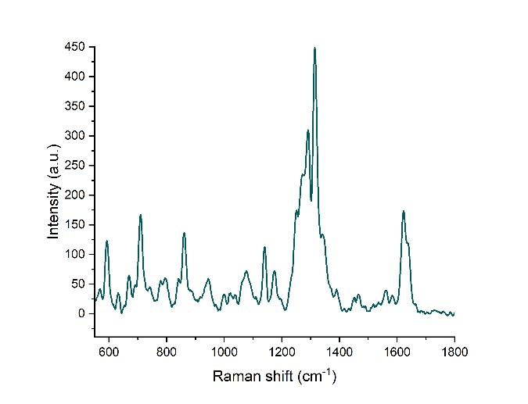
Figure 96
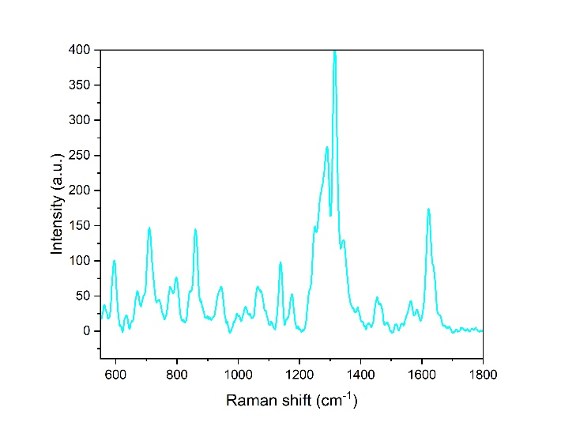
Figure 97
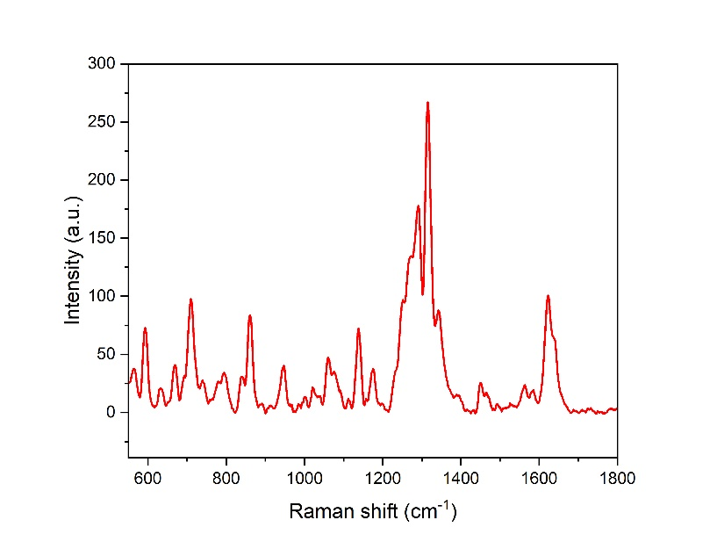
Figure 98
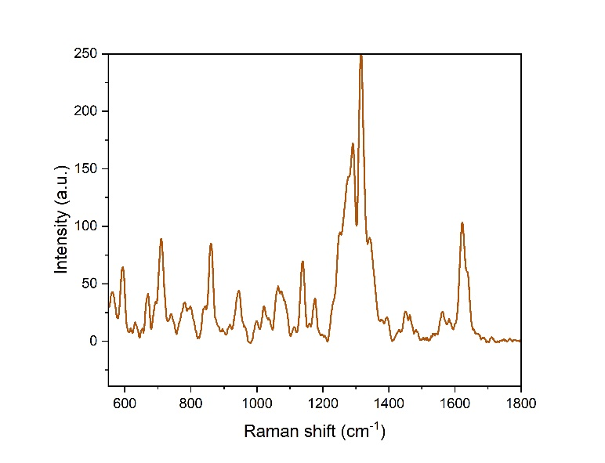
Figure 99
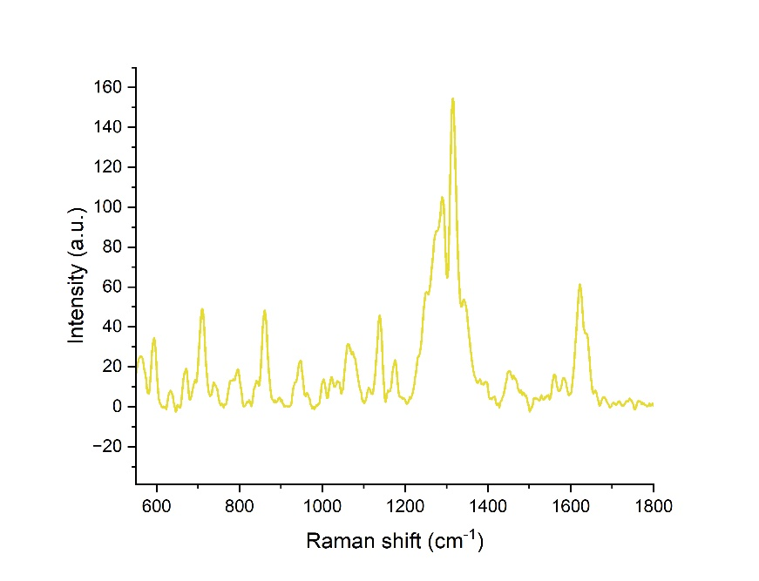
Figure 100
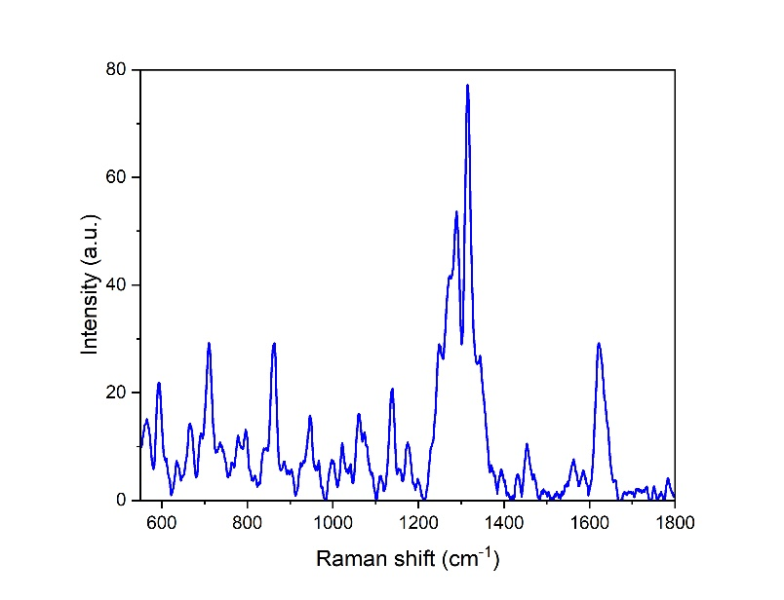
Figure 101
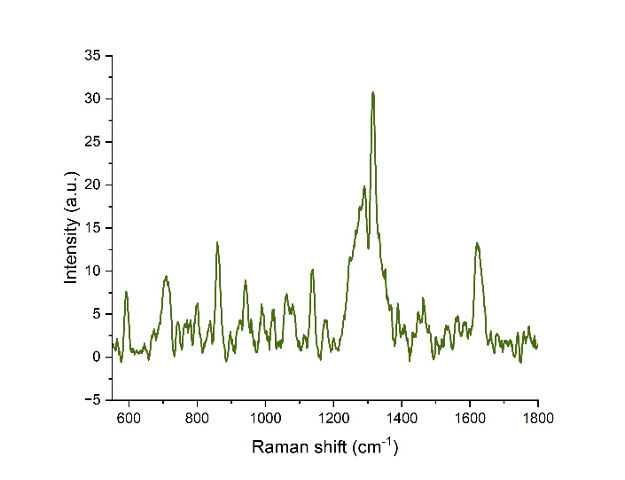
Figure 102
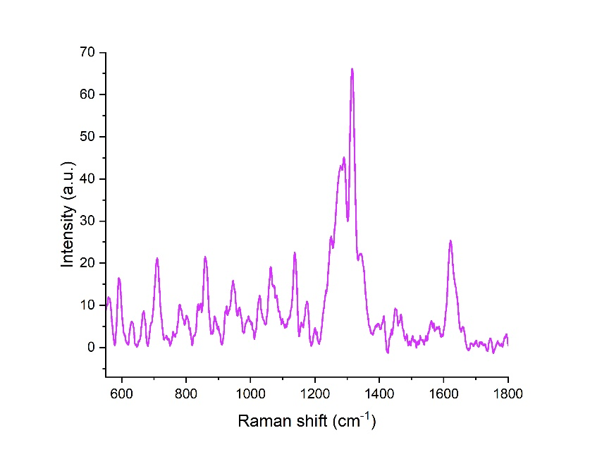
Figure 103
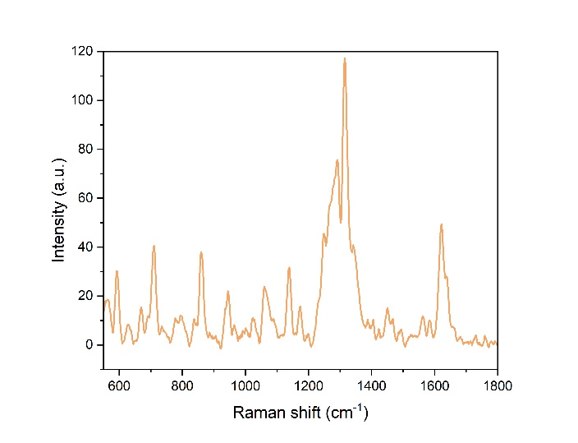
Figure 104
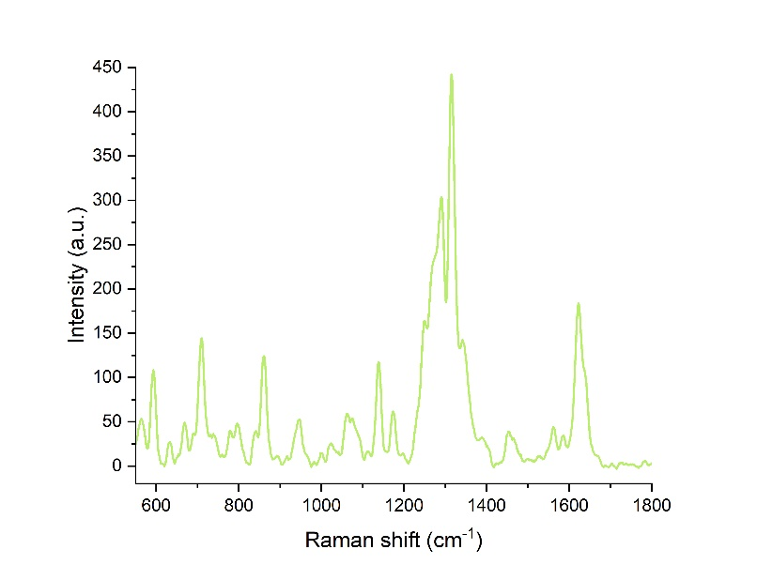
Figure 105
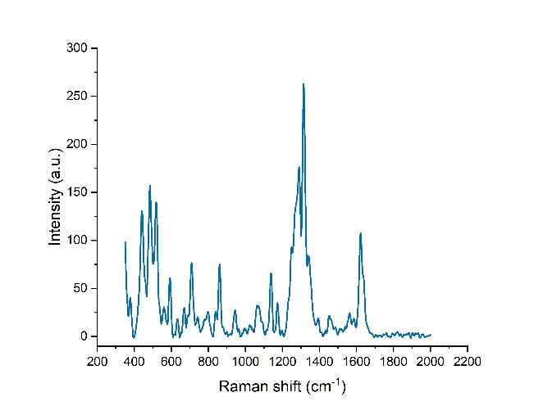
Figure 106
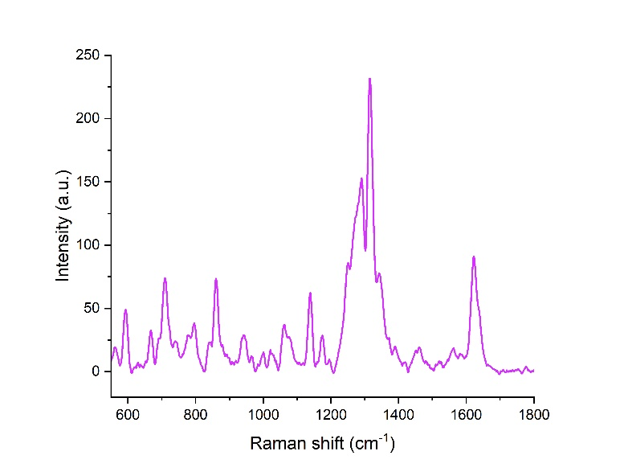
Figure 107
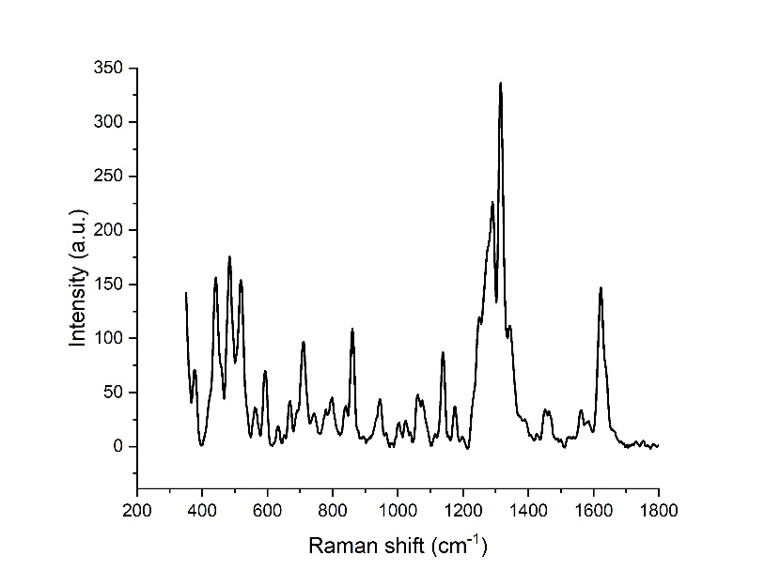
Figure 108
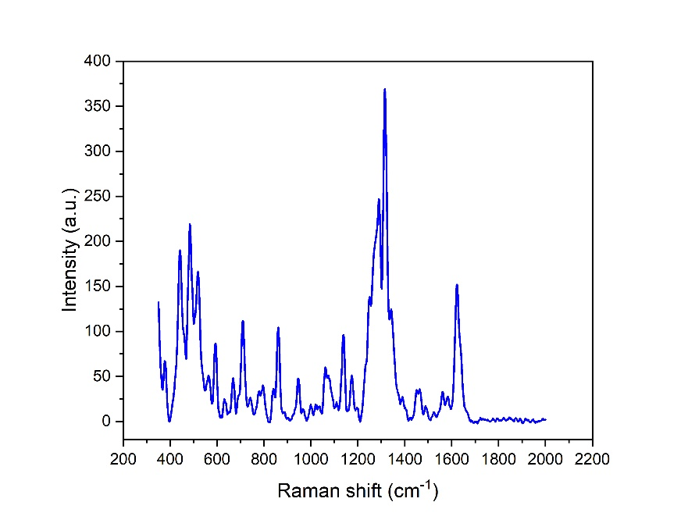
Figure 109
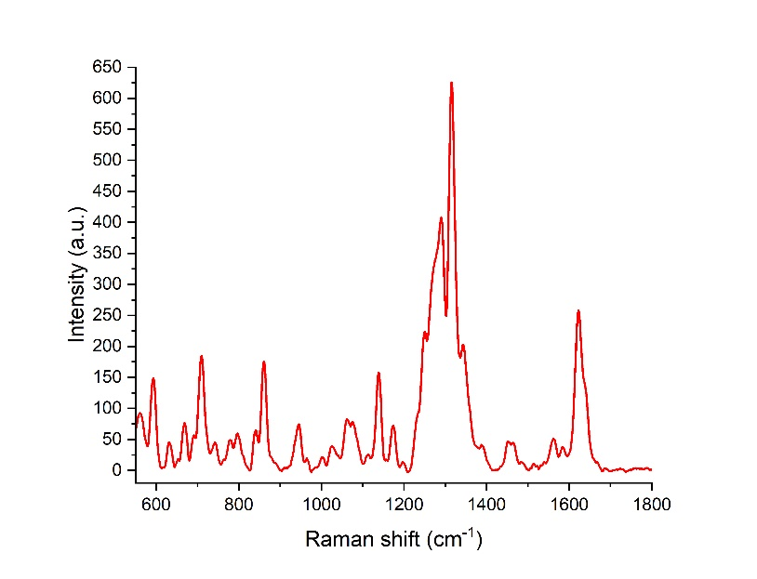
Figure 110
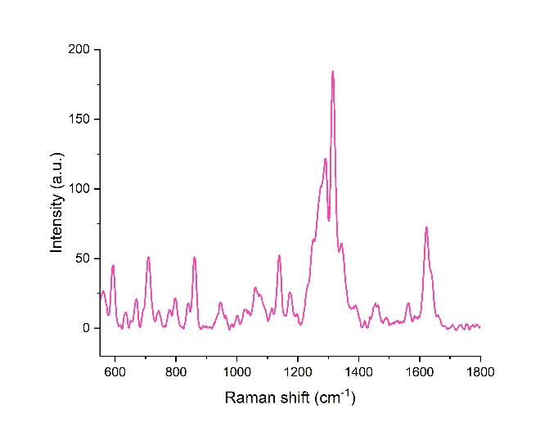
Figure 111
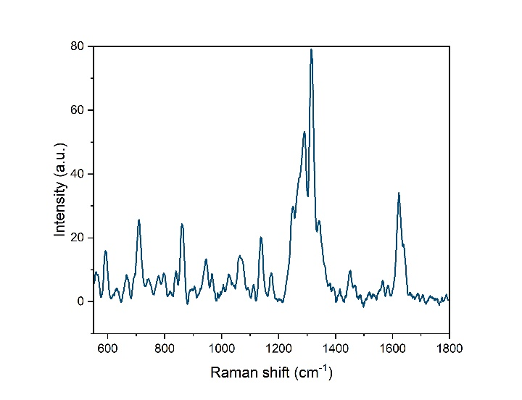
Figure 112
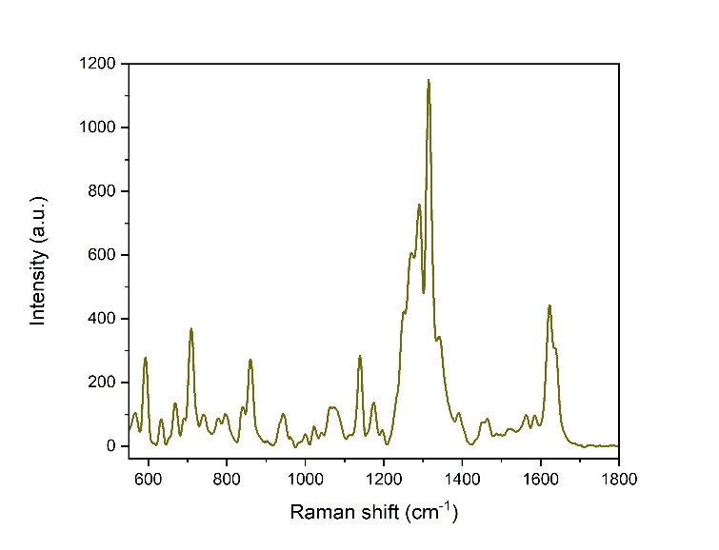
Figure 113
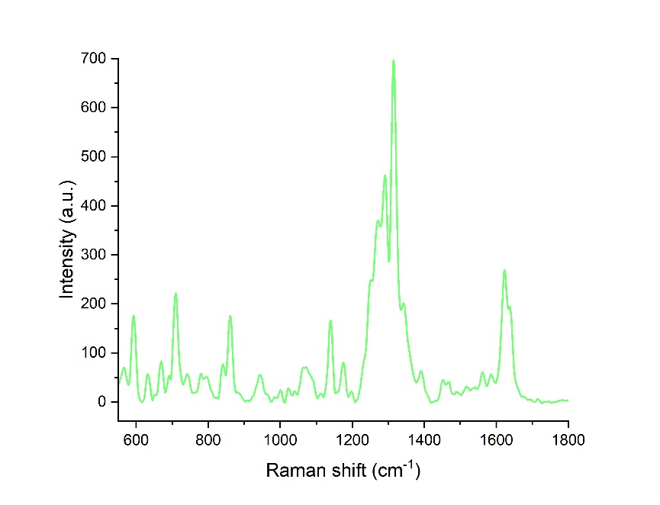
Figure 114
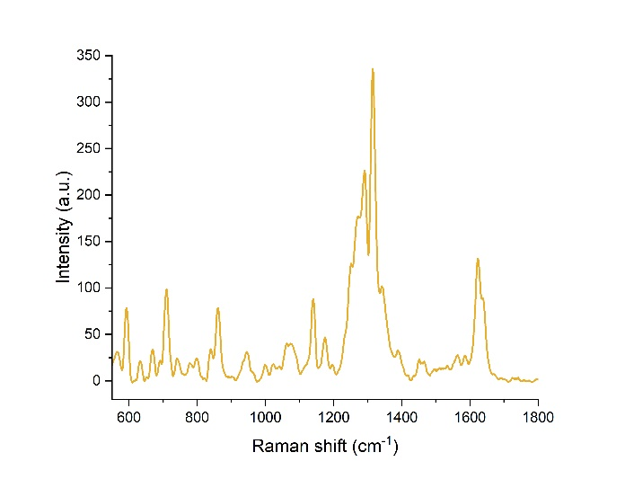
Figure 115
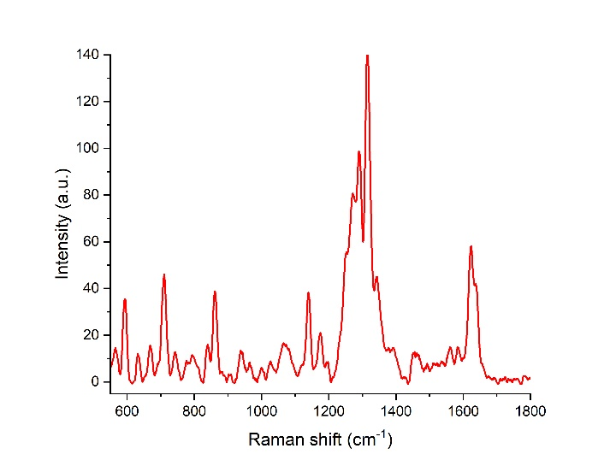
Figure 116
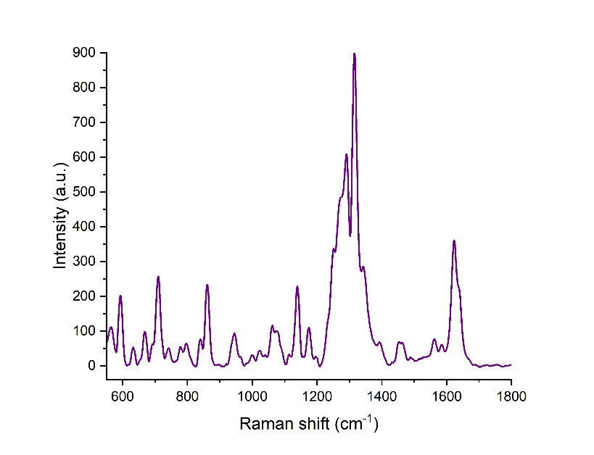
Figure 117
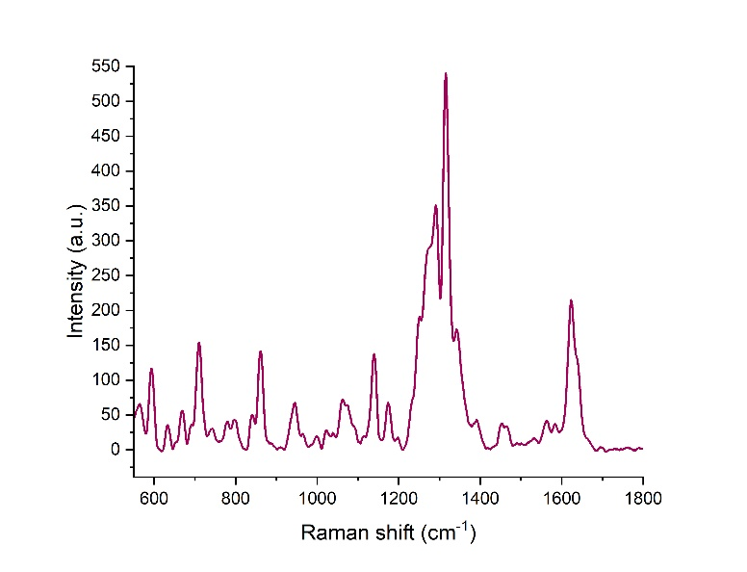
Figure 118
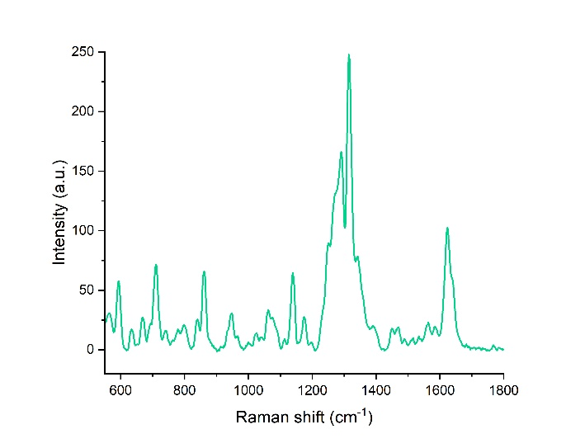
Figure 119
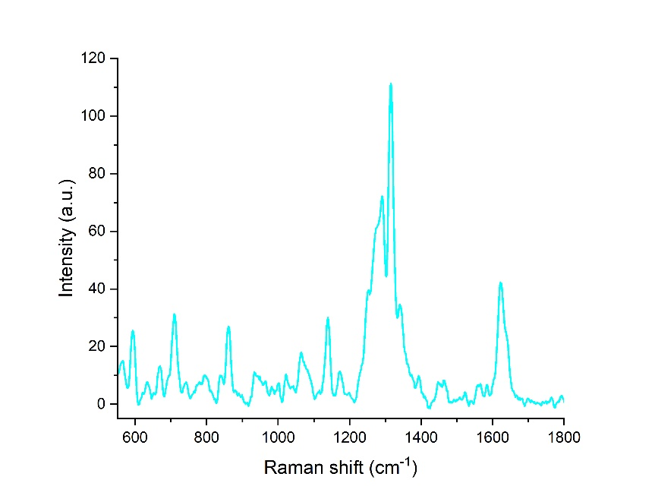
Figure 120
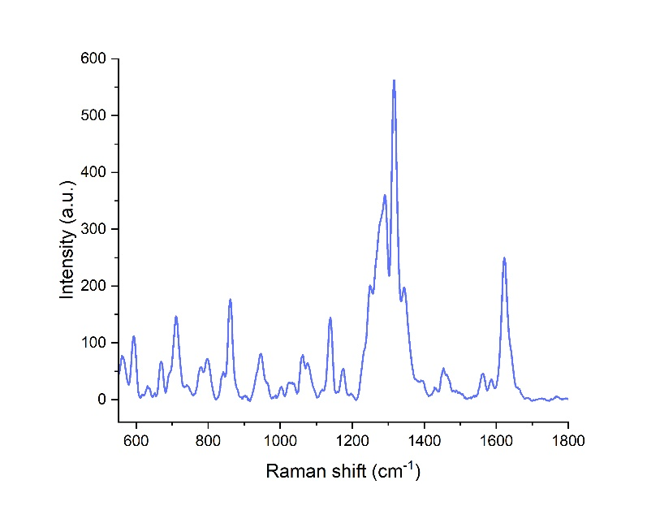
Figure 121
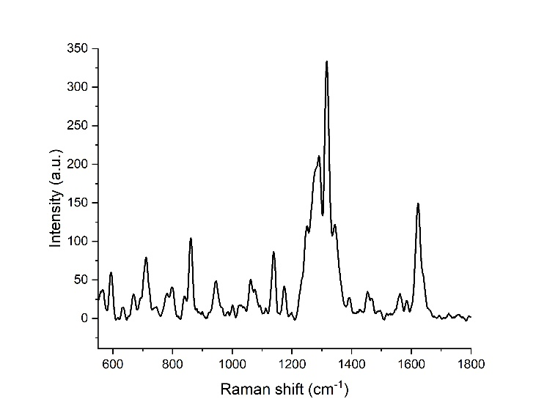
Figure 122
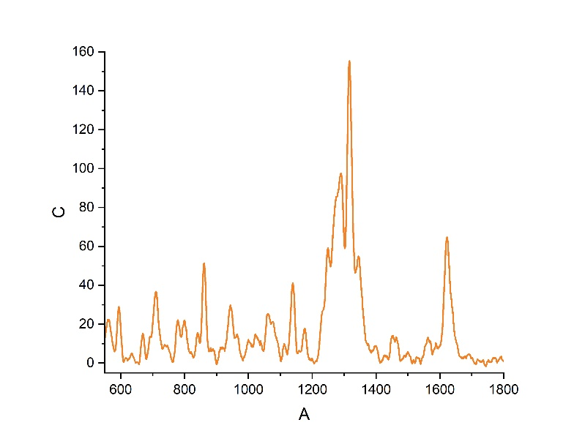
Figure 123
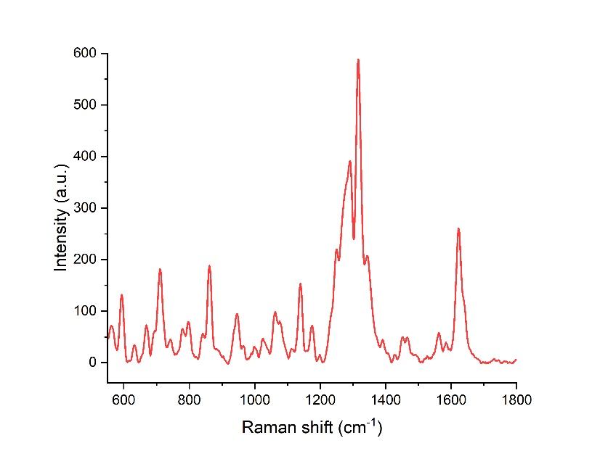
Figure 124
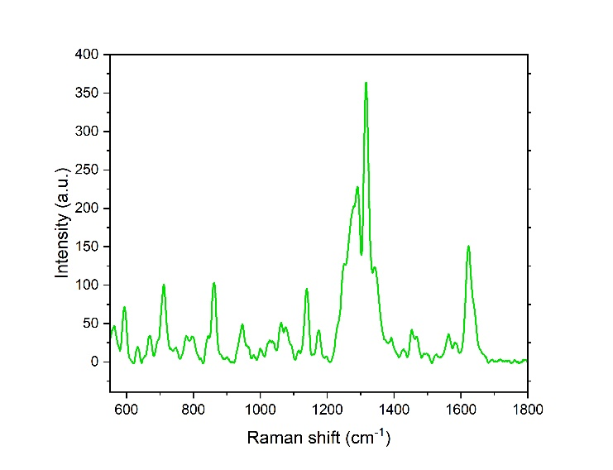
Figure 125
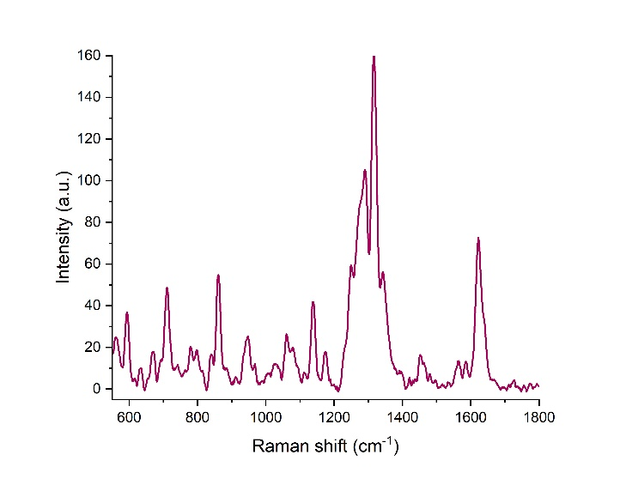
Figure 126
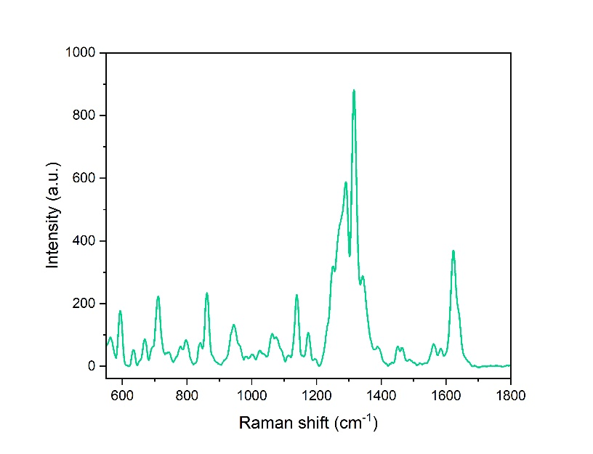
Figure 127
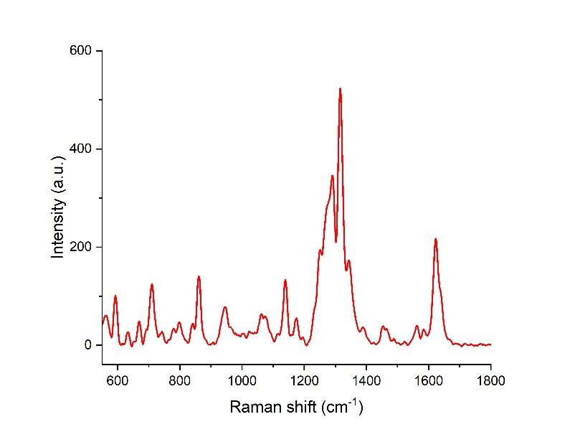
Figure 128
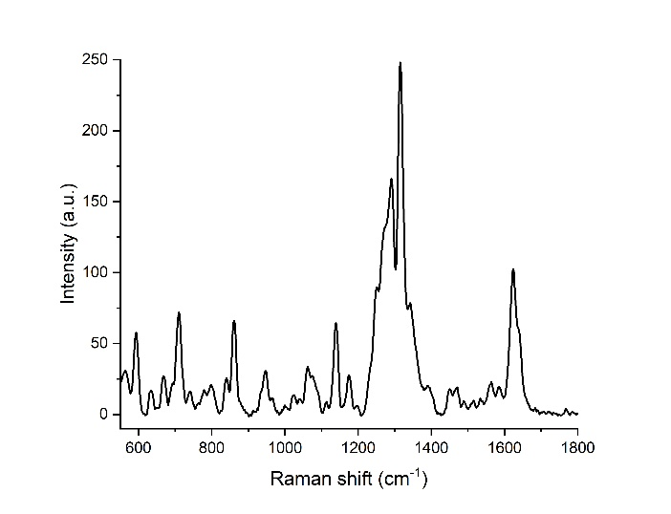
Figure 129
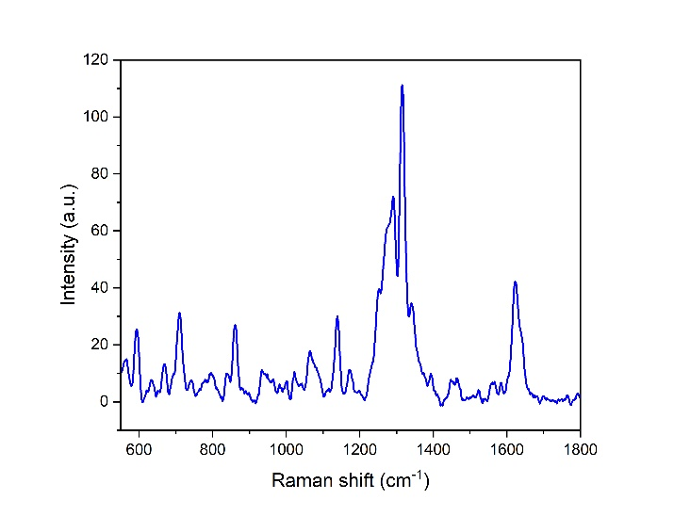
Figure 130
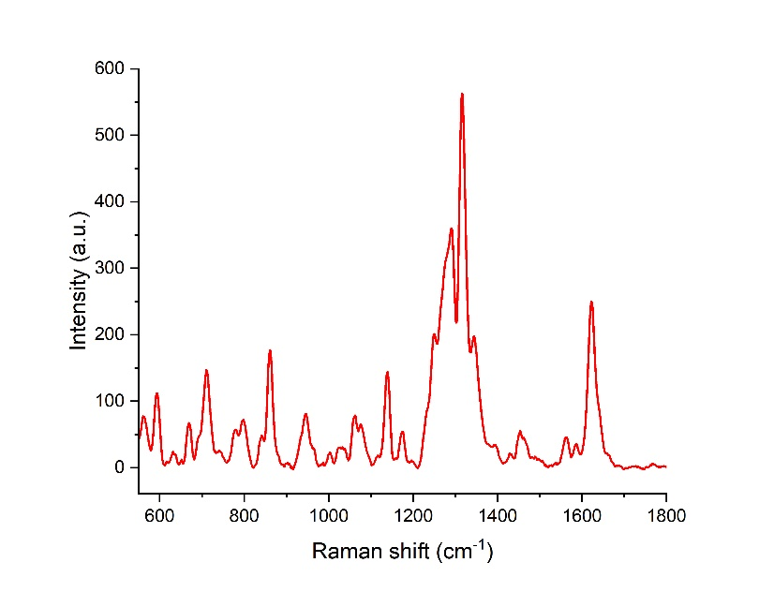
Figure 131
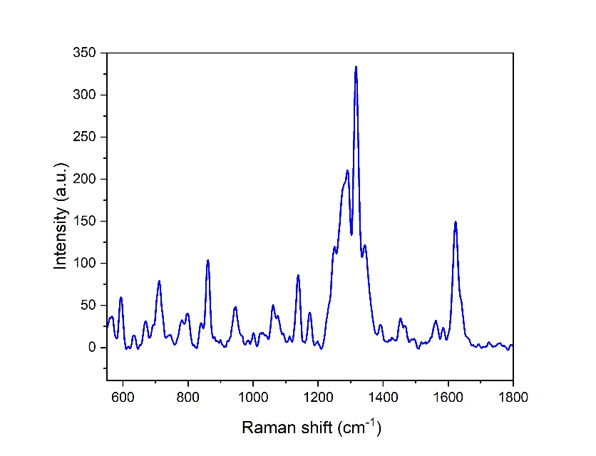
Figure 132
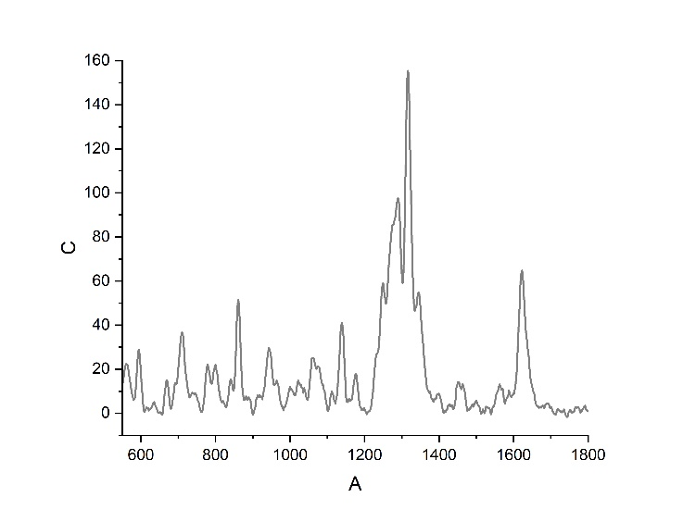
Figure 133
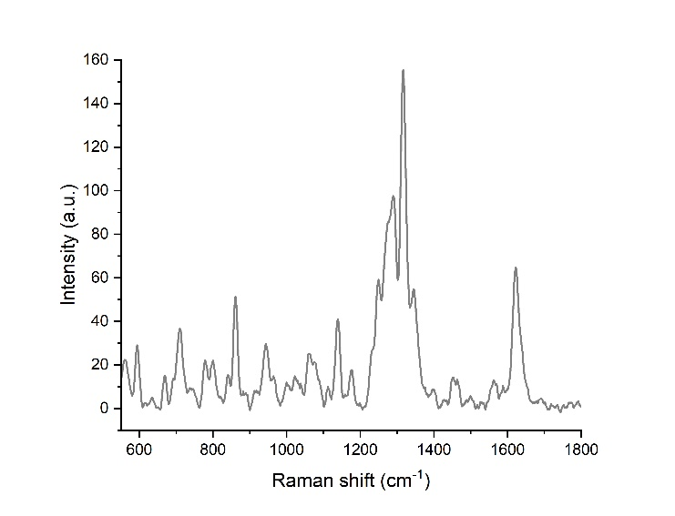
Figure 134
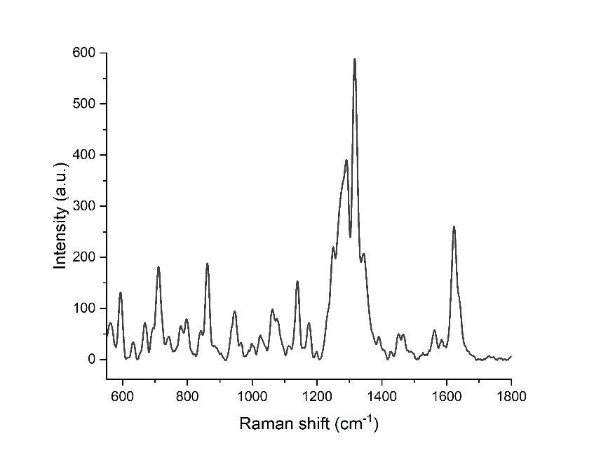
Figure 135
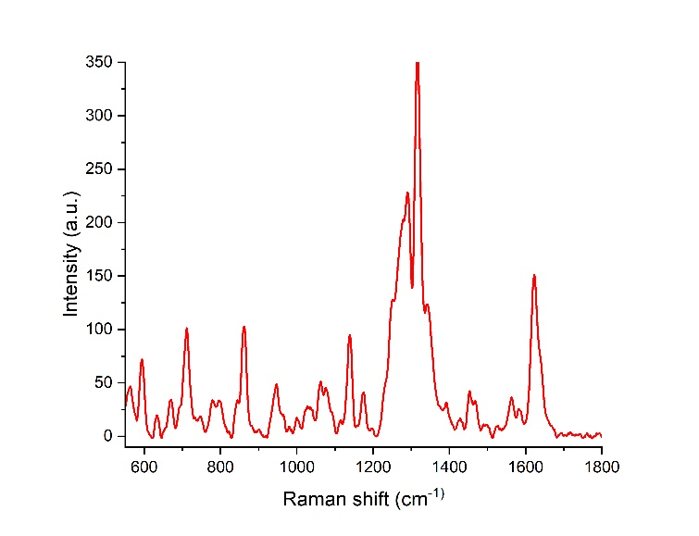
Figure 136
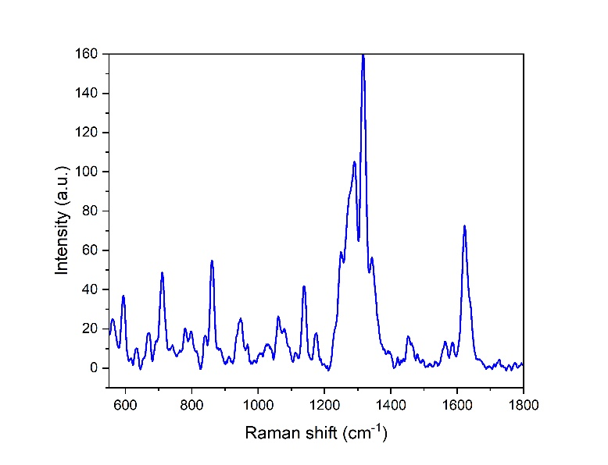
Figure 137
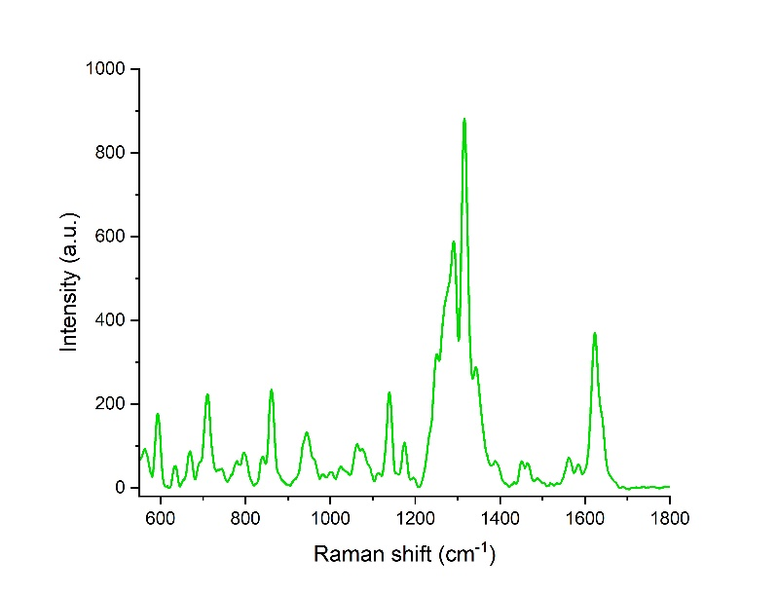
Figure 138
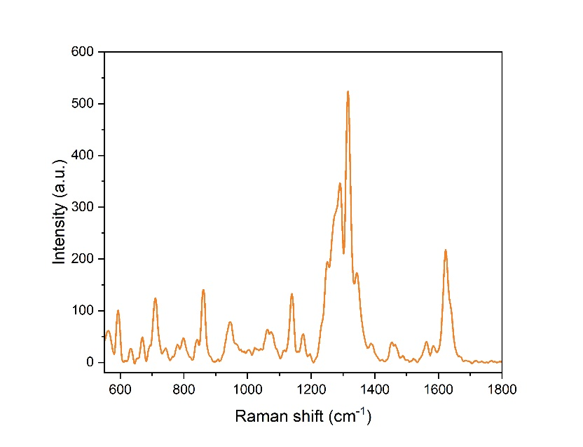
Figure 139
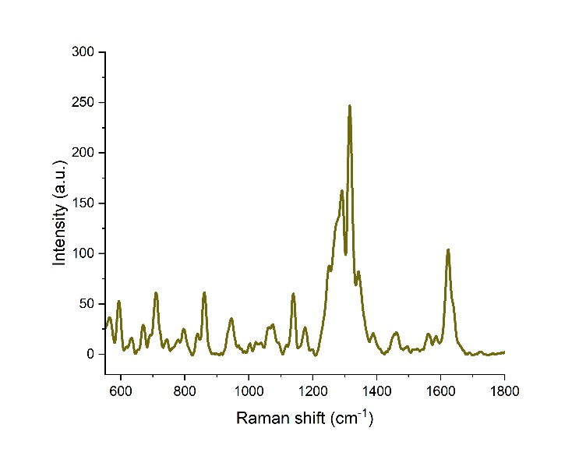
Figure 140
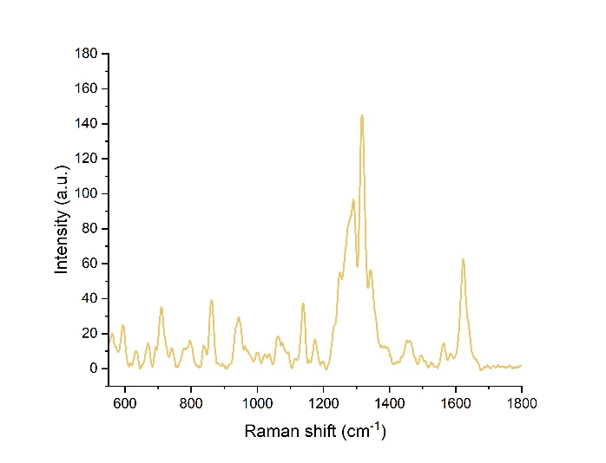
Figure 141

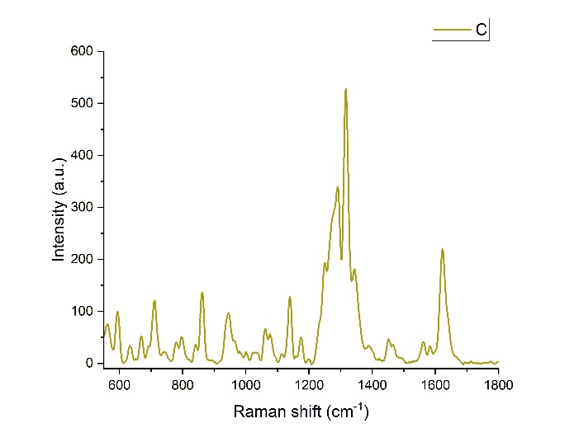
Figure 142
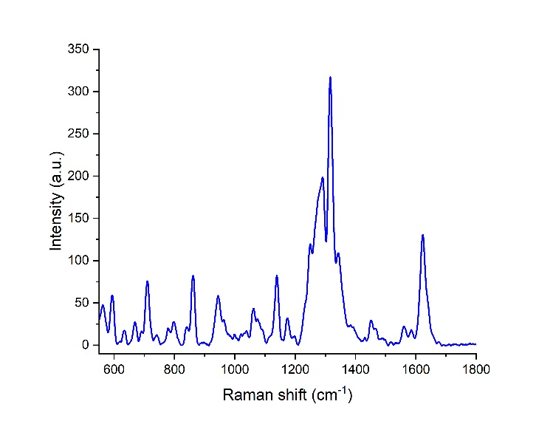
Figure 143

