# Install and set up environment

1. **Pre-condition**

* Maven: Download Node JS (Note: Cucumber can only run on Node.js versions 18 || >=20)
* IntelliJ IDE: [Download](https://www.jetbrains.com/idea/download/?section=windows) IntelliJ IDE Community Edition

1. Steps to download and run test cases:

* Step 1: Checking Maven is installed by using command “mvn –v”.

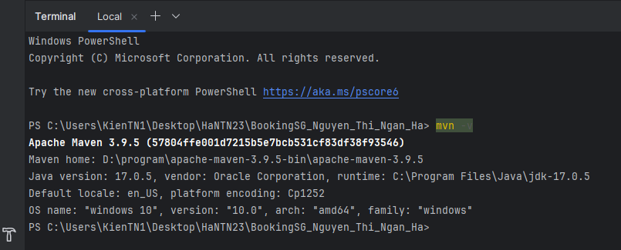

* Step 2: Checking Cucumber (Gherkin) Full Support plugin is installed.

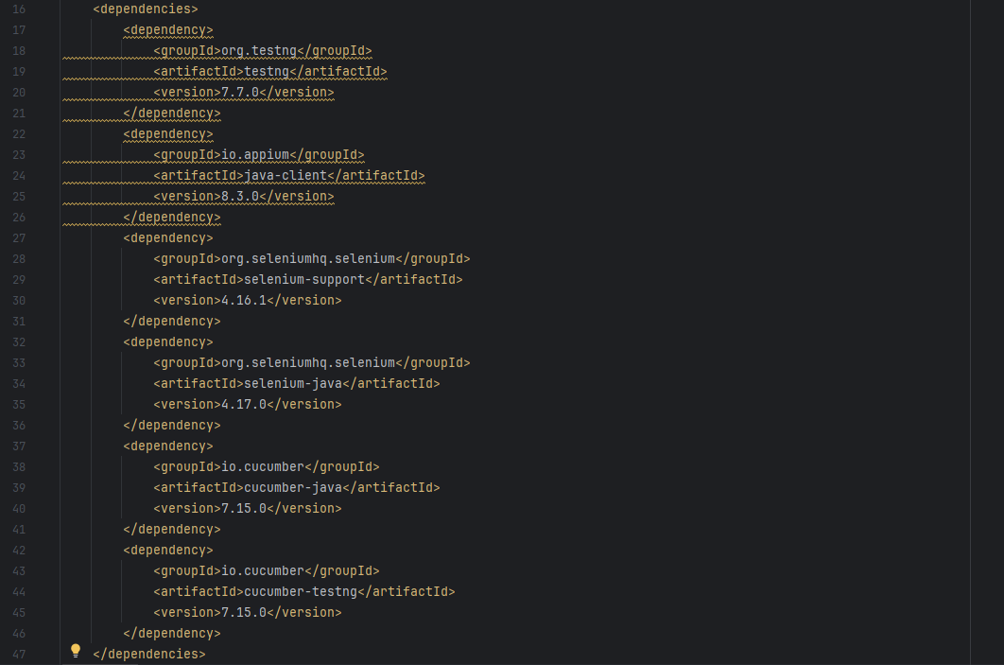

* Step 3: Download , extract file and open folder code by IntelliJ.

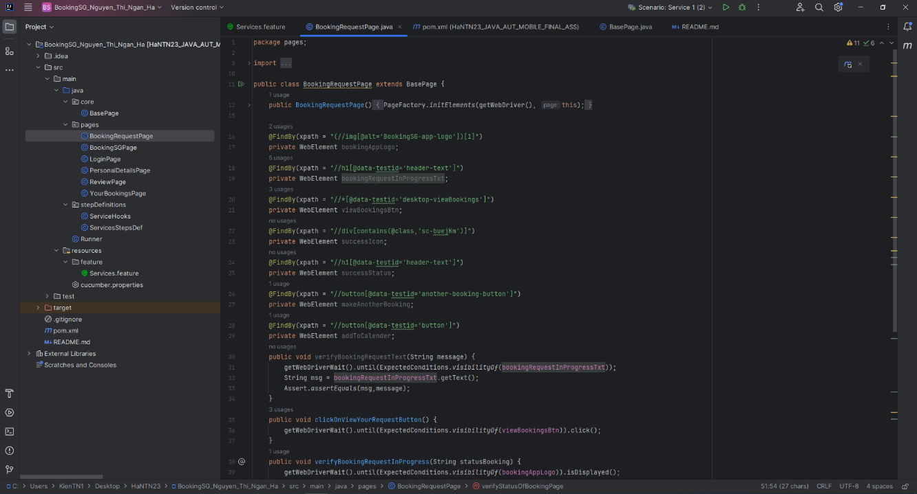

* Step 4: Chosse “Terminal” -> “New Terminal” and run command “**mvn clean install**” to install libraries and dependencies.

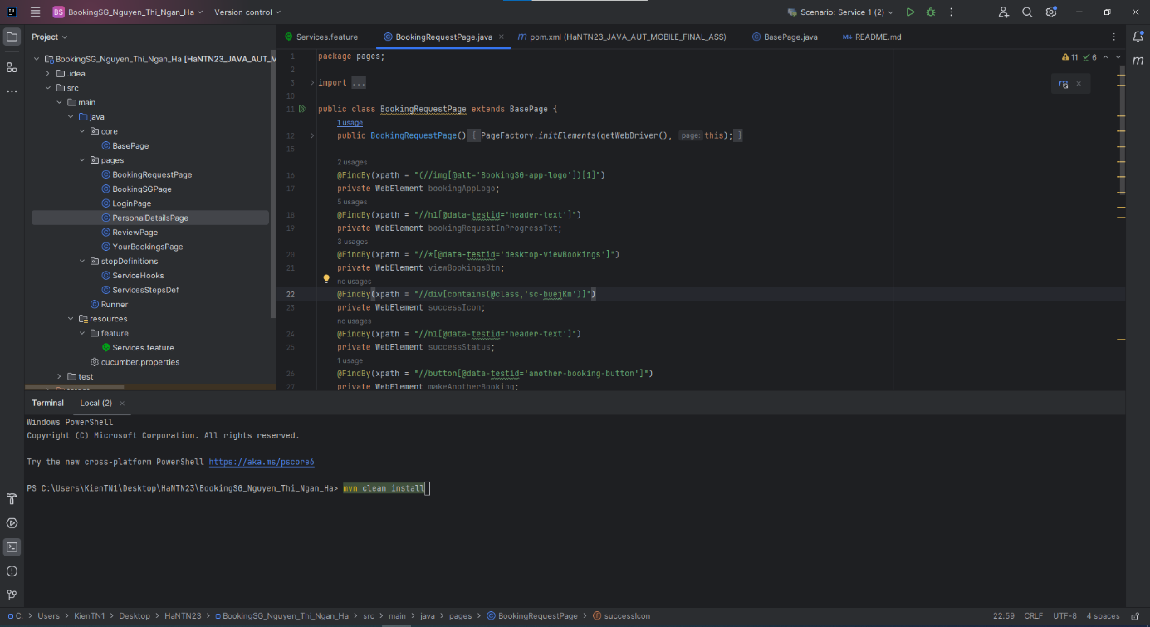

* Step 5:
  + Click on Service.feature >> Click on run button >> click on Run scenario to run specify test case or right-click on Service.feature >> click on “Run feature: Service”

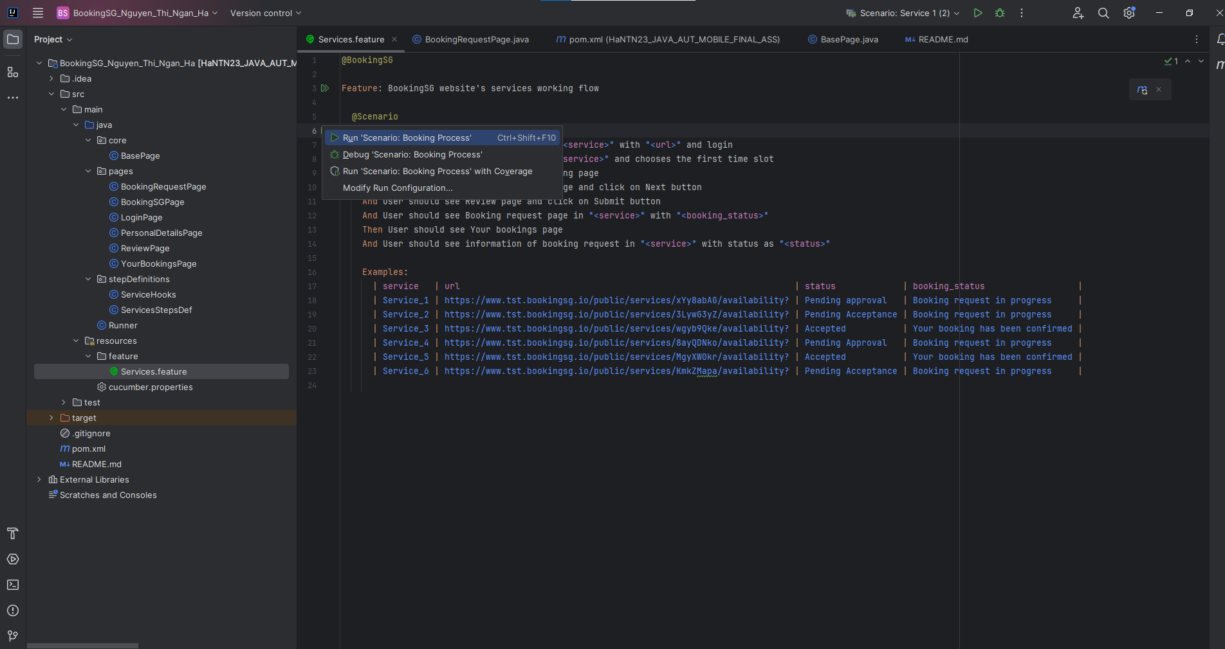

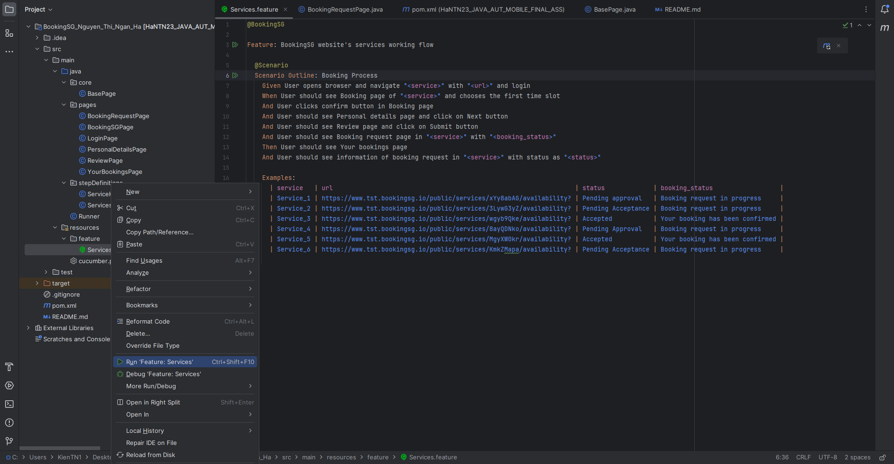

* Right -click on Runner >> click on Run Runner or Click on Runner >> click on Run on Runner class

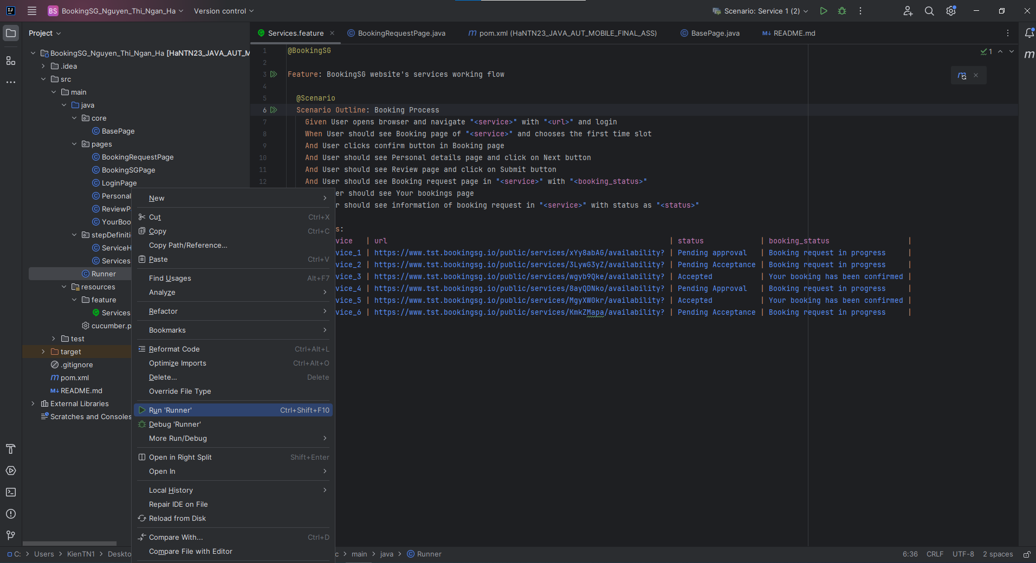

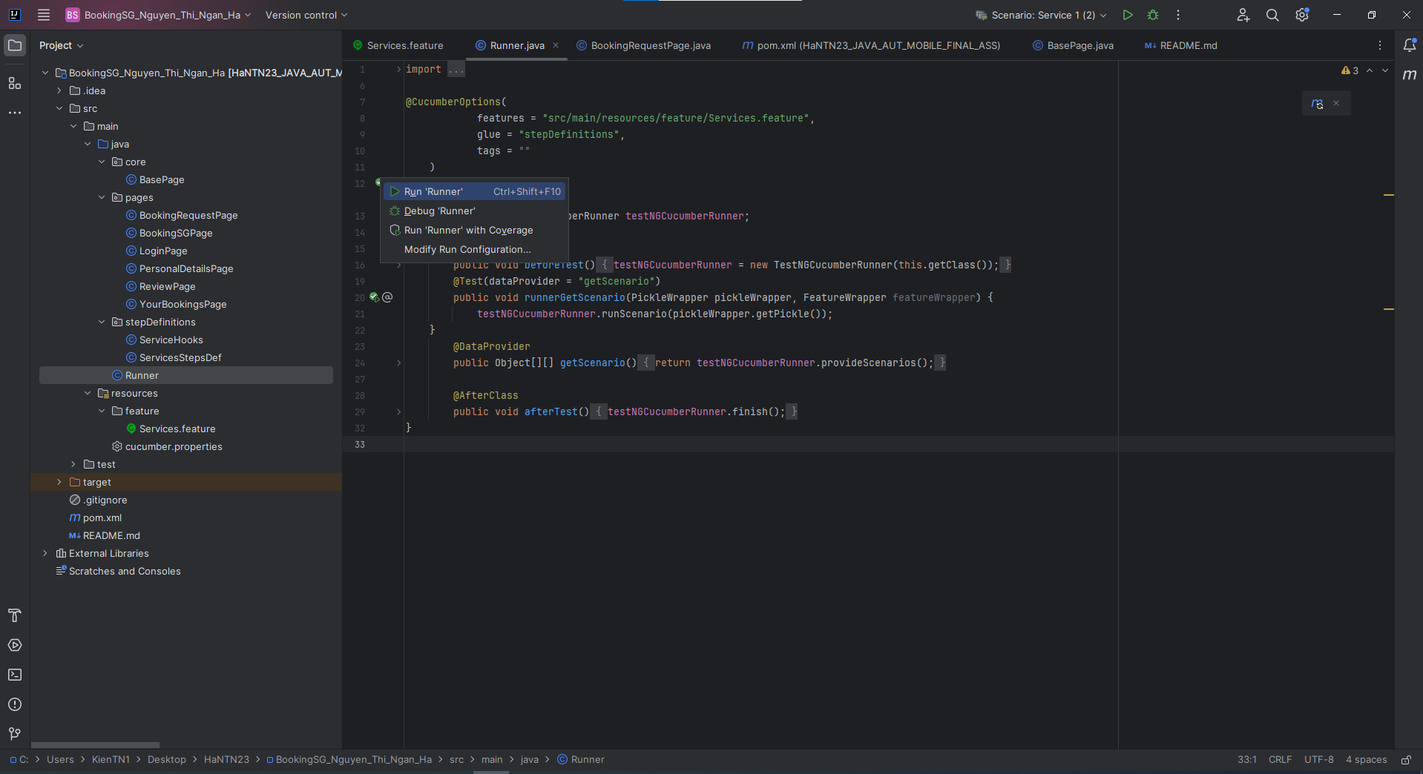

* Step 6: After running, you can see the log

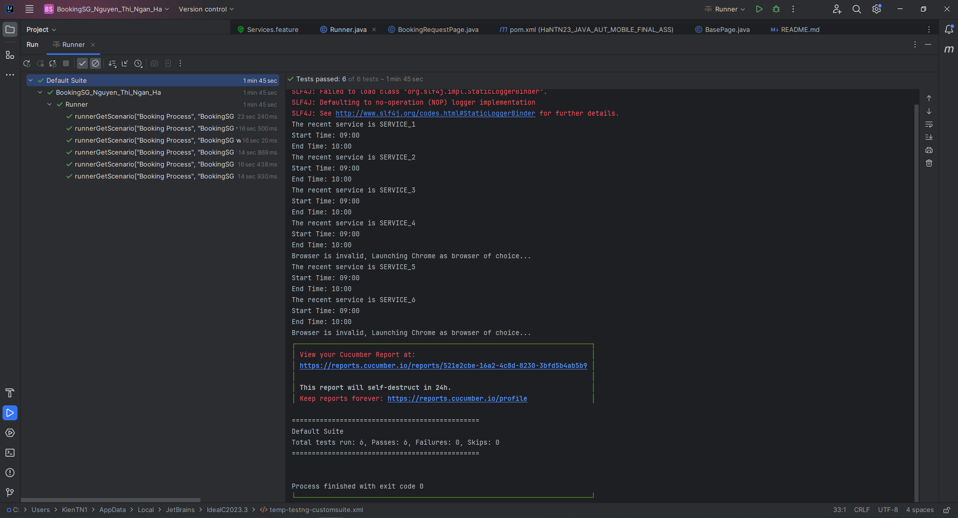

* Step 7: If you want to see the report, you can double –click on the link of the log to see report on browser

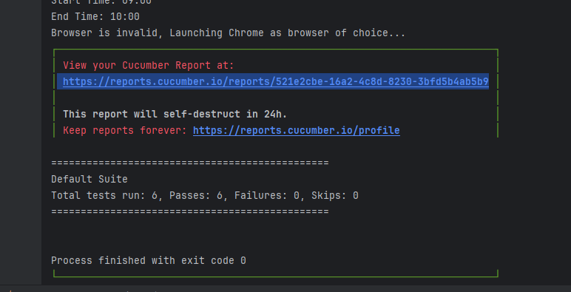

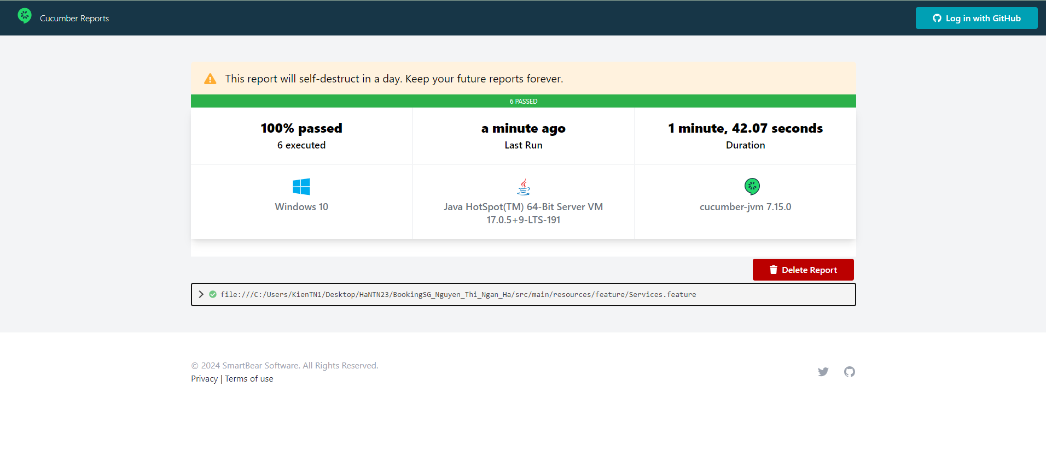

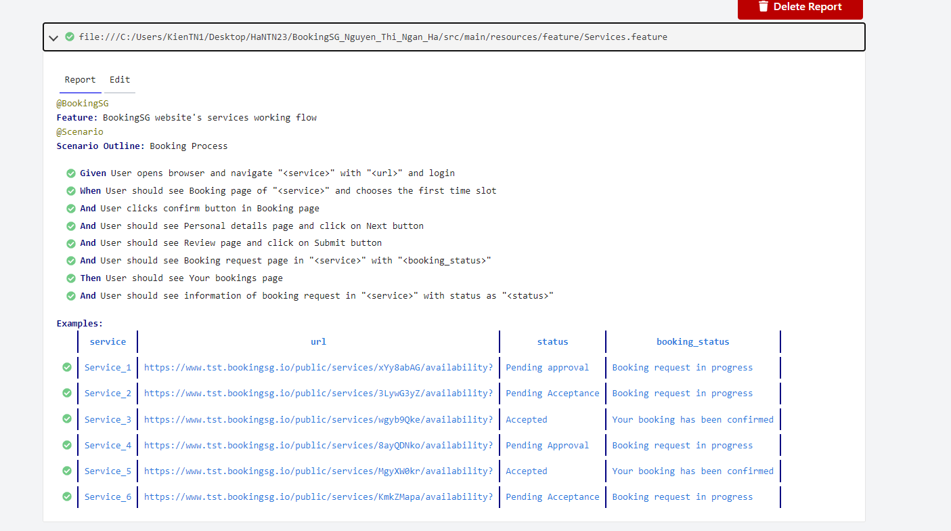

# Describle the automation test framework structure

1. **The framework structure is designed with Page Object Model**

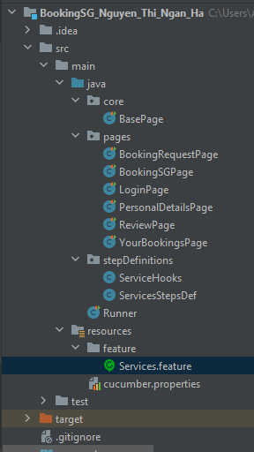

* "**core**" folder contains common classes to use commonly like BasePage class to wrapper all actions of the framework cucumber.
* "**page**" folder includes classes for each web page that contain locators and methods to interact with the page.
* "**feature**" folder store all cucumber feature files. These files contain Gherkin syntax that describes your scenario.
* "**stepDefinitions**" folder define step definitions in Java classes. These classes contain code that corresponds to the steps defined in feature files
* "**Runner**" class to execute Cucumber tests. This class specifies the location of your feature files and step definitions

1. **How to write new test script**

* Step 1: Write scenario in feature file

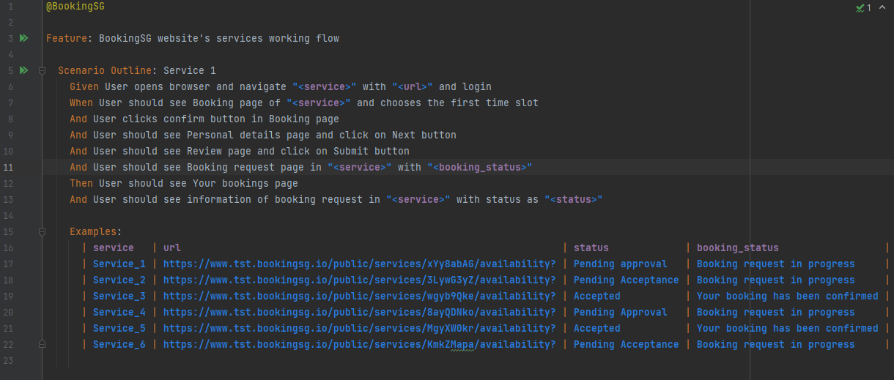

* Step 2: Run feature file. It will generate automatically all steps definition.

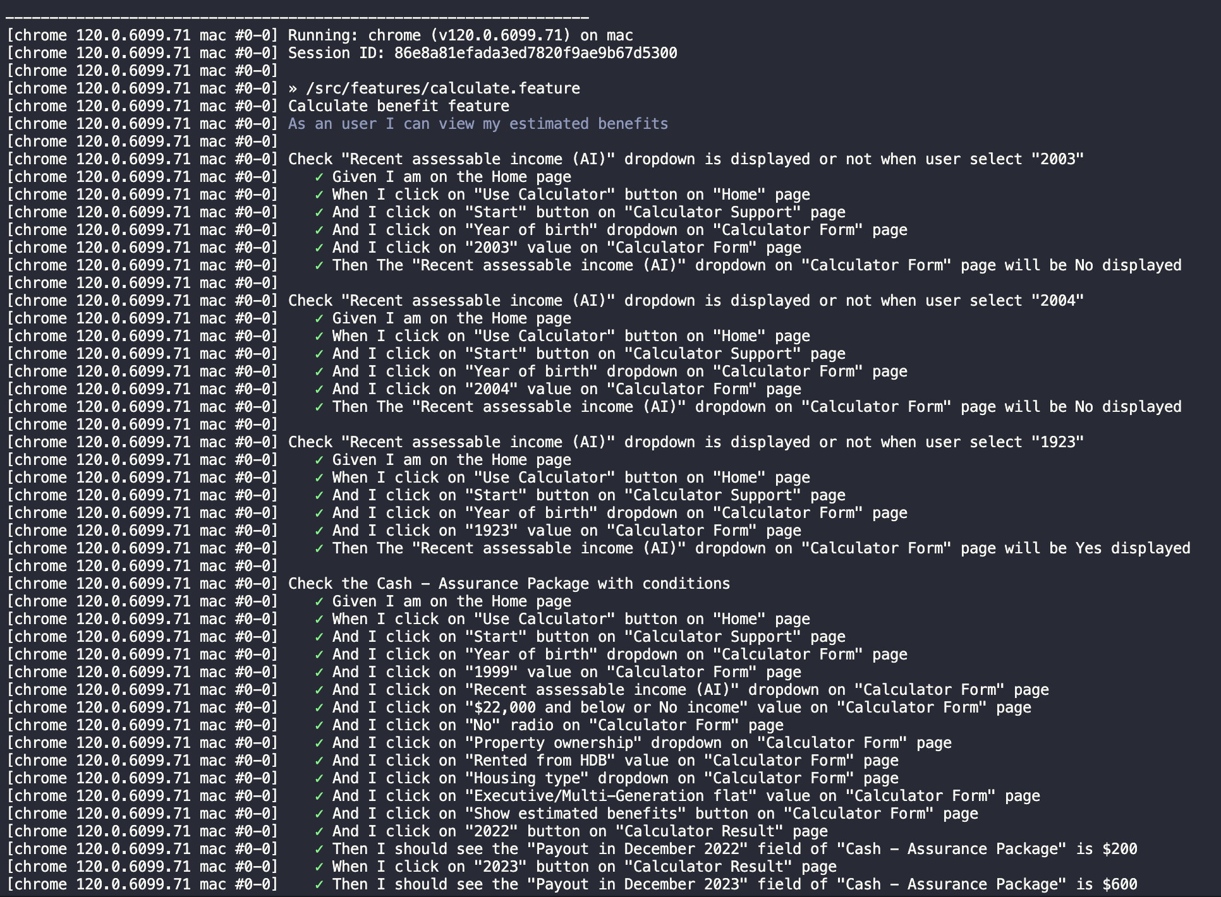

* Step 3: Copy those into step.ts file and implement the action in those steps.

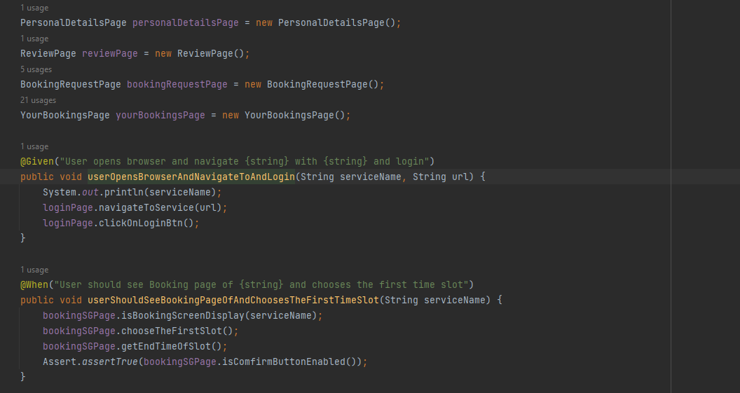

* Step 4: Implement functions in pages folder

