Mini E-Commerce System — Requirement Specification & Design Document (Python Version)

1. Functional Requirements
The system is a simplified e-commerce application suitable for a student group to implement using Python.
Main Functional Requirements:
Browse product catalog: list all products with pagination, filter by category.
Search products: find by name or keyword.
View product details: name, price, description, image, stock quantity.
User registration and login: with email + password; store hashed passwords only.
Shopping cart: add products, update quantity, or remove items. Cart linked to user account/session.
Checkout: place an order with Cash On Delivery (COD) option; system validates stock and updates inventory.
Order history: registered users can view their past orders and order statuses.
Admin management: create, edit, or delete products/categories; update order status; view summary reports (total sales, order count, etc.).

2. Non-Functional Requirements
Programming language: Python
Database: TEXT
Authentication: session-based or token-based (JWT); password hashing using bcrypt.
Security: validate inputs, protect admin endpoints, never store plaintext passwords.
Usability: responsive and simple UI (Bootstrap or basic CSS).
Portability: can run on Windows or Linux with minimal setup.

3. Data Flow Diagram
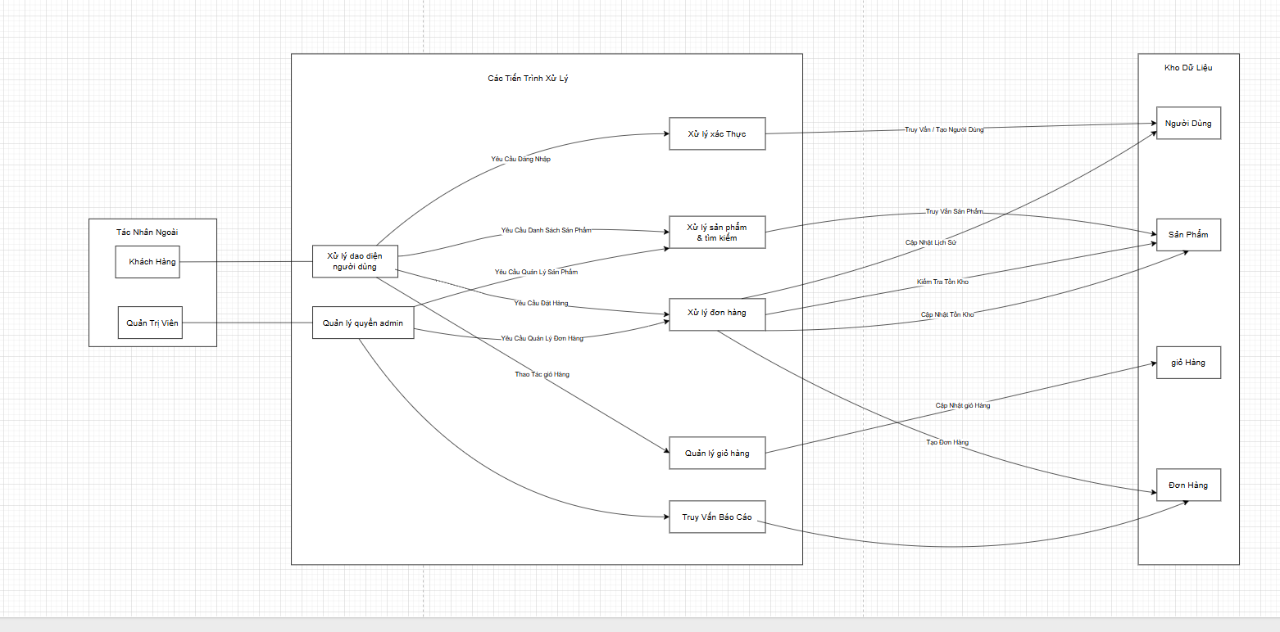

4. Use Case Diagram
Actors:
Guest: browse and search products, view product details.
Registered User: same as guest + add to cart, manage cart, checkout, view order history.
Admin: manage products, categories, and orders.
Main Use Cases:
Browse Products
Search Products
View Product Detail
Add to Cart
Manage Cart
Checkout (COD)
Manage Products and Orders (Admin)
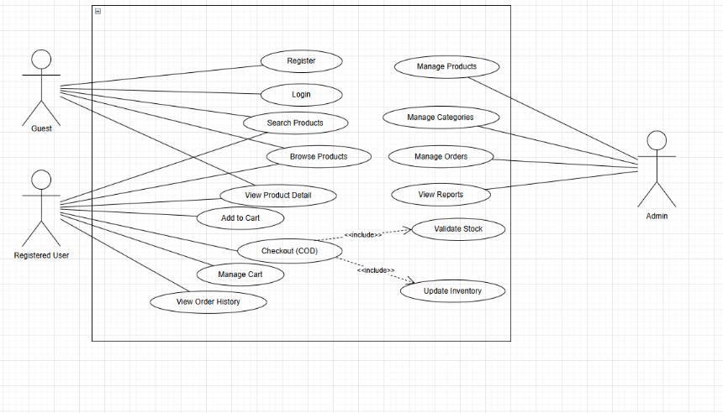

5. Class Diagram
Core Classes:
User
id, name, email, password_hash, role
Category
id, name, parent_id
Product
id, name, price, stock, category_id
Cart
id, user_id, created_at
CartItem
id, cart_id, product_id, qty
Order
id, user_id, total, status, created_at
OrderItem
id, order_id, product_id, qty, price
Relationships:
One user → many carts, orders.
One category → many products.
One cart → many cart items.
One order → many order items
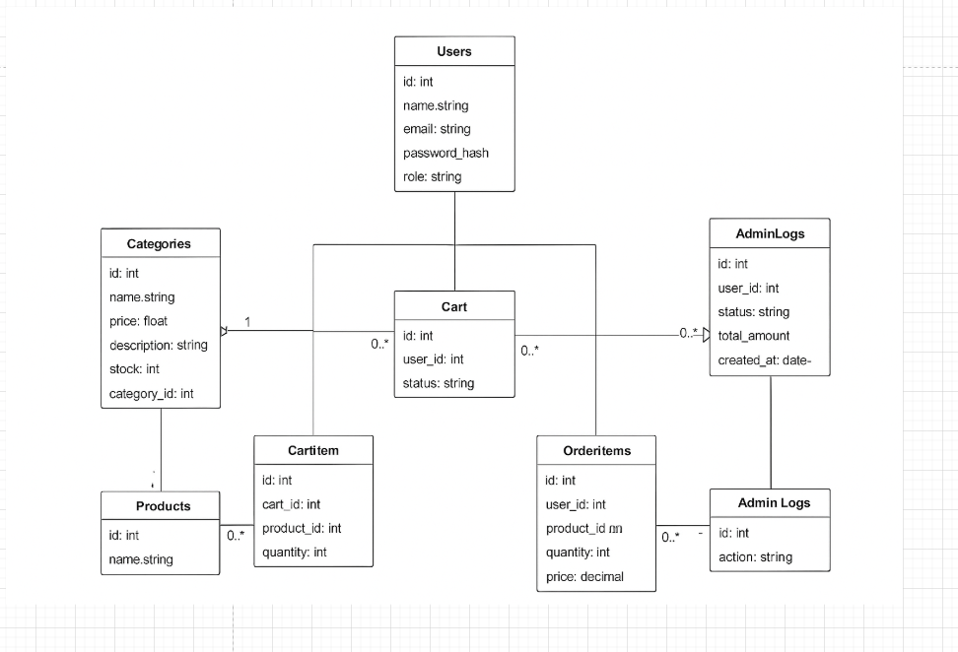

6. Data Model
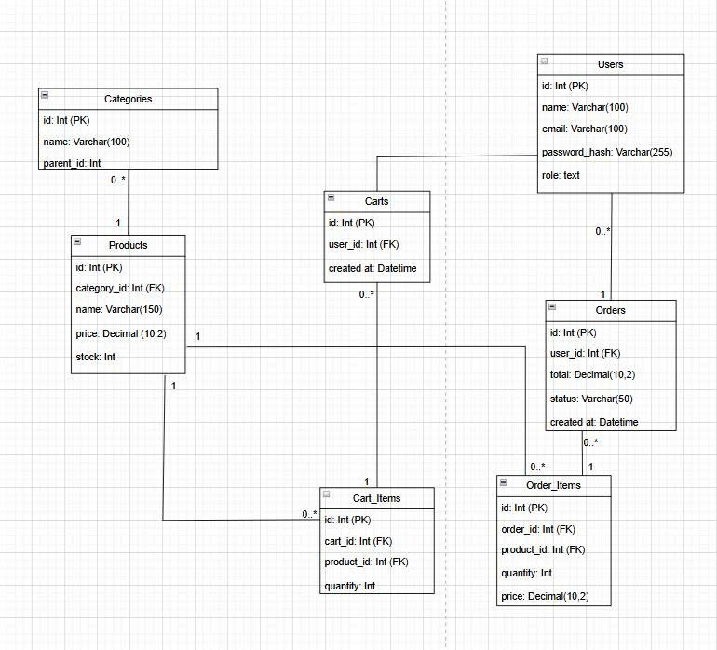
- Interface Design Description (if any)
UI Pages (basic demo):
Home / Product list
Product detail page
Shopping cart
Checkout page
Admin dashboard (product & order management)

