**Ha Noi University of Science and Technology**



**----** **School of Electronic Engineering ----**

**REPORT**

control devices by sound and switch

|  |  |
| --- | --- |
| Subject: | Thesis I |
| Students: | Nguyen Thai Nguyen– 20192241 |
| Instructor: | Ph.d Tran Thi Anh Xuan |
|  |  |

HaNoi, 08/2022

Table of Contents

Table of Contents

Table of Contents 2

Abstract 3

Chapter 1 Introduction 3

Application 3

Advantage: 4

Chapter 2 Design the idea. 4

Idea of code: 4

Idea Of Hardware 4

Chapter 3 DESIGN 5

Design software 5

Design hardware 10

Chapter 4 RESULT 15

Demo in proteus 15

real circuit 15

Chapter 5 CONCLUSION 16

design 16

program 16

create real circuit 16

Chapter 6 REFERENCE: 16

## Abstract

As society develops, people increasingly use technology in life and work. is a student of ''HANOI University of Science and Technology'', a school known for its rich history, which has trained high-quality technical human resources for the country, based on the spirit of of the previous generations, I want through this project to train myself in design thinking, problem-solving thinking and as a driving force to promote my passion for engineering technology, to have the most solid foundation. for future projects.

Besides having a foundation of theoretical knowledge, we need to add experience in building real circuits in practice. Since taking the course, I have been able to discover my strengths and limitations in doing a real task, especially the flexibility in problem solving to get a final result, the ability to filter information, and many other skills were developed. However, there are still many constraints that I will plan to perfect to have the best preparation for the following projects.

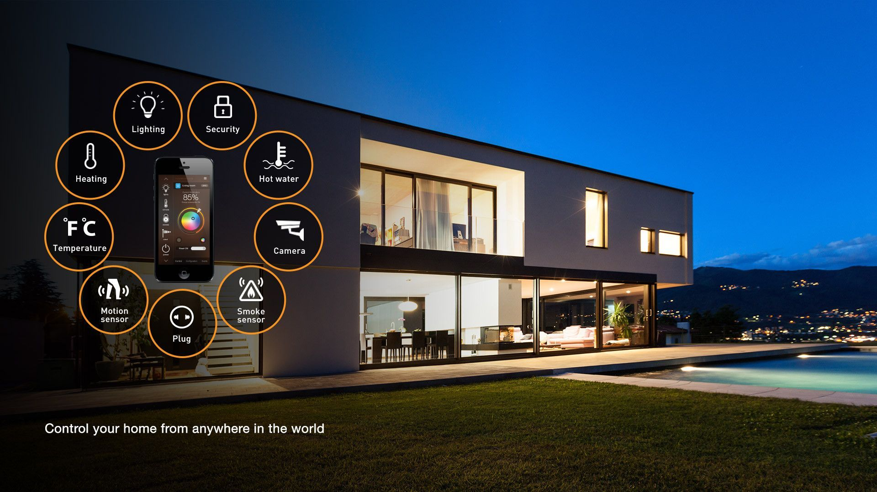Finally, I would like to thank my teacher Dr Nguyen Thi Anh Xuan for creating the best environment for me to research and create, especially she has supported me throughout the whole time since from start to finish the project.

# Introduction

## Application

The technology of social is more and more modern, especially, smart home is more popular because the convenient of it. And control device by sound and switch it is applicated in smart home technique. use sound to be able to control desired devices remotely, or directly.

## Advantage:

* + Control devices by sound help user control devices in the long distance, it convenient than traditional control (only by switches).
  + User have more than one choice to control, if sound control is failed, user can use switches. And if switches are failed, user can control devices by sound.
  + Control devices by sound help user decrease accidents by electric when it decreases the contact directly with electric devices.
  + Basic circuit structure does not need control communication via phone
  + It helps your home/room is more modern.

# Design the idea.

## Idea of code:

* Use Interrupt for design: Because control device by two ways: sound and switch so the events of sound signal/ switch cannot determine before, so we have to use Interrupt to solve undermine signal.
* Use interrupt with switches signal: because sound signal has to execute more complex than switch signal, so we choose interrupt witch switch signals.
* Design algorithm:
  + The numbers of devices and the numbers of switches is the same, and the signal of switch is high or low, therefore they need not to analyst the signal more.
  + We have to analyst the signal of sound sensor, because the communication of it witch microcontroller is divided to many cases it depends on the numbers of controlled devices. And the way to analyst signal is that: first we have to determine the apparent of signal, if it exists, we have to know how many times the signal appear, and then we control each device by cases.
  + Design interrupt: depend of the signal of switch, we will call interrupt function, and the state variable will be change, to change the state of device.

## Idea Of Hardware

* **choose microcontroller**: Arduino Uno is chosen.
  + **Inexpensive** - Arduino boards are relatively cheap compared to other microcontroller platforms. The least expensive version of the Arduino module that can be assembled by hand, and ecause Arduino Uno is one of the most popular microcontrollers in the market.
  + **It is not complicate** with user who begin to learn microcontroller; however, it is the most choice to start because beginner do not have many experiences, and they have a lot of problem to solve, therefore the basic microcontroller helps beginner more confident, and motivated to learn by myself in free time, and begin to approach with code microcontroller in the friendly way.
  + **Open source and extension software.**
* **Choose Arduino IDE**.

# DESIGN

## Design software

* **Flowchart.**

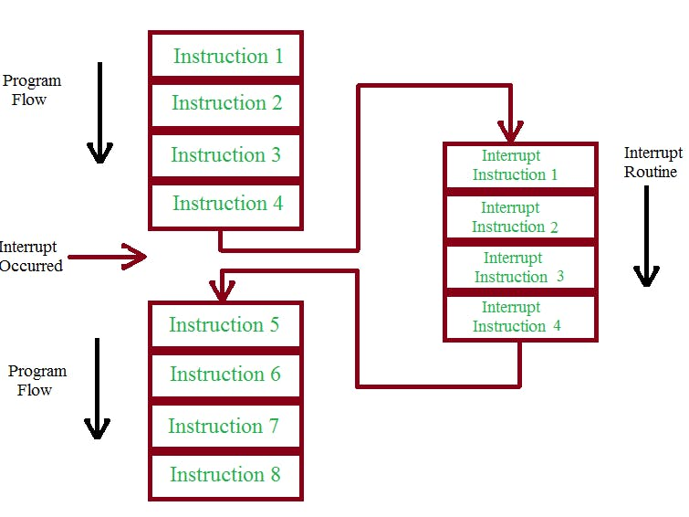

Step1: First block used to define the setup of relay1, relay2, senser with pin 12, pin 11, pin 13 in order.

Step2: execute the instruction in setup function, especially interrupt functions are settled

Step3:

* + 1. Case1: execute the instruction in void loop function if do not exist interrupt signal
    2. Case2: If the interrupt signal occurs, the microcontroller stops the current job immediately and executes the interrupt service routine.

* Text, letter

  Description automatically generatedFirst block:
  + 1. Set sensor signal is input signal
    2. Set relay1 and relay2 signal is output signal
* Text

  Description automatically generated with medium confidenceSecond block:
  + 1. Text, letter

       Description automatically generatedSet state1 and state2 variable is 1, it means that initial state of relay1 and relay2 is turned on.
* Third block
  + 1. Set pin 2 and pin 3 are high states, and if the states are low, the interrupts signal will be occurred.
    2. Text, letter

       Description automatically generatedDeclare interrupts of first switch and second switch In Arduino, we are supported with 2 types of interrupts as follows:
       - Interrupt number 0 is connected to pin 2.
       - Interrupt number 1 is connected to pin number 3.
    3. mode: interrupt trigger type, including
       - LOW: continuous activation when the digital foot state is low
       - HIGH: continuous activation when the digital foot state has a high level.
       - CHANGE: Interrupt when there is a change, perform the interrupt program when there is a change on the breaker, from low to high, from high to low (edge up, edge down)
       - RISING: activates when the state of the digital pin changes from a low voltage level to a high voltage level.
       - FALLING: triggers when the state of the digital pin changes from a high voltage level to a low voltage level.

Void loop function:

* First block: control relay1 and ralay2 base on state1 and state 2 variable, if state variables equal 1, relays will be turn on, opposite it will be turn off. this block is put to the top, because it is the common block of the case of interrupt signal or not
* Second block: Read signal of sensor and save the value into valueSensor variable.
* Third block to the final block are working with void sensor signal. If the signal of sensor appears.
  + 1. Firstly, microcontroller will check how many clapping sounds?
    2. Secondly, information will be checked two cases, if the number of swipes is once, the state1 variable will be changed state. if the number of swipes is twice, the state2 variable will be changed state

## Design hardware

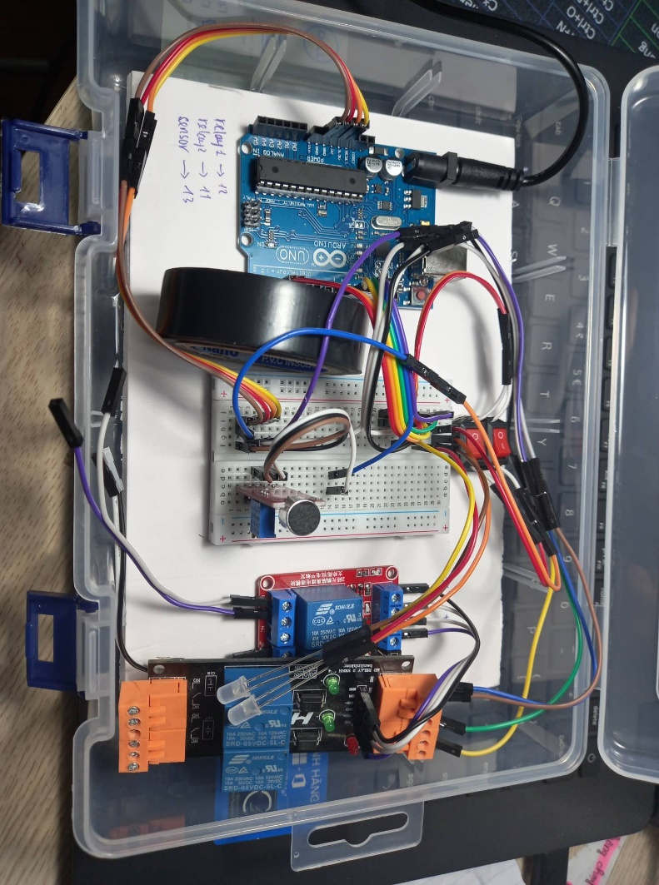

* **Component:**
  + Relay:
    - Because control current should be equal the the current set bit high state of microcontroller, therefore choose control current is 5V and to control the devices in home we choose the current of load is 220V.
    - Relay should have Opto to protect the circuit, especially it protects microcontroller by High voltage.
  + Sound sensor KY-037

This module includes a sensitive condenser microphone for sound detection and an amplifier circuit. The output of this module is both analog and digital. The digital output acts as a key and it

activated when the sound intensity has reached a certain threshold. The sensitivity threshold can be adjusted via the potentiometer on the sensor.

The analog output voltage varies with the intensity of the sound received by the microphone. You can connect this output to the analog pins of the Arduino and process the output voltage.

* + - A picture containing chart

      Description automatically generated

To use this module with Arduino simply connect the supply voltage of the module and, according to your need, connect its analog or digital pins to Arduino.

* + Current wire
  + Switch
  + Led
  + Adapter

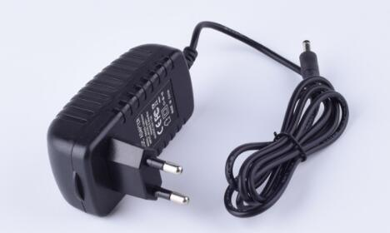

The main function of the Adapter The most important and primary role of the Adapter is to convert the voltage. Power adapters can provide a suitable power supply for all types of devices by reducing the voltage input and output current in accordance with the rating of each device.

* **Therefore, In this project it is used to power Arduino**
  + Board Arduino\

* + 1. Hardware Structure of Arduino

Microcontroller

14 Digital Pin (for INPUT and Output)

6 Analog Pins ( named as A0 – A5)

Power Supply

Power Jack

USB Port

Reset Button

Microcontroller: Microcontroller is the main component of Arduino Uno ,The Arduino Uno board is a microcontroller based on the ATmega328.

14 Digital Pins: Arduino Uno Consist of 14 Digital Pins Where output Components like: LED, LCD, Relay etc; are connected.

Analog Pins: Arduino Uno Consist of 6 Analog Pins, Analog Pins are usually used to connect sensor like: IR Sensor , RF Sensor these all sensor have analog value that’s why they are connected to analog pins, Most of the input components are connected here.

Power Supply: The power supply pins are Vin, 5V, 3.3V, GND, IOREF are used to power Input and output components. The recommended range is 7 to 12 volts to play your board safe.

Power Jack: Arduino board can be powered either by USB connection or with an external power supply. This is used to power the Arduino board where we connect the 9-volt battery.

USB Port: This port function to program the board or to upload the program. The one end of USB cable is connected to the laptop and another to this port. With help of Arduino software and USB cable, one can upload the program on the board.

Reset Button: This is used to start the program again which is once uploaded.

* + 1. SCHEMATICS

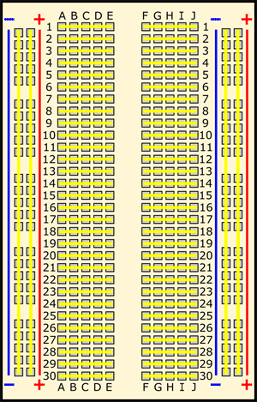

* + Test breadboard

Breadboards allow components to be easily inserted and removed therefore, the word prototyping immediately comes to mind. If an engineer designs a simple module or circuit that they want to test, a breadboard provides a cheap and quick solution (designing a PCB just to test a simple circuit can be overkill and expensive)

# RESULT

## Demo in proteus

## real circuit

# CONCLUSION

## design

this is considered a difficult project for beginners, and the design is the most important thing from start to finish of the project, is a new project about incorporating the sound sensor and the switch makes the designer to have background knowledge and problem-solving mindset when experience is a hindrance, after this project training in design thinking is the most important thing when working on other projects bigger

## program

The use of C language is an advantage when this language has been learned before, in addition, the program also requires knowledge of microprocessors, especially using interrupts in this project. the most important thing, the program still has many disadvantages, especially in audio processing, the processor itself is still fundamentally unable to meet the higher requirements. But the fact that the program has controlled 2 devices using two external interrupts may be enough to meet the requirements.

## create real circuit

Being able to make a real circuit for the first time in a project is an exciting and useful thing to put knowledge into practice, the design of a real circuit has many problems when it is not the same as the simulation on software, occurs many times. Errors are more complicated and difficult to solve, in addition, choosing the right components is very important and it is necessary to choose reusable components in the following projects.

# REFERENCE:

Interrupt:

[Ngắt ngoài trên Arduino - Điện Tử Hello (dientuhello.com)](https://www.dientuhello.com/ngat-ngoai-tren-arduino/#:~:text=Ng%E1%BA%AFt%20trong%20Arduino%201%20C%E1%BA%A5u%20tr%C3%BAc%20c%E1%BB%A7a%20h%C3%A0m,Uno.%203%20V%C3%A0i%20v%E1%BA%A5n%20%C4%91%E1%BB%81%20v%E1%BB%9Bi%20ng%E1%BA%AFt.%20)

https://create.arduino.cc/projecthub/rafitc/interrupts-basics-f475d5

Microcontroller:

[Basic concept of Arduino & Hardware Structure of Arduino (electronicsmedia.info)](https://www.electronicsmedia.info/2019/02/01/basic-concept-arduino-hardware-structure-arduino/)

Sound sensor:

[How to Use KY-037 Sound Detection Sensor with Arduino - Arduino Project Hub](https://create.arduino.cc/projecthub/electropeak/how-to-use-ky-037-sound-detection-sensor-with-arduino-a757a7)

Test Breadboard:

[How to Use a Breadboard (sciencebuddies.org)](https://www.sciencebuddies.org/science-fair-projects/references/how-to-use-a-breadboard)