Student: Nguyen Tuan Hiep - 20205151

Processor: Intel(R) Core(TM) i7-7Y75 CPU @ 1.30GHz - 1.60 GHz

**TSP backtracking:**

Test case 1: n = 5

Test case 2: n = 10

Test case 3: n = 15 (Time out)

**TSP branch and bound**

Test case 1: n = 5

Test case 2: n = 10

Test case 4: n = 20 (Time out)

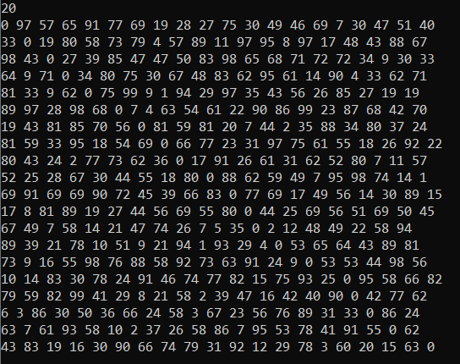

|  |  |  |
| --- | --- | --- |
| **n** | **Time (TSP Backtracking)** | **Time (TSP Branch and bound)** |
| 5 | 0s | 0s |
| 10 | 0.043s | 0.029s |
| 15 | Time out | 7.895s |
| 20 | Time out | Time out |
| 30 | Time out | Time out |