

Nguyen Nguyen  Natthakorn Rattanakun  Md Rahman | Student ID: e2301514  Student ID: e2301505  Student ID: e2305279
REPORT OF EMBEDDED SYSTEMS DESIGN
Group 2

Information Technology,
2026

CONTENTS
ABSTRACT
11 Introduction 7
12 System Architecture 8
Overall System Description 8
Block Diagram 9
Flowchart: Communication Cycle (Modbus RTU Master–Slave) 10
13 Hardware Design and Justification 12
STM32L52RE 12
3.2 Sensor Interfaces 12
13.1.1 LMT84LP Temperature Sensor 12
13.1.2 NSL-19M51 Light Measurement 13
13.1.3 DHT22 Temperature and Humidity Sensor 14
13.1.4 Grove SGP30 Gas Sensor 14
13.1.5 AC Voltage Measurement 15
13.1.6 Power Consumption Measurement 16
14 Analytical calculations and simulations 17
14.1.1 LMT84LP Temperature Sensor 17
14.1.2 NSL‑19M51 Light Sensor (LDR) 18
14.1.3 Digital relative humidity & temperature sensor DHT22 20
14.1.4 Grove Air Quality Sensor — SGP30 (TVOC & eCO₂) 21
14.1.5 AC voltage measurement 22
14.1.6 Power consumption measurement 24
15 Embedded Software Design 26
Software Architecture 26
15.1.1 Architecture Model 26
15.1.2 Software Layering 26
15.1.3 Driver Layer 26
15.1.4 MCU Peripheral Drivers 26
15.1.5 Sensor Drivers 27
15.1.6 AC Voltage and Power Measurement 28
15.1.7 Utility and Reliability Functions 28
15.1.8 RS-485 / Modbus Communication Driver 28
Sensor Abstraction via read_sensor() 29
Program Flow and Execution Logic 30
15.2.1 System Start-Up and Initialization 31
15.2.2 USART Interrupt and Modbus Frame Reception 31
15.2.3 Main Super-Loop Execution 31
15.2.4 Modbus Request Validation 32
15.2.5 Sensor Acquisition and Data Processing 32
15.2.6 Modbus Response Transmission 33
15.2.7 Continuous Operation 33
16 Communication Design 34
RS-485 Hardware Design 34
Modbus RTU Frame and Register Mapping 34
16.1.1 Modbus Communication Model 34
16.1.2 Modbus RTU Request Frame Format 35
16.1.3 Modbus RTU Response Frame Format 35
16.1.4 Modbus Unit ID and Measurement Mapping 36
Reliability Analysis 37
Timing Analysis 37
17 PCB Design 39
Design Requirements 39
Schematic Justification 39
17.1.1 Power Supply Section 39
17.1.2 Sensor Interface Blocks 40
PCB Layout Principles and Final Design 40
18 Gateway and Cloud Integration 41
PC Gateway Functionality 41
Modbus RTU Communication 41
Data Parsing and Validation 42
Periodic Polling Operation 42
IoT-Tickets Data Upload and Visualization 43
19 RESULTS AND ANALYSIS 44
System Performance 44
Demonstration of Expertise and Problem-Solving 44
Contribution to Development of the Field 45
20 DISCUSSION AND FUTURE DEVELOPMENT 46
Discussion 46
Future Development 46
21 Conclusion 48
Final Assessment of Objectives Achieved 48
Learning Outcomes and Professional Relevance 48
APPENDIX 2: EMBEDDED SOFTWARE SOURCE CODE 53

REFERENCES
Light Dependent Resistors (LDR) | Tutorials on Electronics | Next Electronics. n.d.-a. Retrieved March 17, 2026. https://www.next.gr/tutorials/sensors-and-transducers/light-dependent-resistors-ldr-tutorial.
Maxim Integrated Products, Inc. 2021. MAX3485 - 3.3V-Powered, 10Mbps and Slew-Rate-Limited True RS-485/RS-422 Transceivers. https://www.analog.com/media/cn/technical-documentation/data-sheets/1079.pdf.
OP-AMP COOKBOOK — Part 4. n.d. Retrieved March 17, 2026. https://www.nutsvolts.com/magazine/article/op-amp-cookbook-part-4.
Advanced Photonix. n.d. NSL-19M51 Photocoupler Datasheet. Advanced Photonix. https://www.farnell.com/datasheets/77395.pdf.
Sensirion. 2017. Sensirion SGP30. Sensirion. https://files.seeedstudio.com/wiki/Grove-VOC_and_eCO2_Gas_Sensor-SGP30/res/Sensirion_Gas_Sensors_SGP30_Datasheet_EN.pdf.
Sensirion. 2022. Grove-SGP30 Datasheet. Sensirion. https://www.farnell.com/datasheets/3759017.pdf.
Texas Instruments. 2017. LMT84 Analog Temperature Sensor Datasheet. Texas Instruments. https://www.ti.com/lit/ds/symlink/lmt84.pdf.
Liu, Thomas. n.d. DHT22. Aosong Electronics Co.,Ltd. https://components101.com/sites/default/files/component_datasheet/DHT22%20Sensor%20Datasheet.pdf.
Modbus Protocol. n.d. Retrieved March 18, 2026. https://www.modbustools.com/modbus.html#function03.
Storey, Neil. 2017. Electronics: A Systems Approach, 6th Edition. PEARSON EDUCATION LIMITED.

VAASAN AMMATTIKORKEAKOULU
UNIVERSITY OF APPLIED SCIENCES
Information Technology

ABSTRACT
Author Nguyen Nguyen, Natthakorn Rattanakun, Natthakorn Rattanakun
Title Embedded Systems Design
Year 2026
Language English
Pages 30 + 2 Appendices
Name of Supervisor Tommi Rintala

This project addressed the design and implementation of a distributed home-automation and monitoring system based on low-power embedded devices. The work was motivated by the growing demand for scalable, reliable, and energy-aware monitoring solutions in residential environments. The primary objective was to design and validate a modular system capable of acquiring environmental and electrical parameters, transmitting data reliably over an industrial fieldbus, and supporting future integration with cloud-based monitoring platforms.
The study was grounded in embedded systems theory, industrial fieldbus communication, and Internet of Things (IoT) architectures. Key concepts included Modbus RTU communication over RS-485, mixed-signal sensor interfacing, and gateway-based data aggregation. The system was implemented using STM32L152RE microcontrollers configured as Modbus slave nodes, while a PC-based gateway operated as the Modbus master. Multiple sensors were integrated to measure temperature, humidity, light intensity, gas concentration, AC voltage, and power consumption.
Experimental results demonstrated reliable multi-node data acquisition and stable Modbus RTU communication between slave nodes and the gateway. Environmental sensors and communication subsystems operated as expected, validating the proposed architecture. Although cloud integration with the IoT-Tickets platform was not fully implemented at this stage, the system was designed to support future data upload and visualization with minimal modification.
It is concluded that the proposed design provides a flexible and extensible foundation for small-scale home-automation and IoT-based monitoring applications, while also offering valuable practical insights into real-world embedded system design and validation.

Introduction
Embedded systems and IoT technologies play an increasingly central role in modern smart homes and buildings, enabling efficient data collection, real‑time processing, and seamless integration between physical devices and cloud‑based services.
This project focuses on creating a small‑scale but realistic setup that brings together different types of sensors, operates under real‑time constraints, and communicates over a wired RS‑485 fieldbus. The work involves several practical challenges: ensuring accurate sensor interfacing, safely measuring AC voltage, working within the limits of a microcontroller, and maintaining deterministic communication using Modbus RTU.
The goal of the project is to design, build, and test a distributed home automation system that gathers sensor data based on STM32 microcontrollers, sends it to a PC gateway via Modbus RTU, and forwards it to a cloud platform for visualisation. Through this process, the project strengthens hands‑on skills in embedded development, peripheral interfacing, and industrial communication, while highlighting the value of real‑time thinking, systematic design methods, and forward‑looking system architecture.

- System Architecture

Overall System Description
The system follows a master–slave architecture designed for scalable data acquisition, local control, and cloud-based monitoring. It is structured into three logical layers:
- Slave Layer – STM32 Sensor Nodes
- Master Layer – PC Gateway
- Cloud Layer – IoT-Tickets Platform
The system is based on a master–slave architecture comprising embedded sensor nodes, a PC-based gateway, and a cloud service layer. This structure enables reliable distributed data acquisition and centralized data management.
Multiple STM32 L52RE based nodes operate as Modbus RTU slaves. Each node interfaces with environmental and electrical sensors and performs periodic sampling and preprocessing. Processed measurements are stored in Modbus registers and are transmitted only in response to master requests.
A PC gateway acts as the Modbus RTU master, coordinating communication over an RS-485 network. It polls the slave nodes, aggregates the acquired data, and forwards the results to the cloud using standard internet protocols.
The IoT-Tickets cloud platform provides data storage, visualization, and remote access. This layered design separates real-time embedded tasks from higher-level data handling, improving scalability and system reliability.

Block Diagram
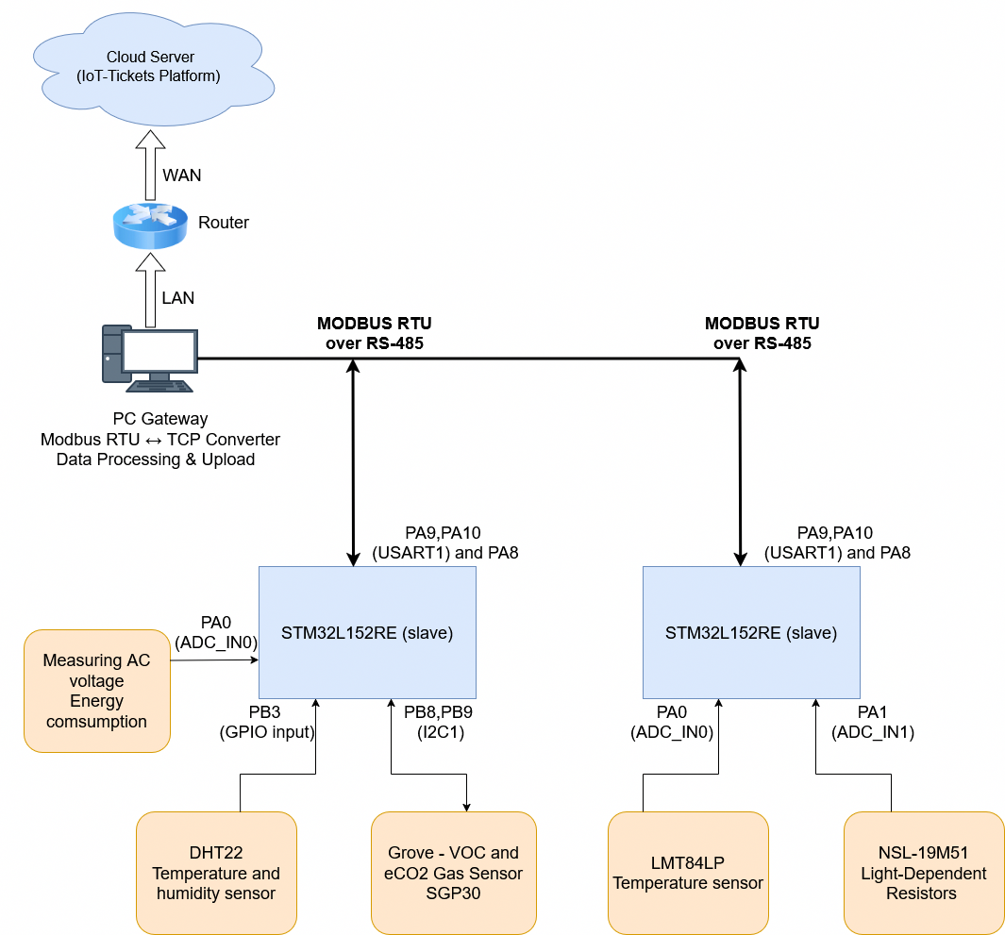
Each STM32 slave node integrates sensor interfaces (ADC, GPIO, I²C), embedded processing, and an RS-485 communication interface. Sensor data are acquired, converted into engineering units, and mapped to Modbus registers.
All slave nodes are connected to a shared RS-485 Modbus RTU bus, which implements a master-initiated request–response communication model with CRC-based error detection.
The PC gateway polls the slave nodes, validates received data, aggregates measurements, and converts them into cloud-compatible formats. The processed data are then transmitted to the IoT-Tickets cloud, where they are stored and visualized.
Data Flow Summary:
Sensors → STM32 slave nodes → RS-485 Modbus RTU
→ PC gateway → Internet → IoT-Tickets cloud

Flowchart: Communication Cycle (Modbus RTU Master–Slave)
This flowchart describes the PC Gateway as Modbus Master and STM32 nodes as Slaves.
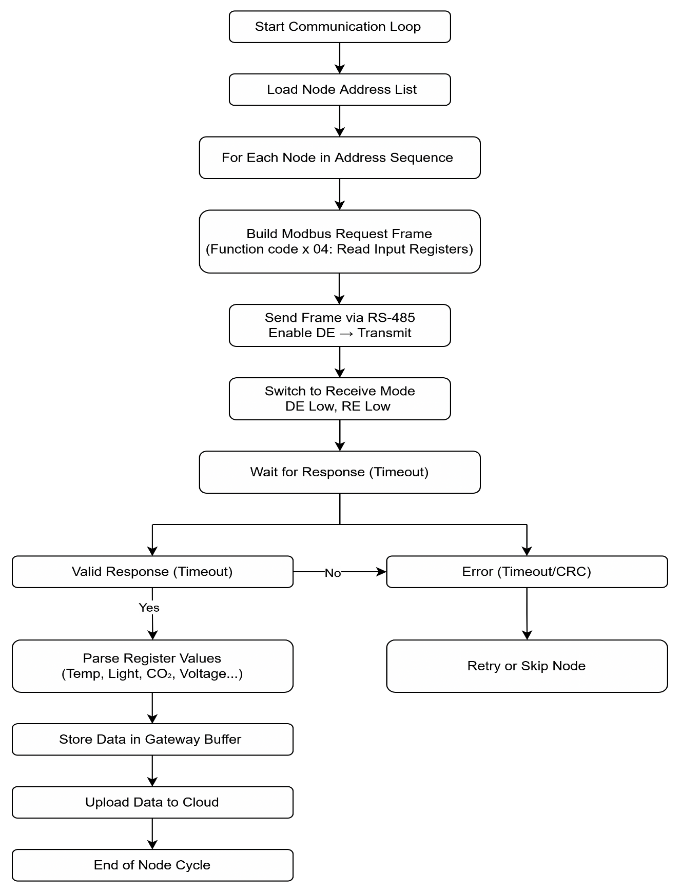
The flowchart depicts the communication sequence between the PC gateway, operating as a Modbus RTU master, and multiple STM32 slave nodes connected via an RS-485 bus.
The PC gateway initializes the Modbus communication parameters and enters a cyclic polling loop. In each cycle, the master sends a Modbus request to a selected STM32 slave node. The addressed slave validates the request, reads the requested registers, and returns a Modbus response containing sensor data.
Upon receiving the response, the gateway verifies the frame integrity, extracts the data, and proceeds to poll the next slave node. This process repeats continuously, enabling periodic and deterministic data acquisition from all STM32 slave devices while preventing bus contention.
- Hardware Design and Justification

STM32L52RE
Key features:
- Ultra-low-power ARM Cortex-M4 core.
- Multiple 12-bit ADC channels, used for interfacing analog sensors such as temperature sensors, light-dependent resistors, and conditioned AC voltage measurement signals.
- Integrated digital interfaces, including GPIO and I²C.
- USART peripheral support, required for RS-485 communication and Modbus RTU implementation.
- Low-power modes, enabling future extensions where nodes may enter sleep states between measurement cycles.
The STM32L52RE therefore provides a balanced platform that meets real-time communication requirements while maintaining low power consumption and design flexibility.

3.2 Sensor Interfaces

LMT84LP Temperature Sensor
The LMT84LP is a low‑power, analog temperature sensor from Texas Instruments. It outputs a voltage that decreases linearly with increasing temperature. Its simplicity, low current consumption, and wide operating range make it ideal for embedded systems, battery‑powered devices, and general temperature monitoring.
Key Electrical Characteristics:
Parameter | Typical Value | Notes
Supply Voltage | 1.5 V – 5.5 V | Works directly from MCU supply
Quiescent Current | ~5.4 µA | Ultra-low power
Output Type | Analog voltage | Inversely proportional to temperature
Output Impedance | — | Can drive ADC inputs directly
Operating Temp Range | –50°C to +150°C | Full sensor range
Package | TO-92 (LMT84P) | Through-hole

- The sensor output is connected directly to an ADC input pin of the STM32.
- A decoupling capacitor 10nF is placed close to the sensor to reduce noise.
- Temperature values are calculated in software using the sensor’s voltage–temperature characteristic.

NSL-19M51 Light Measurement
The NSL-19M51 is a cadmium-sulfide (CdS) photoresistor whose resistance decreases as light intensity increases. It is commonly used in ambient-light detection, auto-brightness control, and simple lux-estimation systems.
Key Electrical Characteristics:
Parameter | Value | Notes
Dark resistance | 1 MΩ – 10 MΩ | Very high in darkness
Light resistance | 5 kΩ – 20 kΩ @ 10 lux | Strongly nonlinear
Spectral peak | ~540 nm | Green region
Response time | 20–30 ms | Suitable for ambient sensing
Operating voltage | Passive | Requires voltage divider

The LDR is used in a voltage divider configuration with a fixed resistor 10kΩ.
- The divider output is connected to an STM32 ADC input.
- Light intensity is derived from the measured voltage and the known resistor values.

DHT22 Temperature and Humidity Sensor
The DHT22 is a calibrated digital temperature and relative humidity sensor. It integrates a capacitive humidity sensing element and an temperature sensor with a dedicated 8-bit microcontroller for signal processing. The sensor provides fully digital output via a proprietary single-wire serial interface.
Key Electrical Characteristics:
Parameter | Typical Value | Notes
Supply Voltage | 3.3 V – 6.0 V | Compatible with STM32 (3.3 V)
Average Current | ~1 mA (measuring) | Very low standby current
Humidity Range | 0–100 %RH | Full range
Humidity Accuracy | ±2–5 %RH | Typical ±2 %
Temperature Range | –40°C to +80°C | Wide range
Temperature Accuracy | ±0.5°C | Typical
Resolution | 0.1 °C / 0.1 %RH | 16-bit internal
Sampling Rate | 0.5 Hz (2 s min) | Do not poll faster
Output Type | Single-wire digital | Custom timing protocol

- The sensor is connected to a GPIO pin configured for bidirectional communication.
- A 1 kΩ pull-up resistor is used on the data line to ensure reliable signal transitions.
- Timing-critical communication is handled in firmware to decode the sensor data.

Grove SGP30 Gas Sensor
The Grove – SGP30 is a digital multi-pixel gas sensor module based on the Sensirion SGP30. It measures indoor air quality by estimating:
- TVOC (Total Volatile Organic Compounds) in ppb
- eCO₂ (equivalent CO₂) in ppm
The Grove version integrates:
- I²C interface
- 3.3 V / 5 V compatibility
- Onboard level shifting and pull-ups.
Key Electrical Characteristics:
Parameter | Typical Value | Notes
Supply Voltage | 3.3 V – 5.0 V | Grove compatible
Interface | I²C | 7-bit address: 0x58
Current Consumption | ~48 mA (active) | During measurement
TVOC Range | 0 – 60,000 ppb | Indoor use optimized
eCO₂ Range | 400 – 60,000 ppm | Algorithm-derived
Sampling Interval | 1 second | Required for algorithm
Warm-up Time | ~15 seconds | Initial stabilization
Long-Term Calibration | 12 hours | Baseline stabilization

AC Voltage Measurement
This section describes an isolated low-voltage AC measurement designed for:
- AC voltage magnitude estimation (maximum 24V)
- Full-wave bridge rectifier.
- STM32 ADC interfacing pin PA0.
The design consists of:
- Full-wave bridge rectifier (4× 1N4148)
- Smoothing capacitor (100 µF)
- Op-amp attenuation + inversion stage
- Buffered ADC output
To protect the STM32 from input overvoltage, we use a 1N4148 diode to clamp Vin, so it does not exceed 3.3 V. This approach provides galvanic isolation, safety, and stable DC output proportional to AC amplitude.

Power Consumption Measurement
This section describes a power consumption measurement:
- Power consumption from measuring AC current magnitude estimation (maximum 2A RMS)
- RMS approximation (via peak measurement)
- STM32 ADC interfacing Pin PA1.
Power consumption is estimated using:
- Shunt resistor (0.01 Ω)
- Differential amplifier (gain stage) with gain 100, by using 1 op-amp LMC6482, 2 resistors 2 kΩ and 2 resistor 200 kΩ.
- Peak detector circuit with op-amps LM741, a diode 1N4148, resistor 1 MΩ and filter capacitor 10uF.
- Buffered ADC output
The STM32 input is protected against overvoltage by a 1N4148 diode that clamps Vin to a maximum of 3.3 V. The LMC6482 op-amp is safeguarded against AC input currents using two 1N5822 Schottky diodes, and its supply pins are decoupled with 100 nF capacitors for noise suppression and stable operation.
- Analytical calculations and simulations

LMT84LP Temperature Sensor
Hardware Setup:
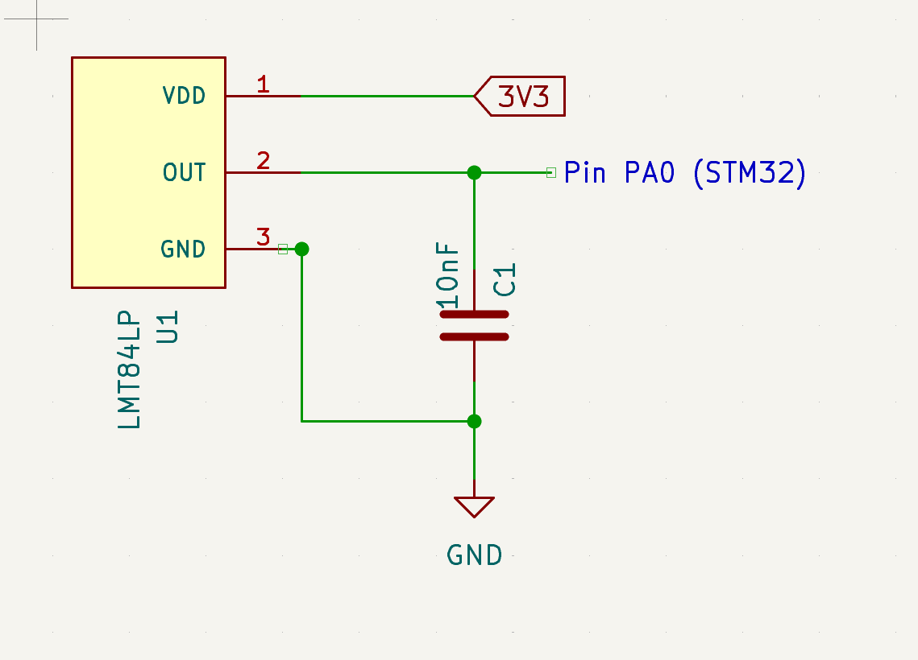
ADC Integration
ADC Conversion to Millivolts
$V_{out}=\frac{ADC_{value}*3300}{4095}$ mV
With:
- 12-bit ADC
- 3.3 V reference
The LMT84 output voltage decreases with temperature. The typical linear approximation is as follows:
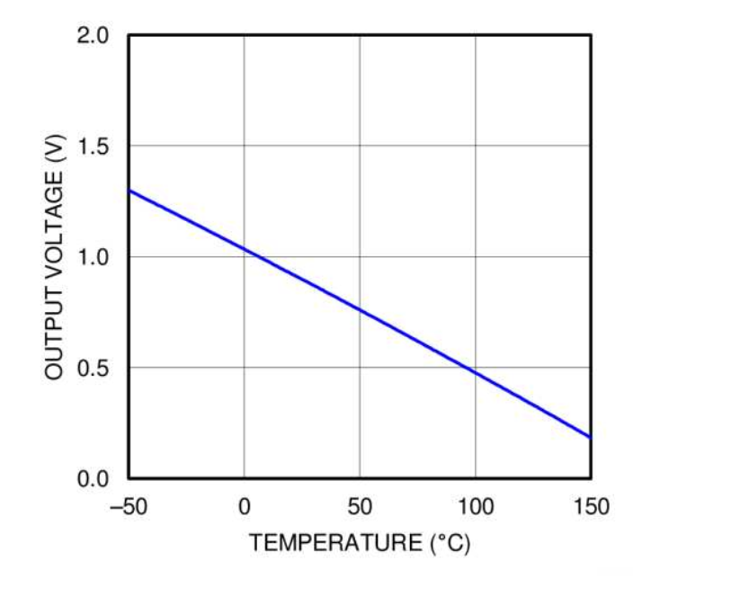
We are interested in measuring temperature range from -30°C to 50°C with corresponding output voltage 1194mV to 760mV (table 3, datasheet). Using equation 3(Texas Instruments 2017):
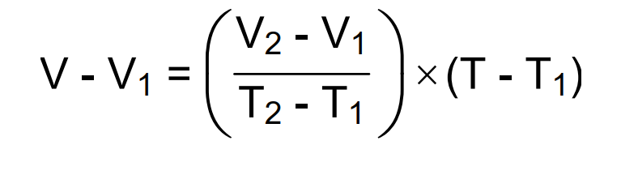
Where:
• V is in mV,
• T is in °C,
• T1 and V1 are the coordinates of the lowest temperature,
• and T2 and V2 are the coordinates of the highest temperature.
$V_{out}-1194=\frac{\left(760-1194\right)}{\left(50-\left(-30\right)\right)}*(T-\left(-30\right))$ (mV)
  - $T=\frac{41250}{217}-\frac{40}{217}{*V}_{out}$ (°C)
The raw data reading from LMT84P will be multiplied by 100 before sending to master Modbus node.

NSL‑19M51 Light Sensor (LDR)
Hardware Setup:
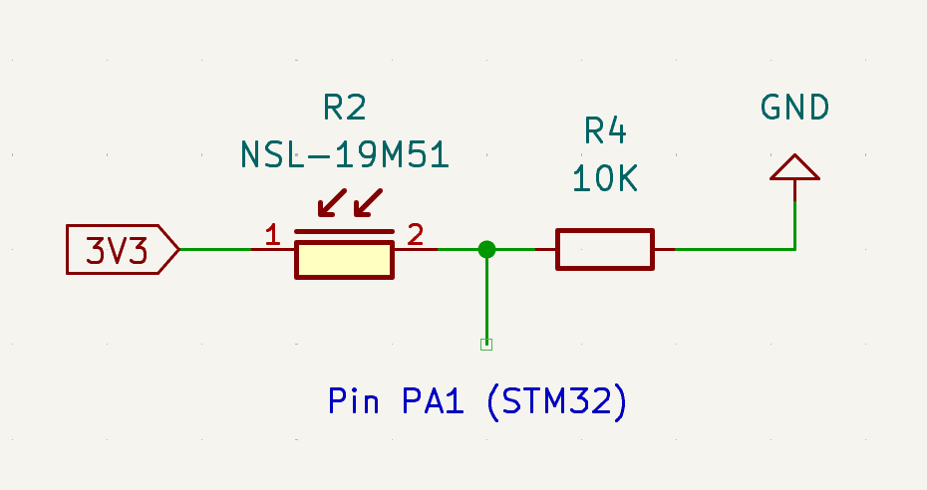
ADC Integration
ADC Conversion to Millivolts:
$V_{ADCmV}=\frac{ADC_{value}*3300}{4095}$ mV
With:
- 12-bit ADC
- 3.3 V reference
Compute LDR Resistance:
$R_{LDR}=R_{fixed}*\frac{3300-V_{ADCmV}}{V_{ADCmV}}$
Lux estimation:
The resistance–illuminance relationship of CdS photoresistors follows an inverse power-law behavior $R=kE^{-γ}$ (Light Dependent Resistors (LDR) | Tutorials on Electronics | Next Electronics n.d.). Rearranging this relationship yields a practical lux estimation model of the form $E=A⋅R^{-γ}$, where A and γ are empirically calibrated constants.
$Lux=A*{R_{LDR}}^{-γ}$
With:
- Lux: Luminance (lux or lm/m²)
- $R_{LDR}$ LDR Resistance (ohms)
- A (scaling constant) - calibration gain
- γ (gamma, slope/exponent) = 0.7 (datasheet of NSL-19M51) when R_{LDR} <= 5 kΩ.
For the NSL‑19M51 photoresistor, the resistance‑to‑lux relationship follows a power‑law response. According to the datasheet, in the high‑illumination region (R ≤ 5 kΩ), the slope γ decreases due to material saturation. After laboratory calibration using a reference point of 5 kΩ at 100 lux, the model parameters were fitted to A = 130 000 and γ = 0.65 for this region.

Digital relative humidity & temperature sensor DHT22
Hardware Setup:
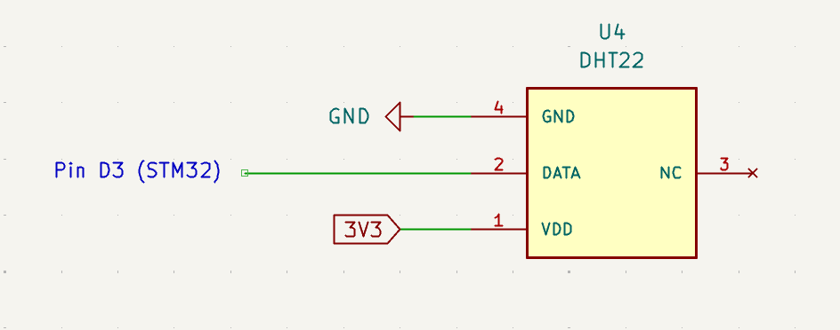
According to the DHT22 protocol:
Bit Value | LOW Period | HIGH Period
0 | ~50 µs | ~26–28 µs
1 | ~50 µs | ~70 µs

The DHT22 transmits 40 bits per measurement:
Byte | Content
Byte 1 | Humidity High
Byte 2 | Humidity Low
Byte 3 | Temperature High
Byte 4 | Temperature Low
Byte 5 | Checksum
Data Conversion
$$raw_humidity=(Rh_byte1<<8)∣Rh_byte2 \\ raw_temperature=(Temp_byte1<<8)∣Temp_byte2$$
DHT22 scaling:
The DHT22 transmits Measured value×10, thus:
$$RH=\frac{raw_humidity}{10} \\ T=\frac{raw_temperature}{10}$$
The raw data reading from DHT22 will be multiplied by 100 before sending to master Modbus node.
Checksum Verification Probability
$$Checksum=\left(RH1+RH2+T1+T2\right)\% 256$$

Grove Air Quality Sensor — SGP30 (TVOC & eCO₂)
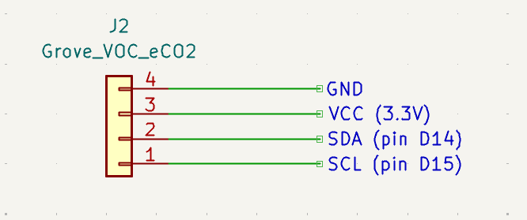
The SGP30 measures:
- eCO₂ (ppm)
- TVOC (ppb)
Format: 2 data bytes (MSB first) and 1 CRC byte
Internal sensor is humidity dependent. To compensate this, SGP30 sensor requires:
$$Absolute Humidity in g/m³ encoded as Q8.8$$
- Computers absolute humidity (AH ×100) from DHT22 data
- Convert it to Q8.8 fixed-point format.
- Supplies it to the SGP30 compensation command.
Absolute humidity:
$$AH=\frac{e_{s}(T)⋅RH⋅2.1674}{273.15+T}$$Where:
- $e_{s}(T)$= saturation vapor pressure (Pa)
- $RH$= relative humidity (0–1)
- $T$= temperature (°C)
Conversion to Q8.8
$$AH_{Q8.8}=AH×256$$SGP30 I²C CRC-8 Properties:
Property | Value
Name | CRC-8
Polynomial | 0x31 → ( x⁸ + x⁵ + x⁴ + 1 )
Init value | 0xFF
Final XOR | 0x00
Reflect input | FALSE
Reflect output | FALSE
Width | 8 bits

AC voltage measurement
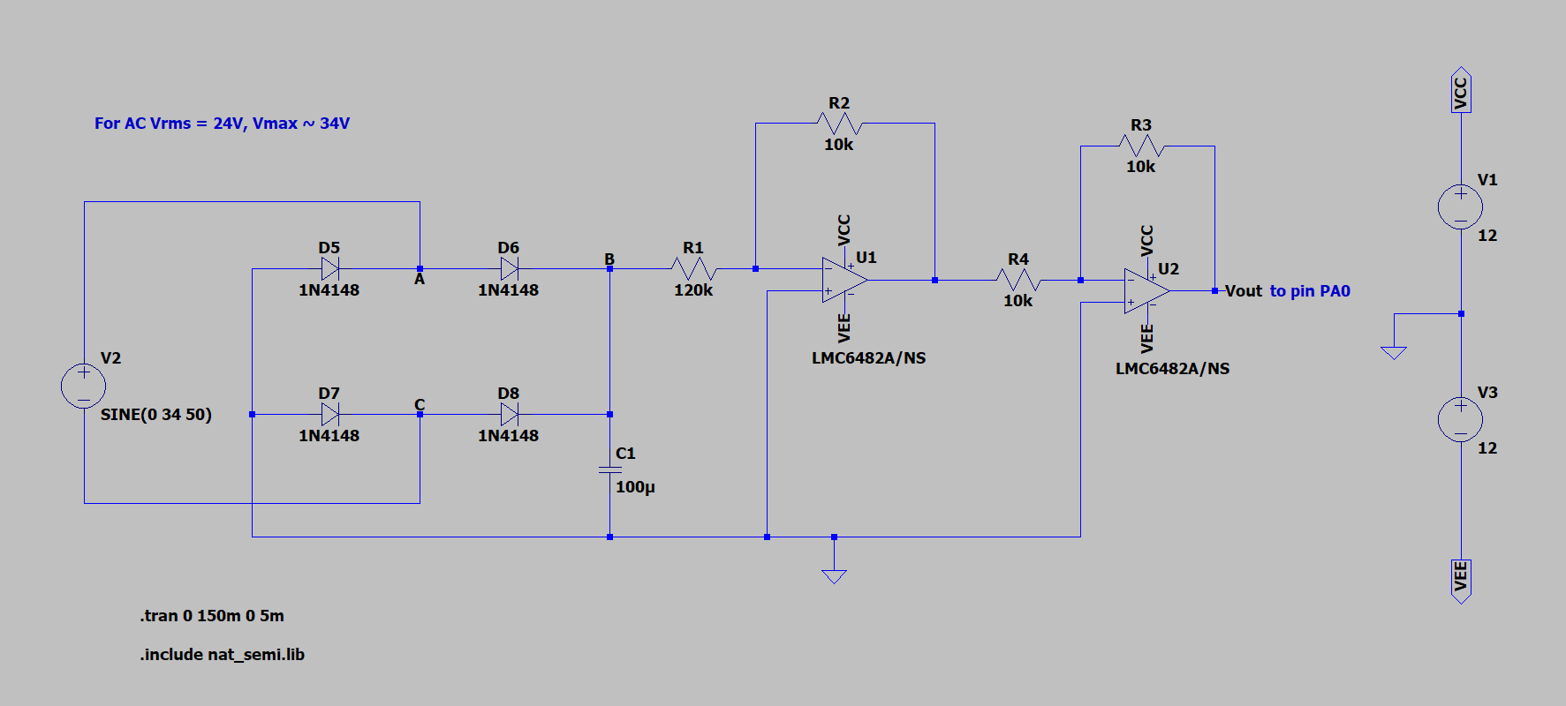
Rectifier stage analysis
$$V_{B}=V_{A}-0.6(V)$$$V_{A}=V_{RMS}\sqrt{2}+V_{C}$(V)
$V_{C}=-0.6$(v)
Gain stage (1/12 Scaling)
$V_{o}=\frac{V_{B}}{12}=\frac{V_{RMS}\sqrt{2}-1.2}{12}$(V)
ADC forward equation 12-bit ADC, Vref = 3.3 V:
$$V_{o}=\frac{ADC}{4095}*3.3(V)$$
Thus:
$$V_{RMS}=\frac{12*V_{o}+1.2}{\sqrt{2}}(V)$$
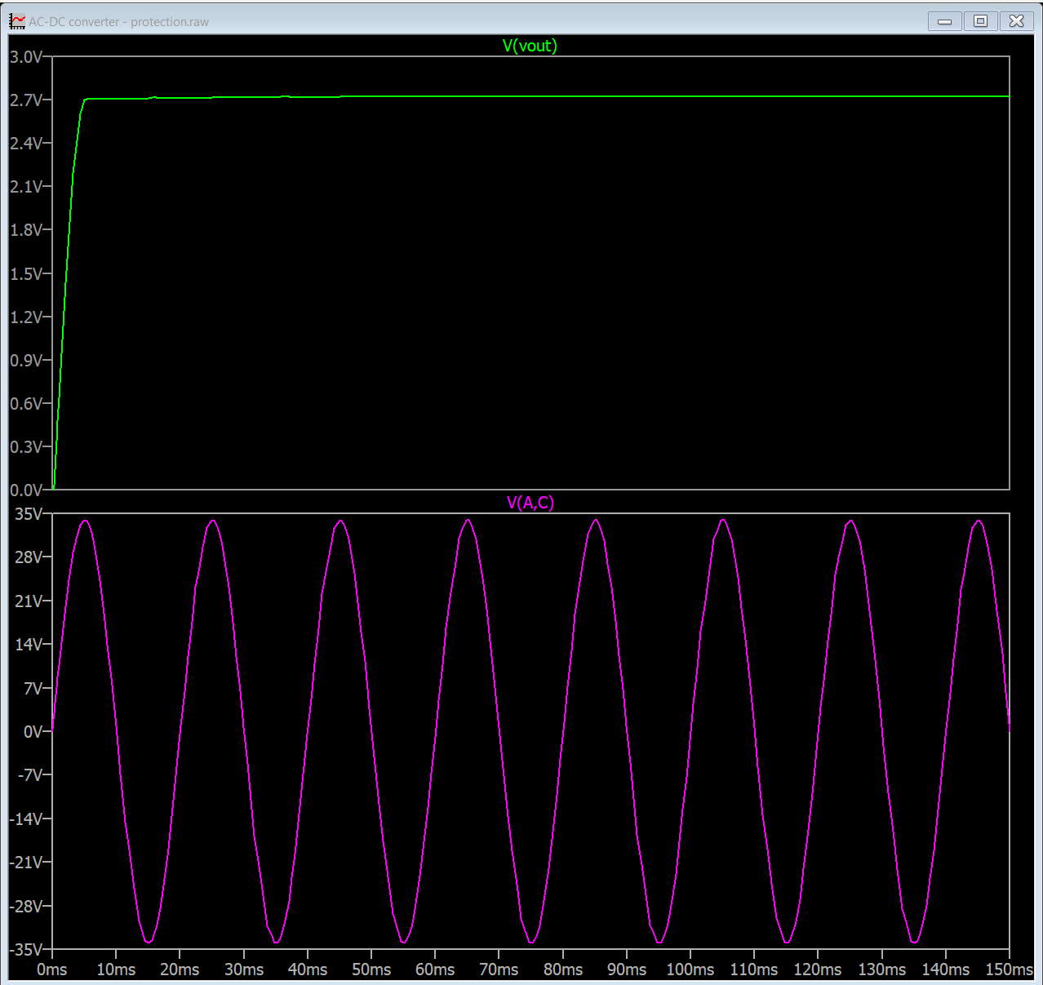
The simulation of design on LTspice verified the calculation. With input Vrms = 24V (Vpeak = 34V), the output voltage is approximately 2.7V.

Power consumption measurement
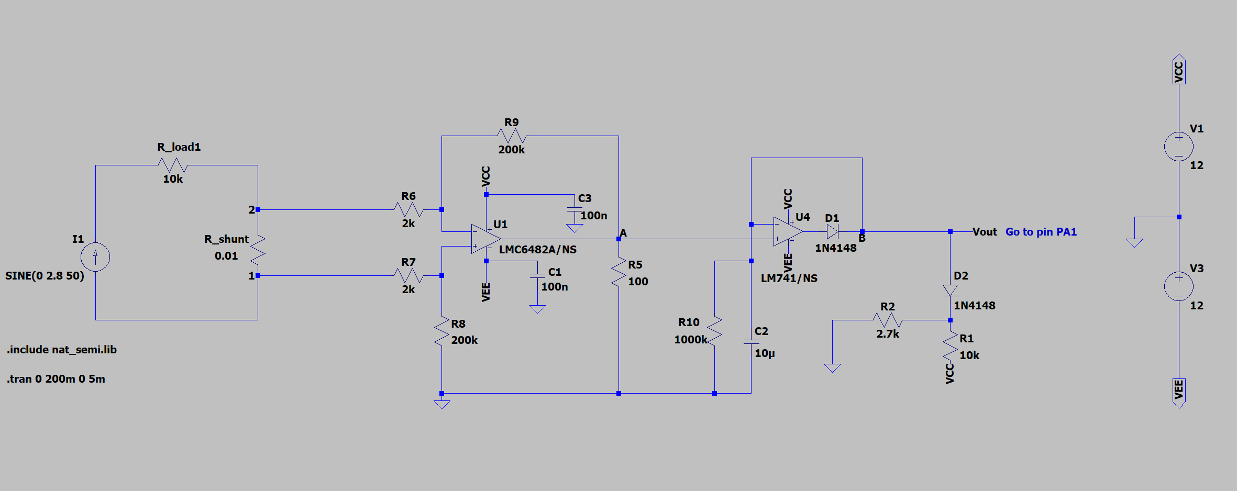
Shunt Resistor Stage:
$${ R}_{shunt}=0.01$$Instantaneous current:$I_{peak}$
Shunt voltage:$V_{shunt,peak}=0.01I_{peak}$
Differential Amplifier (Gain = 100):
$$V_{Apeak}=100⋅V_{shunt}=100⋅0.01I_{peak}$$
The amplifier scaling perfectly cancels the shunt factor.
$$V_{A,peak}=I_{peak}$$Units: volts numerically equal to amps.
Precision Rectifier + Peak Detector:
$$V_{o}=V_{A,peak}=I_{peak}$$Relationship Between Peak and RMS Current
$$I_{RMS}=\frac{I_{peak}}{\sqrt{2}}=\frac{V_{o}}{\sqrt{2}}$$ADC Conversion 12-bit ADC:
$$V_{o}=\frac{ADC}{4095}⋅3.3$$Power Calculation:
$$P=V_{RMS}⋅I_{RMS}$$Substitute:
$$P=12⋅\frac{V_{o}}{\sqrt{2}}(W)$$
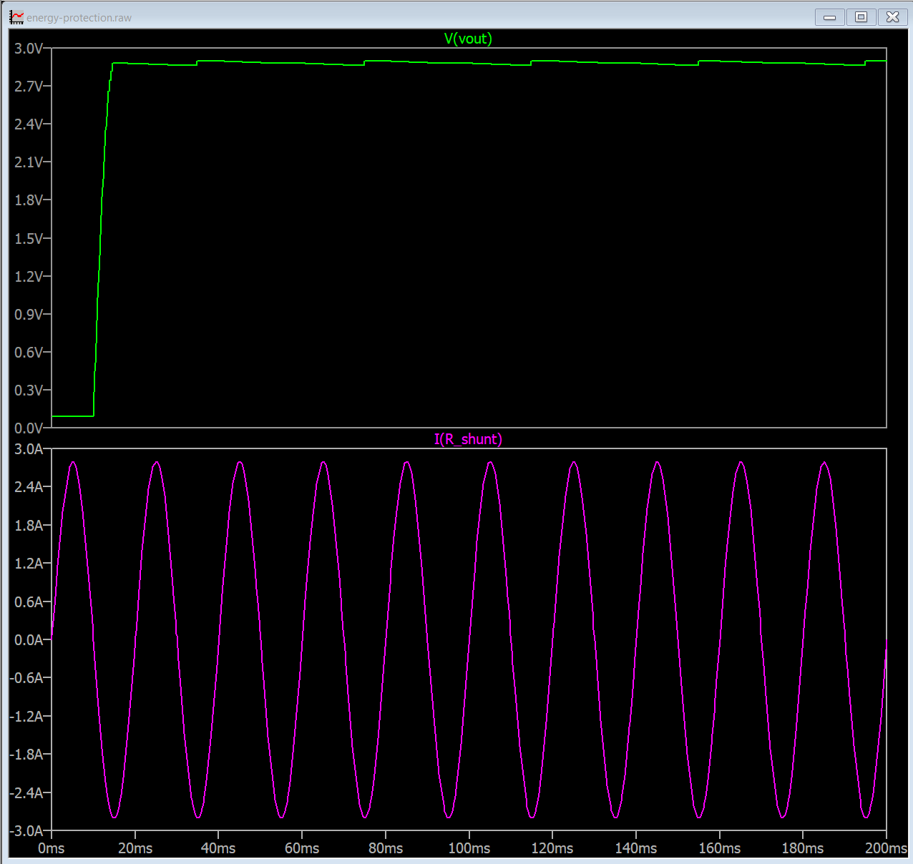
The simulation of design on LTspice verified the calculation. With input Irms = 2A (Ipeak = 2.8A), the output voltage is approximately 2.88V.
- Embedded Software Design
The complete embedded software implementation is available in the project GitHub repository, referenced in Appendix 2.

Software Architecture

Architecture Model
The embedded software for both slave nodes is implemented using a super-loop architecture with interrupt support. The super-loop executes application logic sequentially, while USART receive interrupts are used to ensure timely and reliable handling of Modbus RTU communication frames.
This architecture was selected because:
- It provides deterministic behavior without the complexity of an RTOS
- It is well-suited for low-power STM32 microcontrollers
- It simplifies debugging and validation during prototyping

Software Layering
The firmware is organized into two main layers: a Driver Layer and an Application Layer.
This separation improves modularity, maintainability, and scalability of the system.

Driver Layer
The Driver Layer provides direct access to hardware peripherals and sensors, abstracting low-level details from the application logic.

MCU Peripheral Drivers
- ADC: analog signal acquisition for sensors and AC measurements
- I2C1: digital communication with the SGP30 air quality sensor
- Timers: timing control and protocol support
- USART1: RS-485 Modbus RTU communication
- USART2: debug output and diagnostics

Sensor Drivers
Temperature Sensor (LMT84LP – ADC based)
- int32_tread_lmt84lp_celsius_x100_median(void)
- Median filtering over 5 samples is applied to reduce ADC noise and improve measurement stability.
Light Sensor (NSL19M51 – ADC based)
- uint16_t read_NSL19M51_lux(void)
- Median filtering used to suppress transient fluctuations.
Humidity and Temperature Sensor (DHT22 – 1-Wire protocol)
- DHT22_init()
- DHT22_CheckResponse()
- int32_t* read_DHT22_value_time_100(void)
Timing-critical 1-Wire communication is implemented carefully to ensure protocol compliance.
Air Quality Sensor (SGP30 – I²C based)
- sgp30_iaq_init()
- sgp30_set_absolute_humidity()
- sgp30_measure_iaq(sgp30_iaq_data_t *out)
- sgp30_crc8()
The SGP30 requires a warm-up period 15 seconds and continuous operation to produce valid IAQ values.

AC Voltage and Power Measurement
- int32_t measure_ac_voltage_mv(void)
- int32_t measure_power_mw(void)
Measurements are performed via ADC and processed in software to obtain RMS voltage and estimated power consumption.

Utility and Reliability Functions
To improve robustness and data quality, several utility functions are implemented:
- Absolute humidity calculation:
- calculate_absolute_humidity_x100(temperature_x100, humidity_x100)
- Median filtering:
- bubble_sort(int32_t *arr, uint8_t n)
- Sensor safety and recovery:
  - read_dht22_safe()
  - sgp30_warmup() (15s warm-up)
  - sgp30_recover() (I²C failure recovery)

RS-485 / Modbus Communication Driver
The Modbus RTU slave implementation includes:
- modbus_slave_init()
- respond_frame(uint8_t slave_addr, int32_t sensor_value)
- CRC16(char *nData, unsigned short int wLength)
Debug support is provided via:
- write_debug_msg()
- write_debug_frame()
  - Application Layer
The Application Layer coordinates sensor acquisition, data processing, and Modbus register responses.

Sensor Abstraction via read_sensor()
All sensor access is centralized through:
int32_t read_sensor(uint8_t input_address);
This function maps Modbus input register addresses directly to physical measurements.
Slave Node 1 (Unit IDs 0x01–0x02)
Unit IDs (Address) | Measurement
0x01 | Temperature (LMT84LP)
0x02 | Luminance (NSL19M51)

Slave Node 2 (Unit IDs 0x03–0x06)
Unit IDs (Address) | Measurement
0x03 | Temperature & humidity  (DHT22)
0x04 | TVOC / eCO₂ (SGP30)
0x05 | AC voltage (mV)
0x06 | Power consumption (mW)
Error codes:
- -9999: unknown register address
- -9990: sensor or communication error
This design ensures clean separation between communication logic and measurement logic.

Program Flow and Execution Logic
The software execution of each slave node follows a deterministic sequence based on a super-loop architecture with interrupt-driven communication. The flowchart is divided into four main phases: initialization, interrupt-based frame reception, main loop execution, and Modbus response handling.
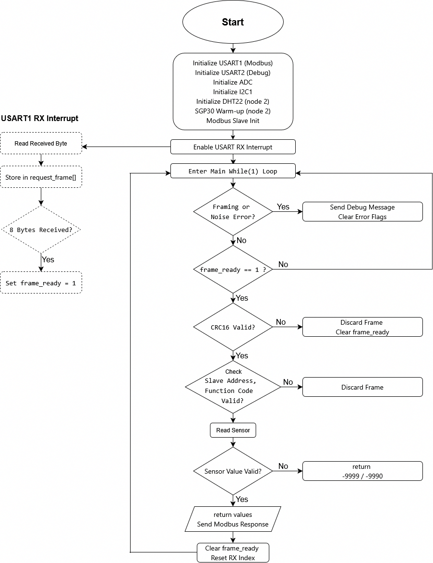

System Start-Up and Initialization
After power-up or reset, the program begins with a hardware and communication initialization phase.
First, the USART peripherals are configured. USART1 is initialized for RS-485 Modbus RTU communication, while USART2 is configured for debug message output. Next, the ADC and I2C1 peripherals are initialized to enable analog sensor acquisition and digital communication with the SGP30 sensor. The DHT22 sensor interface is then initialized to prepare the 1-Wire protocol timing.
For slave node 2, an additional SGP30 warm-up sequence (15 seconds) is executed to ensure valid air-quality measurements, as required by the sensor datasheet.
After peripheral setup, the Modbus slave stack is initialized and the USART1 receive interrupt is enabled. Finally, the program enters the main execution loop.

USART Interrupt and Modbus Frame Reception
Modbus RTU communication is handled asynchronously using the USART1 interrupt service routine.
Each received byte is stored sequentially in a fixed-length buffer representing a Modbus request frame. An index counter tracks the number of received bytes. When all 8 bytes of the Modbus RTU frame are received, a global flag (frame_ready) is set.
If a framing error or noise error is detected by the USART hardware, the corresponding error flags (frameFlag or neFlag) are raised. These errors are later reported through the debug interface.
This interrupt-based approach ensures reliable frame reception without blocking the main program flow.

Main Super-Loop Execution
Once initialization is complete, the program continuously executes an infinite while(1) loop.
At the beginning of each loop iteration, the software checks for USART error flags. If framing or noise errors are detected, a diagnostic message is sent via USART2, and the error flags are cleared. This provides visibility into communication issues during runtime.
The program then checks whether a complete Modbus request frame has been received by evaluating the frame_ready flag.

Modbus Request Validation
When a Modbus frame is ready, the received frame is first printed to the debug interface for diagnostic purposes.
Next, a CRC-16 checksum is calculated over the received data bytes and compared with the CRC bytes included in the request frame. If the CRC validation fails, the request is discarded, and the system returns to the main loop without responding.
If the CRC is valid, the software extracts the slave address and verifies whether it matches the configured address range of the node.
- Slave Node 1 responds to addresses 0x01–0x02
- Slave Node 2 responds to addresses 0x03–0x06
The function code and register parameters are then validated. Only Function Code 0x04 (Read Input Registers) with the expected register configuration is accepted.

Sensor Acquisition and Data Processing
For valid Modbus requests, the software calls the centralized function:
read_sensor(slave_addr);
This function maps the Modbus input register address directly to the corresponding physical sensor.
Depending on the address:
- ADC-based sensors apply median filtering to reduce noise
- DHT22 readings are validated using safe-read logic
- SGP30 measurements use I²C communication with CRC checking
- AC voltage and power measurements are processed from ADC samples
If the sensor reading is successful, a scaled 32-bit integer value is returned. In case of an error, a predefined negative error code is produced.

Modbus Response Transmission
If a valid sensor value is obtained, the software constructs a Modbus RTU response frame containing:
- Slave address
- Function code
- Sensor data payload
- CRC-16 checksum
The response is transmitted via the RS-485 interface using USART1. After transmission, the frame_ready flag is cleared, and the system returns to the main loop, ready to process the next request.
If the sensor returns an error code, no response is sent, preventing invalid data from propagating to the master.

Continuous Operation
The system continuously repeats this cycle, responding to Modbus requests on demand. Sensor measurements are only performed when requested, minimizing CPU load and power consumption.
This flow ensures deterministic timing, robust communication, and stable sensor data acquisition, making the software suitable for long-term operation in home automation and industrial monitoring environments.
The application entry point read_sensor(input_address) implements the Modbus data model used on the RS-485 bus. The Modbus request is accepted only for Function Code 0x04 (Read Input Registers) and a fixed request length. The Unit Identifier (slave address) is used as the selector for which measurement is returned. Each request results in exactly one 32-bit measurement, transmitted as two Modbus input registers (4 data bytes), with CRC-16 appended. The complete mapping between Unit IDs and measurements is defined in Section 7 (Register Mapping).
- Communication Design

RS-485 Hardware Design
The communication between the STM32 slave nodes and the PC gateway is implemented using Modbus RTU over an RS-485 half-duplex bus. RS-485 was selected due to its robustness against noise, support for multi-drop networks, and suitability for industrial and building-automation environments.
Each STM32 slave node is connected to the shared RS-485 bus through an external transceiver. The bus operates in half-duplex mode, meaning that transmission and reception cannot occur simultaneously. To prevent bus contention, the RS-485 transceiver is controlled using a dedicated Driver Enable (DE) signal driven by the microcontroller.
In the implemented design, the DE pin is connected to PA8 of the STM32. During normal operation, the DE signal is kept low, placing the transceiver in receive mode. When the slave needs to transmit a Modbus response, the firmware sets the DE signal high, enabling the transmitter. After the complete frame has been sent and the USART transmission-complete flag is set, the DE signal is immediately returned low, switching the transceiver back to receive mode.
This explicit DE control ensures that:
- Only one device drives the RS-485 bus at any time
- Bus collisions are avoided
- Communication remains deterministic and reliable
The RS-485 physical layer therefore provides a solid foundation for the Modbus RTU protocol implemented in software.

Modbus RTU Frame and Register Mapping

Modbus Communication Model
The system follows a master–slave Modbus RTU communication model. A PC-based gateway acts as the Modbus master, while the STM32 nodes operate exclusively as Modbus slaves. All communication is initiated by the master; slave nodes never transmit data autonomously.
Each Modbus transaction follows a strict request–response pattern:
- The master sends a Modbus RTU request frame to a specific slave.
- The addressed slave validates the request.
- If valid, the slave returns a response frame containing the requested data.
- If the request is invalid, the slave remains silent.

Modbus RTU Request Frame Format
The Modbus RTU request frame used in this project has a fixed length of 8 bytes:
[ Unit ID ][ Function ][ Addr Hi ][ Addr Lo ][ Qty Hi ][ Qty Lo ][ CRC Lo ][ CRC Hi ]
- Unit ID: Identifies the measurement endpoint (slave address).
- Function Code: 0x04 (Read Input Registers).
- Register Address: Fixed value used to maintain a simple request format.
- Quantity: Fixed to request two input registers.
- CRC-16: Error-detection checksum.
Only requests matching this exact structure are accepted by the slave firmware. All other frames are discarded without response.

Modbus RTU Response Frame Format
When a valid request is received, the STM32 slave responds with a 9-byte Modbus RTU response frame:
[ Unit ID ][ 0x04 ][ Byte Count = 0x04 ][ Data3 ][ Data2 ][ Data1 ][ Data0 ][ CRC Lo ][ CRC Hi ]
The response contains:
- The same Unit ID as the request
- Function code 0x04
- A byte count of 0x04, indicating four data bytes
- A 32-bit signed sensor value, transmitted in big-endian order (MSB first)
- A CRC-16 checksum
The four data bytes correspond to two Modbus input registers (2 × 16-bit), allowing a single physical measurement to be transferred as a scaled 32-bit integer.

Modbus Unit ID and Measurement Mapping
In this project, each physical STM32 slave node supports multiple Modbus Unit IDs, where each Unit ID represents a single measurement endpoint. This design choice simplifies the master polling logic and keeps each Modbus response payload fixed and uniform.
Table 7.1 — Modbus Unit ID to Measurement Mapping
Unit ID | Slave Node | Measurement | Data Format
0x01 | Node 1 | Temperature (LMT84LP) | int32, °C × 100
0x02 | Node 1 | Luminance (NSL19M51) | int32, lux
0x03 | Node 2 | Temperature / Humidity (DHT22) | int32, scaled
0x04 | Node 2 | Air Quality (SGP30: TVOC / eCO₂) | int32
0x05 | Node 2 | AC Voltage | int32, mV
0x06 | Node 2 | Power Consumption | int32, mW

Each request results in the transmission of exactly one 32-bit measurement value. The mapping between Unit ID and sensor is implemented in the embedded software through the centralized read_sensor() function, as described in Section 6.
Error handling is implemented using predefined return values:
- -9999: Unknown or unsupported Unit ID
- -9990: Sensor or communication error
If an error occurs, the slave suppresses the response frame, preventing invalid data from propagating to the master.

Reliability Analysis
Communication reliability is ensured through multiple mechanisms implemented at both hardware and software levels:
- CRC-16 Error Detection Every Modbus request and response includes a CRC-16 checksum. Frames with invalid CRC values are discarded immediately.
- USART Error Monitoring The firmware monitors USART framing and noise errors. Detected errors are flagged and reported via the debug interface, enabling diagnostics during development and testing.
- Half-Duplex Bus Control Explicit control of the RS-485 DE signal ensures that the bus is driven only during valid transmissions, preventing contention and data corruption.
- Fail-Silent Behavior In the presence of invalid requests or sensor failures, the slave does not respond, preserving bus stability and protocol correctness.
Together, these measures provide robust and fault-tolerant communication suitable for long-term operation in electrically noisy environments.

Timing Analysis
The Modbus RTU network operates under a deterministic polling scheme controlled by the PC gateway. The master communicates with one Unit ID at a time and waits for a response or timeout before proceeding to the next request.
Key timing characteristics include:
- Interrupt-driven reception, ensuring prompt handling of incoming frames
- Non-blocking main loop, avoiding unnecessary delays
- On-demand sensor acquisition, minimizing CPU load and power consumption
- Sequential master polling, preventing bus collisions
Because all communication is master-initiated and slave responses are strictly bounded in size and duration, the system exhibits predictable timing behavior and consistent update intervals for all measured parameters.
- PCB Design

Design Requirements
The printed circuit board (PCB) was designed to support the STM32-based slave nodes, including sensor interfacing, Modbus RTU communication over RS-485, and stable power delivery. The design was implemented using KiCad software.
The main electrical requirement was to accept a 12 V input supply and regulate it down to 3.3 V, which is required by the STM32L152RE microcontroller and all connected sensors. The ADC reference voltage of the STM32 is tied directly to the 3.3 V supply to ensure consistent and predictable analog-to-digital conversion.
The PCB layout follows the following constraints:
- Minimum clearance: 0.5 mm
- Signal trace width: 0.5 mm
- Board dimensions: 60 mm × 90 mm
- Double-sided PCB
- All Design Rule Check (DRC) and Electrical Rule Check (ERC) errors were inspected and resolved
These requirements ensure manufacturability, electrical safety, and compatibility with standard PCB fabrication processes.

Schematic Justification

Power Supply Section
The PCB includes a dedicated power supply section that accepts 12 V input voltage at VIN. This voltage is regulated down to 3.3 V to supply the STM32L152RE microcontroller, sensor circuits, and the Modbus RS-485 driver (MAX3485).
Decoupling capacitors are placed close to:
- The STM32 microcontroller
- Sensor supply pins
- The MAX3485 Modbus transceiver
These capacitors reduce voltage ripple and high-frequency noise, improving system stability and ADC measurement accuracy.
The ADC reference is connected to the regulated 3.3 V rail, ensuring that all analog measurements are referenced to a stable and known voltage.

Sensor Interface Blocks
The PCB supports two different slave node configurations.
Node 1 – Environmental Sensors (ADC Based)
Node 1 includes the following sensor interfaces:
- LMT84LP temperature sensor, connected to an ADC input
- NSL19M51 light sensor, implemented using a voltage divider and connected to an ADC input
These sensors are routed with short analog traces to minimize noise and improve measurement accuracy.
Node 2 – Environmental and Electrical Measurements
Node 2 integrates additional sensor interfaces:
- AC voltage and power measurement circuits, connected to ADC inputs
- DHT22 temperature and humidity sensor, connected to a GPIO pin with a pull-up resistor
- SGP30 air quality sensor, connected via the I²C interface with pull-up resistors on the data lines
The sensor interfaces are organized to separate analog measurement circuits from digital communication signals.

PCB Layout Principles and Final Design
The PCB layout was designed following basic mixed-signal layout principles. Sensitive analog traces were kept short and routed away from digital communication lines and power switching paths. The use of a double-sided PCB allows better routing flexibility and improved ground connectivity.
All components are reasonably placed, and connectors are positioned to allow easy access for power, RS-485 communication, and sensors. The final PCB layout satisfies all defined clearance and trace width requirements.
The complete schematic diagrams and PCB layouts were created using KiCad and are provided in the Appendix, including both the schematic and the final PCB design files.
- Gateway and Cloud Integration

PC Gateway Functionality
The PC gateway acts as the Modbus RTU master in the system. Its main role is to periodically poll the STM32 slave nodes over the RS-485 bus, collect sensor data, validate communication integrity, and process the received measurements for further use.
The gateway functionality is implemented using a Python script running on a PC. Communication with the RS-485 network is established through a serial interface configured with the following parameters:
- Baud rate: 9600 bps
- 8 data bits, no parity, 1 stop bit
- Configured timeout to handle missing or delayed responses

Modbus RTU Communication
The gateway constructs Modbus RTU request frames using Function Code 0x04 (Read Input Registers). Each request targets a specific slave address corresponding to a measurement endpoint. A CRC-16 checksum is calculated and appended to each request frame to ensure data integrity.
For each Modbus transaction:
- A request frame is transmitted to the selected slave node.
- The gateway waits for a fixed-length response frame.
- The received frame is validated using CRC-16.
- The sensor value is extracted and converted into engineering units.
To improve robustness, each request is retried up to three times if:
- No response is received
- The response length is incorrect
- CRC validation fails
This retry mechanism increases reliability in the presence of communication noise or temporary bus disturbances.

Data Parsing and Validation
The slave nodes return sensor values as 32-bit signed integers, transmitted as two Modbus input registers (4 data bytes). The gateway reconstructs these values using big-endian byte order and applies sign extension when necessary.
Depending on the slave address, the received data is interpreted as:
- Temperature (°C)
- Luminance (lux)
- Temperature and humidity (DHT22)
- Air quality data (eCO₂ and TVOC)
- AC voltage (V)
- Power consumption (W)
Each measurement is validated against expected ranges before being printed to the console. Special error values returned by the slave (e.g. -9990 or -9999) are detected and reported as sensor or communication errors.

Periodic Polling Operation
The gateway operates in a continuous loop, sequentially polling all configured slave addresses. A fixed delay is inserted between requests to:
- Avoid overloading the RS-485 bus
- Respect sensor timing constraints
- Maintain deterministic communication behavior
This polling strategy ensures stable and predictable data acquisition from all connected slave nodes.

IoT-Tickets Data Upload and Visualization
The system architecture is designed to support integration with the IoT-Tickets cloud platform for data storage and visualization. In a complete implementation, the PC gateway would forward the acquired sensor data to the cloud using standard internet protocols, enabling remote monitoring and historical data analysis.
However, at the current stage of the project, IoT-Tickets integration is not available. Therefore, sensor data is displayed locally via the PC gateway console output. Despite this limitation, the gateway software is structured in a way that allows future extension to cloud upload functionality with minimal changes.
- RESULTS AND ANALYSIS

System Performance
The implemented system demonstrated stable and reliable operation for the communication architecture and sensor data acquisition aspects. All STM32 slave nodes successfully responded to Modbus RTU requests issued by the PC gateway over the RS-485 bus. Sensor data were acquired correctly, transmitted using CRC-protected frames, and decoded accurately at the gateway.
The polling-based master–slave communication ensured deterministic behavior and prevented bus contention. ADC-based environmental measurements (LMT84LP temperature and NSL19M51 luminance) showed stable values due to proper signal conditioning and software filtering. Digital sensors (DHT22 and SGP30) operated within their specified timing and protocol constraints when tested.
However, AC voltage and power consumption measurements could not be fully validated on the final PCB. During testing, the operational amplifier LMC6482 and two 1N4148 diodes in the measurement circuit were found to be damaged. This failure resulted in an unexpected high-voltage level (approximately 10 V) being applied to ADC input pins PA0 and PA1, which subsequently caused permanent damage to the STM32 Nucleo board.
These measurement circuits were previously tested successfully on a breadboard, indicating that the issue is likely related to PCB implementation, component failure, or layout-related factors, rather than the theoretical design itself. Further investigation of this issue is ongoing.
Overall, while the communication system and most sensor measurements met the functional requirements, the AC measurement subsystem requires redesign and additional validation.

Demonstration of Expertise and Problem-Solving
The project demonstrates practical expertise in embedded systems design through the integration of hardware, firmware, and industrial communication protocols. Key problem-solving aspects include:
- Implementation of a robust Modbus RTU slave using interrupt-driven USART communication
- Reliable RS-485 bus operation with CRC-based error detection and retry mechanisms
- Successful integration of multiple sensor types with different electrical and protocol requirements
- Systematic handling of timing-critical sensors and warm-up constraints
In addition, the project highlights real-world engineering challenges encountered during hardware testing. The failure of the AC measurement circuitry and subsequent damage to the microcontroller demonstrate the importance of protection mechanisms, thorough PCB-level verification, and staged power-up testing. Identifying these issues and analyzing their causes reflects an understanding of practical embedded-system limitations, such as component tolerances, layout sensitivity, and fault propagation.

Contribution to Development of the Field
Although implemented as a small-scale prototype, the system reflects design principles used in real industrial and home-automation applications. The combination of modular slave nodes, RS-485 Modbus communication, and gateway-based data aggregation provides a scalable foundation for larger monitoring systems.
The project contributes to the field by demonstrating how low-power microcontrollers can be integrated into distributed measurement systems and how design validation across breadboard, PCB, and system levels is critical for reliable operation. The encountered hardware failures further emphasize the importance of protection, testing methodology, and iterative refinement in embedded system development, which are essential considerations in professional engineering practice.
- DISCUSSION AND FUTURE DEVELOPMENT

Discussion
The implemented system demonstrates that the main project objectives—designing a distributed embedded system using STM32 microcontrollers, Modbus RTU communication, and a PC-based gateway—were largely achieved. The overall architecture, combining modular slave nodes with a deterministic RS-485 master–slave communication model, resulted in stable operation and predictable system behavior, as shown in Section 9.
The use of interrupt-driven communication, modular sensor abstraction, and standardized protocols reflects sound embedded system design practices and aligns with real industrial and home-automation approaches. Environmental sensors and communication subsystems operated reliably and validated the core system architecture.
At the same time, the project exposed important practical limitations during hardware validation, particularly in the AC voltage and power consumption measurement circuits. Failures at the PCB level, including component damage and over-voltage at MCU ADC inputs, highlighted the challenges of translating theoretical designs and breadboard prototypes into robust PCB implementations. Additionally, incorrect external power connection led to damage of the Nucleo board, emphasizing the importance of clear labeling and systematic power-up procedures.
These issues do not contradict the conclusions of the project but rather reinforce its learning value. They demonstrate real-world constraints commonly encountered in embedded system development and provide concrete insight into design validation, protection strategies, and testing methodology. As reflected in the Conclusion, these experiences significantly contributed to the achieved learning outcomes and professional relevance of the work.

Future Development
Several extensions can be implemented to build upon the achieved results and extend the system beyond monitoring toward full automation and control.
- Node 1 – Automation and Actuation
Node 1 can be extended from passive sensing to active control:
- An automatic curtain system using a servo motor, controlled based on ambient light levels measured by the NSL19M51 photoresistor
- A cooling fan or ventilation system controlled via PWM, with speed adjusted according to temperature values from the LMT84LP sensor
These enhancements would transform Node 1 into a closed-loop control system, strengthening its relevance for practical home-automation applications.
- Node 2 – Alarm and Event-Driven Functions
Node 2 can be expanded with event-based safety and monitoring features:
- Alarm triggering based on abnormal temperature or humidity values measured by the DHT22
- Indoor air-quality alerts based on eCO₂ or TVOC thresholds from the SGP30 sensor
- Triggered actions such as buzzers, warning LEDs, or gateway notifications when predefined limits are exceeded
Such features would increase system robustness and applicability in safety-critical and comfort-oriented environments.
- System-Level Enhancements
At the system level, future development may include:
- Full integration with the IoT-Tickets cloud platform for data storage and visualization
- Historical data analysis and trend detection
- Migration toward event-driven or hybrid scheduling models
- Expansion of Modbus register mapping and standardized addressing

- Conclusion

Final Assessment of Objectives Achieved
The primary objective of this project was to design and implement a distributed embedded system for home automation and monitoring using STM32 microcontrollers, Modbus RTU communication, and a PC-based gateway. This objective was successfully achieved.
The system demonstrates reliable sensor data acquisition, deterministic RS-485 communication, and correct master–slave interaction using the Modbus RTU protocol. Multiple sensor types—including analog, digital, and I²C-based devices—were integrated and validated. The gateway application successfully collected, verified, and interpreted data from all slave nodes. The overall system architecture proved to be stable, modular, and scalable, meeting the technical and functional requirements defined at the beginning of the project.

Learning Outcomes and Professional Relevance
Through this project, significant practical skills in embedded systems engineering were developed. These include microcontroller programming, mixed-signal hardware design, PCB layout, industrial communication protocols, and system-level integration. The project also strengthened problem-solving abilities related to real-time constraints, communication reliability, and sensor-specific limitations.
From a professional perspective, the implemented solution reflects design principles commonly used in industrial automation and IoT systems. The experience gained is directly applicable to real working-life scenarios involving embedded development, fieldbus communication, and gateway-based data aggregation. Overall, the project provides a solid foundation for further work in embedded systems, automation, and IoT-oriented engineering roles.

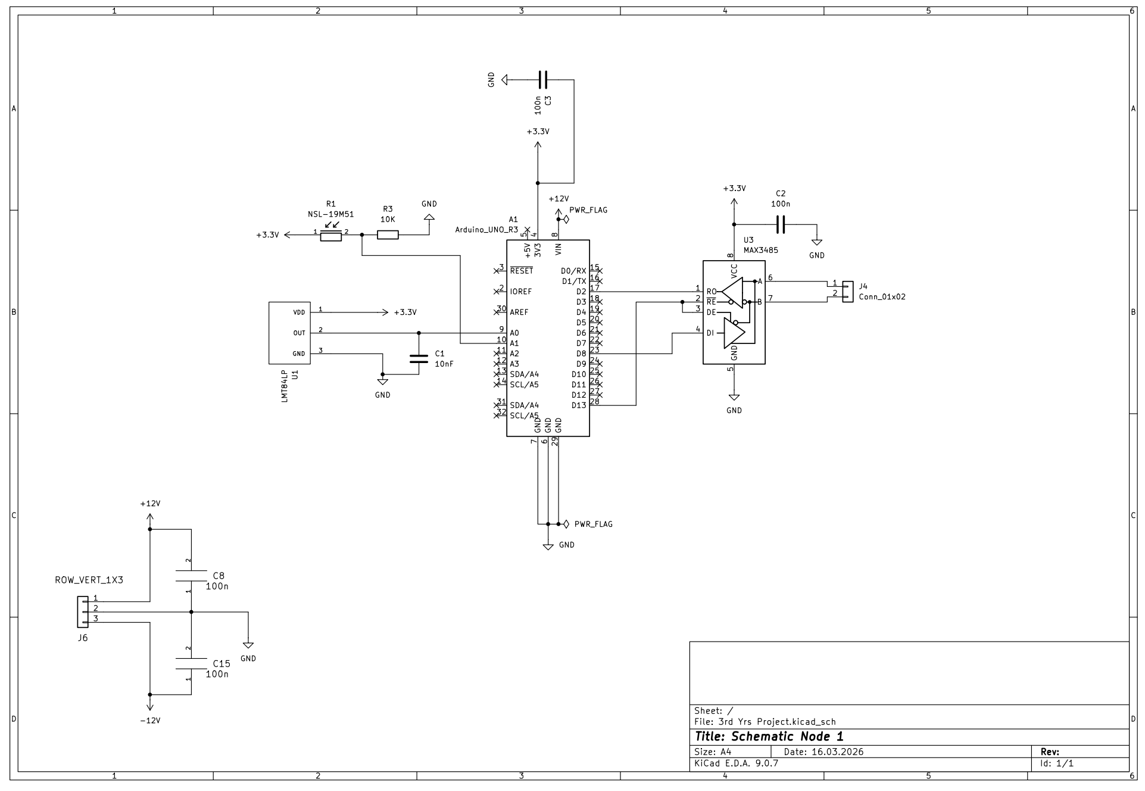
NODE 1
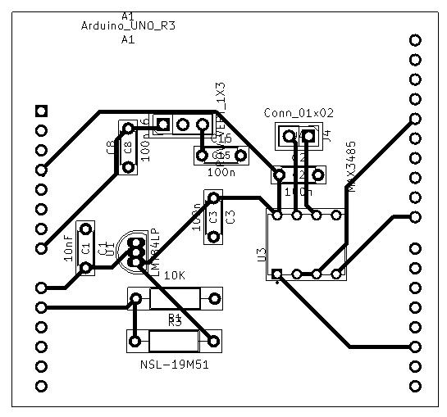 | 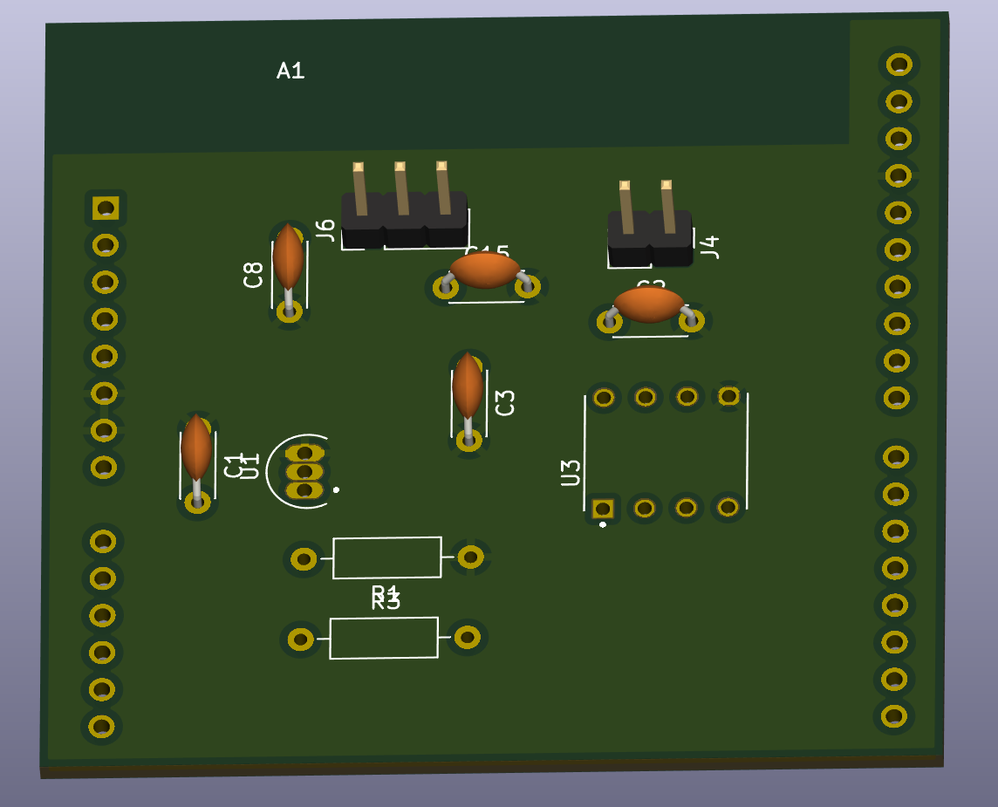
PCB Board Node 1 | 3D view PCB Board Node 1
NODE 1

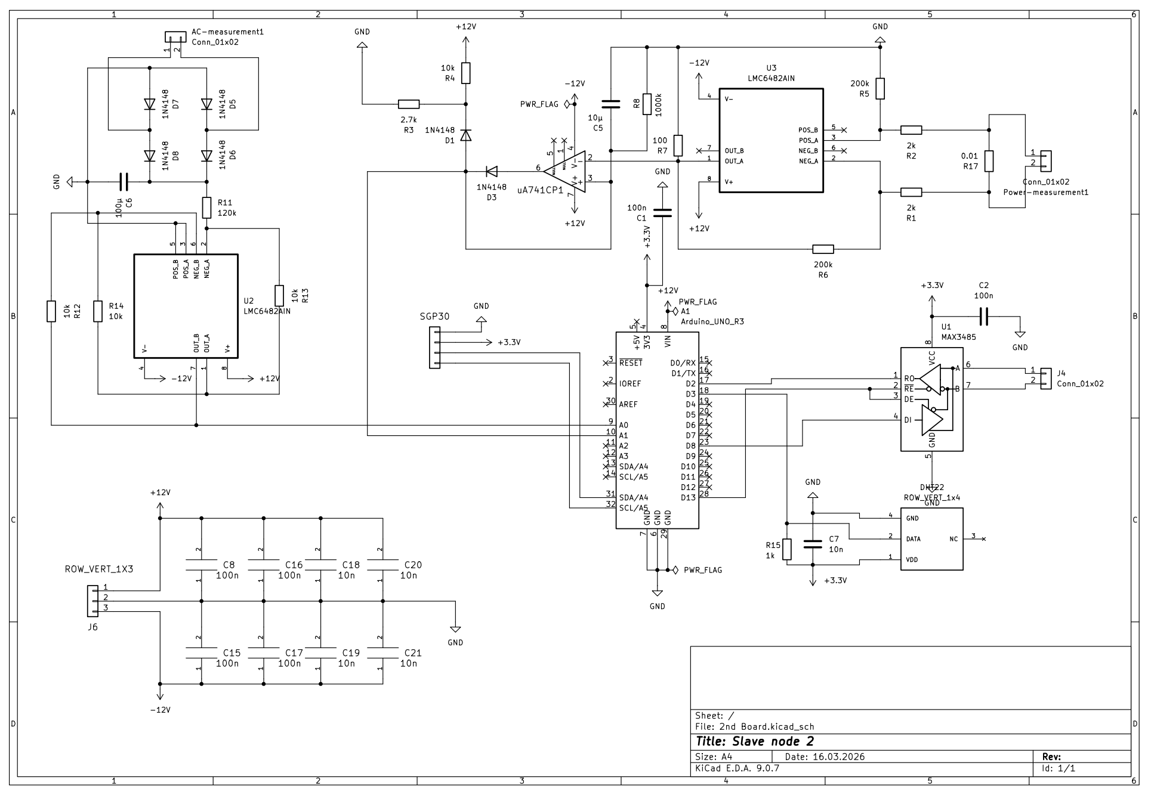
NODE 2
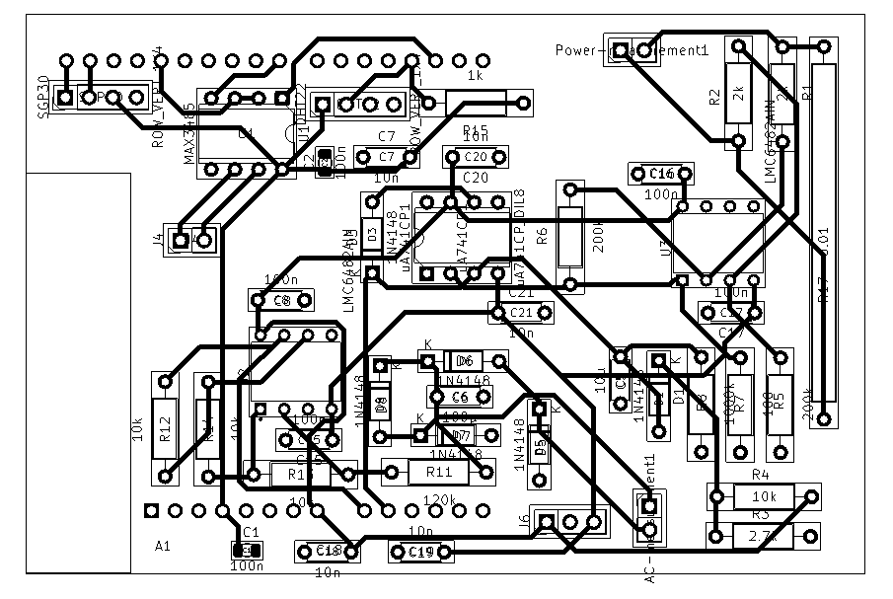  PCB Board Node 2 | 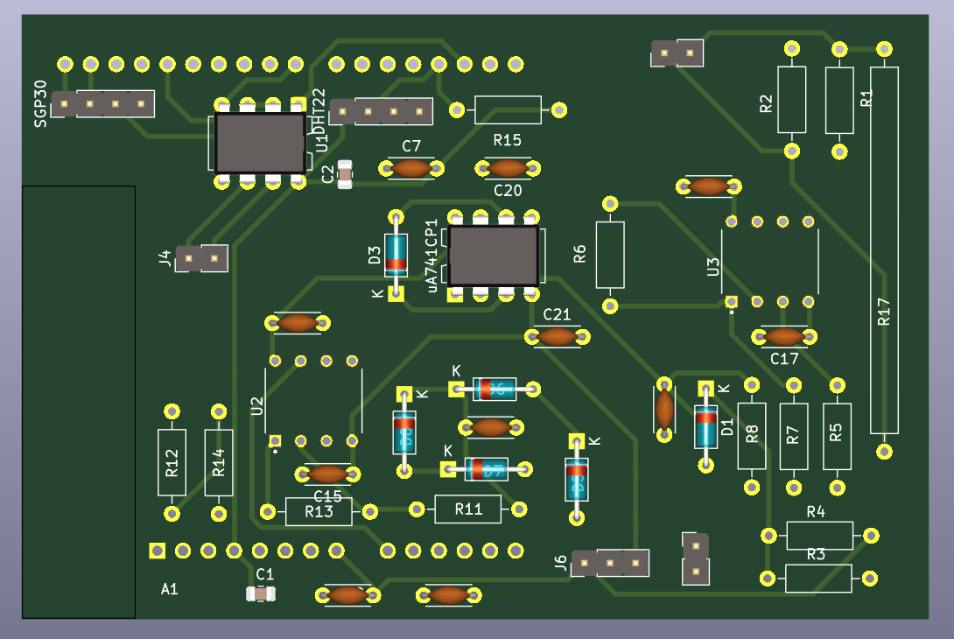  3D view PCB Board Node 2

APPENDIX 2: EMBEDDED SOFTWARE SOURCE CODE
The complete and buildable source code developed for this project is available in a public GitHub repository:
Repository:
https://github.com/nguyen1013/IoT-Modbus-STM32-project
The repository contains all software and design files required to reproduce the implemented system, including:
- STM32 embedded software
  - Main application source code
  - Sensor driver implementations
  - Configuration files and header files
- PC gateway (Modbus master) software
  - Python-based Modbus RTU master program
- Hardware design files
  - KiCad schematics and PCB layout designs
- Simulation files
  - LTspice simulation files for analog and power measurement circuits
- Reference materials
  - Datasheets and supporting documentation used during design
The repository represents the exact version of the source code and design files used for system testing and validation as described in this report.

