1. **Retrieve the name, birth date and address of the employee(s) whose name is “John B.Smith”**

SELECT Fname, Minit, Lname, Bdate, Address

FROM EMPLOYEE

WHERE Fname = 'John'

AND Minit = 'B'

  AND Lname = 'Smith';



1. **Retrieve the names of all employees in the “Administration” department.**

SELECT E.Fname, E.Minit, E.Lname

FROM EMPLOYEE AS E, DEPARTMENT AS D

WHERE D.Dname = 'Administration'

AND E.Dno = D.Dnumber;

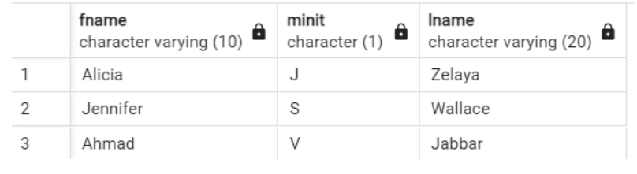

1. **Retrieve the names of all employees in department 5 who work more than 10 hours per  
   week on the ProductX project.**

SELECT E.Fname, E.Minit, E.Lname

FROM EMPLOYEE AS E, WORKS_ON AS W, PROJECT AS P

WHERE E.Ssn = W.Essn

AND P.Pnumber = W.Pno

AND E.Dno = 5

AND W.Hours > 10

AND P.Pname = 'ProductX';

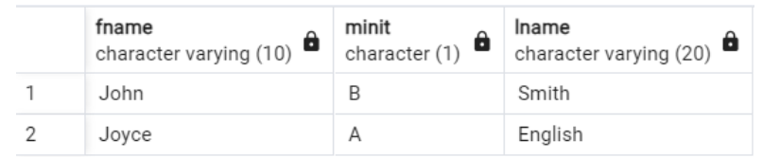

1. **For each employee, retrieve the employee’s first name and last name and the first and last  
   name of his/her immediate supervisor.**

SELECT e1.Fname, e1.Lname, e2.Fname, e2.Lname

FROM EMPLOYEE AS e1, EMPLOYEE AS e2

WHERE e1.Super_ssn = e2.Ssn;

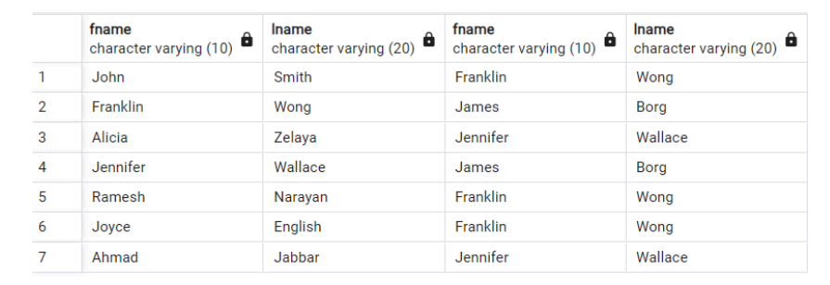

1. **Retrieve the names of all employees in the departments which are located in Houston**

SELECT E.Fname, E.Minit, E.Lname

FROM EMPLOYEE AS E, DEPT_LOCATIONS AS DL

WHERE DL.Dlocation = 'Houston'

AND E.Dno = DL.Dnumber;

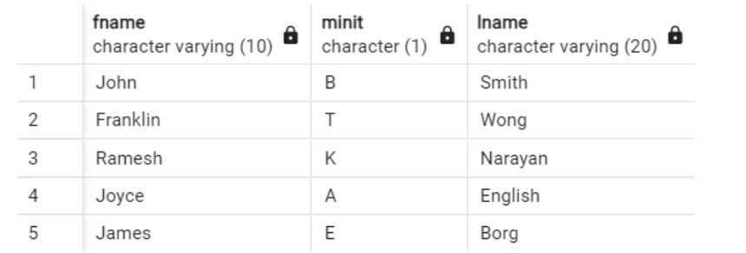

1. **List the names of all employees who have a dependent with the same first name as  
   themselves**

SELECT *

FROM EMPLOYEE AS E, DEPENDENT AS D

WHERE E.Fname = D.Dependent_name;

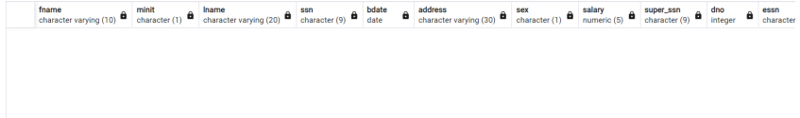

1. **For each project, calculate the total number of employees who work for it, and the total  
   number of hours that these employees work for the project.**

SELECT P.Pname, COUNT(*) as Number_of_employees, SUM(W.Hours) as total_number_of_hours

FROM EMPLOYEE AS E, WORKS_ON AS W, PROJECT AS P

WHERE E.Ssn = W.Essn

AND P.Pnumber = W.Pno

GROUP BY P.Pname;

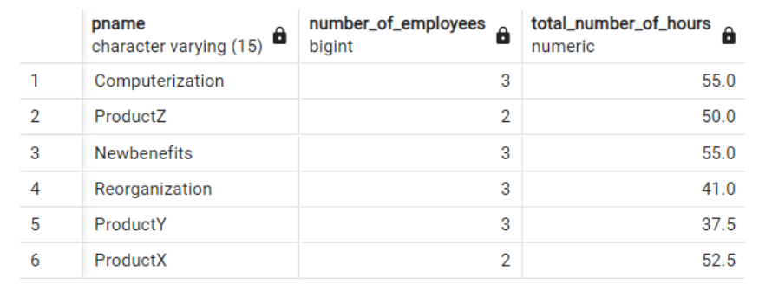

1. **Retrieve the average salary of all female employees.**

SELECT AVG(salary)

FROM EMPLOYEE

WHERE Sex = 'F';

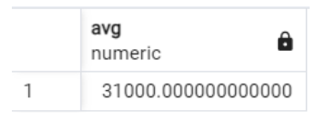

1. **For each department whose average employee salary is more than $30.000, retrieve the  
   department name and the number of employees work for that department.**

SELECT D.Dname, COUNT(*) as Number_of_employees

FROM EMPLOYEE AS E, DEPARTMENT AS D

WHERE E.Dno = D.Dnumber

GROUP BY D.Dname

HAVING AVG(salary) > 30000;

