ROOT OF TRUST SUBSYSTEM
Architecture Specification
Hardware and software architecture of the Root of Trust subsystem, and its integration into the application SoC: secure boot, cryptographic and key services, device identity, attestation, and the contract with the Boot & Power Management Unit.
Status | Design baseline
Revision | 0.1s
Date | August 2026
Scope | RoT subsystem, its application-facing boundary, and the RoT↔BMU interface
Audience | SoC architects, RTL and firmware engineers, security evaluators

How to read this document
The architecture is carried by the figures. Each is a full-page landscape drawing on its own page, and the surrounding prose is deliberately short: it states what the figure does not show, and why the arrangement is the way it is.
Three statements — INV-1, INV-2 and INV-3 in section 1.5 — are the security architecture. Everything else is implementation detail in service of them.
Contents
1 | Purpose, context and threat model | Figure 1
2 | Interfaces and isolation | Figure 2
3 | RoT hardware blocks
4 | Boot media and software stages
5 | Secure boot | Figures 3–5
6 | Keys, identity and attestation | Figures 6–13
7 | The mailbox interface | Figures 14–15
8 | RoT firmware
9 | The BMU and the RoT↔BMU contract | Figure 16
10 | Implementation phasing
11 | Verification, validation and certification
12 | Glossary

Figures
1 | System-level view — die partitioning and the five paths
2 | The five data paths and what each is constrained by
3 | Boot sequence, part 1 — cold power-on to SoC bring-up
4 | Boot sequence, part 2 — FSBL verification to steady state
5 | Stage handoff and staged write-protect release
6 | Measured boot and the DICE construction
7 | keymgr_dpe — internal hardware
8 | keymgr_dpe — hardware ports
9 | Flow A — measured boot, one stage transition
10 | Flow B1 — sealing
11 | Flow B2 — unsealing
12 | Flow C — attestation with freshness
13 | Flow D — enclave sealing under the Security Monitor
14 | Mailbox structure
15 | Mailbox transaction protocol
16 | The RoT↔BMU contract and the INV-3 interlock

1 Purpose, context and threat model

1.1 What the subsystem is
The Root of Trust (RoT) is a small, isolated, always-on security subsystem embedded inside a larger application SoC. It is the first thing in the system to make any decision and the last thing an attacker can bypass. It owns three responsibilities.
Responsibility | What it means
Secure boot | Establish an unbroken chain of cryptographic verification from immutable on-die ROM up to the operating system, and withhold permission for the rest of the SoC to start until the first link of that chain is proven good.
Cryptographic and key services | Provide the application subsystem with hashing, signature verification, encryption, random number generation and hardware-derived keys — without ever exposing key material outside the RoT security perimeter.
Identity, attestation and lifecycle | Give the device a unique, unforgeable, hardware-anchored identity; produce evidence that the software currently running is genuine and untampered; and enforce manufacturing and debug lifecycle policy, including anti-rollback and key revocation.

One qualification on “first to execute”, stated up front because it is load-bearing. Something must ramp the RoT’s power rails and release it from reset, and that something cannot be the RoT. That job belongs to a hardwired power-on sequencer: a state machine with no core, no instruction fetch and no software of any kind. It ramps the RoT domain’s rails, waits for power-good, releases RoT reset, and does nothing else.
No software executes anywhere in the system before the RoT. The BMU has a core and a boot ROM, but both are held in reset until step [T5] — after the RoT has verified BMU firmware and released them. The RoT is therefore not merely the first component to decide anything; it is the first to execute anything.
This does not eliminate pre-RoT trust. The sequencer and the power tree remain in the trusted computing base, because something must still bring the RoT up and could be glitched into bringing it up wrongly. What it does is reduce that trusted element from a core running immutable software to hardwired logic with nothing to exploit — and it is why the environmental monitors must confirm the RoT’s operating envelope independently before the first verification runs.

1.2 The application subsystem
The application SoC is a multicore RISC-V system: application cores CPU cluster, NPU cluster, DSP, each with private L1I/L1D and a page-table walker, a shared L2, a DDR memory subsystem reached through a TileLink→AXI4 bridge, and a peripheral complex. It runs a rich stack — OpenSBI, Linux, and one or more Trusted Execution Environments alongside the Rich Execution Environment.
Those cores are large, complex and speculatively executing. They are explicitly not trusted to enforce security policy. The RoT is small, in-order and auditable, and it is the only component in the system whose correctness the entire security argument rests on.
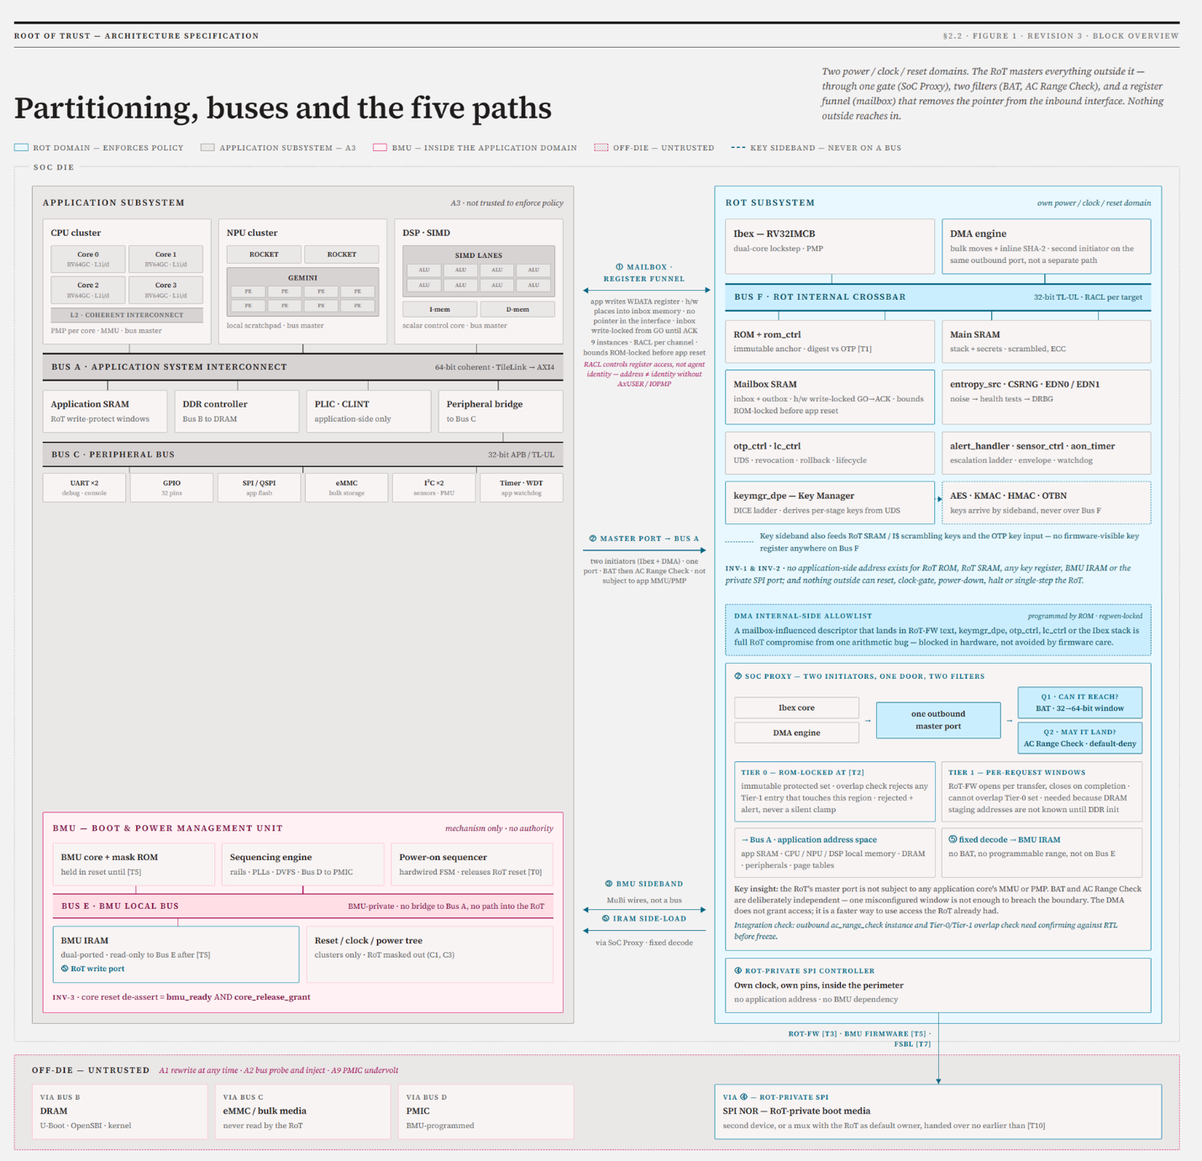
Figure 1. Partitioning, buses and the five paths. The RoT sits in its own power, clock and reset domain, masters every application memory through a single gated outbound port, and holds sole authority over application-core release.

1.3 Domains and terminology
Three domains sit on the die. They are not interchangeable, and this document uses these terms strictly.
Term | What it covers
RoT | Everything inside the RoT security perimeter: the Ibex core, RoT SRAM and ROM, crypto cores, entropy, OTP, lifecycle, key manager, boundary logic, and the RoT-private SPI controller.
Application subsystem | Everything outside the RoT that consumes RoT services: the application cores, their SRAM and DRAM, the system bus, and all shared peripherals — including every software domain running there.
Application cores | The four application cores specifically, where the cores rather than the whole subsystem are meant.
BMU | The Boot & Power Management Unit. Outside the RoT, but not part of the application subsystem: it serves the RoT rather than requesting from it, and reaches the RoT over dedicated sideband signals rather than the mailbox.

The word host is deliberately avoided throughout. In silicon contexts it usually means the debug host — the workstation driving JTAG — which is a different thing entirely.

1.4 Adversary model
Every architectural decision in this document traces to one or more of the following. Where a decision exists specifically to defeat one of them, the tag is cited inline.
 | The attacker can
A1 | Rewrite any off-die non-volatile storage (SPI NOR, eMMC) at will, at any time — including after the RoT has read and verified it.
A2 | Probe, record and inject traffic on off-die buses (SPI, DDR, MMC).
A3 | Execute arbitrary code on the application cores at the highest application privilege level (M-mode), including inside a compromised TEE.
A4 | Drive every application-visible register interface of the RoT with arbitrary values, in arbitrary order, at arbitrary rates.
A5 | Apply physical fault injection: clock glitching, voltage glitching, EM pulse, laser.
A6 | Perform side-channel analysis: power (SPA/DPA/CPA), EM, timing.
A7 | Attempt to roll firmware back to an older, validly signed but known-vulnerable version.
A8 | Attempt to re-enable debug access (JTAG) on a production device.
A9 | Compromise or exploit a bug in the BMU. The BMU controls reset and power for the whole SoC and is reachable from application software at runtime for DVFS and suspend/resume, so it is a bridge from A3 into the reset domain. Includes resetting the RoT mid-verification, releasing application cores without authorisation, and undervolting the RoT through a programmable off-die PMIC.

Explicitly out of scope
Full-die decapsulation with circuit edit or FIB; unlimited-time invasive probing of on-die signals; supply-chain substitution of the die itself.
A2 has a stated boundary. The design’s resistance to bus probing and injection stops at the on-die SRAM boundary. Stages that execute from on-die SRAM are protected by copy-then-execute; stages that execute from DRAM — U-Boot, OpenSBI, the kernel — are protected against A1 only. Section 5.3 states what closing that gap would cost.

1.5 The three hard invariants
Everything else in this document is implementation detail. These three statements are the security architecture.
INV-1 Asymmetric isolation
Inbound: the application subsystem has no path into RoT internal address space at all — only the mailbox register interface and the RACL-governed register windows. It has no address for RoT SRAM, RoT ROM, or any key register, and no transaction it can issue produces one.
Outbound: the RoT can read and write application address space, because it must in order to verify and place application firmware — but only through the SoC Proxy, address-translated and range-filtered, with that configuration owned exclusively by RoT firmware and never influenced by the application side.
The asymmetry is the security model, not an imprecision in it. A design in which the RoT could not reach application memory could not verify anything.

INV-2 Reset asymmetry
No agent outside the RoT security perimeter — application core, TEE, peripheral, or BMU — can reset, clock-gate, power-down, halt or single-step the RoT.
There are exactly two reset sources, both inside the perimeter or hardwired: the power-on sequencer at cold power-on, and the RoT’s own alert escalation ladder. Both run the full boot sequence from the beginning — there is no partial or fast RoT restart — and escalation resets are counted against a terminal threshold, so a fault-injection attacker cannot loop the RoT through reset looking for a favourable outcome.
The BMU’s reset, clock-gate and halt paths to the RoT are masked from cold reset onward, so there is no interval in which the BMU legitimately holds such a path.

INV-3 Release authority
Application cores leave reset only when the BMU’s sequencing is complete and the RoT has asserted core_release_grant. The grant is a multi-bit encoded hardware signal driven by the RoT and AND-gated into the reset de-assert path — not a message the BMU receives and chooses to honour. No BMU register write, bus transaction or firmware action can synthesise it.

INV-2 and INV-3 together are what make the RoT a root. If anything could reset the verifier, verification would be advisory. If anything could start the application cores without the verifier’s consent, verification would be optional

2 Interfaces and isolation
Five paths cross the RoT boundary. Each exists for one purpose and is separately constrained. The security value comes from their being separate: a single general-purpose interconnect between the RoT and everything else would collapse the isolation argument.
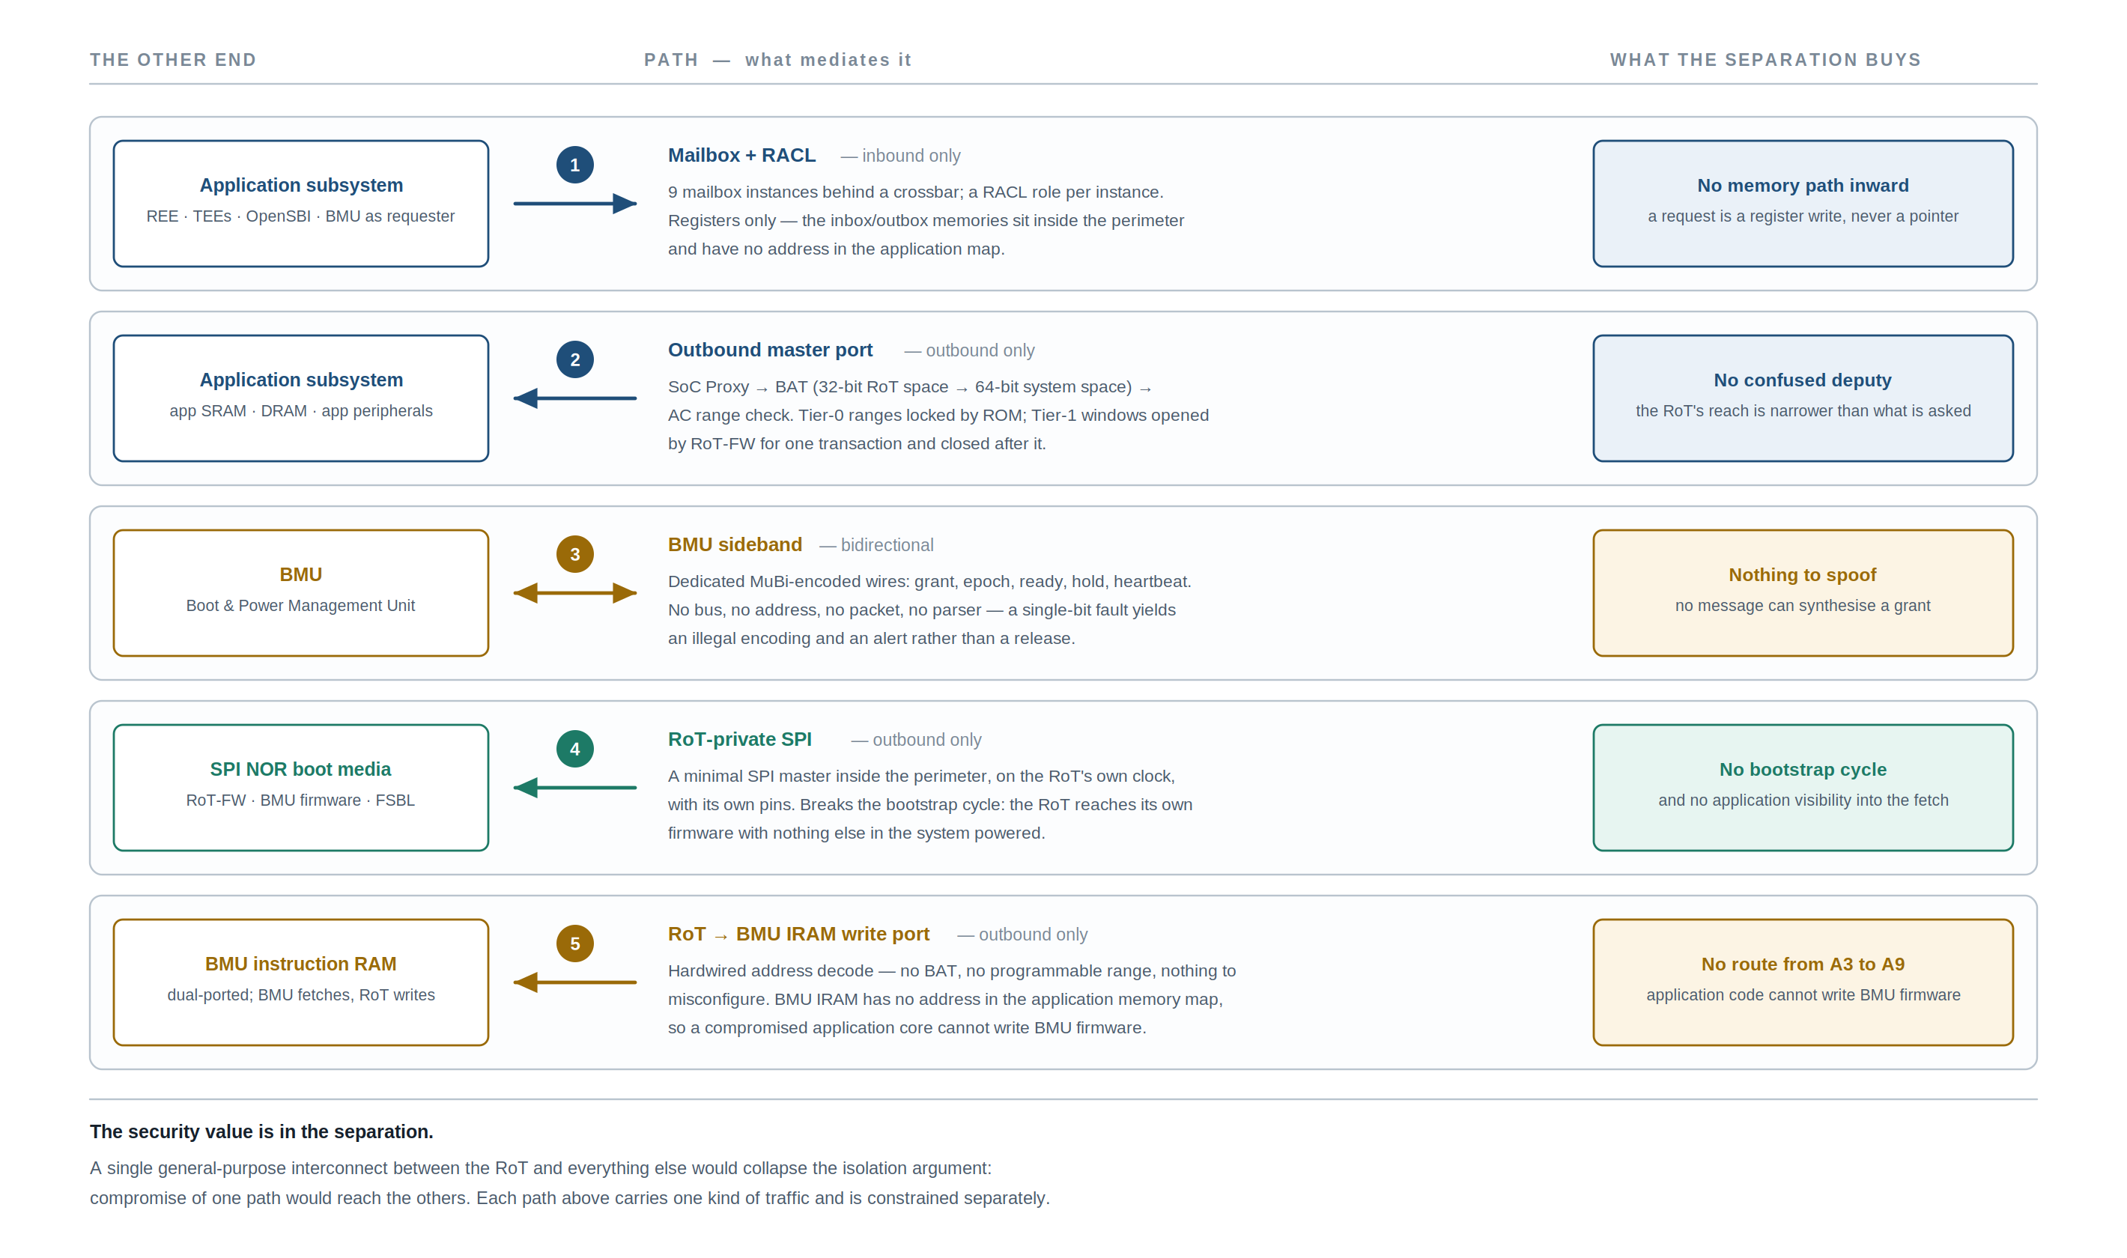
Figure 2. The five data paths. Only one is inbound, and it carries register writes rather than pointers.

2.1 The boundary blocks
Four blocks together implement INV-1, and they are the most security-critical integration logic in the design.
Block | What it does
Mailbox × 9 + crossbar | The only inbound path. Nine independent bidirectional channels, each with its own registers, its own inbox/outbox memory ranges and its own access-control role.
RACL | A hardware-enforced policy filter on RoT register accesses. Each register is tagged with a policy identifier; each incoming transaction carries a role derived from the mailbox or bus port it arrived on; access is permitted or denied per role, register and direction.
SoC Proxy + BAT | The outbound path. The RoT’s internal address space is 32-bit and the application system space is 64-bit; base address translation provides a small number of windows mapping one into the other, so the RoT can only reach memory that firmware has explicitly opened a window onto.
AC Range Check | A 32-entry allowlist filter: base/limit ranges, each with read/write/execute attributes, a bound policy, a denied-access logging bit and a per-range write-enable lock. Translation says where a transaction can be aimed; the range check says whether it is permitted to land.

Four semantics must be fixed in RTL rather than left to the integrator, because firmware will otherwise assume the opposite of whatever is built:
- Default deny. A transaction matching no enabled range is blocked and logged. There is no default-allow fallback.
- Overlap priority. When two enabled ranges both match with differing permissions, state which wins — lowest index, or most restrictive. Both are defensible; only one can be implemented, and firmware must know which.
- Granularity and encoding. Base/limit or base/mask, and the alignment quantum, must be fixed and documented — each application stage’s linker script depends on this value.
- Entry budget. 32 entries are shared across Tier 0, Tier 1, the per-stage write-protect windows and the nine mailbox apertures. Allocate the budget explicitly at design time; it is not obviously sufficient.

2.2 Two-tier range configuration
A single set of ranges locked in ROM cannot work, because the DRAM staging addresses for later stages are not known until the application side has initialised DDR — long after it is released. The configuration is therefore tiered.
Tier | Programmed by | Lifetime and constraint
Tier 0 — protected set | Immutable ROM, before the application side leaves reset | Locked for the remainder of the boot. Names the regions the RoT must never touch, regardless of what any later stage or any application request asks for.
Tier 1 — working windows | RoT firmware at runtime | Opened for a specific verification transaction and closed on completion. Hardware constrains Tier 1 so that no Tier-1 range can overlap, widen or override a Tier-0 range.

What the Tier-0 constraint actually requires — confirm before RTL freeze
In a default-deny allowlist, a Tier-0 entry that merely “names a region to never touch” achieves nothing: everything not allowed is already denied. The real requirement is an overlap check performed at programming time, in hardware, between two register sets.
No Tier-1 entry may be programmed such that it grants any access to any address within the Tier-0 protected set. An attempted programming that would do so is rejected and raises an alert; it does not silently clamp.
This is not a stock feature of a range-check block, and neither is outbound filtering. Treat both as one investigation, and do it during planning rather than during integration.

Every application-supplied address is validated against the Tier-1 window that RoT firmware itself opened for that request — never against a bound derived from the same request. Tier-0 configuration for all four boundary blocks is written by immutable ROM code and locked before the application side is ever released from reset. The locks are multi-bit encoded: a lock is not a single bit that a glitch can flip, but an encoding where only two specific patterns are valid and anything else raises a fatal alert.

2.3 Write-protect windows on application memory
Every stage that executes on the application side runs from a region the RoT has locked against writes. Without this, the stage doing the loading can modify verified code after the hash and before it executes — and that stage spends its life parsing attacker-authored media: image headers carrying load addresses and lengths, partition tables, device-tree nodes. One trusted length or destination field is enough to steer a DMA write into an already-verified region.
This places a requirement on the application SRAM controller — or on a firewall block in front of its port — for address-range write filtering:
- At least two concurrently active base/limit windows, since consecutive stages’ windows overlap across a handoff; four gives headroom.
- Write-deny enforced against every bus initiator, including DMA engines and the other application cores — not core accesses only.
- Programmable from the RoT’s outbound master port and lockable with a write-enable plus multi-bit lock.
- Documented granularity and alignment, since it constrains each stage’s linker script: only text and rodata sit inside a window, with data, bss and stack outside.

Core-local PMP does not satisfy this and is not a substitute. It filters a single hart, so it does not see DMA traffic at all, and it is programmed by the application-side M-mode software the window exists to constrain. The enforcement point must sit outside the thing it constrains. If any initiator can reach these regions by a path that bypasses the filter, the guarantee is void — confirm this against the interconnect before RTL freeze.

3 RoT hardware blocks

3.1 Compute and memory
Block | What it is, and what depends on it
Ibex core | A small 32-bit RISC-V (RV32IMCB) in-order, single-issue CPU — the only processor that executes RoT firmware, configured in its security-hardened variant:  • dual-core lockstep — a shadow core executes the same instruction stream one cycle behind; any divergence raises a fatal alert (A5)  • ECC on register file and data paths — detects glitch-induced bit flips  • PMP — restricts what each firmware stage can reach  • instruction-cache scrambling, dummy instruction insertion, randomised register reset (A6)  The core is deliberately small. Its entire firmware is auditable by a human, which is the property that lets the RoT be the trust anchor for cores that are not.
ROM | Mask-programmed, immutable, on-die; holds the first-stage RoT firmware. Organised as two partitions so a portion may be reserved for manufacturing and test code that is locked out in production lifecycle states.
rom_ctrl | At every reset, before the core is released, it streams the entire ROM through the hash engine and compares the digest against a value in ROM cross-checked against OTP. On mismatch the core is never released and a fatal alert is raised. This makes the ROM the Root of Trust for Verification — the one component whose integrity is checked by hardware rather than by software. It also feeds the ROM digest into the key manager, so an altered ROM would derive different keys even if the digest check were somehow bypassed.
Main SRAM + sram_ctrl | RoT working memory, with address and data scrambled under a per-boot random key and ECC across the array, so that physically reading SRAM yields ciphertext and a glitch-induced bit flip in a buffered image or key is detected rather than silently used.
Mailbox SRAM | A physically separate array holding mailbox inbox and outbox buffers, so application-supplied data never lands in the same memory as RoT secrets, even transiently.

3.2 Cryptographic cores
Block | Role
KMAC | Keccak-based hashing and MAC (SHA-3, SHAKE, cSHAKE, KMAC). The workhorse: firmware digests for secure boot, ROM digests, and all key derivations. Implemented with domain-oriented masking, so instantaneous power consumption is statistically independent of the secret; this consumes fresh randomness on every operation. (A6)
HMAC | SHA-2 family hashing and HMAC. Present because signature schemes, certificate formats and application-facing protocols require SHA-256/384 specifically, and because it is a cheaper path for large non-secret bulk hashing.
AES | AES-128/192/256 in ECB, CBC, CFB, OFB, CTR and GCM. Used for sealing, for decrypting encrypted firmware updates, and for application-requested bulk encryption. Also masked. (A6)
OTBN | A programmable wide-word coprocessor with a 256-bit datapath and its own instruction and data memory, running software implementations of RSA, ECDSA/ECDH over P-256 and P-384, Ed25519, and post-quantum signature schemes. Boot-time signature verification runs here.

OTBN is programmable rather than fixed-function for one reason: algorithm agility. Silicon designed today will be in the field past the point where classical signatures alone are acceptable for firmware signing. Because verification is software rather than hardwired logic, the device can be updated to verify post-quantum signatures without a respin. The boot path is therefore specified as algorithm-agile from the start: the image manifest carries an algorithm identifier, OTP carries the set of algorithms permitted in the current lifecycle state, and ROM dispatches to the corresponding program.

3.3 Entropy
Three blocks form a chain, and conflating them is a common error.
Block | Role
entropy_src | The physical noise source: free-running ring oscillators whose jitter is digitised, plus continuous online health tests — repetition count, adaptive proportion, bucket, Markov — that run on the raw bitstream and raise an alert if the source degrades. This is the block that requires statistical validation; everything downstream is deterministic given its output.
CSRNG | A deterministic random bit generator (CTR_DRBG on AES), seeded and periodically reseeded from the noise source. Turns a slow trickle of physical entropy into a fast stream of cryptographically strong bits.
EDN0 / EDN1 | The fan-out fabric routing generator output to every consumer with its own flow control. Two instances: one general-purpose, one dedicated to the high-rate demand of masked AES and KMAC. The separation exists because masking consumes enormous amounts of randomness, and a masked core starved of entropy either stalls or — much worse — silently reduces its own masking strength.

3.4 Policy, identity and secret storage
Block | Role
otp_ctrl | Manages on-die fuses — write-once, surviving power loss. This is the device’s root secret and root policy storage. Secret partitions are scrambled in the fuse array, and every partition is digest-locked: once its digest is computed and burned, any subsequent modification is detected at every boot.
lc_ctrl | A hardware state machine holding the manufacturing and deployment state, and the sole authority on debug access.
keymgr_dpe | The identity and key derivation engine. Section 6.
alert_handler | The escalation fabric. Every block raises alerts on detected anomalies; this block classifies them, counts and times them against thresholds, and escalates through a programmable ladder.
sensor_ctrl | Interface to analog environmental sensors — clock frequency, voltage, temperature. Detects the operating-envelope excursions that precede or constitute glitch attacks and converts them into alerts. (A5)

What the fuses hold
Partition | Contents and property
UDS | A per-device random value programmed at manufacture, never readable by any software including RoT firmware. Routed to the key manager over a dedicated hardware sideband only.
Device identifier | Per-device unique, readable, non-secret.
Root key authorities | Digests of the public keys authorised to sign firmware, with multiple slots and per-slot revocation bits. Multiple slots are what make rotation and revocation possible; a single hardcoded key would mean one compromised signing key permanently compromises the fleet. (A7)
Anti-rollback counters | Monotonic counters implemented as fuse bit-vectors that can only ever have more bits burned. Firmware whose declared security version is below the burned counter is rejected. (A7)
Lifecycle and configuration | Lifecycle state, debug enablement, feature disables, and the expected ROM digest.

Lifecycle states
State | Meaning | JTAG | Keys
RAW | Fresh from fab, unprovisioned | Open | None
TEST_UNLOCKED | Wafer and package test | Open | None real
TEST_LOCKED | Between test steps | Closed | None real
DEV | Development silicon | Open | Development keys, diversified
PROD | Production device | Closed | Production keys
PROD_END | Production, no further transitions | Closed | Production keys
RMA | Returned for analysis | Open | Wiped first
SCRAP | Terminal | Closed | None

Three properties matter. Transitions are one-way and gated by authentication tokens burned into OTP, so a production device cannot be walked back to open JTAG (A8). The controller drives a diversification value into the key manager, so development and production silicon derive completely different key trees — secrets extracted from development parts are worthless against production parts. And the RMA transition wipes secrets before opening debug, so returning a failed unit for analysis does not surrender its keys.

Anti-rollback: when the counter advances
The check is easy; the burn timing is the hard part, and the three obvious answers are all wrong. Burning at verification time kills the fallback to the older slot exactly when it is needed. Burning at first successful boot with no health confirmation means firmware that boots but is broken in the field can no longer be rolled back. Never burning means rollback protection does nothing at all.
The policy
The counter advances only at UPDATE_CONFIRM, and UPDATE_CONFIRM requires both slots to hold images at or above the new security version.
Phase 1 — update slot A, boot it, take an application health signal, mark it good. The counter is still at the old version and rollback to slot B remains possible throughout.
Phase 2 — update slot B, boot it, take a health signal. Both slots are now at the new version, so nothing is lost by advancing, and UPDATE_CONFIRM burns the counter.
By the time both slots hold the new version, the ability to roll back below it is already gone as a practical matter; the burn merely makes it cryptographically enforced. The counter is never the thing that removes the fallback.

A deployment that genuinely needs the ceiling raised faster may set an explicit accept-loss-of-fallback policy flag permitting confirmation after phase 1. It must be an explicit, recorded choice per product, never a default.

Fuse budget
These are one-time-programmable bit vectors, so the allocation is permanent and must be stated rather than discovered.
Counter | Bits | Increments over device life
RoT-FW | 32 | 32 security-version steps
BMU firmware | 16 | 16
FSBL | 16 | 16
Application chain (SPL / U-Boot / OpenSBI / kernel) | 32 shared | 32

One counter per independently released piece of software. The application chain’s bits are a shared security-version namespace across all four of its stages, so bumping it for a kernel fix raises the floor for the others at the same time. That is workable only under a discipline this document states rather than assumes: the four application stages are versioned, signed and released as a set. A product that intends to release them independently must split the budget instead — and must decide this before fuse-map freeze, because the allocation cannot be revisited afterwards.
Note what a counter step is: a security version, not a release. Routine releases that fix no vulnerability reuse the current security version and burn nothing. A ten-year life at two or three security-version bumps a year fits inside 32 with margin. On exhaustion the behaviour is chosen rather than emergent: the device continues to boot and run normally and refuses only updates that would require a further increment; it does not brick.
Every fuse write must survive power loss mid-burn. The burn protocol is therefore burn, read-back verify, re-burn on mismatch, with each field using an encoding that remains unambiguously decodable when partially written — monotonic bit vectors already have this property; multi-word fields need an explicit commit bit burned last.

Why the escalation fabric has the shape it has
Four reasons, because each one rules out a cheaper arrangement that looks adequate.
- Detection without escalation is decoration. Lockstep, ECC, health tests, digest mismatch, illegal-state detectors and integrity checks all detect an anomaly and do nothing about it. A lockstep comparator that reports a mismatch to nobody has not detected anything, so without this block the area spent on all of them buys no security property at all.
- The response must be graduated. Hardwire “reset on any alert” and every transient becomes a self-inflicted denial of service — drive one benign detector and the part never boots. Hardwire “interrupt only” and a sustained attacker is never stopped. Classification plus counting and timing against thresholds is what lets a noisy-but-benign source be tolerated while a real campaign climbs the ladder.
- It must be hardware, inside the perimeter. The alerts that matter most are the ones saying the core itself is no longer trustworthy, and firmware running on that core cannot be the responder to that news. Nor can the response be delegated outward: an escalation path owned by the BMU or by application software would itself be an external reset path into the RoT, which INV-2 forbids.
- Escalation resets must be counted. Reset-on-fault without a bound is an unlimited retry oracle: glitch, get reset, re-roll indefinitely until a fault lands favourably. The terminal threshold converts that into a bounded number of attempts.

The ladder runs: interrupt the core → wipe secrets → reset the RoT → assert hold to the BMU, holding the whole SoC down. An escalation reset must re-run the full boot sequence including the ROM digest check with no stale pass indication, must clear every core release grant, and must not clear the application-side write-protect windows, which are what keeps already-verified stages intact across the event. Because the final rung crosses the BMU interface and a compromised BMU might not honour it, the release grant is the primary containment and the hold is secondary: withholding release does not require BMU cooperation, whereas forcing a system-wide reset does.

3.5 Infrastructure
Block | Role
RoT-private SPI controller | A minimal SPI master inside the perimeter, on the RoT’s own clock, with its own pins to the flash holding RoT firmware, BMU firmware and FSBL. It exists to break a bootstrap cycle: the shared controller sits on the application bus behind rails and clocks that only BMU firmware brings up, and BMU firmware is not verified until after RoT firmware is running. Deliberately minimal — read and status commands sufficient to pull images, plus what the update flow requires to write them. Not exposed over the mailbox, and carrying no descriptors from application-supplied addresses.
DMA | Moves bulk data without tying up the core. 64-bit source and destination addresses with a per-endpoint address-space selector; inline hashing, so an image of any size can be digested with zero bytes resident in RoT SRAM; its own range restriction on the RoT-internal side, locked by ROM; and a per-transfer configuration lock so a partially configured transfer cannot be hijacked mid-flight.
Reset and clock control | Manages the RoT’s own internal reset tree and clock gating and drives the RoT’s side of the BMU interface. SoC-wide sequencing is not in the RoT: what the RoT retains is authority, not mechanism.
aon_timer | Always-on wall-clock timer and system watchdog. See the three timers below.
rv_dm | JTAG debug access to the core, hard-gated by lifecycle. In production states the gate is closed in hardware, not by firmware policy. (A8)
Pinmux / straps | Sampled once at reset for boot-mode selection, then locked.

The DMA’s internal allowlist must exclude RoT firmware’s own text
The RoT-internal allowlist must exclude RoT ROM, the key-manager, OTP and lifecycle register apertures, the stack, and — critically — RoT firmware’s own text.
A descriptor whose length or destination is influenced by a mailbox-supplied value and which lands in firmware text is full RoT compromise from a single arithmetic bug. It must be blocked in hardware rather than avoided by firmware care.

4 Boot media and software stages
Off-die storage is all untrusted. The architecture constrains when each medium must be reachable and who verifies what comes off it — not which device type is fitted.
Class | Holds | Constraint
RoT-private medium — mandatory | RoT firmware, BMU firmware, FSBL | Reached over the RoT-private SPI controller, never the shared controller. It must be readable with the BMU halted and the application subsystem unpowered, because that is what breaks the bootstrap cycle. In practice this is SPI NOR: no PHY training, no rails beyond the RoT’s own, and a controller small enough to sit inside the perimeter.
Bulk medium — optional | SPL, U-Boot, OpenSBI, the OS | Nothing in the trust model requires a particular device type, or a second device at all. Whatever it is, it becomes reachable only once the BMU has brought its domain up and the application cores are running, so its images are loaded by the running stage and verified by the RoT in place at their final execution address.

The division follows bootstrap order, not device type: everything the RoT needs before the system is up lives on RoT-private media; everything fetched after the application cores are running is verified in place, gated over the mailbox. The guarantee is unchanged whether an image arrives from eMMC, from NOR, or over a network.

4.1 Software stages
# | Stage | Runs on | Executes from | Verified by | Mutable
0 | Power-on sequencer | hardwired FSM | — | — | no
1 | ROM digest check | hardware | — | — | no
2 | RoT ROM | Ibex | RoT ROM | rom_ctrl | no
3 | RoT-FW | Ibex | RoT SRAM | RoT ROM | yes
4 | BMU boot ROM | BMU core | BMU ROM | measured only | no
5 | BMU firmware | BMU core | BMU IRAM | RoT-FW | yes
6 | ZSBL / FSBL | application core 0 | application SRAM | RoT-FW | yes
7 | SPL | application core 0 | application SRAM | RoT gate | yes
8 | U-Boot | application core 0 | DRAM | RoT gate | yes
9 | OpenSBI + OS | all application cores | DRAM | RoT gate | yes

Stage 0 is not software: it is a hardwired state machine with no core and no instruction fetch. Stage 2 is therefore both the first stage to execute anything and the first to decide anything, and it remains the Root of Trust for Verification.
Stage 4 is the one software stage trusted without being verified. Note where it sits in the order: the BMU’s core and boot ROM are held in reset until after the RoT has checked its own ROM digest, launched its firmware, locked its application-facing boundary, verified BMU firmware, written it into BMU instruction RAM and locked that memory against BMU writes. The BMU boot ROM therefore begins executing with the RoT already sovereign and every RoT verification decision already made. It cannot influence any of them, because none of them are still ahead of it.

Stage 3 exists and is mutable, and this is a deliberate structural choice
A design in which all RoT logic lives in mask ROM has no field-patchable component: a single logic bug in verification, a cryptographic algorithm deprecation, or a newly discovered fault-injection path becomes a silicon respin and a fleet recall.
The immutable ROM is therefore kept as small as possible — ROM controller handoff, boundary configuration, and exactly one job of its own: verify and launch RoT firmware. Everything with meaningful complexity — image parsing, application protocol handling, attestation, certificate generation — lives in RoT firmware, which is signed, anti-rollback-protected and updatable in the field.
There is no configuration in which RoT firmware is delivered to the RoT by the application side over a mailbox. At the point it is fetched, the application subsystem is unpowered and the BMU core is in reset, so no such requester exists.

4.2 Consolidating onto a single flash device
Because the bulk medium is optional, a system with a small root filesystem can hold every image on SPI NOR and omit eMMC entirely. Capacity is the binding constraint, not security: the whole image set comes to roughly 10–15 MB and fits comfortably in a 32–64 MB device, whereas a general-purpose distribution root filesystem does not — and NOR’s erase-block granularity and write endurance make it a poor host for A/B update slots or any writable filesystem.
Consolidation carries one security cost, which should be an explicit decision rather than a default. With separate media the application side has no path of any kind to the storage holding RoT and BMU firmware. Put every image on one device and the application side must be able to read that device, which ends the property. This is not a verification bypass — signature checks and anti-rollback still gate execution at the next boot — but it hands the attacker a route to attempt persistence and to brick the part.
Arrangement | Property
Two flash devices (recommended) | A small permanently RoT-private device for RoT firmware, BMU firmware and FSBL; a second for the application stages. Keeps the isolation property intact for the cost of one cheap component.
One device, RoT owns the write-protect pin | The application side is granted read access and never write access. Preserves integrity; concedes confidentiality, which costs little here — these images are signed, not secret.
One device behind a mux | RoT as default owner, handed off only after the cores are released. Simplest board, weakest property.

Under all three the RoT remains the arbiter, and the application side never acquires the boot medium before the cores are released.

5 Secure boot
The sequence runs from cold power-on to steady state in fifteen labelled steps. It is drawn in two parts.
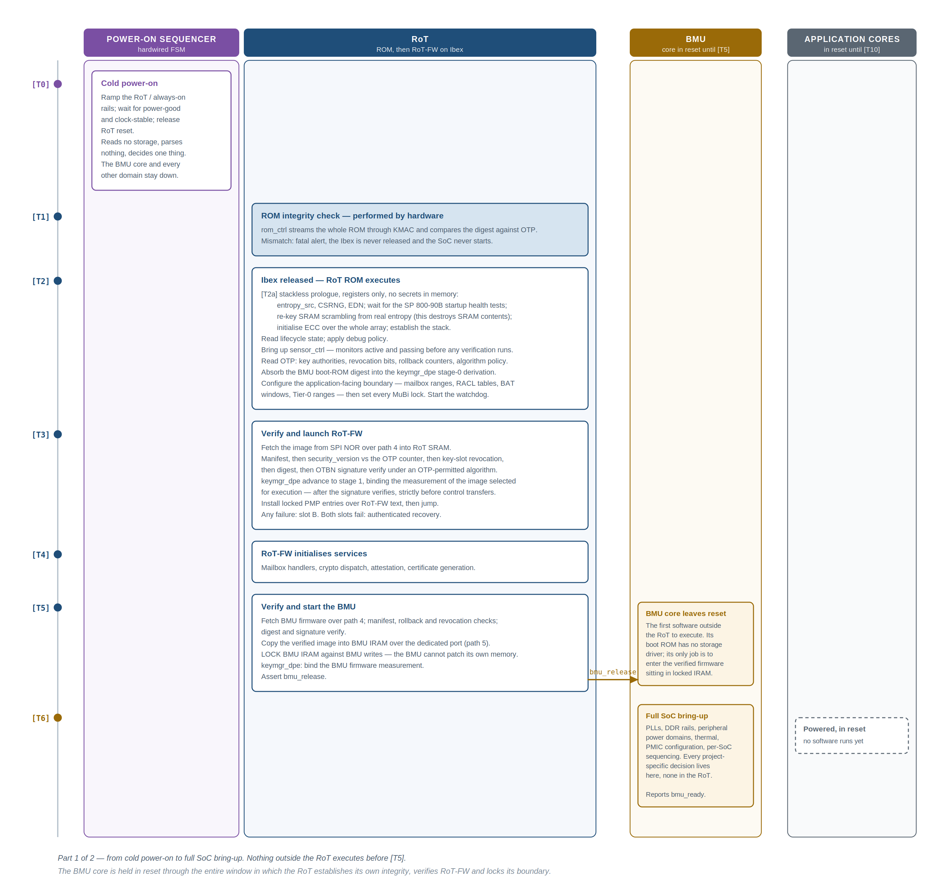
Figure 3. Boot sequence, part 1 — from cold power-on through RoT firmware launch, BMU verification and full SoC bring-up.
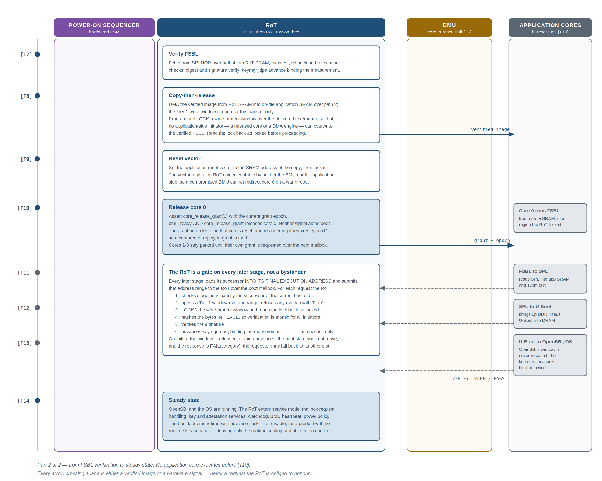
Figure 4. Boot sequence, part 2 — FSBL verification, copy-then-release, core release, and the mailbox-gated stages up to steady state.
Note what runs when. The BMU core is not executing during the window in which the RoT establishes its own integrity and launches its firmware; from that point onward the BMU runs only firmware the RoT verified. There is no point in the flow at which unverified code executes anywhere in the system except the sequencer, whose scope is bounded by the six conditions in section 9.
Note also what each path carries. The three fetches the RoT performs before the application cores exist all go over the RoT-private SPI controller, with no dependency on BMU-supplied clocks or rails and no visibility to the application subsystem. BMU firmware delivery uses the dedicated instruction-RAM port; the FSBL copy uses the outbound master port; the core release is a sideband wire. The four are physically distinct, which is what keeps a compromise of one from reaching the others.

5.1 Measurement is mandatory, and how that is enforced
At every stage transition the next stage’s measurement is bound into the key manager before that stage executes. This is not a logging convenience and it is not optional.
The enforcement mechanism is structural, not procedural: the key manager will not produce the keys a stage needs until the advance operation carrying that stage’s measurement has been performed, and each slot can only be advanced once per boot. A stage that skips its measurement does not get a key. A stage that lies about its measurement gets a key derived from the lie, which will not match anything a verifier accepts and will not decrypt anything previously sealed.
Why “the application side reports its measurement for logging” is not an acceptable design
If the application side can proceed without extending, an attacker’s stage simply does not extend, and the measurement chain — and with it every attestation and sealing guarantee — is worthless.
The application side does not choose whether to be measured. It sends its next-stage image to the RoT, the RoT measures it, and the RoT decides whether it runs.

For the application stages the mailbox verification transaction is therefore a gate, not a notification. Three steps carry the weight.
Step | Why it is load-bearing
The boot-stage gate | RoT firmware holds an explicit, monotonic, one-shot-per-state boot state machine, and a verification request is rejected unless its stage identifier is exactly the successor of the current state. Without it, an application-side agent can submit any stage, at any time, repeatedly — driving the RoT’s stage machinery out of order.
The Tier-1 window | The range that bounds the read is opened by RoT firmware for this specific request and validated against the Tier-0 protected set. It is never derived from the request’s own fields. This is what prevents the verification service being used as a read oracle.
Advance on success only | Advancing on failure would break A/B fallback outright: since each slot advances at most once per boot, a single corrupted byte in slot A would burn the boot’s only advance, leaving a perfectly good slot B unable to be measured. One corrupted byte per device is cheap for an attacker who can rewrite storage, so this would be a fleet-wide availability attack.

The legitimate requirement behind the word “mandatory” is that a stage must not be able to skip its own measurement. That is delivered by the ordering — the advance strictly precedes execution, and no stage can obtain keys without it — not by advancing on failure. The two are easy to conflate and must not be.

5.2 Copy-then-execute, never execute-in-place
The verified image is copied into on-die SRAM before the application side is released to run it. The alternative — verifying an image in external flash and then letting the application side execute directly from that same flash — is a time-of-check-to-time-of-use vulnerability and is prohibited by this architecture.
The attack it prevents: the RoT reads flash, hashes it, and finds it good. The application side then fetches instructions from the same flash. Between those two events an attacker rewrites the flash, or interposes on the bus and serves different bytes to the core’s fetches than were served to the RoT’s read. Verification of a mutable, externally controlled, re-readable medium guarantees only that at one moment the medium held good bytes.
Copy-then-execute closes this by making the verified bytes and the executed bytes the same bytes, in on-die memory the attacker cannot reach. Every stage follows the same discipline: fetch to trusted memory, verify in trusted memory, execute from trusted memory.
Where the guarantee stops: DRAM-resident stages and bus interposition
Against A1 — rewrite of off-die storage — DRAM-resident stages are protected. The lock-first-then-hash order closes the on-die race completely: the RoT programs and confirms the DRAM-path write filter before it hashes, so no on-die initiator can alter the bytes between the hash and the jump. A rewritten flash image is caught at verification like any other.
Against A2 — probe and inject on off-die buses, explicitly including DDR — they are not, and no arrangement in this design makes them so. An interposer on the DDR bus serves correct bytes to the RoT’s hash reads and different bytes to the core’s instruction fetches. Range filtering does not help: the filter is on-die and the substitution is off-die.
U-Boot, OpenSBI and the kernel are protected against A1 but not against A2. The design’s A2 resistance stops at the on-die SRAM boundary.
Bringing this into scope is possible but is a different design: it requires a memory encryption and integrity engine on the DDR path — confidentiality plus a MAC tree for integrity and replay resistance — which is a significant block absent from this architecture and from the phasing. It is not a firmware change and should not be scoped as one.

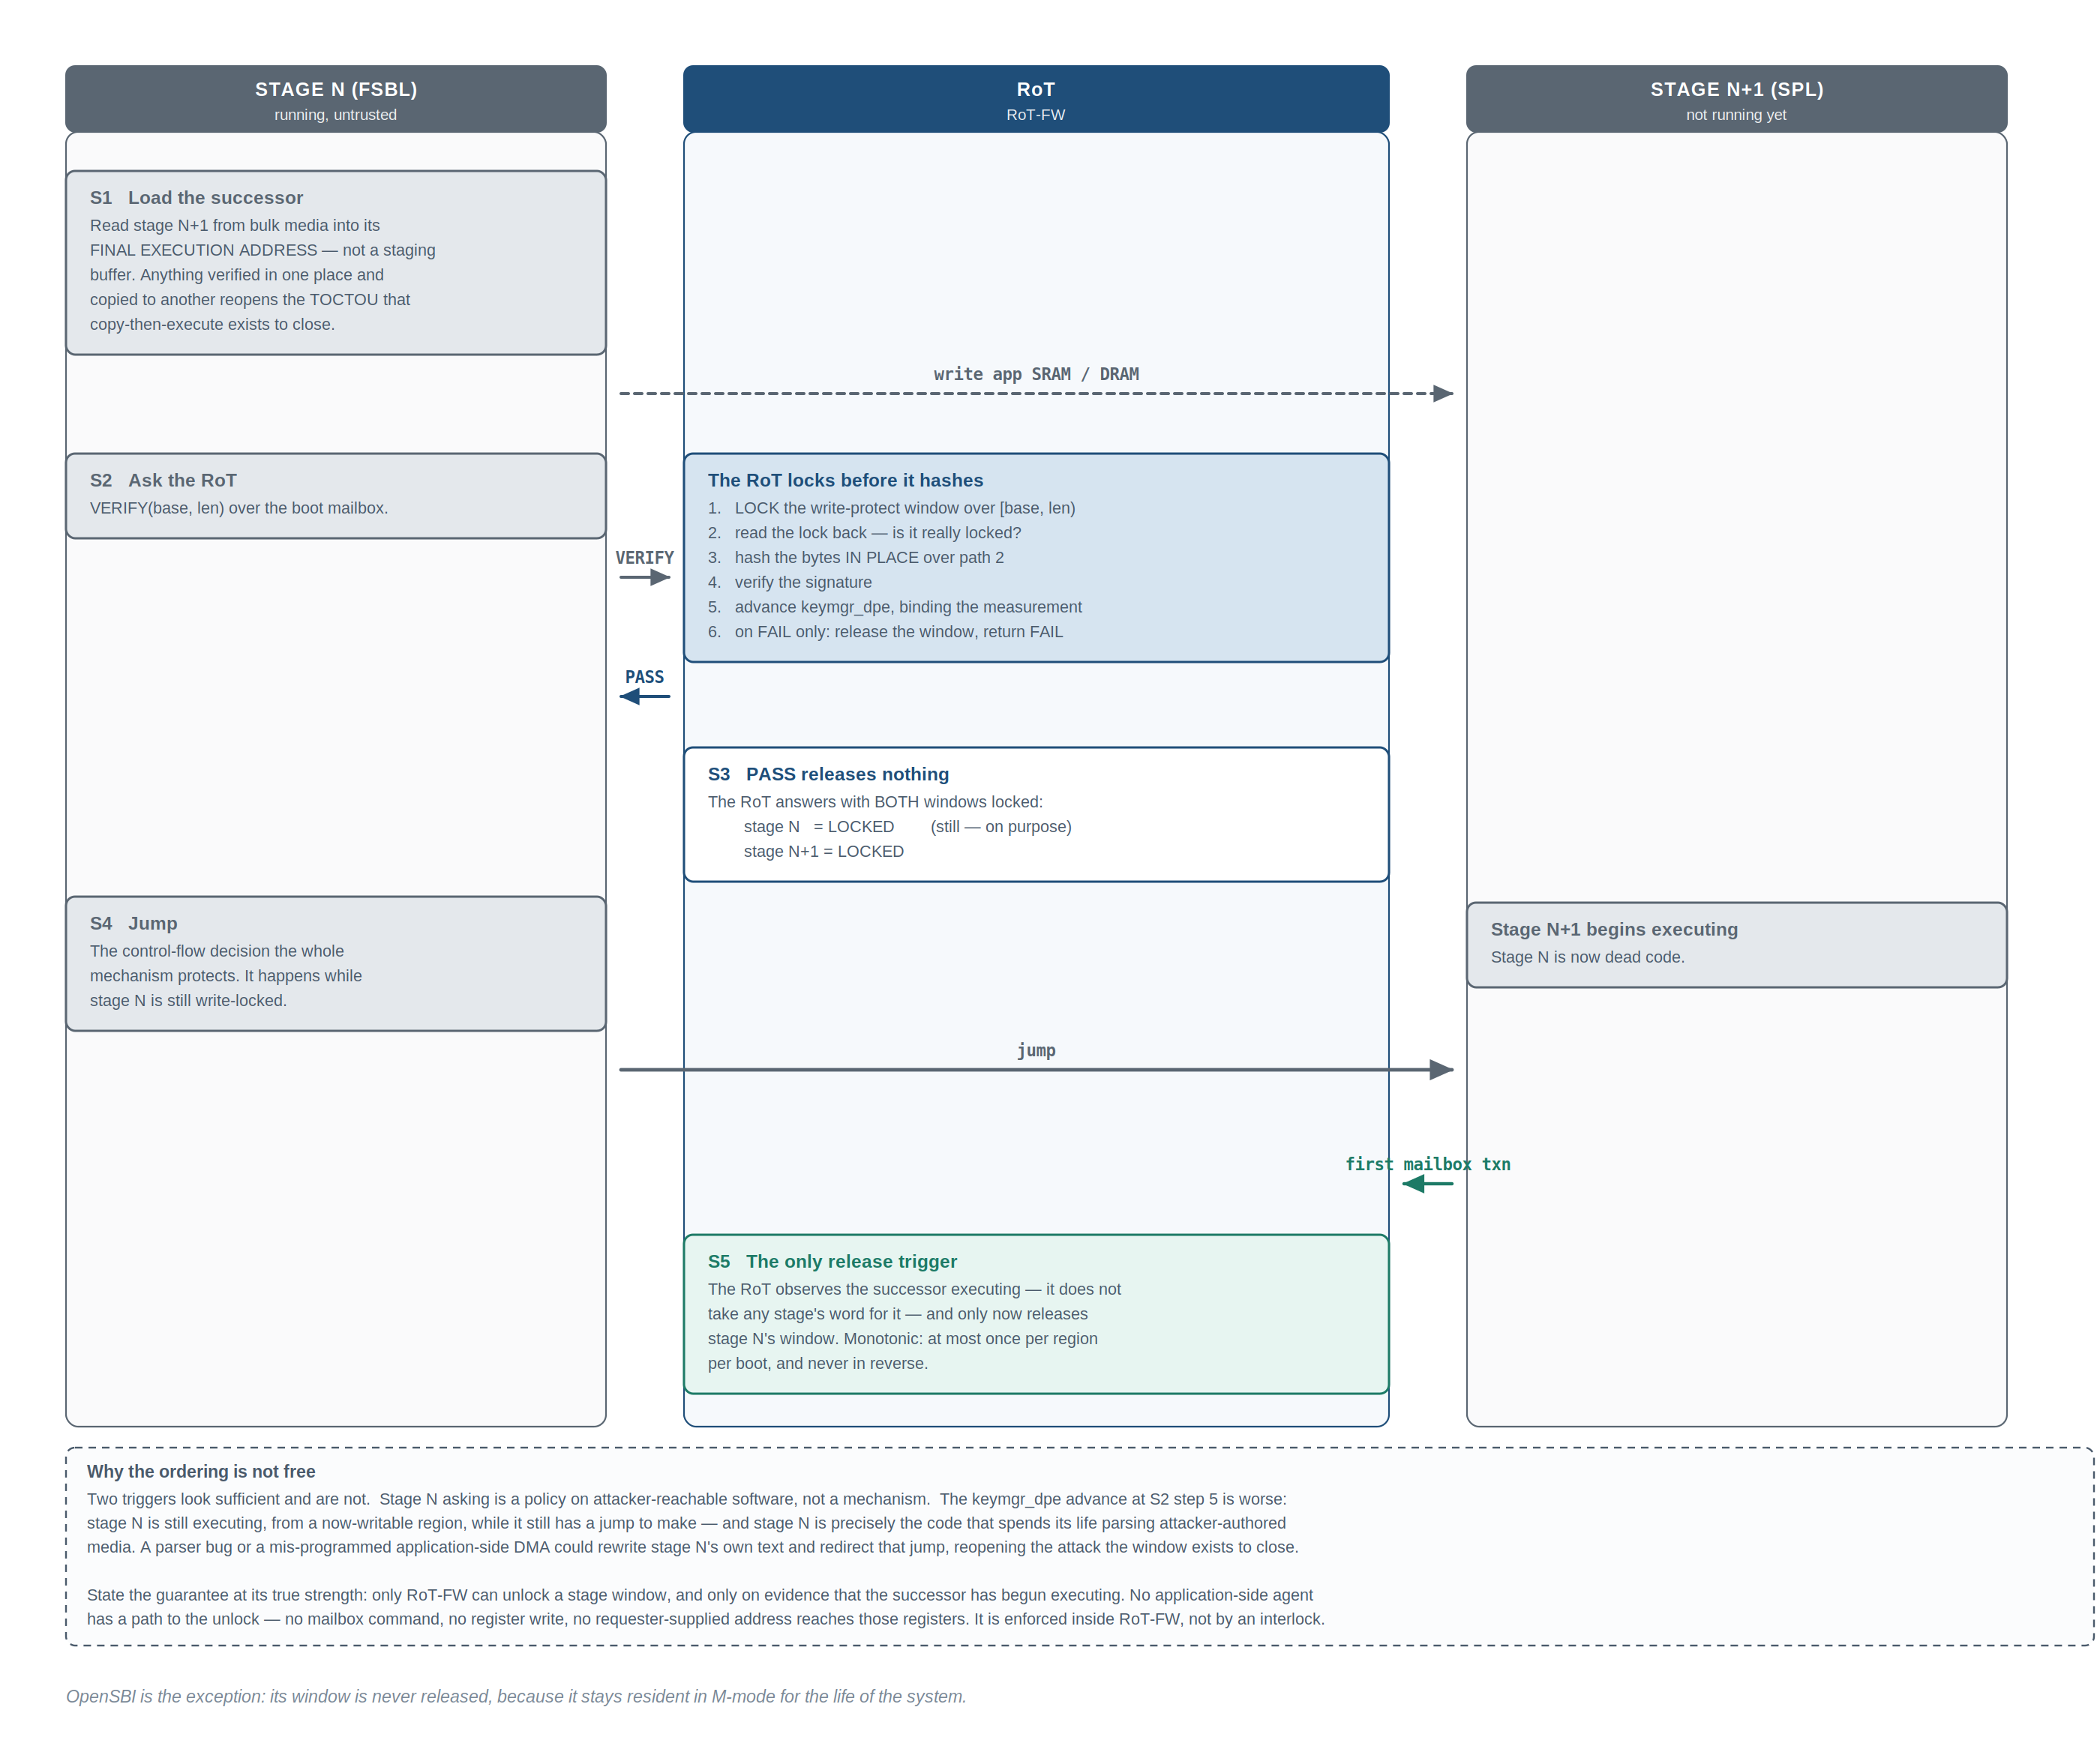
The write-protect window over each verified stage is not held until reset — window registers are a bounded resource, and a stage that has genuinely handed off is no longer an execution target. But the release is triggered neither by the handing-off stage nor by the key-manager advance that locks its successor.
Read the figure as four facts. The RoT locks before it hashes, so verification is atomic against every application-side initiator — there is no interval between the last byte hashed and the lock taking effect. PASS does not release anything. The jump is the control-flow decision the whole mechanism protects, and it happens while the predecessor is still locked. And the successor’s first mailbox transaction is the only release trigger — an event the RoT observes directly rather than a claim any stage makes about itself.
OpenSBI is the exception: its window is never released, because it stays resident in M-mode for the life of the system. This is the one permanent lock. The kernel is the opposite case — verified and measured but deliberately not locked, because it relocates itself, patches alternatives and static keys, and frees its init section. Kernel text protection is the kernel’s own job via page tables; the RoT’s guarantee for Linux is measurement at load, not immutability at runtime.
Figure 5. Stage handoff. The RoT locks before it hashes, answers PASS with both windows still locked, and releases the predecessor’s window only on evidence that the successor is executing.

5.3 Failure handling and recovery
Fail-closed is necessary but not sufficient. A device that halts on any verification failure with no path forward is bricked by one bad update or one flash bit-rot, which converts an availability problem into a fleet recall. The policy is therefore three-tiered.
Tier | Mechanism
A/B slot fallback | Every mutable stage has two slots. Failure of slot A falls back to slot B. Both are independently signed and independently rollback-checked; fallback is not a bypass.
Authenticated recovery | If both slots fail, the RoT enters a minimal recovery mode in which it will accept a signed recovery image. Recovery images are signed by a distinct recovery key authority in OTP, are subject to the same rollback rules, and recovery mode is available only in lifecycle states that permit it.
Terminal fail-closed | If recovery is unavailable or itself fails, the RoT escalates and holds the SoC down.

Recovery mode exist only after RoT-firmware starts, accessed through the mailbox.
A RoT-firmware verification failure occurs while the BMU core is still in reset and the application subsystem is unpowered — there is nobody in the system that can write a mailbox. Supporting recovery at this stage would require ROM to implement a recovery transport, image authentication, and SPI NOR write capability, significantly increasing the immutable trusted computing base and permanently embedding any implementation defects in silicon.
ROM provides only A/B slot fallback, not recovery for RoT-firmware verification failure.
Later recovery runs over the mailbox, for failures of FSBL and later stages where the application side exists and can carry the image.

Failure reporting is deliberately coarse. Error responses name a category and never indicate where in a signature comparison a mismatch occurred, never vary observably in timing with secret-dependent data, and never echo internal addresses or key material. A detailed error message is an oracle.

5.4 Verifying images larger than RoT memory
The RoT’s SRAM is measured in tens of kilobytes; U-Boot is megabytes and a kernel plus initramfs is tens of megabytes. No image is ever fully resident in RoT memory, and image size places no limit on what the RoT can verify.
Mechanism | How it works
Inline hashing in the DMA (preferred) | The DMA streams from application memory with its digest engine enabled and the write destination discarded. An image of any size is digested with zero bytes buffered in RoT SRAM; the core then verifies one signature over the resulting digest. The cost is bus bandwidth, not memory.
Chunked streaming | The DMA moves a fixed-size chunk into a RoT SRAM buffer, the core feeds it to the hash engine incrementally, and the buffer is reused. Used where the digest algorithm or a pre-processing step is not supported by the inline engine.
Window sliding | A translation window need not be image-sized; for images larger than the available window, the window is walked across the image between chunks.

Root filesystems are verified differently. A rootfs is not hashed in its entirety at boot — the latency would be seconds to minutes and the result would be stale the moment the filesystem is written to. Instead the image is built with a Merkle tree over its blocks, the RoT verifies a signature over the root hash only, that root hash is bound into the key manager as the rootfs measurement, and the kernel verifies each block against the tree on demand as it is read. The RoT’s work is constant-time regardless of filesystem size, and tampering with any block is caught at the moment that block is used rather than only at boot.

6 Keys, identity and attestation
Two questions have to be answerable for a device in the field. Is this data safe on this device, even though the storage it sits in is readable and writable by an attacker and the software on the device can be replaced? And is the thing on the other end of this connection really one of my devices, running software I approve of, even though anything software says about itself can be faked by different software?
Four ideas, layered on each other, answer both. Each exists because the previous one alone is not enough.
Idea | What it is, and why it must be hardware
Device identity | A per-device secret that no software — not even RoT firmware — can read, and a public identity derived from it that a manufacturer vouches for. Anything stored in normal storage can be copied to another device; anything readable by software can be exfiltrated by compromised software. The root of identity is therefore the UDS: generated on the device itself during manufacturing, burned into fuses, wired over a dedicated sideband into the key manager, and appearing at no bus address. Software can cause keys to be derived from it; it can never see it.
Measurement and measured boot | A measurement is a cryptographic hash of a piece of software, taken before that software runs. At every stage transition the currently trusted code measures the next stage before handing control to it, and records the measurement somewhere the next stage cannot rewrite. Each link is recorded by code that ran before the software being measured, so software cannot lie about itself: by the time a stage is running and could want to lie, its fingerprint is already on record.
Attestation | The device produces a signed statement — evidence — saying which device it is and what its measurement chain is. The signing key is itself derived from the UDS and that chain, so modified software cannot produce evidence claiming to be unmodified software: it would need the unmodified software’s key, and it cannot derive that key, because the hardware mixes in the actual measurements the RoT took rather than anything software claims.
Sealing | Encrypting data under a key derived from device secret plus software measurement chain and never exposed to software. The ciphertext can sit in completely untrusted storage, because decrypting requires re-deriving the key, and the key re-derives correctly only on the same device running the same software.

The single requirement underneath all four
A key that is a deterministic, one-way function of (device secret, hardware state, complete software measurement chain) — computable only inside hardware, never visible to software as data.
Device identity is that function with an empty software chain. Sealing is its symmetric output. Attestation is its asymmetric output. Measured boot is the discipline that feeds the software-chain input honestly.

Note why the record is not a log. If the measurement chain were a log that each stage appends to, a compromised stage would simply append the hash of the good software instead of its own. The measurements are therefore not stored as a readable log at all — they are folded into key derivation, so that running with the wrong measurement means running with the wrong keys, which means sealed data will not open and attestation will not verify. Lying is not prevented; it is made pointless.

6.1 Verified boot and measured boot are different, and this design does both
Verified boot is a gate: check a signature, refuse to run the image if it fails. Measured boot is a record: note exactly what ran. Verified boot answers “only approved software runs”; measured boot answers “and here is precisely which approved software it was — which version, which build”. The second is needed because “approved” changes over time: yesterday’s approved firmware is today’s known-vulnerable firmware, and a remote party deciding whether to trust the device needs to know which one it is talking to, not merely that some signature once passed.

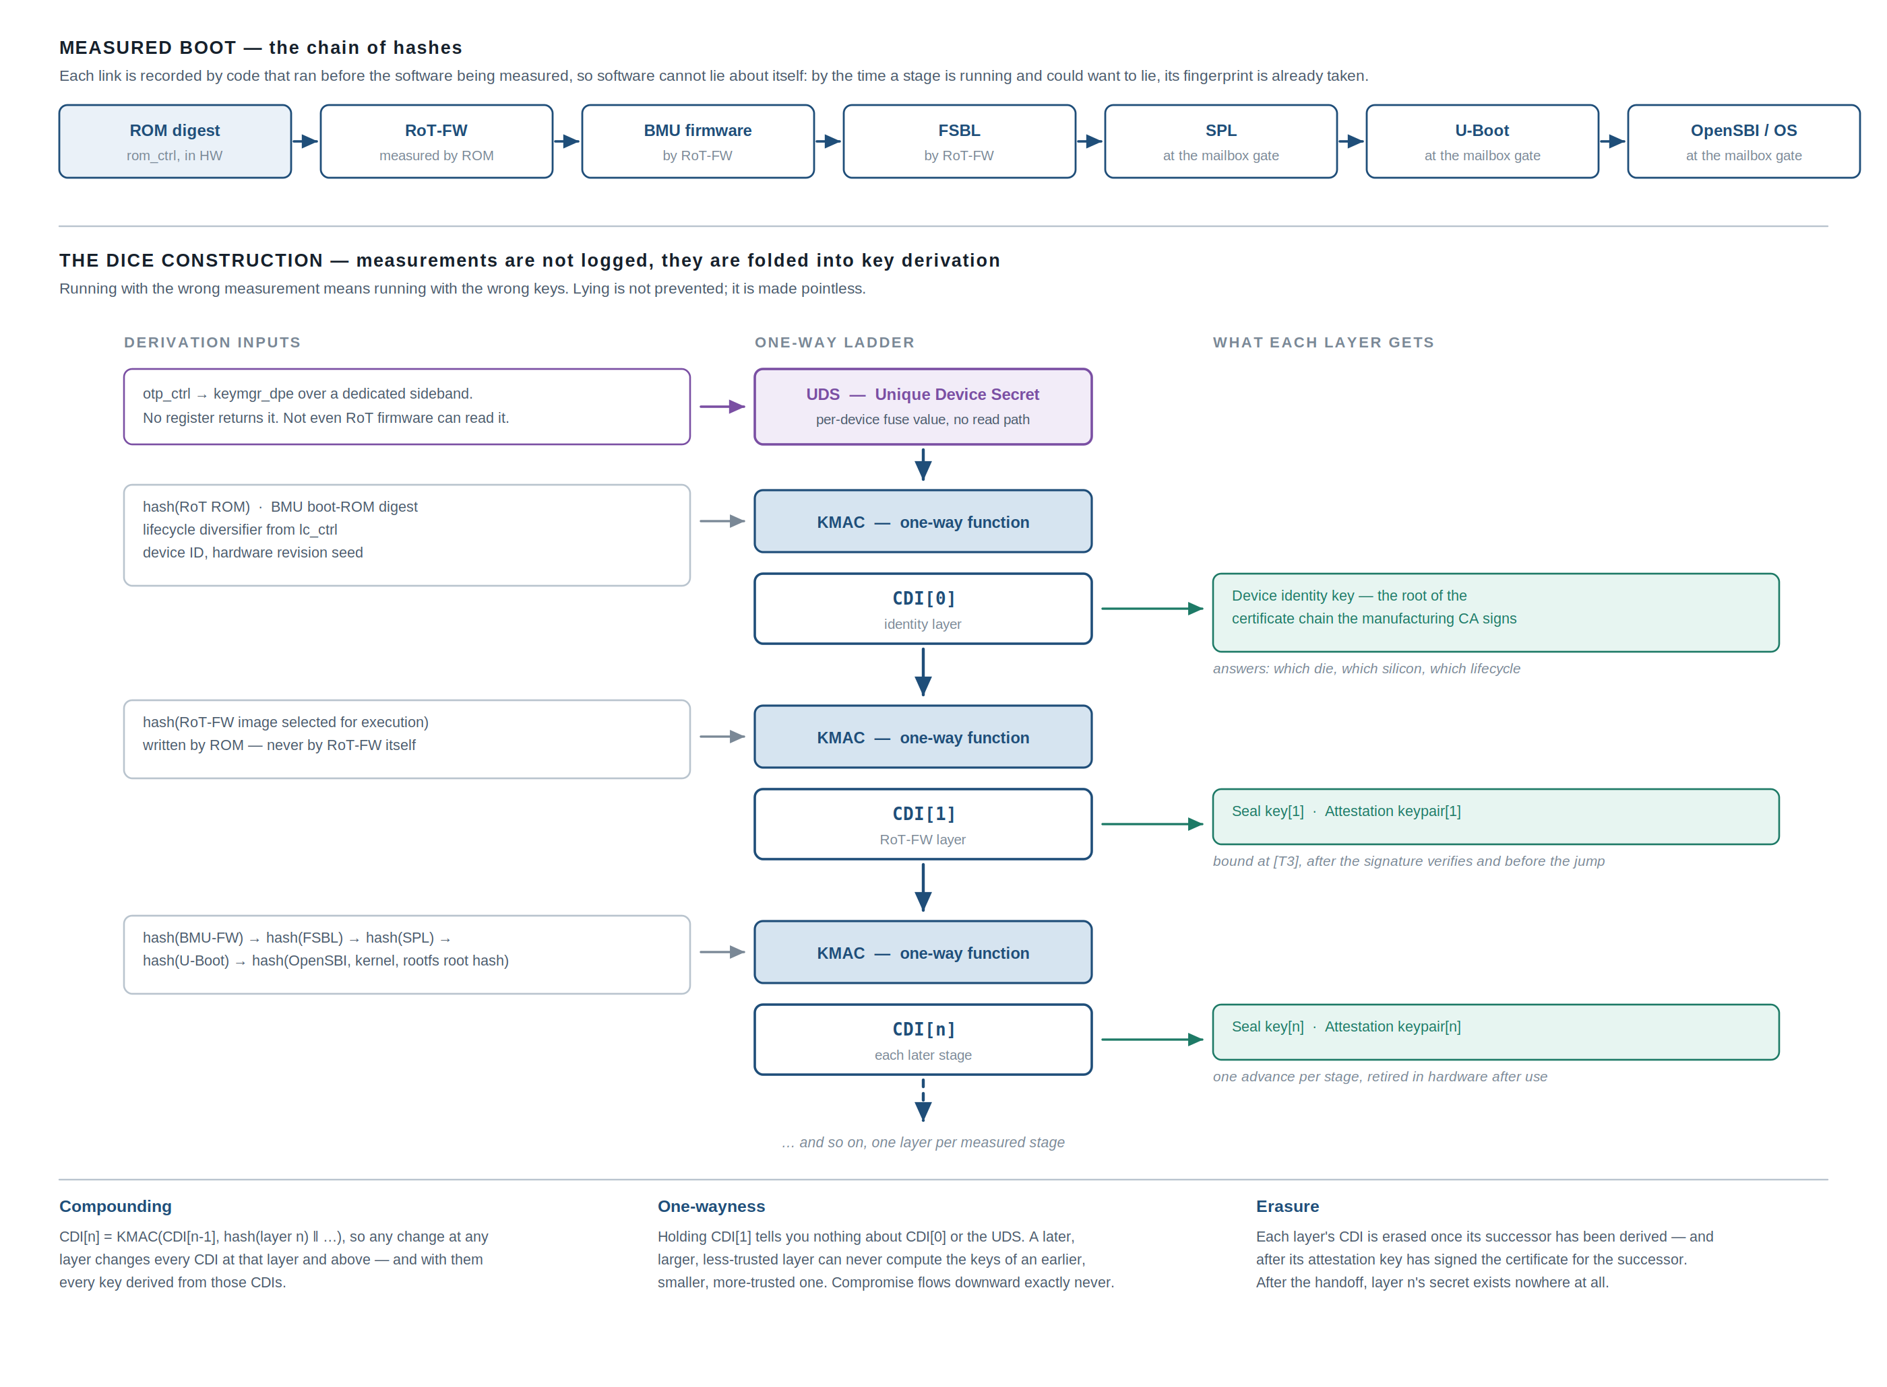
Figure 6. Measured boot and the DICE construction. Any change at any layer changes every key at that layer and above.

The scheme is DICE — a layered key derivation specified by the Trusted Computing Group. Using the standard answer rather than an invented one is what lets third-party verifiers consume the output. The variant implemented here generalises the single chain to a small set of parallel contexts held in key slots, so that the boot chain, a per-client sealing context and an attestation context can coexist without one being able to derive another’s keys.

6.2 The key manager hardware
A useful way to audit this block: every internal component exists to keep one specific promise. Two things are worth reading off the figure before anything else. Every input that must not be forgeable arrives on a dedicated wire from the block that owns it, so no firmware bug and no register poke can substitute it. And every path by which a secret could leave is either absent or point-to-point.

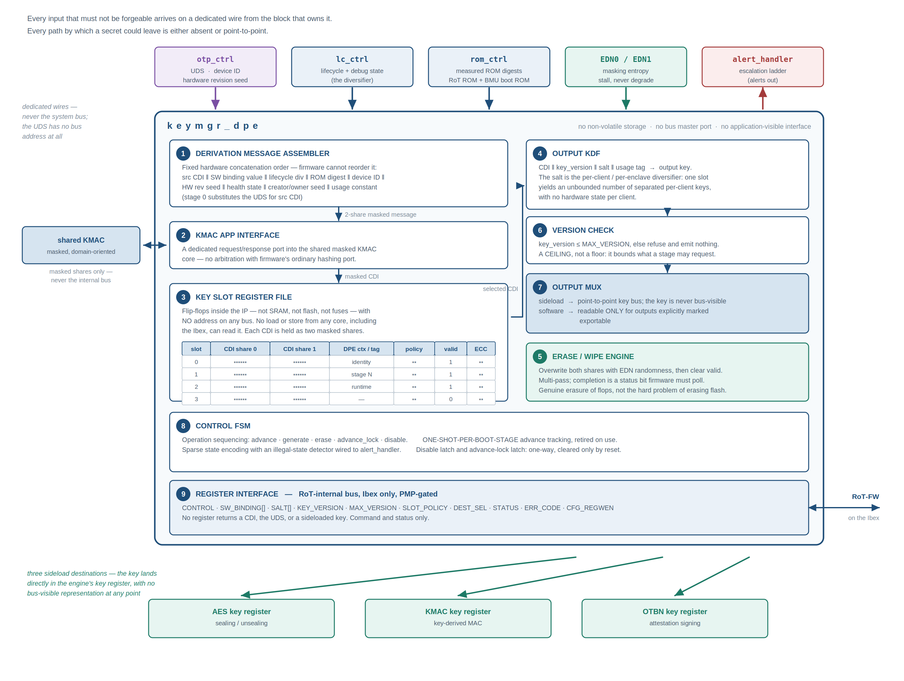
Figure 7. keymgr_dpe internal hardware. Secrets live in flip-flops with no bus address; keys leave only over point-to-point sideload buses.

Why the slot file is flip-flops
The promise being kept is that no CDI ever exists in non-volatile storage and no CDI survives power-off. The only persistent secret in the entire system is the UDS in fuses; the whole ladder is rebuilt from it on every boot by re-running the measured-boot advances. Three consequences, each load-bearing:
- It is what makes “measurement is mandatory” enforceable: if a CDI survived a reset, a later boot could reach that layer’s keys without re-measuring the layer, and the gate would be decorative.
- An attacker holding a powered-down device has nothing to extract — the secrets do not exist outside powered logic.
- Erasure is genuine erasure of flops, trivially and verifiably complete, rather than the genuinely hard problem of erasing flash.

The version check is a ceiling, not a floor
The name invites the wrong reading. A ceiling cannot revoke anything: raising it widens what may be requested, and lowering it makes the newest keys unavailable while leaving every old key perfectly derivable. What the register actually provides is privilege reduction across the boot chain — a stage lowers the maximum before handing off, so a later, less-trusted stage cannot request key versions the earlier stage could. Combined with the write-enable lock, this is a one-way narrowing as the boot proceeds, the same shape as every other lock in this design.

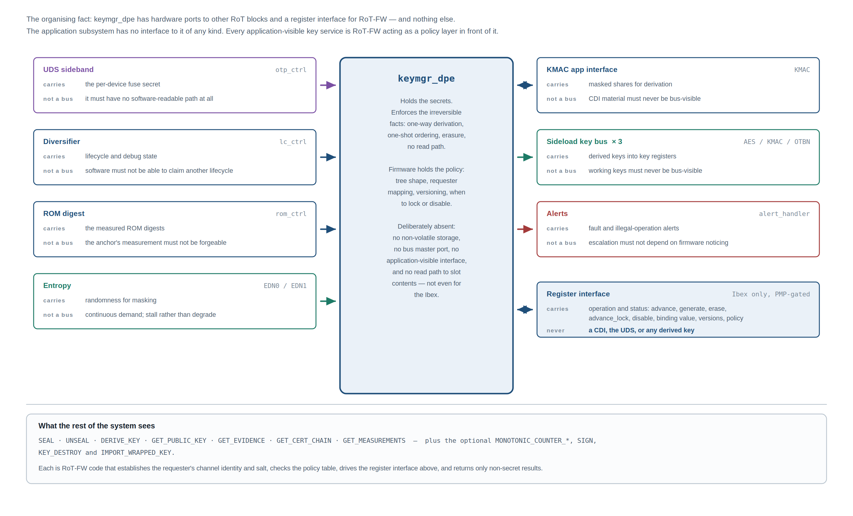
Figure 8. keymgr_dpe interfaces. Hardware ports to other RoT blocks, a register interface for RoT firmware, and nothing else.

6.3 Why this is a hardware block at all
A fair question: RoT firmware is trusted, so why not implement the ladder in firmware with calls to the hash engine? Because each promise requires a property firmware cannot provide even when honest.
Promise | What it requires
Not even RoT firmware can read the device secret | The UDS must have no address — an absence of a path, not an access-control rule.
No secret survives power-off | The CDIs must live in flops that a firmware bug cannot have quietly spilled to memory. A firmware ladder holds them in SRAM and registers, one memory-safety bug from exfiltration.
An advance happens at most once, in order | The tracking must be a hardware state machine, or a compromised firmware can re-run it.
Keys reach the crypto cores with no bus-visible representation | The sideload wiring must exist physically.

The division of labour is: hardware holds the secrets and enforces the irreversible facts — one-way derivation, one-shot ordering, erasure, no read path. Firmware holds the policy — tree shape, requester mapping, versioning, when to lock or disable. A design that moves any item from the first list into firmware has silently weakened the promises from structural to best-effort.

6.4 The life of the key manager across a boot
Point | What the key manager holds
Reset | All slots invalid, zero useful state. Everything that follows is reconstruction.
Stage-0 seeding, in ROM | The derivation absorbs the hardware inputs: UDS over the sideband, RoT ROM digest, BMU boot-ROM digest, lifecycle diversifier, device ID. The result is the identity layer — nothing software-mutable has been mixed in yet, so it answers only “which physical device, which silicon, which lifecycle”.
Advance to stage 1 | After RoT firmware’s signature verifies and strictly before control transfers to it, ROM advances with that image’s measurement as the binding value. Ordering matters twice: after verification, so a failed slot costs nothing and the alternate slot can still be tried; and before execution, so the stage cannot influence its own measurement.
Further advances | Same pattern for BMU firmware, FSBL, and then each application stage through the mailbox gate. After each advance the predecessor CDI is erased. From that point a runtime compromise cannot recover the earlier layers’ secrets: they are gone from the flops and never existed anywhere else.
Steady state | Exactly two slots stay live for the rest of the boot: a runtime sealing context, from which every seal and unseal key is produced, and an attestation context, from which the leaf attestation key is produced when evidence is requested. Everything below them is erased.
Reset, of any kind | Everything vanishes. INV-2 guarantees any RoT reset re-runs the whole sequence, so there is no path to a booted system whose key state was not rebuilt through the full measured chain.

Retiring the ladder without killing the services
Once the last boot-stage advance has happened, no further advance should ever be legal for this boot — but generation from the two surviving slots must keep working. Two different operations, and conflating them is a common mistake.
Operation | Effect | Use it when
advance_lock() | Retires all remaining advances while leaving generate and erase available on the surviving slots. A one-way latch in the control state machine, cleared only by reset. | The product has runtime sealing or on-demand attestation.
disable() | Stops everything, including generate. The block is inert until reset. | The product has no runtime key services at all — it seals nothing and attests only at boot.

Every product calls one of them. What no product should do is neither: leaving the advance path open through steady state buys nothing and costs a real property. RoT firmware is still handling hostile mailbox traffic all through steady state, and a bug that reached the advance path could graft an attacker-chosen measurement onto the tree. With the lock set, the only thing runtime firmware can do is derive keys from contexts whose contents were fixed before any application software ran.

Why one runtime sealing slot is enough, even for many clients
Slots are a small, fixed hardware resource — typically four to eight. A design that spends one advance per client runs out immediately and does not scale. It is also unnecessary: client separation belongs at generation time, not at advance time. The generate operation takes a salt alongside the key version, so the per-client key is derived from the runtime sealing context diversified by the client’s measurement and identifier. That gives an unbounded number of cryptographically separated per-client keys out of one slot, with no hardware state per client. The slot fixes what software stack the keys belong to; the salt fixes which client within that stack.

The five operations
Operation | What it does
advance_slot(src, dst) | Derive a new CDI into the destination from the source CDI plus the derivation message. One-shot per boot stage, enforced in hardware.
generate(slot, version, salt, dest) | Derive a versioned output key from a slot, diversified by the salt: either delivered to firmware — only for outputs explicitly marked exportable — or sideloaded directly into a crypto core. Unlimited invocations; this is the runtime workhorse.
erase_slot(slot) | Destroy a slot’s contents. Genuine, verifiable flop erasure.
advance_lock() | Retire all further advances for this boot, leaving generate and erase working. One-way latch.
disable() | Irreversibly stop all derivation, generate included, for the rest of this boot.

What firmware chooses, and what it can never choose
The hardware enforces the derivation mathematics, the one-shot ordering and the no-read-path property. Everything else is policy, and these are the decisions an implementer actually has to make:
- How deep the tree goes and what is in each layer. Binding sealing keys to the full chain including the kernel maximises tamper-sensitivity but means every kernel update re-keys everything sealed; binding a client’s sealing context at a lower layer survives kernel updates. This is a per-product trade between sensitivity and update ergonomics, made by choosing which slot each sealing context derives from.
- When to erase. The architecture requires erasure of a layer’s CDI once its successor is derived; erasing immediately at the advance is the default and the safest.
- Lock versus disable at the end of boot, which follows directly from whether the product has runtime key services. Make the call once, in one place, explicitly.
- The maximum key version at each handoff, lowered as the boot proceeds so that later stages have strictly less reach than earlier ones.
- What goes into the generate salt, and therefore how clients are separated from each other.

What firmware can never choose, because no register exists for it: reading a slot, reading the UDS, re-running a retired advance, resurrecting an erased CDI, or producing a key without the measurement chain that leads to it.

How a derived key is actually revoked — not by the version field
The hardware offers a ceiling and no floor, so there is no register that makes an already-derivable key stop being derivable. Revocation is available by two other routes, and a design that needs it must use one of them deliberately.
Rotate through the measurement chain. Every key is a function of the measurements below it, so shipping a firmware update to any layer changes every key at and above that layer. This is the primary mechanism. Its cost is that it is not selective: the whole subtree rotates, and sealed data must be re-sealed.
Rotate the salt. For runtime keys derived under a salt, retiring a salt value retires exactly the keys derived under it and nothing else. This is the selective mechanism, and it is the reason salt-based client separation is worth having beyond scalability.
Monotonic counters are the third leg: they do not revoke a key, but they invalidate data sealed under one, which is what most revocation use cases actually need.

6.5 The flows
Three flows cover everything the block is used for, plus a fourth for enclave key services. In all of them the application never touches the key manager directly: every operation is performed by RoT firmware acting as a policy layer.
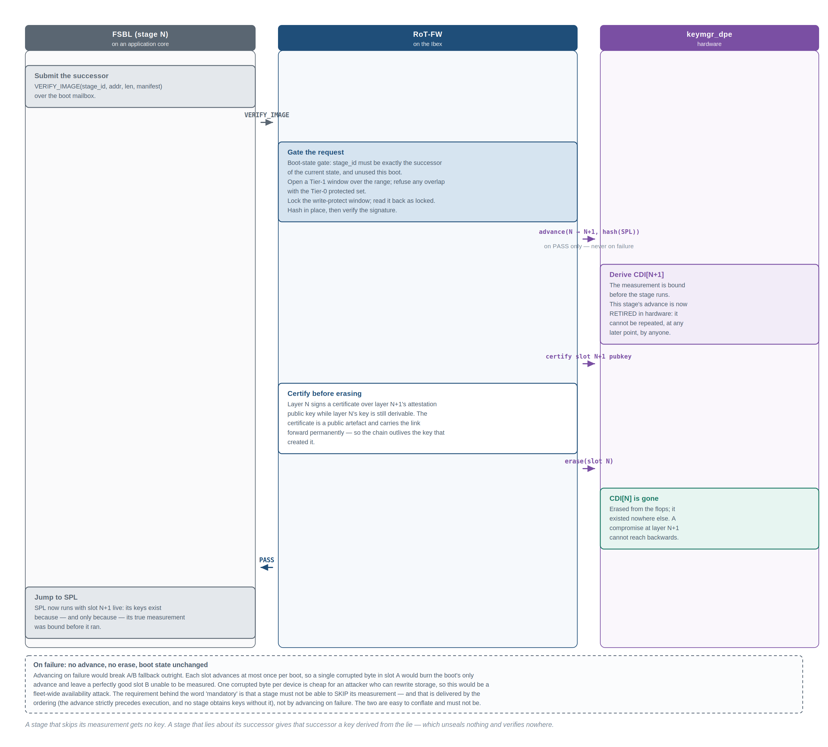
Figure 9. Flow A — measured boot, one stage transition. The advance happens on success only, and certification precedes erasure.
Two arrangements are possible for the certificate chain, and the ordering above is not free. The architecture certifies eagerly: the certificate linking one layer to the next is generated inside the stage transition while the earlier CDI is still live, and that CDI dies at the boundary. The chain outlives the keys that built it because each link is a signed public artefact.
The alternative — keep every layer’s attestation key derivable and build the chain later in one pass — is simpler to implement and concentrates the signing cost in one place, but it requires every layer’s CDI to stay live for the whole boot. That destroys the erasure discipline, and a late-boot compromise then holds the earliest layer’s signing key and can forge a chain for any software it likes. Deferred certification quietly converts DICE back into a flat key hierarchy. It is admissible only as a temporary bring-up step, and only as a recorded decision with the residual stated.

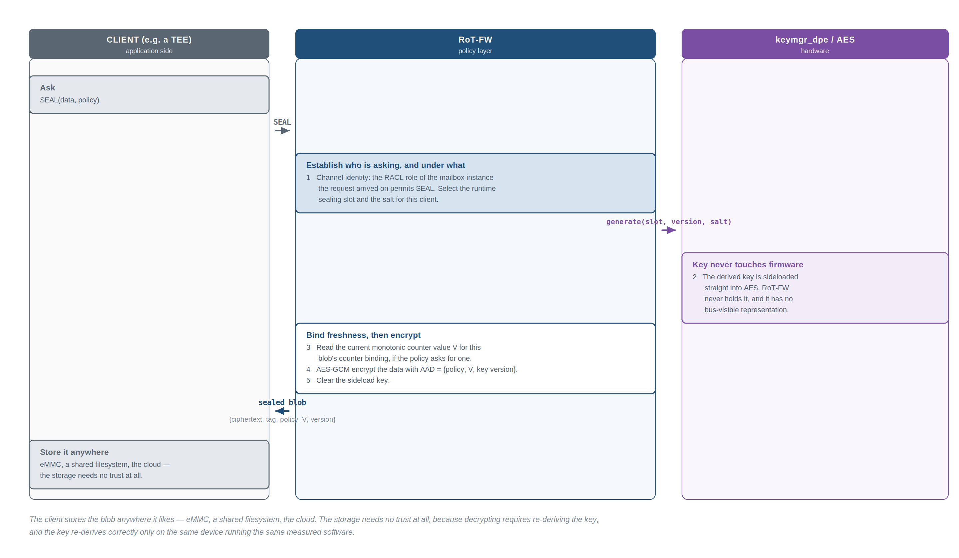
Figure 10. Flow B1 — sealing. The key is sideloaded into AES and never held by firmware.

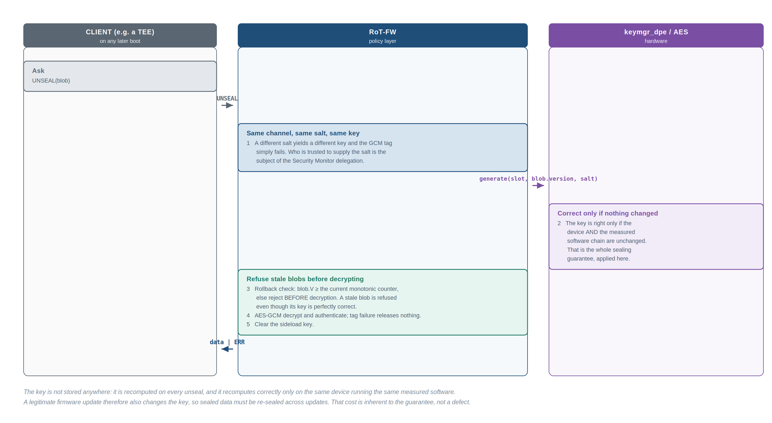
Figure 11. Flow B2 — unsealing. The rollback check happens before decryption, so a stale blob is refused even though its key is correct.

What sealing does not provide — rollback protection
Sealing binds who can decrypt, not which version is latest. An attacker who can rewrite storage copies today’s sealed blob, waits until a credential inside it is revoked and the blob re-sealed, then writes the old ciphertext back. It unseals perfectly, because device and software are unchanged, and the revocation has been undone.
Any use of sealing for state that must not go backwards — credential revocation, retry counters, anti-replay state — is broken without a second mechanism. This design therefore provides RoT-backed monotonic counters as a first-class service, and sealed blobs may bind to one.
Storage requirement, stated honestly. Monotonic counters need RoT-controlled non-volatile, many-write storage: a dedicated RoT-owned region on the private flash device with wear-levelled, power-loss-safe update, or an authenticated partition of equivalent character. OTP fuses are not an admissible backing store — runtime counters increment thousands of times and fuses are budgeted in the hundreds of one-time bits. A design that silently backs these counters with fuses has a service that stops working in the field.

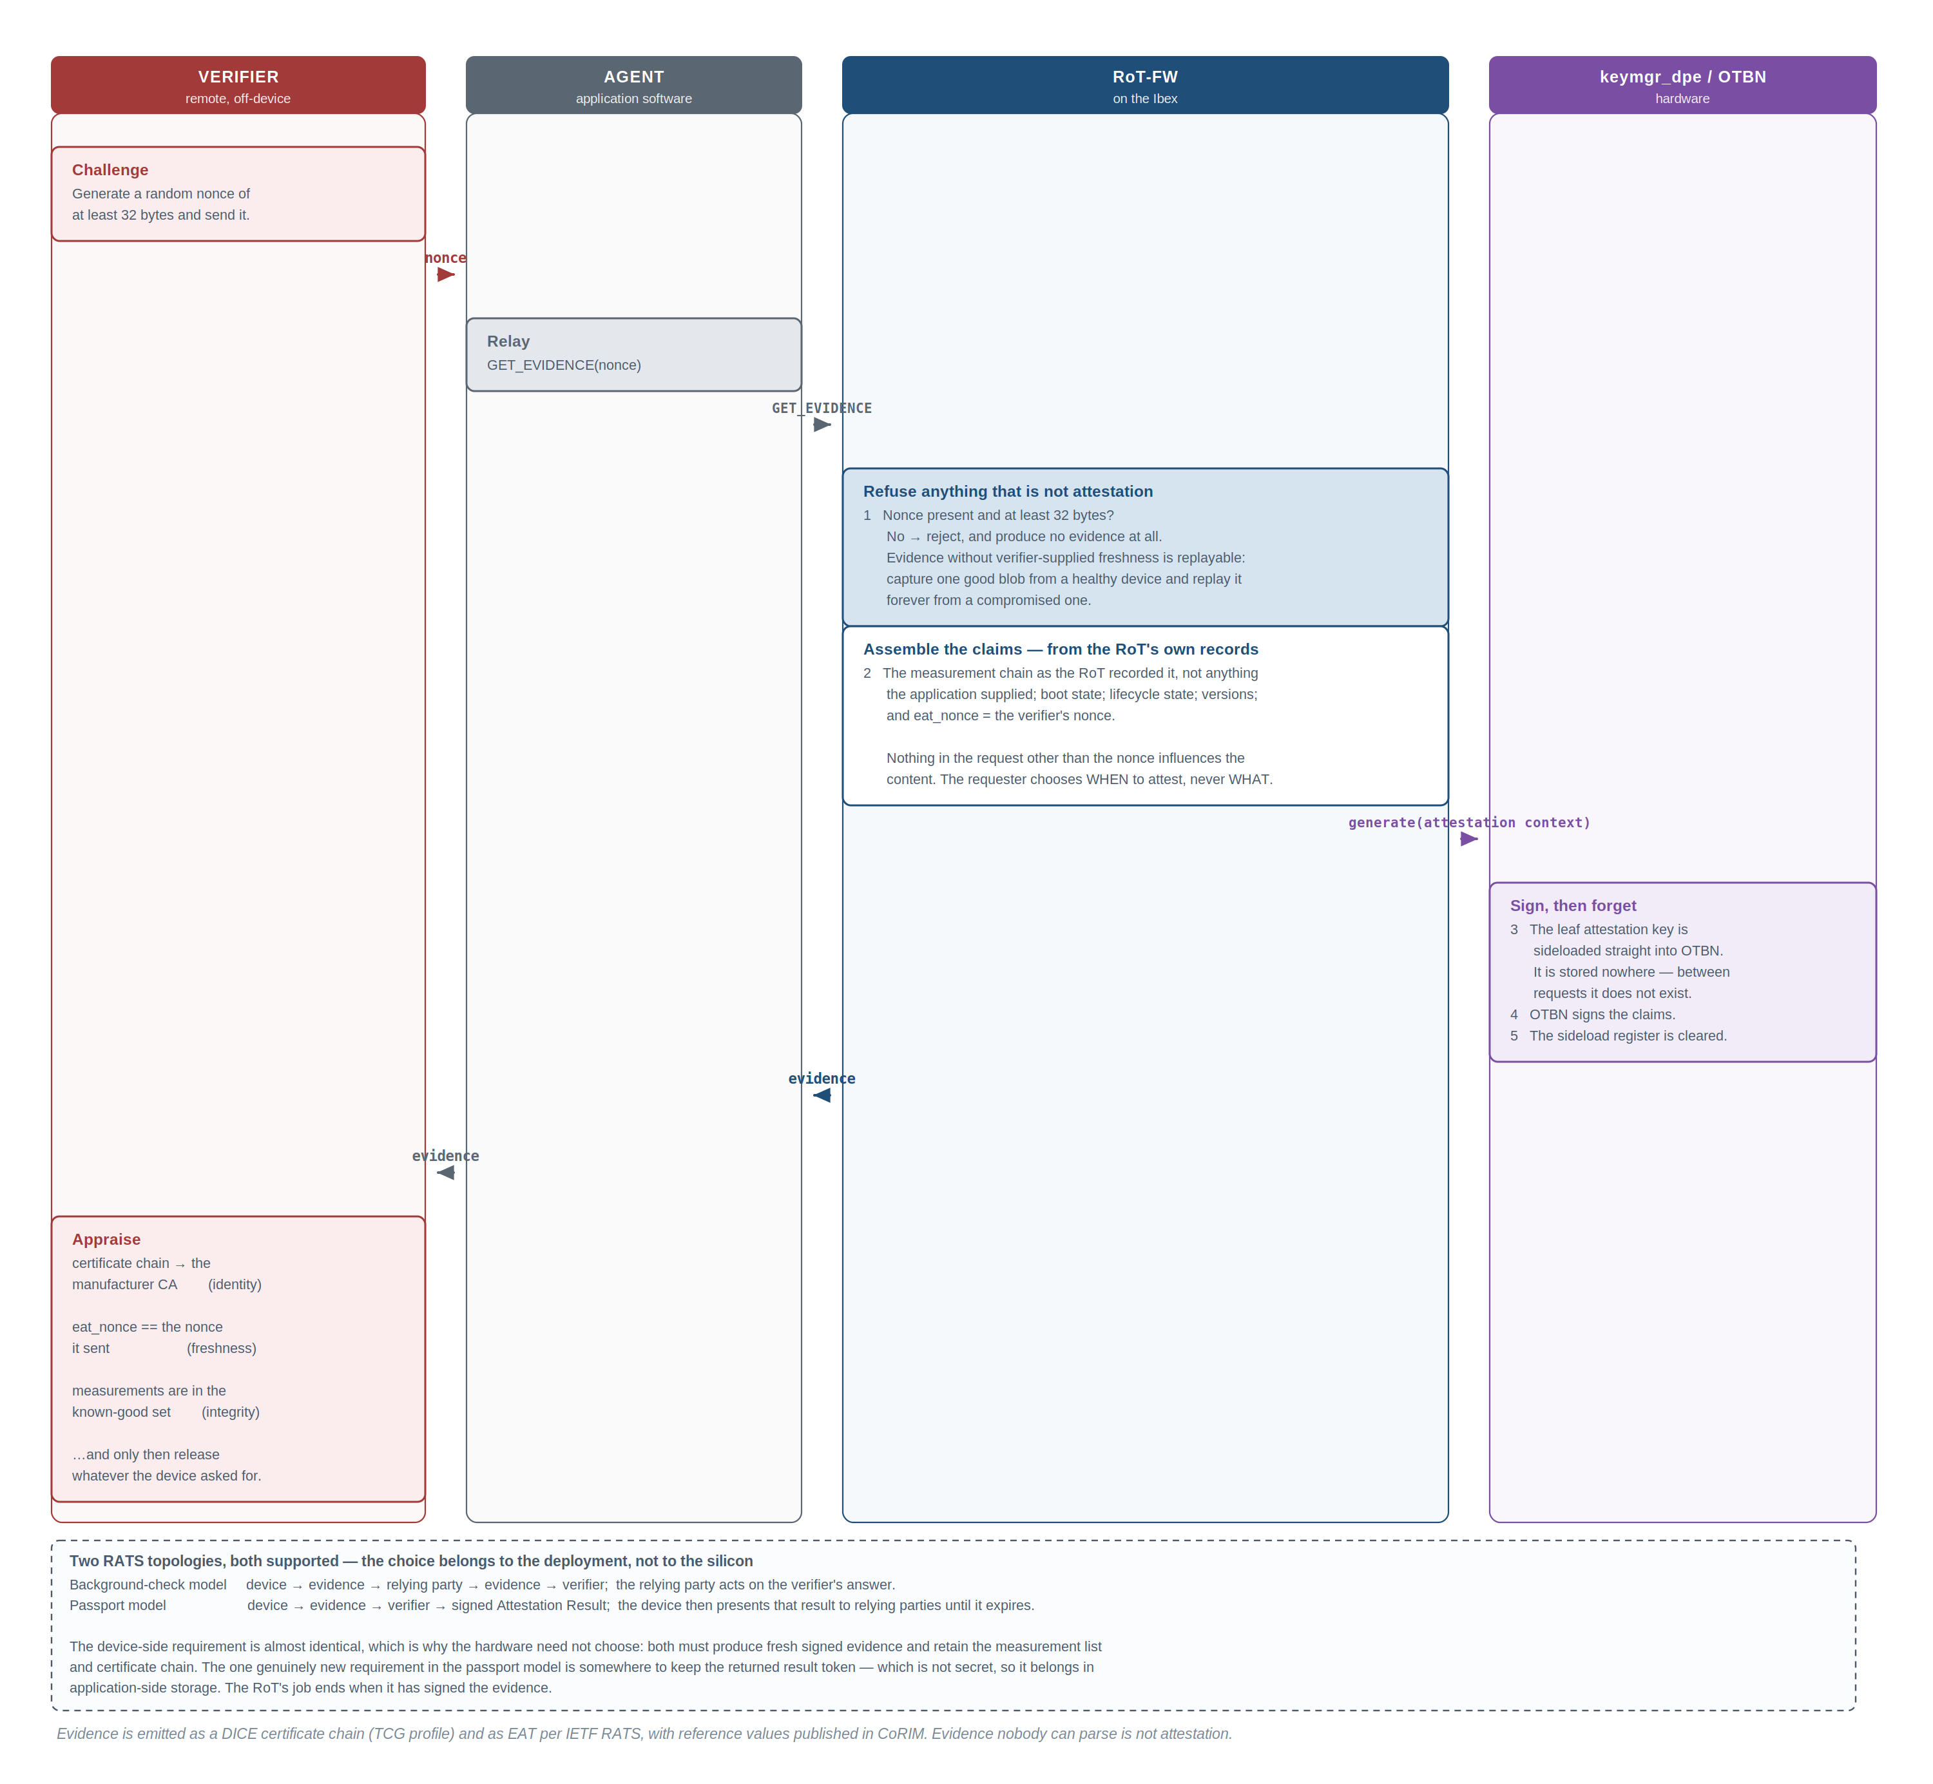
Figure 12. Flow C — attestation. The nonce is mandatory; without verifier-supplied freshness, evidence is a recording rather than an attestation.

The claims are the RoT’s own records. Nothing in the request other than the nonce influences the evidence content: the requester chooses when to attest, never what is attested.

6.6 Requester identity and the Security Monitor
Everything above assumed the RoT knows who is asking. This section says exactly how much it knows, and — for the case that matters most, many TEE applications on one device — states the deliberate decision to delegate that knowledge rather than attempt it in hardware.
Tier | What it is
Tier 1 — coarse channel identity, hardware-derived | Each subsystem-level requester gets its own mailbox instance: the boot channel, the rich environment, the TEE subsystem, the BMU, a management controller. The instance a request arrives on determines its access-control role, which determines which commands and which contexts it may reach. This is a small, fixed set that fits the nine available instances, and its separation is real.
Tier 2 — fine-grained client identity, delegated | Individual TEE applications are not given RoT-visible identities. The RoT maintains no enclave table, tracks no enclave lifetimes, and does not attempt to distinguish one enclave from another. That job belongs to the Security Monitor — the M-mode component that creates, measures, isolates and tears down enclaves. The SM owns the enclave table; the RoT trusts it.

Two reasons for delegating, and the first is decisive. It does not scale and cannot be made to: mailbox instances are a fixed hardware resource, and a system running dozens of enclaves created and destroyed dynamically cannot be given one channel each. And channel identity would not have delivered enclave separation anyway — under A3 the attacker runs at application M-mode, which owns the page tables and PMP that decide which software can touch which MMIO page, so a compromised M-mode can map any mailbox instance’s page into any address space it likes. Nine instances on one shared port are nine addresses, not nine authenticated identities.
Given that, the honest architecture is to place the enclave-separation responsibility where it is actually enforceable — in the component that already owns the page tables, the PMP and the enclave lifecycle — and to say so.

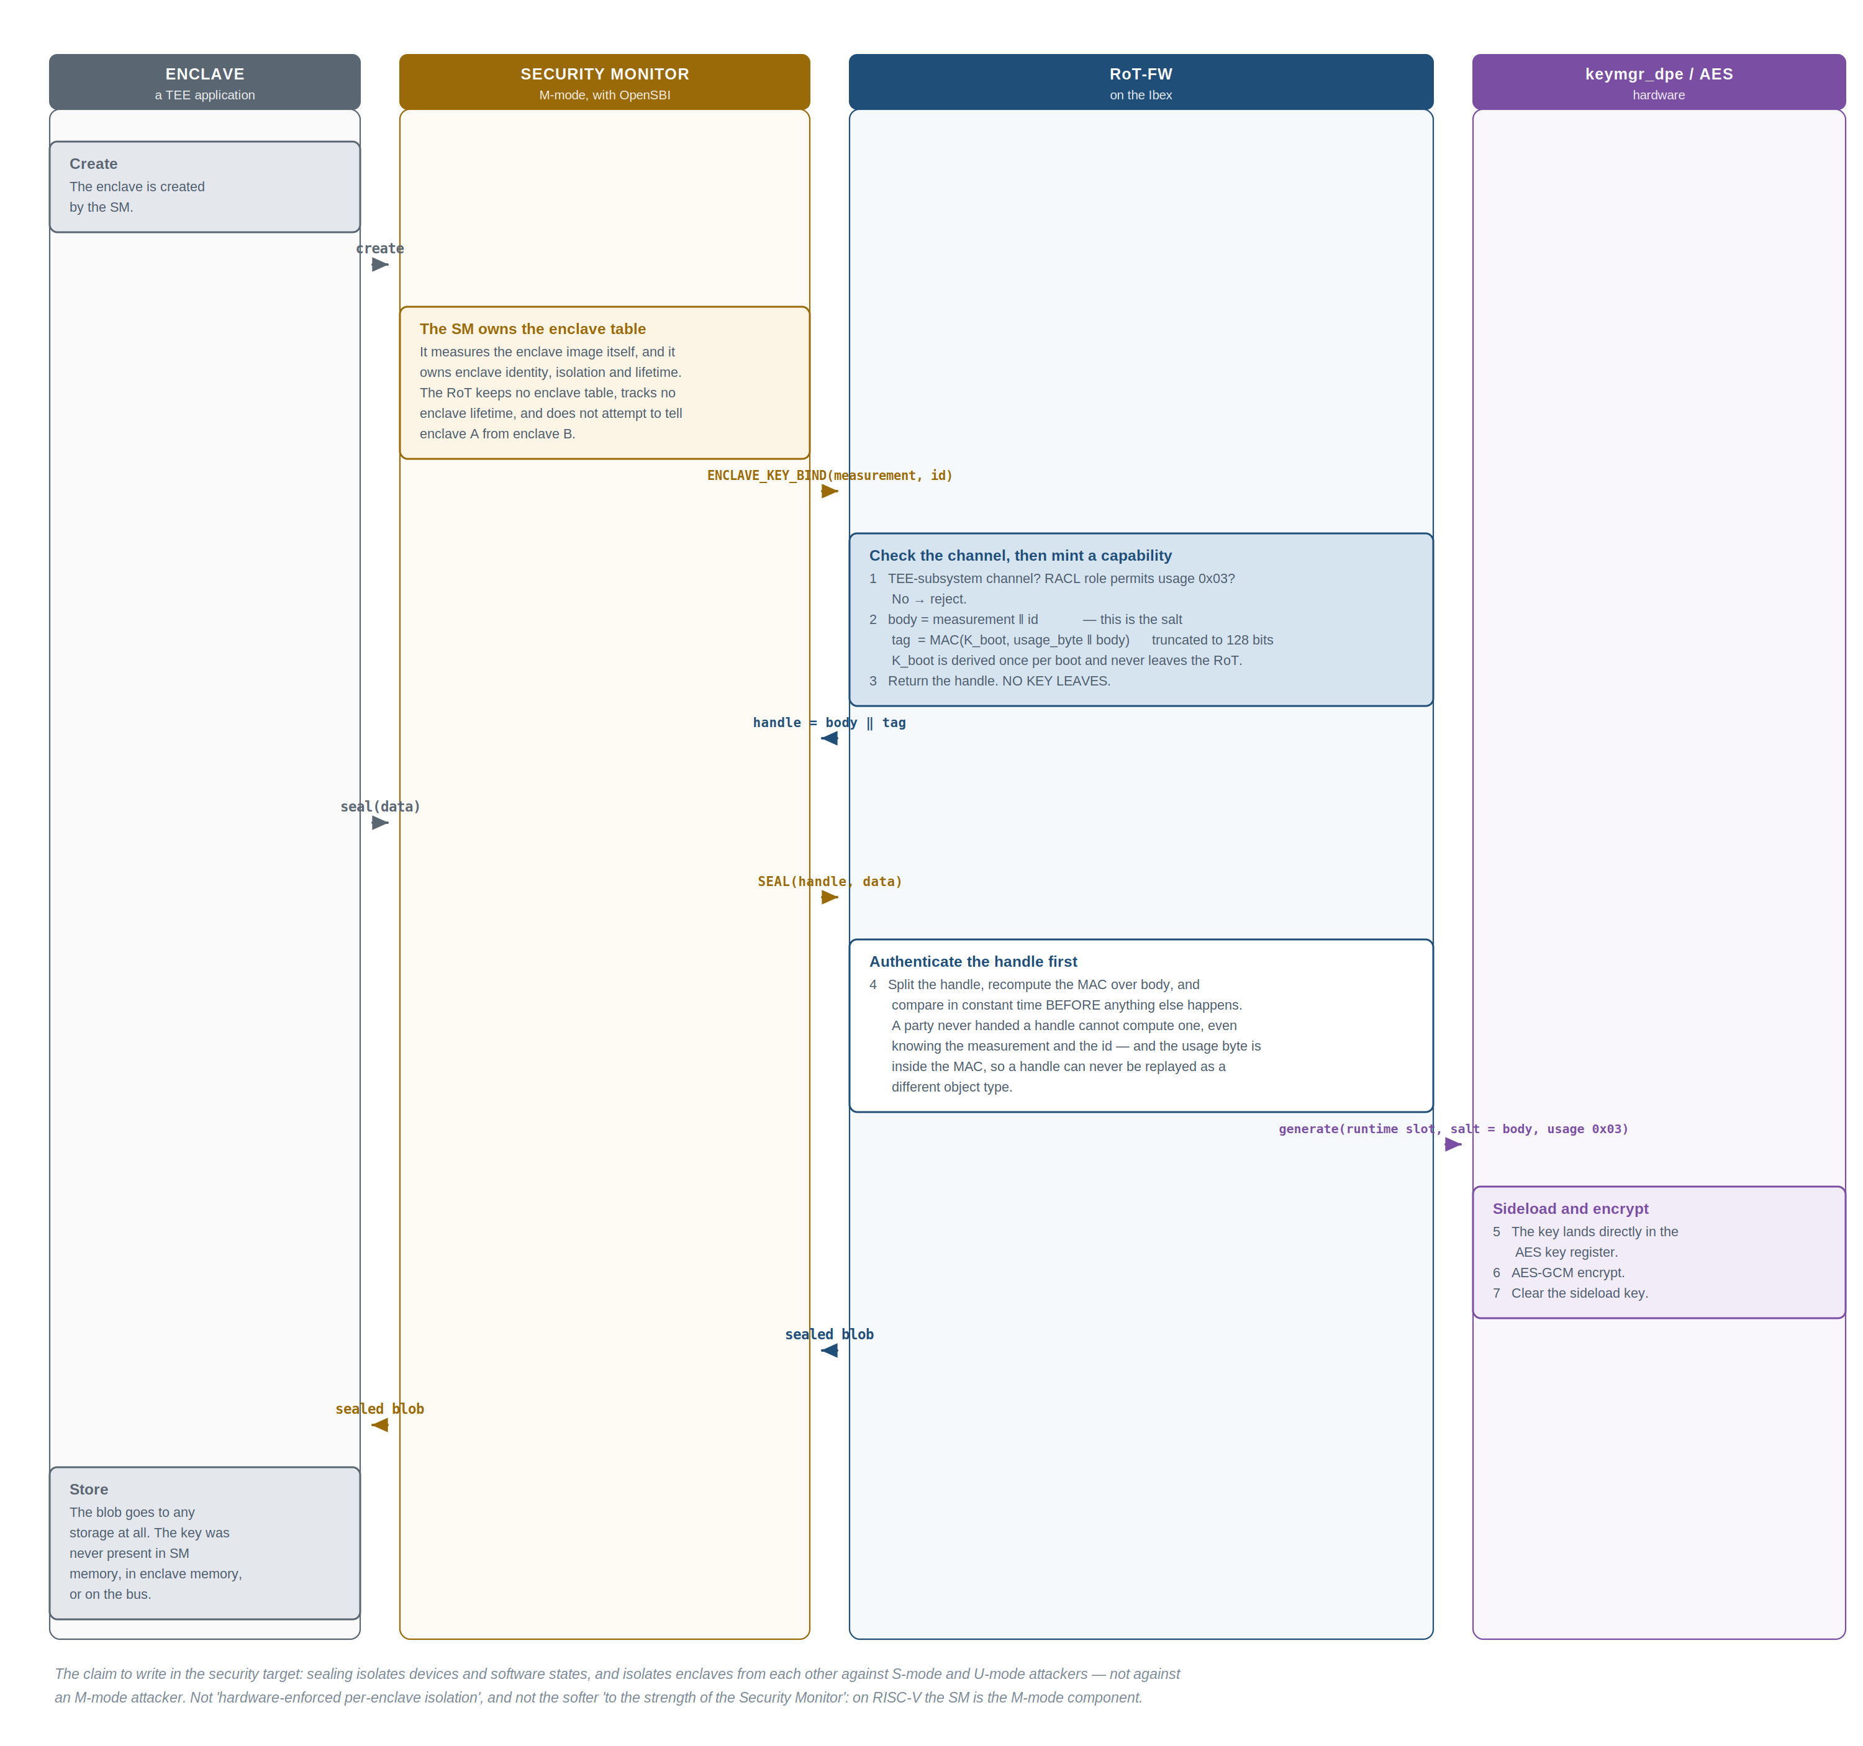
Figure 13. Flow D — enclave sealing under the Security Monitor. The RoT returns an unforgeable handle, never a key.

What that trust costs, stated plainly
The Security Monitor is in the trusted computing base for enclave isolation. A compromised SM can request any enclave’s sealing key by supplying that enclave’s measurement, and the RoT will produce it. Nothing in this design detects that. Cross-enclave isolation is exactly as strong as the SM, and no stronger.
That is a real cost, and it is affordable for a specific reason: the SM is not unverified trust. It is signature-verified and measured by the RoT before it runs, its measurement is bound into the key tree, and it appears in attestation evidence — a verifier can tell which SM a device is running. It sits in the same category as OpenSBI: verified, measured, mutable, patchable. Contrast the alternative: an RoT-side enclave table would place enclave lifecycle management, a dynamic and complex responsibility, inside RoT firmware, growing the one component whose smallness is the reason it can be audited at all.
What the RoT still guarantees, regardless of the SM, because none of it depends on distinguishing one enclave from another: device binding, so no key derives on any other device; software-state binding, so keys change if any measured layer changes, including the SM itself; no secret at rest, since no CDI exists outside powered flops; and boot-chain integrity, since the SM cannot forge its own measurement and cannot reach any boot-stage or attestation key through the enclave interface.
The claim to write in the security target
Sealing isolates devices and software states, and isolates enclaves from each other against S-mode and U-mode attackers, and not against an M-mode attacker.
Not “hardware-enforced per-enclave isolation”, and not the softer “to the strength of the Security Monitor” — that phrasing invites a reader to think SM compromise is a narrower event than M-mode compromise. On RISC-V it is the same privilege event: the SM is the M-mode component.

Domain separation — the one thing the SM must not be able to do
The SM supplies a salt and receives keys derived under it. Without a constraint, a malicious SM could supply a salt chosen so that the enclave derivation collides with a boot-stage key or the attestation key — escalating from “I can obtain any enclave’s key”, which is accepted, to “I can obtain the RoT’s own keys”, which is not. The constraint is a fixed usage constant concatenated into every derivation by hardware, distinct per key class.
Key class | Usage | Salt | Who may request
Boot-stage keys | 0x01 | none | RoT firmware only
Attestation keys | 0x02 | none | RoT firmware only
Enclave sealing keys | 0x03 | SM-supplied | the TEE-subsystem channel
Monotonic counters | 0x04 | counter id | the owning requester domain
Handle authentication | 0x05 | none | RoT firmware only, per boot

Because the constant is placed by hardware and is not part of the firmware-writable salt field, the enclave key space is provably disjoint from every other key space no matter what salt is supplied. The SM’s reach is bounded to one usage class, and within it to enclaves — which is precisely the authority it is being granted.

Do not hand the key out
When the SM launches an enclave and needs a sealing key for it, there are three possible arrangements. They differ enormously and the choice is architectural, not an implementation detail.
Option | Assessment
A — return the sealing key to the SM | Rejected. The key travels key manager → firmware → mailbox → system bus → SM memory, and every hop is a place it can be observed — most practically SM DRAM, where it lives for the enclave’s lifetime and where any SM memory-safety bug exposes it. Worse, the exposure is permanent: the key is a deterministic function of device secret, measurement chain and salt, so it cannot be rotated without a firmware update. A single leak is unrecoverable for that stack. It also discards the sideload architecture entirely.
B — handle-based (baseline) | The SM receives an opaque, unforgeable reference; the RoT performs the cryptography. The key never leaves the RoT.
C — wrapped ephemeral key export | A permitted optimisation where B’s bandwidth is genuinely limiting: the enclave seals a wrapping key through the RoT and performs bulk encryption itself under that key. The root sealing key still never leaves; what leaves is a per-enclave, per-session key whose compromise costs one enclave’s data rather than the whole stack’s root. A real weakening, and it should be a recorded decision — but bounded in a way option A is not.

The general rule that makes option B affordable: seal keys, not payloads. The RoT is a small core on a mailbox, not a bulk crypto offload engine. A design that streams megabytes of enclave data through the RoT will be slow and will find the rate limiter; a design that seals 32-byte keys through the RoT and does bulk work locally is fast and keeps the property.
The handle is stateless but not unauthenticated. Making it a plain encoding of the salt would make it a name whose inputs are both public — the measurement is a hash the device publishes in attestation evidence anyway — so anyone who can spell the name could use it. It is therefore a capability: the body is the salt, and the tag is a MAC under a per-boot key that never leaves the RoT, with the usage byte inside the MAC so a handle can never be replayed as a different object type. The RoT stores one key, not one entry per enclave: no table, no ceiling on concurrent enclaves, no teardown protocol, nothing to garbage-collect.

6.7 Attestation evidence and what the RoT retains
The RoT produces a DICE certificate chain — one certificate per boot layer, each signed by the previous layer’s attestation key, rooted in the device identity certificate whose manufacturer-signed counterpart is provisioned at production. For interoperability it additionally produces evidence in the standard attestation token format, with reference values published in the corresponding reference-value format and the verifier’s challenge carried as the token nonce. The reason a wire format is specified rather than left to implementation: evidence nobody can parse is not attestation.
The retention question decides how much RoT memory the attestation service costs, and the answer is: very little, because almost nothing that must be retained is secret, and almost nothing secret must be retained.
Item | Secret | Where it lives | Size
UDS | yes | OTP fuses — the one persistent secret, with no read path | 32 B
CDIs | yes | key manager flops only; never in memory, never non-volatile | —
Attestation private keys | yes | nowhere — re-derived and sideloaded for each signature, then cleared | 0
Measurement list | no | RoT main SRAM, append-only, firmware-owned | ~0.5 KB
Certificate chain | no | RoT main SRAM; public artefacts served on request | ~1–4 KB
Device identity certificate | no | provisioned at manufacture | ~1 KB
Attestation result / passport | no | application-side storage — produced by the verifier, not the RoT | ~1 KB

The measurement list is not secret and does not belong in the key manager. A measurement is a hash of a public firmware image that the device is about to publish in signed evidence anyway; putting it in the key manager would consume scarce hardware state to protect something that needs no confidentiality. What it needs is integrity and append-only discipline, which RoT main SRAM provides: the application side has no address for it, the region is scrambled and ECC-protected, and the list is written only by the measuring path.
No private key is ever kept, not even the leaf. On each evidence request the attestation key is generated, sideloaded straight into the signing engine, used, and the sideload register cleared. Between requests the key does not exist.

6.8 Provisioning
Keys, identity and policy do not appear by magic; a manufacturing flow puts them there, and that flow is part of the security architecture. It runs in parallel with hardware development, not after it.
Step | Lifecycle | Action
Wafer test | RAW → TEST_UNLOCKED | Structural test; burn test tokens.
Personalisation | TEST_UNLOCKED | Burn the UDS — generated on-die from the noise source, never leaving the die — plus device ID and the expected ROM digest.
Key authority | TEST_UNLOCKED | Burn root key authority digests, the recovery key authority, and algorithm policy.
Identity certificate | TEST_UNLOCKED | The RoT derives the device identity keypair from the UDS and exports only the public key; the manufacturing CA issues and stores the certificate.
Lock | TEST_UNLOCKED → TEST_LOCKED | Compute and burn all partition digests.
Release | TEST_LOCKED → PROD | Debug closed in hardware; production keys live.

The manufacturing CA, the token custody model, the failure and rework flow, and the return-for-analysis handling are each governed by a key management policy document that is a required deliverable and an audited artefact for certification.

7 The mailbox interface
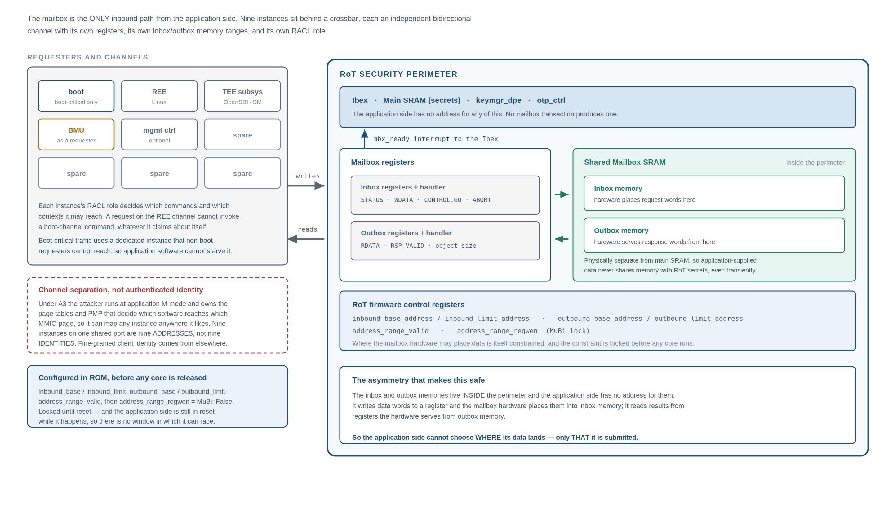
Figure 14. Mailbox structure. The inbox and outbox memories sit inside the perimeter and have no address in the application map.

7.1 Why the inbox is hardware-locked
Without the lock, the application side can mutate a request field between the RoT’s validation read and its use read: validate a length, change the length, have the RoT act on the changed value. This double-fetch pattern is the most common vulnerability class in real mailbox, SMM and TEE interfaces, and it is not adequately defended by firmware care alone. The hardware inbox lock and the firmware single-fetch discipline are two halves of one defence; neither is sufficient on its own.
Abort is a request, not a seizure. The requester may ask for an in-flight request to be discarded, but that sets a request bit rather than freeing the buffer under the RoT’s feet. The RoT samples the bit only at defined quiescent points in its own processing, and it is the RoT — not the hardware — that then discards its working state, zeroises the request, clears the busy flag and releases the lock. Aborts never leave a partially-processed request visible, and never make the inbox writable while the RoT still holds a reference into it.

7.2 Message envelope
Offset | Size | Field | Rule
0 | 2 | protocol_version | Reject unknown values.
2 | 2 | command_id
4 | 4 | payload_length | Must equal the actual bytes written, not merely fit the inbox.
8 | 4 | sequence_number | Meaningful only inside an authenticated session; otherwise reserved and must be zero.
12 | … | payload | Fixed binary layout for Boot and Policy; canonical CBOR for the rich services.

Two points about this envelope are load-bearing. The declared length is validated against the actual bytes written, not merely against the inbox size — the hardware separately exposes a write pointer, so there are two lengths available and they can disagree; a mismatch is a hard reject, never a truncation and never a zero-fill. And the sequence number does not provide replay protection on this transport: there is no authentication on the register interface, so an attacker who can write a request can write any sequence number. Treating it as a replay defence would be a false assurance.
Boot-critical commands do not go through a parser
A canonical CBOR decoder is a few thousand lines of state machine, and putting it on the one path that must never fail — in the code that gates every stage transition — is the wrong trade.
The Boot and Policy command groups therefore use a fixed binary layout with no parser: fields at fixed offsets, fixed widths, no variable-length encoding, no recursion. CBOR and the standard management protocol are reserved for the attestation and management services, where interoperability genuinely requires them. This costs nothing in interoperability and removes the highest-value attack surface from the highest-consequence path.

7.3 Command set
Group | Commands
Boot | VERIFY_IMAGE, GET_BOOT_STATE, REPORT_STAGE_COMPLETE, CORE_RELEASE_REQUEST
Crypto | HASH, HMAC, AES_ENC, AES_DEC, RANDOM
Key | SEAL, UNSEAL, DERIVE_KEY, GET_PUBLIC_KEY
Attest | GET_EVIDENCE, GET_CERT_CHAIN, GET_MEASUREMENTS
Policy | GET_LIFECYCLE_STATE, GET_VERSION, GET_ROLLBACK_COUNTERS
Update | UPDATE_BEGIN, UPDATE_WRITE, UPDATE_FINALIZE, UPDATE_ACTIVATE, UPDATE_CONFIRM
Admin | RECOVERY_* — restricted by role and by lifecycle state

Three entries are not simple renames.
- GET_EVIDENCE takes a mandatory verifier nonce of at least 32 bytes, included in the signed claims. A request with a missing or short nonce is rejected and no evidence is produced. Evidence without verifier-supplied freshness is replayable, so the nonce is not an option of the protocol — it is what makes the command attestation at all.
- CORE_RELEASE_REQUEST(core_id) closes a gap in core release: the other cores stay parked until their own grant is asserted, but nothing previously requested that grant. It is valid only from the boot mailbox, only once the boot state has reached the supervisor stage, and only for a core not currently granted. The RoT sets the target core’s reset vector before asserting its grant, and the epoch rules apply.
- The Update group is a five-phase flow, not three. The rollback counter is advanced by UPDATE_CONFIRM alone, which requires both slots to hold images at or above the new security version unless an explicit accept-loss-of-fallback policy is set. Until confirmation, the previous version stays bootable.

A further set of commands is optional and may be added when the corresponding service is built; they are allocated in the command-ID space now rather than retrofitted: capability discovery and authenticated sessions; asynchronous poll, fetch and cancel; suspend and resume verification; streaming hash variants; sign and verify under a derived key; key destruction, for the zeroisation claim; wrapped key import; monotonic counter create, increment and read; device identifier retrieval; and a rate-limited, coarse alert log.

7.4 Availability
An interface a hostile requester can spam is a denial-of-service surface, and the RoT is on the critical path for application boot.
- Per-channel request rate limiting, with the access-control role determining the budget.
- A hard per-request work bound enforced by the per-request timer, not by the system watchdog. Expiry aborts that request, zeroises its state and increments a per-channel penalty counter feeding the rate limiter. It resets nothing and escalates nothing, so an expensive request costs the requester its channel budget rather than costing the system a reboot.
- The boot-progress watchdog covers the boot-critical requests at a different granularity: each still bears only its own work bound, but the boot state machine must reach its final state within an RoT-timed budget, so a stage that takes its timeout — or never submits anything at all — cannot stall the boot undetected.
- Boot-critical traffic uses a dedicated mailbox instance that non-boot requesters cannot reach, so application software cannot starve the boot path.
- Long-running operations return a handle and complete asynchronously rather than holding the channel busy for their duration.

8 RoT firmware
Two software components run on the Ibex. Immutable ROM does ROM-controller handoff, entropy bring-up, boundary configuration and lock, OTP and lifecycle reads, minimal recovery, the first two key-manager advances, and exactly one job of its own: verify and launch the mutable firmware. Everything with meaningful complexity lives in that mutable stage.
Layer | Modules
Platform | plat_init, plat_pmp, plat_clock, plat_alert
Transport | mbx_transport (envelope, length, copy-in — the only reader of mailbox memory), mbx_dispatch (role → permission table), codec_fixed (Boot, Policy), codec_cbor (rich services), spdm
Service | svc_boot, svc_crypto, svc_key, svc_attest, svc_update
Trusted core | sec_image (manifest, digest, signature), sec_keymgr, sec_otp, sec_lifecycle, sec_range (Tier-0 / Tier-1 window management)
Drivers | drv_kmac, drv_hmac, drv_aes, drv_otbn, drv_dma, drv_spi, drv_edn, drv_wdt, drv_sensor

The firmware runs entirely in M-mode. Privilege separation between the parser and the trusted core was considered and deliberately rejected: at this scale a user/machine split imposes a trampoline ABI and a trap-handling burden on every service that outweighs its benefit. The consequence is that a memory-safety bug anywhere is a full compromise of that stage, and the compensating controls carry more weight because of it — the locked PMP entries over firmware text, the DMA internal-side allowlist, single-fetch discipline, and the fact that the immutable ROM’s decisions are already made and locked before the mutable stage runs.
The module boundary is therefore an auditing boundary rather than an enforcement one, and it should be treated as one: the trusted-core layer is what gets the line-count budget, the formal work and the review attention. The range-window module deserves particular attention — it implements the Tier-0/Tier-1 non-overlap property, which is what stops the confused-deputy attack. It is small, it is pure logic over integers, and it should be formally verified alongside the security state machines.

8.1 Coding rules
These are testable properties rather than aspirations.
- Fail closed. Every function returns an explicit status. There is no implicit success path and no default case that continues.
- No unbounded loops. Every loop has a compile-time or configuration-time bound, and exceeding it is an error, not a retry.
- Validate every untrusted length and address at the boundary, before use, against the locked range configuration — never against a value derived from the same untrusted input.
- Single-fetch discipline. Every field of a request is read from mailbox memory exactly once, copied into private memory, and acted on only from that copy. No code outside the transport layer’s copy-in path ever reads mailbox memory. This is what makes validation meaningful: a field validated in mailbox memory and then re-read has not been validated. The rule is mechanically checkable — enforce it with a lint over the mailbox memory symbol.
- Firmware cannot unprotect itself. The PMP entries covering firmware text as read-and-execute-only are installed by ROM with the lock bit set before the jump, so they survive the jump and a later bug cannot unprogram them.
- Redundant checks on security decisions. Critical branches — signature valid, lifecycle permits, range permits — are evaluated twice with different encodings, so a single glitched comparison does not grant access.
- Constant-time comparison for all digest, MAC and token comparisons.
- Explicit zeroisation. Every buffer that held key material, a CDI or plaintext is overwritten before the function returns, with the write not elidable by the compiler.
- No dynamic allocation. All memory is statically assigned.
- Debug and test paths compiled out. Any allow-unsigned, skip-verify or bypass facility that exists for development is removed by the preprocessor in production profiles — not a runtime flag that merely defaults to off. A runtime flag is a single bit an attacker can aim at.

8.2 Image manifest
The verification unit for every mutable stage.
Field | Purpose
magic, format_version | Identify the format; reject unknown versions.
image_length | Bounded against the destination region.
security_version | Compared against the OTP rollback counter.
key_slot | Which root key authority signed this.
signature_algorithm | Dispatch to the corresponding verification program; must be permitted by OTP algorithm policy.
digest_algorithm
load_address, entry_address | Must lie entirely inside the permitted execution window; checked before any copy.
platform_id | Binds an image to a hardware variant.
flags
digest | Over the image body.
signature | Over the manifest and digest.

Verification order is fixed and each step gates the next: format, length, rollback, key revocation, algorithm policy, digest, signature, address range, measure into the key manager, decrypt if encrypted, copy, execute. Signature verification never runs on a manifest whose lengths have not already been bounded, and no copy ever happens before the signature passes.
Verify then decrypt, never the reverse
Where the encrypted-update path is used, the signature is computed over the ciphertext and is checked before any decryption occurs — or an authenticated encryption mode is used whose tag is verified before any plaintext is released.
Decrypting first would hand an attacker a chosen-ciphertext oracle against a hardware engine and let attacker-shaped plaintext reach the manifest parser, which is exactly the input the rest of this section is written to keep bounded.

Note that the two address fields are checked at different points and against different things. The request’s target address is bounded by the Tier-1 window firmware opens before any data is read. The manifest’s load and entry addresses are checked after the signature, because until the signature verifies the manifest is attacker-authored data with no standing. Both checks are required; neither replaces the other.
Integrity here is cryptographic. A checksum such as CRC32 detects accidental corruption and provides no protection against an adversary who can trivially recompute it; it has no role in the verification chain.

8.3 Streaming verification
Images larger than RoT SRAM are verified incrementally, so the internal interface is streaming rather than whole-buffer: a begin call that performs all policy checks — boot-state successor, rollback, revocation, algorithm, address range — before any data is accepted, so a rejected image consumes no bandwidth and no verification state; repeated update calls that extend the digest; and a final call that performs signature verification and, only on success, the key-manager advance. There is no interface by which a caller can obtain a verified result without the final call having succeeded.

8.4 State machines and errors
Four state machines are load-bearing and must be specified explicitly rather than emerging from control flow. In each, an unspecified transition is a vulnerability, so every state pair needs a defined answer.
Machine | States and rules
Boot state | INIT → ROT_FW_OK → BMU_OK → FSBL_OK → SPL_OK → UBOOT_OK → OPENSBI_OK → OS_RUNNING. Monotonic, one-shot per state. Enforces the stage gate, determines which commands are legal at all, and is reported in attestation evidence. Every command needs its legal state set written down. It is also the machine the boot-progress watchdog observes.
Per-channel request state | IDLE → RECEIVING → VALIDATING → EXECUTING → RESPONDING → IDLE, with the abort transition legal only at defined quiescent points.
Update state | IDLE → STAGING → STAGED → ACTIVATED → CONFIRMED, with defined power-loss recovery from every state.
Escalation state | The alert ladder as an explicit machine, including the escalation-reset counter and its terminal threshold.

The error categories are a closed set — manifest, signature, rollback, range, state, work bound, busy, unsupported, lifecycle — and the mapping from internal error to reported category is many-to-one by design: a deliberately lossy projection, documented and reviewed for oracle leakage rather than allowed to grow organically. No category is ever refined at runtime, by a debug build, or by a verbosity setting. A detailed error message is an oracle, and a build flag that produces one is a build flag an attacker will aim at.

9 The BMU and the RoT↔BMU contract
Something must physically power the RoT before the RoT can execute. That work cannot be done by the RoT itself, so the question is only what does it.
It is tempting to answer “a small core with a mask ROM”, on the grounds that a realistic power tree — rail ramp ordering, PLL lock waits, retention domains, an external regulator over a serial bus — is too complex for a pure hardware state machine. That reasoning is sound for full SoC bring-up and wrong for RoT bring-up, and the distinction is what makes this design work.
 | RoT / always-on domain | Full SoC
Rails | a small, fixed set | many, project-specific
PLL | none needed — the RoT runs on the reference clock and programs its own | multiple, with ordering constraints
DDR, thermal, DVFS, peripherals | none | all of it
Decisions to make | one: rails good → release | many

Bringing up the RoT domain alone is a counter, a power-good comparator and a reset de-assert. That is implementable as hardwired logic, so it is — and everything genuinely complex stays in BMU firmware, where it is verified before it runs. The arrangement is therefore three components, not two, and the ordering between them is the structural move that makes it safe: a hardwired power-on sequencer that is part of the trusted computing base; an immutable BMU boot ROM held in reset until after the RoT is sovereign, also in the trusted computing base; and mutable BMU firmware, verified by the RoT before it ever executes, which is not.

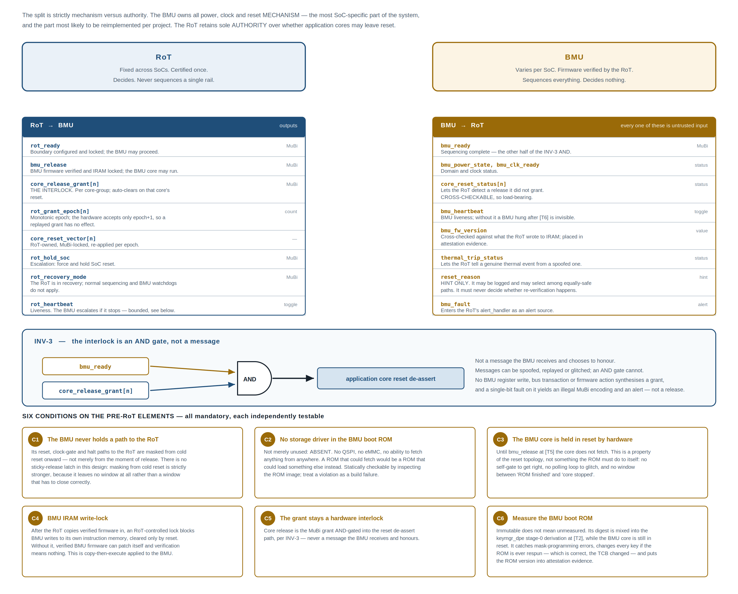
Figure 16. The RoT↔BMU contract: the signal set in both directions, the INV-3 interlock, and the six conditions the pre-RoT elements must meet.

9.1 Why trusting the pre-RoT elements is affordable
Two components are trusted without being verified. That trust is acceptable, but for specific reasons and only under specific conditions.
Reason one: neither is a verifier. Neither verifies an image, touches an image, decides what executes, or reads untrusted storage. A component that never checks a signature cannot lie about one; a component with no storage driver cannot substitute an image. Neither element can forge a boot; at most either can deny one. That reduces their trust from integrity trust — the expensive kind that must be hardened, audited and certified — to availability and sequencing trust.
Reason two: neither runs while the RoT is deciding anything. The sequencer has no instruction fetch at all, and the BMU core is held in reset past every RoT verification decision, past the boundary lock and past the instruction-memory lock. This is a hardware property of the reset topology, not a behaviour the ROM has to implement correctly.
Being on-die is not the justification
On-die defeats storage rewriting and bus probing only. It does not confer integrity verification, does not confer fault-injection resistance, and says nothing about runtime reachability from application software.
Nor does “it is hardwired logic” confer immunity: a sequencer can still be glitched into releasing the RoT with rails out of spec, which is exactly why the environmental monitors must confirm the operating envelope independently before any verification runs. Moving RoT bring-up out of software shrinks the pre-RoT element; it does not remove it from the trusted computing base.

9.2 Rules on the interface
- No RoT secret, key or CDI ever crosses it, in either direction.
- If the BMU has a bus interface into RoT register space, it is assigned an access-control role and treated exactly like an application requester — mediated, never privileged.
- Versioned with a compatibility field, since the BMU changes per SoC and the RoT does not.
- The RoT continuously compares observed core reset status against the grants it has issued, and raises an alert on any core observed out of reset without one. Prevention and detection.
- Every BMU-to-RoT signal is untrusted input, because the adversary model places the BMU under attacker control. Each is either cross-checkable against RoT-observable state or usable only as a hint, and which one must be stated per signal. Core reset status is cross-checkable and therefore load-bearing. The reset reason is a hint only: it may be logged and may select among equally safe paths, but it must never decide whether re-verification is required, because that would let a compromised BMU report the reason that gets it the cheap path.
- Heartbeat escalation is bounded on both sides. BMU escalation on a missing RoT heartbeat may hold the application subsystem down; it may never touch the RoT, since a BMU-initiated RoT reset is a violation of the first condition whether or not it is labelled a feature. The heartbeat carries a tolerance window and a consecutive-miss threshold, so an attacker who can stall the RoT briefly cannot convert a marginal fault-injection attempt into a reliable system-reset primitive.
- Every signal has a defined value during the interval before the BMU core is released.

9.3 The off-die regulator, and the boot clock
This is the one genuinely new attack surface the split introduces, and the only part of RoT bring-up that resists being reduced to hardwired logic. If RoT voltage is set by talking to a programmable off-die regulator, then an attacker who controls that regulator can undervolt the RoT during verification. Voltage glitching to fault a signature comparison is well-trodden, and here it is reachable through a legitimate interface before the RoT is even running.
 | Mitigation, strongest first
1 | Derive RoT rails from a fixed, non-runtime-programmable regulator, so no transaction can affect RoT voltage at all. Preferred.
2 | Select a regulator whose power-on defaults are already correct for the RoT domain, so no configuration transaction is required before the RoT runs. This is a component-selection constraint and belongs in the schematic review, not a problem to solve later in logic or firmware. Together with the first, it is what allows the sequencer to remain a counter and a comparator rather than acquiring a serial-bus engine.
3 | If a transaction before RoT release is genuinely unavoidable, it is issued by the sequencer as a fixed constant sequence burned into hardwired logic — never a programmable one, and never with the regulator’s response used for control flow. This is the fallback, not the plan: it re-introduces a parser-shaped element into the pre-RoT trusted computing base and should be escalated at design review rather than accepted quietly.
4 | Voltage and clock monitors must be active and passing before the first verification runs, not initialised alongside it. The RoT independently confirms its own operating envelope rather than trusting that whatever brought it up did so correctly. This is the backstop for a glitched or faulty sequencer as much as for a hostile regulator.

The identical hole exists for the RoT’s clock, and it is worth naming because it hides behind an innocuous phrase. If the boot clock is an off-die crystal or oscillator, an attacker who can stop, slow or glitch that source is clock-gating the RoT by another name — and INV-2 states flatly that no agent outside the perimeter can clock-gate the RoT. The rule is in two parts: the boot clock is an on-die always-on oscillator, whose accuracy need not be good because nothing on the boot path requires a precise frequency, only a present and bounded one; and frequency monitoring cross-checks any other clock source against that reference, raising an alert before a verification result is produced. The split is the same one drawn for INV-2 generally — topology cannot be retrofitted, hardening can.
Thermal shutdown is the one legitimate exception to INV-2
INV-2 forbids any agent from powering down the RoT, but thermal runaway requires something to shut the die down including the RoT domain. Left unresolved, either INV-2 is quietly violated in the thermal path or the RoT domain cannot be thermally protected.
Therefore: thermal shutdown of the RoT domain, where present, is a hardwired analog trip, independent of the BMU and of all software, wired directly to the power-on sequencer. It is not a BMU-commandable path and takes no input from software, so it sits in the same trust category as the sequencer itself.
Any arrangement in which the BMU can command RoT shutdown for thermal reasons must be rejected — a spoofed thermal event would otherwise be an INV-2 bypass that resets the RoT mid-verification. The RoT observes die temperature independently and the BMU reports its trip status, so the RoT can distinguish a genuine excursion from a spoofed trip in its alert log and in attestation.

9.4 Power states, resume and partial reset
Because the BMU owns power states, three flows need explicit policy. Each is a secure-boot bypass if left to a general-purpose power controller’s defaults.
Flow | Policy
Suspend and resume | A resume brings cores back up executing from a resume vector without the boot sequence happening — skipping the entire verification chain. The RoT must be in the resume path. Choose one deliberately: re-verify the resume image and context on every resume; hold the resume vector and context in RoT-protected storage with integrity protection and restore it only after checking; or forbid resume entirely. The default behaviour of a power controller optimising for resume latency is to skip all of this. It must not be the default here.
Warm reset of an application core | If the BMU can reset a core while the RoT stays up, a core can be restarted at a different vector while the RoT still believes that stage is verified. The rule: any application core reset invalidates that core’s verification state and requires a fresh grant. The mechanism is the grant epoch — the grant auto-clears on the observed reset, and re-asserting it requires the RoT to write the next epoch, which it does only after re-running the stage-appropriate verification and re-applying the reset-vector lock.
RoT reset | Any path that re-releases RoT reset must run the full boot sequence from the beginning. There is no partial or fast RoT restart.

Note the dependency: the staged release of write-protect windows described in section 5.2 depends on dead stages being genuinely unreachable, which these rules supply. If either guarantee is relaxed, staged release must be withdrawn and every window held until reset.

9.5 Trusted computing base
The honest accounting of what this arrangement costs. This table is what an evaluator will ask for.
Component | Verified by | Patchable | Executes code | In TCB
Rail / regulator hardware | — | no | no | yes
Power-on sequencer | — | no | no | yes — runs before the RoT
BMU boot ROM | measured only | no | yes, after release | yes
BMU core hardware | — | no | — | yes
RoT ROM | rom_ctrl, in hardware | no | yes | yes
RoT hardware | — | no | — | yes
BMU firmware | RoT-FW | yes | yes | no
RoT-FW | RoT ROM | yes | yes | no
FSBL and all later application stages | RoT-FW | yes | yes | no
Security Monitor | RoT-FW | yes | yes | for enclave isolation only

Two rows deserve an evaluator’s attention, and they are different in kind. The power-on sequencer is the only element that acts before the RoT exists; it is un-patchable, but it executes no code — there is no image to audit, no instruction stream to glitch into a different path, and its entire specification is “rails good and clock stable, then release”. It is small enough to formally verify alongside the other security state machines.
The BMU boot ROM is un-patchable software, which is the more expensive kind of entry — but it is held in reset until after every RoT verification decision has already been made. Its position in the order is what keeps it cheap. A design in which it ran first would be trusted for integrity; this one is trusted only for availability.
The Security Monitor row is a different kind of entry again and should not be read as an exception to the other two. It is verified and measured like any other application stage, so it is not in the trusted computing base for boot integrity — the RoT decides whether it runs and binds its measurement into the key tree. It enters for one specific property only: isolation between TEE applications on one device.

9.6 Keeping the TCB out of per-project code
A consequence that constrains the split further: because the power-on sequencer and the BMU boot ROM are both in the trusted computing base, if either varies per SoC then the trusted computing base varies per SoC, and certification evidence does not carry forward between projects. That would defeat the reason for creating the BMU in the first place.
Where the boundary actually falls
Fixed, audited, certified once: the RoT, the power-on sequencer, the BMU boot ROM, and the RoT↔BMU interface.
Per-SoC and freely variable: BMU firmware.
The sequencer’s contract — ramp the RoT domain, wait for power-good, release — is nearly SoC-independent when rail count and ramp ordering are parameters of the state machine rather than logic. This is easier to hold to than the equivalent promise about firmware, because a parameterised state machine cannot quietly acquire scope the way a mask ROM can. The boot ROM’s contract is smaller still: enter locked instruction memory.

10 Implementation phasing
Each phase produces a system with a coherent security property, not a collection of instantiated blocks. The ordering constraint driving it: a phase cannot claim secure boot unless it also contains the blocks that make secure boot mean something. Verification against a key stored in mask ROM, on a device whose debug port is open and which will accept any older signed image, is not secure boot — so OTP, lifecycle and rollback are phase-1 content, not later additions.
Phase | Property delivered, and what it adds
1 Verified boot with a real trust anchor | An unbroken, hardware-anchored chain from ROM to the first application stage, with per-device keys, key revocation, anti-rollback and hardware-enforced debug lockout.  Blocks: hardened core, ROM and its controller, main SRAM and controller, hash and signature engines, the entropy chain, OTP, lifecycle, alert handler, interrupt controller, DMA, RoT-internal reset and clock control, watchdog, lifecycle-gated debug, environmental monitors, and the RoT-private SPI controller. BMU-side: the power-on sequencer, a boot ROM meeting the conditions, the grant AND-gate, the dedicated instruction-RAM write port, and the application SRAM write-protect window.  The private SPI controller is phase-1 content, not an optimisation: without it there is no way to fetch RoT firmware before the BMU is verified, and the boot order does not close.
2 Mutable RoT firmware, update and recovery | The RoT is field-serviceable without becoming field-attackable.  Adds the mutable firmware stage, the signed update flow with staging and commit, rollback counter management, authenticated recovery and its key authority, BMU firmware verification with the instruction-memory lock, power-state policy for resume and warm reset, and the completion of INV-2 — upper escalation rungs, classification and threshold tables, escalation-reset counting with a terminal threshold, and masking of test and debug reset paths.
3 Application interface | The application side can request RoT services without gaining any access to RoT memory, and without being able to steer the RoT’s own application-side accesses to an address of its choosing.  Adds the nine mailboxes and crossbar, access-control policy, the outbound proxy and translation, inbound and outbound range checking with two-tier configuration, the protocol implementation, and rate limiting.
4 Identity, attestation, sealing | Hardware-rooted device identity, remote attestation, and sealing bound to device and software state — with per-client separation to the strength of the Security Monitor.  Adds the key manager, AES, the sideload paths, certificate chain generation, standard-format evidence, seal and unseal services, the handle-based enclave key service, monotonic counters and the environmental monitors.
Parallel track Provisioning and lifecycle | Runs from phase 1 onward, never as a later phase: OTP programming flow, UDS generation, manufacturing CA and identity certificate issuance, token custody, lifecycle transition scripts, the return-for-analysis flow with secret wipe, and test-time rework handling.  Phase 1 cannot be validated without at least a bring-up version of this, which is precisely why it is not scheduled after phase 1.

10.1 Exit criteria worth stating explicitly
- Phase 1. ROM digest enforced; unsigned, wrong-key, revoked-key, rolled-back and truncated images all rejected; JTAG closed in production; application cores release only on sequencing-complete AND grant; no external reset, clock-gate, halt or single-step path into the RoT domain exists in the netlist; every failure reaches the alert handler and raises its first rung.
- Phase 2. A signed update applies and survives power loss mid-update; downgrade rejected; both-slots-bad reaches recovery; unsigned recovery and unsigned BMU firmware rejected; the BMU cannot write its own instruction memory after the lock; resume and warm-reset paths cannot bypass verification; every escalation path reaches its terminal state; an escalation reset re-runs the full sequence with no stale pass indication, clears every grant, and leaves the write-protect windows intact. INV-2 may be quoted in a security claim only once this exit is met.
- Phase 3. INV-1 demonstrated by negative testing in both directions; Tier-1 windows provably cannot override Tier 0; the verification service cannot be used as a read oracle; range locks hold against reconfiguration attempts; the parser survives a fuzzing campaign; the application side cannot starve the boot channel.
- Phase 4. Measurement proven mandatory; a modified stage yields different keys; sealed data does not unseal on a different device, after a stage change, or under a different salt; a blob bound to a monotonic counter does not unseal once the counter has advanced past it; evidence with a missing, short or stale nonce is rejected; the advance lock blocks further advances while generation continues to work; no interface returns a raw sealing key; a third-party verifier consumes the evidence without custom integration.

Not claimed at the phase-4 exit, deliberately: hardware-enforced isolation between enclaves on one device. That is delegated to the Security Monitor, and the security target must say so.

10.2 Known risks
Risk | Disposition
Key manager maturity | The DICE-style key manager is newer and less silicon-proven than a classic single-chain key manager. Phase-4 schedule risk, mitigated by keeping the earlier phases independent of it.
Boot latency | Signature verification and hashing of multi-megabyte images on a small 32-bit core is a hundreds-of-milliseconds-class cost. A boot-time budget is a phase-1 requirement with per-stage allocations, not a phase-4 discovery. The startup health-test wait, the private-SPI fetch time and the bulk hashing are each named line items.
Masking entropy demand | Masked engines consume randomness at a rate that can starve on misconfiguration, degrading side-channel protection silently. Requires explicit measurement, not inspection.
Outbound filtering may not exist in the IP as delivered | If the available range-check instance filters only inbound traffic, the confused-deputy protection is absent and must be added — a second instance, or an SoC-side firewall on the RoT master port. Resolve by RTL inspection during phase-3 planning, not during phase-3 integration.
Tier-0 / Tier-1 overlap checking may not exist either | The programming-time hardware check is not a stock feature. Same investigation, same deadline as the item above — resolve both together.
Pre-RoT scope creep | Every byte added to the BMU boot ROM, and every state added to the sequencer, is permanently in the trusted computing base and un-patchable for the life of the silicon. Pressure to add “just one more” init step will be constant and must be resisted; the correct destination for anything non-essential is BMU firmware, which is verified. The sequencer is the more dangerous of the two, because scope added there executes before the RoT.
Pre-RoT elements drifting per project | If either varies per SoC, the trusted computing base varies per SoC and certification does not carry forward. Treat both as parameterised fixed artefacts, not as project code.
Off-die regulator in the pre-RoT window | If RoT rails depend on a programmable regulator, an attacker with access to it can undervolt the RoT during verification. Resolve at power-tree design time — it is very expensive to fix later.
Integration violation of the invariants | The most likely catastrophic failure is not a design flaw but an integration one: a shared reset tree, an RoT clock gate reachable from application or BMU software, a release latch that is not epoch-monotonic, a reset de-assert path that bypasses the AND-gate, a range left unlocked, a Tier-1 window programmable over Tier 0. Each invariant needs a checked assertion at every integration milestone — these are formal assertion targets, not review checklist items.

11 Verification, validation and certification

11.1 Required artefacts
None of the following is optional, and each is a prerequisite for the corresponding certification claim. Architecture alone qualifies for nothing.
- Threat model — the adversary model elaborated per interface, with each countermeasure traced to the threats it addresses and each threat traced to countermeasures. This is the document every evaluator asks for first.
- Trusted computing base enumeration — with justification for every un-verified entry, and the six pre-RoT conditions evidenced.
- Security target — the formal statement of what is claimed, against which the evaluation is performed.
- Key management policy — key hierarchy, generation, storage, use, rotation, revocation, destruction; manufacturing CA operation and token custody.
- Formal verification of the security-critical state machines — lifecycle transitions, key-manager slot progression, escalation, range-lock logic. These are small enough to prove and too important to only test.
- Side-channel and fault-injection test plan and results — differential power analysis on the masked engines with a stated trace budget; clock, voltage, EM and laser campaigns against the verification decision points and the lifecycle gate.
- Continuous fuzzing of the mailbox parser — the primary external attack surface, and the one place where an unauthenticated input reaches parsing code.
- Power-on self-tests — known-answer tests for every cryptographic primitive at every boot, entropy health tests, and defined behaviour on failure.
- Zeroisation procedures — demonstrable, for every key and CDI.
- Independent penetration test — by an evaluator who did not build it.

11.2 Certification targets
Target | What it evaluates | What it requires of this design
FIPS 140-3 | Cryptographic module | Algorithm validation for the symmetric, hash, MAC, signature and DRBG primitives; entropy-source validation; power-on self-tests; zeroisation; role-based access control.
NIST SP 800-193 | Platform firmware resiliency | All three pillars: protection through signed, rollback-protected images; detection through the ROM checker, digests and the alert handler; and recovery.
TCG DICE / DPE | Layered identity | The derivation construction and the certificate profile.
IETF RATS | Attestation interoperability | Standard evidence tokens and published reference values.
PSA Certified, SESIP | Embedded security assurance | The higher levels require evidence of side-channel and fault-injection resistance, not merely countermeasures on a slide.
Common Criteria | Formal assurance | Security target, formal methods on the state machines, evaluated development process.
ISO/SAE 21434, ISO 26262 | Automotive, if applicable | Threat analysis and risk assessment, cybersecurity lifecycle, safety-integrity decomposition.
EU Cyber Resilience Act | Market access | Software bill of materials, coordinated vulnerability disclosure, and a security update commitment over the support period.
CNSA 2.0 | Long-life firmware signing | Post-quantum signature support in the boot path — satisfied by the programmable signature engine.

11.3 Negative testing
The security argument is carried by tests that prove things cannot happen. Each must exist as an automated test.
Area | Must be demonstrated
Image verification | Unsigned, wrong-key, revoked-key, corrupted-signature, truncated, oversized and overlapping-region images are all rejected. A rolled-back but validly signed image is rejected. An image far larger than RoT SRAM verifies correctly, and a single flipped bit anywhere in it is detected.
Isolation | An application-side attempt to read RoT SRAM through any interface fails. An RoT access to an application address outside the currently open window is blocked. A verification request naming an address inside a protected range is rejected, and the rejection leaks nothing about that range’s contents. A Tier-1 window cannot be programmed to overlap, widen or override Tier 0. Reconfiguring a locked range, mailbox range or policy table after lock fails.
Reset and release | An application-side attempt to reset, gate or halt the RoT has no effect. Application cores do not leave reset with sequencing complete but no grant, nor with a grant but no sequencing. No BMU register write, bus transaction or firmware action synthesises a grant. A single-bit fault on the grant yields an illegal encoding and an alert, not a release. Forcing a core out of reset without a grant is detected and raises an alert.
Path isolation | No application address exists for BMU instruction memory or for the RoT-private SPI controller, with no aliasing window and no translation configuration that exposes them. Boot media fetches complete with the BMU halted and the application subsystem unpowered. Where a flash mux is used, the application side cannot acquire the boot flash before core release and cannot force ownership at any point.
Write-protect windows | After the lock, no application-side initiator — core or DMA — can overwrite the locked stage’s text and rodata; a boot that fails to set a stage’s lock does not proceed to that stage; the lock is cleared only once the successor has demonstrably begun executing, and never at the key-manager advance. No mailbox command, register write or requester-supplied address reaches the window registers.
Keys and attestation | A stage that omits its measurement cannot obtain its key. An application-side jump to an unverified image yields no keys and no valid attestation. Sealed data does not unseal on a different device, under a different stage measurement, or under a different salt. A blob bound to a monotonic counter does not unseal once the counter has advanced past its recorded value. Evidence with a missing or short nonce is rejected, and evidence produced for one nonce does not verify against another. No command in any role returns an output key that was not explicitly marked exportable. No supplied salt, of any value or length, causes the enclave key space to collide with a boot-stage, attestation or counter key — tested by exhaustive usage-tag differencing, not by sampling. After the advance lock, every advance is refused while generation continues to succeed; after disable, both are refused.
Pre-RoT elements | At every point in the boot, every BMU attempt to reset, clock-gate, halt or single-step the RoT has no effect — tested per path and again under fault injection. Static analysis of the boot ROM image confirms the absence of any storage-controller access. The BMU core is confirmed non-executing by reset state rather than software halt, and a glitch aimed at the release does not start it early. The sequencer’s reachable state set is enumerated exhaustively. After the lock, every BMU write to its own instruction memory fails. Altering the boot ROM digest changes all derived keys and is visible in attestation.
Environment | Driving the RoT out of its voltage envelope during verification is detected and escalates before any verification result is produced. Injected faults at each verification decision point either produce a correct result or escalate — never a bypass. JTAG is inaccessible in production, and the return-for-analysis transition wipes secrets first.

What is deliberately absent from that list
A test that one enclave cannot obtain another’s key against a hostile Security Monitor. The SM is trusted for that separation, and a test asserting otherwise would pass only because the harness respects a boundary the threat model does not.

12 Glossary
A/B slots | Two independently signed copies of a firmware stage, so that a failed update falls back rather than bricking.
AC Range Check | A 32-entry base/limit allowlist filter with per-range read, write and execute attributes and locks, applied to transactions crossing the RoT boundary in both directions.
advance lock | A one-way latch retiring all further key-manager advances for the boot while leaving key generation working; what a product with runtime key services uses instead of disable.
alert | Hardware-signalled detection of a security-relevant anomaly.
attestation | Producing verifiable evidence of what software and hardware are running.
BAT | Base Address Translation — maps the RoT’s 32-bit local address space into the application side’s 64-bit system address space through a limited set of windows.
BMU | Boot & Power Management Unit — separate IP owning all SoC power, clock and reset mechanism. Its core is held in reset until the RoT has verified its firmware and locked it into instruction RAM. It does not power or release the RoT.
CDI | Compound Device Identifier — the per-layer DICE secret; depends on all lower layers.
core_release_grant | A multi-bit hardware signal from the RoT, AND-gated into the application-core reset de-assert path; the RoT’s sole authority over whether the application cores may start.
CSRNG | Deterministic random bit generator seeded from the physical noise source.
DICE | Device Identifier Composition Engine — layered key derivation, specified by the Trusted Computing Group.
DPE | DICE Protection Environment — a multi-slot DICE implementation.
EDN | Entropy Distribution Network — fans generator output out to consumers with flow control.
entropy_src | The physical noise source, with continuous health testing.
grant epoch | The monotonic counter accompanying each core release grant. The grant auto-clears on that core’s reset and can only be re-asserted with the next epoch, so a replayed grant is inert.
Ibex | The small hardened 32-bit RISC-V core running RoT firmware.
KMAC | Keccak-based hash and MAC engine (SHA-3, cSHAKE, KMAC).
lc_ctrl | Lifecycle controller — owns manufacturing state and debug policy.
lockstep | A shadow core executing in parallel; divergence indicates a fault.
masking | Splitting secrets into random shares so that power consumption is independent of the secret.
mechanism vs. authority | The BMU split: the BMU performs sequencing, the RoT decides whether cores may run. Mechanism varies per SoC; authority does not.
MuBi | Multi-bit boolean — an encoding where only two patterns are valid, so a single flipped bit is detected rather than obeyed.
nonce | A verifier-supplied random challenge included in signed evidence, without which evidence is replayable.
OTBN | Programmable wide-word coprocessor running asymmetric cryptography in software, providing algorithm agility.
otp_ctrl | One-time-programmable fuse controller — root secrets and policy.
passport / background-check | The two attestation topologies: the device presents a verifier-issued result token, or the relying party forwards raw evidence to a verifier.
power-on sequencer | Hardwired state machine, no core and no instruction fetch, that ramps the RoT domain’s rails and releases RoT reset. The only element acting before the RoT executes.
PQC | Post-quantum cryptography; here, post-quantum schemes for firmware signing.
RACL | Register Access Control List — hardware per-role, per-register access policy.
REE / TEE | Rich / Trusted Execution Environment.
regwen | Register write-enable — a lock that holds until reset.
rom_ctrl | Hardware ROM integrity checker; the Root of Trust for Verification.
RoT-FW | The mutable, signed, field-updatable RoT firmware stage.
RTV | Root of Trust for Verification — the component whose integrity is established by hardware rather than software.
salt | A firmware-supplied diversifier mixed into an output key derivation, so that one key slot yields an unbounded number of separated per-client keys.
SCA | Side-channel analysis — extracting secrets from power, EM or timing.
sealing | Encrypting data under a key bound to device and software state.
Security Monitor | The M-mode component that creates, measures, isolates and destroys TEE applications, and owns the enclave table. Verified and measured by the RoT; trusted by the RoT for enclave identity.
sideload | Delivering a derived key to a crypto core over a dedicated hardware path, never over the system bus.
SPDM | Security Protocol and Data Model — a standard requester-to-device security protocol.
SPL / ZSBL / FSBL | Secondary program loader / zero-stage / first-stage bootloader — early application boot stages.
sram_ctrl | SRAM controller providing scrambling and ECC.
TCB | Trusted Computing Base — the set of components whose correctness is assumed rather than verified.
TOCTOU | Time-of-check-to-time-of-use — a bug class where verified data is replaced before it is used; the reason for copy-then-execute.
UDS | Unique Device Secret — per-device fuse secret, never software-readable, the root of the DICE key tree.
usage tag | A hardware-placed constant distinguishing key classes, so that no salt can make one class collide with another.

