

**<<HOSTEL MANAGEMENT>>**

**Software Design Document**

**Table of Contents**

I. Overview 3

1. Code Packages 3

2. Database Schema 3

II. Code Designs 4

1. <Feature/Function Name1> 4

a. Class Diagram 4

b. Class Specifications 4

c. Sequence Diagram(s) 4

d. Database queries 5

2. <Feature/Function Name2> 5

III. Database Tables 5

1. <Table name 1> 5

2. <Table name 2…> 5

# I. Overview

## 1. Code Packages/Namespaces

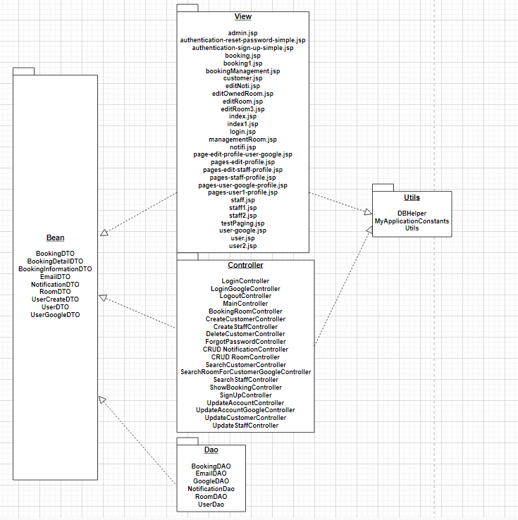

***Package descriptions & package class naming conventions***

|  |  |  |
| --- | --- | --- |
| **No** | **Package** | **Description** |
| *01* | Bean | BookingDTO  <Contains Customer's booking information from Database> |
| *02* | Bean | BookingDetailDTO  <Contains the details of the customer's reservation from Database> |
| *03* | Bean | BookingInformationDTO  <Contains information about bookings from the database > |
| *04* | Bean | EmailDTO <Contains Email data from Database> |
| *05* | Bean | NotificationDTO  <Contains Notification data from Database> |
| *06* | Bean | RoomDTO  <Contains Room data from Database> |
| *07* | Bean | UserCreateDTO  <Contains UserCreate data from Database> |
| *08* | Bean | UserDTO  <Contains User data from Database> |
| *09* | Bean | UserGoogleDTO  <Contains UserGoogle data from Database> |
|  |  |  |
| *10* | Dao | BookingDAO  <The booking object is reserved for communication with the Data Layer> |
| *11* | Dao | EmailDAO  <The Email object is reserved for communication with the Data Layer> |
| *12* | Dao | GoogleDAO  <The Google object is reserved for communication with the Data Layer> |
| *13* | Dao | NotificationDAO  <The Notification object is reserved for communication with the Data Layer> |
| *14* | Dao | RoomDAO  <The Room object is reserved for communication with the Data Layer> |
| *15* | Dao | UserDAO  <The User object is reserved for communication with the Data Layer> |
|  |  |  |
| *16* | Utils | DBHelper  <Connect to the SQL> |
| *17* | Utils | MyApplicationConstants  <Site Map> |
| *18* | Utils | Utils  <Help handle functions that check the correctness of user input data> |
|  |  |  |
| *19* | Controller | LoginController  <Receive requests from users, process requests, build data for login> |
| *20* | Controller | LoginGoogleController  <Receive requests from Google users, process requests, build data for login> |
| *21* | Controller | LogoutController  <Receive requests from users, process requests, build data for logout> |
| *22* | Controller | MainController  <Receive requests from users, process requests, build data for the entire project> |
| *23* | Controller | BookingRoomController  <Receive requests from users, process requests, build data for booking room> |
| *24* | Controller | CreateCustomerController  <Receive requests from users, process requests, build data for create customer> |
| *25* | Controller | CreateStaffController  <Receive requests from users, process requests, build data for create staff> |
| *26* | Controller | DeleteCustomerController  <Receive requests from users, process requests, build data for delete customer> |
| *27* | Controller | ForgotPasswordController  <Receive requests from users, process requests, build data for forgot password> |
| *28* | Controller | CRUD NotificationController  <Receive requests from users, process requests, build data for CRUD notification> |
| *29* | Controller | CRUD RoomController  <Receive requests from users, process requests, build data for CRUD room> |
| *30* | Controller | SearchCustomerController  <Receive requests from users, process requests, build data for search customer> |
| *31* | Controller | SearchRoomForCustomerGoogleController  <Receive requests from users, process requests, build data for search room for customer google> |
| *32* | Controller | SearchStaffController  <Receive requests from users, process requests, build data for search staff> |
| *33* | Controller | ShowBookingController  <Receive requests from users, process requests, build data for show booking> |
| *34* | Controller | SignUpController  <Receive requests from users, process requests, build data for sign up> |
| *35* | Controller | UpdateAccountController  <Receive requests from users, process requests, build data for update account> |
| *36* | Controller | UpdateAccountGoogleController  <Receive requests from users, process requests, build data for update google account> |
| *37* | Controller | UpdateCustomerController  <Receive requests from users, process requests, build data for update customer> |
| *38* | Controller | UpdateStaffController  <Receive requests from users, process requests, build data for update staff> |
|  |  |  |
| *39* | View | admin.jsp  <adminpage template> |
| *40* | View | authentication-reset-password-simple  <authentication reset password page template> |
| *41* | View | authentication-sign-up-simple.jsp  <authentication sign-up page template> |
| *42* | View | booking.jsp  <booking page template> |
| *43* | View | booking1.jsp  <booking page template> |
| *44* | View | bookingManagement.jsp  <booking management page template> |
| *45* | View | customer.jsp  <customer page template> |
| *46* | View | editNoti.jsp  <edit notification page template> |
| *47* | View | editOwnedRoom.jsp  <edit owned room page template> |
| *48* | View | editRoom.jsp  <edit room page template> |
| *49* | View | editRoom3.jsp  <edit room page template> |
| *50* | View | index.jsp  <home page template> |
| *51* | View | index1.jsp  <home page template> |
| *52* | View | login.jsp  <login page template> |
| *53* | View | managementRoom.jsp  <management room page template> |
| *54* | View | notifi.jsp  <notification page template> |
| *55* | View | page-edit-profile-user-google.jsp  <page edit profile user google template> |
| *56* | View | pages-edit-profile.jsp  <pages edit profile template> |
| *57* | View | pages-edit-staff-profile.jsp  <pages edit staff template> |
| *58* | View | pages-staff-profile.jsp  <pages staff profile template> |
| *59* | View | pages-user-google-profile.jsp  <pages user google profile template> |
| *60* | View | pages-user1-profile.jsp  <pages user1 profile template> |
| *61* | View | staff.jsp  <Staff page template> |
| *62* | View | staff1.jsp  <Staff1 page template> |
| *63* | View | staff2.jsp  <Staff2 page template> |
| *64* | View | testPaging.jsp  <testPaging page template> |
| *65* | View | user-google.jsp  <user-google page template> |
| *66* | View | user.jsp  <User page template> |
| *67* | View | user2.jsp  <User2page template> |
|  |  |  |

## 2. Database Schema

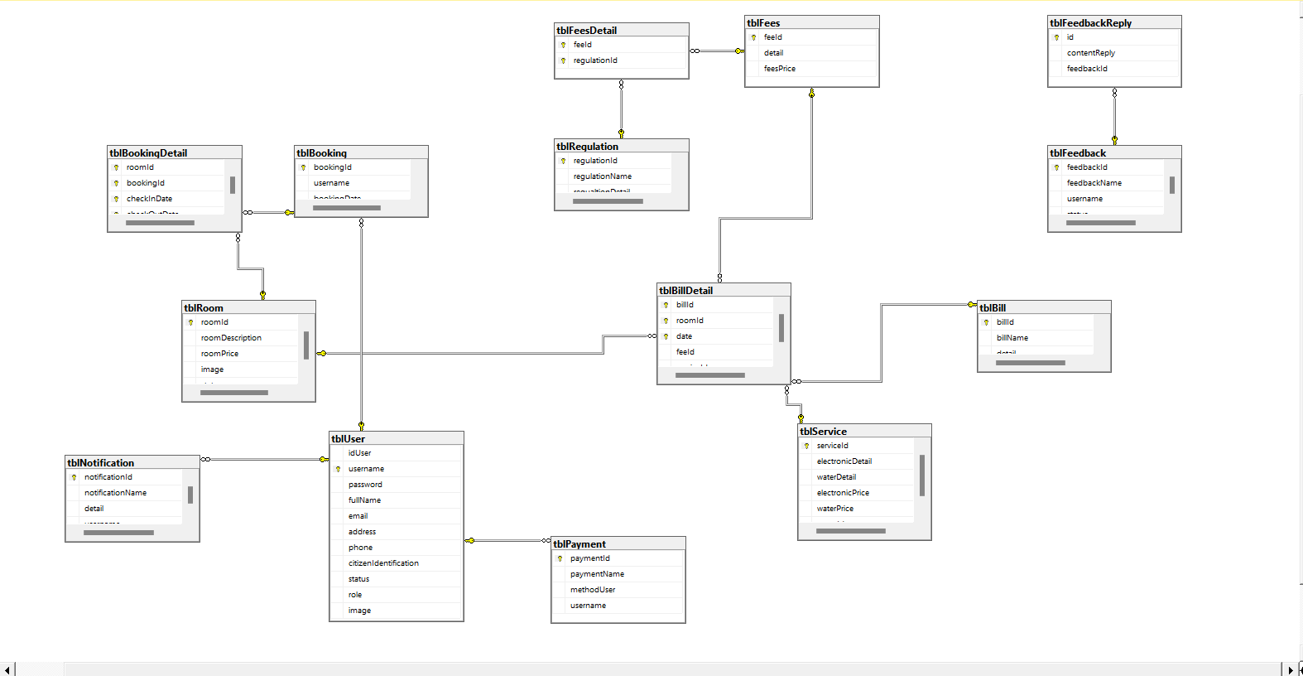

***Table descriptions & package class naming conventions are as below***

|  |  |  |
| --- | --- | --- |
| **No** | **Table** | **Description** |
| 01 | Bill | <tblBill>  - Primary keys : <<billId>>  - Foreign keys : <<list of foreign key fields>> |
| 02 | BillDetail | <tblBillDetail>  - Primary keys : <<billId>>, <<roomId>>, <<date>>  - Foreign keys : <<list of foreign key fields>> |
| 03 | Booking | <tblBooking>  - Primary keys : <<bookingId>>  - Foreign keys : <<list of foreign key fields>> |
| 04 | BookingDetail | <tblBookingDetail>  - Primary keys : <<roomId>>, <<bookingId>>, <<checkInDate>>, <<checkOutDate>>  - Foreign keys : <<list of foreign key fields>> |
| 05 | Feedback | <tblFeedback>  - Primary keys : <<feedbackId>>  - Foreign keys : <<list of foreign key fields>> |
| 06 | FeedbackReply | <tblFeedbackReply>  - Primary keys : <<id>>  - Foreign keys : <<list of foreign key fields>> |
| 07 | Fees | <tblFees>  - Primary keys : <<feeId>>  - Foreign keys : <<list of foreign key fields>> |
| 08 | FeesDetail | <tblFeesDetail>  - Primary keys : <<feeId>>, <<regulationId>>  - Foreign keys : <<list of foreign key fields>> |
| 09 | Notification | <tblNotification>  - Primary keys : <<notificationId>>  - Foreign keys : <<list of foreign key fields>> |
| 10 | Payment | <tblPayment>  - Primary keys : <<paymentId>>  - Foreign keys : <<list of foreign key fields>> |
| 11 | Regulation | <tblRegulation>  - Primary keys : <<regulationId>>  - Foreign keys : <<list of foreign key fields>> |
| 12 | Room | <tblRoom>  - Primary keys : <<roomId>>  - Foreign keys : <<list of foreign key fields>> |
| 13 | Service | <tblService>  - Primary keys : <<serviceId>>  - Foreign keys : <<list of foreign key fields>> |
| 14 | User | <tblUse>  - Primary keys : <<username>>  - Foreign keys : <<list of foreign key fields>> |

# II. Code Designs

## 1. <Feature/Function Name1>

### a. Class Diagram

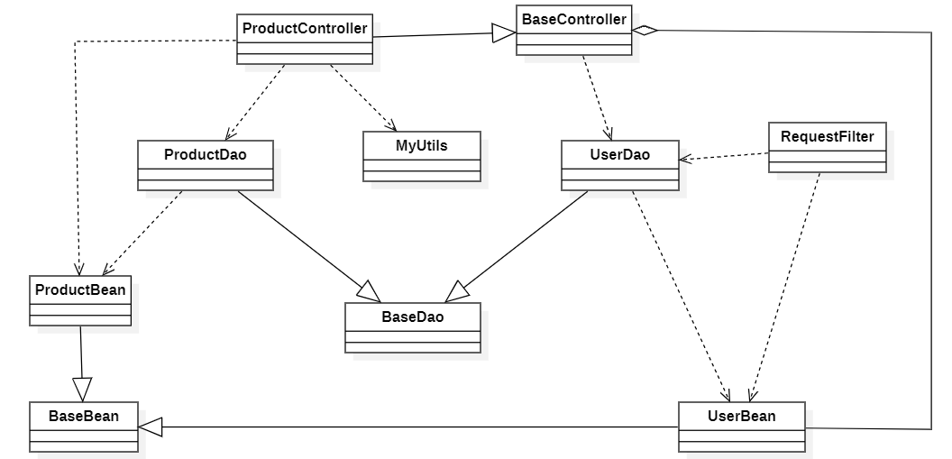

### b. Class Specifications

|  |  |  |
| --- | --- | --- |
| **No** | **Class** | **Description** |
| *01* |  |  |
| *01* |  |  |
| *02* |  |  |
| *03* |  |  |
| *04* |  |  |
| *05* |  |  |
| *06* |  |  |
|  |  |  |
|  |  |  |
|  |  |  |

***Class Methods***

|  |  |  |
| --- | --- | --- |
| **No** | **Method** | **Description** |
| *01* |  |  |
|  |  |  |
|  |  |  |
|  |  |  |
|  |  |  |
|  |  |  |
|  |  |  |
|  |  |  |
|  |  |  |

### c. Sequence Diagram(s)

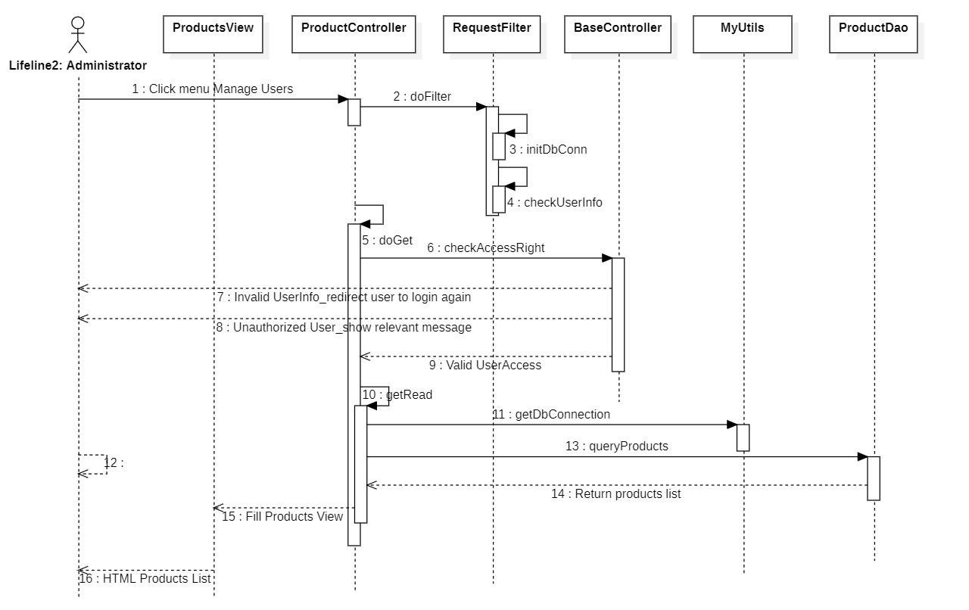

### d. Database queries

## 2. <Feature/Function Name2>

…

# III. Database Tables

## 1. <tblBill>

|  |  |  |  |  |  |  |  |
| --- | --- | --- | --- | --- | --- | --- | --- |
| **#** | **Field name** | **Type** | **Size** | **Unique** | **Not Null** | **PK/FK** | **Notes** |
| 1 | billId | int |  |  | x | PK |  |
| 2 | billName | nvarchar | 50 |  | x |  |  |
| 3 | detail | nvarchar | 100 |  | x |  |  |

## <tblBillDetail>

|  |  |  |  |  |  |  |  |
| --- | --- | --- | --- | --- | --- | --- | --- |
| **#** | **Field name** | **Type** | **Size** | **Unique** | **Not Null** | **PK/FK** | **Notes** |
| 1 | billId | int |  |  | x | PK |  |
| 2 | roomId | int |  |  | x | PK |  |
| 3 | date | nvarchar | 20 |  | x | PK |  |
| 4 | feeId | int |  |  |  |  |  |
| 5 | serviceId | int |  |  |  |  |  |

## 3. <tblBooking>

|  |  |  |  |  |  |  |  |
| --- | --- | --- | --- | --- | --- | --- | --- |
| **#** | **Field name** | **Type** | **Size** | **Unique** | **Not Null** | **PK/FK** | **Notes** |
| 1 | bookingId | int |  |  | x |  |  |
| 2 | username | nvarchar | 100 |  | x |  |  |
| 3 | bookingDate | nvarchar | 20 |  |  |  |  |

## 4. <tblBookingDetail>

|  |  |  |  |  |  |  |  |
| --- | --- | --- | --- | --- | --- | --- | --- |
| **#** | **Field name** | **Type** | **Size** | **Unique** | **Not Null** | **PK/FK** | **Notes** |
| 1 | roomId | int |  |  | x | PK |  |
| 2 | bookingId | int |  |  | x | PK |  |
| 3 | checkInDate | nvarchar | 20 |  | x | PK |  |
| 4 | checkOutDate | nvarchar | 20 |  | x | PK |  |

## 5. <tblFeedback>

|  |  |  |  |  |  |  |  |
| --- | --- | --- | --- | --- | --- | --- | --- |
| **#** | **Field name** | **Type** | **Size** | **Unique** | **Not Null** | **PK/FK** | **Notes** |
| 1 | feedbackId | int |  |  | x | PK |  |
| 2 | feedbackName | nvarchar |  | 100 | x |  |  |
| 3 | username | nvarchar |  | 100 | x |  |  |
| 4 | status | bit |  |  | x |  |  |

## 6. <tblFeedbackReply>

|  |  |  |  |  |  |  |  |
| --- | --- | --- | --- | --- | --- | --- | --- |
| **#** | **Field name** | **Type** | **Size** | **Unique** | **Not Null** | **PK/FK** | **Notes** |
| 1 | id | int |  |  | x | PK |  |
| 2 | contentReply | nvarchar | 100 |  | x |  |  |
| 3 | feedbackId | int |  |  | x |  |  |

## 7. <tblFees>

|  |  |  |  |  |  |  |  |
| --- | --- | --- | --- | --- | --- | --- | --- |
| **#** | **Field name** | **Type** | **Size** | **Unique** | **Not Null** | **PK/FK** | **Notes** |
| 1 | feeId | int |  |  | x | PK |  |
| 2 | detail | nvarchar | 500 |  | x |  |  |
| 3 | feesPrice | float |  |  | x |  |  |

## 8. <tblFeesDetail>

|  |  |  |  |  |  |  |  |
| --- | --- | --- | --- | --- | --- | --- | --- |
| **#** | **Field name** | **Type** | **Size** | **Unique** | **Not Null** | **PK/FK** | **Notes** |
| 1 | feeId | int |  |  | x | PK |  |
| 2 | regulationId | int |  |  | x | PK |  |

## 9. <tblNotification>

|  |  |  |  |  |  |  |  |
| --- | --- | --- | --- | --- | --- | --- | --- |
| **#** | **Field name** | **Type** | **Size** | **Unique** | **Not Null** | **PK/FK** | **Notes** |
| 1 | notificationId | int |  |  | x | PK |  |
| 2 | notificationName | nvarchar | 100 |  | x |  |  |
| 3 | detail | nvarchar | 500 |  | x |  |  |
| 4 | username | nvarchar | 100 |  | x |  |  |

## 10. <tblPayment>

|  |  |  |  |  |  |  |  |
| --- | --- | --- | --- | --- | --- | --- | --- |
| **#** | **Field name** | **Type** | **Size** | **Unique** | **Not Null** | **PK/FK** | **Notes** |
| 1 | paymentId | int |  |  | x | PK |  |
| 2 | paymentName | nvarchar | 100 |  | x |  |  |
| 3 | methodUser | nvarchar | 20 |  | x |  |  |
| 4 | username | nvarchar | 100 |  | x |  |  |

## 11. <tblRegulation>

|  |  |  |  |  |  |  |  |
| --- | --- | --- | --- | --- | --- | --- | --- |
| **#** | **Field name** | **Type** | **Size** | **Unique** | **Not Null** | **PK/FK** | **Notes** |
| 1 | regulationId | int |  |  | x | PK |  |
| 2 | regulationName | nvarchar | 100 |  | x |  |  |
| 3 | regulationDetail | nvarchar | 500 |  | x |  |  |

## 12. <Table name 1>

|  |  |  |  |  |  |  |  |
| --- | --- | --- | --- | --- | --- | --- | --- |
| **#** | **Field name** | **Type** | **Size** | **Unique** | **Not Null** | **PK/FK** | **Notes** |
| 1 | roomId | int |  |  | x | PK |  |
| 2 | roomDescription | nvarchar | 100 |  | x |  |  |
| 3 | roomPrice | float |  |  | x |  |  |
| 4 | image | nvarchar | 50 |  |  |  |  |
| 5 | status | nvarchar | 50 |  |  |  |  |

## 13. <tblService>

|  |  |  |  |  |  |  |  |
| --- | --- | --- | --- | --- | --- | --- | --- |
| **#** | **Field name** | **Type** | **Size** | **Unique** | **Not Null** | **PK/FK** | **Notes** |
| 1 | serviceId | int |  |  | x | PK |  |
| 2 | electronicDetail | nvarchar | 500 |  | x |  |  |
| 3 | waterDetail | nvarchar | 500 |  | x |  |  |
| 4 | electronicPrice | float |  |  | x |  |  |
| 5 | waterPrice | float |  |  | x |  |  |
| 6 | roomId | int |  |  |  |  |  |

## 14. <tblUser>

|  |  |  |  |  |  |  |  |
| --- | --- | --- | --- | --- | --- | --- | --- |
| **#** | **Field name** | **Type** | **Size** | **Unique** | **Not Null** | **PK/FK** | **Notes** |
| 1 | idUser | int |  |  | x |  |  |
| 2 | username | nvarchar | 100 |  | x |  |  |
|  | password | nvarchar | 20 |  | x |  |  |
|  | fullName | nvarchar | 50 |  |  |  |  |
|  | email | nvarchar | 400 |  | x |  |  |
|  | address | nvarchar | 20 |  |  |  |  |
|  | phone | nvarchar | 10 |  |  |  |  |
|  | citizenIdentification | nvarchar | 12 |  |  |  |  |
|  | status | bit |  |  |  |  |  |
|  | role | role | 20 |  |  |  |  |
|  | image | image | 400 |  | x |  |  |