

**HOstel management**

**Software Requirement Specification**

– Ho Chi Minh, May 2022 –

**Table of Contents**

I. Overview 3

1. Introduction 3

2. System Functions 4

3. Common Requirements 5

II. Functional Requirements 6

1. <<Feature Name 1>> 6

a. <<Function Name 1>> 6

b. <<Function Name 2>> 6

2. <<Feature Name 2>> 6

# I. Overview

## 1. Introduction

In our present age of automated systems with it being software or hardware, manual systems should not be used. Hostel without a management system are usually done manually. For example: Currently, the number of students and workers is increasing, and the number of local people moving to the city is also increasing, the number of motel rooms also increases with the manual management of the accommodation, which also encounters many problems, making it difficult for the owners. Hosteller needs hostel management system. The limitations of current systems lead to the design of a computerized system that greatly reduces manual input. With this system, we were able to improve the efficiency of the system, thereby overcoming the limitations of the existing manual system.

This system is designed to benefit the hostel management, helping the innkeeper to easily manage the rooms, staff and monthly/yearly revenue of the hostel. It saves them from manual work from which it is difficult to find messy customer bills, and information about people who left the hostel many years ago. This system gives an idea of ​​how to maintain a customer and clutter fee, room, spending details in a better way. The hostel management system will also include special features such as the number of customers staying in a room, the customer id, and the available rooms or spaces. The admin panel has a separate identity for each member as well as customer details.

Hostel management system is web-based software to provide accommodation for university students and workers, locals to the city at the hostel more efficiently. This project also keeps detailed information about hostels and Monthly/Yearly Revenue and customer information. The system is intended to reduce human work and make hostel allocation easier for residents by providing an online hostel application, automatically selecting customers from a waiting list, and counting. mess math, complaint registration, bulletin board, etc. Customers will receive approval notices in their mail. Guests can view bulletin boards, accommodation fees and messy details by logging into the online system.

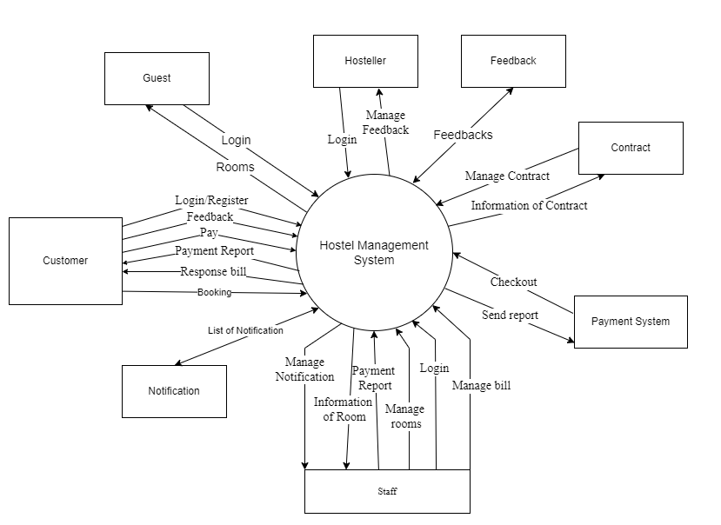

## 2. System Functions

#### a. Screen Flow

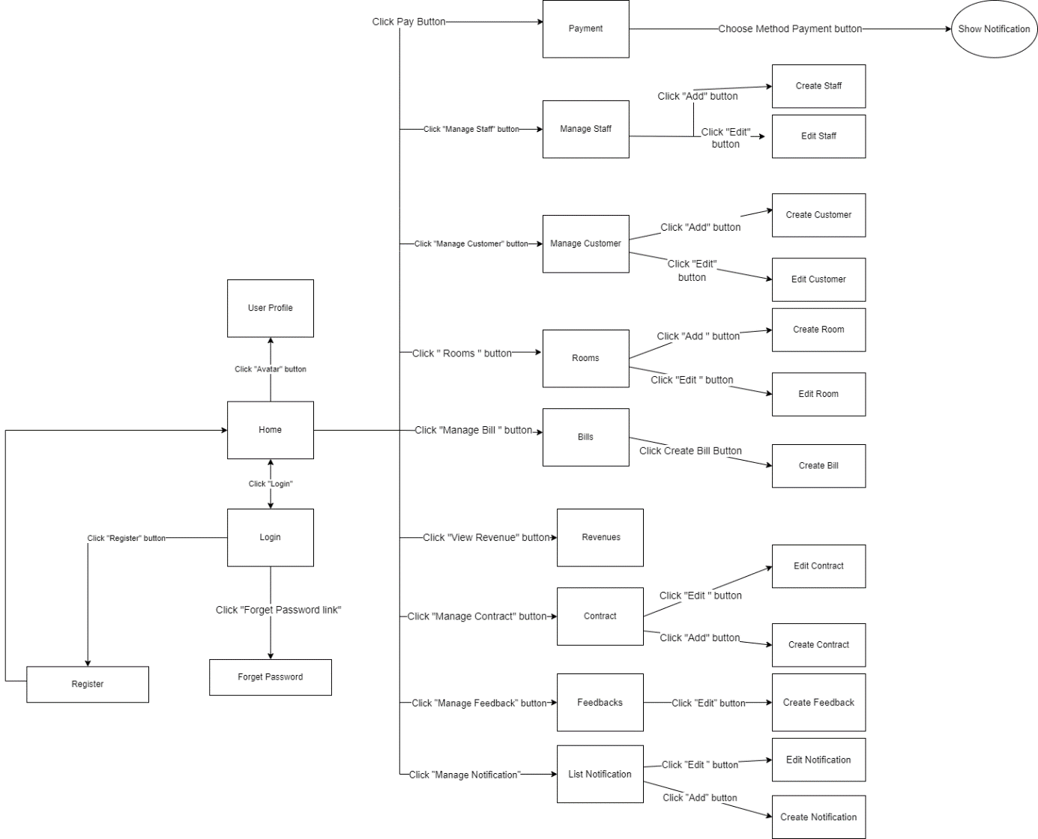

#### b. Screen Details

|  |  |  |  |
| --- | --- | --- | --- |
| **#** | **Feature** | **Screen** | **Description** |
| 1 | Authentication | Login | Check login for staff , hosteller or guest |
| 2 | Authentication | Forget Password | Ask the user to enter the email, the system will send the password via email |
| 3 | Notification | ShowNotification | Pay with Momo |
| 4 | Authentication | Register | Enter information to register |
| 5 | Authentication | Create Account | Hosteller/Staff create for guest or staff to login into system |
| 6 | ManageRevenue | Revenues | Hosteller Manage total profit per month |
| 7 | ManageBill | Bills | Show list of bills |
| 8 | ManageBill | Create Bill | Staff will create a new bill |
| 9 | ViewRevenue | Revenues | Hosteller can watch revenues of his/her hostel |
| 11 | ManageRoom | Rooms | Show list of rooms |
| 12 | ManageRoom | Create Room | Staff will add a new room |
| 13 | ManageRoom | Edit Room | The staff will correct the room information |
| 14 | ManageFeedbacks | Feedback | Customer view feedback |
| 15 | Manage Feedbacks | Create Feedback | Customer send feedback |
| 16 | Manage Payment | Pay | Staff/Customer pay for consumption per month |
| 17 | ManageRegulation | Regulation | All role can manipulate regulation |
| 19 | ViewRevenue | Revenues | Hosteller can watch revenues of his/her hostel |
| 20 | ManageContract | Contracts | Show list of contract |
| 21 | ManageContract | Add Contract | Create new contract |
| 22 | ManageContract | Edit Contract | Update/Delete contract |
| 23 | ManageCustomer | Customers | Staff can view list customer |
| 24 | ManageCustomer | Create Customer | Add new customer |
| 25 | ManageCustomer | Edit Customer | Update/Delete customer out of room |
| 26 | ManageStaff | Staffs | View list of Staff |
| 27 | ManageStaff | Create Staff | Create new Staff |
| 28 | ManageStaff | Edit Staff | Update/Detele staff out of hostel |
| 29 | Notification | List Notification | View list of notification |
| 30 | Notification | Create Notification | Create new notifications for customers |
| 31 | Notification | Edit Notification | Update/Delete notifications |

#### c. User Authorization

|  |  |  |  |  |
| --- | --- | --- | --- | --- |
| **Screen** | **Role1** | **Role2** | **Role3** | **Role4** |
| 1. Authentication |  |  |  |  |
| 1.1 Login | X | X | X | X |
| 1.2 Register |  | X | X | X |
| 1.3 Forget Password | X | X | X | X |
| 1.4 View Profile | X | X | X | X |
| 1.5 Edit Profile | X | X | X | X |
|  |  |  |  |  |
| 2. Manage Rooms |  |  |  |  |
| 2.1 View list of room |  | X | X | X |
| 2.2 Search room |  | X | X | X |
| 2.3 Sort list of rooms |  | X | X | X |
| 2.4 Add room |  | X |  |  |
| 2.5 Update room |  | X |  |  |
| 2.6 Delete room |  | X |  |  |
|  |  |  |  |  |
| 3. Manage Customer |  |  |  |  |
| 3.1 View list of customers | X | X |  |  |
| 3.2 Search customer | X | X |  |  |
| 3.3 Sort list of customers | X | X |  |  |
| 3.4 Update customer | X | X |  |  |
| 3.5 Add customer | X | X |  |  |
| 3.6 Delete customer | X | X |  |  |
|  |  |  |  |  |
| 4. Manage Staff | X |  |  |  |
| 4.1. View list of staff | X |  |  |  |
| 4.2 Search staff | X |  |  |  |
| 4.3 Sort list of staffs | X |  |  |  |
| 4.3 Update staff | X |  |  |  |
| 4.4 Add staff | X |  |  |  |
| 4.5 Delete staff |  |  |  |  |
|  |  |  |  |  |
| 5. Manage Feedback |  | X |  |  |
| 5.1 Send Feedback |  | X | X |  |
| 5.2 View Feedback |  | X | X |  |
| 5.3 Search Feedback |  | X | X |  |
| 5.4 Sort Feedback |  | X | X |  |
|  |  |  |  |  |
| 6. Manage Bill |  | X |  |  |
| 6.1. View list of bill |  | X | X |  |
| 6.2 Update bill |  |  |  |  |
| 6.3 Search Bill |  |  |  |  |
| 6.4 Sort Bill |  |  |  |  |
| 7. Payment |  |  | X |  |
|  |  |  |  |  |
| 8. Manage Revenue | X |  |  |  |
| 8.1 View Revenue | X |  |  |  |
| 8.2 Compute Revenue Statistic | X |  |  |  |
|  |  |  |  |  |
| 9. Manage Regulation |  | X |  |  |
| 9.1 Show Regulation | X | X | X | X |
| 9.2 Create Regulation | X | X |  |  |
| 9.3 Update Regulation | X | X |  |  |
| 9.4 Delete Regulation | X | X |  |  |
|  |  |  |  |  |
| 10 Manage Notification |  |  |  |  |
| 10.1 Show Notification | X | X | X | X |
| 10.2 Update Notification | X | X |  |  |

In which:

* Role1: Hosteller
* Role2: Staff
* Role3: Customer

#### d. Non-Screen Functions

|  |  |  |  |
| --- | --- | --- | --- |
| **#** | **Feature** | **System Function** | **Description** |
| 1 | Payment | Payment | Pay with Momo |
|  |  |  |  |

## 3. Common Requirements

- Web server : Apache Tomcat

-Database : MySQL Database

-User Login: Authenticate the correct login account of the user.

-User Authorization: Authenticate the correct user role.

# II. Functional Requirements

## MANAGE CUSTOMER

## Function trigger: This function is enabled if you are logged in as an administrator/staff and click on the manage customer button.

## Function description: This is a function for administrators to manage information of customer in the list.

* Screen layout: The sample below is intended for the project customer management screen.

## 

* Function Details: Customer management page helps administrators track information about ID, full name, phone number, email or room ID so that they can edit, add customer or delete customer accordingly.

## MANAGE ROOM

* Function trigger: This function is enabled if you are logged in as an staff and click on the manage room button.
* Function description: This is a function for staff to manage information of room in the list.
* Screen layout: The sample below is intended for the project room management screen.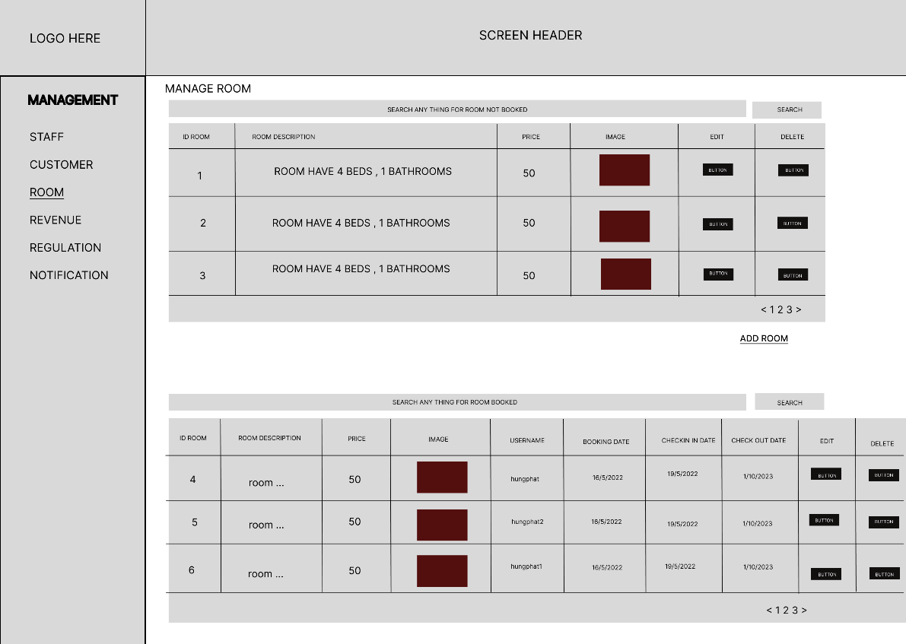
* Function Details: Room management page helps staff track information about ID, description, price, image or so that they can update, add room or delete room accordingly.

1. **Manage Staff**

* **-** Function trigger: This function is enabled if you are logged in as an staff and click on the manage staff button.

- Function description: this is a function for staff to manage information of staff in the list.

- Screen layout: The sample below is intended for the project staff management screen.

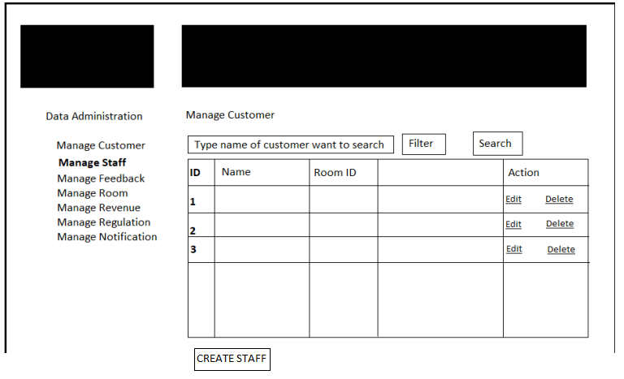

* - Function details: Staff management page helps staff track information about staff so that they can edit, create or delete staff accordingly.

1. **Manage Feedback**

* **-** Function trigger: This function is enabled if you are logged in as an staff/user and click on the manage feedback button.

- Function description: this is a function for staff/user to manage information of feedback in the list.

- Screen layout: The sample below is intended for the project feedback management screen.

**\*Staff:**

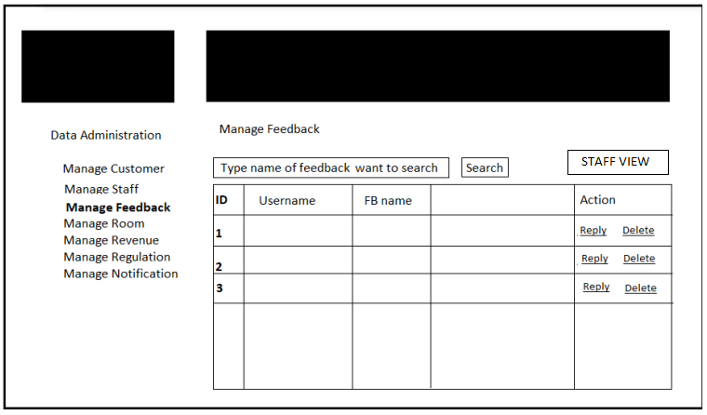

**\*User:**

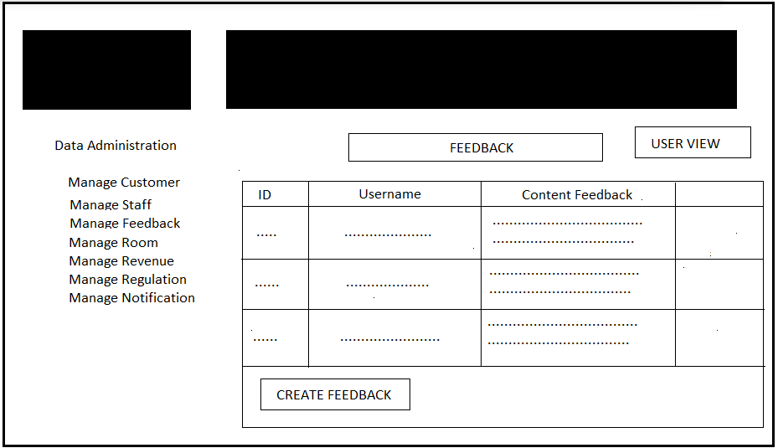

* - Function details: Feedback management page helps staff/user track information about feedback so that they can create, edit or delete feedback accordingly.

1. **Manage Revenue**

* **-** Function trigger: This function is enabled if you are logged in as an staff and click on the manage feedback button.

- Function description: this is a function for staff to manage information of revenue in the list.

- Screen layout: The sample below is intended for the project revenue management screen.

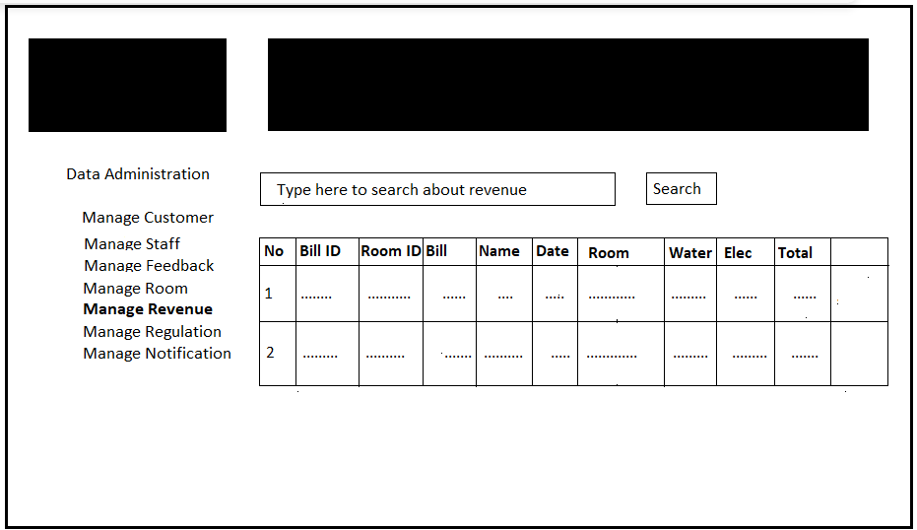

* - Function details: Revenue management page helps staff track information about revenue so that they can handle revenue accordingly.

1. **Manage Regulation**

* **-** Function trigger: This function is enabled if you are logged in as an staff/user and click on the manage regulation button.

- Function description: this is a function for staff/user to manage/view information of revenue in the list.

- Screen layout: The sample below is intended for the project regulation management screen.

**\* Staff :**

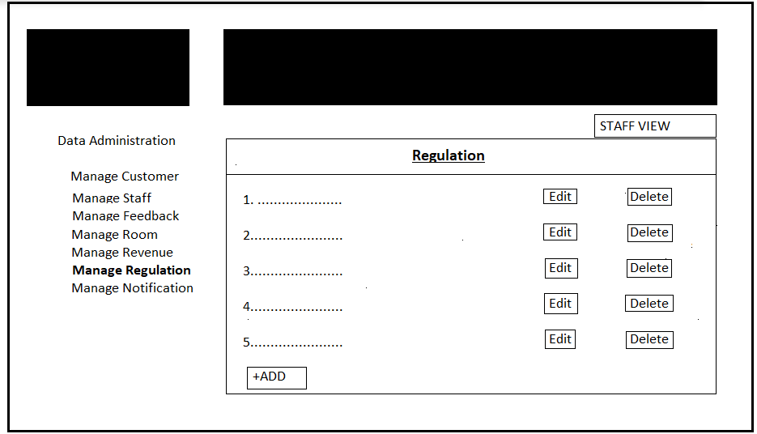

**\* User :**

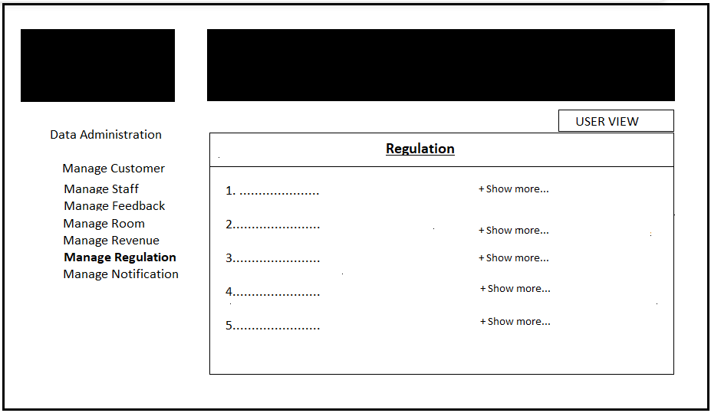

* - Function details: Regulation management page helps staff track information about regulation so that they can handle regulation accordingly.

1. **Manage Notification**

* **-** Function trigger: This function is enabled if you are logged in as an staff/user and click on the manage notification button.

- Function description: this is a function for staff/user to manage/view information of notification in the list.

- Screen layout: The sample below is intended for the project notification management screen.

**\*Staff :**

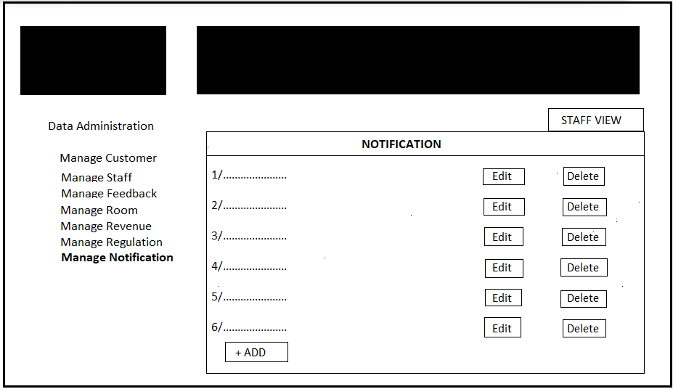

**\*User:**

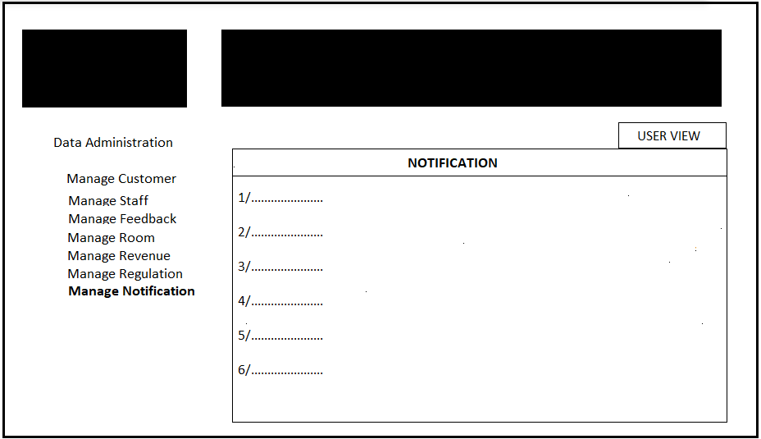

* - Function details: Notification management page helps staff/user track information about notification so that they can handle regulation accordingly.

1. **LOGIN**

* Function trigger: This function is enabled if you click Login in the home page and login with username/password or login with google account
* Function description: This is the function for customer/staff/administrator to log into the system.
* Screen layout: The sample below is intended for the project login screen.

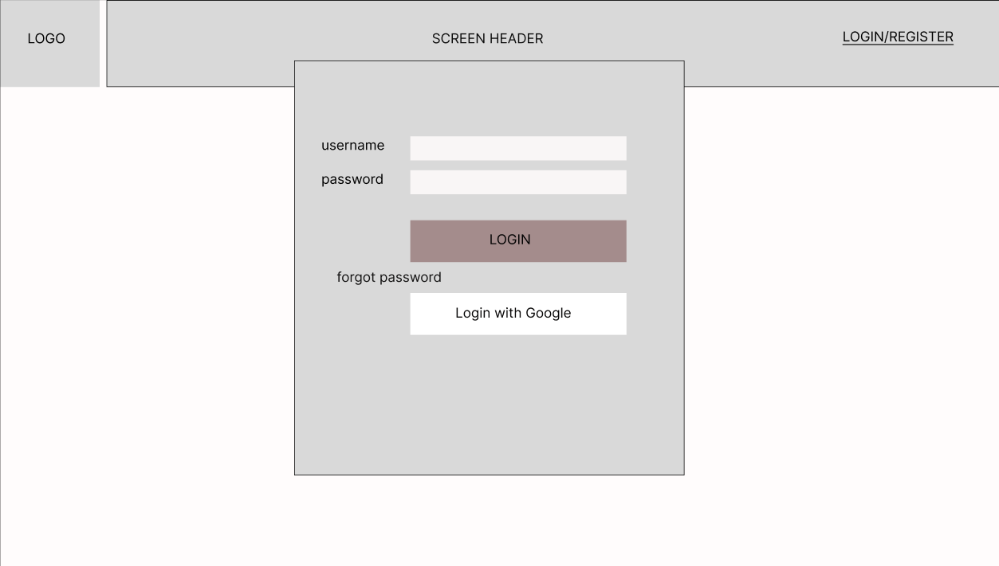

- Function Details: The login page helps staff/customers log into the system. In case the user does not have an account, you can register directly on the page or you can log in with google.

1. **REGISTER**

* Function trigger: This function is enabled if you click Register in the home page and perform account creation operations
* Function description: This is the function for customer/staff/administrator to register an account, log in to the system
* Screen layout: The sample below is intended for the project register screen.

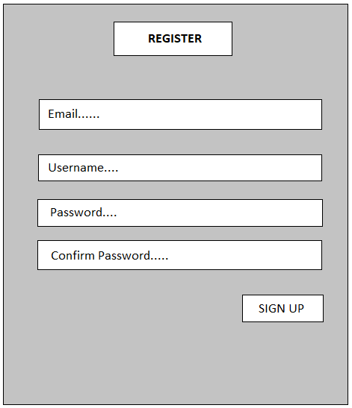

- Function Details: The register page helps staff/customers create the account to log into the system.

1. **FORGET PASSWORD**

* **-** Function trigger: This function is enabled if you are logged in as an staff/user and click on the forgot password button.

- Function description: this is a function for staff/user to reset password.

- Screen layout: The sample below is intended for the project forget password

management screen.

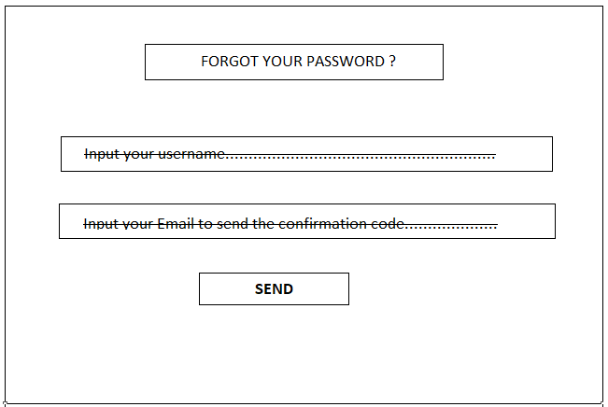

* - Function details: Forget password management page helps staff/user track information about password so that they can handle password accordingly.

1. **EDIT PROFILE**

* Function trigger: This function is enabled if you are logged in as an administrator/staff/customer and click on the edit profile button.
* Function description: This is a function for administrator/staff/customer to manage their personal information.
* Screen layout: The sample below is for the profile management screen.

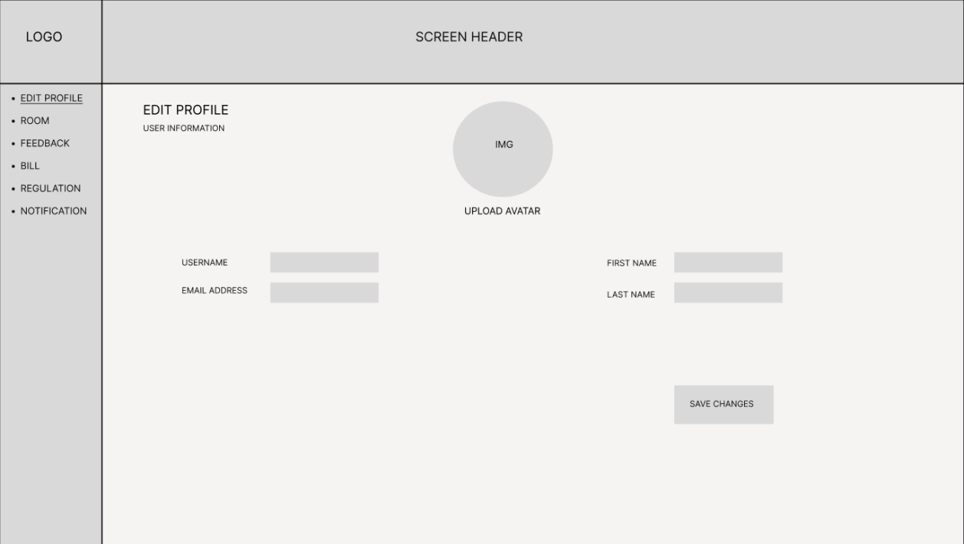

* Function Details: Edit profile page helps user track information about username, image, first name, last name or so that they can update(except username) accordingly.

1. **BOOKING**

* Function trigger: This function is enabled if you are logged in as an customer and click on the room button.
* Function description: This is a function for customers to view rooms in the system (booked/unbooked rooms) and book that room.
* Screen layout: The sample below is for booking room screen.

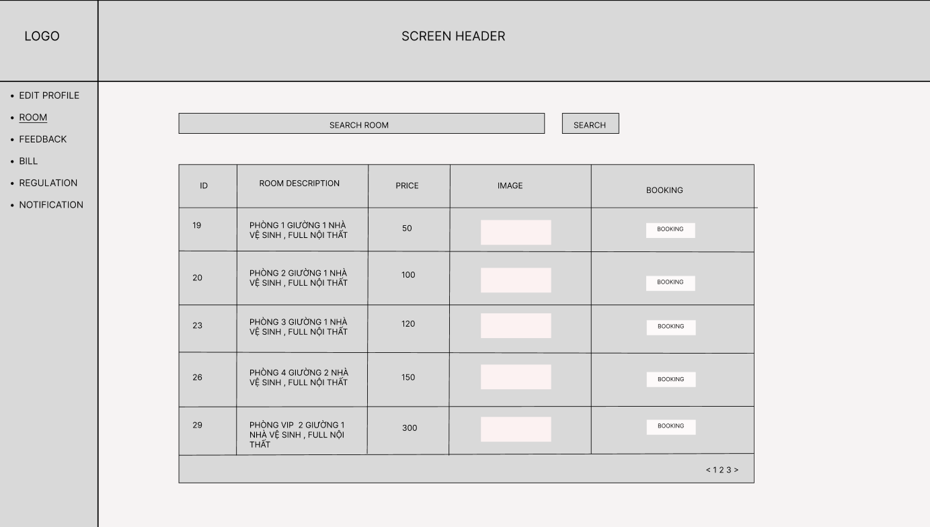

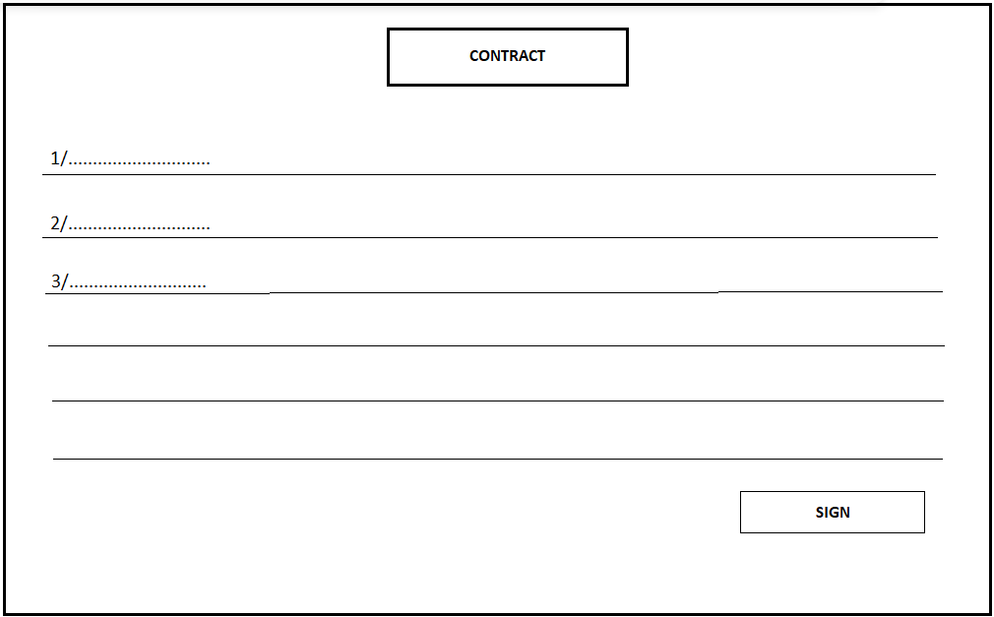

* Function Details: Booking room helps users see the list of rooms and choose the room they like and make a reservation.

1. **BILLS**

* **-** Function trigger: This function is enabled if you are logged in as an staff/user and click on the bill button.

- Function description: this is a function for staff/user manage/view information of bills in the list.

- Screen layout: The sample below is intended for the project bills management screen.

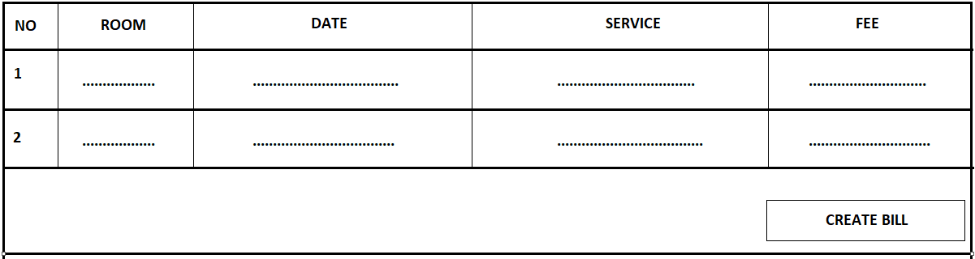

* - Function details: Bills management page helps staff/user track information about the bill so that they can handle regulation accordingly.

1. **PAYMENT**

* **-** Function trigger: This function is enabled if you are logged in as an user and click on the payment button.

- Function description: this is a function for user to manage/view information of payment.

- Screen layout: The sample below is intended for the project payment management screen.

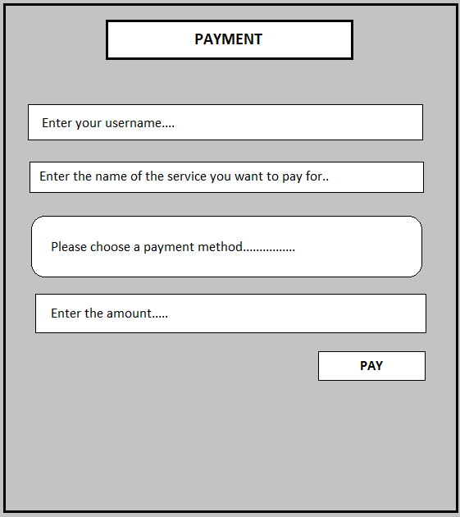

* - Function details: Payment management page helps user track information about the payment so that they can handle regulation accordingly.