|  |  |
| --- | --- |
|  |  |

|  |  |
| --- | --- |
|  |  |
|  |  |
|  |  |

Ho Chi Minh City – 2023

1. Form

# REVIEW AND EVALUATION

......................................................................................................................................................

......................................................................................................................................................

......................................................................................................................................................

......................................................................................................................................................

......................................................................................................................................................

1. Content

......................................................................................................................................................

......................................................................................................................................................

......................................................................................................................................................

......................................................................................................................................................

......................................................................................................................................................

......................................................................................................................................................

......................................................................................................................................................

......................................................................................................................................................

Scores: Form .......................................... Content ...................................... Total score:.......................

Day Month Year 202 Lecture

# PREMISE

As the technology era develops to catch up with the current trend in Vietnam, Information Technology has also been widely researched and applied in many fields, especially in the field of software or application programming. Informatics has become an indispensable tool.

Recently, the mobile phone has become an “must have” item in everyone's daily life. Writing utility software that adds value to them has also become a trend for software development companies, professional and amateur programmers alike. Especially the applications for the device running on the Android operating system.

After learning about the Android operating system, we all realized that on Android it is possible to develop a program to help users plan and manage their personal schedule effectively and qualitatively. Based on this statement, we have built a personal schedule management application. Hope to bring a convenient and useful application for the purpose of managing plans, schedules, timetables as well as organizing daily work.

In the process of completing the thesis, our group has received a lot of help, especially the guidance of Master Dang Thi Kim Giao, I would like to thank her.

## Contents

**TABLE OF CONTENTS**

REVIEW AND EVALUATION 2

PREMISE 3

CHAPTER 1: INTRODUCTION 1

* 1. About Android 1
  2. Background and reason for doing the topic 1
  3. How it works 1

CHAPTER 2: THEORETICAL BASIS 3

* 1. Android Open Features 3
     1. Giới thiệu 3
  2. Architecture of Android 3
     1. Android Platform 3
     2. Linux Kernel Layer 4
     3. Native Libraries 4
     4. Runtime Layer 4
     5. Application Framework Layer: 4

CHAPTER 3. PROGRAMMING ENVIRONMENT 6

* 1. Introduce 6
  2. Android Studio: 6
  3. Android SDK 7

CHAPTER 4. PERFORM 9

* 1. Usecase 9
     1. UC01: Create notes/events/appointments on the calendar. 9
     2. UC02: Update notes/events/appointments created on the calendar. 11
     3. UC03: Delete notes/events/appointments created on the calendar. 12
     4. UC04: Notify when a note/event/appointment on the calendar arrives 13
     5. UC05: Search for notes/events/appointments on the calendar once created. 14
  2. Class Diagram and ERD 15

..............................................................................................................................................15

..............................................................................................................................................15

* 1. Activity Diagram 16
  2. Sequence Diagram 17
     1. Create and Notify: 17
     2. Update 17
     3. Lookup: 17
     4. Delete 17

CHAPTER 5. INTERFACES 19

* 1. Set of note 19
  2. Set time and date 20

5.3 Functions 21

CHAPTER 6: CONCLUSION AND DEVELOPMENT 22

* 1. Conclusion: 22
  2. Limit 22
  3. Development 22

THANK YOU! 23

### About Android

# CHAPTER 1: INTRODUCTION

Android is a Linux-based operating system designed for touch screen mobile devices such as smartphones and tablets. Initially, Android was developed by Android, Inc. with financial support from Google and later acquired by Google itself in 2005.

Android launched in 2007 with the announcement of the Open Handset Alliance: an association of hardware, software, and telecommunications companies with the goal of promoting open standards for mobile devices. The first phone to run Android was sold in 2008. Android is open source and Google releases the source code under the Apache License. It is open-source code coupled with an unfettered license that allows device developers, mobile networks, and passionate programmers to adapt and distribute Android freely. In addition, Android has a large community of programmers who specialize in writing applications to extend the functionality of the device, in a modified Java programming language. As of October 2012, there were 700,000 applications. on Android, and app downloads from Google Play, Android's main app store, are estimated at 25 billion.

Currently, programming applications on Android platforms is favored by many developers because of its high practicality. For application, we have chosen the topic of personal schedule management to conduct research and hope it will be widely applied in the future.

### Background and reason for doing the topic

Nowadays, our lives are becoming increasingly chaotic and it is exceedingly difficult to control our own schedules. So, to make sure everyone can secure their jobs, we have created this management application with efficiency and quality criteria in mind, giving users a completely satisfied experience.

### How it works

* + - Personal schedule management application used to help users manage their own activities. Through the functions of adding, editing, and deleting activities of the application, people will easily manipulate on the machine. This application will suit everyone because of its friendliness, users of any age will easily manipulate.
    - Some features:
* This is a personal app, not social, so it will not build an account system.
* App has 2 main views: existing notes and calendar.
* In Note view there will be features such as adding/deleting/editing the list of notes.
* The added note will have the content, appointment date, tag of the note (each tag has its own color for easy selection).
* When adding a note, both views can be viewed.
* In the Calendar view is the same, in addition to viewing the calendar, you can also click on a date you want to go to the appointment date editing section like in Note view.
* The date with the note will be marked in that calendar box with the color of the note tag.

# CHAPTER 2: THEORETICAL BASIS

### Android Open Features:

Android was built to allow developers to create compelling mobile applications, taking advantage of all the features a phone has to offer. It was built to be truly open. For example, an application can call any of the phone's core functions such as making calls, sending text messages, or using the camera, allowing developers to create multiple richer apps for users (this is not currently available on Microsoft's Windows Phone 7). Android is built on the open-source Linux Kernel. Furthermore, it uses a custom virtual machine designed to optimize memory and hardware resources in a mobile environment.

Android does not distinguish between your phone's core apps and third-party apps. All can be built to be accessible using the capabilities of a mobile device providing users with a wide range of applications and services. With devices built on Android, users can completely adapt the phone to their benefit. With Android, a developer can build an app that allows users to see the location of their friends and be alerted when they are in the vicinity giving them a chance to connect.

Android provides access to a wide range of useful tool libraries and can be used to build rich applications. For example, Android allows devices to communicate with each other facilitating rich-to-peer in social apps. In addition, Android includes a complete set of tools that have been elaborately built, with providing a development platform, with high productivity and insight into .***2.1.1 Introduction***

### Architecture of Android

"Understanding Android" is how we approach Android programming and understand its system architecture. We may not need to understand the structure of an HDH but We can still program an application on that HDH, this is what the manufacturer wants when releasing the SDK with their existing framework. As we know this also has good and bad sides. Framework is an advanced layer for programmers, it has its limitations, we can only program popular applications but should not progress to advanced applications that go deep into our system. HDH. In our own way, before starting to learn Android, we should study through the Android HDH itself, we don't need to understand it well, our most important purpose is to have a general and complete overview. The best about Android.

#### *Android Platform:*

Includes the full-featured Android operating system, applications, and middle layers for developers to extend, customize, or add to their components.

There are 4 basic layers in Android OS: Application Framework, Android Runtime, Native Libraries, Linux Kernel... Each layer works with the help of the layer below.

#### *Linux Kernel Layer:*

This is the kernel of the Android operating system; all processing of the system must go through this layer. Linux Kernel provides hardware device drivers (drivers) such as: camera, USB, WIFI, Bluetooth, Display, Power Management ...

Android-based Linux version 2.6 selects core features such as security, memory management, process management, network stack, and hardware drivers. The kernel acts as an abstraction layer between the rest of the system's hardware and software.

#### *Native Libraries:*

* + - * System C library - derived from the system C standard library (libc), which adapts embedded devices on Linux.
      * Media Libraries - expansion from PacketVideo's Open CORE; Library supports playback and recording of many popular video and image formats:
      * MPEG4, H.264, MP3, AAC, AMR, JPG, and PNG
      * Surface Manager - manages the rendering and compositing of 2D and 3D graphics.
      * LibWebCore - Android reuses web kit engine for default browser rendering of HDH Android browser and for embedded web (like embedded HTML)
      * SGL - 2D engine
      * 3D libraries - 3D libraries based on OpenGL ES 1.0 API, with enhanced "hardware 3D acceleration"
      * FreeType - render bitmaps and vector fonts.

#### *Runtime Layer:*

Each Android application runs on its own Dalvik VM (virtual machine) process. Dalvik was written to efficiently run multiple virtual machines at the same time on the same device.

The Dalvik virtual machine executes .dex (Dalvik Excitable) files. This format is optimized to take up only a small and usable amount of memory. The VM runs the classes (which have been compiled before by a Java compiler), the reason the VM can run these classes is because the DX tool program converts the classes to .dex format.

#### *Application Framework Layer:*

This is the layer that Google builds for developers to develop their apps on Android, just by calling pre-existing APIs that Google has written to use hardware features without understanding the underlying structure.

By providing an open development platform, Android gives developers the ability to build incredibly rich and innovative applications. Developers are free to take advantage of device hardware, access location information, background services, set alarms, add notifications to the status bar, and much, much more.

All applications typically include a set of the following basic systems and services:

* View UI is used to build the layout of the application including: list view, text field, button, dialog, form, ...
* Content Providers allow apps to either access data from other apps (like our app can get the Contacts information of an Android phone), or to share the app's own data.
* Resource Manager provides access to non-code resources such as assets, graphics, images, music, videos, etc.
* Notification Manager allows all applications to display their notifications on the operating system.
* Activity Manager manages the lifecycle of applications

# CHAPTER 3. PROGRAMMING ENVIRONMENT

In May 2013, Google announced Android Studio, an open-source, Android-specific integrated application development environment (IDE), based on JetBrains' IntelliJ Java IDE (a competitor to Eclipse and NetBeans, which is quite familiar with Java programmers).

Android Studio runs on Windows, Mac, and Linux, replacing the Eclipse Android Development Tool (ADT) that was used as the main IDE in previous years.

### Introduce:

In this chapter will introduce programming tools for Android (Android Development Tools). We will gradually get acquainted with Eclipse and the Android Development Tool plug-in, through the Android SDK and its tools, running an Android application on the Emulator (translated as Android's interface emulator on PC). With those skills in hand, we will explore the Java packages provided in the SDK that enhance programming on Android.

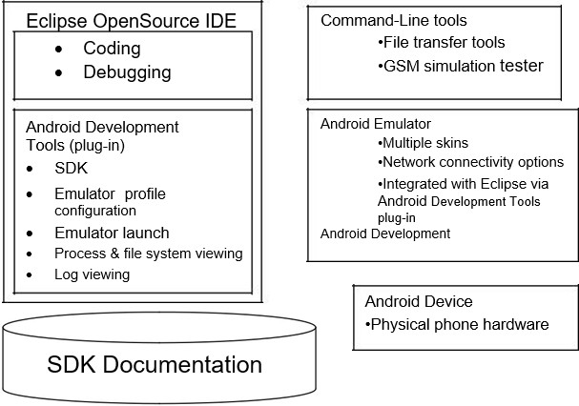

### Android Studio:

The function of Android Studio is to provide an interface to create applications and handle most of the complex file management stuff behind the scenes. The programming language used here is Java and is installed separately on your device. Android Studio is quite simple, you just need to write, edit, and save your projects and the files in them. Also, Android Studio will grant access to the Android SDK.

Think of this as a tail for Java code that allows it to run smoothly on Android devices and take advantage of native hardware. You need to use the Java programming language to write programs, the Android SDK is responsible for connecting these parts together. At the same time, Android Studio activates to run the code, either through an emulator or through a piece of hardware connected to the device. Then you can also

“debug” the program as it runs and get feedback explaining the problem and so on so you can quickly resolve the issue.

Google has put a lot of effort into making Android Studio as powerful and useful as possible. It provides direct suggestions while coding and often suggests changes needed to fix bugs or make code more efficient. For example, if a variable is not used, it will be highlighted in gray. And when you start typing a line of code, Android Studio will provide a list of self-complete suggestions to help you perfect that line of code. This function is useful when you cannot remember the exact syntax or to save time.

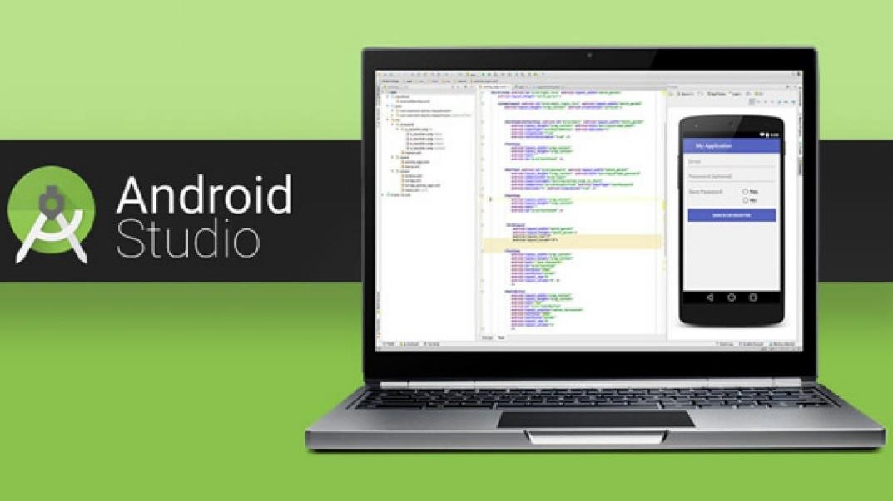

### Android SDK:

Accordingly, the SDK provides libraries, documentation, templates, sample code, debugging utilities, supporting notes (documentation) or additional documents, ... for developers to integrate. integrated into your software/application. Most of them are usually the function of displaying ads, push notifications, etc.

SDKs can also contain APIs in the form of libraries or some complex hardware.

The SDK is custom built to be compatible with the respective programming language and characteristics. Accordingly, you will encounter the following common types of SDKs:

* + - Android SDK Toolkit: uses the Java language, used to program applications on the Android platform.
    - iOS SDK Toolkit: uses the Swift language, used to support application programming on the iOS platform.
    - Windows SDK Toolkit: Windows requires the .NET Framework SDK included with .NET to program specialized software.
    - VMware SDK toolkit: used to integrate with the VMware platform (allowing virtualization on cloud computing technology).
    - Nordic SDK Toolkit: used to assist in the creation of Bluetooth or wireless products.

### Use Case:

# CHAPTER 4. PERFORM

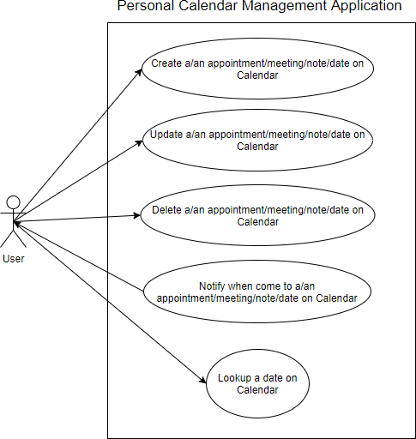

*Figure 1 Use case*

#### *UC01: Create notes/events/appointments on the calendar.*

Use Case Description

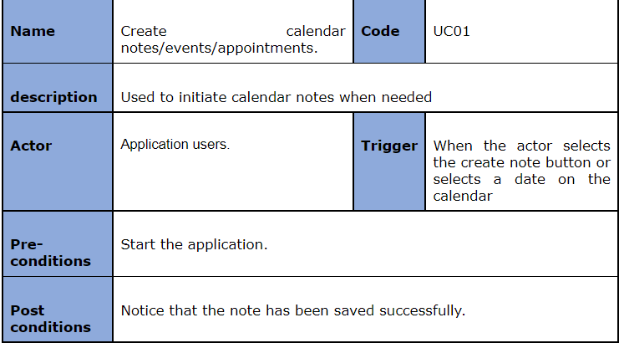

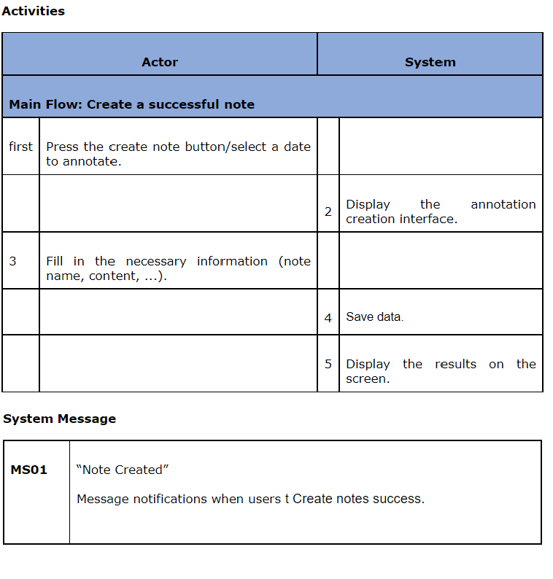

#### *UC02: Update notes/events/appointments created on the calendar.*

Use Case Description

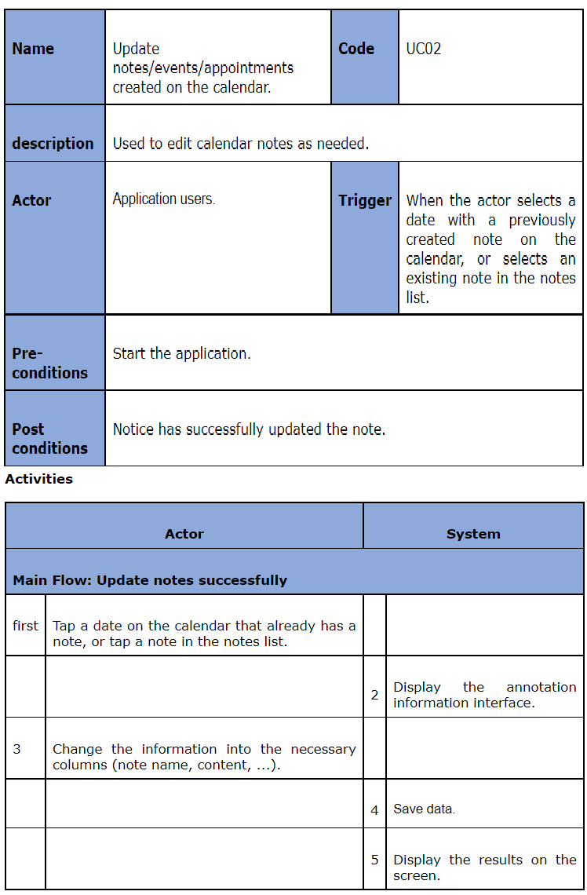

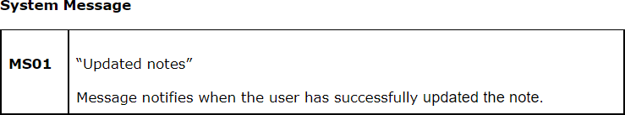

#### *UC03: Delete notes/events/appointments created on the calendar.*

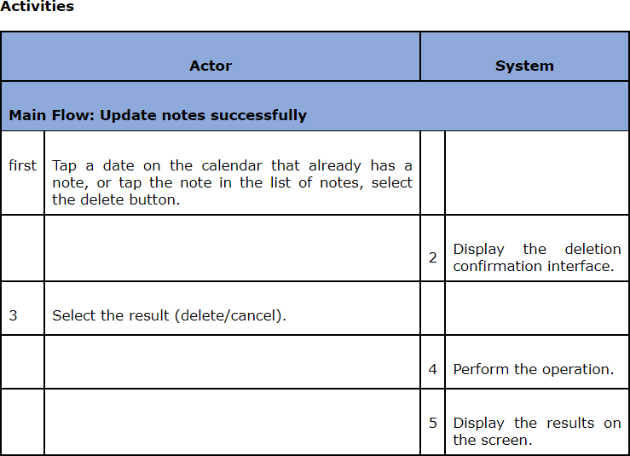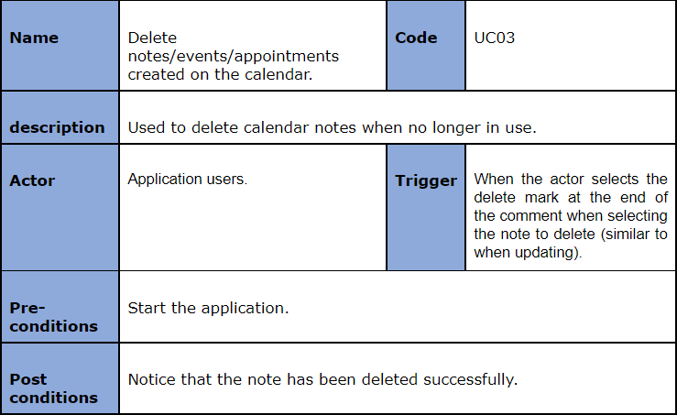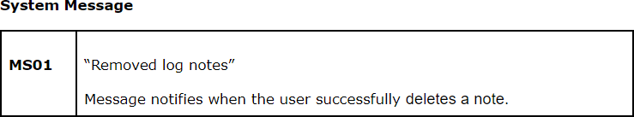

#### *UC04: Notify when a note/event/appointment on the calendar arrives.*

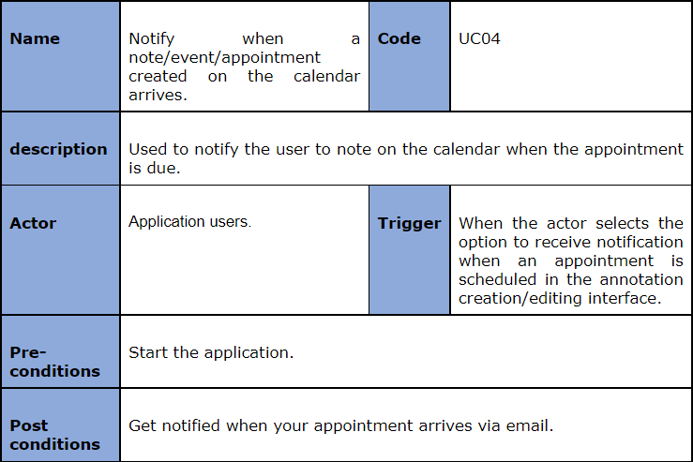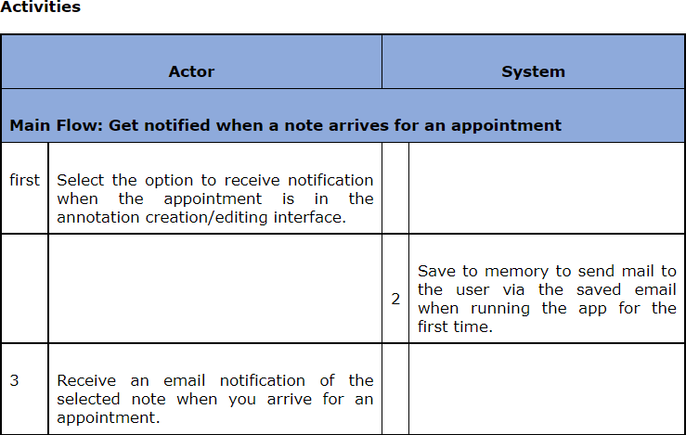

#### *UC05: Search for notes/events/appointments on the calendar once created.*

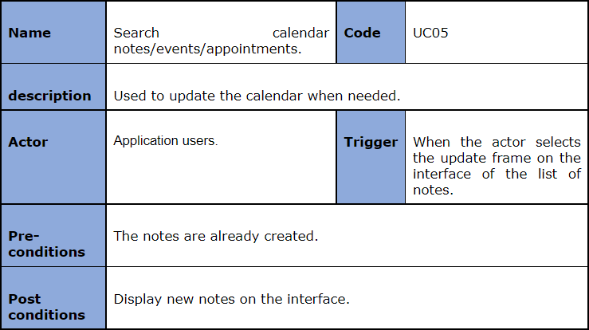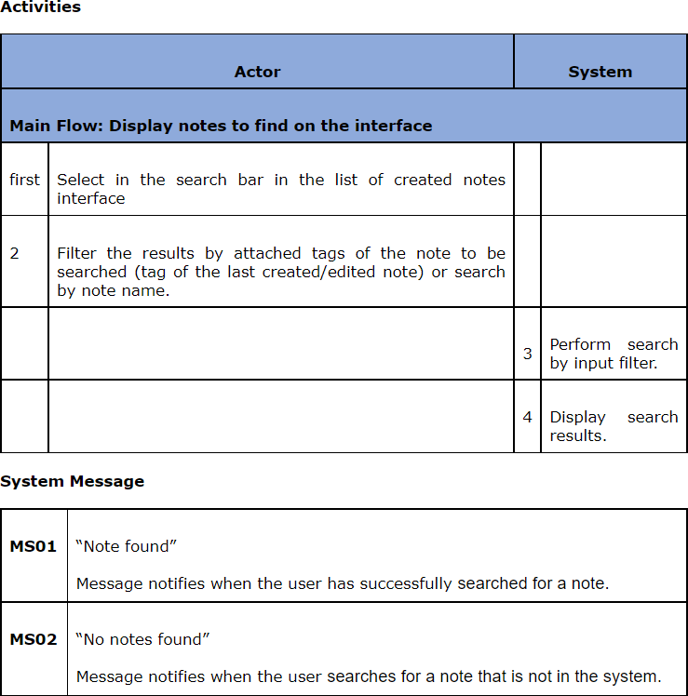

### Class Diagram and ERD

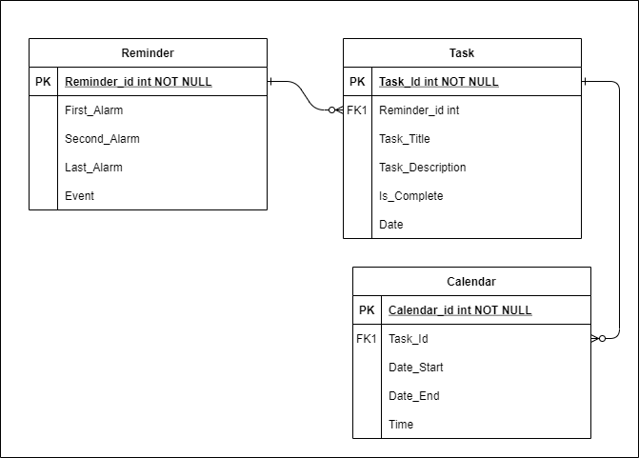

*Figure 2 Class Diagram*

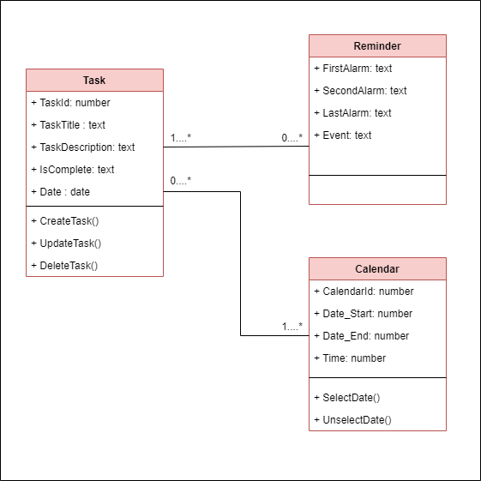

*Figure 3 Entity Relationship Diagram*

### Activity Diagram:

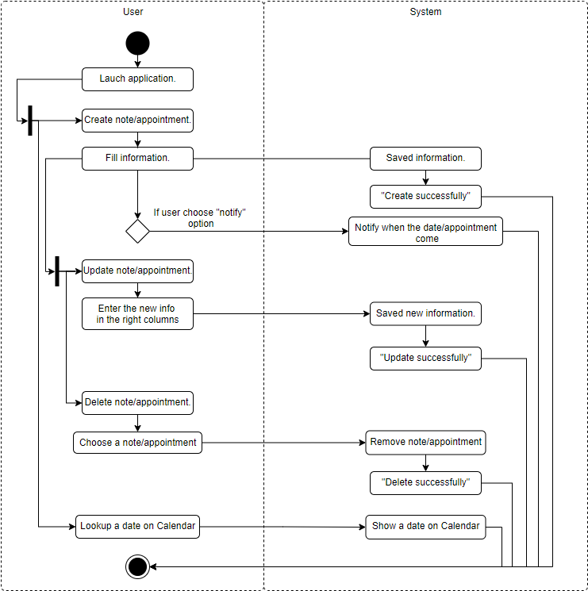

*Figure 4 Activity Diagram*

### Sequence Diagram

#### *Create and Notify:*

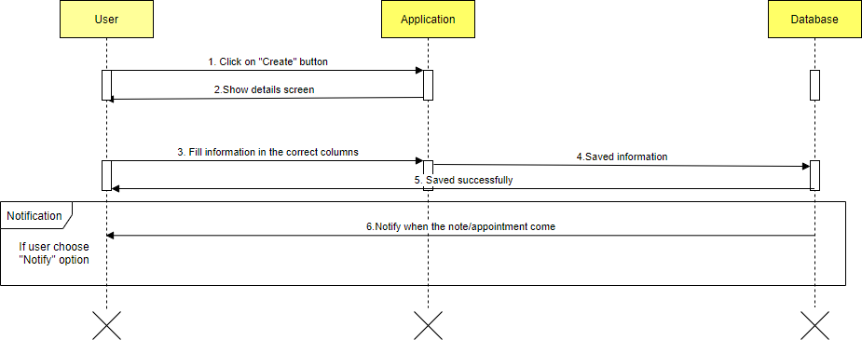

#### *Update:*

*Figure 5 Sequence Diagram for Create and Notify*

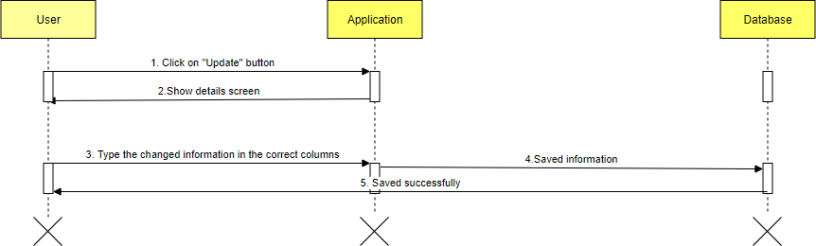

#### *Lookup:*

*Figure 6 Sequence Update*

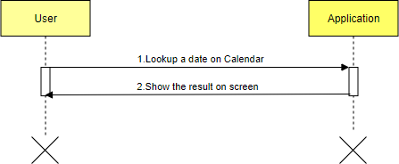

*Figure 7 Sequence Lookup*

#### *Delete:*

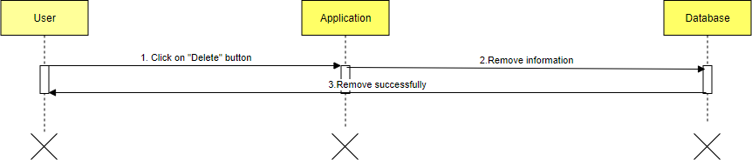

*Figure 8 Sequence Delete*

### Set of note:

**CHAPTER 5. INTERFACES**

* + - The function appears when the user has a need to use to set his schedule in the application.
    - There will be information the user needs to take notes: the title of the schedule, the job description, select the date, select the time, enter the data for the event.

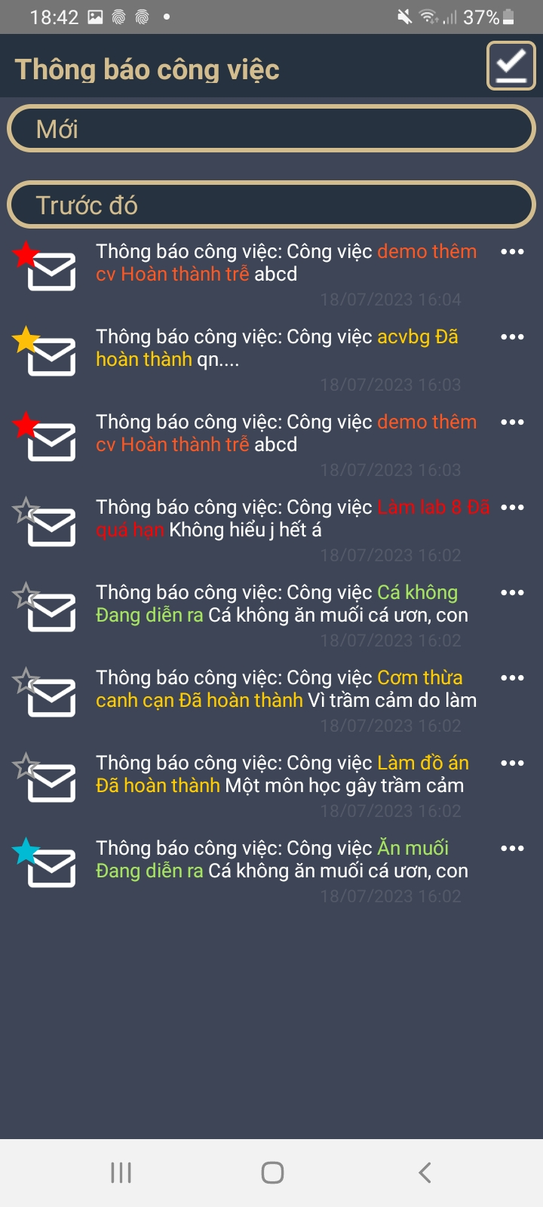

*Figure 9. Set of note*

### Set time and date:

*Figure 11 Set date*

*Figure 10 Set Time*

* + - The function appears when the user sets the time and date of the event in his personal schedule. It will then be saved and notified to the user when the appointment is due.

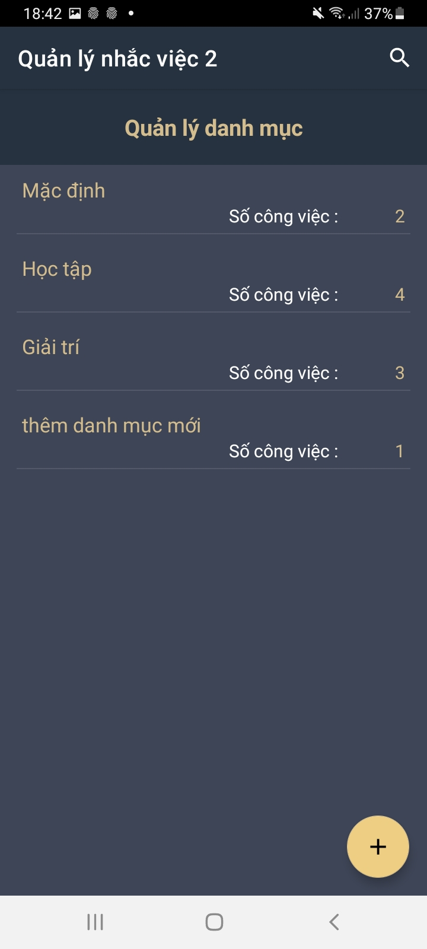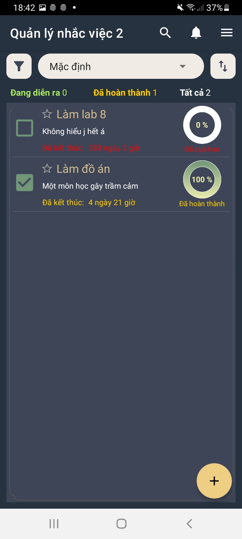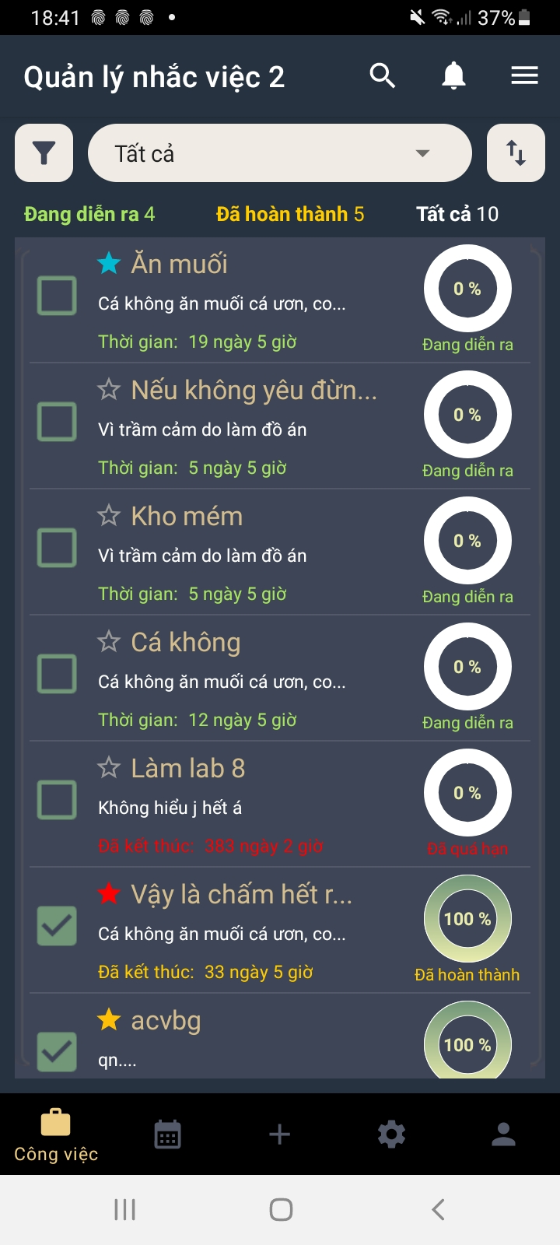

#### *Functions:*

*Figure 13 Interface when selecting functions*

*Figure 15 The interface notifies when the job is done.*

*Figure 12 Interface when deleting notes*

*Figure 14 Notification interface when it's time to work*

# CHAPTER 6: CONCLUSION AND DEVELOPMENT

### Conclusion:

* + - Facing the development trend of information technology like Vu Bao, the computerization of personal schedule management is extremely important and necessary. It will help individuals to solve problems quickly and efficiently.

The database application solved that problem.

* + - With the topic: Personal schedule management, although the installation program has not yet completed its functions, if it has time to develop and perfect it, this program will be extremely helpful to everyone in the community. system work and manage his time properly.

### Limit:

* + - Due to the limited implementation time of the project, the program cannot avoid certain shortcomings. In addition, the stork program has several potential search and statistics functions that have not had enough time to implement. At the same time there are still some incomplete and incomplete forms and data constraints that are still incomplete. Moreover, in the process of writing the program and learning about the SQLite Server language, shortcomings cannot be avoided.

### Development:

* + - For the program to work more efficiently, data must be stored in a more secure database management system. Along with that, we will try to improve it more with outstanding and unique features in the future.

# THANK YOU!

* + - For the completion of this thesis, I would like to express my sincere thanks to:
* The Board of Directors of Ho Chi Minh City University of Economics and Finance for creating favorable conditions in terms of facilities with a modern library system, a variety of books and documents, convenient for searching and researching information retrieval.
* I would like to thank the subject lecturer - Master Dang Thi Kim Giao for her dedicated and detailed teaching so that I have enough knowledge and apply them to this topic.
* Due to our inexperience in doing the subject as well as the limitations of our knowledge, we will inevitably make mistakes. We look forward to receiving comments, suggestions, and criticism from the lecturer to improve the essay.

-Group 7-