Begin  
 Input a,b,c  
   max=a  
   if(b>max)  
   Display “b lớn nhất”  
   max=b  
   if(c>max)  
   Display “c lớn nhất”  
   max=c  
   if(a>max)  
   Display “a lớn nhất”  
 Display max  
End

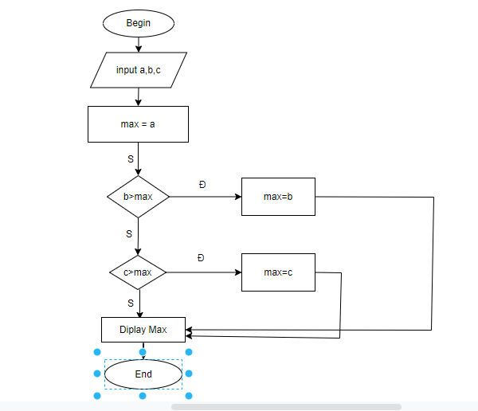

%3CmxGraphModel%3E%3Croot%3E%3CmxCell%20id%3D%220%22%2F%3E%3CmxCell%20id%3D%221%22%20parent%3D%220%22%2F%3E%3CmxCell%20id%3D%222%22%20value%3D%22max%3Db%22%20style%3D%22rounded%3D0%3BwhiteSpace%3Dwrap%3Bhtml%3D1%3B%22%20vertex%3D%221%22%20parent%3D%221%22%3E%3CmxGeometry%20x%3D%22684%22%20y%3D%22273%22%20width%3D%2292%22%20height %3CmxGraphModel%3E%3Croot%3E%3CmxCell%20id%3D%220%22%2F%3E%3CmxCell%20id%3D%221%22%20parent%3D%220%22%2F%3E%3CmxCell%20id%3D%222%22%20value%3D%22max%3Db%22%20style%3D%22rounded%3D0%3BwhiteSpace%3Dwrap%3Bhtml%3D1%3B%22%20vertex%3D%221%22%20parent%3D%221%22%3E%3CmxGeometry%20x%3D%22684%22%20y%3D%22273%22%20width%3D%2292%22%20height%3D%2247%22%20as%3D%22geometry%22%2F%3E%3C%2FmxCell%3E%3C%2Froot%3E%3C%2FmxGraphModel%3E%3D%2247%22%20as%3D%22geometry%22%2F%3E%3C%2FmxCell%3E%3C%2Froot%3E%3C%2FmxGraphModel%3E