Nguyễn Thị Quỳnh Như
KTPM3
Q1: Create the tables (with the most appropriate/economic field/column constraints & types) and add at least 10 records into each created table.
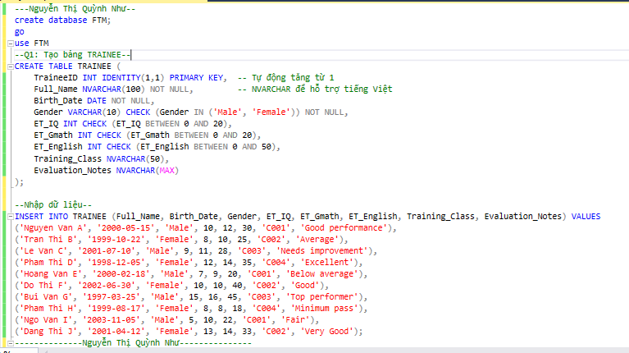 Q2: Change the table TRAINEE to add one more field named Fsoft_Account which is a not-null & unique field.
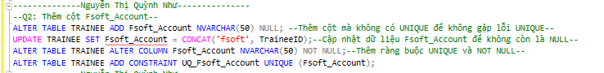
Q3: Create a VIEW which includes all the ET-passed trainees. One trainee is considered as ET-passed when he/she has the entry test points satisfied below criteria:
- ET_IQ + ET_Gmath >=20
- ET_IQ>=8
- ET_Gmath>=8
- ET_English>=18
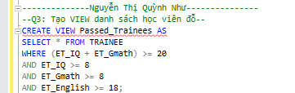
Q4: Query all the trainees who is passed the entry test, group them into different birth months.
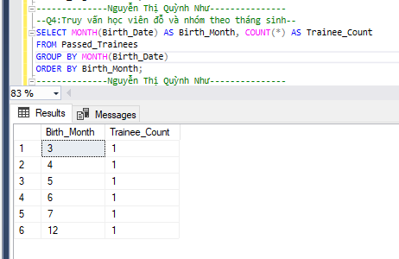
Q5: Query the trainee who has the longest name, showing his/her age along with his/her basic information (as defined in the table)
