Question 1
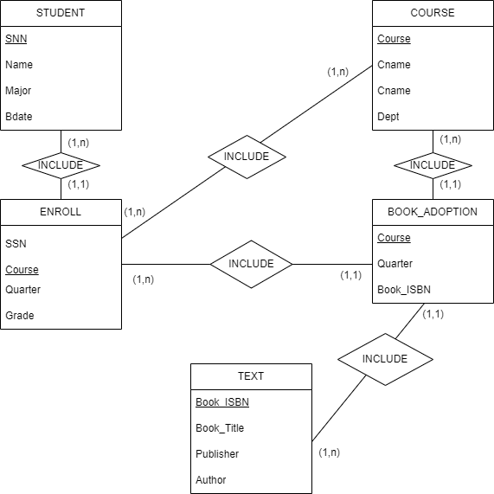

Question 2
1.
1NF
Invoice# | Cust# | Name | Addr | Quantity | Part | Amount
1001 | 43 | Jones | 121 1st | 200 | Screw | 2.00
1001 | 43 | Jones | 121 1st | 300 | Nut | 2.25
1001 | 43 | Jones | 121 1st | 100 | Washr | 0.75
1002 | 55 | Smith | 222 2nd | 1 | Motor | 52.00
1002 | 55 | Smith | 222 2nd | 5 | Brace | 44.44
1003 | 43 | Jones | 121 1st | 10 | Saw | 121.00
2NF
Table Customer
Cust# | Name | Addr
43 | Jones | 121 1st
55 | Smith | 222 2nd
Table Invoice
Invoice# | Cust#
1001 | 43
1002 | 55
1003 | 43
Table Invoice_Details
Invoice# | Part | Quantity | Amount
1001 | Screw | 200 | 2.00
1001 | Nut | 300 | 2.25
1001 | Washr | 100 | 0.75
1002 | Motor | 1 | 52.00
1002 | Brace | 5 | 44.44
1003 | Saw | 10 | 121.00

3NF
Table Customer
Cust# | Name | Addr
43 | Jones | 121 1st
55 | Smith | 222 2nd

Table Invoice
Invoice# | Cust#
1001 | 43
1002 | 55
1003 | 43

Table Invoice_Details
Invoice# | Part | Quantity | Amount
1001 | Screw | 200 | 2.00
1001 | Nut | 300 | 2.25
1001 | Washr | 100 | 0.75
1002 | Motor | 1 | 52.00
1002 | Brace | 5 | 44.44
1003 | Saw | 10 | 121.00

Table Product
Part# | Price
Screw | 2.00
Nut | 2.25
Washr | 0.75
Motor | 52.00
Brace | 44.44
Saw | 121.00

2. 