Antall Nguyen

Assignment 1 Part 2

I am uploading just my header and source files due to size of the zip file

Screenshots:  
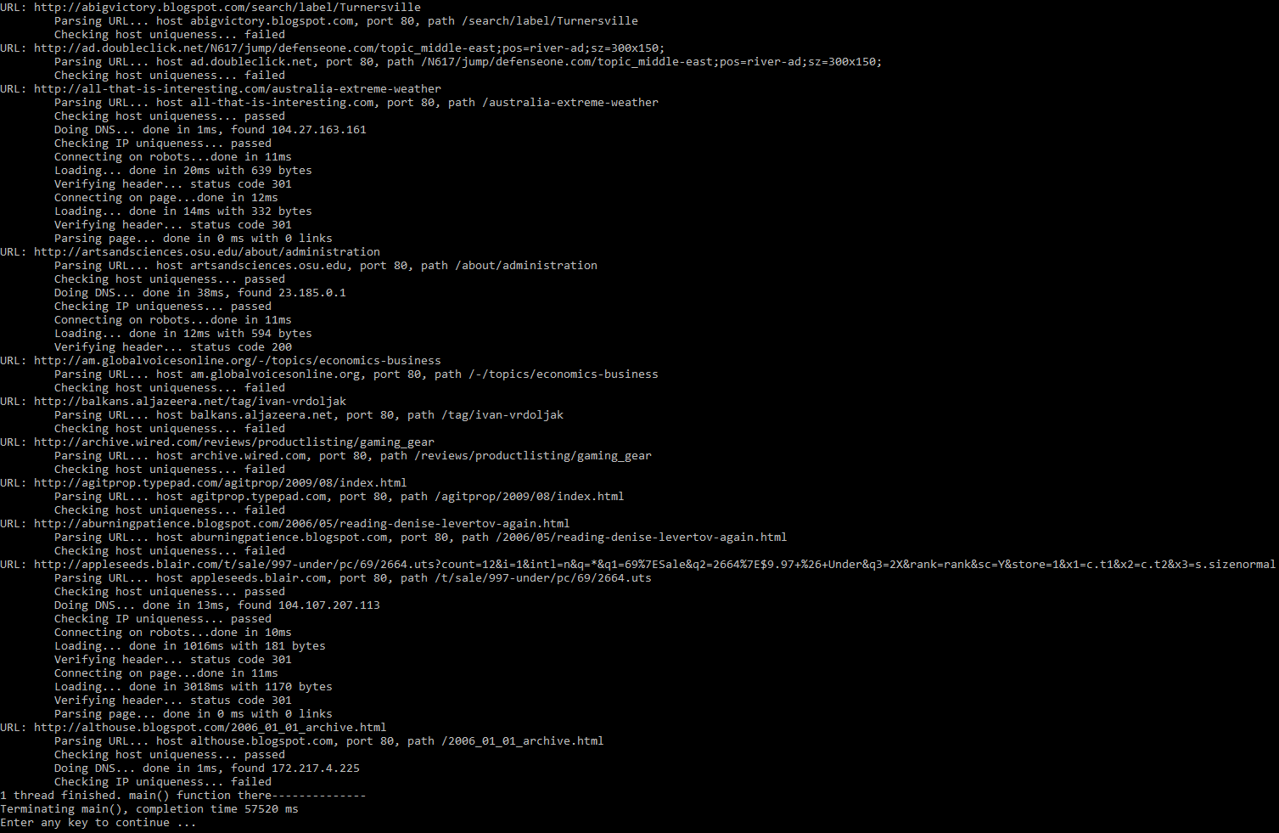  
The single thread signaled exit and finished after the queue is empty

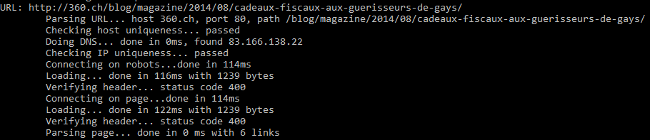  
Website download and webpage parsed for links, seen with 6 links counted.