Antall Nguyen

Assignment 1 Part 1 Report

URL: [http://www.yahoo.com/](http://yahoo.com/). It can be seen that the status code is 301, therefore my program does creates another socket and does a HEAD request, instead of a GET request. I chose to print the reply as shown below.

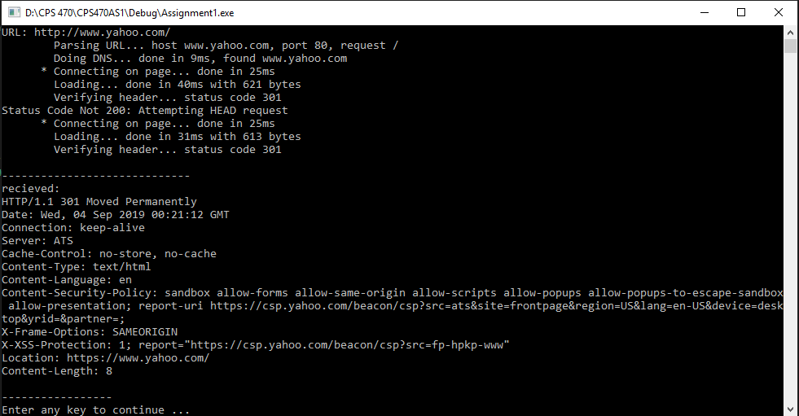

URL: <http://www.google.com/> The status code that Google returns is 200, therefore a HEAD request is not made on a new socket. I chose to print the reply as seen below.

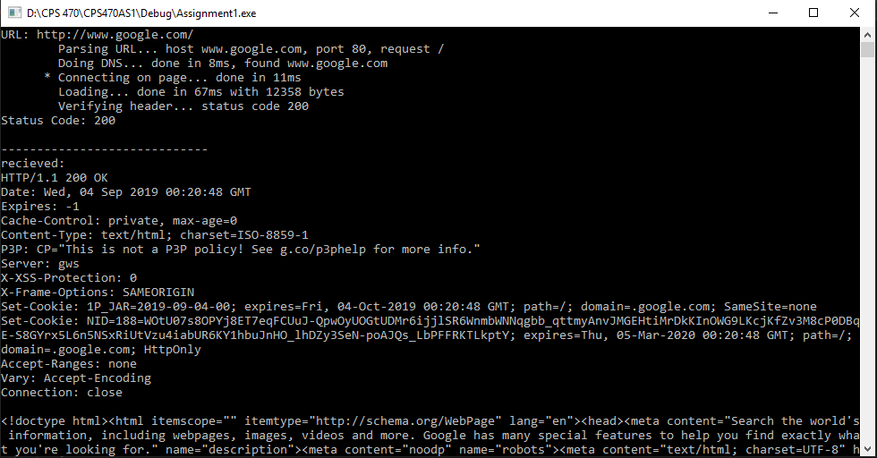

URL: <http://128.194.135.11?viewcart.php/>. This is the fail case that is shown in the assignment 1 part 1 grading rubric. It can be seen below that the connection failed with 10090 error code.

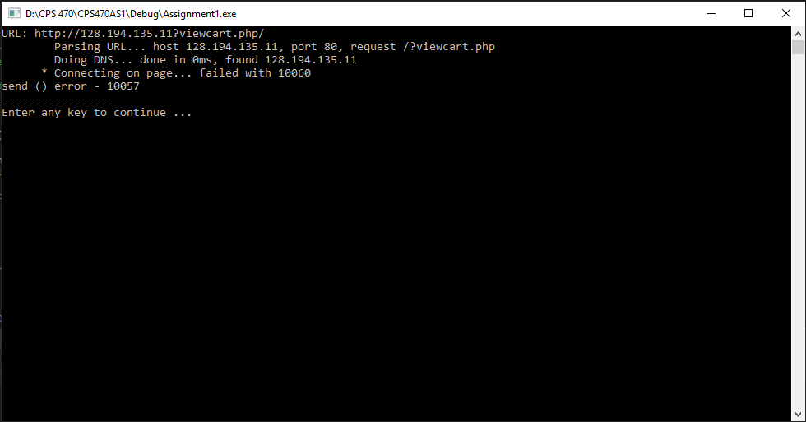

Overall, I learned in this part how to format the HEAD and GET requests, and how to properly request a connection and receive a reply. I also learned how to use winsock and implement these receive and request functions. I also got to practice string manipulation by parsing the URL.