***PRINCIPLE OF DATABASE MANAGEMENT***

***Final progress report***

***Topic:***P – Online Retail Application

***Group members :*** ***IDs:***

Nguyễn Anh Dũng ITITIU17073

Nguyễn Hà Văn ITITUN17030

Lê Nguyễn Khôi Nguyên ITITUN17031

***Class :***Wednesday Morning



**Contribution:**

Nguyễn Anh Dũng: 40%

Nguyễn Hà Văn: 30%

Lê Nguyễn Khôi Nguyên: 30%

**Contents:**

1.Introduction

2. Member's jobs

3.Designing an ERD

3a. ERD

3b. Reasons behind the ERD

4. ERD to relational database schema

4a. Schema

4b. Explanation

5. Creating the database

5a. Creating the database

5b. Creating the tables

5c. An extra view

6. Querying the database using Java

6a. Java code

6b. How to run the program

7. Conclusion

**1. Introduction:**

Our project – project P is about creating and managing a database for an online retailer store .The project main goal is to allow the owners to manage the store's items, the supplies, customers information and also allow customers to register an account for purchasing items and pay the bills with their bank account by using the application.

**2. Member's jobs:**

- From 13/2/2019 to 20/3/2019: We chose our topic which is P - online retail application. Dũng will be in charge of the resoning, Văn and Nguyên will write the introduction to the project.

- From 20/3/2019 to 26/3/2019: Each memeber is require to draw their own version of the ERD, and then share it with each other so we can find the finalized version of it.

- From 26/3/2019 to 1/4/2019: At this point we haven't came up with a perfect solution for our ERD so the work continue on and we are delayed for the relation database schema conversion. That's why our midterm report doesn't consist of the schema. Dũng is the one writing the midterm report.

- From 17/4/2019 to 27/4/2019: After the midterm, we change our ERD a little bit from the one in the midterm report. Văn and Nghĩa will work on the shcema and give it to Dũng to create the database in SQL Server.

- From 27/4/2019 to 12/5/2019: After the database is created, Dũng will create and test the Java program to run queries on the database. Văn will work on the report's main body while Nghĩa will do the introduction and title page.

- After 12/5/2019: All of us will have to prepare a presentation to show the class our group project. After that it's done.

**3. Desigining an ERD:**

**a. ERD:**

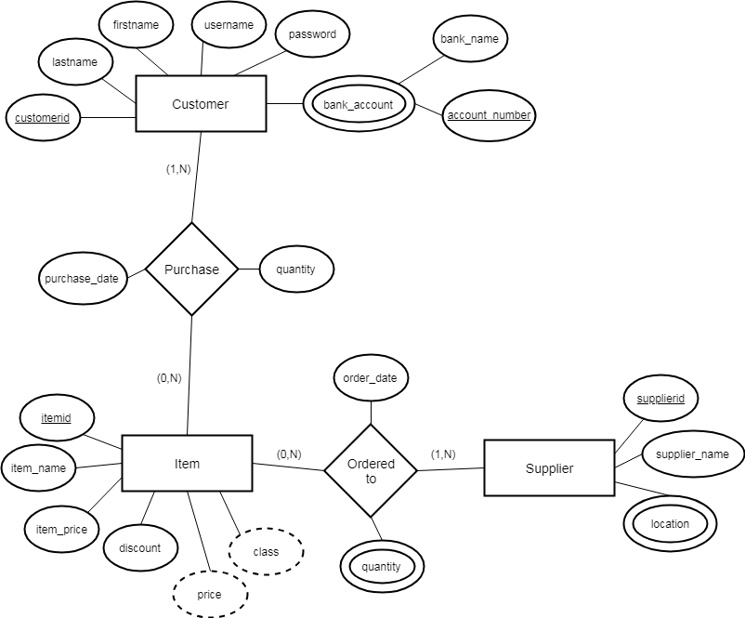

**b. Resons behind the ERD:**

We will need 3 main entities for our database:

- A customer entity with id, login , password, name and bank account ( one or multiple).

- A item entity consist of item's id,name,price,discount,actual price which can be computed and a class according to it's price.

- A supplier entity with the supplier's id, name a several location

Along with the 3 entities, some relationships are:

- A customer can purchase many items and an item can be purchased by many people.

- An item can be ordered from one or many supplier and a supplier can supply manny items.

**4. ERD to relational database schema:**

**a.Schema:**

Customer(customerid,firstname,lastname,username,password)

Customer_bank(customerid,account_number,bank_name)

Item(itemid,item_name,item_price,discount,price,class)

Supplier(supplierid,supplier_name)

Supplier_location(supplierid,location)

Purchase(customerid,itemid,quantity,purchase_date)

Ordered_to(itemid,supplierid,quantity,order_date)

**b. Explanation:**

*Entities and attributes:*

- Each customer will have a unique customerid, userid, password, firstname and lastname after registering.

- Each bank account of any customer will have a unique accountnumber and bankname.

- Each item have a unique itemid, price, itemname, discount and a class that is compute base upon their price.

- Each supplier has a unique supplierid, different types of item (itemname), different location and a suppliername.

- Each time a purchase occurs, there will be bill that is generated. Each bill will display the amount of money to pay, the tax, a unique bill id and a date of payment.

*Relationships:*

- A customer can purchase many items, and one item can be purchased by many people. Each purchase will come with a date, price after discounted and in different quantities.

- An item can be ordered by many suppliers, and one supplier can supply many items. Each order will come with a date and the items in different quantities.

- A bill will require a bank account to settle. One bill will be settled by one bank account, and one bank account can settle many bills.

- Each customer has one or more bank accounts, but each bank account is belong to one customer only.

**5.Creating the database:**

**a.Creating the database:**

We use SQL server to create our database name RetailApp.

**b. Creating the tables:**

The codes we use to create our tables is included in the project folder

**c.** **An extra view:**

The project also require a bill to print after every purchase, so we will have a view called Bill which combines the customer's name , item's name , price and the purchase's date.

**6. Querying the database using Java:**

**a. Java code:**

The java code to run the program is included in the project folder.

**b. How to run the program:**

Open up netbeans IDE , remember to install JDBC in your computer. Open the Java program folder , add the JDBC to your library and execute the DisplayQueryResults class. A window should pop up and you can enter in the queries.

**7.Conclusion:**

Managing a retail store or a database in general is a very dificult task and require many steps to do. Many trials and error occurs along the way but as long as we recognize the mistakes and refine them we can make it work.