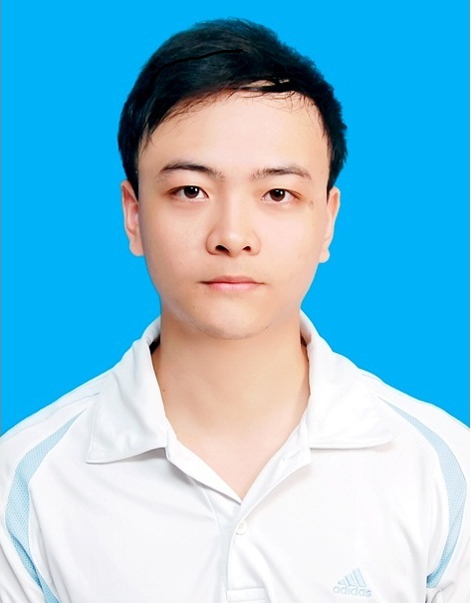Paste your photo here)
Personal Information:
- Name: TUNG THANH VU
- Nationality: Vietnamese
- Date of Birth: July, 10th 1988
- Sex: Male
- Marital status: Single
- Phone number: (+84)977978323
- Email: vuthanhtung0336@gmail.com
- Address: No 4, 256 lane, Xuan Dinh street, Bac Tu Liem district Ha Noi

Working Experience:
- Design the system based on All programmable SOC Zynq 7010 and camera PICO Gen2. Programming image processing, stalking and identify objects.
Responsibilities:
- Analyze the system
- Design schematic and Prototype
Technologies Used:
Hardware environment
- Window
Development tools
- ISE Design Suite 14.6
- Cadence, Altium
Programming Language:
- VHDL
- Researching and developing glove sensor system applied to interacting interpreter between voice and sign language. The project is the data acquisition system using flex sensors and accelerometer integrated on the motherboard attached to the back of the hand of the disabled. Signals from the sensors obtained from the various movements of the fingers and hand will be transmitted to the computer via COM port interface. A huge number of data collected will be trained to convert to text or voice format.

Responsibilities:
- Analyze the requirement
- Design hardware and Prototype
- Coding and unit testing
Hardware environment
- Window
- ATmega328
Software environment
- .NET Framework 5.0
Development tools
- Visual Studio 2013
- SQL Server 2008
- Arduino
- Altium
Programming Language:
- C#
- C/C++
- Join in the project: "Wrist System support to reading Vietnamese paper for the blind.". Building the system of ring format mounted camera and testing programs to help the blind to read normal printed Vietnamese documents instead of braille. Designing the image acquisition module including camera worn on the finger. The module has power block, Raspberry Pi board development, OV5647 camera module and camera control circuitry.
Responsibilities:
- Analyze the system
- Design hardware and prototype
- Write a program to acquire real-time images and stored in memory.
Technologies Used:
Hardware environment
- Raspbian
Development tools
- XDLE
- Altium
Programming Language:
- Python
- Research and development of a device that is capable of mornitoring the patients’ health remotely, activity-based low power source of the smartphone audio interface. System monitors basic parameters of medicine, including 02 main sections:

+ Universal module-UM: Module connected to smartphone via audio interface

+ Sensor interfaces: the sensors measure the biological parameters are connected to the module UM through ADC, I2C, GPIO

The system can be operated entirely by the energy supplied via the smartphone's audio interface and simultaneous bidirectional communication with smartphone via this channel. The equipment is easy to use, and has high commercial value. Developing a software platform together with applications on smartphone that display information and communicate data to center system based availability features of the phone.

Responsibilities:
- Design power harvester circuit from the phone’s headset interface. The alternative voltage is amplified and rectified into direct voltage to supply microcontroller and external sensors
- Design communication module to connect MCU, smartphone, and electro-biology measurement sensor
- Research encode and decode methods to transfer data over audio channel
Technologies Used:
Hardware environment
- MSP430F1611
Development tools
- Eclipse
- IAR embedded workbench
- Altium
Programming Language:
- C/C++
- Design system to determines coordinates of the object based on GPS positioning technology and network GSM/GPS using SIM908 module. The system is mounted on the object to track and monitor. User call or send message to the system. It will read the message content to determine control commands. The system will acquire GPS signal and send its coordinates to user. User can display the coordinates of the object on the digital map to see the location of the object.

Responsibilities:
- Design hardware of system and prototype
- Coding and testing
Technologies Used:
Hardware environment
- Atmega328
- Window
Development tools
- WinAVR
- Altium
Programming Language:
- C/C++
- Joining the projects to design PCB based on the customer’s requirement. Making suitable BOMs and checking the quality of products.
Education:
- 2014 - 2016: M.S of Electrical and Electronic Engineering – Military Technical Academy – Viet Nam
    - Master thesis: Research, design, and produce peripheral sensors communicating with smart phone
    - Total score of thesis: 8.2
    - Academic GPA: 7.63
- 2006 - 2011: B.S of Electrical and Electronic Engineering – Military Technical Academy – Viet Nam
    - Graduation thesis: Research and design antenna using for the base transceiver station
    - Total score of graduation thesis: 9.6
    - Academic GPA: 7.57
Skills:

SOFTWARE
- Databases: MS SQL Server
- Programming Languages: C#, C, C++ , Python, VHDL
- Programming Tools: Visual Studio 2013, Win AVR, IAR Embedded Workbench, ISE Design Suite, Matlab.
- Framework: .NET
- Design tools: Altium, Allegro, Proteus, Inventor, Autocad, CST

HARDWARE

Microcontroller family: AVR, 8051, MSP430, SMT32.
Soc: Zynq, Spartan 3E

OPERATING SYSTEMS

Windows, Linux (Ubuntu, Debian)

Languages:
- English reading and writing proficiency. Good English communication.
- TOEIC: 660
Additional Info:
- 02 year experience in embedded system design
- Having the ability to analyze the electronic circuit analog circuits digital circuits
- Having the good knowledge about telecommunication including GSM/UMTS/LTE, satellite communication system, antenna, microwave
- Ability to quickly learn new software system, and technologies
- Having ability to work under high pressure
- Good team working skill

