CURRICULUM VITAE

PERSONAL DATA:
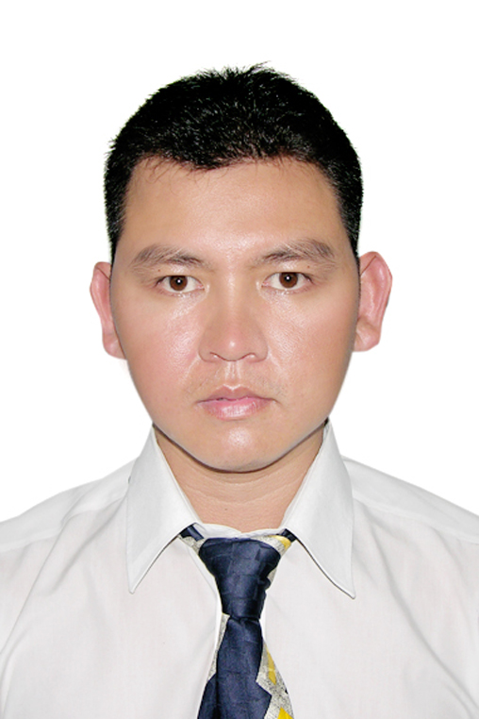
Full name : NGUYEN QUANG HIEN Sex: Male
Date of birth : May 22nd, 1980
Place of birth : Bien Hoa, Dong Nai
Current house : 214 Nguyen Trai Str., Dist 01, HCM City
Marital Status : Married
Cell-phone : 0938.073749
Email : Ronald_quanghien@yahoo.com

FAMILY BACKGROUND:
Father’s name : NGUYEN VAN LINH
Occupation : Small trader
Age : 62 years-old
Mother’s name : PHAM THI TU
Occupation : Small trader
Age : 56 years-old

EDUCATION:
1998 – 2002 : Bachelor degree in Marine Transportation Economic of Vietnam Maritime University – HCMC Branch.
1995 – 1998 : Ngo Quyen High School, Bien Hoa City, Dong Nai
2001 : Finished the in-service training of Maritime University

JOB EXPERIENCE:

1) GIANG HAI HA CO., LTD (TRACONSHIP) :
Add: 65B Calmette, Nguyen Thai Binh ward, Dist. 1, HCMC.
From Nov 2001 to Feb 2003
POSITION: CHIEF FOREMAN
- Responsible for all workers for the procedure of loading and unloading containers at Phuoc Long Buoys
- On behalf of Traconship to co-ordinate with Gemadept/ Gematrans for all vessels operations at Phuoc Long Buoys
- Supervised and managed for over 120 labors per voyage and working time from at least 2 days non-stop.
- Performing cargo plan for Feeders, understand how to control and balance the vessel while loading and sailing.

2) VINALINK – VINATRANS GROUP
Add: 145 – 147 Nguyen Tat Thanh, Dist. 4, HCMC.
From Mar 2003 to Apr 2006

POSITION: SALES EXECUTIVE
- Undertake as Deputy Manager of Import Department for 10 months.
- Contact, negotiate directly with agents to deal for reasonable and competitive rates. Build up tariff import rate for Import Department.
- Have good relationship with VIP accounts.
- Enthusiasm and skilled in getting direct shippers in LCL, FCL shipments.
- Well co-ordinate Customer Service Team to operate all direct consol boxes.
- Well-communicate with partners and colleagues.
- Fully understand the company internal process as well as maintain good relationship with other departments/ personnel’s to handle job/ shipments smoothly.

3) TVL GLOBAL LOGISTICS (T.V.L GROUP)
Add: 169 Dien Bien Phu, Dist. 1, HCMC
From May 2006 to May 2009
POSITION: SALES SUPERVISOR
- Take part in all the process of handling all nomination shipments (sea, air and logistics).
- Control all customs clearance staffs; keep close contacted with customers in delivery time.
- Supervisor of Sales Department and Customers Service.

4) SATRANSCO FREIGHT FORWARDER CO., LTD
Add: 119 Chu Van An Str. – Binh Thanh District – HCMC
From Jun 2009 to Oct 2015
POSITION: OVERSEAS MANAGER
- Manage all Network Agent Systems, person in charge for all overseas activities.
- Can work on behalf of Shipper and Consignee for whole international business.
- Manage and control Export-Import document department
- Also work as Sale Manager; support Sales Team in Skill, Target and experience.

OTHER INFORMATION:

  - Skilled in Microsoft Office (Word, Excel, PowerPoint, Outlook).
  - Good operational background in forwarding, logistics, 3PL and trading is essential.
  - Standard level in international business, import-export and network agent.
  - Skilled in communicating, negotiating and dealing with customers.
  - Work under pressure, overtime, high motivate and good team spirit.
  - Willing to learn, open-minded, being self-confident.

NGUYEN QUANG HIEN

