CURRICULUM VITAE

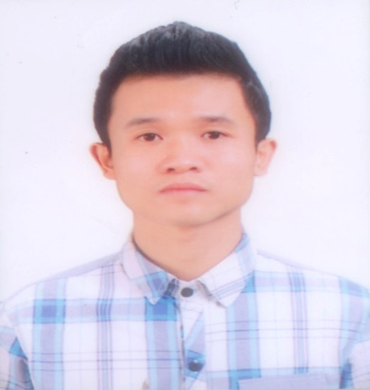

An enthusiastic and passionate person with experience in the field of IT (hardware and software computer – global helpdesk- network – installation – maintenance-management website – experience with hardware and software mobile – Android-IOS ) When was a student , I was learned to become a coder but only worked 1 year.I’m looking for a suitable position with a exciting company where develop my skills and work in an environment with chances to learn more about computer,moblie and network.I want to improve myself.

Personal Details :

Name: TRINH AI QUOC
Date of birth: SEP 9th 1988
Nationality: VIET NAM
Home address: 459 Bach Mai street - HaNoi city. Contact telephone: +84 91 314 8822
Marital status: Single
Email: taq991988@gmail.com

EDUCATION:

HA NOI University of Technology
Falcuty of Information Internet ( 2007-2011)

Employment Experience

2006-2008 : Setup and manages at HanoiComputer.
2007-2009 : Trade computer components , accessories.
Consult and maintain Sonlinhthu.Co.Ltd
Install , mantain , repair hardware and software of PC,Laptop,Printer(setup and replace printer’s ink),Mobile.
2009 -2010 : Code E-commerce web (PHP & MySQL) The administrator of Class’s forum uses Joomla’s Framework,XenForo )
2010-2012 : IT for Hoa Binh Palace Hotel (27 Hang Be), Vietours (532 Tran Khat Chan) The administrator of http://vietours.vn/ http://tochuctiec.com.vn
2012 : Management and investment in E-commerce business.
2014 – 2016 : Shopping Systems Management for LotteData Communication Company ( check systems daily,monitor datacenter,manage website,network, global helpdesk for Lotte’s Department Store )

SKILL :

While I was studying , i worked in the internet café (intallation, maintenance….) and then managing the website of tourist company, setup and maintain the system network in hotel.
- Good command of computer applications
- System management , Server, network ...
- Have some experience in design and maintenance of new and existing websites.
- Troubleshooting PC,Printer, laptop, application , mobile devices, networking, Ethernet, wireless router and users issues.
- Very efficient use of Internet for information searching
- Ability to work well in a team environment.
- A quick learner on the job and highly responsible for all assignments.
- Good problem solving skills along with the ability to maintain calm under pressure
- Very good interpersonal skills.
- My greatest strengths in all the work are sense of responsibility and carefulness; always learn positively.

Signature:

Trịnh Ái Quốc.

