**PERSONAL DETAILS**

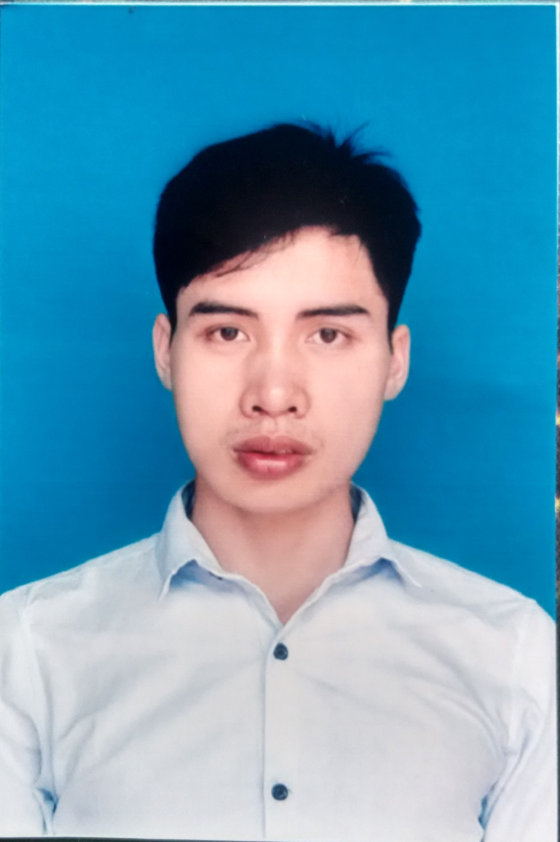

* Name : **Nguyen Van Cong**
* Nationality : Vietnamese
* Date of Birth : 26/08/1992
* Sex : Male
* Marital status : Single
* Phone No. : 01677606578
* Email : congnv.hust@gmail.com

**EDUCATIONAL BACKGROUND**

* Student – Hanoi University of science and techlonogy (HUST).
* CPA: 2.53

**CERTIFICATE AND AWARD**

* Training courses of Samsung Talent Program.

**PROFESSIONAL SUMMARY**

* Can work independently, have faculty for work in teams and work under pressure well.
* Good communication.
* Analysis, Design Software Project.
* Soft skills certificate of Hanoi University of science and techlonogy: communication skills, problem-solving skills, time management abilities, teamwork skills.
* Hard working, eager to learn.
* Hobbies: Reading book, traveling, watching movies, listening to music.

**SOFTWARE**

* **Databases**: MS SQL Server, SQLite ,Oracle
* **Programming Languages:** Java, C/C++
* **Programming Tools:** Eclipse, Netbean, Microsoft Visual Studio, UML, SQLite Studio.
* **Browsers**: IE 8+, Firefox 10+, Chrome 10+.
* **OOAD/OOP**: Object Oriented Programming (OOP), Unified Modeling Language (UML).

**OPERATING SYSTEMS**

* Windows
* Linux(Ubuntu, fedora) .

**PROFESSIONAL EXPERIENCE**

**2014/08 – 2014/11**

**Project:** Health controller application by java and android.

**Address:** Developer at Intel lab (HUST).

**Teamsize:** 3 people.

**Project Description**:

This project can help and support users having better health. It includes heart beat, blood pressure, Glucozo concentration. It must be easy for using, doesn’t take more time to discover. The app shows chart to evaluate health state.

**Responsibilities**:

* Project Analysis.
* Testing
* Coding.

**Technologies Used**:

* Eclipse
* AchartEngine lib.
* DB: Sqlite.

**2015/01 - 2015/03**

**Project:** Weather forecast on smart phone android.

**Address:** Training courses of Samsung Talent Program.

**Teamsize:** 2 people.

**Project Description**:

This project can help and support users having weather information for their’s plans. It bases on OpenWeatherMap site. It must be easy for using, doesn’t take more time to discover.

**Responsibilities**:

* Analyze the requirement.
* Solving algorithms.
* Design Interface.
* Coding.

**Technologies Used**:

* Eclipse 4.2
* JavaScript & Ajax: JSon

**2015/01 - 2015/05**

**Project:** “Back to school” by Java.

**Address:** Training courses of Samsung Talent Program.

**Teamsize:** 2 people.

**Project Description**:

This project is a game like quiz-show, bases on “Who is a millionaire”. It must be easy for using, doesn’t take more time to discover.

**Responsibilities**:

* Analyze the requirement.
* Solving algorithms.
* Design Interface.
* Coding.

**Technologies Used**:

* Eclipse 4.2

**2015/10 - 2015/12**

**Project:** Maps and location Application.

**Address:** Developer at R&D lab (HUST).

**Teamsize:** 1 person.

**Project Description**:

This project is a part of Map System. The application collects locations (latitude, longitude) in the area. Saving data into database and send to System by email with xml file. System will show offline map and use OpenStreetMap datas.

**Responsibilities**:

* Analyze the requirement.
* Solving algorithms.
* Design Interface.
* Coding.

**Technologies Used**:

* Eclipse 4.2
* DB:MySQL
* OpenStreetMap.