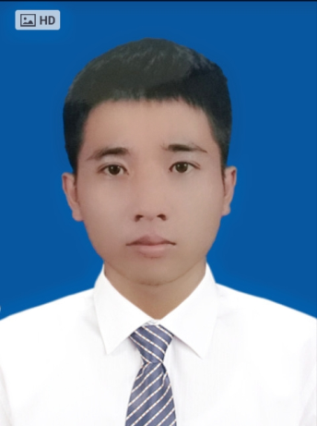**PROFILE**

**OF NGUYEN VAN TUAN**

PERSIONAL INFORMATION

* **Full name: NGUYEN VAN TUAN**
* **Date of birth:** 20/10/1994
* **Adress:** I live in dormitory room 411 of Technology Information Colleges, Luu Quang Vu street belongs country Ngu Hanh Son in Da Nang city.
* **Phone number:** (+84) 1692273907 or (+84) 1266200712
* **Email:** vantuan2010.cit@gmail.com

CAREER GOALS

* Be working in company profession work environment dynamic.
* Learn experience and import skills in myself.
* Design and programmers created an interesting program.

PRACTICAL EXPERIENCE

* PROGRAMMING LANGUAGES & TOOLS

|  |  |
| --- | --- |
| C/ C++ | 3 months at school |
| Microsoft Visual Basic  Java Basic | 3 months at school  3 months at school |
| Java Basic, JSP, servlet, JSF, EJB | 6 months at Iviettech center |
| HTM, CSS, Java script, PHP | 3 months at school |

* DATABASES

|  |  |
| --- | --- |
| MySQL | 3 months at school |
| MS SQL Server | 3 months at school |

STUDY PROCESS

* 2012-11/2015: TECHNOLOGY INFORMATION COLLEGES

Specialized: Technology Information.

Point average: 7.47

* 11/2013 – 05/2014: I do scientific research school-level: Create application read comic in mobile phone with operating system Android.
* 08/2014 – 01/2015: I do blueprints specialized: Create maps management shool in Dong Ha city.
* 11/2014 - 05/2015: I do scientific reseach school-level: Create application WebGIS help study and teach geography of class 12.
* 02/2015 – 06/2015: I do blueprints graduate: Building( Create ) WebGIS manage shool in Dong Ha city.
* 07/2016 – 09/2016: I do project design website books shop. (JAVA)

WORK EXPRERIENCE

* **11/2013 – 12/2013: Company joint stock FPT.**

**Technical department .**

- Installation system internet in home customers.

- Maintenance network equipment(modem, capble, network signal.v.v.).

- Help customers about preservation device.

SOCIAL ACTIVITIES

* **2013, 2014: Hội “Hành Trình Xanh”**

Paraticipants activities the environmental protection, activities volunteer in school and some one street in Da Nang city.

SKILLS

* Computer skills:
* Proficient used of office computer programs (Winword, Excel, Power point) and potentially good typing about 40 the word/ 1 minute.
* Photoshop.
* Solf skills:
* Group work skill.
* Manage time skill.

HOBBIES

* I like reading books, playing games, listening to music, football.