**CURRICULUM VITAE OF GIANG TRƯỜNG CHINH**

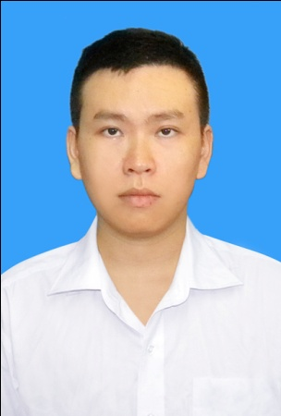**Personal Details**

Full name: Giang Trường Chinh

Date of birth: 06 June 1988

Address: 120/4 Lương Ngọc Quyến, Ward 5, Gò Vấp District

Email: [gtruongchinh@gmail.com](mailto:gtruongchinh@gmail.com)

Mobile: 01212001108

**Education**

2008 – 2012: Van Hien University

-Major: Business Administration

-Mode of study : Full – time

-Degree classification: Average Good

2003 – 2006: Gia Dinh High School, HCM City

**Skills**

+Language: English

+Computer skills:

-Ms Word

-Ms Excel

-Ms Powerpoint

+Internet Application

**Personality**

-Motivated, enthusiastic, reliable

-Friendly, fast learner, hard worker

-Can work well under pressure

-Work in group or individually

-High responsibility

**Interests**

-Travelling

-Swimming

- Playing game

**Working Experiences**

-From 8/2012 to 5/2015: Collaborator input data – Truong Doan marketing group company.

-From 5/2015 to present: QA for CRM (Customer Relationship Managerment) team in SA2 of Gameloft company.

**Job description:**

* Follow the internal email of company to receive daily job..
* Read the documents relate to the game to understand the contents of game and what I need to do.
* Base on Android CRM checklist and tools (Crom, Fed Debug, Agency ADs, etc.) to start the job.
* Create the segments and campaigns via CROM Tool and make sure they are retrieved in application under test (AUT) such as: promo IAP and Offline items, send Gift and Pop-up, modify Game parameter,etc.
* Base on checklist to check all test cases and find the bugs in AUT.
* Add bugs into QADB (QA Data Base) and contact with developer to solve them.
* Report the results at the end of the day.