**Tran Cong Tu**

**Que Thuan Village, Que Son District, Quang Nam Province**

**PERSONAL INFORMATION**

Full name: **Tran Cong Tu**

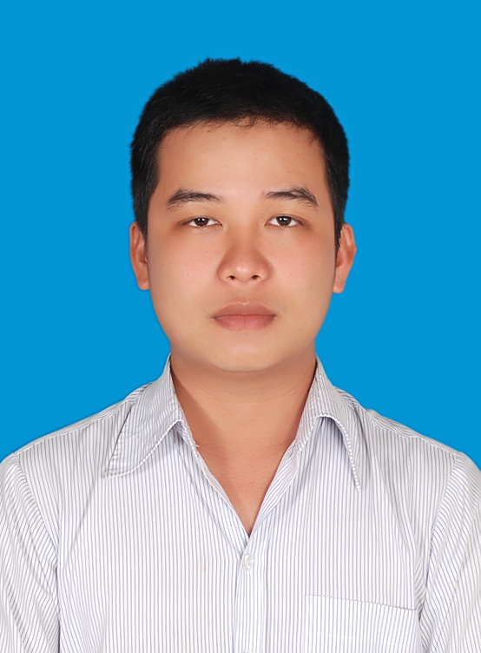

Date of birth: March 9th, 1989

Gender: Male

Place of birth: Quang Nam

Marital Status: Single

Phone No: +84 935170086

Email: congtu89qs@gmail.com

**EDUCATION**

University

* Passed Certificate in Electronic & Telecommunication Engineering–

Danang University of Technology(2007-2012)

High school

* Passed High School Certificate- Que Son High School (2004-2007)

Secondary school

* Passed Secondary School Certificate– Que Thuan Secondary School (2000-2004)

Academic Achievements

* 2 Prizes for Best English Student (2000, 2001)
* 3 Prizes for Best Mathematics Student (2002, 2003)
* First Prize for Solving Mathematics on a Casio Calculator (2003)
* Achieved several academic commendations in High School for Mathematics and Physics

**WORK EXPERIENCE**

* Practised at Information Technology Danang Company – Telecommunication Danang for 2 months (47 Tran Phu Street, Hai Chau District, Danang City)
* Tutored for tutoring company Nghien But. Developed good pedagogical skills
* **2 years Experienced in testing (Gameloft):**

**+ Write Gaming Scenario Checklist**

**+ Run Testcases**

* **Working in HQ Soft company (1/2015 – 12/2015):**

**+ About company: Han Quang Soft solution company provided advanced software solutions to multiple industries and countries**

**+ My position: Support Specialist**

**+ My skill for work: SQL Server, Crystal report, Professional knowledge**

**+ My projects: Johnson baby, Perfecti, Kao**

* **Working in VnResource : 3/2016-now**

**+ About company: Built and developed HRM Pro software with aspiration not only to satisfy such common functions of the human resources management**

**+ My position: Project Engineer**

**+ Skill for work: Project planning, HRM knowledge, Communication, Persuasion**

**+ My projects: THACO**

**SKILLS**

* **Communication, Persuasion and Presentation skills**

I am a confident speaker. I am able to create and maintain audience attention. This skill was developed while I studied at University.

* + - * Prepared and presented many reports in a variety of subjects in front of the class.
      * Participated in many extracurricular activities and social activities. Gained experience through organizing large events in the university and persuading over 20 people to attend charitable programs in Quang Nam province.
* **Analysis Skills**

As a major in a Technology, I developed a range of abilities in analysis and problem-solving competencies.

* **Computer skills**
  + - * Database knowledge: SQL server
      * Proficient use of technical computer applications
* **Foreign Language Skills**
* I have studied English since I was in Grade 6 with both an English teacher and textbooks. I can confidently use English as my communication language.
  + - * Able to communicate in Chinese

**STRENGTHS**

* Positive attitude
* Quick learner
* Smart, loyal worker

**HOBBIES**

* Listening to music
* Traveling
* Cooking
* Singing
* Reading books