

**Koi Ordering System in Japan**

**Software Requirement Document**

– HoChiMinh, November 2024 –

**Table of Contents**

Record of Changes 4

Definition and Acronyms 5

I. Introduction 6

1. Product Background 6

2. Existing Systems 6

2.1 LiveAquaria 6

2.2 Koi Matsuda 6

3. Business Opportunity 6

4. Software Product Vision 6

5. Major Features 6

6. Limitations and Exclusions 8

II. Overall Description 9

1. Product Overview 9

2. Business Process 10

III. User Requirements 13

1. Actors 13

2. Use Cases 14

2.1 Diagram 14

2.2 Descriptions 15

3. Business Rules 74

IV. Functional Requirements 76

1. System Functional Overview 76

1.1 Screen Flow 76

1.2 Screen Descriptions 78

1.3 Screen Authorization 79

1.4 Non-Screen Functions 80

2. Data Requirements 80

2.1 Logical Data Model 80

2.2 Data Dictionary 80

1.3 Reports 84

1.4 State transition diagram 84

3. <<Dashboard>> 88

3.1 <<Dashboard Screen>> 88

4. <<Search And Booking>> 88

4.1 <<Search Tour>> 88

4.2 <<Booking Tour>> 90

5. <<Manager>> 90

5.1<<Manager profile>> 90

5.2<<Customer list>> 91

5.3<<History Order>> 92

5.4 <<Edit password>> 93

6. <<Sales Staff>> 94

6.1<<Sales Staff profile>> 94

6.2<<History Order>> 94

6.3<<Edit password>> 95

7. <<Customer>> 95

7.1<<Customer profile>> 95

7.2<<History Order>> 96

7.3<<Edit password>> 97

8. <<Consulting Staff>> 98

8.1<<Consulting Staff profile>> 98

8.2<<Edit password>> 98

V. Non-Functional Requirements 99

1. External Interface Requirements 99

1.1 User Interfaces 99

1.2 Software Interfaces 99

1.3 Hardware Interfaces 100

1.4 Communications Interfaces 101

2. Quality Attributes 102

2.1 Usability 102

2.2 Performance 102

2.3 Security 103

2.4 Safety 103

1.5 Availability 104

1.6 Reliability 104

1.7 Design Contrainsts 104

2.8 Efficiency 105

# Record of Changes

|  |  |  |  |
| --- | --- | --- | --- |
| Date | A* M, D | In charge | Change Description |
|  |  |  |  |
|  |  |  |  |
|  |  |  |  |
|  |  |  |  |
|  |  |  |  |
|  |  |  |  |
|  |  |  |  |
|  |  |  |  |
|  |  |  |  |
|  |  |  |  |
|  |  |  |  |
|  |  |  |  |
|  |  |  |  |

*A - Added M - Modified D - Deleted

# Definition and Acronyms

|  |  |
| --- | --- |
| **Acronym** | **Definition** |
| PWM | Psychology website |
| AWS | Amazon Web Services |
| BA | Business Analysis |
| BR | Business Rule |
| ERD | Entity Relationship Diagram |
| GUI | Graphical User Interface |
| PM | Project Manager |
| SDD | Software Design Description |
| SPMP | Software Project Management Plan |
| SRS | Software Requirement Specification |
| UAT | User Acceptance Test |
| UC | Use Case |
| API | Application Program Interface |

# I. Introduction

## 1. Product Background

The hobby of ornamental fish has appeared for a long time. One of the fish species that players everywhere love is KOI fish, also known as Nishikigoi, a species of fish that is carefully bred in Japan. But to access beautiful and quality KOI fish, buyers must find a place that sells good and reputable fish. And this is one of the problems that KOI players often encounter, because most of the good KOI breeds are concentrated in Japan and players in many other places outside of Japan will have difficulty accessing this.

## 2. Existing Systems

### 2.1 LiveAquaria

-Description: LiveAquaria is an online platform for purchasing aquarium fish and related products , offering species profile , safe delivery and health guarantees.

-Link: <https://www.liveaquaria.com/>

-Learning for KOI system : The browsing, purchasing, and health certification features inspire similar functionalities in the Koi Ordering System.

### 2.2 Koi Matsuda

-Description: Koi Matsuda is a Japanese website that offers Koi fish for sale directly from the farm, providing detailed fish profiles and information about breeders.

-Link: <https://www.koikoimatsuda.jp/en/index.php>

-Learning for KOI system : Koi Matsuda’s direct farm access and breeder focus inspire the marketplace and breeder connection features of the Koi Ordering System.

## 3. Business Opportunity

Some KOI fish players want a system to help them order KOI fish in Japan. The system will let buyers know about KOI fish farms in Japan, help them schedule a visit and choose the fish breed that suits their needs. At this time, customers can visit and choose KOI breeds right at the farm or authorize the service provider to order the fish breed they like (going to the farm to choose KOI during the tour will ensure that buyers will choose the beautiful KOI according to their wishes and ensure clear prices).

## 4. Software Product Vision

For Koi enthusiasts and collectors who wish to purchase high-quality Koi fish, either locally or internationally, the Koi Ordering System is an online platform, accessible via web and mobile, that allows users to browse available Koi, book in-person or virtual farm tours, and authorize trusted experts to purchase on their behalf. The system will facilitate seamless transactions, ensuring safe delivery and offering expert guidance throughout the process. Unlike the current system of in-person visits and fragmented purchasing processes, the Koi Ordering System enables customers to explore a wide selection of Koi from the best farms in Japan, providing both convenience and confidence in their purchases, while also helping breeders optimize their operations and expand their reach globally.

## 5. Major Features

**1. Guest :**

**FE-01**: Access details about Koi farms in Japan and different Koi varieties.

**FE-02**: Search available tours by criteria such as farm, Koi variety, price range, and time.

**FE-03**: Explore Koi buying services in Japan, including tour options and customized services.

**FE-04**: Create an account to become a customer.

**2. Customer :**

**FE-05**: Book koi fish purchasing services through pre-existing tours or customized requests.

**FE-06**: Access detailed information about booked tours and services, including itineraries and farm details.

**FE-07**: View order history and the status of koi fish purchases.

**FE-08**: Manage personal information, including address and payment methods.

**FE-09**: Receive notifications about order status, tour updates, and special offers.

**FE-10**: Check current trip status and verify check-in status.

**FE-11**: Cancel trips if needed and manage cancellations and refunds.

**FE-12**: Request support or raise concerns during trips or regarding services.

**3. Sales Staff :**

**FE-13**: Finalize itineraries for koi fish tours and services with customers.

**FE-14**: Prepare and send quotes for approval to the manager.

**FE-15**: Communicate approved quotes to customers and manage their responses.

**FE-16**: Track service progress and update customers.

**FE-17**: Generate and manage sales contracts and reports.

**FE-18**: Review customer transaction history for service improvements.

**FE-19**: Verify and update customer check-in status for ongoing trips.

**FE-20**: Handle trip cancellation requests from customers and process refunds or adjustments.

**FE-21**: Coordinate with consulting staff to ensure a seamless customer experience and manage any special requests.

**4. Consulting Staff :**

**FE-22**: Provide detailed information about booked tours and services to customers.

**FE-23**: Assist customers with airport check-in and departure procedures.

**FE-24**: Record and manage koi fish purchase orders and customer deposits at Japanese farms.

**FE-25**: Update customers on the delivery date of their koi fish post-tour.

**FE-26**: Handle customer complaints and support requests effectively.

**FE-27**: Submit reports on service execution and customer interactions.

**FE-28**: Confirm customer check-in status and provide assistance as needed.

**FE-29**: Support customers throughout their trip, addressing tour or koi fish purchase issues.

**FE-30**: Process additional requests or changes to customer itineraries during their trip.

**5. Delivering Staff :**

**FE-31**: Organize the delivery of purchased Koi fish to customers.

**FE-32**: Collect any remaining payments upon successful delivery of the Koi fish.

**FE-33**: Manage delivery schedules and status updates.

**6. Manager :**

**FE-34**: Approve or reject service quotes submitted by sales staff.

**FE-35**: Set and manage policies related to payments, cancellations, and refunds.

**FE-36**: Review and approve customer support requests.

**FE-37**: Monitor financial reports, sales performance, and key metrics.

**FE-38**: Oversee staff management, including role assignments and performance evaluations.

**FE-39**: Update and enforce service and payment policies.

**FE-40**: Review and approve trip cancellations and refund requests.

**FE-41**: Track and address service-related issues reported by customers or staff.

## 6. Limitations and Exclusions

**A. Geographical limitations:**

**LI-01 :** The software only supports customers booking services at Koi fish farms in Japan and does not apply to areas outside Japan.

**B. Limitations on the number of farms and Koi breeds:**

**LI-02 :** It only provides information and services for Koi fish farms partnered with the company, not all Koi fish farms in Japan.

**LI-03 :** The range is limited to certain Koi breeds, and special or rare breeds may not be supported.

**C. Limitations on the purchasing process and timeline:**

**LI-04 :** The process of booking services and purchasing Koi fish must follow the available itineraries or pre-arranged timelines.

**LI-05 :** The time from service booking to Koi fish delivery to customers may be affected by various factors such as legal procedures, international shipping, or import/export regulations.

**D. Exclusion of import procedures in the customer's country:**

**LI-06 :** The software only supports the process of purchasing and transporting Koi fish from Japan; customers are responsible for handling import procedures, permits, or legal regulations related to their home country.

**E. Exclusion of post-sale services:**

**LI-07 :** Once the Koi fish are delivered to the customer, the software does not provide warranty or post-sale services, including fish health or any issues that arise after the purchase.

**F. Limitations on order cancellation or refunds:**

**LI-08 :** Refund or order cancellation policies may be limited to a certain period, depending on the farm’s terms and the company’s regulations.

**LI-09 :** Once the Koi fish have been shipped or delivered to the customer, refunds or exchanges will not be supported unless there is a special agreement.

**G. Exclusion of certain international payment methods:**

**LI-10** **:** The system may not support all international payment methods, being limited to some popular payment gateways already integrated into the system.

**H. Limitations on additional services:**

**LI-11 :** Additional services (such as guides or Koi fish care during transportation) may not be available for all itineraries or may depend on the farm offering the service.

**I. Limitations on rating and feedback:**

**LI-12 :** Only customers who have completed the service can leave ratings and feedback.

**LI-13 :** The rating system may not apply to customized or personalized Koi fish purchase services.

# II. Overall Description

## 1. Product Overview

The **Koi Fish Management Software** is a comprehensive system designed to streamline the process of managing koi fish tours, sales, and services in Japan. It caters to various actors, including **Guests**, **Customers**, **Sales Staff**, **Consulting Staff**, **Delivering Staff**, and **Managers**. The system helps users search, book, and manage koi fish tours, facilitate koi fish purchases, and handle associated logistics such as pricing, delivery, and customer support. It replaces the traditional manual processes involved in planning koi fish farm tours and purchasing koi fish, offering a unified digital platform.

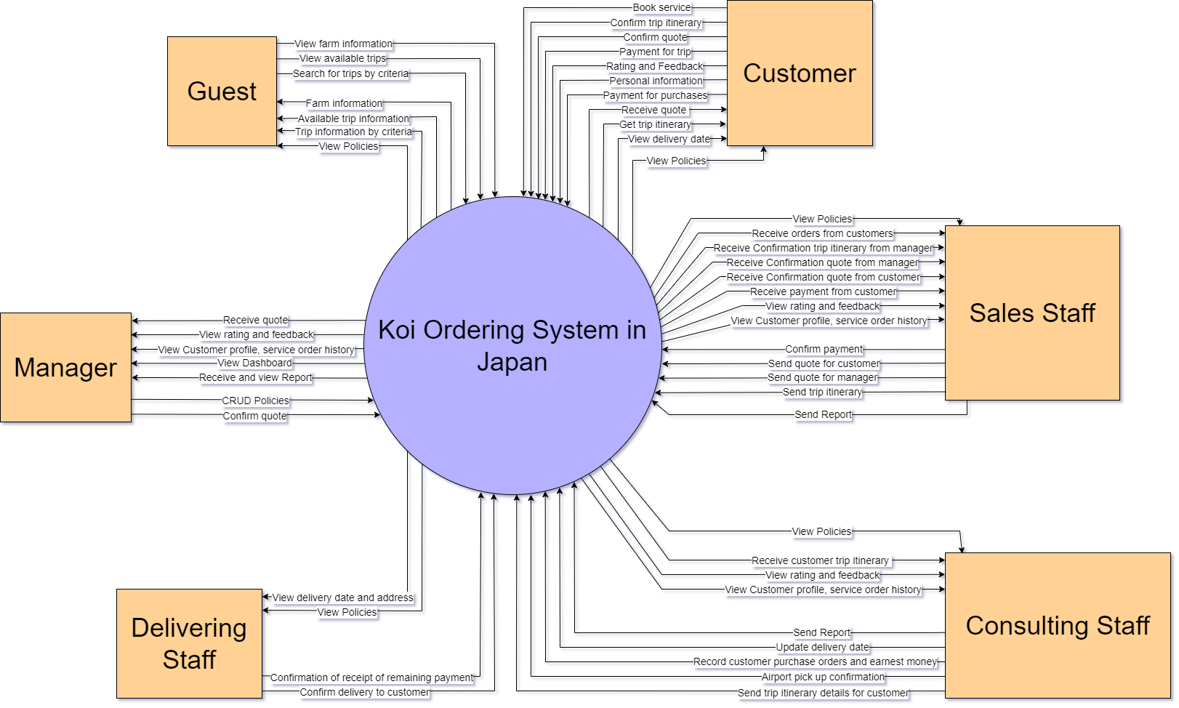

## 2. Business Process

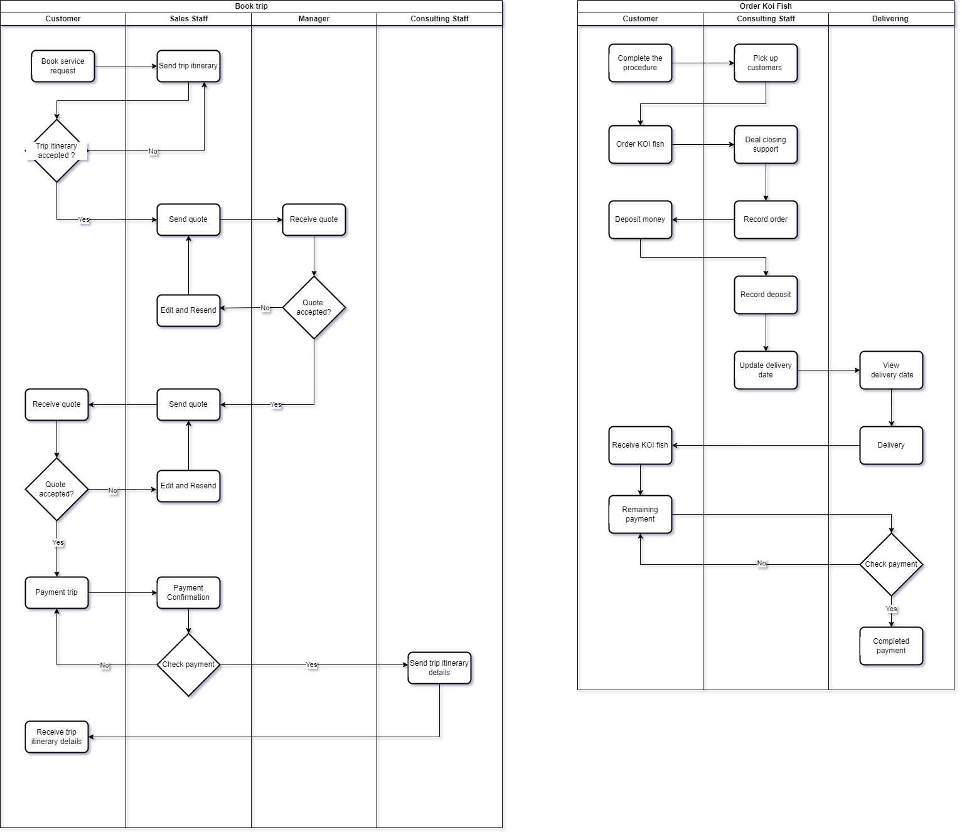

2.1 Book Trip Process

|  |  |  |
| --- | --- | --- |
| **#** | **Process Step** | **Description** |
| 1 | Book service request | Customer initiates the booking process by submitting a service request |
| 2 | Send trip itinerary | Sales staff sends the proposed trip itinerary to the customer for review |
| 3 | Trip itinerary acceptance | Customer reviews the itinerary and decides whether to accept or reject it |
| 4 | Send quote | If itinerary is accepted, sales staff prepares and sends a price quote to the customer |
| 5 | Receive quote | Manager receives the quote for review |
| 6 | Quote acceptance (Manager) | Manager reviews and decides whether to accept or modify the quote |
| 7 | Edit and Resend | If quote is not accepted, sales staff edits and resends the modified quote |
| 8 | Receive quote (Customer) | Customer receives the final quote for review |
| 9 | Quote acceptance (Customer) | Customer decides whether to accept or reject the quote |
| 10 | Payment trip | If quote is accepted, customer proceeds with payment |
| 11 | Payment Confirmation | Sales staff confirms the received payment |
| 12 | Check payment | Verification of payment completion |
| 13 | Send trip itinerary details | Manager sends final trip itinerary details to consulting staff |
| 14 | Receive trip itinerary details | Customer receives the final confirmed trip itinerary details |

2.2 Order Koi Fish Process

|  |  |  |
| --- | --- | --- |
| **#** | **Process Step** | **Description** |
| 1 | Complete the procedure | Customer initiates the Koi fish order process |
| 2 | Pick up customers | Consulting staff handles customer pickup |
| 3 | Order KOI fish | Customer places the specific Koi fish order |
| 4 | Deal closing support | Consulting staff provides support for finalizing the deal |
| 5 | Record order | Staff records the order details |
| 6 | Deposit money | Customer makes the initial deposit payment |
| 7 | Record deposit | Staff records the deposit payment |
| 8 | Update delivery date | Staff updates the system with planned delivery date |
| 9 | View delivery date | Delivering department views the scheduled delivery date |
| 10 | Delivery | Delivery of Koi fish is executed |
| 11 | Receive KOI fish | Customer receives the ordered Koi fish |
| 12 | Check payment | Verification of complete payment |
| 13 | Remaining payment | Processing of any remaining balance |
| 14 | Completed payment | Confirmation of full payment completion |

# III. User Requirements

## 1. Actors

|  |  |  |
| --- | --- | --- |
| **#** | **Actor** | **Description** |
| 1 | Guest | Can explore information about Koi farms in Japan, search for available tours by criteria such as price and time, learn about Koi buying services, and create an account. |
| 2 | Customer | Can book koi fish tours, view order history, manage personal info, check trip statuses, request support, receive notifications, and manage cancellations and refunds. |
| 3 | Saler Staff | Handles tour itineraries, prepares quotes, communicates with customers, manages sales contracts, tracks service progress, and coordinates with consulting staff. |
| 4 | Consulting Staff | Provides assistance to customers during trips, manages Koi purchases, updates delivery dates, handles complaints, and supports customers with trip changes or issues. |
| 5 | Delivering Staff | Manages the delivery of Koi fish, collects final payments upon delivery, and provides delivery updates and schedules. |
| 6 | Manager | Oversees the approval of quotes, manages policies, monitors staff performance, reviews financial reports, and handles customer and staff-related service issues. |

## 2. Use Cases

### 2.1 Diagram

### 2.2 Descriptions

|  |  |  |  |
| --- | --- | --- | --- |
| **ID** | **Use Case** | **Actors** | **Use Case Description** |
| UC-01 | View Available Trips | Guest | Browse available trip options without authentication |
| UC-02 | View Koi Farm Information | Guest | Guests view details about Koi farms and varieties in Japan. |
| UC-03 | Login | Guest | Guests create and login account to become customers for booking services. |
| UC-04 | Booking Available Trips | Customer | Browse and search available booking options |
| UC-05 | Booking Trip by Criteria | Customer | Search and book trips using specific criteria |
| UC-06 | Confirm Trip Itinerary | Customer | View and confirm detailed trip itinerary |
| UC-07 | Confirm Quote | Customer | Confirm pricing quote for selected trips |
| UC-08 | Payment Purchases | Customer | Process and view history of purchases |
| UC-09 | Payment Trip | Customer | Process payment for specific trips |
| UC-10 | Logout | Customer | Securely exit the system |
| UC-11 | Manage Personal Profile View | Customer | View current profile information |
| UC-12 | Manage Personal Profile Edit | Customer | Modify profile information |
| UC-13 | Manage Personal Profile Update Password | Customer | Change account password |
| UC-14 | View Delivery Date | Customer | Check delivery dates for orders |
| UC-15 | View Quote | Manager | Review customer quotes |
| UC-16 | Manage Policies Create | Manager | Create new system policies |
| UC-17 | Manage Policies Edit | Manager | Modify existing policies |
| UC-18 | Manage Policies View | Manager | Review current policies |
| UC-19 | View Report | Manager | Access system reports |
| UC-20 | View Rating and Feedback | Manager | Review customer feedback |
| UC-21 | View Customer Profile | Manager | Access customer information |
| UC-22 | View Dashboard | Manager | Access system dashboard |
| UC-23 | Confirm Quote | Manager | Approve customer quotes |
| UC-24 | Service Order History | Manager | View history of service orders |
| UC-25 | View List of Order detail | Sales Staff | Access customer order list detail |
| UC-26 | Confirmation from Manager | Sales Staff | Process manager order approvals |
| UC-27 | Confirmation from Customer | Sales Staff | Handle customer confirmations |
| UC-28 | Confirmation Payment from Customer | Sales Staff | Handle customer payments |
| UC-29 | Send Quote for Manager | Sales Staff | Submit quotes for manager review |
| UC-30 | Send Quote for Customer | Sales Staff | Prepare quotes for customers |
| UC-31 | Send Trip Itinerary | Sales Staff | Manage and send trip itineraries |
| UC-32 | Send Report for Manager | Sales Staff | Generate and send reports for management |
| UC-33 | View Rating and Feedback | Sales Staff | Access customer feedback |
| UC-34 | View Policies | Sales Staff | Review system policies |
| UC-35 | View Customer History order | Sales Staff | Access customer History information |
| UC-36 | Send Report For Manager | Consulting Staff | Generate and send reports for management |
| UC-37 | Send Trip Itinerary details for customer | Consulting Staff | Send Trip Itinerary details to customer |
| UC-38 | AirPort pickup confirmation | Consulting Staff | Handle customer pickup at Ariport |
| UC-39 | Record Customer Purchase | Consulting Staff | Record customer purchases |
| UC-40 | Record Earnest Money from Customer | Consulting Staff | Track deposit payments |
| UC-41 | Update Delivery Date | Consulting Staff | Modify delivery schedules |
| UC-42 | View Policies | Consulting Staff | Access system policies |
| UC-43 | View Rating and Feedback | Consulting Staff | Review customer feedback |
| UC-44 | View Customer History order | Consulting Staff | Access customer History information |
| UC-45 | View Delivery Date and Address | Delivering Staff | Check delivery information |
| UC-46 | View Policies | Delivering Staff | Access system policies |
| UC-47 | Confirm Receipt of Remaining Payment | Delivering Staff | Confirm final payment receipt |
| UC-48 | Confirm Delivery to Customer | Delivering Staff | Mark deliveries as completed |

|  |  |  |  |
| --- | --- | --- | --- |
| ID and Name: | UC-01 View Available Trips | | |
| Created By: | Group 8 | Date Created: | 10/10/24 |
| Primary Actor: | Guest | Secondary Actors: | Koi Ordering System from Japan |
| Description: | Guests browse available trip options to Koi farms in Japan without the need for authentication. | | |
| Trigger: | Guest visits the website and navigates to the trips section. | | |
| Preconditions: | Guest has internet access and can access the website. | | |
| Postconditions: | A list of available trips matching the guest's criteria is displayed on the screen. | | |
| Normal Flow: | 1. Guest accesses the website homepage.  2. Guest clicks on the "View Available Trips" section.  3. The system displays general information about available Koi farm trips, including descriptions, prices, and dates.  4. Guest can filter or sort the trips based on criteria such as farm, duration, and price.  5. Guest browses the list and selects specific trips for more information if needed. | | |
| Alternative Flows: | If no trips are available that match the selected criteria, the system will prompt the guest to adjust their filters or search parameters. | | |
| Exceptions: | - E1: The system is unable to retrieve trip information due to a technical error, displaying an error message to the guest.  - E2: The selected trip date is unavailable, and the system prompts the guest to select another date or trip. | | |
| Priority: | Medium | | |
| Business Rules: | - BR-01: Guests must create an account to access detailed trip information and booking features.  - BR-03: Guests are limited to viewing general information only without logging in. | | |
| Other Information: | Guests are assumed to be familiar with using online browsing and filtering tools. | | |

|  |  |  |  |
| --- | --- | --- | --- |
| ID and Name: | UC-02 View Koi Farm Information | | |
| Created By: | Group 8 | Date Created: | 10/10/24 |
| Primary Actor: | Guest | Secondary Actors: | Koi Ordering System from Japan |
| Description: | Guests view details about Koi farms and varieties in Japan, including farm location, Koi breeds, and other specifics. | | |
| Trigger: | Guest selects to view information about Koi farms or specific Koi varieties. | | |
| Preconditions: | Guests have internet access.Guests have internet access and can access the website. | | |
| Postconditions: | Detailed information about selected Koi farms or varieties is displayed to the guest. | | |
| Normal Flow: | 1. Guest navigates to the "Koi Farms" section on the website. 2. The system displays a list of Koi farms and varieties with general information. 3. Guest selects a specific Koi farm or Koi variety to view more details. 4. If the guest is not logged in, the system prompts them to log in or create an account to access detailed information. 5. If the guest logs in or already has an active session, the system displays detailed information about the selected farm or variety, including location, types of Koi bred, farm practices, and images. 6. Guest reviews the information and can choose to save or inquire further about the farm or variety. | | |
| Alternative Flows: | - If the guest decides not to log in, they are limited to viewing only general information. - If the guest encounters difficulty logging in, they can choose to reset their password or contact support. | | |
| Exceptions: | - **E1**: The requested information is unavailable due to technical issues; the system displays an error message and suggests trying again later. - **E2**: The guest enters invalid credentials during login; the system prompts them to re-enter correct information. - **E3**: The Koi farm or variety selected does not exist; the system notifies the guest and suggests alternative options. | | |
| Priority: | High | | |
| Business Rules: | - **BR-03**: Guests can only search for general information and cannot view details if they are not logged in. - **BR-04**: Guests must become Customers to access full details. - **BR-13**: Provide timely updates on Koi fish delivery status to Customers. | | |
| Other Information: | The system should ensure that all farm information is up-to-date and accurate to provide the best user experience. | | |

|  |  |  |  |
| --- | --- | --- | --- |
| ID and Name: | UC-03 Login | | |
| Created By: | Group 8 | Date Created: | 10/10/24 |
| Primary Actor: | Guest | Secondary Actors: | None |
| Description: | Guests create and log into an account to become Customers for booking services and accessing detailed information. | | |
| Trigger: | Guest chooses to log in or create a new account to access more features. | | |
| Preconditions: | Guest has access to the login page and has an existing account or chooses to create one. | | |
| Postconditions: | Guest is authenticated and becomes a Customer with access to additional features. | | |
| Normal Flow: | **For Existing Account:** 1. Guest clicks on the "Login" button. 2. The system displays the login form requesting email and password. 3. Guest enters valid credentials and submits the form. 4. The system verifies the credentials and logs the guest in, redirecting them to the dashboard.  **For New Account Creation:** 1. Guest clicks on "Create Account" or "Sign Up". 2. The system presents a registration form requesting personal information (name, email, password, etc.). 3. Guest fills out the form and submits it. 4. The system validates the information and sends a verification email to the guest's email address. 5. Guest clicks on the verification link in the email. 6. The system confirms the account activation and logs the guest in as a Customer. | | |
| Alternative Flows: | - If the guest forgets their password, they can click on "Forgot Password" to initiate a password reset process. - If the email is already associated with an account during registration, the system prompts the guest to log in or use a different email. | | |
| Exceptions: | - **E1**: Guest enters incorrect login credentials; the system displays an error message and prompts to retry. - **E2**: The account is not verified; the system prompts the guest to check their email for the verification link. - **E3**: System experiences technical issues during login or registration; an error message is displayed, and the guest is asked to try again later. | | |
| Priority: | High | | |
| Business Rules: | - **BR-01**: Guests must create an account to access booking and customer-specific features. - **BR-02**: Permissions are assigned based on the actor's role, with varying levels of access. - **BR-04**: Guests see high-level details; full access requires becoming a Customer. | | |
| Other Information: | Security measures should be in place to protect user data during the login and registration process. | | |

|  |  |  |  |
| --- | --- | --- | --- |
| ID and Name: | UC-04 Booking Available Trips | | |
| Created By: | Group 8 | Date Created: | 10/10/24 |
| Primary Actor: | Customer | Secondary Actors: | Sales Staff, Consulting Staff |
| Description: | Customers browse and search available booking options for trips to Koi farms in Japan. | | |
| Trigger: | Customer decides to book a trip to visit Koi farms. | | |
| Preconditions: | Customer is logged into their account and has access to the booking section. | | |
| Postconditions: | Customer has selected a trip and proceeds to booking confirmation or payment. | | |
| Normal Flow: | 1. Customer navigates to the "Book a Trip" section after logging in. 2. The system displays available trips with filters for date, farm, price, and duration. 3. Customer browses through the list or uses filters to narrow down options. 4. Customer selects a desired trip to view more details. 5. The system displays detailed trip information, including itinerary, inclusions, and exclusions. 6. Customer clicks on "Book Now" to proceed. 7. The system prompts the customer to confirm the booking details. 8. Customer confirms and proceeds to the payment section. | | |
| Alternative Flows: | **- A1**: Customer saves the trip to a wishlist for future booking. - **A2**: Customer decides to modify search criteria and returns to step 3. | | |
| Exceptions: | - **E1**: The selected trip is no longer available; the system notifies the customer and suggests alternative trips. - **E2**: System error occurs during the booking process; an error message is displayed, and the customer is asked to try again later. | | |
| Priority: | High | | |
| Business Rules: | - **BR-05**: Customers can book tours if a valid payment method is on file. - **BR-10**: Itineraries must be confirmed with Customers before final booking. | | |
| Other Information: | The system should provide real-time updates on trip availability to prevent overbooking. | | |

|  |  |  |  |
| --- | --- | --- | --- |
| ID and Name: | UC-05 Booking Trip by Criteria | | |
| Created By: | Group 8 | Date Created: | 10/10/24 |
| Primary Actor: | Customer | Secondary Actors: | None |
| Description: | Customers search and book trips using specific criteria such as farm, Koi breed, price range, and dates. | | |
| Trigger: | Customer wants to find a trip that meets specific preferences. | | |
| Preconditions: | Customer is logged in and has access to the trip search feature. | | |
| Postconditions: | Customer finds and books a trip that matches their criteria. | | |
| Normal Flow: | 1. Customer accesses the advanced search option in the booking section. 2. The system presents various search filters (farm, Koi breed, price range, date range, duration). 3. Customer selects preferred criteria and submits the search. 4. The system processes the search and displays matching trips. 5. Customer reviews the results and selects a trip for more details. 6. The system shows detailed trip information. 7. Customer decides to book the trip and proceeds to booking confirmation. | | |
| Alternative Flows: | - **A1**: No trips match the criteria; the system suggests broadening the search parameters. - **A2**: Customer modifies criteria and repeats the search. | | |
| Exceptions: | - **E1**: System fails to process the search due to technical issues; an error message is displayed. - **E2**: Customer inputs invalid criteria; the system prompts for correction. | | |
| Priority: | Medium | | |
| Business Rules: | - **BR-05**: Customers can book tours if a valid payment method is on file. - **BR-03**: Guests can only search for tours, not book or access detailed info without an account. | | |
| Other Information: | Search functionality should be optimized for quick and accurate results. | | |

|  |  |  |  |
| --- | --- | --- | --- |
| ID and Name: | UC-06 Confirm Trip Itinerary | | |
| Created By: | Group 8 | Date Created: | 10/10/24 |
| Primary Actor: | Customer | Secondary Actors: | Consulting Staff |
| Description: | Customers view and confirm the detailed itinerary of their selected trip before finalizing the booking. | | |
| Trigger: | Customer proceeds to confirm the trip after selecting it. | | |
| Preconditions: | Customer has selected a trip and is ready to confirm the itinerary. | | |
| Postconditions: | Trip itinerary is confirmed, and the customer moves to payment. | | |
| Normal Flow: | 1. After selecting a trip, the customer clicks on "View Itinerary". 2. The system displays the detailed itinerary, including daily schedules, activities, and accommodations. 3. Customer reviews all the details carefully. 4. Customer clicks "Confirm Itinerary" to proceed. 5. The system records the confirmation and prompts the customer to proceed to payment. 6. Customer moves to the payment process. | | |
| Alternative Flows: | - **A1**: Customer wants to make changes to the itinerary; they contact Sales Staff for customization. - **A2**: Customer decides not to confirm and returns to trip selection. | | |
| Exceptions: | - **E1**: Itinerary details fail to load due to system error; an error message is displayed. - **E2**: Changes occur in the itinerary (e.g., overbooked activities); the system notifies the customer and suggests alternatives. | | |
| Priority: | High | | |
| Business Rules: | - **BR-10**: Itineraries must be confirmed with Customers before final booking. - **BR-09**: All custom requests require a Manager-approved quote. | | |
| Other Information: | Accurate itinerary information enhances customer trust and satisfaction. | | |

|  |  |  |  |
| --- | --- | --- | --- |
| ID and Name: | UC-07 Confirm Quote | | |
| Created By: | Group 8 | Date Created: | 10/10/24 |
| Primary Actor: | Customer | Secondary Actors: | Sales Staff |
| Description: | Customer confirms the pricing quote for the selected trip before proceeding with payment. | | |
| Trigger: | Customer receives a quote for the trip and needs to confirm it. | | |
| Preconditions: | A quote has been generated and provided to the customer. | | |
| Postconditions: | Quote is confirmed, and the customer proceeds to payment. | | |
| Normal Flow: | 1. After confirming the itinerary, the customer is presented with the pricing quote. 2. The system displays the detailed cost breakdown (trip cost, taxes, fees, etc.). 3. Customer reviews the quote carefully. 4. Customer clicks "Accept Quote" to confirm the pricing. 5. The system records the confirmation and directs the customer to the payment page. 6. Customer proceeds to make the payment. | | |
| Alternative Flows: | - **A1**: Customer disagrees with the quote and requests clarification or negotiation with Sales Staff. - **A2**: Customer decides not to proceed and cancels the booking process. | | |
| Exceptions: | - **E1**: The quote has expired; the system notifies the customer and requests a new quote be generated. - **E2**: System error occurs while loading the quote; an error message is displayed. | | |
| Priority: | High | | |
| Business Rules: | - **BR-09**: All custom requests require a Manager-approved quote. - **BR-17**: Custom services or quotes need Manager approval before proceeding. | | |
| Other Information: | Clear and transparent pricing helps prevent disputes and builds customer trust. | | |

|  |  |  |  |
| --- | --- | --- | --- |
| ID and Name: | UC-08 Payment Purchases | | |
| Created By: | Group 8 | Date Created: | 10/10/24 |
| Primary Actor: | Customer | Secondary Actors: | Customer |
| Description: | Customer processes payments for purchases and can view their purchase history. | | |
| Trigger: | Customer proceeds to make a payment after confirming the quote. | | |
| Preconditions: | Customer has confirmed the quote and is ready to make a payment. | | |
| Postconditions: | Payment is processed successfully, and the purchase is recorded in the customer's history. | | |
| Normal Flow: | 1. Customer is redirected to the payment page after confirming the quote. 2. The system displays available payment options (credit card, PayPal, etc.). 3. Customer selects a payment method and enters necessary payment details. 4. Customer reviews the payment summary and confirms the payment. 5. The system processes the payment through the payment gateway. 6. Upon successful payment, the system displays a confirmation message and updates the purchase history. 7. Customer can view the purchase details in their account history. | | |
| Alternative Flows: | - **A1**: Payment fails due to insufficient funds; the system notifies the customer and allows retrying with a different method. - **A2**: Customer cancels the payment process before completion. | | |
| Exceptions: | - **E1**: Payment gateway is unavailable; the system informs the customer of the issue and suggests trying again later. - **E2**: Technical error occurs during payment processing; an error message is displayed. | | |
| Priority: | High | | |
| Business Rules: | - **BR-07**: All payments must be completed before Koi delivery. - **BR-05**: Customers can book tours if a valid payment method is on file. | | |
| Other Information: | Secure payment processing is crucial for customer trust and compliance with regulations. | | |

|  |  |  |  |
| --- | --- | --- | --- |
| ID and Name: | UC-09 Payment Trip | | |
| Created By: | Group 8 | Date Created: | 10/10/24 |
| Primary Actor: | Customer | Secondary Actors: | Consulting Staff, Customer |
| Description: | Customer processes payment specifically for a selected trip. | | |
| Trigger: | Customer decides to pay for a trip they have booked or reserved. | | |
| Preconditions: | Customer has a booked trip awaiting payment. | | |
| Postconditions: | Payment for the trip is completed, and the booking is confirmed. | | |
| Normal Flow: | 1. Customer navigates to "My Trips" section in their account. 2. The system displays a list of trips with their statuses. 3. Customer selects the trip that requires payment. 4. The system shows the payment amount due and available payment options. 5. Customer selects a payment method and enters payment details. 6. Customer reviews and confirms the payment. 7. The system processes the payment and updates the trip status to "Confirmed". 8. Customer receives a payment confirmation and booking confirmation via email or notification. | | |
| Alternative Flows: | - **A1**: Customer chooses to pay a deposit instead of the full amount if available. - **A2**: Customer schedules the payment for a later date within allowed time frame. | | |
| Exceptions: | - **E1**: Payment fails; the system notifies the customer and allows for retry or selection of a different payment method. - **E2**: Trip is canceled due to non-payment within the allowed time; the system updates the status and notifies the customer. | | |
| Priority: | High | | |
| Business Rules: | - **BR-07**: All payments must be completed before Koi delivery. - **BR-06**: Customers can cancel within the allowed period, with penalties for late cancellations. | | |
| Other Information: | Timely payments ensure reservations are secured and services are delivered as planned. | | |

|  |  |  |  |
| --- | --- | --- | --- |
| ID and Name: | UC-10 Logout | | |
| Created By: | Group 8 | Date Created: | 10/10/24 |
| Primary Actor: | Customer | Secondary Actors: | Customer, Manager |
| Description: | Customer securely exits the system by logging out of their account. | | |
| Trigger: | Customer chooses to log out after completing their activities. | | |
| Preconditions: | Customer is logged into their account. | | |
| Postconditions: | Customer is logged out, and their session is terminated securely. | | |
| Normal Flow: | 1. 1. Customer clicks on the "Logout" button or link available on the website. 2. The system prompts for confirmation if necessary. 3. Customer confirms the logout action. 4. The system terminates the customer's session and redirects them to the homepage or login page. 5. Any sensitive information cached during the session is cleared from the browser (if applicable). | | |
| Alternative Flows: | - **A1**: Customer closes the browser without clicking "Logout"; the system automatically terminates the session after a set timeout period for security. | | |
| Exceptions: | - **E1**: System error occurs during logout; the customer may remain logged in, and the system should prompt them to try again or automatically log them out after detecting inactivity. | | |
| Priority: | Medium | | |
| Business Rules: | - **BR-08**: Critical notifications are mandatory, but others can be managed by the Customer. - **BR-02**: Permissions are assigned based on the actor's role, with varying levels of access. | | |
| Other Information: | Secure logout processes help protect customer data and prevent unauthorized access. | | |

|  |  |  |  |
| --- | --- | --- | --- |
| ID and Name: | UC-11 Manage Personal Profile View | | |
| Created By: | Group 8 | Date Created: | 10/10/24 |
| Primary Actor: | Customer | Secondary Actors: | None |
| Description: | Allows the customer to view their personal profile information, including name, email, and contact details, to ensure accuracy and verify their data. | | |
| Trigger: | Customer selects the "View Profile" option in their account settings. | | |
| Preconditions: | Customer is logged into their account. | | |
| Postconditions: | The customer’s profile information is displayed on the screen. | | |
| Normal Flow: | 1. Customer logs into their account and navigates to the main dashboard.  2. Customer selects the "View Profile" option in account settings.  3. System retrieves the customer’s profile information from the database.  4. System displays profile details such as name, email, phone number, and address.  5. Customer reviews their profile information and exits the view. | | |
| Alternative Flows: | - **A1:** If the customer cannot find the "View Profile" option, they may contact customer support for assistance. | | |
| Exceptions: | - **E1:** If there is a system error retrieving profile information, an error message is displayed, and the customer is advised to try again later.  - **E2:** If profile data is incomplete, a prompt directs the customer to update their information. | | |
| Priority: | Medium | | |
| Business Rules: | - **BR-08:** Critical notifications related to account security should be visible within the profile view.  - **BR-02:** Only the customer can view their own profile information, with access restricted by role. | | |
| Other Information: | Viewing profile information allows customers to verify their data, improving trust and transparency. | | |

|  |  |  |  |
| --- | --- | --- | --- |
| ID and Name: | UC-12 Manage Personal Profile Edit | | |
| Created By: | Group 8 | Date Created: | 10/10/24 |
| Primary Actor: | Customer | Secondary Actors: | None |
| Description: | Allows customers to edit their personal profile information, such as name, email, phone number, and address, to ensure their details are accurate and up-to-date. | | |
| Trigger: | Customer selects the "Edit Profile" option in their account settings. | | |
| Preconditions: | Customer is logged into their account. | | |
| Postconditions: | The customer’s profile information is updated in the system database. | | |
| Normal Flow: | 1. Customer navigates to "Edit Profile" in account settings.  2. System displays editable fields for profile details.  3. Customer makes changes to their information.  4. Customer saves the changes.  5. System updates the profile information in the database and confirms the update. | | |
| Alternative Flows: | - **A1:** Customer decides not to save changes and exits the edit mode. | | |
| Exceptions: | - **E1:** System error occurs while saving changes, displaying an error message.  - **E2:** Validation error if incorrect or incomplete data is entered, prompting the customer to correct it. | | |
| Priority: | Medium | | |
| Business Rules: | - **BR-08:** Critical notifications are mandatory, especially if contact details are changed. | | |
| Other Information: | Editing profile information ensures that customer contact details are accurate, which is important for communication and service delivery. | | |

|  |  |  |  |
| --- | --- | --- | --- |
| ID and Name: | UC-13 Manage Personal Profile Update Password | | |
| Created By: | Group 8 | Date Created: | 10/10/24 |
| Primary Actor: | Customer | Secondary Actors: | None |
| Description: | Allows customers to update their password for security purposes. | | |
| Trigger: | Customer selects the "Change Password" option in their account settings. | | |
| Preconditions: | Customer is logged into their account. | | |
| Postconditions: | The customer’s password is updated, and they are notified. | | |
| Normal Flow: | 1. Customer navigates to "Change Password" in account settings.  2. System prompts for the current password and the new password.  3. Customer enters and confirms the new password.  4. System validates the current password and updates the password with the new one.  5. System logs the customer out as a security measure and prompts them to log in again with the new password. | | |
| Alternative Flows: | None | | |
| Exceptions: | - **E1:** Incorrect current password entered, and system displays an error message.  - **E2:** Password does not meet security requirements; customer is prompted to use a stronger password. | | |
| Priority: | High | | |
| Business Rules: | - **BR-08:** Notifications for security-related changes, such as password updates, are mandatory. | | |
| Other Information: | Regular password updates are recommended for account security. Customers should be informed of best practices for creating a secure password. | | |

|  |  |  |  |
| --- | --- | --- | --- |
| ID and Name: | UC-14 View Delivery Date | | |
| Created By: | Group 8 | Date Created: | 10/10/24 |
| Primary Actor: | Customer | Secondary Actors: | None |
| Description: | Enables customers to check the scheduled delivery dates for their orders. | | |
| Trigger: | Customer accesses the "Order Status" section to view delivery information. | | |
| Preconditions: | Customer has an existing order with a scheduled delivery date. | | |
| Postconditions: | The scheduled delivery date is displayed on the screen. | | |
| Normal Flow: | 1. Customer navigates to "Order Status" in their account.  2. System retrieves the delivery date from the order details.  3. System displays the scheduled delivery date on the screen. | | |
| Alternative Flows: | - **A1:** If the delivery date is pending, the system displays "Awaiting confirmation." | | |
| Exceptions: | - **E1:** System error retrieving delivery information; an error message is displayed. | | |
| Priority: | Medium | | |
| Business Rules: | - **BR-13:** Delivery date updates must be timely and accurate for customer satisfaction. | | |
| Other Information: | Accurate delivery information is critical for customer satisfaction and helps in managing expectations. | | |

|  |  |  |  |
| --- | --- | --- | --- |
| ID and Name: | UC-15 View Quote | | |
| Created By: | Group 8 | Date Created: | 10/10/24 |
| Primary Actor: | Manager | Secondary Actors: | None |
| Description: | Allows managers to view and review quotes provided to customers for approval. | | |
| Trigger: | Manager accesses the "Quotes" section to view customer quotes. | | |
| Preconditions: | A quote must have been generated for a customer. | | |
| Postconditions: | The quote details are displayed to the manager for review. | | |
| Normal Flow: | 1. Manager navigates to "Quotes" in the system.  2. System retrieves the customer quote from the database.  3. System displays detailed quote information, including itemized costs and any applicable discounts. | | |
| Alternative Flows: | None | | |
| Exceptions: | - **E1:** System error retrieving quote information; an error message is displayed. | | |
| Priority: | Medium | | |
| Business Rules: | - **BR-09:** All custom quotes must be reviewed and approved by a manager before being sent to the customer. | | |
| Other Information: | Accurate quote information ensures transparency in pricing and customer trust. | | |

|  |  |  |  |
| --- | --- | --- | --- |
| ID and Name: | UC-16 Manage Policies Create | | |
| Created By: | Group 8 | Date Created: | 10/10/24 |
| Primary Actor: | Manager | Secondary Actors: | None |
| Description: | Allows the manager to create new policies related to booking, payment, and customer service. These policies are used to guide system behavior and customer interactions. | | |
| Trigger: | Manager accesses the "Policy Management" section and selects "Create New Policy." | | |
| Preconditions: | Manager is logged into the system with the required permissions. | | |
| Postconditions: | The new policy is saved in the system and becomes accessible to relevant staff and customers (if applicable). | | |
| Normal Flow: | 1. Manager navigates to the "Policy Management" section.  2. Manager selects the "Create New Policy" option.  3. System presents a form for entering policy details, including title, description, and applicable conditions.  4. Manager fills out the form with policy information.  5. Manager reviews and submits the policy for approval.  6. System saves the new policy and makes it available to staff. | | |
| Alternative Flows: | - **A1:** Manager decides not to save the policy and exits the form without saving. | | |
| Exceptions: | - **E1:** If there is a system error while saving the policy, an error message is displayed, and the manager is prompted to try again later. | | |
| Priority: | High | | |
| Business Rules: | - **BR-19:** Only managers can create and approve policies, ensuring consistency in policy enforcement. | | |
| Other Information: | Clear policies improve service quality by setting expectations for both customers and staff. | | |

|  |  |  |  |
| --- | --- | --- | --- |
| ID and Name: | UC-17 Manage Policies Edit | | |
| Created By: | Group 8 | Date Created: | 10/10/24 |
| Primary Actor: | Manager | Secondary Actors: | None |
| Description: | Allows the manager to modify existing policies to reflect changes in business operations or regulations. | | |
| Trigger: | Manager selects an existing policy to edit in the "Policy Management" section. | | |
| Preconditions: | - The policy to be edited already exists in the system.  - Manager is logged in with appropriate permissions. | | |
| Postconditions: | The updated policy is saved and becomes effective immediately or as per the specified activation date. | | |
| Normal Flow: | 1. Manager navigates to the "Policy Management" section.  2. Manager selects an existing policy to edit.  3. System displays the policy details in an editable format.  4. Manager updates necessary fields, such as conditions or descriptions.  5. Manager reviews and submits the changes.  6. System saves the updated policy and notifies relevant staff if required. | | |
| Alternative Flows: | - **A1:** Manager decides not to save changes and exits without saving. | | |
| Exceptions: | - **E1:** System error occurs while saving changes, displaying an error message | | |
| Priority: | Medium | | |
| Business Rules: | - **BR-19:** Policy modifications must be authorized by a manager to ensure consistency. | | |
| Other Information: | Updated policies help the organization stay compliant with industry standards and customer expectations. | | |

|  |  |  |  |
| --- | --- | --- | --- |
| ID and Name: | UC-18 Manage Policies View | | |
| Created By: | Group 8 | Date Created: | 10/10/24 |
| Primary Actor: | Manager | Secondary Actors: | None |
| Description: | Allows the manager to view existing policies, ensuring they are up-to-date and relevant for operational needs. | | |
| Trigger: | Manager selects "View Policies" in the "Policy Management" section. | | |
| Preconditions: | Policies must already exist in the system. | | |
| Postconditions: | Policies are displayed on the screen for the manager to review. | | |
| Normal Flow: | 1. Manager navigates to "Policy Management" and selects "View Policies."  2. System retrieves a list of current policies.  3. Manager selects a specific policy to view its details.  4. System displays the selected policy information. | | |
| Alternative Flows: | - **A1:** Manager searches for policies by keyword or category to quickly locate specific ones. | | |
| Exceptions: | - **E1:** System error occurs while retrieving policies; an error message is displayed. | | |
| Priority: | Medium | | |
| Business Rules: | **BR-19:** Only authorized personnel, such as managers, can view policies in full detail. | | |
| Other Information: | Viewing policies regularly helps managers ensure that staff and customer guidelines are accurate and enforced. | | |

|  |  |  |  |
| --- | --- | --- | --- |
| ID and Name: | UC-19 View Report | | |
| Created By: | Group 8 | Date Created: | 10/10/24 |
| Primary Actor: | Manager | Secondary Actors: | None |
| Description: | Allows the manager to view various reports, such as financial, sales, and customer feedback, to support decision-making. | | |
| Trigger: | Manager selects "View Reports" in the system menu. | | |
| Preconditions: | - Relevant reports are available in the system.  - Manager is logged in with the necessary permissions. | | |
| Postconditions: | The selected report is displayed for the manager’s review. | | |
| Normal Flow: | 1. Manager navigates to "Reports" in the system menu.  2. System displays a list of available reports.  3. Manager selects a specific report to view.  4. System retrieves and displays the report with relevant data. | | |
| Alternative Flows: | - **A1:** Manager exports the report for offline analysis. | | |
| Exceptions: | - **E1:** System error retrieving report data, and an error message is displayed. | | |
| Priority: | High | | |
| Business Rules: | - **BR-20:** Managers are responsible for reviewing and analyzing reports for strategic decision-making. | | |
| Other Information: | Access to reports enables managers to track performance and make informed operational adjustments. | | |

|  |  |  |  |
| --- | --- | --- | --- |
| ID and Name: | UC-20 View Rating and Feedback | | |
| Created By: | Group 8 | Date Created: | 10/10/24 |
| Primary Actor: | Manager | Secondary Actors: | None |
| Description: | Allows the manager to view customer ratings and feedback on services, which aids in assessing service quality and identifying areas for improvement. | | |
| Trigger: | Manager selects "View Ratings and Feedback" in the customer management section. | | |
| Preconditions: | Customer feedback data must be available in the system. | | |
| Postconditions: | Feedback and ratings are displayed on the screen. | | |
| Normal Flow: | 1. 1. Manager accesses "Customer Management" and selects "View Ratings and Feedback."  2. System retrieves and displays customer feedback and ratings.  3. Manager reviews the feedback and may take notes for further action. | | |
| Alternative Flows: | - **A1:** Manager filters feedback by rating level or service type for focused analysis. | | |
| Exceptions: | - **E1:** Feedback retrieval fails due to a system error; an error message is displayed. | | |
| Priority: | Medium | | |
| Business Rules: | - **BR-14:** Unresolved issues or complaints from customer feedback should be addressed or escalated to ensure satisfaction. | | |
| Other Information: | Regularly reviewing feedback helps maintain high service standards and address customer concerns promptly. | | |

|  |  |  |  |
| --- | --- | --- | --- |
| ID and Name: | UC-21 View Customer Profile | | |
| Created By: | Group 8 | Date Created: | 10/10/24 |
| Primary Actor: | Manager | Secondary Actors: | None |
| Description: | Allows the manager to access and view detailed profiles of customers, including personal details and purchase history. | | |
| Trigger: | Manager selects "View Customer Profile" in the customer management section. | | |
| Preconditions: | The customer profile exists in the system database. | | |
| Postconditions: | Customer's profile information is displayed for the manager’s review. | | |
| Normal Flow: | 1. Manager navigates to "Customer Management" and selects "View Customer Profile."  2. System displays a search option for the manager to locate specific customers.  3. Manager selects a customer from the search results.  4. System retrieves and displays the customer's profile with relevant details. | | |
| Alternative Flows: | - **A1:** Manager filters customers by criteria (e.g., location, purchase history) for targeted review. | | |
| Exceptions: | - **E1:** System error retrieving customer data, displaying an error message. | | |
| Priority: | Medium | | |
| Business Rules: | - **BR-02:** Only authorized personnel can access detailed customer information to maintain privacy and security. | | |
| Other Information: | Access to customer profiles helps managers provide personalized support and make informed decisions. | | |

|  |  |  |  |
| --- | --- | --- | --- |
| ID and Name: | UC-22 View Dashboard | | |
| Created By: | Group 8 | Date Created: | 10/10/24 |
| Primary Actor: | Manager | Secondary Actors: | None |
| Description: | Provides managers with an overview of key metrics and performance indicators related to business operations. | | |
| Trigger: | Manager logs into the system and accesses the "Dashboard" section. | | |
| Preconditions: | Dashboard data is available and updated in the system. | | |
| Postconditions: | The dashboard displays key metrics and performance summaries. | | |
| Normal Flow: | 1. Manager logs into the system and accesses the "Dashboard."  2. System retrieves relevant metrics (e.g., sales, customer satisfaction, recent feedback).  3. System displays the dashboard with updated performance indicators. | | |
| Alternative Flows: | - **A1:** Manager customizes the dashboard to view specific metrics. | | |
| Exceptions: | - **E1:** System error loading dashboard data, and an error message is displayed. | | |
| Priority: | High | | |
| Business Rules: | - **BR-20:** Dashboard data should be accurate and reflect real-time information for decision-making purposes. | | |
| Other Information: | An effective dashboard provides managers with quick insights into business performance. | | |

|  |  |  |  |
| --- | --- | --- | --- |
| ID and Name: | UC-23 Confirm Quote | | |
| Created By: | Group 8 | Date Created: | 10/10/24 |
| Primary Actor: | Manager | Secondary Actors: | Sales Staff |
| Description: | Allows the manager to review and approve or reject quotes prepared for customers by the sales staff. | | |
| Trigger: | Manager selects a quote to review in the "Quotes" section. | | |
| Preconditions: | A quote is prepared and pending manager approval. | | |
| Postconditions: | The quote is approved or rejected, and the status is updated in the system. | | |
| Normal Flow: | 1. Manager navigates to "Quotes" and selects a pending quote.  2. System displays the quote details for review.  3. Manager approves or rejects the quote.  4. System updates the quote status and notifies the sales staff. | | |
| Alternative Flows: | - **A1:** Manager requests adjustments before approving the quote. | | |
| Exceptions: | - **E1:** System error retrieving customer data, displaying an error message. | | |
| Priority: | Medium | | |
| Business Rules: | - **BR-09:** All quotes must be reviewed by a manager before being shared with customers. | | |
| Other Information: | Approval of quotes ensures consistency and oversight in pricing and service offerings. | | |

|  |  |  |  |
| --- | --- | --- | --- |
| ID and Name: | UC-24 Service Order History | | |
| Created By: | Group 8 | Date Created: | 10/10/24 |
| Primary Actor: | Manager | Secondary Actors: | None |
| Description: | Allows the manager to view the history of service orders placed by customers for review and auditing. | | |
| Trigger: | Manager selects "Order History" in the service management section. | | |
| Preconditions: | Service order history data is available in the system. | | |
| Postconditions: | The manager views the service order history. | | |
| Normal Flow: | 1. Manager navigates to "Service Management" and selects "Order History."  2. System retrieves and displays the history of service orders. | | |
| Alternative Flows: | - **A1:** Manager filters order history by date, customer, or service type. | | |
| Exceptions: | - **E1:** System error retrieving order history, and an error message is displayed. | | |
| Priority: | Medium | | |
| Business Rules: | - **BR-20:** Service order history must be accessible for auditing and operational analysis. | | |
| Other Information: | Access to order history helps track customer interactions and service delivery. | | |

|  |  |  |  |
| --- | --- | --- | --- |
| ID and Name: | UC-25 View List of Order DetailUC-25 View List of Order Detail | | |
| Created By: | Group 8 | Date Created: | 10/10/24 |
| Primary Actor: | Sales Staff | Secondary Actors: | None |
| Description: | Enables sales staff to access and view detailed information on customer orders to assist with order management and customer inquiries. | | |
| Trigger: | Sales staff selects "Order Details" in the order management section. | | |
| Preconditions: | Orders must exist in the system database. | | |
| Postconditions: | Order details are displayed for review. | | |
| Normal Flow: | 1. Sales staff navigates to "Order Management" and selects "Order Details."  2. System retrieves and displays a list of customer orders.  3. Sales staff selects an order to view its details. | | |
| Alternative Flows: | - **A1:** Sales staff filters orders by customer or order status. | | |
| Exceptions: | - **E1:** System error retrieving order details; an error message is displayed. | | |
| Priority: | Medium | | |
| Business Rules: | - **BR-02:** Only authorized sales staff can view customer order details. | | |
| Other Information: | Viewing order details assists in customer support and order fulfillment. | | |

|  |  |  |  |
| --- | --- | --- | --- |
| ID and Name: | UC-26 Confirmation from Manager | | |
| Created By: | Group 8 | Date Created: | 10/10/24 |
| Primary Actor: | Sales Staff | Secondary Actors: | Manager |
| Description: | Sales staff request confirmation from the manager for specific actions or approvals related to customer orders or customizations. | | |
| Trigger: | Sales staff submits a confirmation request to the manager. | | |
| Preconditions: | Manager is available to provide confirmation. | | |
| Postconditions: | Manager provides confirmation, and the action is approved. | | |
| Normal Flow: | 1. Sales staff initiates a confirmation request to the manager.  2. Manager reviews the request.  3. Manager approves or rejects the request. | | |
| Alternative Flows: | None | | |
| Exceptions: | - **E1:** System error occurs while sending the request; an error message is displayed. | | |
| Priority: | High | | |
| Business Rules: | - **BR-09:** Manager confirmation is required for custom orders or changes. | | |
| Other Information: | Confirmation from managers ensures that sales actions comply with company policies. | | |

|  |  |  |  |
| --- | --- | --- | --- |
| ID and Name: | UC-27 Confirmation from Customer | | |
| Created By: | Group 8 | Date Created: | 10/10/24 |
| Primary Actor: | Sales Staff | Secondary Actors: | Customer |
| Description: | Sales staff request confirmation from the customer for specific actions, such as order details, customizations, or approval of additional charges. | | |
| Trigger: | Manager selects "Order History" in the service management section. | | |
| Preconditions: | Customer has an active order requiring confirmation for specific actions. | | |
| Postconditions: | Customer provides confirmation, and the sales staff proceeds with the order as per the confirmed details. | | |
| Normal Flow: | 1. Sales staff initiates a confirmation request for the customer.  2. Customer receives a notification or message for confirmation.  3. Customer reviews the request and approves or rejects it.  4. System records the customer’s response and notifies the sales staff. | | |
| Alternative Flows: | - **A1:** Customer delays response, and sales staff follows up with a reminder. | | |
| Exceptions: | - **E1:** System error while sending or receiving confirmation, displaying an error message. | | |
| Priority: | Medium | | |
| Business Rules: | - **BR-08:** Customer confirmation is required for specific actions to ensure transparency and consent. | | |
| Other Information: | Customer confirmation ensures that changes to orders or additional charges are communicated and approved beforehand. | | |

|  |  |  |  |
| --- | --- | --- | --- |
| ID and Name: | UC-28 Confirmation Payment from Customer | | |
| Created By: | Group 8 | Date Created: | 10/10/24 |
| Primary Actor: | Sales Staff | Secondary Actors: | Customer |
| Description: | Sales staff request payment confirmation from the customer for pending orders or balance amounts. | | |
| Trigger: | Sales staff initiates a payment confirmation request to the customer. | | |
| Preconditions: | Customer has a pending payment associated with an order. | | |
| Postconditions: | Customer confirms the payment, and the order is processed or shipped as applicable. | | |
| Normal Flow: | 1. Sales staff sends a payment request notification to the customer.  2. Customer receives the notification and accesses the payment details.  3. Customer confirms payment and completes the transaction.  4. System records the payment confirmation and updates the order status. | | |
| Alternative Flows: | - **A1:** Customer schedules the payment for a later date within the allowable timeframe. | | |
| Exceptions: | - **E1:** Payment gateway error, and customer is unable to complete the payment; an error message is displayed. | | |
| Priority: | High | | |
| Business Rules: | - **BR-07:** Full payment must be confirmed before order fulfillment or delivery. | | |
| Other Information: | Payment confirmation helps ensure timely order processing and minimizes potential issues with unpaid orders. | | |

|  |  |  |  |
| --- | --- | --- | --- |
| ID and Name: | UC-29 Send Quote for Manager | | |
| Created By: | Group 8 | Date Created: | 10/10/24 |
| Primary Actor: | Sales Staff | Secondary Actors: | Manager |
| Description: | Sales staff prepare a quote and submit it to the manager for review and approval before sending it to the customer. | | |
| Trigger: | Manager selects "Order History" in the service management section. | | |
| Preconditions: | A quote is ready and requires managerial approval before being sent to the customer. | | |
| Postconditions: | The manager reviews and approves or rejects the quote, which is then sent to the customer if approved. | | |
| Normal Flow: | 1. Sales staff finalize the quote and submit it to the manager.  2. System notifies the manager about the pending quote.  3. Manager reviews the quote details.  4. Manager approves or rejects the quote.  5. If approved, the system notifies the sales staff, who then send it to the customer. | | |
| Alternative Flows: | - **A1:** Manager requests changes to the quote, and sales staff make adjustments before resubmitting. | | |
| Exceptions: | - **E1:** System error prevents submission or review of the quote, displaying an error message. | | |
| Priority: | Medium | | |
| Business Rules: | - **BR-09:** All quotes must be reviewed and approved by the manager to maintain consistency in pricing. | | |
| Other Information: | Managerial oversight on quotes ensures proper pricing and adherence to business guidelines before presenting to the customer. | | |

|  |  |  |  |
| --- | --- | --- | --- |
| ID and Name: | UC-30 Send Quote for Customer | | |
| Created By: | Group 8 | Date Created: | 10/10/24 |
| Primary Actor: | Sales Staff | Secondary Actors: | Customer |
| Description: | Sales staff send an approved quote to the customer for review and confirmation. | | |
| Trigger: | Sales staff receives manager approval and sends the quote to the customer. | | |
| Preconditions: | The quote is approved by the manager. | | |
| Postconditions: | Customer receives and reviews the quote, with the option to confirm or request modifications. | | |
| Normal Flow: | 1. Sales staff receives an approved quote from the manager.  2. Sales staff send the quote to the customer via the system.  3. Customer receives the quote and reviews the details.  4. Customer accepts or requests adjustments to the quote.  5. System updates the quote status based on customer response. | | |
| Alternative Flows: | - **A1:** Customer requests changes to the quote, and sales staff collaborate with the manager to adjust and resend. | | |
| Exceptions: | - **E1:** System error occurs when sending the quote to the customer; an error message is displayed. | | |
| Priority: | High | | |
| Business Rules: | - **BR-09:** Only manager-approved quotes are sent to the customer to ensure accuracy and consistency. | | |
| Other Information: | Sending quotes to customers allows them to review terms and pricing before committing, improving transparency and trust. | | |

|  |  |  |  |
| --- | --- | --- | --- |
| ID and Name: | UC-31 Send Trip Itinerary | | |
| Created By: | Group 8 | Date Created: | 10/10/24 |
| Primary Actor: | Sales Staff | Secondary Actors: | Customer |
| Description: | Allows sales staff to send a detailed trip itinerary to the customer, including travel dates, locations, activities, and other relevant details. | | |
| Trigger: | Sales staff finalizes the trip details and sends the itinerary to the customer. | | |
| Preconditions: | Trip itinerary is prepared and finalized for the customer’s review. | | |
| Postconditions: | Customer receives the trip itinerary and can review the trip details | | |
| Normal Flow: | 1. Sales staff access the finalized trip itinerary.  2. Sales staff select the customer and send the itinerary.  3. Customer receives the itinerary and reviews the trip details, including dates and activities.  4. System logs the sending action for record-keeping. | | |
| Alternative Flows: | - **A1:** Customer requests additional details or changes, and sales staff update the itinerary as needed. | | |
| Exceptions: | - **E1:** System error occurs while sending the itinerary; an error message is displayed. | | |
| Priority: | High | | |
| Business Rules: | - **BR-10:** Itineraries must be confirmed and shared with customers prior to trip commencement. | | |
| Other Information: | Sharing trip itineraries with customers helps them prepare for their travel and ensures all details are clear in advance. | | |

|  |  |  |  |
| --- | --- | --- | --- |
| ID and Name: | UC-32 Send Report for Manager | | |
| Created By: | Group 8 | Date Created: | 10/10/24 |
| Primary Actor: | Sales Staff | Secondary Actors: | Manager |
| Description: | Allows sales staff to generate and send a report on customer transactions, sales metrics, or other relevant data to the manager for review. | | |
| Trigger: | Sales staff completes a report and sends it to the manager. | | |
| Preconditions: | The report is prepared and ready for managerial review. | | |
| Postconditions: | The manager receives the report and reviews it. | | |
| Normal Flow: | 1. Sales staff access the report generation tool and prepare the report.  2. Sales staff select the manager as the recipient and send the report.  3. System sends a notification to the manager about the new report.  4. Manager reviews the report. | | |
| Alternative Flows: | - **A1:** Manager requests modifications to the report, and sales staff update and resend. | | |
| Exceptions: | - **E1:** System error occurs while generating or sending the report; an error message is displayed. | | |
| Priority: | Medium | | |
| Business Rules: | - **BR-20:** Reports should be accurate and comprehensive to aid in managerial decision-making. | | |
| Other Information: | Sending reports to managers helps ensure data-driven management and oversight of sales activities. | | |

|  |  |  |  |
| --- | --- | --- | --- |
| ID and Name: | UC-33 View Rating and Feedback | | |
| Created By: | Group 8 | Date Created: | 10/10/24 |
| Primary Actor: | Sales Staff | Secondary Actors: | Customer |
| Description: | Allows sales staff to access and review customer ratings and feedback on products or services to monitor customer satisfaction and address any issues. | | |
| Trigger: | Sales staff selects "View Ratings and Feedback" in the customer service section. | | |
| Preconditions: | Customer feedback data is available in the system. | | |
| Postconditions: | Sales staff reviews the feedback to identify areas for improvement. | | |
| Normal Flow: | 1. Sales staff navigate to the "Ratings and Feedback" section.  2. System retrieves and displays customer feedback.  3. Sales staff review ratings and comments from customers. | | |
| Alternative Flows: | - **A1:** Sales staff filter feedback by rating or category to focus on specific areas. | | |
| Exceptions: | - **E1:** Feedback retrieval fails due to a system error; an error message is displayed. | | |
| Priority: | Medium | | |
| Business Rules: | - **BR-14:** All customer issues in feedback should be addressed or escalated if necessary. | | |
| Other Information: | Regularly reviewing feedback helps the sales team enhance customer satisfaction and address concerns proactively. | | |

|  |  |  |  |
| --- | --- | --- | --- |
| ID and Name: | UC-34 View Policies | | |
| Created By: | Group 8 | Date Created: | 10/10/24 |
| Primary Actor: | Sales Staff | Secondary Actors: | None |
| Description: | Allows sales staff to view company policies on sales, customer service, refunds, and other operational guidelines to ensure compliance in customer interactions. | | |
| Trigger: | Sales staff select "View Policies" in the resources section. | | |
| Preconditions: | Policies are available and up-to-date in the system. | | |
| Postconditions: | Policies are displayed for review, aiding the staff in their role. | | |
| Normal Flow: | 1. Sales staff navigate to the "Policies" section in resources.  2. System retrieves and displays all current policies.  3. Sales staff review relevant policies for guidance. | | |
| Alternative Flows: | - **A1:** Sales staff use the search function to find specific policies quickly. | | |
| Exceptions: | - **E1:** System error occurs when loading policies, displaying an error message. | | |
| Priority: | Medium | | |
| Business Rules: | - **BR-19:** Policies must be readily accessible to staff to ensure compliance with organizational standards. | | |
| Other Information: | Access to policies helps staff provide consistent and policy-compliant service to customers. | | |

|  |  |  |  |
| --- | --- | --- | --- |
| ID and Name: | UC-35 View Customer History Order | | |
| Created By: | Group 8 | Date Created: | 10/10/24 |
| Primary Actor: | Sales Staff | Secondary Actors: | Customer |
| Description: | Enables sales staff to view a customer's order history to better assist with inquiries or manage repeat orders. | | |
| Trigger: | Sales staff select "View Customer History" for a particular customer. | | |
| Preconditions: | The customer has placed orders in the past, and this information is stored in the system. | | |
| Postconditions: | Sales staff access and review the customer's order history. | | |
| Normal Flow: | 1. Sales staff search for a customer and select "View Customer History."  2. System retrieves and displays the order history for the selected customer.  3. Sales staff review the history to understand past interactions and purchases. | | |
| Alternative Flows: | - **A1:** Sales staff filter order history by date or product type. | | |
| Exceptions: | - **E1:** System error retrieving order history; an error message is displayed. | | |
| Priority: | Medium | | |
| Business Rules: | - **BR-02:** Only authorized staff should access customer order history to protect customer privacy. | | |
| Other Information: | Access to customer order history helps sales staff provide personalized support and manage repeat business effectively. | | |

|  |  |  |  |
| --- | --- | --- | --- |
| ID and Name: | UC-36 Send Report for Manager | | |
| Created By: | Group 8 | Date Created: | 10/10/24 |
| Primary Actor: | Consulting Staff | Secondary Actors: | Manager |
| Description: | Allows consulting staff to generate and send reports, such as customer interaction summaries or service feedback, to the manager for review. | | |
| Trigger: | Consulting staff completes a report and sends it to the manager for review. | | |
| Preconditions: | Report data is available and prepared for submission. | | |
| Postconditions: | Manager receives the report and reviews the information. | | |
| Normal Flow: | 1. Consulting staff generate the report in the system.  2. Consulting staff select the manager as the recipient and send the report.  3. System notifies the manager of the new report.  4. Manager accesses and reviews the report. | | |
| Alternative Flows: | - **A1:** Manager requests additional information or edits, and consulting staff update the report and resend. | | |
| Exceptions: | - **E1:** System error while generating or sending the report; an error message is displayed. | | |
| Priority: | Medium | | |
| Business Rules: | - **BR-20:** Reports must be accurate to support managerial decision-making. | | |
| Other Information: | Regular reporting helps maintain communication and transparency between consulting staff and management. | | |

|  |  |  |  |
| --- | --- | --- | --- |
| ID and Name: | UC-37 Send Trip Itinerary Details for Customer | | |
| Created By: | Group 8 | Date Created: | 10/10/24 |
| Primary Actor: | Consulting Staff | Secondary Actors: | Customer |
| Description: | Consulting staff send detailed trip itineraries to customers, outlining schedules, locations, and travel details. | | |
| Trigger: | Consulting staff finalizes trip details and sends the itinerary to the customer. | | |
| Preconditions: | Trip itinerary details are ready and confirmed. | | |
| Postconditions: | Customer receives the itinerary and can review the complete trip schedule. | | |
| Normal Flow: | 1. Consulting staff access the finalized trip itinerary.  2. Consulting staff select the customer and send the itinerary details.  3. Customer receives the itinerary via email or system notification and reviews the trip schedule. | | |
| Alternative Flows: | - **A1:** Customer requests adjustments, and consulting staff update the itinerary accordingly. | | |
| Exceptions: | - **E1:** System error occurs while sending the itinerary; an error message is displayed. | | |
| Priority: | High | | |
| Business Rules: | - **BR-10:** Customers must receive and confirm their itinerary prior to departure. | | |
| Other Information: | Sharing itineraries helps customers prepare for their trip and ensures alignment on travel plans. | | |

|  |  |  |  |
| --- | --- | --- | --- |
| ID and Name: | UC-38 Airport Pickup Confirmation | | |
| Created By: | Group 8 | Date Created: | 10/10/24 |
| Primary Actor: | Consulting Staff | Secondary Actors: | Customer |
| Description: | Consulting staff confirm airport pickup arrangements with the customer, including time and location. | | |
| Trigger: | Consulting staff confirm pickup arrangements before the customer’s trip. | | |
| Preconditions: | Customer has an upcoming trip with scheduled airport pickup. | | |
| Postconditions: | Airport pickup is confirmed, and the customer is informed of the details. | | |
| Normal Flow: | 1. Consulting staff access the pickup schedule and confirm the time and location.  2. Consulting staff notify the customer of the pickup details.  3. Customer acknowledges the pickup confirmation. | | |
| Alternative Flows: | - **A1:** Customer requests changes to pickup time or location, and consulting staff update the schedule. | | |
| Exceptions: | - **E1:** Pickup service provider is unavailable; alternative arrangements are made and communicated to the customer. | | |
| Priority: | Medium | | |
| Business Rules: | - **BR-15:** Pickup arrangements must align with the customer’s travel preferences. | | |
| Other Information: | Confirming airport pickups improves customer experience by ensuring smooth travel coordination. | | |

|  |  |  |  |
| --- | --- | --- | --- |
| ID and Name: | UC-39 Record Customer Purchase | | |
| Created By: | Group 8 | Date Created: | 10/10/24 |
| Primary Actor: | Consulting Staff | Secondary Actors: | None |
| Description: | Consulting staff record details of customer purchases, including items bought, amounts, and payment status, for accurate tracking and reporting. | | |
| Trigger: | Customer completes a purchase, and consulting staff record it in the system. | | |
| Preconditions: | Purchase details are available, and customer has completed the transaction. | | |
| Postconditions: | Purchase details are available, and customer has completed the transaction. | | |
| Normal Flow: | 1. Consulting staff access the purchase recording section.  2. Consulting staff enter the customer’s purchase details, including items and payment status.  3. System saves the purchase record for future reference. | | |
| Alternative Flows: | - **A1:** Consulting staff modify the record if additional items are purchased or payment details change. | | |
| Exceptions: | - **E1:** System error occurs during recording, and an error message is displayed. | | |
| Priority: | High | | |
| Business Rules: | - **BR-07:** All purchases must be recorded accurately before delivery. | | |
| Other Information: | Accurate purchase records ensure proper tracking of customer transactions and inventory. | | |

|  |  |  |  |
| --- | --- | --- | --- |
| ID and Name: | UC-40 Record Earnest Money from Customer | | |
| Created By: | Group 8 | Date Created: | 10/10/24 |
| Primary Actor: | Consulting Staff | Secondary Actors: | None |
| Description: | Consulting staff record earnest money (deposit) paid by the customer for future services or purchases. This ensures partial commitment from the customer. | | |
| Trigger: | Customer pays earnest money, and consulting staff record the transaction. | | |
| Preconditions: | Earnest money payment has been completed by the customer. | | |
| Postconditions: | Earnest money is recorded and associated with the customer’s account. | | |
| Normal Flow: | 1. Consulting staff access the earnest money recording section.  2. Consulting staff enter the amount of earnest money received and link it to the customer’s account.  3. System saves the deposit record for tracking purposes. | | |
| Alternative Flows: | - **A1:** Consulting staff update the deposit amount if additional earnest money is received. | | |
| Exceptions: | - **E1:** System error occurs while recording the earnest money; an error message is displayed. | | |
| Priority: | Medium | | |
| Business Rules: | - **BR-16:** Earnest money must be collected and recorded prior to reserving services. | | |
| Other Information: | Recording earnest money ensures that there is a financial commitment from customers, helping in resource allocation and planning. | | |

|  |  |  |  |
| --- | --- | --- | --- |
| ID and Name: | UC-41 Update Delivery Date | | |
| Created By: | Group 8 | Date Created: | 10/10/24 |
| Primary Actor: | Consulting Staff | Secondary Actors: | Customer |
| Description: | Allows consulting staff to update the delivery date for customer orders as requested or required due to logistical changes. | | |
| Trigger: | Consulting staff receive a request to change the delivery date or need to update it due to scheduling. | | |
| Preconditions: | The customer has an order with a scheduled delivery date. | | |
| Postconditions: | The updated delivery date is saved, and the customer is notified of the change. | | |
| Normal Flow: | 1. Consulting staff access the delivery management section.  2. Consulting staff select the customer’s order and update the delivery date.  3. System saves the new delivery date and notifies the customer. | | |
| Alternative Flows: | **- A1:** Customer requests a specific new delivery date, and consulting staff check availability before updating. | | |
| Exceptions: | - **E1:** System error occurs while updating the delivery date; an error message is displayed. | | |
| Priority: | Medium | | |
| Business Rules: | - **BR-15:** Delivery dates must be coordinated with the customer’s preferences whenever possible. | | |
| Other Information: | Timely updates to delivery dates help manage customer expectations and avoid potential issues with scheduling. | | |

|  |  |  |  |
| --- | --- | --- | --- |
| ID and Name: | UC-42 View Policies | | |
| Created By: | Group 8 | Date Created: | 10/10/24 |
| Primary Actor: | Consulting Staff | Secondary Actors: | None |
| Description: | Allows consulting staff to access and review company policies related to customer interactions, refunds, and service guidelines. | | |
| Trigger: | Consulting staff select "View Policies" in the resources section. | | |
| Preconditions: | Policies are available in the system and accessible to staff. | | |
| Postconditions: | Consulting staff review relevant policies to ensure compliance in their activities. | | |
| Normal Flow: | 1. Consulting staff navigate to the "Policies" section.  2. System retrieves and displays current policies.  3. Consulting staff review the policies as needed. | | |
| Alternative Flows: | - **A1:** Consulting staff search for specific policies by keyword or category. | | |
| Exceptions: | - **E1:** System error occurs while loading policies, and an error message is displayed. | | |
| Priority: | Medium | | |
| Business Rules: | - **BR-19:** Policies must be accessible to ensure all staff actions are in line with company standards. | | |
| Other Information: | Having policies readily available helps ensure consistent customer service and compliance. | | |

|  |  |  |  |
| --- | --- | --- | --- |
| ID and Name: | UC-43 View Rating and Feedback | | |
| Created By: | Group 8 | Date Created: | 10/10/24 |
| Primary Actor: | Consulting Staff | Secondary Actors: | Customer |
| Description: | Allows consulting staff to view customer feedback and ratings to gauge service satisfaction and address any potential issues. | | |
| Trigger: | Consulting staff access the "Rating and Feedback" section to review customer responses. | | |
| Preconditions: | Customer feedback is available in the system. | | |
| Postconditions: | Consulting staff review feedback and note any areas for improvement. | | |
| Normal Flow: | 1. Consulting staff navigate to "Rating and Feedback."  2. System retrieves and displays customer feedback and ratings.  3. Consulting staff review the feedback for insights on service quality. | | |
| Alternative Flows: | - **A1:** Consulting staff filter feedback by rating or service category. | | |
| Exceptions: | - **E1:** Feedback retrieval fails due to a system error, and an error message is displayed. | | |
| Priority: | Medium | | |
| Business Rules: | - **BR-14:** All issues raised in feedback should be addressed or escalated to the appropriate level. | | |
| Other Information: | Regularly reviewing feedback allows consulting staff to improve service quality and customer satisfaction. | | |

|  |  |  |  |
| --- | --- | --- | --- |
| ID and Name: | UC-44 View Customer History Order | | |
| Created By: | Group 8 | Date Created: | 10/10/24 |
| Primary Actor: | Consulting Staff | Secondary Actors: | None |
| Description: | Consulting staff can view the complete order history of a customer to provide personalized service and understand past interactions. | | |
| Trigger: | Consulting staff select "View Customer History" for a particular customer. | | |
| Preconditions: | The customer has previous orders recorded in the system. | | |
| Postconditions: | Consulting staff review the customer's order history to assist in customer interactions. | | |
| Normal Flow: | 1. Consulting staff search for a customer and select "View Customer History."  2. System retrieves and displays the order history for the customer.  3. Consulting staff review past purchases and service interactions. | | |
| Alternative Flows: | - **A1:** Consulting staff filter the order history by date or type of purchase. | | |
| Exceptions: | - **E1:** System error retrieving order history; an error message is displayed. | | |
| Priority: | Medium | | |
| Business Rules: | - **BR-02:** Access to customer order history is limited to authorized staff to ensure privacy. | | |
| Other Information: | Access to order history allows consulting staff to provide better support and continuity of service. | | |

|  |  |  |  |
| --- | --- | --- | --- |
| ID and Name: | UC-45 View Delivery Date and Address | | |
| Created By: | Group 8 | Date Created: | 10/10/24 |
| Primary Actor: | Delivering Staff | Secondary Actors: | Customer |
| Description: | Allows delivering staff to view the delivery date and address associated with a customer’s order to ensure timely and accurate delivery. | | |
| Trigger: | Delivering staff access the "Delivery Schedule" section. | | |
| Preconditions: | Delivery details are recorded in the system for the customer’s order. | | |
| Postconditions: | Delivery date and address are displayed to delivering staff. | | |
| Normal Flow: | 1. Delivering staff access the "Delivery Schedule" section.  2. System retrieves the delivery date and address details.  3. Delivering staff review the details for scheduling and preparation. | | |
| Alternative Flows: | None | | |
| Exceptions: | - **E1:** System error occurs while retrieving delivery details; an error message is displayed. | | |
| Priority: | High | | |
| Business Rules: | - **BR-15:** Delivery dates must be coordinated with the customer’s preferences whenever possible. | | |
| Other Information: | Access to delivery details ensures that the staff are properly prepared for scheduled deliveries. | | |

|  |  |  |  |
| --- | --- | --- | --- |
| ID and Name: | UC-46 View Policies | | |
| Created By: | Group 8 | Date Created: | 10/10/24 |
| Primary Actor: | Delivering Staff | Secondary Actors: | None |
| Description: | Allows delivering staff to view company policies relevant to delivery, customer interaction, and product handling. | | |
| Trigger: | Delivering staff access the "Policies" section in the resources menu. | | |
| Preconditions: | Policies are available in the system for delivering staff to review. | | |
| Postconditions: | Delivering staff review policies to ensure compliance in their activities. | | |
| Normal Flow: | 1. Delivering staff navigate to the "Policies" section.  2. System retrieves and displays the relevant policies.  3. Delivering staff review the policies as needed. | | |
| Alternative Flows: | None | | |
| Exceptions: | - **E1:** System error occurs while loading policies; an error message is displayed | | |
| Priority: | Medium | | |
| Business Rules: | - **BR-19:** Policies must be accessible to all relevant staff to ensure consistent service. | | |
| Other Information: | Policies ensure delivering staff are aware of company standards and customer expectations. | | |

|  |  |  |  |
| --- | --- | --- | --- |
| ID and Name: | UC-47 Confirm Receipt of Remaining Payment | | |
| Created By: | Group 8 | Date Created: | 10/10/24 |
| Primary Actor: | Delivering Staff | Secondary Actors: | Customer |
| Description: | Allows delivering staff to confirm the receipt of any remaining balance due from the customer at the time of delivery. | | |
| Trigger: | Delivering staff arrive at the customer's location and collect the remaining payment. | | |
| Preconditions: | Customer has an outstanding balance that is due upon delivery. | | |
| Postconditions: | The remaining payment is recorded in the system, and the delivery is completed. | | |
| Normal Flow: | 1. Delivering staff collect the remaining payment from the customer.  2. Delivering staff enter the payment information into the system via a mobile device or POS terminal.  3. System confirms the payment receipt and updates the payment status.  4. Delivery is completed and confirmed in the system. | | |
| Alternative Flows: | - **A1:** Customer is unable to make the payment at delivery, and staff contact customer service for further instructions. | | |
| Exceptions: | - **E1:** System error occurs while recording the payment; an error message is displayed, and staff may contact support for manual entry. | | |
| Priority: | Medium | | |
| Business Rules: | - **BR-07:** All outstanding balances must be cleared before the delivery can be officially completed. | | |
| Other Information: | Confirming payment at the time of delivery ensures that transactions are finalized, improving accountability and reducing potential issues with unpaid balances. | | |

|  |  |  |  |
| --- | --- | --- | --- |
| ID and Name: | UC-48 Record Delivery Completion | | |
| Created By: | Group 8 | Date Created: | 10/10/24 |
| Primary Actor: | Delivering Staff | Secondary Actors: | Customer |
| Description: | Allows delivering staff to record the successful completion of a delivery, noting the time and any relevant details regarding the delivery. | | |
| Trigger: | Delivering staff finish the delivery at the customer's location and confirm that all items have been handed over. | | |
| Preconditions: | The customer order is ready for completion and all items have been delivered. | | |
| Postconditions: | The delivery is marked as completed in the system, and any final details are recorded. | | |
| Normal Flow: | 1. Delivering staff confirm that all items have been handed over to the customer.  2. Delivering staff access the delivery completion section in the system.  3. Staff enter relevant details, including any notes on the delivery or customer feedback.  4. System marks the delivery as completed and updates the status in the order history. | | |
| Alternative Flows: | - **A1:** Customer is not available to receive the delivery, and staff reschedule the delivery or leave a notification. | | |
| Exceptions: | - **E1:** System error occurs while recording delivery completion; staff may contact support for manual entry. | | |
| Priority: | Medium | | |
| Business Rules: | - **BR-18:** Delivering staff must verify item handover before marking the delivery as completed. | | |
| Other Information: | Recording delivery completion ensures accurate tracking of fulfilled orders and provides a clear record of interactions with customers. | | |

## 3. Business Rules

|  |  |
| --- | --- |
| ID | Rule Definition |
| BR-01 | Guests must create an account to access booking and customer-specific features. |
| BR-02 | Permissions are assigned based on the actor's role, with varying levels of access. |
| BR-03 | Guests can only search for tours, not book or access detailed info without an account. |
| BR-04 | Guests see high-level details; full access requires becoming a Customer. |
| BR-05 | Customers can book tours if a valid payment method is on file. |
| BR-06 | Customers can cancel within the allowed period, with penalties for late |
| BR-07 | All payments must be completed before Koi delivery. |
| BR-08 | Critical notifications are mandatory, but others can be managed by the Customer. |
| BR-09 | All custom requests require a Manager-approved quote. |
| BR-10 | Itineraries must be confirmed with Customers before final booking. |
| BR-11 | Sales Staff handle cancellations and ensure correct refund policies are applied. |
| BR-12 | Consulting Staff must assist Customers during trips with check-ins and concerns. |
| BR-13 | Provide timely updates on Koi fish delivery status to Customers. |
| BR-14 | Unresolved customer issues must be escalated to the Manager. |
| BR-15 | Coordinate delivery based on customer preferences. |
| BR-16 | Ensure remaining payments are collected upon delivery. |
| BR-17 | Custom services or quotes need Manager approval before proceeding. |
| BR-18 | Managers approve or deny trip cancellations and refunds. |
| BR-19 | Managers set and update payment, cancellation, and service policies. |
| BR-20 | Regularly review financial and sales reports to make strategic decisions. |

# IV. Functional Requirements

## 1. System Functional Overview

### 1.1 Screen Flow

* Manager Screen Flow

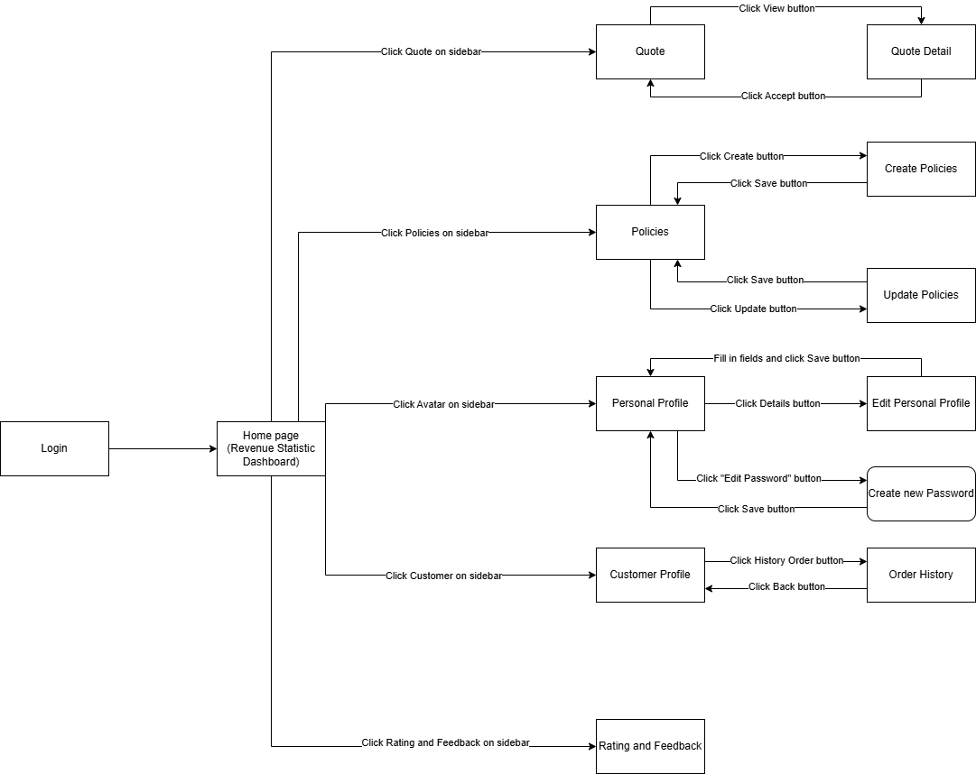

* Customer Screen Flow

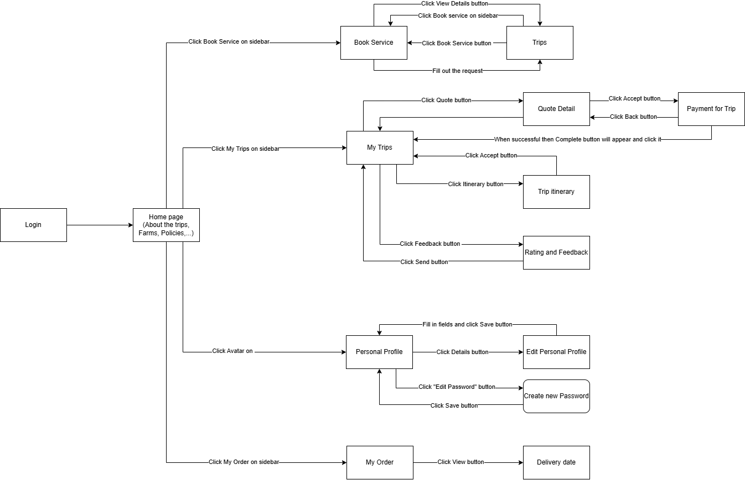

* Sales Staff Screen Flow

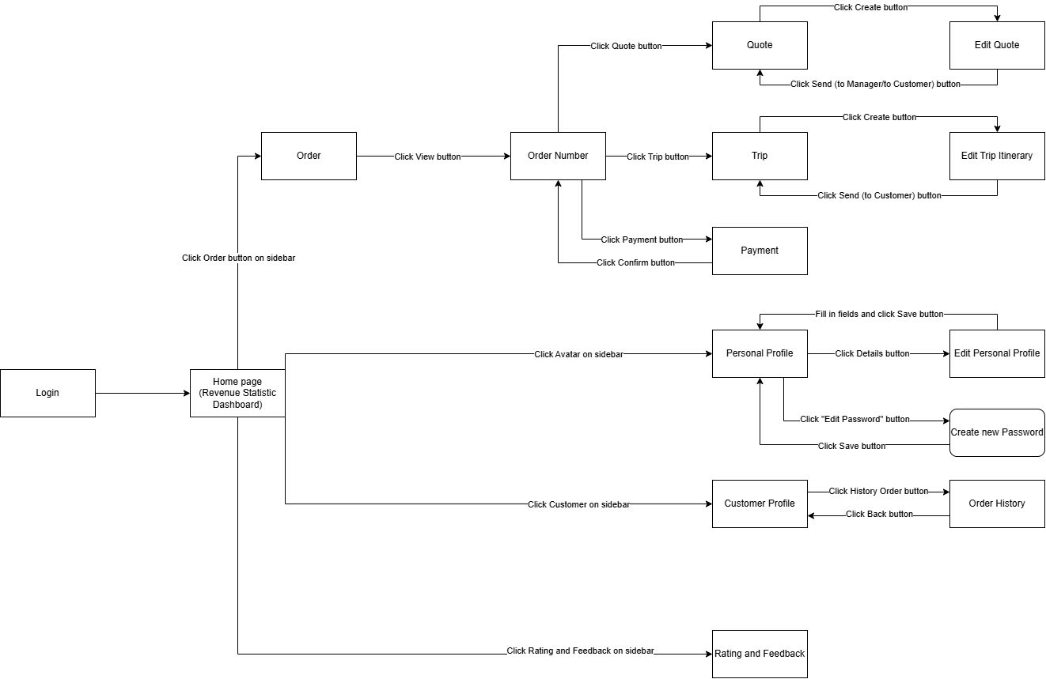

### 1.2 Screen Descriptions

#### 1.2.a Manager Screen Descriptions

|  |  |  |  |
| --- | --- | --- | --- |
| **#** | **Screen** | **Feature** | **Description** |
| FR-01 | Quote | Manage Quote | This screen allows manager to view list of quote. |
| FR-02 | Quote Detail | Manage Quote | This screen allows manager to view quote detail. |
| FR-03 | Policies | Manage Policies | This screen allows manager to view list of policies. |
| FR-04 | Create Policies | Create New Policies | This screen allows manager to create new policies. |
| FR-05 | Update Policies | Update Policies | This screen allows manager to update policies. |
| FR-06 | Personal Profile | Manage Personal Profile | This screen allows manager to view Personal Profile. |
| FR-07 | Edit Personal Profile | Edit Personal Profile | This screen allows manager to edit personal profile. |
| FR-08 | Create new Password | Create new Password | This screen allows manager to Create new Password. |
| FR-09 | Customer Profile | View list of Customer Profile. | This screen allows manager to view list of Customer Profile. |
| FR-10 | Order History | View list of History Order | This screen allows manager to View list of history order. |

#### 1.2.b Customer Screen Description

|  |  |  |  |
| --- | --- | --- | --- |
| **#** | **Screen** | **Feature** | **Description** |
| FR-01 | Book Service | Booking Trip | This screen allows Customer to create booking trips. |
| FR-02 | Trips | Booking Trip | This screen allows Customer to create booking trips. |
| FR-03 | My Trips | View Information of trip | This screen allows Customer to view items of trip. |
| FR-04 | Quote Detail | View and Confirm quote detail. | This screen allows Customer to View and Confirm quote detail. |
| FR-05 | Trip itinerary | View trip itinerary | This screen allows Customer to View trip itinerary |
| FR-06 | Personal Profile | Manage Personal Profile | This screen allows Customer to view Personal Profile. |
| FR-07 | Edit Personal Profile | Edit Personal Profile | This screen allows Customer to edit personal profile. |
| FR-08 | Create new Password | Create new Password | This screen allows Customer to Create new Password. |
| FR-09 | Rating and Feedback | Send Rating and Feedback | This screen allows Customer to Send Rating and Feedback |
| FR-10 | My Order | View list of Koi fish order | This screen allows Customer to View list of Koi fish order |
| FR-11 | Delivery date | View Delivery date | This screen allows Customer to View Delivery date |

#### 1.2.c Sales Staff Screen Descriptions

|  |  |  |  |
| --- | --- | --- | --- |
| **#** | **Screen** | **Feature** | **Description** |
| FR-01 | Order | View list of order | This screen allows Sales Staff to view list of order. |
| FR-02 | Order Number | View order number detail | This screen allows Sales Staff to View order number detail. |
| FR-03 | Quote | View list of quote | This screen allows Sales Staff to View list of quote. |
| FR-04 | Edit Quote | Create and send quote | This screen allows Sales Staff to Create and send quote. |
| FR-05 | Trip | View trip | This screen allows Sales Staff to View trip |
| FR-06 | Personal Profile | Manage Personal Profile | This screen allows Sales Staff to view Personal Profile. |
| FR-07 | Edit Personal Profile | Edit Personal Profile | This screen allows Sales Staff to edit personal profile. |
| FR-08 | Create new Password | Create new Password | This screen allows Sales Staff to Create new Password. |
| FR-09 | Edit Trip Itinerary | Create and Send Trip Itinerary | This screen allows Sales Staff to Create and Send Trip Itinerary. |
| FR-10 | Customer Profile | View list of Customer Profile. | This screen allows Sales Staff to view list of Customer Profile. |
| FR-11 | Order History | View list of History Order | This screen allows Sales Staff to View list of history order. |
| FR-12 | Rating and Feedback | View rating and feedback | This screen allows Sales Staff to View rating and feedback. |

### 1.3 Screen Authorization

|  |  |  |  |
| --- | --- | --- | --- |
| **Screen** | **Manager** | **Customer** | **Sales Staff** |
| Quote | X |  | X |
| Quote Detail | X |  | X |
| Policies | X |  |  |
| Create Policies | X |  |  |
| Update Policies | X |  |  |
| Personal Profile | X | X | X |
| Edit Personal Profile | X | X | X |
| Create new Password | X | X | X |
| Customer Profile | X |  | X |
| Order History | X |  | X |
| Booking |  | X | X |
| Trip Itinerary |  | X | X |
| Rating and Feedback |  | X | X |

In which:

* Customer: Registered users who can book tours, manage their bookings, and make payments.
* Manager: Approves quotes and oversees the entire service lifecycle, including managing staff and reviewing tour cancellations.
* Sales Staff: Finalizes tour itineraries, prepares quotes, and communicates with customers.

### 1.4 Non-Screen Functions

|  |  |  |  |
| --- | --- | --- | --- |
| **#** | **System Function** | **Feature** | **Description** |
| FR-1 | Role Authorization | Access Control | Grants or denies access to certain screens based on user roles. |
| FR-2 | Fetch Available Tour | Display Tour list | Retrieves a list of available tours based on filters. |
| FR-3 | Generate Quote | Sales Quote Creation | Creates a quote for koi fish services or tours and sends it for approval. |
| FR-4 | Cancel Booking | Booking Cancellation | Handles user requests to cancel a booking and manages the refund process. |

## 2. Data Requirements

### 2.1 Logical Data Model

### 2.2 Data Dictionary

|  |  |  |  |  |
| --- | --- | --- | --- | --- |
| **Data Element** | **Description** | **Composition or Data Type** | **Length** | **Values** |
| guestID | Unique identifier for each guest | UUID | 36 | Auto Generated UUID |
| customerID | Unique identifier for the Customer | UUID(Primary Key) | 36 | Auto Generated UUID |
| firstName | Customer First Name | String | 50 | Any Alphanumeric string |
| lastName | Customer Last Name | String | 50 | Alphanumeric string |
| email | Customer Email | String | 100 | Valid Email Format |
| address | Address details of the customer | String | 255 | Alphanumeric,user-defined |
| paymentMethod | Preferred payment method for the customer | String | 30 | Credit Card,  Bank Transfer,  Paypal |
| createdAt | Date and time customer was created | DateTime | 10 | YYYY-MM-DD HH:MM |
| updateAt | Date and time customer data was last updated | DateTime | 10 | YYYY-MM-DD HH:MM |
| saleStaffID | Unique identifier for each sales staff | UUID(Primary Key) | 36 | Auto Generated UUID |
| name | Name of the sales staff member | String | 50 | Alphanumeric,user-defined |
| role | Job role | String | 30 | Sales Associate,  Account Manager |
| consultingStaffID | Unique identifier for each consulting staff | UUID(Primary Key) |  | Auto Generated UUID |
| name | Name of the consulting staff member | String | 50 | Alphanumeric,user-defined |
| role | Job role | String | 30 | Consultant,  Tour Specialist |
| deliveringStaffID | Unique identifier for each delivering staff | UUID(Primary Key) |  | Auto Generated UUID |
| name | Name of the delivering staff member | String | 50 | Alphanumeric,user-defined |
| role | Job role | String | 30 | Delivery Specialist |
| managerID | Unique identifier for each manager | UUID(Primary Key) |  | Auto Generated UUID |
| name | Name of the manager | String | 50 | Alphanumeric,user-defined |
| role | Job role | String | 30 | Operations Manager |
| tourID | Unique identifier for the Tour | UUID(Primary Key) | 36 | Auto Generated UUID |
| koiFarm | The Farm where the tour takes place | String | 100 | Name of the KOI Farm |
| tourName | Name of Tour | String | 100 | Any Alphanumeric string |
| price | Price of tour | Decimal |  | Numeric,user-defined |
| startDate | Start date of the tour | Date | 10 | YYYY-MM-DD |
| endDate | End date of the tour | Date | 10 | YYYY-MM-DD |
| availableSlot | Number of available slots on the tour | Integer | 4 | Positive Number |
| description | Detailed of the Tour | String | 255 | Any Aphanumeric string |
| bookingID | Unique identifier for the booking | UUID(Primary Key) | 36 | Auto Generated UUID |
| customerID | Identifier for customer making the booking | UUID (Foreign Key) | 36 | Reference to customerID |
| tourID | Identifier for the booked tour | UUID(Foreign Key) | 36 | Refernce to tourID |
| status | Status of booking | String | 20 | Pending,  Confirmed,  Canceled,  Finalized |
| createdAt | Date and time booking record was created | DateTime | 10 | YYYY-MM-DD HH:MM |
| updateAt | Date and time booking record was last updated | DateTime | 10 | YYYY-MM-DD HH:MM |
| paymentID | Unique identifier for the payment | UUID(Primary Key) | 36 | Auto Generated  UUID |
| bookingID | Identifier for the associated amount | UUID(Foreign Key) | 36 | Reference to bookingID |
| amount | Amount paid for the booking | Decimal |  | Numeric |
| paymentMethod | Method of payment | String | 20 | Credit Card,  Bank Tranfer,  PayPal |
| paymentStatus | Status of the payment | String | 20 | Pending,  Completed,  Failed,  Refunded |
| createdAt | Date and time payment record was created | DateTime | 10 | YYYY-MM-DD HH:MM |
| deliveryID | Unique identifier of the delivery | UUID(Primary Key) | 36 | Auto Generated UUID |
| orderID | Unique identifier of the order being delivered | UUID(Foreign Key) | 36 | Reference to orderID |
| deliveringStaffID | Identifier for delivering staff handling the delivery | UUID(Foreign Key) | 35 | Reference to deliveringStaffID |
| deliveryDate | Date of the delivery | Date | 10 | YYYY-MM-DD |
| deliveryStatus | Status of delivery | String | 20 | Scheduled,  In Transit,  Delivered,  Failed,  Rescheduled |
| feedbackID | Unique identifier of the feedback | UUID(Primary Key) | 36 | Auto Generated UUID |
| customerID | Unique identifier for Customer providing feedback | UUID(Foreign Key)) | 36 | Reference to customerID |
| tourID | Identifier for the associated tour | UUID(Foreign Key) | 36 | Reference to tourID |
| comments | Customer’s comments on the tour | text | 255 | User-defined |
| createdAt | Date and time feedback record was created | DateTime | 10 | YYYY-MM-DD HH:MM |
| quoteID | Unique identifier for each quote | UUID(Primary Key) | 36 | Auto Generated UUID |
| saleStaffID | Identifier for sales staff providing the quote | UUID(Foreign Key) | 36 | Reference to saleStaffID |
| tourID | Identifier for the quote of tour | UUID(Foreign Key) | 36 | Refernce to tourID |
| price | Price of tour | Decimal(Foreign Key) |  | Numeric,user-defined |
| status | Status of quote | String | 20 | Pending,  Approved,  Rejected |
| createdAt | Date and time quote was created | DateTime | 10 | YYYY-MM-DD HH:MM |
| approvedAt | Date and time quote was approved | DateTime | 10 | YYYY-MM-DD HH:MM |
| orderID | Unique identifier for each koi fish order | UUID(Primary Key) | 36 | Auto Generated UUID |
| customerID | Unique identifier for Customer placing order | UUID(Foreign Key)) | 36 | Reference to customerID |
| tourID | Identifier for the tour have that order | UUID(Foreign Key) | 36 | Refernce to tourID |
| orderPrice | Order Price | Decimal(Foreign Key) |  | Numeric,user-defined |
| koifishDetail | Detail of the KOI fish that had been order | String | 255 | Any Aphanumeric string |
| orderStatus | Status of the order | String | 20 | Pending,  Shipped,  Delivered,  Cancelled |
| createdAt | Date and time order was created | DateTime | 10 | YYYY-MM-DD HH:MM |

### Reports

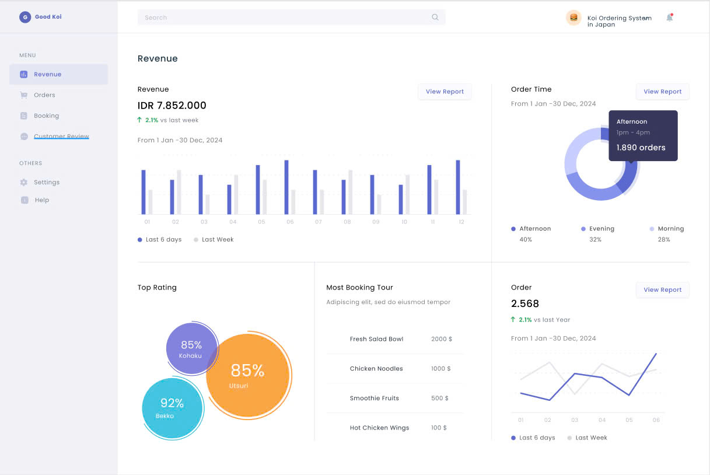

### State transition diagram

* **Guest State**

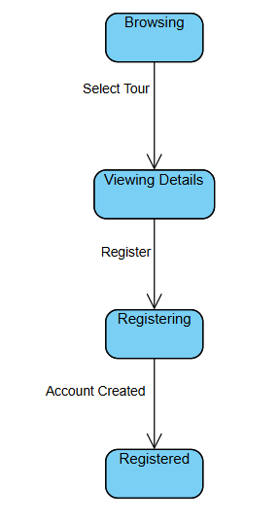

* **Customer State**

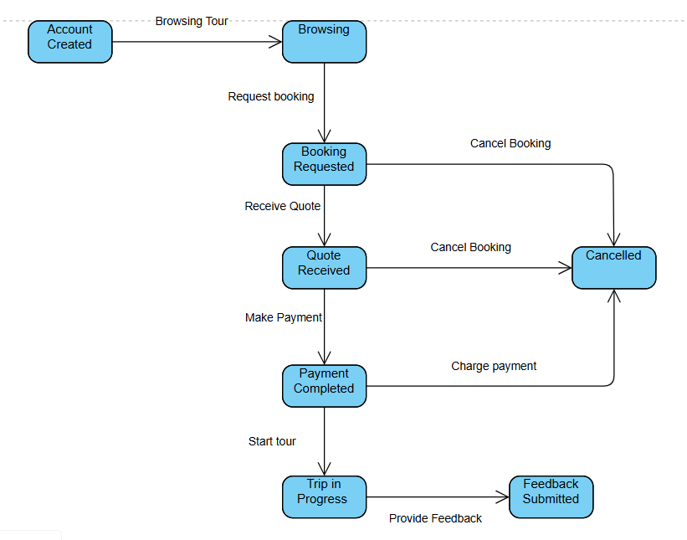

* **Sales Staff State**

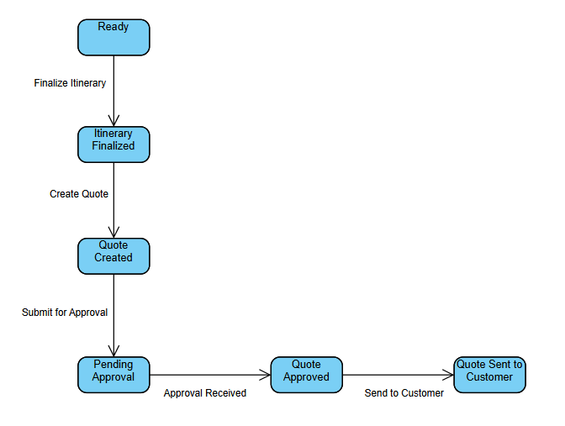

* **Consulting Staff State**

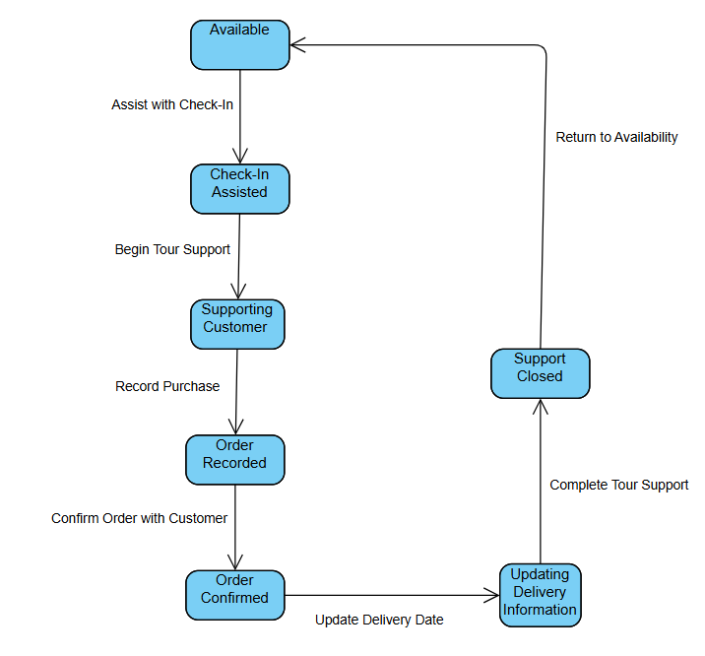

* **Delivering Staff State**

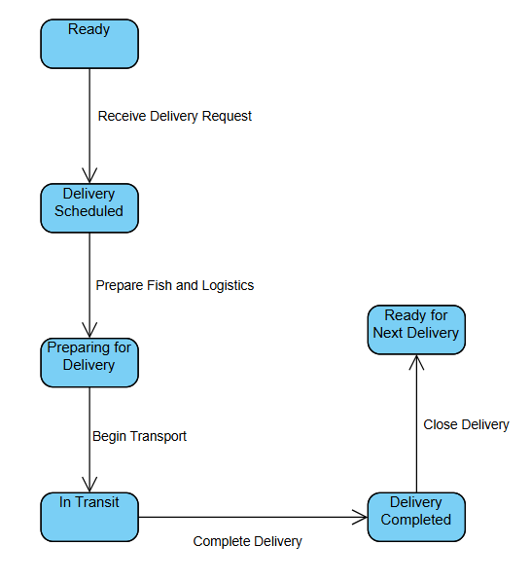

* **Manager Staff**

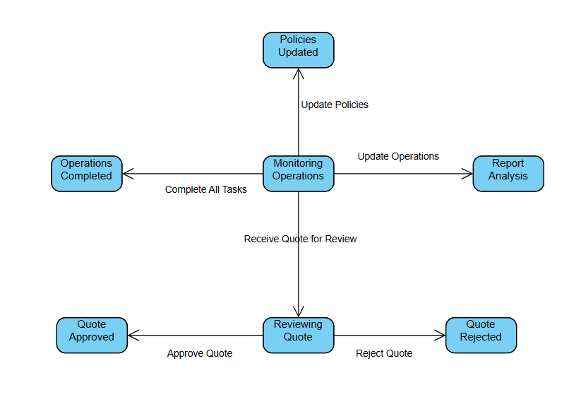

## 3. <<Dashboard>>

### 3.1 <<Dashboard Screen>>

* This Screen Show Dashboard of System
* Actor: Manager

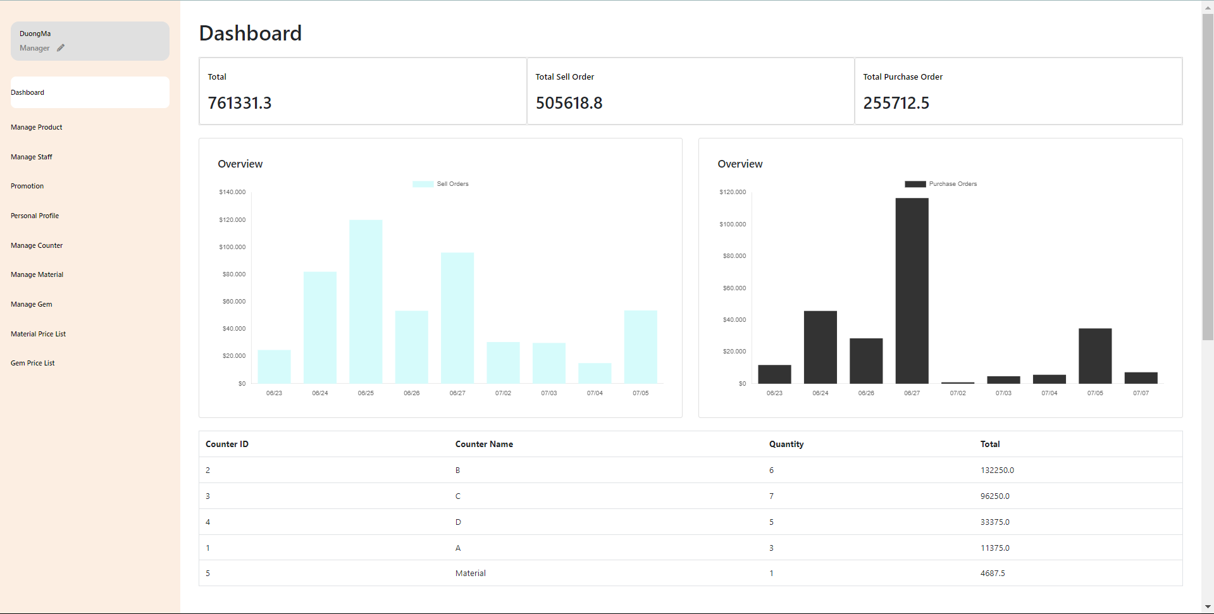

## 4. <<Search And Booking>>

### 4.1 <<Search Tour>>

* This screen show home page to view available trip
* Actor: Customer

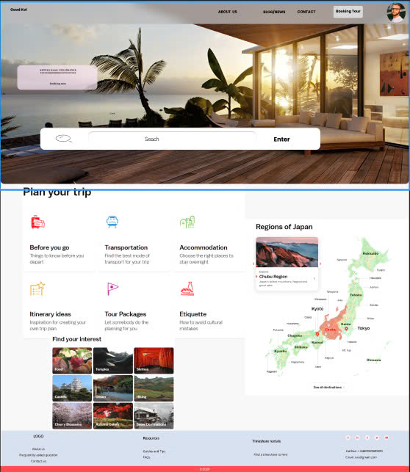

### 4.2 <<Booking Tour>>

* This screen to show price and booking tour
* Actor: Customer

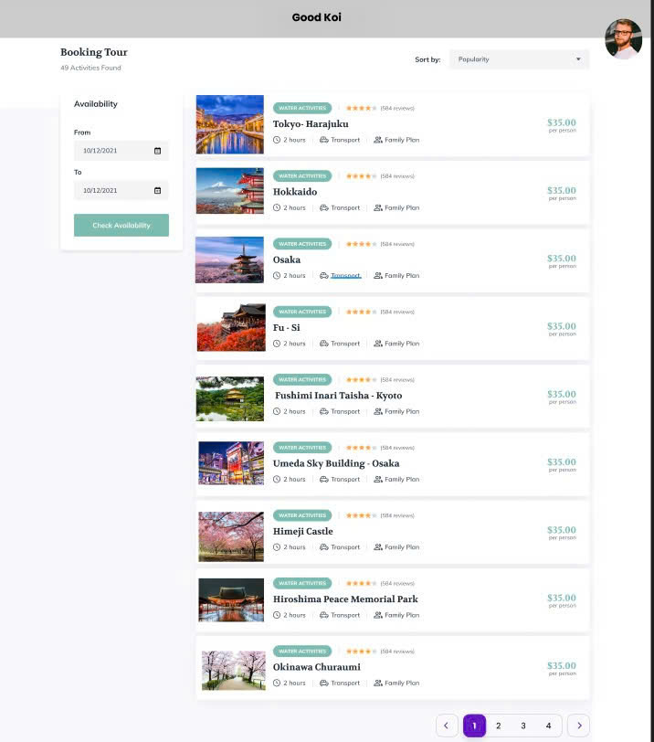

## 5. <<Manager>>

### 5.1<<Manager profile>>

* This screen to show staff profile and update staff information
* Actor: Manager
* 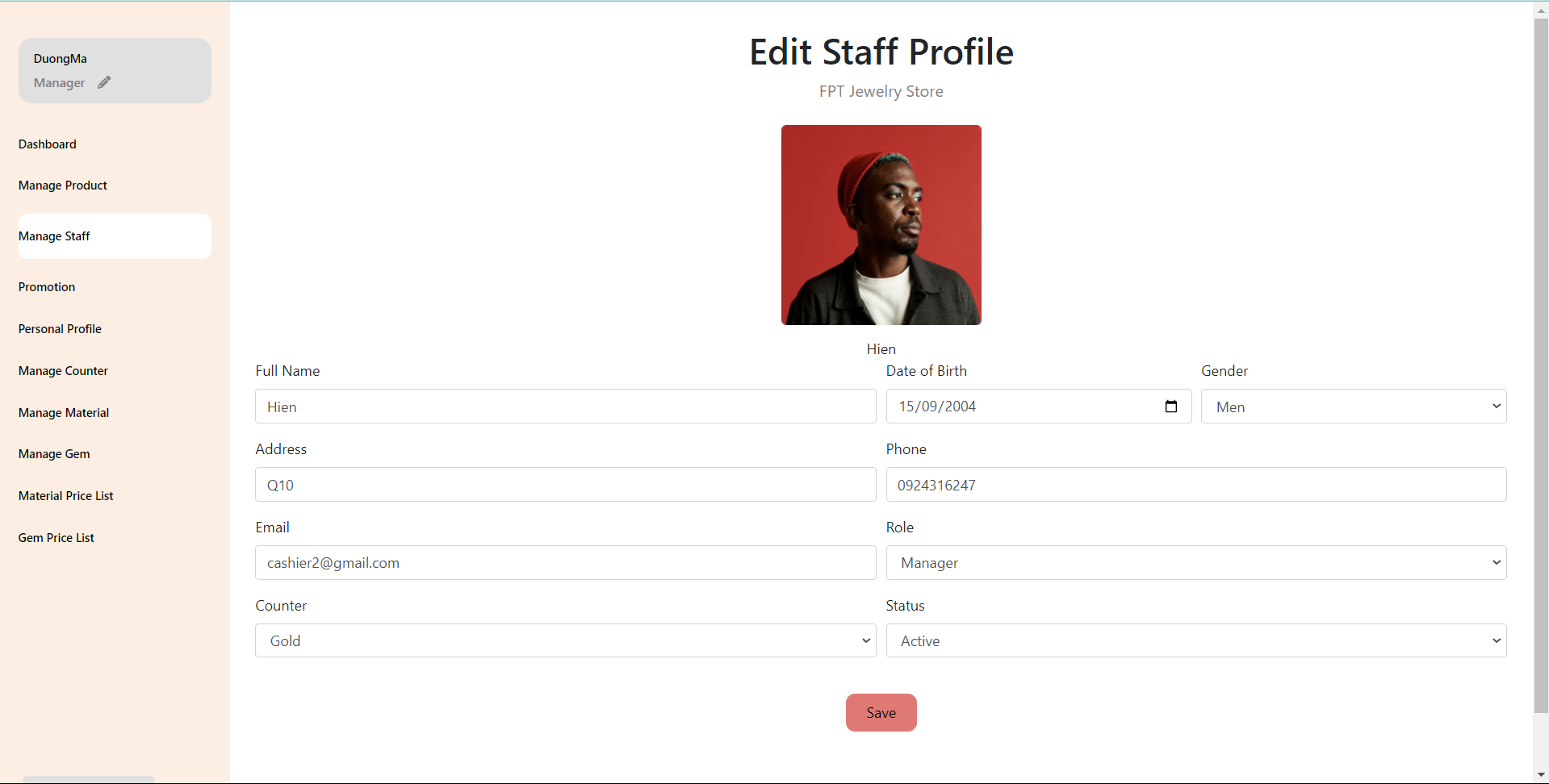

### 5.2<<Customer list>>

* This screen show list of customer
* Actor: Manager
* 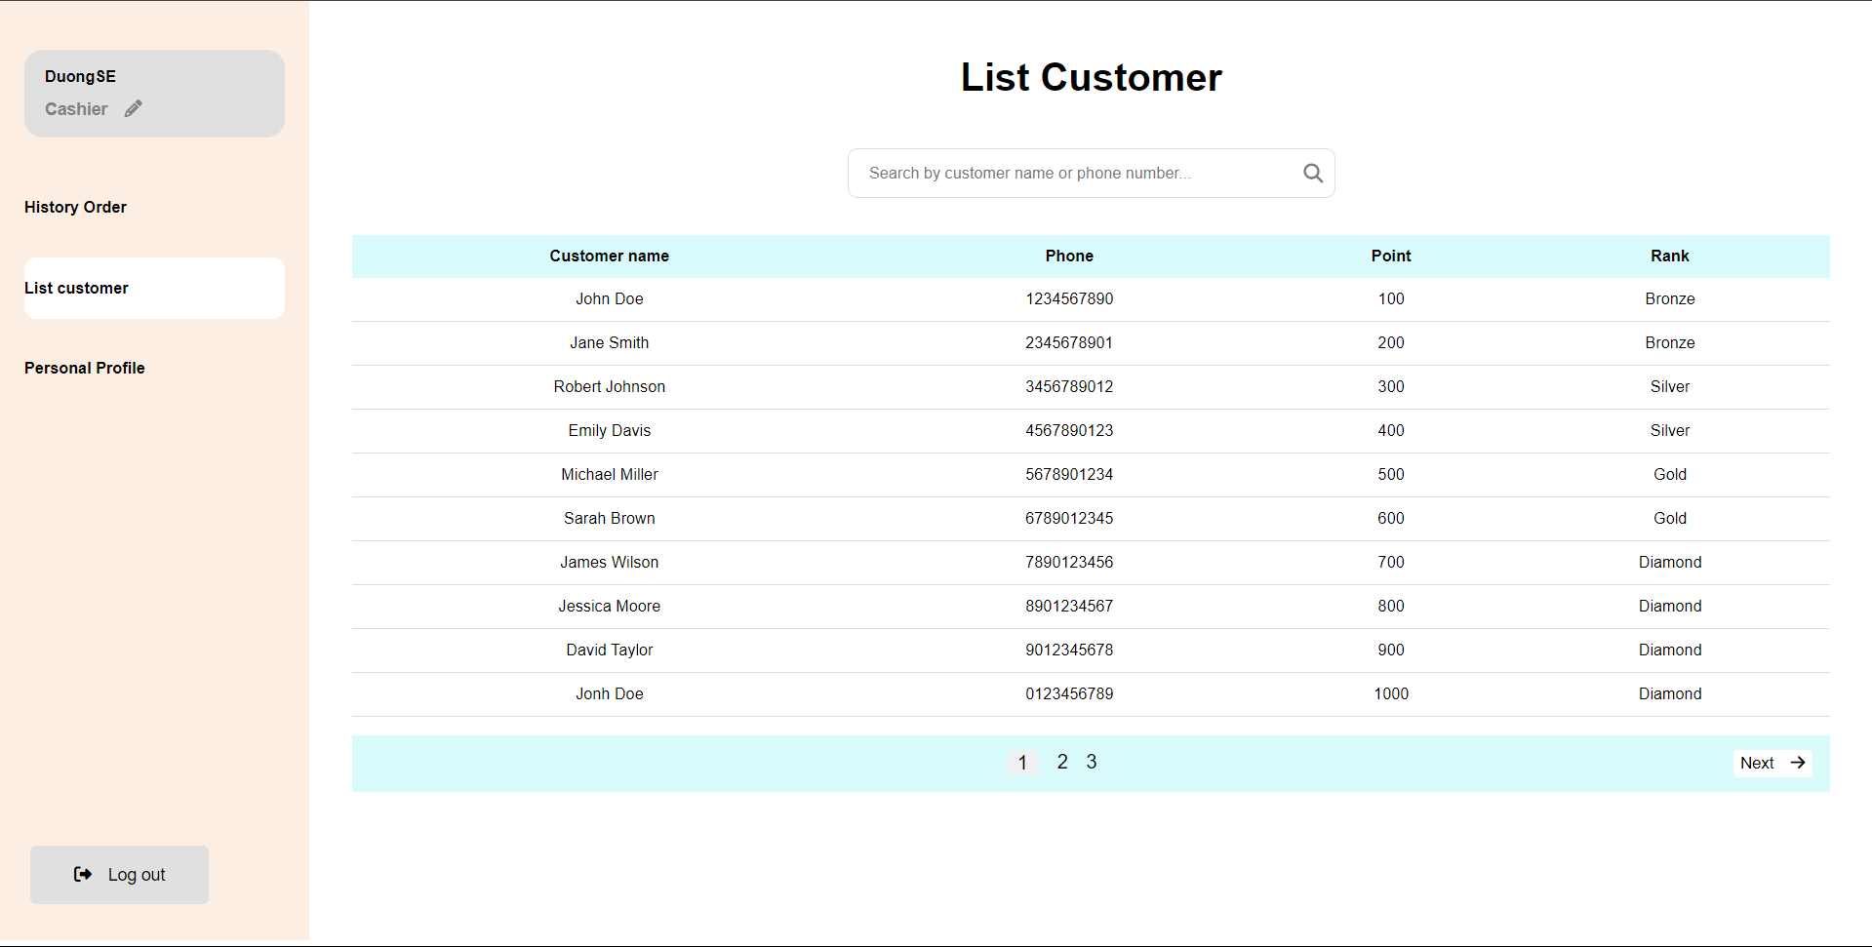

### 5.3<<History Order>>

* This screen show history order.
* Actor: Cashier

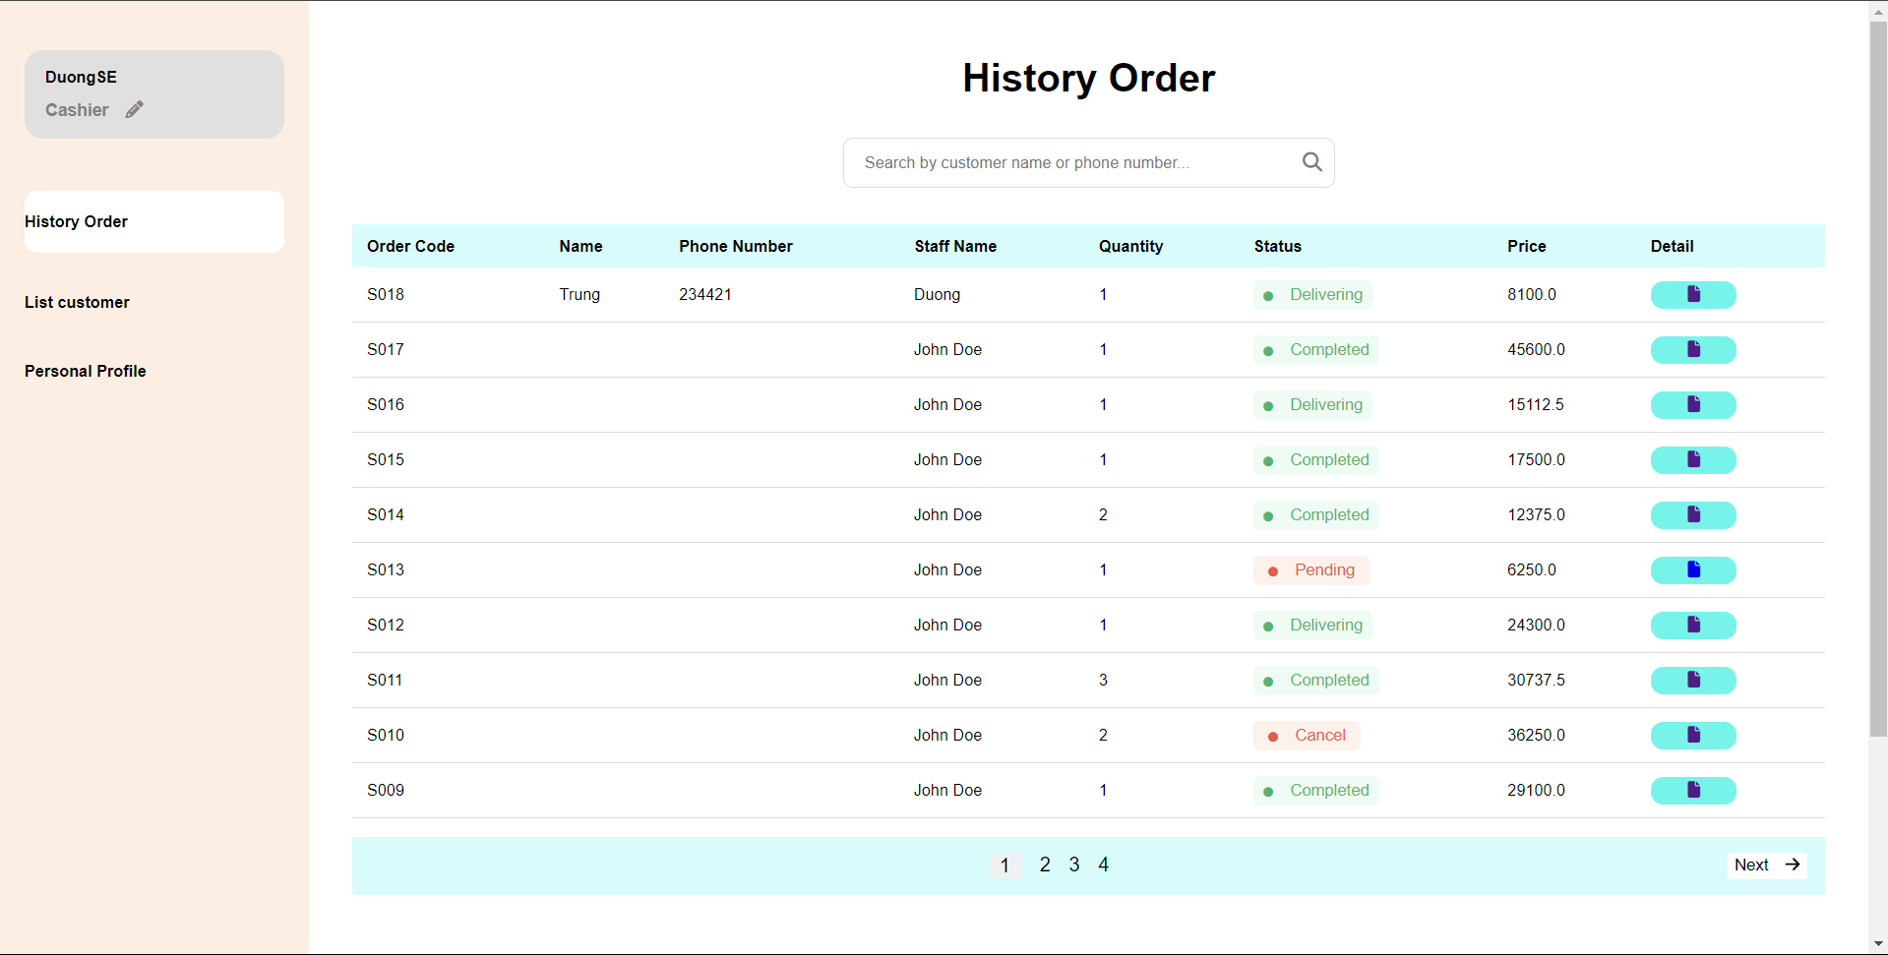

### 5.4 <<Edit password>>

* This screen use to update password of the account
* Actor: Manager

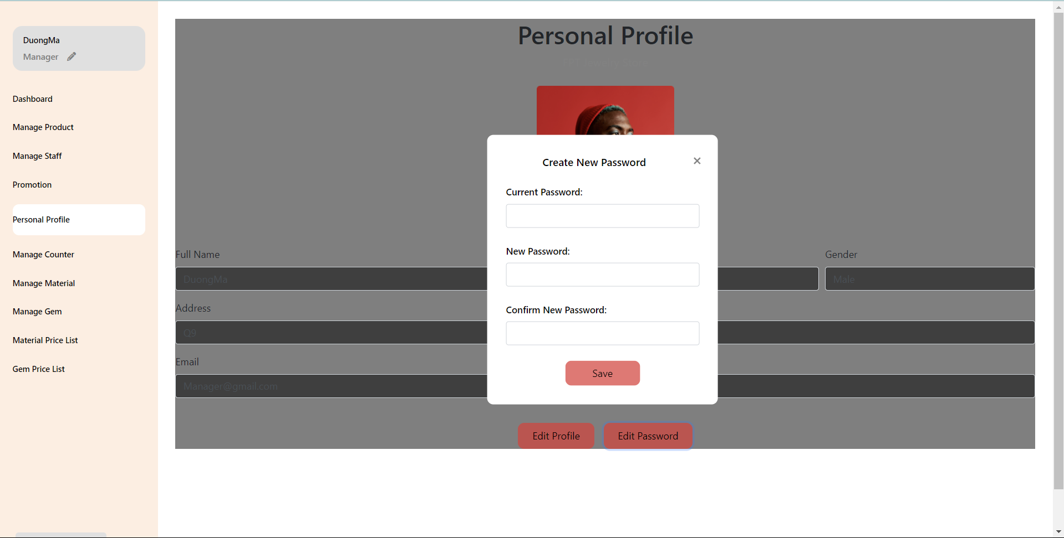

## 6. <<Sales Staff>>

### 6.1<<Sales Staff profile>>

* This screen to show staff profile and update staff information
* Actor: Sales Staff



### 6.2<<History Order>>

* This screen show history order.
* Actor: Sales Staff



### 6.3<<Edit password>>

* This screen use to update password of the account
* Actor: Sales Staff

## 7. <<Customer>>

### 7.1<<Customer profile>>

* This screen to show staff profile and update staff information
* Actor: Customer



### 7.2<<History Order>>

* This screen show history order.
* Actor: Customer

### 7.3<<Edit password>>

* This screen use to update password of the account
* Actor: Customer

## 8. <<Consulting Staff>>

### 8.1<<Consulting Staff profile>>

* This screen to show staff profile and update staff information
* Actor: Consulting Staff



### 8.2<<Edit password>>

* This screen use to update password of the account
* Actor: Consulting Staff



# V. Non-Functional Requirements

## 1. External Interface Requirements

### 1.1 User Interfaces

**UI-1:** All screens within the Koi Ordering System must adhere to the internal "Koi Ordering UI Standard, Version 1.0," which includes guidelines on colors, fonts, layouts, and standard components (e.g., navigation bar, account icon, help button).

**UI-2:** The system must provide a “Help” button on each screen to allow users to access guidance on the functions of that particular screen. Each help page will clearly describe the steps required on the current screen and offer solutions for common issues that users may encounter.

**UI-3:** The web pages must support complete navigation and Koi item selection using both keyboard and mouse, as well as touch interactions for touch-screen devices.This ensures the system is accessible for users with various navigation preferences or limitations.

**UI-4:**The user interface will include standard buttons (such as “Confirm”, “Cancel” ,“Next” and “Back”) to standardize interactions. Error messages will display as pop-up dialogs to be easily recognizable by users and will include instructions for resolving the issue.

**UI-5:** The interface must support multiple languages (Japanese, English, and Vietnamese) to serve users from different countries. Users can switch languages via the main navigation bar to access content in their preferred language.

**UI-6:** The design of the user interface will be documented in a separate specification, including sample images, layout diagrams, and layout guidelines to ensure consistency throughout.

### 1.2 Software Interfaces

**SI-1: PayEase Payment Gateway**

**SI-1.1:** The Koi Ordering System will communicate with the PayEase payment gateway through a programmatic interface to securely process transactions.

**SI-1.2:** The system will transmit payment data (including amount, payment method, and transaction ID) to the PayEase gateway and receive the transaction status response (e.g., “Success”, “Failure” or “Pending”).

**SI-1.3:** Data formatting and encryption will comply with PCI-DSS security standards to protect users’ financial information during transactions.

**SI-2: Customer and Order Database (MySQL 8.0)**

**I-2.1:** The system will connect with the MySQL database to retrieve and store customer information, order details, and Koi information, including but not limited to customer ID, order history, payment status, and delivery status.

**SI-2.2:** All data output from the database will be converted to JSON or XML format to ensure compatibility with other system components when necessary.

**SI-2.3:** Non-functional requirements, such as response time, must ensure that each query to the database returns results within 2 seconds during peak load times.

**SI-3: Notification Manager API**

**SI-3.1:** The Koi system will send requests to the Notification Manager API to automatically notify customers of order status, payments, and deliveries via email or SMS.

**SI-3.2:** Data formats are standardized to be compatible with the Notification Manager, ensuring that the information sent is complete and accurate, with error codes for cases where notifications cannot be sent successfully.

### 1.3 Hardware Interfaces

**HI-1: Server Configuration**

**Application Server**

CPU : Intel Xeon 8 Core 2.40 GHz

RAM : 128 GB 1333 MHz

Storage : 2 TB

Operating System : Windows Server 2019

Software : Microsoft IIS 10, .NET Framework 4.8

**Database Server**

CPU : Intel Xeon 12 Core 2.40 GHz

RAM : 256 GB 1333 MHz

Storage : 3 TB

Operating System : Windows Server 2019

Software : MySQL 8.0

**HI-2: Client Device Configuration**

**PC Device**

CPU : Intel Core i5 2.40 GHz

RAM : 8 GB

Storage : 500 GB SSD

Operating System : Windows 10 or macOS Catalina and above

Display : Minimum resolution of 1280 x 720 pixels

**Mobile Device**

CPU : Quad-Core 1.5 GHz

RAM : 2 GB

Operating System : Android 8.0 or iOS 12 and above

Display : Minimum resolution of 1280 x 800 pixels, Wi-Fi 5GHz support.

**HI-3: Network Interface**

**LAN Network** : Speed ≥ 1 Gbps

**WAN Network** : Minimum speed of 2 Mbps per 10 users.

### 1.4 Communications Interfaces

**CI-1: Email/SMS Notifications**

**CI-1.1:** The Koi system will send email or SMS notifications to customers to confirm orders, prices, and delivery instructions based on their account settings. Notifications must be sent within 5 minutes of any order status update.

**CI-1.2:** In cases of order or delivery issues, the system will automatically notify the customer with details on the status and steps for resolution.

**CI-2: Encryption and Security**

**CI-2.1:** All sensitive information (including account and payment details) will be encrypted via SSL/TLS protocols to prevent unauthorized access.

**CI-2.2:** Transmission Speed: Sensitive messages and data must be transmitted with a maximum delay of 2 seconds to ensure timely information delivery.

## 2. Quality Attributes

### 2.1 Usability

**USE-1: The homepage shall clearly present information about Koi farms and Koi varieties, allowing users to access this information with no more than three clicks.**

**USE-2: The system shall allow Customers to search for and filter tours based on criteria such as farm, Koi variety, price, and time, retrieving relevant results within five seconds.**

**USE-3: 90% of new users shall be able to successfully book a Koi tour and order fish during their trip without errors on their first attempt.**

**USE-4: The booking process shall provide step-by-step guidance, ensuring that 95% of users feel confident in their ability to complete the tour booking and Koi ordering process.**

**USE-5: Confirmation messages shall summarize the details of the tour booking and Koi order, allowing users to review and verify their selections within 30 seconds of completion.**

**USE-6: The Customer Dashboard shall feature an organized layout for managing bookings, Koi orders, and personal information, enabling users to find specific details within two clicks.**

**USE-7: The system shall offer contextual help and FAQs accessible during the booking process, ensuring that 80% of users can find answers without needing external assistance.**

**USE-8: Customers shall be able to submit feedback on their tour experience and Koi orders with no more than two interactions, making it easy to share their thoughts.**

### 2.2 Performance

**PER-1:** The system shall accommodate a total of 500 users and support a maximum of 150 concurrent users during peak usage times, particularly between 9:00 A.M. and 11:00 A.M. local time, with an estimated average session duration of 10 minutes.

**PER-2:** 95% of pages generated by the system shall load completely within 3 seconds over a 20Mbps or faster Internet connection.

**PER-3:** The system shall retrieve and display Koi tour options within an average of 2 seconds and a maximum of 4 seconds after a user submits a search query.

**PER-4:** The system shall process booking requests and display confirmation messages within an average of 3 seconds and a maximum of 5 seconds after the user submits their booking information.

**PER-5:** The system shall maintain an average response time of less than 1 second for user interactions, such as clicking buttons or selecting filters.

**PER-6:** The system shall be capable of handling up to 200 simultaneous payment transactions without degradation in performance during peak times.

**PER-7:** The system shall cache frequently accessed data, such as Koi farm details and tour options, to ensure that 90% of repeat requests are served within 1 second.

**PER-8:** The system shall automatically scale resources to handle sudden spikes in user traffic, ensuring that performance remains stable without noticeable delays during peak periods, such as promotional events or holiday seasons.

### 2.3 Security

**SEC-1:** All network transactions involving payment information or personally identifiable information (PII) shall be encrypted using industry-standard protocols such as TLS 1.2 or higher.

**SEC-2:** Users shall be required to log in to the system for all operations except viewing general information about Koi farms and available tours.

**SEC-3:** Only authorized sales staff and management personnel shall be permitted to access and modify booking details and financial information.

**SEC-4:** The system shall allow users to view only their own Koi orders and booking history, ensuring that customers cannot access information belonging to other users.

**SEC-5:** User sessions shall automatically expire after 15 minutes of inactivity, requiring re-authentication to enhance security against unauthorized access.

**SEC-6:** The system shall implement multi-factor authentication (MFA) for all users accessing sensitive features, such as payment processing and personal information management.

**SEC-7:** All user activity logs shall be maintained for auditing purposes, with access to logs restricted to authorized personnel only.

### 2.4 Safety

**SAF-1:** The system shall provide clear information about the handling and transport conditions of Koi fish, including any known risks associated with specific varieties, ensuring customers are aware of the care needed.

**SAF-2:** The system shall allow users to report any issues or concerns regarding Koi health or transportation conditions during their tour, and these reports shall be prioritized and addressed within 24 hours.

**SAF-3:** The system shall display warnings to users about potential environmental hazards related to Koi transport and care, such as temperature fluctuations or poor water quality, before finalizing their orders.

**SAF-4:** The system shall include safety instructions for customers regarding the handling of Koi fish during and after transport, ensuring they are aware of best practices to maintain the fish's health.

**SAF-5:** The system shall automatically log and notify relevant personnel of any incidents reported by users concerning Koi health or transport safety, enabling timely intervention.

### Availability

**AVL-1:** The system shall be available at least 99% of the time between 6:00 A.M. and 11:00 P.M. local time and at least 95% of the time between 11:00 P.M. and 6:00 A.M. local time, excluding scheduled maintenance windows.

**AVL-2:** Downtime that is excluded from the availability calculation shall include maintenance scheduled during the hours from 8:00 P.M. Saturday to 4:00 A.M. Sunday local time.

**AVL-3:** The system shall implement redundancy measures, such as load balancing and failover mechanisms, to ensure continuous availability even during unexpected outages.

**AVL-4:** The system shall provide real-time status updates to users regarding availability and any ongoing maintenance, ensuring transparency about service status.

**AVL-5:** The system shall automatically switch to backup servers within 5 minutes in the event of a primary server failure, minimizing service disruption.

### Reliability

**REL-1:** No more than 3 transactions out of 1,000 shall fail due to software errors, ensuring high reliability during user interactions.

**REL-2:** The mean time between failures (MTBF) for the booking and payment processing components shall be at least 120 days, minimizing disruption for users.

**REL-3:** The system shall automatically log errors and generate alerts for administrators within 1 minute of a failure occurring, allowing for prompt investigation and resolution.

**REL-4:** The system shall maintain consistent performance under varying loads, with 95% of transactions completed successfully even during peak usage times.

**REL-5:** The system shall implement regular backup procedures to ensure data integrity, with backups performed daily to prevent data loss in case of failures.

### Design Contrainsts

**DES-1:** Programming languages: JavaScript (for frontend), React (for UI framework), and Node.js (for backend services).

**DES-2:** Web server: Nginx or Apache, configured to handle high traffic and support SSL/TLS for secure transactions.

**DES-3:** Web browser compatibility: The system shall support modern web browsers, including Chrome, Firefox, Safari, and Edge, with a minimum version requirement of two versions prior to the current release.

**DES-4:** Database: PostgreSQL or MySQL for data management, with a focus on scalability and support for complex queries.

**DES-5:** Reporting tools: Integration with reporting tools such as Jasper Reports or Google Data Studio for generating dynamic reports and visualizations.

**DES-6:** Design tools: Figma for UI/UX design and Lucidchart for flowchart and diagram creation.

**DES-7:** Development environment: The system shall be developed using Visual Studio Code, with support for Git version control.

**DES-8:** API standard: The system shall use RESTful APIs for communication between frontend and backend components, adhering to REST principles for resource representation.

**DES-9:** Accessibility compliance: The application shall comply with WCAG 2.1 AA standards to ensure accessibility for users with disabilities.

**DES-10:** Deployment: The system shall be containerized using Docker to facilitate consistent deployment across different environments (development, testing, production).

### 2.8 Efficiency

**EFF-1:** The system shall ensure that at least 90% of all search requests return results within 2 seconds, even under peak load conditions, allowing users to find information quickly.

**EFF-2:** User-initiated actions (e.g., submitting a booking request) shall be processed with a response time of no more than 3 seconds in 95% of cases, enhancing user satisfaction during interactions.

**EFF-3:** The application shall utilize caching mechanisms to store frequently accessed data, aiming to reduce database load by at least 30%, thereby improving overall performance.

**EFF-4:** The system shall optimize image and media file sizes to ensure that webpage loading times do not exceed 3 seconds, promoting a smoother user experience.

**EFF-5:** The system shall support at least 500 concurrent users during peak usage without degradation in response time, ensuring that multiple users can access the platform simultaneously.

**EFF-6:** Server resources shall automatically scale up to accommodate a 50% increase in user load during peak times, ensuring consistent performance.

**EFF-7:** The system shall process payment transactions within 5 seconds for 95% of all requests, ensuring a smooth and efficient checkout experience for users.

**EFF-8:** The system shall provide real-time updates for order statuses, with an update interval of no more than 10 seconds, keeping users informed without delay.